Americas to Africa topic models

Charlie J. Gomez, Harshvardhan Singh

2023-08-21

library('stm')

## stm v1.3.6 successfully loaded. See ?stm for help.   
## Papers, resources, and other materials at structuraltopicmodel.com

library(dplyr)

##   
## Attaching package: 'dplyr'

## The following objects are masked from 'package:stats':  
##   
## filter, lag

## The following objects are masked from 'package:base':  
##   
## intersect, setdiff, setequal, union

library(stringr)  
library(wordcloud)

## Loading required package: RColorBrewer

#Read csv file  
data = read.csv("preprocessed_data_Jul14.csv")  
  
  
##Topic generation for Americas (in collaboration) publications  
  
data_collab <- data[data[["Americas"]] != 0,]  
  
# Save the original title data for future use  
data_collab$original_concatenated_title_abstract <- data_collab$concatenated_title_abstract  
  
#pre-processing the titles using textProcessor from the stm package  
processed_text <- textProcessor(data_collab$concatenated_title_abstract, metadata = data_collab)

## Building corpus...   
## Converting to Lower Case...   
## Removing punctuation...   
## Removing stopwords...   
## Removing numbers...   
## Stemming...   
## Creating Output...

# Further prepare the data by removing low-frequency terms  
out_text <- prepDocuments(processed_text$documents, processed_text$vocab, processed_text$meta)

## Removing 2834 of 9898 terms (2834 of 176304 tokens) due to frequency   
## Your corpus now has 2128 documents, 7064 terms and 173470 tokens.

docs_text <- out_text$documents  
vocab_text <- out_text$vocab  
meta_text <- out_text$meta  
  
  
#Prepare data  
plotRemoved(processed_text$documents, lower.thresh = seq(1, 200, by = 100))

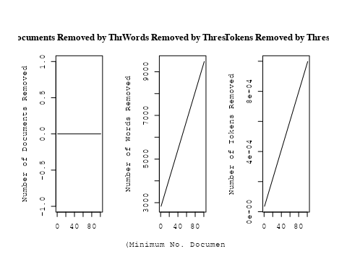

out_text <- prepDocuments(processed_text$documents, processed_text$vocab, processed_text$meta, lower.thresh = 8)

## Removing 7704 of 9898 terms (18901 of 176304 tokens) due to frequency   
## Your corpus now has 2128 documents, 2194 terms and 157403 tokens.

str(out_text$meta)

## 'data.frame': 2128 obs. of 39 variables:  
## $ concept_id : chr "https://openalex.org/C44870925" "https://openalex.org/C1276947" "https://openalex.org/C1276947" "https://openalex.org/C44870925" ...  
## $ work_id : chr "https://openalex.org/W2982505463" "https://openalex.org/W2950791913" "https://openalex.org/W1760966995" "https://openalex.org/W3104422960" ...  
## $ publication_year : int 2019 2010 2010 2004 1998 2006 2011 2002 2008 2020 ...  
## $ title : chr "On the possibilities of classical nova identifications among historical Far Eastern guest star observations" "A comprehensive classification of galaxies in the SDSS: How to tell true from fake AGN?" "Alternative diagnostic diagrams and the 'forgotten' population of weak line galaxies in the SDSS" "The star formation history of Seyfert 2 nuclei" ...  
## $ paperabstract : chr "More than 100 guest star observations have been obtained by Chinese, Korean, Japanese and Vietnamese astronomer"| __truncated__ "We use the W Hα versus [NII]/Hα (WHAN) diagram introduced by us in previous work to provide a comprehensive emi"| __truncated__ "A numerous population of weak line galaxies (WLGs) is often left out of statistical studies on emission-line ga"| __truncated__ "We present a study of the stellar populations in the central ∼200 pc of a large and homogeneous sample comprisi"| __truncated__ ...  
## $ country : chr "CL US" "BR BR BR BR" "BR BR BR BR" "BR FR FR BR" ...  
## $ year_concept : chr "2019+https://openalex.org/C44870925" "2010+https://openalex.org/C1276947" "2010+https://openalex.org/C1276947" "2004+https://openalex.org/C44870925" ...  
## $ concatenated_title_abstract : chr "On the possibilities of classical nova identifications among historical Far Eastern guest star observations Mor"| __truncated__ "A comprehensive classification of galaxies in the SDSS: How to tell true from fake AGN? We use the W Hα versus "| __truncated__ "Alternative diagnostic diagrams and the 'forgotten' population of weak line galaxies in the SDSS A numerous pop"| __truncated__ "The star formation history of Seyfert 2 nuclei We present a study of the stellar populations in the central ∼20"| __truncated__ ...  
## $ US : num 50 0 0 0 66.7 ...  
## $ IN : num 0 0 0 0 0 0 0 0 0 0 ...  
## $ DE : num 0 0 0 0 0 0 0 0 0 0 ...  
## $ CH : num 0 0 0 0 0 0 0 0 0 0 ...  
## $ GB : num 0 0 0 0 0 0 0 0 0 0 ...  
## $ CN : num 0 0 0 0 0 0 0 0 0 0 ...  
## $ FR : num 0 0 0 50 0 0 50 0 0 0 ...  
## $ IT : num 0 0 0 0 0 0 0 0 0 0 ...  
## $ RU : num 0 0 0 0 0 0 0 0 0 0 ...  
## $ CA : num 0 0 0 0 0 0 0 0 0 0 ...  
## $ NL : num 0 0 0 0 0 0 0 0 0 0 ...  
## $ AU : num 0 0 0 0 0 0 0 0 0 0 ...  
## $ JP : num 0 0 0 0 0 0 0 0 0 0 ...  
## $ ES : num 0 0 0 0 0 0 0 0 0 0 ...  
## $ IL : num 0 0 0 0 0 0 0 0 0 0 ...  
## $ Americas : num 50 100 100 50 33.3 ...  
## $ Europe : num 0 0 0 0 0 0 0 0 0 0 ...  
## $ Africa : num 0 0 0 0 0 0 0 0 0 0 ...  
## $ AsiaAndOceania : num 0 0 0 0 0 0 0 0 0 0 ...  
## $ pub_interval_2020_2022 : int 0 0 0 0 0 0 0 0 0 1 ...  
## $ pub_interval_2015_2019 : int 1 0 0 0 0 0 0 0 0 0 ...  
## $ pub_interval_2010_2014 : int 0 1 1 0 0 0 1 0 0 0 ...  
## $ pub_interval_2005_2009 : int 0 0 0 0 0 1 0 0 1 0 ...  
## $ pub_interval_2000_2004 : int 0 0 0 1 0 0 0 1 0 0 ...  
## $ pub_interval_1995_1999 : int 0 0 0 0 1 0 0 0 0 0 ...  
## $ pub_interval_1985_1994 : int 0 0 0 0 0 0 0 0 0 0 ...  
## $ pub_interval_1975_1984 : int 0 0 0 0 0 0 0 0 0 0 ...  
## $ pub_interval_1965_1974 : int 0 0 0 0 0 0 0 0 0 0 ...  
## $ pub_interval_1900_1964 : int 0 0 0 0 0 0 0 0 0 0 ...  
## $ pub_interval_1824_1899 : int 0 0 0 0 0 0 0 0 0 0 ...  
## $ original_concatenated_title_abstract: chr "On the possibilities of classical nova identifications among historical Far Eastern guest star observations Mor"| __truncated__ "A comprehensive classification of galaxies in the SDSS: How to tell true from fake AGN? We use the W Hα versus "| __truncated__ "Alternative diagnostic diagrams and the 'forgotten' population of weak line galaxies in the SDSS A numerous pop"| __truncated__ "The star formation history of Seyfert 2 nuclei We present a study of the stellar populations in the central ∼20"| __truncated__ ...

# Initialize an empty formula string  
prevalence_formula_str <- "~"  
  
# Define the publication intervals  
pub_intervals <- c("pub_interval_2020_2022", "pub_interval_2015_2019", "pub_interval_2010_2014",   
 "pub_interval_2005_2009", "pub_interval_2000_2004", "pub_interval_1995_1999",  
 "pub_interval_1985_1994", "pub_interval_1975_1984", "pub_interval_1965_1974",  
 "pub_interval_1900_1964", "pub_interval_1824_1899")  
  
# Add each publication interval to the formula string  
for (interval in pub_intervals) {  
 # add an if statement to handle the first addition (without '+')  
 if (prevalence_formula_str == "~") {  
 prevalence_formula_str <- paste(prevalence_formula_str, interval)  
 } else {  
 prevalence_formula_str <- paste(prevalence_formula_str, "+", interval)  
 }  
}  
  
  
# Convert the string to a formula  
prevalence_formula <- as.formula(prevalence_formula_str)  
print(prevalence_formula)

## ~pub_interval_2020_2022 + pub_interval_2015_2019 + pub_interval_2010_2014 +   
## pub_interval_2005_2009 + pub_interval_2000_2004 + pub_interval_1995_1999 +   
## pub_interval_1985_1994 + pub_interval_1975_1984 + pub_interval_1965_1974 +   
## pub_interval_1900_1964 + pub_interval_1824_1899

# Run STM model  
Research_topics <- stm(documents = out_text$documents,   
 vocab = out_text$vocab,   
 K = 45,   
 prevalence = prevalence_formula,   
 data = out_text$meta,   
 init.type = "Spectral",  
 max.em.its = 1000,  
 gamma.prior = 'L1')

## Beginning Spectral Initialization   
## Calculating the gram matrix...  
## Finding anchor words...  
## .............................................  
## Recovering initialization...  
## .....................  
## Initialization complete.  
## .....................................................................................................  
## Completed E-Step (2 seconds).   
## Completed M-Step.   
## Completing Iteration 1 (approx. per word bound = -6.485)   
## .....................................................................................................  
## Completed E-Step (2 seconds).   
## Completed M-Step.   
## Completing Iteration 2 (approx. per word bound = -6.194, relative change = 4.495e-02)   
## .....................................................................................................  
## Completed E-Step (1 seconds).   
## Completed M-Step.   
## Completing Iteration 3 (approx. per word bound = -6.117, relative change = 1.243e-02)   
## .....................................................................................................  
## Completed E-Step (1 seconds).   
## Completed M-Step.   
## Completing Iteration 4 (approx. per word bound = -6.086, relative change = 5.060e-03)   
## .....................................................................................................  
## Completed E-Step (1 seconds).   
## Completed M-Step.   
## Completing Iteration 5 (approx. per word bound = -6.069, relative change = 2.787e-03)   
## Topic 1: system, binari, orbit, period, two   
## Topic 2: star, neutron, rate, cool, format   
## Topic 3: solar, observ, flare, event, coron   
## Topic 4: simul, gas, pressur, format, earli   
## Topic 5: outburst, disk, eclips, bright, spectrum   
## Topic 6: survey, present, dark, observ, data   
## Topic 7: star, observ, telescop, use, data   
## Topic 8: rotat, star, spiral, veloc, kinemat   
## Topic 9: galaxi, abund, chemic, evolut, metal   
## Topic 10: variabl, optic, galact, x-ray, band   
## Topic 11: popul, stellar, galaxi, age, star   
## Topic 12: disk, magnet, turbul, field, model   
## Topic 13: galaxi, hole, black, mass, x-ray   
## Topic 14: cosmic, energi, ray, background, gamma-ray   
## Topic 15: dwarf, white, star, model, pulsat   
## Topic 16: x-ray, emiss, pulsar, kev, puls   
## Topic 17: physic, radio, univers, review, astronom   
## Topic 18: star, format, object, stellar, massiv   
## Topic 19: star, cluster, photometri, ngc, variabl   
## Topic 20: galaxi, sourc, gravit, cluster, quasar   
## Topic 21: light, result, gravit, use, asteroid   
## Topic 22: featur, spectra, absorpt, line, nova   
## Topic 23: galaxi, group, cluster, redshift, luminos   
## Topic 24: star, galact, cluster, stellar, cent   
## Topic 25: region, line, ioniz, cloud, densiti   
## Topic 26: mass, model, evolut, stellar, loss   
## Topic 27: period, star, transit, orbit, observ   
## Topic 28: x-ray, metal, galaxi, abund, luminos   
## Topic 29: planet, orbit, system, planetari, reson   
## Topic 30: supernova, type, sne, present, progenitor   
## Topic 31: distanc, cepheid, determin, relat, star   
## Topic 32: accret, hole, black, galaxi, disk   
## Topic 33: loop, scale, larg, heat, extinct   
## Topic 34: observ, solar, orbit, high, state   
## Topic 35: use, temperatur, region, color, method   
## Topic 36: model, dark, energi, cosmolog, matter   
## Topic 37: agn, line, galaxi, sourc, activ   
## Topic 38: galaxi, dust, seyfert, emiss, starburst   
## Topic 39: star, object, accret, disk, emiss   
## Topic 40: cluster, ngc, galaxi, globular, mass   
## Topic 41: star, parallax, system, sampl, present   
## Topic 42: halo, galaxi, dark, matter, mass   
## Topic 43: sourc, jet, radio, emiss, observ   
## Topic 44: veloc, gas, kinemat, nebula, ngc   
## Topic 45: technolog, observ, model, also, use   
## .....................................................................................................  
## Completed E-Step (1 seconds).   
## Completed M-Step.   
## Completing Iteration 6 (approx. per word bound = -6.058, relative change = 1.742e-03)   
## .....................................................................................................  
## Completed E-Step (1 seconds).   
## Completed M-Step.   
## Completing Iteration 7 (approx. per word bound = -6.051, relative change = 1.266e-03)   
## .....................................................................................................  
## Completed E-Step (1 seconds).   
## Completed M-Step.   
## Completing Iteration 8 (approx. per word bound = -6.045, relative change = 8.990e-04)   
## .....................................................................................................  
## Completed E-Step (1 seconds).   
## Completed M-Step.   
## Completing Iteration 9 (approx. per word bound = -6.041, relative change = 6.905e-04)   
## .....................................................................................................  
## Completed E-Step (1 seconds).   
## Completed M-Step.   
## Completing Iteration 10 (approx. per word bound = -6.038, relative change = 5.637e-04)   
## Topic 1: system, binari, orbit, period, mass   
## Topic 2: star, neutron, cool, format, rate   
## Topic 3: solar, observ, flare, event, magnet   
## Topic 4: simul, gas, format, pressur, form   
## Topic 5: outburst, bright, disk, eclips, mass   
## Topic 6: survey, present, observ, data, catalog   
## Topic 7: star, observ, use, data, telescop   
## Topic 8: rotat, spiral, arm, star, veloc   
## Topic 9: abund, galaxi, metal, chemic, evolut   
## Topic 10: variabl, optic, galact, x-ray, band   
## Topic 11: popul, stellar, galaxi, age, star   
## Topic 12: disk, magnet, turbul, field, densiti   
## Topic 13: hole, black, galaxi, mass, agn   
## Topic 14: cosmic, energi, ray, observ, neutrino   
## Topic 15: dwarf, white, star, model, pulsat   
## Topic 16: x-ray, emiss, pulsar, kev, puls   
## Topic 17: physic, review, radio, univers, understand   
## Topic 18: star, format, massiv, outflow, stellar   
## Topic 19: star, cluster, lyra, ngc, variabl   
## Topic 20: galaxi, sourc, quasar, redshift, gravit   
## Topic 21: result, light, gravit, use, effect   
## Topic 22: featur, line, spectra, absorpt, profil   
## Topic 23: galaxi, group, redshift, luminos, sampl   
## Topic 24: star, cluster, galact, stellar, member   
## Topic 25: region, ioniz, line, cloud, densiti   
## Topic 26: mass, model, evolut, stellar, loss   
## Topic 27: period, star, transit, light, orbit   
## Topic 28: x-ray, metal, galaxi, luminos, star   
## Topic 29: planet, orbit, system, planetari, reson   
## Topic 30: supernova, type, sne, present, progenitor   
## Topic 31: distanc, cepheid, relat, determin, cloud   
## Topic 32: accret, hole, black, galaxi, observ   
## Topic 33: loop, extinct, heat, larg, line   
## Topic 34: orbit, observ, satellit, galaxi, high   
## Topic 35: use, method, region, color, studi   
## Topic 36: model, dark, energi, matter, cosmolog   
## Topic 37: agn, galaxi, line, activ, popul   
## Topic 38: dust, galaxi, seyfert, emiss, starburst   
## Topic 39: star, accret, object, disk, emiss   
## Topic 40: cluster, ngc, galaxi, globular, system   
## Topic 41: star, parallax, sampl, system, proper   
## Topic 42: halo, dark, galaxi, matter, mass   
## Topic 43: sourc, jet, radio, emiss, observ   
## Topic 44: veloc, ngc, gas, kinemat, nebula   
## Topic 45: observ, model, technolog, also, high   
## .....................................................................................................  
## Completed E-Step (1 seconds).   
## Completed M-Step.   
## Completing Iteration 11 (approx. per word bound = -6.035, relative change = 4.697e-04)   
## .....................................................................................................  
## Completed E-Step (1 seconds).   
## Completed M-Step.   
## Completing Iteration 12 (approx. per word bound = -6.032, relative change = 4.827e-04)   
## .....................................................................................................  
## Completed E-Step (1 seconds).   
## Completed M-Step.   
## Completing Iteration 13 (approx. per word bound = -6.029, relative change = 4.722e-04)   
## .....................................................................................................  
## Completed E-Step (1 seconds).   
## Completed M-Step.   
## Completing Iteration 14 (approx. per word bound = -6.026, relative change = 4.397e-04)   
## .....................................................................................................  
## Completed E-Step (1 seconds).   
## Completed M-Step.   
## Completing Iteration 15 (approx. per word bound = -6.024, relative change = 3.880e-04)   
## Topic 1: system, binari, orbit, period, mass   
## Topic 2: star, neutron, cool, thermal, observ   
## Topic 3: solar, observ, magnet, flare, event   
## Topic 4: simul, gas, format, form, pressur   
## Topic 5: outburst, bright, disk, eclips, mass   
## Topic 6: survey, present, observ, data, catalog   
## Topic 7: star, observ, photometri, use, associ   
## Topic 8: rotat, spiral, arm, star, veloc   
## Topic 9: abund, galaxi, metal, chemic, evolut   
## Topic 10: variabl, optic, galact, x-ray, band   
## Topic 11: popul, stellar, galaxi, age, star   
## Topic 12: disk, turbul, magnet, densiti, cloud   
## Topic 13: hole, black, galaxi, agn, mass   
## Topic 14: cosmic, energi, observ, ray, neutrino   
## Topic 15: dwarf, white, star, model, pulsat   
## Topic 16: x-ray, emiss, pulsar, kev, sourc   
## Topic 17: physic, review, radio, univers, understand   
## Topic 18: star, format, massiv, stellar, outflow   
## Topic 19: star, cluster, lyra, ngc, variabl   
## Topic 20: galaxi, sourc, quasar, redshift, detect   
## Topic 21: result, gravit, asteroid, effect, use   
## Topic 22: featur, line, spectra, absorpt, profil   
## Topic 23: galaxi, group, redshift, luminos, sampl   
## Topic 24: star, cluster, galact, stellar, member   
## Topic 25: region, ioniz, line, cloud, densiti   
## Topic 26: mass, model, evolut, stellar, loss   
## Topic 27: period, star, transit, orbit, light   
## Topic 28: x-ray, metal, galaxi, luminos, gas   
## Topic 29: planet, system, orbit, planetari, reson   
## Topic 30: supernova, type, sne, progenitor, rate   
## Topic 31: distanc, cepheid, relat, determin, magellan   
## Topic 32: hole, accret, black, galaxi, observ   
## Topic 33: loop, extinct, heat, line, larg   
## Topic 34: orbit, observ, satellit, galaxi, densiti   
## Topic 35: use, method, color, gradient, studi   
## Topic 36: model, dark, energi, matter, cosmolog   
## Topic 37: line, galaxi, agn, activ, popul   
## Topic 38: dust, galaxi, seyfert, emiss, starburst   
## Topic 39: star, accret, object, disk, emiss   
## Topic 40: cluster, ngc, galaxi, globular, system   
## Topic 41: star, parallax, sampl, system, proper   
## Topic 42: halo, dark, galaxi, matter, mass   
## Topic 43: sourc, jet, radio, emiss, observ   
## Topic 44: veloc, ngc, gas, kinemat, nebula   
## Topic 45: high, also, therefor, studi, observ   
## .....................................................................................................  
## Completed E-Step (1 seconds).   
## Completed M-Step.   
## Completing Iteration 16 (approx. per word bound = -6.022, relative change = 3.702e-04)   
## .....................................................................................................  
## Completed E-Step (1 seconds).   
## Completed M-Step.   
## Completing Iteration 17 (approx. per word bound = -6.020, relative change = 3.207e-04)   
## .....................................................................................................  
## Completed E-Step (1 seconds).   
## Completed M-Step.   
## Completing Iteration 18 (approx. per word bound = -6.018, relative change = 2.787e-04)   
## .....................................................................................................  
## Completed E-Step (1 seconds).   
## Completed M-Step.   
## Completing Iteration 19 (approx. per word bound = -6.016, relative change = 2.688e-04)   
## .....................................................................................................  
## Completed E-Step (1 seconds).   
## Completed M-Step.   
## Completing Iteration 20 (approx. per word bound = -6.015, relative change = 2.439e-04)   
## Topic 1: system, binari, orbit, period, mass   
## Topic 2: star, neutron, cool, thermal, observ   
## Topic 3: solar, magnet, observ, flare, event   
## Topic 4: simul, gas, format, form, model   
## Topic 5: outburst, bright, disk, eclips, mass   
## Topic 6: survey, present, observ, data, catalog   
## Topic 7: star, photometri, observ, use, associ   
## Topic 8: rotat, spiral, arm, star, veloc   
## Topic 9: abund, galaxi, metal, chemic, evolut   
## Topic 10: variabl, optic, galact, x-ray, band   
## Topic 11: popul, stellar, galaxi, age, model   
## Topic 12: disk, turbul, densiti, cloud, magnet   
## Topic 13: hole, black, agn, galaxi, mass   
## Topic 14: cosmic, energi, observ, ray, neutrino   
## Topic 15: dwarf, white, star, model, pulsat   
## Topic 16: x-ray, emiss, pulsar, kev, sourc   
## Topic 17: physic, review, radio, univers, understand   
## Topic 18: star, format, massiv, stellar, rate   
## Topic 19: star, cluster, lyra, ngc, variabl   
## Topic 20: galaxi, sourc, quasar, redshift, detect   
## Topic 21: result, gravit, binari, asteroid, effect   
## Topic 22: featur, line, spectra, absorpt, profil   
## Topic 23: galaxi, group, redshift, luminos, sampl   
## Topic 24: star, cluster, stellar, galact, member   
## Topic 25: region, ioniz, line, cloud, densiti   
## Topic 26: mass, model, evolut, stellar, loss   
## Topic 27: period, star, transit, orbit, observ   
## Topic 28: x-ray, metal, galaxi, luminos, gas   
## Topic 29: planet, system, orbit, planetari, reson   
## Topic 30: supernova, type, sne, progenitor, rate   
## Topic 31: distanc, cepheid, relat, determin, magellan   
## Topic 32: hole, black, accret, galaxi, observ   
## Topic 33: loop, extinct, heat, line, larg   
## Topic 34: orbit, observ, satellit, galaxi, densiti   
## Topic 35: use, method, bar, studi, gradient   
## Topic 36: model, dark, energi, matter, cosmolog   
## Topic 37: line, galaxi, agn, activ, popul   
## Topic 38: dust, galaxi, emiss, seyfert, starburst   
## Topic 39: star, accret, object, disk, emiss   
## Topic 40: cluster, ngc, galaxi, globular, system   
## Topic 41: star, parallax, sampl, teff, system   
## Topic 42: halo, dark, matter, galaxi, densiti   
## Topic 43: sourc, jet, radio, emiss, observ   
## Topic 44: ngc, veloc, gas, kinemat, nucleus   
## Topic 45: high, low, confirm, therefor, luminos   
## .....................................................................................................  
## Completed E-Step (1 seconds).   
## Completed M-Step.   
## Completing Iteration 21 (approx. per word bound = -6.014, relative change = 2.105e-04)   
## .....................................................................................................  
## Completed E-Step (1 seconds).   
## Completed M-Step.   
## Completing Iteration 22 (approx. per word bound = -6.013, relative change = 1.735e-04)   
## .....................................................................................................  
## Completed E-Step (1 seconds).   
## Completed M-Step.   
## Completing Iteration 23 (approx. per word bound = -6.012, relative change = 1.696e-04)   
## .....................................................................................................  
## Completed E-Step (1 seconds).   
## Completed M-Step.   
## Completing Iteration 24 (approx. per word bound = -6.011, relative change = 1.629e-04)   
## .....................................................................................................  
## Completed E-Step (1 seconds).   
## Completed M-Step.   
## Completing Iteration 25 (approx. per word bound = -6.010, relative change = 1.478e-04)   
## Topic 1: system, binari, orbit, period, mass   
## Topic 2: star, neutron, cool, thermal, observ   
## Topic 3: solar, magnet, observ, flare, event   
## Topic 4: simul, gas, galaxi, form, format   
## Topic 5: outburst, bright, disk, mass, dwarf   
## Topic 6: survey, present, observ, sampl, catalog   
## Topic 7: star, photometri, associ, use, observ   
## Topic 8: rotat, spiral, arm, star, veloc   
## Topic 9: abund, galaxi, metal, chemic, evolut   
## Topic 10: variabl, optic, galact, x-ray, band   
## Topic 11: popul, stellar, galaxi, age, model   
## Topic 12: disk, turbul, densiti, cloud, magnet   
## Topic 13: hole, black, agn, galaxi, mass   
## Topic 14: cosmic, observ, energi, ray, model   
## Topic 15: dwarf, white, star, model, pulsat   
## Topic 16: x-ray, emiss, pulsar, kev, sourc   
## Topic 17: physic, review, radio, univers, understand   
## Topic 18: star, format, massiv, stellar, rate   
## Topic 19: star, cluster, lyra, variabl, ngc   
## Topic 20: galaxi, sourc, quasar, detect, cluster   
## Topic 21: result, binari, gravit, asteroid, effect   
## Topic 22: featur, line, spectra, absorpt, profil   
## Topic 23: galaxi, group, redshift, luminos, sampl   
## Topic 24: star, cluster, galact, stellar, member   
## Topic 25: region, ioniz, line, cloud, densiti   
## Topic 26: mass, model, evolut, stellar, loss   
## Topic 27: period, star, transit, orbit, observ   
## Topic 28: x-ray, metal, luminos, galaxi, gas   
## Topic 29: planet, system, orbit, planetari, reson   
## Topic 30: supernova, type, sne, progenitor, present   
## Topic 31: distanc, cepheid, relat, determin, magellan   
## Topic 32: hole, black, accret, galaxi, observ   
## Topic 33: loop, extinct, heat, line, sight   
## Topic 34: orbit, observ, satellit, galaxi, densiti   
## Topic 35: use, method, bar, studi, gradient   
## Topic 36: model, dark, matter, energi, cosmolog   
## Topic 37: line, galaxi, agn, activ, popul   
## Topic 38: dust, galaxi, emiss, seyfert, starburst   
## Topic 39: star, accret, object, disk, emiss   
## Topic 40: cluster, ngc, galaxi, globular, system   
## Topic 41: star, parallax, sampl, teff, system   
## Topic 42: halo, dark, matter, galaxi, densiti   
## Topic 43: sourc, jet, radio, emiss, observ   
## Topic 44: ngc, veloc, gas, kinemat, nucleus   
## Topic 45: high, luminos, brightest, confirm, low   
## .....................................................................................................  
## Completed E-Step (1 seconds).   
## Completed M-Step.   
## Completing Iteration 26 (approx. per word bound = -6.009, relative change = 1.261e-04)   
## .....................................................................................................  
## Completed E-Step (1 seconds).   
## Completed M-Step.   
## Completing Iteration 27 (approx. per word bound = -6.008, relative change = 1.047e-04)   
## .....................................................................................................  
## Completed E-Step (1 seconds).   
## Completed M-Step.   
## Completing Iteration 28 (approx. per word bound = -6.008, relative change = 1.017e-04)   
## .....................................................................................................  
## Completed E-Step (1 seconds).   
## Completed M-Step.   
## Completing Iteration 29 (approx. per word bound = -6.007, relative change = 9.986e-05)   
## .....................................................................................................  
## Completed E-Step (1 seconds).   
## Completed M-Step.   
## Completing Iteration 30 (approx. per word bound = -6.007, relative change = 8.414e-05)   
## Topic 1: system, binari, orbit, mass, period   
## Topic 2: star, neutron, cool, thermal, observ   
## Topic 3: solar, magnet, observ, flare, event   
## Topic 4: simul, gas, galaxi, form, format   
## Topic 5: outburst, disk, bright, mass, dwarf   
## Topic 6: survey, present, sampl, observ, catalog   
## Topic 7: star, photometri, use, associ, observ   
## Topic 8: rotat, spiral, arm, star, veloc   
## Topic 9: abund, galaxi, metal, chemic, evolut   
## Topic 10: variabl, optic, galact, x-ray, band   
## Topic 11: popul, stellar, galaxi, age, model   
## Topic 12: disk, turbul, densiti, cloud, simul   
## Topic 13: hole, black, agn, galaxi, mass   
## Topic 14: cosmic, observ, energi, ray, model   
## Topic 15: dwarf, white, star, pulsat, model   
## Topic 16: x-ray, emiss, pulsar, kev, sourc   
## Topic 17: physic, review, radio, univers, understand   
## Topic 18: star, format, massiv, stellar, rate   
## Topic 19: star, cluster, lyra, variabl, ngc   
## Topic 20: galaxi, sourc, quasar, detect, cluster   
## Topic 21: binari, result, gravit, asteroid, effect   
## Topic 22: line, featur, spectra, absorpt, profil   
## Topic 23: galaxi, group, luminos, redshift, function   
## Topic 24: star, cluster, galact, stellar, member   
## Topic 25: region, ioniz, line, cloud, densiti   
## Topic 26: mass, model, evolut, stellar, initi   
## Topic 27: period, star, transit, orbit, observ   
## Topic 28: x-ray, metal, luminos, galaxi, gas   
## Topic 29: planet, system, orbit, planetari, reson   
## Topic 30: supernova, type, sne, present, progenitor   
## Topic 31: distanc, cepheid, determin, relat, magellan   
## Topic 32: hole, black, accret, galaxi, observ   
## Topic 33: loop, extinct, heat, line, sight   
## Topic 34: orbit, observ, satellit, galaxi, densiti   
## Topic 35: use, bar, method, studi, gradient   
## Topic 36: model, dark, matter, energi, cosmolog   
## Topic 37: galaxi, line, agn, activ, popul   
## Topic 38: dust, galaxi, emiss, seyfert, starburst   
## Topic 39: star, accret, object, disk, emiss   
## Topic 40: cluster, ngc, galaxi, globular, system   
## Topic 41: star, parallax, teff, sampl, temperatur   
## Topic 42: halo, dark, matter, galaxi, densiti   
## Topic 43: sourc, jet, radio, emiss, observ   
## Topic 44: ngc, veloc, gas, kinemat, nucleus   
## Topic 45: high, low, luminos, brightest, confirm   
## .....................................................................................................  
## Completed E-Step (1 seconds).   
## Completed M-Step.   
## Completing Iteration 31 (approx. per word bound = -6.006, relative change = 9.187e-05)   
## .....................................................................................................  
## Completed E-Step (1 seconds).   
## Completed M-Step.   
## Completing Iteration 32 (approx. per word bound = -6.006, relative change = 9.409e-05)   
## .....................................................................................................  
## Completed E-Step (1 seconds).   
## Completed M-Step.   
## Completing Iteration 33 (approx. per word bound = -6.005, relative change = 9.327e-05)   
## .....................................................................................................  
## Completed E-Step (1 seconds).   
## Completed M-Step.   
## Completing Iteration 34 (approx. per word bound = -6.005, relative change = 8.071e-05)   
## .....................................................................................................  
## Completed E-Step (1 seconds).   
## Completed M-Step.   
## Completing Iteration 35 (approx. per word bound = -6.004, relative change = 8.073e-05)   
## Topic 1: system, binari, orbit, mass, period   
## Topic 2: star, neutron, cool, thermal, observ   
## Topic 3: solar, magnet, observ, flare, event   
## Topic 4: simul, gas, galaxi, form, format   
## Topic 5: outburst, disk, bright, mass, dwarf   
## Topic 6: survey, sampl, redshift, present, observ   
## Topic 7: star, photometri, use, associ, observ   
## Topic 8: rotat, spiral, arm, star, veloc   
## Topic 9: abund, galaxi, metal, chemic, evolut   
## Topic 10: variabl, optic, galact, x-ray, band   
## Topic 11: popul, stellar, galaxi, age, model   
## Topic 12: disk, turbul, densiti, cloud, simul   
## Topic 13: hole, black, agn, galaxi, mass   
## Topic 14: cosmic, observ, energi, ray, model   
## Topic 15: dwarf, white, star, pulsat, model   
## Topic 16: x-ray, emiss, pulsar, kev, sourc   
## Topic 17: physic, review, radio, univers, understand   
## Topic 18: star, format, stellar, massiv, rate   
## Topic 19: star, cluster, lyra, ngc, variabl   
## Topic 20: galaxi, sourc, quasar, detect, cluster   
## Topic 21: binari, result, gravit, asteroid, effect   
## Topic 22: line, featur, spectra, absorpt, profil   
## Topic 23: galaxi, group, luminos, function, sampl   
## Topic 24: star, cluster, galact, stellar, member   
## Topic 25: region, ioniz, line, cloud, densiti   
## Topic 26: mass, model, evolut, stellar, initi   
## Topic 27: period, star, transit, orbit, observ   
## Topic 28: x-ray, metal, luminos, galaxi, gas   
## Topic 29: planet, system, orbit, planetari, reson   
## Topic 30: supernova, type, sne, present, progenitor   
## Topic 31: distanc, cepheid, determin, relat, magellan   
## Topic 32: hole, black, accret, galaxi, observ   
## Topic 33: loop, extinct, line, heat, spectra   
## Topic 34: orbit, observ, satellit, galaxi, densiti   
## Topic 35: use, bar, method, galaxi, studi   
## Topic 36: model, dark, matter, energi, cosmolog   
## Topic 37: galaxi, line, agn, activ, popul   
## Topic 38: dust, galaxi, emiss, seyfert, starburst   
## Topic 39: star, accret, disk, object, emiss   
## Topic 40: cluster, ngc, galaxi, globular, system   
## Topic 41: star, parallax, teff, temperatur, sampl   
## Topic 42: halo, dark, matter, galaxi, densiti   
## Topic 43: sourc, jet, radio, emiss, observ   
## Topic 44: ngc, veloc, gas, kinemat, nucleus   
## Topic 45: low, high, bright, luminos, galaxi   
## .....................................................................................................  
## Completed E-Step (1 seconds).   
## Completed M-Step.   
## Completing Iteration 36 (approx. per word bound = -6.004, relative change = 8.282e-05)   
## .....................................................................................................  
## Completed E-Step (1 seconds).   
## Completed M-Step.   
## Completing Iteration 37 (approx. per word bound = -6.003, relative change = 5.466e-05)   
## .....................................................................................................  
## Completed E-Step (1 seconds).   
## Completed M-Step.   
## Completing Iteration 38 (approx. per word bound = -6.003, relative change = 8.987e-05)   
## .....................................................................................................  
## Completed E-Step (1 seconds).   
## Completed M-Step.   
## Completing Iteration 39 (approx. per word bound = -6.002, relative change = 6.869e-05)   
## .....................................................................................................  
## Completed E-Step (1 seconds).   
## Completed M-Step.   
## Completing Iteration 40 (approx. per word bound = -6.002, relative change = 6.790e-05)   
## Topic 1: binari, system, orbit, mass, star   
## Topic 2: star, neutron, cool, thermal, observ   
## Topic 3: solar, magnet, observ, flare, event   
## Topic 4: simul, galaxi, gas, form, format   
## Topic 5: outburst, disk, bright, mass, dwarf   
## Topic 6: survey, redshift, sampl, present, data   
## Topic 7: star, photometri, use, associ, observ   
## Topic 8: rotat, spiral, arm, star, veloc   
## Topic 9: abund, galaxi, metal, chemic, evolut   
## Topic 10: variabl, optic, galact, x-ray, band   
## Topic 11: popul, stellar, galaxi, age, model   
## Topic 12: disk, turbul, densiti, cloud, simul   
## Topic 13: hole, black, agn, galaxi, mass   
## Topic 14: cosmic, observ, energi, ray, model   
## Topic 15: dwarf, white, star, pulsat, model   
## Topic 16: x-ray, emiss, pulsar, kev, sourc   
## Topic 17: physic, review, radio, univers, understand   
## Topic 18: star, format, stellar, massiv, rate   
## Topic 19: star, cluster, lyra, ngc, variabl   
## Topic 20: galaxi, sourc, quasar, detect, cluster   
## Topic 21: binari, result, gravit, asteroid, effect   
## Topic 22: line, featur, spectra, absorpt, profil   
## Topic 23: galaxi, group, luminos, function, sampl   
## Topic 24: star, cluster, galact, stellar, member   
## Topic 25: region, ioniz, line, cloud, densiti   
## Topic 26: mass, model, evolut, stellar, initi   
## Topic 27: period, star, transit, orbit, observ   
## Topic 28: x-ray, metal, luminos, galaxi, gas   
## Topic 29: planet, system, orbit, planetari, solar   
## Topic 30: supernova, type, sne, present, progenitor   
## Topic 31: distanc, cepheid, determin, magellan, smc   
## Topic 32: hole, black, accret, galaxi, observ   
## Topic 33: loop, extinct, line, spectra, sight   
## Topic 34: orbit, observ, satellit, galaxi, densiti   
## Topic 35: use, bar, method, galaxi, studi   
## Topic 36: model, dark, matter, energi, cosmolog   
## Topic 37: galaxi, line, agn, popul, activ   
## Topic 38: dust, galaxi, emiss, starburst, seyfert   
## Topic 39: star, accret, disk, object, emiss   
## Topic 40: cluster, ngc, galaxi, globular, system   
## Topic 41: star, parallax, teff, temperatur, sampl   
## Topic 42: halo, dark, matter, galaxi, densiti   
## Topic 43: sourc, jet, radio, emiss, observ   
## Topic 44: ngc, veloc, gas, kinemat, nucleus   
## Topic 45: low, high, bright, luminos, galaxi   
## .....................................................................................................  
## Completed E-Step (1 seconds).   
## Completed M-Step.   
## Completing Iteration 41 (approx. per word bound = -6.001, relative change = 7.392e-05)   
## .....................................................................................................  
## Completed E-Step (1 seconds).   
## Completed M-Step.   
## Completing Iteration 42 (approx. per word bound = -6.001, relative change = 6.876e-05)   
## .....................................................................................................  
## Completed E-Step (1 seconds).   
## Completed M-Step.   
## Completing Iteration 43 (approx. per word bound = -6.001, relative change = 7.148e-05)   
## .....................................................................................................  
## Completed E-Step (1 seconds).   
## Completed M-Step.   
## Completing Iteration 44 (approx. per word bound = -6.000, relative change = 7.829e-05)   
## .....................................................................................................  
## Completed E-Step (1 seconds).   
## Completed M-Step.   
## Completing Iteration 45 (approx. per word bound = -6.000, relative change = 5.955e-05)   
## Topic 1: binari, system, orbit, mass, star   
## Topic 2: star, neutron, cool, thermal, observ   
## Topic 3: solar, magnet, observ, flare, event   
## Topic 4: simul, galaxi, gas, format, form   
## Topic 5: outburst, disk, bright, mass, dwarf   
## Topic 6: survey, redshift, sampl, present, data   
## Topic 7: star, photometri, use, associ, observ   
## Topic 8: rotat, spiral, arm, star, veloc   
## Topic 9: abund, galaxi, metal, chemic, evolut   
## Topic 10: variabl, optic, galact, x-ray, band   
## Topic 11: popul, stellar, galaxi, age, model   
## Topic 12: disk, turbul, densiti, cloud, simul   
## Topic 13: hole, black, agn, galaxi, mass   
## Topic 14: cosmic, observ, energi, ray, model   
## Topic 15: dwarf, white, star, pulsat, model   
## Topic 16: x-ray, emiss, pulsar, kev, sourc   
## Topic 17: physic, review, radio, univers, understand   
## Topic 18: star, format, stellar, massiv, rate   
## Topic 19: star, cluster, lyra, ngc, variabl   
## Topic 20: galaxi, sourc, quasar, detect, cluster   
## Topic 21: binari, result, gravit, asteroid, effect   
## Topic 22: line, featur, spectra, absorpt, profil   
## Topic 23: galaxi, group, luminos, function, sampl   
## Topic 24: star, cluster, galact, stellar, member   
## Topic 25: region, ioniz, line, cloud, densiti   
## Topic 26: mass, model, evolut, stellar, initi   
## Topic 27: period, star, transit, orbit, observ   
## Topic 28: x-ray, metal, galaxi, luminos, gas   
## Topic 29: planet, system, orbit, planetari, solar   
## Topic 30: supernova, type, sne, present, progenitor   
## Topic 31: distanc, cepheid, determin, magellan, smc   
## Topic 32: hole, black, accret, galaxi, observ   
## Topic 33: loop, extinct, line, spectra, new   
## Topic 34: orbit, observ, satellit, galaxi, densiti   
## Topic 35: bar, use, method, galaxi, studi   
## Topic 36: model, dark, energi, matter, cosmolog   
## Topic 37: galaxi, line, agn, popul, activ   
## Topic 38: dust, galaxi, emiss, starburst, seyfert   
## Topic 39: star, accret, disk, object, emiss   
## Topic 40: cluster, ngc, galaxi, globular, system   
## Topic 41: star, parallax, teff, temperatur, sampl   
## Topic 42: halo, dark, matter, galaxi, densiti   
## Topic 43: sourc, jet, radio, emiss, observ   
## Topic 44: ngc, veloc, gas, kinemat, nucleus   
## Topic 45: low, bright, high, intermedi, galaxi   
## .....................................................................................................  
## Completed E-Step (1 seconds).   
## Completed M-Step.   
## Completing Iteration 46 (approx. per word bound = -5.999, relative change = 5.460e-05)   
## .....................................................................................................  
## Completed E-Step (1 seconds).   
## Completed M-Step.   
## Completing Iteration 47 (approx. per word bound = -5.999, relative change = 5.929e-05)   
## .....................................................................................................  
## Completed E-Step (1 seconds).   
## Completed M-Step.   
## Completing Iteration 48 (approx. per word bound = -5.999, relative change = 5.999e-05)   
## .....................................................................................................  
## Completed E-Step (1 seconds).   
## Completed M-Step.   
## Completing Iteration 49 (approx. per word bound = -5.998, relative change = 5.700e-05)   
## .....................................................................................................  
## Completed E-Step (1 seconds).   
## Completed M-Step.   
## Completing Iteration 50 (approx. per word bound = -5.998, relative change = 5.562e-05)   
## Topic 1: binari, system, orbit, star, mass   
## Topic 2: star, neutron, cool, thermal, observ   
## Topic 3: solar, magnet, observ, flare, event   
## Topic 4: simul, galaxi, gas, format, form   
## Topic 5: outburst, disk, bright, mass, dwarf   
## Topic 6: survey, redshift, sampl, present, photometr   
## Topic 7: star, photometri, use, associ, observ   
## Topic 8: spiral, arm, rotat, star, galact   
## Topic 9: abund, galaxi, metal, chemic, evolut   
## Topic 10: variabl, optic, galact, x-ray, band   
## Topic 11: popul, stellar, galaxi, age, model   
## Topic 12: disk, densiti, turbul, cloud, simul   
## Topic 13: hole, black, agn, galaxi, mass   
## Topic 14: cosmic, observ, energi, ray, model   
## Topic 15: dwarf, white, star, pulsat, model   
## Topic 16: x-ray, emiss, pulsar, kev, sourc   
## Topic 17: physic, review, radio, univers, understand   
## Topic 18: star, format, stellar, massiv, rate   
## Topic 19: star, cluster, lyra, ngc, variabl   
## Topic 20: galaxi, sourc, quasar, detect, cluster   
## Topic 21: binari, result, gravit, asteroid, effect   
## Topic 22: line, featur, spectra, absorpt, profil   
## Topic 23: galaxi, group, luminos, function, sampl   
## Topic 24: star, cluster, galact, stellar, member   
## Topic 25: region, ioniz, line, cloud, densiti   
## Topic 26: mass, model, evolut, stellar, initi   
## Topic 27: period, star, transit, orbit, observ   
## Topic 28: x-ray, metal, galaxi, luminos, gas   
## Topic 29: planet, system, orbit, planetari, solar   
## Topic 30: supernova, type, sne, present, progenitor   
## Topic 31: distanc, cepheid, determin, magellan, smc   
## Topic 32: hole, black, accret, galaxi, observ   
## Topic 33: loop, extinct, line, spectra, new   
## Topic 34: orbit, observ, satellit, galaxi, densiti   
## Topic 35: bar, use, galaxi, method, studi   
## Topic 36: model, dark, energi, matter, cosmolog   
## Topic 37: galaxi, line, agn, seyfert, popul   
## Topic 38: dust, galaxi, emiss, starburst, seyfert   
## Topic 39: star, accret, disk, object, emiss   
## Topic 40: cluster, ngc, galaxi, globular, system   
## Topic 41: star, parallax, teff, temperatur, sampl   
## Topic 42: halo, dark, matter, galaxi, densiti   
## Topic 43: sourc, jet, radio, emiss, observ   
## Topic 44: ngc, veloc, gas, kinemat, nucleus   
## Topic 45: low, high, bright, intermedi, luminos   
## .....................................................................................................  
## Completed E-Step (1 seconds).   
## Completed M-Step.   
## Completing Iteration 51 (approx. per word bound = -5.998, relative change = 5.983e-05)   
## .....................................................................................................  
## Completed E-Step (1 seconds).   
## Completed M-Step.   
## Completing Iteration 52 (approx. per word bound = -5.997, relative change = 5.495e-05)   
## .....................................................................................................  
## Completed E-Step (1 seconds).   
## Completed M-Step.   
## Completing Iteration 53 (approx. per word bound = -5.997, relative change = 4.402e-05)   
## .....................................................................................................  
## Completed E-Step (1 seconds).   
## Completed M-Step.   
## Completing Iteration 54 (approx. per word bound = -5.997, relative change = 4.365e-05)   
## .....................................................................................................  
## Completed E-Step (1 seconds).   
## Completed M-Step.   
## Completing Iteration 55 (approx. per word bound = -5.997, relative change = 4.609e-05)   
## Topic 1: binari, system, orbit, star, mass   
## Topic 2: star, neutron, cool, thermal, observ   
## Topic 3: solar, magnet, observ, flare, event   
## Topic 4: simul, galaxi, gas, disc, format   
## Topic 5: outburst, disk, bright, mass, dwarf   
## Topic 6: survey, redshift, sampl, present, photometr   
## Topic 7: star, photometri, use, associ, observ   
## Topic 8: spiral, arm, rotat, star, region   
## Topic 9: abund, galaxi, metal, chemic, evolut   
## Topic 10: variabl, optic, galact, x-ray, band   
## Topic 11: popul, stellar, galaxi, age, model   
## Topic 12: disk, densiti, turbul, cloud, simul   
## Topic 13: hole, black, agn, galaxi, mass   
## Topic 14: cosmic, observ, energi, ray, model   
## Topic 15: dwarf, white, star, model, pulsat   
## Topic 16: x-ray, emiss, pulsar, kev, sourc   
## Topic 17: physic, review, radio, univers, understand   
## Topic 18: star, format, stellar, massiv, rate   
## Topic 19: star, cluster, lyra, ngc, variabl   
## Topic 20: galaxi, sourc, quasar, detect, cluster   
## Topic 21: binari, result, gravit, asteroid, effect   
## Topic 22: line, featur, spectra, absorpt, profil   
## Topic 23: galaxi, group, luminos, function, sampl   
## Topic 24: star, cluster, galact, stellar, member   
## Topic 25: region, ioniz, line, cloud, model   
## Topic 26: mass, model, evolut, stellar, initi   
## Topic 27: period, star, transit, orbit, observ   
## Topic 28: x-ray, metal, luminos, galaxi, gas   
## Topic 29: planet, system, orbit, planetari, solar   
## Topic 30: supernova, type, sne, present, progenitor   
## Topic 31: distanc, cepheid, determin, magellan, smc   
## Topic 32: hole, black, accret, galaxi, observ   
## Topic 33: loop, extinct, line, spectra, new   
## Topic 34: orbit, observ, satellit, galaxi, densiti   
## Topic 35: bar, use, galaxi, method, studi   
## Topic 36: model, dark, energi, matter, cosmolog   
## Topic 37: galaxi, line, agn, seyfert, popul   
## Topic 38: dust, galaxi, emiss, starburst, seyfert   
## Topic 39: star, disk, accret, object, emiss   
## Topic 40: cluster, ngc, galaxi, globular, system   
## Topic 41: star, parallax, teff, temperatur, sampl   
## Topic 42: halo, dark, matter, galaxi, densiti   
## Topic 43: sourc, jet, radio, emiss, observ   
## Topic 44: ngc, veloc, gas, kinemat, nucleus   
## Topic 45: low, high, bright, intermedi, galaxi   
## .....................................................................................................  
## Completed E-Step (1 seconds).   
## Completed M-Step.   
## Completing Iteration 56 (approx. per word bound = -5.996, relative change = 4.742e-05)   
## .....................................................................................................  
## Completed E-Step (1 seconds).   
## Completed M-Step.   
## Completing Iteration 57 (approx. per word bound = -5.996, relative change = 3.991e-05)   
## .....................................................................................................  
## Completed E-Step (1 seconds).   
## Completed M-Step.   
## Completing Iteration 58 (approx. per word bound = -5.996, relative change = 3.871e-05)   
## .....................................................................................................  
## Completed E-Step (1 seconds).   
## Completed M-Step.   
## Completing Iteration 59 (approx. per word bound = -5.996, relative change = 4.112e-05)   
## .....................................................................................................  
## Completed E-Step (1 seconds).   
## Completed M-Step.   
## Completing Iteration 60 (approx. per word bound = -5.995, relative change = 3.475e-05)   
## Topic 1: binari, system, orbit, star, mass   
## Topic 2: star, neutron, cool, thermal, observ   
## Topic 3: solar, magnet, observ, flare, event   
## Topic 4: simul, galaxi, gas, disc, format   
## Topic 5: outburst, disk, bright, mass, dwarf   
## Topic 6: survey, redshift, sampl, present, photometr   
## Topic 7: star, photometri, use, associ, observ   
## Topic 8: spiral, arm, region, star, rotat   
## Topic 9: abund, galaxi, metal, chemic, evolut   
## Topic 10: variabl, optic, galact, x-ray, band   
## Topic 11: popul, stellar, galaxi, age, model   
## Topic 12: disk, densiti, turbul, cloud, simul   
## Topic 13: hole, black, agn, galaxi, mass   
## Topic 14: cosmic, observ, energi, ray, model   
## Topic 15: dwarf, white, star, model, pulsat   
## Topic 16: x-ray, emiss, pulsar, kev, sourc   
## Topic 17: physic, review, radio, univers, understand   
## Topic 18: star, format, stellar, massiv, rate   
## Topic 19: star, cluster, lyra, ngc, variabl   
## Topic 20: sourc, galaxi, quasar, detect, imag   
## Topic 21: binari, result, gravit, wave, effect   
## Topic 22: line, featur, spectra, absorpt, profil   
## Topic 23: galaxi, group, luminos, function, sampl   
## Topic 24: star, cluster, galact, stellar, member   
## Topic 25: region, ioniz, line, cloud, model   
## Topic 26: mass, model, evolut, stellar, initi   
## Topic 27: period, star, transit, orbit, observ   
## Topic 28: x-ray, metal, galaxi, luminos, gas   
## Topic 29: planet, system, orbit, planetari, solar   
## Topic 30: supernova, type, sne, present, progenitor   
## Topic 31: distanc, cepheid, determin, magellan, smc   
## Topic 32: hole, black, accret, galaxi, observ   
## Topic 33: loop, extinct, line, spectra, new   
## Topic 34: orbit, observ, satellit, galaxi, densiti   
## Topic 35: bar, use, galaxi, method, studi   
## Topic 36: model, dark, energi, matter, cosmolog   
## Topic 37: galaxi, line, agn, seyfert, popul   
## Topic 38: dust, galaxi, emiss, starburst, imag   
## Topic 39: disk, star, accret, object, emiss   
## Topic 40: cluster, ngc, galaxi, globular, system   
## Topic 41: star, parallax, teff, temperatur, system   
## Topic 42: halo, dark, matter, galaxi, densiti   
## Topic 43: sourc, jet, radio, emiss, observ   
## Topic 44: ngc, veloc, gas, kinemat, nucleus   
## Topic 45: low, high, bright, intermedi, galaxi   
## .....................................................................................................  
## Completed E-Step (1 seconds).   
## Completed M-Step.   
## Completing Iteration 61 (approx. per word bound = -5.995, relative change = 4.062e-05)   
## .....................................................................................................  
## Completed E-Step (1 seconds).   
## Completed M-Step.   
## Completing Iteration 62 (approx. per word bound = -5.995, relative change = 3.951e-05)   
## .....................................................................................................  
## Completed E-Step (1 seconds).   
## Completed M-Step.   
## Completing Iteration 63 (approx. per word bound = -5.995, relative change = 3.668e-05)   
## .....................................................................................................  
## Completed E-Step (1 seconds).   
## Completed M-Step.   
## Completing Iteration 64 (approx. per word bound = -5.994, relative change = 3.570e-05)   
## .....................................................................................................  
## Completed E-Step (1 seconds).   
## Completed M-Step.   
## Completing Iteration 65 (approx. per word bound = -5.994, relative change = 4.050e-05)   
## Topic 1: binari, system, orbit, star, mass   
## Topic 2: star, neutron, cool, thermal, observ   
## Topic 3: solar, magnet, observ, flare, event   
## Topic 4: galaxi, simul, gas, disc, format   
## Topic 5: outburst, disk, bright, mass, dwarf   
## Topic 6: survey, redshift, sampl, present, photometr   
## Topic 7: star, photometri, use, associ, observ   
## Topic 8: spiral, arm, region, star, galact   
## Topic 9: abund, galaxi, metal, chemic, evolut   
## Topic 10: variabl, optic, galact, x-ray, band   
## Topic 11: popul, stellar, galaxi, age, model   
## Topic 12: disk, densiti, turbul, cloud, simul   
## Topic 13: hole, black, agn, galaxi, mass   
## Topic 14: cosmic, observ, energi, ray, model   
## Topic 15: dwarf, white, star, model, pulsat   
## Topic 16: x-ray, emiss, pulsar, kev, sourc   
## Topic 17: physic, review, radio, univers, understand   
## Topic 18: star, format, stellar, massiv, rate   
## Topic 19: star, cluster, lyra, ngc, variabl   
## Topic 20: sourc, galaxi, quasar, detect, imag   
## Topic 21: binari, result, gravit, wave, effect   
## Topic 22: line, featur, spectra, absorpt, profil   
## Topic 23: galaxi, group, luminos, function, sampl   
## Topic 24: star, cluster, galact, stellar, young   
## Topic 25: region, ioniz, line, cloud, model   
## Topic 26: mass, model, evolut, stellar, initi   
## Topic 27: period, star, transit, orbit, observ   
## Topic 28: x-ray, metal, galaxi, luminos, gas   
## Topic 29: planet, system, orbit, planetari, solar   
## Topic 30: supernova, type, sne, present, progenitor   
## Topic 31: distanc, cepheid, determin, magellan, smc   
## Topic 32: hole, black, accret, galaxi, observ   
## Topic 33: extinct, loop, line, spectra, new   
## Topic 34: orbit, observ, satellit, galaxi, densiti   
## Topic 35: bar, use, galaxi, method, studi   
## Topic 36: model, dark, energi, matter, cosmolog   
## Topic 37: galaxi, line, agn, seyfert, popul   
## Topic 38: dust, galaxi, emiss, starburst, imag   
## Topic 39: disk, star, accret, object, emiss   
## Topic 40: cluster, ngc, galaxi, globular, system   
## Topic 41: star, parallax, teff, temperatur, system   
## Topic 42: halo, dark, matter, galaxi, densiti   
## Topic 43: sourc, jet, radio, emiss, observ   
## Topic 44: ngc, veloc, gas, kinemat, nucleus   
## Topic 45: low, high, bright, intermedi, galaxi   
## .....................................................................................................  
## Completed E-Step (1 seconds).   
## Completed M-Step.   
## Completing Iteration 66 (approx. per word bound = -5.994, relative change = 3.701e-05)   
## .....................................................................................................  
## Completed E-Step (1 seconds).   
## Completed M-Step.   
## Completing Iteration 67 (approx. per word bound = -5.994, relative change = 3.444e-05)   
## .....................................................................................................  
## Completed E-Step (1 seconds).   
## Completed M-Step.   
## Completing Iteration 68 (approx. per word bound = -5.994, relative change = 3.478e-05)   
## .....................................................................................................  
## Completed E-Step (1 seconds).   
## Completed M-Step.   
## Completing Iteration 69 (approx. per word bound = -5.993, relative change = 3.884e-05)   
## .....................................................................................................  
## Completed E-Step (1 seconds).   
## Completed M-Step.   
## Completing Iteration 70 (approx. per word bound = -5.993, relative change = 3.675e-05)   
## Topic 1: binari, system, orbit, star, mass   
## Topic 2: star, neutron, cool, thermal, observ   
## Topic 3: solar, magnet, observ, flare, event   
## Topic 4: galaxi, simul, gas, disc, format   
## Topic 5: outburst, disk, bright, mass, eclips   
## Topic 6: survey, redshift, sampl, present, photometr   
## Topic 7: star, photometri, use, associ, observ   
## Topic 8: spiral, arm, region, galact, star   
## Topic 9: abund, galaxi, metal, chemic, evolut   
## Topic 10: variabl, optic, galact, x-ray, band   
## Topic 11: popul, stellar, galaxi, age, model   
## Topic 12: disk, densiti, turbul, cloud, simul   
## Topic 13: hole, black, agn, galaxi, mass   
## Topic 14: cosmic, observ, energi, ray, model   
## Topic 15: dwarf, white, star, model, pulsat   
## Topic 16: x-ray, emiss, kev, pulsar, sourc   
## Topic 17: physic, review, radio, univers, understand   
## Topic 18: star, format, stellar, massiv, rate   
## Topic 19: star, cluster, lyra, ngc, variabl   
## Topic 20: sourc, galaxi, quasar, detect, imag   
## Topic 21: binari, result, gravit, wind, wave   
## Topic 22: line, featur, spectra, nebula, absorpt   
## Topic 23: galaxi, group, luminos, function, sampl   
## Topic 24: star, cluster, galact, stellar, young   
## Topic 25: ioniz, region, line, cloud, model   
## Topic 26: mass, model, evolut, stellar, initi   
## Topic 27: period, star, transit, orbit, observ   
## Topic 28: x-ray, metal, galaxi, luminos, gas   
## Topic 29: planet, system, orbit, planetari, solar   
## Topic 30: supernova, type, sne, present, progenitor   
## Topic 31: distanc, cepheid, determin, magellan, smc   
## Topic 32: hole, black, accret, galaxi, observ   
## Topic 33: extinct, loop, line, spectra, new   
## Topic 34: orbit, observ, satellit, galaxi, densiti   
## Topic 35: bar, use, galaxi, method, studi   
## Topic 36: model, dark, energi, matter, cosmolog   
## Topic 37: galaxi, line, agn, seyfert, popul   
## Topic 38: dust, galaxi, emiss, starburst, imag   
## Topic 39: disk, star, accret, object, model   
## Topic 40: cluster, ngc, galaxi, globular, system   
## Topic 41: star, parallax, teff, temperatur, system   
## Topic 42: halo, dark, matter, galaxi, densiti   
## Topic 43: sourc, jet, radio, emiss, observ   
## Topic 44: ngc, veloc, gas, kinemat, nucleus   
## Topic 45: low, high, bright, intermedi, galaxi   
## .....................................................................................................  
## Completed E-Step (1 seconds).   
## Completed M-Step.   
## Completing Iteration 71 (approx. per word bound = -5.993, relative change = 3.729e-05)   
## .....................................................................................................  
## Completed E-Step (1 seconds).   
## Completed M-Step.   
## Completing Iteration 72 (approx. per word bound = -5.993, relative change = 3.938e-05)   
## .....................................................................................................  
## Completed E-Step (1 seconds).   
## Completed M-Step.   
## Completing Iteration 73 (approx. per word bound = -5.992, relative change = 3.738e-05)   
## .....................................................................................................  
## Completed E-Step (1 seconds).   
## Completed M-Step.   
## Completing Iteration 74 (approx. per word bound = -5.992, relative change = 3.881e-05)   
## .....................................................................................................  
## Completed E-Step (1 seconds).   
## Completed M-Step.   
## Completing Iteration 75 (approx. per word bound = -5.992, relative change = 3.306e-05)   
## Topic 1: binari, system, orbit, star, mass   
## Topic 2: neutron, star, cool, thermal, observ   
## Topic 3: solar, magnet, observ, flare, coron   
## Topic 4: galaxi, simul, gas, disc, format   
## Topic 5: outburst, disk, bright, mass, eclips   
## Topic 6: survey, redshift, sampl, present, photometr   
## Topic 7: star, photometri, use, associ, observ   
## Topic 8: spiral, arm, region, galact, star   
## Topic 9: abund, galaxi, metal, chemic, evolut   
## Topic 10: variabl, optic, galact, x-ray, band   
## Topic 11: popul, stellar, galaxi, age, model   
## Topic 12: disk, densiti, turbul, cloud, simul   
## Topic 13: hole, black, agn, galaxi, mass   
## Topic 14: cosmic, observ, ray, energi, model   
## Topic 15: dwarf, white, star, model, pulsat   
## Topic 16: x-ray, emiss, kev, pulsar, sourc   
## Topic 17: physic, review, radio, univers, understand   
## Topic 18: star, format, stellar, massiv, rate   
## Topic 19: star, cluster, lyra, ngc, variabl   
## Topic 20: sourc, galaxi, quasar, detect, optic   
## Topic 21: binari, result, gravit, wind, wave   
## Topic 22: line, featur, spectra, nebula, absorpt   
## Topic 23: galaxi, group, luminos, function, sampl   
## Topic 24: star, cluster, galact, stellar, young   
## Topic 25: ioniz, region, line, cloud, model   
## Topic 26: mass, model, evolut, stellar, initi   
## Topic 27: period, star, transit, orbit, observ   
## Topic 28: x-ray, metal, galaxi, luminos, gas   
## Topic 29: planet, system, orbit, planetari, solar   
## Topic 30: supernova, type, sne, present, progenitor   
## Topic 31: distanc, cepheid, determin, magellan, smc   
## Topic 32: hole, black, accret, galaxi, observ   
## Topic 33: extinct, loop, new, line, spectra   
## Topic 34: orbit, observ, satellit, galaxi, densiti   
## Topic 35: bar, use, galaxi, method, studi   
## Topic 36: model, dark, energi, matter, cosmolog   
## Topic 37: galaxi, line, agn, seyfert, popul   
## Topic 38: dust, galaxi, emiss, starburst, imag   
## Topic 39: disk, star, accret, object, model   
## Topic 40: cluster, ngc, galaxi, globular, system   
## Topic 41: star, parallax, teff, temperatur, system   
## Topic 42: halo, dark, matter, galaxi, densiti   
## Topic 43: sourc, jet, radio, emiss, observ   
## Topic 44: gas, ngc, veloc, kinemat, nucleus   
## Topic 45: low, high, bright, intermedi, galaxi   
## .....................................................................................................  
## Completed E-Step (1 seconds).   
## Completed M-Step.   
## Completing Iteration 76 (approx. per word bound = -5.992, relative change = 3.393e-05)   
## .....................................................................................................  
## Completed E-Step (1 seconds).   
## Completed M-Step.   
## Completing Iteration 77 (approx. per word bound = -5.992, relative change = 3.565e-05)   
## .....................................................................................................  
## Completed E-Step (1 seconds).   
## Completed M-Step.   
## Completing Iteration 78 (approx. per word bound = -5.991, relative change = 2.631e-05)   
## .....................................................................................................  
## Completed E-Step (1 seconds).   
## Completed M-Step.   
## Completing Iteration 79 (approx. per word bound = -5.991, relative change = 2.451e-05)   
## .....................................................................................................  
## Completed E-Step (1 seconds).   
## Completed M-Step.   
## Completing Iteration 80 (approx. per word bound = -5.991, relative change = 2.651e-05)   
## Topic 1: binari, system, orbit, star, mass   
## Topic 2: neutron, star, cool, thermal, observ   
## Topic 3: solar, magnet, observ, flare, coron   
## Topic 4: galaxi, simul, gas, disc, format   
## Topic 5: outburst, disk, bright, mass, eclips   
## Topic 6: survey, redshift, sampl, present, photometr   
## Topic 7: star, photometri, use, associ, observ   
## Topic 8: spiral, arm, region, galact, star   
## Topic 9: abund, galaxi, metal, chemic, evolut   
## Topic 10: variabl, optic, galact, x-ray, band   
## Topic 11: popul, stellar, galaxi, age, model   
## Topic 12: disk, densiti, turbul, cloud, simul   
## Topic 13: hole, black, agn, galaxi, mass   
## Topic 14: cosmic, observ, ray, energi, model   
## Topic 15: dwarf, white, star, model, pulsat   
## Topic 16: x-ray, emiss, kev, pulsar, sourc   
## Topic 17: physic, review, radio, understand, univers   
## Topic 18: star, format, stellar, massiv, mass   
## Topic 19: star, cluster, lyra, ngc, variabl   
## Topic 20: sourc, galaxi, quasar, detect, optic   
## Topic 21: binari, result, gravit, wind, wave   
## Topic 22: line, featur, spectra, nebula, profil   
## Topic 23: galaxi, group, luminos, function, sampl   
## Topic 24: star, cluster, galact, stellar, young   
## Topic 25: ioniz, region, line, cloud, model   
## Topic 26: mass, model, evolut, stellar, initi   
## Topic 27: period, star, transit, orbit, observ   
## Topic 28: x-ray, metal, galaxi, luminos, gas   
## Topic 29: planet, system, orbit, planetari, solar   
## Topic 30: supernova, type, sne, present, progenitor   
## Topic 31: distanc, cepheid, determin, magellan, smc   
## Topic 32: hole, black, accret, galaxi, observ   
## Topic 33: extinct, new, line, spectra, data   
## Topic 34: orbit, observ, satellit, galaxi, densiti   
## Topic 35: bar, use, galaxi, method, studi   
## Topic 36: model, dark, energi, matter, cosmolog   
## Topic 37: galaxi, line, agn, seyfert, popul   
## Topic 38: dust, galaxi, emiss, starburst, imag   
## Topic 39: disk, accret, star, object, model   
## Topic 40: cluster, ngc, galaxi, globular, system   
## Topic 41: star, parallax, teff, temperatur, system   
## Topic 42: halo, dark, matter, galaxi, densiti   
## Topic 43: sourc, jet, radio, emiss, observ   
## Topic 44: gas, veloc, ngc, kinemat, nucleus   
## Topic 45: low, high, bright, intermedi, galaxi   
## .....................................................................................................  
## Completed E-Step (1 seconds).   
## Completed M-Step.   
## Completing Iteration 81 (approx. per word bound = -5.991, relative change = 2.978e-05)   
## .....................................................................................................  
## Completed E-Step (1 seconds).   
## Completed M-Step.   
## Completing Iteration 82 (approx. per word bound = -5.991, relative change = 3.036e-05)   
## .....................................................................................................  
## Completed E-Step (1 seconds).   
## Completed M-Step.   
## Completing Iteration 83 (approx. per word bound = -5.991, relative change = 3.200e-05)   
## .....................................................................................................  
## Completed E-Step (1 seconds).   
## Completed M-Step.   
## Completing Iteration 84 (approx. per word bound = -5.990, relative change = 3.153e-05)   
## .....................................................................................................  
## Completed E-Step (1 seconds).   
## Completed M-Step.   
## Completing Iteration 85 (approx. per word bound = -5.990, relative change = 3.188e-05)   
## Topic 1: binari, system, orbit, star, mass   
## Topic 2: neutron, star, cool, thermal, observ   
## Topic 3: solar, magnet, observ, flare, coron   
## Topic 4: galaxi, simul, gas, disc, format   
## Topic 5: outburst, disk, bright, mass, eclips   
## Topic 6: survey, redshift, sampl, present, photometr   
## Topic 7: star, photometri, use, associ, observ   
## Topic 8: spiral, arm, region, galact, star   
## Topic 9: abund, galaxi, metal, chemic, evolut   
## Topic 10: variabl, optic, galact, x-ray, band   
## Topic 11: popul, stellar, galaxi, age, model   
## Topic 12: disk, densiti, turbul, cloud, simul   
## Topic 13: hole, black, agn, galaxi, mass   
## Topic 14: cosmic, observ, ray, energi, model   
## Topic 15: dwarf, white, star, model, pulsat   
## Topic 16: x-ray, emiss, kev, pulsar, sourc   
## Topic 17: physic, review, radio, understand, univers   
## Topic 18: star, format, stellar, massiv, mass   
## Topic 19: star, cluster, lyra, ngc, variabl   
## Topic 20: sourc, galaxi, quasar, detect, optic   
## Topic 21: binari, result, gravit, wind, wave   
## Topic 22: line, featur, nebula, spectra, profil   
## Topic 23: galaxi, group, luminos, function, sampl   
## Topic 24: star, cluster, galact, stellar, young   
## Topic 25: ioniz, region, line, cloud, model   
## Topic 26: mass, model, evolut, stellar, initi   
## Topic 27: period, star, transit, orbit, observ   
## Topic 28: x-ray, metal, galaxi, luminos, gas   
## Topic 29: planet, system, orbit, planetari, solar   
## Topic 30: supernova, type, sne, present, progenitor   
## Topic 31: distanc, cepheid, determin, magellan, smc   
## Topic 32: hole, black, accret, galaxi, observ   
## Topic 33: extinct, new, line, spectra, data   
## Topic 34: orbit, observ, satellit, galaxi, densiti   
## Topic 35: bar, use, galaxi, method, studi   
## Topic 36: model, dark, energi, matter, cosmolog   
## Topic 37: galaxi, line, agn, seyfert, popul   
## Topic 38: dust, galaxi, emiss, starburst, imag   
## Topic 39: disk, accret, star, object, model   
## Topic 40: cluster, ngc, galaxi, globular, system   
## Topic 41: star, parallax, teff, temperatur, system   
## Topic 42: halo, dark, matter, galaxi, densiti   
## Topic 43: sourc, jet, radio, emiss, observ   
## Topic 44: gas, veloc, ngc, kinemat, nucleus   
## Topic 45: low, high, bright, intermedi, galaxi   
## .....................................................................................................  
## Completed E-Step (1 seconds).   
## Completed M-Step.   
## Completing Iteration 86 (approx. per word bound = -5.990, relative change = 2.690e-05)   
## .....................................................................................................  
## Completed E-Step (1 seconds).   
## Completed M-Step.   
## Completing Iteration 87 (approx. per word bound = -5.990, relative change = 2.581e-05)   
## .....................................................................................................  
## Completed E-Step (1 seconds).   
## Completed M-Step.   
## Completing Iteration 88 (approx. per word bound = -5.990, relative change = 2.589e-05)   
## .....................................................................................................  
## Completed E-Step (1 seconds).   
## Completed M-Step.   
## Completing Iteration 89 (approx. per word bound = -5.990, relative change = 2.643e-05)   
## .....................................................................................................  
## Completed E-Step (1 seconds).   
## Completed M-Step.   
## Completing Iteration 90 (approx. per word bound = -5.989, relative change = 2.274e-05)   
## Topic 1: binari, system, orbit, star, mass   
## Topic 2: neutron, star, cool, thermal, observ   
## Topic 3: solar, magnet, observ, flare, coron   
## Topic 4: galaxi, simul, gas, disc, format   
## Topic 5: outburst, disk, bright, mass, eclips   
## Topic 6: survey, redshift, sampl, present, photometr   
## Topic 7: star, photometri, use, associ, observ   
## Topic 8: spiral, arm, region, galact, star   
## Topic 9: abund, galaxi, metal, chemic, evolut   
## Topic 10: variabl, optic, galact, x-ray, band   
## Topic 11: popul, stellar, galaxi, age, model   
## Topic 12: disk, densiti, cloud, turbul, simul   
## Topic 13: hole, black, agn, galaxi, mass   
## Topic 14: cosmic, observ, ray, energi, model   
## Topic 15: dwarf, white, star, pulsat, model   
## Topic 16: x-ray, emiss, kev, pulsar, sourc   
## Topic 17: physic, review, radio, understand, univers   
## Topic 18: star, format, stellar, massiv, mass   
## Topic 19: star, cluster, lyra, ngc, variabl   
## Topic 20: sourc, galaxi, quasar, detect, optic   
## Topic 21: binari, result, gravit, wind, wave   
## Topic 22: line, featur, nebula, spectra, profil   
## Topic 23: galaxi, group, luminos, function, sampl   
## Topic 24: star, cluster, galact, stellar, young   
## Topic 25: ioniz, region, line, cloud, model   
## Topic 26: mass, model, evolut, stellar, initi   
## Topic 27: period, star, transit, orbit, observ   
## Topic 28: x-ray, metal, galaxi, luminos, gas   
## Topic 29: planet, system, orbit, planetari, solar   
## Topic 30: supernova, type, sne, present, progenitor   
## Topic 31: distanc, cepheid, determin, magellan, smc   
## Topic 32: hole, black, accret, galaxi, observ   
## Topic 33: extinct, new, spectra, line, data   
## Topic 34: orbit, observ, satellit, galaxi, densiti   
## Topic 35: bar, use, galaxi, method, studi   
## Topic 36: model, dark, energi, matter, cosmolog   
## Topic 37: galaxi, line, agn, seyfert, popul   
## Topic 38: dust, galaxi, emiss, starburst, imag   
## Topic 39: disk, accret, star, object, model   
## Topic 40: cluster, ngc, galaxi, globular, system   
## Topic 41: star, parallax, teff, temperatur, system   
## Topic 42: halo, dark, matter, galaxi, densiti   
## Topic 43: sourc, jet, radio, emiss, observ   
## Topic 44: gas, veloc, ngc, kinemat, nucleus   
## Topic 45: low, high, bright, intermedi, galaxi   
## .....................................................................................................  
## Completed E-Step (1 seconds).   
## Completed M-Step.   
## Completing Iteration 91 (approx. per word bound = -5.989, relative change = 2.092e-05)   
## .....................................................................................................  
## Completed E-Step (1 seconds).   
## Completed M-Step.   
## Completing Iteration 92 (approx. per word bound = -5.989, relative change = 2.128e-05)   
## .....................................................................................................  
## Completed E-Step (1 seconds).   
## Completed M-Step.   
## Completing Iteration 93 (approx. per word bound = -5.989, relative change = 1.690e-05)   
## .....................................................................................................  
## Completed E-Step (1 seconds).   
## Completed M-Step.   
## Completing Iteration 94 (approx. per word bound = -5.989, relative change = 1.607e-05)   
## .....................................................................................................  
## Completed E-Step (1 seconds).   
## Completed M-Step.   
## Completing Iteration 95 (approx. per word bound = -5.989, relative change = 1.488e-05)   
## Topic 1: binari, system, orbit, star, mass   
## Topic 2: neutron, star, cool, thermal, observ   
## Topic 3: solar, magnet, observ, flare, coron   
## Topic 4: galaxi, simul, gas, disc, format   
## Topic 5: outburst, disk, bright, mass, eclips   
## Topic 6: survey, redshift, sampl, present, photometr   
## Topic 7: star, photometri, use, associ, observ   
## Topic 8: spiral, arm, region, galact, star   
## Topic 9: abund, galaxi, metal, chemic, evolut   
## Topic 10: variabl, optic, galact, x-ray, band   
## Topic 11: popul, stellar, galaxi, age, model   
## Topic 12: disk, densiti, cloud, turbul, simul   
## Topic 13: hole, black, agn, galaxi, mass   
## Topic 14: cosmic, observ, ray, energi, model   
## Topic 15: dwarf, white, star, pulsat, model   
## Topic 16: x-ray, emiss, kev, pulsar, sourc   
## Topic 17: physic, review, radio, understand, univers   
## Topic 18: star, format, stellar, massiv, mass   
## Topic 19: star, cluster, lyra, ngc, variabl   
## Topic 20: sourc, galaxi, quasar, detect, optic   
## Topic 21: binari, result, gravit, wind, wave   
## Topic 22: line, featur, nebula, spectra, profil   
## Topic 23: galaxi, group, luminos, function, sampl   
## Topic 24: star, cluster, galact, stellar, young   
## Topic 25: ioniz, region, line, cloud, model   
## Topic 26: mass, model, evolut, stellar, initi   
## Topic 27: period, star, transit, orbit, observ   
## Topic 28: x-ray, metal, galaxi, luminos, gas   
## Topic 29: planet, system, orbit, planetari, solar   
## Topic 30: supernova, type, sne, present, progenitor   
## Topic 31: distanc, cepheid, determin, magellan, smc   
## Topic 32: hole, black, accret, galaxi, observ   
## Topic 33: extinct, new, spectra, line, data   
## Topic 34: orbit, observ, satellit, galaxi, densiti   
## Topic 35: bar, use, galaxi, method, studi   
## Topic 36: model, dark, energi, matter, cosmolog   
## Topic 37: galaxi, line, agn, seyfert, popul   
## Topic 38: dust, galaxi, emiss, starburst, imag   
## Topic 39: disk, accret, star, object, model   
## Topic 40: cluster, ngc, galaxi, globular, system   
## Topic 41: star, parallax, teff, temperatur, system   
## Topic 42: halo, dark, matter, galaxi, densiti   
## Topic 43: sourc, jet, radio, emiss, observ   
## Topic 44: gas, ngc, veloc, kinemat, nucleus   
## Topic 45: low, high, bright, intermedi, galaxi   
## .....................................................................................................  
## Completed E-Step (1 seconds).   
## Completed M-Step.   
## Completing Iteration 96 (approx. per word bound = -5.989, relative change = 1.313e-05)   
## .....................................................................................................  
## Completed E-Step (1 seconds).   
## Completed M-Step.   
## Completing Iteration 97 (approx. per word bound = -5.989, relative change = 1.527e-05)   
## .....................................................................................................  
## Completed E-Step (1 seconds).   
## Completed M-Step.   
## Completing Iteration 98 (approx. per word bound = -5.989, relative change = 1.538e-05)   
## .....................................................................................................  
## Completed E-Step (1 seconds).   
## Completed M-Step.   
## Completing Iteration 99 (approx. per word bound = -5.989, relative change = 1.737e-05)   
## .....................................................................................................  
## Completed E-Step (1 seconds).   
## Completed M-Step.   
## Completing Iteration 100 (approx. per word bound = -5.988, relative change = 1.620e-05)   
## Topic 1: binari, system, orbit, star, mass   
## Topic 2: neutron, star, cool, thermal, observ   
## Topic 3: solar, magnet, observ, flare, coron   
## Topic 4: galaxi, simul, gas, disc, format   
## Topic 5: outburst, disk, bright, mass, eclips   
## Topic 6: survey, redshift, sampl, present, photometr   
## Topic 7: star, photometri, use, associ, observ   
## Topic 8: spiral, arm, region, galact, star   
## Topic 9: abund, galaxi, metal, chemic, evolut   
## Topic 10: variabl, optic, galact, x-ray, band   
## Topic 11: popul, stellar, galaxi, age, model   
## Topic 12: disk, densiti, cloud, turbul, simul   
## Topic 13: hole, black, agn, galaxi, mass   
## Topic 14: cosmic, observ, ray, energi, model   
## Topic 15: dwarf, white, star, pulsat, model   
## Topic 16: x-ray, emiss, kev, pulsar, sourc   
## Topic 17: physic, review, radio, understand, univers   
## Topic 18: star, format, stellar, massiv, mass   
## Topic 19: star, cluster, lyra, ngc, variabl   
## Topic 20: sourc, galaxi, quasar, detect, optic   
## Topic 21: binari, result, gravit, wind, wave   
## Topic 22: line, featur, nebula, spectra, profil   
## Topic 23: galaxi, group, luminos, function, sampl   
## Topic 24: star, cluster, galact, stellar, young   
## Topic 25: ioniz, region, line, cloud, model   
## Topic 26: mass, model, evolut, stellar, initi   
## Topic 27: period, star, transit, orbit, observ   
## Topic 28: x-ray, metal, galaxi, luminos, gas   
## Topic 29: planet, system, orbit, planetari, solar   
## Topic 30: supernova, type, sne, present, progenitor   
## Topic 31: distanc, cepheid, determin, magellan, smc   
## Topic 32: hole, black, accret, galaxi, observ   
## Topic 33: extinct, new, spectra, line, data   
## Topic 34: orbit, observ, satellit, galaxi, densiti   
## Topic 35: bar, use, galaxi, method, studi   
## Topic 36: model, dark, energi, matter, cosmolog   
## Topic 37: galaxi, line, agn, seyfert, popul   
## Topic 38: dust, galaxi, emiss, starburst, imag   
## Topic 39: disk, accret, star, object, model   
## Topic 40: cluster, ngc, galaxi, globular, system   
## Topic 41: star, parallax, teff, temperatur, system   
## Topic 42: halo, dark, matter, galaxi, densiti   
## Topic 43: sourc, jet, radio, emiss, observ   
## Topic 44: gas, ngc, veloc, kinemat, nucleus   
## Topic 45: low, high, bright, intermedi, galaxi   
## .....................................................................................................  
## Completed E-Step (1 seconds).   
## Completed M-Step.   
## Completing Iteration 101 (approx. per word bound = -5.988, relative change = 1.597e-05)   
## .....................................................................................................  
## Completed E-Step (1 seconds).   
## Completed M-Step.   
## Completing Iteration 102 (approx. per word bound = -5.988, relative change = 1.411e-05)   
## .....................................................................................................  
## Completed E-Step (1 seconds).   
## Completed M-Step.   
## Completing Iteration 103 (approx. per word bound = -5.988, relative change = 1.803e-05)   
## .....................................................................................................  
## Completed E-Step (1 seconds).   
## Completed M-Step.   
## Completing Iteration 104 (approx. per word bound = -5.988, relative change = 1.995e-05)   
## .....................................................................................................  
## Completed E-Step (1 seconds).   
## Completed M-Step.   
## Completing Iteration 105 (approx. per word bound = -5.988, relative change = 1.855e-05)   
## Topic 1: binari, system, orbit, star, mass   
## Topic 2: neutron, star, cool, thermal, observ   
## Topic 3: solar, magnet, observ, flare, coron   
## Topic 4: galaxi, simul, gas, disc, format   
## Topic 5: outburst, disk, bright, mass, eclips   
## Topic 6: survey, redshift, sampl, present, photometr   
## Topic 7: star, photometri, use, associ, spectra   
## Topic 8: spiral, arm, region, galact, star   
## Topic 9: abund, galaxi, metal, chemic, evolut   
## Topic 10: variabl, optic, galact, x-ray, band   
## Topic 11: popul, stellar, galaxi, age, model   
## Topic 12: disk, densiti, cloud, turbul, simul   
## Topic 13: hole, black, agn, galaxi, mass   
## Topic 14: cosmic, observ, ray, energi, model   
## Topic 15: dwarf, white, star, pulsat, model   
## Topic 16: x-ray, emiss, kev, pulsar, sourc   
## Topic 17: physic, review, radio, understand, univers   
## Topic 18: star, format, stellar, massiv, mass   
## Topic 19: star, cluster, lyra, ngc, variabl   
## Topic 20: sourc, galaxi, quasar, detect, optic   
## Topic 21: binari, result, gravit, wind, wave   
## Topic 22: line, featur, nebula, spectra, profil   
## Topic 23: galaxi, group, luminos, function, sampl   
## Topic 24: star, cluster, galact, stellar, young   
## Topic 25: ioniz, region, line, cloud, model   
## Topic 26: mass, model, evolut, stellar, initi   
## Topic 27: period, star, transit, orbit, observ   
## Topic 28: x-ray, metal, galaxi, luminos, gas   
## Topic 29: planet, system, orbit, planetari, solar   
## Topic 30: supernova, type, sne, present, progenitor   
## Topic 31: distanc, cepheid, determin, magellan, smc   
## Topic 32: hole, black, accret, galaxi, observ   
## Topic 33: extinct, new, spectra, line, data   
## Topic 34: orbit, observ, satellit, galaxi, densiti   
## Topic 35: bar, use, galaxi, method, studi   
## Topic 36: model, dark, energi, matter, cosmolog   
## Topic 37: galaxi, line, agn, seyfert, popul   
## Topic 38: dust, galaxi, emiss, starburst, imag   
## Topic 39: disk, accret, star, object, model   
## Topic 40: cluster, ngc, galaxi, globular, system   
## Topic 41: star, parallax, teff, temperatur, system   
## Topic 42: halo, dark, matter, galaxi, densiti   
## Topic 43: sourc, jet, radio, emiss, observ   
## Topic 44: gas, ngc, kinemat, veloc, nucleus   
## Topic 45: low, high, bright, intermedi, galaxi   
## .....................................................................................................  
## Completed E-Step (1 seconds).   
## Completed M-Step.   
## Completing Iteration 106 (approx. per word bound = -5.988, relative change = 1.851e-05)   
## .....................................................................................................  
## Completed E-Step (1 seconds).   
## Completed M-Step.   
## Completing Iteration 107 (approx. per word bound = -5.988, relative change = 1.623e-05)   
## .....................................................................................................  
## Completed E-Step (1 seconds).   
## Completed M-Step.   
## Completing Iteration 108 (approx. per word bound = -5.988, relative change = 1.745e-05)   
## .....................................................................................................  
## Completed E-Step (1 seconds).   
## Completed M-Step.   
## Completing Iteration 109 (approx. per word bound = -5.987, relative change = 1.767e-05)   
## .....................................................................................................  
## Completed E-Step (1 seconds).   
## Completed M-Step.   
## Completing Iteration 110 (approx. per word bound = -5.987, relative change = 1.321e-05)   
## Topic 1: binari, system, orbit, star, mass   
## Topic 2: neutron, star, cool, thermal, observ   
## Topic 3: solar, magnet, observ, flare, coron   
## Topic 4: galaxi, simul, gas, disc, format   
## Topic 5: outburst, disk, bright, mass, eclips   
## Topic 6: survey, redshift, sampl, present, photometr   
## Topic 7: star, photometri, use, associ, disk   
## Topic 8: spiral, arm, region, galact, star   
## Topic 9: abund, galaxi, metal, chemic, evolut   
## Topic 10: variabl, optic, galact, x-ray, band   
## Topic 11: popul, stellar, galaxi, age, model   
## Topic 12: densiti, disk, cloud, turbul, simul   
## Topic 13: hole, black, agn, galaxi, mass   
## Topic 14: cosmic, observ, ray, energi, model   
## Topic 15: dwarf, white, star, pulsat, model   
## Topic 16: x-ray, emiss, kev, pulsar, sourc   
## Topic 17: physic, review, radio, understand, univers   
## Topic 18: star, format, stellar, massiv, mass   
## Topic 19: star, cluster, lyra, ngc, variabl   
## Topic 20: sourc, galaxi, quasar, optic, detect   
## Topic 21: binari, result, gravit, wind, wave   
## Topic 22: line, featur, nebula, spectra, profil   
## Topic 23: galaxi, group, luminos, function, sampl   
## Topic 24: star, cluster, galact, stellar, young   
## Topic 25: ioniz, region, line, cloud, model   
## Topic 26: mass, model, evolut, stellar, initi   
## Topic 27: period, star, transit, orbit, observ   
## Topic 28: x-ray, metal, galaxi, luminos, gas   
## Topic 29: planet, system, orbit, planetari, solar   
## Topic 30: supernova, type, sne, present, progenitor   
## Topic 31: distanc, cepheid, determin, magellan, smc   
## Topic 32: hole, black, accret, galaxi, observ   
## Topic 33: extinct, new, spectra, line, data   
## Topic 34: orbit, observ, satellit, galaxi, densiti   
## Topic 35: bar, use, galaxi, method, studi   
## Topic 36: model, dark, energi, matter, cosmolog   
## Topic 37: galaxi, line, agn, seyfert, popul   
## Topic 38: dust, galaxi, emiss, starburst, imag   
## Topic 39: disk, accret, star, object, model   
## Topic 40: cluster, ngc, galaxi, globular, system   
## Topic 41: star, parallax, teff, temperatur, system   
## Topic 42: halo, dark, matter, galaxi, densiti   
## Topic 43: sourc, jet, radio, emiss, observ   
## Topic 44: gas, ngc, kinemat, veloc, nucleus   
## Topic 45: low, high, bright, intermedi, galaxi   
## .....................................................................................................  
## Completed E-Step (1 seconds).   
## Completed M-Step.   
## Completing Iteration 111 (approx. per word bound = -5.987, relative change = 1.073e-05)   
## .....................................................................................................  
## Completed E-Step (1 seconds).   
## Completed M-Step.   
## Model Converged

# Plot the STM model summary  
plot(Research_topics, type = "summary", xlim = c(0, 0.3))

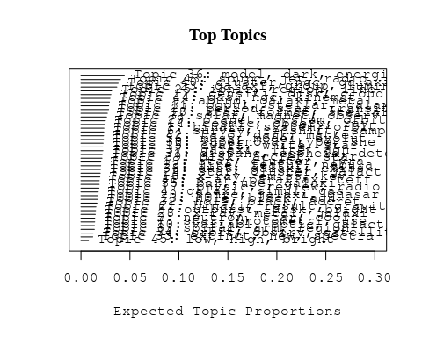

# Print the top 10 labels for each topic  
topic_labels <- labelTopics(Research_topics, n=10)  
print(topic_labels)

## Topic 1 Top Words:  
## Highest Prob: binari, system, orbit, star, mass, period, two, secondari, companion, secular   
## FREX: binari, secular, tripl, system, secondari, companion, multipl, orbit, primari, cvs   
## Lift: adapt, cvs, binari, tripl, secular, binar, hitherto, semi-major, tabl, secondari   
## Score: binari, orbit, system, secondari, secular, adapt, eclips, period, tripl, companion   
## Topic 2 Top Words:  
## Highest Prob: neutron, star, cool, thermal, observ, magnet, field, emiss, envelop, heat   
## FREX: neutron, cool, crust, thermal, envelop, neutrino, solar-typ, interior, superfluid, heat   
## Lift: dimension, crust, neutron, solar-typ, reaction, superfluid, mass-radius, burn, spin-, nucleon   
## Score: neutron, crust, cool, neutrino, thermal, dimension, magnet, interior, pulsar, superfluid   
## Topic 3 Top Words:  
## Highest Prob: solar, magnet, observ, flare, coron, event, flux, loop, field, activ   
## FREX: coron, flare, loop, cme, chromospher, magnet, cmes, event, cycl, proton   
## Lift: cme, cmes, interplanetari, smith, corona, loop, coron, impuls, flare, heliospher   
## Score: cme, flare, coron, loop, magnet, cmes, solar, proton, chromospher, corona   
## Topic 4 Top Words:  
## Highest Prob: galaxi, simul, gas, disc, format, model, form, mass, feedback, merger   
## FREX: ram, feedback, strip, simul, pressur, hydrodynam, semi-analyt, disc, transform, sph   
## Lift: sph, ram, αenhanc, semi-analyt, overdens, reheat, intraclust, feedback, strip, acdm   
## Score: ram, sph, disc, feedback, simul, merger, gas, galaxi, pressur, strip   
## Topic 5 Top Words:  
## Highest Prob: outburst, disk, bright, mass, eclips, dwarf, light, disc, star, emiss   
## FREX: outburst, flicker, oph, eclips, com, quiescenc, nova, ori, steadi, wave   
## Lift: oph, ophiuchi, com, quiescenc, flicker, outburst, uma, contact, juli, high-spe   
## Score: outburst, com, eclips, flicker, oph, nova, ori, dwarf, quiescenc, disk   
## Topic 6 Top Words:  
## Highest Prob: survey, redshift, sampl, present, photometr, data, use, supernova, observ, provid   
## FREX: survey, redshift, sdss, catalog, photometr, catalogu, emitt, sky, select, digit   
## Lift: undertaken, emitt, tully-fish, seek, lyα, lyman, elsewher, catalog, optim, sdss   
## Score: survey, redshift, sdss, supernova, catalog, photometr, emitt, catalogu, digit, undertaken   
## Topic 7 Top Words:  
## Highest Prob: star, photometri, use, associ, disk, spectra, observ, myr, data, find   
## FREX: herbig, aeb, myr, visual, hipparco, member, intermediate-mass, catalog, blazar, photometri   
## Lift: wiyn, aeb, herbig, hipparco, photograph, blazar, campaign, visual, gaia, autom   
## Score: herbig, aeb, blazar, wiyn, photometri, hipparco, myr, member, color-magnitud, star   
## Topic 8 Top Words:  
## Highest Prob: spiral, arm, region, galact, star, distanc, veloc, rotat, format, kinemat   
## FREX: arm, spiral, ambigu, pattern, chile, hco, plot, kinemat, shear, rotat   
## Lift: departamento, tangent, ambigu, arm, chile, bank, shear, plot, vortic, locus   
## Score: arm, spiral, ambigu, departamento, chile, tangent, hco, shear, rotat, kinemat   
## Topic 9 Top Words:  
## Highest Prob: abund, galaxi, metal, chemic, evolut, stellar, ratio, element, model, differ   
## FREX: abund, chemic, oxygen, metal, element, enrich, iron, gradient, histori, dex   
## Lift: ofe, disentangl, αfe, line-strength, nitrogen, oxygen, abund, chemic, enrich, iron   
## Score: abund, metal, chemic, oxygen, enrich, disentangl, galaxi, αfe, element, ofe   
## Topic 10 Top Words:  
## Highest Prob: variabl, optic, galact, x-ray, band, amplitud, observ, cataclysm, star, sourc   
## FREX: variabl, cataclysm, monitor, amplitud, time-scal, rrab, band, vvv, delay, centr   
## Lift: vista, lactea, vvv, cataclysm, strict, spurious, variabl, squar, lag, monitor   
## Score: variabl, rrab, vvv, lactea, cataclysm, vista, amplitud, lag, blazar, x-ray   
## Topic 11 Top Words:  
## Highest Prob: popul, stellar, galaxi, age, model, per, cent, young, observ, metal   
## FREX: popul, synthesi, nir, age, cent, starburst, per, contribut, stellar, younger   
## Lift: methodolog, intermediate-ag, absorption-lin, featureless, younger, synthesi, nir, meaning, older, unambigu   
## Score: age, nir, popul, starburst, synthesi, intermediate-ag, galaxi, cent, metal, seyfert   
## Topic 12 Top Words:  
## Highest Prob: densiti, disk, cloud, turbul, simul, magnet, molecular, core, scale, gas   
## FREX: turbul, torqu, ism, regim, forc, dissip, collaps, pressur, cloud, flow   
## Lift: mhd, self-grav, turbul, torqu, compress, discontinu, cascad, dissip, maintain, viscous   
## Score: turbul, cloud, dissip, torqu, ism, magnet, molecular, disk, mhd, forc   
## Topic 13 Top Words:  
## Highest Prob: hole, black, agn, galaxi, mass, host, x-ray, quasar, redshift, accret   
## FREX: hole, black, agn, host, big, quasar, obscur, transient, burst, γray   
## Lift: big, kerr, misalign, flat-spectrum, warp, transient, hole, black, foreground, obscur   
## Score: black, hole, agn, big, quasar, host, supermass, x-ray, obscur, merger   
## Topic 14 Top Words:  
## Highest Prob: cosmic, observ, ray, energi, model, neutrino, gamma-ray, background, spectrum, photon   
## FREX: ray, cosmic, detector, gamma-ray, neutrino, photon, gamma, background, microquasar, cosmic-ray   
## Lift: auger, tev, pierr, fermi, detector, ray, cosmic-ray, microquasar, ground, hadron   
## Score: neutrino, ray, gamma-ray, cosmic, pierr, auger, tev, detector, cosmic-ray, photon   
## Topic 15 Top Words:  
## Highest Prob: dwarf, white, star, pulsat, model, observ, evolutionari, atmospher, stellar, use   
## FREX: white, pulsat, dwarf, evolutionari, asteroseismolog, atmospher, helium, ceti, crystal, hydrogen   
## Lift: asteroseismolog, clock, ceti, crystal, pulsat, white, flash, wealth, convect, dwarf   
## Score: white, pulsat, dwarf, asteroseismolog, ceti, crystal, helium, atmospher, clock, evolutionari   
## Topic 16 Top Words:  
## Highest Prob: x-ray, emiss, kev, pulsar, sourc, puls, psr, hard, detect, time   
## FREX: kev, psr, pulsar, puls, hard, x-ray, chandra, erg, soft, rosat   
## Lift: softer, psr, kev, pulsar, puls, chandra, hard, rosat, subarcsecond, collid   
## Score: psr, x-ray, pulsar, kev, puls, chandra, hard, millisecond, emiss, softer   
## Topic 17 Top Words:  
## Highest Prob: physic, review, radio, understand, univers, astronom, present, mexico, astronomi, structur   
## FREX: mexico, universidad, astronomi, review, astronom, progress, scienc, nacion, depart, understand   
## Lift: mexico, institut, universidad, instituto, nacion, depart, astronomi, gather, mission, scienc   
## Score: mexico, review, astronomi, universidad, radio, instituto, nacion, scienc, astronom, depart   
## Topic 18 Top Words:  
## Highest Prob: star, format, stellar, massiv, mass, rate, object, recent, may, form   
## FREX: format, star, massiv, trigger, histori, quark, natur, stellar, mechan, recent   
## Lift: quark, format, short-liv, trigger, wit, undergo, hierarch, northwest, hypothes, birth   
## Score: format, star, quark, massiv, outflow, trigger, histori, stellar, burst, star-form   
## Topic 19 Top Words:  
## Highest Prob: star, cluster, lyra, ngc, variabl, distanc, photometri, globular, new, branch   
## FREX: lyra, horizont, branch, phe, globular, ccd, oosterhoff, period-luminos, fourier, photoelectr   
## Lift: phe, oosterhoff, photoelectr, lyra, uvbi, time-seri, horizont, fourier, tip, period-luminos   
## Score: lyra, phe, globular, oosterhoff, photoelectr, horizont, rrab, cluster, period-luminos, variabl   
## Topic 20 Top Words:  
## Highest Prob: sourc, galaxi, quasar, optic, detect, survey, imag, redshift, lens, gravit   
## FREX: lens, quasar, void, mpc, cross-correl, sourc, count, gravit, absorb, weak   
## Lift: void, submillimetr, lens, mji, cross-correl, beam, billion, count, overabund, deg   
## Score: void, quasar, lens, cross-correl, mpc, submillimetr, mji, radio, sourc, redshift   
## Topic 21 Top Words:  
## Highest Prob: binari, result, gravit, wind, wave, effect, asteroid, radiat, calcul, use   
## FREX: asteroid, merg, deflect, gravit, coalesc, wave, axi, impact, speci, hydrodynam   
## Lift: deflect, soon, roch, coalesc, exert, -spiral, weather, deform, ellipsoid, fewer   
## Score: asteroid, deflect, coalesc, binari, merg, wave, gravit, soon, wind, speci   
## Topic 22 Top Words:  
## Highest Prob: line, featur, nebula, spectra, profil, absorpt, show, spectral, present, found   
## FREX: featur, nova, absorpt, ice, wing, nebula, sgr, interstellar, remnant, profil   
## Lift: sgr, low-veloc, ice, high-veloc, wing, kms, nova, snr, featur, highlight   
## Score: sgr, nova, nebula, ice, line, absorpt, featur, wing, snr, profil   
## Topic 23 Top Words:  
## Highest Prob: galaxi, group, luminos, function, sampl, morpholog, ellipt, interact, spiral, pair   
## FREX: pair, group, ellipt, morpholog, interact, function, environ, spiral, isol, asymmetri   
## Lift: faint-end, schechter, sdss-dr, demograph, cas, sersic, neighbour, r-band, criteria, kormendi   
## Score: galaxi, group, spiral, faint-end, ellipt, pair, schechter, morpholog, merger, sloan   
## Topic 24 Top Words:  
## Highest Prob: star, cluster, galact, stellar, young, member, disk, associ, veloc, one   
## FREX: member, spheroid, disrupt, young, old, open, probabl, sun, older, cent   
## Lift: runaway, bona, fide, flybi, youngest, max, disrupt, oldest, debri, percentag   
## Score: cluster, runaway, member, spheroid, star, young, halo, habit, cent, dwarf   
## Topic 25 Top Words:  
## Highest Prob: ioniz, region, line, cloud, model, observ, densiti, temperatur, use, nebula   
## FREX: ioniz, photoion, recombin, excit, cloud, atom, neutral, electron, photoevapor, ultracompact   
## Lift: photodissoci, pdr, photoevapor, recombin, collision, ultracompact, atom, neutral, cm-, photoion   
## Score: ioniz, photoion, recombin, pdr, cloud, nebula, line, excit, ultracompact, atom   
## Topic 26 Top Words:  
## Highest Prob: mass, model, evolut, stellar, initi, loss, rotat, find, function, dynam   
## FREX: loss, mass, shell, initi, mfs, baryon, imf, axion, rotat, without   
## Lift: mfs, axion, maxim, imf, retrograd, underestim, loss, overestim, inventori, lost   
## Score: axion, mfs, loss, mass, baryon, imf, disc, rotat, shell, initi   
## Topic 27 Top Words:  
## Highest Prob: period, star, transit, orbit, observ, curv, light, planet, radial, optic   
## FREX: transit, period, day, curv, radial, candid, cycl, variat, precess, amplitud   
## Lift: time-resolv, quasi-period, carina, cyclic, januari, period, consecut, transit, jovian, doppler   
## Score: period, planet, orbit, transit, curv, day, planetari, extrasolar, time-resolv, amplitud   
## Topic 28 Top Words:  
## Highest Prob: x-ray, metal, galaxi, luminos, gas, hot, dwarf, superbubbl, emiss, observ   
## FREX: superbubbl, hot, fornax, metal, bubbl, oxygen, starburst, luminos, x-ray, chandra   
## Lift: blown, superbubbl, superwind, age-metal, time-depend, capac, bubbl, overpredict, boost, omega   
## Score: superbubbl, metal, x-ray, fornax, blown, starburst, feh, oxygen, dwarf, cmd   
## Topic 29 Top Words:  
## Highest Prob: planet, system, orbit, planetari, solar, reson, disk, atmospher, migrat, giant   
## FREX: planet, migrat, jupit, reson, planetesim, asteroid, belt, protoplanetari, exoplanet, planetari   
## Lift: jupit, planetesim, access, migrat, terrestri, moon, planet, belt, reson, protoplanetari   
## Score: planet, planetesim, migrat, jupit, orbit, asteroid, reson, planetari, access, belt   
## Topic 30 Top Words:  
## Highest Prob: supernova, type, sne, present, progenitor, rate, explos, infrar, declin, use   
## FREX: supernova, sne, explos, progenitor, type, declin, ibc, day, high-z, infrar   
## Lift: δmb, core-collaps, high-z, iin, ibc, explod, sne, explos, supernova, light-curv   
## Score: supernova, sne, ibc, high-z, progenitor, declin, explos, type, δmb, core-collaps   
## Topic 31 Top Words:  
## Highest Prob: distanc, cepheid, determin, magellan, smc, cloud, galaxi, relat, use, lmc   
## FREX: cepheid, magellan, smc, lmc, distanc, precis, modulus, accur, clump, cloud   
## Lift: araucaria, cepheid, smc, magellan, modulus, sculptor, lmc, line--sight, moduli, anchor   
## Score: cepheid, smc, magellan, lmc, modulus, cloud, feh, sculptor, metal, araucaria   
## Topic 32 Top Words:  
## Highest Prob: hole, black, accret, galaxi, observ, disk, agn, supermass, nuclear, merger   
## FREX: black, hole, supermass, circumnuclear, early-typ, accret, merger, nuclear, feed, flow   
## Lift: resumen, supermass, unclear, feed, circumnuclear, reservoir, black, hole, prefer, chaotic   
## Score: black, hole, supermass, agn, accret, circumnuclear, resumen, merger, nuclear, feed   
## Topic 33 Top Words:  
## Highest Prob: extinct, new, spectra, line, data, larg, provid, sight, popul, can   
## FREX: oper, extinct, sight, ultraviolet, entir, topic, degeneraci, systemat, question, fundament   
## Lift: oper, topic, bump, tackl, degeneraci, exposur, instal, automat, enter, strategi   
## Score: oper, sight, extinct, topic, ultraviolet, abund, degeneraci, bump, milki, question   
## Topic 34 Top Words:  
## Highest Prob: orbit, observ, satellit, galaxi, densiti, state, local, galact, high, baryon   
## FREX: satellit, reconstruct, baryon, carlo, state, approach, neighbourhood, mont, construct, martinez   
## Lift: martinez, reconstruct, carlo, bang, mont, oblat, insensit, mbh, dedic, omega   
## Score: martinez, satellit, orbit, baryon, reconstruct, census, milki, microwav, neighbourhood, carlo   
## Topic 35 Top Words:  
## Highest Prob: bar, use, galaxi, method, studi, gradient, color, determin, analysi, disk   
## FREX: bar, comet, gradient, dimens, color, method, famili, pne, quantit, angl   
## Lift: dimens, comet, artifici, suit, bifurc, famili, quantit, bar, sign, azimuth   
## Score: dimens, bar, comet, pne, gradient, color, famili, bulg, method, quantit   
## Topic 36 Top Words:  
## Highest Prob: model, dark, energi, matter, cosmolog, paramet, univers, use, densiti, equat   
## FREX: cosmolog, dark, scalar, equat, coupl, theori, matter, metric, acceler, graviti   
## Lift: fluid, frw, scalar, metric, polytrop, apm, tension, newtonian, vacuum, non-relativist   
## Score: dark, cosmolog, matter, scalar, fluid, equat, energi, univers, theori, acceler   
## Topic 37 Top Words:  
## Highest Prob: galaxi, line, agn, seyfert, popul, activ, sourc, nuclei, diagram, ratio   
## FREX: seyfert, agn, nuclei, classif, liner, broad, diagnost, broad-lin, blr, diagram   
## Lift: blr, eigenvector, iiihβ, iihα, radio-quiet, radio-loud, broad-lin, eddington, retir, unif   
## Score: agn, seyfert, blr, eigenvector, broad-lin, liner, line, iiihβ, nuclei, iihα   
## Topic 38 Top Words:  
## Highest Prob: dust, galaxi, emiss, starburst, imag, central, continuum, grain, disk, observ   
## FREX: dust, fir, grain, dusti, starburst, continuum, edge-, sed, far-infrar, hidden   
## Lift: fir, dust, lane, shadow, dusti, grain, far-infrar, sed, attenu, mid-ir   
## Score: dust, fir, starburst, grain, dusti, sed, galaxi, continuum, imag, far-infrar   
## Topic 39 Top Words:  
## Highest Prob: disk, accret, star, object, model, tauri, present, emiss, observ, spectrum   
## FREX: tauri, irradi, classic, accret, disk, ori, qsos, symbiot, polar, rim   
## Lift: symbiot, qsos, taurus, irradi, rim, tauri, magnetospher, blackbodi, sbs, ori   
## Score: disk, tauri, accret, symbiot, irradi, rim, ori, outburst, magnetospher, polar   
## Topic 40 Top Words:  
## Highest Prob: cluster, ngc, galaxi, globular, system, blue, red, distribut, present, popul   
## FREX: cluster, globular, blue, abel, ngc, center, coma, red, colour, low-luminos   
## Lift: cmds, for, washington, subpopul, decontamin, coma, abel, gcs, cluster, defici   
## Score: cluster, globular, ngc, coma, abel, fornax, gcs, washington, colour, galaxi   
## Topic 41 Top Words:  
## Highest Prob: star, parallax, teff, temperatur, system, sampl, proper, feh, present, dwarf   
## FREX: teff, parallax, trigonometr, proper, feh, tau, metal-poor, program, five, temperatur   
## Lift: ctiopi, teff, astrometri, parallax, trigonometr, astrometr, program, tau, tololo, inter-american   
## Score: parallax, teff, trigonometr, feh, ctiopi, tau, metal-poor, program, dwarf, temperatur   
## Topic 42 Top Words:  
## Highest Prob: halo, dark, matter, galaxi, densiti, profil, mass, model, core, simul   
## FREX: halo, cdm, dark, matter, concentr, time-scal, dsph, profil, cosmolog, momentum   
## Lift: cusp, navarro, frenk, nfw, cuspi, cosmogoni, halo, cdm, dsph, self-interact   
## Score: halo, dark, cdm, matter, dsph, cosmolog, nfw, profil, time-scal, cusp   
## Topic 43 Top Words:  
## Highest Prob: sourc, jet, radio, emiss, observ, outflow, region, object, detect, young   
## FREX: jet, maser, collim, outflow, radio, sourc, bipolar, continuum, ghz, protostar   
## Lift: centimet, maser, protostar, ysos, eman, free-fre, collim, jet, herbig-haro, nontherm   
## Score: jet, maser, radio, outflow, collim, sourc, continuum, protostar, bipolar, ghz   
## Topic 44 Top Words:  
## Highest Prob: gas, ngc, kinemat, veloc, nucleus, galaxi, ring, observ, rotat, region   
## FREX: ring, nucleus, kinemat, nuclear, spatial, knot, gemini, lobe, veloc, ngc   
## Lift: martir, high-excit, ring, cone, pedro, knot, gemini, kinemat, san, nucleus   
## Score: ngc, nucleus, kinemat, ring, gas, outflow, nuclear, nebula, knot, gemini   
## Topic 45 Top Words:  
## Highest Prob: low, high, bright, intermedi, galaxi, mass, luminos, form, brightest, group   
## FREX: intermedi, low, brightest, bright, therefor, high, old, extrem, group, technolog   
## Lift: technolog, intermedi, simpli, brightest, low, valid, degener, specifi, therefor, contradict   
## Score: intermedi, technolog, brightest, low, group, bright, old, galaxi, pne, luminos

# Match the processed documents with the original titles  
matched_titles <- out_text$meta$original_concatenated_title_abstract  
  
# Print top 5 documents for each topic  
top_docs <- findThoughts(Research_topics, texts = matched_titles, n = 5)$docs[[1]]  
print(top_docs)

## [1] "Comparative statistics and origin of triple and quadruple stars The statistics of catalogued quadruple stars consisting of two binaries (hierarchy 2 + 2), is studied in comparison with triple stars, with respective sample sizes of 81 and 724. Seven representative quadruple systems are discussed in greater detail. The main conclusions are as follows. (i) Quadruple systems of e Lyr type with similar masses and inner periods are common, in 42 per cent of the sample the outer mass ratio is above 0.5 and the inner periods differ by less than 10 times. (ii) The distributions of the inner periods in triple and quadruple stars are similar and bimodal. The inner mass ratios do not correlate with the inner periods. (iii) The statistics of outer periods and mass ratios in triples and quadruples are different. The median outer mass ratio in triples is 0.39 independently of the outer period, which has a smooth distribution. In contrast, the outer periods of 25 per cent quadruples concentrate in the narrow range from 10 to 100 yr, the outer mass ratios of these tight quadruples are above 0.6 and their two inner periods are similar to each other. (iv) The outer and inner mass ratios in triple and quadruple stars are not mutually correlated. In 13 per cent of quadruples both inner mass ratios are above 0.85 (double twins). (v) The inner and outer orbital angular momenta and periods in triple and quadruple systems with inner periods above 30 d show some correlation, the ratio of outer-to-inner periods is mostly comprised between 5 and 10 4 . In the systems with small period ratios the directions of the orbital spins are correlated, while in the systems with large ratios they are not. The properties of multiple stars do not correspond to the products of dynamical decay of small clusters, hence the N-body dynamics is not the dominant process of their formation. On the other hand, rotationally driven (cascade) fragmentation possibly followed by migration of inner and/or outer orbits to shorter periods is a promising scenario to explain the origin of triple and quadruple stars."   
## [2] "Comparative statistics and origin of triple and quadruple stars The statistics of catalogued quadruple stars consisting of two binaries (hierarchy 2 + 2), is studied in comparison with triple stars, with respective sample sizes of 81 and 724. Seven representative quadruple systems are discussed in greater detail. The main conclusions are as follows. (i) Quadruple systems of e Lyr type with similar masses and inner periods are common, in 42 per cent of the sample the outer mass ratio is above 0.5 and the inner periods differ by less than 10 times. (ii) The distributions of the inner periods in triple and quadruple stars are similar and bimodal. The inner mass ratios do not correlate with the inner periods. (iii) The statistics of outer periods and mass ratios in triples and quadruples are different. The median outer mass ratio in triples is 0.39 independently of the outer period, which has a smooth distribution. In contrast, the outer periods of 25 per cent quadruples concentrate in the narrow range from 10 to 100 yr, the outer mass ratios of these tight quadruples are above 0.6 and their two inner periods are similar to each other. (iv) The outer and inner mass ratios in triple and quadruple stars are not mutually correlated. In 13 per cent of quadruples both inner mass ratios are above 0.85 (double twins). (v) The inner and outer orbital angular momenta and periods in triple and quadruple systems with inner periods above 30 d show some correlation, the ratio of outer-to-inner periods is mostly comprised between 5 and 10 4 . In the systems with small period ratios the directions of the orbital spins are correlated, while in the systems with large ratios they are not. The properties of multiple stars do not correspond to the products of dynamical decay of small clusters, hence the N-body dynamics is not the dominant process of their formation. On the other hand, rotationally driven (cascade) fragmentation possibly followed by migration of inner and/or outer orbits to shorter periods is a promising scenario to explain the origin of triple and quadruple stars."   
## [3] "Secular dynamics of the three-body problem: application to the υ Andromedae planetary system Abstract The discovery of extra-solar planetary systems with multiple planets in highly eccentric orbits (∼0.1–0.6), in contrast with our own Solar System, makes classical secular perturbation analysis very limited. In this paper, we use a semi-numerical approach to study the secular behavior of a system composed of a central star and two massive planets in co-planar orbits. We show that the secular dynamics of this system can be described using only two parameters, the ratios of the semi-major axes and the planetary masses. The main dynamical features of the system are presented in geometrical pictures that allows us to investigate a large domain of the phase space of this three-body problem without time-expensive numerical integrations of the equations of motion, and without any restriction on the magnitude of the planetary eccentricities. The topology of the phase space is also investigated in detail by means of spectral map techniques, which allow us to detect the separatrix of a non-linear secular apsidal resonance. Finally, the qualitative study is supplemented by direct numerical integrations. Three different regimes of secular motion with respect to the secular angle Δ ϖ are possible: they are circulation, oscillation (around 0° and 180°), and high eccentricity libration in a non-linear secular resonance. The first two regimes are a continuous extension of the classical linear secular perturbation theory; the last is a new feature, hitherto unknown, in the secular dynamics of the three-body problem. We apply the analysis to the case of the two outer planets in the υ Andromedae system, and obtain its periodic and ordinary orbits, the general structure of its secular phase space, and the boundaries of its secular stability; we find that this system is secularly stable over a large domain of eccentricities. Applying this analysis to a wide range of planetary mass and semi-major axis ratios (centered about the υ Andromedae parameters), we find that apsidal oscillation dominates the secular phase space of the three-body coplanar system, and that the non-linear secular resonance is also a common feature."  
## [4] "Secular dynamics of the three-body problem: application to the υ Andromedae planetary system Abstract The discovery of extra-solar planetary systems with multiple planets in highly eccentric orbits (∼0.1–0.6), in contrast with our own Solar System, makes classical secular perturbation analysis very limited. In this paper, we use a semi-numerical approach to study the secular behavior of a system composed of a central star and two massive planets in co-planar orbits. We show that the secular dynamics of this system can be described using only two parameters, the ratios of the semi-major axes and the planetary masses. The main dynamical features of the system are presented in geometrical pictures that allows us to investigate a large domain of the phase space of this three-body problem without time-expensive numerical integrations of the equations of motion, and without any restriction on the magnitude of the planetary eccentricities. The topology of the phase space is also investigated in detail by means of spectral map techniques, which allow us to detect the separatrix of a non-linear secular apsidal resonance. Finally, the qualitative study is supplemented by direct numerical integrations. Three different regimes of secular motion with respect to the secular angle Δ ϖ are possible: they are circulation, oscillation (around 0° and 180°), and high eccentricity libration in a non-linear secular resonance. The first two regimes are a continuous extension of the classical linear secular perturbation theory; the last is a new feature, hitherto unknown, in the secular dynamics of the three-body problem. We apply the analysis to the case of the two outer planets in the υ Andromedae system, and obtain its periodic and ordinary orbits, the general structure of its secular phase space, and the boundaries of its secular stability; we find that this system is secularly stable over a large domain of eccentricities. Applying this analysis to a wide range of planetary mass and semi-major axis ratios (centered about the υ Andromedae parameters), we find that apsidal oscillation dominates the secular phase space of the three-body coplanar system, and that the non-linear secular resonance is also a common feature."  
## [5] "Modeling the 3-D secular planetary three-body problem: Discussion on the outer υ Andromedae planetary system Abstract The three-dimensional secular behavior of a system composed of a central star and two massive planets is modeled semi-analytically in the frame of the general three-body problem. The main dynamical features of the system are presented in geometrical pictures allowing us to investigate a large domain of the phase space of this problem without time-expensive numerical integrations of the equations of motion and without any restriction on the magnitude of the planetary eccentricities, inclinations and mutual distance. Several regimes of motion of the system are observed. With respect to the secular angle Δϖ, possible motions are circulations, oscillations (around 0° and 180°), and high-eccentricity/inclination librations in secular resonances. With respect to the arguments of pericenter, ω 1 and ω 2 , possible motions are direct circulation and high-inclination libration around ±90° in the Lidov–Kozai resonance. The regions of transition between domains of different regimes of motion are characterized by chaotic behavior. We apply the analysis to the case of the two outer planets of the υ Andromedae system, observed edge-on. The topology of the 3-D phase space of this system is investigated in detail by means of surfaces of section, periodic orbits and dynamical spectra, mapping techniques and numerical simulations. We obtain the general structure of the phase space, and the boundaries of the spatial secular stability. We find that this system is secularly stable in a large domain of eccentricities and inclinations."

# Find and plot the key "thoughts" or documents for selected topics  
thoughts6 <- findThoughts(Research_topics, texts = matched_titles, n = 3, topics = 6)$docs[[1]]  
thoughts18 <- findThoughts(Research_topics, texts = matched_titles, n = 3, topics = 18)$docs[[1]]  
par(mfrow = c(1, 2), mar = c(0.5, 0.5, 1, 0.5))  
plotQuote(thoughts6, width = 30, main = "Topic 6")  
plotQuote(thoughts18, width = 30, main = "Topic 18")

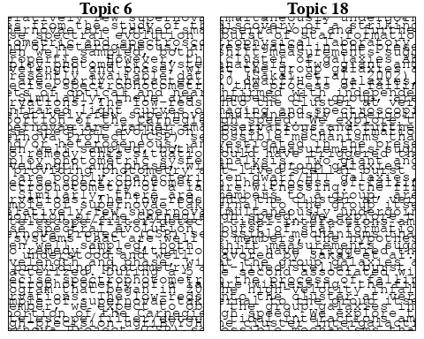

# Calculate and plot the correlation between topics  
mod.out.corr <- topicCorr(Research_topics)  
plot(mod.out.corr, cex = 1.5)  
  
  
# For each topic  
for (topic_num in 1:45) {  
 # Plot the word cloud  
 cloud(Research_topics, topic = topic_num, scale = c(2, 0.25))  
 Sys.sleep(2)  
}

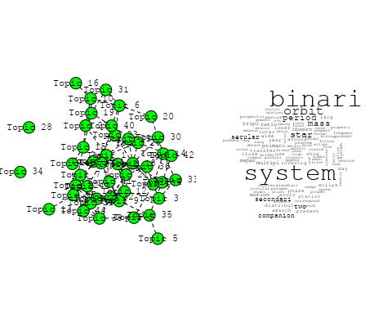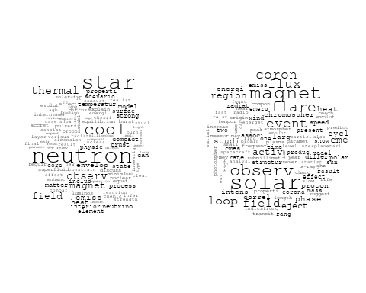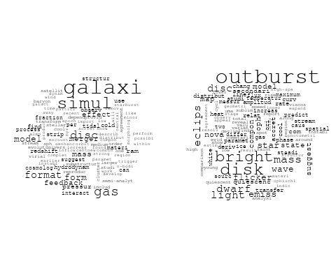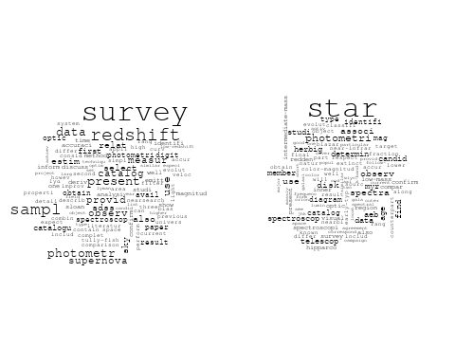

## Warning in wordcloud::wordcloud(words = vocab, freq = vec, max.words =  
## max.words, : spiral could not be fit on page. It will not be plotted.

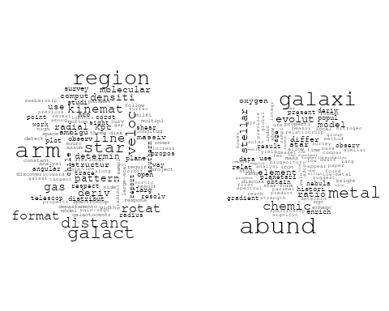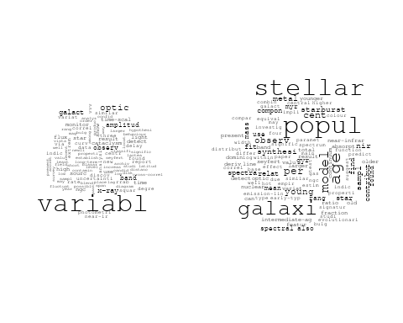

## Warning in wordcloud::wordcloud(words = vocab, freq = vec, max.words =  
## max.words, : simul could not be fit on page. It will not be plotted.

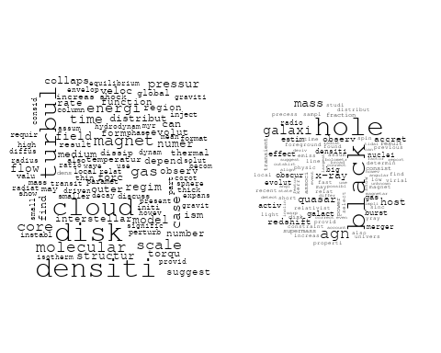

## Warning in wordcloud::wordcloud(words = vocab, freq = vec, max.words =  
## max.words, : energi could not be fit on page. It will not be plotted.

## Warning in wordcloud::wordcloud(words = vocab, freq = vec, max.words =  
## max.words, : background could not be fit on page. It will not be plotted.

## Warning in wordcloud::wordcloud(words = vocab, freq = vec, max.words =  
## max.words, : spectrum could not be fit on page. It will not be plotted.

## Warning in wordcloud::wordcloud(words = vocab, freq = vec, max.words =  
## max.words, : observ could not be fit on page. It will not be plotted.

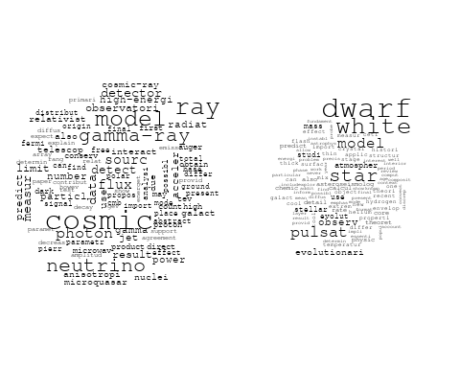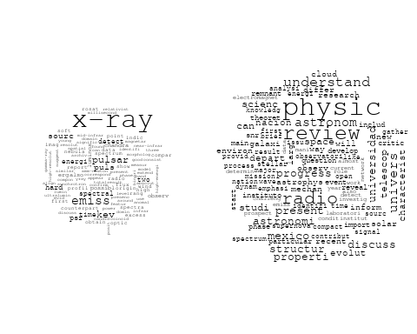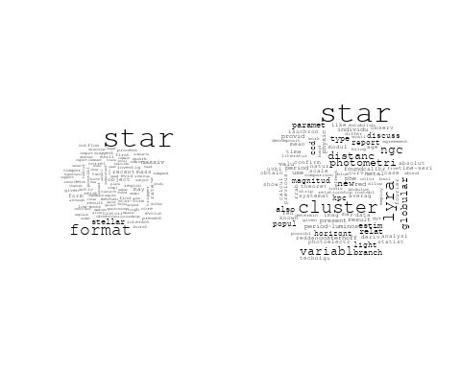

## Warning in wordcloud::wordcloud(words = vocab, freq = vec, max.words =  
## max.words, : galaxi could not be fit on page. It will not be plotted.

## Warning in wordcloud::wordcloud(words = vocab, freq = vec, max.words =  
## max.words, : simul could not be fit on page. It will not be plotted.

## Warning in wordcloud::wordcloud(words = vocab, freq = vec, max.words =  
## max.words, : binari could not be fit on page. It will not be plotted.

## Warning in wordcloud::wordcloud(words = vocab, freq = vec, max.words =  
## max.words, : effici could not be fit on page. It will not be plotted.

## Warning in wordcloud::wordcloud(words = vocab, freq = vec, max.words =  
## max.words, : use could not be fit on page. It will not be plotted.

## Warning in wordcloud::wordcloud(words = vocab, freq = vec, max.words =  
## max.words, : impact could not be fit on page. It will not be plotted.

## Warning in wordcloud::wordcloud(words = vocab, freq = vec, max.words =  
## max.words, : result could not be fit on page. It will not be plotted.

## Warning in wordcloud::wordcloud(words = vocab, freq = vec, max.words =  
## max.words, : gas could not be fit on page. It will not be plotted.

## Warning in wordcloud::wordcloud(words = vocab, freq = vec, max.words =  
## max.words, : coalesc could not be fit on page. It will not be plotted.

## Warning in wordcloud::wordcloud(words = vocab, freq = vec, max.words =  
## max.words, : potenti could not be fit on page. It will not be plotted.

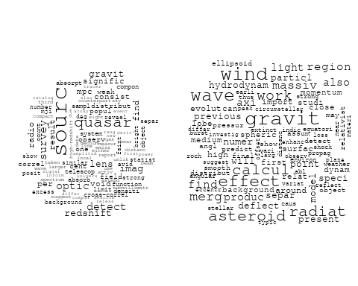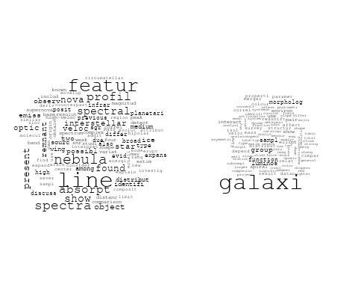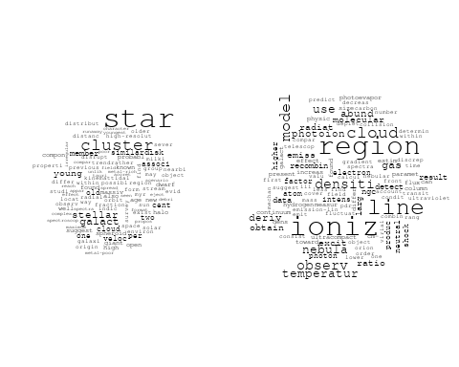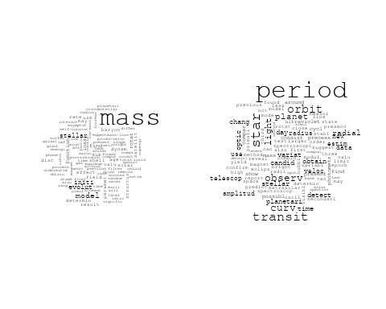

## Warning in wordcloud::wordcloud(words = vocab, freq = vec, max.words =  
## max.words, : luminos could not be fit on page. It will not be plotted.

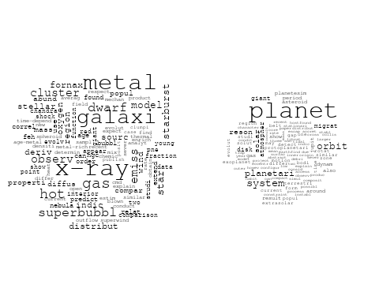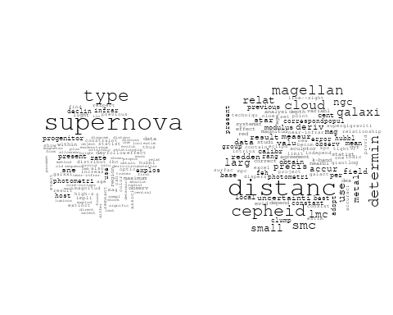

## Warning in wordcloud::wordcloud(words = vocab, freq = vec, max.words =  
## max.words, : spectra could not be fit on page. It will not be plotted.

## Warning in wordcloud::wordcloud(words = vocab, freq = vec, max.words =  
## max.words, : sight could not be fit on page. It will not be plotted.

## Warning in wordcloud::wordcloud(words = vocab, freq = vec, max.words =  
## max.words, : telescop could not be fit on page. It will not be plotted.

## Warning in wordcloud::wordcloud(words = vocab, freq = vec, max.words =  
## max.words, : properti could not be fit on page. It will not be plotted.

## Warning in wordcloud::wordcloud(words = vocab, freq = vec, max.words =  
## max.words, : ultraviolet could not be fit on page. It will not be plotted.

## Warning in wordcloud::wordcloud(words = vocab, freq = vec, max.words =  
## max.words, : wavelength could not be fit on page. It will not be plotted.

## Warning in wordcloud::wordcloud(words = vocab, freq = vec, max.words =  
## max.words, : resolut could not be fit on page. It will not be plotted.

## Warning in wordcloud::wordcloud(words = vocab, freq = vec, max.words =  
## max.words, : use could not be fit on page. It will not be plotted.

## Warning in wordcloud::wordcloud(words = vocab, freq = vec, max.words =  
## max.words, : abund could not be fit on page. It will not be plotted.

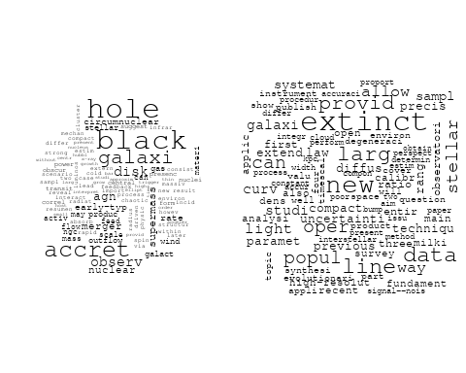

## Warning in wordcloud::wordcloud(words = vocab, freq = vec, max.words =  
## max.words, : orbit could not be fit on page. It will not be plotted.

## Warning in wordcloud::wordcloud(words = vocab, freq = vec, max.words =  
## max.words, : satellit could not be fit on page. It will not be plotted.

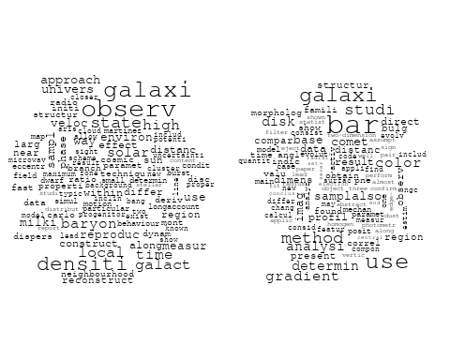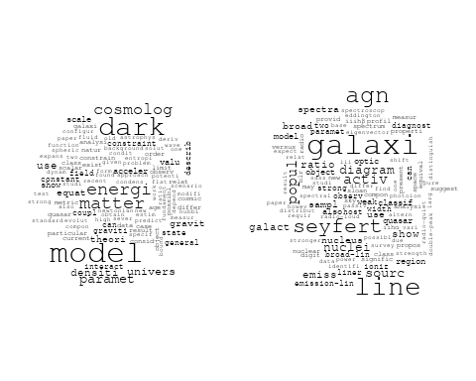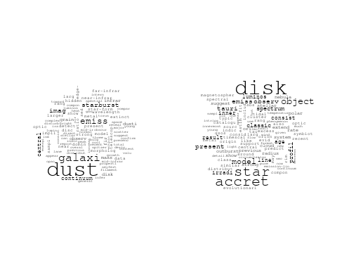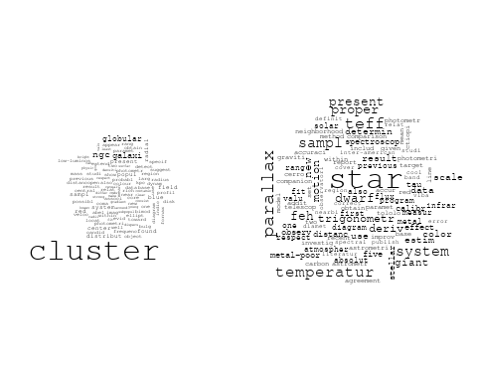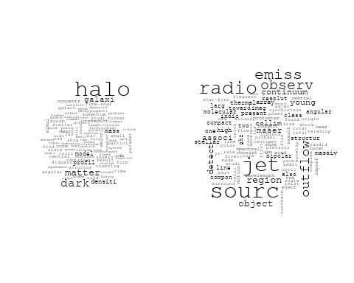

## Warning in wordcloud::wordcloud(words = vocab, freq = vec, max.words =  
## max.words, : region could not be fit on page. It will not be plotted.

## Warning in wordcloud::wordcloud(words = vocab, freq = vec, max.words =  
## max.words, : observ could not be fit on page. It will not be plotted.

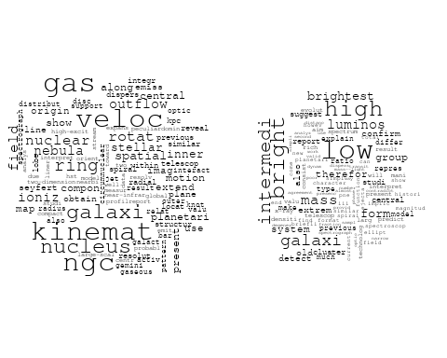

# Get the topic proportions for each document  
topic_proportions <- Research_topics$theta  
  
# Find the index of the topic with the highest proportion for each document  
# This will be the topic that each document is most likely to belong to  
max_topic_idx <- apply(topic_proportions, 1, which.max)  
  
# Add this as a new column to your data  
data_collab$topic <- max_topic_idx  
  
library(ggplot2)  
  
# Define the intervals  
intervals <- c('1824_1899', '1900_1964', '1965_1974', '1975_1984', '1985_1994', '1995_1999', '2000_2004', '2005_2009', '2010_2014', '2015_2019', '2020_2022')  
colors <- c('pink', 'blue', 'purple', 'yellow', 'green', 'pink', 'orange', 'violet', 'green', 'blue', 'pink')  
  
# Loop through the intervals and plot  
for(i in seq_along(intervals)){  
 # Filter data for when the pub_interval is equal to 1  
 data_filtered <- data_collab[data_collab[[paste0('pub_interval_', intervals[i])]] == 1,]  
   
 # Make the histogram  
   
 p <- ggplot(data_filtered, aes(x = topic)) +  
 geom_histogram(binwidth = 1, fill = colors[i], color = "black") +  
 xlab("Topic") +  
 ylab("Count") +  
 ggtitle(paste0("Topics from year ", gsub("_", " to ", intervals[i])))  
   
 print(p)  
}

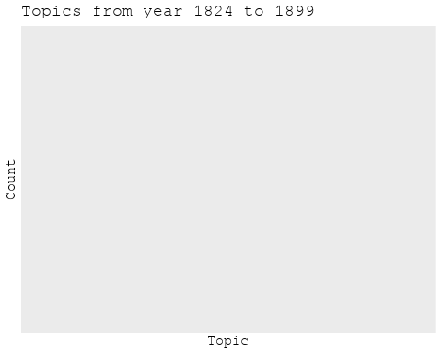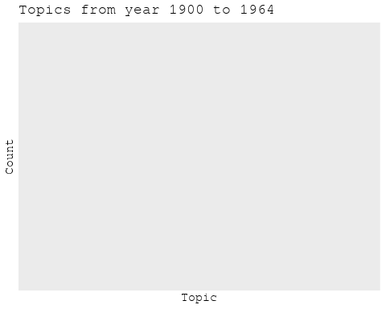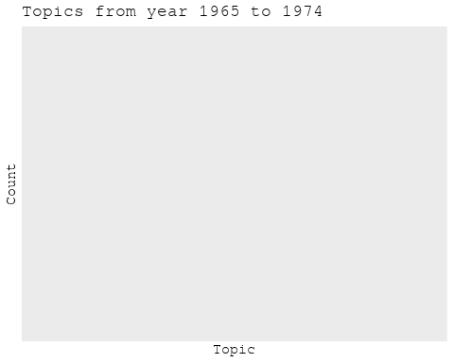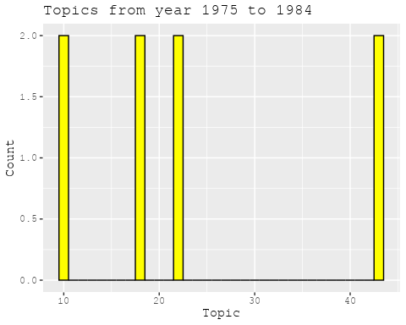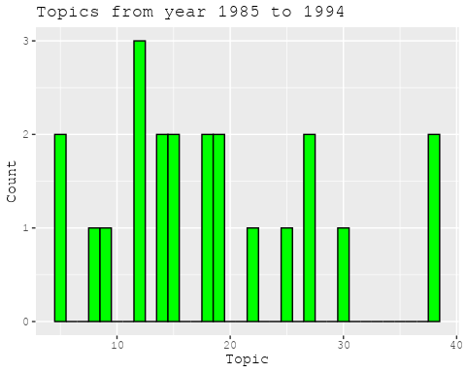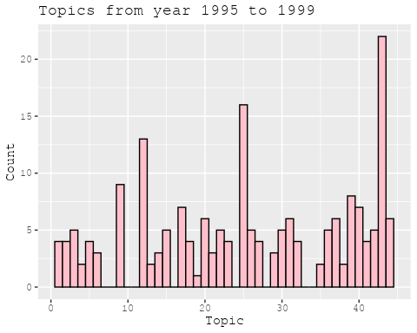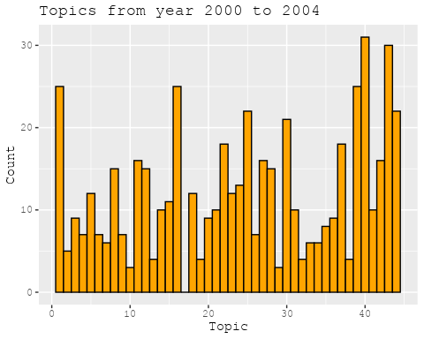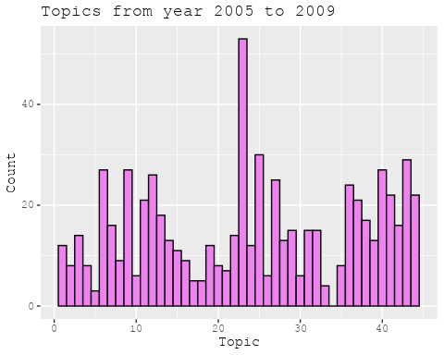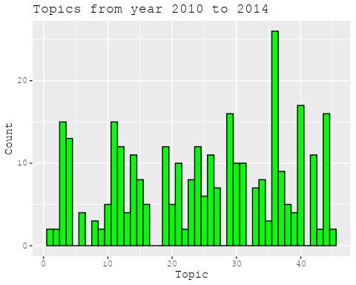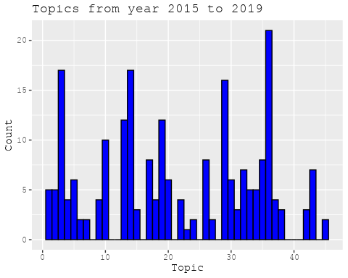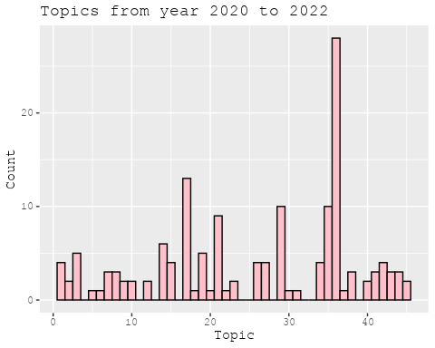

##Topic generation for Americas (independent) publications  
  
data_independent <- data[data[["Americas"]] == 100,]  
  
# Save the original title data for future use  
data_independent$original_concatenated_title_abstract <- data_independent$concatenated_title_abstract  
  
#pre-processing the titles using textProcessor from the stm package  
processed_text <- textProcessor(data_independent$concatenated_title_abstract, metadata = data_independent)

## Building corpus...   
## Converting to Lower Case...   
## Removing punctuation...   
## Removing stopwords...   
## Removing numbers...   
## Stemming...   
## Creating Output...

# Further prepare the data by removing low-frequency terms  
out_text <- prepDocuments(processed_text$documents, processed_text$vocab, processed_text$meta)

## Removing 2056 of 6442 terms (2056 of 73446 tokens) due to frequency   
## Your corpus now has 921 documents, 4386 terms and 71390 tokens.

docs_text <- out_text$documents  
vocab_text <- out_text$vocab  
meta_text <- out_text$meta  
  
  
#Prepare data  
plotRemoved(processed_text$documents, lower.thresh = seq(1, 200, by = 100))

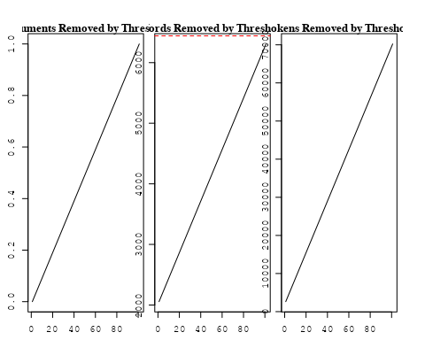

out_text <- prepDocuments(processed_text$documents, processed_text$vocab, processed_text$meta, lower.thresh = 8)

## Removing 5068 of 6442 terms (12162 of 73446 tokens) due to frequency   
## Your corpus now has 921 documents, 1374 terms and 61284 tokens.

str(out_text$meta)

## 'data.frame': 921 obs. of 39 variables:  
## $ concept_id : chr "https://openalex.org/C1276947" "https://openalex.org/C1276947" "https://openalex.org/C44870925" "https://openalex.org/C44870925" ...  
## $ work_id : chr "https://openalex.org/W2950791913" "https://openalex.org/W1760966995" "https://openalex.org/W2034970396" "https://openalex.org/W3100018927" ...  
## $ publication_year : int 2010 2010 2002 2008 2020 2004 2004 2004 2004 2003 ...  
## $ title : chr "A comprehensive classification of galaxies in the SDSS: How to tell true from fake AGN?" "Alternative diagnostic diagrams and the 'forgotten' population of weak line galaxies in the SDSS" "The swallowing of a quark star by a black hole" "Spherically-symmetric Accretion onto a Black Hole at the Center of a Young Stellar Cluster" ...  
## $ paperabstract : chr "We use the W Hα versus [NII]/Hα (WHAN) diagram introduced by us in previous work to provide a comprehensive emi"| __truncated__ "A numerous population of weak line galaxies (WLGs) is often left out of statistical studies on emission-line ga"| __truncated__ "In three-dimensional smooth particle hydrodynamic simulations of the coalescence of a quark star with a pseudo-"| __truncated__ "Here we present a self-consistent, bimodal stationary solution for spherically symmetric flows driven by young "| __truncated__ ...  
## $ country : chr "BR BR BR BR" "BR BR BR BR" "MX" "MX MX" ...  
## $ year_concept : chr "2010+https://openalex.org/C1276947" "2010+https://openalex.org/C1276947" "2002+https://openalex.org/C44870925" "2008+https://openalex.org/C44870925" ...  
## $ concatenated_title_abstract : chr "A comprehensive classification of galaxies in the SDSS: How to tell true from fake AGN? We use the W Hα versus "| __truncated__ "Alternative diagnostic diagrams and the 'forgotten' population of weak line galaxies in the SDSS A numerous pop"| __truncated__ "The swallowing of a quark star by a black hole In three-dimensional smooth particle hydrodynamic simulations of"| __truncated__ "Spherically-symmetric Accretion onto a Black Hole at the Center of a Young Stellar Cluster Here we present a se"| __truncated__ ...  
## $ US : num 0 0 0 0 0 0 0 0 0 0 ...  
## $ IN : num 0 0 0 0 0 0 0 0 0 0 ...  
## $ DE : num 0 0 0 0 0 0 0 0 0 0 ...  
## $ CH : num 0 0 0 0 0 0 0 0 0 0 ...  
## $ GB : num 0 0 0 0 0 0 0 0 0 0 ...  
## $ CN : num 0 0 0 0 0 0 0 0 0 0 ...  
## $ FR : num 0 0 0 0 0 0 0 0 0 0 ...  
## $ IT : num 0 0 0 0 0 0 0 0 0 0 ...  
## $ RU : num 0 0 0 0 0 0 0 0 0 0 ...  
## $ CA : num 0 0 0 0 0 0 0 0 0 0 ...  
## $ NL : num 0 0 0 0 0 0 0 0 0 0 ...  
## $ AU : num 0 0 0 0 0 0 0 0 0 0 ...  
## $ JP : num 0 0 0 0 0 0 0 0 0 0 ...  
## $ ES : num 0 0 0 0 0 0 0 0 0 0 ...  
## $ IL : num 0 0 0 0 0 0 0 0 0 0 ...  
## $ Americas : num 100 100 100 100 100 100 100 100 100 100 ...  
## $ Europe : num 0 0 0 0 0 0 0 0 0 0 ...  
## $ Africa : num 0 0 0 0 0 0 0 0 0 0 ...  
## $ AsiaAndOceania : num 0 0 0 0 0 0 0 0 0 0 ...  
## $ pub_interval_2020_2022 : int 0 0 0 0 1 0 0 0 0 0 ...  
## $ pub_interval_2015_2019 : int 0 0 0 0 0 0 0 0 0 0 ...  
## $ pub_interval_2010_2014 : int 1 1 0 0 0 0 0 0 0 0 ...  
## $ pub_interval_2005_2009 : int 0 0 0 1 0 0 0 0 0 0 ...  
## $ pub_interval_2000_2004 : int 0 0 1 0 0 1 1 1 1 1 ...  
## $ pub_interval_1995_1999 : int 0 0 0 0 0 0 0 0 0 0 ...  
## $ pub_interval_1985_1994 : int 0 0 0 0 0 0 0 0 0 0 ...  
## $ pub_interval_1975_1984 : int 0 0 0 0 0 0 0 0 0 0 ...  
## $ pub_interval_1965_1974 : int 0 0 0 0 0 0 0 0 0 0 ...  
## $ pub_interval_1900_1964 : int 0 0 0 0 0 0 0 0 0 0 ...  
## $ pub_interval_1824_1899 : int 0 0 0 0 0 0 0 0 0 0 ...  
## $ original_concatenated_title_abstract: chr "A comprehensive classification of galaxies in the SDSS: How to tell true from fake AGN? We use the W Hα versus "| __truncated__ "Alternative diagnostic diagrams and the 'forgotten' population of weak line galaxies in the SDSS A numerous pop"| __truncated__ "The swallowing of a quark star by a black hole In three-dimensional smooth particle hydrodynamic simulations of"| __truncated__ "Spherically-symmetric Accretion onto a Black Hole at the Center of a Young Stellar Cluster Here we present a se"| __truncated__ ...

# Initialize an empty formula string  
prevalence_formula_str <- "~"  
  
# Define the publication intervals  
pub_intervals <- c("pub_interval_2020_2022", "pub_interval_2015_2019", "pub_interval_2010_2014",   
 "pub_interval_2005_2009", "pub_interval_2000_2004", "pub_interval_1995_1999",  
 "pub_interval_1985_1994", "pub_interval_1975_1984", "pub_interval_1965_1974",  
 "pub_interval_1900_1964", "pub_interval_1824_1899")  
  
# Add each publication interval to the formula string  
for (interval in pub_intervals) {  
 # add an if statement to handle the first addition (without '+')  
 if (prevalence_formula_str == "~") {  
 prevalence_formula_str <- paste(prevalence_formula_str, interval)  
 } else {  
 prevalence_formula_str <- paste(prevalence_formula_str, "+", interval)  
 }  
}  
  
  
# Convert the string to a formula  
prevalence_formula <- as.formula(prevalence_formula_str)  
print(prevalence_formula)

## ~pub_interval_2020_2022 + pub_interval_2015_2019 + pub_interval_2010_2014 +   
## pub_interval_2005_2009 + pub_interval_2000_2004 + pub_interval_1995_1999 +   
## pub_interval_1985_1994 + pub_interval_1975_1984 + pub_interval_1965_1974 +   
## pub_interval_1900_1964 + pub_interval_1824_1899

# Run STM model  
Research_topics <- stm(documents = out_text$documents,   
 vocab = out_text$vocab,   
 K = 45,   
 prevalence = prevalence_formula,   
 data = out_text$meta,   
 init.type = "Spectral",  
 max.em.its = 1000,  
 gamma.prior = 'L1')

## Beginning Spectral Initialization   
## Calculating the gram matrix...  
## Finding anchor words...  
## .............................................  
## Recovering initialization...  
## .............  
## Initialization complete.  
## ......................................................................................................  
## Completed E-Step (1 seconds).   
## Completed M-Step.   
## Completing Iteration 1 (approx. per word bound = -6.156)   
## ......................................................................................................  
## Completed E-Step (0 seconds).   
## Completed M-Step.   
## Completing Iteration 2 (approx. per word bound = -5.862, relative change = 4.789e-02)   
## ......................................................................................................  
## Completed E-Step (0 seconds).   
## Completed M-Step.   
## Completing Iteration 3 (approx. per word bound = -5.758, relative change = 1.767e-02)   
## ......................................................................................................  
## Completed E-Step (0 seconds).   
## Completed M-Step.   
## Completing Iteration 4 (approx. per word bound = -5.714, relative change = 7.662e-03)   
## ......................................................................................................  
## Completed E-Step (0 seconds).   
## Completed M-Step.   
## Completing Iteration 5 (approx. per word bound = -5.689, relative change = 4.284e-03)   
## Topic 1: present, optic, properti, star, global   
## Topic 2: simul, earli, x-ray, sph, negat   
## Topic 3: supernova, type, star, progenitor, sne   
## Topic 4: galaxi, mass, binari, gas, black   
## Topic 5: eclips, solar, nova, light, emiss   
## Topic 6: galact, star, cluster, distanc, galaxi   
## Topic 7: variabl, star, studi, survey, eso   
## Topic 8: star, neutron, observ, mass, rate   
## Topic 9: larg, scale, telescop, new, precis   
## Topic 10: wind, evolut, diffus, evolutionari, star   
## Topic 11: magnet, field, model, time, energi   
## Topic 12: galaxi, pair, interact, sampl, activ   
## Topic 13: use, correl, method, galaxi, time   
## Topic 14: quasar, light, valu, univers, find   
## Topic 15: model, use, cosmolog, galaxi, dark   
## Topic 16: cluster, star, ngc, open, photometri   
## Topic 17: mass, model, neutrino, dwarf, stellar   
## Topic 18: mass, accret, rate, evolut, system   
## Topic 19: nebula, pulsar, emiss, radio, planetari   
## Topic 20: simul, model, late, pressur, cold   
## Topic 21: system, binari, project, orbit, observ   
## Topic 22: disk, star, accret, around, observ   
## Topic 23: cluster, galaxi, redshift, luminos, relat   
## Topic 24: model, dark, energi, matter, gravit   
## Topic 25: star, observ, also, provid, import   
## Topic 26: energi, cosmic, observ, ray, dark   
## Topic 27: halo, dark, matter, galaxi, densiti   
## Topic 28: star, gas, format, veloc, kinemat   
## Topic 29: cluster, galaxi, ngc, globular, popul   
## Topic 30: spectrum, profil, featur, line, sourc   
## Topic 31: planet, planetari, transit, orbit, star   
## Topic 32: dwarf, white, star, outburst, disk   
## Topic 33: galaxi, group, mass, function, luminos   
## Topic 34: densiti, cloud, molecular, core, region   
## Topic 35: bright, mass, comet, rate, observ   
## Topic 36: spiral, arm, galaxi, imag, nuclear   
## Topic 37: sourc, radio, object, associ, cluster   
## Topic 38: period, orbit, mass, satellit, observ   
## Topic 39: part, scenario, show, remnant, jupit   
## Topic 40: galaxi, line, seyfert, diagram, use   
## Topic 41: galaxi, popul, stellar, age, starburst   
## Topic 42: hole, black, object, agn, accret   
## Topic 43: abund, metal, model, star, observ   
## Topic 44: stellar, environ, effect, solar, theori   
## Topic 45: decoupl, gravit, field, case, potenti   
## ......................................................................................................  
## Completed E-Step (0 seconds).   
## Completed M-Step.   
## Completing Iteration 6 (approx. per word bound = -5.673, relative change = 2.826e-03)   
## ......................................................................................................  
## Completed E-Step (0 seconds).   
## Completed M-Step.   
## Completing Iteration 7 (approx. per word bound = -5.662, relative change = 1.942e-03)   
## ......................................................................................................  
## Completed E-Step (0 seconds).   
## Completed M-Step.   
## Completing Iteration 8 (approx. per word bound = -5.654, relative change = 1.453e-03)   
## ......................................................................................................  
## Completed E-Step (0 seconds).   
## Completed M-Step.   
## Completing Iteration 9 (approx. per word bound = -5.648, relative change = 1.127e-03)   
## ......................................................................................................  
## Completed E-Step (0 seconds).   
## Completed M-Step.   
## Completing Iteration 10 (approx. per word bound = -5.642, relative change = 1.028e-03)   
## Topic 1: properti, optic, present, galaxi, star   
## Topic 2: simul, earli, negat, present, run   
## Topic 3: supernova, type, star, progenitor, sne   
## Topic 4: mass, galaxi, gas, baryon, stellar   
## Topic 5: light, eclips, nova, solar, emiss   
## Topic 6: galact, star, cluster, distanc, orbit   
## Topic 7: variabl, star, galaxi, survey, extrem   
## Topic 8: star, neutron, observ, mass, core   
## Topic 9: larg, precis, new, cepheid, cloud   
## Topic 10: wind, star, evolut, diffus, model   
## Topic 11: magnet, field, model, time, energi   
## Topic 12: galaxi, pair, interact, sampl, activ   
## Topic 13: use, method, correl, flux, gradient   
## Topic 14: quasar, valu, univers, cosmolog, ratio   
## Topic 15: model, use, cosmolog, dark, univers   
## Topic 16: cluster, star, ngc, open, photometri   
## Topic 17: mass, model, neutrino, atmospher, dwarf   
## Topic 18: accret, mass, system, rotat, rate   
## Topic 19: nebula, emiss, pulsar, radio, planetari   
## Topic 20: simul, model, late, galaxi, pressur   
## Topic 21: system, binari, orbit, project, star   
## Topic 22: disk, star, accret, around, observ   
## Topic 23: cluster, galaxi, redshift, luminos, relat   
## Topic 24: dark, model, energi, matter, gravit   
## Topic 25: star, observ, cluster, globular, also   
## Topic 26: energi, observ, cosmic, ray, neutrino   
## Topic 27: halo, dark, matter, galaxi, densiti   
## Topic 28: star, gas, format, veloc, kinemat   
## Topic 29: cluster, galaxi, ngc, globular, popul   
## Topic 30: spectrum, line, emiss, profil, featur   
## Topic 31: planet, planetari, transit, orbit, star   
## Topic 32: dwarf, white, star, outburst, studi   
## Topic 33: galaxi, group, mass, function, luminos   
## Topic 34: densiti, cloud, molecular, core, turbul   
## Topic 35: bright, mass, comet, rate, flicker   
## Topic 36: spiral, arm, galaxi, nucleus, nuclear   
## Topic 37: sourc, radio, object, cluster, associ   
## Topic 38: period, orbit, mass, satellit, observ   
## Topic 39: part, scenario, observ, show, jupit   
## Topic 40: galaxi, seyfert, line, diagram, use   
## Topic 41: popul, galaxi, stellar, age, starburst   
## Topic 42: hole, black, object, agn, accret   
## Topic 43: abund, metal, star, model, stellar   
## Topic 44: stellar, star, environ, theori, effect   
## Topic 45: decoupl, gravit, potenti, work, field   
## ......................................................................................................  
## Completed E-Step (0 seconds).   
## Completed M-Step.   
## Completing Iteration 11 (approx. per word bound = -5.637, relative change = 8.405e-04)   
## ......................................................................................................  
## Completed E-Step (0 seconds).   
## Completed M-Step.   
## Completing Iteration 12 (approx. per word bound = -5.633, relative change = 7.840e-04)   
## ......................................................................................................  
## Completed E-Step (0 seconds).   
## Completed M-Step.   
## Completing Iteration 13 (approx. per word bound = -5.629, relative change = 6.823e-04)   
## ......................................................................................................  
## Completed E-Step (0 seconds).   
## Completed M-Step.   
## Completing Iteration 14 (approx. per word bound = -5.626, relative change = 5.962e-04)   
## ......................................................................................................  
## Completed E-Step (0 seconds).   
## Completed M-Step.   
## Completing Iteration 15 (approx. per word bound = -5.623, relative change = 5.173e-04)   
## Topic 1: properti, optic, galaxi, present, star   
## Topic 2: simul, also, time, earli, properti   
## Topic 3: supernova, type, star, progenitor, sne   
## Topic 4: mass, galaxi, gas, stellar, format   
## Topic 5: light, nova, eclips, curv, solar   
## Topic 6: galact, star, cluster, distanc, orbit   
## Topic 7: variabl, star, galaxi, extrem, survey   
## Topic 8: star, neutron, observ, mass, detect   
## Topic 9: larg, cepheid, precis, distanc, new   
## Topic 10: wind, star, model, diffus, evolut   
## Topic 11: magnet, field, model, energi, time   
## Topic 12: galaxi, pair, interact, activ, sampl   
## Topic 13: use, method, gradient, flux, color   
## Topic 14: quasar, valu, cosmolog, ratio, univers   
## Topic 15: model, use, dark, cosmolog, paramet   
## Topic 16: cluster, star, ngc, open, photometri   
## Topic 17: mass, model, atmospher, neutrino, dwarf   
## Topic 18: accret, mass, system, rotat, model   
## Topic 19: nebula, emiss, pulsar, radio, planetari   
## Topic 20: simul, model, galaxi, late, format   
## Topic 21: system, binari, orbit, project, star   
## Topic 22: disk, star, around, observ, accret   
## Topic 23: cluster, galaxi, redshift, luminos, center   
## Topic 24: dark, model, energi, matter, coupl   
## Topic 25: star, observ, cluster, globular, also   
## Topic 26: energi, observ, ray, cosmic, neutrino   
## Topic 27: halo, dark, matter, galaxi, densiti   
## Topic 28: star, gas, veloc, kinemat, format   
## Topic 29: cluster, galaxi, ngc, globular, popul   
## Topic 30: spectrum, emiss, line, star, spectral   
## Topic 31: planet, planetari, transit, orbit, star   
## Topic 32: dwarf, white, star, outburst, studi   
## Topic 33: galaxi, group, mass, luminos, function   
## Topic 34: densiti, cloud, molecular, core, turbul   
## Topic 35: bright, mass, comet, rate, disk   
## Topic 36: spiral, arm, nucleus, galaxi, nuclear   
## Topic 37: sourc, radio, object, cluster, associ   
## Topic 38: period, orbit, mass, satellit, observ   
## Topic 39: part, scenario, observ, model, show   
## Topic 40: galaxi, seyfert, line, diagram, agn   
## Topic 41: popul, galaxi, stellar, age, starburst   
## Topic 42: hole, black, agn, galaxi, accret   
## Topic 43: abund, metal, star, model, stellar   
## Topic 44: stellar, star, theori, environ, effect   
## Topic 45: work, gravit, decoupl, potenti, involv   
## ......................................................................................................  
## Completed E-Step (0 seconds).   
## Completed M-Step.   
## Completing Iteration 16 (approx. per word bound = -5.620, relative change = 4.525e-04)   
## ......................................................................................................  
## Completed E-Step (0 seconds).   
## Completed M-Step.   
## Completing Iteration 17 (approx. per word bound = -5.618, relative change = 4.054e-04)   
## ......................................................................................................  
## Completed E-Step (0 seconds).   
## Completed M-Step.   
## Completing Iteration 18 (approx. per word bound = -5.616, relative change = 4.075e-04)   
## ......................................................................................................  
## Completed E-Step (0 seconds).   
## Completed M-Step.   
## Completing Iteration 19 (approx. per word bound = -5.613, relative change = 4.239e-04)   
## ......................................................................................................  
## Completed E-Step (0 seconds).   
## Completed M-Step.   
## Completing Iteration 20 (approx. per word bound = -5.611, relative change = 3.602e-04)   
## Topic 1: properti, galaxi, star-form, star, present   
## Topic 2: simul, time, also, show, properti   
## Topic 3: supernova, type, star, progenitor, sne   
## Topic 4: mass, galaxi, gas, stellar, format   
## Topic 5: light, nova, eclips, curv, secondari   
## Topic 6: galact, star, cluster, distanc, orbit   
## Topic 7: variabl, star, galaxi, extrem, survey   
## Topic 8: star, neutron, observ, mass, detect   
## Topic 9: larg, cepheid, precis, distanc, new   
## Topic 10: wind, star, model, diffus, stellar   
## Topic 11: magnet, field, energi, simul, time   
## Topic 12: galaxi, pair, interact, activ, sampl   
## Topic 13: use, method, gradient, flux, color   
## Topic 14: quasar, valu, ratio, cosmolog, abund   
## Topic 15: model, use, dark, cosmolog, paramet   
## Topic 16: cluster, star, ngc, open, photometri   
## Topic 17: mass, model, atmospher, neutrino, loss   
## Topic 18: accret, mass, system, model, rotat   
## Topic 19: nebula, pulsar, emiss, radio, planetari   
## Topic 20: simul, galaxi, model, late, format   
## Topic 21: system, binari, orbit, project, star   
## Topic 22: disk, star, around, observ, accret   
## Topic 23: cluster, galaxi, redshift, luminos, center   
## Topic 24: dark, model, energi, matter, coupl   
## Topic 25: star, observ, model, also, cluster   
## Topic 26: observ, energi, neutrino, ray, cosmic   
## Topic 27: halo, dark, matter, galaxi, densiti   
## Topic 28: star, gas, veloc, kinemat, format   
## Topic 29: cluster, galaxi, ngc, globular, popul   
## Topic 30: spectrum, emiss, line, star, spectral   
## Topic 31: planet, planetari, transit, orbit, star   
## Topic 32: dwarf, white, star, outburst, studi   
## Topic 33: galaxi, group, mass, luminos, function   
## Topic 34: densiti, cloud, molecular, core, turbul   
## Topic 35: bright, mass, comet, rate, disk   
## Topic 36: spiral, arm, nucleus, galaxi, nuclear   
## Topic 37: sourc, radio, object, cluster, extend   
## Topic 38: period, orbit, satellit, mass, observ   
## Topic 39: part, scenario, observ, model, show   
## Topic 40: galaxi, seyfert, diagram, line, agn   
## Topic 41: popul, stellar, galaxi, age, starburst   
## Topic 42: hole, black, agn, galaxi, accret   
## Topic 43: abund, metal, star, stellar, model   
## Topic 44: stellar, theori, star, environ, effect   
## Topic 45: work, gravit, decoupl, matter, possibl   
## ......................................................................................................  
## Completed E-Step (0 seconds).   
## Completed M-Step.   
## Completing Iteration 21 (approx. per word bound = -5.609, relative change = 2.972e-04)   
## ......................................................................................................  
## Completed E-Step (0 seconds).   
## Completed M-Step.   
## Completing Iteration 22 (approx. per word bound = -5.608, relative change = 2.683e-04)   
## ......................................................................................................  
## Completed E-Step (0 seconds).   
## Completed M-Step.   
## Completing Iteration 23 (approx. per word bound = -5.607, relative change = 1.505e-04)   
## ......................................................................................................  
## Completed E-Step (0 seconds).   
## Completed M-Step.   
## Completing Iteration 24 (approx. per word bound = -5.605, relative change = 3.070e-04)   
## ......................................................................................................  
## Completed E-Step (0 seconds).   
## Completed M-Step.   
## Completing Iteration 25 (approx. per word bound = -5.604, relative change = 2.230e-04)   
## Topic 1: properti, galaxi, star-form, star, present   
## Topic 2: simul, also, time, show, properti   
## Topic 3: supernova, type, star, progenitor, sne   
## Topic 4: mass, galaxi, gas, stellar, disc   
## Topic 5: light, nova, eclips, curv, dwarf   
## Topic 6: galact, star, cluster, orbit, distanc   
## Topic 7: variabl, star, galaxi, extrem, survey   
## Topic 8: star, neutron, observ, mass, detect   
## Topic 9: cepheid, larg, precis, distanc, new   
## Topic 10: wind, star, diffus, model, stellar   
## Topic 11: magnet, field, energi, simul, time   
## Topic 12: galaxi, pair, interact, activ, sampl   
## Topic 13: use, method, gradient, flux, color   
## Topic 14: quasar, valu, ratio, cosmolog, abund   
## Topic 15: model, use, cosmolog, dark, paramet   
## Topic 16: cluster, star, ngc, open, field   
## Topic 17: mass, model, atmospher, neutrino, loss   
## Topic 18: accret, system, mass, model, case   
## Topic 19: nebula, pulsar, emiss, radio, planetari   
## Topic 20: galaxi, model, format, late, simul   
## Topic 21: system, binari, orbit, project, star   
## Topic 22: disk, star, around, observ, accret   
## Topic 23: cluster, galaxi, redshift, x-ray, luminos   
## Topic 24: dark, model, energi, matter, coupl   
## Topic 25: star, observ, model, also, cluster   
## Topic 26: observ, energi, ray, flux, neutrino   
## Topic 27: halo, dark, matter, galaxi, densiti   
## Topic 28: gas, star, veloc, kinemat, format   
## Topic 29: cluster, galaxi, ngc, globular, popul   
## Topic 30: spectrum, emiss, line, star, spectral   
## Topic 31: planet, planetari, transit, star, orbit   
## Topic 32: dwarf, white, star, studi, outburst   
## Topic 33: galaxi, group, mass, luminos, function   
## Topic 34: densiti, cloud, molecular, core, turbul   
## Topic 35: bright, mass, comet, disk, rate   
## Topic 36: spiral, nucleus, arm, galaxi, nuclear   
## Topic 37: sourc, radio, object, cluster, extend   
## Topic 38: period, orbit, satellit, mass, observ   
## Topic 39: part, scenario, observ, model, show   
## Topic 40: galaxi, seyfert, diagram, line, agn   
## Topic 41: popul, stellar, galaxi, age, starburst   
## Topic 42: hole, black, agn, galaxi, accret   
## Topic 43: abund, metal, star, stellar, model   
## Topic 44: stellar, theori, star, effect, environ   
## Topic 45: work, gravit, matter, possibl, decoupl   
## ......................................................................................................  
## Completed E-Step (0 seconds).   
## Completed M-Step.   
## Completing Iteration 26 (approx. per word bound = -5.603, relative change = 2.309e-04)   
## ......................................................................................................  
## Completed E-Step (0 seconds).   
## Completed M-Step.   
## Completing Iteration 27 (approx. per word bound = -5.602, relative change = 2.329e-04)   
## ......................................................................................................  
## Completed E-Step (0 seconds).   
## Completed M-Step.   
## Completing Iteration 28 (approx. per word bound = -5.600, relative change = 2.272e-04)   
## ......................................................................................................  
## Completed E-Step (0 seconds).   
## Completed M-Step.   
## Completing Iteration 29 (approx. per word bound = -5.599, relative change = 2.308e-04)   
## ......................................................................................................  
## Completed E-Step (0 seconds).   
## Completed M-Step.   
## Completing Iteration 30 (approx. per word bound = -5.598, relative change = 2.335e-04)   
## Topic 1: galaxi, properti, star-form, star, present   
## Topic 2: simul, halo, mass, also, show   
## Topic 3: supernova, type, star, progenitor, sne   
## Topic 4: mass, galaxi, gas, stellar, disc   
## Topic 5: light, nova, outburst, eclips, dwarf   
## Topic 6: galact, star, cluster, orbit, distanc   
## Topic 7: variabl, star, galaxi, extrem, studi   
## Topic 8: star, neutron, observ, mass, detect   
## Topic 9: cepheid, precis, distanc, larg, new   
## Topic 10: wind, star, diffus, model, stellar   
## Topic 11: magnet, field, energi, time, simul   
## Topic 12: galaxi, pair, interact, activ, sampl   
## Topic 13: use, method, gradient, flux, color   
## Topic 14: quasar, valu, ratio, cosmolog, abund   
## Topic 15: model, use, cosmolog, dark, paramet   
## Topic 16: cluster, star, ngc, open, age   
## Topic 17: mass, model, atmospher, neutrino, loss   
## Topic 18: accret, system, model, mass, case   
## Topic 19: nebula, pulsar, emiss, radio, planetari   
## Topic 20: galaxi, late, model, format, simul   
## Topic 21: binari, system, orbit, project, star   
## Topic 22: disk, star, around, observ, accret   
## Topic 23: cluster, galaxi, redshift, x-ray, luminos   
## Topic 24: dark, model, energi, matter, coupl   
## Topic 25: star, observ, model, also, cluster   
## Topic 26: observ, ray, flux, energi, neutrino   
## Topic 27: halo, dark, matter, galaxi, densiti   
## Topic 28: gas, veloc, star, kinemat, format   
## Topic 29: cluster, galaxi, ngc, globular, popul   
## Topic 30: spectrum, emiss, line, star, spectral   
## Topic 31: planet, planetari, transit, star, orbit   
## Topic 32: dwarf, white, star, studi, evolutionari   
## Topic 33: galaxi, group, luminos, mass, function   
## Topic 34: densiti, cloud, molecular, core, turbul   
## Topic 35: bright, mass, comet, rate, disk   
## Topic 36: spiral, nucleus, arm, galaxi, nuclear   
## Topic 37: sourc, radio, object, extend, cluster   
## Topic 38: period, orbit, satellit, mass, observ   
## Topic 39: part, scenario, observ, model, show   
## Topic 40: galaxi, seyfert, diagram, line, agn   
## Topic 41: popul, stellar, galaxi, age, starburst   
## Topic 42: hole, black, agn, galaxi, accret   
## Topic 43: abund, metal, star, stellar, model   
## Topic 44: stellar, theori, star, effect, environ   
## Topic 45: event, work, gravit, matter, possibl   
## ......................................................................................................  
## Completed E-Step (0 seconds).   
## Completed M-Step.   
## Completing Iteration 31 (approx. per word bound = -5.597, relative change = 1.827e-04)   
## ......................................................................................................  
## Completed E-Step (0 seconds).   
## Completed M-Step.   
## Completing Iteration 32 (approx. per word bound = -5.596, relative change = 1.833e-04)   
## ......................................................................................................  
## Completed E-Step (0 seconds).   
## Completed M-Step.   
## Completing Iteration 33 (approx. per word bound = -5.595, relative change = 1.676e-04)   
## ......................................................................................................  
## Completed E-Step (0 seconds).   
## Completed M-Step.   
## Completing Iteration 34 (approx. per word bound = -5.594, relative change = 1.603e-04)   
## ......................................................................................................  
## Completed E-Step (0 seconds).   
## Completed M-Step.   
## Completing Iteration 35 (approx. per word bound = -5.593, relative change = 1.496e-04)   
## Topic 1: galaxi, properti, star-form, star, present   
## Topic 2: simul, halo, mass, use, also   
## Topic 3: supernova, type, star, progenitor, sne   
## Topic 4: mass, galaxi, gas, stellar, format   
## Topic 5: light, outburst, nova, dwarf, eclips   
## Topic 6: galact, star, cluster, orbit, distanc   
## Topic 7: variabl, star, galaxi, studi, survey   
## Topic 8: star, neutron, observ, mass, model   
## Topic 9: cepheid, precis, distanc, larg, cloud   
## Topic 10: wind, star, diffus, model, evolut   
## Topic 11: magnet, field, energi, time, simul   
## Topic 12: galaxi, pair, interact, activ, sampl   
## Topic 13: use, method, gradient, color, flux   
## Topic 14: quasar, valu, ratio, abund, cosmolog   
## Topic 15: model, use, cosmolog, paramet, dark   
## Topic 16: cluster, star, ngc, open, age   
## Topic 17: mass, model, atmospher, neutrino, loss   
## Topic 18: accret, system, model, mass, case   
## Topic 19: nebula, pulsar, emiss, radio, planetari   
## Topic 20: galaxi, late, star, model, format   
## Topic 21: binari, system, orbit, project, star   
## Topic 22: disk, star, around, observ, accret   
## Topic 23: cluster, galaxi, redshift, x-ray, luminos   
## Topic 24: dark, model, energi, matter, coupl   
## Topic 25: star, observ, model, cluster, also   
## Topic 26: observ, flux, ray, energi, neutrino   
## Topic 27: halo, dark, matter, galaxi, densiti   
## Topic 28: gas, veloc, star, kinemat, format   
## Topic 29: cluster, galaxi, ngc, globular, popul   
## Topic 30: spectrum, emiss, line, star, region   
## Topic 31: planet, planetari, transit, star, orbit   
## Topic 32: dwarf, white, star, studi, evolutionari   
## Topic 33: galaxi, group, luminos, mass, function   
## Topic 34: densiti, cloud, molecular, core, turbul   
## Topic 35: bright, mass, comet, disk, rate   
## Topic 36: spiral, nucleus, galaxi, arm, nuclear   
## Topic 37: sourc, radio, object, extend, cluster   
## Topic 38: period, orbit, satellit, mass, observ   
## Topic 39: part, scenario, asteroid, jupit, observ   
## Topic 40: galaxi, seyfert, diagram, line, agn   
## Topic 41: popul, stellar, galaxi, age, starburst   
## Topic 42: hole, black, agn, galaxi, accret   
## Topic 43: abund, metal, star, stellar, model   
## Topic 44: stellar, theori, star, effect, environ   
## Topic 45: event, matter, work, gravit, maximum   
## ......................................................................................................  
## Completed E-Step (0 seconds).   
## Completed M-Step.   
## Completing Iteration 36 (approx. per word bound = -5.592, relative change = 1.310e-04)   
## ......................................................................................................  
## Completed E-Step (0 seconds).   
## Completed M-Step.   
## Completing Iteration 37 (approx. per word bound = -5.592, relative change = 1.167e-04)   
## ......................................................................................................  
## Completed E-Step (0 seconds).   
## Completed M-Step.   
## Completing Iteration 38 (approx. per word bound = -5.591, relative change = 1.082e-04)   
## ......................................................................................................  
## Completed E-Step (0 seconds).   
## Completed M-Step.   
## Completing Iteration 39 (approx. per word bound = -5.590, relative change = 1.092e-04)   
## ......................................................................................................  
## Completed E-Step (0 seconds).   
## Completed M-Step.   
## Completing Iteration 40 (approx. per word bound = -5.590, relative change = 1.113e-04)   
## Topic 1: galaxi, properti, star-form, star, present   
## Topic 2: simul, halo, mass, use, also   
## Topic 3: supernova, type, star, progenitor, radio   
## Topic 4: mass, galaxi, gas, stellar, format   
## Topic 5: light, outburst, nova, dwarf, eclips   
## Topic 6: galact, star, cluster, orbit, distanc   
## Topic 7: variabl, star, galaxi, studi, survey   
## Topic 8: star, neutron, observ, mass, model   
## Topic 9: cepheid, precis, distanc, larg, cloud   
## Topic 10: wind, star, diffus, model, evolut   
## Topic 11: magnet, field, energi, time, simul   
## Topic 12: galaxi, pair, interact, activ, sampl   
## Topic 13: use, method, gradient, color, galaxi   
## Topic 14: quasar, valu, ratio, abund, cosmolog   
## Topic 15: model, cosmolog, use, paramet, data   
## Topic 16: cluster, star, ngc, open, age   
## Topic 17: mass, model, atmospher, neutrino, loss   
## Topic 18: accret, model, system, mass, case   
## Topic 19: nebula, pulsar, radio, emiss, planetari   
## Topic 20: object, galaxi, star, model, late   
## Topic 21: binari, system, orbit, project, star   
## Topic 22: disk, star, around, observ, accret   
## Topic 23: cluster, galaxi, redshift, x-ray, luminos   
## Topic 24: dark, model, energi, matter, coupl   
## Topic 25: star, observ, model, also, cluster   
## Topic 26: observ, flux, ray, energi, neutrino   
## Topic 27: halo, dark, matter, galaxi, densiti   
## Topic 28: gas, veloc, star, kinemat, format   
## Topic 29: cluster, galaxi, ngc, globular, popul   
## Topic 30: spectrum, emiss, line, star, region   
## Topic 31: planet, planetari, transit, star, orbit   
## Topic 32: dwarf, white, star, studi, evolutionari   
## Topic 33: galaxi, group, mass, luminos, function   
## Topic 34: densiti, cloud, molecular, turbul, core   
## Topic 35: bright, mass, comet, disk, rate   
## Topic 36: spiral, nucleus, galaxi, arm, nuclear   
## Topic 37: sourc, radio, object, extend, cluster   
## Topic 38: period, orbit, satellit, mass, observ   
## Topic 39: part, jupit, asteroid, scenario, observ   
## Topic 40: galaxi, seyfert, diagram, line, agn   
## Topic 41: popul, stellar, galaxi, age, starburst   
## Topic 42: hole, black, agn, galaxi, accret   
## Topic 43: abund, metal, stellar, star, model   
## Topic 44: stellar, theori, star, effect, environ   
## Topic 45: event, matter, work, gravit, maximum   
## ......................................................................................................  
## Completed E-Step (0 seconds).   
## Completed M-Step.   
## Completing Iteration 41 (approx. per word bound = -5.589, relative change = 9.878e-05)   
## ......................................................................................................  
## Completed E-Step (0 seconds).   
## Completed M-Step.   
## Completing Iteration 42 (approx. per word bound = -5.589, relative change = 1.009e-04)   
## ......................................................................................................  
## Completed E-Step (0 seconds).   
## Completed M-Step.   
## Completing Iteration 43 (approx. per word bound = -5.588, relative change = 1.064e-04)   
## ......................................................................................................  
## Completed E-Step (0 seconds).   
## Completed M-Step.   
## Completing Iteration 44 (approx. per word bound = -5.587, relative change = 1.004e-04)   
## ......................................................................................................  
## Completed E-Step (0 seconds).   
## Completed M-Step.   
## Completing Iteration 45 (approx. per word bound = -5.587, relative change = 1.070e-04)   
## Topic 1: galaxi, properti, star-form, star, present   
## Topic 2: simul, halo, mass, use, cosmolog   
## Topic 3: supernova, type, star, progenitor, radio   
## Topic 4: mass, galaxi, gas, stellar, format   
## Topic 5: light, outburst, nova, dwarf, eclips   
## Topic 6: galact, star, cluster, orbit, distanc   
## Topic 7: variabl, star, galaxi, studi, survey   
## Topic 8: star, neutron, observ, mass, model   
## Topic 9: cepheid, precis, distanc, larg, cloud   
## Topic 10: wind, star, diffus, model, evolut   
## Topic 11: magnet, field, energi, time, model   
## Topic 12: galaxi, pair, interact, activ, sampl   
## Topic 13: use, method, gradient, color, galaxi   
## Topic 14: quasar, valu, ratio, abund, cosmolog   
## Topic 15: model, cosmolog, use, paramet, data   
## Topic 16: cluster, star, ngc, open, age   
## Topic 17: mass, model, atmospher, neutrino, loss   
## Topic 18: accret, model, system, mass, case   
## Topic 19: nebula, pulsar, radio, planetari, emiss   
## Topic 20: object, galaxi, star, model, late   
## Topic 21: binari, system, orbit, project, star   
## Topic 22: disk, star, around, observ, accret   
## Topic 23: cluster, galaxi, redshift, x-ray, luminos   
## Topic 24: dark, model, energi, matter, coupl   
## Topic 25: star, observ, model, also, cluster   
## Topic 26: observ, flux, ray, energi, emiss   
## Topic 27: halo, dark, matter, galaxi, densiti   
## Topic 28: gas, star, veloc, kinemat, format   
## Topic 29: cluster, galaxi, ngc, globular, popul   
## Topic 30: spectrum, emiss, line, region, star   
## Topic 31: planet, planetari, transit, star, orbit   
## Topic 32: dwarf, white, star, studi, evolutionari   
## Topic 33: galaxi, group, mass, luminos, function   
## Topic 34: densiti, cloud, molecular, turbul, core   
## Topic 35: bright, mass, comet, disk, rate   
## Topic 36: spiral, nucleus, galaxi, arm, nuclear   
## Topic 37: sourc, radio, object, extend, cluster   
## Topic 38: period, orbit, satellit, mass, observ   
## Topic 39: part, jupit, asteroid, scenario, observ   
## Topic 40: galaxi, seyfert, diagram, line, agn   
## Topic 41: popul, stellar, galaxi, age, starburst   
## Topic 42: hole, black, agn, galaxi, accret   
## Topic 43: abund, metal, stellar, star, model   
## Topic 44: stellar, theori, star, effect, environ   
## Topic 45: event, matter, work, gravit, maximum   
## ......................................................................................................  
## Completed E-Step (0 seconds).   
## Completed M-Step.   
## Completing Iteration 46 (approx. per word bound = -5.586, relative change = 9.262e-05)   
## ......................................................................................................  
## Completed E-Step (0 seconds).   
## Completed M-Step.   
## Completing Iteration 47 (approx. per word bound = -5.586, relative change = 8.180e-05)   
## ......................................................................................................  
## Completed E-Step (0 seconds).   
## Completed M-Step.   
## Completing Iteration 48 (approx. per word bound = -5.585, relative change = 7.855e-05)   
## ......................................................................................................  
## Completed E-Step (0 seconds).   
## Completed M-Step.   
## Completing Iteration 49 (approx. per word bound = -5.585, relative change = 7.884e-05)   
## ......................................................................................................  
## Completed E-Step (0 seconds).   
## Completed M-Step.   
## Completing Iteration 50 (approx. per word bound = -5.585, relative change = 7.355e-05)   
## Topic 1: galaxi, properti, star-form, star, present   
## Topic 2: simul, halo, mass, use, cosmolog   
## Topic 3: supernova, type, star, progenitor, radio   
## Topic 4: mass, galaxi, gas, stellar, format   
## Topic 5: light, outburst, nova, dwarf, eclips   
## Topic 6: galact, star, cluster, orbit, distanc   
## Topic 7: variabl, star, galaxi, studi, survey   
## Topic 8: star, neutron, observ, mass, detect   
## Topic 9: cepheid, precis, distanc, larg, cloud   
## Topic 10: wind, star, diffus, model, evolut   
## Topic 11: magnet, field, energi, time, simul   
## Topic 12: galaxi, pair, interact, activ, sampl   
## Topic 13: use, method, gradient, color, galaxi   
## Topic 14: quasar, valu, ratio, abund, cosmolog   
## Topic 15: model, cosmolog, use, paramet, data   
## Topic 16: cluster, star, ngc, open, age   
## Topic 17: mass, model, atmospher, neutrino, loss   
## Topic 18: model, accret, system, mass, case   
## Topic 19: nebula, pulsar, radio, planetari, bipolar   
## Topic 20: object, star, galaxi, model, late   
## Topic 21: binari, system, orbit, project, star   
## Topic 22: disk, star, around, observ, accret   
## Topic 23: cluster, galaxi, redshift, x-ray, luminos   
## Topic 24: dark, model, energi, matter, coupl   
## Topic 25: star, observ, model, also, cluster   
## Topic 26: observ, flux, ray, energi, emiss   
## Topic 27: halo, dark, matter, galaxi, densiti   
## Topic 28: gas, star, veloc, kinemat, format   
## Topic 29: cluster, galaxi, ngc, globular, popul   
## Topic 30: spectrum, line, emiss, region, star   
## Topic 31: planet, planetari, transit, star, orbit   
## Topic 32: dwarf, white, star, studi, evolutionari   
## Topic 33: galaxi, group, mass, luminos, function   
## Topic 34: densiti, cloud, molecular, turbul, core   
## Topic 35: bright, mass, comet, disk, rate   
## Topic 36: spiral, nucleus, galaxi, arm, nuclear   
## Topic 37: sourc, radio, object, cluster, extend   
## Topic 38: period, orbit, satellit, mass, observ   
## Topic 39: part, jupit, asteroid, scenario, observ   
## Topic 40: galaxi, seyfert, diagram, line, agn   
## Topic 41: popul, galaxi, stellar, age, starburst   
## Topic 42: hole, black, agn, galaxi, accret   
## Topic 43: abund, metal, stellar, star, model   
## Topic 44: stellar, theori, star, effect, environ   
## Topic 45: event, matter, work, gravit, maximum   
## ......................................................................................................  
## Completed E-Step (0 seconds).   
## Completed M-Step.   
## Completing Iteration 51 (approx. per word bound = -5.585, relative change = 1.248e-05)   
## ......................................................................................................  
## Completed E-Step (0 seconds).   
## Completed M-Step.   
## Completing Iteration 52 (approx. per word bound = -5.584, relative change = 1.526e-04)   
## ......................................................................................................  
## Completed E-Step (0 seconds).   
## Completed M-Step.   
## Completing Iteration 53 (approx. per word bound = -5.583, relative change = 8.327e-05)   
## ......................................................................................................  
## Completed E-Step (0 seconds).   
## Completed M-Step.   
## Completing Iteration 54 (approx. per word bound = -5.583, relative change = 6.080e-05)   
## ......................................................................................................  
## Completed E-Step (0 seconds).   
## Completed M-Step.   
## Completing Iteration 55 (approx. per word bound = -5.583, relative change = 6.104e-05)   
## Topic 1: galaxi, properti, star-form, star, present   
## Topic 2: simul, halo, mass, use, cosmolog   
## Topic 3: supernova, type, star, progenitor, radio   
## Topic 4: mass, galaxi, gas, stellar, format   
## Topic 5: light, outburst, nova, dwarf, eclips   
## Topic 6: galact, star, cluster, orbit, distanc   
## Topic 7: variabl, star, galaxi, studi, survey   
## Topic 8: star, neutron, observ, mass, detect   
## Topic 9: cepheid, precis, distanc, larg, cloud   
## Topic 10: wind, star, diffus, model, evolut   
## Topic 11: magnet, field, energi, time, simul   
## Topic 12: galaxi, pair, interact, activ, sampl   
## Topic 13: use, method, gradient, color, galaxi   
## Topic 14: quasar, valu, ratio, abund, cosmolog   
## Topic 15: model, cosmolog, use, paramet, data   
## Topic 16: cluster, star, ngc, open, age   
## Topic 17: mass, model, atmospher, neutrino, loss   
## Topic 18: model, accret, system, mass, case   
## Topic 19: nebula, pulsar, radio, planetari, bipolar   
## Topic 20: object, star, galaxi, late, model   
## Topic 21: binari, system, orbit, project, star   
## Topic 22: disk, star, around, accret, observ   
## Topic 23: cluster, galaxi, redshift, x-ray, luminos   
## Topic 24: dark, model, energi, matter, coupl   
## Topic 25: star, observ, model, also, cluster   
## Topic 26: observ, flux, ray, energi, emiss   
## Topic 27: halo, dark, matter, galaxi, densiti   
## Topic 28: gas, star, veloc, kinemat, format   
## Topic 29: cluster, galaxi, ngc, globular, popul   
## Topic 30: spectrum, line, emiss, region, star   
## Topic 31: planet, planetari, transit, star, orbit   
## Topic 32: dwarf, white, star, studi, evolutionari   
## Topic 33: galaxi, group, mass, luminos, function   
## Topic 34: densiti, cloud, molecular, turbul, core   
## Topic 35: bright, mass, comet, disk, rate   
## Topic 36: spiral, galaxi, nucleus, arm, nuclear   
## Topic 37: sourc, radio, object, cluster, extend   
## Topic 38: period, orbit, satellit, mass, observ   
## Topic 39: part, jupit, asteroid, observ, scenario   
## Topic 40: galaxi, seyfert, diagram, line, agn   
## Topic 41: popul, galaxi, stellar, age, starburst   
## Topic 42: hole, black, agn, galaxi, accret   
## Topic 43: abund, metal, stellar, star, model   
## Topic 44: stellar, theori, star, effect, environ   
## Topic 45: event, matter, gravit, work, maximum   
## ......................................................................................................  
## Completed E-Step (0 seconds).   
## Completed M-Step.   
## Completing Iteration 56 (approx. per word bound = -5.582, relative change = 5.579e-05)   
## ......................................................................................................  
## Completed E-Step (0 seconds).   
## Completed M-Step.   
## Completing Iteration 57 (approx. per word bound = -5.582, relative change = 6.539e-05)   
## ......................................................................................................  
## Completed E-Step (0 seconds).   
## Completed M-Step.   
## Completing Iteration 58 (approx. per word bound = -5.582, relative change = 5.838e-05)   
## ......................................................................................................  
## Completed E-Step (0 seconds).   
## Completed M-Step.   
## Completing Iteration 59 (approx. per word bound = -5.581, relative change = 5.178e-05)   
## ......................................................................................................  
## Completed E-Step (0 seconds).   
## Completed M-Step.   
## Completing Iteration 60 (approx. per word bound = -5.581, relative change = 4.440e-05)   
## Topic 1: galaxi, properti, star-form, star, present   
## Topic 2: simul, halo, mass, use, cosmolog   
## Topic 3: supernova, type, star, progenitor, radio   
## Topic 4: mass, galaxi, gas, format, stellar   
## Topic 5: light, outburst, nova, dwarf, eclips   
## Topic 6: galact, star, cluster, orbit, distanc   
## Topic 7: variabl, star, galaxi, studi, survey   
## Topic 8: star, neutron, observ, mass, detect   
## Topic 9: cepheid, precis, distanc, larg, cloud   
## Topic 10: wind, star, diffus, model, evolut   
## Topic 11: magnet, field, energi, time, simul   
## Topic 12: galaxi, pair, interact, activ, sampl   
## Topic 13: use, method, gradient, color, galaxi   
## Topic 14: quasar, valu, ratio, abund, cosmolog   
## Topic 15: model, cosmolog, use, paramet, data   
## Topic 16: cluster, star, ngc, open, age   
## Topic 17: mass, model, atmospher, neutrino, loss   
## Topic 18: model, accret, system, mass, rotat   
## Topic 19: nebula, pulsar, radio, planetari, bipolar   
## Topic 20: object, star, galaxi, late, format   
## Topic 21: binari, system, orbit, project, star   
## Topic 22: disk, star, around, accret, observ   
## Topic 23: cluster, galaxi, redshift, x-ray, luminos   
## Topic 24: dark, model, energi, matter, coupl   
## Topic 25: star, observ, model, also, cluster   
## Topic 26: observ, flux, ray, emiss, energi   
## Topic 27: halo, dark, matter, galaxi, densiti   
## Topic 28: gas, star, veloc, kinemat, format   
## Topic 29: cluster, galaxi, ngc, globular, popul   
## Topic 30: spectrum, line, emiss, region, star   
## Topic 31: planet, planetari, transit, star, orbit   
## Topic 32: dwarf, white, star, studi, evolutionari   
## Topic 33: galaxi, group, mass, luminos, function   
## Topic 34: densiti, cloud, molecular, turbul, core   
## Topic 35: bright, mass, comet, disk, rate   
## Topic 36: spiral, galaxi, nucleus, arm, nuclear   
## Topic 37: sourc, radio, object, cluster, extend   
## Topic 38: period, orbit, satellit, mass, observ   
## Topic 39: part, jupit, asteroid, observ, scenario   
## Topic 40: galaxi, seyfert, diagram, line, agn   
## Topic 41: popul, galaxi, stellar, age, starburst   
## Topic 42: hole, black, agn, galaxi, accret   
## Topic 43: abund, metal, stellar, star, model   
## Topic 44: stellar, theori, star, effect, environ   
## Topic 45: event, matter, gravit, work, maximum   
## ......................................................................................................  
## Completed E-Step (0 seconds).   
## Completed M-Step.   
## Completing Iteration 61 (approx. per word bound = -5.581, relative change = 4.249e-05)   
## ......................................................................................................  
## Completed E-Step (0 seconds).   
## Completed M-Step.   
## Completing Iteration 62 (approx. per word bound = -5.581, relative change = 4.445e-05)   
## ......................................................................................................  
## Completed E-Step (0 seconds).   
## Completed M-Step.   
## Completing Iteration 63 (approx. per word bound = -5.580, relative change = 4.999e-05)   
## ......................................................................................................  
## Completed E-Step (0 seconds).   
## Completed M-Step.   
## Completing Iteration 64 (approx. per word bound = -5.580, relative change = 5.715e-05)   
## ......................................................................................................  
## Completed E-Step (0 seconds).   
## Completed M-Step.   
## Completing Iteration 65 (approx. per word bound = -5.580, relative change = 6.267e-05)   
## Topic 1: galaxi, properti, star-form, star, present   
## Topic 2: simul, halo, mass, use, cosmolog   
## Topic 3: supernova, type, star, progenitor, age   
## Topic 4: mass, galaxi, gas, format, model   
## Topic 5: light, outburst, nova, dwarf, eclips   
## Topic 6: galact, star, cluster, orbit, distanc   
## Topic 7: variabl, star, galaxi, studi, survey   
## Topic 8: star, neutron, observ, mass, detect   
## Topic 9: cepheid, distanc, precis, larg, determin   
## Topic 10: wind, star, model, diffus, evolut   
## Topic 11: magnet, field, energi, time, simul   
## Topic 12: galaxi, pair, interact, activ, sampl   
## Topic 13: use, method, gradient, color, galaxi   
## Topic 14: quasar, valu, ratio, abund, cosmolog   
## Topic 15: model, cosmolog, use, paramet, data   
## Topic 16: cluster, star, ngc, open, age   
## Topic 17: mass, model, atmospher, neutrino, loss   
## Topic 18: model, system, accret, mass, rotat   
## Topic 19: nebula, pulsar, radio, planetari, bipolar   
## Topic 20: object, star, galaxi, late, format   
## Topic 21: binari, system, orbit, project, star   
## Topic 22: disk, star, around, accret, observ   
## Topic 23: cluster, galaxi, redshift, x-ray, luminos   
## Topic 24: dark, energi, model, matter, coupl   
## Topic 25: star, observ, model, also, cluster   
## Topic 26: observ, flux, ray, emiss, energi   
## Topic 27: halo, dark, matter, galaxi, densiti   
## Topic 28: gas, star, veloc, kinemat, format   
## Topic 29: cluster, galaxi, ngc, globular, popul   
## Topic 30: spectrum, line, emiss, region, star   
## Topic 31: planet, planetari, transit, star, orbit   
## Topic 32: dwarf, white, star, studi, evolutionari   
## Topic 33: galaxi, group, mass, luminos, function   
## Topic 34: densiti, cloud, molecular, turbul, core   
## Topic 35: bright, mass, comet, disk, rate   
## Topic 36: spiral, galaxi, nucleus, arm, nuclear   
## Topic 37: sourc, radio, object, cluster, extend   
## Topic 38: period, orbit, satellit, mass, observ   
## Topic 39: part, jupit, asteroid, observ, scenario   
## Topic 40: galaxi, seyfert, diagram, line, agn   
## Topic 41: popul, galaxi, stellar, age, starburst   
## Topic 42: hole, black, agn, galaxi, accret   
## Topic 43: abund, metal, stellar, star, model   
## Topic 44: stellar, theori, star, effect, environ   
## Topic 45: event, gravit, matter, work, maximum   
## ......................................................................................................  
## Completed E-Step (0 seconds).   
## Completed M-Step.   
## Completing Iteration 66 (approx. per word bound = -5.579, relative change = 6.532e-05)   
## ......................................................................................................  
## Completed E-Step (0 seconds).   
## Completed M-Step.   
## Completing Iteration 67 (approx. per word bound = -5.579, relative change = 5.139e-05)   
## ......................................................................................................  
## Completed E-Step (0 seconds).   
## Completed M-Step.   
## Completing Iteration 68 (approx. per word bound = -5.579, relative change = 4.479e-05)   
## ......................................................................................................  
## Completed E-Step (0 seconds).   
## Completed M-Step.   
## Completing Iteration 69 (approx. per word bound = -5.578, relative change = 4.304e-05)   
## ......................................................................................................  
## Completed E-Step (0 seconds).   
## Completed M-Step.   
## Completing Iteration 70 (approx. per word bound = -5.578, relative change = 4.656e-05)   
## Topic 1: galaxi, properti, star-form, present, star   
## Topic 2: simul, halo, mass, use, cosmolog   
## Topic 3: supernova, type, star, progenitor, age   
## Topic 4: mass, galaxi, gas, format, model   
## Topic 5: light, outburst, nova, dwarf, eclips   
## Topic 6: galact, star, cluster, orbit, distanc   
## Topic 7: variabl, star, galaxi, studi, survey   
## Topic 8: star, neutron, observ, mass, core   
## Topic 9: cepheid, distanc, precis, larg, determin   
## Topic 10: wind, star, model, diffus, evolut   
## Topic 11: magnet, field, energi, time, simul   
## Topic 12: galaxi, pair, interact, activ, sampl   
## Topic 13: use, method, gradient, color, galaxi   
## Topic 14: quasar, valu, ratio, abund, cosmolog   
## Topic 15: model, cosmolog, paramet, use, data   
## Topic 16: cluster, star, ngc, open, age   
## Topic 17: mass, model, atmospher, neutrino, loss   
## Topic 18: model, system, accret, mass, rotat   
## Topic 19: nebula, pulsar, radio, planetari, bipolar   
## Topic 20: object, star, galaxi, late, format   
## Topic 21: binari, system, orbit, project, star   
## Topic 22: disk, star, around, accret, observ   
## Topic 23: cluster, galaxi, redshift, x-ray, mass   
## Topic 24: dark, energi, model, matter, coupl   
## Topic 25: star, observ, model, also, cluster   
## Topic 26: observ, flux, ray, emiss, energi   
## Topic 27: halo, dark, matter, galaxi, densiti   
## Topic 28: gas, star, veloc, kinemat, format   
## Topic 29: cluster, galaxi, ngc, globular, popul   
## Topic 30: spectrum, line, emiss, region, star   
## Topic 31: planet, planetari, transit, star, orbit   
## Topic 32: dwarf, white, star, studi, evolutionari   
## Topic 33: galaxi, group, mass, luminos, function   
## Topic 34: densiti, cloud, molecular, turbul, core   
## Topic 35: bright, mass, comet, rate, disk   
## Topic 36: spiral, galaxi, nucleus, arm, nuclear   
## Topic 37: sourc, radio, object, cluster, extend   
## Topic 38: period, orbit, satellit, mass, observ   
## Topic 39: part, jupit, asteroid, observ, scenario   
## Topic 40: galaxi, seyfert, diagram, line, agn   
## Topic 41: popul, galaxi, stellar, age, starburst   
## Topic 42: hole, black, agn, galaxi, accret   
## Topic 43: abund, metal, stellar, star, model   
## Topic 44: stellar, theori, star, effect, environ   
## Topic 45: event, gravit, matter, work, maximum   
## ......................................................................................................  
## Completed E-Step (0 seconds).   
## Completed M-Step.   
## Completing Iteration 71 (approx. per word bound = -5.578, relative change = 5.288e-05)   
## ......................................................................................................  
## Completed E-Step (0 seconds).   
## Completed M-Step.   
## Completing Iteration 72 (approx. per word bound = -5.578, relative change = 5.406e-05)   
## ......................................................................................................  
## Completed E-Step (0 seconds).   
## Completed M-Step.   
## Completing Iteration 73 (approx. per word bound = -5.577, relative change = 4.513e-05)   
## ......................................................................................................  
## Completed E-Step (0 seconds).   
## Completed M-Step.   
## Completing Iteration 74 (approx. per word bound = -5.577, relative change = 3.521e-05)   
## ......................................................................................................  
## Completed E-Step (0 seconds).   
## Completed M-Step.   
## Completing Iteration 75 (approx. per word bound = -5.577, relative change = 3.272e-05)   
## Topic 1: galaxi, properti, star-form, present, star   
## Topic 2: simul, halo, mass, use, model   
## Topic 3: supernova, type, star, progenitor, age   
## Topic 4: galaxi, mass, gas, format, model   
## Topic 5: light, outburst, nova, eclips, dwarf   
## Topic 6: galact, star, cluster, orbit, distanc   
## Topic 7: variabl, star, galaxi, studi, survey   
## Topic 8: star, neutron, observ, mass, core   
## Topic 9: cepheid, distanc, precis, larg, mass   
## Topic 10: wind, model, star, diffus, evolut   
## Topic 11: magnet, field, energi, time, simul   
## Topic 12: galaxi, pair, interact, activ, sampl   
## Topic 13: use, method, gradient, color, galaxi   
## Topic 14: quasar, valu, abund, ratio, cosmolog   
## Topic 15: model, cosmolog, paramet, use, data   
## Topic 16: cluster, star, ngc, open, age   
## Topic 17: mass, model, atmospher, neutrino, loss   
## Topic 18: model, system, accret, mass, rotat   
## Topic 19: nebula, pulsar, radio, planetari, bipolar   
## Topic 20: object, star, galaxi, late, format   
## Topic 21: binari, system, orbit, project, star   
## Topic 22: disk, star, around, accret, observ   
## Topic 23: cluster, galaxi, redshift, x-ray, mass   
## Topic 24: dark, energi, model, matter, coupl   
## Topic 25: star, observ, model, also, cluster   
## Topic 26: observ, flux, ray, emiss, energi   
## Topic 27: halo, dark, matter, galaxi, densiti   
## Topic 28: gas, star, veloc, kinemat, format   
## Topic 29: cluster, galaxi, ngc, globular, popul   
## Topic 30: spectrum, emiss, line, region, star   
## Topic 31: planet, planetari, transit, star, orbit   
## Topic 32: dwarf, white, star, studi, evolutionari   
## Topic 33: galaxi, group, mass, luminos, function   
## Topic 34: densiti, cloud, molecular, turbul, core   
## Topic 35: bright, mass, comet, rate, flicker   
## Topic 36: spiral, galaxi, nucleus, arm, nuclear   
## Topic 37: sourc, radio, object, cluster, extend   
## Topic 38: period, orbit, satellit, mass, observ   
## Topic 39: part, jupit, asteroid, observ, scenario   
## Topic 40: galaxi, seyfert, diagram, line, agn   
## Topic 41: popul, galaxi, stellar, age, starburst   
## Topic 42: hole, black, agn, galaxi, accret   
## Topic 43: abund, metal, stellar, star, model   
## Topic 44: stellar, theori, star, effect, environ   
## Topic 45: event, gravit, matter, work, maximum   
## ......................................................................................................  
## Completed E-Step (0 seconds).   
## Completed M-Step.   
## Completing Iteration 76 (approx. per word bound = -5.577, relative change = 3.274e-05)   
## ......................................................................................................  
## Completed E-Step (0 seconds).   
## Completed M-Step.   
## Completing Iteration 77 (approx. per word bound = -5.577, relative change = 3.508e-05)   
## ......................................................................................................  
## Completed E-Step (0 seconds).   
## Completed M-Step.   
## Completing Iteration 78 (approx. per word bound = -5.576, relative change = 3.672e-05)   
## ......................................................................................................  
## Completed E-Step (0 seconds).   
## Completed M-Step.   
## Completing Iteration 79 (approx. per word bound = -5.576, relative change = 2.807e-05)   
## ......................................................................................................  
## Completed E-Step (0 seconds).   
## Completed M-Step.   
## Completing Iteration 80 (approx. per word bound = -5.576, relative change = 2.670e-05)   
## Topic 1: galaxi, properti, star-form, present, star   
## Topic 2: simul, halo, mass, use, model   
## Topic 3: supernova, type, star, progenitor, age   
## Topic 4: galaxi, mass, gas, format, model   
## Topic 5: light, outburst, nova, eclips, curv   
## Topic 6: galact, star, cluster, orbit, distanc   
## Topic 7: variabl, star, galaxi, studi, survey   
## Topic 8: star, neutron, observ, mass, core   
## Topic 9: cepheid, distanc, precis, larg, mass   
## Topic 10: wind, model, star, diffus, evolut   
## Topic 11: magnet, field, energi, time, simul   
## Topic 12: galaxi, pair, interact, activ, sampl   
## Topic 13: use, method, gradient, color, galaxi   
## Topic 14: quasar, valu, abund, ratio, cosmolog   
## Topic 15: model, cosmolog, use, paramet, data   
## Topic 16: cluster, star, ngc, open, age   
## Topic 17: mass, model, atmospher, neutrino, loss   
## Topic 18: accret, model, system, mass, rotat   
## Topic 19: nebula, pulsar, radio, planetari, bipolar   
## Topic 20: object, star, galaxi, late, format   
## Topic 21: binari, system, orbit, project, star   
## Topic 22: disk, star, around, accret, observ   
## Topic 23: cluster, galaxi, redshift, x-ray, mass   
## Topic 24: dark, energi, model, matter, coupl   
## Topic 25: star, observ, model, also, cluster   
## Topic 26: observ, flux, ray, emiss, energi   
## Topic 27: halo, dark, matter, galaxi, densiti   
## Topic 28: gas, star, veloc, kinemat, format   
## Topic 29: cluster, galaxi, ngc, globular, popul   
## Topic 30: spectrum, emiss, line, region, star   
## Topic 31: planet, planetari, transit, star, orbit   
## Topic 32: dwarf, white, star, studi, evolutionari   
## Topic 33: galaxi, group, mass, luminos, function   
## Topic 34: densiti, cloud, molecular, turbul, core   
## Topic 35: bright, mass, comet, rate, flicker   
## Topic 36: spiral, galaxi, nucleus, arm, nuclear   
## Topic 37: sourc, radio, object, cluster, extend   
## Topic 38: period, orbit, satellit, mass, observ   
## Topic 39: part, jupit, asteroid, observ, scenario   
## Topic 40: galaxi, seyfert, diagram, line, agn   
## Topic 41: popul, galaxi, stellar, age, starburst   
## Topic 42: hole, black, agn, galaxi, accret   
## Topic 43: abund, metal, stellar, star, model   
## Topic 44: stellar, star, theori, effect, environ   
## Topic 45: event, gravit, matter, maximum, work   
## ......................................................................................................  
## Completed E-Step (0 seconds).   
## Completed M-Step.   
## Completing Iteration 81 (approx. per word bound = -5.576, relative change = 3.090e-05)   
## ......................................................................................................  
## Completed E-Step (0 seconds).   
## Completed M-Step.   
## Completing Iteration 82 (approx. per word bound = -5.576, relative change = 3.613e-05)   
## ......................................................................................................  
## Completed E-Step (0 seconds).   
## Completed M-Step.   
## Completing Iteration 83 (approx. per word bound = -5.575, relative change = 4.095e-05)   
## ......................................................................................................  
## Completed E-Step (0 seconds).   
## Completed M-Step.   
## Completing Iteration 84 (approx. per word bound = -5.575, relative change = 3.677e-05)   
## ......................................................................................................  
## Completed E-Step (0 seconds).   
## Completed M-Step.   
## Completing Iteration 85 (approx. per word bound = -5.575, relative change = 4.143e-05)   
## Topic 1: galaxi, properti, star-form, present, star   
## Topic 2: simul, halo, mass, model, use   
## Topic 3: supernova, type, star, progenitor, age   
## Topic 4: galaxi, mass, gas, format, model   
## Topic 5: light, outburst, nova, eclips, disk   
## Topic 6: galact, star, cluster, orbit, distanc   
## Topic 7: variabl, star, galaxi, studi, survey   
## Topic 8: star, neutron, observ, mass, core   
## Topic 9: cepheid, distanc, precis, larg, mass   
## Topic 10: wind, model, star, diffus, evolut   
## Topic 11: magnet, field, energi, time, simul   
## Topic 12: galaxi, pair, interact, activ, sampl   
## Topic 13: use, method, gradient, color, galaxi   
## Topic 14: quasar, valu, abund, ratio, cosmolog   
## Topic 15: model, cosmolog, use, paramet, data   
## Topic 16: cluster, star, ngc, open, age   
## Topic 17: mass, model, atmospher, neutrino, loss   
## Topic 18: accret, model, system, mass, rotat   
## Topic 19: nebula, pulsar, radio, planetari, bipolar   
## Topic 20: object, star, galaxi, late, format   
## Topic 21: binari, system, orbit, project, star   
## Topic 22: disk, star, around, accret, observ   
## Topic 23: cluster, galaxi, redshift, x-ray, mass   
## Topic 24: dark, energi, model, matter, coupl   
## Topic 25: star, observ, model, also, cluster   
## Topic 26: observ, flux, ray, emiss, energi   
## Topic 27: halo, dark, matter, galaxi, densiti   
## Topic 28: gas, star, veloc, kinemat, format   
## Topic 29: cluster, galaxi, ngc, globular, popul   
## Topic 30: spectrum, line, emiss, region, star   
## Topic 31: planet, planetari, transit, star, orbit   
## Topic 32: dwarf, white, star, studi, evolutionari   
## Topic 33: galaxi, group, mass, luminos, function   
## Topic 34: densiti, cloud, molecular, turbul, core   
## Topic 35: bright, mass, comet, rate, flicker   
## Topic 36: spiral, galaxi, nucleus, arm, nuclear   
## Topic 37: sourc, radio, object, cluster, extend   
## Topic 38: period, orbit, satellit, mass, observ   
## Topic 39: part, jupit, asteroid, observ, scenario   
## Topic 40: galaxi, seyfert, diagram, line, agn   
## Topic 41: popul, galaxi, stellar, age, starburst   
## Topic 42: hole, black, agn, galaxi, accret   
## Topic 43: abund, metal, stellar, star, model   
## Topic 44: stellar, star, theori, effect, environ   
## Topic 45: event, gravit, matter, maximum, work   
## ......................................................................................................  
## Completed E-Step (0 seconds).   
## Completed M-Step.   
## Completing Iteration 86 (approx. per word bound = -5.575, relative change = 3.971e-05)   
## ......................................................................................................  
## Completed E-Step (0 seconds).   
## Completed M-Step.   
## Completing Iteration 87 (approx. per word bound = -5.575, relative change = 3.081e-05)   
## ......................................................................................................  
## Completed E-Step (0 seconds).   
## Completed M-Step.   
## Completing Iteration 88 (approx. per word bound = -5.574, relative change = 2.875e-05)   
## ......................................................................................................  
## Completed E-Step (0 seconds).   
## Completed M-Step.   
## Completing Iteration 89 (approx. per word bound = -5.574, relative change = 2.675e-05)   
## ......................................................................................................  
## Completed E-Step (0 seconds).   
## Completed M-Step.   
## Completing Iteration 90 (approx. per word bound = -5.574, relative change = 2.211e-05)   
## Topic 1: galaxi, properti, star-form, present, star   
## Topic 2: simul, halo, mass, model, use   
## Topic 3: supernova, type, star, progenitor, radio   
## Topic 4: galaxi, mass, gas, format, model   
## Topic 5: light, outburst, nova, eclips, disk   
## Topic 6: galact, star, cluster, orbit, distanc   
## Topic 7: variabl, star, galaxi, studi, survey   
## Topic 8: star, neutron, observ, core, rate   
## Topic 9: distanc, cepheid, precis, larg, mass   
## Topic 10: wind, model, star, diffus, evolut   
## Topic 11: magnet, field, energi, time, simul   
## Topic 12: galaxi, pair, interact, activ, sampl   
## Topic 13: use, method, gradient, color, galaxi   
## Topic 14: quasar, valu, abund, ratio, cosmolog   
## Topic 15: model, cosmolog, use, paramet, data   
## Topic 16: cluster, star, ngc, open, age   
## Topic 17: mass, model, atmospher, neutrino, loss   
## Topic 18: accret, model, system, mass, rotat   
## Topic 19: nebula, pulsar, radio, planetari, bipolar   
## Topic 20: object, star, late, galaxi, format   
## Topic 21: binari, system, orbit, project, star   
## Topic 22: disk, star, around, accret, observ   
## Topic 23: cluster, galaxi, redshift, x-ray, mass   
## Topic 24: dark, energi, model, matter, coupl   
## Topic 25: star, model, observ, cluster, also   
## Topic 26: observ, flux, ray, emiss, energi   
## Topic 27: halo, dark, matter, galaxi, densiti   
## Topic 28: gas, star, veloc, kinemat, format   
## Topic 29: cluster, galaxi, ngc, globular, popul   
## Topic 30: spectrum, line, emiss, region, star   
## Topic 31: planet, planetari, transit, star, orbit   
## Topic 32: dwarf, white, star, studi, evolutionari   
## Topic 33: galaxi, group, mass, luminos, function   
## Topic 34: densiti, cloud, molecular, turbul, core   
## Topic 35: bright, mass, comet, rate, flicker   
## Topic 36: spiral, galaxi, nucleus, arm, nuclear   
## Topic 37: sourc, radio, object, cluster, extend   
## Topic 38: period, orbit, satellit, mass, observ   
## Topic 39: part, jupit, asteroid, observ, scenario   
## Topic 40: galaxi, seyfert, diagram, line, agn   
## Topic 41: popul, galaxi, stellar, age, starburst   
## Topic 42: hole, black, agn, galaxi, accret   
## Topic 43: abund, metal, stellar, star, model   
## Topic 44: stellar, star, theori, effect, environ   
## Topic 45: event, gravit, matter, maximum, work   
## ......................................................................................................  
## Completed E-Step (0 seconds).   
## Completed M-Step.   
## Completing Iteration 91 (approx. per word bound = -5.574, relative change = 2.234e-05)   
## ......................................................................................................  
## Completed E-Step (0 seconds).   
## Completed M-Step.   
## Completing Iteration 92 (approx. per word bound = -5.574, relative change = 2.305e-05)   
## ......................................................................................................  
## Completed E-Step (0 seconds).   
## Completed M-Step.   
## Completing Iteration 93 (approx. per word bound = -5.574, relative change = 2.883e-05)   
## ......................................................................................................  
## Completed E-Step (0 seconds).   
## Completed M-Step.   
## Completing Iteration 94 (approx. per word bound = -5.574, relative change = 3.285e-05)   
## ......................................................................................................  
## Completed E-Step (0 seconds).   
## Completed M-Step.   
## Completing Iteration 95 (approx. per word bound = -5.573, relative change = 3.129e-05)   
## Topic 1: galaxi, properti, star-form, present, star   
## Topic 2: simul, halo, mass, model, use   
## Topic 3: supernova, type, star, progenitor, radio   
## Topic 4: galaxi, mass, gas, format, baryon   
## Topic 5: light, outburst, nova, eclips, disk   
## Topic 6: galact, star, cluster, orbit, distanc   
## Topic 7: variabl, star, galaxi, studi, survey   
## Topic 8: star, neutron, observ, core, rate   
## Topic 9: distanc, cepheid, precis, larg, mass   
## Topic 10: wind, model, star, diffus, evolut   
## Topic 11: magnet, field, energi, time, simul   
## Topic 12: galaxi, pair, interact, activ, sampl   
## Topic 13: use, method, gradient, color, galaxi   
## Topic 14: quasar, valu, abund, ratio, cosmolog   
## Topic 15: model, cosmolog, use, paramet, data   
## Topic 16: cluster, star, ngc, open, age   
## Topic 17: mass, model, atmospher, neutrino, loss   
## Topic 18: accret, model, system, mass, rotat   
## Topic 19: nebula, pulsar, radio, planetari, bipolar   
## Topic 20: object, star, late, galaxi, format   
## Topic 21: binari, system, orbit, project, star   
## Topic 22: disk, star, around, accret, observ   
## Topic 23: cluster, galaxi, redshift, mass, x-ray   
## Topic 24: dark, energi, model, matter, coupl   
## Topic 25: star, model, observ, cluster, also   
## Topic 26: observ, flux, ray, emiss, energi   
## Topic 27: halo, dark, matter, galaxi, densiti   
## Topic 28: gas, star, veloc, kinemat, format   
## Topic 29: cluster, galaxi, ngc, globular, popul   
## Topic 30: spectrum, line, emiss, region, star   
## Topic 31: planet, planetari, transit, star, orbit   
## Topic 32: dwarf, white, star, studi, evolutionari   
## Topic 33: galaxi, group, mass, luminos, function   
## Topic 34: densiti, cloud, molecular, turbul, core   
## Topic 35: bright, mass, comet, rate, flicker   
## Topic 36: spiral, galaxi, nucleus, arm, nuclear   
## Topic 37: sourc, radio, object, cluster, extend   
## Topic 38: period, orbit, satellit, mass, observ   
## Topic 39: part, jupit, asteroid, observ, scenario   
## Topic 40: galaxi, seyfert, diagram, line, agn   
## Topic 41: popul, galaxi, stellar, age, starburst   
## Topic 42: hole, black, galaxi, agn, accret   
## Topic 43: abund, metal, stellar, star, model   
## Topic 44: stellar, star, theori, effect, environ   
## Topic 45: event, gravit, matter, maximum, decoupl   
## ......................................................................................................  
## Completed E-Step (0 seconds).   
## Completed M-Step.   
## Completing Iteration 96 (approx. per word bound = -5.573, relative change = 2.871e-05)   
## ......................................................................................................  
## Completed E-Step (0 seconds).   
## Completed M-Step.   
## Completing Iteration 97 (approx. per word bound = -5.573, relative change = 2.731e-05)   
## ......................................................................................................  
## Completed E-Step (0 seconds).   
## Completed M-Step.   
## Completing Iteration 98 (approx. per word bound = -5.573, relative change = 2.454e-05)   
## ......................................................................................................  
## Completed E-Step (0 seconds).   
## Completed M-Step.   
## Completing Iteration 99 (approx. per word bound = -5.573, relative change = 2.339e-05)   
## ......................................................................................................  
## Completed E-Step (0 seconds).   
## Completed M-Step.   
## Completing Iteration 100 (approx. per word bound = -5.573, relative change = 1.916e-05)   
## Topic 1: galaxi, properti, star-form, present, star   
## Topic 2: simul, halo, mass, model, use   
## Topic 3: supernova, type, star, progenitor, radio   
## Topic 4: galaxi, mass, gas, format, baryon   
## Topic 5: light, outburst, nova, disk, eclips   
## Topic 6: galact, star, cluster, orbit, distanc   
## Topic 7: variabl, star, galaxi, studi, survey   
## Topic 8: star, neutron, observ, rate, core   
## Topic 9: distanc, cepheid, precis, larg, mass   
## Topic 10: wind, model, star, diffus, evolut   
## Topic 11: magnet, field, energi, time, simul   
## Topic 12: galaxi, pair, interact, activ, sampl   
## Topic 13: use, method, gradient, color, distanc   
## Topic 14: quasar, valu, abund, cosmolog, univers   
## Topic 15: model, cosmolog, use, paramet, data   
## Topic 16: cluster, star, ngc, open, age   
## Topic 17: mass, model, atmospher, neutrino, loss   
## Topic 18: accret, model, system, mass, rotat   
## Topic 19: nebula, pulsar, radio, planetari, bipolar   
## Topic 20: object, star, late, galaxi, format   
## Topic 21: binari, system, orbit, project, star   
## Topic 22: disk, star, around, accret, observ   
## Topic 23: cluster, galaxi, redshift, mass, x-ray   
## Topic 24: dark, model, energi, matter, coupl   
## Topic 25: star, model, observ, cluster, also   
## Topic 26: observ, flux, ray, emiss, energi   
## Topic 27: halo, dark, matter, galaxi, densiti   
## Topic 28: gas, star, veloc, kinemat, format   
## Topic 29: cluster, galaxi, ngc, globular, popul   
## Topic 30: spectrum, line, emiss, region, star   
## Topic 31: planet, planetari, transit, star, orbit   
## Topic 32: dwarf, white, star, studi, evolutionari   
## Topic 33: galaxi, group, mass, luminos, function   
## Topic 34: densiti, cloud, molecular, turbul, core   
## Topic 35: bright, mass, comet, rate, flicker   
## Topic 36: spiral, galaxi, nucleus, arm, nuclear   
## Topic 37: sourc, radio, object, cluster, extend   
## Topic 38: period, orbit, satellit, mass, observ   
## Topic 39: part, jupit, asteroid, observ, scenario   
## Topic 40: galaxi, seyfert, diagram, line, agn   
## Topic 41: popul, galaxi, stellar, age, starburst   
## Topic 42: hole, black, galaxi, agn, accret   
## Topic 43: abund, metal, stellar, star, model   
## Topic 44: stellar, star, theori, effect, environ   
## Topic 45: event, gravit, matter, maximum, decoupl   
## ......................................................................................................  
## Completed E-Step (0 seconds).   
## Completed M-Step.   
## Completing Iteration 101 (approx. per word bound = -5.573, relative change = 1.683e-05)   
## ......................................................................................................  
## Completed E-Step (0 seconds).   
## Completed M-Step.   
## Completing Iteration 102 (approx. per word bound = -5.573, relative change = 1.760e-05)   
## ......................................................................................................  
## Completed E-Step (0 seconds).   
## Completed M-Step.   
## Completing Iteration 103 (approx. per word bound = -5.572, relative change = 1.607e-05)   
## ......................................................................................................  
## Completed E-Step (0 seconds).   
## Completed M-Step.   
## Completing Iteration 104 (approx. per word bound = -5.572, relative change = 1.442e-05)   
## ......................................................................................................  
## Completed E-Step (0 seconds).   
## Completed M-Step.   
## Completing Iteration 105 (approx. per word bound = -5.572, relative change = 1.529e-05)   
## Topic 1: galaxi, properti, star-form, present, star   
## Topic 2: simul, halo, mass, model, use   
## Topic 3: supernova, type, star, progenitor, radio   
## Topic 4: galaxi, mass, gas, format, baryon   
## Topic 5: light, outburst, nova, disk, eclips   
## Topic 6: galact, star, cluster, orbit, distanc   
## Topic 7: variabl, star, galaxi, studi, survey   
## Topic 8: star, neutron, observ, rate, core   
## Topic 9: distanc, cepheid, precis, larg, mass   
## Topic 10: wind, model, star, diffus, evolut   
## Topic 11: magnet, field, energi, time, simul   
## Topic 12: galaxi, pair, interact, activ, sampl   
## Topic 13: use, method, gradient, color, distanc   
## Topic 14: quasar, valu, abund, cosmolog, univers   
## Topic 15: model, cosmolog, use, paramet, data   
## Topic 16: cluster, star, ngc, open, age   
## Topic 17: mass, model, atmospher, neutrino, loss   
## Topic 18: accret, model, system, mass, rotat   
## Topic 19: nebula, pulsar, radio, planetari, bipolar   
## Topic 20: object, star, late, galaxi, format   
## Topic 21: binari, system, orbit, project, star   
## Topic 22: disk, star, around, accret, observ   
## Topic 23: cluster, galaxi, redshift, mass, x-ray   
## Topic 24: dark, model, energi, matter, coupl   
## Topic 25: star, model, observ, cluster, also   
## Topic 26: observ, flux, emiss, ray, energi   
## Topic 27: halo, dark, matter, galaxi, densiti   
## Topic 28: gas, star, veloc, kinemat, format   
## Topic 29: cluster, galaxi, ngc, globular, popul   
## Topic 30: spectrum, line, emiss, region, star   
## Topic 31: planet, planetari, transit, star, orbit   
## Topic 32: dwarf, white, star, studi, evolutionari   
## Topic 33: galaxi, group, mass, luminos, function   
## Topic 34: densiti, cloud, molecular, turbul, core   
## Topic 35: bright, mass, comet, rate, flicker   
## Topic 36: spiral, galaxi, nucleus, arm, gas   
## Topic 37: sourc, radio, object, cluster, extend   
## Topic 38: period, orbit, satellit, mass, observ   
## Topic 39: part, jupit, asteroid, observ, scenario   
## Topic 40: galaxi, seyfert, diagram, line, agn   
## Topic 41: popul, galaxi, stellar, age, starburst   
## Topic 42: hole, black, galaxi, agn, accret   
## Topic 43: abund, metal, stellar, star, model   
## Topic 44: stellar, star, theori, effect, environ   
## Topic 45: event, gravit, matter, maximum, decoupl   
## ......................................................................................................  
## Completed E-Step (0 seconds).   
## Completed M-Step.   
## Completing Iteration 106 (approx. per word bound = -5.572, relative change = 1.716e-05)   
## ......................................................................................................  
## Completed E-Step (0 seconds).   
## Completed M-Step.   
## Completing Iteration 107 (approx. per word bound = -5.572, relative change = 1.544e-05)   
## ......................................................................................................  
## Completed E-Step (0 seconds).   
## Completed M-Step.   
## Completing Iteration 108 (approx. per word bound = -5.572, relative change = 1.670e-05)   
## ......................................................................................................  
## Completed E-Step (0 seconds).   
## Completed M-Step.   
## Completing Iteration 109 (approx. per word bound = -5.572, relative change = 1.801e-05)   
## ......................................................................................................  
## Completed E-Step (0 seconds).   
## Completed M-Step.   
## Completing Iteration 110 (approx. per word bound = -5.572, relative change = 1.642e-05)   
## Topic 1: galaxi, properti, star-form, present, star   
## Topic 2: simul, halo, mass, model, use   
## Topic 3: supernova, type, star, progenitor, radio   
## Topic 4: galaxi, mass, gas, format, baryon   
## Topic 5: light, outburst, nova, disk, eclips   
## Topic 6: galact, star, cluster, orbit, distanc   
## Topic 7: variabl, star, galaxi, studi, survey   
## Topic 8: star, neutron, observ, rate, core   
## Topic 9: distanc, cepheid, precis, larg, mass   
## Topic 10: wind, model, star, diffus, evolut   
## Topic 11: magnet, field, energi, time, observ   
## Topic 12: galaxi, pair, interact, activ, sampl   
## Topic 13: use, method, gradient, color, distanc   
## Topic 14: quasar, valu, abund, cosmolog, age   
## Topic 15: model, cosmolog, use, paramet, data   
## Topic 16: cluster, star, ngc, open, age   
## Topic 17: mass, model, atmospher, neutrino, loss   
## Topic 18: accret, model, system, mass, rotat   
## Topic 19: nebula, pulsar, radio, planetari, bipolar   
## Topic 20: object, star, late, galaxi, format   
## Topic 21: binari, system, orbit, project, star   
## Topic 22: disk, star, around, accret, observ   
## Topic 23: cluster, galaxi, redshift, mass, x-ray   
## Topic 24: dark, model, energi, matter, coupl   
## Topic 25: star, model, observ, cluster, also   
## Topic 26: observ, flux, emiss, ray, energi   
## Topic 27: halo, dark, matter, galaxi, densiti   
## Topic 28: gas, star, veloc, kinemat, format   
## Topic 29: cluster, galaxi, ngc, globular, popul   
## Topic 30: spectrum, line, emiss, region, star   
## Topic 31: planet, planetari, transit, star, orbit   
## Topic 32: dwarf, white, star, evolutionari, studi   
## Topic 33: galaxi, group, mass, luminos, function   
## Topic 34: densiti, cloud, molecular, turbul, core   
## Topic 35: bright, mass, comet, rate, flicker   
## Topic 36: spiral, galaxi, nucleus, arm, gas   
## Topic 37: sourc, radio, object, cluster, extend   
## Topic 38: period, orbit, satellit, mass, observ   
## Topic 39: part, jupit, asteroid, observ, scenario   
## Topic 40: galaxi, seyfert, diagram, line, agn   
## Topic 41: popul, galaxi, stellar, age, starburst   
## Topic 42: hole, black, galaxi, agn, accret   
## Topic 43: abund, metal, stellar, star, model   
## Topic 44: stellar, star, theori, effect, environ   
## Topic 45: event, gravit, matter, maximum, decoupl   
## ......................................................................................................  
## Completed E-Step (0 seconds).   
## Completed M-Step.   
## Completing Iteration 111 (approx. per word bound = -5.572, relative change = 1.862e-05)   
## ......................................................................................................  
## Completed E-Step (0 seconds).   
## Completed M-Step.   
## Completing Iteration 112 (approx. per word bound = -5.572, relative change = 2.376e-05)   
## ......................................................................................................  
## Completed E-Step (0 seconds).   
## Completed M-Step.   
## Completing Iteration 113 (approx. per word bound = -5.571, relative change = 2.035e-05)   
## ......................................................................................................  
## Completed E-Step (0 seconds).   
## Completed M-Step.   
## Completing Iteration 114 (approx. per word bound = -5.571, relative change = 1.411e-05)   
## ......................................................................................................  
## Completed E-Step (0 seconds).   
## Completed M-Step.   
## Completing Iteration 115 (approx. per word bound = -5.571, relative change = 1.369e-05)   
## Topic 1: galaxi, properti, star-form, present, star   
## Topic 2: simul, halo, mass, model, use   
## Topic 3: supernova, type, star, progenitor, radio   
## Topic 4: galaxi, mass, gas, format, baryon   
## Topic 5: light, outburst, nova, disk, eclips   
## Topic 6: galact, star, cluster, orbit, distanc   
## Topic 7: variabl, star, galaxi, studi, survey   
## Topic 8: star, neutron, observ, rate, core   
## Topic 9: distanc, cepheid, precis, larg, mass   
## Topic 10: wind, model, star, diffus, evolut   
## Topic 11: magnet, field, energi, time, observ   
## Topic 12: galaxi, pair, interact, activ, sampl   
## Topic 13: use, method, gradient, color, distanc   
## Topic 14: quasar, valu, abund, cosmolog, univers   
## Topic 15: model, cosmolog, paramet, use, data   
## Topic 16: cluster, star, ngc, open, age   
## Topic 17: mass, model, atmospher, neutrino, loss   
## Topic 18: accret, model, system, mass, rotat   
## Topic 19: nebula, pulsar, radio, planetari, bipolar   
## Topic 20: object, star, late, galaxi, format   
## Topic 21: binari, system, orbit, project, star   
## Topic 22: disk, star, around, accret, observ   
## Topic 23: cluster, galaxi, redshift, mass, x-ray   
## Topic 24: dark, model, energi, matter, coupl   
## Topic 25: star, model, observ, cluster, also   
## Topic 26: observ, flux, emiss, ray, energi   
## Topic 27: halo, dark, matter, galaxi, densiti   
## Topic 28: gas, star, veloc, kinemat, format   
## Topic 29: cluster, galaxi, ngc, globular, popul   
## Topic 30: spectrum, line, emiss, region, star   
## Topic 31: planet, planetari, transit, star, orbit   
## Topic 32: dwarf, white, star, evolutionari, studi   
## Topic 33: galaxi, group, mass, luminos, function   
## Topic 34: densiti, cloud, molecular, turbul, core   
## Topic 35: bright, mass, comet, rate, flicker   
## Topic 36: spiral, galaxi, nucleus, arm, gas   
## Topic 37: sourc, radio, object, cluster, extend   
## Topic 38: period, orbit, satellit, mass, observ   
## Topic 39: part, jupit, asteroid, observ, scenario   
## Topic 40: galaxi, seyfert, diagram, line, agn   
## Topic 41: popul, galaxi, stellar, age, starburst   
## Topic 42: hole, black, galaxi, agn, accret   
## Topic 43: abund, metal, stellar, star, model   
## Topic 44: stellar, star, theori, effect, environ   
## Topic 45: event, gravit, matter, maximum, decoupl   
## ......................................................................................................  
## Completed E-Step (0 seconds).   
## Completed M-Step.   
## Completing Iteration 116 (approx. per word bound = -5.571, relative change = 1.319e-05)   
## ......................................................................................................  
## Completed E-Step (0 seconds).   
## Completed M-Step.   
## Completing Iteration 117 (approx. per word bound = -5.571, relative change = 1.324e-05)   
## ......................................................................................................  
## Completed E-Step (0 seconds).   
## Completed M-Step.   
## Completing Iteration 118 (approx. per word bound = -5.571, relative change = 1.525e-05)   
## ......................................................................................................  
## Completed E-Step (0 seconds).   
## Completed M-Step.   
## Completing Iteration 119 (approx. per word bound = -5.571, relative change = 1.863e-05)   
## ......................................................................................................  
## Completed E-Step (0 seconds).   
## Completed M-Step.   
## Completing Iteration 120 (approx. per word bound = -5.571, relative change = 2.596e-05)   
## Topic 1: galaxi, properti, star-form, present, star   
## Topic 2: simul, halo, mass, model, use   
## Topic 3: supernova, type, star, progenitor, radio   
## Topic 4: galaxi, mass, gas, format, baryon   
## Topic 5: light, outburst, nova, disk, eclips   
## Topic 6: galact, star, cluster, orbit, distanc   
## Topic 7: variabl, star, galaxi, studi, survey   
## Topic 8: star, neutron, observ, rate, core   
## Topic 9: distanc, cepheid, precis, larg, mass   
## Topic 10: wind, model, star, diffus, evolut   
## Topic 11: magnet, field, energi, time, observ   
## Topic 12: galaxi, pair, interact, activ, sampl   
## Topic 13: use, method, gradient, color, distanc   
## Topic 14: quasar, valu, abund, cosmolog, univers   
## Topic 15: model, cosmolog, paramet, use, data   
## Topic 16: cluster, star, ngc, open, age   
## Topic 17: mass, model, atmospher, neutrino, loss   
## Topic 18: accret, model, system, mass, rotat   
## Topic 19: nebula, pulsar, radio, planetari, bipolar   
## Topic 20: object, star, late, galaxi, format   
## Topic 21: binari, system, orbit, project, star   
## Topic 22: disk, star, around, accret, observ   
## Topic 23: cluster, galaxi, redshift, mass, x-ray   
## Topic 24: dark, model, energi, matter, coupl   
## Topic 25: star, model, observ, cluster, also   
## Topic 26: observ, flux, emiss, ray, energi   
## Topic 27: halo, dark, matter, galaxi, densiti   
## Topic 28: gas, star, veloc, kinemat, format   
## Topic 29: cluster, galaxi, ngc, globular, popul   
## Topic 30: spectrum, line, emiss, region, star   
## Topic 31: planet, planetari, transit, star, orbit   
## Topic 32: dwarf, white, star, evolutionari, studi   
## Topic 33: galaxi, group, mass, luminos, function   
## Topic 34: densiti, cloud, molecular, turbul, core   
## Topic 35: bright, mass, comet, flicker, rate   
## Topic 36: spiral, galaxi, nucleus, arm, gas   
## Topic 37: sourc, radio, object, cluster, extend   
## Topic 38: period, orbit, satellit, mass, observ   
## Topic 39: part, jupit, asteroid, observ, scenario   
## Topic 40: galaxi, seyfert, diagram, line, agn   
## Topic 41: popul, galaxi, stellar, age, starburst   
## Topic 42: hole, black, galaxi, agn, accret   
## Topic 43: abund, metal, stellar, model, star   
## Topic 44: stellar, star, theori, effect, environ   
## Topic 45: event, gravit, matter, maximum, decoupl   
## ......................................................................................................  
## Completed E-Step (0 seconds).   
## Completed M-Step.   
## Completing Iteration 121 (approx. per word bound = -5.571, relative change = 2.895e-05)   
## ......................................................................................................  
## Completed E-Step (0 seconds).   
## Completed M-Step.   
## Completing Iteration 122 (approx. per word bound = -5.571, relative change = 2.928e-05)   
## ......................................................................................................  
## Completed E-Step (0 seconds).   
## Completed M-Step.   
## Completing Iteration 123 (approx. per word bound = -5.570, relative change = 2.183e-05)   
## ......................................................................................................  
## Completed E-Step (0 seconds).   
## Completed M-Step.   
## Completing Iteration 124 (approx. per word bound = -5.570, relative change = 1.840e-05)   
## ......................................................................................................  
## Completed E-Step (0 seconds).   
## Completed M-Step.   
## Completing Iteration 125 (approx. per word bound = -5.570, relative change = 1.632e-05)   
## Topic 1: galaxi, properti, star-form, present, star   
## Topic 2: simul, halo, mass, model, use   
## Topic 3: supernova, type, star, progenitor, radio   
## Topic 4: galaxi, mass, gas, format, baryon   
## Topic 5: light, outburst, nova, disk, eclips   
## Topic 6: galact, star, cluster, orbit, distanc   
## Topic 7: variabl, star, galaxi, studi, survey   
## Topic 8: star, neutron, observ, rate, core   
## Topic 9: distanc, cepheid, precis, larg, mass   
## Topic 10: wind, model, star, diffus, evolut   
## Topic 11: magnet, field, energi, time, observ   
## Topic 12: galaxi, pair, interact, activ, sampl   
## Topic 13: use, method, gradient, color, distanc   
## Topic 14: quasar, valu, abund, cosmolog, univers   
## Topic 15: model, cosmolog, paramet, use, data   
## Topic 16: cluster, star, ngc, open, age   
## Topic 17: mass, model, atmospher, neutrino, loss   
## Topic 18: accret, model, system, mass, rotat   
## Topic 19: nebula, pulsar, radio, planetari, bipolar   
## Topic 20: object, star, late, galaxi, format   
## Topic 21: binari, system, orbit, project, star   
## Topic 22: disk, star, around, accret, observ   
## Topic 23: cluster, galaxi, redshift, mass, x-ray   
## Topic 24: dark, model, energi, matter, coupl   
## Topic 25: star, model, observ, also, cluster   
## Topic 26: observ, flux, emiss, ray, energi   
## Topic 27: halo, dark, matter, galaxi, densiti   
## Topic 28: gas, star, veloc, kinemat, format   
## Topic 29: cluster, galaxi, ngc, globular, popul   
## Topic 30: spectrum, line, emiss, region, star   
## Topic 31: planet, planetari, transit, star, orbit   
## Topic 32: dwarf, white, star, evolutionari, studi   
## Topic 33: galaxi, group, mass, luminos, function   
## Topic 34: cloud, densiti, molecular, turbul, core   
## Topic 35: bright, mass, comet, flicker, rate   
## Topic 36: spiral, galaxi, nucleus, arm, nuclear   
## Topic 37: sourc, radio, object, cluster, extend   
## Topic 38: period, orbit, satellit, mass, observ   
## Topic 39: part, jupit, asteroid, observ, scenario   
## Topic 40: galaxi, seyfert, diagram, line, agn   
## Topic 41: popul, galaxi, stellar, age, starburst   
## Topic 42: hole, black, galaxi, agn, accret   
## Topic 43: abund, metal, stellar, model, star   
## Topic 44: stellar, star, theori, effect, environ   
## Topic 45: event, gravit, matter, maximum, decoupl   
## ......................................................................................................  
## Completed E-Step (0 seconds).   
## Completed M-Step.   
## Completing Iteration 126 (approx. per word bound = -5.570, relative change = 1.824e-05)   
## ......................................................................................................  
## Completed E-Step (0 seconds).   
## Completed M-Step.   
## Completing Iteration 127 (approx. per word bound = -5.570, relative change = 2.147e-05)   
## ......................................................................................................  
## Completed E-Step (0 seconds).   
## Completed M-Step.   
## Completing Iteration 128 (approx. per word bound = -5.570, relative change = 2.255e-05)   
## ......................................................................................................  
## Completed E-Step (0 seconds).   
## Completed M-Step.   
## Completing Iteration 129 (approx. per word bound = -5.570, relative change = 2.106e-05)   
## ......................................................................................................  
## Completed E-Step (0 seconds).   
## Completed M-Step.   
## Completing Iteration 130 (approx. per word bound = -5.570, relative change = 2.280e-05)   
## Topic 1: galaxi, properti, star-form, present, star   
## Topic 2: simul, halo, mass, model, use   
## Topic 3: supernova, type, star, progenitor, radio   
## Topic 4: galaxi, mass, gas, format, baryon   
## Topic 5: light, outburst, nova, disk, eclips   
## Topic 6: galact, star, cluster, orbit, distanc   
## Topic 7: variabl, star, galaxi, studi, survey   
## Topic 8: star, neutron, observ, rate, core   
## Topic 9: distanc, cepheid, precis, larg, mass   
## Topic 10: wind, model, star, diffus, evolut   
## Topic 11: magnet, field, energi, time, observ   
## Topic 12: galaxi, pair, interact, activ, sampl   
## Topic 13: use, method, gradient, color, distanc   
## Topic 14: quasar, valu, abund, cosmolog, univers   
## Topic 15: model, cosmolog, paramet, use, data   
## Topic 16: cluster, star, ngc, open, age   
## Topic 17: mass, model, atmospher, neutrino, loss   
## Topic 18: accret, model, system, mass, rotat   
## Topic 19: nebula, pulsar, radio, planetari, bipolar   
## Topic 20: object, star, late, galaxi, format   
## Topic 21: binari, system, orbit, project, star   
## Topic 22: disk, star, around, accret, mass   
## Topic 23: cluster, galaxi, redshift, mass, x-ray   
## Topic 24: dark, model, energi, matter, coupl   
## Topic 25: star, model, observ, also, cluster   
## Topic 26: observ, flux, emiss, ray, energi   
## Topic 27: halo, dark, matter, galaxi, densiti   
## Topic 28: gas, star, veloc, kinemat, format   
## Topic 29: cluster, galaxi, ngc, globular, popul   
## Topic 30: spectrum, line, emiss, region, star   
## Topic 31: planet, planetari, transit, star, orbit   
## Topic 32: dwarf, white, star, evolutionari, studi   
## Topic 33: galaxi, group, mass, luminos, function   
## Topic 34: cloud, densiti, turbul, molecular, core   
## Topic 35: bright, mass, comet, rate, flicker   
## Topic 36: spiral, galaxi, nucleus, arm, nuclear   
## Topic 37: sourc, radio, object, cluster, extend   
## Topic 38: period, orbit, satellit, mass, observ   
## Topic 39: part, jupit, asteroid, observ, scenario   
## Topic 40: galaxi, seyfert, diagram, line, agn   
## Topic 41: popul, galaxi, stellar, age, starburst   
## Topic 42: hole, black, galaxi, agn, accret   
## Topic 43: abund, metal, stellar, model, star   
## Topic 44: stellar, star, theori, effect, environ   
## Topic 45: event, gravit, matter, maximum, decoupl   
## ......................................................................................................  
## Completed E-Step (0 seconds).   
## Completed M-Step.   
## Completing Iteration 131 (approx. per word bound = -5.569, relative change = 2.157e-05)   
## ......................................................................................................  
## Completed E-Step (0 seconds).   
## Completed M-Step.   
## Completing Iteration 132 (approx. per word bound = -5.569, relative change = 1.900e-05)   
## ......................................................................................................  
## Completed E-Step (0 seconds).   
## Completed M-Step.   
## Completing Iteration 133 (approx. per word bound = -5.569, relative change = 1.834e-05)   
## ......................................................................................................  
## Completed E-Step (0 seconds).   
## Completed M-Step.   
## Completing Iteration 134 (approx. per word bound = -5.569, relative change = 1.547e-05)   
## ......................................................................................................  
## Completed E-Step (0 seconds).   
## Completed M-Step.   
## Completing Iteration 135 (approx. per word bound = -5.569, relative change = 1.208e-05)   
## Topic 1: galaxi, properti, star-form, present, star   
## Topic 2: simul, halo, mass, model, use   
## Topic 3: supernova, type, star, progenitor, radio   
## Topic 4: galaxi, mass, gas, baryon, format   
## Topic 5: light, outburst, nova, disk, eclips   
## Topic 6: galact, star, cluster, orbit, distanc   
## Topic 7: variabl, star, galaxi, studi, survey   
## Topic 8: star, neutron, observ, rate, core   
## Topic 9: distanc, cepheid, precis, larg, mass   
## Topic 10: wind, model, star, diffus, evolut   
## Topic 11: magnet, field, energi, time, observ   
## Topic 12: galaxi, pair, interact, activ, sampl   
## Topic 13: use, method, gradient, color, distanc   
## Topic 14: quasar, valu, abund, cosmolog, univers   
## Topic 15: model, cosmolog, paramet, use, data   
## Topic 16: cluster, star, ngc, open, age   
## Topic 17: mass, model, atmospher, neutrino, loss   
## Topic 18: accret, model, system, mass, rotat   
## Topic 19: nebula, pulsar, radio, planetari, bipolar   
## Topic 20: object, star, late, galaxi, format   
## Topic 21: binari, system, orbit, project, star   
## Topic 22: disk, star, around, accret, mass   
## Topic 23: cluster, galaxi, redshift, mass, x-ray   
## Topic 24: dark, model, energi, matter, coupl   
## Topic 25: star, model, observ, cluster, also   
## Topic 26: observ, flux, emiss, ray, energi   
## Topic 27: halo, dark, matter, galaxi, densiti   
## Topic 28: gas, star, veloc, kinemat, format   
## Topic 29: cluster, galaxi, ngc, globular, popul   
## Topic 30: spectrum, line, emiss, region, star   
## Topic 31: planet, planetari, transit, star, orbit   
## Topic 32: dwarf, white, star, evolutionari, studi   
## Topic 33: galaxi, group, mass, luminos, function   
## Topic 34: cloud, densiti, turbul, molecular, core   
## Topic 35: bright, mass, comet, rate, flicker   
## Topic 36: spiral, galaxi, nucleus, arm, nuclear   
## Topic 37: sourc, radio, object, cluster, extend   
## Topic 38: period, orbit, satellit, mass, observ   
## Topic 39: part, jupit, asteroid, observ, scenario   
## Topic 40: galaxi, seyfert, diagram, line, agn   
## Topic 41: popul, galaxi, stellar, age, starburst   
## Topic 42: hole, black, galaxi, agn, accret   
## Topic 43: abund, metal, stellar, model, star   
## Topic 44: stellar, star, theori, effect, environ   
## Topic 45: event, gravit, matter, maximum, decoupl   
## ......................................................................................................  
## Completed E-Step (0 seconds).   
## Completed M-Step.   
## Model Converged

# Plot the STM model summary  
plot(Research_topics, type = "summary", xlim = c(0, 0.3))  
  
# Print the top 10 labels for each topic  
topic_labels <- labelTopics(Research_topics, n=10)  
print(topic_labels)

## Topic 1 Top Words:  
## Highest Prob: galaxi, properti, star-form, present, star, stellar, show, global, period, like   
## FREX: star-form, warm, global, enrich, sight, chemic, like, properti, histori, spectroscop   
## Lift: warm, span, sight, revisit, decompos, star-form, slowli, nois, closer, enrich   
## Score: warm, star-form, chemic, galaxi, outburst, global, histori, enrich, spectroscop, period   
## Topic 2 Top Words:  
## Highest Prob: simul, halo, mass, model, use, properti, also, cosmolog, show, method   
## FREX: simul, halo, negat, virial, pressur, sph, bias, size, small, hydrodynam   
## Lift: sph, negat, virial, bias, semi-analyt, prove, infal, recov, individu, full   
## Score: halo, simul, sph, cosmolog, bias, virial, negat, pressur, accuraci, hydrodynam   
## Topic 3 Top Words:  
## Highest Prob: supernova, type, star, progenitor, radio, sne, galaxi, age, remnant, region   
## FREX: supernova, progenitor, sne, type, remnant, explos, conserv, impli, review, distant   
## Lift: distant, supernova, sne, explos, progenitor, conserv, remnant, brief, plus, parametr   
## Score: supernova, sne, progenitor, remnant, distant, explos, radio, type, review, host   
## Topic 4 Top Words:  
## Highest Prob: galaxi, mass, gas, baryon, format, model, feedback, redshift, disc, ring   
## FREX: baryon, feedback, ring, disc, big, ellipt, filter, primordi, redshift, collis   
## Lift: big, feedback, baryon, eventu, collis, semi-analyt, primordi, earlier, reason, filter   
## Score: big, baryon, feedback, galaxi, agn, ring, merger, redshift, disc, filter   
## Topic 5 Top Words:  
## Highest Prob: light, outburst, nova, disk, eclips, dwarf, curv, star, secondari, mass   
## FREX: outburst, nova, light, eclips, oph, curv, secondari, wave, quiescenc, spot   
## Lift: quiescenc, planck, oph, ophiuchi, outburst, nova, high-spe, eclips, boundari, declin   
## Score: outburst, nova, eclips, oph, secondari, dwarf, planck, wave, light, curv   
## Topic 6 Top Words:  
## Highest Prob: galact, star, cluster, orbit, distanc, galaxi, sampl, halo, plane, data   
## FREX: spheroid, trend, element, plane, proper, behaviour, galact, situat, giant, seen   
## Lift: situat, behaviour, month, astrometri, spheroid, trend, refer, spread, trigonometr, signal--nois   
## Score: spheroid, globular, situat, orbit, halo, cluster, bar, trend, dwarf, bulg   
## Topic 7 Top Words:  
## Highest Prob: variabl, star, galaxi, studi, survey, use, extrem, astronomi, histori, new   
## FREX: astronomi, variabl, nebular, astronom, cataclysm, public, extrem, histori, discov, care   
## Lift: public, astronomi, care, nebular, newli, cataclysm, astronom, residu, figur, choic   
## Score: variabl, astronomi, public, cataclysm, nebular, digit, astronom, histori, sloan, synthesi   
## Topic 8 Top Words:  
## Highest Prob: star, neutron, observ, rate, core, obtain, survey, envelop, mass-loss, detect   
## FREX: neutron, mass-loss, envelop, yr-, helium, phenomenon, definit, suspect, wolf-rayet, star   
## Lift: neutron, suspect, phenomenon, yr-, mass-loss, wolf-rayet, face, definit, carbon, interior   
## Score: neutron, mass-loss, helium, suspect, yr-, pulsar, envelop, wolf-rayet, star, exoplanet   
## Topic 9 Top Words:  
## Highest Prob: distanc, cepheid, precis, larg, mass, determin, cloud, per, cent, pulsat   
## FREX: cepheid, precis, calibr, pulsat, magellan, oper, cent, uncertainti, distanc, eclips   
## Lift: oper, cepheid, precis, calibr, camera, multiwavelength, magellan, uncertainti, access, offer   
## Score: cepheid, precis, magellan, oper, pulsat, calibr, eclips, cloud, cent, per   
## Topic 10 Top Words:  
## Highest Prob: wind, model, star, diffus, evolut, stellar, mass, find, high, key   
## FREX: wind, diffus, key, supergi, momentum, wave, induc, inflow, outflow, stage   
## Lift: key, supergi, wind, molecul, momentum, circumstellar, diffus, dilut, inflow, behav   
## Score: wind, key, diffus, wave, inflow, supergi, chemic, circumstellar, momentum, outflow   
## Topic 11 Top Words:  
## Highest Prob: magnet, field, energi, time, observ, simul, dissip, model, coron, forc   
## FREX: magnet, dissip, coron, forc, magnetohydrodynam, polar, mhd, field, emerg, heat   
## Lift: mhd, magnetohydrodynam, kinet, magnet, dissip, realist, filament, coron, forc, emerg   
## Score: magnet, dissip, mhd, magnetohydrodynam, forc, turbul, polar, coron, agb, wind   
## Topic 12 Top Words:  
## Highest Prob: galaxi, pair, interact, activ, sampl, isol, find, environ, morpholog, show   
## FREX: pair, isol, interact, morpholog, environ, companion, activ, close, merg, merger   
## Lift: xmm-newton, pair, redder, isol, asymmetri, neighbour, ongo, neighbourhood, suitabl, merg   
## Score: pair, galaxi, isol, interact, merger, quasar, environ, merg, companion, spiral   
## Topic 13 Top Words:  
## Highest Prob: use, method, gradient, color, distanc, galaxi, flux, studi, sampl, base   
## FREX: gradient, color, dimens, extinct, method, flux, speed, correl, varianc, proport   
## Lift: dimens, varianc, extinct, camera, proport, coeffici, color, gradient, broadband, apertur   
## Score: dimens, color, gradient, extinct, method, flux, bar, bulg, speed, calibr   
## Topic 14 Top Words:  
## Highest Prob: quasar, valu, abund, cosmolog, univers, ratio, model, age, gyr, old   
## FREX: quasar, gyr, univers, old, enrich, abund, support, attempt, exist, current   
## Lift: attempt, world, high-redshift, quasar, accommod, viabil, iron, accept, enrich, success   
## Score: quasar, attempt, cosmolog, iron, univers, abund, gyr, world, enrich, dark   
## Topic 15 Top Words:  
## Highest Prob: model, cosmolog, paramet, use, data, univers, galaxi, energi, dark, cosmic   
## FREX: univers, cosmic, cosmolog, flat, state, λcdm, equat, constraint, redshift, background   
## Lift: λcdm, frw, vacuum, cmb, flat, lens, plus, bound, microwav, parametr   
## Score: cosmolog, λcdm, cosmic, univers, flat, dark, redshift, frw, equat, microwav   
## Topic 16 Top Words:  
## Highest Prob: cluster, star, ngc, open, age, field, photometri, studi, radial, associ   
## FREX: open, cmds, photometri, ngc, cluster, smc, membership, radial, decontamin, diagram   
## Lift: cmd, cmds, decontamin, photoelectr, membership, contamin, colour-magnitud, open, stochast, smc   
## Score: cluster, ngc, smc, cmds, decontamin, photoelectr, open, cmd, photometri, membership   
## Topic 17 Top Words:  
## Highest Prob: mass, model, atmospher, neutrino, loss, axion, consid, may, rate, theori   
## FREX: atmospher, axion, neutrino, loss, convect, collaps, theori, consid, mix, detail   
## Lift: axion, convect, atmospher, parent, mix, neutrino, loss, upper, edg, timescal   
## Score: axion, neutrino, atmospher, loss, convect, mix, collaps, theori, mass, dwarf   
## Topic 18 Top Words:  
## Highest Prob: accret, model, system, mass, rotat, cool, case, star, rate, initi   
## FREX: accret, cool, rotat, flow, spin, initi, transfer, disc, system, case   
## Lift: resumen, spin, flow, cool, viscos, onto, attent, accret, transfer, primari   
## Score: accret, rotat, resumen, cool, spin, flow, transfer, progenitor, viscos, disc   
## Topic 19 Top Words:  
## Highest Prob: nebula, pulsar, radio, planetari, bipolar, emiss, sourc, star, jet, detect   
## FREX: pulsar, nebula, bipolar, outflow, excess, infrar, synchrotron, jet, planetari, radio   
## Lift: synchrotron, free-fre, pulsar, bipolar, vla, nebula, multiwavelength, mid-infrar, hard, absent   
## Score: pulsar, nebula, bipolar, synchrotron, planetari, radio, jet, nova, outflow, mid-infrar   
## Topic 20 Top Words:  
## Highest Prob: object, star, late, galaxi, format, observ, x-ray, simul, model, find   
## FREX: late, cross-correl, analyt, x-ray, mpc, transform, quasar, object, correl, hydrodynam   
## Lift: late, cross-correl, intergalact, hierarch, declin, assembl, viabil, analyt, mpc, understood   
## Score: late, cross-correl, quasar, mpc, x-ray, simul, hierarch, cosmolog, analyt, correl   
## Topic 21 Top Words:  
## Highest Prob: binari, system, orbit, project, star, observ, motion, period, will, present   
## FREX: binari, project, system, secular, orbit, day, will, motion, inclin, spectroscop   
## Lift: project, binari, secular, semi-major, dramat, spacecraft, day, domain, move, leav   
## Score: project, binari, orbit, secular, system, tripl, day, period, motion, spectroscop   
## Topic 22 Top Words:  
## Highest Prob: disk, star, around, mass, accret, observ, model, inner, format, outer   
## FREX: disk, around, outer, protoplanetari, burst, tauri, irradi, dust, ago, inner   
## Lift: protoplanetari, irradi, vertic, exceed, tauri, disk, ago, transport, dusti, burst   
## Score: disk, protoplanetari, irradi, vertic, tauri, accret, radio, outer, dust, burst   
## Topic 23 Top Words:  
## Highest Prob: cluster, galaxi, redshift, mass, x-ray, luminos, disk, center, relat, function   
## FREX: cluster, center, redshift, abel, x-ray, photometr, southern, align, select, bulg   
## Lift: abel, align, center, brighter, margin, kev, million, rich, younger, intergalact   
## Score: cluster, abel, redshift, galaxi, center, brighter, align, bulg, disk, select   
## Topic 24 Top Words:  
## Highest Prob: dark, model, energi, matter, coupl, gravit, paramet, wave, field, scalar   
## FREX: coupl, dark, scalar, fluid, matter, energi, spheric, wave, gravit, relativist   
## Lift: fluid, coupl, scalar, charg, sector, satisfi, viabl, brief, stabil, metric   
## Score: dark, coupl, matter, scalar, fluid, energi, wave, sector, cosmolog, metric   
## Topic 25 Top Words:  
## Highest Prob: star, model, observ, cluster, also, globular, provid, ngc, predict, lyra   
## FREX: lyra, horizont, status, globular, integr, nir, flare, branch, provid, absolut   
## Lift: status, lyra, horizont, trigonometr, isochron, predomin, modulus, unpreced, parallax, absolut   
## Score: globular, lyra, status, horizont, nir, ngc, cluster, lmc, trigonometr, flare   
## Topic 26 Top Words:  
## Highest Prob: observ, flux, emiss, ray, energi, neutrino, cosmic, model, x-ray, jet   
## FREX: ray, gamma-ray, photon, neutrino, cosmic, flux, high-energi, microwav, microquasar, ghz   
## Lift: ray, gamma-ray, high-energi, proton, microquasar, microwav, photon, non-therm, attenu, electromagnet   
## Score: ray, neutrino, cosmic, jet, flux, photon, microwav, gamma-ray, high-energi, microquasar   
## Topic 27 Top Words:  
## Highest Prob: halo, dark, matter, galaxi, densiti, core, dwarf, particl, cdm, time-scal   
## FREX: halo, cdm, dark, matter, dsph, time-scal, particl, core, friction, dispers   
## Lift: cdm, dsph, cuspi, introduct, halo, reduct, time-scal, friction, specul, often   
## Score: halo, cdm, dark, matter, dsph, time-scal, dwarf, particl, cuspi, core   
## Topic 28 Top Words:  
## Highest Prob: gas, star, veloc, kinemat, format, ioniz, region, molecular, compon, massiv   
## FREX: kinemat, molecular, gas, ioniz, veloc, spatial, radial, unit, massiv, global   
## Lift: high-mass, solid, kinemat, gather, unveil, bin, denser, preferenti, hii, heliocentr   
## Score: kinemat, ioniz, gas, molecular, high-mass, arm, veloc, rotat, galactocentr, ngc   
## Topic 29 Top Words:  
## Highest Prob: cluster, galaxi, ngc, globular, popul, blue, red, distribut, system, profil   
## FREX: globular, low-luminos, blue, ngc, red, fornax, ellipt, specif, cluster, frequenc   
## Lift: subpopul, lenticular, low-luminos, wide-field, fornax, arcmin, outward, globular, washington, quantit   
## Score: globular, cluster, ngc, fornax, low-luminos, bar, blue, subpopul, galaxi, lenticular   
## Topic 30 Top Words:  
## Highest Prob: spectrum, line, emiss, region, star, sourc, spectral, profil, featur, observ   
## FREX: spectrum, line, emiss, spectral, peak, featur, continuum, profil, presenc, spectroscopi   
## Lift: spectrum, k-band, peak, wavelength, line, spectroscopi, emiss, ira, featur, attribut   
## Score: spectrum, line, emiss, spectral, profil, continuum, peak, spectroscopi, nir, sourc   
## Topic 31 Top Words:  
## Highest Prob: planet, planetari, transit, star, orbit, period, stellar, reson, estim, simul   
## FREX: planet, transit, planetari, reson, extrasolar, exoplanet, orbit, solut, day, stationari   
## Lift: extrasolar, headingg, planet, exoplanet, transit, terrestri, migrat, reson, stationari, planetari   
## Score: planet, planetari, extrasolar, orbit, reson, transit, exoplanet, headingg, period, stationari   
## Topic 32 Top Words:  
## Highest Prob: dwarf, white, star, evolutionari, studi, pulsat, physic, model, properti, asteroseismolog   
## FREX: white, dwarf, asteroseismolog, evolutionari, pulsat, instabl, applic, fundament, cyg, inform   
## Lift: asteroseismolog, cyg, white, wealth, juli, pulsat, strip, dwarf, unpreced, valuabl   
## Score: white, dwarf, asteroseismolog, pulsat, evolutionari, cyg, wealth, chemic, juli, instabl   
## Topic 33 Top Words:  
## Highest Prob: galaxi, group, mass, luminos, function, survey, sampl, sky, properti, sloan   
## FREX: group, gaussian, sdss, sloan, sky, luminos, digit, magnitud, function, survey   
## Lift: gaussian, group, sdss, r-band, steeper, subsampl, brighter, criteria, sloan, digit   
## Score: group, gaussian, sdss, sloan, digit, galaxi, luminos, subsampl, catalogu, sky   
## Topic 34 Top Words:  
## Highest Prob: cloud, densiti, turbul, molecular, core, gas, format, field, simul, region   
## FREX: turbul, cloud, molecular, cm-, column, densiti, core, ism, collaps, clump   
## Lift: cm-, column, clump, turbul, ism, sphere, tail, condens, cloud, layer   
## Score: cloud, turbul, cm-, molecular, column, ism, core, densiti, magnet, collaps   
## Topic 35 Top Words:  
## Highest Prob: bright, mass, comet, rate, flicker, chang, eject, disk, observ, differ   
## FREX: comet, flicker, eject, long-term, bright, stream, chang, transfer, polar, intens   
## Lift: comet, long-term, flicker, eject, cometari, steadi, stream, perspect, closest, transfer   
## Score: comet, flicker, long-term, eject, stream, transfer, polar, cycl, outburst, bright   
## Topic 36 Top Words:  
## Highest Prob: spiral, galaxi, nucleus, arm, nuclear, gas, ngc, rotat, imag, ring   
## FREX: arm, spiral, nucleus, pattern, ring, nuclear, circumnuclear, outflow, gemini, spectrograph   
## Lift: spite, trail, circumnuclear, gemini, pattern, channel, arm, spiral, dusti, nucleus   
## Score: arm, spiral, nucleus, nuclear, ring, liner, ngc, trail, gemini, pattern   
## Topic 37 Top Words:  
## Highest Prob: sourc, radio, object, cluster, extend, associ, cloud, survey, present, catalogu   
## FREX: radio, catalogu, sourc, mhz, smc, lmc, extend, orion, magellan, object   
## Lift: youngest, mhz, lmc, orion, smc, catalogu, oldest, arcmin, respond, identif   
## Score: radio, smc, magellan, lmc, catalogu, mhz, sourc, youngest, cloud, cluster   
## Topic 38 Top Words:  
## Highest Prob: period, orbit, satellit, mass, observ, ratio, variabl, star, phase, dwarf   
## FREX: satellit, period, tripl, cycl, orbit, present-day, common, cataclysm, bodi, companion   
## Lift: present-day, satellit, right, tripl, relax, cataclysm, photospher, certain, next, creat   
## Score: orbit, satellit, period, present-day, tripl, cycl, progenitor, cataclysm, bodi, secondari   
## Topic 39 Top Words:  
## Highest Prob: part, jupit, asteroid, observ, scenario, motion, dynam, planet, show, solar   
## FREX: part, jupit, asteroid, escap, agb, motion, captur, lifetim, scenario, remnant   
## Lift: part, jupit, asteroid, escap, captur, agb, solar-typ, specul, treatment, burn   
## Score: part, jupit, asteroid, planet, agb, escap, nova, remnant, bodi, reson   
## Topic 40 Top Words:  
## Highest Prob: galaxi, seyfert, diagram, line, agn, use, classif, popul, nuclear, liner   
## FREX: seyfert, diagram, diagnost, iihα, liner, classif, versus, emission-lin, weak, eso   
## Lift: iihα, low-ion, diagnost, stop, seyfert, retir, versus, eso, tradit, liner   
## Score: seyfert, agn, liner, diagram, diagnost, iihα, classif, galaxi, emission-lin, low-ion   
## Topic 41 Top Words:  
## Highest Prob: popul, galaxi, stellar, age, starburst, spectra, star, synthesi, sampl, cent   
## FREX: starburst, synthesi, popul, spectra, age, intermediate-ag, cent, contribut, nuclei, intermedi   
## Lift: tackl, featureless, intermediate-ag, starburst, synthesi, starlight, younger, quantifi, intermedi, long-slit   
## Score: starburst, synthesi, agn, intermediate-ag, cent, age, emission-lin, popul, galaxi, per   
## Topic 42 Top Words:  
## Highest Prob: hole, black, galaxi, agn, accret, luminos, jet, scale, observ, galact   
## FREX: hole, black, agn, feed, smooth, jet, accret, supermass, nuclei, merger   
## Lift: smooth, hole, black, feed, supermass, chaotic, precess, onset, agn, grow   
## Score: hole, black, agn, smooth, feed, jet, supermass, accret, merger, bar   
## Topic 43 Top Words:  
## Highest Prob: abund, metal, stellar, model, star, deriv, ioniz, effect, nir, observ   
## FREX: abund, metal, nir, oxygen, ioniz, fraction, atom, photoion, deriv, error   
## Lift: atom, metal-poor, oxygen, iron, abund, log, error, metal, feh, spread   
## Score: abund, metal, nir, atom, oxygen, ioniz, iron, metal-poor, photoion, feh   
## Topic 44 Top Words:  
## Highest Prob: stellar, star, theori, effect, environ, solar, graviti, cluster, within, galact   
## FREX: theori, habit, graviti, approach, environ, equilibrium, astrophys, polytrop, zone, natur   
## Lift: polytrop, habit, unlik, treat, neighborhood, astrophys, valid, circl, approach, disrupt   
## Score: polytrop, habit, theori, graviti, neighborhood, environ, modifi, zone, equat, astrophys   
## Topic 45 Top Words:  
## Highest Prob: event, gravit, matter, maximum, compact, decoupl, possibl, can, mass, model   
## FREX: decoupl, event, gravit, maximum, scalar, sim, might, detector, compact, even   
## Lift: decoupl, sim, detector, involv, astrometri, might, certain, scalar, event, anisotrop   
## Score: decoupl, scalar, event, detector, gravit, sim, matter, astrometri, bound, equat

# Match the processed documents with the original titles  
matched_titles <- out_text$meta$original_concatenated_title_abstract  
  
# Print top 5 documents for each topic  
top_docs <- findThoughts(Research_topics, texts = matched_titles, n = 5)$docs[[1]]  
print(top_docs)

## [1] "Spatially-Resolved Spectroscopic Properties of Low-Redshift Star-Forming Galaxies I review here the spatially-resolved spectroscopic properties of low-redshift star-forming galaxies (and their retired counter-parts), using results from the most recent Integral Field Spectroscopy galaxy surveys. First, I briefly summarise the global spectroscopic properties of these galaxies, discussing the main ionization processes, and the global relations described between the star-formation rates, oxygen abundances, and average properties of their stellar populations (age and metallicity) with the stellar mass. Second, I present the local distribution of the ionizing processes, down to kiloparsec scales, and I show how the global scaling relations found between integrated parameters (like the star-formation main sequence, mass-metallicity relation and Schmidt-Kennicutt law) present local/resolved counter-parts, with the global ones being just integrated/average versions of the local ones. I discuss the local/resolved star-formation and chemical enrichment histories and their implication on the inside-out growth of galaxies. Third, I present the radial distributions of the surface densities of the properties explored globally, and how they depend on the integrated galaxy properties. Finally, I summarise all these results and discuss what we have learned from them regarding the evolution of galaxies."  
## [2] "Spatially-Resolved Spectroscopic Properties of Low-Redshift Star-Forming Galaxies I review here the spatially-resolved spectroscopic properties of low-redshift star-forming galaxies (and their retired counter-parts), using results from the most recent Integral Field Spectroscopy galaxy surveys. First, I briefly summarise the global spectroscopic properties of these galaxies, discussing the main ionization processes, and the global relations described between the star-formation rates, oxygen abundances, and average properties of their stellar populations (age and metallicity) with the stellar mass. Second, I present the local distribution of the ionizing processes, down to kiloparsec scales, and I show how the global scaling relations found between integrated parameters (like the star-formation main sequence, mass-metallicity relation and Schmidt-Kennicutt law) present local/resolved counter-parts, with the global ones being just integrated/average versions of the local ones. I discuss the local/resolved star-formation and chemical enrichment histories and their implication on the inside-out growth of galaxies. Third, I present the radial distributions of the surface densities of the properties explored globally, and how they depend on the integrated galaxy properties. Finally, I summarise all these results and discuss what we have learned from them regarding the evolution of galaxies."  
## [3] "Spatially Resolved Spectroscopic Properties of Low-Redshift Star-Forming Galaxies I review here the spatially-resolved spectroscopic properties of low-redshift star-forming galaxies (and their retired counter-parts), using results from the most recent Integral Field Spectroscopy galaxy surveys. First, I briefly summarise the global spectroscopic properties of these galaxies, discussing the main ionization processes, and the global relations described between the star-formation rates, oxygen abundances, and average properties of their stellar populations (age and metallicity) with the stellar mass. Second, I present the local distribution of the ionizing processes, down to kiloparsec scales, and I show how the global scaling relations found between integrated parameters (like the star-formation main sequence, mass-metallicity relation and Schmidt-Kennicutt law) present local/resolved counter-parts, with the global ones being just integrated/average versions of the local ones. I discuss the local/resolved star-formation and chemical enrichment histories and their implication on the inside-out growth of galaxies. Third, I present the radial distributions of the surface densities of the properties explored globally, and how they depend on the integrated galaxy properties. Finally, I summarise all these results and discuss what we have learned from them regarding the evolution of galaxies."  
## [4] "Spatially Resolved Spectroscopic Properties of Low-Redshift Star-Forming Galaxies I review here the spatially-resolved spectroscopic properties of low-redshift star-forming galaxies (and their retired counter-parts), using results from the most recent Integral Field Spectroscopy galaxy surveys. First, I briefly summarise the global spectroscopic properties of these galaxies, discussing the main ionization processes, and the global relations described between the star-formation rates, oxygen abundances, and average properties of their stellar populations (age and metallicity) with the stellar mass. Second, I present the local distribution of the ionizing processes, down to kiloparsec scales, and I show how the global scaling relations found between integrated parameters (like the star-formation main sequence, mass-metallicity relation and Schmidt-Kennicutt law) present local/resolved counter-parts, with the global ones being just integrated/average versions of the local ones. I discuss the local/resolved star-formation and chemical enrichment histories and their implication on the inside-out growth of galaxies. Third, I present the radial distributions of the surface densities of the properties explored globally, and how they depend on the integrated galaxy properties. Finally, I summarise all these results and discuss what we have learned from them regarding the evolution of galaxies."  
## [5] "Uncovering the chemical enrichment and mass-assembly histories of star-forming galaxies We explore the mass-assembly and chemical enrichment histories of star-forming galaxies by applying a population synthesis method to a sample of 84 828 galaxies from the Sloan Digital Sky Survey Data Release 5. Our method decomposes the entire observed spectrum in terms of a sum of simple stellar populations spanning a wide range of ages and metallicities, thus allowing the reconstruction of galaxy histories. A comparative study of galaxy evolution is presented, where galaxies are grouped on to bins of nebular abundances or mass. We find that galaxies whose warm interstellar medium is poor in heavy elements are slow in forming stars. Their stellar metallicities also rise slowly with time, reaching their current values (Z � ∼ 1/ 3Z � ) in the last ∼100 Myr of evolution. Systems with metal-rich nebulae, on the other hand, assembled most of their mass and completed their chemical evolution long ago, reaching Z � ∼"

# Find and plot the key "thoughts" or documents for selected topics  
thoughts6 <- findThoughts(Research_topics, texts = matched_titles, n = 3, topics = 6)$docs[[1]]  
thoughts18 <- findThoughts(Research_topics, texts = matched_titles, n = 3, topics = 18)$docs[[1]]  
par(mfrow = c(1, 2), mar = c(0.5, 0.5, 1, 0.5))

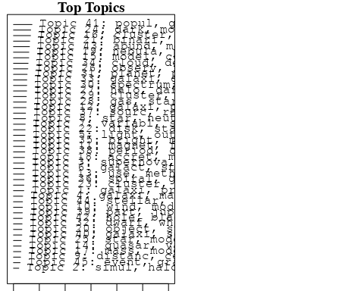

plotQuote(thoughts6, width = 30, main = "Topic 6")  
plotQuote(thoughts18, width = 30, main = "Topic 18")

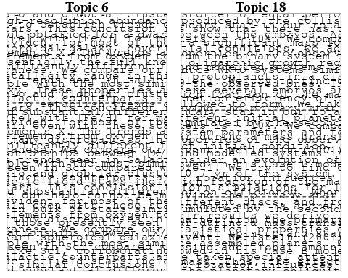

# Calculate and plot the correlation between topics  
mod.out.corr <- topicCorr(Research_topics)  
plot(mod.out.corr, cex = 1.5)  
  
  
# For each topic  
for (topic_num in 1:45) {  
 # Plot the word cloud  
 cloud(Research_topics, topic = topic_num, scale = c(2, 0.25))  
 Sys.sleep(2)  
}

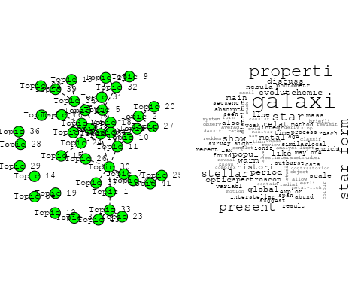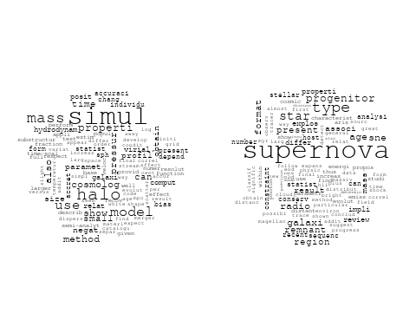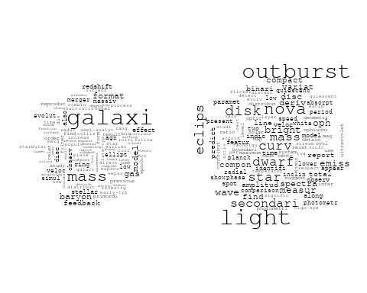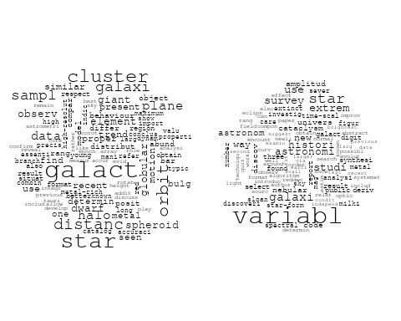

## Warning in wordcloud::wordcloud(words = vocab, freq = vec, max.words =  
## max.words, : cepheid could not be fit on page. It will not be plotted.

## Warning in wordcloud::wordcloud(words = vocab, freq = vec, max.words =  
## max.words, : distanc could not be fit on page. It will not be plotted.

## Warning in wordcloud::wordcloud(words = vocab, freq = vec, max.words =  
## max.words, : telescop could not be fit on page. It will not be plotted.

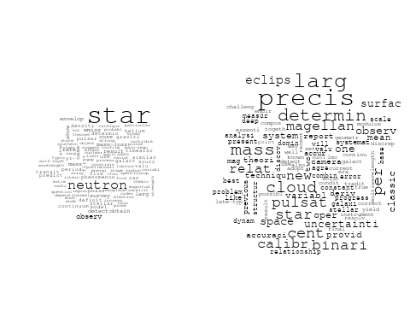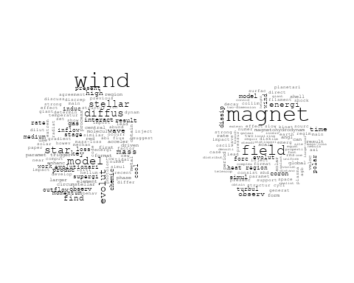

## Warning in wordcloud::wordcloud(words = vocab, freq = vec, max.words =  
## max.words, : color could not be fit on page. It will not be plotted.

## Warning in wordcloud::wordcloud(words = vocab, freq = vec, max.words =  
## max.words, : gradient could not be fit on page. It will not be plotted.

## Warning in wordcloud::wordcloud(words = vocab, freq = vec, max.words =  
## max.words, : galaxi could not be fit on page. It will not be plotted.

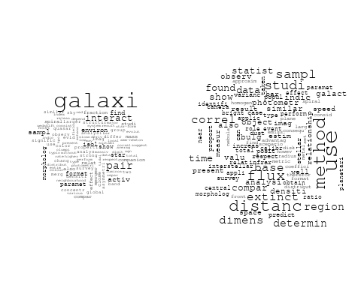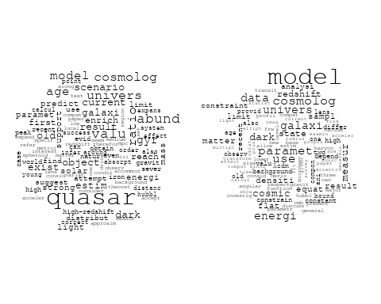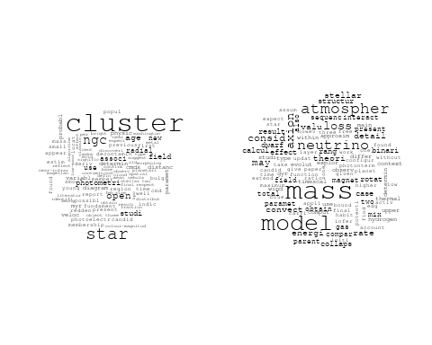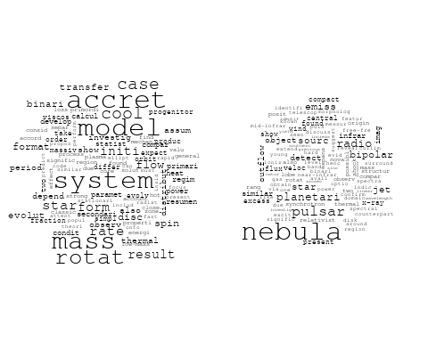

## Warning in wordcloud::wordcloud(words = vocab, freq = vec, max.words =  
## max.words, : star could not be fit on page. It will not be plotted.

## Warning in wordcloud::wordcloud(words = vocab, freq = vec, max.words =  
## max.words, : correl could not be fit on page. It will not be plotted.

## Warning in wordcloud::wordcloud(words = vocab, freq = vec, max.words =  
## max.words, : hydrodynam could not be fit on page. It will not be plotted.

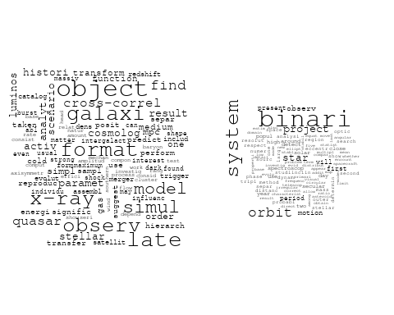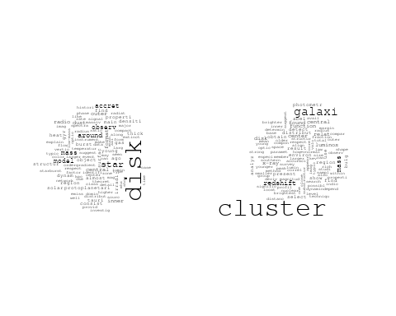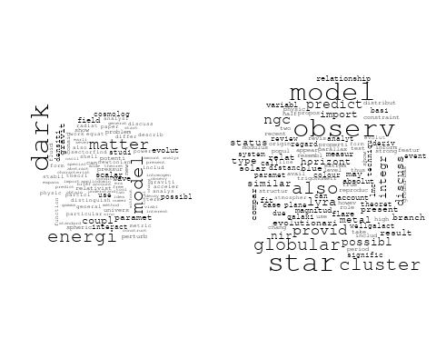

## Warning in wordcloud::wordcloud(words = vocab, freq = vec, max.words =  
## max.words, : microwav could not be fit on page. It will not be plotted.

## Warning in wordcloud::wordcloud(words = vocab, freq = vec, max.words =  
## max.words, : cosmic could not be fit on page. It will not be plotted.

## Warning in wordcloud::wordcloud(words = vocab, freq = vec, max.words =  
## max.words, : high-energi could not be fit on page. It will not be plotted.

## Warning in wordcloud::wordcloud(words = vocab, freq = vec, max.words =  
## max.words, : radiat could not be fit on page. It will not be plotted.

## Warning in wordcloud::wordcloud(words = vocab, freq = vec, max.words =  
## max.words, : neutrino could not be fit on page. It will not be plotted.

## Warning in wordcloud::wordcloud(words = vocab, freq = vec, max.words =  
## max.words, : acceler could not be fit on page. It will not be plotted.

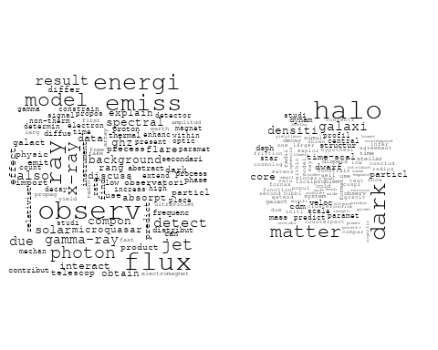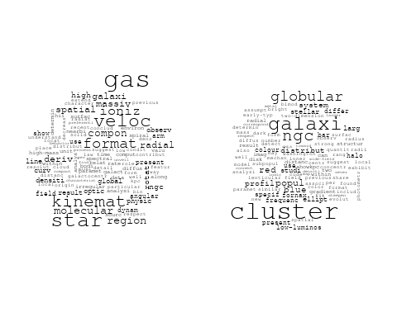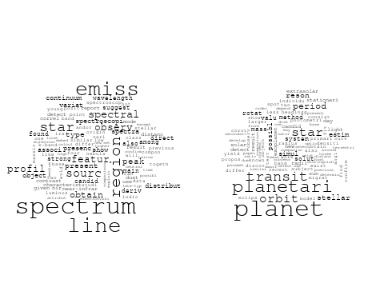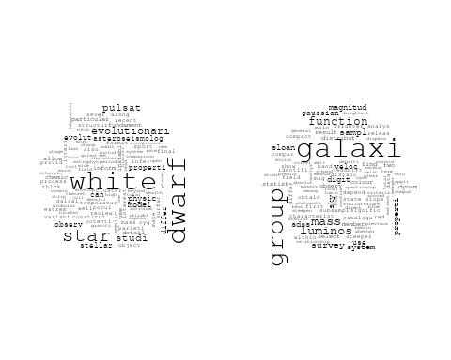

## Warning in wordcloud::wordcloud(words = vocab, freq = vec, max.words =  
## max.words, : flicker could not be fit on page. It will not be plotted.

## Warning in wordcloud::wordcloud(words = vocab, freq = vec, max.words =  
## max.words, : comet could not be fit on page. It will not be plotted.

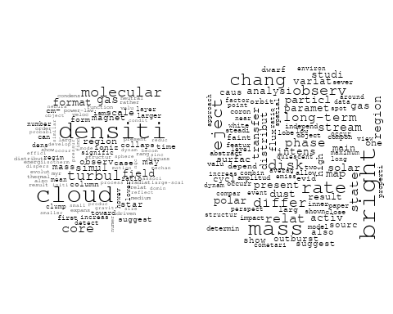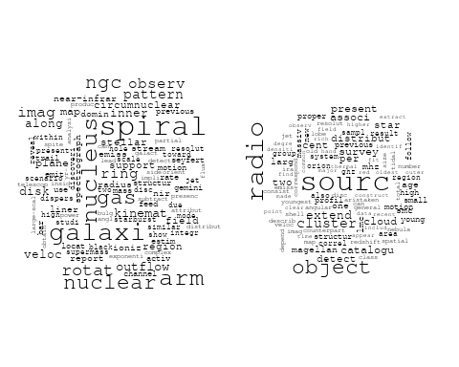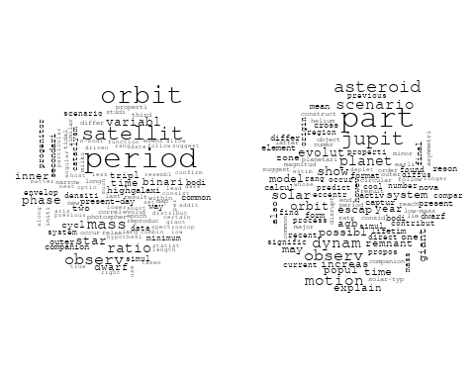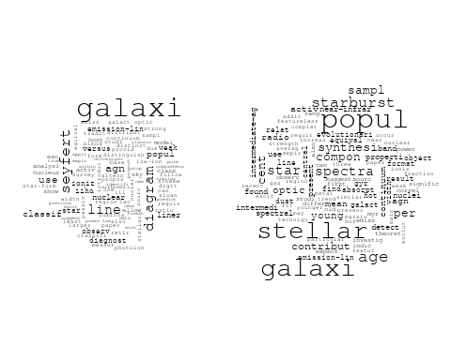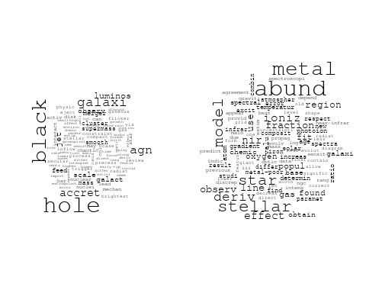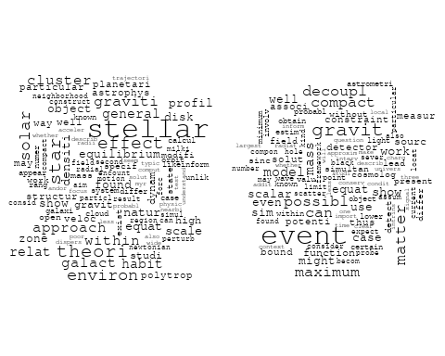

# Get the topic proportions for each document  
topic_proportions <- Research_topics$theta  
  
# Find the index of the topic with the highest proportion for each document  
# This will be the topic that each document is most likely to belong to  
max_topic_idx <- apply(topic_proportions, 1, which.max)  
  
# Add this as a new column to your data  
data_independent$topic <- max_topic_idx  
  
  
  
# Define the intervals  
intervals <- c('1824_1899', '1900_1964', '1965_1974', '1975_1984', '1985_1994', '1995_1999', '2000_2004', '2005_2009', '2010_2014', '2015_2019', '2020_2022')  
colors <- c('pink', 'blue', 'purple', 'yellow', 'green', 'pink', 'orange', 'violet', 'green', 'blue', 'pink')  
  
# Loop through the intervals and plot  
for(i in seq_along(intervals)){  
 # Filter data for when the pub_interval is equal to 1  
 data_filtered <- data_independent[data_independent[[paste0('pub_interval_', intervals[i])]] == 1,]  
   
 # Make the histogram  
   
 p <- ggplot(data_filtered, aes(x = topic)) +  
 geom_histogram(binwidth = 1, fill = colors[i], color = "black") +  
 xlab("Topic") +  
 ylab("Count") +  
 ggtitle(paste0("Topics from year ", gsub("_", " to ", intervals[i])))  
   
 print(p)  
}

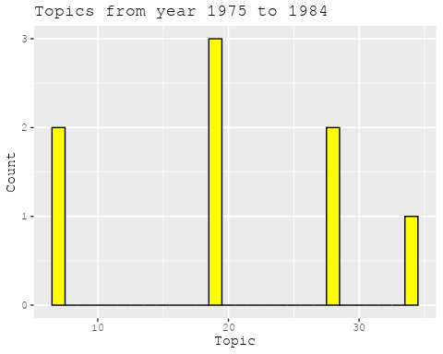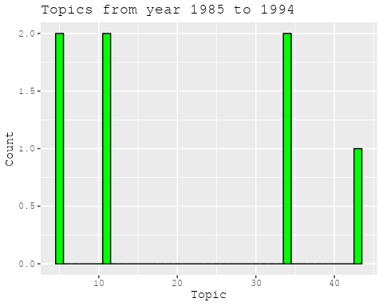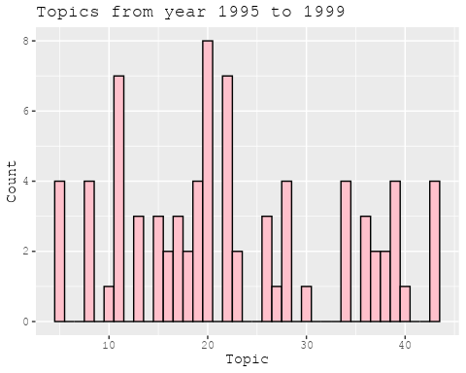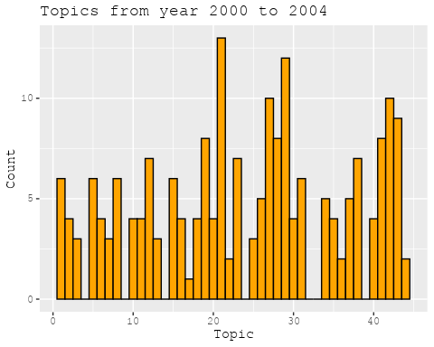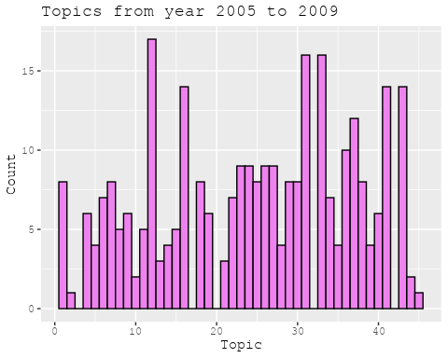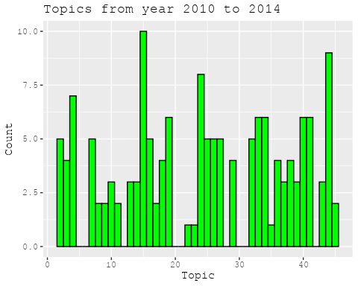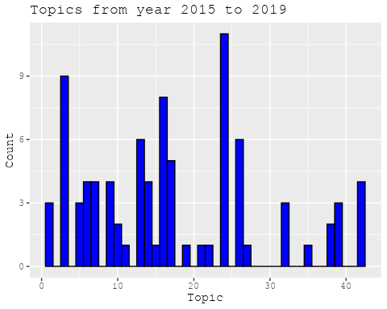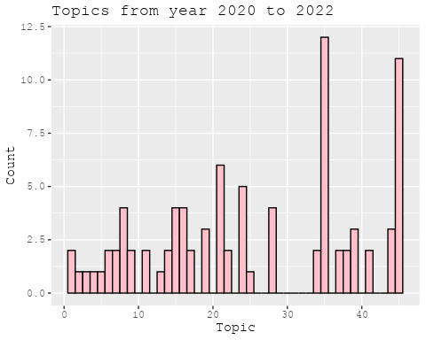

##Topic generation for CN (in collaboration) publications  
  
data_collab <- data[data[["CN"]] != 0,]  
  
# Save the original title data for future use  
data_collab$original_concatenated_title_abstract <- data_collab$concatenated_title_abstract  
  
#pre-processing the titles using textProcessor from the stm package  
processed_text <- textProcessor(data_collab$concatenated_title_abstract, metadata = data_collab)

## Building corpus...   
## Converting to Lower Case...   
## Removing punctuation...   
## Removing stopwords...   
## Removing numbers...   
## Stemming...   
## Creating Output...

# Further prepare the data by removing low-frequency terms  
out_text <- prepDocuments(processed_text$documents, processed_text$vocab, processed_text$meta)

## Removing 2519 of 8725 terms (2519 of 140803 tokens) due to frequency   
## Your corpus now has 1814 documents, 6206 terms and 138284 tokens.

docs_text <- out_text$documents  
vocab_text <- out_text$vocab  
meta_text <- out_text$meta  
  
  
#Prepare data  
plotRemoved(processed_text$documents, lower.thresh = seq(1, 200, by = 100))

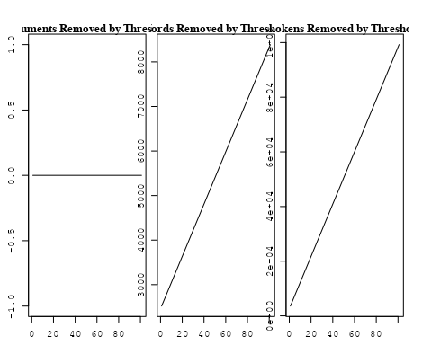

out_text <- prepDocuments(processed_text$documents, processed_text$vocab, processed_text$meta, lower.thresh = 8)

## Removing 6712 of 8725 terms (16287 of 140803 tokens) due to frequency   
## Your corpus now has 1814 documents, 2013 terms and 124516 tokens.

str(out_text$meta)

## 'data.frame': 1814 obs. of 39 variables:  
## $ concept_id : chr "https://openalex.org/C44870925" "https://openalex.org/C44870925" "https://openalex.org/C1276947" "https://openalex.org/C44870925" ...  
## $ work_id : chr "https://openalex.org/W3105293521" "https://openalex.org/W3122804126" "https://openalex.org/W3122804126" "https://openalex.org/W2798563684" ...  
## $ publication_year : int 2007 2010 2010 2018 2009 2003 2021 2021 2002 2016 ...  
## $ title : chr "Post-Oligarchic Evolution of Protoplanetary Embryos and the Stability of Planetary Systems" "Lepto-Hadronic Origin of gamma-rays from the G54.1+0.3 Pulsar Wind Nebula" "Lepto-Hadronic Origin of gamma-rays from the G54.1+0.3 Pulsar Wind Nebula" "Magnetic structure of solar flare regions producing hard X-ray pulsations" ...  
## $ paperabstract : chr "In the sequential accretion model, planets form through the sedimentation of dust, cohesive collisions of plane"| __truncated__ "G54.1+0.3 is a Crab-like pulsar wind nebula (PWN) with the highest γ -ray to X-ray luminosity ratio among all t"| __truncated__ "G54.1+0.3 is a Crab-like pulsar wind nebula (PWN) with the highest γ -ray to X-ray luminosity ratio among all t"| __truncated__ "Abstract We present analysis of the magnetic field in seven solar flare regions accompanied by the pulsations o"| __truncated__ ...  
## $ country : chr "CN CN CN CN" "CN" "CN" "CH RU GB RU CN" ...  
## $ year_concept : chr "2007+https://openalex.org/C44870925" "2010+https://openalex.org/C44870925" "2010+https://openalex.org/C1276947" "2018+https://openalex.org/C44870925" ...  
## $ concatenated_title_abstract : chr "Post-Oligarchic Evolution of Protoplanetary Embryos and the Stability of Planetary Systems In the sequential ac"| __truncated__ "Lepto-Hadronic Origin of gamma-rays from the G54.1+0.3 Pulsar Wind Nebula G54.1+0.3 is a Crab-like pulsar wind "| __truncated__ "Lepto-Hadronic Origin of gamma-rays from the G54.1+0.3 Pulsar Wind Nebula G54.1+0.3 is a Crab-like pulsar wind "| __truncated__ "Magnetic structure of solar flare regions producing hard X-ray pulsations Abstract We present analysis of the m"| __truncated__ ...  
## $ US : num 0 0 0 0 25 0 25 25 0 0 ...  
## $ IN : num 0 0 0 0 0 0 0 0 0 0 ...  
## $ DE : num 0 0 0 0 0 50 0 0 0 0 ...  
## $ CH : num 0 0 0 20 0 0 0 0 0 0 ...  
## $ GB : num 0 0 0 20 0 0 0 0 50 0 ...  
## $ CN : num 100 100 100 20 75 50 25 25 50 100 ...  
## $ FR : num 0 0 0 0 0 0 0 0 0 0 ...  
## $ IT : num 0 0 0 0 0 0 0 0 0 0 ...  
## $ RU : num 0 0 0 40 0 0 0 0 0 0 ...  
## $ CA : num 0 0 0 0 0 0 0 0 0 0 ...  
## $ NL : num 0 0 0 0 0 0 25 25 0 0 ...  
## $ AU : num 0 0 0 0 0 0 0 0 0 0 ...  
## $ JP : num 0 0 0 0 0 0 0 0 0 0 ...  
## $ ES : num 0 0 0 0 0 0 25 25 0 0 ...  
## $ IL : num 0 0 0 0 0 0 0 0 0 0 ...  
## $ Americas : num 0 0 0 0 0 0 0 0 0 0 ...  
## $ Europe : num 0 0 0 0 0 0 0 0 0 0 ...  
## $ Africa : num 0 0 0 0 0 0 0 0 0 0 ...  
## $ AsiaAndOceania : num 0 0 0 0 0 0 0 0 0 0 ...  
## $ pub_interval_2020_2022 : int 0 0 0 0 0 0 1 1 0 0 ...  
## $ pub_interval_2015_2019 : int 0 0 0 1 0 0 0 0 0 1 ...  
## $ pub_interval_2010_2014 : int 0 1 1 0 0 0 0 0 0 0 ...  
## $ pub_interval_2005_2009 : int 1 0 0 0 1 0 0 0 0 0 ...  
## $ pub_interval_2000_2004 : int 0 0 0 0 0 1 0 0 1 0 ...  
## $ pub_interval_1995_1999 : int 0 0 0 0 0 0 0 0 0 0 ...  
## $ pub_interval_1985_1994 : int 0 0 0 0 0 0 0 0 0 0 ...  
## $ pub_interval_1975_1984 : int 0 0 0 0 0 0 0 0 0 0 ...  
## $ pub_interval_1965_1974 : int 0 0 0 0 0 0 0 0 0 0 ...  
## $ pub_interval_1900_1964 : int 0 0 0 0 0 0 0 0 0 0 ...  
## $ pub_interval_1824_1899 : int 0 0 0 0 0 0 0 0 0 0 ...  
## $ original_concatenated_title_abstract: chr "Post-Oligarchic Evolution of Protoplanetary Embryos and the Stability of Planetary Systems In the sequential ac"| __truncated__ "Lepto-Hadronic Origin of gamma-rays from the G54.1+0.3 Pulsar Wind Nebula G54.1+0.3 is a Crab-like pulsar wind "| __truncated__ "Lepto-Hadronic Origin of gamma-rays from the G54.1+0.3 Pulsar Wind Nebula G54.1+0.3 is a Crab-like pulsar wind "| __truncated__ "Magnetic structure of solar flare regions producing hard X-ray pulsations Abstract We present analysis of the m"| __truncated__ ...

# Initialize an empty formula string  
prevalence_formula_str <- "~"  
  
# Define the publication intervals  
pub_intervals <- c("pub_interval_2020_2022", "pub_interval_2015_2019", "pub_interval_2010_2014",   
 "pub_interval_2005_2009", "pub_interval_2000_2004", "pub_interval_1995_1999",  
 "pub_interval_1985_1994", "pub_interval_1975_1984", "pub_interval_1965_1974",  
 "pub_interval_1900_1964", "pub_interval_1824_1899")  
  
# Add each publication interval to the formula string  
for (interval in pub_intervals) {  
 # add an if statement to handle the first addition (without '+')  
 if (prevalence_formula_str == "~") {  
 prevalence_formula_str <- paste(prevalence_formula_str, interval)  
 } else {  
 prevalence_formula_str <- paste(prevalence_formula_str, "+", interval)  
 }  
}  
  
  
# Convert the string to a formula  
prevalence_formula <- as.formula(prevalence_formula_str)  
print(prevalence_formula)

## ~pub_interval_2020_2022 + pub_interval_2015_2019 + pub_interval_2010_2014 +   
## pub_interval_2005_2009 + pub_interval_2000_2004 + pub_interval_1995_1999 +   
## pub_interval_1985_1994 + pub_interval_1975_1984 + pub_interval_1965_1974 +   
## pub_interval_1900_1964 + pub_interval_1824_1899

# Run STM model  
Research_topics <- stm(documents = out_text$documents,   
 vocab = out_text$vocab,   
 K = 44,   
 prevalence = prevalence_formula,   
 data = out_text$meta,   
 init.type = "Spectral",  
 max.em.its = 1000,  
 gamma.prior = 'L1')

## Beginning Spectral Initialization   
## Calculating the gram matrix...  
## Finding anchor words...  
## ............................................  
## Recovering initialization...  
## ....................  
## Initialization complete.  
## ....................................................................................................  
## Completed E-Step (1 seconds).   
## Completed M-Step.   
## Completing Iteration 1 (approx. per word bound = -6.333)   
## ....................................................................................................  
## Completed E-Step (1 seconds).   
## Completed M-Step.   
## Completing Iteration 2 (approx. per word bound = -6.040, relative change = 4.626e-02)   
## ....................................................................................................  
## Completed E-Step (1 seconds).   
## Completed M-Step.   
## Completing Iteration 3 (approx. per word bound = -5.969, relative change = 1.181e-02)   
## ....................................................................................................  
## Completed E-Step (1 seconds).   
## Completed M-Step.   
## Completing Iteration 4 (approx. per word bound = -5.942, relative change = 4.445e-03)   
## ....................................................................................................  
## Completed E-Step (1 seconds).   
## Completed M-Step.   
## Completing Iteration 5 (approx. per word bound = -5.928, relative change = 2.415e-03)   
## Topic 1: ray, cosmic, energi, measur, nuclei   
## Topic 2: neutrino, physic, univers, astrophys, mass   
## Topic 3: observ, variabl, variat, corona, use   
## Topic 4: model, dark, energi, data, cosmolog   
## Topic 5: pulsar, time, glitch, polar, observ   
## Topic 6: scienc, china, univers, laboratori, observatori   
## Topic 7: dust, extinct, model, disk, spiral   
## Topic 8: gravit, wave, cosmolog, can, paramet   
## Topic 9: temperatur, zone, ultraviolet, star, outflow   
## Topic 10: hole, black, mass, galaxi, binari   
## Topic 11: magnet, field, observ, reconnect, magnetar   
## Topic 12: solar, activ, cycl, region, magnet   
## Topic 13: galaxi, format, mass, stellar, survey   
## Topic 14: star, giant, red, abund, observ   
## Topic 15: period, binari, orbit, system, mass   
## Topic 16: sourc, detect, observ, emiss, galact   
## Topic 17: flare, observ, solar, erupt, magnet   
## Topic 18: method, two, use, featur, also   
## Topic 19: x-ray, kev, sourc, binari, oscil   
## Topic 20: data, observ, background, can, line   
## Topic 21: luminos, agn, sampl, correl, ratio   
## Topic 22: cluster, star, telescop, age, stellar   
## Topic 23: star, mass, supernova, progenitor, binari   
## Topic 24: model, differ, use, equat, paramet   
## Topic 25: mode, pulsat, star, observ, dwarf   
## Topic 26: gas, core, format, planet, giant   
## Topic 27: halo, galaxi, mass, group, satellit   
## Topic 28: flux, magnet, rope, field, region   
## Topic 29: system, planet, orbit, solar, result   
## Topic 30: afterglow, grb, gamma-ray, burst, optic   
## Topic 31: line, emiss, region, ratio, electron   
## Topic 32: hole, black, effect, paramet, spectral   
## Topic 33: measur, mission, will, high, observ   
## Topic 34: matter, dark, mass, cosmolog, particl   
## Topic 35: gamma-ray, detector, grid, blazar, earth   
## Topic 36: jet, emiss, gas, relativist, observ   
## Topic 37: model, gamma-ray, gap, outer, neutron   
## Topic 38: accret, disk, flow, hole, black   
## Topic 39: nebula, planetari, abund, mass, line   
## Topic 40: galaxi, format, star, infrar, gas   
## Topic 41: lag, spectral, puls, grbs, burst   
## Topic 42: shock, wind, model, paramet, emiss   
## Topic 43: radio, burst, frbs, frb, observ   
## Topic 44: cluster, use, probabl, gaia, motion   
## ....................................................................................................  
## Completed E-Step (1 seconds).   
## Completed M-Step.   
## Completing Iteration 6 (approx. per word bound = -5.919, relative change = 1.466e-03)   
## ....................................................................................................  
## Completed E-Step (1 seconds).   
## Completed M-Step.   
## Completing Iteration 7 (approx. per word bound = -5.913, relative change = 1.026e-03)   
## ....................................................................................................  
## Completed E-Step (1 seconds).   
## Completed M-Step.   
## Completing Iteration 8 (approx. per word bound = -5.909, relative change = 7.672e-04)   
## ....................................................................................................  
## Completed E-Step (1 seconds).   
## Completed M-Step.   
## Completing Iteration 9 (approx. per word bound = -5.905, relative change = 5.477e-04)   
## ....................................................................................................  
## Completed E-Step (1 seconds).   
## Completed M-Step.   
## Completing Iteration 10 (approx. per word bound = -5.903, relative change = 4.397e-04)   
## Topic 1: ray, cosmic, energi, measur, nuclei   
## Topic 2: neutrino, physic, mass, univers, astrophys   
## Topic 3: observ, variabl, variat, optic, show   
## Topic 4: model, dark, energi, data, cosmolog   
## Topic 5: pulsar, time, glitch, polar, observ   
## Topic 6: scienc, china, univers, laboratori, observatori   
## Topic 7: dust, extinct, model, disk, spiral   
## Topic 8: gravit, wave, binari, cosmolog, can   
## Topic 9: temperatur, zone, outflow, star, quasar   
## Topic 10: hole, black, mass, galaxi, accret   
## Topic 11: magnet, field, observ, reconnect, magnetar   
## Topic 12: solar, activ, cycl, region, magnet   
## Topic 13: galaxi, format, mass, stellar, dwarf   
## Topic 14: star, giant, abund, red, observ   
## Topic 15: period, binari, system, orbit, mass   
## Topic 16: sourc, detect, observ, emiss, galact   
## Topic 17: flare, observ, solar, erupt, filament   
## Topic 18: method, use, two, featur, estim   
## Topic 19: x-ray, kev, sourc, binari, emiss   
## Topic 20: background, observ, can, redshift, line   
## Topic 21: agn, luminos, sampl, quasar, ratio   
## Topic 22: cluster, star, age, galaxi, stellar   
## Topic 23: star, mass, supernova, progenitor, binari   
## Topic 24: model, solut, differ, use, paramet   
## Topic 25: mode, pulsat, star, observ, instabl   
## Topic 26: core, gas, planet, format, giant   
## Topic 27: halo, galaxi, mass, group, central   
## Topic 28: flux, magnet, rope, field, region   
## Topic 29: system, planet, orbit, solar, multipl   
## Topic 30: grb, afterglow, burst, gamma-ray, grbs   
## Topic 31: line, emiss, region, ratio, flux   
## Topic 32: hole, black, effect, paramet, observ   
## Topic 33: measur, mission, high, observ, will   
## Topic 34: matter, dark, mass, cosmolog, baryon   
## Topic 35: gamma-ray, detector, grid, blazar, energi   
## Topic 36: jet, emiss, gas, observ, galaxi   
## Topic 37: gamma-ray, model, gap, outer, photon   
## Topic 38: disk, accret, flow, black, hole   
## Topic 39: nebula, planetari, abund, line, mass   
## Topic 40: galaxi, format, star, infrar, gas   
## Topic 41: spectral, lag, puls, grbs, burst   
## Topic 42: shock, wind, model, paramet, x-ray   
## Topic 43: radio, burst, frbs, frb, observ   
## Topic 44: cluster, use, probabl, open, data   
## ....................................................................................................  
## Completed E-Step (1 seconds).   
## Completed M-Step.   
## Completing Iteration 11 (approx. per word bound = -5.901, relative change = 3.419e-04)   
## ....................................................................................................  
## Completed E-Step (1 seconds).   
## Completed M-Step.   
## Completing Iteration 12 (approx. per word bound = -5.899, relative change = 3.044e-04)   
## ....................................................................................................  
## Completed E-Step (1 seconds).   
## Completed M-Step.   
## Completing Iteration 13 (approx. per word bound = -5.897, relative change = 2.504e-04)   
## ....................................................................................................  
## Completed E-Step (1 seconds).   
## Completed M-Step.   
## Completing Iteration 14 (approx. per word bound = -5.896, relative change = 2.467e-04)   
## ....................................................................................................  
## Completed E-Step (1 seconds).   
## Completed M-Step.   
## Completing Iteration 15 (approx. per word bound = -5.895, relative change = 2.248e-04)   
## Topic 1: ray, cosmic, energi, measur, nuclei   
## Topic 2: neutrino, physic, mass, astrophys, univers   
## Topic 3: observ, variabl, optic, variat, band   
## Topic 4: model, dark, energi, data, cosmolog   
## Topic 5: pulsar, time, glitch, polar, observ   
## Topic 6: scienc, china, univers, observatori, laboratori   
## Topic 7: dust, extinct, model, disk, spiral   
## Topic 8: gravit, wave, binari, sourc, detect   
## Topic 9: temperatur, zone, outflow, quasar, star   
## Topic 10: hole, black, mass, galaxi, accret   
## Topic 11: magnet, field, observ, reconnect, magnetar   
## Topic 12: solar, activ, cycl, region, magnet   
## Topic 13: galaxi, format, mass, stellar, sampl   
## Topic 14: star, giant, abund, red, observ   
## Topic 15: period, binari, system, orbit, mass   
## Topic 16: sourc, detect, observ, emiss, galact   
## Topic 17: flare, observ, solar, erupt, filament   
## Topic 18: method, use, featur, two, estim   
## Topic 19: x-ray, kev, sourc, binari, emiss   
## Topic 20: background, telescop, detect, redshift, observ   
## Topic 21: agn, luminos, quasar, sampl, ratio   
## Topic 22: cluster, star, galaxi, age, mass   
## Topic 23: star, mass, supernova, progenitor, model   
## Topic 24: solut, model, paramet, differ, equat   
## Topic 25: mode, pulsat, star, observ, instabl   
## Topic 26: core, gas, planet, format, giant   
## Topic 27: halo, galaxi, mass, group, satellit   
## Topic 28: flux, magnet, rope, field, region   
## Topic 29: system, planet, orbit, solar, multipl   
## Topic 30: grb, afterglow, burst, gamma-ray, grbs   
## Topic 31: line, emiss, region, ratio, optic   
## Topic 32: hole, black, effect, paramet, observ   
## Topic 33: measur, mission, observ, high, will   
## Topic 34: matter, dark, mass, cosmolog, baryon   
## Topic 35: gamma-ray, detector, grid, energi, blazar   
## Topic 36: jet, gas, emiss, observ, produc   
## Topic 37: gamma-ray, pulsar, gap, model, photon   
## Topic 38: disk, accret, flow, hot, rate   
## Topic 39: nebula, planetari, abund, line, mass   
## Topic 40: galaxi, format, star, infrar, gas   
## Topic 41: spectral, lag, puls, burst, grbs   
## Topic 42: shock, model, wind, paramet, x-ray   
## Topic 43: radio, burst, frbs, frb, observ   
## Topic 44: cluster, use, motion, probabl, proper   
## ....................................................................................................  
## Completed E-Step (1 seconds).   
## Completed M-Step.   
## Completing Iteration 16 (approx. per word bound = -5.894, relative change = 1.936e-04)   
## ....................................................................................................  
## Completed E-Step (1 seconds).   
## Completed M-Step.   
## Completing Iteration 17 (approx. per word bound = -5.892, relative change = 2.005e-04)   
## ....................................................................................................  
## Completed E-Step (1 seconds).   
## Completed M-Step.   
## Completing Iteration 18 (approx. per word bound = -5.891, relative change = 1.881e-04)   
## ....................................................................................................  
## Completed E-Step (1 seconds).   
## Completed M-Step.   
## Completing Iteration 19 (approx. per word bound = -5.890, relative change = 1.773e-04)   
## ....................................................................................................  
## Completed E-Step (1 seconds).   
## Completed M-Step.   
## Completing Iteration 20 (approx. per word bound = -5.889, relative change = 1.359e-04)   
## Topic 1: ray, cosmic, energi, measur, nuclei   
## Topic 2: neutrino, physic, mass, astrophys, univers   
## Topic 3: observ, optic, variabl, variat, band   
## Topic 4: model, dark, energi, data, cosmolog   
## Topic 5: pulsar, time, polar, glitch, observ   
## Topic 6: scienc, china, univers, observatori, laboratori   
## Topic 7: dust, extinct, model, disk, spiral   
## Topic 8: gravit, wave, binari, sourc, detect   
## Topic 9: temperatur, zone, outflow, quasar, star   
## Topic 10: hole, black, mass, galaxi, accret   
## Topic 11: magnet, field, observ, reconnect, magnetar   
## Topic 12: solar, activ, cycl, region, magnet   
## Topic 13: galaxi, format, stellar, mass, sampl   
## Topic 14: star, giant, abund, red, observ   
## Topic 15: period, binari, system, orbit, mass   
## Topic 16: sourc, detect, observ, emiss, galact   
## Topic 17: flare, observ, solar, erupt, coron   
## Topic 18: method, use, featur, two, estim   
## Topic 19: x-ray, kev, sourc, binari, emiss   
## Topic 20: background, detect, redshift, telescop, galaxi   
## Topic 21: agn, luminos, quasar, sampl, ratio   
## Topic 22: cluster, galaxi, star, age, mass   
## Topic 23: star, mass, supernova, progenitor, model   
## Topic 24: solut, model, equat, paramet, differ   
## Topic 25: mode, pulsat, star, observ, instabl   
## Topic 26: gas, core, planet, format, giant   
## Topic 27: halo, galaxi, mass, group, satellit   
## Topic 28: flux, magnet, rope, field, region   
## Topic 29: system, planet, solar, orbit, multipl   
## Topic 30: grb, afterglow, burst, gamma-ray, grbs   
## Topic 31: line, emiss, region, ratio, flux   
## Topic 32: hole, black, effect, observ, paramet   
## Topic 33: measur, observ, high, mission, will   
## Topic 34: matter, dark, mass, cosmolog, baryon   
## Topic 35: gamma-ray, detector, energi, grid, blazar   
## Topic 36: jet, gas, emiss, observ, produc   
## Topic 37: pulsar, gamma-ray, gap, model, emiss   
## Topic 38: disk, accret, flow, hot, rate   
## Topic 39: nebula, planetari, abund, line, mass   
## Topic 40: galaxi, format, star, infrar, gas   
## Topic 41: spectral, lag, puls, burst, grbs   
## Topic 42: shock, model, wind, paramet, x-ray   
## Topic 43: radio, burst, frbs, frb, sourc   
## Topic 44: cluster, motion, use, probabl, proper   
## ....................................................................................................  
## Completed E-Step (1 seconds).   
## Completed M-Step.   
## Completing Iteration 21 (approx. per word bound = -5.889, relative change = 1.458e-04)   
## ....................................................................................................  
## Completed E-Step (1 seconds).   
## Completed M-Step.   
## Completing Iteration 22 (approx. per word bound = -5.888, relative change = 1.161e-04)   
## ....................................................................................................  
## Completed E-Step (1 seconds).   
## Completed M-Step.   
## Completing Iteration 23 (approx. per word bound = -5.887, relative change = 1.230e-04)   
## ....................................................................................................  
## Completed E-Step (1 seconds).   
## Completed M-Step.   
## Completing Iteration 24 (approx. per word bound = -5.886, relative change = 1.198e-04)   
## ....................................................................................................  
## Completed E-Step (1 seconds).   
## Completed M-Step.   
## Completing Iteration 25 (approx. per word bound = -5.886, relative change = 1.202e-04)   
## Topic 1: ray, cosmic, energi, measur, nuclei   
## Topic 2: neutrino, physic, mass, astrophys, univers   
## Topic 3: observ, optic, variabl, variat, band   
## Topic 4: model, dark, energi, data, cosmolog   
## Topic 5: pulsar, time, polar, glitch, observ   
## Topic 6: scienc, univers, china, observatori, laboratori   
## Topic 7: dust, extinct, model, disk, spiral   
## Topic 8: wave, gravit, binari, sourc, detect   
## Topic 9: temperatur, zone, outflow, quasar, star   
## Topic 10: hole, black, mass, galaxi, accret   
## Topic 11: magnet, field, observ, reconnect, magnetar   
## Topic 12: solar, activ, cycl, region, magnet   
## Topic 13: galaxi, format, stellar, mass, sampl   
## Topic 14: star, giant, abund, red, observ   
## Topic 15: period, binari, system, orbit, mass   
## Topic 16: sourc, detect, observ, emiss, galact   
## Topic 17: flare, observ, solar, erupt, coron   
## Topic 18: method, use, featur, can, estim   
## Topic 19: x-ray, kev, sourc, binari, emiss   
## Topic 20: galaxi, detect, background, redshift, survey   
## Topic 21: agn, luminos, quasar, sampl, ratio   
## Topic 22: cluster, star, galaxi, age, mass   
## Topic 23: star, mass, supernova, progenitor, model   
## Topic 24: solut, model, equat, paramet, differ   
## Topic 25: mode, pulsat, star, observ, instabl   
## Topic 26: gas, core, planet, format, giant   
## Topic 27: halo, galaxi, mass, group, central   
## Topic 28: flux, magnet, rope, field, region   
## Topic 29: system, planet, solar, multipl, galaxi   
## Topic 30: grb, afterglow, burst, gamma-ray, grbs   
## Topic 31: line, emiss, region, flux, ratio   
## Topic 32: hole, black, effect, observ, paramet   
## Topic 33: measur, observ, high, mission, will   
## Topic 34: matter, dark, mass, cosmolog, baryon   
## Topic 35: gamma-ray, detector, grid, energi, blazar   
## Topic 36: jet, gas, emiss, observ, produc   
## Topic 37: pulsar, gamma-ray, gap, emiss, photon   
## Topic 38: disk, accret, flow, hot, rate   
## Topic 39: nebula, planetari, abund, line, element   
## Topic 40: galaxi, format, star, gas, infrar   
## Topic 41: spectral, lag, puls, grbs, burst   
## Topic 42: shock, model, wind, paramet, x-ray   
## Topic 43: radio, burst, frbs, frb, sourc   
## Topic 44: cluster, motion, use, probabl, proper   
## ....................................................................................................  
## Completed E-Step (1 seconds).   
## Completed M-Step.   
## Completing Iteration 26 (approx. per word bound = -5.885, relative change = 1.150e-04)   
## ....................................................................................................  
## Completed E-Step (1 seconds).   
## Completed M-Step.   
## Completing Iteration 27 (approx. per word bound = -5.884, relative change = 1.075e-04)   
## ....................................................................................................  
## Completed E-Step (1 seconds).   
## Completed M-Step.   
## Completing Iteration 28 (approx. per word bound = -5.884, relative change = 1.118e-04)   
## ....................................................................................................  
## Completed E-Step (1 seconds).   
## Completed M-Step.   
## Completing Iteration 29 (approx. per word bound = -5.883, relative change = 6.606e-05)   
## ....................................................................................................  
## Completed E-Step (1 seconds).   
## Completed M-Step.   
## Completing Iteration 30 (approx. per word bound = -5.883, relative change = 9.462e-05)   
## Topic 1: ray, cosmic, energi, measur, nuclei   
## Topic 2: neutrino, physic, mass, astrophys, univers   
## Topic 3: observ, optic, variabl, variat, band   
## Topic 4: model, dark, energi, data, cosmolog   
## Topic 5: pulsar, time, polar, glitch, observ   
## Topic 6: scienc, univers, china, observatori, laboratori   
## Topic 7: dust, extinct, model, disk, spiral   
## Topic 8: wave, gravit, binari, sourc, detect   
## Topic 9: temperatur, zone, outflow, quasar, star   
## Topic 10: hole, black, mass, galaxi, accret   
## Topic 11: magnet, field, observ, reconnect, plasma   
## Topic 12: solar, activ, cycl, region, magnet   
## Topic 13: galaxi, format, stellar, mass, sampl   
## Topic 14: star, giant, abund, red, observ   
## Topic 15: period, binari, system, orbit, mass   
## Topic 16: sourc, detect, observ, emiss, galact   
## Topic 17: flare, observ, solar, erupt, coron   
## Topic 18: method, use, featur, can, simul   
## Topic 19: x-ray, kev, sourc, binari, emiss   
## Topic 20: galaxi, detect, survey, background, redshift   
## Topic 21: agn, luminos, quasar, sampl, ratio   
## Topic 22: cluster, star, age, galaxi, mass   
## Topic 23: star, mass, supernova, progenitor, model   
## Topic 24: solut, model, equat, paramet, differ   
## Topic 25: mode, pulsat, star, observ, instabl   
## Topic 26: gas, core, planet, format, giant   
## Topic 27: halo, galaxi, mass, group, central   
## Topic 28: flux, magnet, rope, field, region   
## Topic 29: system, planet, solar, multipl, galaxi   
## Topic 30: grb, afterglow, burst, gamma-ray, grbs   
## Topic 31: line, emiss, region, flux, ratio   
## Topic 32: hole, black, effect, observ, paramet   
## Topic 33: measur, observ, high, telescop, will   
## Topic 34: matter, dark, mass, cosmolog, baryon   
## Topic 35: gamma-ray, detector, grid, energi, blazar   
## Topic 36: jet, gas, emiss, observ, produc   
## Topic 37: pulsar, gamma-ray, gap, emiss, photon   
## Topic 38: disk, accret, flow, hot, rate   
## Topic 39: nebula, planetari, abund, line, element   
## Topic 40: galaxi, format, star, star-form, gas   
## Topic 41: spectral, lag, puls, grbs, light   
## Topic 42: shock, model, wind, paramet, x-ray   
## Topic 43: radio, burst, frbs, frb, sourc   
## Topic 44: cluster, use, motion, data, probabl   
## ....................................................................................................  
## Completed E-Step (1 seconds).   
## Completed M-Step.   
## Completing Iteration 31 (approx. per word bound = -5.882, relative change = 7.450e-05)   
## ....................................................................................................  
## Completed E-Step (1 seconds).   
## Completed M-Step.   
## Completing Iteration 32 (approx. per word bound = -5.882, relative change = 6.863e-05)   
## ....................................................................................................  
## Completed E-Step (1 seconds).   
## Completed M-Step.   
## Completing Iteration 33 (approx. per word bound = -5.882, relative change = 7.399e-05)   
## ....................................................................................................  
## Completed E-Step (1 seconds).   
## Completed M-Step.   
## Completing Iteration 34 (approx. per word bound = -5.881, relative change = 4.554e-05)   
## ....................................................................................................  
## Completed E-Step (1 seconds).   
## Completed M-Step.   
## Completing Iteration 35 (approx. per word bound = -5.881, relative change = 8.278e-05)   
## Topic 1: ray, cosmic, energi, measur, nuclei   
## Topic 2: neutrino, physic, mass, astrophys, univers   
## Topic 3: observ, optic, variabl, variat, band   
## Topic 4: model, dark, energi, data, cosmolog   
## Topic 5: pulsar, polar, time, glitch, observ   
## Topic 6: scienc, univers, china, observatori, laboratori   
## Topic 7: dust, extinct, model, disk, spiral   
## Topic 8: wave, gravit, binari, sourc, detect   
## Topic 9: temperatur, zone, outflow, quasar, star   
## Topic 10: hole, black, mass, galaxi, accret   
## Topic 11: magnet, field, reconnect, observ, magnetar   
## Topic 12: solar, activ, cycl, region, magnet   
## Topic 13: galaxi, stellar, format, mass, sampl   
## Topic 14: star, giant, abund, red, observ   
## Topic 15: period, binari, system, orbit, mass   
## Topic 16: sourc, observ, detect, emiss, galact   
## Topic 17: flare, observ, solar, erupt, coron   
## Topic 18: method, use, can, featur, simul   
## Topic 19: x-ray, kev, sourc, binari, emiss   
## Topic 20: galaxi, survey, detect, redshift, background   
## Topic 21: agn, luminos, quasar, sampl, ratio   
## Topic 22: cluster, star, age, galaxi, mass   
## Topic 23: supernova, mass, star, progenitor, model   
## Topic 24: solut, model, equat, paramet, differ   
## Topic 25: mode, pulsat, star, instabl, observ   
## Topic 26: gas, core, planet, format, giant   
## Topic 27: halo, galaxi, mass, group, central   
## Topic 28: flux, magnet, rope, field, region   
## Topic 29: system, planet, solar, multipl, galaxi   
## Topic 30: grb, afterglow, burst, gamma-ray, grbs   
## Topic 31: line, emiss, region, flux, ratio   
## Topic 32: hole, black, effect, observ, paramet   
## Topic 33: measur, telescop, observ, high, will   
## Topic 34: matter, dark, mass, cosmolog, baryon   
## Topic 35: gamma-ray, detector, grid, energi, blazar   
## Topic 36: jet, gas, emiss, observ, produc   
## Topic 37: pulsar, gamma-ray, gap, emiss, photon   
## Topic 38: disk, accret, flow, hot, rate   
## Topic 39: nebula, planetari, abund, line, element   
## Topic 40: galaxi, format, star, star-form, gas   
## Topic 41: spectral, lag, puls, grbs, light   
## Topic 42: shock, model, wind, paramet, x-ray   
## Topic 43: radio, burst, frbs, sourc, frb   
## Topic 44: cluster, use, data, motion, probabl   
## ....................................................................................................  
## Completed E-Step (1 seconds).   
## Completed M-Step.   
## Completing Iteration 36 (approx. per word bound = -5.880, relative change = 6.242e-05)   
## ....................................................................................................  
## Completed E-Step (1 seconds).   
## Completed M-Step.   
## Completing Iteration 37 (approx. per word bound = -5.880, relative change = 5.850e-05)   
## ....................................................................................................  
## Completed E-Step (1 seconds).   
## Completed M-Step.   
## Completing Iteration 38 (approx. per word bound = -5.880, relative change = 5.935e-05)   
## ....................................................................................................  
## Completed E-Step (1 seconds).   
## Completed M-Step.   
## Completing Iteration 39 (approx. per word bound = -5.879, relative change = 5.384e-05)   
## ....................................................................................................  
## Completed E-Step (1 seconds).   
## Completed M-Step.   
## Completing Iteration 40 (approx. per word bound = -5.879, relative change = 5.075e-05)   
## Topic 1: ray, cosmic, energi, measur, nuclei   
## Topic 2: neutrino, physic, mass, astrophys, univers   
## Topic 3: optic, observ, variabl, variat, band   
## Topic 4: model, dark, energi, data, cosmolog   
## Topic 5: pulsar, polar, time, glitch, observ   
## Topic 6: scienc, univers, china, observatori, laboratori   
## Topic 7: dust, extinct, model, disk, spiral   
## Topic 8: wave, gravit, binari, sourc, detect   
## Topic 9: temperatur, outflow, zone, quasar, star   
## Topic 10: hole, black, mass, galaxi, accret   
## Topic 11: magnet, field, reconnect, observ, magnetar   
## Topic 12: solar, activ, cycl, region, magnet   
## Topic 13: galaxi, stellar, format, mass, sampl   
## Topic 14: star, giant, abund, red, observ   
## Topic 15: period, binari, system, orbit, mass   
## Topic 16: sourc, observ, detect, emiss, galact   
## Topic 17: flare, observ, solar, erupt, coron   
## Topic 18: method, use, can, featur, simul   
## Topic 19: x-ray, kev, sourc, binari, emiss   
## Topic 20: galaxi, detect, survey, redshift, larg   
## Topic 21: agn, quasar, luminos, sampl, ratio   
## Topic 22: cluster, star, age, mass, galaxi   
## Topic 23: supernova, mass, star, progenitor, model   
## Topic 24: solut, model, equat, differ, paramet   
## Topic 25: mode, pulsat, star, instabl, observ   
## Topic 26: core, gas, planet, format, giant   
## Topic 27: halo, galaxi, mass, group, central   
## Topic 28: flux, magnet, rope, field, region   
## Topic 29: system, planet, solar, multipl, galaxi   
## Topic 30: grb, afterglow, burst, gamma-ray, grbs   
## Topic 31: line, emiss, region, flux, ratio   
## Topic 32: hole, black, observ, effect, paramet   
## Topic 33: measur, telescop, observ, high, will   
## Topic 34: matter, dark, mass, cosmolog, baryon   
## Topic 35: gamma-ray, detector, energi, grid, fermi   
## Topic 36: jet, gas, emiss, observ, produc   
## Topic 37: pulsar, gap, gamma-ray, emiss, photon   
## Topic 38: disk, accret, flow, hot, rate   
## Topic 39: nebula, planetari, abund, line, element   
## Topic 40: galaxi, format, star, star-form, gas   
## Topic 41: spectral, lag, puls, grbs, burst   
## Topic 42: shock, model, wind, paramet, medium   
## Topic 43: radio, burst, frbs, sourc, frb   
## Topic 44: cluster, use, data, motion, mass   
## ....................................................................................................  
## Completed E-Step (1 seconds).   
## Completed M-Step.   
## Completing Iteration 41 (approx. per word bound = -5.879, relative change = 4.316e-05)   
## ....................................................................................................  
## Completed E-Step (1 seconds).   
## Completed M-Step.   
## Completing Iteration 42 (approx. per word bound = -5.879, relative change = 4.169e-05)   
## ....................................................................................................  
## Completed E-Step (1 seconds).   
## Completed M-Step.   
## Completing Iteration 43 (approx. per word bound = -5.878, relative change = 4.399e-05)   
## ....................................................................................................  
## Completed E-Step (1 seconds).   
## Completed M-Step.   
## Completing Iteration 44 (approx. per word bound = -5.878, relative change = 2.543e-05)   
## ....................................................................................................  
## Completed E-Step (1 seconds).   
## Completed M-Step.   
## Completing Iteration 45 (approx. per word bound = -5.878, relative change = 7.086e-05)   
## Topic 1: ray, cosmic, energi, measur, nuclei   
## Topic 2: neutrino, physic, mass, astrophys, univers   
## Topic 3: optic, observ, variat, variabl, band   
## Topic 4: model, dark, energi, data, cosmolog   
## Topic 5: pulsar, polar, time, glitch, observ   
## Topic 6: scienc, univers, china, observatori, laboratori   
## Topic 7: dust, extinct, model, disk, spiral   
## Topic 8: wave, gravit, binari, sourc, detect   
## Topic 9: temperatur, outflow, zone, quasar, star   
## Topic 10: hole, black, mass, galaxi, accret   
## Topic 11: magnet, field, reconnect, observ, magnetar   
## Topic 12: solar, activ, cycl, region, magnet   
## Topic 13: galaxi, stellar, format, mass, sampl   
## Topic 14: star, giant, abund, red, observ   
## Topic 15: period, binari, system, orbit, mass   
## Topic 16: sourc, detect, observ, emiss, remnant   
## Topic 17: flare, observ, solar, erupt, coron   
## Topic 18: method, use, can, featur, estim   
## Topic 19: x-ray, kev, sourc, binari, emiss   
## Topic 20: galaxi, detect, survey, redshift, larg   
## Topic 21: agn, quasar, luminos, sampl, ratio   
## Topic 22: cluster, age, star, mass, galaxi   
## Topic 23: supernova, mass, star, progenitor, model   
## Topic 24: solut, model, equat, dynam, differ   
## Topic 25: mode, pulsat, star, instabl, observ   
## Topic 26: core, gas, planet, format, giant   
## Topic 27: halo, galaxi, mass, group, central   
## Topic 28: flux, magnet, rope, field, region   
## Topic 29: system, planet, galaxi, solar, multipl   
## Topic 30: grb, afterglow, burst, gamma-ray, grbs   
## Topic 31: line, emiss, region, flux, spectrum   
## Topic 32: hole, black, observ, paramet, effect   
## Topic 33: measur, telescop, observ, high, will   
## Topic 34: matter, dark, mass, cosmolog, baryon   
## Topic 35: gamma-ray, detector, grid, energi, fermi   
## Topic 36: jet, gas, emiss, observ, produc   
## Topic 37: pulsar, gap, gamma-ray, emiss, photon   
## Topic 38: disk, accret, flow, hot, rate   
## Topic 39: nebula, planetari, abund, line, element   
## Topic 40: galaxi, format, star, star-form, gas   
## Topic 41: spectral, lag, puls, grbs, burst   
## Topic 42: shock, model, wind, paramet, medium   
## Topic 43: radio, burst, frbs, sourc, frb   
## Topic 44: cluster, mass, use, star, data   
## ....................................................................................................  
## Completed E-Step (1 seconds).   
## Completed M-Step.   
## Completing Iteration 46 (approx. per word bound = -5.878, relative change = 2.984e-05)   
## ....................................................................................................  
## Completed E-Step (1 seconds).   
## Completed M-Step.   
## Completing Iteration 47 (approx. per word bound = -5.877, relative change = 6.492e-05)   
## ....................................................................................................  
## Completed E-Step (1 seconds).   
## Completed M-Step.   
## Completing Iteration 48 (approx. per word bound = -5.877, relative change = 4.464e-05)   
## ....................................................................................................  
## Completed E-Step (1 seconds).   
## Completed M-Step.   
## Completing Iteration 49 (approx. per word bound = -5.877, relative change = 4.965e-05)   
## ....................................................................................................  
## Completed E-Step (1 seconds).   
## Completed M-Step.   
## Completing Iteration 50 (approx. per word bound = -5.876, relative change = 4.870e-05)   
## Topic 1: ray, cosmic, energi, measur, nuclei   
## Topic 2: neutrino, mass, physic, astrophys, univers   
## Topic 3: optic, observ, variat, variabl, band   
## Topic 4: model, dark, energi, data, cosmolog   
## Topic 5: pulsar, polar, time, glitch, observ   
## Topic 6: scienc, univers, china, observatori, laboratori   
## Topic 7: dust, extinct, model, disk, spiral   
## Topic 8: wave, gravit, binari, sourc, detect   
## Topic 9: outflow, temperatur, zone, quasar, star   
## Topic 10: hole, black, mass, galaxi, accret   
## Topic 11: magnet, field, reconnect, observ, magnetar   
## Topic 12: solar, activ, cycl, region, magnet   
## Topic 13: galaxi, stellar, format, mass, sampl   
## Topic 14: star, giant, abund, red, observ   
## Topic 15: period, binari, system, orbit, mass   
## Topic 16: sourc, detect, observ, emiss, remnant   
## Topic 17: flare, observ, solar, erupt, coron   
## Topic 18: method, use, can, featur, estim   
## Topic 19: x-ray, kev, sourc, binari, emiss   
## Topic 20: galaxi, detect, survey, redshift, larg   
## Topic 21: agn, quasar, luminos, sampl, ratio   
## Topic 22: cluster, age, star, galaxi, mass   
## Topic 23: supernova, mass, star, progenitor, model   
## Topic 24: solut, model, equat, dynam, differ   
## Topic 25: mode, pulsat, star, instabl, observ   
## Topic 26: core, gas, planet, format, giant   
## Topic 27: halo, galaxi, mass, group, central   
## Topic 28: flux, magnet, rope, field, region   
## Topic 29: system, planet, galaxi, solar, multipl   
## Topic 30: grb, afterglow, burst, gamma-ray, grbs   
## Topic 31: line, emiss, region, flux, spectrum   
## Topic 32: hole, black, observ, paramet, effect   
## Topic 33: measur, telescop, observ, high, will   
## Topic 34: matter, dark, mass, cosmolog, baryon   
## Topic 35: gamma-ray, detector, energi, grid, fermi   
## Topic 36: jet, gas, emiss, observ, produc   
## Topic 37: pulsar, emiss, gap, gamma-ray, photon   
## Topic 38: disk, accret, flow, hot, rate   
## Topic 39: nebula, planetari, abund, line, element   
## Topic 40: galaxi, format, star, star-form, gas   
## Topic 41: spectral, lag, puls, grbs, burst   
## Topic 42: shock, model, wind, paramet, medium   
## Topic 43: radio, burst, frbs, sourc, frb   
## Topic 44: cluster, star, mass, use, data   
## ....................................................................................................  
## Completed E-Step (1 seconds).   
## Completed M-Step.   
## Completing Iteration 51 (approx. per word bound = -5.876, relative change = 4.318e-05)   
## ....................................................................................................  
## Completed E-Step (1 seconds).   
## Completed M-Step.   
## Completing Iteration 52 (approx. per word bound = -5.876, relative change = 3.659e-05)   
## ....................................................................................................  
## Completed E-Step (1 seconds).   
## Completed M-Step.   
## Completing Iteration 53 (approx. per word bound = -5.876, relative change = 3.430e-05)   
## ....................................................................................................  
## Completed E-Step (1 seconds).   
## Completed M-Step.   
## Completing Iteration 54 (approx. per word bound = -5.876, relative change = 3.694e-05)   
## ....................................................................................................  
## Completed E-Step (1 seconds).   
## Completed M-Step.   
## Completing Iteration 55 (approx. per word bound = -5.875, relative change = 4.689e-05)   
## Topic 1: ray, cosmic, energi, measur, nuclei   
## Topic 2: neutrino, mass, astrophys, physic, univers   
## Topic 3: optic, observ, variat, variabl, band   
## Topic 4: model, dark, energi, data, cosmolog   
## Topic 5: pulsar, polar, time, glitch, observ   
## Topic 6: scienc, univers, china, observatori, laboratori   
## Topic 7: dust, extinct, model, disk, spiral   
## Topic 8: wave, gravit, binari, sourc, detect   
## Topic 9: outflow, temperatur, zone, quasar, star   
## Topic 10: hole, black, mass, accret, galaxi   
## Topic 11: magnet, field, reconnect, observ, magnetar   
## Topic 12: solar, activ, cycl, region, magnet   
## Topic 13: galaxi, stellar, format, mass, sampl   
## Topic 14: star, giant, abund, red, observ   
## Topic 15: period, binari, system, orbit, mass   
## Topic 16: sourc, detect, observ, emiss, remnant   
## Topic 17: flare, observ, solar, erupt, coron   
## Topic 18: method, use, can, estim, featur   
## Topic 19: x-ray, kev, sourc, emiss, binari   
## Topic 20: galaxi, survey, detect, redshift, larg   
## Topic 21: agn, quasar, luminos, sampl, ratio   
## Topic 22: cluster, age, star, galaxi, mass   
## Topic 23: supernova, mass, star, progenitor, model   
## Topic 24: solut, model, equat, dynam, paramet   
## Topic 25: mode, pulsat, star, instabl, observ   
## Topic 26: core, gas, planet, format, giant   
## Topic 27: halo, galaxi, mass, group, central   
## Topic 28: flux, magnet, rope, field, region   
## Topic 29: system, planet, galaxi, solar, multipl   
## Topic 30: grb, afterglow, burst, gamma-ray, grbs   
## Topic 31: line, emiss, region, flux, spectrum   
## Topic 32: hole, black, observ, paramet, effect   
## Topic 33: measur, telescop, observ, high, will   
## Topic 34: matter, dark, mass, cosmolog, baryon   
## Topic 35: gamma-ray, detector, energi, grid, fermi   
## Topic 36: jet, gas, emiss, observ, produc   
## Topic 37: pulsar, emiss, gap, gamma-ray, photon   
## Topic 38: disk, accret, flow, hot, rate   
## Topic 39: nebula, planetari, abund, line, element   
## Topic 40: galaxi, format, star, star-form, gas   
## Topic 41: spectral, lag, puls, grbs, burst   
## Topic 42: shock, model, wind, paramet, medium   
## Topic 43: radio, burst, frbs, sourc, frb   
## Topic 44: cluster, star, mass, data, use   
## ....................................................................................................  
## Completed E-Step (1 seconds).   
## Completed M-Step.   
## Completing Iteration 56 (approx. per word bound = -5.875, relative change = 5.049e-05)   
## ....................................................................................................  
## Completed E-Step (1 seconds).   
## Completed M-Step.   
## Completing Iteration 57 (approx. per word bound = -5.875, relative change = 4.716e-05)   
## ....................................................................................................  
## Completed E-Step (1 seconds).   
## Completed M-Step.   
## Completing Iteration 58 (approx. per word bound = -5.874, relative change = 5.707e-05)   
## ....................................................................................................  
## Completed E-Step (1 seconds).   
## Completed M-Step.   
## Completing Iteration 59 (approx. per word bound = -5.874, relative change = 4.761e-05)   
## ....................................................................................................  
## Completed E-Step (1 seconds).   
## Completed M-Step.   
## Completing Iteration 60 (approx. per word bound = -5.874, relative change = 3.586e-05)   
## Topic 1: ray, cosmic, energi, measur, nuclei   
## Topic 2: neutrino, mass, astrophys, physic, univers   
## Topic 3: optic, observ, variat, variabl, band   
## Topic 4: model, energi, dark, data, cosmolog   
## Topic 5: pulsar, polar, time, glitch, observ   
## Topic 6: scienc, univers, china, observatori, laboratori   
## Topic 7: dust, extinct, model, disk, spiral   
## Topic 8: wave, gravit, binari, sourc, detect   
## Topic 9: outflow, temperatur, zone, quasar, star   
## Topic 10: hole, black, mass, accret, galaxi   
## Topic 11: magnet, field, reconnect, star, surfac   
## Topic 12: solar, activ, cycl, region, magnet   
## Topic 13: galaxi, stellar, format, mass, sampl   
## Topic 14: star, giant, abund, red, observ   
## Topic 15: period, binari, system, orbit, mass   
## Topic 16: sourc, detect, observ, emiss, remnant   
## Topic 17: flare, observ, solar, erupt, coron   
## Topic 18: method, use, can, estim, model   
## Topic 19: x-ray, kev, sourc, emiss, binari   
## Topic 20: galaxi, survey, redshift, detect, larg   
## Topic 21: agn, quasar, luminos, sampl, ratio   
## Topic 22: cluster, age, star, galaxi, mass   
## Topic 23: supernova, mass, star, progenitor, model   
## Topic 24: solut, model, equat, dynam, paramet   
## Topic 25: mode, pulsat, star, instabl, observ   
## Topic 26: core, planet, gas, format, collaps   
## Topic 27: halo, galaxi, mass, group, central   
## Topic 28: flux, magnet, rope, field, region   
## Topic 29: system, planet, galaxi, solar, multipl   
## Topic 30: grb, afterglow, burst, gamma-ray, grbs   
## Topic 31: line, emiss, region, flux, spectrum   
## Topic 32: hole, black, observ, effect, paramet   
## Topic 33: measur, telescop, observ, high, will   
## Topic 34: matter, dark, mass, cosmolog, baryon   
## Topic 35: gamma-ray, detector, energi, grid, fermi   
## Topic 36: jet, gas, emiss, observ, produc   
## Topic 37: pulsar, emiss, gap, gamma-ray, photon   
## Topic 38: disk, accret, flow, hot, rate   
## Topic 39: nebula, planetari, abund, line, element   
## Topic 40: galaxi, format, star, gas, star-form   
## Topic 41: spectral, lag, puls, grbs, energi   
## Topic 42: shock, model, wind, medium, paramet   
## Topic 43: radio, burst, frbs, sourc, frb   
## Topic 44: cluster, star, mass, data, use   
## ....................................................................................................  
## Completed E-Step (1 seconds).   
## Completed M-Step.   
## Completing Iteration 61 (approx. per word bound = -5.874, relative change = 3.467e-05)   
## ....................................................................................................  
## Completed E-Step (1 seconds).   
## Completed M-Step.   
## Completing Iteration 62 (approx. per word bound = -5.873, relative change = 3.023e-05)   
## ....................................................................................................  
## Completed E-Step (1 seconds).   
## Completed M-Step.   
## Completing Iteration 63 (approx. per word bound = -5.873, relative change = 2.888e-05)   
## ....................................................................................................  
## Completed E-Step (1 seconds).   
## Completed M-Step.   
## Completing Iteration 64 (approx. per word bound = -5.873, relative change = 2.484e-05)   
## ....................................................................................................  
## Completed E-Step (1 seconds).   
## Completed M-Step.   
## Model Converged

# Plot the STM model summary  
plot(Research_topics, type = "summary", xlim = c(0, 0.3))  
  
# Print the top 10 labels for each topic  
topic_labels <- labelTopics(Research_topics, n=10)  
print(topic_labels)

## Topic 1 Top Words:  
## Highest Prob: ray, cosmic, measur, energi, nuclei, model, spectra, sourc, scenario, reaction   
## FREX: ray, cosmic-ray, reaction, cosmic, isotop, composit, shower, damp, proton, soften   
## Lift: low-energi, isotop, cosmic-ray, ams-, soften, positron, shower, radioact, ray, reaction   
## Score: ray, low-energi, cosmic, cosmic-ray, reaction, shower, soften, isotop, ams-, nuclei   
## Topic 2 Top Words:  
## Highest Prob: neutrino, mass, astrophys, physic, univers, densiti, cosmic, massiv, probe, review   
## FREX: neutrino, astrophys, relic, review, probe, depart, electromagnet, experiment, way, yield   
## Lift: depart, experiment, relic, neutrino, topic, emphas, bhs, avenu, outlook, astrophys   
## Score: neutrino, depart, relic, review, cosmic, astrophys, probe, univers, relativist, topic   
## Topic 3 Top Words:  
## Highest Prob: optic, observ, variat, variabl, band, show, light, object, monitor, flux   
## FREX: variabl, variat, monitor, timescal, outburst, band, optic, delay, fluctuat, pks   
## Lift: qualit, lacerta, pks, yunnan, april, tibet, min, variabl, june, otherwis   
## Score: qualit, variabl, variat, monitor, optic, outburst, quasar, pks, disk, blazar   
## Topic 4 Top Words:  
## Highest Prob: model, energi, dark, data, cosmolog, observ, constraint, paramet, univers, can   
## FREX: constraint, cosmolog, cdm, cmb, hubbl, dark, tension, constant, constrain, λcdm   
## Lift: bao, holograph, λcdm, tension, cdm, planck, cmb, inflat, lambdacdm, concord   
## Score: holograph, dark, cosmolog, constraint, cdm, cmb, λcdm, tension, neutrino, hubbl   
## Topic 5 Top Words:  
## Highest Prob: pulsar, polar, time, glitch, observ, detect, frequenc, psr, measur, array   
## FREX: glitch, polar, pulsar, psr, crab, park, millisecond, time, circular, array   
## Lift: glitch, post-glitch, perman, park, psr, polar, recoveri, pulsar, crab, drift   
## Score: glitch, pulsar, polar, psr, park, post-glitch, perman, crab, puls, recoveri   
## Topic 6 Top Words:  
## Highest Prob: scienc, univers, china, observatori, laboratori, chines, physic, research, astronomi, key   
## FREX: china, scienc, chines, academi, laboratori, school, univers, astronomi, research, beij   
## Lift: academi, hefei, road, school, usa, chines, china, scienc, shanghai, nation   
## Score: scienc, china, hefei, school, academi, chines, shanghai, laboratori, astronomi, beij   
## Topic 7 Top Words:  
## Highest Prob: dust, extinct, model, disk, spiral, galact, distanc, region, interstellar, arm   
## FREX: extinct, dust, arm, spiral, grain, ism, interstellar, redden, trace, cepheid   
## Lift: near-ir, galaxy’, arm, extinct, ism, cepheid, grain, dust, templat, well-defin   
## Score: dust, extinct, near-ir, arm, spiral, disk, cepheid, redden, grain, ism   
## Topic 8 Top Words:  
## Highest Prob: wave, gravit, binari, sourc, detect, can, find, cosmolog, galaxi, compact   
## FREX: wave, gravitational-wav, lisa, gravit, siren, primordi, interferomet, binari, resolv, signal   
## Lift: gws, siren, lisa, interferomet, smbhs, space-bas, primordi, antenna, ligo, inspir   
## Score: siren, binari, wave, gravit, lisa, gravitational-wav, cosmolog, detector, gws, primordi   
## Topic 9 Top Words:  
## Highest Prob: outflow, temperatur, zone, quasar, star, rate, host, absorpt, effect, ultraviolet   
## FREX: outflow, zone, temperatur, parsec, convect, kinet, ultraviolet, absorpt, quasar, ten   
## Lift: zone, parsec, outflow, captur, path, molecul, penetr, convect, cvs, life   
## Score: zone, outflow, quasar, convect, temperatur, parsec, ultraviolet, cvs, host, carbon   
## Topic 10 Top Words:  
## Highest Prob: hole, black, mass, accret, galaxi, binari, radio, supermass, activ, format   
## FREX: black, hole, supermass, disrupt, disc, accret, merg, secondari, tidal, centr   
## Lift: govern, supermass, disrupt, extinction-correct, interrupt, black, hole, milliarcsecond, x-ray-emit, discret   
## Score: black, hole, supermass, accret, binari, govern, galaxi, jet, radio, disrupt   
## Topic 11 Top Words:  
## Highest Prob: magnet, field, star, reconnect, surfac, magnetar, observ, plasma, space, densiti   
## FREX: magnet, magnetar, field, reconnect, magnetospher, interplanetari, strength, plasma, surfac, interior   
## Lift: earth’, interplanetari, dynamo, toroid, magnetospher, amplif, magnetar, faraday, magnet, piec   
## Score: magnet, field, reconnect, earth’, magnetar, interplanetari, magnetospher, plasma, progenitor, crust   
## Topic 12 Top Words:  
## Highest Prob: solar, activ, cycl, region, magnet, sunspot, photospher, phase, wind, helic   
## FREX: cycl, sunspot, photospher, solar, helic, hemispher, activ, sun, vector, icm   
## Lift: hemispher, sunspot, photospher, northern, cycl, longitudin, magnetogram, icm, forecast, situ   
## Score: hemispher, cycl, solar, sunspot, helic, photospher, magnet, sun, activ, icm   
## Topic 13 Top Words:  
## Highest Prob: galaxi, stellar, format, mass, sampl, dwarf, survey, fraction, properti, depend   
## FREX: galaxi, sloan, digit, colour, dwarf, sdss, void, environment, feedback, environ   
## Lift: volume-limit, passiv, early-typ, quench, boss, stop, colour, millennium, subsampl, semi-analyt   
## Score: galaxi, void, dwarf, sloan, volume-limit, sdss, metal, digit, survey, colour   
## Topic 14 Top Words:  
## Highest Prob: star, giant, abund, red, observ, binari, predict, low-mass, quark, stellar   
## FREX: quark, red, low-mass, star, pne, strang, abund, metal-poor, lithium, branch   
## Lift: lithium, quark, strang, metal-poor, rgb, neon, nitrogen, nova, overabund, defici   
## Score: lithium, star, pne, red, giant, quark, strang, abund, low-mass, metal-poor   
## Topic 15 Top Words:  
## Highest Prob: period, binari, system, orbit, mass, light, decreas, compon, contact, curv   
## FREX: period, eclips, contact, cyclic, decreas, orbit, secular, overcontact, binari, transfer   
## Lift: cyclic, eclips, o-c, overcontact, secular, dpdt, superpos, wilson-devinney, uma, contact   
## Score: period, binari, eclips, overcontact, orbit, contact, superpos, uma, secular, dpdt   
## Topic 16 Top Words:  
## Highest Prob: sourc, detect, observ, emiss, remnant, supernova, galact, ghz, snr, gev   
## FREX: snr, ghz, remnant, gev, γray, diffus, pev, sourc, fermi-lat, millimet   
## Lift: superlumin, snr, millimet, fermi-lat, hess, gammaray, pev, vla, ghz, high-veloc   
## Score: superlumin, snr, pev, gev, sourc, remnant, hess, γray, molecular, millimet   
## Topic 17 Top Words:  
## Highest Prob: flare, observ, solar, erupt, coron, event, cmes, filament, two, loop   
## FREX: flare, erupt, loop, cmes, coron, cme, filament, hxr, impuls, dim   
## Lift: arcad, eit, impuls, rhessi, hxr, ribbon, aia, x-class, euv, loop   
## Score: flare, erupt, cmes, coron, eit, cme, filament, reconnect, loop, corona   
## Topic 18 Top Words:  
## Highest Prob: method, use, can, model, estim, featur, simul, two, effect, show   
## FREX: method, error, algorithm, network, featur, correct, dataset, deep, max, problem   
## Lift: weight, algorithm, dataset, max, advantag, learn, gaussian, network, evalu, recogn   
## Score: weight, method, algorithm, network, error, dataset, max, learn, mock, gaussian   
## Topic 19 Top Words:  
## Highest Prob: x-ray, kev, sourc, emiss, binari, hard, observ, oscil, spectral, transient   
## FREX: kev, x-ray, insight-hxmt, hard, transient, qpos, oscil, soft, outburst, adaf   
## Lift: khz, insight-hxmt, qpos, kev, qpo, innermost, x-ray, chandra, transient, anticorrel   
## Score: x-ray, khz, kev, qpos, adaf, insight-hxmt, binari, qpo, outburst, transient   
## Topic 20 Top Words:  
## Highest Prob: galaxi, survey, redshift, detect, line, larg, observ, imag, spectra, can   
## FREX: ska, depth, count, high-redshift, survey, reioniz, facil, follow-, absorpt, redshift   
## Lift: ska, arcsec, equip, foreground, meet, reioniz, earliest, facil, depth, station   
## Score: ska, galaxi, survey, redshift, reioniz, depth, high-redshift, line, afterglow, snrs   
## Topic 21 Top Words:  
## Highest Prob: agn, quasar, luminos, sampl, ratio, correl, line, seyfert, eddington, emiss   
## FREX: bolometr, seyfert, agn, eddington, double-peak, broad-lin, quasar, radio-loud, correct, luminos   
## Lift: bolometr, nlss, broad-lin, double-peak, seyfert, radio-quiet, eddington, radio-loud, decrement, qso   
## Score: bolometr, quasar, agn, seyfert, radio-loud, eddington, double-peak, luminos, broad-lin, qsos   
## Topic 22 Top Words:  
## Highest Prob: cluster, age, star, galaxi, mass, stellar, format, form, globular, distribut   
## FREX: age, cluster, globular, old, gyr, metal, uncertainti, imf, young, ellipt   
## Lift: apertur, intermediate-band, globular, imf, cluster, spectrophotometri, batc, age, represent, deg   
## Score: cluster, age, globular, apertur, gyr, metal, galaxi, old, star, older   
## Topic 23 Top Words:  
## Highest Prob: mass, supernova, star, progenitor, model, type, binari, sne, channel, evolut   
## FREX: sne, channel, supernova, companion, synthesi, progenitor, explos, wds, type, donor   
## Lift: donor, moment, single-degener, wds, overflow, chandrasekhar, synthesi, quasi-spher, wolf-rayet, sne   
## Score: sne, supernova, progenitor, moment, binari, companion, wds, synthesi, channel, donor   
## Topic 24 Top Words:  
## Highest Prob: solut, model, equat, dynam, paramet, relat, differ, studi, evolut, densiti   
## FREX: solut, equat, parametr, numer, dynam, condit, equilibrium, delta, potenti, adopt   
## Lift: parametr, express, equat, logarithm, fluid, solut, purpos, celesti, friction, sound   
## Score: parametr, solut, equat, delta, asteroid, dynam, equilibrium, merger, fluid, scalar   
## Topic 25 Top Words:  
## Highest Prob: mode, pulsat, star, instabl, observ, frequenc, model, stellar, oscil, dwarf   
## FREX: mode, pulsat, instabl, white, polytrop, unstabl, oscil, perturb, frequenc, ultraviolet   
## Lift: pulsat, mode, eigenvalu, unstabl, polytrop, instabl, strip, time-depend, acoust, cylind   
## Score: pulsat, mode, instabl, polytrop, white, dwarf, unstabl, oscil, convect, acoust   
## Topic 26 Top Words:  
## Highest Prob: core, planet, gas, format, collaps, giant, accret, disk, tidal, system   
## FREX: planetesim, planet, core, collaps, tidal, migrat, saturn, reson, gas, protoplanetari   
## Lift: planetesim, protoplanetari, sequenti, drag, water, migrat, saturn, extrasolar, nascent, opac   
## Score: planetesim, planet, core, gas, giant, migrat, collaps, accret, saturn, tidal   
## Topic 27 Top Words:  
## Highest Prob: halo, galaxi, mass, group, central, satellit, use, model, stellar, matter   
## FREX: halo, group, satellit, central, subhalo, tidal, reconstruct, function, galaxi, log   
## Lift: finder, halo-bas, subhalo, halo, occup, volum, resid, stack, group, satellit   
## Score: halo, galaxi, finder, group, satellit, subhalo, mass, dark, sdss, matter   
## Topic 28 Top Words:  
## Highest Prob: flux, magnet, rope, field, region, observ, coron, filament, emerg, erupt   
## FREX: rope, flux, emerg, helic, twist, daili, filament, coron, cmes, quiet   
## Lift: daili, rope, force-fre, thread, twist, goe, quiet, emerg, horizont, perpendicular   
## Score: rope, daili, magnet, erupt, flux, filament, coron, cmes, twist, helic   
## Topic 29 Top Words:  
## Highest Prob: system, planet, galaxi, multipl, solar, result, orbit, distribut, format, transit   
## FREX: planet, jupit, metal-rich, eccentr, multipl, preferenti, transit, system, pronounc, singl   
## Lift: exoplanet, pronounc, jupit, preferenti, onlin, lamost, accept, planet, anomali, metal-rich   
## Score: planet, exoplanet, jupit, eccentr, system, metal-rich, orbit, preferenti, solar, galaxi   
## Topic 30 Top Words:  
## Highest Prob: grb, afterglow, burst, gamma-ray, grbs, flare, emiss, x-ray, optic, detect   
## FREX: afterglow, grb, grbs, break, burst, flare, gamma-ray, prompt, swift, decay   
## Lift: multi-band, short-dur, ultrarelativist, afterglow, grb, blast, swift, two-compon, engin, prompt   
## Score: afterglow, grb, grbs, gamma-ray, burst, flare, multi-band, firebal, break, swift   
## Topic 31 Top Words:  
## Highest Prob: line, emiss, region, flux, imag, spectrum, ratio, observ, present, ngc   
## FREX: line, smm, ngc, continuum, emiss, nebular, nucleus, profil, forbidden, bar   
## Lift: smm, forbidden, exchang, triplet, line, blueshift, permit, cm-, doublet, asymmetr   
## Score: smm, line, emiss, ngc, forbidden, bar, balmer, sdss, molecular, nebular   
## Topic 32 Top Words:  
## Highest Prob: hole, black, observ, effect, paramet, lens, gravit, strong, radiat, spin   
## FREX: metric, shadow, deflect, kerr, lens, charg, graviti, hole, spin, pair   
## Lift: magnif, spacetim, kerr, shadow, deflect, metric, schwarzschild, horizon, singular, einstein   
## Score: hole, black, magnif, shadow, lens, deflect, metric, kerr, spacetim, charg   
## Topic 33 Top Words:  
## Highest Prob: measur, telescop, observ, high, will, background, mission, studi, provid, satellit   
## FREX: mission, instrument, calibr, design, understand, lunar, satellit, ground, decad, uncertainti   
## Lift: lunar, payload, ground, mission, thank, softwar, instrument, highlight, complement, design   
## Score: lunar, mission, calibr, instrument, design, review, payload, background, satellit, detector   
## Topic 34 Top Words:  
## Highest Prob: matter, dark, mass, cosmolog, baryon, particl, effect, interact, can, structur   
## FREX: matter, dark, baryon, condens, particl, section, gev, annihil, cross, interact   
## Lift: section, push, condens, misalign, matter, nss, boost, baryon, scalar, kilometr   
## Score: dark, matter, push, baryon, cosmolog, condens, annihil, gev, section, particl   
## Topic 35 Top Words:  
## Highest Prob: gamma-ray, detector, energi, grid, fermi, blazar, data, monitor, high-energi, sky   
## FREX: grid, detector, fermi, build, mev, monitor, multi-messeng, archiv, blazar, ground-bas   
## Lift: build, grid, ultra-high, facilit, multi-messeng, public, mev, fermi, archiv, detector   
## Score: build, grid, detector, gamma-ray, blazar, fermi, monitor, multi-messeng, earth, high-energi   
## Topic 36 Top Words:  
## Highest Prob: jet, gas, emiss, observ, produc, galaxi, radio, relativist, cold, extend   
## FREX: jet, infal, blob, cold, precursor, stream, extend, appar, relativist, gas   
## Lift: blob, interferometri, precursor, lymanα, jet, hint, feed, infal, lyα, vlbi   
## Score: jet, blob, gas, infal, relativist, precursor, blazar, lyα, cold, lymanα   
## Topic 37 Top Words:  
## Highest Prob: pulsar, emiss, gap, gamma-ray, photon, model, electron, outer, can, x-ray   
## FREX: gap, photon, outer, compton, high-energi, pulsar, electron, invers, tev, scatter   
## Lift: generic, egret, glast, lepton, gap, compton, cylind, photon, invers, high-energi   
## Score: pulsar, gap, generic, gamma-ray, photon, compton, electron, glast, outer, tev   
## Topic 38 Top Words:  
## Highest Prob: disk, accret, flow, hot, rate, hole, black, around, radiat, cool   
## FREX: flow, disk, accret, thick, hot, thin, cool, advection-domin, corona, adaf   
## Lift: advect, viscos, advection-domin, thin, flow, thick, viscous, disk, inflow, inward   
## Score: disk, accret, flow, advect, black, adaf, hole, advection-domin, corona, inward   
## Topic 39 Top Words:  
## Highest Prob: nebula, planetari, abund, line, element, temperatur, valu, orl, ngc, observ   
## FREX: nebula, orl, planetari, abund, cel, recombin, element, ngc, bipolar, chemic   
## Lift: cel, bipolar, orl, recombin, knot, nebula, deduc, planetari, collision, dichotomi   
## Score: nebula, orl, bipolar, planetari, cel, recombin, abund, ngc, pne, element   
## Topic 40 Top Words:  
## Highest Prob: galaxi, format, star, gas, star-form, luminos, molecular, infrar, rate, hcn   
## FREX: star-form, hcn, infrar, molecular, fir, dens, spiral, excess, lumin, format   
## Lift: lir, hcn, fir, star-form, gmc, far-infrar, infrar, high-z, spitzer, dens   
## Score: hcn, galaxi, molecular, fir, spiral, star-form, infrar, lir, format, gas   
## Topic 41 Top Words:  
## Highest Prob: spectral, lag, puls, grbs, energi, burst, correl, light, gamma-ray, effect   
## FREX: lag, puls, grbs, episod, spectral, intrins, short, speed, curvatur, grb   
## Lift: episod, lag, acquir, puls, violat, bats, inde, sgrbs, curvatur, intrins   
## Score: episod, lag, puls, grbs, grb, burst, gamma-ray, lorentz, spectral, correl   
## Topic 42 Top Words:  
## Highest Prob: shock, model, wind, medium, paramet, x-ray, similar, burst, revers, radiat   
## FREX: shock, revers, extern, medium, shell, self-similar, void, intern, wind, firebal   
## Lift: termin, shock, revers, discontinu, adiabat, isotherm, hold, self-grav, self-similar, shell   
## Score: shock, termin, revers, void, afterglow, firebal, self-similar, extern, shell, polytrop   
## Topic 43 Top Words:  
## Highest Prob: radio, burst, frbs, sourc, frb, observ, repeat, fast, object, differ   
## FREX: frbs, frb, radio, repeat, fast, nls, lac, burst, scheme, sgr   
## Lift: frbs, frb, scheme, nls, repeat, unifi, lac, radio, resembl, postul   
## Score: radio, frbs, frb, scheme, burst, nls, repeat, lac, blazar, sgr   
## Topic 44 Top Words:  
## Highest Prob: cluster, star, mass, data, use, motion, estim, probabl, associ, photometr   
## FREX: member, motion, proper, near-infrar, probabl, open, photometr, cluster, gaia, radial   
## Lift: gaia, near-infrar, member, laser, adapt, core-collaps, proper, main-sequ, sequenc, late-typ   
## Score: gaia, cluster, member, photometr, motion, star, near-infrar, laser, redden, open

# Match the processed documents with the original titles  
matched_titles <- out_text$meta$original_concatenated_title_abstract  
  
# Print top 5 documents for each topic  
top_docs <- findThoughts(Research_topics, texts = matched_titles, n = 5)$docs[[1]]  
print(top_docs)

## [1] "The radioactive nuclei and in the Cosmos and in the solar system Abstract The cosmic evolution of the chemical elements from the Big Bang to the present time is driven by nuclear fusion reactions inside stars and stellar explosions. A cycle of matter recurrently re-processes metal-enriched stellar ejecta into the next generation of stars. The study of cosmic nucleosynthesis and this matter cycle requires the understanding of the physics of nuclear reactions, of the conditions at which the nuclear reactions are activated inside the stars and stellar explosions, of the stellar ejection mechanisms through winds and explosions, and of the transport of the ejecta towards the next cycle, from hot plasma to cold, star-forming gas. Due to the long timescales of stellar evolution, and because of the infrequent occurrence of stellar explosions, observational studies are challenging, as they have biases in time and space as well as different sensitivities related to the various astronomical methods. Here, we describe in detail the astrophysical and nuclear-physical processes involved in creating two radioactive isotopes useful in such studies, \n$^{26}\\mathrm{Al}$\n and \n$^{60}\\mathrm{Fe}$\n . Due to their radioactive lifetime of the order of a million years, these isotopes are suitable to characterise simultaneously the processes of nuclear fusion reactions and of interstellar transport. We describe and discuss the nuclear reactions involved in the production and destruction of \n$^{26}\\mathrm{Al}$\n and \n$^{60}\\mathrm{Fe}$\n , the key characteristics of the stellar sites of their nucleosynthesis and their interstellar journey after ejection from the nucleosynthesis sites. This allows us to connect the theoretical astrophysical aspects to the variety of astronomical messengers presented here, from stardust and cosmic-ray composition measurements, through observation of \n$\\gamma$\n rays produced by radioactivity, to material deposited in deep-sea ocean crusts and to the inferred composition of the first solids that have formed in the Solar System. We show that considering measurements of the isotopic ratio of \n$^{26}\\mathrm{Al}$\n to \n$^{60}\\mathrm{Fe}$\n eliminate some of the unknowns when interpreting astronomical results, and discuss the lessons learned from these two isotopes on cosmic chemical evolution. This review paper has emerged from an ISSI-BJ Team project in 2017–2019, bringing together nuclear physicists, astronomers, and astrophysicists in this inter-disciplinary discussion."   
## [2] "The radioactive nuclei and in the Cosmos and in the solar system Abstract The cosmic evolution of the chemical elements from the Big Bang to the present time is driven by nuclear fusion reactions inside stars and stellar explosions. A cycle of matter recurrently re-processes metal-enriched stellar ejecta into the next generation of stars. The study of cosmic nucleosynthesis and this matter cycle requires the understanding of the physics of nuclear reactions, of the conditions at which the nuclear reactions are activated inside the stars and stellar explosions, of the stellar ejection mechanisms through winds and explosions, and of the transport of the ejecta towards the next cycle, from hot plasma to cold, star-forming gas. Due to the long timescales of stellar evolution, and because of the infrequent occurrence of stellar explosions, observational studies are challenging, as they have biases in time and space as well as different sensitivities related to the various astronomical methods. Here, we describe in detail the astrophysical and nuclear-physical processes involved in creating two radioactive isotopes useful in such studies, \n$^{26}\\mathrm{Al}$\n and \n$^{60}\\mathrm{Fe}$\n . Due to their radioactive lifetime of the order of a million years, these isotopes are suitable to characterise simultaneously the processes of nuclear fusion reactions and of interstellar transport. We describe and discuss the nuclear reactions involved in the production and destruction of \n$^{26}\\mathrm{Al}$\n and \n$^{60}\\mathrm{Fe}$\n , the key characteristics of the stellar sites of their nucleosynthesis and their interstellar journey after ejection from the nucleosynthesis sites. This allows us to connect the theoretical astrophysical aspects to the variety of astronomical messengers presented here, from stardust and cosmic-ray composition measurements, through observation of \n$\\gamma$\n rays produced by radioactivity, to material deposited in deep-sea ocean crusts and to the inferred composition of the first solids that have formed in the Solar System. We show that considering measurements of the isotopic ratio of \n$^{26}\\mathrm{Al}$\n to \n$^{60}\\mathrm{Fe}$\n eliminate some of the unknowns when interpreting astronomical results, and discuss the lessons learned from these two isotopes on cosmic chemical evolution. This review paper has emerged from an ISSI-BJ Team project in 2017–2019, bringing together nuclear physicists, astronomers, and astrophysicists in this inter-disciplinary discussion."   
## [3] "The radioactive nuclei and in the Cosmos and in the solar system \n The cosmic evolution of the chemical elements from the Big Bang to the present time is driven by nuclear fusion reactions inside stars and stellar explosions. A cycle of matter recurrently re-processes metal-enriched stellar ejecta into the next generation of stars. The study of cosmic nucleosynthesis and this matter cycle requires the understanding of the physics of nuclear reactions, of the conditions at which the nuclear reactions are activated inside the stars and stellar explosions, of the stellar ejection mechanisms through winds and explosions, and of the transport of the ejecta towards the next cycle, from hot plasma to cold, star-forming gas. Due to the long timescales of stellar evolution, and because of the infrequent occurrence of stellar explosions, observational studies are challenging, as they have biases in time and space as well as different sensitivities related to the various astronomical methods. Here, we describe in detail the astrophysical and nuclear-physical processes involved in creating two radioactive isotopes useful in such studies, \n \n \n \n$^{26}\\mathrm{Al}$\n\n \n and \n \n \n \n$^{60}\\mathrm{Fe}$\n\n \n . Due to their radioactive lifetime of the order of a million years, these isotopes are suitable to characterise simultaneously the processes of nuclear fusion reactions and of interstellar transport. We describe and discuss the nuclear reactions involved in the production and destruction of \n \n \n \n$^{26}\\mathrm{Al}$\n\n \n and \n \n \n \n$^{60}\\mathrm{Fe}$\n\n \n , the key characteristics of the stellar sites of their nucleosynthesis and their interstellar journey after ejection from the nucleosynthesis sites. This allows us to connect the theoretical astrophysical aspects to the variety of astronomical messengers presented here, from stardust and cosmic-ray composition measurements, through observation of \n \n \n \n$\\gamma$\n\n \n rays produced by radioactivity, to material deposited in deep-sea ocean crusts and to the inferred composition of the first solids that have formed in the Solar System. We show that considering measurements of the isotopic ratio of \n \n \n \n$^{26}\\mathrm{Al}$\n\n \n to \n \n \n \n$^{60}\\mathrm{Fe}$\n\n \n eliminate some of the unknowns when interpreting astronomical results, and discuss the lessons learned from these two isotopes on cosmic chemical evolution. This review paper has emerged from an ISSI-BJ Team project in 2017–2019, bringing together nuclear physicists, astronomers, and astrophysicists in this inter-disciplinary discussion."  
## [4] "The radioactive nuclei and in the Cosmos and in the solar system \n The cosmic evolution of the chemical elements from the Big Bang to the present time is driven by nuclear fusion reactions inside stars and stellar explosions. A cycle of matter recurrently re-processes metal-enriched stellar ejecta into the next generation of stars. The study of cosmic nucleosynthesis and this matter cycle requires the understanding of the physics of nuclear reactions, of the conditions at which the nuclear reactions are activated inside the stars and stellar explosions, of the stellar ejection mechanisms through winds and explosions, and of the transport of the ejecta towards the next cycle, from hot plasma to cold, star-forming gas. Due to the long timescales of stellar evolution, and because of the infrequent occurrence of stellar explosions, observational studies are challenging, as they have biases in time and space as well as different sensitivities related to the various astronomical methods. Here, we describe in detail the astrophysical and nuclear-physical processes involved in creating two radioactive isotopes useful in such studies, \n \n \n \n$^{26}\\mathrm{Al}$\n\n \n and \n \n \n \n$^{60}\\mathrm{Fe}$\n\n \n . Due to their radioactive lifetime of the order of a million years, these isotopes are suitable to characterise simultaneously the processes of nuclear fusion reactions and of interstellar transport. We describe and discuss the nuclear reactions involved in the production and destruction of \n \n \n \n$^{26}\\mathrm{Al}$\n\n \n and \n \n \n \n$^{60}\\mathrm{Fe}$\n\n \n , the key characteristics of the stellar sites of their nucleosynthesis and their interstellar journey after ejection from the nucleosynthesis sites. This allows us to connect the theoretical astrophysical aspects to the variety of astronomical messengers presented here, from stardust and cosmic-ray composition measurements, through observation of \n \n \n \n$\\gamma$\n\n \n rays produced by radioactivity, to material deposited in deep-sea ocean crusts and to the inferred composition of the first solids that have formed in the Solar System. We show that considering measurements of the isotopic ratio of \n \n \n \n$^{26}\\mathrm{Al}$\n\n \n to \n \n \n \n$^{60}\\mathrm{Fe}$\n\n \n eliminate some of the unknowns when interpreting astronomical results, and discuss the lessons learned from these two isotopes on cosmic chemical evolution. This review paper has emerged from an ISSI-BJ Team project in 2017–2019, bringing together nuclear physicists, astronomers, and astrophysicists in this inter-disciplinary discussion."  
## [5] "Implications on the origin of cosmic rays in light of 10 TV spectral softenings Precise measurements of the energy spectra of cosmic rays (CRs) show various kinds of features deviating from single power-laws, which give very interesting and important implications on their origin and propagation. Most recently, spectral softenings around 10 TV of various CR nuclei have been indicated by a few balloon and space experiments. In particular, the DArk Matter Particle Explorer (DAMPE) measurement about the proton spectrum clearly reveals such a softening with a high significance. Here we study the implications of these new measurements, as well as the groundbased indirect measurements, on the origin of CRs. We find that a single component of CRs fails to fit the spectral softening and the air shower experiment data simultaneously. In the framework of multiple components, we discuss two possible scenarios, the multiple source population scenario and the background plus nearby source scenario. Both scenarios give reasonable fits to the wide-band data from TeV to 100 PeV energies. Considering the anisotropy observations, the nearby source model is favored."

# Find and plot the key "thoughts" or documents for selected topics  
thoughts6 <- findThoughts(Research_topics, texts = matched_titles, n = 3, topics = 6)$docs[[1]]  
thoughts18 <- findThoughts(Research_topics, texts = matched_titles, n = 3, topics = 18)$docs[[1]]  
par(mfrow = c(1, 2), mar = c(0.5, 0.5, 1, 0.5))

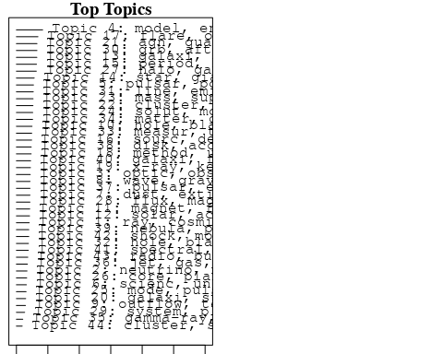

plotQuote(thoughts6, width = 30, main = "Topic 6")  
plotQuote(thoughts18, width = 30, main = "Topic 18")

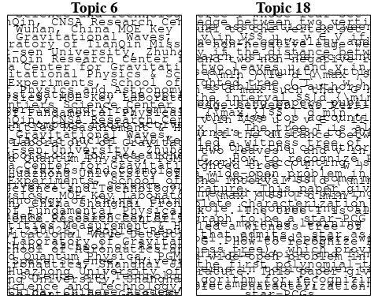

# Calculate and plot the correlation between topics  
mod.out.corr <- topicCorr(Research_topics)  
plot(mod.out.corr, cex = 1.5)  
  
  
# For each topic  
for (topic_num in 1:44) {  
 # Plot the word cloud  
 cloud(Research_topics, topic = topic_num, scale = c(2, 0.25))  
 Sys.sleep(2)  
}

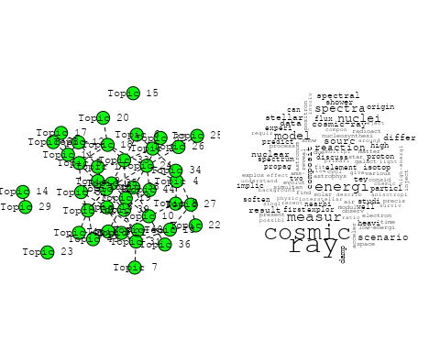

## Warning in wordcloud::wordcloud(words = vocab, freq = vec, max.words =  
## max.words, : optic could not be fit on page. It will not be plotted.

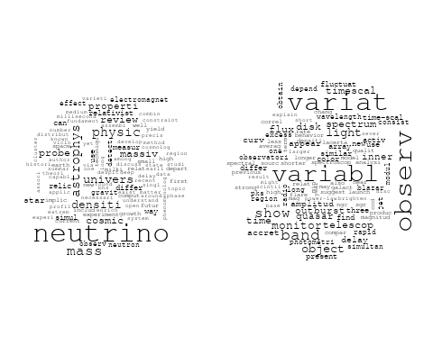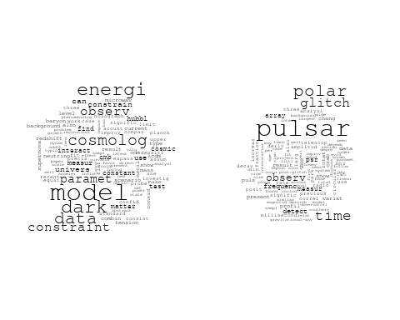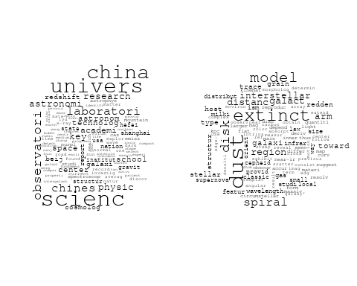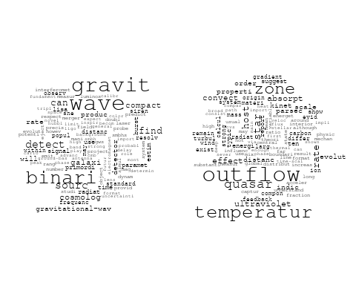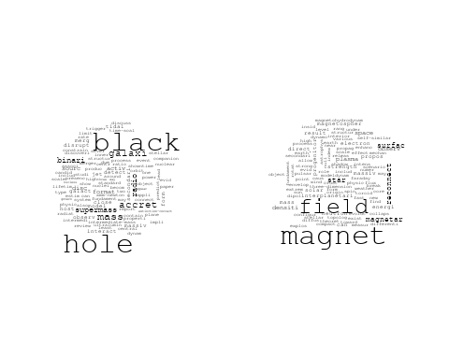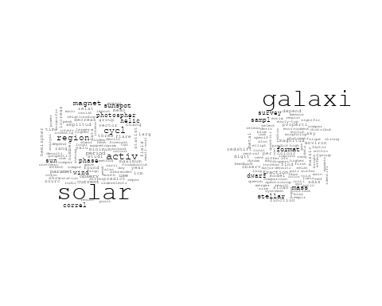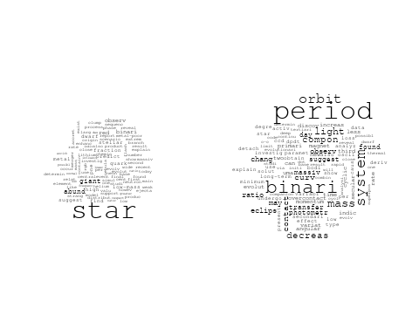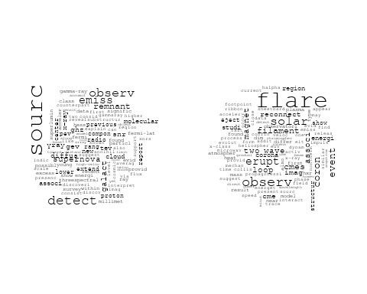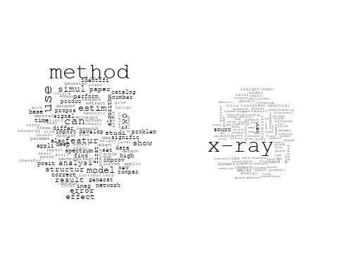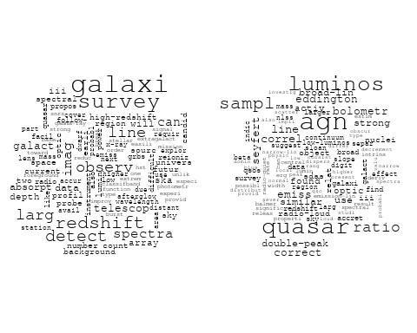

## Warning in wordcloud::wordcloud(words = vocab, freq = vec, max.words =  
## max.words, : supernova could not be fit on page. It will not be plotted.

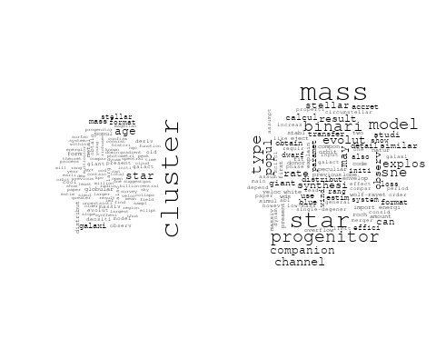

## Warning in wordcloud::wordcloud(words = vocab, freq = vec, max.words =  
## max.words, : distribut could not be fit on page. It will not be plotted.

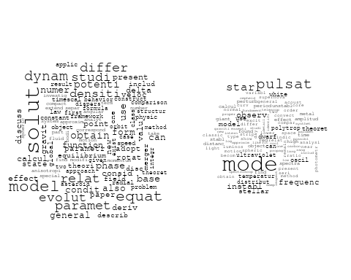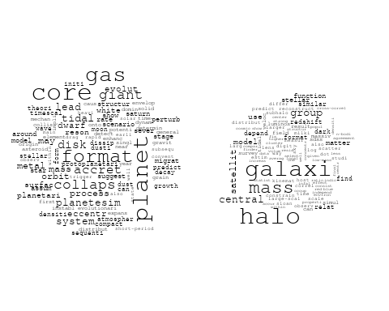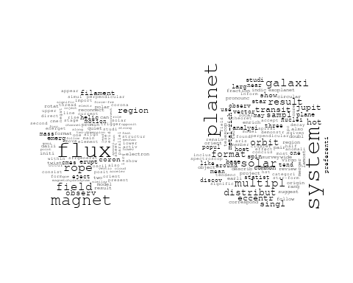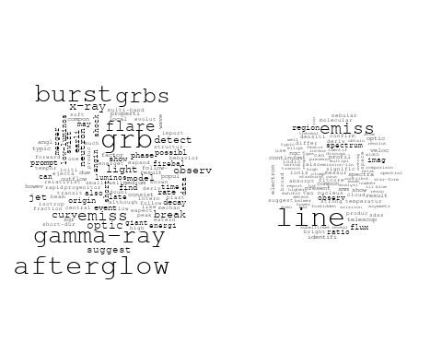

## Warning in wordcloud::wordcloud(words = vocab, freq = vec, max.words =  
## max.words, : measur could not be fit on page. It will not be plotted.

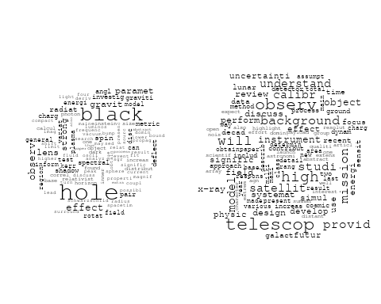

## Warning in wordcloud::wordcloud(words = vocab, freq = vec, max.words =  
## max.words, : gamma-ray could not be fit on page. It will not be plotted.

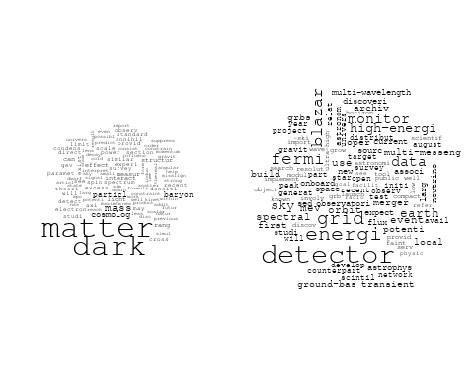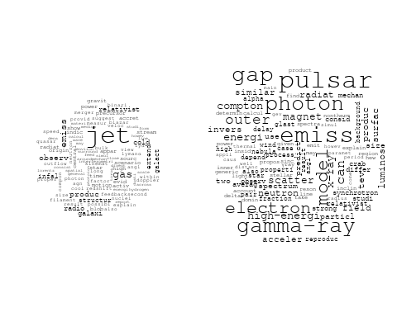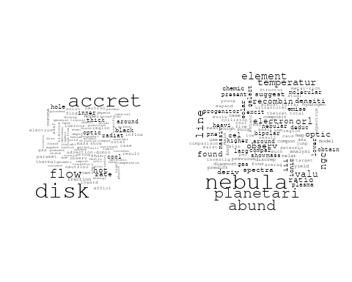

## Warning in wordcloud::wordcloud(words = vocab, freq = vec, max.words =  
## max.words, : spectral could not be fit on page. It will not be plotted.

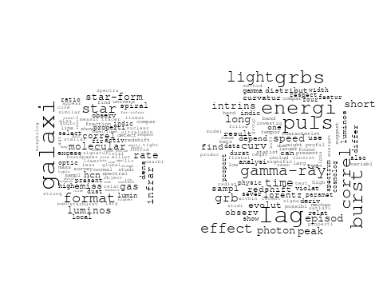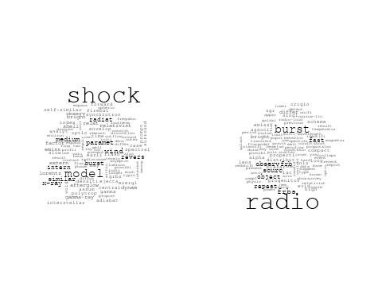

# Get the topic proportions for each document  
topic_proportions <- Research_topics$theta  
  
# Find the index of the topic with the highest proportion for each document  
# This will be the topic that each document is most likely to belong to  
max_topic_idx <- apply(topic_proportions, 1, which.max)  
  
# Add this as a new column to your data  
data_collab$topic <- max_topic_idx  
  
library(ggplot2)  
  
# Define the intervals  
intervals <- c('1824_1899', '1900_1964', '1965_1974', '1975_1984', '1985_1994', '1995_1999', '2000_2004', '2005_2009', '2010_2014', '2015_2019', '2020_2022')  
colors <- c('pink', 'blue', 'purple', 'yellow', 'green', 'pink', 'orange', 'violet', 'green', 'blue', 'pink')  
  
# Loop through the intervals and plot  
for(i in seq_along(intervals)){  
 # Filter data for when the pub_interval is equal to 1  
 data_filtered <- data_collab[data_collab[[paste0('pub_interval_', intervals[i])]] == 1,]  
   
 # Make the histogram  
   
 p <- ggplot(data_filtered, aes(x = topic)) +  
 geom_histogram(binwidth = 1, fill = colors[i], color = "black") +  
 xlab("Topic") +  
 ylab("Count") +  
 ggtitle(paste0("Topics from year ", gsub("_", " to ", intervals[i])))  
   
 print(p)  
}  
  
  
##Topic generation for CN (independent) publications  
  
data_independent <- data[data[["CN"]] == 100,]  
  
# Save the original title data for future use  
data_independent$original_concatenated_title_abstract <- data_independent$concatenated_title_abstract  
  
#pre-processing the titles using textProcessor from the stm package  
processed_text <- textProcessor(data_independent$concatenated_title_abstract, metadata = data_independent)

## Building corpus...   
## Converting to Lower Case...   
## Removing punctuation...   
## Removing stopwords...   
## Removing numbers...   
## Stemming...   
## Creating Output...

# Further prepare the data by removing low-frequency terms  
out_text <- prepDocuments(processed_text$documents, processed_text$vocab, processed_text$meta)

## Removing 1823 of 6149 terms (1823 of 71835 tokens) due to frequency   
## Your corpus now has 975 documents, 4326 terms and 70012 tokens.

docs_text <- out_text$documents  
vocab_text <- out_text$vocab  
meta_text <- out_text$meta  
  
  
#Prepare data  
plotRemoved(processed_text$documents, lower.thresh = seq(1, 200, by = 100))

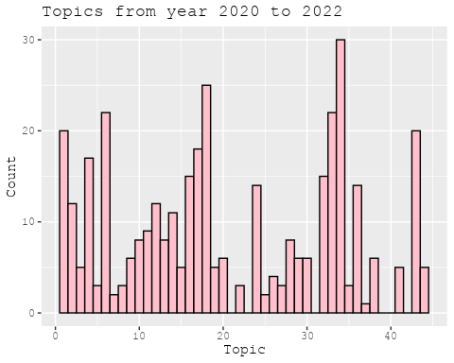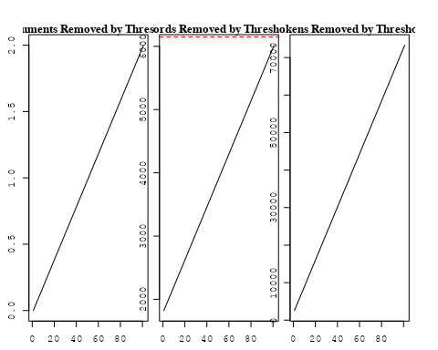

out_text <- prepDocuments(processed_text$documents, processed_text$vocab, processed_text$meta, lower.thresh = 8)

## Removing 4737 of 6149 terms (11468 of 71835 tokens) due to frequency   
## Your corpus now has 975 documents, 1412 terms and 60367 tokens.

str(out_text$meta)

## 'data.frame': 975 obs. of 39 variables:  
## $ concept_id : chr "https://openalex.org/C44870925" "https://openalex.org/C44870925" "https://openalex.org/C1276947" "https://openalex.org/C44870925" ...  
## $ work_id : chr "https://openalex.org/W3105293521" "https://openalex.org/W3122804126" "https://openalex.org/W3122804126" "https://openalex.org/W2559813125" ...  
## $ publication_year : int 2007 2010 2010 2016 2020 2021 2021 2001 2018 1999 ...  
## $ title : chr "Post-Oligarchic Evolution of Protoplanetary Embryos and the Stability of Planetary Systems" "Lepto-Hadronic Origin of gamma-rays from the G54.1+0.3 Pulsar Wind Nebula" "Lepto-Hadronic Origin of gamma-rays from the G54.1+0.3 Pulsar Wind Nebula" "Carbon monoxide in an extremely metal-poor galaxy" ...  
## $ paperabstract : chr "In the sequential accretion model, planets form through the sedimentation of dust, cohesive collisions of plane"| __truncated__ "G54.1+0.3 is a Crab-like pulsar wind nebula (PWN) with the highest γ -ray to X-ray luminosity ratio among all t"| __truncated__ "G54.1+0.3 is a Crab-like pulsar wind nebula (PWN) with the highest γ -ray to X-ray luminosity ratio among all t"| __truncated__ "Extremely metal-poor galaxies with metallicity below 10% of the solar value in the local universe are the best "| __truncated__ ...  
## $ country : chr "CN CN CN CN" "CN" "CN" "CN CN" ...  
## $ year_concept : chr "2007+https://openalex.org/C44870925" "2010+https://openalex.org/C44870925" "2010+https://openalex.org/C1276947" "2016+https://openalex.org/C44870925" ...  
## $ concatenated_title_abstract : chr "Post-Oligarchic Evolution of Protoplanetary Embryos and the Stability of Planetary Systems In the sequential ac"| __truncated__ "Lepto-Hadronic Origin of gamma-rays from the G54.1+0.3 Pulsar Wind Nebula G54.1+0.3 is a Crab-like pulsar wind "| __truncated__ "Lepto-Hadronic Origin of gamma-rays from the G54.1+0.3 Pulsar Wind Nebula G54.1+0.3 is a Crab-like pulsar wind "| __truncated__ "Carbon monoxide in an extremely metal-poor galaxy Extremely metal-poor galaxies with metallicity below 10% of t"| __truncated__ ...  
## $ US : num 0 0 0 0 0 0 0 0 0 0 ...  
## $ IN : num 0 0 0 0 0 0 0 0 0 0 ...  
## $ DE : num 0 0 0 0 0 0 0 0 0 0 ...  
## $ CH : num 0 0 0 0 0 0 0 0 0 0 ...  
## $ GB : num 0 0 0 0 0 0 0 0 0 0 ...  
## $ CN : num 100 100 100 100 100 100 100 100 100 100 ...  
## $ FR : num 0 0 0 0 0 0 0 0 0 0 ...  
## $ IT : num 0 0 0 0 0 0 0 0 0 0 ...  
## $ RU : num 0 0 0 0 0 0 0 0 0 0 ...  
## $ CA : num 0 0 0 0 0 0 0 0 0 0 ...  
## $ NL : num 0 0 0 0 0 0 0 0 0 0 ...  
## $ AU : num 0 0 0 0 0 0 0 0 0 0 ...  
## $ JP : num 0 0 0 0 0 0 0 0 0 0 ...  
## $ ES : num 0 0 0 0 0 0 0 0 0 0 ...  
## $ IL : num 0 0 0 0 0 0 0 0 0 0 ...  
## $ Americas : num 0 0 0 0 0 0 0 0 0 0 ...  
## $ Europe : num 0 0 0 0 0 0 0 0 0 0 ...  
## $ Africa : num 0 0 0 0 0 0 0 0 0 0 ...  
## $ AsiaAndOceania : num 0 0 0 0 0 0 0 0 0 0 ...  
## $ pub_interval_2020_2022 : int 0 0 0 0 1 1 1 0 0 0 ...  
## $ pub_interval_2015_2019 : int 0 0 0 1 0 0 0 0 1 0 ...  
## $ pub_interval_2010_2014 : int 0 1 1 0 0 0 0 0 0 0 ...  
## $ pub_interval_2005_2009 : int 1 0 0 0 0 0 0 0 0 0 ...  
## $ pub_interval_2000_2004 : int 0 0 0 0 0 0 0 1 0 0 ...  
## $ pub_interval_1995_1999 : int 0 0 0 0 0 0 0 0 0 1 ...  
## $ pub_interval_1985_1994 : int 0 0 0 0 0 0 0 0 0 0 ...  
## $ pub_interval_1975_1984 : int 0 0 0 0 0 0 0 0 0 0 ...  
## $ pub_interval_1965_1974 : int 0 0 0 0 0 0 0 0 0 0 ...  
## $ pub_interval_1900_1964 : int 0 0 0 0 0 0 0 0 0 0 ...  
## $ pub_interval_1824_1899 : int 0 0 0 0 0 0 0 0 0 0 ...  
## $ original_concatenated_title_abstract: chr "Post-Oligarchic Evolution of Protoplanetary Embryos and the Stability of Planetary Systems In the sequential ac"| __truncated__ "Lepto-Hadronic Origin of gamma-rays from the G54.1+0.3 Pulsar Wind Nebula G54.1+0.3 is a Crab-like pulsar wind "| __truncated__ "Lepto-Hadronic Origin of gamma-rays from the G54.1+0.3 Pulsar Wind Nebula G54.1+0.3 is a Crab-like pulsar wind "| __truncated__ "Carbon monoxide in an extremely metal-poor galaxy Extremely metal-poor galaxies with metallicity below 10% of t"| __truncated__ ...

# Initialize an empty formula string  
prevalence_formula_str <- "~"  
  
# Define the publication intervals  
pub_intervals <- c("pub_interval_2020_2022", "pub_interval_2015_2019", "pub_interval_2010_2014",   
 "pub_interval_2005_2009", "pub_interval_2000_2004", "pub_interval_1995_1999",  
 "pub_interval_1985_1994", "pub_interval_1975_1984", "pub_interval_1965_1974",  
 "pub_interval_1900_1964", "pub_interval_1824_1899")  
  
# Add each publication interval to the formula string  
for (interval in pub_intervals) {  
 # add an if statement to handle the first addition (without '+')  
 if (prevalence_formula_str == "~") {  
 prevalence_formula_str <- paste(prevalence_formula_str, interval)  
 } else {  
 prevalence_formula_str <- paste(prevalence_formula_str, "+", interval)  
 }  
}  
  
  
# Convert the string to a formula  
prevalence_formula <- as.formula(prevalence_formula_str)  
print(prevalence_formula)

## ~pub_interval_2020_2022 + pub_interval_2015_2019 + pub_interval_2010_2014 +   
## pub_interval_2005_2009 + pub_interval_2000_2004 + pub_interval_1995_1999 +   
## pub_interval_1985_1994 + pub_interval_1975_1984 + pub_interval_1965_1974 +   
## pub_interval_1900_1964 + pub_interval_1824_1899

# Run STM model  
Research_topics <- stm(documents = out_text$documents,   
 vocab = out_text$vocab,   
 K = 43,   
 prevalence = prevalence_formula,   
 data = out_text$meta,   
 init.type = "Spectral",  
 max.em.its = 1000,  
 gamma.prior = 'L1')

## Beginning Spectral Initialization   
## Calculating the gram matrix...  
## Finding anchor words...  
## ...........................................  
## Recovering initialization...  
## ..............  
## Initialization complete.  
## ............................................................................................................  
## Completed E-Step (0 seconds).   
## Completed M-Step.   
## Completing Iteration 1 (approx. per word bound = -6.044)   
## ............................................................................................................  
## Completed E-Step (0 seconds).   
## Completed M-Step.   
## Completing Iteration 2 (approx. per word bound = -5.753, relative change = 4.817e-02)   
## ............................................................................................................  
## Completed E-Step (0 seconds).   
## Completed M-Step.   
## Completing Iteration 3 (approx. per word bound = -5.673, relative change = 1.402e-02)   
## ............................................................................................................  
## Completed E-Step (0 seconds).   
## Completed M-Step.   
## Completing Iteration 4 (approx. per word bound = -5.640, relative change = 5.818e-03)   
## ............................................................................................................  
## Completed E-Step (0 seconds).   
## Completed M-Step.   
## Completing Iteration 5 (approx. per word bound = -5.622, relative change = 3.020e-03)   
## Topic 1: first, cosmic, measur, ray, modul   
## Topic 2: zone, hot, star, temperatur, planet   
## Topic 3: china, scienc, observatori, galaxi, univers   
## Topic 4: observ, variabl, white, dwarf, corona   
## Topic 5: dust, extinct, model, toward, redden   
## Topic 6: spectral, puls, burst, lag, observ   
## Topic 7: wave, cosmolog, gravit, observ, can   
## Topic 8: shock, afterglow, grb, emiss, x-ray   
## Topic 9: pulsar, glitch, crab, time, chang   
## Topic 10: ray, surfac, measur, cosmic, emit   
## Topic 11: dark, model, energi, matter, data   
## Topic 12: period, system, binari, light, orbit   
## Topic 13: interact, jet, disc, radio, sourc   
## Topic 14: neutrino, mass, relic, way, cosmic   
## Topic 15: galaxi, mass, survey, stellar, halo   
## Topic 16: hole, black, agn, quasar, radio   
## Topic 17: method, solar, use, correl, paramet   
## Topic 18: type, star, progenitor, model, channel   
## Topic 19: format, star, rate, star-form, cluster   
## Topic 20: cosmolog, new, survey, will, paramet   
## Topic 21: variat, light, speed, observ, curv   
## Topic 22: oscil, x-ray, star, observ, pulsat   
## Topic 23: distanc, disk, sourc, spiral, classic   
## Topic 24: galaxi, emiss, activ, infrar, ellipt   
## Topic 25: jet, model, relativist, break, dynam   
## Topic 26: polar, scatter, emiss, circular, reson   
## Topic 27: cluster, metal, age, model, star   
## Topic 28: accret, disk, flow, hole, black   
## Topic 29: detector, gamma-ray, detect, orbit, sourc   
## Topic 30: physic, scienc, china, univers, laboratori   
## Topic 31: magnet, field, solar, flare, flux   
## Topic 32: star, abund, metal, element, giant   
## Topic 33: mass, binari, star, transfer, contact   
## Topic 34: line, emiss, temperatur, electron, deriv   
## Topic 35: system, orbit, planet, eccentr, solar   
## Topic 36: solar, activ, cycl, region, imag   
## Topic 37: pulsar, gap, gamma-ray, model, outer   
## Topic 38: grbs, burst, gamma-ray, energi, lag   
## Topic 39: black, hole, event, binari, network   
## Topic 40: star, neutron, radio, frbs, frb   
## Topic 41: x-ray, telescop, observ, flare, time   
## Topic 42: energi, sourc, ray, spectra, electron   
## Topic 43: equilibrium, point, relat, annihil, bodi   
## ............................................................................................................  
## Completed E-Step (0 seconds).   
## Completed M-Step.   
## Completing Iteration 6 (approx. per word bound = -5.612, relative change = 1.922e-03)   
## ............................................................................................................  
## Completed E-Step (0 seconds).   
## Completed M-Step.   
## Completing Iteration 7 (approx. per word bound = -5.604, relative change = 1.398e-03)   
## ............................................................................................................  
## Completed E-Step (0 seconds).   
## Completed M-Step.   
## Completing Iteration 8 (approx. per word bound = -5.598, relative change = 1.013e-03)   
## ............................................................................................................  
## Completed E-Step (0 seconds).   
## Completed M-Step.   
## Completing Iteration 9 (approx. per word bound = -5.594, relative change = 8.174e-04)   
## ............................................................................................................  
## Completed E-Step (0 seconds).   
## Completed M-Step.   
## Completing Iteration 10 (approx. per word bound = -5.590, relative change = 6.580e-04)   
## Topic 1: first, cosmic, can, differ, measur   
## Topic 2: zone, star, hot, planet, temperatur   
## Topic 3: china, galaxi, scienc, observatori, univers   
## Topic 4: observ, disk, dwarf, white, variabl   
## Topic 5: dust, extinct, model, law, redden   
## Topic 6: spectral, puls, lag, burst, observ   
## Topic 7: wave, cosmolog, gravit, observ, can   
## Topic 8: shock, afterglow, grb, emiss, x-ray   
## Topic 9: pulsar, glitch, crab, chang, frequenc   
## Topic 10: ray, surfac, cosmic, data, lunar   
## Topic 11: dark, model, energi, matter, data   
## Topic 12: period, binari, system, light, orbit   
## Topic 13: radio, disc, jet, galaxi, interact   
## Topic 14: neutrino, mass, relic, way, densiti   
## Topic 15: galaxi, mass, stellar, halo, survey   
## Topic 16: agn, black, hole, quasar, line   
## Topic 17: method, solar, use, correl, paramet   
## Topic 18: star, type, model, binari, progenitor   
## Topic 19: format, star, rate, star-form, cluster   
## Topic 20: cosmolog, measur, survey, paramet, new   
## Topic 21: variat, light, speed, observ, quasar   
## Topic 22: oscil, x-ray, observ, pulsat, star   
## Topic 23: distanc, disk, sourc, spiral, galact   
## Topic 24: galaxi, emiss, infrar, activ, ellipt   
## Topic 25: jet, relativist, dynam, break, solut   
## Topic 26: polar, scatter, emiss, circular, reson   
## Topic 27: cluster, age, metal, deriv, star   
## Topic 28: accret, disk, flow, hole, black   
## Topic 29: detector, gamma-ray, detect, sourc, binari   
## Topic 30: scienc, physic, china, univers, chines   
## Topic 31: magnet, field, solar, flare, erupt   
## Topic 32: star, abund, element, metal, giant   
## Topic 33: mass, binari, star, transfer, evolut   
## Topic 34: line, temperatur, emiss, electron, deriv   
## Topic 35: orbit, system, planet, eccentr, solar   
## Topic 36: solar, activ, cycl, region, wind   
## Topic 37: pulsar, gap, gamma-ray, model, outer   
## Topic 38: grbs, burst, gamma-ray, energi, redshift   
## Topic 39: black, hole, binari, event, network   
## Topic 40: star, neutron, radio, frbs, frb   
## Topic 41: x-ray, flare, telescop, observ, time   
## Topic 42: energi, sourc, ray, electron, spectrum   
## Topic 43: equilibrium, point, relat, bodi, annihil   
## ............................................................................................................  
## Completed E-Step (0 seconds).   
## Completed M-Step.   
## Completing Iteration 11 (approx. per word bound = -5.587, relative change = 5.314e-04)   
## ............................................................................................................  
## Completed E-Step (0 seconds).   
## Completed M-Step.   
## Completing Iteration 12 (approx. per word bound = -5.584, relative change = 4.423e-04)   
## ............................................................................................................  
## Completed E-Step (0 seconds).   
## Completed M-Step.   
## Completing Iteration 13 (approx. per word bound = -5.582, relative change = 4.239e-04)   
## ............................................................................................................  
## Completed E-Step (0 seconds).   
## Completed M-Step.   
## Completing Iteration 14 (approx. per word bound = -5.580, relative change = 3.626e-04)   
## ............................................................................................................  
## Completed E-Step (0 seconds).   
## Completed M-Step.   
## Completing Iteration 15 (approx. per word bound = -5.578, relative change = 3.558e-04)   
## Topic 1: first, cosmic, differ, can, composit   
## Topic 2: zone, star, hot, planet, convect   
## Topic 3: galaxi, china, scienc, observatori, univers   
## Topic 4: observ, disk, dwarf, white, variabl   
## Topic 5: dust, extinct, model, galaxi, law   
## Topic 6: spectral, puls, lag, burst, observ   
## Topic 7: wave, gravit, cosmolog, can, observ   
## Topic 8: shock, afterglow, grb, emiss, burst   
## Topic 9: pulsar, glitch, crab, frequenc, chang   
## Topic 10: ray, cosmic, surfac, data, lunar   
## Topic 11: dark, model, energi, matter, data   
## Topic 12: period, binari, system, light, orbit   
## Topic 13: radio, disc, jet, galaxi, sourc   
## Topic 14: neutrino, mass, relic, densiti, way   
## Topic 15: galaxi, mass, halo, stellar, redshift   
## Topic 16: agn, hole, black, line, quasar   
## Topic 17: method, solar, use, paramet, correl   
## Topic 18: star, type, model, binari, progenitor   
## Topic 19: format, star, rate, star-form, cluster   
## Topic 20: cosmolog, measur, survey, paramet, sne   
## Topic 21: variat, light, speed, observ, variabl   
## Topic 22: oscil, x-ray, observ, pulsat, star   
## Topic 23: distanc, disk, sourc, spiral, classic   
## Topic 24: galaxi, emiss, infrar, activ, ellipt   
## Topic 25: jet, relativist, dynam, solut, break   
## Topic 26: polar, scatter, emiss, reson, circular   
## Topic 27: cluster, age, metal, deriv, star   
## Topic 28: accret, disk, flow, hole, black   
## Topic 29: detector, gamma-ray, compact, detect, binari   
## Topic 30: scienc, china, physic, univers, chines   
## Topic 31: magnet, field, solar, flare, observ   
## Topic 32: star, abund, element, metal, giant   
## Topic 33: mass, binari, star, transfer, evolut   
## Topic 34: line, temperatur, electron, emiss, ratio   
## Topic 35: system, orbit, planet, eccentr, solar   
## Topic 36: solar, activ, cycl, region, wind   
## Topic 37: pulsar, gap, gamma-ray, model, outer   
## Topic 38: grbs, burst, gamma-ray, energi, luminos   
## Topic 39: black, hole, binari, event, network   
## Topic 40: star, neutron, radio, frbs, frb   
## Topic 41: x-ray, flare, telescop, observ, time   
## Topic 42: energi, sourc, ray, spectrum, gev   
## Topic 43: equilibrium, point, relat, bodi, annihil   
## ............................................................................................................  
## Completed E-Step (0 seconds).   
## Completed M-Step.   
## Completing Iteration 16 (approx. per word bound = -5.576, relative change = 3.221e-04)   
## ............................................................................................................  
## Completed E-Step (0 seconds).   
## Completed M-Step.   
## Completing Iteration 17 (approx. per word bound = -5.574, relative change = 3.216e-04)   
## ............................................................................................................  
## Completed E-Step (0 seconds).   
## Completed M-Step.   
## Completing Iteration 18 (approx. per word bound = -5.573, relative change = 3.262e-04)   
## ............................................................................................................  
## Completed E-Step (0 seconds).   
## Completed M-Step.   
## Completing Iteration 19 (approx. per word bound = -5.571, relative change = 2.736e-04)   
## ............................................................................................................  
## Completed E-Step (0 seconds).   
## Completed M-Step.   
## Completing Iteration 20 (approx. per word bound = -5.570, relative change = 2.131e-04)   
## Topic 1: first, differ, can, cosmic, element   
## Topic 2: zone, star, hot, planet, convect   
## Topic 3: galaxi, china, scienc, observatori, univers   
## Topic 4: observ, disk, dwarf, white, veloc   
## Topic 5: dust, extinct, galaxi, model, redden   
## Topic 6: spectral, puls, lag, burst, observ   
## Topic 7: wave, gravit, cosmolog, can, observ   
## Topic 8: shock, afterglow, grb, emiss, burst   
## Topic 9: pulsar, glitch, crab, frequenc, chang   
## Topic 10: ray, cosmic, surfac, data, lunar   
## Topic 11: dark, model, energi, matter, data   
## Topic 12: period, binari, system, light, orbit   
## Topic 13: radio, jet, disc, galaxi, hole   
## Topic 14: neutrino, mass, relic, densiti, way   
## Topic 15: galaxi, mass, halo, stellar, redshift   
## Topic 16: agn, hole, black, line, quasar   
## Topic 17: method, solar, use, paramet, cycl   
## Topic 18: star, type, model, binari, progenitor   
## Topic 19: format, star, rate, star-form, gas   
## Topic 20: cosmolog, measur, survey, dark, paramet   
## Topic 21: variat, light, observ, speed, variabl   
## Topic 22: oscil, x-ray, observ, pulsat, star   
## Topic 23: distanc, disk, sourc, spiral, galact   
## Topic 24: galaxi, emiss, infrar, activ, ellipt   
## Topic 25: jet, relativist, dynam, solut, break   
## Topic 26: polar, scatter, emiss, reson, mode   
## Topic 27: cluster, age, metal, deriv, star   
## Topic 28: accret, disk, flow, black, hole   
## Topic 29: gamma-ray, detector, compact, detect, binari   
## Topic 30: scienc, china, physic, univers, chines   
## Topic 31: magnet, field, solar, flare, observ   
## Topic 32: star, abund, element, metal, giant   
## Topic 33: mass, binari, star, transfer, evolut   
## Topic 34: line, temperatur, electron, emiss, ratio   
## Topic 35: system, orbit, planet, galaxi, eccentr   
## Topic 36: solar, activ, cycl, region, period   
## Topic 37: pulsar, gap, gamma-ray, model, outer   
## Topic 38: grbs, gamma-ray, burst, energi, correl   
## Topic 39: black, hole, binari, event, network   
## Topic 40: star, neutron, radio, frbs, burst   
## Topic 41: x-ray, flare, telescop, observ, time   
## Topic 42: energi, sourc, ray, gev, spectrum   
## Topic 43: equilibrium, point, relat, bodi, annihil   
## ............................................................................................................  
## Completed E-Step (0 seconds).   
## Completed M-Step.   
## Completing Iteration 21 (approx. per word bound = -5.569, relative change = 1.785e-04)   
## ............................................................................................................  
## Completed E-Step (0 seconds).   
## Completed M-Step.   
## Completing Iteration 22 (approx. per word bound = -5.568, relative change = 1.652e-04)   
## ............................................................................................................  
## Completed E-Step (0 seconds).   
## Completed M-Step.   
## Completing Iteration 23 (approx. per word bound = -5.567, relative change = 1.533e-04)   
## ............................................................................................................  
## Completed E-Step (0 seconds).   
## Completed M-Step.   
## Completing Iteration 24 (approx. per word bound = -5.566, relative change = 1.253e-04)   
## ............................................................................................................  
## Completed E-Step (0 seconds).   
## Completed M-Step.   
## Completing Iteration 25 (approx. per word bound = -5.566, relative change = 1.191e-04)   
## Topic 1: can, differ, first, element, electron   
## Topic 2: zone, star, hot, planet, convect   
## Topic 3: galaxi, china, scienc, observatori, univers   
## Topic 4: observ, disk, dwarf, white, veloc   
## Topic 5: dust, extinct, galaxi, model, luminos   
## Topic 6: spectral, puls, lag, burst, observ   
## Topic 7: wave, gravit, cosmolog, can, observ   
## Topic 8: shock, afterglow, grb, emiss, burst   
## Topic 9: pulsar, glitch, crab, frequenc, chang   
## Topic 10: ray, cosmic, surfac, data, lunar   
## Topic 11: dark, model, energi, matter, data   
## Topic 12: period, system, binari, orbit, light   
## Topic 13: radio, jet, disc, galaxi, hole   
## Topic 14: neutrino, mass, relic, densiti, cosmic   
## Topic 15: galaxi, mass, halo, stellar, redshift   
## Topic 16: agn, hole, black, line, emiss   
## Topic 17: method, solar, use, paramet, cycl   
## Topic 18: star, type, model, binari, progenitor   
## Topic 19: star, format, rate, star-form, gas   
## Topic 20: cosmolog, measur, dark, survey, paramet   
## Topic 21: variat, light, observ, speed, variabl   
## Topic 22: oscil, x-ray, observ, pulsat, star   
## Topic 23: distanc, disk, sourc, spiral, galact   
## Topic 24: galaxi, emiss, infrar, activ, ellipt   
## Topic 25: jet, relativist, dynam, solut, break   
## Topic 26: polar, mode, scatter, emiss, reson   
## Topic 27: cluster, age, metal, deriv, star   
## Topic 28: accret, disk, flow, black, hole   
## Topic 29: gamma-ray, detector, compact, detect, binari   
## Topic 30: scienc, china, physic, univers, chines   
## Topic 31: magnet, field, solar, flare, observ   
## Topic 32: star, abund, element, metal, giant   
## Topic 33: mass, binari, star, transfer, evolut   
## Topic 34: line, temperatur, electron, emiss, ratio   
## Topic 35: system, orbit, galaxi, planet, eccentr   
## Topic 36: solar, activ, cycl, period, region   
## Topic 37: pulsar, gap, gamma-ray, model, outer   
## Topic 38: grbs, gamma-ray, burst, energi, correl   
## Topic 39: black, hole, binari, event, x-ray   
## Topic 40: star, neutron, radio, frbs, frb   
## Topic 41: x-ray, flare, telescop, observ, time   
## Topic 42: energi, ray, sourc, gev, cosmic   
## Topic 43: equilibrium, point, relat, bodi, annihil   
## ............................................................................................................  
## Completed E-Step (0 seconds).   
## Completed M-Step.   
## Completing Iteration 26 (approx. per word bound = -5.565, relative change = 1.200e-04)   
## ............................................................................................................  
## Completed E-Step (0 seconds).   
## Completed M-Step.   
## Completing Iteration 27 (approx. per word bound = -5.565, relative change = 1.180e-04)   
## ............................................................................................................  
## Completed E-Step (0 seconds).   
## Completed M-Step.   
## Completing Iteration 28 (approx. per word bound = -5.564, relative change = 1.182e-04)   
## ............................................................................................................  
## Completed E-Step (0 seconds).   
## Completed M-Step.   
## Completing Iteration 29 (approx. per word bound = -5.563, relative change = 1.019e-04)   
## ............................................................................................................  
## Completed E-Step (0 seconds).   
## Completed M-Step.   
## Completing Iteration 30 (approx. per word bound = -5.563, relative change = 8.285e-05)   
## Topic 1: can, differ, electron, element, composit   
## Topic 2: zone, star, hot, planet, convect   
## Topic 3: galaxi, china, scienc, observatori, univers   
## Topic 4: observ, disk, dwarf, white, veloc   
## Topic 5: dust, extinct, galaxi, model, luminos   
## Topic 6: spectral, puls, burst, lag, observ   
## Topic 7: wave, gravit, cosmolog, can, observ   
## Topic 8: shock, afterglow, grb, emiss, burst   
## Topic 9: pulsar, glitch, crab, frequenc, detect   
## Topic 10: ray, cosmic, surfac, data, lunar   
## Topic 11: dark, model, energi, matter, data   
## Topic 12: period, system, binari, orbit, light   
## Topic 13: radio, jet, disc, galaxi, black   
## Topic 14: neutrino, mass, relic, densiti, way   
## Topic 15: galaxi, mass, halo, stellar, redshift   
## Topic 16: agn, hole, black, line, emiss   
## Topic 17: method, solar, use, paramet, cycl   
## Topic 18: star, type, model, binari, progenitor   
## Topic 19: star, format, rate, star-form, cluster   
## Topic 20: cosmolog, dark, measur, survey, paramet   
## Topic 21: variat, light, observ, variabl, speed   
## Topic 22: oscil, x-ray, observ, pulsat, kev   
## Topic 23: distanc, disk, spiral, sourc, galact   
## Topic 24: galaxi, emiss, infrar, activ, imag   
## Topic 25: jet, relativist, solut, dynam, phase   
## Topic 26: polar, mode, emiss, scatter, reson   
## Topic 27: cluster, age, metal, deriv, star   
## Topic 28: accret, disk, flow, black, hole   
## Topic 29: gamma-ray, detector, compact, detect, binari   
## Topic 30: scienc, china, physic, univers, chines   
## Topic 31: magnet, field, solar, flare, observ   
## Topic 32: star, abund, element, metal, giant   
## Topic 33: mass, binari, transfer, star, evolut   
## Topic 34: line, temperatur, emiss, electron, ratio   
## Topic 35: system, orbit, galaxi, planet, eccentr   
## Topic 36: solar, activ, cycl, period, region   
## Topic 37: pulsar, gap, gamma-ray, model, outer   
## Topic 38: grbs, gamma-ray, burst, energi, correl   
## Topic 39: black, hole, binari, event, x-ray   
## Topic 40: star, neutron, frbs, radio, frb   
## Topic 41: x-ray, flare, telescop, observ, hard   
## Topic 42: energi, ray, sourc, gev, cosmic   
## Topic 43: equilibrium, point, relat, bodi, annihil   
## ............................................................................................................  
## Completed E-Step (0 seconds).   
## Completed M-Step.   
## Completing Iteration 31 (approx. per word bound = -5.562, relative change = 7.237e-05)   
## ............................................................................................................  
## Completed E-Step (0 seconds).   
## Completed M-Step.   
## Completing Iteration 32 (approx. per word bound = -5.562, relative change = 7.435e-05)   
## ............................................................................................................  
## Completed E-Step (0 seconds).   
## Completed M-Step.   
## Completing Iteration 33 (approx. per word bound = -5.562, relative change = 7.237e-05)   
## ............................................................................................................  
## Completed E-Step (0 seconds).   
## Completed M-Step.   
## Completing Iteration 34 (approx. per word bound = -5.561, relative change = 7.041e-05)   
## ............................................................................................................  
## Completed E-Step (0 seconds).   
## Completed M-Step.   
## Completing Iteration 35 (approx. per word bound = -5.561, relative change = 7.495e-05)   
## Topic 1: can, differ, electron, element, composit   
## Topic 2: zone, star, hot, planet, convect   
## Topic 3: galaxi, china, scienc, observatori, univers   
## Topic 4: observ, disk, dwarf, white, veloc   
## Topic 5: dust, galaxi, extinct, model, luminos   
## Topic 6: spectral, puls, burst, lag, observ   
## Topic 7: wave, gravit, cosmolog, can, observ   
## Topic 8: shock, afterglow, grb, emiss, burst   
## Topic 9: pulsar, glitch, crab, frequenc, detect   
## Topic 10: ray, cosmic, surfac, data, lunar   
## Topic 11: dark, model, energi, matter, data   
## Topic 12: period, system, binari, orbit, light   
## Topic 13: radio, jet, disc, galaxi, black   
## Topic 14: neutrino, mass, relic, densiti, way   
## Topic 15: galaxi, mass, halo, stellar, redshift   
## Topic 16: agn, hole, black, line, emiss   
## Topic 17: method, solar, use, paramet, cycl   
## Topic 18: star, type, model, binari, progenitor   
## Topic 19: star, format, rate, star-form, cluster   
## Topic 20: cosmolog, dark, measur, survey, paramet   
## Topic 21: variat, light, variabl, observ, speed   
## Topic 22: oscil, x-ray, observ, pulsat, kev   
## Topic 23: distanc, disk, spiral, sourc, galact   
## Topic 24: galaxi, emiss, infrar, activ, imag   
## Topic 25: jet, relativist, solut, dynam, phase   
## Topic 26: polar, mode, emiss, scatter, profil   
## Topic 27: cluster, age, metal, deriv, star   
## Topic 28: accret, disk, flow, black, hole   
## Topic 29: gamma-ray, detector, compact, detect, binari   
## Topic 30: scienc, china, physic, univers, chines   
## Topic 31: magnet, field, solar, flare, observ   
## Topic 32: star, abund, element, metal, giant   
## Topic 33: mass, binari, transfer, star, evolut   
## Topic 34: line, temperatur, emiss, electron, ratio   
## Topic 35: system, orbit, galaxi, planet, eccentr   
## Topic 36: solar, activ, cycl, period, flux   
## Topic 37: pulsar, gap, gamma-ray, model, outer   
## Topic 38: grbs, gamma-ray, burst, energi, correl   
## Topic 39: black, hole, binari, event, x-ray   
## Topic 40: star, neutron, frbs, radio, frb   
## Topic 41: x-ray, flare, telescop, observ, hard   
## Topic 42: energi, ray, sourc, gev, cosmic   
## Topic 43: equilibrium, point, relat, bodi, object   
## ............................................................................................................  
## Completed E-Step (0 seconds).   
## Completed M-Step.   
## Completing Iteration 36 (approx. per word bound = -5.560, relative change = 7.390e-05)   
## ............................................................................................................  
## Completed E-Step (0 seconds).   
## Completed M-Step.   
## Completing Iteration 37 (approx. per word bound = -5.560, relative change = 6.971e-05)   
## ............................................................................................................  
## Completed E-Step (0 seconds).   
## Completed M-Step.   
## Completing Iteration 38 (approx. per word bound = -5.560, relative change = 6.759e-05)   
## ............................................................................................................  
## Completed E-Step (0 seconds).   
## Completed M-Step.   
## Completing Iteration 39 (approx. per word bound = -5.559, relative change = 6.534e-05)   
## ............................................................................................................  
## Completed E-Step (0 seconds).   
## Completed M-Step.   
## Completing Iteration 40 (approx. per word bound = -5.559, relative change = 6.053e-05)   
## Topic 1: can, electron, differ, element, composit   
## Topic 2: zone, star, hot, planet, convect   
## Topic 3: galaxi, china, scienc, observatori, univers   
## Topic 4: observ, disk, dwarf, white, veloc   
## Topic 5: dust, galaxi, extinct, model, luminos   
## Topic 6: spectral, puls, burst, lag, observ   
## Topic 7: wave, gravit, cosmolog, can, observ   
## Topic 8: shock, afterglow, grb, emiss, burst   
## Topic 9: pulsar, glitch, crab, frequenc, detect   
## Topic 10: ray, cosmic, surfac, data, lunar   
## Topic 11: dark, model, energi, matter, data   
## Topic 12: period, system, binari, orbit, light   
## Topic 13: radio, jet, disc, galaxi, hole   
## Topic 14: neutrino, mass, relic, densiti, way   
## Topic 15: galaxi, mass, halo, stellar, redshift   
## Topic 16: agn, hole, black, line, emiss   
## Topic 17: method, solar, use, paramet, cycl   
## Topic 18: star, type, model, binari, progenitor   
## Topic 19: star, format, rate, star-form, cluster   
## Topic 20: cosmolog, measur, dark, survey, paramet   
## Topic 21: variat, light, variabl, speed, observ   
## Topic 22: oscil, x-ray, observ, pulsat, kev   
## Topic 23: distanc, disk, spiral, sourc, galact   
## Topic 24: galaxi, emiss, infrar, activ, imag   
## Topic 25: jet, relativist, solut, dynam, phase   
## Topic 26: polar, mode, emiss, scatter, profil   
## Topic 27: cluster, age, metal, deriv, star   
## Topic 28: accret, disk, flow, black, hole   
## Topic 29: gamma-ray, detector, compact, detect, binari   
## Topic 30: scienc, china, physic, univers, chines   
## Topic 31: magnet, field, solar, flare, observ   
## Topic 32: star, abund, element, metal, giant   
## Topic 33: mass, binari, transfer, star, evolut   
## Topic 34: line, temperatur, emiss, electron, ratio   
## Topic 35: system, orbit, galaxi, planet, eccentr   
## Topic 36: solar, activ, cycl, period, flux   
## Topic 37: pulsar, gap, gamma-ray, model, outer   
## Topic 38: grbs, gamma-ray, burst, energi, correl   
## Topic 39: black, hole, binari, x-ray, event   
## Topic 40: star, neutron, frbs, radio, frb   
## Topic 41: x-ray, flare, telescop, observ, hard   
## Topic 42: energi, ray, sourc, gev, cosmic   
## Topic 43: equilibrium, point, relat, bodi, object   
## ............................................................................................................  
## Completed E-Step (0 seconds).   
## Completed M-Step.   
## Completing Iteration 41 (approx. per word bound = -5.559, relative change = 5.055e-05)   
## ............................................................................................................  
## Completed E-Step (0 seconds).   
## Completed M-Step.   
## Completing Iteration 42 (approx. per word bound = -5.558, relative change = 4.680e-05)   
## ............................................................................................................  
## Completed E-Step (0 seconds).   
## Completed M-Step.   
## Completing Iteration 43 (approx. per word bound = -5.558, relative change = 4.421e-05)   
## ............................................................................................................  
## Completed E-Step (0 seconds).   
## Completed M-Step.   
## Completing Iteration 44 (approx. per word bound = -5.558, relative change = 4.427e-05)   
## ............................................................................................................  
## Completed E-Step (0 seconds).   
## Completed M-Step.   
## Completing Iteration 45 (approx. per word bound = -5.558, relative change = 4.085e-05)   
## Topic 1: can, electron, differ, element, composit   
## Topic 2: zone, star, hot, planet, convect   
## Topic 3: galaxi, china, scienc, observatori, univers   
## Topic 4: observ, disk, dwarf, white, veloc   
## Topic 5: dust, galaxi, extinct, model, luminos   
## Topic 6: spectral, puls, burst, lag, observ   
## Topic 7: wave, gravit, cosmolog, can, observ   
## Topic 8: shock, afterglow, grb, emiss, burst   
## Topic 9: pulsar, glitch, crab, frequenc, detect   
## Topic 10: ray, cosmic, surfac, data, lunar   
## Topic 11: dark, model, energi, matter, data   
## Topic 12: period, system, binari, orbit, light   
## Topic 13: radio, jet, disc, galaxi, sourc   
## Topic 14: neutrino, mass, relic, densiti, way   
## Topic 15: galaxi, mass, halo, stellar, redshift   
## Topic 16: agn, hole, black, line, emiss   
## Topic 17: method, solar, use, paramet, cycl   
## Topic 18: star, type, model, binari, progenitor   
## Topic 19: star, format, rate, star-form, galaxi   
## Topic 20: cosmolog, measur, dark, survey, paramet   
## Topic 21: variat, light, variabl, speed, observ   
## Topic 22: oscil, x-ray, observ, pulsat, kev   
## Topic 23: distanc, disk, spiral, sourc, galact   
## Topic 24: galaxi, emiss, infrar, activ, imag   
## Topic 25: jet, relativist, solut, dynam, phase   
## Topic 26: polar, mode, emiss, scatter, profil   
## Topic 27: cluster, age, metal, deriv, star   
## Topic 28: accret, disk, flow, black, hole   
## Topic 29: gamma-ray, detector, compact, detect, binari   
## Topic 30: scienc, china, physic, univers, chines   
## Topic 31: magnet, field, solar, flare, observ   
## Topic 32: star, abund, element, metal, giant   
## Topic 33: mass, binari, transfer, star, evolut   
## Topic 34: line, temperatur, emiss, electron, spectrum   
## Topic 35: system, orbit, galaxi, planet, eccentr   
## Topic 36: solar, activ, cycl, period, flux   
## Topic 37: pulsar, gap, gamma-ray, model, outer   
## Topic 38: grbs, gamma-ray, burst, energi, correl   
## Topic 39: black, hole, binari, x-ray, event   
## Topic 40: star, neutron, frbs, radio, frb   
## Topic 41: x-ray, flare, telescop, observ, hard   
## Topic 42: energi, ray, sourc, gev, cosmic   
## Topic 43: equilibrium, relat, point, bodi, object   
## ............................................................................................................  
## Completed E-Step (0 seconds).   
## Completed M-Step.   
## Completing Iteration 46 (approx. per word bound = -5.557, relative change = 4.379e-05)   
## ............................................................................................................  
## Completed E-Step (0 seconds).   
## Completed M-Step.   
## Completing Iteration 47 (approx. per word bound = -5.557, relative change = 4.765e-05)   
## ............................................................................................................  
## Completed E-Step (0 seconds).   
## Completed M-Step.   
## Completing Iteration 48 (approx. per word bound = -5.557, relative change = 5.580e-05)   
## ............................................................................................................  
## Completed E-Step (0 seconds).   
## Completed M-Step.   
## Completing Iteration 49 (approx. per word bound = -5.557, relative change = 4.839e-05)   
## ............................................................................................................  
## Completed E-Step (0 seconds).   
## Completed M-Step.   
## Completing Iteration 50 (approx. per word bound = -5.556, relative change = 4.454e-05)   
## Topic 1: electron, can, differ, element, composit   
## Topic 2: zone, star, hot, planet, convect   
## Topic 3: galaxi, china, scienc, observatori, univers   
## Topic 4: observ, disk, dwarf, white, veloc   
## Topic 5: dust, galaxi, extinct, model, luminos   
## Topic 6: spectral, burst, puls, lag, observ   
## Topic 7: wave, gravit, cosmolog, can, observ   
## Topic 8: shock, afterglow, grb, emiss, burst   
## Topic 9: pulsar, glitch, crab, frequenc, detect   
## Topic 10: ray, cosmic, surfac, data, lunar   
## Topic 11: dark, model, energi, matter, data   
## Topic 12: period, system, binari, orbit, light   
## Topic 13: radio, jet, disc, galaxi, sourc   
## Topic 14: neutrino, mass, relic, densiti, way   
## Topic 15: galaxi, mass, stellar, halo, redshift   
## Topic 16: agn, hole, black, line, emiss   
## Topic 17: method, solar, use, paramet, cycl   
## Topic 18: star, type, model, binari, progenitor   
## Topic 19: format, star, rate, star-form, cluster   
## Topic 20: cosmolog, measur, dark, survey, paramet   
## Topic 21: variat, light, variabl, speed, observ   
## Topic 22: oscil, x-ray, observ, pulsat, kev   
## Topic 23: distanc, disk, spiral, sourc, galact   
## Topic 24: galaxi, emiss, infrar, activ, imag   
## Topic 25: jet, relativist, solut, dynam, phase   
## Topic 26: polar, mode, emiss, scatter, profil   
## Topic 27: cluster, age, metal, deriv, star   
## Topic 28: accret, disk, flow, black, hole   
## Topic 29: gamma-ray, detector, compact, binari, detect   
## Topic 30: scienc, china, physic, univers, chines   
## Topic 31: magnet, field, solar, flare, observ   
## Topic 32: star, abund, element, metal, giant   
## Topic 33: mass, binari, transfer, star, evolut   
## Topic 34: line, temperatur, emiss, electron, spectrum   
## Topic 35: system, orbit, galaxi, planet, eccentr   
## Topic 36: solar, activ, period, cycl, flux   
## Topic 37: pulsar, gap, gamma-ray, model, outer   
## Topic 38: grbs, gamma-ray, burst, energi, correl   
## Topic 39: black, hole, binari, x-ray, event   
## Topic 40: star, neutron, frbs, radio, frb   
## Topic 41: x-ray, flare, telescop, observ, hard   
## Topic 42: energi, ray, sourc, gev, cosmic   
## Topic 43: relat, equilibrium, point, bodi, rotat   
## ............................................................................................................  
## Completed E-Step (0 seconds).   
## Completed M-Step.   
## Completing Iteration 51 (approx. per word bound = -5.556, relative change = 4.196e-05)   
## ............................................................................................................  
## Completed E-Step (0 seconds).   
## Completed M-Step.   
## Completing Iteration 52 (approx. per word bound = -5.556, relative change = 4.071e-05)   
## ............................................................................................................  
## Completed E-Step (0 seconds).   
## Completed M-Step.   
## Completing Iteration 53 (approx. per word bound = -5.556, relative change = 4.177e-05)   
## ............................................................................................................  
## Completed E-Step (0 seconds).   
## Completed M-Step.   
## Completing Iteration 54 (approx. per word bound = -5.555, relative change = 3.483e-05)   
## ............................................................................................................  
## Completed E-Step (0 seconds).   
## Completed M-Step.   
## Completing Iteration 55 (approx. per word bound = -5.555, relative change = 2.780e-05)   
## Topic 1: electron, can, differ, element, composit   
## Topic 2: zone, star, hot, planet, convect   
## Topic 3: galaxi, china, scienc, observatori, univers   
## Topic 4: observ, disk, dwarf, white, veloc   
## Topic 5: dust, extinct, galaxi, model, luminos   
## Topic 6: spectral, burst, puls, lag, short   
## Topic 7: wave, gravit, cosmolog, can, observ   
## Topic 8: shock, afterglow, grb, emiss, burst   
## Topic 9: pulsar, glitch, crab, frequenc, increas   
## Topic 10: ray, cosmic, surfac, data, lunar   
## Topic 11: dark, model, energi, matter, data   
## Topic 12: period, system, binari, orbit, light   
## Topic 13: jet, radio, disc, galaxi, sourc   
## Topic 14: neutrino, mass, relic, densiti, way   
## Topic 15: galaxi, mass, stellar, halo, redshift   
## Topic 16: agn, hole, black, line, emiss   
## Topic 17: method, solar, use, paramet, cycl   
## Topic 18: star, type, model, binari, progenitor   
## Topic 19: star, format, rate, star-form, cluster   
## Topic 20: cosmolog, measur, dark, survey, paramet   
## Topic 21: variat, light, variabl, speed, observ   
## Topic 22: oscil, x-ray, observ, pulsat, kev   
## Topic 23: distanc, disk, spiral, sourc, galact   
## Topic 24: galaxi, emiss, infrar, activ, imag   
## Topic 25: jet, solut, relativist, dynam, phase   
## Topic 26: polar, mode, emiss, scatter, profil   
## Topic 27: cluster, age, metal, deriv, star   
## Topic 28: accret, disk, flow, black, hole   
## Topic 29: gamma-ray, detector, compact, binari, detect   
## Topic 30: scienc, china, physic, univers, chines   
## Topic 31: magnet, field, solar, flare, observ   
## Topic 32: star, abund, element, metal, giant   
## Topic 33: mass, binari, transfer, star, evolut   
## Topic 34: line, temperatur, emiss, electron, spectrum   
## Topic 35: system, orbit, galaxi, planet, eccentr   
## Topic 36: solar, activ, flux, cycl, period   
## Topic 37: pulsar, gap, gamma-ray, model, outer   
## Topic 38: grbs, gamma-ray, burst, energi, correl   
## Topic 39: black, hole, binari, x-ray, event   
## Topic 40: star, neutron, frbs, radio, frb   
## Topic 41: x-ray, flare, telescop, observ, hard   
## Topic 42: energi, ray, sourc, gev, cosmic   
## Topic 43: relat, equilibrium, point, bodi, rotat   
## ............................................................................................................  
## Completed E-Step (0 seconds).   
## Completed M-Step.   
## Completing Iteration 56 (approx. per word bound = -5.555, relative change = 3.142e-05)   
## ............................................................................................................  
## Completed E-Step (0 seconds).   
## Completed M-Step.   
## Completing Iteration 57 (approx. per word bound = -5.555, relative change = 2.854e-05)   
## ............................................................................................................  
## Completed E-Step (0 seconds).   
## Completed M-Step.   
## Completing Iteration 58 (approx. per word bound = -5.555, relative change = 3.177e-05)   
## ............................................................................................................  
## Completed E-Step (0 seconds).   
## Completed M-Step.   
## Completing Iteration 59 (approx. per word bound = -5.555, relative change = 3.686e-05)   
## ............................................................................................................  
## Completed E-Step (0 seconds).   
## Completed M-Step.   
## Completing Iteration 60 (approx. per word bound = -5.554, relative change = 3.423e-05)   
## Topic 1: electron, can, differ, element, composit   
## Topic 2: zone, star, hot, planet, convect   
## Topic 3: galaxi, china, scienc, observatori, univers   
## Topic 4: observ, disk, dwarf, white, veloc   
## Topic 5: dust, extinct, galaxi, model, redden   
## Topic 6: spectral, burst, puls, lag, short   
## Topic 7: wave, gravit, cosmolog, can, observ   
## Topic 8: shock, afterglow, grb, emiss, burst   
## Topic 9: glitch, pulsar, crab, frequenc, increas   
## Topic 10: ray, cosmic, surfac, data, lunar   
## Topic 11: dark, model, energi, matter, data   
## Topic 12: period, system, binari, orbit, light   
## Topic 13: jet, radio, disc, galaxi, hole   
## Topic 14: neutrino, mass, relic, densiti, way   
## Topic 15: galaxi, mass, stellar, halo, redshift   
## Topic 16: agn, hole, black, line, emiss   
## Topic 17: method, solar, use, paramet, cycl   
## Topic 18: star, type, model, binari, progenitor   
## Topic 19: star, format, rate, star-form, galaxi   
## Topic 20: cosmolog, measur, dark, survey, paramet   
## Topic 21: variat, light, variabl, speed, observ   
## Topic 22: oscil, x-ray, observ, pulsat, kev   
## Topic 23: distanc, disk, spiral, sourc, galact   
## Topic 24: galaxi, emiss, infrar, activ, imag   
## Topic 25: jet, solut, relativist, dynam, phase   
## Topic 26: polar, mode, emiss, scatter, profil   
## Topic 27: cluster, age, metal, deriv, star   
## Topic 28: accret, disk, flow, black, hole   
## Topic 29: gamma-ray, detector, compact, binari, detect   
## Topic 30: scienc, china, physic, univers, chines   
## Topic 31: magnet, field, solar, flare, observ   
## Topic 32: star, abund, element, metal, giant   
## Topic 33: mass, binari, transfer, star, evolut   
## Topic 34: line, temperatur, emiss, electron, spectrum   
## Topic 35: system, orbit, galaxi, planet, eccentr   
## Topic 36: solar, activ, flux, cycl, period   
## Topic 37: pulsar, gap, gamma-ray, model, outer   
## Topic 38: grbs, gamma-ray, burst, energi, correl   
## Topic 39: black, hole, binari, x-ray, event   
## Topic 40: star, neutron, frbs, radio, frb   
## Topic 41: x-ray, flare, telescop, observ, hard   
## Topic 42: energi, ray, sourc, gev, cosmic   
## Topic 43: relat, equilibrium, point, bodi, rotat   
## ............................................................................................................  
## Completed E-Step (0 seconds).   
## Completed M-Step.   
## Completing Iteration 61 (approx. per word bound = -5.554, relative change = 2.948e-05)   
## ............................................................................................................  
## Completed E-Step (0 seconds).   
## Completed M-Step.   
## Completing Iteration 62 (approx. per word bound = -5.554, relative change = 2.752e-05)   
## ............................................................................................................  
## Completed E-Step (0 seconds).   
## Completed M-Step.   
## Completing Iteration 63 (approx. per word bound = -5.554, relative change = 3.059e-05)   
## ............................................................................................................  
## Completed E-Step (0 seconds).   
## Completed M-Step.   
## Completing Iteration 64 (approx. per word bound = -5.554, relative change = 3.552e-05)   
## ............................................................................................................  
## Completed E-Step (0 seconds).   
## Completed M-Step.   
## Completing Iteration 65 (approx. per word bound = -5.554, relative change = 2.555e-05)   
## Topic 1: electron, can, differ, element, energi   
## Topic 2: zone, star, hot, planet, convect   
## Topic 3: galaxi, china, scienc, observatori, univers   
## Topic 4: observ, disk, dwarf, white, veloc   
## Topic 5: dust, extinct, galaxi, model, redden   
## Topic 6: spectral, burst, puls, lag, short   
## Topic 7: wave, gravit, cosmolog, can, observ   
## Topic 8: shock, afterglow, grb, emiss, burst   
## Topic 9: glitch, pulsar, crab, frequenc, increas   
## Topic 10: ray, cosmic, surfac, data, lunar   
## Topic 11: dark, model, energi, matter, data   
## Topic 12: period, system, binari, orbit, light   
## Topic 13: jet, radio, galaxi, disc, hole   
## Topic 14: neutrino, mass, relic, densiti, way   
## Topic 15: galaxi, mass, stellar, halo, redshift   
## Topic 16: agn, hole, black, line, emiss   
## Topic 17: method, solar, use, paramet, data   
## Topic 18: star, type, model, binari, progenitor   
## Topic 19: star, format, rate, star-form, galaxi   
## Topic 20: cosmolog, measur, dark, survey, paramet   
## Topic 21: variat, light, variabl, speed, observ   
## Topic 22: oscil, x-ray, observ, pulsat, kev   
## Topic 23: distanc, disk, sourc, spiral, galact   
## Topic 24: galaxi, emiss, infrar, activ, imag   
## Topic 25: jet, solut, relativist, dynam, phase   
## Topic 26: polar, mode, emiss, scatter, profil   
## Topic 27: cluster, age, metal, deriv, star   
## Topic 28: accret, disk, flow, black, hole   
## Topic 29: gamma-ray, detector, compact, binari, detect   
## Topic 30: scienc, china, physic, univers, chines   
## Topic 31: magnet, field, solar, flare, observ   
## Topic 32: star, abund, element, metal, giant   
## Topic 33: mass, binari, transfer, star, evolut   
## Topic 34: line, temperatur, emiss, electron, spectrum   
## Topic 35: system, orbit, galaxi, planet, eccentr   
## Topic 36: solar, flux, activ, cycl, period   
## Topic 37: pulsar, gap, gamma-ray, model, outer   
## Topic 38: grbs, gamma-ray, burst, energi, correl   
## Topic 39: black, hole, binari, x-ray, event   
## Topic 40: star, neutron, frbs, radio, frb   
## Topic 41: x-ray, flare, telescop, observ, hard   
## Topic 42: energi, ray, sourc, gev, cosmic   
## Topic 43: relat, equilibrium, point, bodi, rotat   
## ............................................................................................................  
## Completed E-Step (0 seconds).   
## Completed M-Step.   
## Completing Iteration 66 (approx. per word bound = -5.553, relative change = 2.004e-05)   
## ............................................................................................................  
## Completed E-Step (0 seconds).   
## Completed M-Step.   
## Completing Iteration 67 (approx. per word bound = -5.553, relative change = 1.488e-05)   
## ............................................................................................................  
## Completed E-Step (0 seconds).   
## Completed M-Step.   
## Completing Iteration 68 (approx. per word bound = -5.553, relative change = 1.816e-05)   
## ............................................................................................................  
## Completed E-Step (0 seconds).   
## Completed M-Step.   
## Completing Iteration 69 (approx. per word bound = -5.553, relative change = 2.139e-05)   
## ............................................................................................................  
## Completed E-Step (0 seconds).   
## Completed M-Step.   
## Completing Iteration 70 (approx. per word bound = -5.553, relative change = 2.387e-05)   
## Topic 1: electron, can, differ, element, energi   
## Topic 2: zone, star, hot, planet, convect   
## Topic 3: galaxi, china, scienc, observatori, univers   
## Topic 4: observ, disk, dwarf, white, veloc   
## Topic 5: dust, galaxi, extinct, model, luminos   
## Topic 6: spectral, burst, lag, puls, short   
## Topic 7: wave, gravit, cosmolog, can, observ   
## Topic 8: shock, afterglow, grb, emiss, burst   
## Topic 9: glitch, pulsar, crab, increas, frequenc   
## Topic 10: ray, cosmic, surfac, data, lunar   
## Topic 11: dark, model, energi, matter, data   
## Topic 12: period, binari, system, orbit, light   
## Topic 13: jet, radio, galaxi, disc, hole   
## Topic 14: neutrino, mass, relic, densiti, way   
## Topic 15: galaxi, mass, stellar, halo, redshift   
## Topic 16: agn, hole, black, line, emiss   
## Topic 17: method, solar, use, paramet, data   
## Topic 18: star, type, model, binari, progenitor   
## Topic 19: star, format, rate, galaxi, cluster   
## Topic 20: cosmolog, measur, dark, survey, paramet   
## Topic 21: variat, light, variabl, speed, observ   
## Topic 22: oscil, x-ray, observ, pulsat, frequenc   
## Topic 23: distanc, disk, sourc, spiral, galact   
## Topic 24: galaxi, emiss, infrar, activ, imag   
## Topic 25: jet, solut, relativist, dynam, phase   
## Topic 26: polar, mode, emiss, scatter, profil   
## Topic 27: cluster, age, metal, deriv, star   
## Topic 28: accret, disk, flow, black, hole   
## Topic 29: gamma-ray, detector, compact, binari, detect   
## Topic 30: scienc, china, physic, univers, chines   
## Topic 31: magnet, field, solar, flare, observ   
## Topic 32: star, abund, element, metal, giant   
## Topic 33: mass, binari, transfer, star, evolut   
## Topic 34: line, temperatur, emiss, electron, spectrum   
## Topic 35: system, orbit, galaxi, planet, eccentr   
## Topic 36: solar, flux, activ, cycl, period   
## Topic 37: pulsar, gap, gamma-ray, model, outer   
## Topic 38: grbs, gamma-ray, burst, energi, correl   
## Topic 39: black, hole, binari, x-ray, event   
## Topic 40: star, neutron, frbs, radio, frb   
## Topic 41: x-ray, flare, telescop, observ, hard   
## Topic 42: energi, ray, sourc, gev, cosmic   
## Topic 43: relat, equilibrium, point, bodi, rotat   
## ............................................................................................................  
## Completed E-Step (0 seconds).   
## Completed M-Step.   
## Completing Iteration 71 (approx. per word bound = -5.553, relative change = 1.686e-05)   
## ............................................................................................................  
## Completed E-Step (0 seconds).   
## Completed M-Step.   
## Completing Iteration 72 (approx. per word bound = -5.553, relative change = 1.523e-05)   
## ............................................................................................................  
## Completed E-Step (0 seconds).   
## Completed M-Step.   
## Completing Iteration 73 (approx. per word bound = -5.553, relative change = 2.818e-05)   
## ............................................................................................................  
## Completed E-Step (0 seconds).   
## Completed M-Step.   
## Completing Iteration 74 (approx. per word bound = -5.552, relative change = 3.704e-05)   
## ............................................................................................................  
## Completed E-Step (0 seconds).   
## Completed M-Step.   
## Completing Iteration 75 (approx. per word bound = -5.552, relative change = 3.884e-05)   
## Topic 1: electron, can, differ, element, energi   
## Topic 2: zone, star, hot, planet, convect   
## Topic 3: galaxi, china, scienc, observatori, univers   
## Topic 4: observ, disk, dwarf, white, veloc   
## Topic 5: dust, galaxi, extinct, model, luminos   
## Topic 6: spectral, burst, lag, puls, short   
## Topic 7: wave, gravit, cosmolog, can, observ   
## Topic 8: shock, afterglow, grb, emiss, burst   
## Topic 9: pulsar, glitch, crab, increas, frequenc   
## Topic 10: ray, cosmic, surfac, data, lunar   
## Topic 11: dark, model, energi, matter, data   
## Topic 12: period, binari, system, orbit, light   
## Topic 13: jet, radio, galaxi, disc, hole   
## Topic 14: neutrino, mass, relic, densiti, way   
## Topic 15: galaxi, mass, stellar, halo, redshift   
## Topic 16: agn, black, hole, line, emiss   
## Topic 17: method, solar, use, paramet, data   
## Topic 18: star, type, model, binari, progenitor   
## Topic 19: star, format, rate, galaxi, cluster   
## Topic 20: cosmolog, measur, dark, survey, paramet   
## Topic 21: variat, light, variabl, speed, observ   
## Topic 22: oscil, x-ray, observ, pulsat, frequenc   
## Topic 23: distanc, disk, sourc, spiral, galact   
## Topic 24: galaxi, emiss, infrar, activ, imag   
## Topic 25: jet, solut, relativist, dynam, phase   
## Topic 26: polar, mode, emiss, scatter, profil   
## Topic 27: cluster, age, metal, deriv, star   
## Topic 28: accret, disk, flow, black, hole   
## Topic 29: gamma-ray, detector, compact, binari, detect   
## Topic 30: scienc, china, physic, univers, chines   
## Topic 31: magnet, field, solar, flare, observ   
## Topic 32: star, abund, element, metal, giant   
## Topic 33: mass, binari, transfer, star, evolut   
## Topic 34: line, temperatur, emiss, electron, spectrum   
## Topic 35: system, orbit, galaxi, planet, eccentr   
## Topic 36: solar, flux, cycl, activ, period   
## Topic 37: pulsar, gap, gamma-ray, model, outer   
## Topic 38: grbs, gamma-ray, burst, energi, correl   
## Topic 39: black, hole, binari, x-ray, event   
## Topic 40: star, neutron, frbs, radio, frb   
## Topic 41: x-ray, flare, telescop, observ, hard   
## Topic 42: energi, ray, sourc, gev, cosmic   
## Topic 43: relat, equilibrium, rotat, point, bodi   
## ............................................................................................................  
## Completed E-Step (0 seconds).   
## Completed M-Step.   
## Completing Iteration 76 (approx. per word bound = -5.552, relative change = 3.976e-05)   
## ............................................................................................................  
## Completed E-Step (0 seconds).   
## Completed M-Step.   
## Completing Iteration 77 (approx. per word bound = -5.552, relative change = 4.952e-05)   
## ............................................................................................................  
## Completed E-Step (0 seconds).   
## Completed M-Step.   
## Completing Iteration 78 (approx. per word bound = -5.552, relative change = 4.457e-05)   
## ............................................................................................................  
## Completed E-Step (0 seconds).   
## Completed M-Step.   
## Completing Iteration 79 (approx. per word bound = -5.551, relative change = 3.402e-05)   
## ............................................................................................................  
## Completed E-Step (0 seconds).   
## Completed M-Step.   
## Completing Iteration 80 (approx. per word bound = -5.551, relative change = 3.100e-05)   
## Topic 1: electron, can, differ, energi, element   
## Topic 2: zone, star, hot, planet, ultraviolet   
## Topic 3: galaxi, china, scienc, observatori, univers   
## Topic 4: observ, disk, dwarf, white, veloc   
## Topic 5: dust, galaxi, extinct, model, luminos   
## Topic 6: spectral, burst, lag, puls, short   
## Topic 7: wave, gravit, cosmolog, can, observ   
## Topic 8: shock, afterglow, grb, emiss, burst   
## Topic 9: pulsar, glitch, crab, frequenc, increas   
## Topic 10: ray, cosmic, data, surfac, lunar   
## Topic 11: dark, model, energi, matter, data   
## Topic 12: period, system, binari, orbit, light   
## Topic 13: jet, radio, galaxi, disc, hole   
## Topic 14: neutrino, mass, relic, densiti, way   
## Topic 15: galaxi, mass, stellar, halo, redshift   
## Topic 16: agn, black, hole, line, emiss   
## Topic 17: method, solar, use, paramet, data   
## Topic 18: star, type, model, binari, progenitor   
## Topic 19: star, format, rate, galaxi, cluster   
## Topic 20: cosmolog, measur, dark, survey, paramet   
## Topic 21: variat, light, variabl, speed, observ   
## Topic 22: oscil, x-ray, observ, pulsat, frequenc   
## Topic 23: distanc, disk, sourc, spiral, galact   
## Topic 24: galaxi, emiss, infrar, activ, imag   
## Topic 25: jet, relativist, solut, dynam, phase   
## Topic 26: polar, mode, emiss, scatter, profil   
## Topic 27: cluster, age, metal, deriv, star   
## Topic 28: accret, disk, flow, black, hole   
## Topic 29: gamma-ray, detector, compact, binari, detect   
## Topic 30: scienc, china, physic, univers, chines   
## Topic 31: magnet, field, solar, flare, observ   
## Topic 32: star, abund, element, metal, giant   
## Topic 33: mass, binari, transfer, star, evolut   
## Topic 34: line, temperatur, emiss, electron, spectrum   
## Topic 35: system, orbit, galaxi, planet, eccentr   
## Topic 36: solar, cycl, activ, period, flux   
## Topic 37: pulsar, gap, gamma-ray, model, outer   
## Topic 38: grbs, gamma-ray, burst, energi, correl   
## Topic 39: black, hole, binari, x-ray, event   
## Topic 40: star, neutron, frbs, radio, frb   
## Topic 41: x-ray, flare, telescop, observ, hard   
## Topic 42: energi, ray, sourc, gev, cosmic   
## Topic 43: relat, equilibrium, rotat, point, field   
## ............................................................................................................  
## Completed E-Step (0 seconds).   
## Completed M-Step.   
## Completing Iteration 81 (approx. per word bound = -5.551, relative change = 2.670e-05)   
## ............................................................................................................  
## Completed E-Step (0 seconds).   
## Completed M-Step.   
## Completing Iteration 82 (approx. per word bound = -5.551, relative change = 2.228e-05)   
## ............................................................................................................  
## Completed E-Step (0 seconds).   
## Completed M-Step.   
## Completing Iteration 83 (approx. per word bound = -5.551, relative change = 2.141e-05)   
## ............................................................................................................  
## Completed E-Step (0 seconds).   
## Completed M-Step.   
## Completing Iteration 84 (approx. per word bound = -5.551, relative change = 2.060e-05)   
## ............................................................................................................  
## Completed E-Step (0 seconds).   
## Completed M-Step.   
## Model Converged

# Plot the STM model summary  
plot(Research_topics, type = "summary", xlim = c(0, 0.3))  
  
# Print the top 10 labels for each topic  
topic_labels <- labelTopics(Research_topics, n=10)  
print(topic_labels)

## Topic 1 Top Words:  
## Highest Prob: electron, can, differ, energi, element, composit, ray, satellit, field, ion   
## FREX: ion, electr, composit, product, element, low-luminos, low-energi, electron, satellit, nearbi   
## Lift: low-energi, overview, electr, ground, ion, product, composit, low-luminos, charg, shell   
## Score: low-energi, electr, ion, element, ray, low-luminos, electron, composit, cmes, charg   
## Topic 2 Top Words:  
## Highest Prob: zone, star, hot, planet, ultraviolet, temperatur, host, convect, radiat, around   
## FREX: zone, hot, ultraviolet, convect, planet, host, preferenti, temperatur, boundari, gradient   
## Lift: zone, preferenti, ultraviolet, life, hot, convect, planet, boundari, gradient, turbul   
## Score: zone, planet, hot, convect, ultraviolet, host, star, preferenti, metal-rich, life   
## Topic 3 Top Words:  
## Highest Prob: galaxi, china, scienc, observatori, univers, cluster, redshift, confirm, cosmolog, laboratori   
## FREX: china, lyα, hefei, confirm, cas, observatori, scienc, laboratori, spectroscop, technolog   
## Lift: hefei, lyα, cas, shanghai, intergalact, china, occupi, academi, scienc, program   
## Score: hefei, scienc, china, academi, shanghai, galaxi, cas, laboratori, lyα, cluster   
## Topic 4 Top Words:  
## Highest Prob: observ, disk, dwarf, white, veloc, sourc, dusti, metal, accret, variabl   
## FREX: white, dusti, certain, corona, dwarf, infal, circumstellar, decay, via, disk   
## Lift: certain, circumstellar, dusti, collim, white, understood, asteroid, get, broken, onto   
## Score: certain, white, disk, dusti, dwarf, dust, asteroid, corona, metal, infal   
## Topic 5 Top Words:  
## Highest Prob: dust, galaxi, extinct, model, luminos, redden, law, correl, distribut, toward   
## FREX: dust, extinct, law, redden, toward, empir, star-form, diffus, flat, decrement   
## Lift: extinct, dust, law, difficulti, redden, decrement, visual, allevi, practic, steep   
## Score: extinct, dust, redden, galaxi, star-form, law, decrement, disc, diffus, empir   
## Topic 6 Top Words:  
## Highest Prob: spectral, burst, lag, puls, short, observ, long, effect, alpha, episod   
## FREX: lag, puls, short, spectral, episod, burst, alpha, curvatur, width, intrins   
## Lift: episod, puls, lag, short, curvatur, alpha, behind, spectral, convinc, coher   
## Score: puls, lag, episod, burst, spectral, sgr, frb, curvatur, short, alpha   
## Topic 7 Top Words:  
## Highest Prob: wave, gravit, cosmolog, can, observ, signal, standard, paramet, probe, siren   
## FREX: signal, wave, siren, primordi, einstein, gravit, lens, graviti, gravitational-wav, cmb   
## Lift: siren, primordi, einstein, signal, gravitational-wav, graviti, spheric, degeneraci, wave, ligo   
## Score: siren, wave, cosmolog, gravit, lens, primordi, signal, einstein, gravitational-wav, graviti   
## Topic 8 Top Words:  
## Highest Prob: shock, afterglow, grb, emiss, burst, optic, medium, gamma-ray, x-ray, earli   
## FREX: afterglow, shock, grb, forward, medium, earli, revers, firebal, expand, flash   
## Lift: multi-band, expand, afterglow, forward, shock, flash, revers, ejecta, medium, grb   
## Score: afterglow, shock, grb, firebal, multi-band, burst, gamma-ray, grbs, forward, sgr   
## Topic 9 Top Words:  
## Highest Prob: pulsar, glitch, crab, frequenc, increas, detect, chang, time, psr, rate   
## FREX: glitch, crab, pulsar, psr, chang, frequenc, size, decemb, occur, magnitud   
## Lift: glitch, psr, crab, decemb, exponenti, pulsar, phenomenon, pure, littl, span   
## Score: glitch, pulsar, crab, psr, puls, frequenc, chang, polar, soft, size   
## Topic 10 Top Words:  
## Highest Prob: ray, cosmic, data, surfac, earth, lunar, propag, can, emit, modul   
## FREX: lunar, ray, propag, descript, inject, emit, modul, earth, surfac, cosmic   
## Lift: descript, lunar, inject, outsid, ams-, ray, propag, meet, emit, heliospher   
## Score: ray, descript, cosmic, lunar, earth, inject, surfac, propag, modul, array   
## Topic 11 Top Words:  
## Highest Prob: dark, model, energi, matter, data, observ, cosmolog, constraint, paramet, measur   
## FREX: dark, matter, baryon, constraint, cdm, λcdm, model, cmb, planck, data   
## Lift: bao, cdm, parametr, λcdm, baryon, planck, dark, acoust, tension, stringent   
## Score: dark, matter, parametr, cosmolog, energi, baryon, cdm, planck, cmb, λcdm   
## Topic 12 Top Words:  
## Highest Prob: period, system, binari, orbit, light, compon, curv, mass, decreas, photometr   
## FREX: period, secular, eclips, overcontact, cyclic, photometr, contact, system, decreas, uma   
## Lift: dpdt, secular, wilson-devinney, cyclic, overcontact, superpos, uma, eclips, irregular, long-term   
## Score: binari, period, secular, overcontact, eclips, contact, cyclic, orbit, photometr, superpos   
## Topic 13 Top Words:  
## Highest Prob: jet, radio, galaxi, disc, hole, black, binari, sourc, blazar, accret   
## FREX: jet, disc, radio, blazar, comprehens, time-scal, supermass, interact, inner, pks   
## Lift: comprehens, time-scal, jet, disc, blazar, random, creat, supermass, neglig, align   
## Score: jet, comprehens, disc, radio, blazar, black, hole, binari, galaxi, time-scal   
## Topic 14 Top Words:  
## Highest Prob: neutrino, mass, relic, densiti, way, cosmic, detect, effect, milki, cluster   
## FREX: neutrino, relic, way, milki, experiment, introduc, densiti, electromagnet, captur, earth   
## Lift: relic, experiment, neutrino, vicin, captur, bound, regular, necessari, phenomenolog, milki   
## Score: neutrino, relic, experiment, milki, cosmic, cluster, earth, way, electromagnet, vicin   
## Topic 15 Top Words:  
## Highest Prob: galaxi, mass, stellar, halo, redshift, depend, sampl, survey, local, observ   
## FREX: halo, environment, galaxi, sloan, digit, redshift, depend, releas, stellar, local   
## Lift: environment, halo, subsampl, lowest, sloan, isol, bin, built, galaxi, slope   
## Score: galaxi, environment, halo, sloan, redshift, sdss, stellar, digit, dwarf, slope   
## Topic 16 Top Words:  
## Highest Prob: agn, black, hole, line, emiss, quasar, ratio, luminos, mass, correl   
## FREX: agn, eddington, double-peak, seyfert, radio-loud, quasar, broad-lin, broad, black, hole   
## Lift: narrow-lin, radio-loud, double-peak, eddington, broad-lin, nls, seyfert, beta, agn, anticorrel   
## Score: radio-loud, agn, eddington, black, hole, double-peak, seyfert, quasar, broad-lin, loud   
## Topic 17 Top Words:  
## Highest Prob: method, solar, use, paramet, data, cycl, time, sunspot, correl, studi   
## FREX: method, sunspot, cycl, month, error, algorithm, solar, mean, maximum, predict   
## Lift: month, sunspot, algorithm, learn, dataset, method, forecast, near-earth, cycl, hybrid   
## Score: month, sunspot, cycl, solar, method, dataset, algorithm, correl, error, forecast   
## Topic 18 Top Words:  
## Highest Prob: star, type, model, binari, progenitor, channel, sne, white, supernova, dwarf   
## FREX: channel, sne, progenitor, type, white, collis, explos, supernova, synthesi, companion   
## Lift: wds, verifi, collis, channel, donor, explos, divers, past, compris, carbon   
## Score: sne, verifi, progenitor, white, wds, dwarf, channel, binari, companion, donor   
## Topic 19 Top Words:  
## Highest Prob: format, star, rate, galaxi, cluster, star-form, gas, sfr, select, show   
## FREX: format, sfr, star-form, select, starburst, align, outflow, gas, perpendicular, rate   
## Lift: sfr, perpendicular, starburst, regul, align, star-form, histori, ongo, spitzer, format   
## Score: sfr, format, star-form, star, cluster, gas, starburst, align, perpendicular, galaxi   
## Topic 20 Top Words:  
## Highest Prob: cosmolog, measur, dark, survey, paramet, sne, will, sky, observ, spectra   
## FREX: sne, kilometr, calibr, mag, tool, allow, will, cosmolog, induc, squar   
## Lift: kilometr, world, squar, tool, drop, calibr, histor, sne, era, lamost   
## Score: kilometr, sne, cosmolog, dark, mag, survey, calibr, sky, tool, flow   
## Topic 21 Top Words:  
## Highest Prob: variat, light, variabl, speed, observ, quasar, disk, spectral, timescal, curv   
## FREX: variat, variabl, speed, timescal, pks, check, quasar, light, inner, lacerta   
## Lift: check, bluer, lacerta, pks, shorter, variat, brighten, speed, clue, faster   
## Score: variat, check, speed, quasar, variabl, disk, timescal, light, blazar, pks   
## Topic 22 Top Words:  
## Highest Prob: oscil, x-ray, observ, pulsat, frequenc, kev, star, instabl, theoret, quasi-period   
## FREX: oscil, pulsat, quasi-period, kev, instabl, solid, branch, insight-hxmt, theoret, frequenc   
## Lift: solid, pulsat, quasi-period, strip, precess, diagram, oscil, edg, branch, insight-hxmt   
## Score: solid, oscil, pulsat, kev, quasi-period, x-ray, frequenc, insight-hxmt, branch, instabl   
## Topic 23 Top Words:  
## Highest Prob: distanc, disk, sourc, spiral, classic, galact, stellar, trace, detect, milki   
## FREX: spiral, classic, distanc, trace, arm, locat, milki, accur, kpc, young   
## Lift: arm, spiral, classic, offer, baselin, trace, opportun, milki, distanc, ref   
## Score: arm, spiral, disk, milki, classic, distanc, trace, kpc, ref, orient   
## Topic 24 Top Words:  
## Highest Prob: galaxi, emiss, infrar, activ, imag, ellipt, line, agn, indic, nuclei   
## FREX: infrar, ellipt, excess, nucleus, sdss, core, nuclear, imag, agn, blue   
## Lift: remark, -band, ellipt, ira, categori, dramat, nucleus, infrar, nuclear, intermediate-mass   
## Score: ellipt, infrar, galaxi, remark, sdss, agn, dwarf, imag, nucleus, seyfert   
## Topic 25 Top Words:  
## Highest Prob: jet, relativist, solut, dynam, phase, break, equat, effect, paramet, studi   
## FREX: solut, break, equat, relativist, adiabat, dynam, numer, class, jet, phase   
## Lift: adiabat, realist, must, break, special, blast, equat, kinet, class, solut   
## Score: adiabat, jet, break, solut, equat, afterglow, relativist, phase, realist, dynam   
## Topic 26 Top Words:  
## Highest Prob: polar, mode, emiss, scatter, profil, circular, sens, reson, compon, observ   
## FREX: polar, mode, sens, reson, circular, scatter, profil, repeat, move, clump   
## Lift: sens, polar, reson, transvers, torus, mode, circular, steep, colour, move   
## Score: polar, sens, mode, circular, pulsar, reson, scatter, clump, profil, torus   
## Topic 27 Top Words:  
## Highest Prob: cluster, age, metal, deriv, star, distribut, model, stellar, popul, orbit   
## FREX: age, cluster, radial, photometri, metal, gradient, deriv, multicolor, kpc, globular   
## Lift: spectrophotometri, intermediate-band, globular, multicolor, gyr, photometri, gradient, age, cluster, filter   
## Score: cluster, age, metal, spectrophotometri, gyr, multicolor, redden, photometri, kpc, dex   
## Topic 28 Top Words:  
## Highest Prob: accret, disk, flow, black, hole, rate, around, hot, radiat, gas   
## FREX: flow, accret, disk, inward, thick, thin, advection-domin, inflow, cool, hot   
## Lift: advect, advection-domin, inward, viscous, inflow, thick, thin, flow, dissip, stellar-mass   
## Score: accret, disk, flow, advect, black, hole, inward, hot, viscous, cool   
## Topic 29 Top Words:  
## Highest Prob: gamma-ray, detector, compact, binari, detect, observ, sourc, gravit, object, propos   
## FREX: detector, compact, nois, oper, facil, mission, ground-bas, doubl, merger, mev   
## Lift: space-bas, facil, concept, implement, detector, ligo, nois, oper, low-frequ, mev   
## Score: detector, gamma-ray, space-bas, grbs, binari, mission, merger, nois, compact, project   
## Topic 30 Top Words:  
## Highest Prob: scienc, china, physic, univers, chines, laboratori, center, key, beij, school   
## FREX: scienc, chines, china, beij, school, center, laboratori, institut, academi, physic   
## Lift: institut, beij, school, scienc, chines, academi, nation, china, technolog, laboratori   
## Score: scienc, institut, china, school, academi, chines, laboratori, beij, technolog, univers   
## Topic 31 Top Words:  
## Highest Prob: magnet, field, solar, flare, observ, filament, erupt, region, flux, coron   
## FREX: filament, erupt, magnet, reconnect, cme, cmes, coron, rope, flare, field   
## Lift: filament, cme, forc, reconnect, magnetohydrodynam, cmes, topolog, erupt, twist, rope   
## Score: magnet, filament, erupt, cmes, rope, flare, cme, reconnect, coron, forc   
## Topic 32 Top Words:  
## Highest Prob: star, abund, element, metal, giant, valu, orl, red, larg, solar   
## FREX: abund, orl, element, red, metal-poor, dex, giant, metal, metal-rich, enrich   
## Lift: metal-poor, enrich, abund, orl, bulg, dex, heavi, signal--nois, metal-rich, element   
## Score: metal-poor, orl, abund, star, element, dex, metal, giant, metal-rich, red   
## Topic 33 Top Words:  
## Highest Prob: mass, binari, transfer, star, evolut, orbit, giant, merger, blue, contact   
## FREX: transfer, blue, contact, roch, lobe, mass, timescal, binari, momentum, merger   
## Lift: roch, lobe, detach, wider, transfer, main-sequ, onset, blue, donor, meanwhil   
## Score: roch, binari, transfer, mass, contact, lobe, detach, companion, giant, orbit   
## Topic 34 Top Words:  
## Highest Prob: line, temperatur, emiss, electron, spectrum, spectra, ratio, flux, deriv, present   
## FREX: line, temperatur, ngc, iii, spectrum, recombin, nebula, electron, permit, planetari   
## Lift: permit, ngc, recombin, nebular, temperatur, atom, photoion, iii, faint, line   
## Score: line, permit, ngc, iii, orl, nebula, temperatur, electron, recombin, planetari   
## Topic 35 Top Words:  
## Highest Prob: system, orbit, galaxi, planet, eccentr, survey, solar, design, deep, imag   
## FREX: eccentr, design, conduct, system, deep, catalog, orbit, planet, circular, inclin   
## Lift: conduct, eccentr, design, station, optim, robust, catalog, control, accept, goal   
## Score: conduct, eccentr, planet, orbit, system, design, circular, galaxi, survey, deep   
## Topic 36 Top Words:  
## Highest Prob: solar, cycl, activ, period, flux, wind, phase, region, helic, observatori   
## FREX: cycl, helic, photospher, solar, northern, second, wind, multiwavelength, coron, period   
## Lift: northern, helic, southern, mhz, multiwavelength, mountain, purpl, content, sign, photospher   
## Score: northern, solar, cycl, helic, photospher, wind, period, erupt, rope, coron   
## Topic 37 Top Words:  
## Highest Prob: pulsar, gap, gamma-ray, model, outer, emiss, photon, x-ray, magnet, can   
## FREX: gap, outer, photon, pulsar, high-energi, pair, tev, compton, gamma-ray, size   
## Lift: bombard, gap, glast, outer, cylind, come, compton, pulsar, high-energi, spin-   
## Score: pulsar, gap, gamma-ray, outer, bombard, photon, tev, high-energi, magnet, glast   
## Topic 38 Top Words:  
## Highest Prob: grbs, gamma-ray, burst, energi, correl, luminos, paramet, grb, redshift, shock   
## FREX: grbs, grb, gamma-ray, extern, burst, correl, shock, peak, intern, luminos   
## Lift: bats, grbs, inde, extern, sigma, intergalact, high-redshift, prompt, isotrop, rest   
## Score: grbs, gamma-ray, bats, grb, burst, shock, extern, cosmolog, correl, luminos   
## Topic 39 Top Words:  
## Highest Prob: black, hole, binari, x-ray, event, spin, measur, tidal, network, research   
## FREX: black, hole, network, spin, topic, tidal, review, event, supermass, decad   
## Lift: topic, network, highlight, decad, spin, summari, review, stellar-mass, led, despit   
## Score: black, hole, topic, binari, tidal, supermass, spin, event, network, x-ray   
## Topic 40 Top Words:  
## Highest Prob: star, neutron, frbs, radio, frb, burst, fast, field, magnet, differ   
## FREX: frbs, neutron, frb, quark, strang, fast, low-mass, collaps, star, lens   
## Lift: strang, quark, frbs, frb, distinguish, neutron, millisecond, idea, collaps, magnetar   
## Score: strang, frbs, neutron, frb, star, quark, fast, progenitor, lens, burst   
## Topic 41 Top Words:  
## Highest Prob: x-ray, flare, telescop, observ, hard, time, energi, emiss, background, loop   
## FREX: flare, hard, loop, nontherm, telescop, kev, x-ray, insight-hxmt, simultan, impuls   
## Lift: juli, impuls, softwar, minut, nontherm, pass, loop, insight, insight-hxmt, cutoff   
## Score: flare, juli, x-ray, loop, kev, telescop, hard, background, insight-hxmt, nontherm   
## Topic 42 Top Words:  
## Highest Prob: energi, ray, sourc, gev, cosmic, particl, tev, measur, spectral, data   
## FREX: gev, tev, pev, soften, particl, ray, violat, proton, damp, cosmic-ray   
## Lift: soften, pev, violat, cosmic-ray, section, gev, fermi-lat, ams-, proton, cross   
## Score: soften, ray, gev, pev, tev, cosmic, proton, cosmic-ray, violat, particl   
## Topic 43 Top Words:  
## Highest Prob: relat, equilibrium, rotat, point, field, asteroid, discuss, bodi, object, number   
## FREX: equilibrium, asteroid, point, rotat, bodi, annihil, approach, relat, minor, discuss   
## Lift: equilibrium, bodi, asteroid, annihil, approach, minor, point, rotat, blueshift, unlik   
## Score: equilibrium, asteroid, annihil, bodi, rotat, point, minor, approach, speed, vari

# Match the processed documents with the original titles  
matched_titles <- out_text$meta$original_concatenated_title_abstract  
  
# Print top 5 documents for each topic  
top_docs <- findThoughts(Research_topics, texts = matched_titles, n = 5)$docs[[1]]  
print(top_docs)

## [1] "Effect of near-earth thunderstorms electric field on the intensity of ground cosmic ray positrons/electrons in Tibet Monte Carlo simulations are performed to study the correlation between the ground cosmic ray intensity and near-earth thunderstorms electric field at YBJ (located at YangBaJing, Tibet, China, 4300 m a. s. l.). The variations of the secondary cosmic ray intensity are found to be highly dependent on the strength and polarity of the electric field. In negative fields and in positive fields greater than 600 V/cm, the total number of ground comic ray positrons and electrons increases with increasing electric field strength. And these values increase more obviously when involving a shower with lower primary energy or a higher zenith angle. While in positive fields ranging from 0 to 600 V/cm, the total number of ground comic ray positrons and electrons declines and the amplitude is up to 3.1% for vertical showers. A decrease of intensity occurs in inclined showers within the range of 0−500 V/cm, which is accompanied by smaller amplitudes. In this paper, the intensity changes are analyzed, especially concerning those decreasing phenomena in positive electric fields. Our simulation results could be helpful in understanding the decreases observed in some ground-based experiments (such as the Carpet air shower array and ARGO-YBJ), and also be useful in understanding the acceleration mechanisms of secondary charged particles caused by an atmospheric electric field."  
## [2] "Simultaneous Line Emission of Solar Flare X Rays and Gamma Rays by Protons The resonant X-ray lines of few-electron ions are produced by stripping of different numbers of shell electrons, which causes different degrees of ionization of ions, and by inner shell ionization and emission processes. The lines from one-electron, twoelectron, three-electron, . . . , ions are called H-like, He-like, Li-like, . . . , X-ray lines, respectively. The satellite lines are usually very weak, but they have a very important role in solar physics. A satellite line is defined not only by its nearby position around the main resonant line, but essentially by the different inner shell excitation of the same charge state of same elemental ions. However, a few authors have misunderstood the satellite meaning as nearby lines of ions of different charges. Satellite at short h side: High-energy satellites are due to the higher excited level to ground state transitions of He-like, Li-like, . . . , ions, respectively, such as Fe: He-Zp, He-3p, He-Sp. Sometimes, they can be due to multiple ionization of K,L-shell electrons of the same ions, especially by ion projectiles, protons, heavy ions, etc. Satellites a t long h side: One type of low-energy satellite is caused by dielectronic recombination, that is, ground state He-like ions capture one electron and acquire a three-electron state: 1S2 + eIS’pnI."   
## [3] "Characteristics and applications of interplanetary coronal mass ejection composition In situ measurements of interplanetary coronal mass ejection (ICME) composition, including elemental abundances and charge states of heavy ions, open a new avenue to study coronal mass ejections (CMEs) besides remote-sensing observations. The ratios between different elemental abundances can diagnose the plasma origin of CMEs (e.g., from the corona or chromosphere/photosphere) due to the first ionization potential (FIP) effect, which means elements with different FIPs get fractionated between the photosphere and corona. The ratios between different charge states of a specific element can provide the electron temperature of CMEs in the corona due to the freeze-in effect, which can be used to investigate their eruption process. In this review, we first give an overview of the ICME composition and then demonstrate their applications in investigating some important subjects related to CMEs, such as the origin of filament plasma and the eruption process of magnetic flux ropes. Finally, we point out several important questions that should be addressed further for better utilizing the ICME composition to study CMEs."   
## [4] "Characteristics and applications of interplanetary coronal mass ejection composition In situ measurements of interplanetary coronal mass ejection (ICME) composition, including elemental abundances and charge states of heavy ions, open a new avenue to study coronal mass ejections (CMEs) besides remote-sensing observations. The ratios between different elemental abundances can diagnose the plasma origin of CMEs (e.g., from the corona or chromosphere/photosphere) due to the first ionization potential (FIP) effect, which means elements with different FIPs get fractionated between the photosphere and corona. The ratios between different charge states of a specific element can provide the electron temperature of CMEs in the corona due to the freeze-in effect, which can be used to investigate their eruption process. In this review, we first give an overview of the ICME composition and then demonstrate their applications in investigating some important subjects related to CMEs, such as the origin of filament plasma and the eruption process of magnetic flux ropes. Finally, we point out several important questions that should be addressed further for better utilizing the ICME composition to study CMEs."   
## [5] "Nearby source interpretation of differences among light and medium composition spectra in cosmic rays Recently the AMS-02 reported the precise measurements of the energy spectra of medium-mass compositions (Neon, Magnesium, Silicon) of primary cosmic rays, which reveal different properties from those of light compositions (Helium, Carbon, Oxygen). Here we propose a nearby source scenario, together with the background source contribution, to explain the newly measured spectra of cosmic ray Ne, Mg, Si, and particularly their differences from that of He, C, O. Their differences at high energies can be naturally accounted for by the element abundance of the nearby source. Specifically, the abundance ratio of the nearby source to the background of the Ne, Mg, Si elements is lower by a factor of $\\sim1.7$ than that of the He, C, O elements. Such a difference could be due to the abundance difference of the stellar evolution of the progenitor star or the acceleration process/environment, of the nearby source. This scenario can simultaneously explain the high-energy spectral softening features of cosmic ray spectra revealed recently by CREAM/NUCLEON/DAMPE, as well as the energy-dependent behaviors of the large-scale anisotropies. It is predicted that the dipole anisotropy amplitudes below PeV energies of the Ne, Mg, Si group are smaller than that of the He, C, O group, which can be tested with future measurements."

# Find and plot the key "thoughts" or documents for selected topics  
thoughts6 <- findThoughts(Research_topics, texts = matched_titles, n = 3, topics = 6)$docs[[1]]  
thoughts18 <- findThoughts(Research_topics, texts = matched_titles, n = 3, topics = 18)$docs[[1]]  
par(mfrow = c(1, 2), mar = c(0.5, 0.5, 1, 0.5))

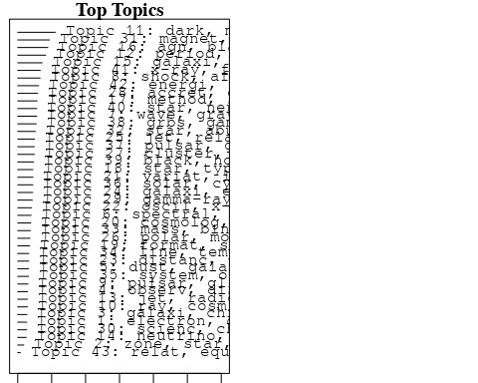

plotQuote(thoughts6, width = 30, main = "Topic 6")  
plotQuote(thoughts18, width = 30, main = "Topic 18")

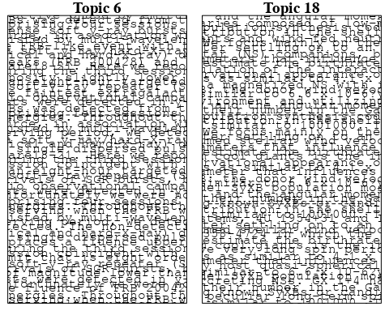

# Calculate and plot the correlation between topics  
mod.out.corr <- topicCorr(Research_topics)  
plot(mod.out.corr, cex = 1.5)  
  
  
# For each topic  
for (topic_num in 1:43) {  
 # Plot the word cloud  
 cloud(Research_topics, topic = topic_num, scale = c(2, 0.25))  
 Sys.sleep(2)  
}

## Warning in wordcloud::wordcloud(words = vocab, freq = vec, max.words =  
## max.words, : composit could not be fit on page. It will not be plotted.

## Warning in wordcloud::wordcloud(words = vocab, freq = vec, max.words =  
## max.words, : satellit could not be fit on page. It will not be plotted.

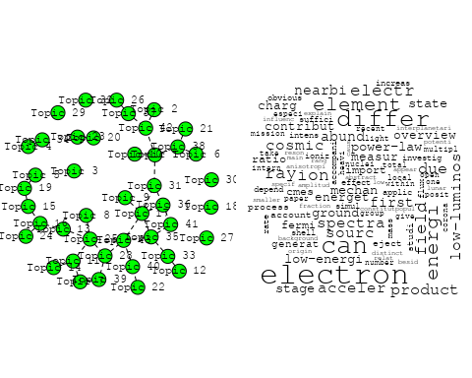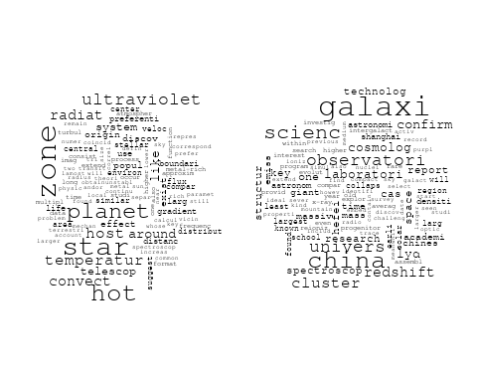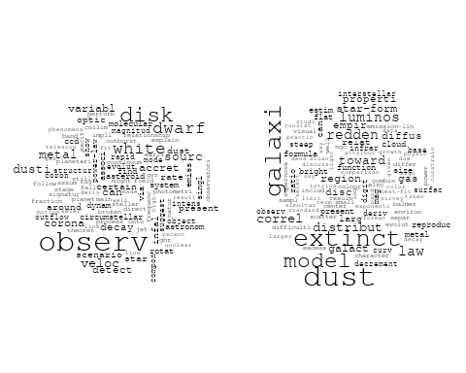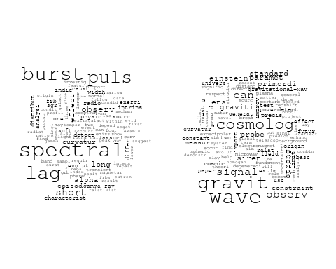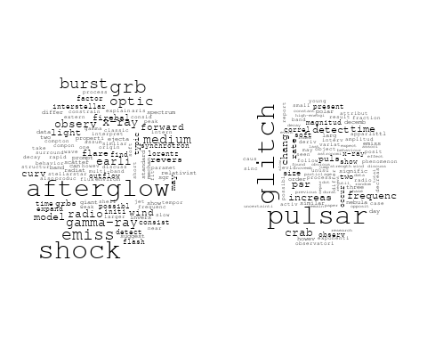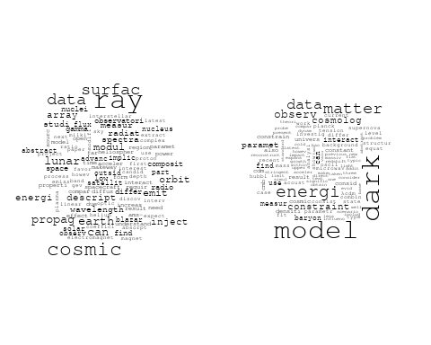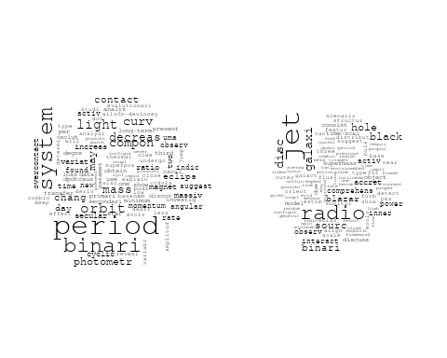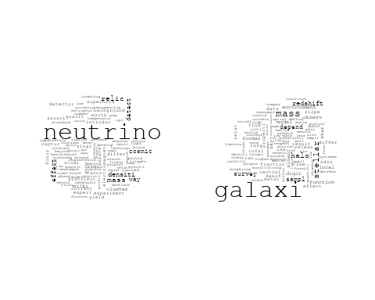

## Warning in wordcloud::wordcloud(words = vocab, freq = vec, max.words =  
## max.words, : double-peak could not be fit on page. It will not be plotted.

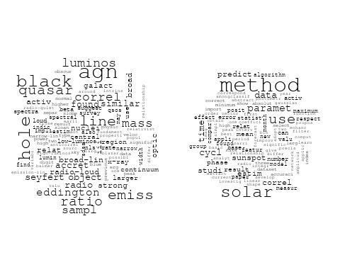

## Warning in wordcloud::wordcloud(words = vocab, freq = vec, max.words =  
## max.words, : binari could not be fit on page. It will not be plotted.

## Warning in wordcloud::wordcloud(words = vocab, freq = vec, max.words =  
## max.words, : model could not be fit on page. It will not be plotted.

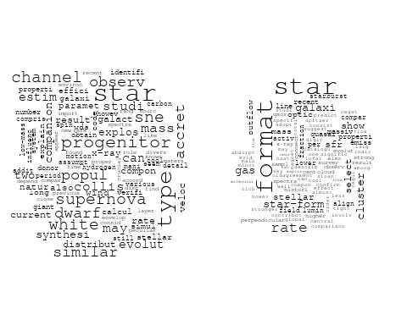

## Warning in wordcloud::wordcloud(words = vocab, freq = vec, max.words =  
## max.words, : cosmolog could not be fit on page. It will not be plotted.

## Warning in wordcloud::wordcloud(words = vocab, freq = vec, max.words =  
## max.words, : survey could not be fit on page. It will not be plotted.

## Warning in wordcloud::wordcloud(words = vocab, freq = vec, max.words =  
## max.words, : distanc could not be fit on page. It will not be plotted.

## Warning in wordcloud::wordcloud(words = vocab, freq = vec, max.words =  
## max.words, : classif could not be fit on page. It will not be plotted.

## Warning in wordcloud::wordcloud(words = vocab, freq = vec, max.words =  
## max.words, : sky could not be fit on page. It will not be plotted.

## Warning in wordcloud::wordcloud(words = vocab, freq = vec, max.words =  
## max.words, : spectral could not be fit on page. It will not be plotted.

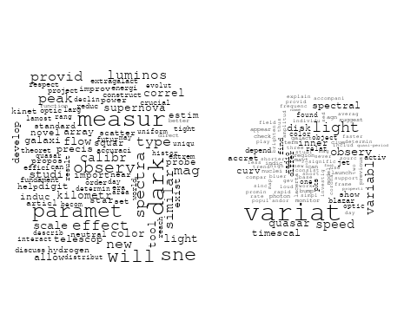

## Warning in wordcloud::wordcloud(words = vocab, freq = vec, max.words =  
## max.words, : stellar could not be fit on page. It will not be plotted.

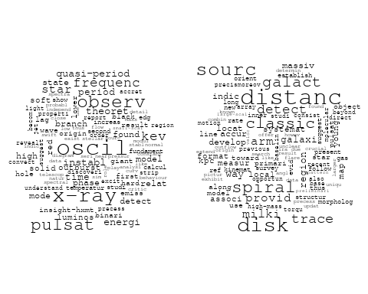

## Warning in wordcloud::wordcloud(words = vocab, freq = vec, max.words =  
## max.words, : energi could not be fit on page. It will not be plotted.

## Warning in wordcloud::wordcloud(words = vocab, freq = vec, max.words =  
## max.words, : paramet could not be fit on page. It will not be plotted.

## Warning in wordcloud::wordcloud(words = vocab, freq = vec, max.words =  
## max.words, : relativist could not be fit on page. It will not be plotted.

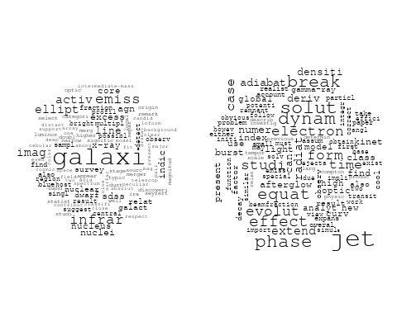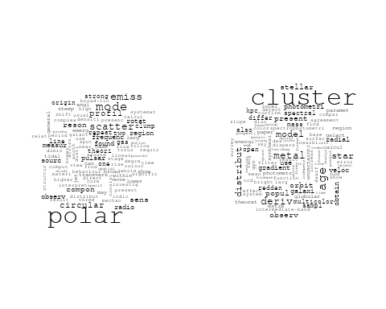

## Warning in wordcloud::wordcloud(words = vocab, freq = vec, max.words =  
## max.words, : compact could not be fit on page. It will not be plotted.

## Warning in wordcloud::wordcloud(words = vocab, freq = vec, max.words =  
## max.words, : observ could not be fit on page. It will not be plotted.

## Warning in wordcloud::wordcloud(words = vocab, freq = vec, max.words =  
## max.words, : multi-wavelength could not be fit on page. It will not be plotted.

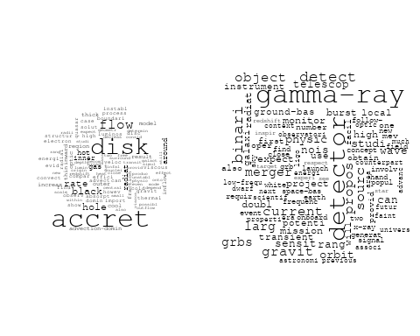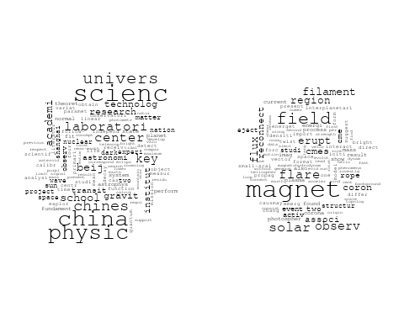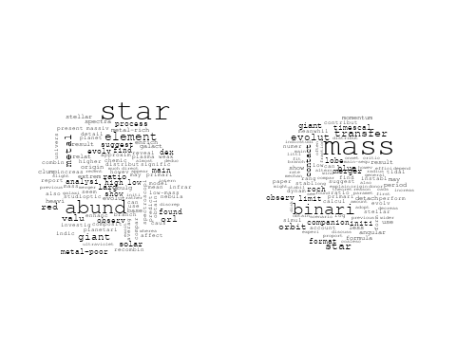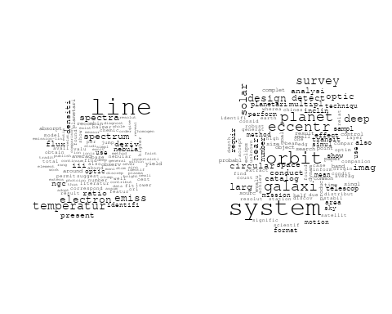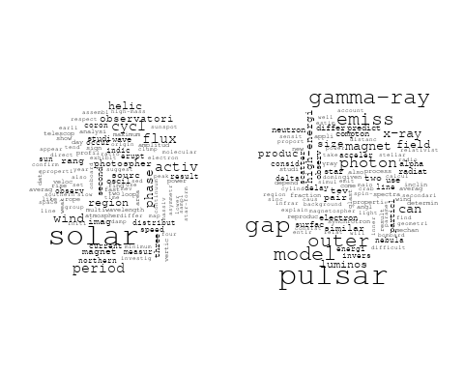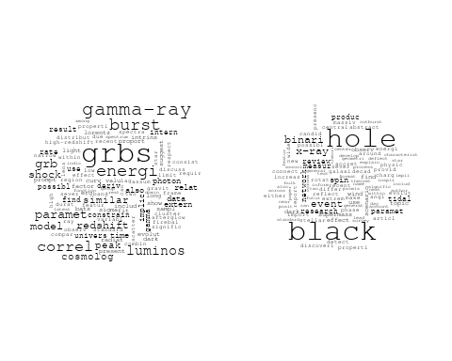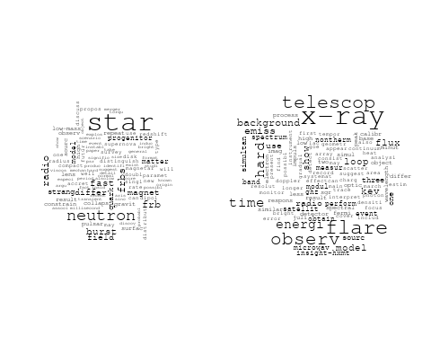

## Warning in wordcloud::wordcloud(words = vocab, freq = vec, max.words =  
## max.words, : spectral could not be fit on page. It will not be plotted.

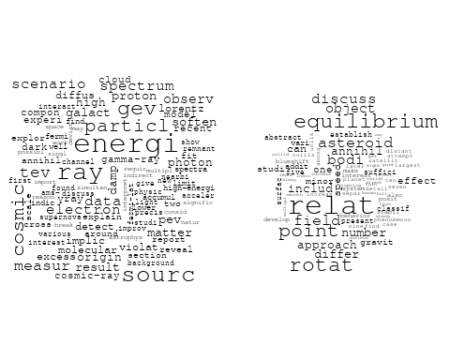

# Get the topic proportions for each document  
topic_proportions <- Research_topics$theta  
  
# Find the index of the topic with the highest proportion for each document  
# This will be the topic that each document is most likely to belong to  
max_topic_idx <- apply(topic_proportions, 1, which.max)  
  
# Add this as a new column to your data  
data_independent$topic <- max_topic_idx  
  
  
  
# Define the intervals  
intervals <- c('1824_1899', '1900_1964', '1965_1974', '1975_1984', '1985_1994', '1995_1999', '2000_2004', '2005_2009', '2010_2014', '2015_2019', '2020_2022')  
colors <- c('pink', 'blue', 'purple', 'yellow', 'green', 'pink', 'orange', 'violet', 'green', 'blue', 'pink')  
  
# Loop through the intervals and plot  
for(i in seq_along(intervals)){  
 # Filter data for when the pub_interval is equal to 1  
 data_filtered <- data_independent[data_independent[[paste0('pub_interval_', intervals[i])]] == 1,]  
   
 # Make the histogram  
   
 p <- ggplot(data_filtered, aes(x = topic)) +  
 geom_histogram(binwidth = 1, fill = colors[i], color = "black") +  
 xlab("Topic") +  
 ylab("Count") +  
 ggtitle(paste0("Topics from year ", gsub("_", " to ", intervals[i])))  
   
 print(p)  
}

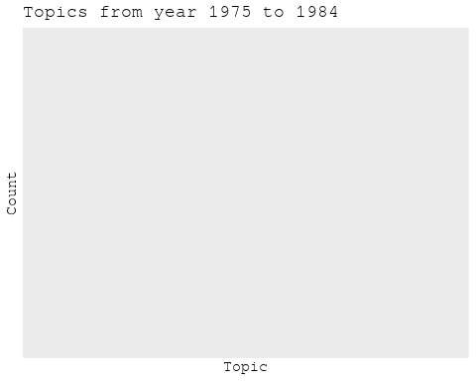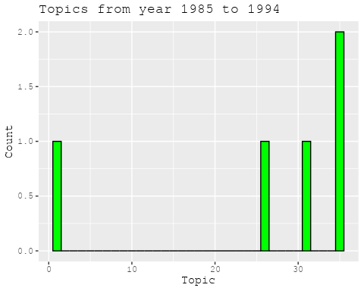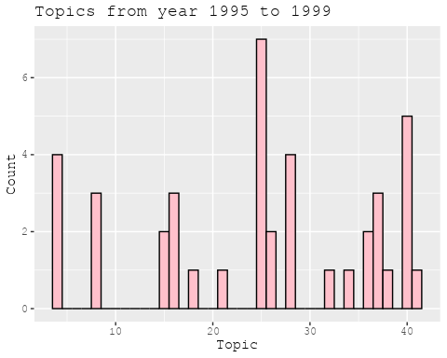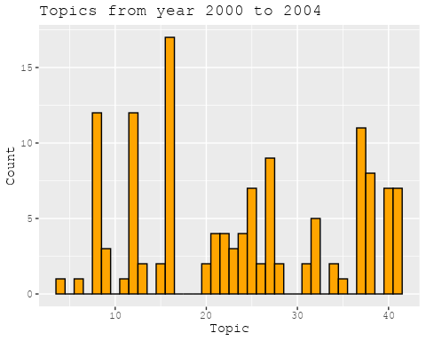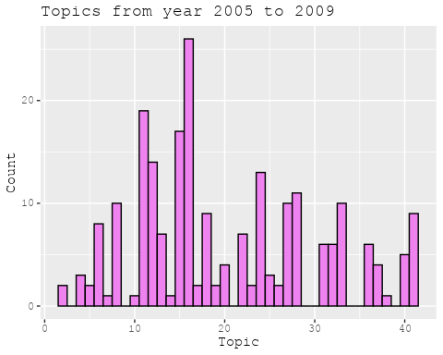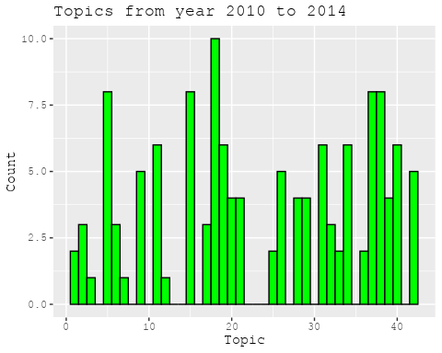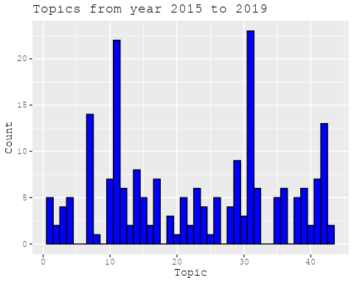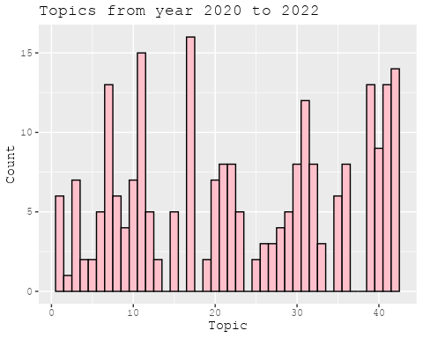

##Topic generation for NL (in collaboration) publications  
  
data_collab <- data[data[["NL"]] != 0,]  
  
# Save the original title data for future use  
data_collab$original_concatenated_title_abstract <- data_collab$concatenated_title_abstract  
  
#pre-processing the titles using textProcessor from the stm package  
processed_text <- textProcessor(data_collab$concatenated_title_abstract, metadata = data_collab)

## Building corpus...   
## Converting to Lower Case...   
## Removing punctuation...   
## Removing stopwords...   
## Removing numbers...   
## Stemming...   
## Creating Output...

# Further prepare the data by removing low-frequency terms  
out_text <- prepDocuments(processed_text$documents, processed_text$vocab, processed_text$meta)

## Removing 2004 of 8772 terms (2004 of 167908 tokens) due to frequency   
## Your corpus now has 2002 documents, 6768 terms and 165904 tokens.

docs_text <- out_text$documents  
vocab_text <- out_text$vocab  
meta_text <- out_text$meta  
  
  
#Prepare data  
plotRemoved(processed_text$documents, lower.thresh = seq(1, 200, by = 100))

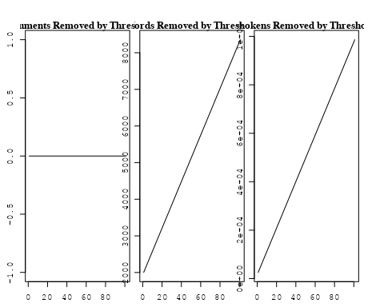

out_text <- prepDocuments(processed_text$documents, processed_text$vocab, processed_text$meta, lower.thresh = 8)

## Removing 6557 of 8772 terms (17027 of 167908 tokens) due to frequency   
## Your corpus now has 2002 documents, 2215 terms and 150881 tokens.

str(out_text$meta)

## 'data.frame': 2002 obs. of 39 variables:  
## $ concept_id : chr "https://openalex.org/C44870925" "https://openalex.org/C1276947" "https://openalex.org/C1276947" "https://openalex.org/C1276947" ...  
## $ work_id : chr "https://openalex.org/W2030196560" "https://openalex.org/W2953328966" "https://openalex.org/W2039791607" "https://openalex.org/W2133651179" ...  
## $ publication_year : int 2009 2009 1988 2007 2008 2007 2004 2021 2021 2009 ...  
## $ title : chr "The Effect of Stellar Rotation on Colour-Magnitude Diagrams: On the apparent presence of multiple populations i"| __truncated__ "Galactic chemical evolution in hierarchical formation models - I. Early-type galaxies in the local Universe" "Fate of the companion stars of ultra-rapid pulsars" "Infrared Molecular Starburst Fingerprints in Deeply Obscured (Ultra)Luminous Infrared Galaxy Nuclei" ...  
## $ paperabstract : chr "A significant number of intermediate age clusters (1 − 2 Gyr) in the Magellanic Clouds appear to have multiple "| __truncated__ "We study the metallicities and abundance ratios of early-type galaxies in cosmological semi-analytic models (SA"| __truncated__ "Abstract A millisecond pulsar that is formed by spin-up 'recycling'1,2 in a binary system will, once the mass t"| __truncated__ "High-resolution spectra of the Spitzer Space Telescope show vibration-rotation absorption bands of gaseous C2H2"| __truncated__ ...  
## $ country : chr "GB NL GB NL" "GB GB NL NL" "NL NL" "NL" ...  
## $ year_concept : chr "2009+https://openalex.org/C44870925" "2009+https://openalex.org/C1276947" "1988+https://openalex.org/C1276947" "2007+https://openalex.org/C1276947" ...  
## $ concatenated_title_abstract : chr "The Effect of Stellar Rotation on Colour-Magnitude Diagrams: On the apparent presence of multiple populations i"| __truncated__ "Galactic chemical evolution in hierarchical formation models - I. Early-type galaxies in the local Universe We "| __truncated__ "Fate of the companion stars of ultra-rapid pulsars Abstract A millisecond pulsar that is formed by spin-up 'rec"| __truncated__ "Infrared Molecular Starburst Fingerprints in Deeply Obscured (Ultra)Luminous Infrared Galaxy Nuclei High-resolu"| __truncated__ ...  
## $ US : num 0 0 0 0 60 0 50 25 25 0 ...  
## $ IN : num 0 0 0 0 0 0 0 0 0 0 ...  
## $ DE : num 0 0 0 0 0 0 0 0 0 25 ...  
## $ CH : num 0 0 0 0 0 0 0 0 0 0 ...  
## $ GB : num 50 50 0 0 0 ...  
## $ CN : num 0 0 0 0 0 0 0 25 25 0 ...  
## $ FR : num 0 0 0 0 0 0 0 0 0 0 ...  
## $ IT : num 0 0 0 0 0 0 0 0 0 0 ...  
## $ RU : num 0 0 0 0 0 0 0 0 0 0 ...  
## $ CA : num 0 0 0 0 0 0 0 0 0 0 ...  
## $ NL : num 50 50 100 100 40 ...  
## $ AU : num 0 0 0 0 0 0 0 0 0 25 ...  
## $ JP : num 0 0 0 0 0 0 0 0 0 0 ...  
## $ ES : num 0 0 0 0 0 0 0 25 25 0 ...  
## $ IL : num 0 0 0 0 0 0 0 0 0 0 ...  
## $ Americas : num 0 0 0 0 0 0 0 0 0 0 ...  
## $ Europe : num 0 0 0 0 0 0 0 0 0 0 ...  
## $ Africa : num 0 0 0 0 0 0 0 0 0 0 ...  
## $ AsiaAndOceania : num 0 0 0 0 0 0 0 0 0 0 ...  
## $ pub_interval_2020_2022 : int 0 0 0 0 0 0 0 1 1 0 ...  
## $ pub_interval_2015_2019 : int 0 0 0 0 0 0 0 0 0 0 ...  
## $ pub_interval_2010_2014 : int 0 0 0 0 0 0 0 0 0 0 ...  
## $ pub_interval_2005_2009 : int 1 1 0 1 1 1 0 0 0 1 ...  
## $ pub_interval_2000_2004 : int 0 0 0 0 0 0 1 0 0 0 ...  
## $ pub_interval_1995_1999 : int 0 0 0 0 0 0 0 0 0 0 ...  
## $ pub_interval_1985_1994 : int 0 0 1 0 0 0 0 0 0 0 ...  
## $ pub_interval_1975_1984 : int 0 0 0 0 0 0 0 0 0 0 ...  
## $ pub_interval_1965_1974 : int 0 0 0 0 0 0 0 0 0 0 ...  
## $ pub_interval_1900_1964 : int 0 0 0 0 0 0 0 0 0 0 ...  
## $ pub_interval_1824_1899 : int 0 0 0 0 0 0 0 0 0 0 ...  
## $ original_concatenated_title_abstract: chr "The Effect of Stellar Rotation on Colour-Magnitude Diagrams: On the apparent presence of multiple populations i"| __truncated__ "Galactic chemical evolution in hierarchical formation models - I. Early-type galaxies in the local Universe We "| __truncated__ "Fate of the companion stars of ultra-rapid pulsars Abstract A millisecond pulsar that is formed by spin-up 'rec"| __truncated__ "Infrared Molecular Starburst Fingerprints in Deeply Obscured (Ultra)Luminous Infrared Galaxy Nuclei High-resolu"| __truncated__ ...

# Initialize an empty formula string  
prevalence_formula_str <- "~"  
  
# Define the publication intervals  
pub_intervals <- c("pub_interval_2020_2022", "pub_interval_2015_2019", "pub_interval_2010_2014",   
 "pub_interval_2005_2009", "pub_interval_2000_2004", "pub_interval_1995_1999",  
 "pub_interval_1985_1994", "pub_interval_1975_1984", "pub_interval_1965_1974",  
 "pub_interval_1900_1964", "pub_interval_1824_1899")  
  
# Add each publication interval to the formula string  
for (interval in pub_intervals) {  
 # add an if statement to handle the first addition (without '+')  
 if (prevalence_formula_str == "~") {  
 prevalence_formula_str <- paste(prevalence_formula_str, interval)  
 } else {  
 prevalence_formula_str <- paste(prevalence_formula_str, "+", interval)  
 }  
}  
  
  
# Convert the string to a formula  
prevalence_formula <- as.formula(prevalence_formula_str)  
print(prevalence_formula)

## ~pub_interval_2020_2022 + pub_interval_2015_2019 + pub_interval_2010_2014 +   
## pub_interval_2005_2009 + pub_interval_2000_2004 + pub_interval_1995_1999 +   
## pub_interval_1985_1994 + pub_interval_1975_1984 + pub_interval_1965_1974 +   
## pub_interval_1900_1964 + pub_interval_1824_1899

# Run STM model  
Research_topics <- stm(documents = out_text$documents,   
 vocab = out_text$vocab,   
 K = 44,   
 prevalence = prevalence_formula,   
 data = out_text$meta,   
 init.type = "Spectral",  
 max.em.its = 1000,  
 gamma.prior = 'L1')

## Beginning Spectral Initialization   
## Calculating the gram matrix...  
## Finding anchor words...  
## ............................................  
## Recovering initialization...  
## ......................  
## Initialization complete.  
## ....................................................................................................  
## Completed E-Step (2 seconds).   
## Completed M-Step.   
## Completing Iteration 1 (approx. per word bound = -6.475)   
## ....................................................................................................  
## Completed E-Step (2 seconds).   
## Completed M-Step.   
## Completing Iteration 2 (approx. per word bound = -6.190, relative change = 4.409e-02)   
## ....................................................................................................  
## Completed E-Step (1 seconds).   
## Completed M-Step.   
## Completing Iteration 3 (approx. per word bound = -6.109, relative change = 1.302e-02)   
## ....................................................................................................  
## Completed E-Step (1 seconds).   
## Completed M-Step.   
## Completing Iteration 4 (approx. per word bound = -6.077, relative change = 5.328e-03)   
## ....................................................................................................  
## Completed E-Step (1 seconds).   
## Completed M-Step.   
## Completing Iteration 5 (approx. per word bound = -6.060, relative change = 2.733e-03)   
## Topic 1: mass, mond, secondari, effect, confid   
## Topic 2: galaxi, gas, ellipt, observ, structur   
## Topic 3: galaxi, ngc, gas, format, star   
## Topic 4: univers, astronomi, physic, institut, centr   
## Topic 5: frequenc, time, two, compon, featur   
## Topic 6: luminos, galaxi, agn, activ, starburst   
## Topic 7: data, gaia, mission, will, lisa   
## Topic 8: astronom, galact, observatori, astrophys, center   
## Topic 9: dwarf, orbit, white, planet, eclips   
## Topic 10: field, magnet, code, astrophys, can   
## Topic 11: mass, galaxi, lens, len, redshift   
## Topic 12: model, disc, observ, bar, galaxi   
## Topic 13: burst, grb, x-ray, gamma-ray, observ   
## Topic 14: star, cluster, mass, merger, format   
## Topic 15: star, stellar, massiv, rotat, binari   
## Topic 16: imag, telescop, studi, array, system   
## Topic 17: halo, galaxi, mass, simul, dark   
## Topic 18: sourc, variabl, core, observ, x-ray   
## Topic 19: shock, supernova, remnant, magnet, energi   
## Topic 20: cosmic, ray, radio, energi, detect   
## Topic 21: metal, star, galaxi, abund, stellar   
## Topic 22: hole, black, accret, binari, x-ray   
## Topic 23: galaxi, star, format, radio, redshift   
## Topic 24: rate, simul, star, temperatur, model   
## Topic 25: radio, sourc, galaxi, absorpt, outflow   
## Topic 26: cluster, galaxi, age, star, stellar   
## Topic 27: pulsar, time, measur, year, group   
## Topic 28: model, measur, use, distribut, fit   
## Topic 29: jet, radio, x-ray, emiss, observ   
## Topic 30: milki, way, matter, dark, star   
## Topic 31: dust, solar, system, interstellar, observ   
## Topic 32: radio, burst, fast, galaxi, host   
## Topic 33: filament, halo, spin, galaxi, maser   
## Topic 34: binari, x-ray, system, accret, optic   
## Topic 35: sampl, sourc, observ, data, optic   
## Topic 36: survey, line, emiss, detect, observ   
## Topic 37: galaxi, evolut, observ, model, format   
## Topic 38: galaxi, similar, will, observ, relat   
## Topic 39: veloc, nebula, binari, star, system   
## Topic 40: flare, magnet, solar, planet, atmospher   
## Topic 41: disk, molecular, star, emiss, gas   
## Topic 42: x-ray, sourc, state, observ, outburst   
## Topic 43: radio, emiss, observ, detect, frequenc   
## Topic 44: star, period, rang, neutron, system   
## ....................................................................................................  
## Completed E-Step (1 seconds).   
## Completed M-Step.   
## Completing Iteration 6 (approx. per word bound = -6.050, relative change = 1.684e-03)   
## ....................................................................................................  
## Completed E-Step (1 seconds).   
## Completed M-Step.   
## Completing Iteration 7 (approx. per word bound = -6.043, relative change = 1.090e-03)   
## ....................................................................................................  
## Completed E-Step (1 seconds).   
## Completed M-Step.   
## Completing Iteration 8 (approx. per word bound = -6.039, relative change = 7.750e-04)   
## ....................................................................................................  
## Completed E-Step (1 seconds).   
## Completed M-Step.   
## Completing Iteration 9 (approx. per word bound = -6.035, relative change = 6.180e-04)   
## ....................................................................................................  
## Completed E-Step (1 seconds).   
## Completed M-Step.   
## Completing Iteration 10 (approx. per word bound = -6.032, relative change = 5.375e-04)   
## Topic 1: mass, effect, rotat, curv, valu   
## Topic 2: galaxi, gas, ellipt, observ, early-typ   
## Topic 3: galaxi, gas, ngc, format, star   
## Topic 4: univers, astronomi, physic, institut, centr   
## Topic 5: frequenc, compon, two, time, featur   
## Topic 6: luminos, galaxi, agn, activ, starburst   
## Topic 7: data, gaia, will, mission, star   
## Topic 8: astronom, galact, observatori, astrophys, center   
## Topic 9: dwarf, orbit, white, planet, system   
## Topic 10: magnet, field, solar, structur, code   
## Topic 11: mass, galaxi, lens, len, redshift   
## Topic 12: model, disc, observ, veloc, distribut   
## Topic 13: burst, grb, gamma-ray, x-ray, observ   
## Topic 14: cluster, star, mass, merger, format   
## Topic 15: star, stellar, rotat, binari, neutron   
## Topic 16: imag, telescop, studi, galaxi, array   
## Topic 17: halo, galaxi, mass, simul, dark   
## Topic 18: sourc, variabl, core, radio, x-ray   
## Topic 19: supernova, shock, remnant, x-ray, energi   
## Topic 20: cosmic, ray, radio, energi, detect   
## Topic 21: metal, star, galaxi, abund, stellar   
## Topic 22: hole, black, accret, binari, x-ray   
## Topic 23: galaxi, star, format, radio, redshift   
## Topic 24: simul, rate, star, model, temperatur   
## Topic 25: radio, sourc, galaxi, outflow, absorpt   
## Topic 26: cluster, age, galaxi, star, stellar   
## Topic 27: pulsar, time, measur, detect, puls   
## Topic 28: model, measur, use, distribut, method   
## Topic 29: jet, radio, x-ray, emiss, observ   
## Topic 30: way, milki, matter, dark, stellar   
## Topic 31: dust, solar, system, observ, interstellar   
## Topic 32: radio, burst, fast, galaxi, host   
## Topic 33: filament, spin, galaxi, maser, halo   
## Topic 34: binari, x-ray, system, optic, accret   
## Topic 35: sampl, sourc, fit, optic, model   
## Topic 36: line, emiss, survey, detect, observ   
## Topic 37: galaxi, evolut, observ, model, format   
## Topic 38: galaxi, similar, will, stellar, observ   
## Topic 39: veloc, nebula, binari, star, system   
## Topic 40: flare, magnet, solar, corona, x-ray   
## Topic 41: disk, molecular, cloud, emiss, gas   
## Topic 42: x-ray, sourc, state, outburst, observ   
## Topic 43: radio, emiss, cluster, field, sourc   
## Topic 44: star, period, neutron, system, pulsar   
## ....................................................................................................  
## Completed E-Step (1 seconds).   
## Completed M-Step.   
## Completing Iteration 11 (approx. per word bound = -6.029, relative change = 4.336e-04)   
## ....................................................................................................  
## Completed E-Step (1 seconds).   
## Completed M-Step.   
## Completing Iteration 12 (approx. per word bound = -6.027, relative change = 3.831e-04)   
## ....................................................................................................  
## Completed E-Step (1 seconds).   
## Completed M-Step.   
## Completing Iteration 13 (approx. per word bound = -6.025, relative change = 3.471e-04)   
## ....................................................................................................  
## Completed E-Step (1 seconds).   
## Completed M-Step.   
## Completing Iteration 14 (approx. per word bound = -6.022, relative change = 3.543e-04)   
## ....................................................................................................  
## Completed E-Step (1 seconds).   
## Completed M-Step.   
## Completing Iteration 15 (approx. per word bound = -6.021, relative change = 3.161e-04)   
## Topic 1: mass, rotat, valu, effect, curv   
## Topic 2: galaxi, gas, ellipt, observ, early-typ   
## Topic 3: gas, galaxi, ngc, format, star   
## Topic 4: univers, astronomi, physic, institut, centr   
## Topic 5: frequenc, oscil, compon, two, time   
## Topic 6: luminos, galaxi, agn, activ, starburst   
## Topic 7: data, gaia, will, mission, star   
## Topic 8: astronom, observatori, galact, astrophys, x-ray   
## Topic 9: dwarf, orbit, white, planet, system   
## Topic 10: magnet, field, solar, structur, code   
## Topic 11: mass, galaxi, lens, len, redshift   
## Topic 12: model, disc, observ, veloc, bar   
## Topic 13: burst, grb, gamma-ray, x-ray, afterglow   
## Topic 14: cluster, star, mass, format, merger   
## Topic 15: star, stellar, rotat, massiv, observ   
## Topic 16: imag, telescop, studi, galaxi, array   
## Topic 17: halo, galaxi, mass, simul, feedback   
## Topic 18: sourc, variabl, core, radio, x-ray   
## Topic 19: supernova, shock, remnant, x-ray, acceler   
## Topic 20: cosmic, ray, radio, energi, detect   
## Topic 21: metal, star, galaxi, abund, stellar   
## Topic 22: hole, black, accret, x-ray, binari   
## Topic 23: galaxi, star, format, radio, redshift   
## Topic 24: simul, rate, model, star, temperatur   
## Topic 25: radio, sourc, galaxi, outflow, absorpt   
## Topic 26: cluster, age, galaxi, star, stellar   
## Topic 27: pulsar, time, measur, detect, puls   
## Topic 28: model, measur, use, method, distribut   
## Topic 29: jet, radio, x-ray, observ, emiss   
## Topic 30: way, milki, matter, dark, may   
## Topic 31: dust, solar, system, observ, interstellar   
## Topic 32: radio, burst, fast, galaxi, observ   
## Topic 33: filament, spin, galaxi, maser, halo   
## Topic 34: binari, x-ray, system, accret, optic   
## Topic 35: sampl, fit, optic, model, sourc   
## Topic 36: emiss, line, survey, detect, observ   
## Topic 37: galaxi, evolut, observ, model, format   
## Topic 38: galaxi, similar, will, stellar, observ   
## Topic 39: veloc, nebula, binari, star, system   
## Topic 40: flare, corona, solar, x-ray, magnet   
## Topic 41: disk, molecular, cloud, gas, star   
## Topic 42: x-ray, sourc, outburst, state, observ   
## Topic 43: radio, cluster, emiss, field, sourc   
## Topic 44: star, neutron, pulsar, system, binari   
## ....................................................................................................  
## Completed E-Step (1 seconds).   
## Completed M-Step.   
## Completing Iteration 16 (approx. per word bound = -6.019, relative change = 3.058e-04)   
## ....................................................................................................  
## Completed E-Step (1 seconds).   
## Completed M-Step.   
## Completing Iteration 17 (approx. per word bound = -6.017, relative change = 2.766e-04)   
## ....................................................................................................  
## Completed E-Step (1 seconds).   
## Completed M-Step.   
## Completing Iteration 18 (approx. per word bound = -6.015, relative change = 2.501e-04)   
## ....................................................................................................  
## Completed E-Step (1 seconds).   
## Completed M-Step.   
## Completing Iteration 19 (approx. per word bound = -6.014, relative change = 2.339e-04)   
## ....................................................................................................  
## Completed E-Step (1 seconds).   
## Completed M-Step.   
## Completing Iteration 20 (approx. per word bound = -6.013, relative change = 2.146e-04)   
## Topic 1: mass, measur, ratio, valu, rotat   
## Topic 2: galaxi, gas, ellipt, observ, rotat   
## Topic 3: gas, galaxi, ngc, format, star   
## Topic 4: univers, astronomi, physic, institut, astrophys   
## Topic 5: frequenc, oscil, qpo, sourc, qpos   
## Topic 6: luminos, galaxi, agn, activ, starburst   
## Topic 7: data, gaia, will, mission, star   
## Topic 8: astronom, observatori, galact, astrophys, x-ray   
## Topic 9: dwarf, orbit, white, planet, system   
## Topic 10: magnet, field, solar, structur, rotat   
## Topic 11: mass, galaxi, lens, len, redshift   
## Topic 12: model, disc, veloc, microlens, bar   
## Topic 13: burst, grb, gamma-ray, x-ray, afterglow   
## Topic 14: cluster, star, mass, format, merger   
## Topic 15: star, stellar, rotat, observ, massiv   
## Topic 16: imag, telescop, studi, galaxi, array   
## Topic 17: halo, galaxi, mass, simul, feedback   
## Topic 18: sourc, variabl, core, radio, x-ray   
## Topic 19: supernova, shock, remnant, x-ray, acceler   
## Topic 20: cosmic, ray, radio, energi, detect   
## Topic 21: star, metal, galaxi, abund, stellar   
## Topic 22: hole, black, accret, x-ray, binari   
## Topic 23: galaxi, star, format, radio, redshift   
## Topic 24: simul, rate, model, star, gas   
## Topic 25: radio, sourc, galaxi, outflow, absorpt   
## Topic 26: cluster, age, galaxi, star, stellar   
## Topic 27: pulsar, time, measur, detect, puls   
## Topic 28: model, measur, use, method, distribut   
## Topic 29: jet, radio, observ, x-ray, emiss   
## Topic 30: way, milki, matter, dark, may   
## Topic 31: dust, solar, system, interstellar, observ   
## Topic 32: radio, burst, fast, galaxi, observ   
## Topic 33: filament, spin, maser, galaxi, halo   
## Topic 34: binari, x-ray, accret, optic, system   
## Topic 35: sampl, optic, fit, model, sourc   
## Topic 36: emiss, line, survey, detect, region   
## Topic 37: galaxi, evolut, observ, model, format   
## Topic 38: galaxi, similar, will, stellar, observ   
## Topic 39: veloc, nebula, binari, star, system   
## Topic 40: flare, corona, solar, emiss, wind   
## Topic 41: disk, molecular, cloud, gas, star   
## Topic 42: x-ray, sourc, outburst, observ, state   
## Topic 43: radio, cluster, emiss, field, galaxi   
## Topic 44: star, neutron, pulsar, binari, system   
## ....................................................................................................  
## Completed E-Step (1 seconds).   
## Completed M-Step.   
## Completing Iteration 21 (approx. per word bound = -6.012, relative change = 1.914e-04)   
## ....................................................................................................  
## Completed E-Step (1 seconds).   
## Completed M-Step.   
## Completing Iteration 22 (approx. per word bound = -6.011, relative change = 1.801e-04)   
## ....................................................................................................  
## Completed E-Step (1 seconds).   
## Completed M-Step.   
## Completing Iteration 23 (approx. per word bound = -6.010, relative change = 1.625e-04)   
## ....................................................................................................  
## Completed E-Step (1 seconds).   
## Completed M-Step.   
## Completing Iteration 24 (approx. per word bound = -6.009, relative change = 1.274e-04)   
## ....................................................................................................  
## Completed E-Step (1 seconds).   
## Completed M-Step.   
## Completing Iteration 25 (approx. per word bound = -6.008, relative change = 1.400e-04)   
## Topic 1: mass, measur, ratio, valu, per   
## Topic 2: galaxi, gas, rotat, observ, ellipt   
## Topic 3: gas, galaxi, ngc, format, star   
## Topic 4: univers, astronomi, physic, institut, scale   
## Topic 5: frequenc, oscil, qpo, sourc, qpos   
## Topic 6: luminos, galaxi, agn, activ, starburst   
## Topic 7: data, gaia, will, mission, star   
## Topic 8: astronom, observatori, astrophys, galact, x-ray   
## Topic 9: dwarf, orbit, white, planet, system   
## Topic 10: magnet, field, solar, structur, rotat   
## Topic 11: mass, galaxi, lens, len, redshift   
## Topic 12: model, disc, veloc, microlens, use   
## Topic 13: burst, grb, gamma-ray, x-ray, afterglow   
## Topic 14: cluster, star, mass, merger, format   
## Topic 15: star, stellar, rotat, observ, model   
## Topic 16: imag, telescop, studi, galaxi, array   
## Topic 17: halo, galaxi, mass, simul, feedback   
## Topic 18: sourc, variabl, core, radio, variat   
## Topic 19: supernova, shock, remnant, x-ray, acceler   
## Topic 20: cosmic, ray, radio, energi, detect   
## Topic 21: star, metal, galaxi, abund, stellar   
## Topic 22: hole, black, accret, x-ray, binari   
## Topic 23: galaxi, star, format, radio, redshift   
## Topic 24: simul, rate, model, star, gas   
## Topic 25: radio, sourc, galaxi, outflow, absorpt   
## Topic 26: cluster, age, galaxi, star, mass   
## Topic 27: pulsar, time, measur, detect, puls   
## Topic 28: measur, model, use, method, distribut   
## Topic 29: jet, radio, observ, emiss, x-ray   
## Topic 30: way, milki, matter, dark, galact   
## Topic 31: dust, solar, system, observ, interstellar   
## Topic 32: radio, burst, fast, galaxi, observ   
## Topic 33: filament, spin, maser, galaxi, halo   
## Topic 34: binari, accret, x-ray, optic, system   
## Topic 35: sampl, model, fit, optic, sourc   
## Topic 36: emiss, line, survey, detect, region   
## Topic 37: galaxi, evolut, observ, model, format   
## Topic 38: galaxi, similar, will, stellar, observ   
## Topic 39: veloc, nebula, binari, star, system   
## Topic 40: flare, corona, solar, emiss, wind   
## Topic 41: disk, molecular, cloud, star, gas   
## Topic 42: x-ray, sourc, outburst, observ, state   
## Topic 43: radio, cluster, emiss, galaxi, field   
## Topic 44: star, neutron, pulsar, binari, system   
## ....................................................................................................  
## Completed E-Step (1 seconds).   
## Completed M-Step.   
## Completing Iteration 26 (approx. per word bound = -6.007, relative change = 1.324e-04)   
## ....................................................................................................  
## Completed E-Step (1 seconds).   
## Completed M-Step.   
## Completing Iteration 27 (approx. per word bound = -6.006, relative change = 1.266e-04)   
## ....................................................................................................  
## Completed E-Step (1 seconds).   
## Completed M-Step.   
## Completing Iteration 28 (approx. per word bound = -6.006, relative change = 1.162e-04)   
## ....................................................................................................  
## Completed E-Step (1 seconds).   
## Completed M-Step.   
## Completing Iteration 29 (approx. per word bound = -6.005, relative change = 1.120e-04)   
## ....................................................................................................  
## Completed E-Step (1 seconds).   
## Completed M-Step.   
## Completing Iteration 30 (approx. per word bound = -6.004, relative change = 9.959e-05)   
## Topic 1: mass, measur, per, ratio, cent   
## Topic 2: galaxi, rotat, gas, observ, kinemat   
## Topic 3: gas, galaxi, ngc, format, star   
## Topic 4: univers, astronomi, physic, institut, scale   
## Topic 5: frequenc, oscil, sourc, qpo, qpos   
## Topic 6: luminos, galaxi, agn, activ, starburst   
## Topic 7: data, gaia, will, mission, star   
## Topic 8: astronom, observatori, astrophys, x-ray, galact   
## Topic 9: dwarf, orbit, planet, white, system   
## Topic 10: magnet, field, structur, solar, rotat   
## Topic 11: mass, galaxi, lens, len, redshift   
## Topic 12: model, disc, veloc, use, microlens   
## Topic 13: burst, grb, gamma-ray, x-ray, afterglow   
## Topic 14: cluster, star, mass, merger, format   
## Topic 15: star, stellar, rotat, observ, model   
## Topic 16: imag, telescop, studi, galaxi, array   
## Topic 17: halo, galaxi, mass, simul, feedback   
## Topic 18: sourc, variabl, core, radio, variat   
## Topic 19: supernova, shock, remnant, x-ray, acceler   
## Topic 20: cosmic, ray, radio, detect, energi   
## Topic 21: star, metal, galaxi, abund, stellar   
## Topic 22: hole, black, accret, x-ray, power   
## Topic 23: galaxi, star, format, radio, redshift   
## Topic 24: simul, rate, model, star, gas   
## Topic 25: radio, sourc, galaxi, outflow, absorpt   
## Topic 26: cluster, age, galaxi, star, mass   
## Topic 27: pulsar, time, measur, detect, puls   
## Topic 28: measur, model, use, method, distribut   
## Topic 29: jet, radio, observ, emiss, x-ray   
## Topic 30: way, milki, matter, dark, galact   
## Topic 31: dust, solar, system, observ, interstellar   
## Topic 32: radio, burst, fast, galaxi, observ   
## Topic 33: filament, spin, maser, galaxi, distribut   
## Topic 34: binari, accret, optic, x-ray, system   
## Topic 35: sampl, model, fit, optic, sourc   
## Topic 36: emiss, line, survey, detect, region   
## Topic 37: galaxi, evolut, observ, model, format   
## Topic 38: galaxi, similar, will, stellar, observ   
## Topic 39: veloc, nebula, binari, star, use   
## Topic 40: flare, corona, solar, emiss, wind   
## Topic 41: disk, molecular, cloud, star, gas   
## Topic 42: x-ray, sourc, observ, outburst, state   
## Topic 43: radio, cluster, emiss, galaxi, field   
## Topic 44: star, neutron, binari, pulsar, system   
## ....................................................................................................  
## Completed E-Step (1 seconds).   
## Completed M-Step.   
## Completing Iteration 31 (approx. per word bound = -6.004, relative change = 9.678e-05)   
## ....................................................................................................  
## Completed E-Step (1 seconds).   
## Completed M-Step.   
## Completing Iteration 32 (approx. per word bound = -6.003, relative change = 8.321e-05)   
## ....................................................................................................  
## Completed E-Step (1 seconds).   
## Completed M-Step.   
## Completing Iteration 33 (approx. per word bound = -6.003, relative change = 8.395e-05)   
## ....................................................................................................  
## Completed E-Step (1 seconds).   
## Completed M-Step.   
## Completing Iteration 34 (approx. per word bound = -6.002, relative change = 8.452e-05)   
## ....................................................................................................  
## Completed E-Step (1 seconds).   
## Completed M-Step.   
## Completing Iteration 35 (approx. per word bound = -6.002, relative change = 7.975e-05)   
## Topic 1: mass, per, cent, measur, ratio   
## Topic 2: galaxi, rotat, observ, gas, kinemat   
## Topic 3: gas, galaxi, ngc, format, star   
## Topic 4: univers, astronomi, physic, institut, scale   
## Topic 5: frequenc, sourc, oscil, qpo, qpos   
## Topic 6: luminos, galaxi, agn, activ, starburst   
## Topic 7: data, gaia, will, mission, star   
## Topic 8: astronom, observatori, astrophys, x-ray, motion   
## Topic 9: orbit, dwarf, planet, white, system   
## Topic 10: magnet, field, structur, solar, rotat   
## Topic 11: mass, galaxi, lens, len, redshift   
## Topic 12: model, veloc, use, microlens, bar   
## Topic 13: burst, grb, gamma-ray, x-ray, afterglow   
## Topic 14: cluster, star, mass, format, merger   
## Topic 15: star, stellar, rotat, observ, model   
## Topic 16: imag, telescop, studi, galaxi, provid   
## Topic 17: halo, galaxi, mass, simul, feedback   
## Topic 18: sourc, variabl, core, radio, variat   
## Topic 19: supernova, shock, remnant, x-ray, acceler   
## Topic 20: cosmic, ray, radio, detect, energi   
## Topic 21: star, metal, galaxi, abund, stellar   
## Topic 22: hole, black, accret, x-ray, power   
## Topic 23: galaxi, star, format, radio, redshift   
## Topic 24: simul, rate, model, star, gas   
## Topic 25: radio, sourc, galaxi, outflow, absorpt   
## Topic 26: cluster, age, star, galaxi, mass   
## Topic 27: pulsar, time, measur, detect, puls   
## Topic 28: measur, model, use, method, signal   
## Topic 29: jet, radio, observ, emiss, x-ray   
## Topic 30: way, milki, matter, dark, galact   
## Topic 31: dust, solar, observ, system, interstellar   
## Topic 32: radio, burst, fast, galaxi, observ   
## Topic 33: filament, spin, maser, galaxi, distribut   
## Topic 34: binari, accret, optic, x-ray, system   
## Topic 35: sampl, model, fit, optic, sourc   
## Topic 36: emiss, line, survey, detect, region   
## Topic 37: galaxi, evolut, observ, model, format   
## Topic 38: galaxi, similar, will, stellar, observ   
## Topic 39: veloc, nebula, binari, star, use   
## Topic 40: flare, corona, emiss, solar, wind   
## Topic 41: disk, molecular, cloud, star, gas   
## Topic 42: x-ray, sourc, observ, outburst, hard   
## Topic 43: radio, cluster, galaxi, emiss, field   
## Topic 44: star, neutron, binari, pulsar, system   
## ....................................................................................................  
## Completed E-Step (1 seconds).   
## Completed M-Step.   
## Completing Iteration 36 (approx. per word bound = -6.001, relative change = 7.638e-05)   
## ....................................................................................................  
## Completed E-Step (1 seconds).   
## Completed M-Step.   
## Completing Iteration 37 (approx. per word bound = -6.001, relative change = 7.211e-05)   
## ....................................................................................................  
## Completed E-Step (1 seconds).   
## Completed M-Step.   
## Completing Iteration 38 (approx. per word bound = -6.001, relative change = 3.769e-05)   
## ....................................................................................................  
## Completed E-Step (1 seconds).   
## Completed M-Step.   
## Completing Iteration 39 (approx. per word bound = -6.000, relative change = 1.168e-04)   
## ....................................................................................................  
## Completed E-Step (1 seconds).   
## Completed M-Step.   
## Completing Iteration 40 (approx. per word bound = -6.000, relative change = 7.382e-05)   
## Topic 1: mass, per, cent, measur, ratio   
## Topic 2: galaxi, rotat, observ, kinemat, ellipt   
## Topic 3: gas, galaxi, ngc, format, star   
## Topic 4: univers, astronomi, physic, institut, astrophys   
## Topic 5: frequenc, oscil, sourc, qpo, qpos   
## Topic 6: luminos, galaxi, agn, activ, starburst   
## Topic 7: data, gaia, will, mission, star   
## Topic 8: astronom, observatori, astrophys, x-ray, motion   
## Topic 9: orbit, dwarf, planet, white, system   
## Topic 10: magnet, field, structur, solar, rotat   
## Topic 11: mass, galaxi, lens, len, redshift   
## Topic 12: model, use, microlens, veloc, bar   
## Topic 13: burst, grb, gamma-ray, x-ray, afterglow   
## Topic 14: cluster, star, mass, format, merger   
## Topic 15: star, stellar, rotat, observ, model   
## Topic 16: imag, telescop, studi, galaxi, provid   
## Topic 17: halo, galaxi, mass, simul, feedback   
## Topic 18: sourc, variabl, core, radio, variat   
## Topic 19: supernova, shock, remnant, x-ray, acceler   
## Topic 20: cosmic, ray, radio, detect, energi   
## Topic 21: star, metal, galaxi, abund, stellar   
## Topic 22: hole, black, accret, x-ray, luminos   
## Topic 23: galaxi, star, format, radio, redshift   
## Topic 24: simul, rate, model, star, gas   
## Topic 25: radio, sourc, galaxi, outflow, absorpt   
## Topic 26: cluster, age, star, galaxi, mass   
## Topic 27: pulsar, time, measur, puls, detect   
## Topic 28: measur, model, use, method, signal   
## Topic 29: jet, radio, observ, x-ray, emiss   
## Topic 30: way, milki, matter, dark, galact   
## Topic 31: dust, solar, observ, interstellar, system   
## Topic 32: radio, burst, fast, galaxi, observ   
## Topic 33: filament, spin, maser, galaxi, distribut   
## Topic 34: binari, accret, optic, system, x-ray   
## Topic 35: sampl, model, fit, sourc, optic   
## Topic 36: emiss, line, survey, region, detect   
## Topic 37: galaxi, evolut, observ, model, format   
## Topic 38: galaxi, similar, will, stellar, observ   
## Topic 39: veloc, nebula, binari, star, system   
## Topic 40: flare, emiss, corona, wind, solar   
## Topic 41: disk, molecular, cloud, star, gas   
## Topic 42: x-ray, sourc, observ, outburst, hard   
## Topic 43: radio, cluster, galaxi, field, emiss   
## Topic 44: star, neutron, binari, pulsar, system   
## ....................................................................................................  
## Completed E-Step (1 seconds).   
## Completed M-Step.   
## Completing Iteration 41 (approx. per word bound = -5.999, relative change = 6.905e-05)   
## ....................................................................................................  
## Completed E-Step (1 seconds).   
## Completed M-Step.   
## Completing Iteration 42 (approx. per word bound = -5.999, relative change = 6.200e-05)   
## ....................................................................................................  
## Completed E-Step (1 seconds).   
## Completed M-Step.   
## Completing Iteration 43 (approx. per word bound = -5.999, relative change = 4.333e-05)   
## ....................................................................................................  
## Completed E-Step (1 seconds).   
## Completed M-Step.   
## Completing Iteration 44 (approx. per word bound = -5.998, relative change = 8.902e-05)   
## ....................................................................................................  
## Completed E-Step (1 seconds).   
## Completed M-Step.   
## Completing Iteration 45 (approx. per word bound = -5.998, relative change = 7.287e-05)   
## Topic 1: mass, per, cent, veloc, measur   
## Topic 2: galaxi, rotat, observ, kinemat, ellipt   
## Topic 3: gas, galaxi, ngc, format, star   
## Topic 4: univers, astronomi, physic, institut, astrophys   
## Topic 5: frequenc, oscil, sourc, qpo, qpos   
## Topic 6: luminos, galaxi, agn, activ, starburst   
## Topic 7: data, gaia, will, mission, star   
## Topic 8: astronom, observatori, astrophys, x-ray, motion   
## Topic 9: orbit, dwarf, planet, white, system   
## Topic 10: magnet, field, structur, solar, rotat   
## Topic 11: mass, lens, galaxi, len, redshift   
## Topic 12: model, use, veloc, microlens, event   
## Topic 13: burst, grb, gamma-ray, x-ray, afterglow   
## Topic 14: cluster, star, mass, format, merger   
## Topic 15: star, stellar, rotat, observ, model   
## Topic 16: imag, telescop, studi, galaxi, provid   
## Topic 17: halo, galaxi, mass, simul, feedback   
## Topic 18: sourc, variabl, core, radio, variat   
## Topic 19: supernova, shock, remnant, x-ray, acceler   
## Topic 20: cosmic, ray, radio, detect, energi   
## Topic 21: star, metal, galaxi, abund, stellar   
## Topic 22: hole, black, accret, x-ray, luminos   
## Topic 23: galaxi, star, format, radio, redshift   
## Topic 24: simul, rate, model, star, gas   
## Topic 25: radio, sourc, galaxi, outflow, absorpt   
## Topic 26: cluster, age, star, mass, galaxi   
## Topic 27: pulsar, time, measur, puls, detect   
## Topic 28: measur, model, use, method, signal   
## Topic 29: jet, radio, observ, x-ray, emiss   
## Topic 30: milki, way, matter, dark, galact   
## Topic 31: dust, solar, observ, interstellar, system   
## Topic 32: radio, burst, fast, galaxi, observ   
## Topic 33: filament, spin, maser, galaxi, distribut   
## Topic 34: binari, accret, optic, system, x-ray   
## Topic 35: sampl, model, sourc, fit, optic   
## Topic 36: emiss, line, region, survey, detect   
## Topic 37: galaxi, evolut, observ, model, format   
## Topic 38: galaxi, similar, will, stellar, observ   
## Topic 39: nebula, veloc, binari, star, polar   
## Topic 40: flare, emiss, wind, corona, solar   
## Topic 41: disk, molecular, cloud, star, gas   
## Topic 42: x-ray, sourc, observ, outburst, hard   
## Topic 43: radio, cluster, galaxi, field, relic   
## Topic 44: star, neutron, binari, pulsar, system   
## ....................................................................................................  
## Completed E-Step (1 seconds).   
## Completed M-Step.   
## Completing Iteration 46 (approx. per word bound = -5.997, relative change = 6.479e-05)   
## ....................................................................................................  
## Completed E-Step (1 seconds).   
## Completed M-Step.   
## Completing Iteration 47 (approx. per word bound = -5.997, relative change = 6.075e-05)   
## ....................................................................................................  
## Completed E-Step (1 seconds).   
## Completed M-Step.   
## Completing Iteration 48 (approx. per word bound = -5.996, relative change = 6.004e-05)   
## ....................................................................................................  
## Completed E-Step (1 seconds).   
## Completed M-Step.   
## Completing Iteration 49 (approx. per word bound = -5.996, relative change = 5.984e-05)   
## ....................................................................................................  
## Completed E-Step (1 seconds).   
## Completed M-Step.   
## Completing Iteration 50 (approx. per word bound = -5.996, relative change = 6.350e-05)   
## Topic 1: mass, per, cent, measur, veloc   
## Topic 2: galaxi, rotat, observ, kinemat, ellipt   
## Topic 3: gas, galaxi, ngc, format, star   
## Topic 4: univers, astronomi, physic, institut, astrophys   
## Topic 5: frequenc, oscil, sourc, qpo, time   
## Topic 6: luminos, galaxi, agn, activ, starburst   
## Topic 7: data, gaia, will, mission, star   
## Topic 8: astronom, observatori, astrophys, x-ray, motion   
## Topic 9: orbit, dwarf, planet, white, system   
## Topic 10: magnet, field, structur, solar, rotat   
## Topic 11: mass, lens, galaxi, len, redshift   
## Topic 12: model, use, veloc, event, bar   
## Topic 13: burst, grb, gamma-ray, x-ray, observ   
## Topic 14: cluster, star, mass, format, merger   
## Topic 15: star, stellar, rotat, observ, model   
## Topic 16: imag, telescop, studi, galaxi, provid   
## Topic 17: halo, galaxi, mass, simul, feedback   
## Topic 18: sourc, variabl, core, radio, variat   
## Topic 19: supernova, shock, remnant, x-ray, acceler   
## Topic 20: cosmic, ray, radio, detect, energi   
## Topic 21: star, metal, galaxi, abund, stellar   
## Topic 22: hole, black, accret, x-ray, power   
## Topic 23: galaxi, star, format, radio, redshift   
## Topic 24: simul, rate, model, star, gas   
## Topic 25: radio, sourc, galaxi, outflow, absorpt   
## Topic 26: cluster, age, star, mass, galaxi   
## Topic 27: pulsar, time, measur, puls, detect   
## Topic 28: model, measur, use, method, signal   
## Topic 29: jet, radio, observ, x-ray, emiss   
## Topic 30: milki, way, matter, dark, satellit   
## Topic 31: dust, solar, observ, interstellar, system   
## Topic 32: radio, burst, fast, galaxi, observ   
## Topic 33: filament, spin, maser, galaxi, distribut   
## Topic 34: binari, accret, optic, system, x-ray   
## Topic 35: model, sampl, sourc, fit, optic   
## Topic 36: emiss, line, region, survey, detect   
## Topic 37: galaxi, evolut, observ, model, format   
## Topic 38: galaxi, similar, will, stellar, observ   
## Topic 39: nebula, veloc, binari, polar, star   
## Topic 40: flare, emiss, wind, corona, solar   
## Topic 41: disk, molecular, cloud, star, gas   
## Topic 42: x-ray, sourc, observ, outburst, hard   
## Topic 43: radio, cluster, galaxi, field, relic   
## Topic 44: star, neutron, binari, pulsar, system   
## ....................................................................................................  
## Completed E-Step (1 seconds).   
## Completed M-Step.   
## Completing Iteration 51 (approx. per word bound = -5.995, relative change = 5.109e-05)   
## ....................................................................................................  
## Completed E-Step (1 seconds).   
## Completed M-Step.   
## Completing Iteration 52 (approx. per word bound = -5.995, relative change = 4.761e-05)   
## ....................................................................................................  
## Completed E-Step (1 seconds).   
## Completed M-Step.   
## Completing Iteration 53 (approx. per word bound = -5.995, relative change = 4.486e-05)   
## ....................................................................................................  
## Completed E-Step (1 seconds).   
## Completed M-Step.   
## Completing Iteration 54 (approx. per word bound = -5.995, relative change = 4.803e-05)   
## ....................................................................................................  
## Completed E-Step (1 seconds).   
## Completed M-Step.   
## Completing Iteration 55 (approx. per word bound = -5.994, relative change = 5.617e-05)   
## Topic 1: mass, per, measur, veloc, cent   
## Topic 2: galaxi, rotat, observ, kinemat, ellipt   
## Topic 3: gas, galaxi, ngc, format, star   
## Topic 4: univers, astronomi, physic, institut, radio   
## Topic 5: frequenc, oscil, sourc, qpo, time   
## Topic 6: luminos, galaxi, agn, activ, starburst   
## Topic 7: data, gaia, will, mission, star   
## Topic 8: astronom, observatori, astrophys, x-ray, motion   
## Topic 9: orbit, dwarf, planet, white, system   
## Topic 10: magnet, field, structur, solar, rotat   
## Topic 11: mass, lens, galaxi, len, redshift   
## Topic 12: model, veloc, use, bar, event   
## Topic 13: burst, grb, gamma-ray, x-ray, observ   
## Topic 14: cluster, star, mass, format, merger   
## Topic 15: star, stellar, rotat, observ, model   
## Topic 16: imag, telescop, studi, galaxi, provid   
## Topic 17: halo, galaxi, mass, simul, feedback   
## Topic 18: sourc, variabl, core, radio, variat   
## Topic 19: supernova, shock, remnant, x-ray, acceler   
## Topic 20: cosmic, ray, radio, detect, energi   
## Topic 21: star, metal, galaxi, abund, stellar   
## Topic 22: hole, black, accret, x-ray, power   
## Topic 23: galaxi, star, format, radio, redshift   
## Topic 24: simul, rate, model, star, gas   
## Topic 25: radio, sourc, galaxi, outflow, absorpt   
## Topic 26: cluster, age, star, mass, galaxi   
## Topic 27: pulsar, time, measur, puls, detect   
## Topic 28: model, measur, use, method, simul   
## Topic 29: jet, radio, observ, x-ray, emiss   
## Topic 30: milki, way, matter, dark, satellit   
## Topic 31: dust, solar, observ, interstellar, system   
## Topic 32: radio, burst, fast, galaxi, observ   
## Topic 33: filament, spin, maser, galaxi, distribut   
## Topic 34: binari, accret, optic, system, x-ray   
## Topic 35: model, sampl, sourc, fit, optic   
## Topic 36: emiss, line, region, spectra, detect   
## Topic 37: galaxi, evolut, observ, model, format   
## Topic 38: galaxi, similar, stellar, will, observ   
## Topic 39: nebula, veloc, binari, polar, star   
## Topic 40: flare, emiss, wind, corona, solar   
## Topic 41: disk, molecular, cloud, star, gas   
## Topic 42: x-ray, sourc, observ, outburst, hard   
## Topic 43: radio, cluster, galaxi, field, relic   
## Topic 44: star, neutron, binari, pulsar, system   
## ....................................................................................................  
## Completed E-Step (1 seconds).   
## Completed M-Step.   
## Completing Iteration 56 (approx. per word bound = -5.994, relative change = 5.665e-05)   
## ....................................................................................................  
## Completed E-Step (1 seconds).   
## Completed M-Step.   
## Completing Iteration 57 (approx. per word bound = -5.994, relative change = 4.974e-05)   
## ....................................................................................................  
## Completed E-Step (1 seconds).   
## Completed M-Step.   
## Completing Iteration 58 (approx. per word bound = -5.993, relative change = 3.939e-05)   
## ....................................................................................................  
## Completed E-Step (1 seconds).   
## Completed M-Step.   
## Completing Iteration 59 (approx. per word bound = -5.993, relative change = 3.870e-05)   
## ....................................................................................................  
## Completed E-Step (1 seconds).   
## Completed M-Step.   
## Completing Iteration 60 (approx. per word bound = -5.993, relative change = 3.824e-05)   
## Topic 1: mass, measur, per, veloc, cent   
## Topic 2: galaxi, rotat, observ, kinemat, ellipt   
## Topic 3: gas, galaxi, ngc, format, star   
## Topic 4: univers, astronomi, physic, institut, radio   
## Topic 5: frequenc, oscil, sourc, qpo, time   
## Topic 6: luminos, galaxi, agn, activ, starburst   
## Topic 7: data, gaia, will, mission, star   
## Topic 8: astronom, observatori, astrophys, x-ray, motion   
## Topic 9: orbit, dwarf, planet, white, system   
## Topic 10: magnet, field, solar, structur, rotat   
## Topic 11: mass, lens, galaxi, len, redshift   
## Topic 12: model, veloc, use, bar, event   
## Topic 13: burst, grb, gamma-ray, x-ray, observ   
## Topic 14: cluster, star, mass, format, merger   
## Topic 15: star, stellar, rotat, observ, model   
## Topic 16: imag, telescop, studi, galaxi, new   
## Topic 17: halo, galaxi, mass, simul, feedback   
## Topic 18: sourc, variabl, core, radio, variat   
## Topic 19: supernova, shock, remnant, x-ray, acceler   
## Topic 20: cosmic, ray, radio, detect, energi   
## Topic 21: star, metal, galaxi, abund, stellar   
## Topic 22: hole, black, accret, x-ray, power   
## Topic 23: galaxi, star, format, radio, redshift   
## Topic 24: simul, rate, model, star, gas   
## Topic 25: radio, sourc, galaxi, outflow, absorpt   
## Topic 26: cluster, age, star, mass, galaxi   
## Topic 27: pulsar, time, measur, puls, detect   
## Topic 28: model, measur, use, method, simul   
## Topic 29: jet, radio, observ, x-ray, emiss   
## Topic 30: milki, way, matter, dark, satellit   
## Topic 31: dust, solar, observ, interstellar, system   
## Topic 32: radio, burst, fast, galaxi, observ   
## Topic 33: filament, spin, maser, galaxi, distribut   
## Topic 34: binari, accret, optic, system, x-ray   
## Topic 35: model, sampl, sourc, fit, optic   
## Topic 36: emiss, line, region, spectra, detect   
## Topic 37: galaxi, evolut, observ, model, format   
## Topic 38: galaxi, similar, stellar, will, observ   
## Topic 39: nebula, veloc, binari, polar, star   
## Topic 40: flare, wind, emiss, corona, solar   
## Topic 41: disk, molecular, cloud, star, gas   
## Topic 42: x-ray, sourc, observ, outburst, hard   
## Topic 43: radio, cluster, galaxi, field, relic   
## Topic 44: star, neutron, binari, pulsar, system   
## ....................................................................................................  
## Completed E-Step (1 seconds).   
## Completed M-Step.   
## Completing Iteration 61 (approx. per word bound = -5.993, relative change = 3.525e-05)   
## ....................................................................................................  
## Completed E-Step (1 seconds).   
## Completed M-Step.   
## Completing Iteration 62 (approx. per word bound = -5.993, relative change = 3.350e-05)   
## ....................................................................................................  
## Completed E-Step (1 seconds).   
## Completed M-Step.   
## Completing Iteration 63 (approx. per word bound = -5.992, relative change = 3.839e-05)   
## ....................................................................................................  
## Completed E-Step (1 seconds).   
## Completed M-Step.   
## Completing Iteration 64 (approx. per word bound = -5.992, relative change = 5.271e-05)   
## ....................................................................................................  
## Completed E-Step (1 seconds).   
## Completed M-Step.   
## Completing Iteration 65 (approx. per word bound = -5.992, relative change = 4.101e-05)   
## Topic 1: mass, measur, per, veloc, cent   
## Topic 2: galaxi, rotat, observ, kinemat, ellipt   
## Topic 3: gas, galaxi, ngc, format, star   
## Topic 4: univers, astronomi, physic, institut, radio   
## Topic 5: frequenc, oscil, sourc, qpo, time   
## Topic 6: luminos, galaxi, agn, activ, starburst   
## Topic 7: data, gaia, will, mission, star   
## Topic 8: astronom, observatori, astrophys, x-ray, motion   
## Topic 9: orbit, dwarf, planet, white, system   
## Topic 10: magnet, field, solar, structur, rotat   
## Topic 11: mass, lens, galaxi, len, redshift   
## Topic 12: model, veloc, use, bar, event   
## Topic 13: burst, grb, gamma-ray, x-ray, observ   
## Topic 14: cluster, star, mass, format, merger   
## Topic 15: star, stellar, rotat, observ, model   
## Topic 16: imag, telescop, studi, galaxi, new   
## Topic 17: halo, galaxi, mass, simul, feedback   
## Topic 18: sourc, variabl, core, radio, variat   
## Topic 19: supernova, shock, remnant, x-ray, acceler   
## Topic 20: cosmic, ray, radio, detect, energi   
## Topic 21: star, metal, galaxi, abund, stellar   
## Topic 22: hole, black, accret, x-ray, power   
## Topic 23: galaxi, star, format, radio, redshift   
## Topic 24: simul, rate, model, star, gas   
## Topic 25: radio, sourc, galaxi, outflow, absorpt   
## Topic 26: cluster, age, star, mass, galaxi   
## Topic 27: pulsar, time, measur, puls, detect   
## Topic 28: model, measur, method, use, simul   
## Topic 29: jet, radio, observ, x-ray, emiss   
## Topic 30: milki, way, matter, dark, satellit   
## Topic 31: dust, solar, observ, interstellar, system   
## Topic 32: radio, burst, fast, galaxi, observ   
## Topic 33: filament, maser, galaxi, spin, distribut   
## Topic 34: binari, accret, optic, system, x-ray   
## Topic 35: model, sourc, sampl, fit, optic   
## Topic 36: emiss, line, spectra, region, detect   
## Topic 37: galaxi, evolut, observ, model, format   
## Topic 38: galaxi, similar, stellar, will, observ   
## Topic 39: nebula, veloc, binari, polar, star   
## Topic 40: flare, wind, emiss, corona, solar   
## Topic 41: disk, molecular, cloud, star, gas   
## Topic 42: x-ray, sourc, observ, outburst, hard   
## Topic 43: radio, cluster, galaxi, field, relic   
## Topic 44: star, neutron, binari, pulsar, system   
## ....................................................................................................  
## Completed E-Step (1 seconds).   
## Completed M-Step.   
## Completing Iteration 66 (approx. per word bound = -5.992, relative change = 3.442e-05)   
## ....................................................................................................  
## Completed E-Step (1 seconds).   
## Completed M-Step.   
## Completing Iteration 67 (approx. per word bound = -5.991, relative change = 3.135e-05)   
## ....................................................................................................  
## Completed E-Step (1 seconds).   
## Completed M-Step.   
## Completing Iteration 68 (approx. per word bound = -5.991, relative change = 4.101e-05)   
## ....................................................................................................  
## Completed E-Step (1 seconds).   
## Completed M-Step.   
## Completing Iteration 69 (approx. per word bound = -5.991, relative change = 4.049e-05)   
## ....................................................................................................  
## Completed E-Step (1 seconds).   
## Completed M-Step.   
## Completing Iteration 70 (approx. per word bound = -5.991, relative change = 3.608e-05)   
## Topic 1: mass, measur, per, veloc, cent   
## Topic 2: galaxi, rotat, observ, kinemat, dynam   
## Topic 3: gas, galaxi, ngc, format, star   
## Topic 4: univers, astronomi, physic, institut, radio   
## Topic 5: frequenc, oscil, sourc, qpo, time   
## Topic 6: luminos, galaxi, agn, activ, starburst   
## Topic 7: data, gaia, will, mission, star   
## Topic 8: astronom, observatori, astrophys, x-ray, motion   
## Topic 9: orbit, dwarf, planet, white, system   
## Topic 10: magnet, field, solar, structur, rotat   
## Topic 11: mass, lens, galaxi, len, redshift   
## Topic 12: model, veloc, use, event, bar   
## Topic 13: burst, grb, gamma-ray, x-ray, observ   
## Topic 14: cluster, star, mass, format, merger   
## Topic 15: star, stellar, rotat, observ, model   
## Topic 16: imag, telescop, studi, galaxi, new   
## Topic 17: halo, galaxi, mass, simul, dark   
## Topic 18: sourc, variabl, core, radio, variat   
## Topic 19: supernova, shock, remnant, x-ray, acceler   
## Topic 20: cosmic, ray, radio, detect, energi   
## Topic 21: star, metal, galaxi, abund, stellar   
## Topic 22: hole, black, accret, x-ray, power   
## Topic 23: galaxi, star, format, radio, redshift   
## Topic 24: simul, rate, model, star, gas   
## Topic 25: radio, sourc, galaxi, outflow, absorpt   
## Topic 26: cluster, age, star, mass, stellar   
## Topic 27: pulsar, time, measur, puls, detect   
## Topic 28: model, measur, method, use, simul   
## Topic 29: jet, radio, observ, x-ray, emiss   
## Topic 30: milki, way, matter, satellit, dark   
## Topic 31: dust, solar, observ, interstellar, system   
## Topic 32: radio, burst, fast, galaxi, observ   
## Topic 33: filament, maser, galaxi, distribut, structur   
## Topic 34: binari, accret, optic, system, x-ray   
## Topic 35: model, sourc, sampl, fit, optic   
## Topic 36: emiss, line, spectra, region, detect   
## Topic 37: galaxi, evolut, observ, model, format   
## Topic 38: galaxi, similar, stellar, will, observ   
## Topic 39: nebula, veloc, binari, polar, star   
## Topic 40: flare, wind, emiss, corona, solar   
## Topic 41: disk, molecular, cloud, star, gas   
## Topic 42: x-ray, sourc, observ, outburst, hard   
## Topic 43: radio, cluster, galaxi, field, relic   
## Topic 44: star, neutron, binari, pulsar, system   
## ....................................................................................................  
## Completed E-Step (1 seconds).   
## Completed M-Step.   
## Completing Iteration 71 (approx. per word bound = -5.990, relative change = 2.942e-05)   
## ....................................................................................................  
## Completed E-Step (1 seconds).   
## Completed M-Step.   
## Completing Iteration 72 (approx. per word bound = -5.990, relative change = 2.798e-05)   
## ....................................................................................................  
## Completed E-Step (1 seconds).   
## Completed M-Step.   
## Completing Iteration 73 (approx. per word bound = -5.990, relative change = 2.713e-05)   
## ....................................................................................................  
## Completed E-Step (1 seconds).   
## Completed M-Step.   
## Completing Iteration 74 (approx. per word bound = -5.990, relative change = 2.823e-05)   
## ....................................................................................................  
## Completed E-Step (1 seconds).   
## Completed M-Step.   
## Completing Iteration 75 (approx. per word bound = -5.990, relative change = 2.795e-05)   
## Topic 1: mass, measur, veloc, per, estim   
## Topic 2: galaxi, rotat, observ, kinemat, dynam   
## Topic 3: gas, galaxi, ngc, format, star   
## Topic 4: univers, astronomi, physic, institut, radio   
## Topic 5: frequenc, oscil, sourc, qpo, time   
## Topic 6: luminos, galaxi, agn, activ, galact   
## Topic 7: data, gaia, will, mission, star   
## Topic 8: astronom, observatori, astrophys, x-ray, motion   
## Topic 9: orbit, dwarf, planet, white, system   
## Topic 10: magnet, field, solar, structur, rotat   
## Topic 11: mass, lens, galaxi, len, redshift   
## Topic 12: model, veloc, use, event, bar   
## Topic 13: burst, grb, gamma-ray, x-ray, observ   
## Topic 14: cluster, star, mass, format, merger   
## Topic 15: star, stellar, rotat, observ, model   
## Topic 16: imag, telescop, studi, galaxi, new   
## Topic 17: halo, galaxi, mass, simul, dark   
## Topic 18: sourc, variabl, core, radio, variat   
## Topic 19: supernova, shock, remnant, x-ray, acceler   
## Topic 20: cosmic, ray, radio, detect, energi   
## Topic 21: star, metal, galaxi, abund, stellar   
## Topic 22: hole, black, accret, x-ray, power   
## Topic 23: galaxi, star, format, radio, redshift   
## Topic 24: simul, rate, model, star, gas   
## Topic 25: radio, sourc, galaxi, outflow, absorpt   
## Topic 26: cluster, age, star, mass, stellar   
## Topic 27: pulsar, time, measur, puls, detect   
## Topic 28: model, measur, method, use, simul   
## Topic 29: jet, radio, observ, x-ray, emiss   
## Topic 30: milki, way, matter, satellit, dark   
## Topic 31: dust, solar, interstellar, observ, system   
## Topic 32: radio, burst, fast, galaxi, observ   
## Topic 33: filament, maser, galaxi, distribut, structur   
## Topic 34: binari, accret, optic, system, x-ray   
## Topic 35: model, sourc, sampl, fit, optic   
## Topic 36: emiss, line, spectra, region, detect   
## Topic 37: galaxi, evolut, observ, model, format   
## Topic 38: galaxi, similar, stellar, will, observ   
## Topic 39: nebula, veloc, binari, polar, star   
## Topic 40: flare, wind, emiss, corona, solar   
## Topic 41: disk, molecular, cloud, star, gas   
## Topic 42: x-ray, sourc, observ, outburst, hard   
## Topic 43: radio, cluster, galaxi, field, relic   
## Topic 44: star, neutron, binari, pulsar, system   
## ....................................................................................................  
## Completed E-Step (1 seconds).   
## Completed M-Step.   
## Completing Iteration 76 (approx. per word bound = -5.990, relative change = 3.049e-05)   
## ....................................................................................................  
## Completed E-Step (1 seconds).   
## Completed M-Step.   
## Completing Iteration 77 (approx. per word bound = -5.989, relative change = 3.070e-05)   
## ....................................................................................................  
## Completed E-Step (1 seconds).   
## Completed M-Step.   
## Completing Iteration 78 (approx. per word bound = -5.989, relative change = 2.729e-05)   
## ....................................................................................................  
## Completed E-Step (1 seconds).   
## Completed M-Step.   
## Completing Iteration 79 (approx. per word bound = -5.989, relative change = 2.694e-05)   
## ....................................................................................................  
## Completed E-Step (1 seconds).   
## Completed M-Step.   
## Completing Iteration 80 (approx. per word bound = -5.989, relative change = 2.964e-05)   
## Topic 1: mass, measur, veloc, per, estim   
## Topic 2: galaxi, rotat, observ, disc, dynam   
## Topic 3: gas, galaxi, ngc, format, star   
## Topic 4: univers, astronomi, physic, institut, radio   
## Topic 5: frequenc, oscil, sourc, qpo, time   
## Topic 6: luminos, galaxi, agn, activ, galact   
## Topic 7: data, gaia, will, mission, star   
## Topic 8: astronom, observatori, astrophys, x-ray, motion   
## Topic 9: orbit, dwarf, planet, white, system   
## Topic 10: magnet, field, solar, structur, flow   
## Topic 11: mass, lens, galaxi, len, redshift   
## Topic 12: model, use, veloc, event, bar   
## Topic 13: burst, grb, gamma-ray, x-ray, observ   
## Topic 14: cluster, star, mass, format, merger   
## Topic 15: star, stellar, observ, rotat, model   
## Topic 16: imag, telescop, studi, galaxi, new   
## Topic 17: halo, galaxi, mass, simul, dark   
## Topic 18: sourc, variabl, core, radio, variat   
## Topic 19: supernova, shock, remnant, x-ray, acceler   
## Topic 20: cosmic, ray, radio, detect, energi   
## Topic 21: star, metal, galaxi, abund, stellar   
## Topic 22: hole, black, accret, x-ray, power   
## Topic 23: galaxi, star, format, radio, redshift   
## Topic 24: simul, rate, model, star, gas   
## Topic 25: radio, sourc, galaxi, outflow, absorpt   
## Topic 26: cluster, age, mass, star, stellar   
## Topic 27: pulsar, time, measur, puls, detect   
## Topic 28: model, measur, method, use, simul   
## Topic 29: jet, radio, observ, x-ray, emiss   
## Topic 30: milki, way, matter, satellit, dark   
## Topic 31: dust, solar, interstellar, observ, system   
## Topic 32: radio, burst, fast, galaxi, observ   
## Topic 33: filament, maser, galaxi, distribut, structur   
## Topic 34: binari, accret, optic, system, x-ray   
## Topic 35: model, sourc, sampl, optic, fit   
## Topic 36: emiss, line, spectra, region, detect   
## Topic 37: galaxi, evolut, observ, model, format   
## Topic 38: galaxi, similar, stellar, will, observ   
## Topic 39: nebula, veloc, binari, polar, star   
## Topic 40: flare, wind, emiss, corona, solar   
## Topic 41: disk, molecular, cloud, star, gas   
## Topic 42: x-ray, sourc, observ, outburst, hard   
## Topic 43: radio, cluster, galaxi, field, relic   
## Topic 44: star, neutron, binari, pulsar, system   
## ....................................................................................................  
## Completed E-Step (1 seconds).   
## Completed M-Step.   
## Completing Iteration 81 (approx. per word bound = -5.989, relative change = 2.831e-05)   
## ....................................................................................................  
## Completed E-Step (1 seconds).   
## Completed M-Step.   
## Completing Iteration 82 (approx. per word bound = -5.989, relative change = 3.031e-05)   
## ....................................................................................................  
## Completed E-Step (1 seconds).   
## Completed M-Step.   
## Model Converged

# Plot the STM model summary  
plot(Research_topics, type = "summary", xlim = c(0, 0.3))  
  
# Print the top 10 labels for each topic  
topic_labels <- labelTopics(Research_topics, n=10)  
print(topic_labels)

## Topic 1 Top Words:  
## Highest Prob: mass, measur, veloc, per, estim, cent, distanc, deriv, rang, valu   
## FREX: mass, cent, confid, per, estim, distanc, valu, secondari, veloc, deriv   
## Lift: den, newtonian, sin, confid, secondari, msun, choic, asymmetr, templat, modifi   
## Score: mass, den, cent, veloc, confid, dot, per, newtonian, secondari, valu   
## Topic 2 Top Words:  
## Highest Prob: galaxi, rotat, disc, observ, dynam, kinemat, ellipt, gas, spiral, early-typ   
## FREX: ellipt, early-typ, mond, spiral, kinemat, disc, gradient, dynam, rotat, regular   
## Lift: lenticular, van, mond, sauron, ionis, ellipt, frequent, integral-field, early-typ, virgo   
## Score: mond, galaxi, early-typ, van, spiral, kinemat, disc, ellipt, gradient, lenticular   
## Topic 3 Top Words:  
## Highest Prob: gas, galaxi, ngc, format, star, disk, halo, accret, observ, model   
## FREX: quench, ngc, gas, pressur, neutral, strip, infal, instabl, societi, part   
## Lift: societi, fountain, warp, condens, disk-halo, quench, exp, jean, strip, galactocentr   
## Score: ngc, societi, gas, quench, halo, disk, galaxi, planet, warp, format   
## Topic 4 Top Words:  
## Highest Prob: univers, astronomi, physic, institut, radio, scale, astrophys, observ, frequenc, centr   
## FREX: astronomi, netherland, pari, institut, franc, univers, université, depart, cnrs, horizon   
## Lift: depart, franc, cnrs, netherland, pari, université, school, astronomi, horizon, millimetr   
## Score: pari, astronomi, netherland, franc, université, cnrs, institut, depart, univers, school   
## Topic 5 Top Words:  
## Highest Prob: frequenc, oscil, sourc, qpo, time, qpos, quasi-period, compon, two, xte   
## FREX: qpo, oscil, qpos, quasi-period, frequenc, khz, kilohertz, atol, xte, branch   
## Lift: qpo, figur, kilohertz, lorentzian, atol, qpos, khz, quasi-period, oscil, twin   
## Score: qpo, oscil, qpos, frequenc, quasi-period, kilohertz, xte, khz, atol, figur   
## Topic 6 Top Words:  
## Highest Prob: luminos, galaxi, agn, activ, galact, starburst, nuclei, function, type, ratio   
## FREX: agn, starburst, nuclei, activ, count, luminos, seyfert, nucleus, anticorrel, eddington   
## Lift: cfa, starburst, seyfert, agn, ultralumin, march, count, anticorrel, mbh, nuclei   
## Score: agn, starburst, luminos, cfa, seyfert, nuclei, activ, anticorrel, eddington, maser   
## Topic 7 Top Words:  
## Highest Prob: data, gaia, will, mission, star, use, lisa, survey, studi, white   
## FREX: gaia, lisa, mission, astrometr, wds, search, microarcsecond, astrometri, will, futur   
## Lift: gaia, microarcsecond, edr, lisa, astrometri, wds, mission, astrometr, upcom, public   
## Score: gaia, lisa, microarcsecond, wds, mission, astrometr, white, microlens, astrometri, edr   
## Topic 8 Top Words:  
## Highest Prob: astronom, observatori, astrophys, x-ray, motion, result, research, first, paper, posit   
## FREX: astronom, observatori, research, proper, motion, astrophys, catalog, nation, plate, design   
## Lift: academi, plate, focal, nation, complement, particip, astronom, breakthrough, centuri, ionospher   
## Score: astronom, academi, institut, astrophys, research, observatori, plate, motion, receiv, sgr   
## Topic 9 Top Words:  
## Highest Prob: orbit, dwarf, planet, white, system, disc, accret, eclips, spin, atmospher   
## FREX: eclips, white, planet, spot, orbit, atmospher, dwarf, graviti, approx, shear   
## Lift: hotspot, cmd, monoxid, extrasolar, colour–magnitud, approx, eclips, planetesim, beta, spot   
## Score: planet, white, dwarf, eclips, orbit, hotspot, approx, spin, atmospher, extrasolar   
## Topic 10 Top Words:  
## Highest Prob: magnet, field, solar, structur, flow, rotat, role, electron, code, can   
## FREX: magnet, action, code, field, convect, magnetohydrodynam, mhd, role, scientif, flow   
## Lift: mhd, transpar, magnetohydrodynam, dynamo, action, scientist, magnet, concept, accept, transport   
## Score: magnet, transpar, mhd, magnetohydrodynam, convect, scientif, field, action, dynamo, astrophys   
## Topic 11 Top Words:  
## Highest Prob: mass, lens, galaxi, len, redshift, gravit, imag, quasar, densiti, profil   
## FREX: len, quasar, lens, substructur, profil, gravit, mass--light, redshift, isotherm, einstein   
## Lift: singular, quasar, nfw, len, isotherm, mcircl, wfpc, lens, substructur, einstein   
## Score: quasar, len, lens, substructur, mass--light, redshift, mcircl, isotherm, mass, einstein   
## Topic 12 Top Words:  
## Highest Prob: model, use, veloc, event, bar, blend, giant, distribut, star, microlens   
## FREX: blend, triaxial, bar, microlens, assumpt, parallax, axisymmetr, two-dimension, scalelength, flatten   
## Lift: scalelength, triaxial, blend, oblat, flatten, microlens, axisymmetr, line--sight, schwarzschild, decoupl   
## Score: blend, scalelength, triaxial, microlens, bar, parallax, axisymmetr, event, two-dimension, flatten   
## Topic 13 Top Words:  
## Highest Prob: burst, grb, gamma-ray, x-ray, observ, afterglow, optic, grbs, type, break   
## FREX: grb, burst, gamma-ray, afterglow, grbs, break, γray, short, blast, igr   
## Lift: bats, grb, grbs, afterglow, prompt, gamma-ray, burst, lmxb, γray, blast   
## Score: burst, grb, afterglow, grbs, gamma-ray, bats, break, blast, thermonuclear, γray   
## Topic 14 Top Words:  
## Highest Prob: cluster, star, mass, format, merger, massiv, form, system, model, stellar   
## FREX: merger, relax, segreg, imbh, collaps, primordi, clump, imf, runaway, dens   
## Lift: two-bodi, segreg, imbh, outward, destruct, runaway, relax, destroy, imf, friction   
## Score: segreg, cluster, merger, planet, imf, runaway, imbh, relax, star, two-bodi   
## Topic 15 Top Words:  
## Highest Prob: star, stellar, observ, rotat, model, popul, evolut, effect, evolutionari, period   
## FREX: evolutionari, helium, pulsat, lyra, diagram, rotat, burn, companion, track, synthesi   
## Lift: seismic, sub-stellar, lyra, doradus, interior, scarciti, inhibit, supergi, preliminari, mix   
## Score: star, sub-stellar, pulsat, helium, lyra, burn, rotat, evolutionari, stellar, age   
## Topic 16 Top Words:  
## Highest Prob: imag, telescop, studi, galaxi, survey, new, provid, array, system, format   
## FREX: alma, submillimetr, instrument, camera, imag, telescop, receiv, unpreced, point, programm   
## Lift: robot, jame, clerk, alma, ccd, submillimetr, scan, programm, atacama, commiss   
## Score: submillimetr, alma, robot, imag, telescop, receiv, array, instrument, scienc, camera   
## Topic 17 Top Words:  
## Highest Prob: halo, galaxi, mass, simul, dark, feedback, gas, matter, model, accret   
## FREX: halo, baryon, feedback, dark, bhs, virial, matter, simul, cosmolog, concentr   
## Lift: macho, baryon, millennium, overwhelm, halo, bhs, semi-analyt, explicit, virial, modif   
## Score: halo, feedback, macho, bhs, baryon, dark, galaxi, cosmolog, mass, matter   
## Topic 18 Top Words:  
## Highest Prob: sourc, variabl, core, radio, variat, x-ray, explain, observ, ngc, flux   
## FREX: variabl, variat, core, identif, doppler, explain, scatter, delay, sign, ghz   
## Lift: scintil, lightcurv, doppler, sign, variabl, hard-stat, reanalyz, jet-domin, identif, radio-emit   
## Score: variabl, scintil, radio, core, sourc, ngc, vlbi, identif, x-ray, doppler   
## Topic 19 Top Words:  
## Highest Prob: supernova, shock, remnant, x-ray, acceler, energi, particl, synchrotron, result, explos   
## FREX: remnant, supernova, acceler, shock, axp, magnetar, explos, synchrotron, ejecta, cosmic-ray   
## Lift: magnetic-field, bow, axp, tev, snr, magnetar, remnant, vela, acceler, proton   
## Score: remnant, supernova, shock, acceler, bow, synchrotron, axp, x-ray, explos, ray   
## Topic 20 Top Words:  
## Highest Prob: cosmic, ray, radio, detect, energi, array, shower, lunar, observ, particl   
## FREX: shower, lunar, ray, air, cosmic, neutrino, ska, detector, moon, antenna   
## Lift: lunar, shower, air, moon, kilomet, ska, ultra-high, cherenkov, detector, ultrahigh-energi   
## Score: lunar, shower, ray, air, cosmic, radio, ska, antenna, detector, moon   
## Topic 21 Top Words:  
## Highest Prob: star, metal, galaxi, abund, stellar, element, galact, dwarf, feh, cluster   
## FREX: metal, feh, metal-poor, element, abund, floor, gcs, enrich, dsphs, globular   
## Lift: dsphs, floor, gcs, sculptor, feh, metal-rich, metal-poor, metal, agb, andromeda   
## Score: metal, floor, feh, dsphs, metal-poor, abund, sculptor, spheroid, element, halo   
## Topic 22 Top Words:  
## Highest Prob: hole, black, accret, x-ray, power, luminos, binari, jet, correl, model   
## FREX: black, hole, supermass, power, kick, accret, eddington, flow, stellar-mass, correl   
## Lift: stellar-mass, black, hole, kick, bondi, natal, ineffici, radio-quiet, innermost, x-rayradio   
## Score: black, hole, stellar-mass, jet, accret, kick, binari, supermass, x-ray, eddington   
## Topic 23 Top Words:  
## Highest Prob: galaxi, star, format, radio, redshift, observ, form, imag, protoclust, region   
## FREX: protoclust, colour, overdens, color, red, blue, emitt, lyα, sequenc, high-redshift   
## Lift: mrc, overdens, lyα, protoclust, bluer, pathway, emitt, lyman, half-light, divers   
## Score: protoclust, galaxi, overdens, mrc, emitt, colour, lyα, radio, lyman, redshift   
## Topic 24 Top Words:  
## Highest Prob: simul, rate, model, star, gas, feedback, accret, use, format, radiat   
## FREX: heat, feedback, hydrodynam, simul, reson, transfer, analyt, code, thermal, igm   
## Lift: coeffici, self-regul, one-dimension, igm, fashion, satisfi, corot, fiduci, torqu, conserv   
## Score: feedback, coeffici, hydrodynam, simul, self-regul, heat, bhs, igm, gas, particl   
## Topic 25 Top Words:  
## Highest Prob: radio, sourc, galaxi, outflow, absorpt, activ, gas, compact, ism, larg   
## FREX: outflow, absorpt, ism, lobe, warm, pks, radio, compact, pair, sourc   
## Lift: double-doubl, intermediate-resolut, restart, pks, narrow-lin, blueshift, lobe, radio-loud, edge-brighten, warm   
## Score: radio, pks, outflow, absorpt, lobe, sourc, ism, double-doubl, intermediate-resolut, warm   
## Topic 26 Top Words:  
## Highest Prob: cluster, age, mass, star, stellar, galaxi, popul, globular, time, distribut   
## FREX: cluster, age, globular, coma, old, disrupt, gyr, young, popul, encount   
## Lift: smc, older, neighbourhood, absorption-lin, horizontal-branch, downsiz, coma, encount, gain, old   
## Score: cluster, age, smc, coma, globular, disrupt, gyr, neighbourhood, young, old   
## Topic 27 Top Words:  
## Highest Prob: pulsar, time, measur, puls, detect, mode, binari, distanc, gravit, observ   
## FREX: puls, pulsar, gravitational-wav, pta, mode, precis, spot, long-term, wave, nois   
## Lift: pta, world, gws, gravitational-wav, jump, puls, low-energi, quantum, long-term, census   
## Score: pulsar, puls, pta, world, gravitational-wav, parallax, millisecond, binari, spin, mode   
## Topic 28 Top Words:  
## Highest Prob: model, measur, method, use, simul, signal, distribut, data, cosmolog, fit   
## FREX: formula, reioniz, signal, foreground, see, -cm, method, cmb, potenti, text   
## Lift: cmb, built, parametr, formula, superposit, inflat, solv, -cm, two-integr, inclus   
## Score: reioniz, cmb, built, signal, cosmolog, -cm, lens, formula, method, text   
## Topic 29 Top Words:  
## Highest Prob: jet, radio, observ, x-ray, emiss, state, relativist, binari, eject, system   
## FREX: jet, grs, eject, relativist, cygnus, state, lorentz, transient, regim, steadi   
## Lift: circinus, quasi-continu, merlin, jet, steadi, lorentz, grs, -long-baselin, blazar, quasi-simultan   
## Score: jet, radio, circinus, grs, relativist, x-ray, eject, cygnus, binari, emiss   
## Topic 30 Top Words:  
## Highest Prob: milki, way, matter, satellit, dark, stellar, galact, galaxi, distribut, univers   
## FREX: milki, way, subhalo, satellit, matter, dark, true, author, group, almost   
## Lift: author, subhalo, exot, milki, lmxbs, disc-lik, concord, latest, way, preserv   
## Score: milki, subhalo, author, matter, way, dark, satellit, halo, substructur, disc-lik   
## Topic 31 Top Words:  
## Highest Prob: dust, solar, interstellar, observ, system, form, comet, object, molecul, asteroid   
## FREX: molecul, comet, ice, water, asteroid, grain, silic, dust, mantl, carbon   
## Lift: polarimetr, mantl, molecul, silic, albedo, comet, organ, water, ice, meteorit   
## Score: comet, dust, asteroid, ice, molecul, polarimetr, grain, water, albedo, silic   
## Topic 32 Top Words:  
## Highest Prob: radio, burst, fast, galaxi, observ, gas, frb, cluster, sourc, host   
## FREX: frb, fast, frbs, caviti, william, repeat, host, burst, hydra, supermass   
## Lift: frbs, william, frb, departur, aid, hydra, upward, caviti, xmm, onlin   
## Score: frb, william, frbs, burst, caviti, radio, fast, repeat, approx, hydra   
## Topic 33 Top Words:  
## Highest Prob: filament, maser, galaxi, distribut, structur, disk, halo, orient, inner, mid-infrar   
## FREX: maser, filament, methanol, mid-infrar, orient, align, wall, elong, circumstellar, random   
## Lift: wall, methanol, plume, elong, maser, axe, mid-infrar, filament, retrograd, perpendicular   
## Score: filament, wall, maser, methanol, mid-infrar, halo, elong, orient, perpendicular, circumstellar   
## Topic 34 Top Words:  
## Highest Prob: binari, accret, system, optic, x-ray, donor, period, observ, orbit, light   
## FREX: donor, cvn, flash, unstabl, period, thermonuclear, binari, porb, light, curv   
## Lift: carbonoxygen, donor, cvn, porb, ultracompact, night, flash, unstabl, minut, com   
## Score: donor, binari, cvn, accret, flash, carbonoxygen, thermonuclear, x-ray, porb, flare   
## Topic 35 Top Words:  
## Highest Prob: model, sourc, sampl, optic, fit, data, use, spectral, measur, paramet   
## FREX: fit, sed, depth, select, sampl, spectral, optic, section, mag, version   
## Lift: version, sed, handl, section, depth, budget, classifi, outlier, k-band, gps   
## Score: version, sed, fit, sampl, optic, sourc, depth, spectral, gps, select   
## Topic 36 Top Words:  
## Highest Prob: emiss, line, spectra, region, detect, observ, spectrum, continuum, absorpt, featur   
## FREX: line, continuum, spectra, width, emiss, absorpt, featur, spectrum, region, nontherm   
## Lift: comptel, mev, nontherm, forthcom, width, double-peak, balmer, photoion, attenu, absorb   
## Score: line, emiss, comptel, continuum, absorpt, spectra, balmer, width, nontherm, spectrum   
## Topic 37 Top Words:  
## Highest Prob: galaxi, evolut, observ, model, format, star, stellar, time, nuclear, gas   
## FREX: nuclear, reaction, evolut, progress, feedback, review, equilibrium, isotop, wind, problem   
## Lift: astrophysicist, mass-metal, recycl, communiti, isotop, govern, reaction, radioact, progress, bring   
## Score: feedback, astrophysicist, recycl, metal, mass-metal, galaxi, reaction, wind, evolut, chemic   
## Topic 38 Top Words:  
## Highest Prob: galaxi, similar, stellar, will, observ, relat, far-infrar, evolut, dust, size   
## FREX: far-infrar, mpc, sdss, sfr, rest-fram, photometri, will, similar, deep, size   
## Lift: deeper, field-south, clarifi, far-infrar, rest-fram, retriev, fine-structur, sfr, photodissoci, -band   
## Score: deeper, far-infrar, rest-fram, galaxi, field-south, dust, sfr, mpc, sdss, photometri   
## Topic 39 Top Words:  
## Highest Prob: nebula, veloc, binari, polar, star, system, central, planetari, use, ngc   
## FREX: nebula, polar, knot, circular, planetari, height, nebular, bipolar, veloc, abel   
## Lift: san, echell, knot, nebula, manchest, bipolar, cap, long-slit, imageri, narrow-band   
## Score: nebula, knot, polar, binari, san, planetari, veloc, nebular, ngc, bipolar   
## Topic 40 Top Words:  
## Highest Prob: flare, wind, emiss, corona, solar, stellar, star, planet, shell, phase   
## FREX: corona, flare, wind, coron, shell, magnetospher, sgr, top, disrupt, exoplanet   
## Lift: top, coron, corona, aurora, erupt, magnetospher, habit, shield, discern, earth-lik   
## Score: top, flare, corona, coron, planet, wind, exoplanet, shell, magnetospher, asteroid   
## Topic 41 Top Words:  
## Highest Prob: disk, molecular, cloud, star, gas, dust, format, emiss, observ, around   
## FREX: molecular, disk, cloud, protoplanet, protoplanetari, ceti, protostar, dust, grain, transit   
## Lift: protoplanet, ceti, hcn, protoplanetari, molecular, millimet, submillimet, credibl, disk, reduct   
## Score: disk, molecular, ceti, dust, cloud, protoplanet, planet, protoplanetari, protostar, gas   
## Topic 42 Top Words:  
## Highest Prob: x-ray, sourc, observ, outburst, hard, kev, state, transient, soft, time   
## FREX: hard, kev, soft, outburst, transient, quiescenc, x-ray, xte, state, decay   
## Lift: aquila, band-limit, unabsorb, softer, quiescenc, soft, septemb, kev, aql, hard   
## Score: x-ray, outburst, hard, xte, kev, soft, transient, quiescenc, flare, rxte   
## Topic 43 Top Words:  
## Highest Prob: radio, cluster, galaxi, field, relic, sourc, diffus, emiss, magnet, shock   
## FREX: relic, diffus, icm, interfer, intraclust, wave, lofar, radio, ridg, westerbork   
## Lift: interfer, relic, faraday, icm, ridg, station, lofar, summaris, outskirt, intraclust   
## Score: radio, relic, interfer, cluster, icm, diffus, magnet, shock, filament, wave   
## Topic 44 Top Words:  
## Highest Prob: star, neutron, binari, pulsar, system, companion, mass, psr, millisecond, orbit   
## FREX: neutron, psr, companion, pulsar, millisecond, binari, neutron-star, star, transfer, system   
## Lift: hydrogen-rich, psr, neutron, neutron-star, spin-, ser, companion, pulsar, crust, millisecond   
## Score: neutron, pulsar, binari, psr, millisecond, star, companion, neutron-star, hydrogen-rich, spin-

# Match the processed documents with the original titles  
matched_titles <- out_text$meta$original_concatenated_title_abstract  
  
# Print top 5 documents for each topic  
top_docs <- findThoughts(Research_topics, texts = matched_titles, n = 5)$docs[[1]]  
print(top_docs)

## [1] "On the mass of the neutron star in V395 Carinae/2s 0921-630 We report high-resolution optical spectroscopy of the low-mass X-ray binary V395 Car/2S 0921-630 obtained with the MIKE echelle spectrograph on the Magellan-Clay telescope. Our spectra are obtained near the inferior conjunction of the mass donor star, and we exploit the absorption lines originating from the back side of the K-type object to accurately derive its rotational velocity. Using K0-K1 III templates, we find v sin i = 32.9 +/- 0.8 km s(-1). We show that the choice of template star and the assumed limb-darkening coefficient has little impact on the derived rotational velocity. This value is a significant revision downward compared to previously published values. We derive new system parameter constraints in light of our much lower rotational velocity. We find,, and, where the errors have been estimated M-1 = 1.44 +/- 0.10 M-circle dot, M = 0.35 +/- 0.03 M-circle dot, q = 0.24 +/- 0.02 through a Monte Carlo simulation. A possible remaining systematic effect is the fact that we may be overestimating the orbital velocity of the mass donor due to irradiation effects. However, any correction for this effect will only reduce the compact object mass further, down to a minimum mass of. There is thus M-1 = 1.05 +/- 0.08 M-circle dot. There is thus strong evidence that the compact object in this binary is a neutron star of rather typical mass and that the previously reported mass values of 2-4 M-circle dot were too high due to an overestimate of the rotational broadening."  
## [2] "On the mass of the neutron star in V395 Carinae/2s 0921-630 We report high-resolution optical spectroscopy of the low-mass X-ray binary V395 Car/2S 0921-630 obtained with the MIKE echelle spectrograph on the Magellan-Clay telescope. Our spectra are obtained near the inferior conjunction of the mass donor star, and we exploit the absorption lines originating from the back side of the K-type object to accurately derive its rotational velocity. Using K0-K1 III templates, we find v sin i = 32.9 +/- 0.8 km s(-1). We show that the choice of template star and the assumed limb-darkening coefficient has little impact on the derived rotational velocity. This value is a significant revision downward compared to previously published values. We derive new system parameter constraints in light of our much lower rotational velocity. We find,, and, where the errors have been estimated M-1 = 1.44 +/- 0.10 M-circle dot, M = 0.35 +/- 0.03 M-circle dot, q = 0.24 +/- 0.02 through a Monte Carlo simulation. A possible remaining systematic effect is the fact that we may be overestimating the orbital velocity of the mass donor due to irradiation effects. However, any correction for this effect will only reduce the compact object mass further, down to a minimum mass of. There is thus M-1 = 1.05 +/- 0.08 M-circle dot. There is thus strong evidence that the compact object in this binary is a neutron star of rather typical mass and that the previously reported mass values of 2-4 M-circle dot were too high due to an overestimate of the rotational broadening."  
## [3] "On the mass of the neutron star in V395 Carinae/2s 0921-630 We report high-resolution optical spectroscopy of the low-mass X-ray binary V395 Car/2S 0921-630 obtained with the MIKE echelle spectrograph on the Magellan-Clay telescope. Our spectra are obtained near superior conjunction of the mass donor star and we exploit the absorption lines originating from the back-side of the K-type object to accurately derive its rotational velocity. Using K0-K1 III templates, we find vsini=32.9 +/- 0.8 km/s. We show that the choice of template star and the assumed limb darkening coefficient has little impact on the derived rotational velocity. This value is a significant revision downwards compared to previously published values. We derive new system parameter constraints in the light of our much lower rotational velocity. We find M_1=1.44 +/- 0.10 Msun, M_2=0.35 +/- 0.03 Msun, and q=0.24 +/- 0.02 where the errors have been estimated through a Monte-Carlo simulation. A possible remaining systematic effect is the fact that we may be over-estimating the orbital velocity of the mass donor due to irradiation effects. However, any correction for this effect will only reduce the compact object mass further, down to a minimum mass of M_1=1.05 +/- 0.08 Msun. There is thus strong evidence that the compact object in this binary is a neutron star of rather typical mass and that the previously reported mass values of 2-4Msun were too high due to an over-estimate of the rotational broadening."   
## [4] "On the mass of the neutron star in V395 Carinae/2s 0921-630 We report high-resolution optical spectroscopy of the low-mass X-ray binary V395 Car/2S 0921-630 obtained with the MIKE echelle spectrograph on the Magellan-Clay telescope. Our spectra are obtained near superior conjunction of the mass donor star and we exploit the absorption lines originating from the back-side of the K-type object to accurately derive its rotational velocity. Using K0-K1 III templates, we find vsini=32.9 +/- 0.8 km/s. We show that the choice of template star and the assumed limb darkening coefficient has little impact on the derived rotational velocity. This value is a significant revision downwards compared to previously published values. We derive new system parameter constraints in the light of our much lower rotational velocity. We find M_1=1.44 +/- 0.10 Msun, M_2=0.35 +/- 0.03 Msun, and q=0.24 +/- 0.02 where the errors have been estimated through a Monte-Carlo simulation. A possible remaining systematic effect is the fact that we may be over-estimating the orbital velocity of the mass donor due to irradiation effects. However, any correction for this effect will only reduce the compact object mass further, down to a minimum mass of M_1=1.05 +/- 0.08 Msun. There is thus strong evidence that the compact object in this binary is a neutron star of rather typical mass and that the previously reported mass values of 2-4Msun were too high due to an over-estimate of the rotational broadening."   
## [5] "The mass of X-ray Nova Scorpii 1994 (=GRO J1655-40) We have obtained high- and intermediate-resolution optical spectra of the black hole candidate Nova Scorpii 1994 in 1998 May/June, when the source was in complete (X-ray) quiescence. We measure the radial velocity curve of the secondary star and obtain a semi-amplitude of K2=215.5 ± 2.4 km s-1, which is 6 per cent lower than the only previously determined value. This new value for K2 thus reduces the binary mass function to f(M) = 2.73 ± 0.09 M⊙. Using only the high-resolution spectra, we constrain the rotational broadening of the secondary star, v sin i, to lie in the range 82.9–94.9 km s-1 (95 per cent confidence) and thus constrain the binary mass ratio to lie in the range 0.337–0.436 (95 per cent confidence). We can also combine our results with published limits for the binary inclination to constrain the mass of the compact object and secondary star to the ranges 5.5–7.9 and 1.7–3.3 M⊙ respectively (95 per cent confidence). Finally, we report on the detection of the lithium resonance line at 6707.8 A, with an equivalent width of 55 ± 8 m A."

# Find and plot the key "thoughts" or documents for selected topics  
thoughts6 <- findThoughts(Research_topics, texts = matched_titles, n = 3, topics = 6)$docs[[1]]  
thoughts18 <- findThoughts(Research_topics, texts = matched_titles, n = 3, topics = 18)$docs[[1]]  
par(mfrow = c(1, 2), mar = c(0.5, 0.5, 1, 0.5))

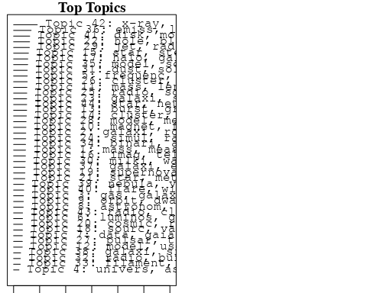

plotQuote(thoughts6, width = 30, main = "Topic 6")  
plotQuote(thoughts18, width = 30, main = "Topic 18")

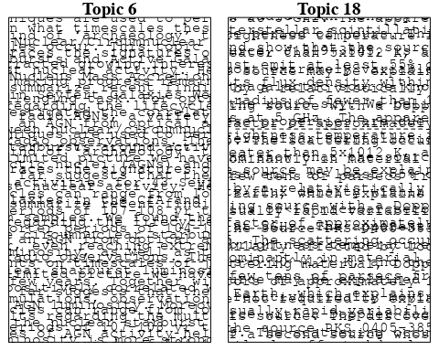

# Calculate and plot the correlation between topics  
mod.out.corr <- topicCorr(Research_topics)  
plot(mod.out.corr, cex = 1.5)  
  
  
# For each topic  
for (topic_num in 1:44) {  
 # Plot the word cloud  
 cloud(Research_topics, topic = topic_num, scale = c(2, 0.25))  
 Sys.sleep(2)  
}

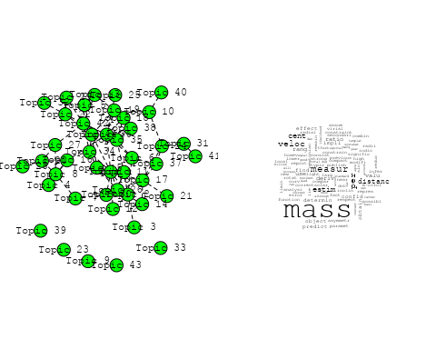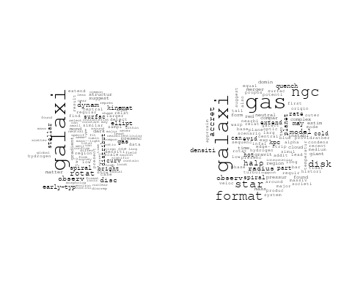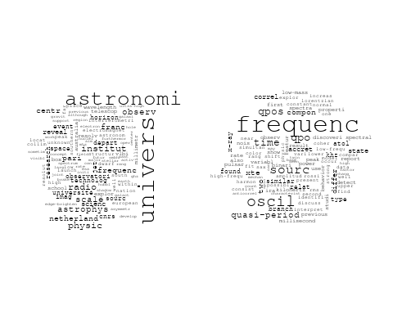

## Warning in wordcloud::wordcloud(words = vocab, freq = vec, max.words =  
## max.words, : galaxi could not be fit on page. It will not be plotted.

## Warning in wordcloud::wordcloud(words = vocab, freq = vec, max.words =  
## max.words, : mission could not be fit on page. It will not be plotted.

## Warning in wordcloud::wordcloud(words = vocab, freq = vec, max.words =  
## max.words, : astrometr could not be fit on page. It will not be plotted.

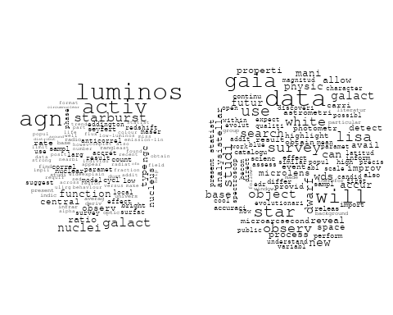

## Warning in wordcloud::wordcloud(words = vocab, freq = vec, max.words =  
## max.words, : research could not be fit on page. It will not be plotted.

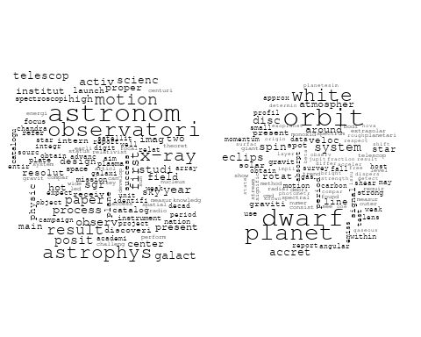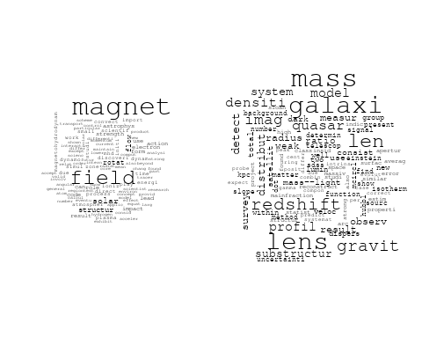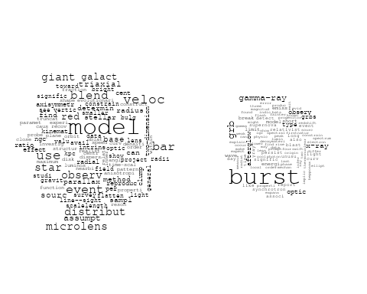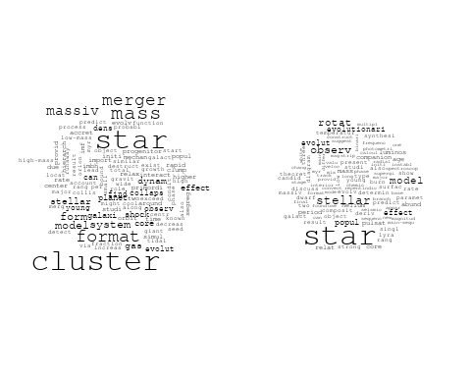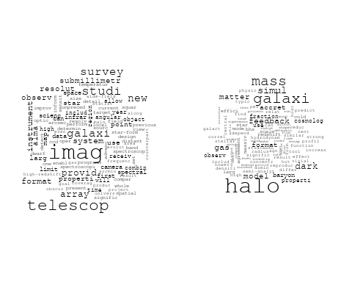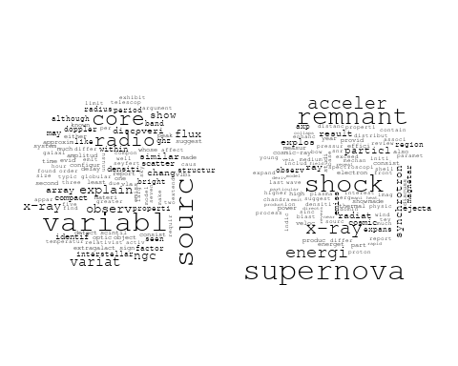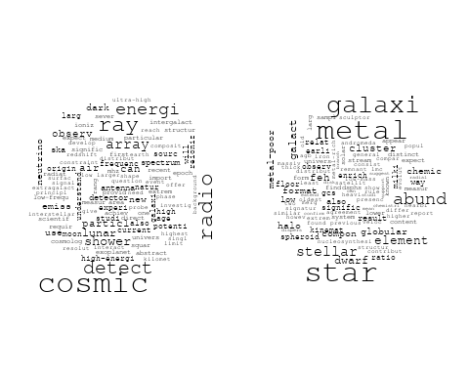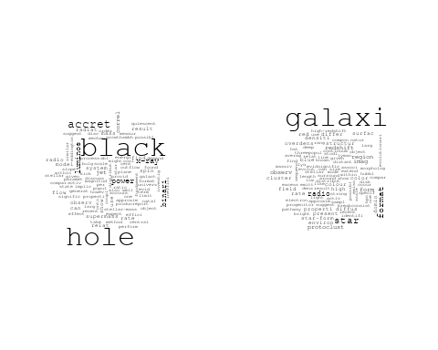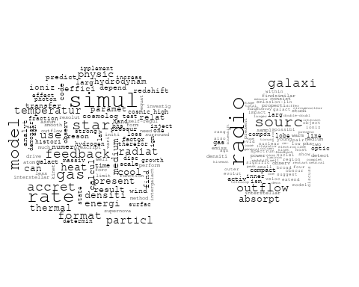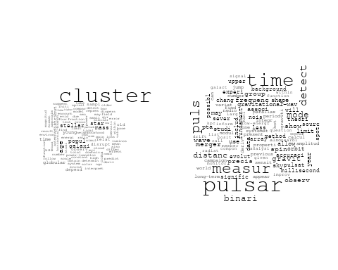

## Warning in wordcloud::wordcloud(words = vocab, freq = vec, max.words =  
## max.words, : find could not be fit on page. It will not be plotted.

## Warning in wordcloud::wordcloud(words = vocab, freq = vec, max.words =  
## max.words, : present could not be fit on page. It will not be plotted.

## Warning in wordcloud::wordcloud(words = vocab, freq = vec, max.words =  
## max.words, : use could not be fit on page. It will not be plotted.

## Warning in wordcloud::wordcloud(words = vocab, freq = vec, max.words =  
## max.words, : independ could not be fit on page. It will not be plotted.

## Warning in wordcloud::wordcloud(words = vocab, freq = vec, max.words =  
## max.words, : observ could not be fit on page. It will not be plotted.

## Warning in wordcloud::wordcloud(words = vocab, freq = vec, max.words =  
## max.words, : cosmolog could not be fit on page. It will not be plotted.

## Warning in wordcloud::wordcloud(words = vocab, freq = vec, max.words =  
## max.words, : model could not be fit on page. It will not be plotted.

## Warning in wordcloud::wordcloud(words = vocab, freq = vec, max.words =  
## max.words, : simul could not be fit on page. It will not be plotted.

## Warning in wordcloud::wordcloud(words = vocab, freq = vec, max.words =  
## max.words, : algorithm could not be fit on page. It will not be plotted.

## Warning in wordcloud::wordcloud(words = vocab, freq = vec, max.words =  
## max.words, : potenti could not be fit on page. It will not be plotted.

## Warning in wordcloud::wordcloud(words = vocab, freq = vec, max.words =  
## max.words, : univers could not be fit on page. It will not be plotted.

## Warning in wordcloud::wordcloud(words = vocab, freq = vec, max.words =  
## max.words, : equat could not be fit on page. It will not be plotted.

## Warning in wordcloud::wordcloud(words = vocab, freq = vec, max.words =  
## max.words, : method could not be fit on page. It will not be plotted.

## Warning in wordcloud::wordcloud(words = vocab, freq = vec, max.words =  
## max.words, : constant could not be fit on page. It will not be plotted.

## Warning in wordcloud::wordcloud(words = vocab, freq = vec, max.words =  
## max.words, : space could not be fit on page. It will not be plotted.

## Warning in wordcloud::wordcloud(words = vocab, freq = vec, max.words =  
## max.words, : statist could not be fit on page. It will not be plotted.

## Warning in wordcloud::wordcloud(words = vocab, freq = vec, max.words =  
## max.words, : studi could not be fit on page. It will not be plotted.

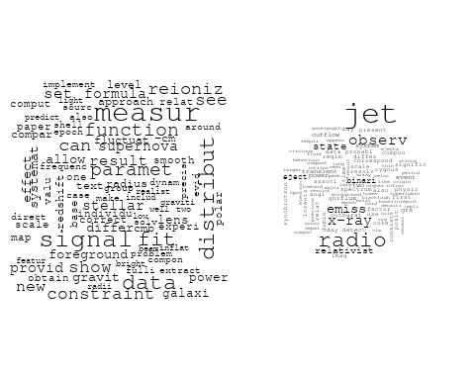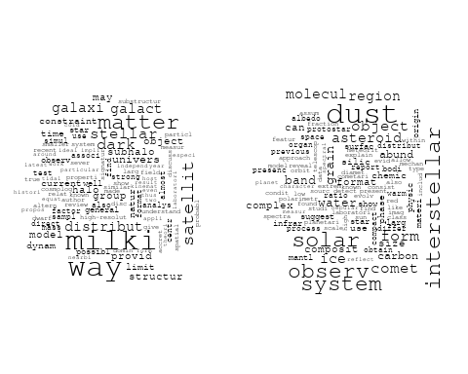

## Warning in wordcloud::wordcloud(words = vocab, freq = vec, max.words =  
## max.words, : circumstellar could not be fit on page. It will not be plotted.

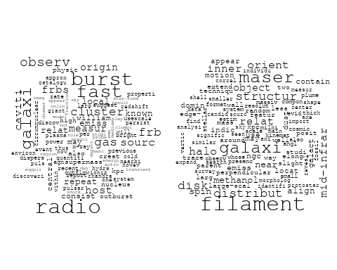

## Warning in wordcloud::wordcloud(words = vocab, freq = vec, max.words =  
## max.words, : sourc could not be fit on page. It will not be plotted.

## Warning in wordcloud::wordcloud(words = vocab, freq = vec, max.words =  
## max.words, : galaxi could not be fit on page. It will not be plotted.

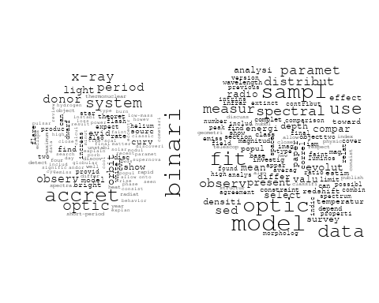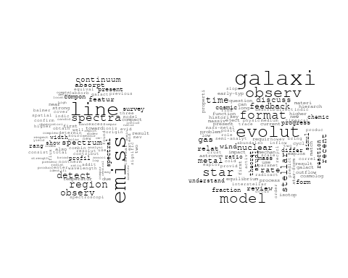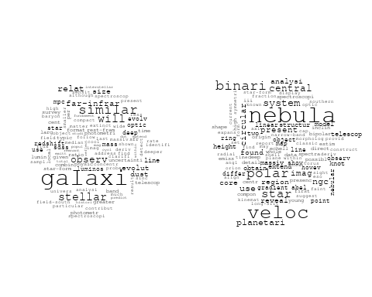

## Warning in wordcloud::wordcloud(words = vocab, freq = vec, max.words =  
## max.words, : flare could not be fit on page. It will not be plotted.

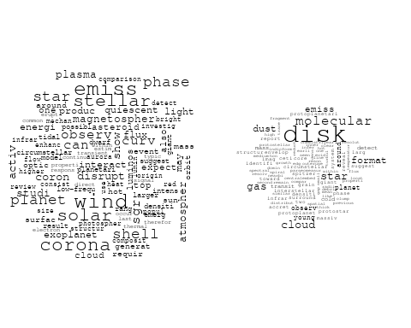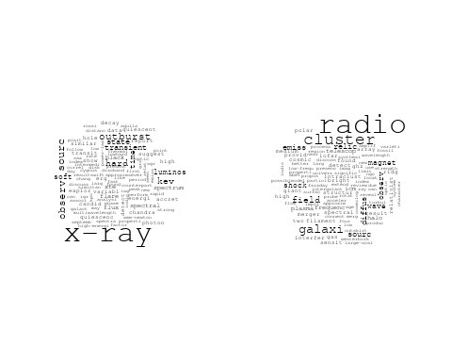

# Get the topic proportions for each document  
topic_proportions <- Research_topics$theta  
  
# Find the index of the topic with the highest proportion for each document  
# This will be the topic that each document is most likely to belong to  
max_topic_idx <- apply(topic_proportions, 1, which.max)  
  
# Add this as a new column to your data  
data_collab$topic <- max_topic_idx  
  
library(ggplot2)  
  
# Define the intervals  
intervals <- c('1824_1899', '1900_1964', '1965_1974', '1975_1984', '1985_1994', '1995_1999', '2000_2004', '2005_2009', '2010_2014', '2015_2019', '2020_2022')  
colors <- c('pink', 'blue', 'purple', 'yellow', 'green', 'pink', 'orange', 'violet', 'green', 'blue', 'pink')  
  
# Loop through the intervals and plot  
for(i in seq_along(intervals)){  
 # Filter data for when the pub_interval is equal to 1  
 data_filtered <- data_collab[data_collab[[paste0('pub_interval_', intervals[i])]] == 1,]  
   
 # Make the histogram  
   
 p <- ggplot(data_filtered, aes(x = topic)) +  
 geom_histogram(binwidth = 1, fill = colors[i], color = "black") +  
 xlab("Topic") +  
 ylab("Count") +  
 ggtitle(paste0("Topics from year ", gsub("_", " to ", intervals[i])))  
   
 print(p)  
}  
  
  
##Topic generation for NL (independent) publications  
  
data_independent <- data[data[["NL"]] == 100,]  
  
# Save the original title data for future use  
data_independent$original_concatenated_title_abstract <- data_independent$concatenated_title_abstract  
  
#pre-processing the titles using textProcessor from the stm package  
processed_text <- textProcessor(data_independent$concatenated_title_abstract, metadata = data_independent)

## Building corpus...   
## Converting to Lower Case...   
## Removing punctuation...   
## Removing stopwords...   
## Removing numbers...   
## Stemming...   
## Creating Output...

# Further prepare the data by removing low-frequency terms  
out_text <- prepDocuments(processed_text$documents, processed_text$vocab, processed_text$meta)

## Removing 1170 of 4756 terms (1170 of 48796 tokens) due to frequency   
## Your corpus now has 603 documents, 3586 terms and 47626 tokens.

docs_text <- out_text$documents  
vocab_text <- out_text$vocab  
meta_text <- out_text$meta  
  
  
#Prepare data  
plotRemoved(processed_text$documents, lower.thresh = seq(1, 200, by = 100))

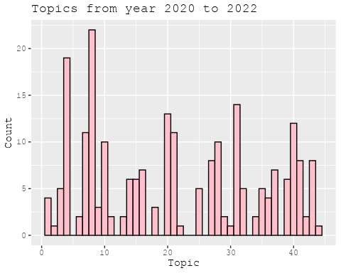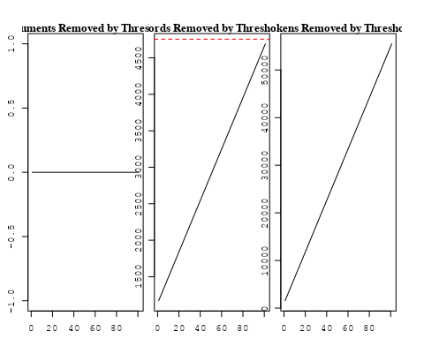

out_text <- prepDocuments(processed_text$documents, processed_text$vocab, processed_text$meta, lower.thresh = 8)

## Removing 3635 of 4756 terms (9706 of 48796 tokens) due to frequency   
## Your corpus now has 603 documents, 1121 terms and 39090 tokens.

str(out_text$meta)

## 'data.frame': 603 obs. of 39 variables:  
## $ concept_id : chr "https://openalex.org/C1276947" "https://openalex.org/C1276947" "https://openalex.org/C1276947" "https://openalex.org/C44870925" ...  
## $ work_id : chr "https://openalex.org/W2039791607" "https://openalex.org/W2133651179" "https://openalex.org/W2111780832" "https://openalex.org/W2118054180" ...  
## $ publication_year : int 1988 2007 2008 2012 2019 2022 2021 2009 2021 2021 ...  
## $ title : chr "Fate of the companion stars of ultra-rapid pulsars" "Infrared Molecular Starburst Fingerprints in Deeply Obscured (Ultra)Luminous Infrared Galaxy Nuclei" "Infall of substructures on to a Milky Way-like dark halo" "The Link between the Baryonic Mass Distribution and the Rotation Curve Shape" ...  
## $ paperabstract : chr "Abstract A millisecond pulsar that is formed by spin-up 'recycling'1,2 in a binary system will, once the mass t"| __truncated__ "High-resolution spectra of the Spitzer Space Telescope show vibration-rotation absorption bands of gaseous C2H2"| __truncated__ "We analyse the dynamical properties of substructures in a high-resolution dark matter simulation of the formati"| __truncated__ "The observed rotation curves of disc galaxies, ranging from late-type dwarf galaxies to early-type spirals, can"| __truncated__ ...  
## $ country : chr "NL NL" "NL" "NL NL" "NL" ...  
## $ year_concept : chr "1988+https://openalex.org/C1276947" "2007+https://openalex.org/C1276947" "2008+https://openalex.org/C1276947" "2012+https://openalex.org/C44870925" ...  
## $ concatenated_title_abstract : chr "Fate of the companion stars of ultra-rapid pulsars Abstract A millisecond pulsar that is formed by spin-up 'rec"| __truncated__ "Infrared Molecular Starburst Fingerprints in Deeply Obscured (Ultra)Luminous Infrared Galaxy Nuclei High-resolu"| __truncated__ "Infall of substructures on to a Milky Way-like dark halo We analyse the dynamical properties of substructures i"| __truncated__ "The Link between the Baryonic Mass Distribution and the Rotation Curve Shape The observed rotation curves of di"| __truncated__ ...  
## $ US : num 0 0 0 0 0 0 0 0 0 0 ...  
## $ IN : num 0 0 0 0 0 0 0 0 0 0 ...  
## $ DE : num 0 0 0 0 0 0 0 0 0 0 ...  
## $ CH : num 0 0 0 0 0 0 0 0 0 0 ...  
## $ GB : num 0 0 0 0 0 0 0 0 0 0 ...  
## $ CN : num 0 0 0 0 0 0 0 0 0 0 ...  
## $ FR : num 0 0 0 0 0 0 0 0 0 0 ...  
## $ IT : num 0 0 0 0 0 0 0 0 0 0 ...  
## $ RU : num 0 0 0 0 0 0 0 0 0 0 ...  
## $ CA : num 0 0 0 0 0 0 0 0 0 0 ...  
## $ NL : num 100 100 100 100 100 100 100 100 100 100 ...  
## $ AU : num 0 0 0 0 0 0 0 0 0 0 ...  
## $ JP : num 0 0 0 0 0 0 0 0 0 0 ...  
## $ ES : num 0 0 0 0 0 0 0 0 0 0 ...  
## $ IL : num 0 0 0 0 0 0 0 0 0 0 ...  
## $ Americas : num 0 0 0 0 0 0 0 0 0 0 ...  
## $ Europe : num 0 0 0 0 0 0 0 0 0 0 ...  
## $ Africa : num 0 0 0 0 0 0 0 0 0 0 ...  
## $ AsiaAndOceania : num 0 0 0 0 0 0 0 0 0 0 ...  
## $ pub_interval_2020_2022 : int 0 0 0 0 0 1 1 0 1 1 ...  
## $ pub_interval_2015_2019 : int 0 0 0 0 1 0 0 0 0 0 ...  
## $ pub_interval_2010_2014 : int 0 0 0 1 0 0 0 0 0 0 ...  
## $ pub_interval_2005_2009 : int 0 1 1 0 0 0 0 1 0 0 ...  
## $ pub_interval_2000_2004 : int 0 0 0 0 0 0 0 0 0 0 ...  
## $ pub_interval_1995_1999 : int 0 0 0 0 0 0 0 0 0 0 ...  
## $ pub_interval_1985_1994 : int 1 0 0 0 0 0 0 0 0 0 ...  
## $ pub_interval_1975_1984 : int 0 0 0 0 0 0 0 0 0 0 ...  
## $ pub_interval_1965_1974 : int 0 0 0 0 0 0 0 0 0 0 ...  
## $ pub_interval_1900_1964 : int 0 0 0 0 0 0 0 0 0 0 ...  
## $ pub_interval_1824_1899 : int 0 0 0 0 0 0 0 0 0 0 ...  
## $ original_concatenated_title_abstract: chr "Fate of the companion stars of ultra-rapid pulsars Abstract A millisecond pulsar that is formed by spin-up 'rec"| __truncated__ "Infrared Molecular Starburst Fingerprints in Deeply Obscured (Ultra)Luminous Infrared Galaxy Nuclei High-resolu"| __truncated__ "Infall of substructures on to a Milky Way-like dark halo We analyse the dynamical properties of substructures i"| __truncated__ "The Link between the Baryonic Mass Distribution and the Rotation Curve Shape The observed rotation curves of di"| __truncated__ ...

# Initialize an empty formula string  
prevalence_formula_str <- "~"  
  
# Define the publication intervals  
pub_intervals <- c("pub_interval_2020_2022", "pub_interval_2015_2019", "pub_interval_2010_2014",   
 "pub_interval_2005_2009", "pub_interval_2000_2004", "pub_interval_1995_1999",  
 "pub_interval_1985_1994", "pub_interval_1975_1984", "pub_interval_1965_1974",  
 "pub_interval_1900_1964", "pub_interval_1824_1899")  
  
# Add each publication interval to the formula string  
for (interval in pub_intervals) {  
 # add an if statement to handle the first addition (without '+')  
 if (prevalence_formula_str == "~") {  
 prevalence_formula_str <- paste(prevalence_formula_str, interval)  
 } else {  
 prevalence_formula_str <- paste(prevalence_formula_str, "+", interval)  
 }  
}  
  
  
# Convert the string to a formula  
prevalence_formula <- as.formula(prevalence_formula_str)  
print(prevalence_formula)

## ~pub_interval_2020_2022 + pub_interval_2015_2019 + pub_interval_2010_2014 +   
## pub_interval_2005_2009 + pub_interval_2000_2004 + pub_interval_1995_1999 +   
## pub_interval_1985_1994 + pub_interval_1975_1984 + pub_interval_1965_1974 +   
## pub_interval_1900_1964 + pub_interval_1824_1899

# Run STM model  
Research_topics <- stm(documents = out_text$documents,   
 vocab = out_text$vocab,   
 K = 43,   
 prevalence = prevalence_formula,   
 data = out_text$meta,   
 init.type = "Spectral",  
 max.em.its = 1000,  
 gamma.prior = 'L1')

## Beginning Spectral Initialization   
## Calculating the gram matrix...  
## Finding anchor words...  
## ...........................................  
## Recovering initialization...  
## ...........  
## Initialization complete.  
## ....................................................................................................  
## Completed E-Step (0 seconds).   
## Completed M-Step.   
## Completing Iteration 1 (approx. per word bound = -5.891)   
## ....................................................................................................  
## Completed E-Step (0 seconds).   
## Completed M-Step.   
## Completing Iteration 2 (approx. per word bound = -5.635, relative change = 4.349e-02)   
## ....................................................................................................  
## Completed E-Step (0 seconds).   
## Completed M-Step.   
## Completing Iteration 3 (approx. per word bound = -5.538, relative change = 1.720e-02)   
## ....................................................................................................  
## Completed E-Step (0 seconds).   
## Completed M-Step.   
## Completing Iteration 4 (approx. per word bound = -5.492, relative change = 8.245e-03)   
## ....................................................................................................  
## Completed E-Step (0 seconds).   
## Completed M-Step.   
## Completing Iteration 5 (approx. per word bound = -5.465, relative change = 4.869e-03)   
## Topic 1: relat, substructur, pulsat, galaxi, quasar   
## Topic 2: univers, astronomi, astronom, observatori, research   
## Topic 3: optic, cloud, data, gaia, phase   
## Topic 4: dynam, publish, equat, can, paper   
## Topic 5: agn, activ, galaxi, galact, nuclei   
## Topic 6: astrophys, scientif, code, test, discoveri   
## Topic 7: veloc, expans, consist, measur, distanc   
## Topic 8: result, ratio, observ, first, give   
## Topic 9: burst, oscil, accret, x-ray, pulsar   
## Topic 10: star, dwarf, popul, helium, evolut   
## Topic 11: radio, sourc, emiss, galaxi, outflow   
## Topic 12: halo, structur, galaxi, simul, dark   
## Topic 13: group, year, satellit, milki, way   
## Topic 14: gas, accret, galaxi, cold, halo   
## Topic 15: galaxi, will, observ, format, imag   
## Topic 16: stellar, potenti, distribut, function, surfac   
## Topic 17: cluster, star, disrupt, time, galact   
## Topic 18: supernova, remnant, x-ray, shock, explos   
## Topic 19: merger, cluster, shock, planet, observ   
## Topic 20: galaxi, sourc, radio, sampl, spectrum   
## Topic 21: frequenc, sourc, xte, time, correl   
## Topic 22: cluster, redshift, orbit, distribut, result   
## Topic 23: system, star, binari, hierarch, supernova   
## Topic 24: x-ray, star, neutron, hard, flare   
## Topic 25: magnet, star, field, measur, motion   
## Topic 26: jet, luminos, observ, model, distribut   
## Topic 27: radio, frequenc, telescop, observ, array   
## Topic 28: format, form, star, cool, halo   
## Topic 29: stellar, metal, star, age, cluster   
## Topic 30: star, region, polar, massiv, extend   
## Topic 31: detect, densiti, object, model, galaxi   
## Topic 32: feedback, model, star, rate, simul   
## Topic 33: hole, black, radio, x-ray, jet   
## Topic 34: simul, signal, fit, foreground, smooth   
## Topic 35: galaxi, cluster, model, halo, dark   
## Topic 36: energi, ray, wind, acceler, spectra   
## Topic 37: sourc, disk, materi, ice, explain   
## Topic 38: period, observ, state, calcul, time   
## Topic 39: mass, galaxi, model, differ, centr   
## Topic 40: matter, dark, galaxi, inner, region   
## Topic 41: galaxi, relat, observ, rotat, spiral   
## Topic 42: x-ray, emiss, observ, kev, spectrum   
## Topic 43: model, examin, strong, studi, use   
## ....................................................................................................  
## Completed E-Step (0 seconds).   
## Completed M-Step.   
## Completing Iteration 6 (approx. per word bound = -5.447, relative change = 3.397e-03)   
## ....................................................................................................  
## Completed E-Step (0 seconds).   
## Completed M-Step.   
## Completing Iteration 7 (approx. per word bound = -5.433, relative change = 2.489e-03)   
## ....................................................................................................  
## Completed E-Step (0 seconds).   
## Completed M-Step.   
## Completing Iteration 8 (approx. per word bound = -5.423, relative change = 1.853e-03)   
## ....................................................................................................  
## Completed E-Step (0 seconds).   
## Completed M-Step.   
## Completing Iteration 9 (approx. per word bound = -5.415, relative change = 1.567e-03)   
## ....................................................................................................  
## Completed E-Step (0 seconds).   
## Completed M-Step.   
## Completing Iteration 10 (approx. per word bound = -5.408, relative change = 1.275e-03)   
## Topic 1: relat, pulsat, substructur, quasar, predict   
## Topic 2: astronomi, univers, astronom, observatori, research   
## Topic 3: cloud, data, gaia, optic, use   
## Topic 4: dynam, equat, publish, can, modifi   
## Topic 5: agn, activ, galaxi, galact, nuclei   
## Topic 6: astrophys, code, test, scientif, discoveri   
## Topic 7: veloc, expans, distanc, consist, measur   
## Topic 8: observ, result, ratio, structur, model   
## Topic 9: burst, oscil, accret, x-ray, pulsar   
## Topic 10: star, dwarf, popul, evolut, helium   
## Topic 11: radio, sourc, galaxi, emiss, outflow   
## Topic 12: halo, galaxi, structur, format, simul   
## Topic 13: group, year, satellit, solar, milki   
## Topic 14: gas, accret, galaxi, cold, halo   
## Topic 15: galaxi, will, format, observ, imag   
## Topic 16: stellar, potenti, distribut, model, function   
## Topic 17: cluster, star, disrupt, time, simul   
## Topic 18: supernova, remnant, x-ray, result, shock   
## Topic 19: merger, cluster, shock, planet, observ   
## Topic 20: galaxi, radio, sourc, sampl, format   
## Topic 21: frequenc, sourc, xte, time, correl   
## Topic 22: cluster, redshift, lens, distribut, orbit   
## Topic 23: system, binari, star, hierarch, effect   
## Topic 24: x-ray, neutron, star, hard, binari   
## Topic 25: magnet, star, field, format, measur   
## Topic 26: jet, model, observ, sourc, luminos   
## Topic 27: radio, frequenc, telescop, observ, state   
## Topic 28: format, form, star, cool, halo   
## Topic 29: stellar, metal, star, age, popul   
## Topic 30: star, region, polar, massiv, extend   
## Topic 31: detect, system, object, densiti, survey   
## Topic 32: feedback, star, rate, model, format   
## Topic 33: hole, black, radio, x-ray, accret   
## Topic 34: simul, signal, foreground, fit, smooth   
## Topic 35: galaxi, cluster, model, halo, dark   
## Topic 36: energi, ray, wind, spectra, particl   
## Topic 37: sourc, disk, materi, ice, explain   
## Topic 38: observ, period, state, calcul, oscil   
## Topic 39: mass, galaxi, model, differ, properti   
## Topic 40: matter, dark, galaxi, inner, jet   
## Topic 41: galaxi, spiral, rotat, relat, observ   
## Topic 42: x-ray, emiss, observ, kev, spectrum   
## Topic 43: galaxi, model, emiss, present, strong   
## ....................................................................................................  
## Completed E-Step (0 seconds).   
## Completed M-Step.   
## Completing Iteration 11 (approx. per word bound = -5.402, relative change = 1.099e-03)   
## ....................................................................................................  
## Completed E-Step (0 seconds).   
## Completed M-Step.   
## Completing Iteration 12 (approx. per word bound = -5.397, relative change = 9.028e-04)   
## ....................................................................................................  
## Completed E-Step (0 seconds).   
## Completed M-Step.   
## Completing Iteration 13 (approx. per word bound = -5.393, relative change = 7.482e-04)   
## ....................................................................................................  
## Completed E-Step (0 seconds).   
## Completed M-Step.   
## Completing Iteration 14 (approx. per word bound = -5.389, relative change = 6.378e-04)   
## ....................................................................................................  
## Completed E-Step (0 seconds).   
## Completed M-Step.   
## Completing Iteration 15 (approx. per word bound = -5.386, relative change = 5.772e-04)   
## Topic 1: pulsat, substructur, relat, quasar, energi   
## Topic 2: astronomi, univers, observatori, astronom, research   
## Topic 3: cloud, gaia, data, optic, phase   
## Topic 4: dynam, equat, publish, galaxi, can   
## Topic 5: agn, activ, galaxi, galact, nuclei   
## Topic 6: astrophys, code, test, discoveri, use   
## Topic 7: veloc, expans, distanc, measur, consist   
## Topic 8: structur, result, ratio, observ, model   
## Topic 9: burst, oscil, accret, x-ray, neutron   
## Topic 10: star, dwarf, popul, evolut, helium   
## Topic 11: radio, sourc, galaxi, outflow, emiss   
## Topic 12: halo, galaxi, format, structur, larg   
## Topic 13: group, satellit, solar, year, associ   
## Topic 14: gas, accret, galaxi, cold, halo   
## Topic 15: galaxi, will, format, observ, imag   
## Topic 16: stellar, distribut, potenti, model, function   
## Topic 17: cluster, star, disrupt, time, simul   
## Topic 18: supernova, remnant, x-ray, result, discuss   
## Topic 19: merger, cluster, shock, planet, observ   
## Topic 20: galaxi, radio, sourc, format, sampl   
## Topic 21: frequenc, sourc, time, xte, correl   
## Topic 22: cluster, redshift, lens, distribut, use   
## Topic 23: system, binari, star, hierarch, effect   
## Topic 24: x-ray, star, neutron, hard, binari   
## Topic 25: magnet, star, field, format, measur   
## Topic 26: jet, model, observ, emiss, sourc   
## Topic 27: radio, frequenc, telescop, observ, state   
## Topic 28: format, star, form, cool, gas   
## Topic 29: stellar, metal, star, cluster, age   
## Topic 30: star, region, polar, massiv, extend   
## Topic 31: system, detect, object, densiti, survey   
## Topic 32: star, rate, feedback, model, format   
## Topic 33: hole, black, radio, accret, x-ray   
## Topic 34: simul, signal, foreground, fit, smooth   
## Topic 35: galaxi, model, cluster, halo, dark   
## Topic 36: energi, ray, wind, particl, spectra   
## Topic 37: sourc, disk, materi, ice, dust   
## Topic 38: observ, state, period, oscil, time   
## Topic 39: mass, galaxi, model, differ, properti   
## Topic 40: matter, dark, galaxi, inner, jet   
## Topic 41: galaxi, spiral, rotat, relat, observ   
## Topic 42: x-ray, emiss, observ, kev, flare   
## Topic 43: galaxi, model, emiss, present, strong   
## ....................................................................................................  
## Completed E-Step (0 seconds).   
## Completed M-Step.   
## Completing Iteration 16 (approx. per word bound = -5.383, relative change = 5.528e-04)   
## ....................................................................................................  
## Completed E-Step (0 seconds).   
## Completed M-Step.   
## Completing Iteration 17 (approx. per word bound = -5.381, relative change = 4.983e-04)   
## ....................................................................................................  
## Completed E-Step (0 seconds).   
## Completed M-Step.   
## Completing Iteration 18 (approx. per word bound = -5.378, relative change = 4.218e-04)   
## ....................................................................................................  
## Completed E-Step (0 seconds).   
## Completed M-Step.   
## Completing Iteration 19 (approx. per word bound = -5.376, relative change = 3.885e-04)   
## ....................................................................................................  
## Completed E-Step (0 seconds).   
## Completed M-Step.   
## Completing Iteration 20 (approx. per word bound = -5.374, relative change = 3.427e-04)   
## Topic 1: pulsat, substructur, relat, quasar, energi   
## Topic 2: astronomi, univers, observatori, astronom, research   
## Topic 3: cloud, phase, optic, gaia, use   
## Topic 4: dynam, equat, publish, galaxi, univers   
## Topic 5: agn, activ, galaxi, galact, gas   
## Topic 6: astrophys, code, test, discoveri, use   
## Topic 7: veloc, distanc, measur, expans, consist   
## Topic 8: structur, result, ratio, observ, model   
## Topic 9: burst, oscil, accret, x-ray, neutron   
## Topic 10: star, dwarf, popul, helium, evolut   
## Topic 11: radio, sourc, galaxi, outflow, emiss   
## Topic 12: halo, galaxi, format, structur, correl   
## Topic 13: group, satellit, solar, associ, milki   
## Topic 14: gas, accret, galaxi, cold, halo   
## Topic 15: galaxi, will, format, observ, imag   
## Topic 16: distribut, stellar, potenti, function, method   
## Topic 17: cluster, star, disrupt, time, simul   
## Topic 18: supernova, remnant, x-ray, result, discuss   
## Topic 19: cluster, merger, shock, planet, observ   
## Topic 20: galaxi, radio, sourc, format, sampl   
## Topic 21: frequenc, sourc, time, xte, correl   
## Topic 22: cluster, redshift, lens, distribut, use   
## Topic 23: system, binari, hierarch, star, effect   
## Topic 24: x-ray, star, neutron, binari, hard   
## Topic 25: magnet, star, field, format, measur   
## Topic 26: jet, model, observ, emiss, sourc   
## Topic 27: radio, telescop, frequenc, observ, state   
## Topic 28: format, star, form, cool, surfac   
## Topic 29: stellar, metal, star, cluster, age   
## Topic 30: region, star, polar, massiv, extend   
## Topic 31: system, object, detect, densiti, comet   
## Topic 32: star, rate, feedback, model, format   
## Topic 33: hole, black, radio, accret, x-ray   
## Topic 34: simul, signal, foreground, fit, smooth   
## Topic 35: galaxi, model, cluster, halo, dark   
## Topic 36: energi, ray, wind, spectra, particl   
## Topic 37: sourc, disk, materi, dust, ice   
## Topic 38: observ, state, period, oscil, time   
## Topic 39: mass, galaxi, model, feedback, properti   
## Topic 40: matter, dark, galaxi, inner, jet   
## Topic 41: galaxi, rotat, spiral, relat, gas   
## Topic 42: x-ray, emiss, observ, kev, flare   
## Topic 43: galaxi, emiss, model, strong, star-form   
## ....................................................................................................  
## Completed E-Step (0 seconds).   
## Completed M-Step.   
## Completing Iteration 21 (approx. per word bound = -5.373, relative change = 2.988e-04)   
## ....................................................................................................  
## Completed E-Step (0 seconds).   
## Completed M-Step.   
## Completing Iteration 22 (approx. per word bound = -5.371, relative change = 3.077e-04)   
## ....................................................................................................  
## Completed E-Step (0 seconds).   
## Completed M-Step.   
## Completing Iteration 23 (approx. per word bound = -5.369, relative change = 3.203e-04)   
## ....................................................................................................  
## Completed E-Step (0 seconds).   
## Completed M-Step.   
## Completing Iteration 24 (approx. per word bound = -5.368, relative change = 2.718e-04)   
## ....................................................................................................  
## Completed E-Step (0 seconds).   
## Completed M-Step.   
## Completing Iteration 25 (approx. per word bound = -5.367, relative change = 2.567e-04)   
## Topic 1: pulsat, substructur, relat, quasar, predict   
## Topic 2: astronomi, univers, observatori, astronom, research   
## Topic 3: cloud, phase, optic, gaia, scienc   
## Topic 4: dynam, equat, publish, galaxi, univers   
## Topic 5: agn, activ, galaxi, galact, nuclei   
## Topic 6: astrophys, code, test, discoveri, calcul   
## Topic 7: veloc, expans, measur, distanc, remnant   
## Topic 8: structur, result, ratio, observ, system   
## Topic 9: burst, oscil, accret, x-ray, pulsar   
## Topic 10: star, dwarf, popul, helium, white   
## Topic 11: radio, sourc, galaxi, outflow, properti   
## Topic 12: halo, galaxi, format, structur, correl   
## Topic 13: group, satellit, solar, associ, milki   
## Topic 14: gas, accret, galaxi, halo, cold   
## Topic 15: galaxi, will, format, observ, imag   
## Topic 16: distribut, stellar, potenti, function, method   
## Topic 17: cluster, star, disrupt, time, simul   
## Topic 18: supernova, remnant, x-ray, result, discuss   
## Topic 19: cluster, merger, shock, planet, observ   
## Topic 20: galaxi, radio, sourc, format, star   
## Topic 21: frequenc, sourc, time, xte, correl   
## Topic 22: cluster, redshift, lens, distribut, use   
## Topic 23: system, binari, hierarch, star, effect   
## Topic 24: x-ray, star, neutron, binari, hard   
## Topic 25: magnet, star, field, format, measur   
## Topic 26: jet, model, observ, emiss, luminos   
## Topic 27: radio, frequenc, telescop, observ, state   
## Topic 28: format, star, form, cool, surfac   
## Topic 29: stellar, metal, star, cluster, age   
## Topic 30: polar, region, star, massiv, extend   
## Topic 31: system, object, detect, densiti, comet   
## Topic 32: rate, star, feedback, model, format   
## Topic 33: hole, black, radio, accret, x-ray   
## Topic 34: simul, signal, fit, foreground, smooth   
## Topic 35: galaxi, model, cluster, halo, dark   
## Topic 36: energi, ray, wind, spectra, particl   
## Topic 37: sourc, disk, materi, dust, ice   
## Topic 38: observ, state, period, oscil, x-ray   
## Topic 39: mass, galaxi, model, feedback, simul   
## Topic 40: matter, dark, galaxi, inner, jet   
## Topic 41: galaxi, rotat, gas, relat, spiral   
## Topic 42: x-ray, emiss, observ, kev, flare   
## Topic 43: galaxi, model, emiss, strong, solar   
## ....................................................................................................  
## Completed E-Step (0 seconds).   
## Completed M-Step.   
## Completing Iteration 26 (approx. per word bound = -5.365, relative change = 2.419e-04)   
## ....................................................................................................  
## Completed E-Step (0 seconds).   
## Completed M-Step.   
## Completing Iteration 27 (approx. per word bound = -5.364, relative change = 2.268e-04)   
## ....................................................................................................  
## Completed E-Step (0 seconds).   
## Completed M-Step.   
## Completing Iteration 28 (approx. per word bound = -5.363, relative change = 2.383e-04)   
## ....................................................................................................  
## Completed E-Step (0 seconds).   
## Completed M-Step.   
## Completing Iteration 29 (approx. per word bound = -5.362, relative change = 2.167e-04)   
## ....................................................................................................  
## Completed E-Step (0 seconds).   
## Completed M-Step.   
## Completing Iteration 30 (approx. per word bound = -5.361, relative change = 1.953e-04)   
## Topic 1: pulsat, substructur, relat, quasar, predict   
## Topic 2: astronomi, univers, observatori, astronom, research   
## Topic 3: cloud, phase, optic, gaia, curv   
## Topic 4: dynam, galaxi, equat, publish, observ   
## Topic 5: agn, activ, galaxi, galact, nuclei   
## Topic 6: astrophys, code, calcul, discoveri, test   
## Topic 7: veloc, expans, measur, remnant, consist   
## Topic 8: structur, result, ratio, observ, system   
## Topic 9: burst, oscil, accret, x-ray, pulsar   
## Topic 10: star, dwarf, popul, helium, companion   
## Topic 11: radio, sourc, galaxi, outflow, properti   
## Topic 12: halo, galaxi, stellar, format, spin   
## Topic 13: group, satellit, associ, solar, star   
## Topic 14: gas, accret, galaxi, halo, cold   
## Topic 15: galaxi, will, format, observ, telescop   
## Topic 16: distribut, stellar, potenti, function, method   
## Topic 17: cluster, star, disrupt, time, simul   
## Topic 18: supernova, remnant, x-ray, result, discuss   
## Topic 19: merger, cluster, shock, planet, observ   
## Topic 20: galaxi, radio, sourc, format, star   
## Topic 21: frequenc, sourc, time, xte, correl   
## Topic 22: cluster, redshift, lens, distribut, use   
## Topic 23: system, binari, hierarch, star, effect   
## Topic 24: x-ray, star, neutron, binari, hard   
## Topic 25: magnet, star, field, format, measur   
## Topic 26: jet, model, observ, emiss, luminos   
## Topic 27: radio, frequenc, telescop, observ, state   
## Topic 28: format, star, form, cool, surfac   
## Topic 29: metal, stellar, cluster, star, age   
## Topic 30: polar, region, star, massiv, extend   
## Topic 31: system, object, detect, densiti, comet   
## Topic 32: rate, star, feedback, model, format   
## Topic 33: hole, black, radio, accret, x-ray   
## Topic 34: simul, signal, fit, foreground, smooth   
## Topic 35: galaxi, model, halo, cluster, dark   
## Topic 36: energi, ray, spectra, wind, acceler   
## Topic 37: sourc, disk, dust, materi, ice   
## Topic 38: observ, state, period, oscil, x-ray   
## Topic 39: mass, galaxi, model, feedback, simul   
## Topic 40: matter, dark, galaxi, inner, model   
## Topic 41: galaxi, rotat, gas, spiral, relat   
## Topic 42: x-ray, emiss, observ, kev, flare   
## Topic 43: galaxi, model, emiss, strong, star-form   
## ....................................................................................................  
## Completed E-Step (0 seconds).   
## Completed M-Step.   
## Completing Iteration 31 (approx. per word bound = -5.360, relative change = 1.964e-04)   
## ....................................................................................................  
## Completed E-Step (0 seconds).   
## Completed M-Step.   
## Completing Iteration 32 (approx. per word bound = -5.359, relative change = 1.622e-04)   
## ....................................................................................................  
## Completed E-Step (0 seconds).   
## Completed M-Step.   
## Completing Iteration 33 (approx. per word bound = -5.358, relative change = 4.154e-05)   
## ....................................................................................................  
## Completed E-Step (0 seconds).   
## Completed M-Step.   
## Completing Iteration 34 (approx. per word bound = -5.357, relative change = 1.875e-04)   
## ....................................................................................................  
## Completed E-Step (0 seconds).   
## Completed M-Step.   
## Completing Iteration 35 (approx. per word bound = -5.357, relative change = 1.256e-04)   
## Topic 1: pulsat, substructur, relat, quasar, halo   
## Topic 2: astronomi, univers, observatori, astronom, research   
## Topic 3: cloud, phase, optic, curv, scienc   
## Topic 4: dynam, galaxi, equat, publish, observ   
## Topic 5: agn, activ, galaxi, galact, nuclei   
## Topic 6: astrophys, code, calcul, discoveri, test   
## Topic 7: veloc, expans, remnant, measur, consist   
## Topic 8: structur, observ, result, ratio, system   
## Topic 9: burst, oscil, accret, x-ray, pulsar   
## Topic 10: star, dwarf, helium, popul, companion   
## Topic 11: radio, sourc, galaxi, outflow, properti   
## Topic 12: halo, stellar, galaxi, spin, format   
## Topic 13: group, satellit, associ, star, solar   
## Topic 14: gas, accret, galaxi, halo, cold   
## Topic 15: galaxi, will, format, observ, telescop   
## Topic 16: distribut, stellar, potenti, function, method   
## Topic 17: cluster, star, disrupt, time, simul   
## Topic 18: supernova, remnant, x-ray, result, discuss   
## Topic 19: merger, cluster, shock, planet, observ   
## Topic 20: galaxi, radio, sourc, format, star   
## Topic 21: frequenc, sourc, time, xte, correl   
## Topic 22: cluster, redshift, lens, distribut, use   
## Topic 23: system, hierarch, binari, star, effect   
## Topic 24: x-ray, star, neutron, binari, system   
## Topic 25: magnet, star, field, format, measur   
## Topic 26: jet, model, observ, emiss, sourc   
## Topic 27: radio, frequenc, telescop, observ, state   
## Topic 28: format, star, form, cool, surfac   
## Topic 29: metal, stellar, cluster, age, star   
## Topic 30: polar, region, star, massiv, extend   
## Topic 31: system, object, detect, densiti, comet   
## Topic 32: rate, star, feedback, model, format   
## Topic 33: hole, black, radio, accret, luminos   
## Topic 34: simul, signal, fit, foreground, smooth   
## Topic 35: galaxi, halo, model, cluster, dark   
## Topic 36: energi, ray, spectra, acceler, particl   
## Topic 37: sourc, disk, dust, materi, ice   
## Topic 38: observ, state, period, oscil, sourc   
## Topic 39: mass, galaxi, model, feedback, disc   
## Topic 40: matter, dark, galaxi, inner, model   
## Topic 41: galaxi, rotat, gas, spiral, relat   
## Topic 42: x-ray, emiss, observ, kev, flare   
## Topic 43: model, galaxi, emiss, strong, solar   
## ....................................................................................................  
## Completed E-Step (0 seconds).   
## Completed M-Step.   
## Completing Iteration 36 (approx. per word bound = -5.356, relative change = 1.538e-04)   
## ....................................................................................................  
## Completed E-Step (0 seconds).   
## Completed M-Step.   
## Completing Iteration 37 (approx. per word bound = -5.355, relative change = 1.289e-04)   
## ....................................................................................................  
## Completed E-Step (0 seconds).   
## Completed M-Step.   
## Completing Iteration 38 (approx. per word bound = -5.355, relative change = 1.083e-04)   
## ....................................................................................................  
## Completed E-Step (0 seconds).   
## Completed M-Step.   
## Completing Iteration 39 (approx. per word bound = -5.354, relative change = 1.018e-04)   
## ....................................................................................................  
## Completed E-Step (0 seconds).   
## Completed M-Step.   
## Completing Iteration 40 (approx. per word bound = -5.354, relative change = 9.898e-05)   
## Topic 1: pulsat, substructur, relat, quasar, halo   
## Topic 2: astronomi, univers, observatori, astronom, research   
## Topic 3: cloud, phase, optic, curv, scienc   
## Topic 4: dynam, galaxi, equat, publish, observ   
## Topic 5: agn, activ, galaxi, galact, nuclei   
## Topic 6: astrophys, code, calcul, discoveri, test   
## Topic 7: veloc, expans, remnant, measur, consist   
## Topic 8: structur, observ, result, ratio, system   
## Topic 9: burst, oscil, accret, x-ray, pulsar   
## Topic 10: star, dwarf, helium, popul, companion   
## Topic 11: radio, sourc, galaxi, outflow, properti   
## Topic 12: halo, stellar, galaxi, spin, orient   
## Topic 13: group, satellit, star, associ, solar   
## Topic 14: gas, accret, galaxi, halo, cold   
## Topic 15: galaxi, will, format, observ, telescop   
## Topic 16: distribut, stellar, potenti, method, function   
## Topic 17: cluster, star, disrupt, time, simul   
## Topic 18: supernova, remnant, x-ray, result, discuss   
## Topic 19: merger, cluster, shock, planet, observ   
## Topic 20: galaxi, radio, sourc, format, star   
## Topic 21: frequenc, sourc, time, xte, correl   
## Topic 22: cluster, redshift, lens, distribut, use   
## Topic 23: system, hierarch, binari, star, halo   
## Topic 24: x-ray, star, neutron, binari, system   
## Topic 25: magnet, star, field, format, measur   
## Topic 26: jet, observ, model, emiss, sourc   
## Topic 27: radio, frequenc, telescop, observ, state   
## Topic 28: format, star, form, cool, gas   
## Topic 29: metal, stellar, cluster, age, star   
## Topic 30: polar, region, star, massiv, extend   
## Topic 31: system, object, detect, densiti, comet   
## Topic 32: rate, star, feedback, model, format   
## Topic 33: hole, black, radio, accret, luminos   
## Topic 34: simul, signal, fit, foreground, smooth   
## Topic 35: galaxi, halo, model, cluster, dark   
## Topic 36: energi, spectra, acceler, particl, ray   
## Topic 37: sourc, disk, dust, materi, ice   
## Topic 38: observ, state, period, oscil, sourc   
## Topic 39: mass, galaxi, model, disc, feedback   
## Topic 40: matter, dark, galaxi, inner, model   
## Topic 41: galaxi, rotat, gas, spiral, relat   
## Topic 42: x-ray, emiss, observ, kev, flare   
## Topic 43: model, galaxi, emiss, strong, solar   
## ....................................................................................................  
## Completed E-Step (0 seconds).   
## Completed M-Step.   
## Completing Iteration 41 (approx. per word bound = -5.353, relative change = 1.015e-04)   
## ....................................................................................................  
## Completed E-Step (0 seconds).   
## Completed M-Step.   
## Completing Iteration 42 (approx. per word bound = -5.352, relative change = 1.057e-04)   
## ....................................................................................................  
## Completed E-Step (0 seconds).   
## Completed M-Step.   
## Completing Iteration 43 (approx. per word bound = -5.352, relative change = 8.821e-05)   
## ....................................................................................................  
## Completed E-Step (0 seconds).   
## Completed M-Step.   
## Completing Iteration 44 (approx. per word bound = -5.352, relative change = 7.736e-05)   
## ....................................................................................................  
## Completed E-Step (0 seconds).   
## Completed M-Step.   
## Completing Iteration 45 (approx. per word bound = -5.351, relative change = 7.619e-05)   
## Topic 1: pulsat, substructur, relat, quasar, halo   
## Topic 2: astronomi, univers, observatori, astronom, research   
## Topic 3: cloud, phase, optic, curv, scienc   
## Topic 4: dynam, galaxi, equat, publish, cluster   
## Topic 5: agn, activ, galaxi, galact, nuclei   
## Topic 6: astrophys, code, calcul, discoveri, test   
## Topic 7: veloc, expans, remnant, measur, consist   
## Topic 8: structur, observ, result, ratio, system   
## Topic 9: burst, oscil, accret, x-ray, pulsar   
## Topic 10: star, dwarf, helium, popul, companion   
## Topic 11: radio, sourc, galaxi, outflow, properti   
## Topic 12: halo, stellar, galaxi, spin, orient   
## Topic 13: group, satellit, star, associ, solar   
## Topic 14: gas, accret, galaxi, halo, cold   
## Topic 15: galaxi, will, format, observ, telescop   
## Topic 16: distribut, stellar, potenti, method, orbit   
## Topic 17: cluster, star, disrupt, time, simul   
## Topic 18: supernova, remnant, x-ray, result, discuss   
## Topic 19: merger, cluster, shock, planet, observ   
## Topic 20: galaxi, radio, sourc, format, star   
## Topic 21: frequenc, sourc, time, xte, correl   
## Topic 22: cluster, redshift, lens, distribut, use   
## Topic 23: system, hierarch, binari, star, halo   
## Topic 24: x-ray, star, neutron, binari, system   
## Topic 25: magnet, star, field, format, measur   
## Topic 26: jet, observ, model, emiss, sourc   
## Topic 27: radio, telescop, frequenc, observ, state   
## Topic 28: format, star, form, cool, gas   
## Topic 29: metal, stellar, cluster, age, popul   
## Topic 30: polar, region, star, massiv, extend   
## Topic 31: system, object, detect, densiti, comet   
## Topic 32: rate, star, feedback, model, format   
## Topic 33: hole, black, radio, accret, luminos   
## Topic 34: simul, signal, fit, foreground, smooth   
## Topic 35: galaxi, halo, model, cluster, dark   
## Topic 36: energi, spectra, acceler, particl, ray   
## Topic 37: sourc, disk, dust, materi, ice   
## Topic 38: observ, state, period, oscil, sourc   
## Topic 39: mass, galaxi, model, disc, feedback   
## Topic 40: matter, dark, galaxi, model, inner   
## Topic 41: galaxi, rotat, gas, spiral, relat   
## Topic 42: x-ray, emiss, observ, kev, flare   
## Topic 43: model, galaxi, emiss, strong, present   
## ....................................................................................................  
## Completed E-Step (0 seconds).   
## Completed M-Step.   
## Completing Iteration 46 (approx. per word bound = -5.351, relative change = 7.353e-05)   
## ....................................................................................................  
## Completed E-Step (0 seconds).   
## Completed M-Step.   
## Completing Iteration 47 (approx. per word bound = -5.350, relative change = 6.887e-05)   
## ....................................................................................................  
## Completed E-Step (0 seconds).   
## Completed M-Step.   
## Completing Iteration 48 (approx. per word bound = -5.350, relative change = 6.249e-05)   
## ....................................................................................................  
## Completed E-Step (0 seconds).   
## Completed M-Step.   
## Completing Iteration 49 (approx. per word bound = -5.350, relative change = 7.260e-05)   
## ....................................................................................................  
## Completed E-Step (0 seconds).   
## Completed M-Step.   
## Completing Iteration 50 (approx. per word bound = -5.349, relative change = 5.982e-05)   
## Topic 1: pulsat, substructur, relat, quasar, predict   
## Topic 2: astronomi, univers, observatori, astronom, research   
## Topic 3: cloud, phase, optic, curv, scienc   
## Topic 4: dynam, galaxi, equat, publish, cluster   
## Topic 5: agn, activ, galaxi, galact, nuclei   
## Topic 6: astrophys, calcul, code, discoveri, use   
## Topic 7: veloc, expans, remnant, measur, distanc   
## Topic 8: observ, structur, result, ratio, system   
## Topic 9: burst, oscil, accret, x-ray, pulsar   
## Topic 10: star, dwarf, helium, popul, companion   
## Topic 11: radio, sourc, galaxi, outflow, properti   
## Topic 12: halo, stellar, galaxi, spin, orient   
## Topic 13: group, satellit, star, associ, solar   
## Topic 14: gas, accret, galaxi, halo, cold   
## Topic 15: galaxi, will, format, observ, telescop   
## Topic 16: distribut, stellar, potenti, method, orbit   
## Topic 17: cluster, star, disrupt, time, simul   
## Topic 18: supernova, remnant, x-ray, result, discuss   
## Topic 19: merger, cluster, shock, planet, observ   
## Topic 20: galaxi, radio, sourc, format, star   
## Topic 21: frequenc, sourc, time, xte, correl   
## Topic 22: cluster, redshift, lens, distribut, use   
## Topic 23: system, hierarch, binari, star, halo   
## Topic 24: x-ray, star, neutron, binari, system   
## Topic 25: magnet, star, field, format, measur   
## Topic 26: jet, observ, model, emiss, sourc   
## Topic 27: radio, telescop, frequenc, observ, state   
## Topic 28: format, star, form, cool, gas   
## Topic 29: metal, stellar, cluster, age, popul   
## Topic 30: polar, region, star, massiv, extend   
## Topic 31: system, object, detect, densiti, comet   
## Topic 32: rate, star, feedback, model, format   
## Topic 33: hole, black, radio, accret, luminos   
## Topic 34: simul, signal, fit, foreground, smooth   
## Topic 35: galaxi, halo, model, cluster, diffus   
## Topic 36: energi, spectra, acceler, particl, ray   
## Topic 37: sourc, disk, dust, materi, ice   
## Topic 38: observ, state, period, oscil, sourc   
## Topic 39: mass, galaxi, model, disc, feedback   
## Topic 40: matter, dark, galaxi, model, inner   
## Topic 41: galaxi, rotat, gas, spiral, relat   
## Topic 42: x-ray, emiss, observ, kev, flare   
## Topic 43: model, galaxi, emiss, strong, present   
## ....................................................................................................  
## Completed E-Step (0 seconds).   
## Completed M-Step.   
## Completing Iteration 51 (approx. per word bound = -5.349, relative change = 6.060e-05)   
## ....................................................................................................  
## Completed E-Step (0 seconds).   
## Completed M-Step.   
## Completing Iteration 52 (approx. per word bound = -5.349, relative change = 5.686e-05)   
## ....................................................................................................  
## Completed E-Step (0 seconds).   
## Completed M-Step.   
## Completing Iteration 53 (approx. per word bound = -5.348, relative change = 5.447e-05)   
## ....................................................................................................  
## Completed E-Step (0 seconds).   
## Completed M-Step.   
## Completing Iteration 54 (approx. per word bound = -5.348, relative change = 5.070e-05)   
## ....................................................................................................  
## Completed E-Step (0 seconds).   
## Completed M-Step.   
## Completing Iteration 55 (approx. per word bound = -5.348, relative change = 4.396e-05)   
## Topic 1: pulsat, substructur, relat, quasar, predict   
## Topic 2: astronomi, univers, observatori, astronom, research   
## Topic 3: cloud, phase, optic, curv, scienc   
## Topic 4: dynam, galaxi, equat, publish, cluster   
## Topic 5: agn, activ, galaxi, galact, nuclei   
## Topic 6: astrophys, calcul, code, discoveri, use   
## Topic 7: veloc, expans, remnant, measur, distanc   
## Topic 8: observ, result, structur, ratio, system   
## Topic 9: burst, oscil, accret, x-ray, pulsar   
## Topic 10: star, dwarf, helium, popul, companion   
## Topic 11: radio, sourc, galaxi, outflow, properti   
## Topic 12: halo, stellar, galaxi, orient, well   
## Topic 13: group, satellit, star, associ, solar   
## Topic 14: gas, accret, galaxi, halo, cold   
## Topic 15: galaxi, will, format, observ, telescop   
## Topic 16: distribut, stellar, potenti, method, orbit   
## Topic 17: cluster, star, disrupt, time, simul   
## Topic 18: supernova, remnant, x-ray, result, discuss   
## Topic 19: merger, cluster, shock, planet, observ   
## Topic 20: galaxi, radio, sourc, format, star   
## Topic 21: frequenc, sourc, time, xte, correl   
## Topic 22: cluster, redshift, lens, distribut, use   
## Topic 23: system, hierarch, binari, star, halo   
## Topic 24: x-ray, star, neutron, binari, system   
## Topic 25: magnet, star, field, format, measur   
## Topic 26: jet, observ, model, emiss, sourc   
## Topic 27: radio, telescop, frequenc, observ, state   
## Topic 28: format, star, form, cool, gas   
## Topic 29: metal, stellar, cluster, age, popul   
## Topic 30: polar, region, star, massiv, extend   
## Topic 31: system, object, detect, densiti, comet   
## Topic 32: rate, star, feedback, model, format   
## Topic 33: hole, black, radio, accret, luminos   
## Topic 34: simul, signal, fit, foreground, smooth   
## Topic 35: galaxi, halo, cluster, model, diffus   
## Topic 36: energi, spectra, acceler, particl, ray   
## Topic 37: sourc, disk, dust, materi, ice   
## Topic 38: observ, state, period, oscil, sourc   
## Topic 39: mass, galaxi, model, disc, feedback   
## Topic 40: matter, dark, galaxi, model, inner   
## Topic 41: galaxi, rotat, gas, spiral, relat   
## Topic 42: x-ray, emiss, observ, kev, flare   
## Topic 43: model, galaxi, emiss, strong, present   
## ....................................................................................................  
## Completed E-Step (0 seconds).   
## Completed M-Step.   
## Completing Iteration 56 (approx. per word bound = -5.348, relative change = 4.544e-05)   
## ....................................................................................................  
## Completed E-Step (0 seconds).   
## Completed M-Step.   
## Completing Iteration 57 (approx. per word bound = -5.347, relative change = 5.828e-05)   
## ....................................................................................................  
## Completed E-Step (0 seconds).   
## Completed M-Step.   
## Completing Iteration 58 (approx. per word bound = -5.347, relative change = 6.223e-05)   
## ....................................................................................................  
## Completed E-Step (0 seconds).   
## Completed M-Step.   
## Completing Iteration 59 (approx. per word bound = -5.347, relative change = 6.070e-05)   
## ....................................................................................................  
## Completed E-Step (0 seconds).   
## Completed M-Step.   
## Completing Iteration 60 (approx. per word bound = -5.346, relative change = 4.912e-05)   
## Topic 1: pulsat, substructur, relat, quasar, predict   
## Topic 2: astronomi, univers, observatori, astronom, research   
## Topic 3: cloud, phase, optic, curv, scienc   
## Topic 4: dynam, galaxi, equat, publish, cluster   
## Topic 5: agn, activ, galaxi, galact, nuclei   
## Topic 6: astrophys, calcul, code, discoveri, use   
## Topic 7: veloc, expans, remnant, measur, averag   
## Topic 8: result, observ, structur, ratio, system   
## Topic 9: burst, oscil, accret, x-ray, pulsar   
## Topic 10: star, dwarf, helium, popul, companion   
## Topic 11: radio, sourc, galaxi, outflow, properti   
## Topic 12: halo, stellar, galaxi, orient, well   
## Topic 13: group, satellit, star, associ, solar   
## Topic 14: gas, accret, galaxi, halo, cold   
## Topic 15: galaxi, will, format, observ, telescop   
## Topic 16: distribut, stellar, potenti, method, orbit   
## Topic 17: cluster, star, time, disrupt, simul   
## Topic 18: supernova, remnant, x-ray, result, discuss   
## Topic 19: merger, cluster, shock, planet, observ   
## Topic 20: galaxi, radio, sourc, format, star   
## Topic 21: frequenc, sourc, time, xte, correl   
## Topic 22: cluster, redshift, lens, distribut, use   
## Topic 23: system, hierarch, binari, star, halo   
## Topic 24: x-ray, star, neutron, binari, system   
## Topic 25: magnet, star, field, format, measur   
## Topic 26: jet, observ, model, emiss, sourc   
## Topic 27: radio, telescop, observ, frequenc, state   
## Topic 28: format, star, form, cool, gas   
## Topic 29: metal, stellar, cluster, age, popul   
## Topic 30: polar, region, star, massiv, circular   
## Topic 31: system, object, detect, densiti, comet   
## Topic 32: rate, star, feedback, model, format   
## Topic 33: hole, black, radio, accret, luminos   
## Topic 34: simul, signal, foreground, fit, smooth   
## Topic 35: galaxi, halo, cluster, model, diffus   
## Topic 36: energi, spectra, acceler, particl, ray   
## Topic 37: sourc, disk, dust, materi, ice   
## Topic 38: observ, state, period, oscil, sourc   
## Topic 39: mass, galaxi, model, disc, feedback   
## Topic 40: matter, dark, galaxi, model, inner   
## Topic 41: galaxi, rotat, gas, spiral, relat   
## Topic 42: x-ray, emiss, observ, kev, flare   
## Topic 43: model, galaxi, emiss, strong, present   
## ....................................................................................................  
## Completed E-Step (0 seconds).   
## Completed M-Step.   
## Completing Iteration 61 (approx. per word bound = -5.346, relative change = 3.836e-05)   
## ....................................................................................................  
## Completed E-Step (0 seconds).   
## Completed M-Step.   
## Completing Iteration 62 (approx. per word bound = -5.346, relative change = 3.489e-05)   
## ....................................................................................................  
## Completed E-Step (0 seconds).   
## Completed M-Step.   
## Completing Iteration 63 (approx. per word bound = -5.346, relative change = 3.079e-05)   
## ....................................................................................................  
## Completed E-Step (0 seconds).   
## Completed M-Step.   
## Completing Iteration 64 (approx. per word bound = -5.346, relative change = 3.201e-05)   
## ....................................................................................................  
## Completed E-Step (0 seconds).   
## Completed M-Step.   
## Completing Iteration 65 (approx. per word bound = -5.346, relative change = 3.360e-05)   
## Topic 1: pulsat, substructur, relat, quasar, predict   
## Topic 2: astronomi, univers, observatori, astronom, research   
## Topic 3: cloud, phase, optic, curv, scienc   
## Topic 4: dynam, galaxi, equat, publish, cluster   
## Topic 5: agn, activ, galaxi, galact, nuclei   
## Topic 6: calcul, astrophys, code, discoveri, use   
## Topic 7: veloc, expans, remnant, measur, distanc   
## Topic 8: result, structur, observ, ratio, system   
## Topic 9: burst, oscil, accret, x-ray, pulsar   
## Topic 10: star, dwarf, helium, popul, companion   
## Topic 11: radio, sourc, galaxi, outflow, properti   
## Topic 12: halo, stellar, galaxi, orient, well   
## Topic 13: group, satellit, star, associ, solar   
## Topic 14: gas, accret, galaxi, cold, halo   
## Topic 15: galaxi, will, format, observ, telescop   
## Topic 16: distribut, stellar, method, potenti, orbit   
## Topic 17: cluster, star, time, disrupt, simul   
## Topic 18: supernova, remnant, x-ray, result, discuss   
## Topic 19: merger, cluster, shock, planet, observ   
## Topic 20: galaxi, radio, sourc, format, star   
## Topic 21: frequenc, sourc, time, xte, correl   
## Topic 22: cluster, redshift, lens, distribut, galaxi   
## Topic 23: system, hierarch, binari, star, halo   
## Topic 24: x-ray, star, neutron, binari, system   
## Topic 25: magnet, star, field, format, measur   
## Topic 26: jet, model, observ, emiss, sourc   
## Topic 27: radio, telescop, observ, frequenc, state   
## Topic 28: format, star, form, cool, gas   
## Topic 29: metal, stellar, cluster, age, popul   
## Topic 30: polar, region, star, massiv, circular   
## Topic 31: system, object, detect, densiti, comet   
## Topic 32: rate, star, feedback, model, format   
## Topic 33: hole, black, radio, accret, luminos   
## Topic 34: simul, signal, foreground, fit, smooth   
## Topic 35: galaxi, halo, cluster, model, diffus   
## Topic 36: energi, spectra, acceler, particl, ray   
## Topic 37: sourc, disk, dust, materi, ice   
## Topic 38: observ, state, period, oscil, sourc   
## Topic 39: mass, galaxi, disc, model, feedback   
## Topic 40: matter, dark, galaxi, model, inner   
## Topic 41: galaxi, rotat, gas, spiral, relat   
## Topic 42: x-ray, emiss, observ, kev, flare   
## Topic 43: model, galaxi, emiss, strong, present   
## ....................................................................................................  
## Completed E-Step (0 seconds).   
## Completed M-Step.   
## Completing Iteration 66 (approx. per word bound = -5.345, relative change = 3.503e-05)   
## ....................................................................................................  
## Completed E-Step (0 seconds).   
## Completed M-Step.   
## Completing Iteration 67 (approx. per word bound = -5.345, relative change = 2.431e-05)   
## ....................................................................................................  
## Completed E-Step (0 seconds).   
## Completed M-Step.   
## Completing Iteration 68 (approx. per word bound = -5.345, relative change = 2.572e-05)   
## ....................................................................................................  
## Completed E-Step (0 seconds).   
## Completed M-Step.   
## Completing Iteration 69 (approx. per word bound = -5.345, relative change = 3.023e-05)   
## ....................................................................................................  
## Completed E-Step (0 seconds).   
## Completed M-Step.   
## Completing Iteration 70 (approx. per word bound = -5.345, relative change = 3.677e-05)   
## Topic 1: pulsat, substructur, relat, quasar, predict   
## Topic 2: astronomi, univers, observatori, astronom, research   
## Topic 3: cloud, phase, optic, curv, scienc   
## Topic 4: dynam, galaxi, equat, publish, cluster   
## Topic 5: agn, activ, galaxi, galact, nuclei   
## Topic 6: calcul, astrophys, code, discoveri, use   
## Topic 7: veloc, expans, remnant, measur, distanc   
## Topic 8: result, structur, observ, ratio, system   
## Topic 9: burst, oscil, accret, x-ray, pulsar   
## Topic 10: star, dwarf, helium, popul, companion   
## Topic 11: radio, sourc, galaxi, outflow, properti   
## Topic 12: halo, stellar, galaxi, orient, structur   
## Topic 13: group, satellit, star, associ, solar   
## Topic 14: gas, accret, galaxi, cold, halo   
## Topic 15: galaxi, will, format, observ, telescop   
## Topic 16: distribut, method, stellar, potenti, orbit   
## Topic 17: cluster, star, time, disrupt, simul   
## Topic 18: supernova, remnant, x-ray, result, discuss   
## Topic 19: merger, cluster, shock, planet, observ   
## Topic 20: galaxi, radio, sourc, format, star   
## Topic 21: frequenc, sourc, time, xte, correl   
## Topic 22: cluster, redshift, lens, distribut, galaxi   
## Topic 23: system, hierarch, binari, star, halo   
## Topic 24: x-ray, star, neutron, binari, system   
## Topic 25: magnet, star, field, format, measur   
## Topic 26: jet, model, observ, emiss, sourc   
## Topic 27: radio, telescop, observ, frequenc, state   
## Topic 28: format, star, form, cool, gas   
## Topic 29: metal, stellar, cluster, age, popul   
## Topic 30: polar, region, star, massiv, circular   
## Topic 31: system, object, detect, densiti, comet   
## Topic 32: rate, star, feedback, model, format   
## Topic 33: hole, black, radio, accret, luminos   
## Topic 34: simul, signal, foreground, fit, smooth   
## Topic 35: galaxi, halo, cluster, model, diffus   
## Topic 36: energi, spectra, acceler, particl, ray   
## Topic 37: sourc, disk, dust, materi, ice   
## Topic 38: observ, state, period, oscil, sourc   
## Topic 39: mass, galaxi, disc, feedback, model   
## Topic 40: matter, dark, galaxi, model, inner   
## Topic 41: galaxi, rotat, gas, spiral, relat   
## Topic 42: x-ray, emiss, observ, kev, flare   
## Topic 43: model, galaxi, emiss, strong, present   
## ....................................................................................................  
## Completed E-Step (0 seconds).   
## Completed M-Step.   
## Completing Iteration 71 (approx. per word bound = -5.345, relative change = 4.126e-05)   
## ....................................................................................................  
## Completed E-Step (0 seconds).   
## Completed M-Step.   
## Completing Iteration 72 (approx. per word bound = -5.344, relative change = 2.950e-05)   
## ....................................................................................................  
## Completed E-Step (0 seconds).   
## Completed M-Step.   
## Completing Iteration 73 (approx. per word bound = -5.344, relative change = 2.349e-05)   
## ....................................................................................................  
## Completed E-Step (0 seconds).   
## Completed M-Step.   
## Completing Iteration 74 (approx. per word bound = -5.344, relative change = 2.694e-05)   
## ....................................................................................................  
## Completed E-Step (0 seconds).   
## Completed M-Step.   
## Completing Iteration 75 (approx. per word bound = -5.344, relative change = 3.149e-05)   
## Topic 1: pulsat, relat, substructur, quasar, predict   
## Topic 2: astronomi, univers, observatori, astronom, research   
## Topic 3: cloud, phase, optic, curv, scienc   
## Topic 4: dynam, galaxi, equat, publish, cluster   
## Topic 5: agn, activ, galaxi, galact, nuclei   
## Topic 6: calcul, astrophys, code, discoveri, use   
## Topic 7: veloc, expans, remnant, measur, distanc   
## Topic 8: result, structur, ratio, observ, system   
## Topic 9: burst, oscil, accret, x-ray, pulsar   
## Topic 10: star, dwarf, helium, popul, companion   
## Topic 11: radio, sourc, galaxi, properti, outflow   
## Topic 12: halo, stellar, galaxi, orient, structur   
## Topic 13: group, satellit, star, associ, milki   
## Topic 14: gas, accret, galaxi, cold, halo   
## Topic 15: galaxi, will, format, observ, telescop   
## Topic 16: distribut, stellar, method, potenti, orbit   
## Topic 17: cluster, star, time, disrupt, simul   
## Topic 18: supernova, remnant, x-ray, result, discuss   
## Topic 19: merger, cluster, shock, planet, observ   
## Topic 20: galaxi, radio, sourc, format, star   
## Topic 21: frequenc, sourc, time, xte, correl   
## Topic 22: cluster, redshift, lens, distribut, galaxi   
## Topic 23: system, hierarch, binari, star, halo   
## Topic 24: x-ray, star, neutron, binari, system   
## Topic 25: magnet, star, field, format, measur   
## Topic 26: jet, observ, model, emiss, sourc   
## Topic 27: radio, telescop, observ, frequenc, state   
## Topic 28: format, star, form, cool, gas   
## Topic 29: metal, stellar, cluster, age, popul   
## Topic 30: polar, region, star, massiv, circular   
## Topic 31: system, object, detect, densiti, comet   
## Topic 32: rate, star, feedback, model, format   
## Topic 33: hole, black, radio, accret, luminos   
## Topic 34: simul, signal, foreground, fit, smooth   
## Topic 35: galaxi, halo, cluster, model, diffus   
## Topic 36: energi, spectra, acceler, particl, ray   
## Topic 37: sourc, disk, dust, materi, ice   
## Topic 38: observ, state, period, oscil, sourc   
## Topic 39: mass, galaxi, disc, feedback, model   
## Topic 40: matter, dark, galaxi, model, inner   
## Topic 41: galaxi, rotat, gas, spiral, relat   
## Topic 42: x-ray, emiss, observ, kev, flare   
## Topic 43: model, galaxi, emiss, strong, present   
## ....................................................................................................  
## Completed E-Step (0 seconds).   
## Completed M-Step.   
## Completing Iteration 76 (approx. per word bound = -5.344, relative change = 3.135e-05)   
## ....................................................................................................  
## Completed E-Step (0 seconds).   
## Completed M-Step.   
## Completing Iteration 77 (approx. per word bound = -5.344, relative change = 2.937e-05)   
## ....................................................................................................  
## Completed E-Step (0 seconds).   
## Completed M-Step.   
## Completing Iteration 78 (approx. per word bound = -5.343, relative change = 3.086e-05)   
## ....................................................................................................  
## Completed E-Step (0 seconds).   
## Completed M-Step.   
## Completing Iteration 79 (approx. per word bound = -5.343, relative change = 3.621e-05)   
## ....................................................................................................  
## Completed E-Step (0 seconds).   
## Completed M-Step.   
## Completing Iteration 80 (approx. per word bound = -5.343, relative change = 3.571e-05)   
## Topic 1: pulsat, relat, substructur, quasar, predict   
## Topic 2: astronomi, univers, observatori, astronom, research   
## Topic 3: cloud, phase, optic, curv, scienc   
## Topic 4: galaxi, dynam, equat, publish, cluster   
## Topic 5: agn, activ, galaxi, galact, nuclei   
## Topic 6: calcul, astrophys, code, discoveri, use   
## Topic 7: veloc, expans, remnant, measur, distanc   
## Topic 8: result, structur, ratio, observ, system   
## Topic 9: burst, oscil, accret, x-ray, pulsar   
## Topic 10: star, dwarf, helium, popul, companion   
## Topic 11: radio, sourc, galaxi, properti, outflow   
## Topic 12: halo, stellar, galaxi, orient, structur   
## Topic 13: group, satellit, star, associ, milki   
## Topic 14: gas, accret, galaxi, cold, halo   
## Topic 15: galaxi, will, format, observ, telescop   
## Topic 16: distribut, stellar, potenti, method, orbit   
## Topic 17: cluster, star, time, disrupt, simul   
## Topic 18: supernova, remnant, x-ray, result, discuss   
## Topic 19: merger, cluster, shock, planet, observ   
## Topic 20: galaxi, radio, sourc, format, star   
## Topic 21: frequenc, sourc, time, xte, correl   
## Topic 22: cluster, redshift, lens, distribut, galaxi   
## Topic 23: system, hierarch, binari, star, halo   
## Topic 24: x-ray, star, neutron, binari, system   
## Topic 25: magnet, star, field, format, measur   
## Topic 26: jet, observ, model, emiss, sourc   
## Topic 27: radio, telescop, observ, frequenc, state   
## Topic 28: format, star, form, cool, gas   
## Topic 29: metal, stellar, cluster, age, popul   
## Topic 30: polar, region, star, massiv, circular   
## Topic 31: system, object, detect, densiti, comet   
## Topic 32: rate, star, feedback, model, format   
## Topic 33: hole, black, radio, accret, luminos   
## Topic 34: simul, signal, foreground, fit, smooth   
## Topic 35: galaxi, halo, cluster, model, diffus   
## Topic 36: energi, spectra, acceler, particl, ray   
## Topic 37: sourc, disk, dust, materi, ice   
## Topic 38: observ, state, period, oscil, sourc   
## Topic 39: mass, galaxi, disc, feedback, model   
## Topic 40: matter, dark, galaxi, model, inner   
## Topic 41: galaxi, rotat, gas, spiral, observ   
## Topic 42: x-ray, emiss, observ, kev, flare   
## Topic 43: model, galaxi, emiss, strong, present   
## ....................................................................................................  
## Completed E-Step (0 seconds).   
## Completed M-Step.   
## Completing Iteration 81 (approx. per word bound = -5.343, relative change = 3.326e-05)   
## ....................................................................................................  
## Completed E-Step (0 seconds).   
## Completed M-Step.   
## Completing Iteration 82 (approx. per word bound = -5.343, relative change = 3.700e-05)   
## ....................................................................................................  
## Completed E-Step (0 seconds).   
## Completed M-Step.   
## Completing Iteration 83 (approx. per word bound = -5.343, relative change = 3.060e-05)   
## ....................................................................................................  
## Completed E-Step (0 seconds).   
## Completed M-Step.   
## Completing Iteration 84 (approx. per word bound = -5.342, relative change = 2.695e-05)   
## ....................................................................................................  
## Completed E-Step (0 seconds).   
## Completed M-Step.   
## Completing Iteration 85 (approx. per word bound = -5.342, relative change = 2.888e-05)   
## Topic 1: pulsat, relat, substructur, quasar, predict   
## Topic 2: astronomi, univers, observatori, astronom, research   
## Topic 3: cloud, phase, optic, curv, scienc   
## Topic 4: galaxi, dynam, equat, cluster, publish   
## Topic 5: agn, activ, galaxi, galact, nuclei   
## Topic 6: calcul, astrophys, code, discoveri, use   
## Topic 7: veloc, expans, remnant, measur, distanc   
## Topic 8: result, structur, ratio, observ, around   
## Topic 9: burst, oscil, accret, x-ray, pulsar   
## Topic 10: star, dwarf, helium, popul, companion   
## Topic 11: radio, sourc, galaxi, properti, outflow   
## Topic 12: halo, stellar, galaxi, orient, structur   
## Topic 13: group, star, satellit, associ, milki   
## Topic 14: gas, accret, galaxi, cold, halo   
## Topic 15: galaxi, will, format, observ, structur   
## Topic 16: distribut, stellar, potenti, method, orbit   
## Topic 17: cluster, star, time, disrupt, simul   
## Topic 18: supernova, remnant, x-ray, result, discuss   
## Topic 19: merger, cluster, shock, planet, observ   
## Topic 20: galaxi, radio, sourc, format, star   
## Topic 21: frequenc, sourc, time, xte, correl   
## Topic 22: cluster, redshift, lens, distribut, galaxi   
## Topic 23: system, hierarch, binari, star, halo   
## Topic 24: x-ray, star, neutron, binari, system   
## Topic 25: magnet, star, field, format, measur   
## Topic 26: jet, model, observ, emiss, sourc   
## Topic 27: radio, telescop, observ, frequenc, state   
## Topic 28: format, star, form, cool, gas   
## Topic 29: metal, stellar, cluster, age, popul   
## Topic 30: polar, region, star, massiv, circular   
## Topic 31: system, object, detect, densiti, comet   
## Topic 32: rate, star, feedback, model, format   
## Topic 33: hole, black, radio, accret, luminos   
## Topic 34: simul, signal, foreground, fit, smooth   
## Topic 35: galaxi, halo, cluster, model, diffus   
## Topic 36: energi, spectra, acceler, particl, ray   
## Topic 37: sourc, disk, dust, materi, ice   
## Topic 38: observ, state, period, oscil, sourc   
## Topic 39: mass, galaxi, disc, feedback, model   
## Topic 40: matter, dark, galaxi, model, inner   
## Topic 41: galaxi, rotat, gas, spiral, observ   
## Topic 42: x-ray, emiss, observ, kev, flare   
## Topic 43: model, galaxi, emiss, strong, present   
## ....................................................................................................  
## Completed E-Step (0 seconds).   
## Completed M-Step.   
## Completing Iteration 86 (approx. per word bound = -5.342, relative change = 2.901e-05)   
## ....................................................................................................  
## Completed E-Step (0 seconds).   
## Completed M-Step.   
## Completing Iteration 87 (approx. per word bound = -5.342, relative change = 2.533e-05)   
## ....................................................................................................  
## Completed E-Step (0 seconds).   
## Completed M-Step.   
## Completing Iteration 88 (approx. per word bound = -5.342, relative change = 2.083e-05)   
## ....................................................................................................  
## Completed E-Step (0 seconds).   
## Completed M-Step.   
## Completing Iteration 89 (approx. per word bound = -5.342, relative change = 2.123e-05)   
## ....................................................................................................  
## Completed E-Step (0 seconds).   
## Completed M-Step.   
## Completing Iteration 90 (approx. per word bound = -5.342, relative change = 2.477e-05)   
## Topic 1: pulsat, relat, substructur, quasar, predict   
## Topic 2: astronomi, univers, observatori, astronom, research   
## Topic 3: cloud, phase, optic, curv, scienc   
## Topic 4: galaxi, dynam, cluster, equat, publish   
## Topic 5: agn, activ, galaxi, galact, nuclei   
## Topic 6: calcul, astrophys, code, discoveri, use   
## Topic 7: veloc, expans, remnant, measur, distanc   
## Topic 8: result, structur, ratio, observ, around   
## Topic 9: burst, oscil, accret, x-ray, pulsar   
## Topic 10: star, dwarf, helium, popul, companion   
## Topic 11: radio, sourc, galaxi, properti, outflow   
## Topic 12: halo, stellar, galaxi, orient, structur   
## Topic 13: group, star, satellit, associ, milki   
## Topic 14: gas, accret, galaxi, halo, cold   
## Topic 15: galaxi, will, format, observ, structur   
## Topic 16: distribut, stellar, potenti, method, orbit   
## Topic 17: cluster, star, time, disrupt, simul   
## Topic 18: supernova, remnant, x-ray, result, discuss   
## Topic 19: merger, cluster, shock, planet, observ   
## Topic 20: galaxi, radio, sourc, format, star   
## Topic 21: frequenc, sourc, time, xte, correl   
## Topic 22: cluster, redshift, lens, distribut, galaxi   
## Topic 23: system, hierarch, binari, star, halo   
## Topic 24: x-ray, star, neutron, binari, system   
## Topic 25: magnet, star, field, format, measur   
## Topic 26: jet, model, emiss, observ, sourc   
## Topic 27: radio, telescop, observ, frequenc, state   
## Topic 28: format, star, form, cool, gas   
## Topic 29: metal, stellar, cluster, age, popul   
## Topic 30: polar, region, star, massiv, circular   
## Topic 31: system, object, detect, densiti, comet   
## Topic 32: rate, star, feedback, model, format   
## Topic 33: hole, black, radio, accret, luminos   
## Topic 34: simul, signal, foreground, fit, smooth   
## Topic 35: galaxi, halo, cluster, model, diffus   
## Topic 36: energi, spectra, acceler, particl, ray   
## Topic 37: sourc, disk, dust, materi, ice   
## Topic 38: observ, state, period, oscil, sourc   
## Topic 39: mass, galaxi, disc, feedback, model   
## Topic 40: matter, dark, galaxi, model, inner   
## Topic 41: galaxi, rotat, gas, spiral, observ   
## Topic 42: x-ray, emiss, observ, kev, flare   
## Topic 43: model, galaxi, strong, emiss, present   
## ....................................................................................................  
## Completed E-Step (0 seconds).   
## Completed M-Step.   
## Completing Iteration 91 (approx. per word bound = -5.341, relative change = 2.558e-05)   
## ....................................................................................................  
## Completed E-Step (0 seconds).   
## Completed M-Step.   
## Completing Iteration 92 (approx. per word bound = -5.341, relative change = 2.286e-05)   
## ....................................................................................................  
## Completed E-Step (0 seconds).   
## Completed M-Step.   
## Completing Iteration 93 (approx. per word bound = -5.341, relative change = 1.975e-05)   
## ....................................................................................................  
## Completed E-Step (0 seconds).   
## Completed M-Step.   
## Completing Iteration 94 (approx. per word bound = -5.341, relative change = 1.814e-05)   
## ....................................................................................................  
## Completed E-Step (0 seconds).   
## Completed M-Step.   
## Completing Iteration 95 (approx. per word bound = -5.341, relative change = 1.579e-05)   
## Topic 1: pulsat, relat, substructur, quasar, predict   
## Topic 2: astronomi, univers, observatori, astronom, observ   
## Topic 3: cloud, phase, optic, curv, scienc   
## Topic 4: galaxi, dynam, cluster, equat, publish   
## Topic 5: agn, activ, galaxi, galact, nuclei   
## Topic 6: calcul, astrophys, code, discoveri, use   
## Topic 7: veloc, expans, remnant, measur, distanc   
## Topic 8: result, structur, ratio, observ, around   
## Topic 9: burst, oscil, accret, x-ray, pulsar   
## Topic 10: star, dwarf, helium, popul, companion   
## Topic 11: radio, sourc, galaxi, properti, outflow   
## Topic 12: halo, stellar, galaxi, orient, well   
## Topic 13: group, star, satellit, associ, milki   
## Topic 14: gas, accret, galaxi, halo, cold   
## Topic 15: galaxi, will, format, observ, structur   
## Topic 16: distribut, stellar, potenti, method, orbit   
## Topic 17: cluster, star, time, disrupt, simul   
## Topic 18: supernova, remnant, x-ray, result, discuss   
## Topic 19: merger, cluster, shock, planet, observ   
## Topic 20: galaxi, radio, sourc, format, star   
## Topic 21: frequenc, sourc, time, xte, correl   
## Topic 22: cluster, redshift, lens, distribut, galaxi   
## Topic 23: system, hierarch, binari, star, halo   
## Topic 24: x-ray, star, neutron, binari, system   
## Topic 25: magnet, star, field, format, measur   
## Topic 26: jet, model, emiss, observ, sourc   
## Topic 27: radio, telescop, observ, frequenc, state   
## Topic 28: format, star, form, cool, gas   
## Topic 29: metal, stellar, cluster, age, popul   
## Topic 30: polar, region, star, massiv, circular   
## Topic 31: system, object, detect, densiti, comet   
## Topic 32: rate, star, feedback, model, format   
## Topic 33: hole, black, radio, accret, luminos   
## Topic 34: simul, signal, foreground, fit, smooth   
## Topic 35: galaxi, halo, cluster, model, diffus   
## Topic 36: energi, spectra, acceler, ray, particl   
## Topic 37: sourc, disk, dust, materi, ice   
## Topic 38: observ, state, period, oscil, sourc   
## Topic 39: mass, galaxi, disc, feedback, model   
## Topic 40: matter, dark, galaxi, model, inner   
## Topic 41: galaxi, rotat, gas, spiral, observ   
## Topic 42: x-ray, emiss, observ, kev, flare   
## Topic 43: model, galaxi, emiss, strong, present   
## ....................................................................................................  
## Completed E-Step (0 seconds).   
## Completed M-Step.   
## Completing Iteration 96 (approx. per word bound = -5.341, relative change = 1.260e-05)   
## ....................................................................................................  
## Completed E-Step (0 seconds).   
## Completed M-Step.   
## Completing Iteration 97 (approx. per word bound = -5.341, relative change = 1.278e-05)   
## ....................................................................................................  
## Completed E-Step (0 seconds).   
## Completed M-Step.   
## Completing Iteration 98 (approx. per word bound = -5.341, relative change = 1.166e-05)   
## ....................................................................................................  
## Completed E-Step (0 seconds).   
## Completed M-Step.   
## Completing Iteration 99 (approx. per word bound = -5.341, relative change = 1.243e-05)   
## ....................................................................................................  
## Completed E-Step (0 seconds).   
## Completed M-Step.   
## Completing Iteration 100 (approx. per word bound = -5.341, relative change = 1.039e-05)   
## Topic 1: pulsat, relat, substructur, quasar, predict   
## Topic 2: astronomi, univers, observatori, astronom, observ   
## Topic 3: cloud, phase, optic, curv, scienc   
## Topic 4: galaxi, dynam, cluster, equat, publish   
## Topic 5: agn, activ, galaxi, galact, nuclei   
## Topic 6: calcul, astrophys, code, discoveri, use   
## Topic 7: veloc, expans, remnant, measur, distanc   
## Topic 8: result, structur, ratio, observ, around   
## Topic 9: burst, oscil, accret, x-ray, pulsar   
## Topic 10: star, dwarf, helium, popul, companion   
## Topic 11: radio, sourc, galaxi, properti, outflow   
## Topic 12: halo, stellar, galaxi, orient, well   
## Topic 13: group, star, satellit, associ, milki   
## Topic 14: gas, accret, galaxi, halo, cold   
## Topic 15: galaxi, will, format, observ, structur   
## Topic 16: distribut, stellar, potenti, method, orbit   
## Topic 17: cluster, star, time, disrupt, simul   
## Topic 18: supernova, remnant, x-ray, result, discuss   
## Topic 19: merger, cluster, shock, planet, observ   
## Topic 20: galaxi, radio, sourc, format, star   
## Topic 21: frequenc, sourc, time, xte, correl   
## Topic 22: cluster, redshift, lens, distribut, galaxi   
## Topic 23: system, hierarch, binari, star, halo   
## Topic 24: x-ray, star, neutron, binari, system   
## Topic 25: magnet, star, field, format, measur   
## Topic 26: jet, model, emiss, observ, sourc   
## Topic 27: radio, telescop, observ, frequenc, state   
## Topic 28: format, star, form, cool, gas   
## Topic 29: metal, stellar, cluster, popul, age   
## Topic 30: polar, region, star, massiv, circular   
## Topic 31: system, object, detect, densiti, comet   
## Topic 32: star, rate, feedback, model, format   
## Topic 33: hole, black, radio, accret, luminos   
## Topic 34: simul, signal, foreground, fit, smooth   
## Topic 35: galaxi, halo, cluster, model, diffus   
## Topic 36: energi, spectra, acceler, ray, particl   
## Topic 37: sourc, disk, dust, materi, ice   
## Topic 38: observ, state, period, oscil, sourc   
## Topic 39: mass, galaxi, disc, feedback, model   
## Topic 40: matter, dark, model, galaxi, inner   
## Topic 41: galaxi, rotat, gas, spiral, observ   
## Topic 42: x-ray, emiss, observ, kev, flare   
## Topic 43: model, galaxi, emiss, strong, solar   
## ....................................................................................................  
## Completed E-Step (0 seconds).   
## Completed M-Step.   
## Completing Iteration 101 (approx. per word bound = -5.341, relative change = 1.119e-05)   
## ....................................................................................................  
## Completed E-Step (0 seconds).   
## Completed M-Step.   
## Completing Iteration 102 (approx. per word bound = -5.341, relative change = 1.692e-05)   
## ....................................................................................................  
## Completed E-Step (0 seconds).   
## Completed M-Step.   
## Completing Iteration 103 (approx. per word bound = -5.340, relative change = 1.494e-05)   
## ....................................................................................................  
## Completed E-Step (0 seconds).   
## Completed M-Step.   
## Completing Iteration 104 (approx. per word bound = -5.340, relative change = 1.870e-05)   
## ....................................................................................................  
## Completed E-Step (0 seconds).   
## Completed M-Step.   
## Completing Iteration 105 (approx. per word bound = -5.340, relative change = 1.368e-05)   
## Topic 1: pulsat, substructur, relat, quasar, predict   
## Topic 2: astronomi, univers, observatori, astronom, observ   
## Topic 3: cloud, phase, optic, curv, scienc   
## Topic 4: galaxi, dynam, cluster, equat, publish   
## Topic 5: agn, activ, galaxi, galact, nuclei   
## Topic 6: calcul, astrophys, code, discoveri, use   
## Topic 7: veloc, expans, remnant, distanc, measur   
## Topic 8: result, structur, ratio, observ, around   
## Topic 9: burst, oscil, accret, x-ray, pulsar   
## Topic 10: star, dwarf, helium, popul, companion   
## Topic 11: radio, sourc, galaxi, properti, outflow   
## Topic 12: halo, stellar, galaxi, orient, well   
## Topic 13: group, star, satellit, associ, milki   
## Topic 14: gas, accret, galaxi, halo, cold   
## Topic 15: galaxi, will, format, observ, structur   
## Topic 16: distribut, potenti, stellar, method, orbit   
## Topic 17: cluster, star, time, disrupt, simul   
## Topic 18: supernova, remnant, x-ray, result, discuss   
## Topic 19: merger, cluster, shock, planet, observ   
## Topic 20: galaxi, radio, sourc, format, star   
## Topic 21: frequenc, sourc, time, xte, correl   
## Topic 22: cluster, redshift, lens, distribut, galaxi   
## Topic 23: system, hierarch, binari, star, halo   
## Topic 24: x-ray, star, neutron, binari, system   
## Topic 25: magnet, star, field, format, measur   
## Topic 26: jet, emiss, model, observ, sourc   
## Topic 27: radio, telescop, observ, frequenc, state   
## Topic 28: format, star, form, cool, gas   
## Topic 29: metal, stellar, cluster, popul, age   
## Topic 30: polar, region, star, massiv, circular   
## Topic 31: system, object, detect, densiti, comet   
## Topic 32: star, rate, feedback, model, format   
## Topic 33: hole, black, radio, accret, luminos   
## Topic 34: simul, signal, foreground, fit, smooth   
## Topic 35: galaxi, halo, cluster, model, diffus   
## Topic 36: energi, spectra, acceler, ray, particl   
## Topic 37: sourc, disk, dust, materi, ice   
## Topic 38: observ, state, period, oscil, sourc   
## Topic 39: mass, galaxi, disc, feedback, model   
## Topic 40: matter, dark, model, galaxi, inner   
## Topic 41: galaxi, rotat, gas, spiral, observ   
## Topic 42: x-ray, emiss, observ, kev, flare   
## Topic 43: model, galaxi, emiss, strong, solar   
## ....................................................................................................  
## Completed E-Step (0 seconds).   
## Completed M-Step.   
## Completing Iteration 106 (approx. per word bound = -5.340, relative change = 1.388e-05)   
## ....................................................................................................  
## Completed E-Step (0 seconds).   
## Completed M-Step.   
## Completing Iteration 107 (approx. per word bound = -5.340, relative change = 1.658e-05)   
## ....................................................................................................  
## Completed E-Step (0 seconds).   
## Completed M-Step.   
## Completing Iteration 108 (approx. per word bound = -5.340, relative change = 1.638e-05)   
## ....................................................................................................  
## Completed E-Step (0 seconds).   
## Completed M-Step.   
## Completing Iteration 109 (approx. per word bound = -5.340, relative change = 1.753e-05)   
## ....................................................................................................  
## Completed E-Step (0 seconds).   
## Completed M-Step.   
## Completing Iteration 110 (approx. per word bound = -5.340, relative change = 1.692e-05)   
## Topic 1: pulsat, substructur, relat, quasar, predict   
## Topic 2: astronomi, univers, observatori, astronom, observ   
## Topic 3: cloud, phase, optic, curv, scienc   
## Topic 4: galaxi, dynam, cluster, equat, publish   
## Topic 5: agn, activ, galaxi, galact, nuclei   
## Topic 6: calcul, astrophys, code, discoveri, use   
## Topic 7: veloc, expans, remnant, distanc, measur   
## Topic 8: result, structur, ratio, observ, around   
## Topic 9: burst, oscil, accret, x-ray, pulsar   
## Topic 10: star, dwarf, helium, popul, companion   
## Topic 11: radio, sourc, galaxi, properti, outflow   
## Topic 12: halo, stellar, galaxi, orient, well   
## Topic 13: group, star, satellit, associ, stellar   
## Topic 14: gas, accret, galaxi, halo, cold   
## Topic 15: galaxi, will, format, observ, structur   
## Topic 16: distribut, potenti, stellar, method, orbit   
## Topic 17: cluster, star, time, disrupt, simul   
## Topic 18: supernova, remnant, x-ray, result, discuss   
## Topic 19: merger, cluster, shock, planet, observ   
## Topic 20: galaxi, radio, sourc, format, star   
## Topic 21: frequenc, sourc, time, xte, correl   
## Topic 22: cluster, redshift, lens, distribut, galaxi   
## Topic 23: system, hierarch, binari, star, halo   
## Topic 24: x-ray, star, neutron, binari, system   
## Topic 25: magnet, star, field, format, measur   
## Topic 26: jet, emiss, model, observ, sourc   
## Topic 27: radio, telescop, observ, frequenc, state   
## Topic 28: format, star, form, cool, gas   
## Topic 29: metal, stellar, cluster, popul, age   
## Topic 30: polar, region, star, massiv, circular   
## Topic 31: system, object, detect, densiti, comet   
## Topic 32: star, rate, feedback, model, format   
## Topic 33: hole, black, radio, accret, luminos   
## Topic 34: simul, signal, foreground, fit, smooth   
## Topic 35: galaxi, halo, cluster, model, diffus   
## Topic 36: energi, spectra, acceler, ray, particl   
## Topic 37: sourc, disk, dust, materi, ice   
## Topic 38: observ, state, period, oscil, sourc   
## Topic 39: mass, galaxi, disc, feedback, model   
## Topic 40: matter, dark, model, galaxi, inner   
## Topic 41: galaxi, rotat, gas, spiral, observ   
## Topic 42: x-ray, emiss, observ, kev, flare   
## Topic 43: model, galaxi, emiss, strong, solar   
## ....................................................................................................  
## Completed E-Step (0 seconds).   
## Completed M-Step.   
## Completing Iteration 111 (approx. per word bound = -5.340, relative change = 1.327e-05)   
## ....................................................................................................  
## Completed E-Step (0 seconds).   
## Completed M-Step.   
## Completing Iteration 112 (approx. per word bound = -5.340, relative change = 1.150e-05)   
## ....................................................................................................  
## Completed E-Step (0 seconds).   
## Completed M-Step.   
## Completing Iteration 113 (approx. per word bound = -5.340, relative change = 1.342e-05)   
## ....................................................................................................  
## Completed E-Step (0 seconds).   
## Completed M-Step.   
## Completing Iteration 114 (approx. per word bound = -5.340, relative change = 1.634e-05)   
## ....................................................................................................  
## Completed E-Step (0 seconds).   
## Completed M-Step.   
## Completing Iteration 115 (approx. per word bound = -5.340, relative change = 1.632e-05)   
## Topic 1: pulsat, substructur, relat, quasar, predict   
## Topic 2: astronomi, univers, observatori, astronom, observ   
## Topic 3: cloud, phase, optic, curv, scienc   
## Topic 4: galaxi, dynam, cluster, equat, publish   
## Topic 5: agn, activ, galaxi, galact, nuclei   
## Topic 6: calcul, astrophys, code, discoveri, use   
## Topic 7: veloc, expans, remnant, distanc, measur   
## Topic 8: result, structur, ratio, observ, around   
## Topic 9: burst, oscil, accret, x-ray, pulsar   
## Topic 10: star, dwarf, helium, popul, companion   
## Topic 11: radio, sourc, galaxi, properti, outflow   
## Topic 12: halo, stellar, galaxi, orient, well   
## Topic 13: group, star, satellit, associ, stellar   
## Topic 14: gas, accret, galaxi, halo, cold   
## Topic 15: galaxi, will, format, observ, structur   
## Topic 16: distribut, potenti, stellar, method, orbit   
## Topic 17: cluster, star, time, disrupt, simul   
## Topic 18: supernova, remnant, x-ray, result, discuss   
## Topic 19: merger, cluster, shock, planet, observ   
## Topic 20: galaxi, radio, sourc, format, star   
## Topic 21: frequenc, sourc, time, xte, correl   
## Topic 22: cluster, redshift, lens, distribut, galaxi   
## Topic 23: system, hierarch, binari, star, halo   
## Topic 24: x-ray, star, neutron, binari, system   
## Topic 25: magnet, star, field, format, measur   
## Topic 26: jet, emiss, model, observ, sourc   
## Topic 27: radio, telescop, observ, frequenc, state   
## Topic 28: format, star, form, cool, gas   
## Topic 29: metal, stellar, cluster, popul, age   
## Topic 30: polar, region, star, massiv, circular   
## Topic 31: system, object, detect, densiti, comet   
## Topic 32: star, rate, feedback, model, format   
## Topic 33: hole, black, radio, accret, detect   
## Topic 34: simul, signal, foreground, fit, smooth   
## Topic 35: galaxi, halo, cluster, model, diffus   
## Topic 36: energi, spectra, acceler, ray, particl   
## Topic 37: sourc, disk, dust, materi, ice   
## Topic 38: observ, state, period, oscil, sourc   
## Topic 39: mass, galaxi, disc, feedback, model   
## Topic 40: matter, dark, model, galaxi, inner   
## Topic 41: galaxi, rotat, gas, spiral, observ   
## Topic 42: x-ray, emiss, observ, kev, flare   
## Topic 43: model, galaxi, emiss, strong, solar   
## ....................................................................................................  
## Completed E-Step (0 seconds).   
## Completed M-Step.   
## Completing Iteration 116 (approx. per word bound = -5.339, relative change = 1.349e-05)   
## ....................................................................................................  
## Completed E-Step (0 seconds).   
## Completed M-Step.   
## Completing Iteration 117 (approx. per word bound = -5.339, relative change = 1.227e-05)   
## ....................................................................................................  
## Completed E-Step (0 seconds).   
## Completed M-Step.   
## Completing Iteration 118 (approx. per word bound = -5.339, relative change = 1.264e-05)   
## ....................................................................................................  
## Completed E-Step (0 seconds).   
## Completed M-Step.   
## Completing Iteration 119 (approx. per word bound = -5.339, relative change = 1.339e-05)   
## ....................................................................................................  
## Completed E-Step (0 seconds).   
## Completed M-Step.   
## Completing Iteration 120 (approx. per word bound = -5.339, relative change = 1.493e-05)   
## Topic 1: pulsat, substructur, relat, quasar, predict   
## Topic 2: astronomi, univers, observatori, astronom, observ   
## Topic 3: cloud, phase, optic, curv, scienc   
## Topic 4: galaxi, dynam, cluster, equat, publish   
## Topic 5: agn, activ, galaxi, galact, nuclei   
## Topic 6: calcul, astrophys, code, discoveri, use   
## Topic 7: veloc, expans, remnant, distanc, measur   
## Topic 8: result, structur, ratio, observ, around   
## Topic 9: burst, oscil, accret, x-ray, pulsar   
## Topic 10: star, helium, dwarf, popul, binari   
## Topic 11: radio, sourc, galaxi, properti, outflow   
## Topic 12: halo, stellar, galaxi, orient, well   
## Topic 13: group, star, satellit, associ, stellar   
## Topic 14: gas, accret, galaxi, halo, cold   
## Topic 15: galaxi, will, format, observ, structur   
## Topic 16: distribut, potenti, stellar, method, orbit   
## Topic 17: cluster, star, time, disrupt, simul   
## Topic 18: supernova, remnant, x-ray, result, discuss   
## Topic 19: merger, cluster, shock, planet, observ   
## Topic 20: galaxi, radio, sourc, format, star   
## Topic 21: frequenc, sourc, time, xte, correl   
## Topic 22: cluster, redshift, lens, distribut, galaxi   
## Topic 23: system, hierarch, binari, star, halo   
## Topic 24: x-ray, star, neutron, binari, system   
## Topic 25: magnet, star, field, format, measur   
## Topic 26: jet, emiss, model, observ, sourc   
## Topic 27: radio, telescop, observ, frequenc, state   
## Topic 28: format, star, form, cool, gas   
## Topic 29: metal, stellar, cluster, popul, age   
## Topic 30: polar, region, star, massiv, circular   
## Topic 31: system, object, detect, densiti, comet   
## Topic 32: star, rate, feedback, model, format   
## Topic 33: hole, black, radio, accret, detect   
## Topic 34: simul, signal, foreground, fit, smooth   
## Topic 35: galaxi, halo, cluster, model, diffus   
## Topic 36: energi, spectra, acceler, ray, particl   
## Topic 37: sourc, disk, dust, ice, materi   
## Topic 38: observ, state, period, oscil, sourc   
## Topic 39: mass, galaxi, disc, feedback, model   
## Topic 40: matter, dark, model, galaxi, inner   
## Topic 41: galaxi, rotat, gas, spiral, observ   
## Topic 42: x-ray, emiss, observ, kev, flare   
## Topic 43: model, galaxi, emiss, strong, solar   
## ....................................................................................................  
## Completed E-Step (0 seconds).   
## Completed M-Step.   
## Completing Iteration 121 (approx. per word bound = -5.339, relative change = 1.678e-05)   
## ....................................................................................................  
## Completed E-Step (0 seconds).   
## Completed M-Step.   
## Completing Iteration 122 (approx. per word bound = -5.339, relative change = 1.612e-05)   
## ....................................................................................................  
## Completed E-Step (0 seconds).   
## Completed M-Step.   
## Completing Iteration 123 (approx. per word bound = -5.339, relative change = 1.325e-05)   
## ....................................................................................................  
## Completed E-Step (0 seconds).   
## Completed M-Step.   
## Completing Iteration 124 (approx. per word bound = -5.339, relative change = 1.281e-05)   
## ....................................................................................................  
## Completed E-Step (0 seconds).   
## Completed M-Step.   
## Completing Iteration 125 (approx. per word bound = -5.339, relative change = 1.315e-05)   
## Topic 1: pulsat, substructur, relat, quasar, predict   
## Topic 2: astronomi, univers, observatori, astronom, observ   
## Topic 3: cloud, phase, optic, curv, scienc   
## Topic 4: galaxi, dynam, cluster, equat, publish   
## Topic 5: agn, activ, galaxi, galact, nuclei   
## Topic 6: calcul, astrophys, code, discoveri, use   
## Topic 7: veloc, expans, remnant, distanc, measur   
## Topic 8: result, structur, ratio, observ, around   
## Topic 9: burst, oscil, accret, x-ray, pulsar   
## Topic 10: star, helium, dwarf, popul, binari   
## Topic 11: radio, sourc, galaxi, properti, outflow   
## Topic 12: halo, stellar, galaxi, orient, well   
## Topic 13: group, star, satellit, associ, stellar   
## Topic 14: gas, accret, galaxi, halo, cold   
## Topic 15: galaxi, will, format, observ, structur   
## Topic 16: distribut, potenti, stellar, method, orbit   
## Topic 17: cluster, star, time, disrupt, simul   
## Topic 18: supernova, remnant, x-ray, result, discuss   
## Topic 19: merger, cluster, shock, planet, observ   
## Topic 20: galaxi, radio, sourc, format, star   
## Topic 21: frequenc, sourc, time, xte, correl   
## Topic 22: cluster, redshift, lens, distribut, galaxi   
## Topic 23: system, hierarch, binari, star, halo   
## Topic 24: x-ray, star, neutron, binari, system   
## Topic 25: magnet, star, field, format, measur   
## Topic 26: jet, emiss, model, observ, sourc   
## Topic 27: radio, telescop, observ, frequenc, state   
## Topic 28: format, star, form, cool, gas   
## Topic 29: metal, stellar, cluster, popul, age   
## Topic 30: polar, region, star, massiv, circular   
## Topic 31: system, object, detect, densiti, comet   
## Topic 32: star, rate, feedback, model, format   
## Topic 33: hole, black, radio, accret, detect   
## Topic 34: simul, signal, foreground, fit, smooth   
## Topic 35: galaxi, halo, cluster, model, diffus   
## Topic 36: energi, spectra, acceler, ray, particl   
## Topic 37: sourc, disk, dust, ice, materi   
## Topic 38: observ, state, period, oscil, sourc   
## Topic 39: mass, galaxi, disc, feedback, model   
## Topic 40: matter, dark, model, galaxi, inner   
## Topic 41: galaxi, rotat, gas, spiral, observ   
## Topic 42: x-ray, emiss, observ, kev, flare   
## Topic 43: model, galaxi, emiss, strong, solar   
## ....................................................................................................  
## Completed E-Step (0 seconds).   
## Completed M-Step.   
## Completing Iteration 126 (approx. per word bound = -5.339, relative change = 1.279e-05)   
## ....................................................................................................  
## Completed E-Step (0 seconds).   
## Completed M-Step.   
## Completing Iteration 127 (approx. per word bound = -5.339, relative change = 1.179e-05)   
## ....................................................................................................  
## Completed E-Step (0 seconds).   
## Completed M-Step.   
## Completing Iteration 128 (approx. per word bound = -5.339, relative change = 1.003e-05)   
## ....................................................................................................  
## Completed E-Step (0 seconds).   
## Completed M-Step.   
## Completing Iteration 129 (approx. per word bound = -5.339, relative change = 1.015e-05)   
## ....................................................................................................  
## Completed E-Step (0 seconds).   
## Completed M-Step.   
## Model Converged

# Plot the STM model summary  
plot(Research_topics, type = "summary", xlim = c(0, 0.3))  
  
# Print the top 10 labels for each topic  
topic_labels <- labelTopics(Research_topics, n=10)  
print(topic_labels)

## Topic 1 Top Words:  
## Highest Prob: pulsat, substructur, relat, quasar, predict, energi, bhs, dark, halo, model   
## FREX: substructur, pulsat, quasar, bhs, level, len, evolutionari, inject, convect, ring   
## Lift: quasar, convect, substructur, ring, unambigu, pulsat, inject, threshold, adjust, arc   
## Score: quasar, pulsat, substructur, bhs, len, inject, dark, threshold, convect, lens   
## Topic 2 Top Words:  
## Highest Prob: astronomi, univers, observatori, astronom, observ, research, institut, earth, physic, solar   
## FREX: astronomi, observatori, institut, astronom, research, univers, earth, cosmic, year, astrophys   
## Lift: institut, observatori, astronomi, research, earth, southern, astronom, public, technolog, univers   
## Score: astronomi, institut, observatori, research, astronom, earth, univers, southern, astrophys, scienc   
## Topic 3 Top Words:  
## Highest Prob: cloud, phase, optic, curv, scienc, gaia, use, work, show, space   
## FREX: cloud, gaia, scienc, curv, optic, mission, highlight, product, scientif, work   
## Lift: highlight, gaia, mission, public, scienc, scientif, technolog, cloud, access, coverag   
## Score: gaia, scientif, scienc, highlight, cloud, curv, optic, phase, mission, research   
## Topic 4 Top Words:  
## Highest Prob: galaxi, dynam, cluster, equat, publish, observ, model, univers, dark, can   
## FREX: equat, publish, dynam, modifi, addit, ngc, scheme, context, enabl, valu   
## Lift: publish, equat, modifi, free, scheme, altern, infer, enabl, context, dynam   
## Score: publish, equat, scheme, ngc, modifi, dynam, dark, galaxi, cluster, discrep   
## Topic 5 Top Words:  
## Highest Prob: agn, activ, galaxi, galact, nuclei, starburst, gas, radio, luminos, observ   
## FREX: agn, starburst, nuclei, activ, nucleus, eddington, cycl, impact, trace, anticorrel   
## Lift: starburst, summar, eddington, agn, nuclei, life, nucleus, anticorrel, activ, cycl   
## Score: agn, starburst, activ, nuclei, anticorrel, nucleus, cycl, gas, eddington, ism   
## Topic 6 Top Words:  
## Highest Prob: calcul, astrophys, code, discoveri, use, scientif, imag, radiat, test, lead   
## FREX: calcul, code, astrophys, formul, scientif, discoveri, valid, modern, flow, lead   
## Lift: formul, modern, accept, code, calcul, hold, valid, eventu, astrophys, scientif   
## Score: scientif, astrophys, formul, code, discoveri, calcul, hold, accept, modern, comput   
## Topic 7 Top Words:  
## Highest Prob: veloc, expans, remnant, distanc, measur, averag, consist, part, shock, map   
## FREX: expans, averag, whole, distanc, veloc, map, gradient, part, point, construct   
## Lift: whole, expans, spectrograph, rest, negat, gradient, construct, archiv, map, sight   
## Score: whole, expans, remnant, gradient, veloc, map, distanc, shock, synchrotron, part   
## Topic 8 Top Words:  
## Highest Prob: structur, result, ratio, observ, around, system, two, first, stellar, galact   
## FREX: formula, ratio, atmospher, around, purpos, structur, first, laboratori, give, less   
## Lift: formula, purpos, subject, laboratori, see, atmospher, suppos, concentr, text, drift   
## Score: formula, laboratori, atmospher, purpos, text, molecular, sun, structur, spiral, ratio   
## Topic 9 Top Words:  
## Highest Prob: burst, oscil, accret, x-ray, pulsar, neutron, star, igr, cool, observ   
## FREX: burst, oscil, igr, pulsar, persist, thermonuclear, millisecond, neutron, cool, sax   
## Lift: igr, burst, thermonuclear, oscil, anomal, drift, persist, photospher, fall, x‐ray   
## Score: burst, oscil, igr, neutron, millisecond, pulsar, sax, thermonuclear, persist, accret   
## Topic 10 Top Words:  
## Highest Prob: star, helium, dwarf, popul, binari, companion, white, neutron, discuss, survey   
## FREX: helium, companion, white, dwarf, evolutionari, synthesi, singl, short, transfer, popul   
## Lift: white, companion, follow-, helium, synthesi, transfer, burn, short, strategi, singl   
## Score: white, helium, companion, neutron, star, dwarf, pulsar, binari, popul, transfer   
## Topic 11 Top Words:  
## Highest Prob: radio, sourc, galaxi, properti, outflow, luminos, young, rang, larg, find   
## FREX: radio, sourc, outflow, compact, morpholog, seri, young, emission-lin, pair, rang   
## Lift: seri, emission-lin, radio-loud, align, coverag, column, five, radio, myr, morpholog   
## Score: radio, sourc, seri, pair, agn, emission-lin, outflow, young, inner, galaxi   
## Topic 12 Top Words:  
## Highest Prob: halo, stellar, galaxi, orient, well, structur, compon, near, format, presenc   
## FREX: orient, slight, halo, filament, chemistri, thick, assembl, near, inner, spin   
## Lift: orient, chemistri, assembl, thick, slight, led, magellan, filament, trajectori, ago   
## Score: halo, orient, filament, thick, milki, spin, chemistri, led, inner, slight   
## Topic 13 Top Words:  
## Highest Prob: group, star, satellit, associ, stellar, milki, goal, flare, solar, may   
## FREX: group, goal, associ, satellit, milki, flare, subhalo, list, ago, substructur   
## Lift: goal, group, list, long-term, ago, member, subhalo, align, infal, assess   
## Score: goal, group, milki, subhalo, flare, satellit, substructur, associ, infal, stream   
## Topic 14 Top Words:  
## Highest Prob: gas, accret, galaxi, halo, cold, mode, hot, smbh, disk, observ   
## FREX: cold, smbh, gas, mode, hot, tail, accret, infal, strip, suppli   
## Lift: stabil, smbh, tail, strip, cold, suppli, infal, mode, onto, circumnuclear   
## Score: gas, cold, halo, accret, smbh, tail, mode, stabil, infal, hot   
## Topic 15 Top Words:  
## Highest Prob: galaxi, will, format, observ, structur, telescop, imag, star, larg, dwarf   
## FREX: will, hubbl, merg, spectroscop, nearbi, histori, telescop, shown, dwarf, perspect   
## Lift: perspect, especi, paradigm, shown, hubbl, ubiquit, merg, web, will, mpc   
## Score: galaxi, perspect, deep, will, star-form, histori, dwarf, progenitor, hubbl, merg   
## Topic 16 Top Words:  
## Highest Prob: distribut, potenti, stellar, method, orbit, function, model, new, lens, galaxi   
## FREX: potenti, method, function, orbit, optim, graviti, break, lens, distribut, constraint   
## Lift: optim, solv, fulli, suffer, graviti, likelihood, potenti, break, inclin, bayesian   
## Score: lens, potenti, optim, method, break, self-consist, orbit, comput, function, solv   
## Topic 17 Top Words:  
## Highest Prob: cluster, star, time, disrupt, simul, galact, similar, energi, effect, relat   
## FREX: disrupt, cluster, encount, gain, bar, center, n-bodi, dissolv, spiral, tidal   
## Lift: lose, dissolv, n-bodi, encount, gain, disrupt, perturb, bar, loss, m-circl   
## Score: cluster, encount, disrupt, bar, gain, n-bodi, spiral, lose, tidal, center   
## Topic 18 Top Words:  
## Highest Prob: supernova, remnant, x-ray, result, discuss, magnetar, shock, radiat, provid, high   
## FREX: supernova, remnant, magnetar, last, ejecta, explos, interest, spectroscopi, contain, review   
## Lift: magnetar, ejecta, canon, supernova, remnant, advanc, anomal, hypothesi, action, last   
## Score: remnant, supernova, magnetar, x-ray, ejecta, synchrotron, plasma, spin, last, acceler   
## Topic 19 Top Words:  
## Highest Prob: merger, cluster, shock, planet, observ, format, spin, gas, along, known   
## FREX: merger, shock, equatori, along, planet, spin, pair, axi, trend, extrasolar   
## Lift: equatori, extrasolar, ubiquit, merger, along, crucial, unclear, trend, bound, axi   
## Score: merger, shock, equatori, planet, spin, cluster, pair, along, extrasolar, gas   
## Topic 20 Top Words:  
## Highest Prob: galaxi, radio, sourc, format, star, sampl, within, mode, light, spectrum   
## FREX: mode, sampl, gps, peak, light, diffus, within, spectrum, select, low   
## Lift: gps, undergo, rule, colour, invers, compton, mode, address, confin, select   
## Score: radio, gps, galaxi, mode, sourc, diffus, peak, spectrum, remnant, cycl   
## Topic 21 Top Words:  
## Highest Prob: frequenc, sourc, time, xte, correl, color, accret, featur, similar, compon   
## FREX: xte, color, frequenc, behavior, sax, correl, millisecond, featur, shift, qpo   
## Lift: behavior, low-luminos, xte, color, shift, sax, break, qpo, unlik, frequenc   
## Score: xte, frequenc, millisecond, behavior, sax, qpo, color, shift, pulsar, anticorrel   
## Topic 22 Top Words:  
## Highest Prob: cluster, redshift, lens, distribut, galaxi, use, result, measur, merger, sourc   
## FREX: lens, relax, redshift, weak, signal, background, uncertainti, mass--light, cluster, gravit   
## Lift: relax, distort, agre, weak, lens, background, distant, random, isotherm, uncertainti   
## Score: lens, relax, redshift, cluster, mass--light, signal, len, merger, uncertainti, regard   
## Topic 23 Top Words:  
## Highest Prob: system, hierarch, binari, star, halo, effect, bhs, form, seed, supernova   
## FREX: hierarch, bhs, seed, multipl, asymmetr, binari, decreas, system, evolv, suppli   
## Lift: hierarch, seed, asymmetr, alreadi, lifetim, inhabit, multipl, bhs, channel, deposit   
## Score: hierarch, bhs, seed, binari, halo, system, supernova, multipl, progenitor, alreadi   
## Topic 24 Top Words:  
## Highest Prob: x-ray, star, neutron, binari, system, black, hole, hard, transient, outburst   
## FREX: neutron, transient, outburst, hard, x-ray, binari, flare, soft, transit, pulsat   
## Lift: aql, puls, outburst, neutron, transient, corona, aquila, hard, transit, soft   
## Score: neutron, x-ray, outburst, binari, black, hole, transient, hard, flare, aql   
## Topic 25 Top Words:  
## Highest Prob: magnet, star, field, format, measur, planet, molecular, gas, reveal, transit   
## FREX: magnet, sign, transit, planet, earlier, field, motion, molecular, strength, probe   
## Lift: sign, magnet, narrow, reduct, necessari, earlier, alreadi, prototyp, motion, proper   
## Score: magnet, sign, planet, molecular, transit, motion, star, reduct, field, measur   
## Topic 26 Top Words:  
## Highest Prob: jet, emiss, model, observ, sourc, luminos, radio, wavelength, distribut, also   
## FREX: jet, wavelength, count, sgr, mild, relativist, transient, infrar, outflow, special   
## Lift: special, sens, sgr, mild, wavelength, lorentz, rank, compton, likelihood, jet   
## Score: jet, special, sgr, wavelength, count, transient, dust, grs, mild, synchrotron   
## Topic 27 Top Words:  
## Highest Prob: radio, telescop, observ, frequenc, state, ghz, receiv, present, detect, array   
## FREX: ghz, receiv, telescop, baselin, radio, array, digit, interferometri, state, mas   
## Lift: digit, mas, baselin, interferometri, receiv, routin, ghz, synthesi, cygnus, array   
## Score: radio, digit, ghz, baselin, interferometri, frequenc, astronom, receiv, mas, telescop   
## Topic 28 Top Words:  
## Highest Prob: format, star, form, cool, gas, carbon, halo, object, surfac, import   
## FREX: carbon, cool, never, atom, primordi, condit, grain, bodi, format, surfac   
## Lift: never, primordi, atom, carbon, bodi, channel, upon, certain, formal, water   
## Score: never, cool, carbon, primordi, format, atom, halo, bodi, grain, ice   
## Topic 29 Top Words:  
## Highest Prob: metal, stellar, cluster, popul, age, star, observ, globular, chemic, galaxi   
## FREX: metal, age, globular, old, chemic, popul, content, stellar, metal-poor, composit   
## Lift: oldest, metal, metal-poor, old, globular, hundr, age, gradual, today, chemic   
## Score: metal, globular, age, popul, old, stream, oldest, chemic, cluster, metal-poor   
## Topic 30 Top Words:  
## Highest Prob: polar, region, star, massiv, circular, molecular, extend, linear, high, low-mass   
## FREX: polar, circular, linear, region, massiv, nebula, molecular, ism, extend, warm   
## Lift: polar, warm, circular, linear, elong, nebula, parsec, angl, wide-field, ism   
## Score: polar, circular, molecular, linear, massiv, ism, region, nebula, warm, earth   
## Topic 31 Top Words:  
## Highest Prob: system, object, detect, densiti, comet, galaxi, model, solar, satellit, survey   
## FREX: comet, diamet, len, techniqu, slope, dot, object, satellit, profil, mcircl   
## Lift: diamet, comet, sigma, mcircl, pixel, brief, techniqu, planetari, len, hint   
## Score: diamet, comet, len, dot, cometari, satellit, interstellar, lens, system, mcircl   
## Topic 32 Top Words:  
## Highest Prob: star, rate, feedback, model, format, gas, simul, accret, cosmolog, physic   
## FREX: feedback, rate, cosmolog, growth, bhs, histori, hand, cosmic, hydrodynam, prescript   
## Lift: motiv, quench, prescript, hand, steep, feedback, drive, match, suppress, declin   
## Score: feedback, bhs, motiv, gas, rate, hand, agn, simul, cosmolog, growth   
## Topic 33 Top Words:  
## Highest Prob: hole, black, radio, accret, detect, luminos, x-ray, observ, show, jet   
## FREX: hole, black, generat, relativist, ska, radio, supermass, luminos, compact, survey   
## Lift: ska, hole, black, generat, squar, essenti, intermediate-mass, throughout, relativist, next   
## Score: hole, black, radio, ska, accret, jet, relativist, luminos, supermass, x-ray   
## Topic 34 Top Words:  
## Highest Prob: simul, signal, foreground, fit, smooth, reioniz, experi, data, emiss, frequenc   
## FREX: foreground, smooth, signal, reioniz, -cm, experi, fit, lofar, instrument, epoch   
## Lift: foreground, -cm, smooth, realist, lofar, reioniz, signal, epoch, excel, respons   
## Score: foreground, reioniz, signal, -cm, smooth, simul, fit, lofar, nois, realist   
## Topic 35 Top Words:  
## Highest Prob: galaxi, halo, cluster, model, diffus, satellit, star, milki, way, properti   
## FREX: diffus, satellit, milki, latest, fossil, agreement, emphasi, way, gradient, domin   
## Lift: emphasi, irregular, overview, latest, fainter, fossil, semi-analyt, spheroid, brightest, prevent   
## Score: milki, halo, diffus, fossil, emphasi, satellit, reioniz, latest, gradient, dark   
## Topic 36 Top Words:  
## Highest Prob: energi, spectra, acceler, ray, particl, observ, spectral, shock, cosmic, show   
## FREX: ray, acceler, spectra, particl, energi, wind, cosmic, spectral, wave, ion   
## Lift: ion, ray, acceler, intergalact, diagnost, wave, suffici, wind, spectra, particl   
## Score: acceler, ray, ion, spectra, shock, remnant, energi, cosmic, particl, chandra   
## Topic 37 Top Words:  
## Highest Prob: sourc, disk, dust, ice, materi, observ, model, interstellar, grain, band   
## FREX: ice, dust, materi, grain, disk, band, nebula, explain, scatter, believ   
## Lift: believ, ice, materi, grain, doppler, silic, red, band, nebula, dust   
## Score: ice, dust, materi, grain, believ, disk, sourc, interstellar, nebula, band   
## Topic 38 Top Words:  
## Highest Prob: observ, state, period, oscil, sourc, x-ray, time, spectral, grs, type   
## FREX: grs, simultan, state, period, oscil, event, repeat, count, eject, qpo   
## Lift: interv, grs, minimum, repeat, branch, simultan, random, sequenc, ref, eject   
## Score: grs, oscil, interv, period, state, qpo, quasi-period, count, branch, simultan   
## Topic 39 Top Words:  
## Highest Prob: mass, galaxi, disc, feedback, model, simul, halo, larg, format, massiv   
## FREX: mass, disc, feedback, baryon, galaxi, run, momentum, fraction, simul, angular   
## Lift: mass, run, disc, net, baryon, overwhelm, momentum, virial, high-redshift, rough   
## Score: mass, galaxi, feedback, halo, disc, run, baryon, simul, net, momentum   
## Topic 40 Top Words:  
## Highest Prob: matter, dark, model, galaxi, inner, region, jet, issu, pair, observ   
## FREX: matter, dark, issu, inner, subhalo, fluctuat, pair, theori, spiral, jet   
## Lift: issu, fluctuat, matter, subhalo, boost, pair, formal, dark, theori, angl   
## Score: matter, issu, dark, pair, subhalo, inner, spiral, fluctuat, jet, boost   
## Topic 41 Top Words:  
## Highest Prob: galaxi, rotat, gas, spiral, observ, relat, ngc, kinemat, curv, presenc   
## FREX: rotat, spiral, ngc, plane, deviat, curv, kinemat, disc, bar, neutral   
## Lift: deviat, plane, stabl, ngc, serv, rotat, neutral, forc, accord, spiral   
## Score: spiral, deviat, ngc, bar, gas, kinemat, galaxi, curv, rotat, neutral   
## Topic 42 Top Words:  
## Highest Prob: x-ray, emiss, observ, kev, flare, spectrum, hard, sourc, luminos, flux   
## FREX: kev, decay, flare, quiescenc, x-ray, cometari, bepposax, day, erg, hard   
## Lift: bepposax, quiescenc, decay, kev, board, onset, cometari, day, aquila, quiescent   
## Score: x-ray, kev, decay, cometari, flare, quiescenc, bepposax, erg, emiss, aquila   
## Topic 43 Top Words:  
## Highest Prob: model, galaxi, emiss, strong, solar, star-form, present, examin, predict, star   
## FREX: star-form, examin, strong, separ, reason, ioniz, continuum, element, abund, solar   
## Lift: examin, reason, heavi, separ, star-form, element, sloan, class, ioniz, empir   
## Score: examin, star-form, ioniz, emiss, solar, reason, separ, abund, galaxi, classif

# Match the processed documents with the original titles  
matched_titles <- out_text$meta$original_concatenated_title_abstract  
  
# Print top 5 documents for each topic  
top_docs <- findThoughts(Research_topics, texts = matched_titles, n = 5)$docs[[1]]  
print(top_docs)

## [1] "Statistics of mass substructure from strong gravitational lensing: quantifying the mass fraction and mass function A Bayesian statistical formalism is developed to quantify the level at which the mass function (dN/dm proportional to m-alpha) and the projected cumulative mass fraction (f) of [cold dark matter (CDM)] substructure in strong gravitational lens galaxies, with arcs or Einstein rings, can be recovered as function of the lens survey parameters and the detection threshold of the substructure mass. The method is applied to different sets of mock data to explore a range of observational limits: (i) the number of lens galaxies in the survey; (ii) the mass threshold, M(low), for the detection of substructures and (iii) the uncertainty of the measured substructure masses. We explore two different priors on the mass function slope: a uniform prior and a Gaussian prior with alpha = 1.90 +/- 0.1. With a substructure detection threshold M(low) = 3 x 108 M(circle dot), the number of lenses available now (n(l) = 30), a true dark matter mass fraction in (CDM) substructure <1.0 per cent and a prior of alpha = 1.90 +/- 0.1, we find that the upper limit of f can be constrained down to a level <1.0 per cent [95 per cent confidence level (CL)]. In the case of a uniform prior, the complete substructure mass distribution (i.e. mass fraction and slope) can only be characterized in a number of favourable cases with a large number of detected substructures. This can be achieved by an increase of the resolution and the signal-to-noise ratio of the lensed images. In the case of a Gaussian prior on alpha, instead, it is always possible to set stringent constraints on both parameters. We also find that lowering the detection threshold has the largest impact on the ability to recover alpha, because of the (expected) steep mass function slope. In the future, thanks to new surveys with telescopes, such as Square Kilometre Array (SKA), Large Synoptic Survey Telescope (LSST) and Joint Dark Energy Mission (JDEM) and follow-up telescopes with high-fidelity data, a significant increase in the number of known lenses (i.e. 104) will allow us to recover the satellite population in its completeness. For example, a sample of 200 lenses, equivalent in data quality to the Sloan Lens ACS Survey and a detection threshold of 108 M(circle dot), allows one to determine f = 0.5 +/- 0.1 per cent (68 per cent CL) and alpha = 1.90 +/- 0.2 (68 per cent CL)."  
## [2] "Statistics of mass substructure from strong gravitational lensing: quantifying the mass fraction and mass function A Bayesian statistical formalism is developed to quantify the level at which the mass function (dN/dm proportional to m-alpha) and the projected cumulative mass fraction (f) of [cold dark matter (CDM)] substructure in strong gravitational lens galaxies, with arcs or Einstein rings, can be recovered as function of the lens survey parameters and the detection threshold of the substructure mass. The method is applied to different sets of mock data to explore a range of observational limits: (i) the number of lens galaxies in the survey; (ii) the mass threshold, M(low), for the detection of substructures and (iii) the uncertainty of the measured substructure masses. We explore two different priors on the mass function slope: a uniform prior and a Gaussian prior with alpha = 1.90 +/- 0.1. With a substructure detection threshold M(low) = 3 x 108 M(circle dot), the number of lenses available now (n(l) = 30), a true dark matter mass fraction in (CDM) substructure <1.0 per cent and a prior of alpha = 1.90 +/- 0.1, we find that the upper limit of f can be constrained down to a level <1.0 per cent [95 per cent confidence level (CL)]. In the case of a uniform prior, the complete substructure mass distribution (i.e. mass fraction and slope) can only be characterized in a number of favourable cases with a large number of detected substructures. This can be achieved by an increase of the resolution and the signal-to-noise ratio of the lensed images. In the case of a Gaussian prior on alpha, instead, it is always possible to set stringent constraints on both parameters. We also find that lowering the detection threshold has the largest impact on the ability to recover alpha, because of the (expected) steep mass function slope. In the future, thanks to new surveys with telescopes, such as Square Kilometre Array (SKA), Large Synoptic Survey Telescope (LSST) and Joint Dark Energy Mission (JDEM) and follow-up telescopes with high-fidelity data, a significant increase in the number of known lenses (i.e. 104) will allow us to recover the satellite population in its completeness. For example, a sample of 200 lenses, equivalent in data quality to the Sloan Lens ACS Survey and a detection threshold of 108 M(circle dot), allows one to determine f = 0.5 +/- 0.1 per cent (68 per cent CL) and alpha = 1.90 +/- 0.2 (68 per cent CL)."  
## [3] "Improving the mass determination of Galactic Cepheids We have selected a sample of Galactic Cepheids for which accurate estimates of radii, distances, and photometric parameters are available. The comparison between their pulsation masses, based on new period-mass-radius (PMR) relations, and their evolutionary masses, based on both optical and NIR color-magnitude (CM) diagrams, suggests that pulsation masses are on average of the order of 10% smaller than the evolutionary masses. Current pulsation masses show, at fixed radius, a strongly reduced dispersion when compared with values published in the literature. The increased precision in the pulsation masses is due to the fact that our predicted PMR relations based on nonlinear, convective Cepheid models present smaller standard deviations than PMR relations based on linear models. At the same time, the empirical radii of our Cepheid sample are typically accurate at the 5% level. Our evolutionary mass determinations are based on stellar models constructed by neglecting the effect of mass loss during the He burning phase. Therefore, the difference between pulsation and evolutionary masses could be intrinsic and does not necessarily imply a problem with either evolutionary and/or nonlinear pulsation models. The marginal evidence of a trend in the difference between evolutionary and pulsation masses when moving from short- to long-period Cepheids is also briefly discussed. The main finding of our investigation is that the long-standing Cepheid mass discrepancy seems now resolved at the 10% level either if we account for canonical or mild convective core overshooting evolutionary models."   
## [4] "Improving the mass determination of Galactic Cepheids We have selected a sample of Galactic Cepheids for which accurate estimates of radii, distances, and photometric parameters are available. The comparison between their pulsation masses, based on new period-mass-radius (PMR) relations, and their evolutionary masses, based on both optical and NIR color-magnitude (CM) diagrams, suggests that pulsation masses are on average of the order of 10% smaller than the evolutionary masses. Current pulsation masses show, at fixed radius, a strongly reduced dispersion when compared with values published in the literature. The increased precision in the pulsation masses is due to the fact that our predicted PMR relations based on nonlinear, convective Cepheid models present smaller standard deviations than PMR relations based on linear models. At the same time, the empirical radii of our Cepheid sample are typically accurate at the 5% level. Our evolutionary mass determinations are based on stellar models constructed by neglecting the effect of mass loss during the He burning phase. Therefore, the difference between pulsation and evolutionary masses could be intrinsic and does not necessarily imply a problem with either evolutionary and/or nonlinear pulsation models. The marginal evidence of a trend in the difference between evolutionary and pulsation masses when moving from short- to long-period Cepheids is also briefly discussed. The main finding of our investigation is that the long-standing Cepheid mass discrepancy seems now resolved at the 10% level either if we account for canonical or mild convective core overshooting evolutionary models."   
## [5] "Dark matter haloes determine the masses of supermassive black holes The energy and momentum deposited by the radiation from accretion flows on to the supermassive black holes (BHs) that reside at the centres of virtually all galaxies can halt or even reverse gas inflow, providing a natural mechanism for supermassive BHs to regulate their growth and to couple their properties to those of their host galaxies. However, it remains unclear whether this self-regulation occurs on the scale at which the BH is gravitationally dominant, on that of the stellar bulge, the galaxy or that of the entire dark matter halo. To answer this question, we use self-consistent simulations of the co-evolution of the BH and galaxy populations that reproduce the observed correlations between the masses of the BHs and the properties of their host galaxies. We first confirm unambiguously that the BHs regulate their growth: the amount of energy that the BHs inject into their surroundings remains unchanged when the fraction of the accreted rest mass energy that is injected is varied by four orders of magnitude. The BHs simply adjust their masses so as to inject the same amount of energy. We then use simulations with artificially reduced star formation rates to demonstrate explicitly that BH mass is not set by the stellar mass. Instead, we find that it is determined by the mass of the dark matter halo with a secondary dependence on the halo concentration, of the form that would be expected if the halo binding energy were the fundamental property that controls the mass of the BH. We predict that the BH mass, mBH, scales with halo mass as mBH∝mαhalo, with α≈ 1.55 ± 0.05, and that the scatter around the mean relation in part reflects the scatter in the halo concentration–mass relation."

# Find and plot the key "thoughts" or documents for selected topics  
thoughts6 <- findThoughts(Research_topics, texts = matched_titles, n = 3, topics = 6)$docs[[1]]  
thoughts18 <- findThoughts(Research_topics, texts = matched_titles, n = 3, topics = 18)$docs[[1]]  
par(mfrow = c(1, 2), mar = c(0.5, 0.5, 1, 0.5))

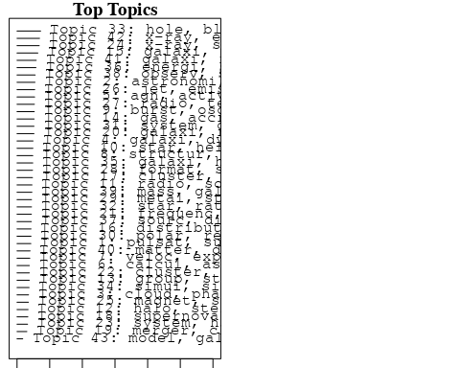

plotQuote(thoughts6, width = 30, main = "Topic 6")  
plotQuote(thoughts18, width = 30, main = "Topic 18")

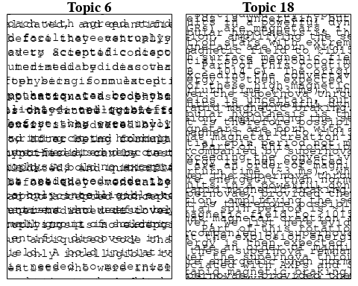

# Calculate and plot the correlation between topics  
mod.out.corr <- topicCorr(Research_topics)  
plot(mod.out.corr, cex = 1.5)  
  
  
# For each topic  
for (topic_num in 1:43) {  
 # Plot the word cloud  
 cloud(Research_topics, topic = topic_num, scale = c(2, 0.25))  
 Sys.sleep(2)  
}

## Warning in wordcloud::wordcloud(words = vocab, freq = vec, max.words =  
## max.words, : substructur could not be fit on page. It will not be plotted.

## Warning in wordcloud::wordcloud(words = vocab, freq = vec, max.words =  
## max.words, : pulsat could not be fit on page. It will not be plotted.

## Warning in wordcloud::wordcloud(words = vocab, freq = vec, max.words =  
## max.words, : determin could not be fit on page. It will not be plotted.

## Warning in wordcloud::wordcloud(words = vocab, freq = vec, max.words =  
## max.words, : supermass could not be fit on page. It will not be plotted.

## Warning in wordcloud::wordcloud(words = vocab, freq = vec, max.words =  
## max.words, : predict could not be fit on page. It will not be plotted.

## Warning in wordcloud::wordcloud(words = vocab, freq = vec, max.words =  
## max.words, : detect could not be fit on page. It will not be plotted.

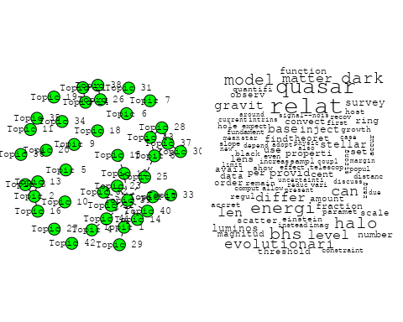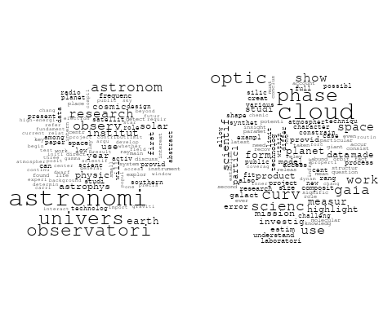

## Warning in wordcloud::wordcloud(words = vocab, freq = vec, max.words =  
## max.words, : publish could not be fit on page. It will not be plotted.

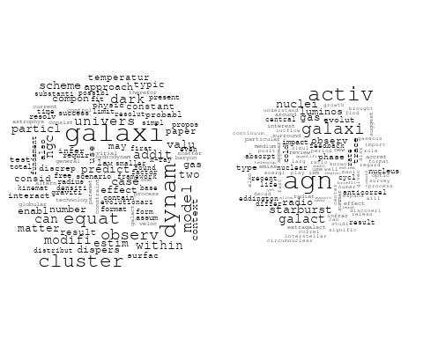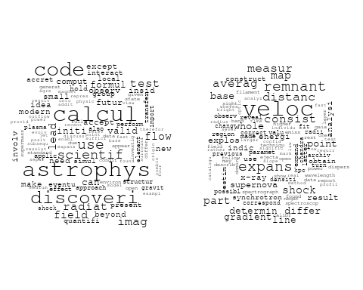

## Warning in wordcloud::wordcloud(words = vocab, freq = vec, max.words =  
## max.words, : atmospher could not be fit on page. It will not be plotted.

## Warning in wordcloud::wordcloud(words = vocab, freq = vec, max.words =  
## max.words, : observ could not be fit on page. It will not be plotted.

## Warning in wordcloud::wordcloud(words = vocab, freq = vec, max.words =  
## max.words, : provid could not be fit on page. It will not be plotted.

## Warning in wordcloud::wordcloud(words = vocab, freq = vec, max.words =  
## max.words, : ratio could not be fit on page. It will not be plotted.

## Warning in wordcloud::wordcloud(words = vocab, freq = vec, max.words =  
## max.words, : formula could not be fit on page. It will not be plotted.

## Warning in wordcloud::wordcloud(words = vocab, freq = vec, max.words =  
## max.words, : concentr could not be fit on page. It will not be plotted.

## Warning in wordcloud::wordcloud(words = vocab, freq = vec, max.words =  
## max.words, : molecular could not be fit on page. It will not be plotted.

## Warning in wordcloud::wordcloud(words = vocab, freq = vec, max.words =  
## max.words, : substanti could not be fit on page. It will not be plotted.

## Warning in wordcloud::wordcloud(words = vocab, freq = vec, max.words =  
## max.words, : distribut could not be fit on page. It will not be plotted.

## Warning in wordcloud::wordcloud(words = vocab, freq = vec, max.words =  
## max.words, : report could not be fit on page. It will not be plotted.

## Warning in wordcloud::wordcloud(words = vocab, freq = vec, max.words =  
## max.words, : import could not be fit on page. It will not be plotted.

## Warning in wordcloud::wordcloud(words = vocab, freq = vec, max.words =  
## max.words, : suggest could not be fit on page. It will not be plotted.

## Warning in wordcloud::wordcloud(words = vocab, freq = vec, max.words =  
## max.words, : investig could not be fit on page. It will not be plotted.

## Warning in wordcloud::wordcloud(words = vocab, freq = vec, max.words =  
## max.words, : system could not be fit on page. It will not be plotted.

## Warning in wordcloud::wordcloud(words = vocab, freq = vec, max.words =  
## max.words, : although could not be fit on page. It will not be plotted.

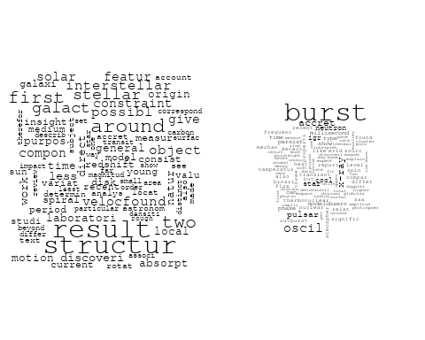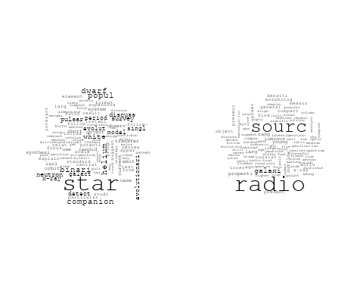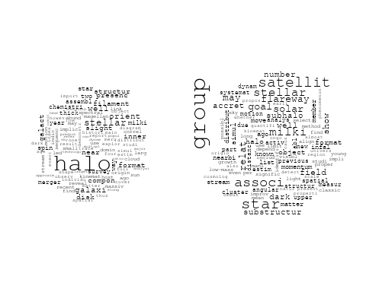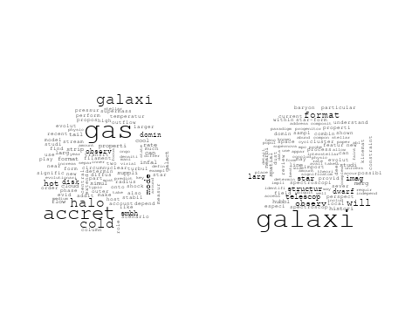

## Warning in wordcloud::wordcloud(words = vocab, freq = vec, max.words =  
## max.words, : distribut could not be fit on page. It will not be plotted.

## Warning in wordcloud::wordcloud(words = vocab, freq = vec, max.words =  
## max.words, : orbit could not be fit on page. It will not be plotted.

## Warning in wordcloud::wordcloud(words = vocab, freq = vec, max.words =  
## max.words, : potenti could not be fit on page. It will not be plotted.

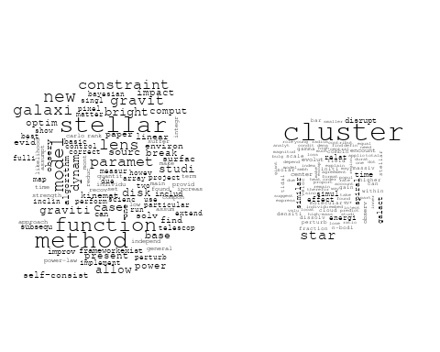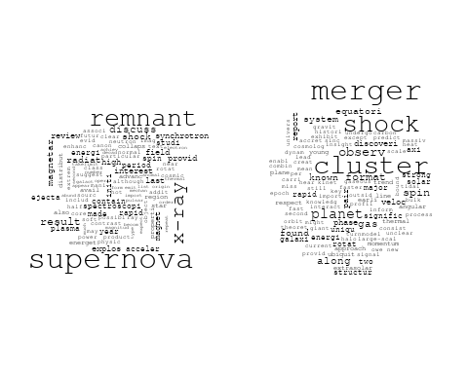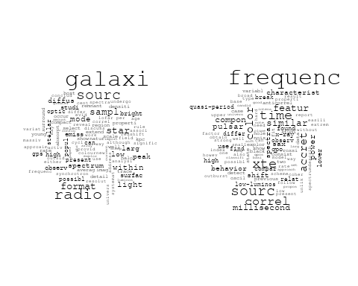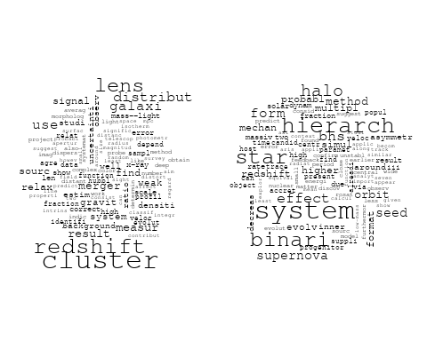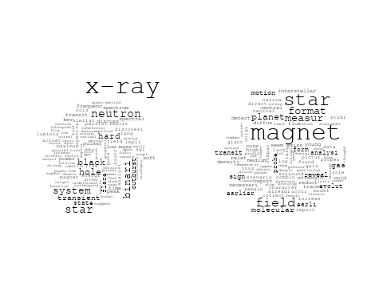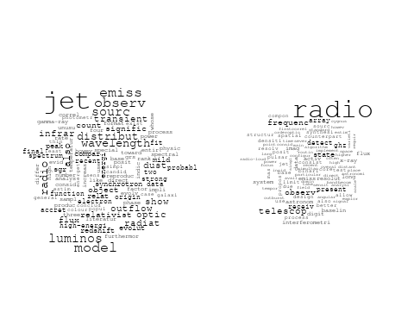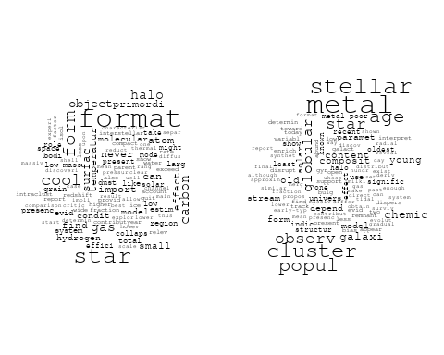

## Warning in wordcloud::wordcloud(words = vocab, freq = vec, max.words =  
## max.words, : densiti could not be fit on page. It will not be plotted.

## Warning in wordcloud::wordcloud(words = vocab, freq = vec, max.words =  
## max.words, : galaxi could not be fit on page. It will not be plotted.

## Warning in wordcloud::wordcloud(words = vocab, freq = vec, max.words =  
## max.words, : interstellar could not be fit on page. It will not be plotted.

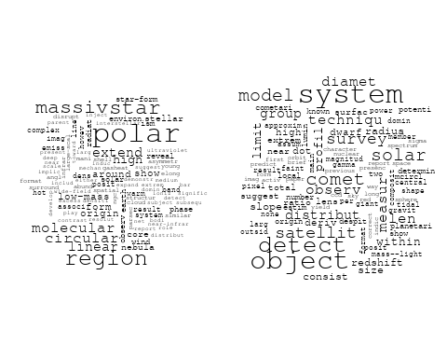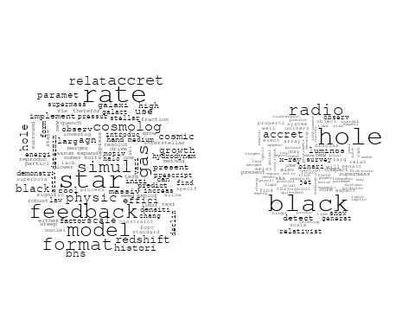

## Warning in wordcloud::wordcloud(words = vocab, freq = vec, max.words =  
## max.words, : simul could not be fit on page. It will not be plotted.

## Warning in wordcloud::wordcloud(words = vocab, freq = vec, max.words =  
## max.words, : signal could not be fit on page. It will not be plotted.

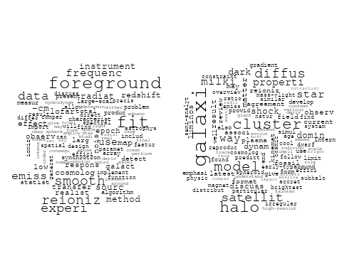

## Warning in wordcloud::wordcloud(words = vocab, freq = vec, max.words =  
## max.words, : energi could not be fit on page. It will not be plotted.

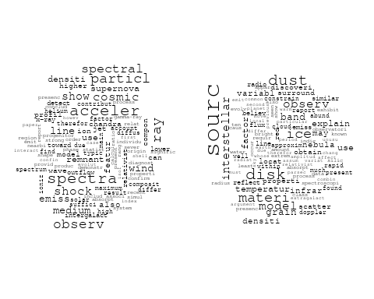

## Warning in wordcloud::wordcloud(words = vocab, freq = vec, max.words =  
## max.words, : period could not be fit on page. It will not be plotted.

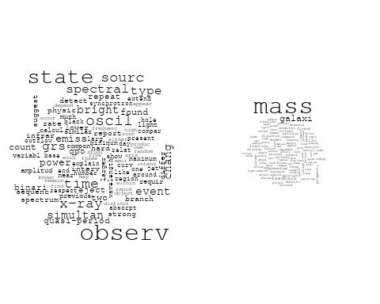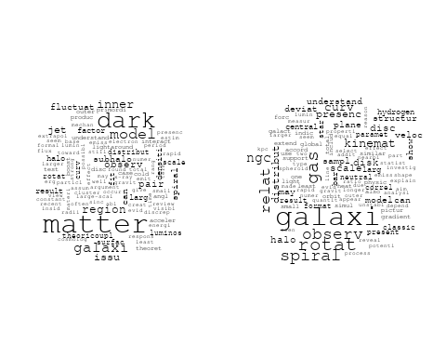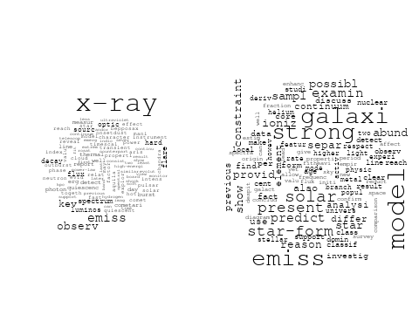

# Get the topic proportions for each document  
topic_proportions <- Research_topics$theta  
  
# Find the index of the topic with the highest proportion for each document  
# This will be the topic that each document is most likely to belong to  
max_topic_idx <- apply(topic_proportions, 1, which.max)  
  
# Add this as a new column to your data  
data_independent$topic <- max_topic_idx  
  
  
  
# Define the intervals  
intervals <- c('1824_1899', '1900_1964', '1965_1974', '1975_1984', '1985_1994', '1995_1999', '2000_2004', '2005_2009', '2010_2014', '2015_2019', '2020_2022')  
colors <- c('pink', 'blue', 'purple', 'yellow', 'green', 'pink', 'orange', 'violet', 'green', 'blue', 'pink')  
  
# Loop through the intervals and plot  
for(i in seq_along(intervals)){  
 # Filter data for when the pub_interval is equal to 1  
 data_filtered <- data_independent[data_independent[[paste0('pub_interval_', intervals[i])]] == 1,]  
   
 # Make the histogram  
   
 p <- ggplot(data_filtered, aes(x = topic)) +  
 geom_histogram(binwidth = 1, fill = colors[i], color = "black") +  
 xlab("Topic") +  
 ylab("Count") +  
 ggtitle(paste0("Topics from year ", gsub("_", " to ", intervals[i])))  
   
 print(p)  
}

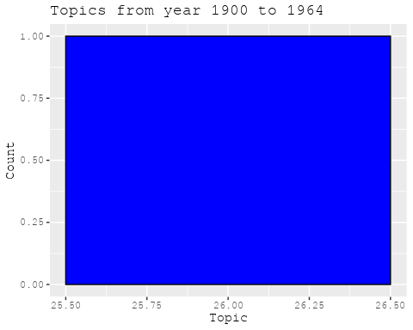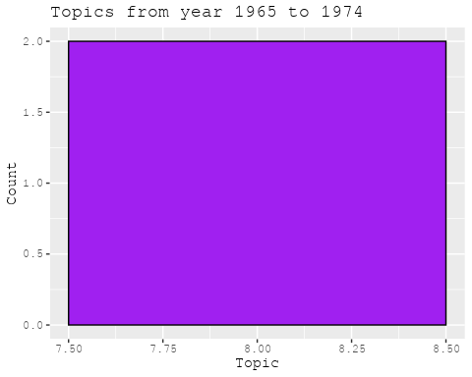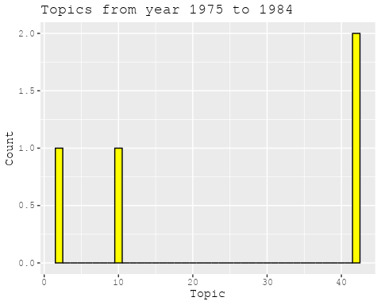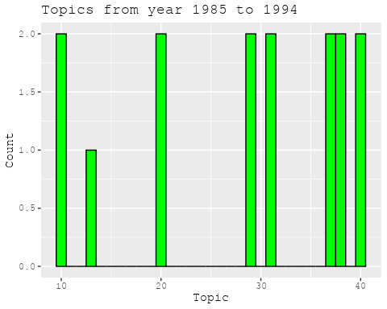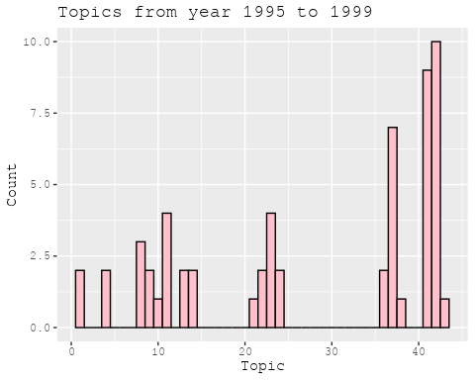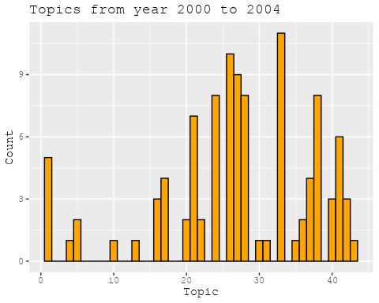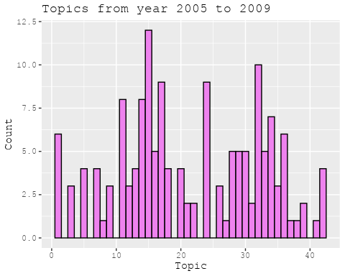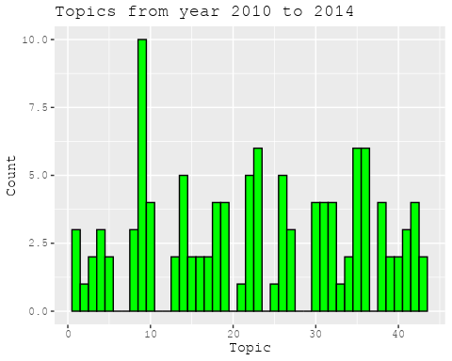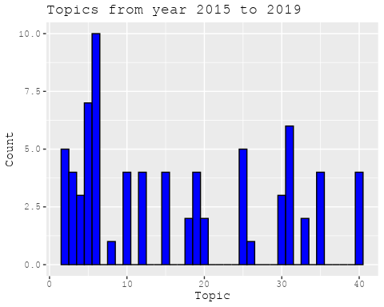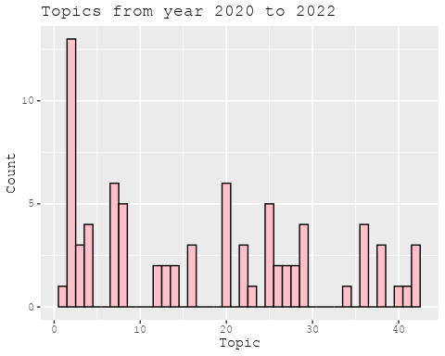

##Topic generation for FR (in collaboration) publications  
  
data_collab <- data[data[["FR"]] != 0,]  
  
# Save the original title data for future use  
data_collab$original_concatenated_title_abstract <- data_collab$concatenated_title_abstract  
  
#pre-processing the titles using textProcessor from the stm package  
processed_text <- textProcessor(data_collab$concatenated_title_abstract, metadata = data_collab)

## Building corpus...   
## Converting to Lower Case...   
## Removing punctuation...   
## Removing stopwords...   
## Removing numbers...   
## Stemming...   
## Creating Output...

# Further prepare the data by removing low-frequency terms  
out_text <- prepDocuments(processed_text$documents, processed_text$vocab, processed_text$meta)

## Removing 2890 of 10117 terms (2890 of 175894 tokens) due to frequency   
## Your corpus now has 2060 documents, 7227 terms and 173004 tokens.

docs_text <- out_text$documents  
vocab_text <- out_text$vocab  
meta_text <- out_text$meta  
  
  
#Prepare data  
plotRemoved(processed_text$documents, lower.thresh = seq(1, 200, by = 100))

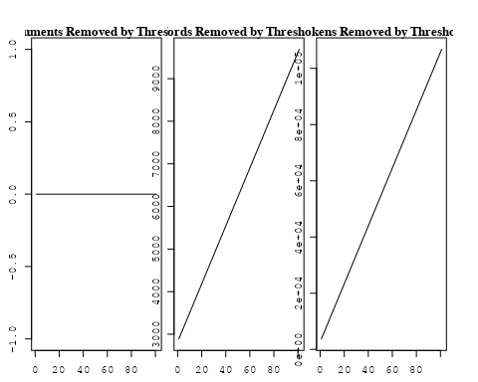

out_text <- prepDocuments(processed_text$documents, processed_text$vocab, processed_text$meta, lower.thresh = 8)

## Removing 7790 of 10117 terms (18889 of 175894 tokens) due to frequency   
## Your corpus now has 2060 documents, 2327 terms and 157005 tokens.

str(out_text$meta)

## 'data.frame': 2060 obs. of 39 variables:  
## $ concept_id : chr "https://openalex.org/C1276947" "https://openalex.org/C44870925" "https://openalex.org/C44870925" "https://openalex.org/C44870925" ...  
## $ work_id : chr "https://openalex.org/W3099195213" "https://openalex.org/W2072757986" "https://openalex.org/W3104422960" "https://openalex.org/W2007504429" ...  
## $ publication_year : int 1996 1977 2004 2011 2020 2008 2004 2012 2008 2020 ...  
## $ title : chr "Angular Sizes of Faint Field Disk Galaxies: Intrinsic Luminosity Evolution" "Hourly variations in O VI P Cygni profiles of hot stars" "The star formation history of Seyfert 2 nuclei" "A Pluto-like radius and a high albedo for the dwarf planet Eris from an occultation" ...  
## $ paperabstract : chr "In order to explain the small scale lengths detected in the recent deep field observations performed from large"| __truncated__ "Significant changes in the ultraviolet absorption profiles are reported in the spectra of Delta Ori A, Iota Ori"| __truncated__ "We present a study of the stellar populations in the central ∼200 pc of a large and homogeneous sample comprisi"| __truncated__ "The dwarf planet Eris is a trans-Neptunian object with an orbital eccentricity of 0.44, an inclination of 44 de"| __truncated__ ...  
## $ country : chr "FR US" "FR US" "BR FR FR BR" "MX FR MX FR" ...  
## $ year_concept : chr "1996+https://openalex.org/C1276947" "1977+https://openalex.org/C44870925" "2004+https://openalex.org/C44870925" "2011+https://openalex.org/C44870925" ...  
## $ concatenated_title_abstract : chr "Angular Sizes of Faint Field Disk Galaxies: Intrinsic Luminosity Evolution In order to explain the small scale "| __truncated__ "Hourly variations in O VI P Cygni profiles of hot stars Significant changes in the ultraviolet absorption profi"| __truncated__ "The star formation history of Seyfert 2 nuclei We present a study of the stellar populations in the central ∼20"| __truncated__ "A Pluto-like radius and a high albedo for the dwarf planet Eris from an occultation The dwarf planet Eris is a "| __truncated__ ...  
## $ US : num 50 50 0 0 0 50 0 50 0 0 ...  
## $ IN : num 0 0 0 0 0 0 0 0 0 0 ...  
## $ DE : num 0 0 0 0 0 0 0 0 0 0 ...  
## $ CH : num 0 0 0 0 0 0 0 0 0 0 ...  
## $ GB : num 0 0 0 0 0 0 0 0 0 0 ...  
## $ CN : num 0 0 0 0 0 0 0 0 0 0 ...  
## $ FR : num 50 50 50 50 100 50 50 50 50 100 ...  
## $ IT : num 0 0 0 0 0 0 0 0 0 0 ...  
## $ RU : num 0 0 0 0 0 0 0 0 0 0 ...  
## $ CA : num 0 0 0 0 0 0 0 0 0 0 ...  
## $ NL : num 0 0 0 0 0 0 0 0 0 0 ...  
## $ AU : num 0 0 0 0 0 0 50 0 0 0 ...  
## $ JP : num 0 0 0 0 0 0 0 0 0 0 ...  
## $ ES : num 0 0 0 0 0 0 0 0 0 0 ...  
## $ IL : num 0 0 0 0 0 0 0 0 0 0 ...  
## $ Americas : num 0 0 50 50 0 0 0 0 0 0 ...  
## $ Europe : num 0 0 0 0 0 0 0 0 0 0 ...  
## $ Africa : num 0 0 0 0 0 0 0 0 0 0 ...  
## $ AsiaAndOceania : num 0 0 0 0 0 0 0 0 50 0 ...  
## $ pub_interval_2020_2022 : int 0 0 0 0 1 0 0 0 0 1 ...  
## $ pub_interval_2015_2019 : int 0 0 0 0 0 0 0 0 0 0 ...  
## $ pub_interval_2010_2014 : int 0 0 0 1 0 0 0 1 0 0 ...  
## $ pub_interval_2005_2009 : int 0 0 0 0 0 1 0 0 1 0 ...  
## $ pub_interval_2000_2004 : int 0 0 1 0 0 0 1 0 0 0 ...  
## $ pub_interval_1995_1999 : int 1 0 0 0 0 0 0 0 0 0 ...  
## $ pub_interval_1985_1994 : int 0 0 0 0 0 0 0 0 0 0 ...  
## $ pub_interval_1975_1984 : int 0 1 0 0 0 0 0 0 0 0 ...  
## $ pub_interval_1965_1974 : int 0 0 0 0 0 0 0 0 0 0 ...  
## $ pub_interval_1900_1964 : int 0 0 0 0 0 0 0 0 0 0 ...  
## $ pub_interval_1824_1899 : int 0 0 0 0 0 0 0 0 0 0 ...  
## $ original_concatenated_title_abstract: chr "Angular Sizes of Faint Field Disk Galaxies: Intrinsic Luminosity Evolution In order to explain the small scale "| __truncated__ "Hourly variations in O VI P Cygni profiles of hot stars Significant changes in the ultraviolet absorption profi"| __truncated__ "The star formation history of Seyfert 2 nuclei We present a study of the stellar populations in the central ∼20"| __truncated__ "A Pluto-like radius and a high albedo for the dwarf planet Eris from an occultation The dwarf planet Eris is a "| __truncated__ ...

# Initialize an empty formula string  
prevalence_formula_str <- "~"  
  
# Define the publication intervals  
pub_intervals <- c("pub_interval_2020_2022", "pub_interval_2015_2019", "pub_interval_2010_2014",   
 "pub_interval_2005_2009", "pub_interval_2000_2004", "pub_interval_1995_1999",  
 "pub_interval_1985_1994", "pub_interval_1975_1984", "pub_interval_1965_1974",  
 "pub_interval_1900_1964", "pub_interval_1824_1899")  
  
# Add each publication interval to the formula string  
for (interval in pub_intervals) {  
 # add an if statement to handle the first addition (without '+')  
 if (prevalence_formula_str == "~") {  
 prevalence_formula_str <- paste(prevalence_formula_str, interval)  
 } else {  
 prevalence_formula_str <- paste(prevalence_formula_str, "+", interval)  
 }  
}  
  
  
# Convert the string to a formula  
prevalence_formula <- as.formula(prevalence_formula_str)  
print(prevalence_formula)

## ~pub_interval_2020_2022 + pub_interval_2015_2019 + pub_interval_2010_2014 +   
## pub_interval_2005_2009 + pub_interval_2000_2004 + pub_interval_1995_1999 +   
## pub_interval_1985_1994 + pub_interval_1975_1984 + pub_interval_1965_1974 +   
## pub_interval_1900_1964 + pub_interval_1824_1899

# Run STM model  
Research_topics <- stm(documents = out_text$documents,   
 vocab = out_text$vocab,   
 K = 45,   
 prevalence = prevalence_formula,   
 data = out_text$meta,   
 init.type = "Spectral",  
 max.em.its = 1000,  
 gamma.prior = 'L1')

## Beginning Spectral Initialization   
## Calculating the gram matrix...  
## Finding anchor words...  
## .............................................  
## Recovering initialization...  
## .......................  
## Initialization complete.  
## .......................................................................................................  
## Completed E-Step (2 seconds).   
## Completed M-Step.   
## Completing Iteration 1 (approx. per word bound = -6.552)   
## .......................................................................................................  
## Completed E-Step (2 seconds).   
## Completed M-Step.   
## Completing Iteration 2 (approx. per word bound = -6.271, relative change = 4.293e-02)   
## .......................................................................................................  
## Completed E-Step (1 seconds).   
## Completed M-Step.   
## Completing Iteration 3 (approx. per word bound = -6.197, relative change = 1.170e-02)   
## .......................................................................................................  
## Completed E-Step (1 seconds).   
## Completed M-Step.   
## Completing Iteration 4 (approx. per word bound = -6.168, relative change = 4.733e-03)   
## .......................................................................................................  
## Completed E-Step (1 seconds).   
## Completed M-Step.   
## Completing Iteration 5 (approx. per word bound = -6.152, relative change = 2.538e-03)   
## Topic 1: galaxi, ngc, gas, interact, format   
## Topic 2: dark, matter, halo, mass, cosmolog   
## Topic 3: cosmic, ray, telescop, space, energi   
## Topic 4: dwarf, star, mass, white, brown   
## Topic 5: frequenc, telescop, time, observ, pulsar   
## Topic 6: discuss, use, gravit, effect, recent   
## Topic 7: galaxi, merger, veloc, mass, format   
## Topic 8: disc, cloud, simul, origin, cluster   
## Topic 9: saturn, moon, planet, evolut, ring   
## Topic 10: star, rotat, period, orbit, cycl   
## Topic 11: star, distanc, optic, use, galact   
## Topic 12: sun, stellar, new, observ, alpha   
## Topic 13: disk, system, imag, observ, detect   
## Topic 14: galaxi, cluster, dwarf, popul, star   
## Topic 15: solar, observ, event, radio, electron   
## Topic 16: model, temperatur, cmb, data, effect   
## Topic 17: dust, interstellar, line, emiss, spectra   
## Topic 18: astrophys, univers, physic, scienc, astronomi   
## Topic 19: survey, redshift, lens, use, galaxi   
## Topic 20: acceler, particl, gamma-ray, process, field   
## Topic 21: atmospher, transit, observ, exoplanet, detect   
## Topic 22: x-ray, hole, black, emiss, radio   
## Topic 23: sourc, emiss, gas, galaxi, peak   
## Topic 24: field, magnet, rotat, observ, polar   
## Topic 25: solar, abund, model, observ, use   
## Topic 26: jet, binari, system, outflow, star   
## Topic 27: line, model, veloc, absorpt, ioniz   
## Topic 28: planet, orbit, disk, system, star   
## Topic 29: supernova, sne, type, mass, star   
## Topic 30: agn, galaxi, redshift, quasar, radio   
## Topic 31: star, giant, stellar, pulsat, paramet   
## Topic 32: nebula, x-ray, central, hot, star   
## Topic 33: metal, galaxi, stellar, star, mass   
## Topic 34: orbit, dynam, bar, spiral, model   
## Topic 35: accret, disk, instabl, disc, rate   
## Topic 36: magnet, flux, field, observ, region   
## Topic 37: format, star, cluster, observ, molecular   
## Topic 38: rotat, cluster, angular, ngc, momentum   
## Topic 39: asteroid, system, dust, observ, comet   
## Topic 40: galaxi, cluster, group, halo, coma   
## Topic 41: mass, star, function, stellar, imf   
## Topic 42: burst, gamma-ray, energi, grb, observ   
## Topic 43: galaxi, luminos, evolut, redshift, observ   
## Topic 44: diffus, model, data, profil, rate   
## Topic 45: line, sagittarius, complex, sgr, detect   
## .......................................................................................................  
## Completed E-Step (1 seconds).   
## Completed M-Step.   
## Completing Iteration 6 (approx. per word bound = -6.143, relative change = 1.526e-03)   
## .......................................................................................................  
## Completed E-Step (1 seconds).   
## Completed M-Step.   
## Completing Iteration 7 (approx. per word bound = -6.137, relative change = 9.444e-04)   
## .......................................................................................................  
## Completed E-Step (1 seconds).   
## Completed M-Step.   
## Completing Iteration 8 (approx. per word bound = -6.133, relative change = 6.800e-04)   
## .......................................................................................................  
## Completed E-Step (1 seconds).   
## Completed M-Step.   
## Completing Iteration 9 (approx. per word bound = -6.130, relative change = 5.220e-04)   
## .......................................................................................................  
## Completed E-Step (1 seconds).   
## Completed M-Step.   
## Completing Iteration 10 (approx. per word bound = -6.127, relative change = 4.457e-04)   
## Topic 1: galaxi, ngc, gas, interact, cluster   
## Topic 2: dark, matter, halo, mass, densiti   
## Topic 3: cosmic, ray, energi, telescop, space   
## Topic 4: dwarf, star, white, mass, brown   
## Topic 5: frequenc, telescop, observ, time, pulsar   
## Topic 6: gravit, discuss, use, observ, detect   
## Topic 7: galaxi, merger, mass, format, veloc   
## Topic 8: disc, cloud, simul, cluster, bulg   
## Topic 9: saturn, moon, planet, system, orbit   
## Topic 10: star, period, rotat, cycl, orbit   
## Topic 11: distanc, star, use, photometri, optic   
## Topic 12: sun, stellar, new, observ, provid   
## Topic 13: disk, system, imag, observ, star   
## Topic 14: galaxi, dwarf, cluster, popul, age   
## Topic 15: solar, observ, event, flare, electron   
## Topic 16: model, effect, temperatur, data, cmb   
## Topic 17: dust, interstellar, line, emiss, galaxi   
## Topic 18: astrophys, univers, physic, scienc, space   
## Topic 19: survey, redshift, use, lens, galaxi   
## Topic 20: acceler, particl, process, field, physic   
## Topic 21: atmospher, transit, observ, exoplanet, detect   
## Topic 22: x-ray, hole, black, emiss, radio   
## Topic 23: galaxi, sourc, emiss, gas, observ   
## Topic 24: field, magnet, rotat, observ, magnetospher   
## Topic 25: solar, abund, model, observ, use   
## Topic 26: jet, binari, outflow, star, young   
## Topic 27: line, ioniz, model, veloc, absorpt   
## Topic 28: planet, orbit, disk, system, star   
## Topic 29: supernova, sne, type, mass, star   
## Topic 30: agn, galaxi, redshift, quasar, luminos   
## Topic 31: star, giant, stellar, studi, pulsat   
## Topic 32: nebula, x-ray, star, hot, central   
## Topic 33: metal, galaxi, stellar, star, mass   
## Topic 34: orbit, dynam, bar, spiral, model   
## Topic 35: accret, disk, instabl, disc, rate   
## Topic 36: magnet, flux, field, observ, plasma   
## Topic 37: format, star, observ, cluster, molecular   
## Topic 38: rotat, cluster, angular, ngc, momentum   
## Topic 39: asteroid, system, dust, observ, comet   
## Topic 40: galaxi, cluster, group, halo, coma   
## Topic 41: mass, star, function, stellar, cluster   
## Topic 42: burst, gamma-ray, energi, grb, observ   
## Topic 43: galaxi, luminos, redshift, evolut, observ   
## Topic 44: diffus, model, rate, data, profil   
## Topic 45: line, detect, region, complex, center   
## .......................................................................................................  
## Completed E-Step (1 seconds).   
## Completed M-Step.   
## Completing Iteration 11 (approx. per word bound = -6.125, relative change = 3.877e-04)   
## .......................................................................................................  
## Completed E-Step (1 seconds).   
## Completed M-Step.   
## Completing Iteration 12 (approx. per word bound = -6.122, relative change = 3.602e-04)   
## .......................................................................................................  
## Completed E-Step (1 seconds).   
## Completed M-Step.   
## Completing Iteration 13 (approx. per word bound = -6.120, relative change = 3.299e-04)   
## .......................................................................................................  
## Completed E-Step (1 seconds).   
## Completed M-Step.   
## Completing Iteration 14 (approx. per word bound = -6.119, relative change = 2.713e-04)   
## .......................................................................................................  
## Completed E-Step (1 seconds).   
## Completed M-Step.   
## Completing Iteration 15 (approx. per word bound = -6.117, relative change = 2.525e-04)   
## Topic 1: galaxi, gas, ngc, cluster, interact   
## Topic 2: dark, matter, halo, mass, densiti   
## Topic 3: cosmic, ray, energi, telescop, sourc   
## Topic 4: dwarf, white, star, mass, brown   
## Topic 5: frequenc, telescop, observ, pulsar, time   
## Topic 6: gravit, detect, use, discuss, will   
## Topic 7: galaxi, merger, mass, format, stellar   
## Topic 8: disc, cloud, simul, cluster, bulg   
## Topic 9: saturn, moon, system, orbit, planet   
## Topic 10: star, period, rotat, cycl, orbit   
## Topic 11: distanc, use, star, photometri, data   
## Topic 12: sun, stellar, observ, discuss, new   
## Topic 13: disk, system, imag, observ, star   
## Topic 14: galaxi, dwarf, cluster, popul, ellipt   
## Topic 15: solar, observ, electron, event, flare   
## Topic 16: model, effect, data, cmb, temperatur   
## Topic 17: dust, interstellar, emiss, line, galaxi   
## Topic 18: astrophys, univers, physic, scienc, space   
## Topic 19: survey, redshift, use, lens, galaxi   
## Topic 20: acceler, particl, process, field, physic   
## Topic 21: atmospher, transit, observ, absorpt, exoplanet   
## Topic 22: x-ray, hole, black, emiss, radio   
## Topic 23: galaxi, sourc, emiss, gas, observ   
## Topic 24: field, magnet, rotat, observ, star   
## Topic 25: solar, abund, model, observ, use   
## Topic 26: jet, binari, outflow, star, young   
## Topic 27: line, ioniz, model, absorpt, veloc   
## Topic 28: planet, orbit, system, disk, planetari   
## Topic 29: supernova, sne, type, mass, star   
## Topic 30: agn, galaxi, redshift, quasar, luminos   
## Topic 31: star, giant, stellar, studi, pulsat   
## Topic 32: nebula, x-ray, hot, star, wind   
## Topic 33: metal, galaxi, stellar, star, mass   
## Topic 34: orbit, dynam, bar, spiral, model   
## Topic 35: accret, disk, instabl, disc, rate   
## Topic 36: magnet, flux, field, observ, plasma   
## Topic 37: format, star, observ, evolut, molecular   
## Topic 38: rotat, cluster, angular, ngc, star   
## Topic 39: asteroid, dust, system, comet, observ   
## Topic 40: galaxi, cluster, group, halo, coma   
## Topic 41: mass, star, function, stellar, cluster   
## Topic 42: burst, gamma-ray, energi, grb, observ   
## Topic 43: galaxi, luminos, redshift, evolut, observ   
## Topic 44: diffus, model, rate, data, neutron   
## Topic 45: line, region, center, detect, observ   
## .......................................................................................................  
## Completed E-Step (1 seconds).   
## Completed M-Step.   
## Completing Iteration 16 (approx. per word bound = -6.116, relative change = 2.283e-04)   
## .......................................................................................................  
## Completed E-Step (1 seconds).   
## Completed M-Step.   
## Completing Iteration 17 (approx. per word bound = -6.114, relative change = 2.341e-04)   
## .......................................................................................................  
## Completed E-Step (1 seconds).   
## Completed M-Step.   
## Completing Iteration 18 (approx. per word bound = -6.113, relative change = 2.005e-04)   
## .......................................................................................................  
## Completed E-Step (1 seconds).   
## Completed M-Step.   
## Completing Iteration 19 (approx. per word bound = -6.112, relative change = 1.748e-04)   
## .......................................................................................................  
## Completed E-Step (1 seconds).   
## Completed M-Step.   
## Completing Iteration 20 (approx. per word bound = -6.111, relative change = 1.564e-04)   
## Topic 1: galaxi, gas, ngc, cluster, interact   
## Topic 2: dark, matter, halo, mass, densiti   
## Topic 3: cosmic, ray, energi, telescop, sourc   
## Topic 4: dwarf, white, star, mass, brown   
## Topic 5: frequenc, telescop, pulsar, observ, time   
## Topic 6: gravit, detect, will, binari, observ   
## Topic 7: galaxi, merger, mass, format, star   
## Topic 8: disc, cloud, simul, cluster, bulg   
## Topic 9: saturn, moon, system, orbit, ring   
## Topic 10: star, period, rotat, cycl, orbit   
## Topic 11: distanc, use, star, data, new   
## Topic 12: sun, stellar, discuss, observ, provid   
## Topic 13: disk, system, observ, imag, star   
## Topic 14: galaxi, dwarf, cluster, popul, ellipt   
## Topic 15: solar, observ, electron, event, flare   
## Topic 16: model, effect, data, cmb, background   
## Topic 17: dust, interstellar, emiss, galaxi, ratio   
## Topic 18: astrophys, univers, physic, scienc, space   
## Topic 19: survey, redshift, use, lens, galaxi   
## Topic 20: acceler, particl, process, shock, field   
## Topic 21: atmospher, transit, observ, absorpt, planet   
## Topic 22: x-ray, hole, black, radio, emiss   
## Topic 23: galaxi, sourc, emiss, gas, observ   
## Topic 24: field, magnet, rotat, observ, star   
## Topic 25: solar, abund, model, observ, use   
## Topic 26: jet, binari, outflow, star, young   
## Topic 27: line, ioniz, model, absorpt, veloc   
## Topic 28: planet, orbit, system, disk, planetari   
## Topic 29: supernova, sne, type, mass, star   
## Topic 30: agn, galaxi, redshift, quasar, luminos   
## Topic 31: star, giant, stellar, pulsat, studi   
## Topic 32: nebula, x-ray, hot, star, wind   
## Topic 33: metal, galaxi, stellar, star, mass   
## Topic 34: orbit, dynam, bar, spiral, model   
## Topic 35: accret, disk, instabl, disc, rate   
## Topic 36: magnet, flux, field, observ, plasma   
## Topic 37: format, star, observ, evolut, molecular   
## Topic 38: rotat, cluster, angular, ngc, star   
## Topic 39: asteroid, dust, system, comet, observ   
## Topic 40: galaxi, cluster, group, halo, coma   
## Topic 41: mass, star, stellar, function, cluster   
## Topic 42: burst, gamma-ray, grb, energi, observ   
## Topic 43: galaxi, luminos, redshift, evolut, observ   
## Topic 44: diffus, model, rate, data, neutron   
## Topic 45: line, region, detect, center, observ   
## .......................................................................................................  
## Completed E-Step (1 seconds).   
## Completed M-Step.   
## Completing Iteration 21 (approx. per word bound = -6.110, relative change = 1.565e-04)   
## .......................................................................................................  
## Completed E-Step (1 seconds).   
## Completed M-Step.   
## Completing Iteration 22 (approx. per word bound = -6.109, relative change = 1.514e-04)   
## .......................................................................................................  
## Completed E-Step (1 seconds).   
## Completed M-Step.   
## Completing Iteration 23 (approx. per word bound = -6.108, relative change = 1.426e-04)   
## .......................................................................................................  
## Completed E-Step (1 seconds).   
## Completed M-Step.   
## Completing Iteration 24 (approx. per word bound = -6.107, relative change = 1.456e-04)   
## .......................................................................................................  
## Completed E-Step (1 seconds).   
## Completed M-Step.   
## Completing Iteration 25 (approx. per word bound = -6.107, relative change = 1.385e-04)   
## Topic 1: galaxi, gas, ngc, cluster, interact   
## Topic 2: dark, matter, halo, mass, densiti   
## Topic 3: cosmic, ray, energi, telescop, sourc   
## Topic 4: dwarf, white, star, mass, brown   
## Topic 5: frequenc, telescop, pulsar, observ, time   
## Topic 6: gravit, detect, binari, will, observ   
## Topic 7: galaxi, merger, mass, format, star   
## Topic 8: disc, cloud, cluster, simul, bulg   
## Topic 9: saturn, moon, system, ring, orbit   
## Topic 10: star, period, rotat, cycl, orbit   
## Topic 11: distanc, use, star, data, new   
## Topic 12: sun, discuss, stellar, provid, observ   
## Topic 13: disk, system, observ, imag, star   
## Topic 14: galaxi, dwarf, cluster, popul, ellipt   
## Topic 15: solar, observ, electron, event, flare   
## Topic 16: model, effect, data, cosmolog, cmb   
## Topic 17: dust, interstellar, galaxi, emiss, ratio   
## Topic 18: astrophys, univers, physic, scienc, space   
## Topic 19: survey, redshift, use, lens, method   
## Topic 20: acceler, particl, shock, process, field   
## Topic 21: atmospher, transit, observ, absorpt, planet   
## Topic 22: x-ray, hole, black, radio, emiss   
## Topic 23: galaxi, sourc, emiss, gas, observ   
## Topic 24: field, magnet, rotat, observ, star   
## Topic 25: solar, abund, model, observ, use   
## Topic 26: jet, outflow, binari, star, young   
## Topic 27: line, ioniz, model, absorpt, veloc   
## Topic 28: planet, orbit, system, disk, planetari   
## Topic 29: supernova, sne, type, mass, star   
## Topic 30: agn, galaxi, redshift, quasar, luminos   
## Topic 31: star, giant, stellar, model, pulsat   
## Topic 32: nebula, x-ray, hot, star, wind   
## Topic 33: metal, galaxi, stellar, star, mass   
## Topic 34: orbit, dynam, bar, spiral, model   
## Topic 35: accret, disk, instabl, disc, model   
## Topic 36: magnet, flux, field, observ, region   
## Topic 37: format, star, observ, evolut, molecular   
## Topic 38: rotat, cluster, angular, ngc, star   
## Topic 39: asteroid, dust, system, comet, observ   
## Topic 40: galaxi, cluster, group, halo, coma   
## Topic 41: mass, star, stellar, function, cluster   
## Topic 42: burst, gamma-ray, grb, energi, observ   
## Topic 43: galaxi, luminos, redshift, evolut, observ   
## Topic 44: diffus, model, rate, data, neutron   
## Topic 45: line, detect, emiss, region, observ   
## .......................................................................................................  
## Completed E-Step (1 seconds).   
## Completed M-Step.   
## Completing Iteration 26 (approx. per word bound = -6.106, relative change = 1.372e-04)   
## .......................................................................................................  
## Completed E-Step (1 seconds).   
## Completed M-Step.   
## Completing Iteration 27 (approx. per word bound = -6.105, relative change = 1.364e-04)   
## .......................................................................................................  
## Completed E-Step (1 seconds).   
## Completed M-Step.   
## Completing Iteration 28 (approx. per word bound = -6.104, relative change = 1.275e-04)   
## .......................................................................................................  
## Completed E-Step (1 seconds).   
## Completed M-Step.   
## Completing Iteration 29 (approx. per word bound = -6.103, relative change = 1.244e-04)   
## .......................................................................................................  
## Completed E-Step (1 seconds).   
## Completed M-Step.   
## Completing Iteration 30 (approx. per word bound = -6.103, relative change = 1.205e-04)   
## Topic 1: galaxi, gas, ngc, cluster, interact   
## Topic 2: dark, matter, halo, mass, densiti   
## Topic 3: cosmic, ray, energi, telescop, sourc   
## Topic 4: dwarf, white, star, mass, brown   
## Topic 5: frequenc, telescop, observ, pulsar, time   
## Topic 6: gravit, detect, binari, will, observ   
## Topic 7: galaxi, merger, mass, format, star   
## Topic 8: disc, cloud, cluster, simul, bulg   
## Topic 9: saturn, moon, system, ring, orbit   
## Topic 10: star, period, rotat, cycl, orbit   
## Topic 11: distanc, use, data, star, new   
## Topic 12: sun, discuss, stellar, provid, observ   
## Topic 13: disk, system, observ, star, imag   
## Topic 14: galaxi, dwarf, cluster, popul, ellipt   
## Topic 15: solar, observ, electron, event, coron   
## Topic 16: model, effect, cosmolog, data, cmb   
## Topic 17: dust, interstellar, galaxi, emiss, ratio   
## Topic 18: astrophys, univers, physic, scienc, space   
## Topic 19: survey, redshift, use, lens, method   
## Topic 20: acceler, particl, shock, process, field   
## Topic 21: atmospher, transit, observ, absorpt, planet   
## Topic 22: x-ray, hole, black, radio, emiss   
## Topic 23: galaxi, sourc, emiss, gas, observ   
## Topic 24: field, magnet, rotat, observ, star   
## Topic 25: abund, solar, model, observ, chemic   
## Topic 26: jet, outflow, binari, star, young   
## Topic 27: line, ioniz, model, absorpt, veloc   
## Topic 28: planet, orbit, system, disk, planetari   
## Topic 29: supernova, sne, type, mass, star   
## Topic 30: agn, galaxi, redshift, quasar, luminos   
## Topic 31: star, giant, stellar, model, pulsat   
## Topic 32: nebula, x-ray, hot, star, wind   
## Topic 33: metal, galaxi, stellar, star, mass   
## Topic 34: orbit, dynam, bar, spiral, model   
## Topic 35: accret, disk, instabl, disc, model   
## Topic 36: magnet, flux, field, observ, region   
## Topic 37: format, star, observ, evolut, molecular   
## Topic 38: rotat, cluster, angular, ngc, star   
## Topic 39: asteroid, dust, system, comet, observ   
## Topic 40: galaxi, cluster, group, halo, coma   
## Topic 41: mass, star, stellar, function, cluster   
## Topic 42: burst, gamma-ray, grb, energi, observ   
## Topic 43: galaxi, luminos, redshift, evolut, observ   
## Topic 44: diffus, model, rate, data, reaction   
## Topic 45: line, emiss, detect, densiti, observ   
## .......................................................................................................  
## Completed E-Step (1 seconds).   
## Completed M-Step.   
## Completing Iteration 31 (approx. per word bound = -6.102, relative change = 1.023e-04)   
## .......................................................................................................  
## Completed E-Step (1 seconds).   
## Completed M-Step.   
## Completing Iteration 32 (approx. per word bound = -6.101, relative change = 9.090e-05)   
## .......................................................................................................  
## Completed E-Step (1 seconds).   
## Completed M-Step.   
## Completing Iteration 33 (approx. per word bound = -6.101, relative change = 8.103e-05)   
## .......................................................................................................  
## Completed E-Step (1 seconds).   
## Completed M-Step.   
## Completing Iteration 34 (approx. per word bound = -6.100, relative change = 8.027e-05)   
## .......................................................................................................  
## Completed E-Step (1 seconds).   
## Completed M-Step.   
## Completing Iteration 35 (approx. per word bound = -6.100, relative change = 7.865e-05)   
## Topic 1: galaxi, gas, ngc, cluster, spiral   
## Topic 2: dark, matter, halo, mass, densiti   
## Topic 3: cosmic, ray, energi, telescop, sourc   
## Topic 4: dwarf, white, star, mass, brown   
## Topic 5: frequenc, telescop, observ, pulsar, time   
## Topic 6: gravit, detect, binari, will, observ   
## Topic 7: galaxi, merger, mass, format, star   
## Topic 8: disc, cloud, cluster, simul, bulg   
## Topic 9: saturn, moon, system, ring, orbit   
## Topic 10: star, period, rotat, cycl, orbit   
## Topic 11: use, distanc, data, new, star   
## Topic 12: sun, discuss, stellar, provid, observ   
## Topic 13: disk, system, observ, star, imag   
## Topic 14: galaxi, dwarf, cluster, popul, ellipt   
## Topic 15: solar, observ, electron, event, coron   
## Topic 16: model, effect, cosmolog, data, energi   
## Topic 17: dust, interstellar, galaxi, ratio, emiss   
## Topic 18: astrophys, univers, physic, scienc, space   
## Topic 19: survey, redshift, use, lens, method   
## Topic 20: acceler, particl, shock, process, field   
## Topic 21: atmospher, transit, observ, absorpt, planet   
## Topic 22: x-ray, hole, black, radio, emiss   
## Topic 23: galaxi, sourc, emiss, gas, observ   
## Topic 24: field, magnet, rotat, observ, star   
## Topic 25: abund, solar, model, observ, element   
## Topic 26: jet, outflow, binari, star, young   
## Topic 27: line, ioniz, model, absorpt, veloc   
## Topic 28: planet, orbit, system, disk, mass   
## Topic 29: supernova, sne, type, mass, star   
## Topic 30: agn, galaxi, redshift, quasar, luminos   
## Topic 31: star, giant, stellar, model, pulsat   
## Topic 32: nebula, x-ray, hot, star, wind   
## Topic 33: metal, galaxi, stellar, star, mass   
## Topic 34: dynam, orbit, bar, spiral, model   
## Topic 35: accret, disk, instabl, disc, model   
## Topic 36: magnet, flux, field, observ, wave   
## Topic 37: format, star, observ, molecular, evolut   
## Topic 38: rotat, cluster, angular, ngc, star   
## Topic 39: asteroid, dust, system, comet, observ   
## Topic 40: galaxi, cluster, group, halo, coma   
## Topic 41: mass, star, stellar, function, cluster   
## Topic 42: burst, gamma-ray, grb, energi, observ   
## Topic 43: galaxi, luminos, redshift, evolut, observ   
## Topic 44: diffus, model, rate, data, reaction   
## Topic 45: line, emiss, detect, densiti, observ   
## .......................................................................................................  
## Completed E-Step (1 seconds).   
## Completed M-Step.   
## Completing Iteration 36 (approx. per word bound = -6.100, relative change = 7.367e-05)   
## .......................................................................................................  
## Completed E-Step (1 seconds).   
## Completed M-Step.   
## Completing Iteration 37 (approx. per word bound = -6.099, relative change = 6.793e-05)   
## .......................................................................................................  
## Completed E-Step (1 seconds).   
## Completed M-Step.   
## Completing Iteration 38 (approx. per word bound = -6.099, relative change = 6.982e-05)   
## .......................................................................................................  
## Completed E-Step (1 seconds).   
## Completed M-Step.   
## Completing Iteration 39 (approx. per word bound = -6.098, relative change = 6.486e-05)   
## .......................................................................................................  
## Completed E-Step (1 seconds).   
## Completed M-Step.   
## Completing Iteration 40 (approx. per word bound = -6.098, relative change = 5.645e-05)   
## Topic 1: galaxi, gas, ngc, cluster, spiral   
## Topic 2: dark, matter, halo, mass, densiti   
## Topic 3: cosmic, ray, energi, telescop, sourc   
## Topic 4: dwarf, white, star, mass, brown   
## Topic 5: frequenc, telescop, observ, pulsar, time   
## Topic 6: detect, gravit, binari, will, observ   
## Topic 7: galaxi, merger, mass, format, star   
## Topic 8: disc, cloud, cluster, simul, bulg   
## Topic 9: saturn, moon, system, ring, orbit   
## Topic 10: star, period, rotat, cycl, orbit   
## Topic 11: use, distanc, data, new, star   
## Topic 12: sun, discuss, stellar, provid, observ   
## Topic 13: disk, system, observ, star, imag   
## Topic 14: galaxi, dwarf, cluster, popul, age   
## Topic 15: solar, observ, electron, event, coron   
## Topic 16: model, effect, cosmolog, energi, data   
## Topic 17: dust, interstellar, galaxi, ratio, emiss   
## Topic 18: astrophys, univers, physic, scienc, space   
## Topic 19: survey, redshift, use, lens, method   
## Topic 20: acceler, particl, shock, process, field   
## Topic 21: atmospher, transit, observ, absorpt, detect   
## Topic 22: x-ray, hole, black, radio, emiss   
## Topic 23: galaxi, emiss, sourc, gas, observ   
## Topic 24: field, magnet, rotat, observ, star   
## Topic 25: abund, solar, model, observ, element   
## Topic 26: jet, outflow, binari, star, young   
## Topic 27: line, ioniz, model, absorpt, veloc   
## Topic 28: planet, orbit, system, star, mass   
## Topic 29: supernova, sne, type, mass, star   
## Topic 30: agn, galaxi, redshift, quasar, luminos   
## Topic 31: star, giant, stellar, pulsat, studi   
## Topic 32: nebula, x-ray, hot, star, wind   
## Topic 33: metal, galaxi, stellar, star, mass   
## Topic 34: dynam, orbit, bar, spiral, model   
## Topic 35: accret, disk, instabl, disc, model   
## Topic 36: magnet, flux, field, observ, wave   
## Topic 37: format, star, molecular, observ, cloud   
## Topic 38: rotat, cluster, angular, ngc, star   
## Topic 39: asteroid, dust, system, comet, observ   
## Topic 40: galaxi, cluster, group, halo, coma   
## Topic 41: mass, star, stellar, function, cluster   
## Topic 42: burst, gamma-ray, grb, energi, observ   
## Topic 43: galaxi, luminos, redshift, evolut, observ   
## Topic 44: diffus, model, rate, data, reaction   
## Topic 45: line, emiss, densiti, detect, gas   
## .......................................................................................................  
## Completed E-Step (1 seconds).   
## Completed M-Step.   
## Completing Iteration 41 (approx. per word bound = -6.098, relative change = 5.852e-05)   
## .......................................................................................................  
## Completed E-Step (1 seconds).   
## Completed M-Step.   
## Completing Iteration 42 (approx. per word bound = -6.097, relative change = 5.618e-05)   
## .......................................................................................................  
## Completed E-Step (1 seconds).   
## Completed M-Step.   
## Completing Iteration 43 (approx. per word bound = -6.097, relative change = 5.719e-05)   
## .......................................................................................................  
## Completed E-Step (1 seconds).   
## Completed M-Step.   
## Completing Iteration 44 (approx. per word bound = -6.097, relative change = 5.452e-05)   
## .......................................................................................................  
## Completed E-Step (1 seconds).   
## Completed M-Step.   
## Completing Iteration 45 (approx. per word bound = -6.096, relative change = 5.142e-05)   
## Topic 1: galaxi, gas, ngc, cluster, spiral   
## Topic 2: dark, matter, halo, mass, densiti   
## Topic 3: cosmic, ray, energi, telescop, sourc   
## Topic 4: dwarf, white, star, mass, brown   
## Topic 5: frequenc, telescop, observ, pulsar, time   
## Topic 6: detect, gravit, binari, will, observ   
## Topic 7: galaxi, merger, mass, format, stellar   
## Topic 8: disc, cloud, cluster, simul, bulg   
## Topic 9: saturn, moon, system, orbit, ring   
## Topic 10: star, period, rotat, cycl, orbit   
## Topic 11: use, distanc, data, new, star   
## Topic 12: sun, discuss, stellar, provid, observ   
## Topic 13: disk, system, observ, star, imag   
## Topic 14: galaxi, dwarf, cluster, popul, age   
## Topic 15: solar, observ, electron, coron, event   
## Topic 16: model, effect, cosmolog, energi, data   
## Topic 17: dust, interstellar, galaxi, ratio, grain   
## Topic 18: astrophys, univers, physic, scienc, space   
## Topic 19: survey, redshift, use, lens, method   
## Topic 20: acceler, particl, shock, process, field   
## Topic 21: atmospher, transit, observ, absorpt, detect   
## Topic 22: x-ray, hole, black, radio, emiss   
## Topic 23: galaxi, emiss, sourc, gas, observ   
## Topic 24: field, magnet, rotat, observ, star   
## Topic 25: abund, solar, model, observ, element   
## Topic 26: jet, outflow, binari, star, young   
## Topic 27: line, ioniz, model, absorpt, veloc   
## Topic 28: planet, orbit, system, star, mass   
## Topic 29: supernova, sne, type, mass, star   
## Topic 30: agn, galaxi, redshift, quasar, luminos   
## Topic 31: star, giant, stellar, pulsat, studi   
## Topic 32: nebula, x-ray, hot, wind, star   
## Topic 33: metal, galaxi, stellar, star, mass   
## Topic 34: dynam, orbit, bar, spiral, model   
## Topic 35: accret, disk, instabl, disc, model   
## Topic 36: magnet, flux, field, observ, wave   
## Topic 37: format, star, molecular, cloud, observ   
## Topic 38: rotat, cluster, angular, ngc, star   
## Topic 39: asteroid, dust, system, comet, observ   
## Topic 40: galaxi, cluster, group, halo, coma   
## Topic 41: mass, star, stellar, function, cluster   
## Topic 42: burst, gamma-ray, grb, energi, observ   
## Topic 43: galaxi, luminos, redshift, evolut, observ   
## Topic 44: diffus, model, rate, data, reaction   
## Topic 45: line, emiss, densiti, detect, gas   
## .......................................................................................................  
## Completed E-Step (1 seconds).   
## Completed M-Step.   
## Completing Iteration 46 (approx. per word bound = -6.096, relative change = 4.978e-05)   
## .......................................................................................................  
## Completed E-Step (1 seconds).   
## Completed M-Step.   
## Completing Iteration 47 (approx. per word bound = -6.096, relative change = 4.514e-05)   
## .......................................................................................................  
## Completed E-Step (1 seconds).   
## Completed M-Step.   
## Completing Iteration 48 (approx. per word bound = -6.095, relative change = 4.749e-05)   
## .......................................................................................................  
## Completed E-Step (1 seconds).   
## Completed M-Step.   
## Completing Iteration 49 (approx. per word bound = -6.095, relative change = 5.828e-05)   
## .......................................................................................................  
## Completed E-Step (1 seconds).   
## Completed M-Step.   
## Completing Iteration 50 (approx. per word bound = -6.095, relative change = 5.162e-05)   
## Topic 1: galaxi, gas, ngc, cluster, spiral   
## Topic 2: dark, matter, halo, mass, densiti   
## Topic 3: cosmic, ray, energi, telescop, sourc   
## Topic 4: dwarf, white, star, mass, brown   
## Topic 5: frequenc, telescop, observ, pulsar, time   
## Topic 6: detect, gravit, binari, observ, will   
## Topic 7: galaxi, merger, mass, format, stellar   
## Topic 8: disc, cloud, cluster, simul, bulg   
## Topic 9: saturn, moon, system, orbit, ring   
## Topic 10: star, period, rotat, cycl, orbit   
## Topic 11: use, distanc, data, new, imag   
## Topic 12: sun, discuss, stellar, provid, observ   
## Topic 13: disk, system, star, observ, imag   
## Topic 14: galaxi, dwarf, cluster, popul, age   
## Topic 15: solar, observ, electron, coron, event   
## Topic 16: model, cosmolog, effect, energi, data   
## Topic 17: dust, interstellar, galaxi, ratio, grain   
## Topic 18: astrophys, physic, univers, scienc, space   
## Topic 19: survey, redshift, use, lens, method   
## Topic 20: acceler, particl, shock, process, field   
## Topic 21: atmospher, transit, observ, absorpt, detect   
## Topic 22: x-ray, hole, black, radio, emiss   
## Topic 23: galaxi, emiss, sourc, gas, observ   
## Topic 24: field, magnet, rotat, observ, star   
## Topic 25: abund, solar, model, observ, element   
## Topic 26: jet, outflow, binari, star, young   
## Topic 27: line, ioniz, model, absorpt, veloc   
## Topic 28: planet, orbit, system, star, mass   
## Topic 29: supernova, sne, type, mass, star   
## Topic 30: agn, galaxi, redshift, quasar, luminos   
## Topic 31: star, giant, stellar, pulsat, studi   
## Topic 32: nebula, x-ray, wind, hot, star   
## Topic 33: metal, galaxi, stellar, star, mass   
## Topic 34: dynam, orbit, bar, spiral, model   
## Topic 35: accret, disk, instabl, model, disc   
## Topic 36: magnet, flux, field, observ, wave   
## Topic 37: format, star, cloud, molecular, observ   
## Topic 38: cluster, rotat, angular, ngc, star   
## Topic 39: asteroid, dust, system, comet, observ   
## Topic 40: galaxi, cluster, group, halo, coma   
## Topic 41: mass, star, stellar, function, cluster   
## Topic 42: burst, gamma-ray, grb, energi, observ   
## Topic 43: galaxi, luminos, redshift, evolut, observ   
## Topic 44: diffus, model, rate, data, reaction   
## Topic 45: line, emiss, densiti, detect, gas   
## .......................................................................................................  
## Completed E-Step (1 seconds).   
## Completed M-Step.   
## Completing Iteration 51 (approx. per word bound = -6.094, relative change = 4.976e-05)   
## .......................................................................................................  
## Completed E-Step (1 seconds).   
## Completed M-Step.   
## Completing Iteration 52 (approx. per word bound = -6.094, relative change = 4.897e-05)   
## .......................................................................................................  
## Completed E-Step (1 seconds).   
## Completed M-Step.   
## Completing Iteration 53 (approx. per word bound = -6.094, relative change = 4.496e-05)   
## .......................................................................................................  
## Completed E-Step (1 seconds).   
## Completed M-Step.   
## Completing Iteration 54 (approx. per word bound = -6.094, relative change = 4.202e-05)   
## .......................................................................................................  
## Completed E-Step (1 seconds).   
## Completed M-Step.   
## Completing Iteration 55 (approx. per word bound = -6.093, relative change = 3.588e-05)   
## Topic 1: galaxi, gas, ngc, cluster, spiral   
## Topic 2: dark, matter, halo, mass, densiti   
## Topic 3: ray, cosmic, energi, telescop, galact   
## Topic 4: dwarf, white, star, mass, brown   
## Topic 5: frequenc, telescop, observ, pulsar, time   
## Topic 6: detect, gravit, binari, observ, will   
## Topic 7: galaxi, merger, mass, format, stellar   
## Topic 8: disc, cloud, cluster, simul, bulg   
## Topic 9: saturn, moon, system, orbit, ring   
## Topic 10: star, period, cycl, rotat, orbit   
## Topic 11: use, distanc, data, new, imag   
## Topic 12: sun, discuss, stellar, observ, provid   
## Topic 13: disk, system, star, observ, imag   
## Topic 14: galaxi, dwarf, cluster, popul, age   
## Topic 15: solar, observ, electron, coron, event   
## Topic 16: model, cosmolog, effect, energi, data   
## Topic 17: dust, interstellar, galaxi, grain, ratio   
## Topic 18: astrophys, physic, univers, scienc, space   
## Topic 19: survey, redshift, use, lens, method   
## Topic 20: acceler, particl, shock, process, field   
## Topic 21: atmospher, transit, observ, detect, absorpt   
## Topic 22: x-ray, hole, black, radio, emiss   
## Topic 23: galaxi, emiss, gas, sourc, observ   
## Topic 24: field, magnet, rotat, observ, star   
## Topic 25: abund, solar, model, observ, element   
## Topic 26: jet, outflow, binari, star, young   
## Topic 27: line, ioniz, model, absorpt, veloc   
## Topic 28: planet, orbit, system, star, mass   
## Topic 29: supernova, sne, type, mass, star   
## Topic 30: agn, galaxi, redshift, quasar, luminos   
## Topic 31: star, giant, stellar, pulsat, studi   
## Topic 32: nebula, x-ray, wind, hot, star   
## Topic 33: metal, galaxi, stellar, star, mass   
## Topic 34: dynam, orbit, bar, spiral, model   
## Topic 35: accret, disk, instabl, model, disc   
## Topic 36: magnet, flux, field, observ, wave   
## Topic 37: format, star, cloud, molecular, observ   
## Topic 38: cluster, rotat, angular, ngc, star   
## Topic 39: asteroid, dust, system, comet, observ   
## Topic 40: galaxi, cluster, group, halo, coma   
## Topic 41: mass, star, stellar, function, cluster   
## Topic 42: burst, gamma-ray, grb, energi, observ   
## Topic 43: galaxi, luminos, redshift, evolut, observ   
## Topic 44: diffus, model, rate, data, reaction   
## Topic 45: line, emiss, densiti, gas, detect   
## .......................................................................................................  
## Completed E-Step (1 seconds).   
## Completed M-Step.   
## Completing Iteration 56 (approx. per word bound = -6.093, relative change = 3.376e-05)   
## .......................................................................................................  
## Completed E-Step (1 seconds).   
## Completed M-Step.   
## Completing Iteration 57 (approx. per word bound = -6.093, relative change = 3.577e-05)   
## .......................................................................................................  
## Completed E-Step (1 seconds).   
## Completed M-Step.   
## Completing Iteration 58 (approx. per word bound = -6.093, relative change = 3.846e-05)   
## .......................................................................................................  
## Completed E-Step (1 seconds).   
## Completed M-Step.   
## Completing Iteration 59 (approx. per word bound = -6.093, relative change = 3.464e-05)   
## .......................................................................................................  
## Completed E-Step (1 seconds).   
## Completed M-Step.   
## Completing Iteration 60 (approx. per word bound = -6.092, relative change = 1.098e-05)   
## Topic 1: galaxi, gas, ngc, cluster, spiral   
## Topic 2: dark, matter, halo, mass, densiti   
## Topic 3: ray, cosmic, energi, telescop, galact   
## Topic 4: dwarf, white, star, mass, brown   
## Topic 5: frequenc, telescop, observ, pulsar, time   
## Topic 6: detect, gravit, binari, observ, will   
## Topic 7: galaxi, merger, mass, format, stellar   
## Topic 8: disc, cloud, cluster, simul, bulg   
## Topic 9: saturn, moon, system, orbit, ring   
## Topic 10: star, period, cycl, rotat, orbit   
## Topic 11: use, distanc, data, new, imag   
## Topic 12: sun, discuss, stellar, observ, provid   
## Topic 13: disk, system, star, observ, imag   
## Topic 14: galaxi, dwarf, cluster, popul, age   
## Topic 15: solar, observ, electron, coron, event   
## Topic 16: model, cosmolog, effect, energi, data   
## Topic 17: dust, interstellar, galaxi, grain, ratio   
## Topic 18: astrophys, physic, univers, scienc, space   
## Topic 19: survey, redshift, use, lens, method   
## Topic 20: acceler, particl, shock, process, field   
## Topic 21: atmospher, transit, observ, detect, absorpt   
## Topic 22: x-ray, hole, black, radio, emiss   
## Topic 23: galaxi, emiss, gas, sourc, observ   
## Topic 24: field, magnet, rotat, observ, star   
## Topic 25: abund, solar, model, observ, element   
## Topic 26: jet, outflow, binari, star, young   
## Topic 27: line, ioniz, model, absorpt, veloc   
## Topic 28: planet, orbit, system, star, mass   
## Topic 29: supernova, sne, type, mass, star   
## Topic 30: agn, galaxi, redshift, quasar, luminos   
## Topic 31: star, giant, stellar, pulsat, studi   
## Topic 32: nebula, x-ray, wind, hot, star   
## Topic 33: metal, galaxi, stellar, star, mass   
## Topic 34: dynam, bar, orbit, spiral, model   
## Topic 35: accret, disk, instabl, model, disc   
## Topic 36: magnet, flux, field, observ, region   
## Topic 37: format, star, cloud, molecular, observ   
## Topic 38: cluster, rotat, angular, ngc, star   
## Topic 39: asteroid, dust, system, comet, observ   
## Topic 40: galaxi, cluster, group, halo, coma   
## Topic 41: mass, star, stellar, function, cluster   
## Topic 42: burst, gamma-ray, grb, energi, observ   
## Topic 43: galaxi, luminos, redshift, evolut, observ   
## Topic 44: diffus, model, rate, data, state   
## Topic 45: line, emiss, densiti, gas, detect   
## .......................................................................................................  
## Completed E-Step (1 seconds).   
## Completed M-Step.   
## Completing Iteration 61 (approx. per word bound = -6.092, relative change = 5.213e-05)   
## .......................................................................................................  
## Completed E-Step (1 seconds).   
## Completed M-Step.   
## Completing Iteration 62 (approx. per word bound = -6.092, relative change = 2.793e-05)   
## .......................................................................................................  
## Completed E-Step (1 seconds).   
## Completed M-Step.   
## Completing Iteration 63 (approx. per word bound = -6.092, relative change = 2.706e-05)   
## .......................................................................................................  
## Completed E-Step (1 seconds).   
## Completed M-Step.   
## Completing Iteration 64 (approx. per word bound = -6.092, relative change = 2.291e-05)   
## .......................................................................................................  
## Completed E-Step (1 seconds).   
## Completed M-Step.   
## Completing Iteration 65 (approx. per word bound = -6.092, relative change = 1.851e-05)   
## Topic 1: galaxi, gas, ngc, cluster, spiral   
## Topic 2: dark, matter, halo, mass, densiti   
## Topic 3: ray, cosmic, energi, telescop, galact   
## Topic 4: dwarf, white, star, mass, brown   
## Topic 5: frequenc, telescop, observ, pulsar, time   
## Topic 6: detect, gravit, binari, observ, will   
## Topic 7: galaxi, merger, mass, format, stellar   
## Topic 8: disc, cluster, cloud, simul, bulg   
## Topic 9: saturn, moon, system, orbit, ring   
## Topic 10: star, period, cycl, rotat, orbit   
## Topic 11: use, distanc, data, new, imag   
## Topic 12: sun, discuss, stellar, observ, provid   
## Topic 13: disk, system, star, observ, imag   
## Topic 14: galaxi, dwarf, cluster, popul, age   
## Topic 15: solar, observ, electron, coron, event   
## Topic 16: model, cosmolog, effect, energi, cosmic   
## Topic 17: dust, interstellar, galaxi, grain, ratio   
## Topic 18: astrophys, physic, univers, scienc, space   
## Topic 19: survey, redshift, use, lens, method   
## Topic 20: acceler, particl, shock, process, field   
## Topic 21: atmospher, transit, observ, detect, absorpt   
## Topic 22: x-ray, hole, black, radio, emiss   
## Topic 23: galaxi, emiss, gas, sourc, observ   
## Topic 24: field, magnet, rotat, star, observ   
## Topic 25: abund, solar, model, observ, element   
## Topic 26: jet, binari, outflow, star, young   
## Topic 27: line, ioniz, model, absorpt, veloc   
## Topic 28: planet, orbit, system, star, mass   
## Topic 29: supernova, sne, type, mass, star   
## Topic 30: agn, galaxi, redshift, quasar, luminos   
## Topic 31: star, giant, stellar, pulsat, studi   
## Topic 32: nebula, x-ray, wind, hot, star   
## Topic 33: metal, galaxi, stellar, star, mass   
## Topic 34: dynam, bar, orbit, spiral, model   
## Topic 35: accret, disk, instabl, model, disc   
## Topic 36: magnet, flux, field, observ, region   
## Topic 37: format, star, cloud, molecular, observ   
## Topic 38: cluster, rotat, angular, ngc, star   
## Topic 39: asteroid, dust, system, comet, observ   
## Topic 40: galaxi, cluster, group, halo, coma   
## Topic 41: mass, star, stellar, function, cluster   
## Topic 42: burst, gamma-ray, grb, energi, observ   
## Topic 43: galaxi, luminos, redshift, evolut, observ   
## Topic 44: diffus, model, rate, data, state   
## Topic 45: line, emiss, gas, densiti, detect   
## .......................................................................................................  
## Completed E-Step (1 seconds).   
## Completed M-Step.   
## Completing Iteration 66 (approx. per word bound = -6.091, relative change = 2.274e-05)   
## .......................................................................................................  
## Completed E-Step (1 seconds).   
## Completed M-Step.   
## Completing Iteration 67 (approx. per word bound = -6.091, relative change = 2.273e-05)   
## .......................................................................................................  
## Completed E-Step (1 seconds).   
## Completed M-Step.   
## Completing Iteration 68 (approx. per word bound = -6.091, relative change = 2.402e-05)   
## .......................................................................................................  
## Completed E-Step (1 seconds).   
## Completed M-Step.   
## Completing Iteration 69 (approx. per word bound = -6.091, relative change = 2.752e-05)   
## .......................................................................................................  
## Completed E-Step (1 seconds).   
## Completed M-Step.   
## Model Converged

# Plot the STM model summary  
plot(Research_topics, type = "summary", xlim = c(0, 0.3))  
  
# Print the top 10 labels for each topic  
topic_labels <- labelTopics(Research_topics, n=10)  
print(topic_labels)

## Topic 1 Top Words:  
## Highest Prob: galaxi, gas, ngc, cluster, spiral, interact, observ, format, model, pressur   
## FREX: strip, ngc, pressur, spiral, ram, virgo, virgohi, interact, gas, tail   
## Lift: american, virgohi, ram, strip, starvat, loos, galex, quench, west, debri   
## Score: ngc, galaxi, strip, spiral, cluster, ram, virgohi, american, gas, virgo   
## Topic 2 Top Words:  
## Highest Prob: dark, matter, halo, mass, densiti, particl, observ, annihil, scale, data   
## FREX: dark, matter, annihil, halo, quantum, wimp, neutrino, bound, constant, cross-sect   
## Lift: wimp, elus, dark, annihil, quantum, matter, -kev, cross-sect, neutrino, decoupl   
## Score: dark, matter, halo, annihil, wimp, quantum, neutrino, elus, particl, positron   
## Topic 3 Top Words:  
## Highest Prob: ray, cosmic, energi, telescop, galact, sourc, gamma-ray, gamma, shower, new   
## FREX: ray, shower, gamma, mev, air, cosmic, γray, gamma-ray, hess, signal   
## Lift: agenc, shower, air, volt, ray, stereoscop, hess, ultra-high, mev, cherenkov   
## Score: ray, shower, gamma-ray, cosmic, air, agenc, γray, cherenkov, mev, gamma   
## Topic 4 Top Words:  
## Highest Prob: dwarf, white, star, mass, brown, object, accret, observ, cool, calcul   
## FREX: white, dwarf, brown, substellar, deplet, teff, cool, delay, substanti, lithium   
## Lift: substellar, white, brown, bottom, dwarf, teff, non-detect, burn, faintest, delay   
## Score: dwarf, substellar, white, brown, teff, color-magnitud, accret, lithium, deplet, delay   
## Topic 5 Top Words:  
## Highest Prob: frequenc, telescop, observ, pulsar, time, star, system, around, mission, millisecond   
## FREX: millisecond, frequenc, inspir, ghz, figur, psr, refer, oper, astrometr, pulsar   
## Lift: figur, inspir, millisecond, mirror, green, bank, baselin, nhz, youngest, ever   
## Score: figur, pulsar, millisecond, frequenc, psr, bank, inspir, astrometr, green, mission   
## Topic 6 Top Words:  
## Highest Prob: detect, gravit, binari, observ, will, wave, satellit, use, event, galaxi   
## FREX: coalesc, microlens, gravit, lisa, next, detector, smbhs, wave, graviti, will   
## Lift: onlin, lisa, multi-messeng, einstein, gravitational-wav, coalesc, smbhs, next, quest, violat   
## Score: onlin, microlens, coalesc, lisa, binari, smbhs, multi-messeng, detector, wave, exoplanet   
## Topic 7 Top Words:  
## Highest Prob: galaxi, merger, mass, format, stellar, star, relat, sampl, find, show   
## FREX: merger, isol, galaxi, early-typ, attenu, starburst, pair, growth, supermass, averag   
## Lift: isol, tully-fish, mbh, merger, attenu, nir, fabry-perot, undergon, criteria, ukirt   
## Score: isol, galaxi, merger, starburst, early-typ, spiral, black, attenu, ulirg, hole   
## Topic 8 Top Words:  
## Highest Prob: disc, cluster, cloud, simul, inner, bulg, plane, fundament, colour, galaxi   
## FREX: disc, colour, oort, bulg, fundament, plane, inner, cloud, feedback, group   
## Lift: oort, colour, gmbh, kgaa, verlag, weinheim, wiley-vch, disc, lose, violent   
## Score: oort, disc, colour, bulg, cluster, cloud, inner, plane, fundament, group   
## Topic 9 Top Words:  
## Highest Prob: saturn, moon, system, orbit, ring, planet, show, format, jupit, satellit   
## FREX: moon, saturn, saturn’, ring, jupit, cassini, encount, uranus, collis, adiabat   
## Lift: planet’, saturn’, moon, cassini, saturn, uranus, accommod, viscous, atlas, adiabat   
## Score: moon, saturn, saturn’, ring, planet’, cassini, jupit, planet, uranus, encount   
## Topic 10 Top Words:  
## Highest Prob: star, period, cycl, rotat, orbit, activ, stellar, oscil, planet, observ   
## FREX: cycl, period, oscil, close-, variat, minut, spin-, convect, solar-typ, differenti   
## Lift: beat, cycl, low-amplitud, close-, pic, midi, sinusoid, tide, inerti, synchron   
## Score: cycl, beat, period, oscil, planet, close-, rotat, convect, orbit, spin-   
## Topic 11 Top Words:  
## Highest Prob: use, distanc, data, new, imag, photometri, survey, star, telescop, obtain   
## FREX: photometri, calibr, distanc, catalog, accur, spectroscop, magnitud, reliabl, cepheid, hubbl   
## Lift: charact, cepheid, calibr, hawaii, photometri, catalog, templat, suspect, stis, human   
## Score: photometri, charact, calibr, catalog, distanc, imag, cepheid, survey, photometr, curv   
## Topic 12 Top Words:  
## Highest Prob: sun, discuss, stellar, observ, provid, key, model, new, mission, instrument   
## FREX: key, sun, corot, databas, insight, earth’, pictur, question, mission, aspect   
## Lift: took, geolog, databas, maintain, remot, key, pathway, spectropolarimetri, aspect, return   
## Score: took, sun, corot, mission, databas, earth’, key, earth, geolog, habit   
## Topic 13 Top Words:  
## Highest Prob: disk, system, star, observ, imag, detect, young, pictori, form, use   
## FREX: pictori, disk, circumstellar, protoplanet, arc, gap, asymmetri, reson, ring, polarimetr   
## Lift: pictori, polarimetr, arc, shadow, shed, protoplanet, hamper, asymmetri, circumstellar, grand   
## Score: disk, polarimetr, pictori, protoplanet, circumstellar, ring, arc, protostar, tauri, imag   
## Topic 14 Top Words:  
## Highest Prob: galaxi, dwarf, cluster, popul, age, ellipt, star, stellar, metal, format   
## FREX: ellipt, age, globular, gradient, irregular, dwarf, popul, gyr, blue, metal   
## Lift: ssp-equival, entiti, lick, des, coeval, ellipt, long-liv, intermediate-ag, irregular, color-magnitud   
## Score: dwarf, galaxi, ellipt, cluster, globular, age, metal, irregular, entiti, gradient   
## Topic 15 Top Words:  
## Highest Prob: solar, observ, electron, coron, event, flare, corona, radio, imag, measur   
## FREX: cmes, corona, coron, cme, electron, flare, heliospher, promin, height, solar   
## Lift: cme, cmes, white-light, impuls, heliospher, promin, soho, coronagraph, corona, height   
## Score: cmes, coron, corona, flare, cme, solar, electron, impuls, heliospher, chromospher   
## Topic 16 Top Words:  
## Highest Prob: model, cosmolog, effect, energi, cosmic, background, data, cmb, univers, microwav   
## FREX: cmb, anisotropi, microwav, planck, fluctuat, cosmolog, background, moment, primordi, equat   
## Lift: distort, tension, cmb, sunyaev-zeldovich, planck, anisotropi, sachs-wolf, microwav, flexibl, anisotrop   
## Score: cmb, distort, cosmolog, anisotropi, microwav, planck, fluctuat, cosmic, equat, background   
## Topic 17 Top Words:  
## Highest Prob: dust, interstellar, galaxi, grain, ratio, emiss, model, stellar, medium, spectral   
## FREX: interstellar, grain, dust, ism, pah, band, ira, ice, medium, submillimetr   
## Lift: aromat, gas-phas, pah, micron, interstellar, well-studi, deuterium, grain, ism, tie   
## Score: dust, gas-phas, interstellar, grain, ism, pah, galaxi, ira, ice, submillimetr   
## Topic 18 Top Words:  
## Highest Prob: astrophys, physic, univers, scienc, space, astronomi, high, studi, field, research   
## FREX: scienc, institut, astronomi, research, astrophys, nation, esa, depart, interest, franc   
## Lift: institut, depart, research, observatoir, softwar, matur, esa, scienc, astronomi, germani   
## Score: institut, astronomi, astrophys, scienc, research, depart, univers, franc, esa, nation   
## Topic 19 Top Words:  
## Highest Prob: survey, redshift, use, lens, method, galaxi, mass, model, paramet, estim   
## FREX: lens, method, map, void, catalogu, varianc, algorithm, weak, optim, reconstruct   
## Lift: bin, non-gaussian, two-point, void, lens, optim, mock, spars, varianc, arcmin   
## Score: lens, bin, redshift, non-gaussian, varianc, void, survey, galaxi, shear, reconstruct   
## Topic 20 Top Words:  
## Highest Prob: acceler, particl, shock, process, field, plasma, relativist, physic, observ, review   
## FREX: acceler, shock, particl, relativist, experiment, plasma, electromagnet, product, energet, proton   
## Lift: wit, amplif, vacuum, collisionless, equipartit, acceler, experiment, shock, relativist, unsolv   
## Score: shock, acceler, particl, wit, plasma, relativist, gamma-ray, grbs, experiment, review   
## Topic 21 Top Words:  
## Highest Prob: atmospher, transit, observ, detect, absorpt, planet, exoplanet, star, stellar, use   
## FREX: transit, atmospher, exoplanet, water, depth, pluto, absorpt, transmiss, escap, lyα   
## Lift: pluto, transmiss, doublet, transit, kilomet, atmospher, vapor, kilometr, parsec, jovian   
## Score: atmospher, pluto, exoplanet, planet, transit, absorpt, transmiss, jupit, water, microlens   
## Topic 22 Top Words:  
## Highest Prob: x-ray, hole, black, radio, emiss, accret, observ, state, sourc, luminos   
## FREX: hole, black, xte, x-ray, hard, state, radio, cyg, outburst, soft   
## Lift: self-compton, radiox-ray, cyg, xte, swift, cygnus, quiescenc, hole, rxte, synchrotron   
## Score: black, hole, x-ray, xte, radio, accret, jet, outburst, state, cyg   
## Topic 23 Top Words:  
## Highest Prob: galaxi, emiss, gas, sourc, observ, quasar, central, detect, radio, star   
## FREX: seyfert, quasar, continuum, central, nucleus, lyα, submillimet, ref, hidden, starburst   
## Lift: chile, seyfert, hidden, fuel, kiloparsec, blob, double-peak, submillimet, iram, gemini   
## Score: galaxi, seyfert, quasar, chile, starburst, emiss, redshift, gas, submillimet, lyα   
## Topic 24 Top Words:  
## Highest Prob: field, magnet, rotat, star, observ, magnetospher, polar, pulsar, large-scal, surfac   
## FREX: magnetospher, magnet, field, dynamo, large-scal, topolog, polar, rotat, poloid, pulsar   
## Lift: longitudin, poloid, toroid, espadon, zeeman, canada–france–hawaii, dipolar, spectropolarimet, spectropolarimetr, dynamo   
## Score: magnet, longitudin, field, magnetospher, pulsar, rotat, dynamo, polar, topolog, poloid   
## Topic 25 Top Words:  
## Highest Prob: abund, solar, model, observ, element, chemic, predict, use, evolut, determin   
## FREX: abund, element, seismic, solar, oxygen, dex, nucleosynthesi, big, mix, mode   
## Lift: helioseism, seismic, bang, big, nucleosynthesi, conflict, spite, abund, element, reduct   
## Score: abund, helioseism, solar, seismic, element, dex, oxygen, chemic, bang, mix   
## Topic 26 Top Words:  
## Highest Prob: jet, binari, outflow, star, young, system, may, observ, collim, object   
## FREX: jet, outflow, collim, precess, misalign, thought, doppler, frame, young, binari   
## Lift: precess, collim, misalign, jet, doppler, lobe, devic, outflow, histor, knot   
## Score: jet, precess, outflow, collim, binari, young, misalign, doppler, thought, brown   
## Topic 27 Top Words:  
## Highest Prob: line, ioniz, model, absorpt, veloc, effect, galaxi, observ, wind, temperatur   
## FREX: ioniz, width, beam, absorpt, line, ultraviolet, continuum, iii, wing, ion   
## Lift: adjac, recombin, ioniz, wing, patchi, high-veloc, iihα, iiihβ, blueshift, recip   
## Score: line, ioniz, absorpt, adjac, outflow, sfr, wing, high-veloc, beam, width   
## Topic 28 Top Words:  
## Highest Prob: planet, orbit, system, star, mass, disk, planetari, solar, giant, gas   
## FREX: planet, planetesim, extrasolar, ice, planetari, terrestri, orbit, migrat, water, earth   
## Lift: ocean, neptun, volatil, super-earth, rocki, earth-lik, planet, m-dwarf, ici, extrasolar   
## Score: planet, planetesim, ocean, planetari, migrat, orbit, extrasolar, jupit, disk, exoplanet   
## Topic 29 Top Words:  
## Highest Prob: supernova, sne, type, mass, star, progenitor, model, explos, energi, spectra   
## FREX: sne, supernova, explos, progenitor, ejecta, type, ii-p, supergi, mix, light-curv   
## Lift: radiative-transf, ii-p, snls, sne, light-curv, non-loc, ejecta, stretch, explos, core-collaps   
## Score: sne, snls, supernova, ii-p, explos, progenitor, ejecta, light-curv, bind, mix   
## Topic 30 Top Words:  
## Highest Prob: agn, galaxi, redshift, quasar, luminos, sampl, survey, object, activ, sourc   
## FREX: agn, quasar, sed, eddington, redshift, absorb, bolometr, lumin, nuclei, luminos   
## Lift: oiii, ska, narrow-lin, agn, radio-loud, torus, sed, interven, damp, quasar   
## Score: agn, quasar, redshift, ska, sed, galaxi, bolometr, eddington, luminos, torus   
## Topic 31 Top Words:  
## Highest Prob: star, giant, stellar, studi, pulsat, branch, model, paramet, red, mass   
## FREX: pulsat, branch, smc, life, red, fourier, mass-loss, giant, star, habit   
## Lift: collabor, smc, cno, s-process, eff, agb, branch, zero-ag, track, heavier   
## Score: collabor, star, branch, pulsat, smc, mass-loss, agb, habit, giant, life   
## Topic 32 Top Words:  
## Highest Prob: nebula, x-ray, wind, hot, star, planetari, emiss, central, binari, observ   
## FREX: nebula, bubbl, hot, chandra, wind, planetari, x-ray, central, kev, rosat   
## Lift: harbor, rosat, bubbl, nebula, rim, symmetri, chandra, serendipit, narrow-band, xmm-newton   
## Score: nebula, bubbl, harbor, x-ray, planetari, chandra, hot, wind, pulsar, binari   
## Topic 33 Top Words:  
## Highest Prob: metal, galaxi, stellar, star, mass, model, evolut, star-form, use, relat   
## FREX: metal, metal-poor, star-form, sdss, sloan, digit, lithium, chemic, grb, bias   
## Lift: compil, charlot, bruzual, igm, overabund, metal, low-metal, metal-poor, lithium, bivari   
## Score: metal, galaxi, compil, metal-poor, star-form, grb, sdss, lithium, digit, redshift   
## Topic 34 Top Words:  
## Highest Prob: dynam, bar, orbit, spiral, model, veloc, galaxi, perturb, structur, simul   
## FREX: bar, perturb, dynam, secular, eccentr, arm, spiral, axisymmetr, chaotic, motion   
## Lift: chaotic, arm, bar, non-axisymmetr, secular, eccentr, block, guid, axisymmetr, lagrangian   
## Score: bar, chaotic, spiral, orbit, arm, ring, perturb, secular, axisymmetr, eccentr   
## Topic 35 Top Words:  
## Highest Prob: accret, disk, instabl, model, disc, turbul, region, rate, planetesim, veloc   
## FREX: instabl, planetesim, torqu, viscos, accret, front, shell, turbul, stabil, flow   
## Lift: reynold, viscos, advect, torqu, penetr, instabl, self-grav, unless, destabil, front   
## Score: accret, disk, planetesim, instabl, reynold, torqu, viscos, disc, turbul, front   
## Topic 36 Top Words:  
## Highest Prob: magnet, flux, field, observ, region, wave, plasma, coron, helic, model   
## FREX: helic, reconnect, rope, magnet, twist, coron, erupt, mhd, wave, flux   
## Lift: rope, helic, reconnect, force-fre, twist, resist, tube, mhd, sheet, cancel   
## Score: rope, magnet, helic, reconnect, coron, erupt, twist, plasma, wave, flare   
## Topic 37 Top Words:  
## Highest Prob: format, star, cloud, molecular, observ, process, evolut, form, molecul, star-form   
## FREX: molecul, high-mass, molecular, clump, protostar, passiv, complex, format, mantl, star-form   
## Lift: high-mass, passiv, newborn, prestellar, mantl, atacama, protostar, molecul, fascin, ultim   
## Score: high-mass, protostar, molecul, molecular, star-form, cloud, clump, passiv, mantl, review   
## Topic 38 Top Words:  
## Highest Prob: cluster, rotat, angular, ngc, star, class, momentum, measur, spin, project   
## FREX: angular, momentum, spin, class, slow, project, align, fast, ngc, rotat   
## Lift: ctio, mosaic-ii, b-type, mass-depend, time-seri, align, momentum, speckl, spin, slow   
## Score: cluster, ngc, rotat, momentum, mosaic-ii, slow, angular, spin, align, mass-depend   
## Topic 39 Top Words:  
## Highest Prob: asteroid, dust, system, comet, observ, surfac, chondrit, spectral, meteorit, use   
## FREX: asteroid, chondrit, comet, meteorit, famili, cometari, albedo, taxonom, isotop, bodi   
## Lift: carbonac, chondrit, taxonom, main-belt, s-type, asteroid, near-earth, famili, albedo, comet   
## Score: asteroid, chondrit, comet, carbonac, meteorit, taxonom, dust, albedo, famili, cometari   
## Topic 40 Top Words:  
## Highest Prob: galaxi, cluster, halo, group, coma, distanc, mass, virgo, sampl, veloc   
## FREX: coma, virgo, mpc, abel, group, filament, halo, kpc, cluster, member   
## Lift: abel, coma, mpc, outskirt, virial, mild, virgo, hydrostat, princip, k-band   
## Score: abel, cluster, galaxi, coma, halo, virgo, group, mpc, filament, kpc   
## Topic 41 Top Words:  
## Highest Prob: mass, star, stellar, function, cluster, imf, observ, initi, format, per   
## FREX: imf, onc, function, spheroid, initi, globular, gcs, eject, mass, collaps   
## Lift: lognorm, imf, onc, free-float, salpet, spheroid, gcs, sub-stellar, albeit, embryo   
## Score: imf, onc, lognorm, cluster, gcs, spheroid, globular, brown, star, eject   
## Topic 42 Top Words:  
## Highest Prob: burst, gamma-ray, grb, energi, observ, emiss, afterglow, x-ray, time, model   
## FREX: burst, grb, afterglow, gamma-ray, grbs, durat, puls, bats, photon, oscil   
## Lift: afterglow, bats, rossi, burst, grb, lorentz, grbs, flash, gamma-ray, fluenc   
## Score: burst, gamma-ray, grb, afterglow, bats, grbs, durat, x-ray, oscil, pulsar   
## Topic 43 Top Words:  
## Highest Prob: galaxi, luminos, redshift, evolut, observ, survey, sourc, sampl, format, model   
## FREX: luminos, smgs, redshift, count, deep, herschel, infrar, mip, high-z, cosmolog   
## Lift: cib, comov, smgs, mip, emitt, herschel, high-z, confus, multiband, lfs   
## Score: galaxi, cib, redshift, smgs, luminos, herschel, high-z, infrar, count, comov   
## Topic 44 Top Words:  
## Highest Prob: diffus, model, rate, data, state, reaction, use, neutron, give, paramet   
## FREX: diffus, reaction, nuclear, neutron, equat, speci, propag, state, give, coeffici   
## Lift: delta, reaction, coeffici, diffus, venus, exclud, tri, recommend, speci, cosmic-ray   
## Score: delta, diffus, reaction, neutron, nuclear, equat, cosmic-ray, coeffici, speci, atom   
## Topic 45 Top Words:  
## Highest Prob: line, emiss, gas, densiti, detect, absorpt, observ, molecular, cloud, column   
## FREX: line, column, sight, sgr, cm-, molecular, toward, spectromet, absorpt, carbon   
## Lift: sagittarius, photodissoci, cm-, sgr, spectromet, carrier, column, sight, tentat, aboard   
## Score: line, sagittarius, column, sgr, sight, absorpt, cm-, molecular, gas, emiss

# Match the processed documents with the original titles  
matched_titles <- out_text$meta$original_concatenated_title_abstract  
  
# Print top 5 documents for each topic  
top_docs <- findThoughts(Research_topics, texts = matched_titles, n = 5)$docs[[1]]  
print(top_docs)

## [1] "The fate of spiral galaxies in clusters: the star formation history of the anemic Virgo cluster galaxy NGC 4569 We present a new method for studying the star formation history of late-type cluster galaxies undergoing gas starvation or a ram pressure stripping event by combining bidimensional multifrequency observations with multizone models of galactic chemical and spectrophotometric evolution. This method is applied to the Virgo Cluster anemic galaxy NGC 4569. We extract radial profiles from recently obtained UV GALEX images at 1530 and 2310 A, from visible and near-IR narrow (Hα) and broadband images at different wavelengths (u, B, g, V, r, i, z, J, H, and K), from Spitzer IRAC and MIPS images, and from atomic and molecular gas maps. The model in the absence of interaction (characterized by its rotation velocity and spin parameter) is constrained by the unperturbed H-band light profile and by the Hα rotation curve. We can reconstruct the observed total gas radial density profile and the light surface brightness profiles at all wavelengths in a ram pressure stripping scenario by making simple assumptions about the gas removal process and the orbit of NGC 4569 inside the cluster. The observed profiles cannot be reproduced by simply stopping gas infall, thus mimicking starvation. Gas removal is required, which is more efficient in the outer disk, inducing radial quenching in the star formation activity, as observed and reproduced by the model. This observational result, consistent with theoretical predictions that a galaxy cluster-IGM interaction is able to modify structural disk parameters without gravitational perturbations, is discussed in the framework of the origin of lenticular galaxies in clusters."   
## [2] "The fate of spiral galaxies in clusters: the star formation history of the anemic Virgo cluster galaxy NGC 4569 We present a new method for studying the star formation history of late-type cluster galaxies undergoing gas starvation or a ram pressure stripping event by combining bidimensional multifrequency observations with multizone models of galactic chemical and spectrophotometric evolution. This method is applied to the Virgo Cluster anemic galaxy NGC 4569. We extract radial profiles from recently obtained UV GALEX images at 1530 and 2310 A, from visible and near-IR narrow (Hα) and broadband images at different wavelengths (u, B, g, V, r, i, z, J, H, and K), from Spitzer IRAC and MIPS images, and from atomic and molecular gas maps. The model in the absence of interaction (characterized by its rotation velocity and spin parameter) is constrained by the unperturbed H-band light profile and by the Hα rotation curve. We can reconstruct the observed total gas radial density profile and the light surface brightness profiles at all wavelengths in a ram pressure stripping scenario by making simple assumptions about the gas removal process and the orbit of NGC 4569 inside the cluster. The observed profiles cannot be reproduced by simply stopping gas infall, thus mimicking starvation. Gas removal is required, which is more efficient in the outer disk, inducing radial quenching in the star formation activity, as observed and reproduced by the model. This observational result, consistent with theoretical predictions that a galaxy cluster-IGM interaction is able to modify structural disk parameters without gravitational perturbations, is discussed in the framework of the origin of lenticular galaxies in clusters."   
## [3] "The fate of spiral galaxies in clusters : The star formation history of the anemic virgo cluster galaxy NGC 4569 We present a new method for studying the star formation history of late-type cluster galaxies undergoing gas starvation or a ram pressure stripping event by combining bidimensional multifrequency observations with multizone models of galactic chemical and spectrophotometric evolution. This method is applied to the Virgo Cluster anemic galaxy NGC 4569. We extract radial profiles from recently obtained UV GALEX images at 1530 and 2310 A, from visible and near-IR narrow (Hα) and broadband images at different wavelengths (u, B, g, V, r, i, z, J, H, and K), from Spitzer IRAC and MIPS images, and from atomic and molecular gas maps. The model in the absence of interaction (characterized by its rotation velocity and spin parameter) is constrained by the unperturbed H-band light profile and by the Hα rotation curve. We can reconstruct the observed total gas radial density profile and the light surface brightness profiles at all wavelengths in a ram pressure stripping scenario by making simple assumptions about the gas removal process and the orbit of NGC 4569 inside the cluster. The observed profiles cannot be reproduced by simply stopping gas infall, thus mimicking starvation. Gas removal is required, which is more efficient in the outer disk, inducing radial quenching in the star formation activity, as observed and reproduced by the model. This observational result, consistent with theoretical predictions that a galaxy cluster-IGM interaction is able to modify structural disk parameters without gravitational perturbations, is discussed in the framework of the origin of lenticular galaxies in clusters."  
## [4] "The fate of spiral galaxies in clusters : The star formation history of the anemic virgo cluster galaxy NGC 4569 We present a new method for studying the star formation history of late-type cluster galaxies undergoing gas starvation or a ram pressure stripping event by combining bidimensional multifrequency observations with multizone models of galactic chemical and spectrophotometric evolution. This method is applied to the Virgo Cluster anemic galaxy NGC 4569. We extract radial profiles from recently obtained UV GALEX images at 1530 and 2310 A, from visible and near-IR narrow (Hα) and broadband images at different wavelengths (u, B, g, V, r, i, z, J, H, and K), from Spitzer IRAC and MIPS images, and from atomic and molecular gas maps. The model in the absence of interaction (characterized by its rotation velocity and spin parameter) is constrained by the unperturbed H-band light profile and by the Hα rotation curve. We can reconstruct the observed total gas radial density profile and the light surface brightness profiles at all wavelengths in a ram pressure stripping scenario by making simple assumptions about the gas removal process and the orbit of NGC 4569 inside the cluster. The observed profiles cannot be reproduced by simply stopping gas infall, thus mimicking starvation. Gas removal is required, which is more efficient in the outer disk, inducing radial quenching in the star formation activity, as observed and reproduced by the model. This observational result, consistent with theoretical predictions that a galaxy cluster-IGM interaction is able to modify structural disk parameters without gravitational perturbations, is discussed in the framework of the origin of lenticular galaxies in clusters."  
## [5] "The Dynamical Status of Stephan's Quintet Multiwavelength data for Stephan's Quintet (SQ) are consistent with the following model for this compact galaxy group. (1) Discordant-redshift NGC 7320 is an unrelated foreground galaxy. (2) In the past SQ was an accordant-redshift quartet involving NGC 7317, 7318A, 7319, and 7320C. NGC 7320C collided (probably not for the first time) with the group a few times 108 yr ago and stripped the interstellar medium from NGC 7319. (3) In the present SQ is again an accordant quartet involving NGC 7317, 7318A, B, and 7319. NGC 7318B is now entering the group at high velocity for the first time, giving rise to a shock zone. If most compact groups are like SQ, then they are frequently visited by infalling neighbors that perturb the group and themselves. SQ represents strong evidence for secondary infall in a small group environment. Tidal stripping reduces the mass of the infalling galaxies, thereby increasing the timescale for their orbital decay. There is little evidence that these high-velocity \"intruders\" are rapidly captured and/or merge with the system. Instead, they are the mechanism that sustains compact groups against collapse. Efficient gas stripping may account for the low star formation rate observed in compact groups, and infall of residual gas into galactic nuclei may also foster the onset of active galactic nucleus activity."

# Find and plot the key "thoughts" or documents for selected topics  
thoughts6 <- findThoughts(Research_topics, texts = matched_titles, n = 3, topics = 6)$docs[[1]]  
thoughts18 <- findThoughts(Research_topics, texts = matched_titles, n = 3, topics = 18)$docs[[1]]  
par(mfrow = c(1, 2), mar = c(0.5, 0.5, 1, 0.5))

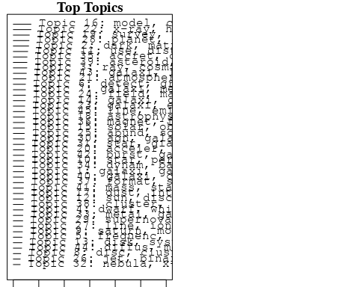

plotQuote(thoughts6, width = 30, main = "Topic 6")  
plotQuote(thoughts18, width = 30, main = "Topic 18")

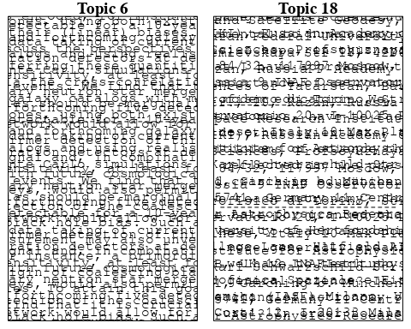

# Calculate and plot the correlation between topics  
mod.out.corr <- topicCorr(Research_topics)  
plot(mod.out.corr, cex = 1.5)  
  
  
# For each topic  
for (topic_num in 1:45) {  
 # Plot the word cloud  
 cloud(Research_topics, topic = topic_num, scale = c(2, 0.25))  
 Sys.sleep(2)  
}

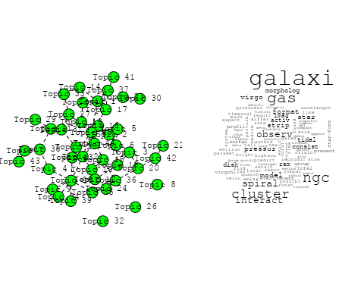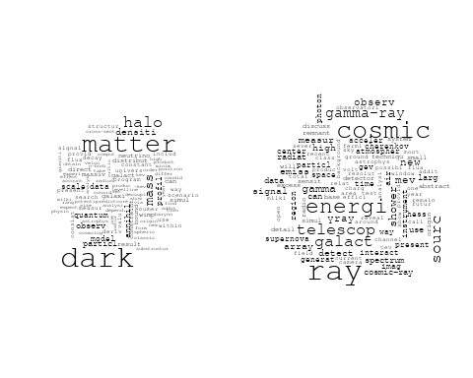

## Warning in wordcloud::wordcloud(words = vocab, freq = vec, max.words =  
## max.words, : pulsar could not be fit on page. It will not be plotted.

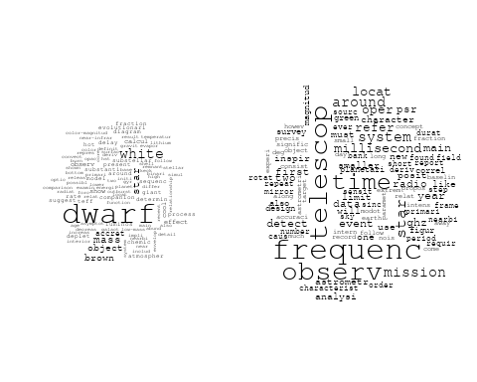

## Warning in wordcloud::wordcloud(words = vocab, freq = vec, max.words =  
## max.words, : gravit could not be fit on page. It will not be plotted.

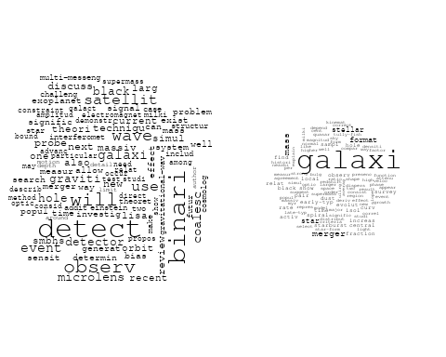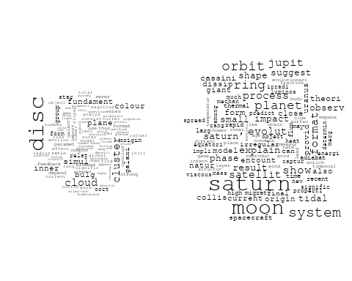

## Warning in wordcloud::wordcloud(words = vocab, freq = vec, max.words =  
## max.words, : spectroscop could not be fit on page. It will not be plotted.

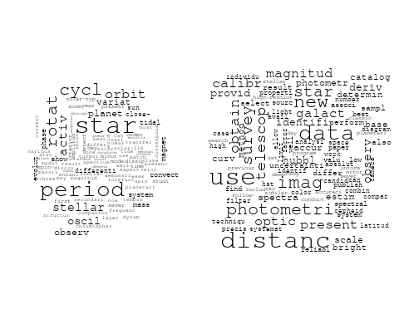

## Warning in wordcloud::wordcloud(words = vocab, freq = vec, max.words =  
## max.words, : stellar could not be fit on page. It will not be plotted.

## Warning in wordcloud::wordcloud(words = vocab, freq = vec, max.words =  
## max.words, : discuss could not be fit on page. It will not be plotted.

## Warning in wordcloud::wordcloud(words = vocab, freq = vec, max.words =  
## max.words, : sun could not be fit on page. It will not be plotted.

## Warning in wordcloud::wordcloud(words = vocab, freq = vec, max.words =  
## max.words, : observ could not be fit on page. It will not be plotted.

## Warning in wordcloud::wordcloud(words = vocab, freq = vec, max.words =  
## max.words, : model could not be fit on page. It will not be plotted.

## Warning in wordcloud::wordcloud(words = vocab, freq = vec, max.words =  
## max.words, : instrument could not be fit on page. It will not be plotted.

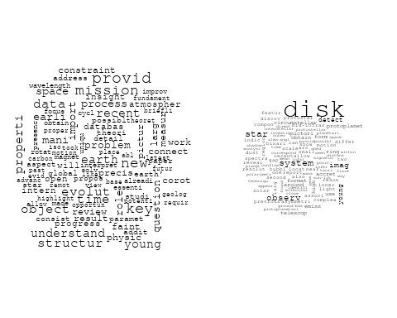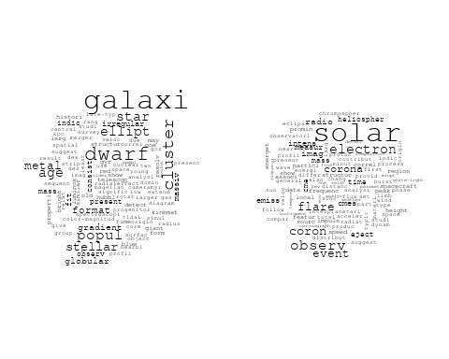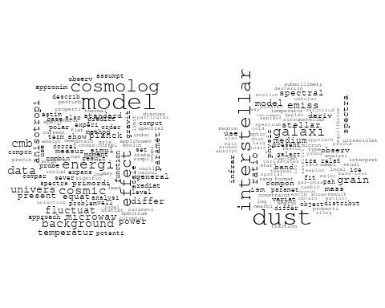

## Warning in wordcloud::wordcloud(words = vocab, freq = vec, max.words =  
## max.words, : galaxi could not be fit on page. It will not be plotted.

## Warning in wordcloud::wordcloud(words = vocab, freq = vec, max.words =  
## max.words, : structur could not be fit on page. It will not be plotted.

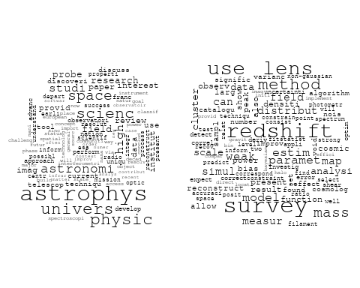

## Warning in wordcloud::wordcloud(words = vocab, freq = vec, max.words =  
## max.words, : shock could not be fit on page. It will not be plotted.

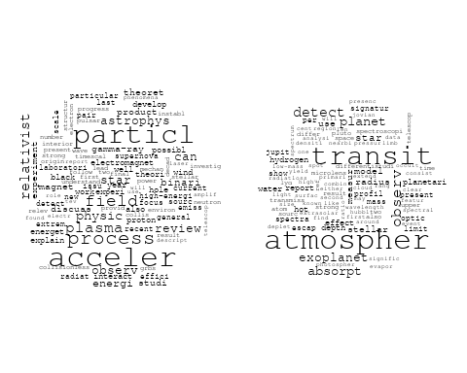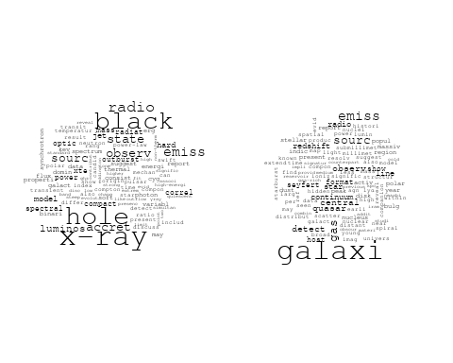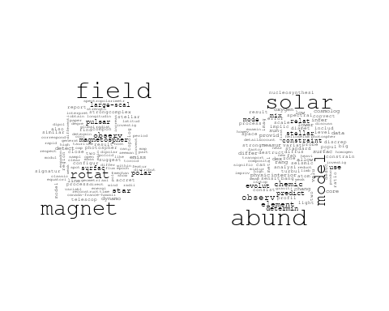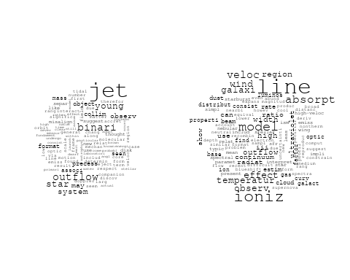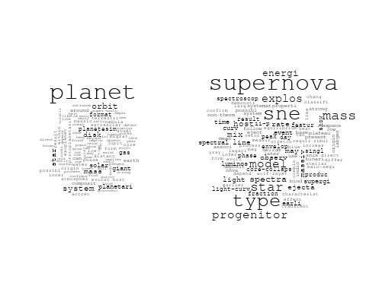

## Warning in wordcloud::wordcloud(words = vocab, freq = vec, max.words =  
## max.words, : galaxi could not be fit on page. It will not be plotted.

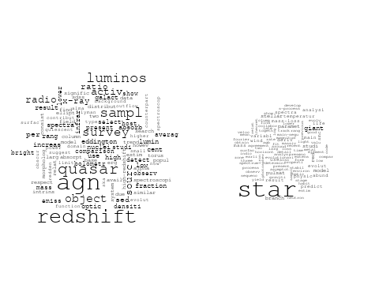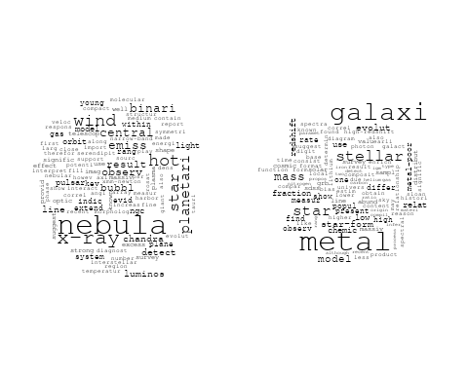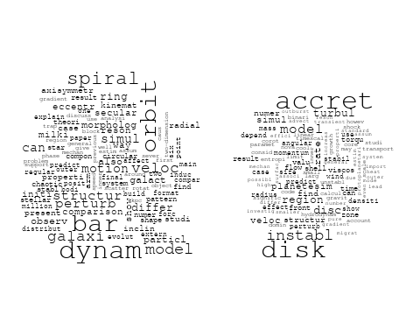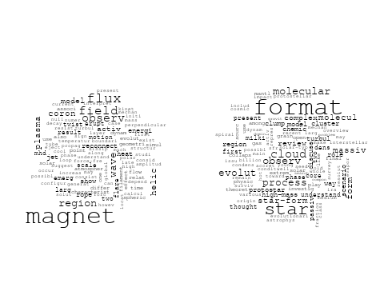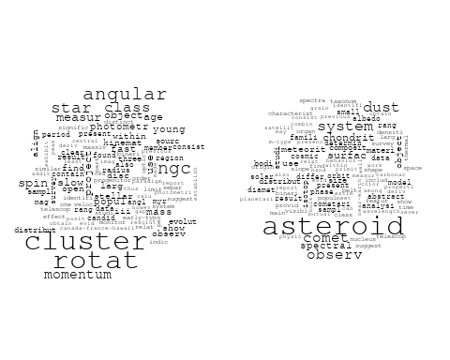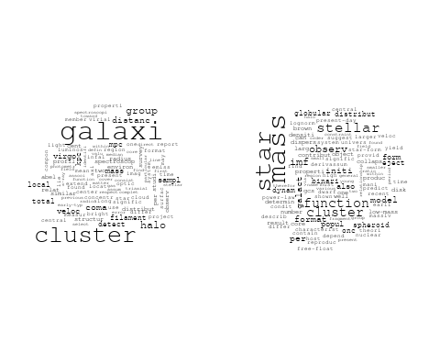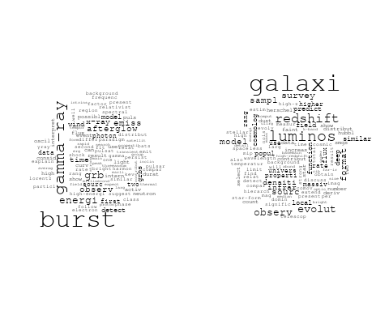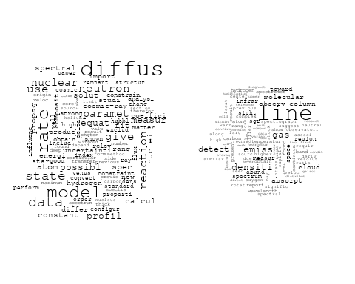

# Get the topic proportions for each document  
topic_proportions <- Research_topics$theta  
  
# Find the index of the topic with the highest proportion for each document  
# This will be the topic that each document is most likely to belong to  
max_topic_idx <- apply(topic_proportions, 1, which.max)  
  
# Add this as a new column to your data  
data_collab$topic <- max_topic_idx  
  
library(ggplot2)  
  
# Define the intervals  
intervals <- c('1824_1899', '1900_1964', '1965_1974', '1975_1984', '1985_1994', '1995_1999', '2000_2004', '2005_2009', '2010_2014', '2015_2019', '2020_2022')  
colors <- c('pink', 'blue', 'purple', 'yellow', 'green', 'pink', 'orange', 'violet', 'green', 'blue', 'pink')  
  
# Loop through the intervals and plot  
for(i in seq_along(intervals)){  
 # Filter data for when the pub_interval is equal to 1  
 data_filtered <- data_collab[data_collab[[paste0('pub_interval_', intervals[i])]] == 1,]  
   
 # Make the histogram  
   
 p <- ggplot(data_filtered, aes(x = topic)) +  
 geom_histogram(binwidth = 1, fill = colors[i], color = "black") +  
 xlab("Topic") +  
 ylab("Count") +  
 ggtitle(paste0("Topics from year ", gsub("_", " to ", intervals[i])))  
   
 print(p)  
}

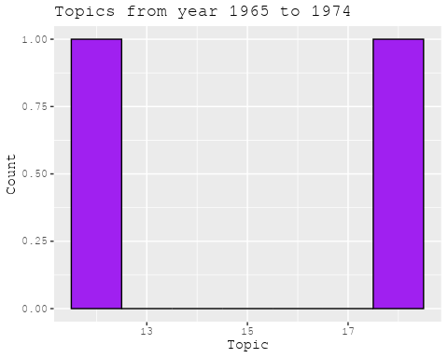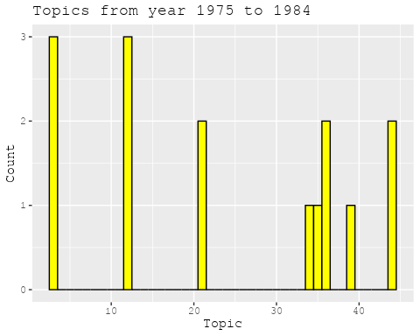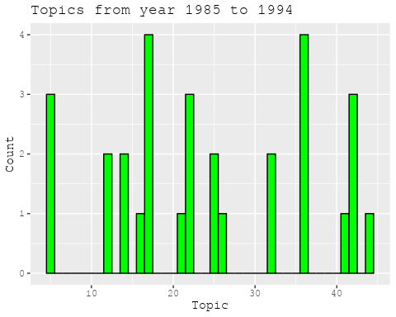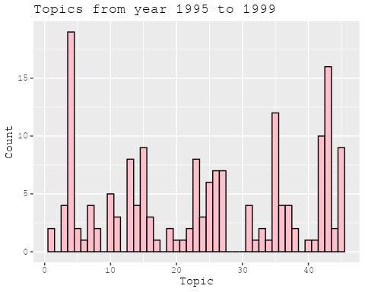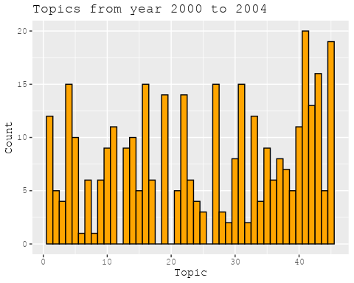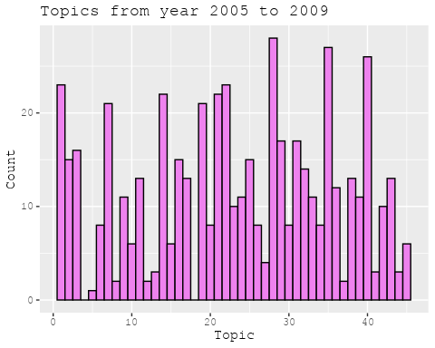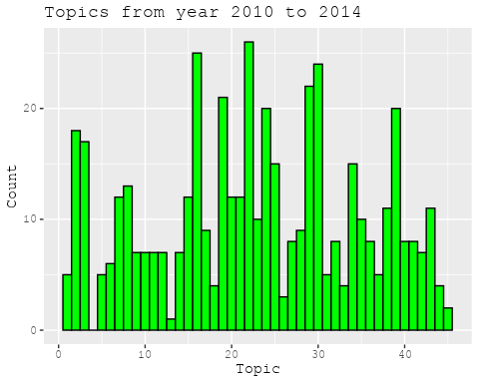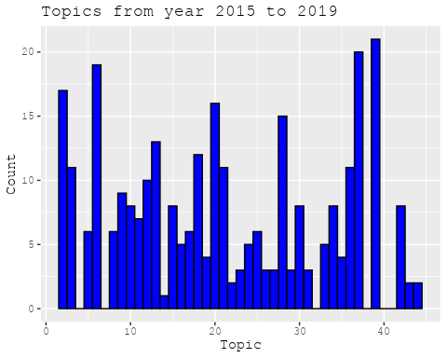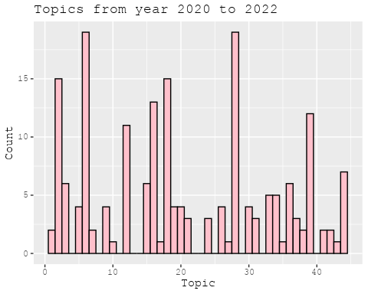

##Topic generation for FR (independent) publications  
  
data_independent <- data[data[["FR"]] == 100,]  
  
# Save the original title data for future use  
data_independent$original_concatenated_title_abstract <- data_independent$concatenated_title_abstract  
  
#pre-processing the titles using textProcessor from the stm package  
processed_text <- textProcessor(data_independent$concatenated_title_abstract, metadata = data_independent)

## Building corpus...   
## Converting to Lower Case...   
## Removing punctuation...   
## Removing stopwords...   
## Removing numbers...   
## Stemming...   
## Creating Output...

# Further prepare the data by removing low-frequency terms  
out_text <- prepDocuments(processed_text$documents, processed_text$vocab, processed_text$meta)

## Removing 1531 of 4813 terms (1531 of 43533 tokens) due to frequency   
## Your corpus now has 544 documents, 3282 terms and 42002 tokens.

docs_text <- out_text$documents  
vocab_text <- out_text$vocab  
meta_text <- out_text$meta  
  
  
#Prepare data  
plotRemoved(processed_text$documents, lower.thresh = seq(1, 200, by = 100))

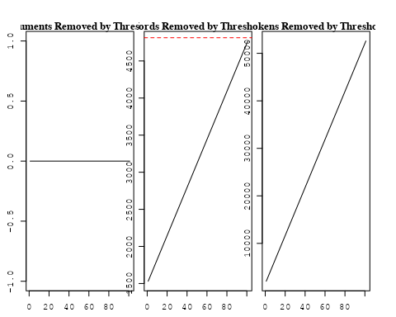

out_text <- prepDocuments(processed_text$documents, processed_text$vocab, processed_text$meta, lower.thresh = 8)

## Removing 3712 of 4813 terms (8994 of 43533 tokens) due to frequency   
## Your corpus now has 544 documents, 1101 terms and 34539 tokens.

str(out_text$meta)

## 'data.frame': 544 obs. of 39 variables:  
## $ concept_id : chr "https://openalex.org/C44870925" "https://openalex.org/C44870925" "https://openalex.org/C44870925" "https://openalex.org/C44870925" ...  
## $ work_id : chr "https://openalex.org/W3099448667" "https://openalex.org/W3100854839" "https://openalex.org/W2876806167" "https://openalex.org/W2769873429" ...  
## $ publication_year : int 2020 2020 2020 2017 2019 2007 2008 1996 1977 2014 ...  
## $ title : chr "Long-term orbital dynamics of trans-Neptunian objects" "Is the Faint Young Sun Problem for Earth Solved" "USINE: semi-analytical models for Galactic cosmic-ray propagation" "The Interstellar dust properties of nearby galaxies" ...  
## $ paperabstract : chr "This article reviews the different mechanisms affecting the orbits of trans-Neptunian objects, ranging from int"| __truncated__ "Stellar evolution models predict that the solar luminosity was lower in the past, typically 20-25% lower during"| __truncated__ "Abstract I present the first public releases (v3.4 and v3.5) of the usine code for cosmic-ray propagation in th"| __truncated__ "This article gives an overview of the constitution, physical conditions, and observables of dust in the interst"| __truncated__ ...  
## $ country : chr "FR" "FR FR" "FR" "FR FR FR FR FR FR" ...  
## $ year_concept : chr "2020+https://openalex.org/C44870925" "2020+https://openalex.org/C44870925" "2020+https://openalex.org/C44870925" "2017+https://openalex.org/C44870925" ...  
## $ concatenated_title_abstract : chr "Long-term orbital dynamics of trans-Neptunian objects This article reviews the different mechanisms affecting t"| __truncated__ "Is the Faint Young Sun Problem for Earth Solved Stellar evolution models predict that the solar luminosity was "| __truncated__ "USINE: semi-analytical models for Galactic cosmic-ray propagation Abstract I present the first public releases "| __truncated__ "The Interstellar dust properties of nearby galaxies This article gives an overview of the constitution, physica"| __truncated__ ...  
## $ US : num 0 0 0 0 0 0 0 0 0 0 ...  
## $ IN : num 0 0 0 0 0 0 0 0 0 0 ...  
## $ DE : num 0 0 0 0 0 0 0 0 0 0 ...  
## $ CH : num 0 0 0 0 0 0 0 0 0 0 ...  
## $ GB : num 0 0 0 0 0 0 0 0 0 0 ...  
## $ CN : num 0 0 0 0 0 0 0 0 0 0 ...  
## $ FR : num 100 100 100 100 100 100 100 100 100 100 ...  
## $ IT : num 0 0 0 0 0 0 0 0 0 0 ...  
## $ RU : num 0 0 0 0 0 0 0 0 0 0 ...  
## $ CA : num 0 0 0 0 0 0 0 0 0 0 ...  
## $ NL : num 0 0 0 0 0 0 0 0 0 0 ...  
## $ AU : num 0 0 0 0 0 0 0 0 0 0 ...  
## $ JP : num 0 0 0 0 0 0 0 0 0 0 ...  
## $ ES : num 0 0 0 0 0 0 0 0 0 0 ...  
## $ IL : num 0 0 0 0 0 0 0 0 0 0 ...  
## $ Americas : num 0 0 0 0 0 0 0 0 0 0 ...  
## $ Europe : num 0 0 0 0 0 0 0 0 0 0 ...  
## $ Africa : num 0 0 0 0 0 0 0 0 0 0 ...  
## $ AsiaAndOceania : num 0 0 0 0 0 0 0 0 0 0 ...  
## $ pub_interval_2020_2022 : int 1 1 1 0 0 0 0 0 0 0 ...  
## $ pub_interval_2015_2019 : int 0 0 0 1 1 0 0 0 0 0 ...  
## $ pub_interval_2010_2014 : int 0 0 0 0 0 0 0 0 0 1 ...  
## $ pub_interval_2005_2009 : int 0 0 0 0 0 1 1 0 0 0 ...  
## $ pub_interval_2000_2004 : int 0 0 0 0 0 0 0 0 0 0 ...  
## $ pub_interval_1995_1999 : int 0 0 0 0 0 0 0 1 0 0 ...  
## $ pub_interval_1985_1994 : int 0 0 0 0 0 0 0 0 0 0 ...  
## $ pub_interval_1975_1984 : int 0 0 0 0 0 0 0 0 1 0 ...  
## $ pub_interval_1965_1974 : int 0 0 0 0 0 0 0 0 0 0 ...  
## $ pub_interval_1900_1964 : int 0 0 0 0 0 0 0 0 0 0 ...  
## $ pub_interval_1824_1899 : int 0 0 0 0 0 0 0 0 0 0 ...  
## $ original_concatenated_title_abstract: chr "Long-term orbital dynamics of trans-Neptunian objects This article reviews the different mechanisms affecting t"| __truncated__ "Is the Faint Young Sun Problem for Earth Solved Stellar evolution models predict that the solar luminosity was "| __truncated__ "USINE: semi-analytical models for Galactic cosmic-ray propagation Abstract I present the first public releases "| __truncated__ "The Interstellar dust properties of nearby galaxies This article gives an overview of the constitution, physica"| __truncated__ ...

# Initialize an empty formula string  
prevalence_formula_str <- "~"  
  
# Define the publication intervals  
pub_intervals <- c("pub_interval_2020_2022", "pub_interval_2015_2019", "pub_interval_2010_2014",   
 "pub_interval_2005_2009", "pub_interval_2000_2004", "pub_interval_1995_1999",  
 "pub_interval_1985_1994", "pub_interval_1975_1984", "pub_interval_1965_1974",  
 "pub_interval_1900_1964", "pub_interval_1824_1899")  
  
# Add each publication interval to the formula string  
for (interval in pub_intervals) {  
 # add an if statement to handle the first addition (without '+')  
 if (prevalence_formula_str == "~") {  
 prevalence_formula_str <- paste(prevalence_formula_str, interval)  
 } else {  
 prevalence_formula_str <- paste(prevalence_formula_str, "+", interval)  
 }  
}  
  
  
# Convert the string to a formula  
prevalence_formula <- as.formula(prevalence_formula_str)  
print(prevalence_formula)

## ~pub_interval_2020_2022 + pub_interval_2015_2019 + pub_interval_2010_2014 +   
## pub_interval_2005_2009 + pub_interval_2000_2004 + pub_interval_1995_1999 +   
## pub_interval_1985_1994 + pub_interval_1975_1984 + pub_interval_1965_1974 +   
## pub_interval_1900_1964 + pub_interval_1824_1899

# Run STM model  
Research_topics <- stm(documents = out_text$documents,   
 vocab = out_text$vocab,   
 K = 45,   
 prevalence = prevalence_formula,   
 data = out_text$meta,   
 init.type = "Spectral",  
 max.em.its = 1000,  
 gamma.prior = 'L1')

## Beginning Spectral Initialization   
## Calculating the gram matrix...  
## Finding anchor words...  
## .............................................  
## Recovering initialization...  
## ...........  
## Initialization complete.  
## ............................................................................................................  
## Completed E-Step (0 seconds).   
## Completed M-Step.   
## Completing Iteration 1 (approx. per word bound = -5.933)   
## ............................................................................................................  
## Completed E-Step (0 seconds).   
## Completed M-Step.   
## Completing Iteration 2 (approx. per word bound = -5.694, relative change = 4.028e-02)   
## ............................................................................................................  
## Completed E-Step (0 seconds).   
## Completed M-Step.   
## Completing Iteration 3 (approx. per word bound = -5.601, relative change = 1.620e-02)   
## ............................................................................................................  
## Completed E-Step (0 seconds).   
## Completed M-Step.   
## Completing Iteration 4 (approx. per word bound = -5.558, relative change = 7.835e-03)   
## ............................................................................................................  
## Completed E-Step (0 seconds).   
## Completed M-Step.   
## Completing Iteration 5 (approx. per word bound = -5.532, relative change = 4.577e-03)   
## Topic 1: cloud, origin, scatter, secular, numer   
## Topic 2: survey, galact, sourc, low, stellar   
## Topic 3: sun, reveal, pictur, resolut, activ   
## Topic 4: model, isotop, abund, cosmolog, chemic   
## Topic 5: format, star, high-mass, massiv, cluster   
## Topic 6: dark, matter, densiti, particl, profil   
## Topic 7: gamma-ray, pulsar, binari, emiss, high-energi   
## Topic 8: model, galaxi, use, evolut, way   
## Topic 9: dwarf, white, disc, hot, outburst   
## Topic 10: grain, comet, disc, emerg, region   
## Topic 11: cosmic, earth, signal, earth’, model   
## Topic 12: disk, zone, region, model, water   
## Topic 13: wave, gravit, larg, binari, detect   
## Topic 14: halo, galaxi, matter, dark, similar   
## Topic 15: reaction, rate, nuclear, measur, abund   
## Topic 16: mass, star, function, imf, stellar   
## Topic 17: galaxi, redshift, line, quasar, gas   
## Topic 18: magnet, jet, field, outflow, accret   
## Topic 19: method, measur, techniqu, use, redshift   
## Topic 20: rotat, field, magnet, reconstruct, simul   
## Topic 21: accret, wind, x-ray, binari, disc   
## Topic 22: solar, distribut, use, result, system   
## Topic 23: black, mass, hole, possibl, will   
## Topic 24: cluster, galaxi, merger, simul, globular   
## Topic 25: temperatur, region, model, transit, coron   
## Topic 26: star, object, dwarf, theori, first   
## Topic 27: bulg, star, metal, mass, galact   
## Topic 28: ray, cosmic, shower, energi, air   
## Topic 29: galaxi, gas, kinemat, ngc, veloc   
## Topic 30: star, cluster, stellar, rotat, observ   
## Topic 31: planet, disk, gas, atmospher, mass   
## Topic 32: dwarf, brown, mass, fraction, companion   
## Topic 33: energi, radiat, type, envelop, star   
## Topic 34: particl, acceler, shock, neutrino, data   
## Topic 35: atmospher, observ, line, atom, venus   
## Topic 36: imag, solar, observ, measur, data   
## Topic 37: energi, burst, observ, emiss, γray   
## Topic 38: solar, mode, detect, frequenc, core   
## Topic 39: galaxi, infrar, discuss, stellar, emiss   
## Topic 40: data, diffus, model, new, paramet   
## Topic 41: asteroid, chondrit, spectra, surfac, analysi   
## Topic 42: mass, lens, cosmolog, model, result   
## Topic 43: hole, black, mass, central, matter   
## Topic 44: dust, magnetospher, observ, pulsar, differ   
## Topic 45: shock, magnet, field, scale, mhd   
## ............................................................................................................  
## Completed E-Step (0 seconds).   
## Completed M-Step.   
## Completing Iteration 6 (approx. per word bound = -5.515, relative change = 3.165e-03)   
## ............................................................................................................  
## Completed E-Step (0 seconds).   
## Completed M-Step.   
## Completing Iteration 7 (approx. per word bound = -5.502, relative change = 2.344e-03)   
## ............................................................................................................  
## Completed E-Step (0 seconds).   
## Completed M-Step.   
## Completing Iteration 8 (approx. per word bound = -5.492, relative change = 1.839e-03)   
## ............................................................................................................  
## Completed E-Step (0 seconds).   
## Completed M-Step.   
## Completing Iteration 9 (approx. per word bound = -5.484, relative change = 1.446e-03)   
## ............................................................................................................  
## Completed E-Step (0 seconds).   
## Completed M-Step.   
## Completing Iteration 10 (approx. per word bound = -5.477, relative change = 1.149e-03)   
## Topic 1: cloud, origin, structur, secular, scatter   
## Topic 2: sourc, survey, galact, low, observ   
## Topic 3: sun, pictur, reveal, activ, cycl   
## Topic 4: model, isotop, solar, chemic, abund   
## Topic 5: format, star, high-mass, massiv, cluster   
## Topic 6: dark, matter, densiti, profil, particl   
## Topic 7: gamma-ray, binari, emiss, pulsar, high-energi   
## Topic 8: model, galaxi, use, evolut, dust   
## Topic 9: dwarf, white, hot, disc, outburst   
## Topic 10: grain, comet, region, emerg, disc   
## Topic 11: cosmic, earth, signal, earth’, model   
## Topic 12: disk, zone, region, model, water   
## Topic 13: wave, gravit, binari, larg, detect   
## Topic 14: halo, galaxi, matter, dark, similar   
## Topic 15: reaction, rate, nuclear, abund, measur   
## Topic 16: mass, star, function, imf, stellar   
## Topic 17: galaxi, line, redshift, gas, quasar   
## Topic 18: jet, magnet, field, accret, outflow   
## Topic 19: method, use, measur, data, techniqu   
## Topic 20: rotat, field, magnet, reconstruct, simul   
## Topic 21: accret, wind, x-ray, binari, effect   
## Topic 22: distribut, use, result, solar, two   
## Topic 23: mass, black, hole, possibl, will   
## Topic 24: cluster, galaxi, merger, simul, globular   
## Topic 25: temperatur, model, transit, region, coron   
## Topic 26: star, object, dwarf, present, time   
## Topic 27: bulg, metal, star, mass, hole   
## Topic 28: ray, cosmic, shower, energi, air   
## Topic 29: galaxi, gas, kinemat, ngc, veloc   
## Topic 30: star, cluster, stellar, convect, observ   
## Topic 31: planet, disk, gas, atmospher, mass   
## Topic 32: dwarf, brown, system, mass, fraction   
## Topic 33: energi, type, radiat, star, envelop   
## Topic 34: particl, acceler, neutrino, shock, data   
## Topic 35: atmospher, line, observ, atom, venus   
## Topic 36: imag, solar, observ, measur, data   
## Topic 37: energi, burst, observ, γray, emiss   
## Topic 38: solar, mode, detect, core, frequenc   
## Topic 39: galaxi, infrar, discuss, emiss, mass   
## Topic 40: data, diffus, model, new, compon   
## Topic 41: asteroid, chondrit, spectra, analysi, surfac   
## Topic 42: mass, cosmolog, model, lens, simul   
## Topic 43: hole, black, galaxi, mass, central   
## Topic 44: dust, magnetospher, pulsar, observ, differ   
## Topic 45: shock, magnet, field, wave, region   
## ............................................................................................................  
## Completed E-Step (0 seconds).   
## Completed M-Step.   
## Completing Iteration 11 (approx. per word bound = -5.473, relative change = 8.514e-04)   
## ............................................................................................................  
## Completed E-Step (0 seconds).   
## Completed M-Step.   
## Completing Iteration 12 (approx. per word bound = -5.468, relative change = 7.665e-04)   
## ............................................................................................................  
## Completed E-Step (0 seconds).   
## Completed M-Step.   
## Completing Iteration 13 (approx. per word bound = -5.465, relative change = 6.452e-04)   
## ............................................................................................................  
## Completed E-Step (0 seconds).   
## Completed M-Step.   
## Completing Iteration 14 (approx. per word bound = -5.462, relative change = 6.035e-04)   
## ............................................................................................................  
## Completed E-Step (0 seconds).   
## Completed M-Step.   
## Completing Iteration 15 (approx. per word bound = -5.458, relative change = 6.152e-04)   
## Topic 1: cloud, origin, structur, interstellar, secular   
## Topic 2: sourc, survey, galact, observ, low   
## Topic 3: sun, pictur, solar, reveal, activ   
## Topic 4: solar, isotop, model, abund, chemic   
## Topic 5: format, star, high-mass, massiv, cluster   
## Topic 6: dark, matter, densiti, profil, particl   
## Topic 7: gamma-ray, binari, emiss, pulsar, high-energi   
## Topic 8: model, galaxi, dust, use, evolut   
## Topic 9: dwarf, white, hot, disc, outburst   
## Topic 10: comet, grain, region, emerg, disc   
## Topic 11: cosmic, earth, signal, model, earth’   
## Topic 12: disk, zone, region, water, model   
## Topic 13: wave, gravit, binari, larg, detect   
## Topic 14: halo, galaxi, matter, similar, dark   
## Topic 15: reaction, rate, nuclear, abund, measur   
## Topic 16: mass, star, function, imf, stellar   
## Topic 17: galaxi, line, redshift, gas, quasar   
## Topic 18: jet, magnet, field, accret, outflow   
## Topic 19: method, use, data, measur, techniqu   
## Topic 20: rotat, field, magnet, reconstruct, differenti   
## Topic 21: accret, wind, binari, planetesim, x-ray   
## Topic 22: use, distribut, result, two, satellit   
## Topic 23: mass, black, hole, possibl, will   
## Topic 24: cluster, galaxi, merger, simul, globular   
## Topic 25: temperatur, model, transit, disc, coron   
## Topic 26: star, object, dwarf, time, present   
## Topic 27: bulg, metal, star, mass, hole   
## Topic 28: ray, cosmic, energi, shower, air   
## Topic 29: galaxi, gas, kinemat, ngc, veloc   
## Topic 30: star, cluster, stellar, cool, observ   
## Topic 31: planet, disk, gas, atmospher, mass   
## Topic 32: dwarf, brown, mass, system, fraction   
## Topic 33: energi, type, star, envelop, radiat   
## Topic 34: particl, acceler, neutrino, shock, data   
## Topic 35: atmospher, line, observ, atom, venus   
## Topic 36: imag, solar, observ, measur, data   
## Topic 37: burst, energi, observ, γray, wind   
## Topic 38: solar, mode, detect, review, core   
## Topic 39: galaxi, infrar, discuss, emiss, mass   
## Topic 40: data, diffus, model, compon, new   
## Topic 41: asteroid, chondrit, spectra, analysi, sampl   
## Topic 42: mass, cosmolog, model, lens, simul   
## Topic 43: hole, black, galaxi, mass, central   
## Topic 44: dust, pulsar, magnetospher, observ, differ   
## Topic 45: shock, magnet, field, wave, region   
## ............................................................................................................  
## Completed E-Step (0 seconds).   
## Completed M-Step.   
## Completing Iteration 16 (approx. per word bound = -5.455, relative change = 5.660e-04)   
## ............................................................................................................  
## Completed E-Step (0 seconds).   
## Completed M-Step.   
## Completing Iteration 17 (approx. per word bound = -5.453, relative change = 4.435e-04)   
## ............................................................................................................  
## Completed E-Step (0 seconds).   
## Completed M-Step.   
## Completing Iteration 18 (approx. per word bound = -5.451, relative change = 3.935e-04)   
## ............................................................................................................  
## Completed E-Step (0 seconds).   
## Completed M-Step.   
## Completing Iteration 19 (approx. per word bound = -5.449, relative change = 3.630e-04)   
## ............................................................................................................  
## Completed E-Step (0 seconds).   
## Completed M-Step.   
## Completing Iteration 20 (approx. per word bound = -5.447, relative change = 3.582e-04)   
## Topic 1: cloud, origin, interstellar, secular, structur   
## Topic 2: sourc, survey, galact, observ, low   
## Topic 3: sun, pictur, solar, system, activ   
## Topic 4: solar, isotop, model, abund, chemic   
## Topic 5: format, star, high-mass, massiv, cluster   
## Topic 6: dark, matter, densiti, profil, halo   
## Topic 7: gamma-ray, binari, emiss, pulsar, high-energi   
## Topic 8: model, galaxi, dust, use, evolut   
## Topic 9: dwarf, white, hot, disc, nova   
## Topic 10: comet, grain, emerg, region, disc   
## Topic 11: cosmic, earth, signal, model, earth’   
## Topic 12: disk, zone, region, water, model   
## Topic 13: wave, gravit, binari, larg, detect   
## Topic 14: galaxi, halo, similar, emiss, matter   
## Topic 15: reaction, rate, nuclear, abund, measur   
## Topic 16: mass, star, function, imf, stellar   
## Topic 17: galaxi, redshift, quasar, gas, line   
## Topic 18: jet, magnet, field, outflow, accret   
## Topic 19: method, use, data, techniqu, measur   
## Topic 20: field, rotat, magnet, differenti, reconstruct   
## Topic 21: accret, wind, binari, planetesim, star   
## Topic 22: use, distribut, halo, result, satellit   
## Topic 23: mass, black, hole, possibl, will   
## Topic 24: cluster, galaxi, merger, simul, globular   
## Topic 25: temperatur, model, disc, transit, coron   
## Topic 26: star, object, dwarf, time, present   
## Topic 27: bulg, metal, star, mass, hole   
## Topic 28: cosmic, ray, shower, energi, air   
## Topic 29: galaxi, gas, kinemat, ngc, veloc   
## Topic 30: star, cluster, stellar, cool, interior   
## Topic 31: planet, disk, gas, atmospher, mass   
## Topic 32: dwarf, brown, mass, system, show   
## Topic 33: energi, star, type, envelop, progenitor   
## Topic 34: particl, acceler, neutrino, data, shock   
## Topic 35: atmospher, line, observ, atom, venus   
## Topic 36: solar, observ, imag, measur, data   
## Topic 37: burst, energi, observ, wind, γray   
## Topic 38: solar, mode, detect, review, core   
## Topic 39: galaxi, infrar, discuss, mass, compon   
## Topic 40: data, diffus, model, compon, new   
## Topic 41: asteroid, chondrit, spectra, analysi, sampl   
## Topic 42: mass, cosmolog, model, lens, simul   
## Topic 43: hole, black, galaxi, mass, central   
## Topic 44: dust, pulsar, magnetospher, observ, differ   
## Topic 45: shock, magnet, field, wave, region   
## ............................................................................................................  
## Completed E-Step (0 seconds).   
## Completed M-Step.   
## Completing Iteration 21 (approx. per word bound = -5.445, relative change = 3.604e-04)   
## ............................................................................................................  
## Completed E-Step (0 seconds).   
## Completed M-Step.   
## Completing Iteration 22 (approx. per word bound = -5.443, relative change = 3.466e-04)   
## ............................................................................................................  
## Completed E-Step (0 seconds).   
## Completed M-Step.   
## Completing Iteration 23 (approx. per word bound = -5.441, relative change = 3.024e-04)   
## ............................................................................................................  
## Completed E-Step (0 seconds).   
## Completed M-Step.   
## Completing Iteration 24 (approx. per word bound = -5.439, relative change = 3.123e-04)   
## ............................................................................................................  
## Completed E-Step (0 seconds).   
## Completed M-Step.   
## Completing Iteration 25 (approx. per word bound = -5.438, relative change = 2.923e-04)   
## Topic 1: cloud, origin, interstellar, secular, scatter   
## Topic 2: sourc, survey, observ, galact, low   
## Topic 3: sun, pictur, solar, system, activ   
## Topic 4: solar, isotop, abund, model, chemic   
## Topic 5: format, star, high-mass, massiv, cluster   
## Topic 6: dark, matter, densiti, profil, halo   
## Topic 7: gamma-ray, binari, emiss, pulsar, high-energi   
## Topic 8: galaxi, model, dust, use, line   
## Topic 9: dwarf, white, hot, disc, nova   
## Topic 10: comet, emerg, region, grain, disc   
## Topic 11: cosmic, earth, signal, model, earth’   
## Topic 12: disk, zone, region, water, model   
## Topic 13: wave, gravit, binari, larg, detect   
## Topic 14: galaxi, halo, similar, emiss, matter   
## Topic 15: reaction, rate, nuclear, abund, measur   
## Topic 16: mass, star, function, imf, stellar   
## Topic 17: galaxi, redshift, quasar, gas, star   
## Topic 18: jet, magnet, field, outflow, accret   
## Topic 19: method, use, data, measur, techniqu   
## Topic 20: field, rotat, magnet, differenti, large-scal   
## Topic 21: accret, wind, binari, planetesim, star   
## Topic 22: use, halo, distribut, result, satellit   
## Topic 23: mass, hole, black, possibl, will   
## Topic 24: cluster, galaxi, merger, simul, globular   
## Topic 25: temperatur, model, disc, transit, coron   
## Topic 26: star, time, period, object, galaxi   
## Topic 27: bulg, metal, star, mass, hole   
## Topic 28: cosmic, ray, shower, energi, air   
## Topic 29: galaxi, gas, kinemat, ngc, veloc   
## Topic 30: star, cluster, stellar, cool, interior   
## Topic 31: planet, disk, atmospher, gas, mass   
## Topic 32: dwarf, brown, mass, system, show   
## Topic 33: energi, star, type, envelop, progenitor   
## Topic 34: particl, acceler, neutrino, data, shock   
## Topic 35: atmospher, line, observ, atom, venus   
## Topic 36: imag, solar, observ, measur, space   
## Topic 37: burst, energi, observ, wind, γray   
## Topic 38: solar, mode, detect, review, use   
## Topic 39: galaxi, infrar, discuss, mass, compon   
## Topic 40: diffus, model, data, compon, paramet   
## Topic 41: asteroid, chondrit, spectra, analysi, sampl   
## Topic 42: mass, cosmolog, model, lens, simul   
## Topic 43: hole, black, galaxi, mass, bound   
## Topic 44: dust, pulsar, magnetospher, observ, differ   
## Topic 45: shock, magnet, field, wave, acceler   
## ............................................................................................................  
## Completed E-Step (0 seconds).   
## Completed M-Step.   
## Completing Iteration 26 (approx. per word bound = -5.436, relative change = 2.729e-04)   
## ............................................................................................................  
## Completed E-Step (0 seconds).   
## Completed M-Step.   
## Completing Iteration 27 (approx. per word bound = -5.435, relative change = 2.122e-04)   
## ............................................................................................................  
## Completed E-Step (0 seconds).   
## Completed M-Step.   
## Completing Iteration 28 (approx. per word bound = -5.434, relative change = 2.534e-04)   
## ............................................................................................................  
## Completed E-Step (0 seconds).   
## Completed M-Step.   
## Completing Iteration 29 (approx. per word bound = -5.432, relative change = 2.599e-04)   
## ............................................................................................................  
## Completed E-Step (0 seconds).   
## Completed M-Step.   
## Completing Iteration 30 (approx. per word bound = -5.431, relative change = 2.257e-04)   
## Topic 1: cloud, origin, interstellar, secular, scatter   
## Topic 2: sourc, survey, observ, galact, low   
## Topic 3: sun, pictur, solar, activ, cycl   
## Topic 4: solar, isotop, abund, model, chemic   
## Topic 5: format, star, high-mass, massiv, cluster   
## Topic 6: dark, matter, densiti, profil, distribut   
## Topic 7: gamma-ray, binari, emiss, pulsar, high-energi   
## Topic 8: model, galaxi, dust, use, line   
## Topic 9: dwarf, white, hot, disc, nova   
## Topic 10: emerg, comet, region, disc, grain   
## Topic 11: cosmic, earth, signal, model, earth’   
## Topic 12: disk, zone, region, water, model   
## Topic 13: wave, gravit, binari, larg, detect   
## Topic 14: galaxi, halo, similar, emiss, detect   
## Topic 15: reaction, rate, nuclear, abund, measur   
## Topic 16: mass, star, function, imf, stellar   
## Topic 17: galaxi, redshift, quasar, gas, star   
## Topic 18: jet, magnet, field, outflow, plasma   
## Topic 19: method, data, use, measur, techniqu   
## Topic 20: rotat, field, magnet, differenti, large-scal   
## Topic 21: accret, wind, binari, planetesim, star   
## Topic 22: use, halo, result, distribut, satellit   
## Topic 23: hole, black, mass, possibl, will   
## Topic 24: cluster, galaxi, merger, simul, globular   
## Topic 25: temperatur, model, magnet, disc, accret   
## Topic 26: star, galaxi, time, period, present   
## Topic 27: bulg, metal, star, mass, hole   
## Topic 28: cosmic, ray, shower, energi, air   
## Topic 29: galaxi, kinemat, gas, ngc, veloc   
## Topic 30: star, cluster, stellar, cool, interior   
## Topic 31: planet, disk, atmospher, gas, mass   
## Topic 32: dwarf, brown, mass, show, system   
## Topic 33: energi, star, type, envelop, progenitor   
## Topic 34: particl, acceler, neutrino, data, telescop   
## Topic 35: atmospher, line, observ, atom, venus   
## Topic 36: imag, solar, observ, measur, space   
## Topic 37: burst, energi, observ, wind, γray   
## Topic 38: solar, mode, detect, review, use   
## Topic 39: galaxi, infrar, discuss, mass, compon   
## Topic 40: model, diffus, data, compon, paramet   
## Topic 41: asteroid, chondrit, analysi, spectra, sampl   
## Topic 42: cosmolog, mass, model, lens, simul   
## Topic 43: hole, black, galaxi, mass, bound   
## Topic 44: dust, pulsar, magnetospher, observ, differ   
## Topic 45: shock, magnet, field, wave, acceler   
## ............................................................................................................  
## Completed E-Step (0 seconds).   
## Completed M-Step.   
## Completing Iteration 31 (approx. per word bound = -5.430, relative change = 1.816e-04)   
## ............................................................................................................  
## Completed E-Step (0 seconds).   
## Completed M-Step.   
## Completing Iteration 32 (approx. per word bound = -5.429, relative change = 1.830e-04)   
## ............................................................................................................  
## Completed E-Step (0 seconds).   
## Completed M-Step.   
## Completing Iteration 33 (approx. per word bound = -5.428, relative change = 1.764e-04)   
## ............................................................................................................  
## Completed E-Step (0 seconds).   
## Completed M-Step.   
## Completing Iteration 34 (approx. per word bound = -5.427, relative change = 1.903e-04)   
## ............................................................................................................  
## Completed E-Step (0 seconds).   
## Completed M-Step.   
## Completing Iteration 35 (approx. per word bound = -5.426, relative change = 1.830e-04)   
## Topic 1: cloud, origin, secular, interstellar, scatter   
## Topic 2: sourc, survey, observ, galact, low   
## Topic 3: sun, pictur, solar, activ, cycl   
## Topic 4: solar, isotop, abund, model, chemic   
## Topic 5: format, star, high-mass, cluster, massiv   
## Topic 6: dark, matter, densiti, distribut, profil   
## Topic 7: gamma-ray, binari, emiss, pulsar, high-energi   
## Topic 8: model, galaxi, dust, use, line   
## Topic 9: dwarf, white, hot, disc, nova   
## Topic 10: emerg, region, comet, disc, evapor   
## Topic 11: cosmic, earth, signal, model, earth’   
## Topic 12: disk, zone, region, water, model   
## Topic 13: wave, gravit, binari, larg, detect   
## Topic 14: galaxi, halo, similar, emiss, matter   
## Topic 15: reaction, rate, nuclear, abund, measur   
## Topic 16: mass, star, function, imf, stellar   
## Topic 17: galaxi, redshift, quasar, star, gas   
## Topic 18: jet, magnet, field, outflow, plasma   
## Topic 19: method, data, use, measur, techniqu   
## Topic 20: rotat, field, magnet, differenti, star   
## Topic 21: accret, wind, binari, planetesim, star   
## Topic 22: halo, use, result, distribut, satellit   
## Topic 23: mass, hole, black, possibl, will   
## Topic 24: cluster, galaxi, merger, simul, globular   
## Topic 25: temperatur, model, magnet, disc, accret   
## Topic 26: star, galaxi, time, period, present   
## Topic 27: bulg, metal, star, mass, hole   
## Topic 28: cosmic, ray, shower, energi, air   
## Topic 29: galaxi, gas, kinemat, ngc, veloc   
## Topic 30: star, cluster, stellar, cool, interior   
## Topic 31: planet, disk, atmospher, gas, mass   
## Topic 32: dwarf, brown, mass, show, system   
## Topic 33: energi, star, type, envelop, progenitor   
## Topic 34: particl, acceler, neutrino, data, telescop   
## Topic 35: atmospher, line, observ, atom, venus   
## Topic 36: imag, solar, observ, measur, space   
## Topic 37: burst, observ, energi, wind, emiss   
## Topic 38: solar, mode, detect, review, use   
## Topic 39: galaxi, infrar, discuss, mass, compon   
## Topic 40: model, diffus, data, compon, paramet   
## Topic 41: asteroid, chondrit, spectra, analysi, observ   
## Topic 42: cosmolog, mass, model, lens, simul   
## Topic 43: hole, black, galaxi, mass, bound   
## Topic 44: dust, pulsar, magnetospher, observ, differ   
## Topic 45: shock, magnet, field, wave, acceler   
## ............................................................................................................  
## Completed E-Step (0 seconds).   
## Completed M-Step.   
## Completing Iteration 36 (approx. per word bound = -5.425, relative change = 1.452e-04)   
## ............................................................................................................  
## Completed E-Step (0 seconds).   
## Completed M-Step.   
## Completing Iteration 37 (approx. per word bound = -5.425, relative change = 1.200e-04)   
## ............................................................................................................  
## Completed E-Step (0 seconds).   
## Completed M-Step.   
## Completing Iteration 38 (approx. per word bound = -5.424, relative change = 1.031e-04)   
## ............................................................................................................  
## Completed E-Step (0 seconds).   
## Completed M-Step.   
## Completing Iteration 39 (approx. per word bound = -5.424, relative change = 9.384e-05)   
## ............................................................................................................  
## Completed E-Step (0 seconds).   
## Completed M-Step.   
## Completing Iteration 40 (approx. per word bound = -5.423, relative change = 9.337e-05)   
## Topic 1: cloud, origin, secular, scatter, interstellar   
## Topic 2: sourc, survey, observ, galact, low   
## Topic 3: sun, pictur, solar, cycl, model   
## Topic 4: solar, isotop, abund, model, chemic   
## Topic 5: format, star, high-mass, cluster, massiv   
## Topic 6: dark, matter, densiti, distribut, profil   
## Topic 7: gamma-ray, binari, emiss, pulsar, high-energi   
## Topic 8: galaxi, model, dust, use, line   
## Topic 9: dwarf, white, hot, disc, nova   
## Topic 10: emerg, region, comet, disc, evapor   
## Topic 11: cosmic, signal, earth, earth’, model   
## Topic 12: disk, zone, region, water, model   
## Topic 13: wave, gravit, binari, larg, detect   
## Topic 14: galaxi, halo, similar, matter, emiss   
## Topic 15: reaction, rate, nuclear, abund, predict   
## Topic 16: mass, star, function, imf, stellar   
## Topic 17: galaxi, redshift, quasar, star, observ   
## Topic 18: jet, field, magnet, outflow, plasma   
## Topic 19: data, method, use, measur, techniqu   
## Topic 20: rotat, field, magnet, differenti, star   
## Topic 21: accret, wind, star, planetesim, binari   
## Topic 22: halo, use, result, satellit, distribut   
## Topic 23: mass, hole, black, possibl, will   
## Topic 24: cluster, galaxi, merger, simul, globular   
## Topic 25: model, temperatur, magnet, disc, accret   
## Topic 26: star, galaxi, time, period, present   
## Topic 27: bulg, metal, star, mass, hole   
## Topic 28: cosmic, ray, shower, energi, air   
## Topic 29: galaxi, gas, kinemat, ngc, veloc   
## Topic 30: star, cluster, stellar, cool, interior   
## Topic 31: planet, disk, atmospher, gas, mass   
## Topic 32: dwarf, brown, mass, show, system   
## Topic 33: energi, star, type, envelop, progenitor   
## Topic 34: particl, acceler, neutrino, data, telescop   
## Topic 35: atmospher, observ, line, atom, venus   
## Topic 36: imag, solar, observ, measur, space   
## Topic 37: burst, observ, wind, energi, emiss   
## Topic 38: solar, mode, detect, review, use   
## Topic 39: galaxi, infrar, discuss, mass, stellar   
## Topic 40: model, diffus, compon, data, paramet   
## Topic 41: asteroid, chondrit, spectra, analysi, observ   
## Topic 42: cosmolog, mass, model, lens, simul   
## Topic 43: hole, black, galaxi, mass, bound   
## Topic 44: dust, pulsar, magnetospher, observ, differ   
## Topic 45: shock, magnet, field, wave, acceler   
## ............................................................................................................  
## Completed E-Step (0 seconds).   
## Completed M-Step.   
## Completing Iteration 41 (approx. per word bound = -5.423, relative change = 9.904e-05)   
## ............................................................................................................  
## Completed E-Step (0 seconds).   
## Completed M-Step.   
## Completing Iteration 42 (approx. per word bound = -5.422, relative change = 1.063e-04)   
## ............................................................................................................  
## Completed E-Step (0 seconds).   
## Completed M-Step.   
## Completing Iteration 43 (approx. per word bound = -5.422, relative change = 1.164e-04)   
## ............................................................................................................  
## Completed E-Step (0 seconds).   
## Completed M-Step.   
## Completing Iteration 44 (approx. per word bound = -5.421, relative change = 1.180e-04)   
## ............................................................................................................  
## Completed E-Step (0 seconds).   
## Completed M-Step.   
## Completing Iteration 45 (approx. per word bound = -5.420, relative change = 1.166e-04)   
## Topic 1: cloud, origin, secular, scatter, interstellar   
## Topic 2: sourc, survey, observ, galact, low   
## Topic 3: sun, pictur, solar, model, stellar   
## Topic 4: solar, isotop, abund, model, chemic   
## Topic 5: format, star, high-mass, cluster, massiv   
## Topic 6: dark, matter, densiti, distribut, profil   
## Topic 7: gamma-ray, binari, emiss, pulsar, high-energi   
## Topic 8: galaxi, model, dust, use, line   
## Topic 9: dwarf, white, hot, disc, nova   
## Topic 10: emerg, region, comet, disc, evapor   
## Topic 11: cosmic, signal, earth, earth’, model   
## Topic 12: disk, zone, region, water, model   
## Topic 13: wave, gravit, binari, larg, detect   
## Topic 14: galaxi, halo, similar, matter, detect   
## Topic 15: reaction, rate, nuclear, abund, predict   
## Topic 16: mass, star, function, imf, stellar   
## Topic 17: galaxi, redshift, quasar, star, observ   
## Topic 18: jet, field, magnet, outflow, plasma   
## Topic 19: data, method, use, measur, techniqu   
## Topic 20: rotat, field, magnet, star, differenti   
## Topic 21: accret, wind, star, planetesim, binari   
## Topic 22: halo, use, result, distribut, satellit   
## Topic 23: mass, hole, black, possibl, will   
## Topic 24: cluster, galaxi, merger, simul, globular   
## Topic 25: model, temperatur, disc, magnet, accret   
## Topic 26: star, galaxi, time, period, present   
## Topic 27: bulg, metal, star, mass, hole   
## Topic 28: cosmic, ray, shower, energi, air   
## Topic 29: galaxi, gas, kinemat, ngc, veloc   
## Topic 30: star, cluster, stellar, cool, interior   
## Topic 31: planet, disk, atmospher, gas, transit   
## Topic 32: dwarf, brown, mass, show, system   
## Topic 33: energi, star, type, envelop, progenitor   
## Topic 34: particl, acceler, neutrino, data, telescop   
## Topic 35: atmospher, observ, line, atom, venus   
## Topic 36: solar, imag, observ, measur, space   
## Topic 37: burst, emiss, wind, observ, energi   
## Topic 38: solar, mode, detect, review, use   
## Topic 39: galaxi, infrar, discuss, mass, stellar   
## Topic 40: model, diffus, compon, data, paramet   
## Topic 41: asteroid, chondrit, spectra, analysi, observ   
## Topic 42: mass, cosmolog, model, lens, simul   
## Topic 43: hole, black, galaxi, mass, bound   
## Topic 44: dust, pulsar, magnetospher, observ, differ   
## Topic 45: shock, magnet, field, wave, acceler   
## ............................................................................................................  
## Completed E-Step (0 seconds).   
## Completed M-Step.   
## Completing Iteration 46 (approx. per word bound = -5.420, relative change = 1.035e-04)   
## ............................................................................................................  
## Completed E-Step (0 seconds).   
## Completed M-Step.   
## Completing Iteration 47 (approx. per word bound = -5.419, relative change = 8.851e-05)   
## ............................................................................................................  
## Completed E-Step (0 seconds).   
## Completed M-Step.   
## Completing Iteration 48 (approx. per word bound = -5.419, relative change = 7.704e-05)   
## ............................................................................................................  
## Completed E-Step (0 seconds).   
## Completed M-Step.   
## Completing Iteration 49 (approx. per word bound = -5.418, relative change = 6.802e-05)   
## ............................................................................................................  
## Completed E-Step (0 seconds).   
## Completed M-Step.   
## Completing Iteration 50 (approx. per word bound = -5.418, relative change = 6.609e-05)   
## Topic 1: cloud, origin, secular, interstellar, scatter   
## Topic 2: sourc, survey, observ, galact, low   
## Topic 3: sun, pictur, solar, model, stellar   
## Topic 4: solar, isotop, abund, model, system   
## Topic 5: format, star, high-mass, cluster, massiv   
## Topic 6: dark, matter, densiti, distribut, profil   
## Topic 7: gamma-ray, binari, emiss, pulsar, high-energi   
## Topic 8: galaxi, model, dust, line, use   
## Topic 9: dwarf, white, hot, disc, nova   
## Topic 10: emerg, region, comet, disc, evapor   
## Topic 11: cosmic, signal, earth, earth’, model   
## Topic 12: disk, zone, region, water, model   
## Topic 13: wave, gravit, binari, larg, detect   
## Topic 14: galaxi, halo, similar, matter, detect   
## Topic 15: reaction, rate, nuclear, abund, predict   
## Topic 16: mass, star, function, imf, stellar   
## Topic 17: galaxi, redshift, quasar, star, observ   
## Topic 18: jet, magnet, outflow, field, plasma   
## Topic 19: data, method, use, measur, techniqu   
## Topic 20: rotat, field, magnet, star, differenti   
## Topic 21: accret, wind, star, planetesim, binari   
## Topic 22: halo, use, distribut, result, satellit   
## Topic 23: mass, hole, black, possibl, will   
## Topic 24: galaxi, cluster, merger, globular, simul   
## Topic 25: model, temperatur, disc, magnet, accret   
## Topic 26: star, galaxi, time, period, present   
## Topic 27: bulg, metal, star, mass, hole   
## Topic 28: cosmic, ray, shower, energi, air   
## Topic 29: galaxi, gas, kinemat, ngc, veloc   
## Topic 30: star, cluster, stellar, cool, interior   
## Topic 31: planet, disk, atmospher, transit, gas   
## Topic 32: dwarf, mass, brown, show, function   
## Topic 33: energi, star, type, envelop, progenitor   
## Topic 34: particl, acceler, neutrino, data, energi   
## Topic 35: atmospher, observ, line, atom, venus   
## Topic 36: solar, imag, observ, measur, space   
## Topic 37: burst, wind, emiss, observ, energi   
## Topic 38: solar, mode, detect, review, use   
## Topic 39: galaxi, infrar, discuss, mass, stellar   
## Topic 40: model, diffus, compon, data, paramet   
## Topic 41: asteroid, chondrit, spectra, analysi, observ   
## Topic 42: mass, model, cosmolog, lens, dark   
## Topic 43: hole, black, galaxi, mass, bound   
## Topic 44: dust, pulsar, magnetospher, observ, differ   
## Topic 45: shock, magnet, field, wave, acceler   
## ............................................................................................................  
## Completed E-Step (0 seconds).   
## Completed M-Step.   
## Completing Iteration 51 (approx. per word bound = -5.418, relative change = 6.370e-05)   
## ............................................................................................................  
## Completed E-Step (0 seconds).   
## Completed M-Step.   
## Completing Iteration 52 (approx. per word bound = -5.417, relative change = 6.069e-05)   
## ............................................................................................................  
## Completed E-Step (0 seconds).   
## Completed M-Step.   
## Completing Iteration 53 (approx. per word bound = -5.417, relative change = 5.826e-05)   
## ............................................................................................................  
## Completed E-Step (0 seconds).   
## Completed M-Step.   
## Completing Iteration 54 (approx. per word bound = -5.417, relative change = 5.169e-05)   
## ............................................................................................................  
## Completed E-Step (0 seconds).   
## Completed M-Step.   
## Completing Iteration 55 (approx. per word bound = -5.417, relative change = 4.745e-05)   
## Topic 1: cloud, origin, secular, interstellar, scatter   
## Topic 2: sourc, survey, observ, galact, low   
## Topic 3: sun, pictur, solar, model, stellar   
## Topic 4: solar, isotop, abund, model, system   
## Topic 5: format, star, high-mass, cluster, massiv   
## Topic 6: dark, matter, densiti, distribut, profil   
## Topic 7: gamma-ray, binari, emiss, pulsar, high-energi   
## Topic 8: galaxi, model, dust, line, use   
## Topic 9: dwarf, white, hot, disc, nova   
## Topic 10: region, emerg, comet, disc, evapor   
## Topic 11: cosmic, signal, earth, earth’, model   
## Topic 12: disk, zone, region, water, model   
## Topic 13: wave, gravit, binari, larg, detect   
## Topic 14: galaxi, halo, similar, matter, detect   
## Topic 15: reaction, rate, nuclear, abund, predict   
## Topic 16: mass, star, function, imf, stellar   
## Topic 17: galaxi, redshift, quasar, star, observ   
## Topic 18: jet, outflow, magnet, field, plasma   
## Topic 19: data, method, use, measur, techniqu   
## Topic 20: rotat, field, magnet, star, differenti   
## Topic 21: accret, wind, star, planetesim, binari   
## Topic 22: halo, use, distribut, result, satellit   
## Topic 23: mass, black, hole, possibl, will   
## Topic 24: galaxi, cluster, merger, globular, simul   
## Topic 25: model, temperatur, disc, magnet, accret   
## Topic 26: star, galaxi, time, period, present   
## Topic 27: bulg, metal, star, mass, black   
## Topic 28: cosmic, ray, shower, energi, air   
## Topic 29: galaxi, gas, kinemat, ngc, veloc   
## Topic 30: star, cluster, stellar, cool, interior   
## Topic 31: planet, disk, atmospher, transit, gas   
## Topic 32: dwarf, mass, brown, show, function   
## Topic 33: energi, star, type, envelop, progenitor   
## Topic 34: particl, acceler, neutrino, data, energi   
## Topic 35: atmospher, observ, line, atom, venus   
## Topic 36: solar, imag, observ, measur, space   
## Topic 37: burst, wind, emiss, observ, energi   
## Topic 38: solar, mode, detect, review, use   
## Topic 39: galaxi, infrar, discuss, mass, stellar   
## Topic 40: model, diffus, compon, data, paramet   
## Topic 41: asteroid, chondrit, spectra, analysi, observ   
## Topic 42: mass, model, cosmolog, lens, dark   
## Topic 43: hole, black, galaxi, mass, bound   
## Topic 44: dust, magnetospher, pulsar, observ, differ   
## Topic 45: shock, magnet, field, wave, acceler   
## ............................................................................................................  
## Completed E-Step (0 seconds).   
## Completed M-Step.   
## Completing Iteration 56 (approx. per word bound = -5.416, relative change = 4.472e-05)   
## ............................................................................................................  
## Completed E-Step (0 seconds).   
## Completed M-Step.   
## Completing Iteration 57 (approx. per word bound = -5.416, relative change = 5.275e-05)   
## ............................................................................................................  
## Completed E-Step (0 seconds).   
## Completed M-Step.   
## Completing Iteration 58 (approx. per word bound = -5.416, relative change = 4.306e-05)   
## ............................................................................................................  
## Completed E-Step (0 seconds).   
## Completed M-Step.   
## Completing Iteration 59 (approx. per word bound = -5.416, relative change = 3.319e-05)   
## ............................................................................................................  
## Completed E-Step (0 seconds).   
## Completed M-Step.   
## Completing Iteration 60 (approx. per word bound = -5.415, relative change = 2.967e-05)   
## Topic 1: cloud, origin, secular, interstellar, scatter   
## Topic 2: sourc, survey, observ, galact, low   
## Topic 3: sun, pictur, solar, model, stellar   
## Topic 4: solar, isotop, abund, model, system   
## Topic 5: format, star, high-mass, cluster, massiv   
## Topic 6: dark, matter, densiti, distribut, profil   
## Topic 7: gamma-ray, binari, emiss, pulsar, high-energi   
## Topic 8: model, galaxi, dust, line, use   
## Topic 9: dwarf, white, hot, disc, nova   
## Topic 10: region, emerg, disc, comet, evapor   
## Topic 11: cosmic, signal, earth, earth’, model   
## Topic 12: disk, zone, region, water, model   
## Topic 13: wave, gravit, binari, larg, detect   
## Topic 14: galaxi, halo, similar, matter, detect   
## Topic 15: reaction, rate, nuclear, abund, predict   
## Topic 16: mass, star, function, imf, stellar   
## Topic 17: redshift, galaxi, quasar, star, observ   
## Topic 18: jet, outflow, magnet, field, plasma   
## Topic 19: data, method, use, measur, techniqu   
## Topic 20: rotat, field, magnet, star, differenti   
## Topic 21: accret, wind, planetesim, binari, star   
## Topic 22: halo, use, distribut, result, satellit   
## Topic 23: mass, black, hole, possibl, will   
## Topic 24: galaxi, cluster, merger, globular, simul   
## Topic 25: model, temperatur, disc, magnet, accret   
## Topic 26: star, galaxi, time, period, present   
## Topic 27: bulg, metal, star, mass, black   
## Topic 28: cosmic, ray, shower, energi, air   
## Topic 29: galaxi, gas, kinemat, ngc, veloc   
## Topic 30: star, cluster, stellar, cool, interior   
## Topic 31: planet, disk, atmospher, transit, gas   
## Topic 32: dwarf, mass, brown, show, function   
## Topic 33: energi, star, type, envelop, progenitor   
## Topic 34: particl, acceler, neutrino, data, energi   
## Topic 35: atmospher, observ, line, atom, venus   
## Topic 36: solar, imag, observ, measur, space   
## Topic 37: burst, wind, emiss, observ, γray   
## Topic 38: solar, mode, detect, review, use   
## Topic 39: galaxi, infrar, discuss, mass, stellar   
## Topic 40: model, diffus, compon, data, paramet   
## Topic 41: asteroid, chondrit, spectra, analysi, observ   
## Topic 42: mass, model, cosmolog, lens, dark   
## Topic 43: hole, black, galaxi, mass, bound   
## Topic 44: dust, magnetospher, pulsar, observ, differ   
## Topic 45: shock, magnet, field, wave, acceler   
## ............................................................................................................  
## Completed E-Step (0 seconds).   
## Completed M-Step.   
## Completing Iteration 61 (approx. per word bound = -5.415, relative change = 2.773e-05)   
## ............................................................................................................  
## Completed E-Step (0 seconds).   
## Completed M-Step.   
## Completing Iteration 62 (approx. per word bound = -5.415, relative change = 2.667e-05)   
## ............................................................................................................  
## Completed E-Step (0 seconds).   
## Completed M-Step.   
## Completing Iteration 63 (approx. per word bound = -5.415, relative change = 2.896e-05)   
## ............................................................................................................  
## Completed E-Step (0 seconds).   
## Completed M-Step.   
## Completing Iteration 64 (approx. per word bound = -5.415, relative change = 3.735e-05)   
## ............................................................................................................  
## Completed E-Step (0 seconds).   
## Completed M-Step.   
## Completing Iteration 65 (approx. per word bound = -5.415, relative change = 4.367e-05)   
## Topic 1: cloud, origin, secular, interstellar, scatter   
## Topic 2: sourc, survey, observ, galact, low   
## Topic 3: sun, pictur, model, solar, stellar   
## Topic 4: solar, isotop, abund, model, system   
## Topic 5: format, star, high-mass, cluster, massiv   
## Topic 6: dark, matter, densiti, distribut, profil   
## Topic 7: gamma-ray, binari, emiss, pulsar, high-energi   
## Topic 8: model, galaxi, dust, line, use   
## Topic 9: dwarf, white, hot, disc, nova   
## Topic 10: region, emerg, disc, comet, evapor   
## Topic 11: cosmic, signal, earth, earth’, model   
## Topic 12: disk, zone, region, water, model   
## Topic 13: wave, gravit, binari, larg, detect   
## Topic 14: galaxi, halo, similar, matter, detect   
## Topic 15: reaction, rate, nuclear, abund, predict   
## Topic 16: mass, star, function, imf, stellar   
## Topic 17: redshift, galaxi, quasar, star, observ   
## Topic 18: jet, outflow, magnet, field, plasma   
## Topic 19: data, method, use, measur, techniqu   
## Topic 20: rotat, field, magnet, star, differenti   
## Topic 21: accret, wind, planetesim, binari, star   
## Topic 22: halo, use, distribut, result, satellit   
## Topic 23: mass, black, hole, possibl, will   
## Topic 24: galaxi, cluster, merger, globular, simul   
## Topic 25: model, temperatur, disc, magnet, accret   
## Topic 26: star, galaxi, time, period, present   
## Topic 27: bulg, metal, star, mass, black   
## Topic 28: cosmic, ray, shower, energi, air   
## Topic 29: galaxi, gas, kinemat, ngc, veloc   
## Topic 30: star, cluster, stellar, cool, interior   
## Topic 31: planet, disk, atmospher, transit, gas   
## Topic 32: dwarf, mass, brown, show, function   
## Topic 33: energi, star, type, envelop, progenitor   
## Topic 34: particl, acceler, neutrino, data, energi   
## Topic 35: atmospher, observ, line, atom, venus   
## Topic 36: solar, imag, observ, measur, space   
## Topic 37: burst, wind, emiss, observ, γray   
## Topic 38: solar, mode, detect, review, use   
## Topic 39: galaxi, infrar, discuss, mass, stellar   
## Topic 40: model, diffus, compon, data, paramet   
## Topic 41: asteroid, chondrit, spectra, analysi, observ   
## Topic 42: model, mass, cosmolog, lens, dark   
## Topic 43: hole, black, galaxi, mass, bound   
## Topic 44: dust, magnetospher, pulsar, observ, differ   
## Topic 45: shock, magnet, field, wave, acceler   
## ............................................................................................................  
## Completed E-Step (0 seconds).   
## Completed M-Step.   
## Completing Iteration 66 (approx. per word bound = -5.414, relative change = 4.623e-05)   
## ............................................................................................................  
## Completed E-Step (0 seconds).   
## Completed M-Step.   
## Completing Iteration 67 (approx. per word bound = -5.414, relative change = 3.921e-05)   
## ............................................................................................................  
## Completed E-Step (0 seconds).   
## Completed M-Step.   
## Completing Iteration 68 (approx. per word bound = -5.414, relative change = 3.468e-05)   
## ............................................................................................................  
## Completed E-Step (0 seconds).   
## Completed M-Step.   
## Completing Iteration 69 (approx. per word bound = -5.414, relative change = 3.550e-05)   
## ............................................................................................................  
## Completed E-Step (0 seconds).   
## Completed M-Step.   
## Completing Iteration 70 (approx. per word bound = -5.414, relative change = 3.444e-05)   
## Topic 1: cloud, origin, secular, interstellar, scatter   
## Topic 2: sourc, survey, observ, galact, low   
## Topic 3: sun, pictur, model, solar, stellar   
## Topic 4: solar, isotop, abund, model, system   
## Topic 5: format, star, high-mass, cluster, massiv   
## Topic 6: dark, matter, densiti, distribut, profil   
## Topic 7: gamma-ray, binari, emiss, pulsar, high-energi   
## Topic 8: model, galaxi, dust, line, use   
## Topic 9: dwarf, white, hot, disc, nova   
## Topic 10: region, emerg, disc, comet, evapor   
## Topic 11: cosmic, signal, earth, earth’, model   
## Topic 12: disk, zone, region, water, model   
## Topic 13: wave, gravit, binari, larg, detect   
## Topic 14: galaxi, halo, similar, matter, detect   
## Topic 15: reaction, rate, nuclear, abund, predict   
## Topic 16: mass, star, function, imf, stellar   
## Topic 17: redshift, galaxi, quasar, star, observ   
## Topic 18: jet, outflow, magnet, field, plasma   
## Topic 19: data, method, use, measur, techniqu   
## Topic 20: rotat, field, magnet, star, differenti   
## Topic 21: accret, wind, planetesim, binari, star   
## Topic 22: halo, use, distribut, result, satellit   
## Topic 23: mass, black, hole, possibl, will   
## Topic 24: galaxi, cluster, merger, globular, simul   
## Topic 25: model, temperatur, disc, magnet, accret   
## Topic 26: star, galaxi, time, period, present   
## Topic 27: bulg, metal, star, mass, black   
## Topic 28: cosmic, ray, shower, energi, air   
## Topic 29: galaxi, gas, kinemat, ngc, veloc   
## Topic 30: star, cluster, stellar, cool, interior   
## Topic 31: planet, disk, atmospher, transit, gas   
## Topic 32: dwarf, mass, brown, show, function   
## Topic 33: energi, star, type, envelop, progenitor   
## Topic 34: particl, acceler, neutrino, data, energi   
## Topic 35: atmospher, observ, line, atom, venus   
## Topic 36: solar, imag, observ, measur, space   
## Topic 37: burst, wind, emiss, γray, observ   
## Topic 38: solar, mode, detect, use, review   
## Topic 39: galaxi, infrar, discuss, mass, stellar   
## Topic 40: model, diffus, compon, data, paramet   
## Topic 41: asteroid, chondrit, spectra, analysi, observ   
## Topic 42: model, mass, cosmolog, lens, dark   
## Topic 43: hole, black, galaxi, mass, bound   
## Topic 44: dust, magnetospher, pulsar, observ, differ   
## Topic 45: shock, magnet, field, wave, acceler   
## ............................................................................................................  
## Completed E-Step (0 seconds).   
## Completed M-Step.   
## Completing Iteration 71 (approx. per word bound = -5.413, relative change = 4.257e-05)   
## ............................................................................................................  
## Completed E-Step (0 seconds).   
## Completed M-Step.   
## Completing Iteration 72 (approx. per word bound = -5.413, relative change = 3.811e-05)   
## ............................................................................................................  
## Completed E-Step (0 seconds).   
## Completed M-Step.   
## Completing Iteration 73 (approx. per word bound = -5.413, relative change = 3.619e-05)   
## ............................................................................................................  
## Completed E-Step (0 seconds).   
## Completed M-Step.   
## Completing Iteration 74 (approx. per word bound = -5.413, relative change = 2.719e-05)   
## ............................................................................................................  
## Completed E-Step (0 seconds).   
## Completed M-Step.   
## Completing Iteration 75 (approx. per word bound = -5.413, relative change = 2.757e-05)   
## Topic 1: cloud, origin, secular, interstellar, scatter   
## Topic 2: sourc, survey, observ, galact, low   
## Topic 3: sun, pictur, model, solar, stellar   
## Topic 4: solar, isotop, abund, system, model   
## Topic 5: format, star, high-mass, cluster, massiv   
## Topic 6: dark, matter, densiti, distribut, profil   
## Topic 7: gamma-ray, binari, emiss, pulsar, high-energi   
## Topic 8: model, galaxi, dust, line, use   
## Topic 9: dwarf, white, hot, disc, nova   
## Topic 10: region, emerg, disc, comet, evapor   
## Topic 11: cosmic, signal, earth, earth’, model   
## Topic 12: disk, zone, region, water, model   
## Topic 13: wave, gravit, binari, larg, detect   
## Topic 14: galaxi, halo, similar, matter, detect   
## Topic 15: reaction, rate, nuclear, abund, predict   
## Topic 16: mass, star, function, imf, stellar   
## Topic 17: redshift, galaxi, quasar, star, observ   
## Topic 18: jet, outflow, magnet, field, plasma   
## Topic 19: data, method, use, measur, techniqu   
## Topic 20: rotat, field, magnet, star, differenti   
## Topic 21: accret, wind, planetesim, binari, star   
## Topic 22: halo, use, distribut, result, satellit   
## Topic 23: mass, black, hole, possibl, will   
## Topic 24: galaxi, cluster, merger, globular, simul   
## Topic 25: model, temperatur, disc, magnet, accret   
## Topic 26: star, galaxi, time, period, present   
## Topic 27: bulg, metal, star, mass, black   
## Topic 28: cosmic, ray, shower, energi, air   
## Topic 29: galaxi, gas, kinemat, ngc, veloc   
## Topic 30: star, cluster, stellar, cool, interior   
## Topic 31: planet, disk, atmospher, transit, gas   
## Topic 32: dwarf, mass, brown, show, function   
## Topic 33: energi, star, type, envelop, progenitor   
## Topic 34: particl, acceler, neutrino, data, energi   
## Topic 35: atmospher, observ, line, atom, venus   
## Topic 36: solar, imag, observ, measur, space   
## Topic 37: burst, wind, emiss, γray, observ   
## Topic 38: solar, mode, detect, use, review   
## Topic 39: galaxi, infrar, discuss, mass, stellar   
## Topic 40: model, diffus, compon, data, paramet   
## Topic 41: asteroid, chondrit, spectra, analysi, observ   
## Topic 42: model, mass, cosmolog, lens, dark   
## Topic 43: hole, black, galaxi, mass, bound   
## Topic 44: dust, magnetospher, pulsar, observ, differ   
## Topic 45: shock, magnet, field, wave, acceler   
## ............................................................................................................  
## Completed E-Step (0 seconds).   
## Completed M-Step.   
## Completing Iteration 76 (approx. per word bound = -5.412, relative change = 2.444e-05)   
## ............................................................................................................  
## Completed E-Step (0 seconds).   
## Completed M-Step.   
## Completing Iteration 77 (approx. per word bound = -5.412, relative change = 2.334e-05)   
## ............................................................................................................  
## Completed E-Step (0 seconds).   
## Completed M-Step.   
## Completing Iteration 78 (approx. per word bound = -5.412, relative change = 2.148e-05)   
## ............................................................................................................  
## Completed E-Step (0 seconds).   
## Completed M-Step.   
## Completing Iteration 79 (approx. per word bound = -5.412, relative change = 2.506e-05)   
## ............................................................................................................  
## Completed E-Step (0 seconds).   
## Completed M-Step.   
## Completing Iteration 80 (approx. per word bound = -5.412, relative change = 2.021e-05)   
## Topic 1: cloud, origin, secular, scatter, interstellar   
## Topic 2: sourc, survey, observ, galact, low   
## Topic 3: sun, pictur, model, solar, stellar   
## Topic 4: solar, isotop, abund, system, model   
## Topic 5: format, star, high-mass, cluster, massiv   
## Topic 6: dark, matter, densiti, distribut, profil   
## Topic 7: gamma-ray, binari, emiss, pulsar, high-energi   
## Topic 8: model, galaxi, dust, line, use   
## Topic 9: dwarf, white, hot, disc, nova   
## Topic 10: region, emerg, disc, comet, evapor   
## Topic 11: cosmic, signal, earth, earth’, model   
## Topic 12: disk, zone, region, water, model   
## Topic 13: wave, gravit, binari, larg, detect   
## Topic 14: galaxi, halo, similar, matter, detect   
## Topic 15: reaction, rate, nuclear, abund, predict   
## Topic 16: mass, star, function, imf, stellar   
## Topic 17: redshift, galaxi, quasar, star, observ   
## Topic 18: jet, outflow, magnet, field, plasma   
## Topic 19: data, method, use, measur, techniqu   
## Topic 20: rotat, field, magnet, star, differenti   
## Topic 21: accret, wind, planetesim, binari, star   
## Topic 22: halo, use, distribut, result, satellit   
## Topic 23: black, hole, mass, possibl, will   
## Topic 24: galaxi, cluster, merger, globular, simul   
## Topic 25: model, temperatur, disc, magnet, accret   
## Topic 26: star, galaxi, time, period, present   
## Topic 27: bulg, metal, star, mass, black   
## Topic 28: cosmic, ray, shower, energi, air   
## Topic 29: galaxi, gas, kinemat, ngc, veloc   
## Topic 30: star, cluster, stellar, cool, interior   
## Topic 31: planet, disk, atmospher, transit, gas   
## Topic 32: dwarf, mass, brown, function, show   
## Topic 33: energi, star, type, envelop, progenitor   
## Topic 34: particl, acceler, neutrino, data, energi   
## Topic 35: atmospher, observ, line, atom, venus   
## Topic 36: solar, imag, observ, measur, space   
## Topic 37: burst, wind, emiss, γray, observ   
## Topic 38: solar, mode, detect, use, review   
## Topic 39: galaxi, infrar, discuss, mass, stellar   
## Topic 40: model, diffus, compon, paramet, data   
## Topic 41: asteroid, chondrit, spectra, analysi, observ   
## Topic 42: model, mass, cosmolog, lens, dark   
## Topic 43: hole, black, galaxi, mass, bound   
## Topic 44: dust, magnetospher, pulsar, observ, differ   
## Topic 45: shock, magnet, field, wave, acceler   
## ............................................................................................................  
## Completed E-Step (0 seconds).   
## Completed M-Step.   
## Completing Iteration 81 (approx. per word bound = -5.412, relative change = 2.043e-05)   
## ............................................................................................................  
## Completed E-Step (0 seconds).   
## Completed M-Step.   
## Completing Iteration 82 (approx. per word bound = -5.412, relative change = 2.906e-05)   
## ............................................................................................................  
## Completed E-Step (0 seconds).   
## Completed M-Step.   
## Completing Iteration 83 (approx. per word bound = -5.411, relative change = 3.976e-05)   
## ............................................................................................................  
## Completed E-Step (0 seconds).   
## Completed M-Step.   
## Completing Iteration 84 (approx. per word bound = -5.411, relative change = 3.021e-05)   
## ............................................................................................................  
## Completed E-Step (0 seconds).   
## Completed M-Step.   
## Completing Iteration 85 (approx. per word bound = -5.411, relative change = 3.591e-05)   
## Topic 1: cloud, origin, secular, scatter, interstellar   
## Topic 2: sourc, survey, observ, galact, low   
## Topic 3: sun, pictur, model, stellar, solar   
## Topic 4: solar, isotop, abund, system, model   
## Topic 5: format, star, high-mass, cluster, massiv   
## Topic 6: dark, matter, densiti, distribut, profil   
## Topic 7: gamma-ray, binari, emiss, pulsar, high-energi   
## Topic 8: model, galaxi, dust, line, use   
## Topic 9: dwarf, white, hot, disc, nova   
## Topic 10: region, emerg, disc, comet, evapor   
## Topic 11: cosmic, signal, earth, earth’, model   
## Topic 12: disk, zone, water, region, model   
## Topic 13: wave, gravit, binari, larg, detect   
## Topic 14: galaxi, halo, similar, matter, detect   
## Topic 15: reaction, rate, nuclear, abund, predict   
## Topic 16: mass, star, function, imf, stellar   
## Topic 17: redshift, galaxi, quasar, star, observ   
## Topic 18: jet, outflow, magnet, field, plasma   
## Topic 19: data, method, use, measur, techniqu   
## Topic 20: rotat, field, magnet, star, differenti   
## Topic 21: accret, wind, planetesim, binari, star   
## Topic 22: halo, use, distribut, result, satellit   
## Topic 23: hole, black, mass, possibl, will   
## Topic 24: galaxi, cluster, merger, globular, simul   
## Topic 25: model, temperatur, disc, magnet, accret   
## Topic 26: star, galaxi, time, period, present   
## Topic 27: bulg, metal, star, mass, black   
## Topic 28: cosmic, ray, shower, energi, air   
## Topic 29: galaxi, gas, kinemat, ngc, veloc   
## Topic 30: star, cluster, stellar, cool, interior   
## Topic 31: planet, disk, atmospher, transit, gas   
## Topic 32: dwarf, mass, brown, function, show   
## Topic 33: energi, star, type, envelop, progenitor   
## Topic 34: particl, acceler, neutrino, data, energi   
## Topic 35: atmospher, observ, line, atom, venus   
## Topic 36: solar, imag, observ, measur, space   
## Topic 37: burst, wind, emiss, γray, observ   
## Topic 38: solar, mode, detect, use, review   
## Topic 39: galaxi, infrar, discuss, mass, stellar   
## Topic 40: model, diffus, compon, paramet, data   
## Topic 41: asteroid, chondrit, spectra, analysi, observ   
## Topic 42: model, mass, cosmolog, lens, dark   
## Topic 43: hole, black, galaxi, mass, bound   
## Topic 44: dust, magnetospher, pulsar, observ, differ   
## Topic 45: shock, magnet, field, acceler, wave   
## ............................................................................................................  
## Completed E-Step (0 seconds).   
## Completed M-Step.   
## Completing Iteration 86 (approx. per word bound = -5.411, relative change = 3.271e-05)   
## ............................................................................................................  
## Completed E-Step (0 seconds).   
## Completed M-Step.   
## Completing Iteration 87 (approx. per word bound = -5.411, relative change = 3.688e-05)   
## ............................................................................................................  
## Completed E-Step (0 seconds).   
## Completed M-Step.   
## Completing Iteration 88 (approx. per word bound = -5.411, relative change = 4.025e-05)   
## ............................................................................................................  
## Completed E-Step (0 seconds).   
## Completed M-Step.   
## Completing Iteration 89 (approx. per word bound = -5.410, relative change = 3.731e-05)   
## ............................................................................................................  
## Completed E-Step (0 seconds).   
## Completed M-Step.   
## Completing Iteration 90 (approx. per word bound = -5.410, relative change = 4.441e-05)   
## Topic 1: cloud, origin, secular, scatter, interstellar   
## Topic 2: sourc, survey, observ, galact, low   
## Topic 3: pictur, sun, model, stellar, activ   
## Topic 4: solar, isotop, abund, system, model   
## Topic 5: format, star, high-mass, cluster, massiv   
## Topic 6: dark, matter, densiti, distribut, profil   
## Topic 7: gamma-ray, binari, emiss, pulsar, high-energi   
## Topic 8: model, galaxi, dust, line, use   
## Topic 9: dwarf, white, hot, disc, nova   
## Topic 10: region, emerg, disc, comet, evapor   
## Topic 11: cosmic, signal, earth, earth’, model   
## Topic 12: disk, zone, water, region, model   
## Topic 13: wave, gravit, binari, larg, detect   
## Topic 14: galaxi, halo, similar, matter, detect   
## Topic 15: reaction, rate, nuclear, abund, predict   
## Topic 16: mass, star, function, imf, stellar   
## Topic 17: redshift, galaxi, quasar, star, observ   
## Topic 18: jet, outflow, magnet, field, plasma   
## Topic 19: data, method, use, measur, techniqu   
## Topic 20: rotat, field, magnet, star, differenti   
## Topic 21: accret, wind, planetesim, binari, star   
## Topic 22: halo, use, distribut, result, cent   
## Topic 23: hole, black, mass, possibl, will   
## Topic 24: galaxi, cluster, merger, globular, simul   
## Topic 25: model, temperatur, disc, magnet, accret   
## Topic 26: star, galaxi, time, period, present   
## Topic 27: bulg, star, metal, mass, black   
## Topic 28: cosmic, ray, shower, energi, air   
## Topic 29: galaxi, gas, kinemat, ngc, veloc   
## Topic 30: star, cluster, stellar, cool, interior   
## Topic 31: planet, disk, atmospher, transit, gas   
## Topic 32: dwarf, mass, brown, function, show   
## Topic 33: energi, star, type, envelop, progenitor   
## Topic 34: particl, acceler, neutrino, data, energi   
## Topic 35: atmospher, observ, line, atom, venus   
## Topic 36: solar, imag, observ, measur, space   
## Topic 37: burst, wind, emiss, observ, γray   
## Topic 38: solar, mode, detect, use, review   
## Topic 39: galaxi, infrar, discuss, mass, format   
## Topic 40: model, diffus, compon, paramet, data   
## Topic 41: asteroid, chondrit, spectra, analysi, observ   
## Topic 42: model, mass, cosmolog, lens, dark   
## Topic 43: hole, black, galaxi, mass, bound   
## Topic 44: dust, magnetospher, pulsar, observ, differ   
## Topic 45: shock, magnet, field, acceler, wave   
## ............................................................................................................  
## Completed E-Step (0 seconds).   
## Completed M-Step.   
## Completing Iteration 91 (approx. per word bound = -5.410, relative change = 6.073e-05)   
## ............................................................................................................  
## Completed E-Step (0 seconds).   
## Completed M-Step.   
## Completing Iteration 92 (approx. per word bound = -5.410, relative change = 3.550e-05)   
## ............................................................................................................  
## Completed E-Step (0 seconds).   
## Completed M-Step.   
## Completing Iteration 93 (approx. per word bound = -5.409, relative change = 2.678e-05)   
## ............................................................................................................  
## Completed E-Step (0 seconds).   
## Completed M-Step.   
## Completing Iteration 94 (approx. per word bound = -5.409, relative change = 2.903e-05)   
## ............................................................................................................  
## Completed E-Step (0 seconds).   
## Completed M-Step.   
## Completing Iteration 95 (approx. per word bound = -5.409, relative change = 2.699e-05)   
## Topic 1: cloud, origin, secular, scatter, interstellar   
## Topic 2: sourc, survey, observ, galact, low   
## Topic 3: pictur, sun, model, stellar, activ   
## Topic 4: solar, isotop, abund, system, model   
## Topic 5: format, star, high-mass, cluster, massiv   
## Topic 6: dark, matter, densiti, distribut, profil   
## Topic 7: gamma-ray, binari, emiss, pulsar, high-energi   
## Topic 8: model, galaxi, dust, line, use   
## Topic 9: dwarf, white, hot, disc, nova   
## Topic 10: region, emerg, disc, comet, evapor   
## Topic 11: cosmic, signal, earth, earth’, model   
## Topic 12: disk, zone, water, region, model   
## Topic 13: wave, gravit, binari, larg, detect   
## Topic 14: galaxi, halo, similar, matter, detect   
## Topic 15: reaction, rate, nuclear, abund, predict   
## Topic 16: mass, star, function, imf, stellar   
## Topic 17: redshift, galaxi, quasar, star, observ   
## Topic 18: jet, outflow, magnet, field, plasma   
## Topic 19: data, method, use, measur, techniqu   
## Topic 20: rotat, field, magnet, star, differenti   
## Topic 21: accret, wind, planetesim, binari, star   
## Topic 22: halo, use, distribut, result, cent   
## Topic 23: mass, hole, black, possibl, will   
## Topic 24: galaxi, cluster, merger, globular, simul   
## Topic 25: model, temperatur, disc, magnet, accret   
## Topic 26: star, galaxi, time, period, present   
## Topic 27: bulg, metal, star, mass, black   
## Topic 28: cosmic, ray, shower, energi, air   
## Topic 29: galaxi, gas, kinemat, ngc, veloc   
## Topic 30: star, cluster, cool, stellar, interior   
## Topic 31: planet, disk, atmospher, transit, gas   
## Topic 32: dwarf, mass, brown, function, show   
## Topic 33: energi, star, type, envelop, progenitor   
## Topic 34: particl, acceler, neutrino, data, energi   
## Topic 35: atmospher, observ, line, atom, venus   
## Topic 36: solar, imag, observ, measur, space   
## Topic 37: burst, wind, emiss, observ, γray   
## Topic 38: solar, mode, detect, use, review   
## Topic 39: galaxi, infrar, discuss, mass, format   
## Topic 40: model, diffus, compon, paramet, data   
## Topic 41: asteroid, chondrit, spectra, analysi, observ   
## Topic 42: model, mass, cosmolog, lens, dark   
## Topic 43: hole, black, galaxi, mass, bound   
## Topic 44: dust, magnetospher, pulsar, observ, differ   
## Topic 45: shock, magnet, field, acceler, wave   
## ............................................................................................................  
## Completed E-Step (0 seconds).   
## Completed M-Step.   
## Completing Iteration 96 (approx. per word bound = -5.409, relative change = 2.132e-05)   
## ............................................................................................................  
## Completed E-Step (0 seconds).   
## Completed M-Step.   
## Completing Iteration 97 (approx. per word bound = -5.409, relative change = 1.586e-05)   
## ............................................................................................................  
## Completed E-Step (0 seconds).   
## Completed M-Step.   
## Completing Iteration 98 (approx. per word bound = -5.409, relative change = 1.453e-05)   
## ............................................................................................................  
## Completed E-Step (0 seconds).   
## Completed M-Step.   
## Completing Iteration 99 (approx. per word bound = -5.409, relative change = 1.686e-05)   
## ............................................................................................................  
## Completed E-Step (0 seconds).   
## Completed M-Step.   
## Completing Iteration 100 (approx. per word bound = -5.409, relative change = 1.772e-05)   
## Topic 1: cloud, origin, secular, scatter, structur   
## Topic 2: sourc, observ, survey, galact, low   
## Topic 3: pictur, sun, model, stellar, activ   
## Topic 4: solar, isotop, abund, system, model   
## Topic 5: format, star, high-mass, cluster, massiv   
## Topic 6: dark, matter, densiti, distribut, profil   
## Topic 7: gamma-ray, binari, emiss, pulsar, high-energi   
## Topic 8: model, galaxi, dust, line, use   
## Topic 9: dwarf, white, hot, disc, nova   
## Topic 10: region, emerg, disc, comet, evapor   
## Topic 11: cosmic, signal, earth, earth’, model   
## Topic 12: disk, zone, water, region, model   
## Topic 13: wave, gravit, binari, larg, detect   
## Topic 14: galaxi, halo, similar, matter, detect   
## Topic 15: reaction, rate, nuclear, abund, predict   
## Topic 16: mass, star, function, imf, stellar   
## Topic 17: redshift, galaxi, quasar, star, observ   
## Topic 18: jet, outflow, magnet, field, plasma   
## Topic 19: data, method, use, measur, techniqu   
## Topic 20: rotat, field, magnet, star, differenti   
## Topic 21: accret, wind, planetesim, binari, star   
## Topic 22: halo, use, distribut, result, cent   
## Topic 23: mass, hole, black, possibl, will   
## Topic 24: galaxi, cluster, merger, globular, simul   
## Topic 25: model, temperatur, disc, magnet, accret   
## Topic 26: star, galaxi, time, period, present   
## Topic 27: bulg, metal, star, mass, black   
## Topic 28: cosmic, ray, shower, energi, air   
## Topic 29: galaxi, gas, kinemat, ngc, veloc   
## Topic 30: star, cluster, cool, stellar, interior   
## Topic 31: planet, disk, atmospher, transit, gas   
## Topic 32: dwarf, mass, brown, function, show   
## Topic 33: energi, star, type, envelop, progenitor   
## Topic 34: particl, acceler, neutrino, data, energi   
## Topic 35: atmospher, observ, line, atom, venus   
## Topic 36: solar, imag, observ, measur, space   
## Topic 37: burst, wind, emiss, observ, γray   
## Topic 38: solar, mode, detect, use, review   
## Topic 39: galaxi, infrar, discuss, mass, format   
## Topic 40: model, diffus, compon, paramet, data   
## Topic 41: asteroid, chondrit, spectra, analysi, observ   
## Topic 42: model, mass, cosmolog, lens, dark   
## Topic 43: hole, black, galaxi, mass, bound   
## Topic 44: dust, pulsar, magnetospher, observ, differ   
## Topic 45: shock, magnet, field, acceler, wave   
## ............................................................................................................  
## Completed E-Step (0 seconds).   
## Completed M-Step.   
## Completing Iteration 101 (approx. per word bound = -5.409, relative change = 1.666e-05)   
## ............................................................................................................  
## Completed E-Step (0 seconds).   
## Completed M-Step.   
## Completing Iteration 102 (approx. per word bound = -5.408, relative change = 1.312e-05)   
## ............................................................................................................  
## Completed E-Step (0 seconds).   
## Completed M-Step.   
## Completing Iteration 103 (approx. per word bound = -5.408, relative change = 1.176e-05)   
## ............................................................................................................  
## Completed E-Step (0 seconds).   
## Completed M-Step.   
## Completing Iteration 104 (approx. per word bound = -5.408, relative change = 1.110e-05)   
## ............................................................................................................  
## Completed E-Step (0 seconds).   
## Completed M-Step.   
## Completing Iteration 105 (approx. per word bound = -5.408, relative change = 1.132e-05)   
## Topic 1: cloud, origin, secular, scatter, structur   
## Topic 2: sourc, observ, survey, galact, low   
## Topic 3: pictur, sun, model, stellar, activ   
## Topic 4: solar, isotop, abund, system, model   
## Topic 5: format, star, high-mass, cluster, massiv   
## Topic 6: dark, matter, densiti, distribut, profil   
## Topic 7: gamma-ray, binari, emiss, pulsar, high-energi   
## Topic 8: model, galaxi, dust, line, use   
## Topic 9: dwarf, white, hot, disc, nova   
## Topic 10: region, emerg, disc, comet, evapor   
## Topic 11: cosmic, signal, earth, earth’, model   
## Topic 12: disk, zone, water, region, model   
## Topic 13: wave, gravit, binari, larg, detect   
## Topic 14: galaxi, halo, similar, detect, matter   
## Topic 15: reaction, rate, nuclear, abund, predict   
## Topic 16: mass, function, star, imf, stellar   
## Topic 17: redshift, galaxi, quasar, star, observ   
## Topic 18: jet, outflow, magnet, field, plasma   
## Topic 19: data, method, use, measur, techniqu   
## Topic 20: rotat, field, magnet, star, differenti   
## Topic 21: accret, wind, planetesim, binari, star   
## Topic 22: halo, use, distribut, result, cent   
## Topic 23: mass, hole, black, possibl, will   
## Topic 24: galaxi, cluster, merger, globular, simul   
## Topic 25: model, temperatur, disc, magnet, accret   
## Topic 26: star, galaxi, time, period, present   
## Topic 27: bulg, metal, star, mass, black   
## Topic 28: cosmic, ray, shower, energi, air   
## Topic 29: galaxi, gas, kinemat, ngc, veloc   
## Topic 30: star, cluster, cool, stellar, interior   
## Topic 31: planet, disk, atmospher, transit, gas   
## Topic 32: dwarf, mass, brown, function, show   
## Topic 33: energi, star, type, envelop, progenitor   
## Topic 34: particl, acceler, neutrino, data, energi   
## Topic 35: atmospher, observ, atom, line, venus   
## Topic 36: solar, imag, observ, measur, space   
## Topic 37: burst, wind, emiss, observ, γray   
## Topic 38: solar, mode, detect, use, review   
## Topic 39: galaxi, infrar, discuss, mass, format   
## Topic 40: model, diffus, compon, paramet, data   
## Topic 41: asteroid, chondrit, spectra, analysi, observ   
## Topic 42: model, mass, cosmolog, lens, dark   
## Topic 43: hole, black, galaxi, mass, bound   
## Topic 44: dust, pulsar, magnetospher, observ, differ   
## Topic 45: shock, magnet, field, acceler, wave   
## ............................................................................................................  
## Completed E-Step (0 seconds).   
## Completed M-Step.   
## Completing Iteration 106 (approx. per word bound = -5.408, relative change = 1.067e-05)   
## ............................................................................................................  
## Completed E-Step (0 seconds).   
## Completed M-Step.   
## Completing Iteration 107 (approx. per word bound = -5.408, relative change = 1.321e-05)   
## ............................................................................................................  
## Completed E-Step (0 seconds).   
## Completed M-Step.   
## Completing Iteration 108 (approx. per word bound = -5.408, relative change = 1.322e-05)   
## ............................................................................................................  
## Completed E-Step (0 seconds).   
## Completed M-Step.   
## Completing Iteration 109 (approx. per word bound = -5.408, relative change = 1.610e-05)   
## ............................................................................................................  
## Completed E-Step (0 seconds).   
## Completed M-Step.   
## Completing Iteration 110 (approx. per word bound = -5.408, relative change = 1.688e-05)   
## Topic 1: cloud, origin, secular, scatter, structur   
## Topic 2: sourc, observ, survey, galact, low   
## Topic 3: pictur, sun, model, stellar, activ   
## Topic 4: solar, isotop, abund, system, model   
## Topic 5: format, star, high-mass, cluster, massiv   
## Topic 6: dark, matter, densiti, distribut, profil   
## Topic 7: gamma-ray, binari, emiss, pulsar, high-energi   
## Topic 8: model, galaxi, dust, line, use   
## Topic 9: dwarf, white, hot, disc, nova   
## Topic 10: region, emerg, disc, comet, evapor   
## Topic 11: cosmic, signal, earth, earth’, model   
## Topic 12: disk, zone, water, region, model   
## Topic 13: wave, gravit, binari, larg, detect   
## Topic 14: galaxi, halo, similar, detect, matter   
## Topic 15: reaction, rate, nuclear, abund, predict   
## Topic 16: mass, function, star, imf, stellar   
## Topic 17: redshift, galaxi, quasar, star, observ   
## Topic 18: jet, outflow, magnet, field, plasma   
## Topic 19: data, method, use, measur, techniqu   
## Topic 20: rotat, field, magnet, star, differenti   
## Topic 21: accret, wind, planetesim, binari, star   
## Topic 22: halo, use, result, distribut, cent   
## Topic 23: mass, hole, black, possibl, will   
## Topic 24: galaxi, cluster, merger, globular, simul   
## Topic 25: model, temperatur, disc, magnet, accret   
## Topic 26: star, galaxi, time, period, present   
## Topic 27: bulg, metal, star, mass, black   
## Topic 28: cosmic, ray, shower, energi, air   
## Topic 29: galaxi, gas, kinemat, ngc, veloc   
## Topic 30: star, cluster, cool, stellar, interior   
## Topic 31: planet, disk, atmospher, transit, gas   
## Topic 32: dwarf, mass, brown, show, function   
## Topic 33: energi, star, type, envelop, progenitor   
## Topic 34: particl, acceler, neutrino, data, energi   
## Topic 35: atmospher, observ, atom, line, venus   
## Topic 36: solar, imag, observ, measur, space   
## Topic 37: burst, wind, emiss, observ, γray   
## Topic 38: solar, mode, detect, use, review   
## Topic 39: galaxi, infrar, discuss, mass, format   
## Topic 40: model, diffus, compon, paramet, data   
## Topic 41: asteroid, chondrit, spectra, analysi, observ   
## Topic 42: model, mass, cosmolog, lens, dark   
## Topic 43: hole, black, galaxi, mass, bound   
## Topic 44: dust, pulsar, magnetospher, observ, differ   
## Topic 45: shock, magnet, field, acceler, wave   
## ............................................................................................................  
## Completed E-Step (0 seconds).   
## Completed M-Step.   
## Completing Iteration 111 (approx. per word bound = -5.408, relative change = 1.399e-05)   
## ............................................................................................................  
## Completed E-Step (0 seconds).   
## Completed M-Step.   
## Completing Iteration 112 (approx. per word bound = -5.408, relative change = 1.401e-05)   
## ............................................................................................................  
## Completed E-Step (0 seconds).   
## Completed M-Step.   
## Completing Iteration 113 (approx. per word bound = -5.408, relative change = 1.460e-05)   
## ............................................................................................................  
## Completed E-Step (0 seconds).   
## Completed M-Step.   
## Completing Iteration 114 (approx. per word bound = -5.408, relative change = 1.279e-05)   
## ............................................................................................................  
## Completed E-Step (0 seconds).   
## Completed M-Step.   
## Completing Iteration 115 (approx. per word bound = -5.408, relative change = 1.150e-05)   
## Topic 1: cloud, origin, secular, scatter, structur   
## Topic 2: sourc, observ, survey, galact, low   
## Topic 3: pictur, sun, model, stellar, activ   
## Topic 4: solar, isotop, abund, system, model   
## Topic 5: format, star, high-mass, cluster, massiv   
## Topic 6: dark, matter, densiti, distribut, profil   
## Topic 7: gamma-ray, binari, emiss, pulsar, high-energi   
## Topic 8: model, galaxi, dust, line, use   
## Topic 9: dwarf, white, hot, disc, nova   
## Topic 10: region, emerg, disc, comet, evapor   
## Topic 11: cosmic, signal, earth, earth’, model   
## Topic 12: disk, zone, water, region, model   
## Topic 13: wave, gravit, binari, larg, detect   
## Topic 14: galaxi, halo, similar, detect, matter   
## Topic 15: reaction, rate, nuclear, abund, predict   
## Topic 16: mass, function, star, imf, stellar   
## Topic 17: redshift, galaxi, quasar, star, observ   
## Topic 18: jet, outflow, magnet, field, plasma   
## Topic 19: data, method, use, measur, techniqu   
## Topic 20: rotat, field, magnet, star, differenti   
## Topic 21: accret, wind, planetesim, binari, star   
## Topic 22: halo, use, result, distribut, cent   
## Topic 23: mass, hole, black, possibl, will   
## Topic 24: galaxi, cluster, merger, globular, simul   
## Topic 25: model, temperatur, disc, magnet, accret   
## Topic 26: star, galaxi, time, period, present   
## Topic 27: bulg, mass, black, hole, star   
## Topic 28: ray, cosmic, shower, energi, air   
## Topic 29: galaxi, gas, kinemat, ngc, veloc   
## Topic 30: star, cluster, cool, stellar, interior   
## Topic 31: planet, disk, atmospher, transit, gas   
## Topic 32: dwarf, mass, brown, show, function   
## Topic 33: energi, star, type, envelop, progenitor   
## Topic 34: particl, acceler, neutrino, energi, data   
## Topic 35: atmospher, observ, atom, line, venus   
## Topic 36: solar, imag, observ, measur, space   
## Topic 37: burst, wind, emiss, observ, γray   
## Topic 38: solar, mode, detect, use, review   
## Topic 39: galaxi, infrar, discuss, mass, format   
## Topic 40: model, diffus, compon, paramet, data   
## Topic 41: asteroid, chondrit, spectra, analysi, observ   
## Topic 42: model, mass, cosmolog, lens, dark   
## Topic 43: hole, black, galaxi, mass, bound   
## Topic 44: dust, pulsar, magnetospher, observ, differ   
## Topic 45: shock, magnet, field, acceler, wave   
## ............................................................................................................  
## Completed E-Step (0 seconds).   
## Completed M-Step.   
## Model Converged

# Plot the STM model summary  
plot(Research_topics, type = "summary", xlim = c(0, 0.3))  
  
# Print the top 10 labels for each topic  
topic_labels <- labelTopics(Research_topics, n=10)  
print(topic_labels)

## Topic 1 Top Words:  
## Highest Prob: cloud, origin, secular, scatter, structur, interstellar, object, long-term, turbul, medium   
## FREX: scatter, secular, cloud, long-term, interstellar, inclin, turbul, belt, analyt, approach   
## Lift: long-term, secular, scatter, belt, eventu, restrict, cloud, inclin, pure, analyt   
## Score: long-term, cloud, secular, pulsar, turbul, inclin, scatter, planetesim, interstellar, belt   
## Topic 2 Top Words:  
## Highest Prob: sourc, observ, survey, galact, low, latitud, stellar, scienc, magnitud, present   
## FREX: latitud, survey, scienc, sourc, low, sky, magnitud, content, sensit, identif   
## Lift: latitud, identif, scienc, content, goal, sky, most, spectroscop, low, survey   
## Score: latitud, survey, sourc, scienc, low, galact, content, sensit, identif, spectroscop   
## Topic 3 Top Words:  
## Highest Prob: pictur, sun, model, stellar, activ, solar, chang, system, magnet, reveal   
## FREX: pictur, chang, sun, reveal, cycl, activ, stream, radius, seen, closer   
## Lift: pictur, closer, chang, relax, stream, cycl, seen, radial, oscil, reveal   
## Score: pictur, sun, cycl, magnet, oscil, chang, reveal, activ, seen, stream   
## Topic 4 Top Words:  
## Highest Prob: solar, isotop, abund, system, model, nebula, chemic, format, element, measur   
## FREX: isotop, nebula, element, abund, homogen, chemic, bulk, meteorit, cosmic-ray, light   
## Lift: isotop, homogen, element, bulk, meteorit, synthesi, nebula, gase, minimum, helium   
## Score: isotop, nebula, meteorit, element, abund, chemic, solar, homogen, cosmic-ray, bulk   
## Topic 5 Top Words:  
## Highest Prob: format, star, high-mass, cluster, massiv, cloud, process, black, hole, issu   
## FREX: high-mass, seed, issu, introduc, evolutionari, format, overview, star-form, cluster, scenario   
## Lift: high-mass, millimet, seed, broad, introduc, across, overview, atacama, research, evolutionari   
## Score: high-mass, cluster, format, supermass, seed, star-form, massiv, cloud, overview, hole   
## Topic 6 Top Words:  
## Highest Prob: dark, matter, densiti, distribut, profil, signal, annihil, halo, new, can   
## FREX: dark, annihil, matter, profil, ocean, program, signal, indirect, densiti, clumpi   
## Lift: ocean, indirect, annihil, enter, program, smooth, extrapol, extragalact, dark, brightest   
## Score: dark, ocean, matter, annihil, program, halo, clumpi, signal, profil, ray   
## Topic 7 Top Words:  
## Highest Prob: gamma-ray, binari, emiss, pulsar, high-energi, energi, ray, wind, acceler, gamma   
## FREX: gamma-ray, high-energi, pulsar, gamma, binari, emit, ray, acceler, mev, wind   
## Lift: motiv, gamma, high-energi, gamma-ray, mev, puls, emit, pulsar, emphasi, access   
## Score: gamma-ray, pulsar, binari, high-energi, motiv, gamma, ray, acceler, hess, emiss   
## Topic 8 Top Words:  
## Highest Prob: model, galaxi, dust, line, use, optic, ism, estim, spectral, observ   
## FREX: ism, dust, line, estim, optic, absorpt, iii, colour, spiral, prescript   
## Lift: prescript, colour, ism, neutral, iii, nebular, empir, oxygen, difficult, continuum   
## Score: prescript, dust, galaxi, ism, absorpt, spiral, colour, nearbi, optic, disc   
## Topic 9 Top Words:  
## Highest Prob: dwarf, white, hot, disc, nova, outburst, radiat, observ, three, inner   
## FREX: white, hot, nova, outburst, dwarf, illumin, inner, disc, deplet, radiat   
## Lift: white, illumin, nova, outburst, hot, promis, remov, abstra, dwarf, merg   
## Score: white, dwarf, nova, outburst, hot, disc, coalesc, illumin, deplet, radiat   
## Topic 10 Top Words:  
## Highest Prob: region, emerg, comet, disc, evapor, grain, observ, format, dust, sign   
## FREX: emerg, comet, evapor, sign, grain, jupit, absorpt, gase, ism, disc   
## Lift: sign, evapor, comet, emerg, orient, appar, gase, pattern, jupit, grain   
## Score: sign, evapor, emerg, grain, comet, dust, absorpt, jupit, disc, magnet   
## Topic 11 Top Words:  
## Highest Prob: cosmic, signal, earth, earth’, model, sun, dust, terrestri, young, atmospher   
## FREX: earth’, earth, signal, terrestri, young, faint, sun, cosmic, addit, absorpt   
## Lift: earth’, terrestri, faint, earth, young, highlight, warm, carbon, climat, next   
## Score: earth’, terrestri, earth, dust, sun, absorpt, young, signal, faint, cosmic   
## Topic 12 Top Words:  
## Highest Prob: disk, zone, water, region, model, habit, ice, process, ring, can   
## FREX: zone, water, disk, habit, ice, ring, protoplanetari, layer, experiment, transport   
## Lift: habit, zone, water, experiment, ring, life, layer, protoplanetari, disk, ice   
## Score: habit, disk, zone, water, ice, protoplanetari, ring, experiment, layer, turbul   
## Topic 13 Top Words:  
## Highest Prob: wave, gravit, binari, larg, detect, amplitud, bias, coalesc, spheric, detector   
## FREX: wave, bias, coalesc, spheric, gravit, amplitud, forthcom, though, detector, binari   
## Lift: though, forthcom, wave, coalesc, bias, third, unveil, capabl, quantiti, spheric   
## Score: wave, though, coalesc, binari, pulsar, gravit, quantiti, spheric, amplitud, unveil   
## Topic 14 Top Words:  
## Highest Prob: galaxi, halo, similar, detect, matter, emiss, optic, dark, structur, relat   
## FREX: similar, halo, depth, tidal, ongo, trace, optic, radio, techniqu, extend   
## Lift: ongo, plateau, embed, analog, trace, somewhat, difficulti, perhap, kpc, depth   
## Score: halo, ongo, galaxi, dark, depth, similar, optic, matter, somewhat, tidal   
## Topic 15 Top Words:  
## Highest Prob: reaction, rate, nuclear, abund, predict, measur, use, astrophys, product, uncertainti   
## FREX: reaction, nuclear, abund, product, rate, uncertainti, classic, accur, made, factor   
## Lift: reaction, nuclear, classic, product, bring, remov, self-consist, nucleus, enhanc, helium   
## Score: reaction, nuclear, nova, abund, rate, product, accur, classic, uncertainti, core-collaps   
## Topic 16 Top Words:  
## Highest Prob: mass, function, star, imf, stellar, galact, form, disk, observ, initi   
## FREX: function, imf, mass, initi, lognorm, yield, present-day, theori, collaps, core   
## Lift: lognorm, imf, present-day, function, relationship, initi, robust, wherea, keep, examin   
## Score: imf, function, lognorm, mass, present-day, disk, brown, star-form, initi, stellar   
## Topic 17 Top Words:  
## Highest Prob: redshift, galaxi, quasar, star, observ, gas, detect, emiss, high, line   
## FREX: quasar, redshift, photon, alma, ioniz, companion, intergalact, reioniz, ref, photoion   
## Lift: photoion, quasar, reioniz, lymanα, alma, intergalact, redshift, compat, assembl, ref   
## Score: quasar, redshift, alma, galaxi, companion, photoion, reioniz, ref, ioniz, dust   
## Topic 18 Top Words:  
## Highest Prob: jet, outflow, magnet, field, plasma, accret, collim, x-ray, power, core   
## FREX: outflow, jet, collim, plasma, core, x-ray, dens, laboratori, power, eject   
## Lift: collim, outflow, jet, plasma, ideal, disrupt, debat, solid, launch, laboratori   
## Score: jet, collim, outflow, magnet, plasma, accret, x-ray, eject, field, ideal   
## Topic 19 Top Words:  
## Highest Prob: data, method, use, measur, techniqu, imag, telescop, improv, new, field   
## FREX: method, improv, reconstruct, map, interferometri, techniqu, separ, imag, data, intens   
## Lift: interferometri, pixel, recov, improv, method, map, separ, advantag, extract, invers   
## Score: interferometri, method, hess, reconstruct, data, techniqu, improv, map, imag, telescop   
## Topic 20 Top Words:  
## Highest Prob: rotat, field, magnet, star, differenti, convect, large-scal, observ, reconstruct, algorithm   
## FREX: rotat, differenti, large-scal, algorithm, reconstruct, convect, magnet, field, fluctuat, rapid   
## Lift: algorithm, differenti, large-scal, target, rotat, reconstruct, convect, practic, tempor, today   
## Score: magnet, algorithm, rotat, differenti, convect, field, reconstruct, large-scal, fluctuat, rapid   
## Topic 21 Top Words:  
## Highest Prob: accret, wind, planetesim, binari, star, disc, observ, x-ray, effect, veloc   
## FREX: planetesim, accret, focus, wind, gmbh, kgaa, verlag, weinheim, wiley-vch, primari   
## Lift: gmbh, kgaa, verlag, weinheim, wiley-vch, feedback, planetesim, focus, spectroscopi, forc   
## Score: accret, planetesim, gmbh, binari, kgaa, verlag, weinheim, wiley-vch, wind, disc   
## Topic 22 Top Words:  
## Highest Prob: halo, use, result, cent, per, distribut, two, burst, satellit, fit   
## FREX: cent, halo, group, anisotropi, instead, fit, ring, satellit, burst, per   
## Lift: instead, anisotropi, intrins, ring, revis, refin, cent, neglect, group, thin   
## Score: instead, halo, cent, group, anisotropi, per, burst, ring, spin, satellit   
## Topic 23 Top Words:  
## Highest Prob: mass, hole, black, possibl, will, telescop, analysi, compos, data, sourc   
## FREX: compos, intermedi, neutron, black, hole, hundr, planck, challeng, compact, will   
## Lift: compos, intermedi, hundr, might, planck, third, strategi, remnant, neutron, plus   
## Score: compos, hole, black, intermedi, planck, neutron, hundr, compact, mass, third   
## Topic 24 Top Words:  
## Highest Prob: galaxi, cluster, merger, globular, simul, massiv, form, tidal, observ, object   
## FREX: merger, globular, cluster, tidal, group, simul, progenitor, collis, massiv, plane   
## Lift: globular, tidal, merger, far, ago, gas-rich, visibl, cluster, high-resolut, group   
## Score: globular, cluster, merger, galaxi, progenitor, tidal, group, dark, massiv, tight   
## Topic 25 Top Words:  
## Highest Prob: model, temperatur, disc, magnet, accret, coron, boundari, corona, field, state   
## FREX: boundari, coron, corona, temperatur, grid, proton, disc, cool, much, state   
## Lift: boundari, corona, coron, grid, compton, non-therm, proton, synchrotron, front, collis   
## Score: boundari, coron, corona, magnet, temperatur, disc, grid, accret, synchrotron, proton   
## Topic 26 Top Words:  
## Highest Prob: star, galaxi, time, period, present, consider, dwarf, low-mass, mass, spiral   
## FREX: consider, period, low-mass, spiral, gyr, red, come, evid, per, theori   
## Lift: consider, red, next, gyr, period, low-mass, idea, photometri, band, blue   
## Score: consider, spiral, dwarf, low-mass, period, galaxi, brown, gyr, imf, per   
## Topic 27 Top Words:  
## Highest Prob: bulg, mass, black, hole, star, metal, correl, galact, kinemat, luminos   
## FREX: bulg, metal, correl, myr, kinemat, growth, starburst, black, hole, luminos   
## Lift: bulg, myr, metal, correl, growth, build, plausibl, debat, centr, suppress   
## Score: bulg, metal, hole, black, correl, myr, kinemat, starburst, growth, luminos   
## Topic 28 Top Words:  
## Highest Prob: ray, cosmic, shower, energi, air, simul, model, atmospher, cherenkov, can   
## FREX: ray, shower, air, cosmic, cherenkov, detector, realist, complet, energi, array   
## Lift: air, shower, cherenkov, cutoff, hadron, ray, coher, discrimin, macroscop, dramat   
## Score: shower, air, ray, cherenkov, cosmic, energi, detector, coher, atmospher, charg   
## Topic 29 Top Words:  
## Highest Prob: galaxi, gas, kinemat, ngc, veloc, format, spiral, way, morpholog, observ   
## FREX: kinemat, ngc, morpholog, spiral, galaxi, starburst, local, gas, milki, way   
## Lift: ngc, kinemat, morpholog, dispers, starburst, isol, ellipt, merg, clumpi, spiral   
## Score: galaxi, ngc, spiral, kinemat, starburst, gas, morpholog, clumpi, star-form, milki   
## Topic 30 Top Words:  
## Highest Prob: star, cluster, cool, stellar, interior, observ, cloud, last, align, momentum   
## FREX: interior, cool, align, asteroseismolog, last, momentum, spin, cluster, solar-typ, angular   
## Lift: asteroseismolog, solar-typ, interior, align, thank, revolution, excit, imprint, huge, cool   
## Score: asteroseismolog, cluster, align, interior, spin, cool, solar-typ, oscil, momentum, cloud   
## Topic 31 Top Words:  
## Highest Prob: planet, disk, atmospher, transit, gas, mass, can, star, detect, possibl   
## FREX: planet, transit, extrasolar, ice, ici, giant, disk, composit, atmospher, orbit   
## Lift: ici, extrasolar, planet, adiabat, ice, late, discov, parent, revis, oxygen   
## Score: planet, ici, extrasolar, disk, ice, atmospher, transit, water, protoplanetari, gas   
## Topic 32 Top Words:  
## Highest Prob: dwarf, mass, brown, show, function, system, fraction, companion, distribut, determin   
## FREX: brown, dwarf, companion, substanti, fraction, function, nearbi, discrep, determin, hubbl   
## Lift: substanti, discrep, brown, companion, dwarf, hubbl, singl, correct, lack, under   
## Score: dwarf, brown, substanti, companion, binari, function, nearbi, discrep, singl, metal   
## Topic 33 Top Words:  
## Highest Prob: energi, star, type, envelop, progenitor, explos, sne, result, radiat, model   
## FREX: envelop, explos, progenitor, sne, transient, type, eddington, eject, phenomena, variabl   
## Lift: eddington, envelop, explos, progenitor, transient, phenomena, sne, deposit, modest, eject   
## Score: progenitor, envelop, eddington, sne, explos, eject, energi, transient, phenomena, shock   
## Topic 34 Top Words:  
## Highest Prob: particl, acceler, neutrino, energi, data, telescop, detect, process, shock, field   
## FREX: neutrino, particl, acceler, product, cherenkov, proton, energet, pair, telescop, planck   
## Lift: neutrino, horizon, easili, particl, acceler, product, planck, extragalact, hadron, margin   
## Score: neutrino, acceler, particl, cherenkov, outburst, shock, gamma-ray, planck, telescop, magnet   
## Topic 35 Top Words:  
## Highest Prob: atmospher, observ, atom, line, venus, stellar, upper, detect, densiti, also   
## FREX: atom, venus, atmospher, upper, column, hydrogen, ref, line, around, pressur   
## Lift: venus, column, atom, upper, ground-bas, ref, doubl, somewhat, hydrogen, alon   
## Score: venus, atmospher, atom, ref, upper, column, hydrogen, absorpt, planet, line   
## Topic 36 Top Words:  
## Highest Prob: solar, imag, observ, measur, space, instrument, telescop, diamet, spectral, observatori   
## FREX: imag, diamet, observatori, instrument, mission, photometr, space, solar, scientif, error   
## Lift: astrometr, observatori, scientif, mission, diamet, photometr, spacecraft, spectromet, imag, absolut   
## Score: imag, astrometr, diamet, solar, instrument, photometr, mission, telescop, space, scientif   
## Topic 37 Top Words:  
## Highest Prob: burst, wind, emiss, observ, γray, energi, polar, kev, gamma-ray, result   
## FREX: burst, γray, polar, kev, wind, relativist, neutron, nebula, intern, emiss   
## Lift: γray, polar, kev, burst, compton, fail, intern, neither, simultan, neutron   
## Score: γray, burst, kev, pulsar, wind, polar, gamma-ray, emiss, nebula, neutron   
## Topic 38 Top Words:  
## Highest Prob: solar, mode, detect, use, review, frequenc, core, cycl, data, astrophys   
## FREX: mode, solar, frequenc, oscil, cycl, complex, climat, core, amplitud, review   
## Lift: mode, author, climat, oscil, frequenc, hard, complex, sequenc, cycl, unpreced   
## Score: mode, solar, oscil, climat, cycl, frequenc, hard, amplitud, author, zone   
## Topic 39 Top Words:  
## Highest Prob: galaxi, infrar, discuss, mass, format, stellar, compon, metal, univers, review   
## FREX: infrar, mid-infrar, ultraviolet, far-infrar, discuss, metal, galaxi, grain, illustr, equilibrium   
## Lift: mid-infrar, far-infrar, infrar, hierarch, aspect, ultraviolet, modern, revolution, content, outlin   
## Score: infrar, galaxi, mid-infrar, metal, far-infrar, ultraviolet, grain, star-form, quantiti, aspect   
## Topic 40 Top Words:  
## Highest Prob: model, diffus, compon, paramet, data, new, propag, coeffici, give, cosmic   
## FREX: diffus, coeffici, propag, cmb, compon, good, paramet, give, solut, convect   
## Lift: coeffici, diffus, cmb, good, relev, index, propag, nuclei, aspect, without   
## Score: coeffici, diffus, cmb, propag, solut, convect, paramet, compon, cosmic-ray, ray   
## Topic 41 Top Words:  
## Highest Prob: asteroid, chondrit, spectra, analysi, observ, sampl, surfac, size, system, thermal   
## FREX: asteroid, chondrit, spectra, view, absorb, diamet, composit, size, thermal, sampl   
## Lift: chondrit, asteroid, absorb, damp, reflect, geometr, view, diamet, match, draw   
## Score: chondrit, asteroid, absorb, diamet, spectra, binari, sampl, surfac, reflect, composit   
## Topic 42 Top Words:  
## Highest Prob: model, mass, cosmolog, lens, dark, result, simul, scale, function, densiti   
## FREX: lens, cosmolog, weak, n-bodi, dark, scale, function, kev, univers, simul   
## Lift: lens, formula, n-bodi, cosmolog, random, seri, degre, today, weak, evalu   
## Score: lens, dark, cosmolog, function, n-bodi, halo, mass, matter, univers, kev   
## Topic 43 Top Words:  
## Highest Prob: hole, black, galaxi, mass, bound, central, matter, dark, primordi, halo   
## FREX: bound, central, supermass, hole, primordi, black, minim, cmb, presenc, domin   
## Lift: minim, alter, supermass, bound, central, updat, prove, nonetheless, act, modifi   
## Score: supermass, hole, black, minim, bound, galaxi, dark, primordi, halo, alter   
## Topic 44 Top Words:  
## Highest Prob: dust, pulsar, magnetospher, observ, differ, properti, process, wind, magnet, field   
## FREX: magnetospher, pulsar, dust, comet, electr, constitut, electromagnet, grain, charg, polar   
## Lift: magnetospher, constitut, summar, electr, nucleus, microscop, electromagnet, neither, tool, abil   
## Score: magnetospher, pulsar, dust, magnet, electromagnet, grain, electr, charg, summar, wind   
## Topic 45 Top Words:  
## Highest Prob: shock, magnet, field, acceler, wave, region, scale, observ, mhd, process   
## FREX: shock, mhd, acceler, wave, coron, magnet, heat, electron, field, ion   
## Lift: mhd, shock, ion, coron, coher, heat, lie, wave, electr, address   
## Score: shock, mhd, magnet, acceler, wave, coron, heat, field, electron, coher

# Match the processed documents with the original titles  
matched_titles <- out_text$meta$original_concatenated_title_abstract  
  
# Print top 5 documents for each topic  
top_docs <- findThoughts(Research_topics, texts = matched_titles, n = 5)$docs[[1]]  
print(top_docs)

## [1] "A 3 Year Long Extreme Scattering Event in the Direction of the Millisecond Pulsar J1643-1224 An extreme scattering event (ESE) has been detected in the direction of the millisecond pulsar J1643-1224 at 1.28 and 1.41 GHz. Its duration is 3 years and this makes it the longest ESE ever recorded. We have used the standard model of a purely refractive lens to interpret the observed radio light curves. This lens is a fully ionized cloud crossing the line of sight. We have found that our data imply that its transverse size is 56 AU, which is much larger than ~1 AU typical of the other ESEs in the direction of the pulsar B1937+21. If the cloud is located at the mid-distance to J1643-1224 (2500 pc), its electron density is 130 e cm-3. Such a highly pressurized structure has a short lifetime (29 yr), and this requires a replenishment mechanism at work in the interstellar medium that is unidentified at present. Alternative models are filamentary clouds seen through their long axis or a cold molecular hydrogen cloud with an ionized shell, as proposed by Walker & Wardle."  
## [2] "A 3 Year Long Extreme Scattering Event in the Direction of the Millisecond Pulsar J1643-1224 An extreme scattering event (ESE) has been detected in the direction of the millisecond pulsar J1643-1224 at 1.28 and 1.41 GHz. Its duration is 3 years and this makes it the longest ESE ever recorded. We have used the standard model of a purely refractive lens to interpret the observed radio light curves. This lens is a fully ionized cloud crossing the line of sight. We have found that our data imply that its transverse size is 56 AU, which is much larger than ~1 AU typical of the other ESEs in the direction of the pulsar B1937+21. If the cloud is located at the mid-distance to J1643-1224 (2500 pc), its electron density is 130 e cm-3. Such a highly pressurized structure has a short lifetime (29 yr), and this requires a replenishment mechanism at work in the interstellar medium that is unidentified at present. Alternative models are filamentary clouds seen through their long axis or a cold molecular hydrogen cloud with an ionized shell, as proposed by Walker & Wardle."  
## [3] "Self-gravity as an explanation of the fractal structure of the interstellar medium THE gas clouds of the interstellar medium have a fractal structure, the origin of which has generally been thought to lie in turbulence1,2. The energy of turbulence could come from galactic rotation at large scale, then cascade down to be dissipated on small scales by viscosity5,14; it has been suggested that such turbulence helps to prevent massive molecular clouds from collapsing in response to their own gravity15,16. Here we show that, on the contrary, self-gravity itself may be the dominant factor in making clouds fractal. We develop a field-theory approach to the structure of clouds, assuming them to be isothermal, and with only gravitational interactions; we find that the observed fractal dimension of the clouds arises naturally from this approach. Although this result does not imply that turbulence is not important, it does demonstrate that the fractal structure can be understood without it."   
## [4] "Self-gravity as an explanation of the fractal structure of the interstellar medium THE gas clouds of the interstellar medium have a fractal structure, the origin of which has generally been thought to lie in turbulence1,2. The energy of turbulence could come from galactic rotation at large scale, then cascade down to be dissipated on small scales by viscosity5,14; it has been suggested that such turbulence helps to prevent massive molecular clouds from collapsing in response to their own gravity15,16. Here we show that, on the contrary, self-gravity itself may be the dominant factor in making clouds fractal. We develop a field-theory approach to the structure of clouds, assuming them to be isothermal, and with only gravitational interactions; we find that the observed fractal dimension of the clouds arises naturally from this approach. Although this result does not imply that turbulence is not important, it does demonstrate that the fractal structure can be understood without it."   
## [5] "Long-term orbital dynamics of trans-Neptunian objects This article reviews the different mechanisms affecting the orbits of trans-Neptunian objects, ranging from internal perturbations (planetary scattering, mean-motion resonances, and secular effects) to external perturbations (galactic tides and passing stars). We outline the theoretical tools that can be used to model and study them, focussing on analytical approaches. We eventually compare these mechanisms to the observed distinct populations of trans-Neptunian objects and conclude on how they participate to the sculpting of the whole distribution."

# Find and plot the key "thoughts" or documents for selected topics  
thoughts6 <- findThoughts(Research_topics, texts = matched_titles, n = 3, topics = 6)$docs[[1]]  
thoughts18 <- findThoughts(Research_topics, texts = matched_titles, n = 3, topics = 18)$docs[[1]]  
par(mfrow = c(1, 2), mar = c(0.5, 0.5, 1, 0.5))

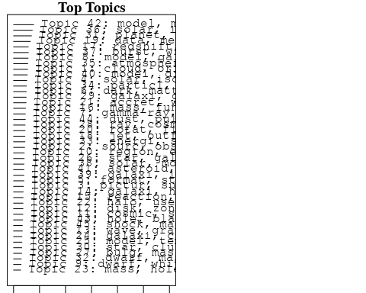

plotQuote(thoughts6, width = 30, main = "Topic 6")  
plotQuote(thoughts18, width = 30, main = "Topic 18")

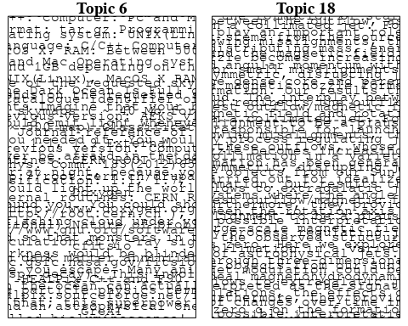

# Calculate and plot the correlation between topics  
mod.out.corr <- topicCorr(Research_topics)  
plot(mod.out.corr, cex = 1.5)  
  
  
# For each topic  
for (topic_num in 1:45) {  
 # Plot the word cloud  
 cloud(Research_topics, topic = topic_num, scale = c(2, 0.25))  
 Sys.sleep(2)  
}

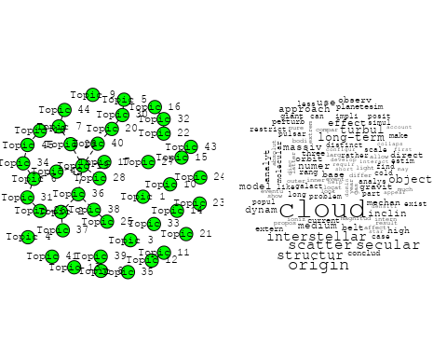

## Warning in wordcloud::wordcloud(words = vocab, freq = vec, max.words =  
## max.words, : structur could not be fit on page. It will not be plotted.

## Warning in wordcloud::wordcloud(words = vocab, freq = vec, max.words =  
## max.words, : chang could not be fit on page. It will not be plotted.

## Warning in wordcloud::wordcloud(words = vocab, freq = vec, max.words =  
## max.words, : activ could not be fit on page. It will not be plotted.

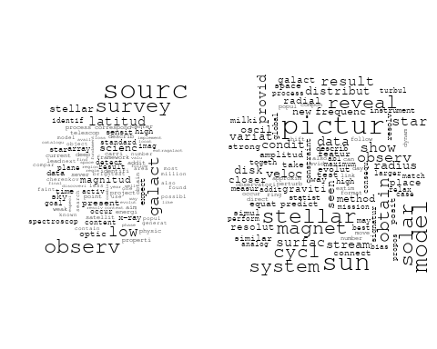

## Warning in wordcloud::wordcloud(words = vocab, freq = vec, max.words =  
## max.words, : system could not be fit on page. It will not be plotted.

## Warning in wordcloud::wordcloud(words = vocab, freq = vec, max.words =  
## max.words, : isotop could not be fit on page. It will not be plotted.

## Warning in wordcloud::wordcloud(words = vocab, freq = vec, max.words =  
## max.words, : nebula could not be fit on page. It will not be plotted.

## Warning in wordcloud::wordcloud(words = vocab, freq = vec, max.words =  
## max.words, : solar could not be fit on page. It will not be plotted.

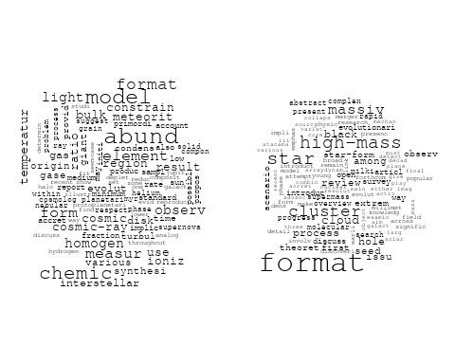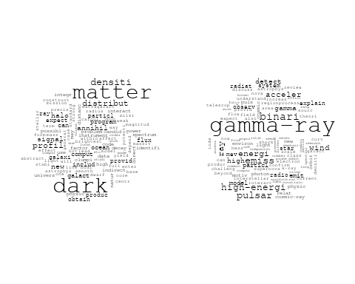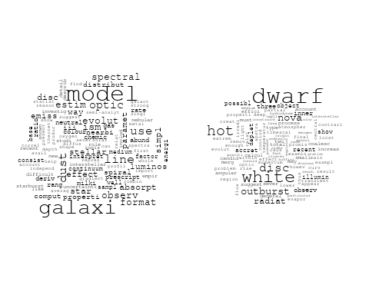

## Warning in wordcloud::wordcloud(words = vocab, freq = vec, max.words =  
## max.words, : magnet could not be fit on page. It will not be plotted.

## Warning in wordcloud::wordcloud(words = vocab, freq = vec, max.words =  
## max.words, : photospher could not be fit on page. It will not be plotted.

## Warning in wordcloud::wordcloud(words = vocab, freq = vec, max.words =  
## max.words, : detect could not be fit on page. It will not be plotted.

## Warning in wordcloud::wordcloud(words = vocab, freq = vec, max.words =  
## max.words, : interstellar could not be fit on page. It will not be plotted.

## Warning in wordcloud::wordcloud(words = vocab, freq = vec, max.words =  
## max.words, : show could not be fit on page. It will not be plotted.

## Warning in wordcloud::wordcloud(words = vocab, freq = vec, max.words =  
## max.words, : evapor could not be fit on page. It will not be plotted.

## Warning in wordcloud::wordcloud(words = vocab, freq = vec, max.words =  
## max.words, : sign could not be fit on page. It will not be plotted.

## Warning in wordcloud::wordcloud(words = vocab, freq = vec, max.words =  
## max.words, : materi could not be fit on page. It will not be plotted.

## Warning in wordcloud::wordcloud(words = vocab, freq = vec, max.words =  
## max.words, : data could not be fit on page. It will not be plotted.

## Warning in wordcloud::wordcloud(words = vocab, freq = vec, max.words =  
## max.words, : suggest could not be fit on page. It will not be plotted.

## Warning in wordcloud::wordcloud(words = vocab, freq = vec, max.words =  
## max.words, : paper could not be fit on page. It will not be plotted.

## Warning in wordcloud::wordcloud(words = vocab, freq = vec, max.words =  
## max.words, : found could not be fit on page. It will not be plotted.

## Warning in wordcloud::wordcloud(words = vocab, freq = vec, max.words =  
## max.words, : field could not be fit on page. It will not be plotted.

## Warning in wordcloud::wordcloud(words = vocab, freq = vec, max.words =  
## max.words, : propos could not be fit on page. It will not be plotted.

## Warning in wordcloud::wordcloud(words = vocab, freq = vec, max.words =  
## max.words, : signatur could not be fit on page. It will not be plotted.

## Warning in wordcloud::wordcloud(words = vocab, freq = vec, max.words =  
## max.words, : problem could not be fit on page. It will not be plotted.

## Warning in wordcloud::wordcloud(words = vocab, freq = vec, max.words =  
## max.words, : absorpt could not be fit on page. It will not be plotted.

## Warning in wordcloud::wordcloud(words = vocab, freq = vec, max.words =  
## max.words, : characterist could not be fit on page. It will not be plotted.

## Warning in wordcloud::wordcloud(words = vocab, freq = vec, max.words =  
## max.words, : fundament could not be fit on page. It will not be plotted.

## Warning in wordcloud::wordcloud(words = vocab, freq = vec, max.words =  
## max.words, : model could not be fit on page. It will not be plotted.

## Warning in wordcloud::wordcloud(words = vocab, freq = vec, max.words =  
## max.words, : terrestri could not be fit on page. It will not be plotted.

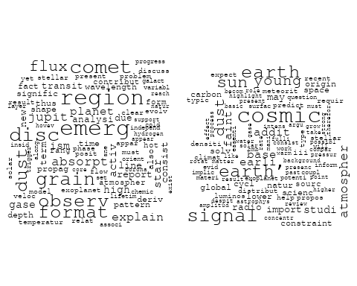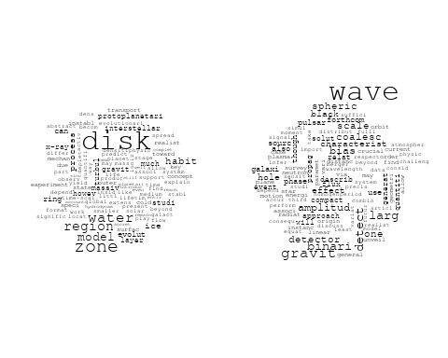

## Warning in wordcloud::wordcloud(words = vocab, freq = vec, max.words =  
## max.words, : galaxi could not be fit on page. It will not be plotted.

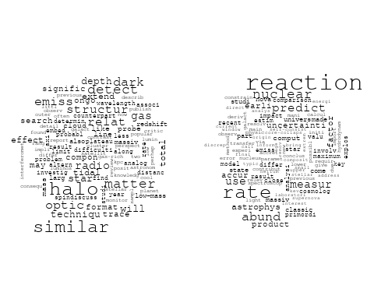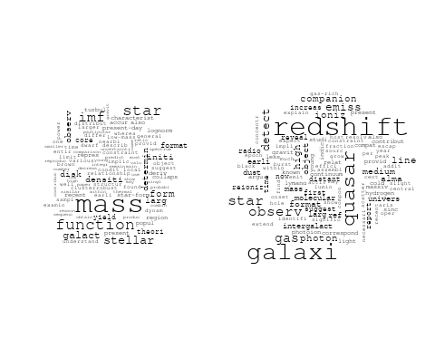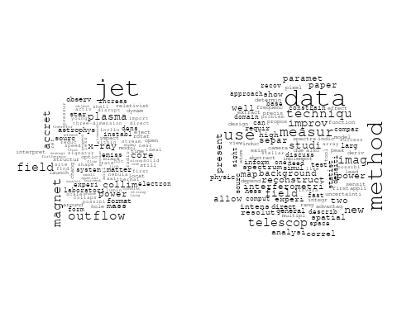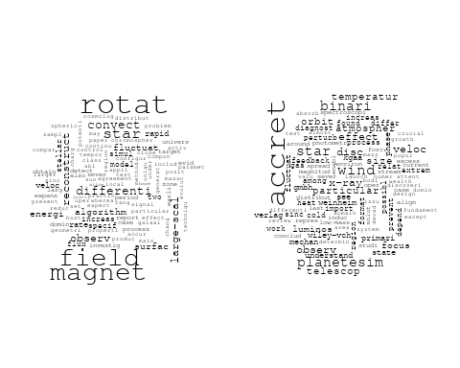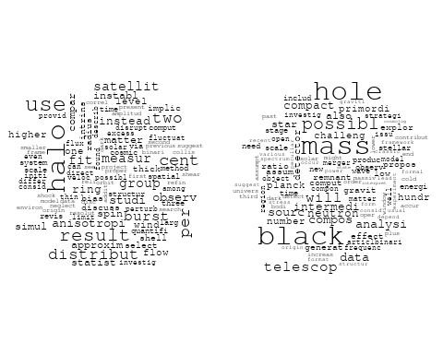

## Warning in wordcloud::wordcloud(words = vocab, freq = vec, max.words =  
## max.words, : temperatur could not be fit on page. It will not be plotted.

## Warning in wordcloud::wordcloud(words = vocab, freq = vec, max.words =  
## max.words, : model could not be fit on page. It will not be plotted.

## Warning in wordcloud::wordcloud(words = vocab, freq = vec, max.words =  
## max.words, : accret could not be fit on page. It will not be plotted.

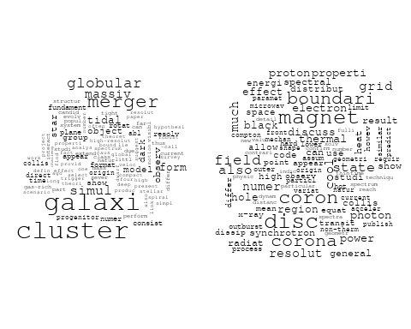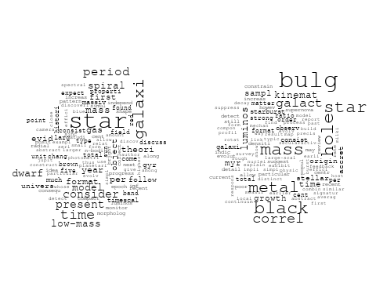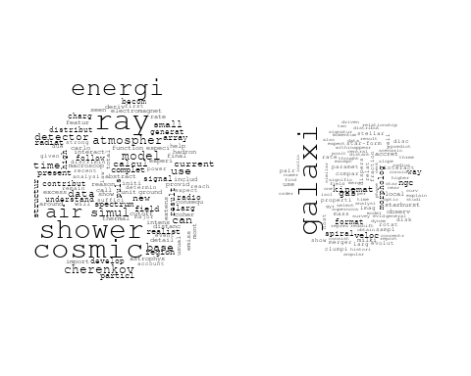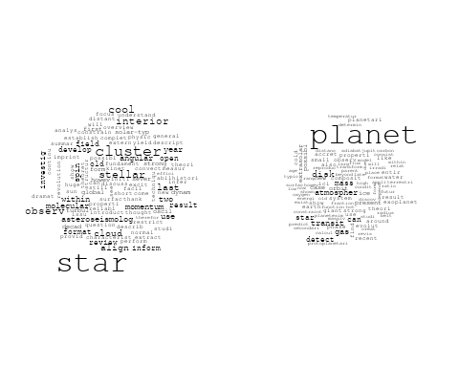

## Warning in wordcloud::wordcloud(words = vocab, freq = vec, max.words =  
## max.words, : energi could not be fit on page. It will not be plotted.

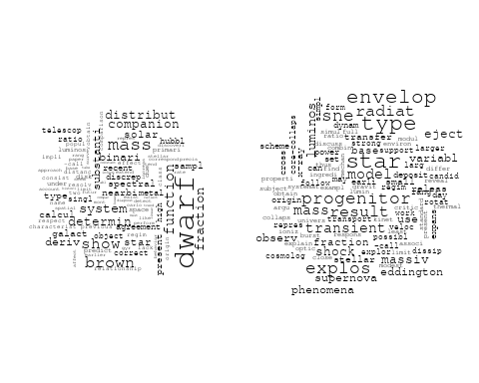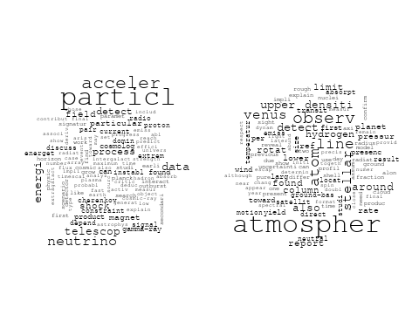

## Warning in wordcloud::wordcloud(words = vocab, freq = vec, max.words =  
## max.words, : observ could not be fit on page. It will not be plotted.

## Warning in wordcloud::wordcloud(words = vocab, freq = vec, max.words =  
## max.words, : γray could not be fit on page. It will not be plotted.

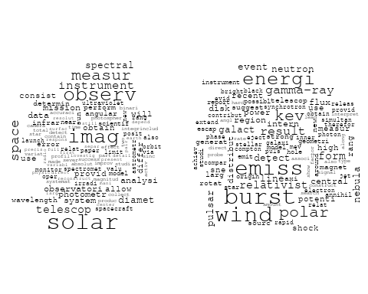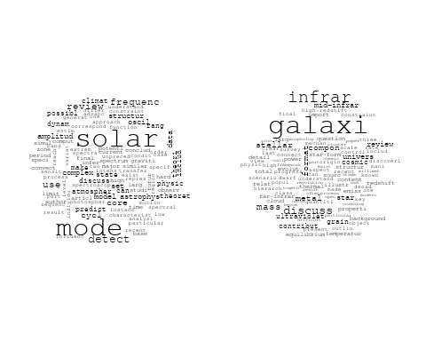

## Warning in wordcloud::wordcloud(words = vocab, freq = vec, max.words =  
## max.words, : compon could not be fit on page. It will not be plotted.

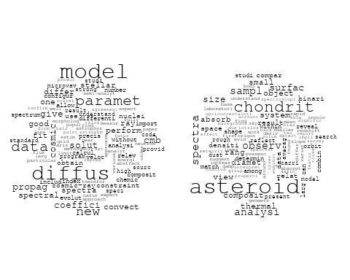

## Warning in wordcloud::wordcloud(words = vocab, freq = vec, max.words =  
## max.words, : mass could not be fit on page. It will not be plotted.

## Warning in wordcloud::wordcloud(words = vocab, freq = vec, max.words =  
## max.words, : result could not be fit on page. It will not be plotted.

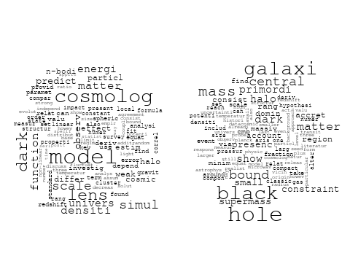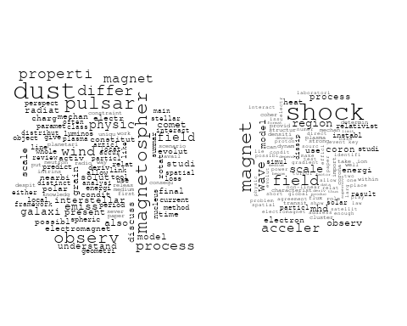

# Get the topic proportions for each document  
topic_proportions <- Research_topics$theta  
  
# Find the index of the topic with the highest proportion for each document  
# This will be the topic that each document is most likely to belong to  
max_topic_idx <- apply(topic_proportions, 1, which.max)  
  
# Add this as a new column to your data  
data_independent$topic <- max_topic_idx  
  
  
  
# Define the intervals  
intervals <- c('1824_1899', '1900_1964', '1965_1974', '1975_1984', '1985_1994', '1995_1999', '2000_2004', '2005_2009', '2010_2014', '2015_2019', '2020_2022')  
colors <- c('pink', 'blue', 'purple', 'yellow', 'green', 'pink', 'orange', 'violet', 'green', 'blue', 'pink')  
  
# Loop through the intervals and plot  
for(i in seq_along(intervals)){  
 # Filter data for when the pub_interval is equal to 1  
 data_filtered <- data_independent[data_independent[[paste0('pub_interval_', intervals[i])]] == 1,]  
   
 # Make the histogram  
   
 p <- ggplot(data_filtered, aes(x = topic)) +  
 geom_histogram(binwidth = 1, fill = colors[i], color = "black") +  
 xlab("Topic") +  
 ylab("Count") +  
 ggtitle(paste0("Topics from year ", gsub("_", " to ", intervals[i])))  
   
 print(p)  
}

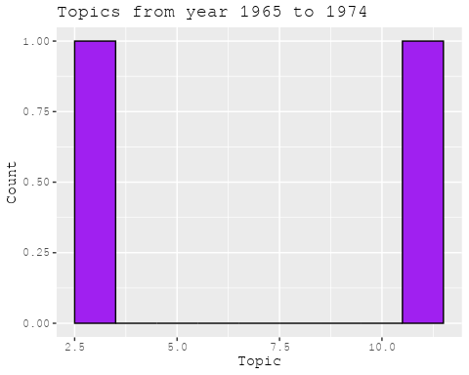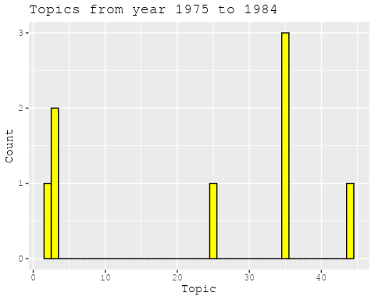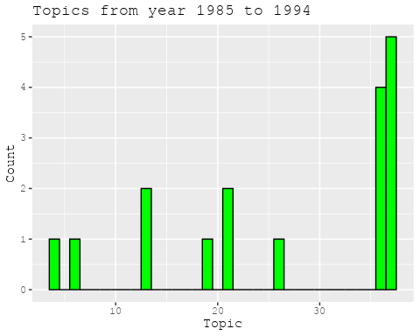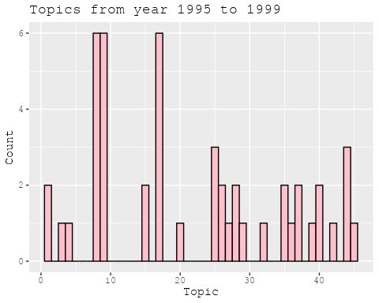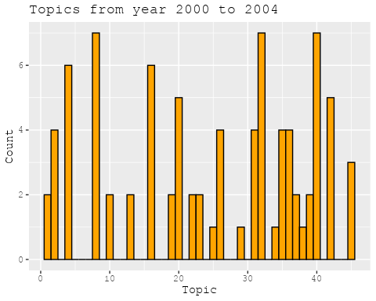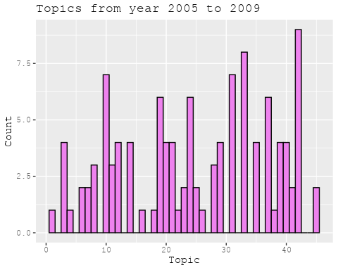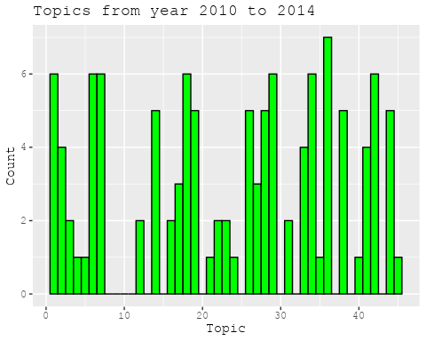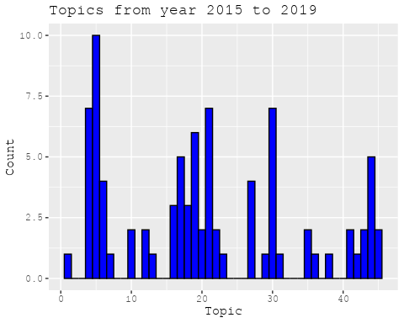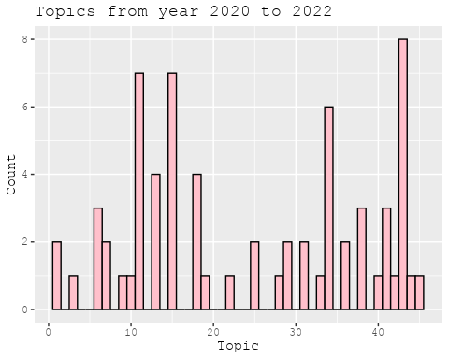

##Topic generation for RU (in collaboration) publications  
  
data_collab <- data[data[["RU"]] != 0,]  
  
# Save the original title data for future use  
data_collab$original_concatenated_title_abstract <- data_collab$concatenated_title_abstract  
  
#pre-processing the titles using textProcessor from the stm package  
processed_text <- textProcessor(data_collab$concatenated_title_abstract, metadata = data_collab)

## Building corpus...   
## Converting to Lower Case...   
## Removing punctuation...   
## Removing stopwords...   
## Removing numbers...   
## Stemming...   
## Creating Output...

# Further prepare the data by removing low-frequency terms  
out_text <- prepDocuments(processed_text$documents, processed_text$vocab, processed_text$meta)

## Removing 2357 of 8083 terms (2357 of 118251 tokens) due to frequency   
## Your corpus now has 1629 documents, 5726 terms and 115894 tokens.

docs_text <- out_text$documents  
vocab_text <- out_text$vocab  
meta_text <- out_text$meta  
  
  
#Prepare data  
plotRemoved(processed_text$documents, lower.thresh = seq(1, 200, by = 100))

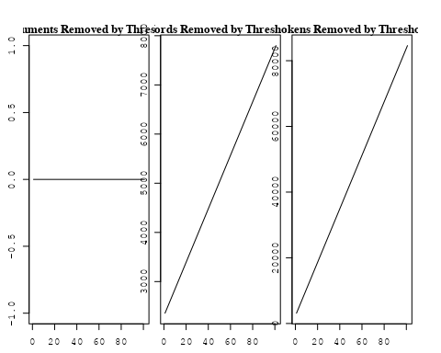

out_text <- prepDocuments(processed_text$documents, processed_text$vocab, processed_text$meta, lower.thresh = 8)

## Removing 6235 of 8083 terms (14915 of 118251 tokens) due to frequency   
## Your corpus now has 1629 documents, 1848 terms and 103336 tokens.

str(out_text$meta)

## 'data.frame': 1629 obs. of 39 variables:  
## $ concept_id : chr "https://openalex.org/C44870925" "https://openalex.org/C44870925" "https://openalex.org/C44870925" "https://openalex.org/C44870925" ...  
## $ work_id : chr "https://openalex.org/W2091953534" "https://openalex.org/W2950971381" "https://openalex.org/W1974527970" "https://openalex.org/W2798563684" ...  
## $ publication_year : int 2004 2010 1989 2018 2002 2014 2006 2006 1984 2014 ...  
## $ title : chr "Inner Polar Rings in Regular Lenticular Galaxies" "Gravitational lensing in a non-uniform plasma" "A survey of the radio continuum emission of RS Canum Venaticorum and related active binary systems" "Magnetic structure of solar flare regions producing hard X-ray pulsations" ...  
## $ paperabstract : chr "We have investigated a sample of S0 galaxies, mostly with circumnuclear dust lanes orthogonal to their major ax"| __truncated__ "We develop a model of gravitational lensing in a non-uniform plasma. When a gravitating body is surrounded by a"| __truncated__ "Observations of 77 RS CVn and related active binary systems were made with VLA at a continuum frequency of 4.86"| __truncated__ "Abstract We present analysis of the magnetic field in seven solar flare regions accompanied by the pulsations o"| __truncated__ ...  
## $ country : chr "RU RU GB" "RU RU RU RU RU RU RU RU" "RU RU RU RU" "CH RU GB RU CN" ...  
## $ year_concept : chr "2004+https://openalex.org/C44870925" "2010+https://openalex.org/C44870925" "1989+https://openalex.org/C44870925" "2018+https://openalex.org/C44870925" ...  
## $ concatenated_title_abstract : chr "Inner Polar Rings in Regular Lenticular Galaxies We have investigated a sample of S0 galaxies, mostly with circ"| __truncated__ "Gravitational lensing in a non-uniform plasma We develop a model of gravitational lensing in a non-uniform plas"| __truncated__ "A survey of the radio continuum emission of RS Canum Venaticorum and related active binary systems Observations"| __truncated__ "Magnetic structure of solar flare regions producing hard X-ray pulsations Abstract We present analysis of the m"| __truncated__ ...  
## $ US : num 0 0 0 0 0 0 0 0 50 0 ...  
## $ IN : num 0 0 0 0 0 0 0 0 0 0 ...  
## $ DE : num 0 0 0 0 0 0 0 0 0 0 ...  
## $ CH : num 0 0 0 20 0 0 0 0 0 0 ...  
## $ GB : num 33.3 0 0 20 0 ...  
## $ CN : num 0 0 0 20 0 0 0 0 0 0 ...  
## $ FR : num 0 0 0 0 0 0 0 0 0 0 ...  
## $ IT : num 0 0 0 0 0 0 0 0 0 0 ...  
## $ RU : num 66.7 100 100 40 100 ...  
## $ CA : num 0 0 0 0 0 0 0 0 0 0 ...  
## $ NL : num 0 0 0 0 0 0 0 0 0 0 ...  
## $ AU : num 0 0 0 0 0 0 0 0 0 0 ...  
## $ JP : num 0 0 0 0 0 0 0 0 0 0 ...  
## $ ES : num 0 0 0 0 0 0 0 0 0 0 ...  
## $ IL : num 0 0 0 0 0 0 0 0 0 0 ...  
## $ Americas : num 0 0 0 0 0 0 0 0 0 0 ...  
## $ Europe : num 0 0 0 0 0 0 0 0 0 0 ...  
## $ Africa : num 0 0 0 0 0 0 0 0 0 0 ...  
## $ AsiaAndOceania : num 0 0 0 0 0 0 0 0 0 0 ...  
## $ pub_interval_2020_2022 : int 0 0 0 0 0 0 0 0 0 0 ...  
## $ pub_interval_2015_2019 : int 0 0 0 1 0 0 0 0 0 0 ...  
## $ pub_interval_2010_2014 : int 0 1 0 0 0 1 0 0 0 1 ...  
## $ pub_interval_2005_2009 : int 0 0 0 0 0 0 1 1 0 0 ...  
## $ pub_interval_2000_2004 : int 1 0 0 0 1 0 0 0 0 0 ...  
## $ pub_interval_1995_1999 : int 0 0 0 0 0 0 0 0 0 0 ...  
## $ pub_interval_1985_1994 : int 0 0 1 0 0 0 0 0 0 0 ...  
## $ pub_interval_1975_1984 : int 0 0 0 0 0 0 0 0 1 0 ...  
## $ pub_interval_1965_1974 : int 0 0 0 0 0 0 0 0 0 0 ...  
## $ pub_interval_1900_1964 : int 0 0 0 0 0 0 0 0 0 0 ...  
## $ pub_interval_1824_1899 : int 0 0 0 0 0 0 0 0 0 0 ...  
## $ original_concatenated_title_abstract: chr "Inner Polar Rings in Regular Lenticular Galaxies We have investigated a sample of S0 galaxies, mostly with circ"| __truncated__ "Gravitational lensing in a non-uniform plasma We develop a model of gravitational lensing in a non-uniform plas"| __truncated__ "A survey of the radio continuum emission of RS Canum Venaticorum and related active binary systems Observations"| __truncated__ "Magnetic structure of solar flare regions producing hard X-ray pulsations Abstract We present analysis of the m"| __truncated__ ...

# Initialize an empty formula string  
prevalence_formula_str <- "~"  
  
# Define the publication intervals  
pub_intervals <- c("pub_interval_2020_2022", "pub_interval_2015_2019", "pub_interval_2010_2014",   
 "pub_interval_2005_2009", "pub_interval_2000_2004", "pub_interval_1995_1999",  
 "pub_interval_1985_1994", "pub_interval_1975_1984", "pub_interval_1965_1974",  
 "pub_interval_1900_1964", "pub_interval_1824_1899")  
  
# Add each publication interval to the formula string  
for (interval in pub_intervals) {  
 # add an if statement to handle the first addition (without '+')  
 if (prevalence_formula_str == "~") {  
 prevalence_formula_str <- paste(prevalence_formula_str, interval)  
 } else {  
 prevalence_formula_str <- paste(prevalence_formula_str, "+", interval)  
 }  
}  
  
  
# Convert the string to a formula  
prevalence_formula <- as.formula(prevalence_formula_str)  
print(prevalence_formula)

## ~pub_interval_2020_2022 + pub_interval_2015_2019 + pub_interval_2010_2014 +   
## pub_interval_2005_2009 + pub_interval_2000_2004 + pub_interval_1995_1999 +   
## pub_interval_1985_1994 + pub_interval_1975_1984 + pub_interval_1965_1974 +   
## pub_interval_1900_1964 + pub_interval_1824_1899

# Run STM model  
Research_topics <- stm(documents = out_text$documents,   
 vocab = out_text$vocab,   
 K = 44,   
 prevalence = prevalence_formula,   
 data = out_text$meta,   
 init.type = "Spectral",  
 max.em.its = 1000,  
 gamma.prior = 'L1')

## Beginning Spectral Initialization   
## Calculating the gram matrix...  
## Finding anchor words...  
## ............................................  
## Recovering initialization...  
## ..................  
## Initialization complete.  
## .....................................................................................................  
## Completed E-Step (1 seconds).   
## Completed M-Step.   
## Completing Iteration 1 (approx. per word bound = -6.341)   
## .....................................................................................................  
## Completed E-Step (1 seconds).   
## Completed M-Step.   
## Completing Iteration 2 (approx. per word bound = -6.074, relative change = 4.209e-02)   
## .....................................................................................................  
## Completed E-Step (1 seconds).   
## Completed M-Step.   
## Completing Iteration 3 (approx. per word bound = -5.992, relative change = 1.344e-02)   
## .....................................................................................................  
## Completed E-Step (1 seconds).   
## Completed M-Step.   
## Completing Iteration 4 (approx. per word bound = -5.957, relative change = 5.901e-03)   
## .....................................................................................................  
## Completed E-Step (1 seconds).   
## Completed M-Step.   
## Completing Iteration 5 (approx. per word bound = -5.939, relative change = 3.068e-03)   
## Topic 1: state, equat, energi, differ, deriv   
## Topic 2: ray, cosmic, gamma, particl, tev   
## Topic 3: curv, light, observ, period, result   
## Topic 4: galaxi, sampl, dwarf, survey, gcs   
## Topic 5: x-ray, function, galaxi, relat, binari   
## Topic 6: puls, giant, profil, averag, factor   
## Topic 7: grb, burst, gamma-ray, afterglow, grbs   
## Topic 8: disc, accret, model, format, evolut   
## Topic 9: magnet, field, strong, star, format   
## Topic 10: observ, telescop, use, object, data   
## Topic 11: period, time, variat, observ, solar   
## Topic 12: abund, galaxi, disc, spiral, model   
## Topic 13: map, correl, cmb, spectrum, power   
## Topic 14: galaxi, ngc, stellar, ring, disk   
## Topic 15: sourc, kev, x-ray, energi, detect   
## Topic 16: radio, physic, observatori, transient, astronomi   
## Topic 17: cluster, gas, galaxi, cool, observ   
## Topic 18: sourc, emiss, observ, ghz, maser   
## Topic 19: binari, star, system, dwarf, white   
## Topic 20: dark, matter, model, energi, halo   
## Topic 21: cloud, line, emiss, ioniz, observ   
## Topic 22: luminos, sourc, erg, function, detect   
## Topic 23: star, pulsar, neutron, mass, dwarf   
## Topic 24: line, supernova, absorpt, emiss, model   
## Topic 25: star, cluster, paramet, veloc, use   
## Topic 26: jet, observ, speed, flow, model   
## Topic 27: model, ion, grain, ioniz, gas   
## Topic 28: pair, gravit, redshift, two, observ   
## Topic 29: orbit, studi, planet, use, system   
## Topic 30: hole, black, accret, mass, disk   
## Topic 31: solar, magnet, coron, field, cme   
## Topic 32: cosmic, energi, ray, method, use   
## Topic 33: oscil, region, solar, observ, activ   
## Topic 34: neutron, neutrino, emiss, star, heat   
## Topic 35: group, disk, local, outflow, mass   
## Topic 36: star, model, accret, rate, mass   
## Topic 37: orbit, system, determin, period, mass   
## Topic 38: x-ray, optic, variabl, observ, hard   
## Topic 39: star, region, galaxi, format, distribut   
## Topic 40: flare, event, burst, energi, microwav   
## Topic 41: radio, observ, frequenc, burst, rang   
## Topic 42: star, stellar, evolut, dust, distribut   
## Topic 43: shock, acceler, particl, electron, plasma   
## Topic 44: line, approxim, redistribut, partial, radiat   
## .....................................................................................................  
## Completed E-Step (1 seconds).   
## Completed M-Step.   
## Completing Iteration 6 (approx. per word bound = -5.928, relative change = 1.875e-03)   
## .....................................................................................................  
## Completed E-Step (1 seconds).   
## Completed M-Step.   
## Completing Iteration 7 (approx. per word bound = -5.920, relative change = 1.275e-03)   
## .....................................................................................................  
## Completed E-Step (1 seconds).   
## Completed M-Step.   
## Completing Iteration 8 (approx. per word bound = -5.914, relative change = 9.505e-04)   
## .....................................................................................................  
## Completed E-Step (1 seconds).   
## Completed M-Step.   
## Completing Iteration 9 (approx. per word bound = -5.910, relative change = 7.351e-04)   
## .....................................................................................................  
## Completed E-Step (1 seconds).   
## Completed M-Step.   
## Completing Iteration 10 (approx. per word bound = -5.906, relative change = 6.633e-04)   
## Topic 1: state, equat, energi, differ, deriv   
## Topic 2: cosmic, ray, gamma, particl, galact   
## Topic 3: curv, light, observ, result, use   
## Topic 4: galaxi, dwarf, sampl, survey, gcs   
## Topic 5: x-ray, galaxi, function, relat, popul   
## Topic 6: puls, giant, profil, averag, pulsar   
## Topic 7: burst, grb, gamma-ray, grbs, afterglow   
## Topic 8: disc, accret, model, format, gas   
## Topic 9: magnet, field, polar, strong, format   
## Topic 10: observ, telescop, use, solar, present   
## Topic 11: period, variat, solar, time, observ   
## Topic 12: galaxi, abund, disc, spiral, ratio   
## Topic 13: map, correl, scale, cmb, spectrum   
## Topic 14: galaxi, ngc, stellar, ring, disk   
## Topic 15: sourc, kev, x-ray, energi, band   
## Topic 16: radio, physic, observatori, transient, astronomi   
## Topic 17: cluster, gas, galaxi, cool, observ   
## Topic 18: sourc, observ, maser, ghz, emiss   
## Topic 19: binari, star, dwarf, system, white   
## Topic 20: dark, matter, univers, halo, energi   
## Topic 21: cloud, line, emiss, ioniz, observ   
## Topic 22: luminos, sourc, function, erg, detect   
## Topic 23: star, pulsar, neutron, loss, mass   
## Topic 24: line, emiss, absorpt, supernova, wind   
## Topic 25: star, cluster, veloc, paramet, use   
## Topic 26: jet, observ, speed, flow, factor   
## Topic 27: model, ion, grain, result, ioniz   
## Topic 28: pair, gravit, redshift, quasar, survey   
## Topic 29: orbit, planet, use, studi, system   
## Topic 30: hole, black, accret, mass, star   
## Topic 31: solar, coron, cme, event, magnet   
## Topic 32: cosmic, ray, energi, method, use   
## Topic 33: oscil, region, solar, observ, corona   
## Topic 34: neutron, star, neutrino, heat, emiss   
## Topic 35: group, disk, local, outflow, mass   
## Topic 36: star, model, rate, accret, mode   
## Topic 37: orbit, system, mass, binari, determin   
## Topic 38: x-ray, optic, variabl, observ, hard   
## Topic 39: star, region, galaxi, format, star-form   
## Topic 40: flare, emiss, event, sourc, microwav   
## Topic 41: radio, observ, frequenc, burst, emiss   
## Topic 42: star, stellar, dust, observ, cluster   
## Topic 43: shock, acceler, particl, electron, plasma   
## Topic 44: line, chromospher, temperatur, approxim, redistribut   
## .....................................................................................................  
## Completed E-Step (1 seconds).   
## Completed M-Step.   
## Completing Iteration 11 (approx. per word bound = -5.903, relative change = 6.002e-04)   
## .....................................................................................................  
## Completed E-Step (1 seconds).   
## Completed M-Step.   
## Completing Iteration 12 (approx. per word bound = -5.900, relative change = 4.969e-04)   
## .....................................................................................................  
## Completed E-Step (1 seconds).   
## Completed M-Step.   
## Completing Iteration 13 (approx. per word bound = -5.897, relative change = 4.314e-04)   
## .....................................................................................................  
## Completed E-Step (1 seconds).   
## Completed M-Step.   
## Completing Iteration 14 (approx. per word bound = -5.895, relative change = 3.628e-04)   
## .....................................................................................................  
## Completed E-Step (1 seconds).   
## Completed M-Step.   
## Completing Iteration 15 (approx. per word bound = -5.893, relative change = 2.769e-04)   
## Topic 1: state, equat, energi, differ, deriv   
## Topic 2: ray, cosmic, energi, galact, particl   
## Topic 3: curv, light, observ, result, use   
## Topic 4: galaxi, dwarf, sampl, survey, gcs   
## Topic 5: x-ray, galaxi, relat, function, popul   
## Topic 6: puls, giant, profil, averag, pulsar   
## Topic 7: burst, grb, gamma-ray, grbs, afterglow   
## Topic 8: disc, accret, model, gas, format   
## Topic 9: magnet, field, polar, format, strong   
## Topic 10: observ, telescop, use, solar, present   
## Topic 11: period, variat, solar, activ, observ   
## Topic 12: galaxi, abund, disc, spiral, disk   
## Topic 13: map, scale, spectrum, power, correl   
## Topic 14: ngc, galaxi, stellar, ring, disk   
## Topic 15: sourc, kev, x-ray, energi, band   
## Topic 16: radio, physic, observatori, transient, astronomi   
## Topic 17: cluster, gas, galaxi, cool, observ   
## Topic 18: sourc, observ, maser, ghz, emiss   
## Topic 19: binari, star, dwarf, system, white   
## Topic 20: dark, matter, halo, univers, densiti   
## Topic 21: line, cloud, emiss, ioniz, redshift   
## Topic 22: luminos, sourc, function, erg, detect   
## Topic 23: star, pulsar, neutron, loss, mass   
## Topic 24: line, absorpt, emiss, wind, supernova   
## Topic 25: star, cluster, veloc, paramet, use   
## Topic 26: jet, observ, speed, flow, factor   
## Topic 27: model, ion, cloud, result, grain   
## Topic 28: pair, redshift, gravit, quasar, survey   
## Topic 29: orbit, planet, use, system, asteroid   
## Topic 30: hole, black, mass, accret, star   
## Topic 31: solar, coron, cme, event, erupt   
## Topic 32: cosmic, ray, energi, method, use   
## Topic 33: oscil, region, solar, observ, corona   
## Topic 34: neutron, star, neutrino, heat, energi   
## Topic 35: group, disk, local, outflow, mass   
## Topic 36: star, model, rate, accret, mass   
## Topic 37: orbit, system, mass, binari, compon   
## Topic 38: x-ray, optic, variabl, observ, hard   
## Topic 39: star, region, galaxi, format, star-form   
## Topic 40: flare, emiss, sourc, microwav, event   
## Topic 41: radio, observ, frequenc, burst, emiss   
## Topic 42: star, stellar, dust, galaxi, observ   
## Topic 43: shock, acceler, particl, electron, plasma   
## Topic 44: line, chromospher, temperatur, model, star   
## .....................................................................................................  
## Completed E-Step (1 seconds).   
## Completed M-Step.   
## Completing Iteration 16 (approx. per word bound = -5.891, relative change = 3.353e-04)   
## .....................................................................................................  
## Completed E-Step (1 seconds).   
## Completed M-Step.   
## Completing Iteration 17 (approx. per word bound = -5.890, relative change = 2.947e-04)   
## .....................................................................................................  
## Completed E-Step (1 seconds).   
## Completed M-Step.   
## Completing Iteration 18 (approx. per word bound = -5.888, relative change = 2.551e-04)   
## .....................................................................................................  
## Completed E-Step (1 seconds).   
## Completed M-Step.   
## Completing Iteration 19 (approx. per word bound = -5.887, relative change = 2.177e-04)   
## .....................................................................................................  
## Completed E-Step (1 seconds).   
## Completed M-Step.   
## Completing Iteration 20 (approx. per word bound = -5.886, relative change = 1.979e-04)   
## Topic 1: state, equat, energi, paramet, differ   
## Topic 2: ray, cosmic, energi, galact, particl   
## Topic 3: curv, light, observ, result, model   
## Topic 4: galaxi, dwarf, sampl, survey, gcs   
## Topic 5: x-ray, galaxi, relat, function, popul   
## Topic 6: puls, giant, profil, averag, pulsar   
## Topic 7: burst, grb, gamma-ray, grbs, afterglow   
## Topic 8: disc, accret, binari, model, gas   
## Topic 9: magnet, field, polar, current, strong   
## Topic 10: telescop, observ, use, present, imag   
## Topic 11: solar, period, variat, activ, observ   
## Topic 12: galaxi, abund, disc, spiral, disk   
## Topic 13: scale, map, spectrum, power, cmb   
## Topic 14: ngc, galaxi, stellar, ring, disk   
## Topic 15: sourc, kev, x-ray, energi, band   
## Topic 16: radio, physic, observatori, transient, astronomi   
## Topic 17: cluster, gas, galaxi, cool, observ   
## Topic 18: sourc, observ, maser, object, ghz   
## Topic 19: binari, star, dwarf, system, white   
## Topic 20: dark, matter, halo, univers, densiti   
## Topic 21: line, cloud, emiss, ioniz, redshift   
## Topic 22: luminos, sourc, function, erg, galaxi   
## Topic 23: star, pulsar, neutron, loss, mass   
## Topic 24: line, absorpt, emiss, envelop, wind   
## Topic 25: star, cluster, veloc, paramet, use   
## Topic 26: jet, observ, speed, flow, factor   
## Topic 27: model, ion, cloud, result, ioniz   
## Topic 28: pair, redshift, gravit, quasar, survey   
## Topic 29: orbit, planet, use, asteroid, system   
## Topic 30: hole, black, mass, accret, star   
## Topic 31: solar, coron, cme, event, erupt   
## Topic 32: cosmic, ray, energi, method, use   
## Topic 33: oscil, region, solar, observ, corona   
## Topic 34: neutron, star, neutrino, heat, energi   
## Topic 35: group, local, disk, outflow, mass   
## Topic 36: star, model, rate, accret, mass   
## Topic 37: orbit, system, mass, binari, compon   
## Topic 38: x-ray, optic, variabl, observ, hard   
## Topic 39: star, region, galaxi, format, star-form   
## Topic 40: flare, emiss, sourc, microwav, event   
## Topic 41: radio, observ, frequenc, emiss, burst   
## Topic 42: star, stellar, dust, galaxi, observ   
## Topic 43: shock, acceler, particl, electron, plasma   
## Topic 44: line, chromospher, temperatur, model, star   
## .....................................................................................................  
## Completed E-Step (1 seconds).   
## Completed M-Step.   
## Completing Iteration 21 (approx. per word bound = -5.885, relative change = 1.610e-04)   
## .....................................................................................................  
## Completed E-Step (1 seconds).   
## Completed M-Step.   
## Completing Iteration 22 (approx. per word bound = -5.883, relative change = 2.027e-04)   
## .....................................................................................................  
## Completed E-Step (1 seconds).   
## Completed M-Step.   
## Completing Iteration 23 (approx. per word bound = -5.883, relative change = 1.604e-04)   
## .....................................................................................................  
## Completed E-Step (1 seconds).   
## Completed M-Step.   
## Completing Iteration 24 (approx. per word bound = -5.882, relative change = 1.434e-04)   
## .....................................................................................................  
## Completed E-Step (1 seconds).   
## Completed M-Step.   
## Completing Iteration 25 (approx. per word bound = -5.881, relative change = 1.388e-04)   
## Topic 1: state, equat, energi, paramet, deriv   
## Topic 2: ray, cosmic, energi, galact, particl   
## Topic 3: curv, light, observ, model, result   
## Topic 4: galaxi, dwarf, sampl, gcs, survey   
## Topic 5: x-ray, galaxi, relat, function, binari   
## Topic 6: puls, giant, profil, pulsar, averag   
## Topic 7: burst, grb, gamma-ray, grbs, afterglow   
## Topic 8: disc, accret, binari, model, form   
## Topic 9: magnet, field, polar, current, strong   
## Topic 10: telescop, observ, use, imag, present   
## Topic 11: solar, variat, period, cycl, activ   
## Topic 12: galaxi, abund, disc, disk, spiral   
## Topic 13: scale, map, power, spectrum, cmb   
## Topic 14: ngc, galaxi, stellar, ring, disk   
## Topic 15: sourc, kev, x-ray, energi, band   
## Topic 16: radio, physic, observatori, transient, survey   
## Topic 17: cluster, gas, galaxi, cool, observ   
## Topic 18: sourc, object, observ, maser, ghz   
## Topic 19: binari, star, dwarf, system, white   
## Topic 20: dark, matter, halo, univers, densiti   
## Topic 21: line, cloud, emiss, ioniz, redshift   
## Topic 22: luminos, sourc, function, galaxi, erg   
## Topic 23: star, pulsar, neutron, mass, loss   
## Topic 24: line, absorpt, emiss, envelop, wind   
## Topic 25: cluster, star, veloc, paramet, catalog   
## Topic 26: jet, observ, flow, speed, factor   
## Topic 27: model, ion, cloud, result, ioniz   
## Topic 28: pair, quasar, redshift, gravit, survey   
## Topic 29: orbit, planet, asteroid, use, system   
## Topic 30: hole, black, mass, star, cluster   
## Topic 31: solar, coron, cme, event, erupt   
## Topic 32: cosmic, ray, energi, method, use   
## Topic 33: oscil, region, solar, observ, corona   
## Topic 34: neutron, star, neutrino, heat, temperatur   
## Topic 35: group, local, disk, galaxi, outflow   
## Topic 36: star, model, rate, accret, mass   
## Topic 37: orbit, system, binari, mass, compon   
## Topic 38: x-ray, optic, variabl, observ, hard   
## Topic 39: star, region, galaxi, format, star-form   
## Topic 40: flare, emiss, sourc, microwav, event   
## Topic 41: radio, observ, frequenc, emiss, burst   
## Topic 42: star, stellar, dust, galaxi, cluster   
## Topic 43: shock, acceler, particl, electron, plasma   
## Topic 44: line, chromospher, temperatur, model, star   
## .....................................................................................................  
## Completed E-Step (1 seconds).   
## Completed M-Step.   
## Completing Iteration 26 (approx. per word bound = -5.880, relative change = 1.425e-04)   
## .....................................................................................................  
## Completed E-Step (1 seconds).   
## Completed M-Step.   
## Completing Iteration 27 (approx. per word bound = -5.879, relative change = 1.375e-04)   
## .....................................................................................................  
## Completed E-Step (1 seconds).   
## Completed M-Step.   
## Completing Iteration 28 (approx. per word bound = -5.878, relative change = 1.280e-04)   
## .....................................................................................................  
## Completed E-Step (1 seconds).   
## Completed M-Step.   
## Completing Iteration 29 (approx. per word bound = -5.878, relative change = 1.255e-04)   
## .....................................................................................................  
## Completed E-Step (1 seconds).   
## Completed M-Step.   
## Completing Iteration 30 (approx. per word bound = -5.877, relative change = 1.097e-04)   
## Topic 1: state, equat, energi, paramet, can   
## Topic 2: ray, cosmic, energi, galact, particl   
## Topic 3: curv, light, model, observ, result   
## Topic 4: galaxi, dwarf, sampl, gcs, survey   
## Topic 5: x-ray, galaxi, relat, function, popul   
## Topic 6: puls, giant, profil, pulsar, averag   
## Topic 7: burst, grb, gamma-ray, grbs, afterglow   
## Topic 8: disc, accret, disk, binari, model   
## Topic 9: magnet, field, polar, current, plasma   
## Topic 10: telescop, observ, use, imag, present   
## Topic 11: solar, variat, period, cycl, activ   
## Topic 12: galaxi, abund, disk, disc, spiral   
## Topic 13: scale, map, spectrum, power, cmb   
## Topic 14: ngc, galaxi, stellar, ring, star   
## Topic 15: sourc, kev, x-ray, energi, band   
## Topic 16: radio, physic, observatori, transient, survey   
## Topic 17: cluster, gas, galaxi, cool, observ   
## Topic 18: sourc, object, maser, observ, ghz   
## Topic 19: binari, dwarf, star, system, white   
## Topic 20: dark, matter, halo, densiti, univers   
## Topic 21: line, cloud, emiss, ioniz, redshift   
## Topic 22: luminos, sourc, function, galaxi, erg   
## Topic 23: star, pulsar, neutron, mass, loss   
## Topic 24: line, absorpt, emiss, envelop, wind   
## Topic 25: cluster, star, veloc, paramet, catalog   
## Topic 26: jet, observ, flow, speed, factor   
## Topic 27: model, ion, cloud, result, abund   
## Topic 28: pair, quasar, redshift, gravit, survey   
## Topic 29: orbit, planet, asteroid, use, system   
## Topic 30: hole, black, mass, star, cluster   
## Topic 31: solar, coron, cme, event, erupt   
## Topic 32: cosmic, ray, energi, method, use   
## Topic 33: oscil, solar, region, corona, observ   
## Topic 34: neutron, star, neutrino, heat, temperatur   
## Topic 35: group, local, galaxi, outflow, disk   
## Topic 36: star, model, rate, accret, mass   
## Topic 37: orbit, system, binari, compon, mass   
## Topic 38: x-ray, optic, variabl, observ, hard   
## Topic 39: star, region, galaxi, format, star-form   
## Topic 40: flare, sourc, emiss, microwav, event   
## Topic 41: radio, observ, frequenc, emiss, burst   
## Topic 42: star, stellar, dust, galaxi, cluster   
## Topic 43: shock, acceler, particl, electron, plasma   
## Topic 44: line, star, chromospher, model, temperatur   
## .....................................................................................................  
## Completed E-Step (1 seconds).   
## Completed M-Step.   
## Completing Iteration 31 (approx. per word bound = -5.877, relative change = 8.642e-05)   
## .....................................................................................................  
## Completed E-Step (1 seconds).   
## Completed M-Step.   
## Completing Iteration 32 (approx. per word bound = -5.876, relative change = 8.570e-05)   
## .....................................................................................................  
## Completed E-Step (1 seconds).   
## Completed M-Step.   
## Completing Iteration 33 (approx. per word bound = -5.876, relative change = 3.629e-05)   
## .....................................................................................................  
## Completed E-Step (1 seconds).   
## Completed M-Step.   
## Completing Iteration 34 (approx. per word bound = -5.875, relative change = 2.274e-04)   
## .....................................................................................................  
## Completed E-Step (1 seconds).   
## Completed M-Step.   
## Completing Iteration 35 (approx. per word bound = -5.874, relative change = 7.725e-05)   
## Topic 1: state, equat, energi, paramet, can   
## Topic 2: ray, cosmic, energi, galact, particl   
## Topic 3: curv, light, model, observ, result   
## Topic 4: galaxi, dwarf, sampl, gcs, survey   
## Topic 5: x-ray, galaxi, relat, function, binari   
## Topic 6: puls, giant, profil, pulsar, averag   
## Topic 7: burst, grb, gamma-ray, grbs, afterglow   
## Topic 8: disc, accret, disk, model, binari   
## Topic 9: magnet, field, polar, current, plasma   
## Topic 10: telescop, observ, use, imag, present   
## Topic 11: solar, variat, period, cycl, activ   
## Topic 12: galaxi, abund, disk, disc, spiral   
## Topic 13: scale, map, spectrum, power, cmb   
## Topic 14: ngc, galaxi, stellar, ring, star   
## Topic 15: sourc, kev, x-ray, energi, band   
## Topic 16: radio, physic, observatori, transient, survey   
## Topic 17: cluster, gas, galaxi, cool, observ   
## Topic 18: sourc, object, maser, ghz, observ   
## Topic 19: binari, dwarf, star, white, system   
## Topic 20: dark, matter, halo, densiti, univers   
## Topic 21: line, cloud, emiss, ioniz, redshift   
## Topic 22: luminos, sourc, function, galaxi, erg   
## Topic 23: star, pulsar, neutron, mass, loss   
## Topic 24: line, absorpt, emiss, envelop, wind   
## Topic 25: cluster, star, veloc, paramet, catalog   
## Topic 26: jet, observ, flow, speed, factor   
## Topic 27: model, ion, cloud, abund, ioniz   
## Topic 28: pair, quasar, redshift, gravit, survey   
## Topic 29: orbit, planet, use, asteroid, system   
## Topic 30: hole, black, mass, cluster, star   
## Topic 31: solar, coron, cme, event, erupt   
## Topic 32: cosmic, ray, energi, method, use   
## Topic 33: oscil, solar, region, corona, observ   
## Topic 34: neutron, star, neutrino, heat, temperatur   
## Topic 35: group, local, galaxi, outflow, mass   
## Topic 36: star, model, rate, mass, accret   
## Topic 37: orbit, system, binari, compon, mass   
## Topic 38: x-ray, optic, variabl, observ, hard   
## Topic 39: star, region, galaxi, format, star-form   
## Topic 40: flare, sourc, emiss, microwav, event   
## Topic 41: radio, observ, frequenc, emiss, burst   
## Topic 42: star, stellar, dust, galaxi, cluster   
## Topic 43: shock, acceler, particl, electron, plasma   
## Topic 44: line, star, model, chromospher, temperatur   
## .....................................................................................................  
## Completed E-Step (1 seconds).   
## Completed M-Step.   
## Completing Iteration 36 (approx. per word bound = -5.874, relative change = 5.822e-05)   
## .....................................................................................................  
## Completed E-Step (1 seconds).   
## Completed M-Step.   
## Completing Iteration 37 (approx. per word bound = -5.873, relative change = 5.564e-05)   
## .....................................................................................................  
## Completed E-Step (1 seconds).   
## Completed M-Step.   
## Completing Iteration 38 (approx. per word bound = -5.873, relative change = 6.561e-05)   
## .....................................................................................................  
## Completed E-Step (1 seconds).   
## Completed M-Step.   
## Completing Iteration 39 (approx. per word bound = -5.873, relative change = 4.342e-05)   
## .....................................................................................................  
## Completed E-Step (1 seconds).   
## Completed M-Step.   
## Completing Iteration 40 (approx. per word bound = -5.872, relative change = 9.774e-05)   
## Topic 1: state, equat, energi, paramet, can   
## Topic 2: ray, energi, cosmic, galact, particl   
## Topic 3: curv, light, model, result, observ   
## Topic 4: galaxi, dwarf, sampl, gcs, survey   
## Topic 5: galaxi, x-ray, relat, function, popul   
## Topic 6: puls, giant, profil, pulsar, averag   
## Topic 7: burst, grb, gamma-ray, grbs, afterglow   
## Topic 8: accret, disc, disk, model, binari   
## Topic 9: magnet, field, polar, current, plasma   
## Topic 10: telescop, observ, use, imag, present   
## Topic 11: solar, variat, period, cycl, activ   
## Topic 12: galaxi, abund, disc, disk, spiral   
## Topic 13: scale, map, spectrum, power, cmb   
## Topic 14: ngc, galaxi, stellar, ring, star   
## Topic 15: sourc, kev, x-ray, energi, band   
## Topic 16: radio, physic, observatori, transient, survey   
## Topic 17: cluster, gas, galaxi, cool, observ   
## Topic 18: sourc, object, maser, ghz, observ   
## Topic 19: binari, star, dwarf, white, system   
## Topic 20: dark, matter, halo, densiti, univers   
## Topic 21: line, cloud, emiss, ioniz, redshift   
## Topic 22: luminos, sourc, function, galaxi, erg   
## Topic 23: star, pulsar, neutron, mass, loss   
## Topic 24: line, absorpt, emiss, envelop, wind   
## Topic 25: cluster, star, veloc, paramet, catalog   
## Topic 26: jet, observ, flow, factor, speed   
## Topic 27: model, ion, cloud, abund, result   
## Topic 28: pair, quasar, redshift, gravit, survey   
## Topic 29: orbit, planet, use, asteroid, consid   
## Topic 30: hole, black, mass, cluster, star   
## Topic 31: solar, coron, cme, event, erupt   
## Topic 32: cosmic, ray, method, energi, use   
## Topic 33: oscil, solar, region, corona, observ   
## Topic 34: neutron, star, neutrino, heat, temperatur   
## Topic 35: group, local, galaxi, outflow, mass   
## Topic 36: star, model, rate, mass, mode   
## Topic 37: orbit, system, binari, compon, observ   
## Topic 38: x-ray, optic, variabl, observ, hard   
## Topic 39: star, region, galaxi, format, star-form   
## Topic 40: flare, sourc, emiss, microwav, event   
## Topic 41: radio, observ, frequenc, emiss, burst   
## Topic 42: star, stellar, dust, galaxi, cluster   
## Topic 43: shock, acceler, particl, electron, plasma   
## Topic 44: line, star, model, chromospher, temperatur   
## .....................................................................................................  
## Completed E-Step (1 seconds).   
## Completed M-Step.   
## Completing Iteration 41 (approx. per word bound = -5.872, relative change = 7.521e-05)   
## .....................................................................................................  
## Completed E-Step (1 seconds).   
## Completed M-Step.   
## Completing Iteration 42 (approx. per word bound = -5.871, relative change = 7.160e-05)   
## .....................................................................................................  
## Completed E-Step (1 seconds).   
## Completed M-Step.   
## Completing Iteration 43 (approx. per word bound = -5.871, relative change = 6.365e-05)   
## .....................................................................................................  
## Completed E-Step (1 seconds).   
## Completed M-Step.   
## Completing Iteration 44 (approx. per word bound = -5.871, relative change = 6.389e-05)   
## .....................................................................................................  
## Completed E-Step (1 seconds).   
## Completed M-Step.   
## Completing Iteration 45 (approx. per word bound = -5.870, relative change = 3.098e-05)   
## Topic 1: state, equat, energi, paramet, can   
## Topic 2: ray, energi, cosmic, galact, particl   
## Topic 3: curv, light, model, result, observ   
## Topic 4: galaxi, dwarf, sampl, gcs, survey   
## Topic 5: galaxi, x-ray, relat, function, popul   
## Topic 6: puls, giant, profil, pulsar, averag   
## Topic 7: burst, grb, gamma-ray, grbs, afterglow   
## Topic 8: accret, disc, disk, model, star   
## Topic 9: magnet, field, polar, current, plasma   
## Topic 10: telescop, observ, use, imag, solar   
## Topic 11: solar, variat, period, cycl, activ   
## Topic 12: galaxi, abund, disc, disk, spiral   
## Topic 13: scale, map, spectrum, power, cmb   
## Topic 14: galaxi, ngc, stellar, ring, star   
## Topic 15: sourc, kev, x-ray, energi, band   
## Topic 16: radio, physic, observatori, transient, survey   
## Topic 17: cluster, gas, galaxi, cool, observ   
## Topic 18: sourc, object, maser, ghz, observ   
## Topic 19: binari, star, dwarf, white, system   
## Topic 20: dark, matter, halo, densiti, univers   
## Topic 21: line, cloud, emiss, redshift, ioniz   
## Topic 22: luminos, sourc, function, galaxi, erg   
## Topic 23: star, pulsar, neutron, mass, loss   
## Topic 24: line, absorpt, emiss, envelop, wind   
## Topic 25: cluster, star, veloc, paramet, catalog   
## Topic 26: jet, observ, flow, factor, speed   
## Topic 27: model, ion, cloud, interstellar, ioniz   
## Topic 28: pair, quasar, redshift, gravit, survey   
## Topic 29: orbit, planet, use, asteroid, consid   
## Topic 30: hole, black, mass, cluster, star   
## Topic 31: solar, coron, cme, event, erupt   
## Topic 32: cosmic, ray, method, energi, use   
## Topic 33: oscil, solar, region, observ, corona   
## Topic 34: neutron, star, neutrino, heat, temperatur   
## Topic 35: group, local, galaxi, outflow, mass   
## Topic 36: star, model, rate, mass, mode   
## Topic 37: orbit, system, binari, compon, observ   
## Topic 38: x-ray, optic, variabl, observ, emiss   
## Topic 39: star, region, galaxi, format, star-form   
## Topic 40: flare, sourc, emiss, microwav, event   
## Topic 41: radio, observ, frequenc, emiss, burst   
## Topic 42: star, stellar, dust, galaxi, cluster   
## Topic 43: shock, acceler, particl, electron, plasma   
## Topic 44: line, star, model, temperatur, chromospher   
## .....................................................................................................  
## Completed E-Step (1 seconds).   
## Completed M-Step.   
## Completing Iteration 46 (approx. per word bound = -5.870, relative change = 8.826e-05)   
## .....................................................................................................  
## Completed E-Step (1 seconds).   
## Completed M-Step.   
## Completing Iteration 47 (approx. per word bound = -5.870, relative change = 5.413e-05)   
## .....................................................................................................  
## Completed E-Step (1 seconds).   
## Completed M-Step.   
## Completing Iteration 48 (approx. per word bound = -5.869, relative change = 4.652e-05)   
## .....................................................................................................  
## Completed E-Step (1 seconds).   
## Completed M-Step.   
## Completing Iteration 49 (approx. per word bound = -5.869, relative change = 6.138e-05)   
## .....................................................................................................  
## Completed E-Step (1 seconds).   
## Completed M-Step.   
## Completing Iteration 50 (approx. per word bound = -5.869, relative change = 5.655e-05)   
## Topic 1: equat, state, energi, paramet, numer   
## Topic 2: ray, energi, cosmic, galact, particl   
## Topic 3: curv, light, model, result, observ   
## Topic 4: galaxi, dwarf, sampl, gcs, survey   
## Topic 5: galaxi, x-ray, relat, popul, function   
## Topic 6: puls, giant, profil, pulsar, averag   
## Topic 7: burst, grb, gamma-ray, grbs, afterglow   
## Topic 8: accret, disc, disk, model, star   
## Topic 9: magnet, field, polar, current, plasma   
## Topic 10: telescop, observ, use, imag, solar   
## Topic 11: solar, variat, period, cycl, activ   
## Topic 12: galaxi, abund, disc, disk, spiral   
## Topic 13: scale, map, spectrum, power, cmb   
## Topic 14: galaxi, ngc, stellar, ring, star   
## Topic 15: sourc, kev, x-ray, energi, band   
## Topic 16: radio, physic, observatori, transient, survey   
## Topic 17: cluster, gas, galaxi, cool, observ   
## Topic 18: sourc, object, maser, ghz, observ   
## Topic 19: binari, star, dwarf, white, system   
## Topic 20: dark, matter, halo, densiti, univers   
## Topic 21: line, cloud, emiss, redshift, ioniz   
## Topic 22: luminos, sourc, function, galaxi, erg   
## Topic 23: star, pulsar, neutron, mass, loss   
## Topic 24: line, absorpt, emiss, envelop, wind   
## Topic 25: cluster, star, veloc, paramet, catalog   
## Topic 26: jet, observ, flow, factor, speed   
## Topic 27: model, ion, cloud, interstellar, ioniz   
## Topic 28: pair, quasar, redshift, gravit, survey   
## Topic 29: orbit, planet, use, asteroid, consid   
## Topic 30: hole, black, mass, cluster, star   
## Topic 31: solar, coron, cme, event, erupt   
## Topic 32: cosmic, ray, method, energi, use   
## Topic 33: oscil, region, solar, observ, corona   
## Topic 34: neutron, star, neutrino, heat, temperatur   
## Topic 35: group, local, galaxi, outflow, mass   
## Topic 36: star, model, rate, mass, mode   
## Topic 37: orbit, system, binari, compon, observ   
## Topic 38: x-ray, optic, variabl, observ, emiss   
## Topic 39: star, region, galaxi, format, star-form   
## Topic 40: flare, sourc, emiss, microwav, event   
## Topic 41: radio, observ, frequenc, emiss, burst   
## Topic 42: star, stellar, dust, galaxi, cluster   
## Topic 43: shock, acceler, particl, plasma, electron   
## Topic 44: line, star, temperatur, model, chromospher   
## .....................................................................................................  
## Completed E-Step (1 seconds).   
## Completed M-Step.   
## Completing Iteration 51 (approx. per word bound = -5.868, relative change = 5.509e-05)   
## .....................................................................................................  
## Completed E-Step (1 seconds).   
## Completed M-Step.   
## Completing Iteration 52 (approx. per word bound = -5.868, relative change = 5.638e-05)   
## .....................................................................................................  
## Completed E-Step (1 seconds).   
## Completed M-Step.   
## Completing Iteration 53 (approx. per word bound = -5.868, relative change = 5.534e-05)   
## .....................................................................................................  
## Completed E-Step (1 seconds).   
## Completed M-Step.   
## Completing Iteration 54 (approx. per word bound = -5.867, relative change = 5.158e-05)   
## .....................................................................................................  
## Completed E-Step (1 seconds).   
## Completed M-Step.   
## Completing Iteration 55 (approx. per word bound = -5.867, relative change = 4.303e-05)   
## Topic 1: equat, state, energi, paramet, numer   
## Topic 2: energi, ray, cosmic, galact, particl   
## Topic 3: curv, light, model, result, observ   
## Topic 4: galaxi, dwarf, sampl, gcs, survey   
## Topic 5: galaxi, x-ray, relat, popul, binari   
## Topic 6: puls, giant, profil, pulsar, averag   
## Topic 7: burst, grb, gamma-ray, grbs, afterglow   
## Topic 8: accret, disc, disk, model, star   
## Topic 9: magnet, field, polar, current, plasma   
## Topic 10: telescop, observ, use, imag, solar   
## Topic 11: solar, variat, period, cycl, activ   
## Topic 12: galaxi, abund, disc, spiral, disk   
## Topic 13: scale, map, spectrum, power, cmb   
## Topic 14: galaxi, ngc, stellar, ring, star   
## Topic 15: sourc, kev, x-ray, energi, band   
## Topic 16: radio, physic, observatori, transient, survey   
## Topic 17: cluster, gas, galaxi, cool, observ   
## Topic 18: sourc, object, maser, ghz, observ   
## Topic 19: binari, dwarf, star, white, system   
## Topic 20: dark, matter, halo, densiti, univers   
## Topic 21: line, cloud, emiss, redshift, observ   
## Topic 22: luminos, sourc, function, galaxi, erg   
## Topic 23: star, pulsar, neutron, mass, loss   
## Topic 24: line, absorpt, emiss, envelop, wind   
## Topic 25: cluster, star, veloc, paramet, catalog   
## Topic 26: jet, observ, flow, factor, speed   
## Topic 27: model, interstellar, cloud, ion, ioniz   
## Topic 28: pair, quasar, redshift, gravit, survey   
## Topic 29: orbit, planet, use, consid, system   
## Topic 30: hole, black, mass, cluster, star   
## Topic 31: solar, coron, cme, event, erupt   
## Topic 32: cosmic, ray, method, energi, use   
## Topic 33: oscil, region, solar, corona, observ   
## Topic 34: neutron, star, neutrino, heat, temperatur   
## Topic 35: group, local, galaxi, outflow, mass   
## Topic 36: star, model, rate, mass, accret   
## Topic 37: orbit, system, binari, compon, observ   
## Topic 38: x-ray, optic, variabl, observ, emiss   
## Topic 39: star, region, galaxi, format, star-form   
## Topic 40: flare, sourc, emiss, microwav, event   
## Topic 41: radio, observ, frequenc, emiss, burst   
## Topic 42: star, stellar, dust, galaxi, cluster   
## Topic 43: shock, acceler, particl, plasma, electron   
## Topic 44: line, star, temperatur, model, chromospher   
## .....................................................................................................  
## Completed E-Step (1 seconds).   
## Completed M-Step.   
## Completing Iteration 56 (approx. per word bound = -5.867, relative change = 3.433e-05)   
## .....................................................................................................  
## Completed E-Step (1 seconds).   
## Completed M-Step.   
## Completing Iteration 57 (approx. per word bound = -5.867, relative change = 3.465e-05)   
## .....................................................................................................  
## Completed E-Step (1 seconds).   
## Completed M-Step.   
## Completing Iteration 58 (approx. per word bound = -5.866, relative change = 3.633e-05)   
## .....................................................................................................  
## Completed E-Step (1 seconds).   
## Completed M-Step.   
## Completing Iteration 59 (approx. per word bound = -5.866, relative change = 3.840e-05)   
## .....................................................................................................  
## Completed E-Step (1 seconds).   
## Completed M-Step.   
## Model Converged

# Plot the STM model summary  
plot(Research_topics, type = "summary", xlim = c(0, 0.3))  
  
# Print the top 10 labels for each topic  
topic_labels <- labelTopics(Research_topics, n=10)  
print(topic_labels)

## Topic 1 Top Words:  
## Highest Prob: equat, state, energi, paramet, numer, can, distribut, depend, model, gravit   
## FREX: equat, numer, solut, state, analyt, reflect, solv, express, formula, ultrarelativist   
## Lift: ultrarelativist, formula, express, impos, solv, ideal, restrict, realiz, random, fourier   
## Score: ultrarelativist, equat, state, solut, spin-, gravit, beam, numer, energi, formula   
## Topic 2 Top Words:  
## Highest Prob: energi, ray, cosmic, galact, particl, spectrum, sourc, photon, proton, tev   
## FREX: tev, ray, proton, photon, gamma, cosmic, anisotropi, particl, galact, burn   
## Lift: burn, muon, tev, pev, anisotropi, gamma, proton, shower, gain, photon   
## Score: ray, burn, cosmic, tev, proton, gamma, particl, muon, neutrino, energi   
## Topic 3 Top Words:  
## Highest Prob: curv, light, model, result, observ, use, cepheid, supernova, calcul, explos   
## FREX: curv, cepheid, light, explos, photoelectr, hydrodynam, agreement, code, made, supernova   
## Lift: photoelectr, cepheid, breakout, curv, revis, lmc, elucid, light, compat, explos   
## Score: photoelectr, cepheid, curv, explos, breakout, light, supernova, photometri, parallax, eddington   
## Topic 4 Top Words:  
## Highest Prob: galaxi, dwarf, sampl, gcs, survey, sdss, nearbi, surfac, measur, use   
## FREX: gcs, sdss, nearbi, galaxi, dwarf, irregular, sampl, lumin, sloan, spiral   
## Lift: gcs, neighborhood, dsph, sdss, gmrt, apertur, metal-poor, wfpc, metal-rich, lick   
## Score: gcs, galaxi, sdss, dwarf, neighborhood, nearbi, gmrt, globular, spiral, sloan   
## Topic 5 Top Words:  
## Highest Prob: galaxi, x-ray, relat, popul, binari, function, star, distribut, stellar, evolut   
## FREX: lmxbs, early-typ, colour, centr, popul, imf, power-law, function, x-ray, mass-luminos   
## Lift: mass-luminos, lmxbs, early-typ, galex, shed, life, high-mass, imf, colour, centr   
## Score: lmxbs, mass-luminos, x-ray, colour, galaxi, binari, galex, imf, early-typ, function   
## Topic 6 Top Words:  
## Highest Prob: puls, giant, profil, pulsar, averag, observ, factor, densiti, detect, psr   
## FREX: puls, giant, profil, psr, averag, millisecond, intermedi, factor, pulsar, peak   
## Lift: puls, psr, night, bimod, millisecond, strongest, giant, coher, trail, profil   
## Score: puls, giant, psr, pulsar, profil, oscil, averag, millisecond, mhz, period   
## Topic 7 Top Words:  
## Highest Prob: burst, grb, gamma-ray, grbs, afterglow, observ, optic, short, emiss, model   
## FREX: grb, grbs, afterglow, burst, gamma-ray, short, prompt, durat, log, earli   
## Lift: afterglow, grb, grbs, prompt, lomonosov, burst, gamma-ray, fade, durat, swift   
## Score: grb, burst, afterglow, grbs, gamma-ray, prompt, lomonosov, curv, log, optic   
## Topic 8 Top Words:  
## Highest Prob: accret, disc, disk, model, star, binari, flow, gas, inner, form   
## FREX: disc, accret, disk, inner, diffus, viscos, flow, regim, onto, gaseous   
## Lift: russia, disc, keplerian, protostar, viscous, accret, viscos, exchang, census, disk   
## Score: disc, accret, disk, russia, binari, viscous, gas, planet, inner, flow   
## Topic 9 Top Words:  
## Highest Prob: magnet, field, polar, current, plasma, format, strong, rotat, model, generat   
## FREX: magnet, field, revers, electr, polar, current, large-scal, dynamo, asymmetr, generat   
## Lift: recoil, magnet, field, toroid, cross-sect, revers, violat, cyclotron, cascad, electr   
## Score: magnet, field, recoil, polar, electr, plasma, revers, asymmetr, current, dynamo   
## Topic 10 Top Words:  
## Highest Prob: telescop, observ, use, imag, solar, present, observatori, studi, new, data   
## FREX: telescop, spectroscopi, ground-bas, near-infrar, instrument, ccd, carri, special, resolut, astrophys   
## Lift: long-slit, prospect, crimean, arc, ras, near-infrar, ccd, telescop, abel, status   
## Score: telescop, long-slit, observatori, instrument, spectroscopi, near-infrar, imag, ccd, solar, ground-bas   
## Topic 11 Top Words:  
## Highest Prob: solar, variat, period, cycl, activ, observ, time, sunspot, data, number   
## FREX: cycl, variat, sunspot, area, cyclic, period, day, interv, vari, hemispher   
## Lift: maxima, tilt, cyclic, -year, cycl, divid, asymmetri, hemispher, sunspot, tendenc   
## Score: cycl, sunspot, maxima, solar, period, variat, pulsar, -year, cyclic, day   
## Topic 12 Top Words:  
## Highest Prob: galaxi, abund, disc, disk, spiral, ratio, distribut, galact, bulg, mass   
## FREX: spiral, abund, oxygen, bulg, arm, disc, bar, thin, logoh, ratio   
## Lift: corot, logoh, arm, edge-, axial, oxygen, low-metal, bar, bulg, spiral   
## Score: corot, disc, abund, spiral, galaxi, bulg, arm, logoh, oxygen, edge-   
## Topic 13 Top Words:  
## Highest Prob: scale, map, spectrum, power, cmb, correl, background, data, statist, temperatur   
## FREX: cmb, map, distort, background, foreground, statist, signal, power, scintil, scale   
## Lift: foreground, cmb, distort, scintil, map, signal, maxim, versus, exclud, introduc   
## Score: foreground, cmb, map, distort, scintil, microwav, background, neutrino, dust, statist   
## Topic 14 Top Words:  
## Highest Prob: galaxi, ngc, stellar, ring, star, disk, format, popul, metal, polar   
## FREX: ngc, ring, stellar, circumnuclear, gyr, photometri, nucleus, myr, ellipt, inclin   
## Lift: circumnuclear, youngest, ring, multipupil, ngc, colour–magnitud, feh, eso, camera, myr   
## Score: ngc, ring, youngest, galaxi, stellar, circumnuclear, metal, photometri, gyr, eso   
## Topic 15 Top Words:  
## Highest Prob: sourc, kev, x-ray, energi, band, integr, detect, limit, hard, observ   
## FREX: kev, band, ibi, extragalact, integr, coma, sourc, hard, count, serendipit   
## Lift: ibi, mcrab, serendipit, euclidean, fals, count, xmm-newton, coma, kev, cm-   
## Score: kev, mcrab, ibi, serendipit, sourc, hard, band, x-ray, count, xmm-newton   
## Topic 16 Top Words:  
## Highest Prob: radio, physic, observatori, transient, survey, sky, astronomi, institut, scienc, optic   
## FREX: astronomi, transient, institut, scienc, physic, observatori, scientif, sky, dim, archiv   
## Lift: nation, astronomi, technolog, institut, scienc, transient, european, chart, scientif, academi   
## Score: nation, institut, radio, astronomi, observatori, transient, scienc, scientif, sky, academi   
## Topic 17 Top Words:  
## Highest Prob: cluster, gas, galaxi, cool, observ, merger, mass, temperatur, halo, x-ray   
## FREX: merger, cold, cool, gas, merg, cluster, subclust, intraclust, pressur, halo   
## Lift: subclust, substructur, entropi, ram, regul, asca, intraclust, abel, easili, valuabl   
## Score: cluster, subclust, gas, cool, merger, halo, sfr, intraclust, galaxi, merg   
## Topic 18 Top Words:  
## Highest Prob: sourc, object, ghz, maser, observ, core, radio, polar, compact, bright   
## FREX: maser, ghz, methanol, baselin, vlba, blazar, compact, superlumin, core, polar   
## Lift: methanol, maser, blazar, vlbi, vlba, superlumin, baselin, lacerta, tend, parsec   
## Score: methanol, maser, vlba, ghz, baselin, blazar, sourc, superlumin, jet, vlbi   
## Topic 19 Top Words:  
## Highest Prob: binari, dwarf, star, white, system, close, mass, singl, observ, high   
## FREX: white, dwarf, binari, cataclysm, singl, common, system, merg, log, close   
## Lift: cataclysm, incid, white, symbiot, wds, lobe, tripl, binari, constitut, common   
## Score: white, binari, dwarf, incid, cataclysm, star, system, envelop, merg, symbiot   
## Topic 20 Top Words:  
## Highest Prob: dark, matter, halo, densiti, univers, model, energi, mass, cosmolog, use   
## FREX: dark, matter, halo, cosmolog, univers, fluid, scalar, reconstruct, diagnost, bulk   
## Lift: fluid, scalar, dark, sphere, matter, λcdm, halo, environment, cosmolog, reconstruct   
## Score: dark, fluid, matter, halo, univers, cosmolog, cluster, energi, scalar, reconstruct   
## Topic 21 Top Words:  
## Highest Prob: line, cloud, emiss, redshift, observ, ioniz, absorpt, lyα, spectrum, medium   
## FREX: lyα, cloud, hydrogen, intergalact, ioniz, redshift, absorpt, reioniz, medium, igm   
## Lift: igm, lyα, qso, absorb, boost, reioniz, intergalact, lyman, clump, confin   
## Score: qso, lyα, igm, ioniz, cloud, redshift, reioniz, quasar, line, hydrogen   
## Topic 22 Top Words:  
## Highest Prob: luminos, sourc, function, galaxi, erg, detect, faint, stellar, emiss, rang   
## FREX: luminos, erg, faint, agn, function, sfr, cumul, way, chandra, synthesi   
## Lift: cumul, sfr, bolometr, luminos, faraday, unpreced, magellan, agn, quantifi, far-infrar   
## Score: luminos, cumul, erg, sfr, faint, function, chandra, sourc, faraday, milki   
## Topic 23 Top Words:  
## Highest Prob: star, pulsar, neutron, mass, rotat, loss, model, radio, angular, possibl   
## FREX: pulsar, neutron, hybrid, loss, momentum, companion, magnetar, psr, magnetospher, millisecond   
## Lift: emphasi, torqu, hybrid, birth, pulsar, brake, longitudin, millisecond, neutron, vacuum   
## Score: pulsar, neutron, emphasi, psr, star, hybrid, companion, magnetar, eccentr, momentum   
## Topic 24 Top Words:  
## Highest Prob: line, absorpt, emiss, envelop, wind, supernova, spectra, profil, optic, star   
## FREX: absorpt, circumstellar, envelop, line, cds, explos, supergi, wind, broad, ejecta   
## Lift: cds, ori, circumstellar, forbidden, visual, deposit, wing, radioact, recov, bubbl   
## Score: cds, line, circumstellar, envelop, absorpt, explos, supernova, wing, wind, supergi   
## Topic 25 Top Words:  
## Highest Prob: cluster, star, veloc, paramet, catalog, motion, radial, use, distanc, data   
## FREX: gaia, proper, catalog, catalogu, kms, radial, subsystem, motion, open, distanc   
## Lift: gaia, membership, subsystem, proper, hipparco, catalogu, color-magnitud, micron, parallax, reduct   
## Score: gaia, cluster, catalog, subsystem, proper, catalogu, kms, membership, globular, kpc   
## Topic 26 Top Words:  
## Highest Prob: jet, observ, flow, factor, speed, veloc, featur, relativist, radio, intrins   
## FREX: jet, speed, intrins, flow, lorentz, relativist, doppler, factor, appar, bulk   
## Lift: -line, lorentz, ballist, jet, canon, collim, multiepoch, doppler, intrins, lac   
## Score: jet, -line, speed, quasar, lorentz, intrins, flow, relativist, doppler, multiepoch   
## Topic 27 Top Words:  
## Highest Prob: model, interstellar, cloud, ion, ioniz, abund, result, grain, gas, format   
## FREX: grain, ion, interstellar, cloud, chemic, iron, molecular, ioniz, photoion, abund   
## Lift: section, grain, deplet, evapor, speci, reaction, ignor, ion, meteorit, quantum   
## Score: section, grain, ion, ioniz, abund, cloud, interstellar, photoion, chemic, molecular   
## Topic 28 Top Words:  
## Highest Prob: pair, quasar, redshift, gravit, survey, candid, observ, two, effect, lens   
## FREX: pair, quasar, candid, lens, redshift, gravit, morpholog, select, distant, follow-   
## Lift: attract, len, follow-, viabl, bias, radio-loud, pair, lens, mixtur, discret   
## Score: pair, quasar, attract, lens, redshift, candid, gravit, follow-, len, bias   
## Topic 29 Top Words:  
## Highest Prob: orbit, planet, use, consid, system, studi, asteroid, can, satellit, dynam   
## FREX: planet, asteroid, jupit, orbit, bodi, satellit, axi, dissip, planetari, semimajor   
## Lift: paid, jupit, semimajor, planet, cours, celesti, concept, motiv, asteroid, axe   
## Score: planet, paid, orbit, asteroid, jupit, semimajor, satellit, celesti, concept, tidal   
## Topic 30 Top Words:  
## Highest Prob: hole, black, mass, cluster, star, central, massiv, accret, galact, format   
## FREX: black, hole, bhs, supermass, central, sgr, massiv, kerr, primordi, globular   
## Lift: kerr, black, hole, horizon, bhs, intermediate-mass, closest, supermass, schwarzschild, disrupt   
## Score: black, hole, kerr, cluster, bhs, supermass, accret, globular, mass, spin   
## Topic 31 Top Words:  
## Highest Prob: solar, coron, cme, event, erupt, wind, flux, wave, shock, cmes   
## FREX: cme, erupt, cmes, coron, geomagnet, interplanetari, heliospher, storm, earth’, rope   
## Lift: earth’, cmes, geomagnet, cme, storm, rope, stretch, erupt, interplanetari, heliospher   
## Score: cme, earth’, coron, erupt, cmes, solar, geomagnet, storm, rope, icm   
## Topic 32 Top Words:  
## Highest Prob: cosmic, ray, method, energi, use, studi, data, measur, space, detector   
## FREX: ray, detector, cosmic-ray, cosmic, station, modul, nuclei, method, earth, forbush   
## Lift: cherenkov, forbush, cosmic-ray, rigid, station, detector, hadron, space-born, altitud, assess   
## Score: ray, cosmic, cherenkov, detector, cosmic-ray, forbush, station, modul, monitor, nuclei   
## Topic 33 Top Words:  
## Highest Prob: oscil, region, solar, observ, corona, activ, coron, photospher, measur, imag   
## FREX: oscil, corona, facula, delay, photospher, sunspot, coron, height, promin, loop   
## Lift: facula, umbra, delay, oscil, sdo, astrophi, assembl, corona, minut, height   
## Score: facula, oscil, corona, coron, sunspot, photospher, solar, chromospher, delay, loop   
## Topic 34 Top Words:  
## Highest Prob: star, neutron, neutrino, heat, temperatur, cool, thermal, energi, surfac, radiat   
## FREX: heat, neutrino, convect, thermal, layer, cool, neutron, firebal, interior, crust   
## Lift: firebal, crust, interior, blanket, shear, heat, neutrino, maintain, upward, fuel   
## Score: firebal, neutrino, neutron, heat, convect, crust, cool, thermal, interior, blanket   
## Topic 35 Top Words:  
## Highest Prob: group, local, galaxi, mass, outflow, mpc, veloc, distanc, densiti, simul   
## FREX: group, mpc, local, outflow, virial, global, zone, distanc, boundari, fossil   
## Lift: fossil, zero-veloc, virgo, virial, vlg, mpc, neighbor, superclust, group, -ski   
## Score: group, fossil, mpc, outflow, local, virial, galaxi, vlg, ioniz, global   
## Topic 36 Top Words:  
## Highest Prob: star, model, rate, mass, accret, mode, use, age, can, rotat   
## FREX: stress, track, mode, carbon, solid, rate, age, convect, time-scal, break   
## Lift: stress, asymptot, enter, track, solid, protostellar, invok, carbon, claim, overshoot   
## Score: stress, accret, oscil, track, mode, metal, star, carbon, tidal, convect   
## Topic 37 Top Words:  
## Highest Prob: orbit, system, binari, compon, observ, mass, period, determin, asteroid, relat   
## FREX: asteroid, eclips, orbit, modot, element, system, left, compon, overabund, deg   
## Lift: left, modot, echell, msun, overabund, teff, ime, asteroid, eclips, deg   
## Score: left, asteroid, eclips, orbit, binari, modot, period, teff, eccentr, overabund   
## Topic 38 Top Words:  
## Highest Prob: x-ray, optic, variabl, observ, emiss, hard, sourc, signific, integr, correl   
## FREX: x-ray, variabl, optic, hard, outburst, cyg, seyfert, integr, soft, correl   
## Lift: campaign, reflector, swift, reprocess, seyfert, cyg, x-ray, supercrit, drastic, outburst   
## Score: x-ray, campaign, hard, optic, variabl, outburst, cyg, seyfert, eclips, band   
## Topic 39 Top Words:  
## Highest Prob: star, region, galaxi, format, star-form, distribut, group, gas, shell, associ   
## FREX: star-form, shell, size, young, kinemat, older, ddo, associ, tauri, dirr   
## Lift: ellips, tauri, star-form, ddo, dirr, lowest, sternberg, older, -cm, interferomet   
## Score: star-form, ellips, shell, star, group, ddo, gas, dirr, kinemat, galaxi   
## Topic 40 Top Words:  
## Highest Prob: flare, sourc, emiss, microwav, event, energi, observ, loop, burst, flux   
## FREX: flare, microwav, loop, hxr, repeat, γray, soft, pulsat, fluenc, impuls   
## Lift: konus-wind, hxr, flare, rhessi, footpoint, repeat, fluenc, ribbon, nobeyama, long-dur   
## Score: flare, hxr, microwav, loop, konus-wind, hard, fluenc, burst, ribbon, erg   
## Topic 41 Top Words:  
## Highest Prob: radio, observ, frequenc, emiss, burst, rang, wave, type, sourc, detect   
## FREX: radio, frequenc, mhz, fine, wave, drift, propag, type, burst, characterist   
## Lift: lebedev, siberian, multifrequ, gyrosynchrotron, nois, drift, antenna, fine, vla, conjunct   
## Score: radio, lebedev, burst, frequenc, mhz, wave, siberian, drift, fine, radioheliograph   
## Topic 42 Top Words:  
## Highest Prob: star, stellar, dust, cluster, galaxi, observ, abund, evolut, discuss, model   
## FREX: dust, icm, concentr, blue, extinct, chemic, enrich, abund, big, review   
## Lift: devot, extinct, big, dust, sagittarius, key, overview, rest, opportun, issu   
## Score: dust, devot, star, cluster, icm, abund, extinct, blue, chemic, enrich   
## Topic 43 Top Words:  
## Highest Prob: shock, acceler, particl, plasma, electron, emiss, supernova, wind, radiat, synchrotron   
## FREX: acceler, shock, synchrotron, crs, bow, particl, collisionless, energet, superbubbl, remnant   
## Lift: upstream, bow, multiwavelength, collisionless, synchrotron, acceler, fermi, first-ord, crs, reacceler   
## Score: shock, acceler, upstream, particl, crs, synchrotron, bow, supernova, ray, plasma   
## Topic 44 Top Words:  
## Highest Prob: line, star, temperatur, model, chromospher, region, stellar, emiss, ultraviolet, observ   
## FREX: chromospher, alpha, iue, ultraviolet, redistribut, strength, line, photospher, temperatur, wing   
## Lift: redistribut, iue, alpha, quiet, chromospher, redden, wing, percent, departur, partial   
## Score: redistribut, chromospher, iue, alpha, line, wing, photospher, ultraviolet, temperatur, strength

# Match the processed documents with the original titles  
matched_titles <- out_text$meta$original_concatenated_title_abstract  
  
# Print top 5 documents for each topic  
top_docs <- findThoughts(Research_topics, texts = matched_titles, n = 5)$docs[[1]]  
print(top_docs)

## [1] "Barometric Formula for Ultrarelativistic Degenerate Fermi-Gases An exact explicit barometric formula is derived for an ultrarelativistic degenerate Fermi-gas governed by the Chandrasekhar equation of state."   
## [2] "Is there supernova evidence for dark energy metamorphosis We reconstruct the equation of state w(z) of dark energy (DE) using a recently released data set containing 172 Type Ia supernovae (SNe) without assuming the prior w(z) ≥−1 (in contrast to previous studies). We find that DE evolves rapidly and metamorphoses from dust-like behaviour at high z (w≃ 0 at z∼ 1) to a strongly negative equation of state at present (w≲−1 at z≃ 0). DE metamorphosis appears to be a robust phenomenon which manifests for a large variety of SNe data samples provided one does not invoke the weak energy prior ρ+p≥ 0. Invoking this prior considerably weakens the rate of growth of w(z). These results demonstrate that DE with an evolving equation of state provides a compelling alternative to a cosmological constant if data are analysed in a prior-free manner and the weak energy condition is not imposed by hand."   
## [3] "Is there Supernova Evidence for Dark Energy Metamorphosis We reconstruct the equation of state w(z) of dark energy (DE) using a recently released data set containing 172 Type Ia supernovae (SNe) without assuming the prior w(z) ≥−1 (in contrast to previous studies). We find that DE evolves rapidly and metamorphoses from dust-like behaviour at high z (w≃ 0 at z∼ 1) to a strongly negative equation of state at present (w≲−1 at z≃ 0). DE metamorphosis appears to be a robust phenomenon which manifests for a large variety of SNe data samples provided one does not invoke the weak energy prior ρ+p≥ 0. Invoking this prior considerably weakens the rate of growth of w(z). These results demonstrate that DE with an evolving equation of state provides a compelling alternative to a cosmological constant if data are analysed in a prior-free manner and the weak energy condition is not imposed by hand."   
## [4] "Energy conservation in the restricted elliptical three-body problem The energy conservation law for the elliptical three-body problem is derived using an invariant relation corresponding to the Jacobi integral in the circular problem. The minimum-energy surfaces are constructed, which transform in the case of zero eccentricity into zero-velocity surfaces. Some astronomical applications of the results are considered. In particular, it is shown that Roche-lobe overflow displays pulsational behavior in the elliptical three-body problem."   
## [5] "A model for nulling and mode changing in pulsars We propose that in some pulsars the magnetosphere has different states with different geometries or/and different distributions of currents; it occasionally switches between them. These states have different spin-down rates and emission beams; in some of the states no radio emission is produced at all. Switching into a different state manifests as a mode change when we see different parts of the emission beam or the beams in different states have significantly different geometries; it manifests as nulling when either we miss the new beam or no radio emission is generated in the new state. We show that modest variations in the beam shape can be accompanied by large variations in the pulsar spin-down rate W – the dependence of W on the opening angle of the emission beam α can be as strong as W ∝ α 4 . We speculate about physical mechanisms which may cause reconfiguration of the magnetosphere."

# Find and plot the key "thoughts" or documents for selected topics  
thoughts6 <- findThoughts(Research_topics, texts = matched_titles, n = 3, topics = 6)$docs[[1]]  
thoughts18 <- findThoughts(Research_topics, texts = matched_titles, n = 3, topics = 18)$docs[[1]]  
par(mfrow = c(1, 2), mar = c(0.5, 0.5, 1, 0.5))

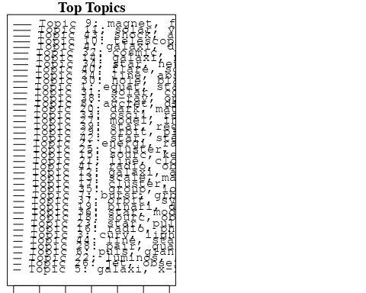

plotQuote(thoughts6, width = 30, main = "Topic 6")  
plotQuote(thoughts18, width = 30, main = "Topic 18")

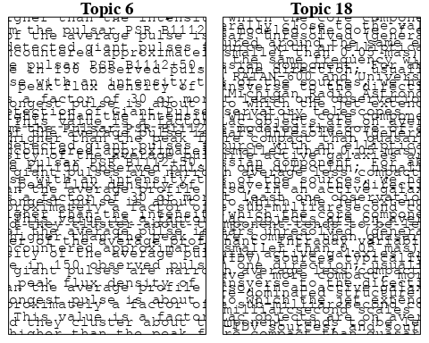

# Calculate and plot the correlation between topics  
mod.out.corr <- topicCorr(Research_topics)  
plot(mod.out.corr, cex = 1.5)  
  
  
# For each topic  
for (topic_num in 1:44) {  
 # Plot the word cloud  
 cloud(Research_topics, topic = topic_num, scale = c(2, 0.25))  
 Sys.sleep(2)  
}

## Warning in wordcloud::wordcloud(words = vocab, freq = vec, max.words =  
## max.words, : distribut could not be fit on page. It will not be plotted.

## Warning in wordcloud::wordcloud(words = vocab, freq = vec, max.words =  
## max.words, : approxim could not be fit on page. It will not be plotted.

## Warning in wordcloud::wordcloud(words = vocab, freq = vec, max.words =  
## max.words, : solut could not be fit on page. It will not be plotted.

## Warning in wordcloud::wordcloud(words = vocab, freq = vec, max.words =  
## max.words, : behavior could not be fit on page. It will not be plotted.

## Warning in wordcloud::wordcloud(words = vocab, freq = vec, max.words =  
## max.words, : gravit could not be fit on page. It will not be plotted.

## Warning in wordcloud::wordcloud(words = vocab, freq = vec, max.words =  
## max.words, : formula could not be fit on page. It will not be plotted.

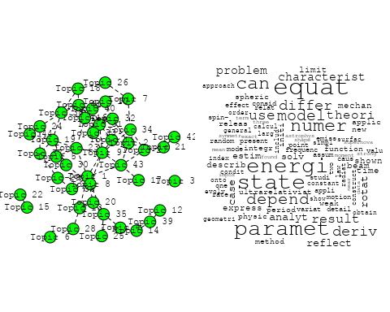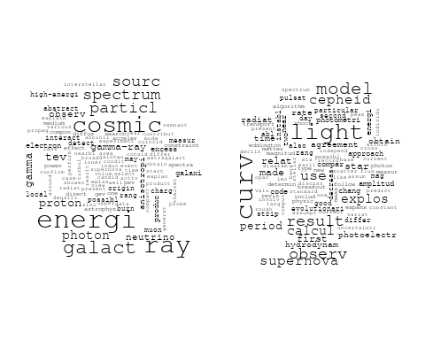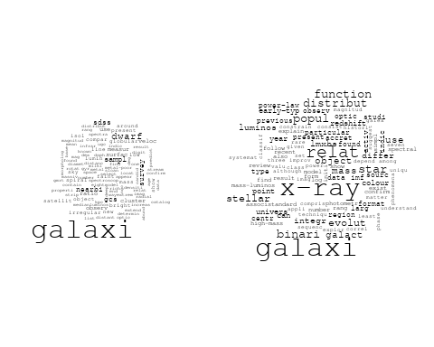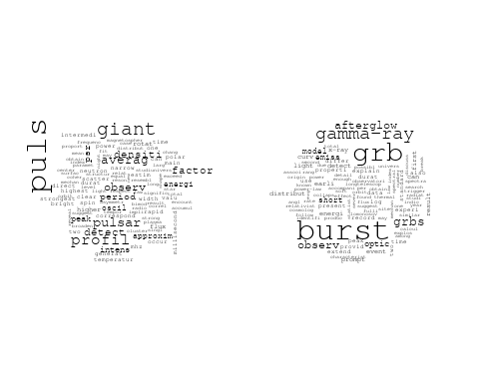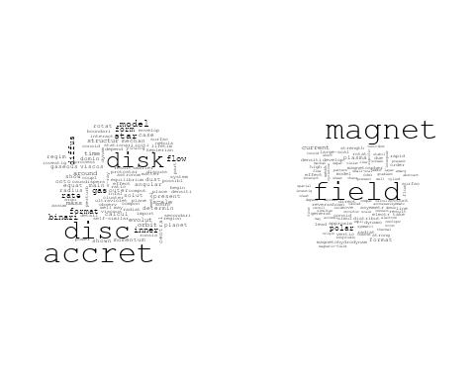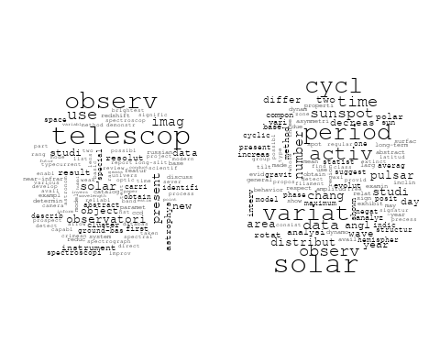

## Warning in wordcloud::wordcloud(words = vocab, freq = vec, max.words =  
## max.words, : background could not be fit on page. It will not be plotted.

## Warning in wordcloud::wordcloud(words = vocab, freq = vec, max.words =  
## max.words, : correl could not be fit on page. It will not be plotted.

## Warning in wordcloud::wordcloud(words = vocab, freq = vec, max.words =  
## max.words, : power could not be fit on page. It will not be plotted.

## Warning in wordcloud::wordcloud(words = vocab, freq = vec, max.words =  
## max.words, : map could not be fit on page. It will not be plotted.

## Warning in wordcloud::wordcloud(words = vocab, freq = vec, max.words =  
## max.words, : fluctuat could not be fit on page. It will not be plotted.

## Warning in wordcloud::wordcloud(words = vocab, freq = vec, max.words =  
## max.words, : data could not be fit on page. It will not be plotted.

## Warning in wordcloud::wordcloud(words = vocab, freq = vec, max.words =  
## max.words, : problem could not be fit on page. It will not be plotted.

## Warning in wordcloud::wordcloud(words = vocab, freq = vec, max.words =  
## max.words, : scale could not be fit on page. It will not be plotted.

## Warning in wordcloud::wordcloud(words = vocab, freq = vec, max.words =  
## max.words, : improv could not be fit on page. It will not be plotted.

## Warning in wordcloud::wordcloud(words = vocab, freq = vec, max.words =  
## max.words, : foreground could not be fit on page. It will not be plotted.

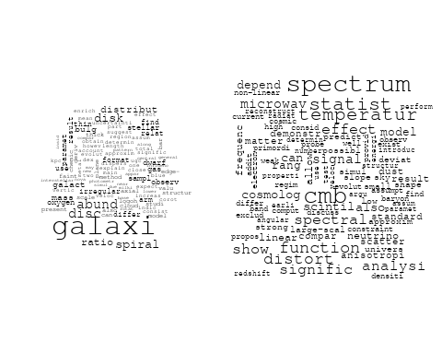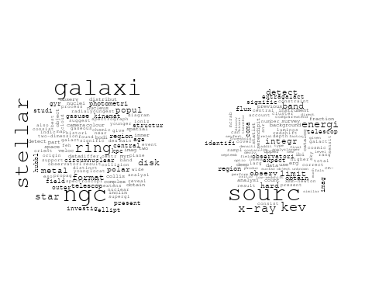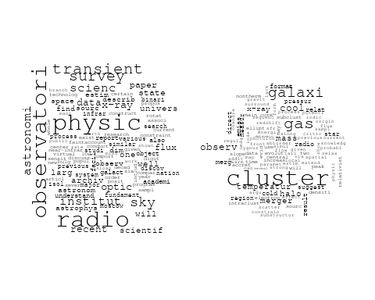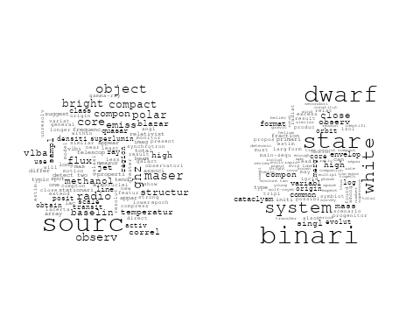

## Warning in wordcloud::wordcloud(words = vocab, freq = vec, max.words =  
## max.words, : line could not be fit on page. It will not be plotted.

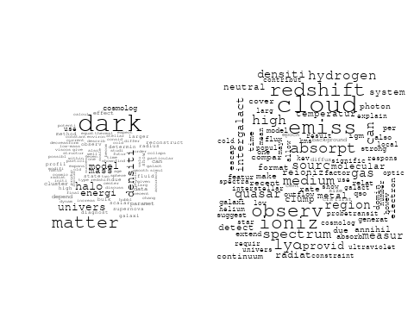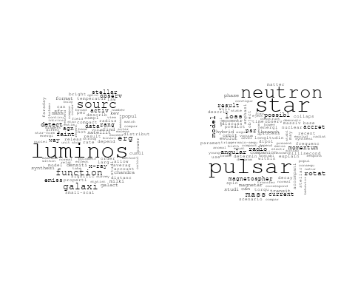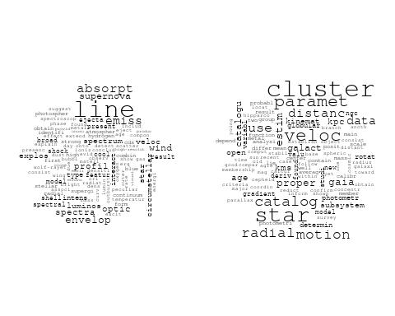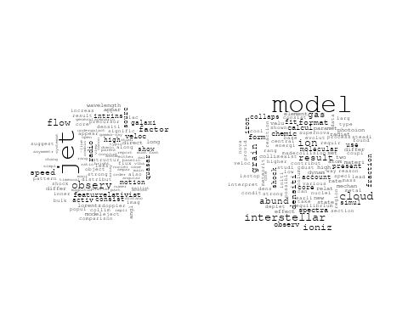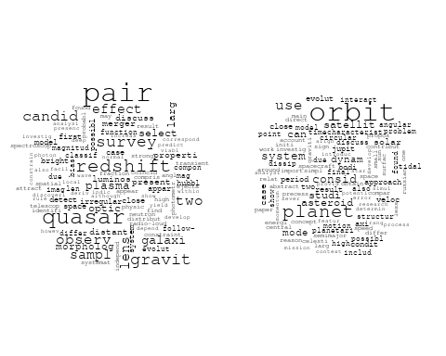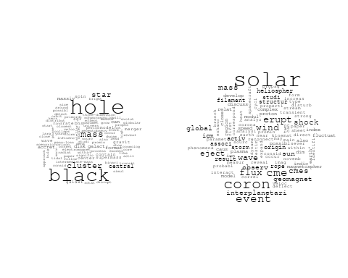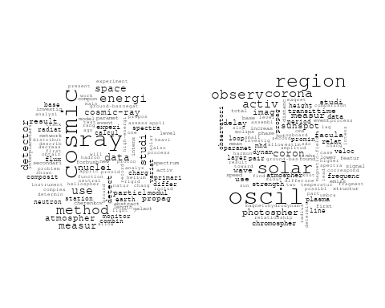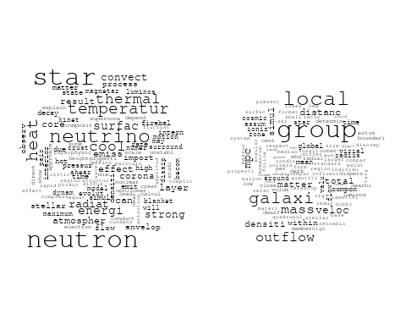

## Warning in wordcloud::wordcloud(words = vocab, freq = vec, max.words =  
## max.words, : system could not be fit on page. It will not be plotted.

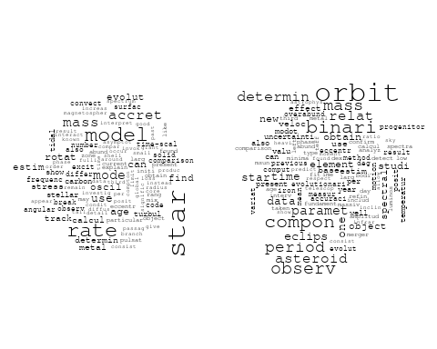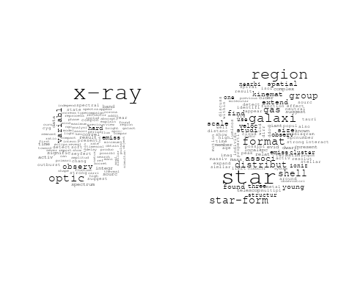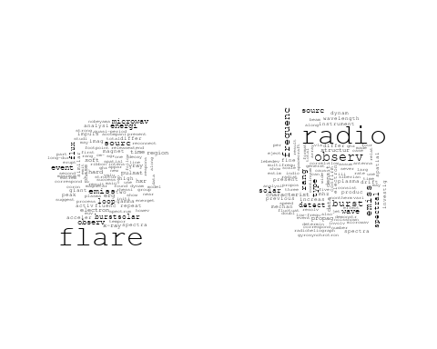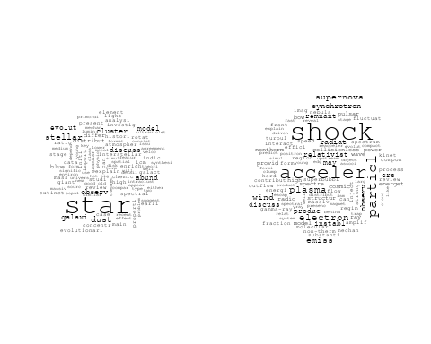

# Get the topic proportions for each document  
topic_proportions <- Research_topics$theta  
  
# Find the index of the topic with the highest proportion for each document  
# This will be the topic that each document is most likely to belong to  
max_topic_idx <- apply(topic_proportions, 1, which.max)  
  
# Add this as a new column to your data  
data_collab$topic <- max_topic_idx  
  
library(ggplot2)  
  
# Define the intervals  
intervals <- c('1824_1899', '1900_1964', '1965_1974', '1975_1984', '1985_1994', '1995_1999', '2000_2004', '2005_2009', '2010_2014', '2015_2019', '2020_2022')  
colors <- c('pink', 'blue', 'purple', 'yellow', 'green', 'pink', 'orange', 'violet', 'green', 'blue', 'pink')  
  
# Loop through the intervals and plot  
for(i in seq_along(intervals)){  
 # Filter data for when the pub_interval is equal to 1  
 data_filtered <- data_collab[data_collab[[paste0('pub_interval_', intervals[i])]] == 1,]  
   
 # Make the histogram  
   
 p <- ggplot(data_filtered, aes(x = topic)) +  
 geom_histogram(binwidth = 1, fill = colors[i], color = "black") +  
 xlab("Topic") +  
 ylab("Count") +  
 ggtitle(paste0("Topics from year ", gsub("_", " to ", intervals[i])))  
   
 print(p)  
}  
  
  
##Topic generation for RU (independent) publications  
  
data_independent <- data[data[["RU"]] == 100,]  
  
# Save the original title data for future use  
data_independent$original_concatenated_title_abstract <- data_independent$concatenated_title_abstract  
  
#pre-processing the titles using textProcessor from the stm package  
processed_text <- textProcessor(data_independent$concatenated_title_abstract, metadata = data_independent)

## Building corpus...   
## Converting to Lower Case...   
## Removing punctuation...   
## Removing stopwords...   
## Removing numbers...   
## Stemming...   
## Creating Output...

# Further prepare the data by removing low-frequency terms  
out_text <- prepDocuments(processed_text$documents, processed_text$vocab, processed_text$meta)

## Removing 1630 of 5316 terms (1630 of 50858 tokens) due to frequency   
## Your corpus now has 761 documents, 3686 terms and 49228 tokens.

docs_text <- out_text$documents  
vocab_text <- out_text$vocab  
meta_text <- out_text$meta  
  
  
#Prepare data  
plotRemoved(processed_text$documents, lower.thresh = seq(1, 200, by = 100))

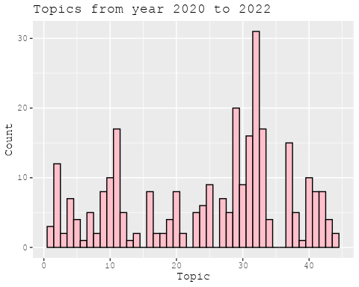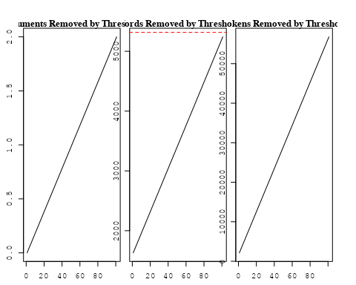

out_text <- prepDocuments(processed_text$documents, processed_text$vocab, processed_text$meta, lower.thresh = 8)

## Removing 4186 of 5316 terms (10209 of 50858 tokens) due to frequency   
## Your corpus now has 761 documents, 1130 terms and 40649 tokens.

str(out_text$meta)

## 'data.frame': 761 obs. of 39 variables:  
## $ concept_id : chr "https://openalex.org/C44870925" "https://openalex.org/C44870925" "https://openalex.org/C1276947" "https://openalex.org/C44870925" ...  
## $ work_id : chr "https://openalex.org/W2950971381" "https://openalex.org/W1974527970" "https://openalex.org/W1986409356" "https://openalex.org/W2021620469" ...  
## $ publication_year : int 2010 1989 2002 2014 2006 2014 2009 2020 2004 1976 ...  
## $ title : chr "Gravitational lensing in a non-uniform plasma" "A survey of the radio continuum emission of RS Canum Venaticorum and related active binary systems" "Evolutionary changes in the optical spectrum of the peculiar supergiant IRC+10420" "Suppression of cooling by strong magnetic fields in white dwarf stars" ...  
## $ paperabstract : chr "We develop a model of gravitational lensing in a non-uniform plasma. When a gravitating body is surrounded by a"| __truncated__ "Observations of 77 RS CVn and related active binary systems were made with VLA at a continuum frequency of 4.86"| __truncated__ "We present new spectroscopic observations of the peculiar supergiant IRC+10420. In 1997–2000, we obtained three"| __truncated__ "Isolated cool white dwarf stars more often have strong magnetic fields than young, hotter white dwarfs, which h"| __truncated__ ...  
## $ country : chr "RU RU RU RU RU RU RU RU" "RU RU RU RU" "RU RU" "RU RU RU RU" ...  
## $ year_concept : chr "2010+https://openalex.org/C44870925" "1989+https://openalex.org/C44870925" "2002+https://openalex.org/C1276947" "2014+https://openalex.org/C44870925" ...  
## $ concatenated_title_abstract : chr "Gravitational lensing in a non-uniform plasma We develop a model of gravitational lensing in a non-uniform plas"| __truncated__ "A survey of the radio continuum emission of RS Canum Venaticorum and related active binary systems Observations"| __truncated__ "Evolutionary changes in the optical spectrum of the peculiar supergiant IRC+10420 We present new spectroscopic "| __truncated__ "Suppression of cooling by strong magnetic fields in white dwarf stars Isolated cool white dwarf stars more ofte"| __truncated__ ...  
## $ US : num 0 0 0 0 0 0 0 0 0 0 ...  
## $ IN : num 0 0 0 0 0 0 0 0 0 0 ...  
## $ DE : num 0 0 0 0 0 0 0 0 0 0 ...  
## $ CH : num 0 0 0 0 0 0 0 0 0 0 ...  
## $ GB : num 0 0 0 0 0 0 0 0 0 0 ...  
## $ CN : num 0 0 0 0 0 0 0 0 0 0 ...  
## $ FR : num 0 0 0 0 0 0 0 0 0 0 ...  
## $ IT : num 0 0 0 0 0 0 0 0 0 0 ...  
## $ RU : num 100 100 100 100 100 100 100 100 100 100 ...  
## $ CA : num 0 0 0 0 0 0 0 0 0 0 ...  
## $ NL : num 0 0 0 0 0 0 0 0 0 0 ...  
## $ AU : num 0 0 0 0 0 0 0 0 0 0 ...  
## $ JP : num 0 0 0 0 0 0 0 0 0 0 ...  
## $ ES : num 0 0 0 0 0 0 0 0 0 0 ...  
## $ IL : num 0 0 0 0 0 0 0 0 0 0 ...  
## $ Americas : num 0 0 0 0 0 0 0 0 0 0 ...  
## $ Europe : num 0 0 0 0 0 0 0 0 0 0 ...  
## $ Africa : num 0 0 0 0 0 0 0 0 0 0 ...  
## $ AsiaAndOceania : num 0 0 0 0 0 0 0 0 0 0 ...  
## $ pub_interval_2020_2022 : int 0 0 0 0 0 0 0 1 0 0 ...  
## $ pub_interval_2015_2019 : int 0 0 0 0 0 0 0 0 0 0 ...  
## $ pub_interval_2010_2014 : int 1 0 0 1 0 1 0 0 0 0 ...  
## $ pub_interval_2005_2009 : int 0 0 0 0 1 0 1 0 0 0 ...  
## $ pub_interval_2000_2004 : int 0 0 1 0 0 0 0 0 1 0 ...  
## $ pub_interval_1995_1999 : int 0 0 0 0 0 0 0 0 0 0 ...  
## $ pub_interval_1985_1994 : int 0 1 0 0 0 0 0 0 0 0 ...  
## $ pub_interval_1975_1984 : int 0 0 0 0 0 0 0 0 0 1 ...  
## $ pub_interval_1965_1974 : int 0 0 0 0 0 0 0 0 0 0 ...  
## $ pub_interval_1900_1964 : int 0 0 0 0 0 0 0 0 0 0 ...  
## $ pub_interval_1824_1899 : int 0 0 0 0 0 0 0 0 0 0 ...  
## $ original_concatenated_title_abstract: chr "Gravitational lensing in a non-uniform plasma We develop a model of gravitational lensing in a non-uniform plas"| __truncated__ "A survey of the radio continuum emission of RS Canum Venaticorum and related active binary systems Observations"| __truncated__ "Evolutionary changes in the optical spectrum of the peculiar supergiant IRC+10420 We present new spectroscopic "| __truncated__ "Suppression of cooling by strong magnetic fields in white dwarf stars Isolated cool white dwarf stars more ofte"| __truncated__ ...

# Initialize an empty formula string  
prevalence_formula_str <- "~"  
  
# Define the publication intervals  
pub_intervals <- c("pub_interval_2020_2022", "pub_interval_2015_2019", "pub_interval_2010_2014",   
 "pub_interval_2005_2009", "pub_interval_2000_2004", "pub_interval_1995_1999",  
 "pub_interval_1985_1994", "pub_interval_1975_1984", "pub_interval_1965_1974",  
 "pub_interval_1900_1964", "pub_interval_1824_1899")  
  
# Add each publication interval to the formula string  
for (interval in pub_intervals) {  
 # add an if statement to handle the first addition (without '+')  
 if (prevalence_formula_str == "~") {  
 prevalence_formula_str <- paste(prevalence_formula_str, interval)  
 } else {  
 prevalence_formula_str <- paste(prevalence_formula_str, "+", interval)  
 }  
}  
  
  
# Convert the string to a formula  
prevalence_formula <- as.formula(prevalence_formula_str)  
print(prevalence_formula)

## ~pub_interval_2020_2022 + pub_interval_2015_2019 + pub_interval_2010_2014 +   
## pub_interval_2005_2009 + pub_interval_2000_2004 + pub_interval_1995_1999 +   
## pub_interval_1985_1994 + pub_interval_1975_1984 + pub_interval_1965_1974 +   
## pub_interval_1900_1964 + pub_interval_1824_1899

# Run STM model  
Research_topics <- stm(documents = out_text$documents,   
 vocab = out_text$vocab,   
 K = 44,   
 prevalence = prevalence_formula,   
 data = out_text$meta,   
 init.type = "Spectral",  
 max.em.its = 1000,  
 gamma.prior = 'L1')

## Beginning Spectral Initialization   
## Calculating the gram matrix...  
## Finding anchor words...  
## ............................................  
## Recovering initialization...  
## ...........  
## Initialization complete.  
## ............................................................................................................  
## Completed E-Step (0 seconds).   
## Completed M-Step.   
## Completing Iteration 1 (approx. per word bound = -5.895)   
## ............................................................................................................  
## Completed E-Step (0 seconds).   
## Completed M-Step.   
## Completing Iteration 2 (approx. per word bound = -5.657, relative change = 4.023e-02)   
## ............................................................................................................  
## Completed E-Step (0 seconds).   
## Completed M-Step.   
## Completing Iteration 3 (approx. per word bound = -5.576, relative change = 1.448e-02)   
## ............................................................................................................  
## Completed E-Step (0 seconds).   
## Completed M-Step.   
## Completing Iteration 4 (approx. per word bound = -5.537, relative change = 6.983e-03)   
## ............................................................................................................  
## Completed E-Step (0 seconds).   
## Completed M-Step.   
## Completing Iteration 5 (approx. per word bound = -5.515, relative change = 3.916e-03)   
## Topic 1: energi, dark, state, deriv, equat   
## Topic 2: grb, gamma-ray, optic, burst, x-ray   
## Topic 3: puls, factor, averag, giant, higher   
## Topic 4: space, astronomi, observatori, scientif, institut   
## Topic 5: x-ray, binari, optic, observ, hard   
## Topic 6: magnet, field, white, neutrino, dwarf   
## Topic 7: observ, telescop, imag, use, mode   
## Topic 8: paramet, equat, can, use, model   
## Topic 9: studi, use, experi, nuclei, detector   
## Topic 10: sourc, emiss, ghz, microwav, line   
## Topic 11: abund, element, chemic, arm, model   
## Topic 12: ray, cosmic, field, magnet, method   
## Topic 13: physic, investig, import, problem, interstellar   
## Topic 14: paramet, catalog, star, veloc, motion   
## Topic 15: oscil, region, solar, photospher, sunspot   
## Topic 16: hole, black, cluster, mass, star   
## Topic 17: galaxi, star, dwarf, relat, format   
## Topic 18: cluster, star, catalogu, globular, subsystem   
## Topic 19: radio, frequenc, observ, data, pulsar   
## Topic 20: flare, event, burst, energi, erg   
## Topic 21: cool, gas, format, galaxi, star   
## Topic 22: shell, x-ray, wind, observ, perturb   
## Topic 23: star, model, stellar, evolut, metal   
## Topic 24: solar, magnet, activ, field, cycl   
## Topic 25: current, magnet, pulsar, field, can   
## Topic 26: group, matter, galaxi, densiti, local   
## Topic 27: neutron, star, x-ray, sourc, transient   
## Topic 28: solar, observ, instrument, catalog, present   
## Topic 29: accret, plasma, black, hole, gravit   
## Topic 30: line, compon, determin, result, observ   
## Topic 31: distribut, burst, differ, observ, possibl   
## Topic 32: wave, time, gravit, cme, shock   
## Topic 33: shock, cloud, emiss, supernova, line   
## Topic 34: period, angl, oscil, spin, model   
## Topic 35: veloc, rotat, scale, motion, galaxi   
## Topic 36: star, emiss, dwarf, line, variabl   
## Topic 37: shell, region, complex, kinemat, sourc   
## Topic 38: energi, ray, particl, acceler, spectrum   
## Topic 39: galaxi, disk, spiral, ngc, halo   
## Topic 40: orbit, period, system, star, observ   
## Topic 41: disc, accret, disk, star, model   
## Topic 42: burst, gamma-ray, grbs, observ, detect   
## Topic 43: evolut, univers, big, model, histori   
## Topic 44: paramet, eccentr, obtain, observ, develop   
## ............................................................................................................  
## Completed E-Step (0 seconds).   
## Completed M-Step.   
## Completing Iteration 6 (approx. per word bound = -5.501, relative change = 2.470e-03)   
## ............................................................................................................  
## Completed E-Step (0 seconds).   
## Completed M-Step.   
## Completing Iteration 7 (approx. per word bound = -5.492, relative change = 1.621e-03)   
## ............................................................................................................  
## Completed E-Step (0 seconds).   
## Completed M-Step.   
## Completing Iteration 8 (approx. per word bound = -5.486, relative change = 1.085e-03)   
## ............................................................................................................  
## Completed E-Step (0 seconds).   
## Completed M-Step.   
## Completing Iteration 9 (approx. per word bound = -5.482, relative change = 8.875e-04)   
## ............................................................................................................  
## Completed E-Step (0 seconds).   
## Completed M-Step.   
## Completing Iteration 10 (approx. per word bound = -5.477, relative change = 7.864e-04)   
## Topic 1: energi, dark, state, deriv, model   
## Topic 2: grb, gamma-ray, optic, burst, thermal   
## Topic 3: puls, factor, averag, giant, detect   
## Topic 4: observatori, astronomi, space, scientif, astronom   
## Topic 5: x-ray, binari, optic, observ, hard   
## Topic 6: magnet, field, format, white, neutrino   
## Topic 7: observ, telescop, imag, use, new   
## Topic 8: paramet, use, equat, model, can   
## Topic 9: studi, use, experi, nuclei, composit   
## Topic 10: sourc, emiss, ghz, microwav, line   
## Topic 11: abund, element, chemic, star, arm   
## Topic 12: ray, cosmic, interplanetari, solar, method   
## Topic 13: physic, import, investig, observ, recent   
## Topic 14: catalog, paramet, veloc, star, radial   
## Topic 15: oscil, region, solar, photospher, activ   
## Topic 16: black, hole, cluster, star, mass   
## Topic 17: galaxi, star, dwarf, relat, format   
## Topic 18: cluster, star, catalogu, subsystem, globular   
## Topic 19: radio, frequenc, observ, sourc, data   
## Topic 20: flare, event, burst, phase, energi   
## Topic 21: cool, gas, star, format, galaxi   
## Topic 22: shell, x-ray, wind, observ, optic   
## Topic 23: star, model, stellar, metal, evolut   
## Topic 24: solar, magnet, field, activ, cycl   
## Topic 25: current, pulsar, magnet, field, can   
## Topic 26: matter, group, galaxi, local, mass   
## Topic 27: neutron, star, x-ray, transient, sourc   
## Topic 28: solar, instrument, observ, observatori, present   
## Topic 29: accret, plasma, black, hole, gravit   
## Topic 30: line, compon, determin, result, observ   
## Topic 31: distribut, burst, explos, differ, observ   
## Topic 32: wave, cme, erupt, time, shock   
## Topic 33: shock, cloud, emiss, supernova, molecular   
## Topic 34: period, angl, oscil, spin, model   
## Topic 35: veloc, galaxi, correl, scale, background   
## Topic 36: star, dwarf, emiss, high, line   
## Topic 37: region, complex, shell, kinemat, sourc   
## Topic 38: energi, ray, particl, acceler, spectrum   
## Topic 39: galaxi, disk, spiral, ngc, halo   
## Topic 40: orbit, system, period, observ, star   
## Topic 41: disc, accret, star, disk, model   
## Topic 42: burst, gamma-ray, grbs, observ, detect   
## Topic 43: evolut, univers, model, big, histori   
## Topic 44: paramet, obtain, observ, eccentr, object   
## ............................................................................................................  
## Completed E-Step (0 seconds).   
## Completed M-Step.   
## Completing Iteration 11 (approx. per word bound = -5.473, relative change = 7.155e-04)   
## ............................................................................................................  
## Completed E-Step (0 seconds).   
## Completed M-Step.   
## Completing Iteration 12 (approx. per word bound = -5.470, relative change = 6.400e-04)   
## ............................................................................................................  
## Completed E-Step (0 seconds).   
## Completed M-Step.   
## Completing Iteration 13 (approx. per word bound = -5.467, relative change = 5.160e-04)   
## ............................................................................................................  
## Completed E-Step (0 seconds).   
## Completed M-Step.   
## Completing Iteration 14 (approx. per word bound = -5.465, relative change = 4.540e-04)   
## ............................................................................................................  
## Completed E-Step (0 seconds).   
## Completed M-Step.   
## Completing Iteration 15 (approx. per word bound = -5.462, relative change = 4.058e-04)   
## Topic 1: energi, dark, deriv, state, model   
## Topic 2: grb, gamma-ray, optic, burst, thermal   
## Topic 3: puls, factor, averag, giant, pulsar   
## Topic 4: observatori, scientif, space, astronomi, institut   
## Topic 5: x-ray, binari, optic, observ, hard   
## Topic 6: magnet, field, format, neutrino, lead   
## Topic 7: observ, telescop, imag, use, first   
## Topic 8: paramet, use, model, equat, numer   
## Topic 9: studi, use, experi, nuclei, composit   
## Topic 10: sourc, emiss, ghz, microwav, line   
## Topic 11: abund, star, element, chemic, arm   
## Topic 12: cosmic, ray, solar, interplanetari, method   
## Topic 13: physic, observ, import, investig, differ   
## Topic 14: veloc, paramet, catalog, star, radial   
## Topic 15: oscil, region, solar, photospher, activ   
## Topic 16: black, hole, cluster, star, mass   
## Topic 17: galaxi, star, relat, dwarf, format   
## Topic 18: cluster, star, catalogu, subsystem, globular   
## Topic 19: radio, observ, frequenc, sourc, pulsar   
## Topic 20: flare, event, burst, energi, phase   
## Topic 21: cool, gas, star, format, galaxi   
## Topic 22: shell, x-ray, wind, observ, optic   
## Topic 23: star, model, stellar, metal, evolut   
## Topic 24: solar, magnet, activ, field, cycl   
## Topic 25: current, pulsar, can, star, model   
## Topic 26: matter, group, local, galaxi, mass   
## Topic 27: neutron, star, x-ray, transient, sourc   
## Topic 28: solar, instrument, observ, observatori, present   
## Topic 29: accret, plasma, black, hole, gravit   
## Topic 30: line, compon, determin, spectra, system   
## Topic 31: distribut, burst, explos, differ, observ   
## Topic 32: wave, cme, erupt, shock, time   
## Topic 33: shock, cloud, emiss, supernova, line   
## Topic 34: period, angl, oscil, spin, profil   
## Topic 35: veloc, galaxi, correl, scale, background   
## Topic 36: star, dwarf, white, high, emiss   
## Topic 37: region, complex, shell, galaxi, sourc   
## Topic 38: energi, particl, ray, acceler, spectrum   
## Topic 39: galaxi, disk, spiral, ngc, halo   
## Topic 40: orbit, system, period, observ, star   
## Topic 41: disc, accret, star, disk, model   
## Topic 42: burst, grbs, gamma-ray, observ, detect   
## Topic 43: evolut, model, univers, big, histori   
## Topic 44: object, paramet, obtain, observ, eccentr   
## ............................................................................................................  
## Completed E-Step (0 seconds).   
## Completed M-Step.   
## Completing Iteration 16 (approx. per word bound = -5.460, relative change = 3.544e-04)   
## ............................................................................................................  
## Completed E-Step (0 seconds).   
## Completed M-Step.   
## Completing Iteration 17 (approx. per word bound = -5.459, relative change = 3.248e-04)   
## ............................................................................................................  
## Completed E-Step (0 seconds).   
## Completed M-Step.   
## Completing Iteration 18 (approx. per word bound = -5.457, relative change = 2.809e-04)   
## ............................................................................................................  
## Completed E-Step (0 seconds).   
## Completed M-Step.   
## Completing Iteration 19 (approx. per word bound = -5.455, relative change = 3.351e-04)   
## ............................................................................................................  
## Completed E-Step (0 seconds).   
## Completed M-Step.   
## Completing Iteration 20 (approx. per word bound = -5.453, relative change = 3.233e-04)   
## Topic 1: energi, dark, deriv, halo, densiti   
## Topic 2: grb, gamma-ray, optic, burst, x-ray   
## Topic 3: puls, factor, averag, giant, detect   
## Topic 4: observatori, space, scientif, astronomi, institut   
## Topic 5: x-ray, binari, optic, observ, hard   
## Topic 6: magnet, field, format, lead, neutrino   
## Topic 7: observ, telescop, imag, use, first   
## Topic 8: paramet, use, model, numer, equat   
## Topic 9: studi, use, experi, composit, nuclei   
## Topic 10: sourc, emiss, ghz, microwav, line   
## Topic 11: abund, star, element, chemic, arm   
## Topic 12: cosmic, ray, solar, method, interplanetari   
## Topic 13: physic, observ, import, investig, differ   
## Topic 14: veloc, catalog, star, paramet, radial   
## Topic 15: oscil, region, solar, photospher, activ   
## Topic 16: black, hole, cluster, star, mass   
## Topic 17: galaxi, star, relat, dwarf, format   
## Topic 18: cluster, star, catalogu, subsystem, use   
## Topic 19: radio, observ, frequenc, sourc, emiss   
## Topic 20: flare, event, burst, energi, phase   
## Topic 21: cool, gas, star, format, galaxi   
## Topic 22: shell, x-ray, wind, observ, optic   
## Topic 23: star, model, stellar, metal, evolut   
## Topic 24: solar, activ, magnet, cycl, field   
## Topic 25: current, pulsar, can, star, model   
## Topic 26: group, matter, local, galaxi, mass   
## Topic 27: neutron, star, x-ray, transient, sourc   
## Topic 28: solar, observ, instrument, telescop, observatori   
## Topic 29: accret, black, plasma, hole, gravit   
## Topic 30: line, compon, determin, spectra, present   
## Topic 31: distribut, burst, explos, supernova, differ   
## Topic 32: wave, cme, erupt, shock, time   
## Topic 33: shock, cloud, emiss, supernova, line   
## Topic 34: period, angl, spin, oscil, profil   
## Topic 35: veloc, galaxi, correl, scale, background   
## Topic 36: star, dwarf, white, high, emiss   
## Topic 37: region, complex, shell, galaxi, sourc   
## Topic 38: energi, particl, ray, acceler, spectrum   
## Topic 39: galaxi, disk, spiral, ngc, structur   
## Topic 40: orbit, period, system, observ, star   
## Topic 41: disc, accret, star, disk, model   
## Topic 42: burst, grbs, gamma-ray, observ, detect   
## Topic 43: evolut, model, univers, big, histori   
## Topic 44: object, paramet, mass, observ, obtain   
## ............................................................................................................  
## Completed E-Step (0 seconds).   
## Completed M-Step.   
## Completing Iteration 21 (approx. per word bound = -5.452, relative change = 2.919e-04)   
## ............................................................................................................  
## Completed E-Step (1 seconds).   
## Completed M-Step.   
## Completing Iteration 22 (approx. per word bound = -5.450, relative change = 2.781e-04)   
## ............................................................................................................  
## Completed E-Step (0 seconds).   
## Completed M-Step.   
## Completing Iteration 23 (approx. per word bound = -5.449, relative change = 2.756e-04)   
## ............................................................................................................  
## Completed E-Step (0 seconds).   
## Completed M-Step.   
## Completing Iteration 24 (approx. per word bound = -5.447, relative change = 2.732e-04)   
## ............................................................................................................  
## Completed E-Step (0 seconds).   
## Completed M-Step.   
## Completing Iteration 25 (approx. per word bound = -5.446, relative change = 2.362e-04)   
## Topic 1: energi, dark, matter, deriv, halo   
## Topic 2: grb, gamma-ray, optic, burst, x-ray   
## Topic 3: puls, factor, averag, giant, detect   
## Topic 4: observatori, space, scientif, astronomi, physic   
## Topic 5: x-ray, binari, optic, observ, hard   
## Topic 6: magnet, field, format, lead, surfac   
## Topic 7: observ, telescop, imag, use, first   
## Topic 8: paramet, model, use, calcul, numer   
## Topic 9: studi, use, cosmic, nuclei, composit   
## Topic 10: sourc, emiss, ghz, microwav, line   
## Topic 11: abund, star, element, chemic, model   
## Topic 12: cosmic, ray, solar, method, interplanetari   
## Topic 13: physic, observ, import, investig, differ   
## Topic 14: veloc, catalog, star, paramet, radial   
## Topic 15: oscil, region, solar, photospher, facula   
## Topic 16: black, hole, cluster, star, mass   
## Topic 17: galaxi, star, relat, dwarf, format   
## Topic 18: cluster, star, catalogu, subsystem, use   
## Topic 19: radio, observ, sourc, frequenc, emiss   
## Topic 20: flare, event, burst, energi, phase   
## Topic 21: cool, gas, format, star, galaxi   
## Topic 22: shell, x-ray, wind, observ, optic   
## Topic 23: star, model, stellar, metal, mass   
## Topic 24: solar, activ, cycl, polar, coron   
## Topic 25: current, pulsar, can, star, neutron   
## Topic 26: group, local, galaxi, matter, mass   
## Topic 27: neutron, star, x-ray, transient, sourc   
## Topic 28: solar, observ, instrument, telescop, present   
## Topic 29: accret, black, hole, plasma, gravit   
## Topic 30: line, compon, determin, spectra, absorpt   
## Topic 31: distribut, burst, explos, supernova, differ   
## Topic 32: wave, cme, erupt, shock, event   
## Topic 33: shock, cloud, emiss, supernova, line   
## Topic 34: period, angl, spin, oscil, profil   
## Topic 35: veloc, galaxi, scale, correl, background   
## Topic 36: star, dwarf, white, high, emiss   
## Topic 37: region, complex, galaxi, shell, sourc   
## Topic 38: energi, particl, ray, acceler, spectrum   
## Topic 39: galaxi, disk, spiral, ngc, structur   
## Topic 40: orbit, period, system, observ, star   
## Topic 41: disc, accret, star, disk, model   
## Topic 42: burst, grbs, gamma-ray, observ, detect   
## Topic 43: evolut, univers, big, model, histori   
## Topic 44: object, paramet, mass, observ, obtain   
## ............................................................................................................  
## Completed E-Step (0 seconds).   
## Completed M-Step.   
## Completing Iteration 26 (approx. per word bound = -5.445, relative change = 2.053e-04)   
## ............................................................................................................  
## Completed E-Step (0 seconds).   
## Completed M-Step.   
## Completing Iteration 27 (approx. per word bound = -5.444, relative change = 1.839e-04)   
## ............................................................................................................  
## Completed E-Step (0 seconds).   
## Completed M-Step.   
## Completing Iteration 28 (approx. per word bound = -5.443, relative change = 1.648e-04)   
## ............................................................................................................  
## Completed E-Step (0 seconds).   
## Completed M-Step.   
## Completing Iteration 29 (approx. per word bound = -5.442, relative change = 1.594e-04)   
## ............................................................................................................  
## Completed E-Step (0 seconds).   
## Completed M-Step.   
## Completing Iteration 30 (approx. per word bound = -5.441, relative change = 1.488e-04)   
## Topic 1: energi, dark, matter, deriv, halo   
## Topic 2: grb, gamma-ray, optic, burst, x-ray   
## Topic 3: puls, factor, averag, giant, pulsar   
## Topic 4: space, observatori, scientif, astronomi, physic   
## Topic 5: x-ray, binari, optic, observ, hard   
## Topic 6: magnet, field, format, lead, surfac   
## Topic 7: observ, telescop, imag, use, first   
## Topic 8: paramet, model, use, calcul, equat   
## Topic 9: studi, energi, cosmic, use, nuclei   
## Topic 10: sourc, emiss, ghz, microwav, line   
## Topic 11: abund, star, element, chemic, model   
## Topic 12: cosmic, ray, solar, method, interplanetari   
## Topic 13: physic, observ, import, differ, investig   
## Topic 14: veloc, catalog, star, paramet, radial   
## Topic 15: oscil, region, solar, photospher, facula   
## Topic 16: black, hole, cluster, star, mass   
## Topic 17: galaxi, star, relat, dwarf, format   
## Topic 18: cluster, star, catalogu, subsystem, globular   
## Topic 19: radio, observ, sourc, frequenc, emiss   
## Topic 20: flare, event, burst, energi, phase   
## Topic 21: cool, gas, format, star, galaxi   
## Topic 22: shell, x-ray, wind, observ, optic   
## Topic 23: star, model, stellar, metal, mass   
## Topic 24: solar, activ, cycl, polar, coron   
## Topic 25: pulsar, current, can, star, neutron   
## Topic 26: group, local, galaxi, matter, mass   
## Topic 27: neutron, star, x-ray, transient, sourc   
## Topic 28: solar, observ, instrument, telescop, present   
## Topic 29: accret, black, hole, plasma, gravit   
## Topic 30: line, compon, determin, spectra, present   
## Topic 31: distribut, burst, explos, supernova, differ   
## Topic 32: wave, cme, erupt, shock, event   
## Topic 33: shock, cloud, emiss, supernova, line   
## Topic 34: period, angl, spin, oscil, profil   
## Topic 35: veloc, galaxi, scale, correl, background   
## Topic 36: star, dwarf, white, high, variabl   
## Topic 37: region, complex, galaxi, shell, sourc   
## Topic 38: energi, acceler, particl, ray, spectrum   
## Topic 39: galaxi, disk, spiral, ngc, structur   
## Topic 40: orbit, period, system, observ, star   
## Topic 41: disc, accret, star, disk, model   
## Topic 42: burst, grbs, gamma-ray, observ, detect   
## Topic 43: evolut, big, univers, model, histori   
## Topic 44: object, mass, paramet, observ, compon   
## ............................................................................................................  
## Completed E-Step (0 seconds).   
## Completed M-Step.   
## Completing Iteration 31 (approx. per word bound = -5.441, relative change = 1.350e-04)   
## ............................................................................................................  
## Completed E-Step (0 seconds).   
## Completed M-Step.   
## Completing Iteration 32 (approx. per word bound = -5.440, relative change = 1.390e-04)   
## ............................................................................................................  
## Completed E-Step (0 seconds).   
## Completed M-Step.   
## Completing Iteration 33 (approx. per word bound = -5.439, relative change = 1.275e-04)   
## ............................................................................................................  
## Completed E-Step (0 seconds).   
## Completed M-Step.   
## Completing Iteration 34 (approx. per word bound = -5.439, relative change = 1.152e-04)   
## ............................................................................................................  
## Completed E-Step (0 seconds).   
## Completed M-Step.   
## Completing Iteration 35 (approx. per word bound = -5.438, relative change = 1.152e-04)   
## Topic 1: energi, dark, matter, model, halo   
## Topic 2: grb, gamma-ray, optic, burst, x-ray   
## Topic 3: puls, factor, averag, giant, pulsar   
## Topic 4: space, observatori, scientif, astronomi, physic   
## Topic 5: x-ray, binari, optic, observ, hard   
## Topic 6: magnet, field, format, lead, surfac   
## Topic 7: observ, telescop, imag, use, activ   
## Topic 8: paramet, calcul, model, use, equat   
## Topic 9: energi, studi, cosmic, ray, use   
## Topic 10: sourc, emiss, ghz, microwav, line   
## Topic 11: abund, star, element, model, chemic   
## Topic 12: cosmic, ray, solar, method, interplanetari   
## Topic 13: physic, observ, import, differ, investig   
## Topic 14: veloc, star, catalog, paramet, radial   
## Topic 15: oscil, region, solar, photospher, facula   
## Topic 16: black, hole, cluster, star, mass   
## Topic 17: galaxi, star, relat, dwarf, format   
## Topic 18: cluster, star, catalogu, subsystem, use   
## Topic 19: radio, observ, emiss, sourc, frequenc   
## Topic 20: flare, event, burst, energi, phase   
## Topic 21: cool, gas, format, star, galaxi   
## Topic 22: shell, x-ray, wind, observ, optic   
## Topic 23: star, model, stellar, metal, mass   
## Topic 24: solar, activ, cycl, polar, coron   
## Topic 25: pulsar, current, can, star, convect   
## Topic 26: group, local, galaxi, mass, matter   
## Topic 27: neutron, star, x-ray, transient, sourc   
## Topic 28: solar, observ, instrument, telescop, present   
## Topic 29: accret, black, hole, plasma, gravit   
## Topic 30: line, determin, compon, spectra, present   
## Topic 31: distribut, burst, explos, supernova, differ   
## Topic 32: wave, cme, shock, erupt, event   
## Topic 33: shock, cloud, emiss, supernova, line   
## Topic 34: period, angl, spin, oscil, profil   
## Topic 35: veloc, galaxi, scale, correl, background   
## Topic 36: star, dwarf, white, high, variabl   
## Topic 37: region, complex, galaxi, shell, sourc   
## Topic 38: energi, acceler, particl, ray, spectrum   
## Topic 39: galaxi, disk, spiral, ngc, structur   
## Topic 40: orbit, period, system, observ, star   
## Topic 41: disc, accret, star, disk, model   
## Topic 42: burst, grbs, gamma-ray, observ, detect   
## Topic 43: evolut, big, univers, histori, model   
## Topic 44: object, compon, observ, mass, paramet   
## ............................................................................................................  
## Completed E-Step (0 seconds).   
## Completed M-Step.   
## Completing Iteration 36 (approx. per word bound = -5.437, relative change = 1.146e-04)   
## ............................................................................................................  
## Completed E-Step (0 seconds).   
## Completed M-Step.   
## Completing Iteration 37 (approx. per word bound = -5.437, relative change = 1.014e-04)   
## ............................................................................................................  
## Completed E-Step (0 seconds).   
## Completed M-Step.   
## Completing Iteration 38 (approx. per word bound = -5.436, relative change = 9.363e-05)   
## ............................................................................................................  
## Completed E-Step (0 seconds).   
## Completed M-Step.   
## Completing Iteration 39 (approx. per word bound = -5.436, relative change = 9.168e-05)   
## ............................................................................................................  
## Completed E-Step (0 seconds).   
## Completed M-Step.   
## Completing Iteration 40 (approx. per word bound = -5.435, relative change = 8.653e-05)   
## Topic 1: energi, dark, matter, model, halo   
## Topic 2: grb, gamma-ray, optic, burst, x-ray   
## Topic 3: puls, factor, averag, giant, pulsar   
## Topic 4: space, observatori, scientif, astronomi, physic   
## Topic 5: x-ray, binari, optic, observ, hard   
## Topic 6: magnet, field, format, surfac, lead   
## Topic 7: observ, telescop, imag, use, activ   
## Topic 8: paramet, calcul, model, use, equat   
## Topic 9: energi, cosmic, studi, ray, use   
## Topic 10: sourc, emiss, ghz, microwav, line   
## Topic 11: abund, star, element, model, chemic   
## Topic 12: cosmic, ray, solar, method, interplanetari   
## Topic 13: physic, observ, import, differ, investig   
## Topic 14: veloc, star, catalog, paramet, radial   
## Topic 15: oscil, region, solar, photospher, facula   
## Topic 16: black, hole, cluster, star, mass   
## Topic 17: galaxi, star, relat, dwarf, format   
## Topic 18: cluster, star, catalogu, subsystem, use   
## Topic 19: radio, observ, emiss, sourc, frequenc   
## Topic 20: flare, event, burst, energi, phase   
## Topic 21: cool, gas, format, star, galaxi   
## Topic 22: shell, x-ray, wind, observ, optic   
## Topic 23: star, model, stellar, metal, mass   
## Topic 24: solar, activ, cycl, polar, coron   
## Topic 25: pulsar, current, can, star, convect   
## Topic 26: group, local, galaxi, mass, matter   
## Topic 27: neutron, star, x-ray, transient, sourc   
## Topic 28: solar, observ, instrument, telescop, present   
## Topic 29: accret, black, hole, plasma, gravit   
## Topic 30: line, determin, compon, spectra, present   
## Topic 31: distribut, burst, explos, supernova, differ   
## Topic 32: wave, cme, shock, erupt, event   
## Topic 33: shock, cloud, emiss, supernova, line   
## Topic 34: period, angl, spin, oscil, profil   
## Topic 35: veloc, galaxi, scale, correl, background   
## Topic 36: dwarf, star, white, high, variabl   
## Topic 37: region, complex, galaxi, shell, sourc   
## Topic 38: energi, acceler, particl, ray, spectrum   
## Topic 39: galaxi, disk, spiral, ngc, structur   
## Topic 40: orbit, period, system, observ, star   
## Topic 41: disc, accret, star, disk, model   
## Topic 42: burst, grbs, gamma-ray, observ, detect   
## Topic 43: evolut, big, univers, model, histori   
## Topic 44: object, compon, observ, paramet, mass   
## ............................................................................................................  
## Completed E-Step (0 seconds).   
## Completed M-Step.   
## Completing Iteration 41 (approx. per word bound = -5.435, relative change = 9.474e-05)   
## ............................................................................................................  
## Completed E-Step (0 seconds).   
## Completed M-Step.   
## Completing Iteration 42 (approx. per word bound = -5.434, relative change = 1.115e-04)   
## ............................................................................................................  
## Completed E-Step (0 seconds).   
## Completed M-Step.   
## Completing Iteration 43 (approx. per word bound = -5.434, relative change = 1.118e-04)   
## ............................................................................................................  
## Completed E-Step (0 seconds).   
## Completed M-Step.   
## Completing Iteration 44 (approx. per word bound = -5.433, relative change = 9.015e-05)   
## ............................................................................................................  
## Completed E-Step (0 seconds).   
## Completed M-Step.   
## Completing Iteration 45 (approx. per word bound = -5.433, relative change = 8.371e-05)   
## Topic 1: energi, dark, matter, model, halo   
## Topic 2: grb, gamma-ray, optic, burst, x-ray   
## Topic 3: puls, factor, averag, giant, pulsar   
## Topic 4: space, observatori, scientif, astronomi, physic   
## Topic 5: x-ray, binari, optic, observ, hard   
## Topic 6: magnet, field, format, surfac, lead   
## Topic 7: observ, telescop, imag, use, activ   
## Topic 8: paramet, calcul, use, model, equat   
## Topic 9: energi, cosmic, studi, ray, nuclei   
## Topic 10: sourc, emiss, ghz, microwav, line   
## Topic 11: abund, star, element, chemic, model   
## Topic 12: cosmic, ray, solar, method, wind   
## Topic 13: physic, observ, import, differ, investig   
## Topic 14: veloc, star, catalog, radial, paramet   
## Topic 15: oscil, region, solar, photospher, facula   
## Topic 16: black, hole, cluster, star, mass   
## Topic 17: galaxi, star, relat, dwarf, format   
## Topic 18: cluster, star, catalogu, subsystem, use   
## Topic 19: radio, observ, emiss, sourc, frequenc   
## Topic 20: flare, event, burst, energi, phase   
## Topic 21: cool, gas, format, star, galaxi   
## Topic 22: shell, x-ray, wind, observ, optic   
## Topic 23: star, model, stellar, metal, mass   
## Topic 24: solar, activ, cycl, polar, coron   
## Topic 25: pulsar, current, star, can, convect   
## Topic 26: group, local, galaxi, mass, matter   
## Topic 27: neutron, star, x-ray, transient, sourc   
## Topic 28: solar, observ, instrument, telescop, present   
## Topic 29: accret, black, hole, plasma, gravit   
## Topic 30: line, determin, compon, spectra, present   
## Topic 31: distribut, burst, explos, supernova, differ   
## Topic 32: wave, cme, shock, erupt, event   
## Topic 33: shock, cloud, emiss, supernova, line   
## Topic 34: period, angl, spin, oscil, profil   
## Topic 35: veloc, galaxi, scale, correl, background   
## Topic 36: dwarf, star, white, high, variabl   
## Topic 37: region, complex, galaxi, shell, sourc   
## Topic 38: energi, acceler, particl, spectrum, ray   
## Topic 39: galaxi, disk, spiral, ngc, structur   
## Topic 40: orbit, period, system, observ, star   
## Topic 41: disc, accret, star, disk, model   
## Topic 42: burst, grbs, gamma-ray, observ, detect   
## Topic 43: evolut, big, univers, model, radiat   
## Topic 44: compon, object, paramet, observ, mass   
## ............................................................................................................  
## Completed E-Step (0 seconds).   
## Completed M-Step.   
## Completing Iteration 46 (approx. per word bound = -5.432, relative change = 9.161e-05)   
## ............................................................................................................  
## Completed E-Step (0 seconds).   
## Completed M-Step.   
## Completing Iteration 47 (approx. per word bound = -5.432, relative change = 9.218e-05)   
## ............................................................................................................  
## Completed E-Step (0 seconds).   
## Completed M-Step.   
## Completing Iteration 48 (approx. per word bound = -5.431, relative change = 8.270e-05)   
## ............................................................................................................  
## Completed E-Step (0 seconds).   
## Completed M-Step.   
## Completing Iteration 49 (approx. per word bound = -5.431, relative change = 6.994e-05)   
## ............................................................................................................  
## Completed E-Step (0 seconds).   
## Completed M-Step.   
## Completing Iteration 50 (approx. per word bound = -5.430, relative change = 6.180e-05)   
## Topic 1: energi, dark, matter, model, densiti   
## Topic 2: grb, gamma-ray, optic, burst, x-ray   
## Topic 3: puls, factor, averag, giant, pulsar   
## Topic 4: space, observatori, scientif, astronomi, physic   
## Topic 5: x-ray, binari, optic, observ, hard   
## Topic 6: magnet, field, format, surfac, lead   
## Topic 7: observ, telescop, imag, use, activ   
## Topic 8: paramet, calcul, use, model, numer   
## Topic 9: energi, cosmic, studi, ray, use   
## Topic 10: sourc, emiss, ghz, microwav, line   
## Topic 11: abund, star, element, chemic, model   
## Topic 12: cosmic, ray, solar, wind, method   
## Topic 13: physic, observ, import, differ, investig   
## Topic 14: veloc, star, catalog, radial, paramet   
## Topic 15: oscil, region, solar, photospher, facula   
## Topic 16: black, hole, cluster, star, mass   
## Topic 17: galaxi, star, relat, dwarf, format   
## Topic 18: cluster, star, catalogu, subsystem, use   
## Topic 19: radio, observ, emiss, sourc, frequenc   
## Topic 20: flare, event, burst, energi, phase   
## Topic 21: cool, gas, star, format, galaxi   
## Topic 22: shell, x-ray, wind, observ, optic   
## Topic 23: model, star, stellar, metal, evolut   
## Topic 24: solar, activ, cycl, polar, coron   
## Topic 25: pulsar, current, star, can, convect   
## Topic 26: group, local, galaxi, mass, matter   
## Topic 27: neutron, star, x-ray, transient, sourc   
## Topic 28: solar, observ, instrument, telescop, present   
## Topic 29: accret, black, hole, plasma, gravit   
## Topic 30: line, determin, compon, spectra, present   
## Topic 31: distribut, burst, explos, supernova, differ   
## Topic 32: wave, cme, shock, erupt, event   
## Topic 33: shock, cloud, emiss, supernova, line   
## Topic 34: period, angl, spin, oscil, profil   
## Topic 35: veloc, galaxi, scale, correl, background   
## Topic 36: dwarf, star, white, high, variabl   
## Topic 37: region, complex, galaxi, shell, sourc   
## Topic 38: acceler, energi, particl, spectrum, ray   
## Topic 39: galaxi, disk, spiral, ngc, structur   
## Topic 40: orbit, period, system, observ, star   
## Topic 41: disc, accret, star, disk, model   
## Topic 42: burst, grbs, gamma-ray, observ, detect   
## Topic 43: evolut, big, univers, model, radiat   
## Topic 44: compon, object, paramet, observ, mass   
## ............................................................................................................  
## Completed E-Step (0 seconds).   
## Completed M-Step.   
## Completing Iteration 51 (approx. per word bound = -5.430, relative change = 6.760e-05)   
## ............................................................................................................  
## Completed E-Step (0 seconds).   
## Completed M-Step.   
## Completing Iteration 52 (approx. per word bound = -5.430, relative change = 5.740e-05)   
## ............................................................................................................  
## Completed E-Step (0 seconds).   
## Completed M-Step.   
## Completing Iteration 53 (approx. per word bound = -5.429, relative change = 5.631e-05)   
## ............................................................................................................  
## Completed E-Step (0 seconds).   
## Completed M-Step.   
## Completing Iteration 54 (approx. per word bound = -5.429, relative change = 5.554e-05)   
## ............................................................................................................  
## Completed E-Step (0 seconds).   
## Completed M-Step.   
## Completing Iteration 55 (approx. per word bound = -5.429, relative change = 5.677e-05)   
## Topic 1: energi, dark, matter, model, densiti   
## Topic 2: grb, gamma-ray, optic, burst, x-ray   
## Topic 3: puls, factor, averag, giant, pulsar   
## Topic 4: space, observatori, scientif, astronomi, physic   
## Topic 5: x-ray, binari, optic, observ, hard   
## Topic 6: magnet, field, format, surfac, flux   
## Topic 7: telescop, observ, imag, use, activ   
## Topic 8: paramet, calcul, model, use, result   
## Topic 9: energi, cosmic, studi, ray, use   
## Topic 10: sourc, emiss, ghz, microwav, line   
## Topic 11: abund, star, element, chemic, model   
## Topic 12: cosmic, ray, solar, wind, method   
## Topic 13: physic, observ, import, differ, investig   
## Topic 14: veloc, star, catalog, radial, paramet   
## Topic 15: oscil, region, solar, photospher, facula   
## Topic 16: black, hole, cluster, star, mass   
## Topic 17: galaxi, star, relat, dwarf, format   
## Topic 18: cluster, star, catalogu, subsystem, use   
## Topic 19: radio, observ, emiss, sourc, frequenc   
## Topic 20: flare, event, burst, energi, phase   
## Topic 21: cool, gas, star, format, galaxi   
## Topic 22: shell, x-ray, wind, observ, optic   
## Topic 23: model, star, stellar, metal, evolut   
## Topic 24: solar, activ, cycl, polar, coron   
## Topic 25: pulsar, current, star, can, convect   
## Topic 26: group, local, galaxi, mass, matter   
## Topic 27: neutron, star, x-ray, transient, sourc   
## Topic 28: solar, observ, instrument, telescop, wavelength   
## Topic 29: accret, black, hole, plasma, gravit   
## Topic 30: line, compon, determin, spectra, present   
## Topic 31: distribut, burst, explos, supernova, differ   
## Topic 32: wave, cme, erupt, shock, event   
## Topic 33: shock, cloud, emiss, supernova, line   
## Topic 34: period, angl, spin, oscil, profil   
## Topic 35: veloc, galaxi, scale, correl, background   
## Topic 36: dwarf, star, white, high, variabl   
## Topic 37: region, complex, galaxi, shell, sourc   
## Topic 38: acceler, energi, ray, particl, spectrum   
## Topic 39: galaxi, disk, spiral, ngc, structur   
## Topic 40: orbit, period, system, star, observ   
## Topic 41: disc, accret, star, disk, model   
## Topic 42: burst, grbs, gamma-ray, observ, detect   
## Topic 43: evolut, big, univers, model, radiat   
## Topic 44: compon, object, observ, paramet, mass   
## ............................................................................................................  
## Completed E-Step (0 seconds).   
## Completed M-Step.   
## Completing Iteration 56 (approx. per word bound = -5.429, relative change = 5.328e-05)   
## ............................................................................................................  
## Completed E-Step (0 seconds).   
## Completed M-Step.   
## Completing Iteration 57 (approx. per word bound = -5.428, relative change = 5.035e-05)   
## ............................................................................................................  
## Completed E-Step (0 seconds).   
## Completed M-Step.   
## Completing Iteration 58 (approx. per word bound = -5.428, relative change = 4.937e-05)   
## ............................................................................................................  
## Completed E-Step (0 seconds).   
## Completed M-Step.   
## Completing Iteration 59 (approx. per word bound = -5.428, relative change = 4.786e-05)   
## ............................................................................................................  
## Completed E-Step (0 seconds).   
## Completed M-Step.   
## Completing Iteration 60 (approx. per word bound = -5.428, relative change = 4.190e-05)   
## Topic 1: energi, dark, matter, model, densiti   
## Topic 2: grb, gamma-ray, optic, burst, x-ray   
## Topic 3: puls, factor, averag, giant, pulsar   
## Topic 4: space, observatori, scientif, astronomi, physic   
## Topic 5: x-ray, binari, optic, observ, hard   
## Topic 6: magnet, field, format, surfac, flux   
## Topic 7: telescop, observ, imag, use, activ   
## Topic 8: paramet, calcul, model, use, result   
## Topic 9: energi, cosmic, studi, ray, use   
## Topic 10: sourc, emiss, ghz, microwav, line   
## Topic 11: abund, star, element, chemic, model   
## Topic 12: cosmic, ray, solar, wind, method   
## Topic 13: physic, observ, import, investig, differ   
## Topic 14: veloc, star, catalog, radial, paramet   
## Topic 15: oscil, region, solar, photospher, facula   
## Topic 16: black, hole, cluster, star, mass   
## Topic 17: galaxi, star, relat, dwarf, format   
## Topic 18: cluster, star, catalogu, subsystem, use   
## Topic 19: radio, observ, emiss, sourc, frequenc   
## Topic 20: flare, event, burst, energi, phase   
## Topic 21: cool, gas, star, format, galaxi   
## Topic 22: shell, x-ray, wind, observ, optic   
## Topic 23: model, star, stellar, metal, evolut   
## Topic 24: solar, activ, cycl, polar, coron   
## Topic 25: pulsar, current, star, can, convect   
## Topic 26: group, local, galaxi, mass, matter   
## Topic 27: neutron, star, x-ray, transient, thermal   
## Topic 28: solar, observ, instrument, telescop, wavelength   
## Topic 29: accret, black, hole, plasma, gravit   
## Topic 30: line, compon, determin, spectra, present   
## Topic 31: distribut, burst, explos, supernova, differ   
## Topic 32: wave, cme, erupt, shock, event   
## Topic 33: shock, cloud, emiss, line, supernova   
## Topic 34: period, angl, spin, oscil, profil   
## Topic 35: veloc, galaxi, scale, correl, background   
## Topic 36: dwarf, star, white, high, variabl   
## Topic 37: region, complex, galaxi, shell, sourc   
## Topic 38: acceler, ray, energi, particl, spectrum   
## Topic 39: galaxi, disk, spiral, ngc, structur   
## Topic 40: orbit, period, system, star, observ   
## Topic 41: disc, accret, star, disk, model   
## Topic 42: burst, grbs, gamma-ray, observ, energi   
## Topic 43: evolut, big, univers, model, radiat   
## Topic 44: compon, object, observ, paramet, mass   
## ............................................................................................................  
## Completed E-Step (0 seconds).   
## Completed M-Step.   
## Completing Iteration 61 (approx. per word bound = -5.427, relative change = 3.580e-05)   
## ............................................................................................................  
## Completed E-Step (0 seconds).   
## Completed M-Step.   
## Completing Iteration 62 (approx. per word bound = -5.427, relative change = 3.460e-05)   
## ............................................................................................................  
## Completed E-Step (0 seconds).   
## Completed M-Step.   
## Completing Iteration 63 (approx. per word bound = -5.427, relative change = 3.352e-05)   
## ............................................................................................................  
## Completed E-Step (0 seconds).   
## Completed M-Step.   
## Completing Iteration 64 (approx. per word bound = -5.427, relative change = 3.726e-05)   
## ............................................................................................................  
## Completed E-Step (0 seconds).   
## Completed M-Step.   
## Completing Iteration 65 (approx. per word bound = -5.427, relative change = 4.431e-05)   
## Topic 1: energi, dark, matter, model, densiti   
## Topic 2: grb, gamma-ray, optic, burst, x-ray   
## Topic 3: puls, factor, averag, giant, pulsar   
## Topic 4: space, observatori, scientif, astronomi, physic   
## Topic 5: x-ray, binari, optic, observ, hard   
## Topic 6: magnet, field, format, flux, surfac   
## Topic 7: telescop, observ, imag, use, activ   
## Topic 8: paramet, calcul, model, use, result   
## Topic 9: energi, cosmic, ray, studi, use   
## Topic 10: sourc, emiss, ghz, microwav, flare   
## Topic 11: abund, star, element, chemic, model   
## Topic 12: cosmic, ray, solar, wind, method   
## Topic 13: physic, observ, import, investig, star   
## Topic 14: veloc, star, catalog, paramet, radial   
## Topic 15: oscil, region, solar, photospher, facula   
## Topic 16: black, hole, cluster, star, mass   
## Topic 17: galaxi, star, relat, dwarf, format   
## Topic 18: cluster, star, catalogu, subsystem, use   
## Topic 19: radio, observ, emiss, frequenc, sourc   
## Topic 20: flare, event, burst, energi, phase   
## Topic 21: cool, gas, star, format, galaxi   
## Topic 22: shell, x-ray, wind, observ, optic   
## Topic 23: model, star, stellar, metal, evolut   
## Topic 24: solar, activ, cycl, polar, coron   
## Topic 25: pulsar, current, star, can, convect   
## Topic 26: group, local, galaxi, mass, matter   
## Topic 27: neutron, star, x-ray, transient, thermal   
## Topic 28: solar, observ, instrument, telescop, wavelength   
## Topic 29: accret, black, hole, plasma, rotat   
## Topic 30: line, compon, determin, spectra, present   
## Topic 31: distribut, burst, explos, supernova, differ   
## Topic 32: wave, cme, erupt, shock, event   
## Topic 33: shock, cloud, emiss, line, supernova   
## Topic 34: period, angl, spin, oscil, profil   
## Topic 35: veloc, galaxi, scale, correl, background   
## Topic 36: dwarf, star, white, high, variabl   
## Topic 37: region, complex, galaxi, shell, sourc   
## Topic 38: acceler, ray, energi, particl, spectrum   
## Topic 39: galaxi, disk, spiral, ngc, structur   
## Topic 40: orbit, period, system, star, observ   
## Topic 41: disc, accret, star, disk, model   
## Topic 42: burst, grbs, gamma-ray, observ, energi   
## Topic 43: evolut, big, univers, model, radiat   
## Topic 44: compon, object, observ, paramet, mass   
## ............................................................................................................  
## Completed E-Step (0 seconds).   
## Completed M-Step.   
## Completing Iteration 66 (approx. per word bound = -5.426, relative change = 4.316e-05)   
## ............................................................................................................  
## Completed E-Step (0 seconds).   
## Completed M-Step.   
## Completing Iteration 67 (approx. per word bound = -5.426, relative change = 4.146e-05)   
## ............................................................................................................  
## Completed E-Step (0 seconds).   
## Completed M-Step.   
## Completing Iteration 68 (approx. per word bound = -5.426, relative change = 4.322e-05)   
## ............................................................................................................  
## Completed E-Step (0 seconds).   
## Completed M-Step.   
## Completing Iteration 69 (approx. per word bound = -5.426, relative change = 4.834e-05)   
## ............................................................................................................  
## Completed E-Step (0 seconds).   
## Completed M-Step.   
## Completing Iteration 70 (approx. per word bound = -5.425, relative change = 4.544e-05)   
## Topic 1: energi, dark, matter, model, densiti   
## Topic 2: grb, gamma-ray, optic, burst, x-ray   
## Topic 3: puls, factor, averag, giant, pulsar   
## Topic 4: space, observatori, scientif, astronomi, physic   
## Topic 5: x-ray, binari, optic, observ, hard   
## Topic 6: magnet, field, format, flux, surfac   
## Topic 7: telescop, observ, imag, use, activ   
## Topic 8: paramet, calcul, model, use, result   
## Topic 9: energi, cosmic, ray, studi, use   
## Topic 10: sourc, emiss, ghz, microwav, flare   
## Topic 11: abund, star, element, chemic, model   
## Topic 12: cosmic, ray, solar, wind, method   
## Topic 13: physic, observ, import, investig, star   
## Topic 14: veloc, star, catalog, paramet, radial   
## Topic 15: oscil, region, solar, photospher, facula   
## Topic 16: black, hole, cluster, star, mass   
## Topic 17: galaxi, star, relat, dwarf, format   
## Topic 18: cluster, star, catalogu, subsystem, galaxi   
## Topic 19: radio, observ, emiss, sourc, frequenc   
## Topic 20: flare, event, burst, phase, energi   
## Topic 21: cool, gas, star, format, galaxi   
## Topic 22: shell, x-ray, wind, observ, optic   
## Topic 23: model, star, stellar, metal, evolut   
## Topic 24: solar, activ, cycl, polar, coron   
## Topic 25: pulsar, current, star, can, convect   
## Topic 26: group, local, galaxi, mass, matter   
## Topic 27: neutron, star, x-ray, transient, thermal   
## Topic 28: solar, observ, instrument, telescop, wavelength   
## Topic 29: accret, black, hole, plasma, rotat   
## Topic 30: line, compon, determin, spectra, present   
## Topic 31: distribut, burst, explos, supernova, differ   
## Topic 32: wave, cme, erupt, shock, event   
## Topic 33: shock, cloud, emiss, line, supernova   
## Topic 34: period, angl, spin, oscil, profil   
## Topic 35: veloc, galaxi, scale, correl, background   
## Topic 36: dwarf, star, white, high, singl   
## Topic 37: region, complex, galaxi, shell, sourc   
## Topic 38: acceler, ray, particl, energi, spectrum   
## Topic 39: galaxi, disk, spiral, ngc, structur   
## Topic 40: orbit, period, system, star, observ   
## Topic 41: disc, accret, star, disk, model   
## Topic 42: burst, grbs, gamma-ray, observ, energi   
## Topic 43: evolut, big, univers, model, radiat   
## Topic 44: compon, object, observ, mass, paramet   
## ............................................................................................................  
## Completed E-Step (0 seconds).   
## Completed M-Step.   
## Completing Iteration 71 (approx. per word bound = -5.425, relative change = 3.740e-05)   
## ............................................................................................................  
## Completed E-Step (0 seconds).   
## Completed M-Step.   
## Completing Iteration 72 (approx. per word bound = -5.425, relative change = 3.164e-05)   
## ............................................................................................................  
## Completed E-Step (0 seconds).   
## Completed M-Step.   
## Completing Iteration 73 (approx. per word bound = -5.425, relative change = 3.113e-05)   
## ............................................................................................................  
## Completed E-Step (0 seconds).   
## Completed M-Step.   
## Completing Iteration 74 (approx. per word bound = -5.425, relative change = 3.826e-05)   
## ............................................................................................................  
## Completed E-Step (0 seconds).   
## Completed M-Step.   
## Completing Iteration 75 (approx. per word bound = -5.424, relative change = 4.043e-05)   
## Topic 1: energi, dark, matter, model, densiti   
## Topic 2: grb, gamma-ray, optic, burst, x-ray   
## Topic 3: puls, factor, averag, giant, pulsar   
## Topic 4: space, observatori, scientif, astronomi, physic   
## Topic 5: x-ray, binari, optic, observ, hard   
## Topic 6: magnet, field, format, flux, surfac   
## Topic 7: telescop, observ, imag, use, activ   
## Topic 8: paramet, calcul, model, use, result   
## Topic 9: energi, cosmic, ray, studi, use   
## Topic 10: sourc, emiss, ghz, microwav, flare   
## Topic 11: abund, star, element, chemic, model   
## Topic 12: cosmic, ray, solar, wind, method   
## Topic 13: physic, observ, import, investig, star   
## Topic 14: veloc, star, catalog, paramet, radial   
## Topic 15: oscil, region, solar, photospher, facula   
## Topic 16: black, hole, cluster, star, mass   
## Topic 17: galaxi, star, relat, dwarf, format   
## Topic 18: cluster, star, catalogu, subsystem, galaxi   
## Topic 19: radio, observ, emiss, sourc, frequenc   
## Topic 20: flare, event, burst, phase, energi   
## Topic 21: cool, gas, star, format, galaxi   
## Topic 22: shell, x-ray, wind, observ, optic   
## Topic 23: model, star, stellar, metal, mass   
## Topic 24: solar, activ, cycl, polar, coron   
## Topic 25: pulsar, current, star, can, convect   
## Topic 26: group, local, galaxi, mass, matter   
## Topic 27: neutron, star, x-ray, transient, thermal   
## Topic 28: solar, observ, instrument, telescop, wavelength   
## Topic 29: accret, black, hole, plasma, gravit   
## Topic 30: line, compon, determin, spectra, present   
## Topic 31: distribut, burst, explos, supernova, differ   
## Topic 32: wave, cme, erupt, shock, event   
## Topic 33: shock, cloud, emiss, line, supernova   
## Topic 34: period, angl, spin, oscil, profil   
## Topic 35: veloc, galaxi, scale, correl, background   
## Topic 36: dwarf, star, white, high, singl   
## Topic 37: region, complex, galaxi, shell, sourc   
## Topic 38: acceler, ray, particl, energi, spectrum   
## Topic 39: galaxi, disk, spiral, ngc, structur   
## Topic 40: orbit, period, system, star, observ   
## Topic 41: disc, accret, star, disk, model   
## Topic 42: burst, grbs, gamma-ray, observ, energi   
## Topic 43: evolut, big, univers, model, radiat   
## Topic 44: compon, object, observ, mass, paramet   
## ............................................................................................................  
## Completed E-Step (0 seconds).   
## Completed M-Step.   
## Completing Iteration 76 (approx. per word bound = -5.424, relative change = 3.494e-05)   
## ............................................................................................................  
## Completed E-Step (0 seconds).   
## Completed M-Step.   
## Completing Iteration 77 (approx. per word bound = -5.424, relative change = 3.748e-05)   
## ............................................................................................................  
## Completed E-Step (0 seconds).   
## Completed M-Step.   
## Completing Iteration 78 (approx. per word bound = -5.424, relative change = 3.195e-05)   
## ............................................................................................................  
## Completed E-Step (0 seconds).   
## Completed M-Step.   
## Completing Iteration 79 (approx. per word bound = -5.424, relative change = 4.010e-05)   
## ............................................................................................................  
## Completed E-Step (0 seconds).   
## Completed M-Step.   
## Completing Iteration 80 (approx. per word bound = -5.423, relative change = 3.725e-05)   
## Topic 1: energi, dark, matter, model, densiti   
## Topic 2: grb, gamma-ray, optic, burst, x-ray   
## Topic 3: puls, factor, averag, giant, pulsar   
## Topic 4: space, observatori, scientif, astronomi, physic   
## Topic 5: x-ray, binari, optic, observ, hard   
## Topic 6: magnet, field, format, flux, surfac   
## Topic 7: telescop, observ, imag, use, activ   
## Topic 8: paramet, calcul, model, use, result   
## Topic 9: energi, cosmic, ray, studi, use   
## Topic 10: sourc, emiss, ghz, microwav, flare   
## Topic 11: abund, star, element, chemic, model   
## Topic 12: cosmic, ray, solar, wind, method   
## Topic 13: physic, observ, import, investig, star   
## Topic 14: veloc, star, catalog, paramet, radial   
## Topic 15: oscil, region, solar, photospher, facula   
## Topic 16: black, hole, cluster, star, mass   
## Topic 17: galaxi, star, relat, dwarf, format   
## Topic 18: cluster, star, catalogu, subsystem, galaxi   
## Topic 19: radio, observ, emiss, sourc, frequenc   
## Topic 20: flare, event, burst, phase, energi   
## Topic 21: cool, gas, star, format, galaxi   
## Topic 22: shell, x-ray, wind, observ, optic   
## Topic 23: star, model, stellar, metal, mass   
## Topic 24: solar, activ, cycl, polar, coron   
## Topic 25: pulsar, current, star, can, convect   
## Topic 26: group, local, galaxi, mass, matter   
## Topic 27: neutron, star, x-ray, transient, thermal   
## Topic 28: solar, observ, instrument, telescop, wavelength   
## Topic 29: accret, black, hole, plasma, gravit   
## Topic 30: line, compon, determin, spectra, present   
## Topic 31: distribut, burst, explos, supernova, differ   
## Topic 32: wave, cme, shock, erupt, event   
## Topic 33: shock, cloud, emiss, supernova, line   
## Topic 34: period, angl, spin, oscil, profil   
## Topic 35: veloc, galaxi, scale, correl, background   
## Topic 36: dwarf, star, white, high, singl   
## Topic 37: region, complex, galaxi, shell, sourc   
## Topic 38: acceler, ray, particl, energi, spectrum   
## Topic 39: galaxi, disk, spiral, ngc, structur   
## Topic 40: orbit, system, period, star, observ   
## Topic 41: disc, accret, star, disk, model   
## Topic 42: burst, grbs, gamma-ray, observ, energi   
## Topic 43: evolut, big, univers, radiat, model   
## Topic 44: compon, object, observ, mass, paramet   
## ............................................................................................................  
## Completed E-Step (0 seconds).   
## Completed M-Step.   
## Completing Iteration 81 (approx. per word bound = -5.423, relative change = 3.022e-05)   
## ............................................................................................................  
## Completed E-Step (0 seconds).   
## Completed M-Step.   
## Completing Iteration 82 (approx. per word bound = -5.423, relative change = 2.955e-05)   
## ............................................................................................................  
## Completed E-Step (0 seconds).   
## Completed M-Step.   
## Completing Iteration 83 (approx. per word bound = -5.423, relative change = 3.002e-05)   
## ............................................................................................................  
## Completed E-Step (0 seconds).   
## Completed M-Step.   
## Completing Iteration 84 (approx. per word bound = -5.423, relative change = 3.373e-05)   
## ............................................................................................................  
## Completed E-Step (0 seconds).   
## Completed M-Step.   
## Completing Iteration 85 (approx. per word bound = -5.423, relative change = 3.813e-05)   
## Topic 1: energi, dark, matter, model, densiti   
## Topic 2: grb, gamma-ray, optic, burst, x-ray   
## Topic 3: puls, factor, averag, giant, pulsar   
## Topic 4: space, observatori, scientif, astronomi, physic   
## Topic 5: x-ray, binari, optic, observ, hard   
## Topic 6: magnet, field, format, flux, surfac   
## Topic 7: telescop, observ, imag, use, activ   
## Topic 8: calcul, paramet, use, result, model   
## Topic 9: energi, cosmic, ray, studi, composit   
## Topic 10: sourc, emiss, ghz, microwav, flare   
## Topic 11: abund, star, element, chemic, model   
## Topic 12: cosmic, ray, solar, wind, method   
## Topic 13: physic, observ, import, investig, star   
## Topic 14: veloc, star, catalog, paramet, radial   
## Topic 15: oscil, region, solar, photospher, facula   
## Topic 16: black, hole, cluster, star, mass   
## Topic 17: galaxi, star, relat, dwarf, format   
## Topic 18: cluster, star, catalogu, subsystem, galaxi   
## Topic 19: radio, observ, emiss, sourc, frequenc   
## Topic 20: flare, event, burst, phase, energi   
## Topic 21: cool, gas, star, format, galaxi   
## Topic 22: shell, x-ray, wind, observ, optic   
## Topic 23: star, model, stellar, metal, mass   
## Topic 24: solar, activ, cycl, polar, coron   
## Topic 25: pulsar, current, star, can, convect   
## Topic 26: group, local, galaxi, mass, matter   
## Topic 27: neutron, star, x-ray, transient, thermal   
## Topic 28: solar, observ, instrument, telescop, wavelength   
## Topic 29: accret, black, hole, plasma, gravit   
## Topic 30: line, compon, determin, spectra, system   
## Topic 31: distribut, burst, explos, supernova, differ   
## Topic 32: wave, cme, erupt, shock, event   
## Topic 33: shock, cloud, emiss, supernova, line   
## Topic 34: period, angl, spin, oscil, profil   
## Topic 35: veloc, galaxi, scale, correl, background   
## Topic 36: dwarf, star, white, high, singl   
## Topic 37: region, complex, galaxi, shell, sourc   
## Topic 38: acceler, ray, particl, energi, spectrum   
## Topic 39: galaxi, disk, spiral, ngc, structur   
## Topic 40: orbit, system, period, star, observ   
## Topic 41: disc, accret, star, disk, model   
## Topic 42: burst, grbs, gamma-ray, observ, energi   
## Topic 43: evolut, big, univers, radiat, histori   
## Topic 44: compon, model, object, observ, mass   
## ............................................................................................................  
## Completed E-Step (0 seconds).   
## Completed M-Step.   
## Completing Iteration 86 (approx. per word bound = -5.422, relative change = 3.233e-05)   
## ............................................................................................................  
## Completed E-Step (0 seconds).   
## Completed M-Step.   
## Completing Iteration 87 (approx. per word bound = -5.422, relative change = 2.973e-05)   
## ............................................................................................................  
## Completed E-Step (0 seconds).   
## Completed M-Step.   
## Completing Iteration 88 (approx. per word bound = -5.422, relative change = 2.897e-05)   
## ............................................................................................................  
## Completed E-Step (0 seconds).   
## Completed M-Step.   
## Completing Iteration 89 (approx. per word bound = -5.422, relative change = 3.258e-05)   
## ............................................................................................................  
## Completed E-Step (0 seconds).   
## Completed M-Step.   
## Completing Iteration 90 (approx. per word bound = -5.422, relative change = 3.299e-05)   
## Topic 1: energi, dark, matter, model, densiti   
## Topic 2: grb, gamma-ray, optic, burst, x-ray   
## Topic 3: puls, factor, averag, giant, pulsar   
## Topic 4: space, observatori, scientif, astronomi, physic   
## Topic 5: x-ray, binari, optic, observ, hard   
## Topic 6: magnet, field, format, flux, surfac   
## Topic 7: telescop, observ, imag, use, activ   
## Topic 8: calcul, paramet, use, result, numer   
## Topic 9: energi, cosmic, ray, studi, composit   
## Topic 10: sourc, emiss, ghz, microwav, flare   
## Topic 11: abund, star, element, chemic, model   
## Topic 12: cosmic, ray, solar, wind, method   
## Topic 13: physic, observ, import, investig, star   
## Topic 14: veloc, star, catalog, paramet, radial   
## Topic 15: oscil, region, solar, photospher, facula   
## Topic 16: black, hole, cluster, star, mass   
## Topic 17: galaxi, star, relat, dwarf, format   
## Topic 18: cluster, star, catalogu, subsystem, galaxi   
## Topic 19: radio, observ, emiss, sourc, frequenc   
## Topic 20: flare, event, burst, phase, energi   
## Topic 21: cool, gas, star, format, galaxi   
## Topic 22: shell, x-ray, wind, observ, optic   
## Topic 23: star, model, stellar, line, chromospher   
## Topic 24: solar, activ, cycl, polar, coron   
## Topic 25: pulsar, current, star, can, convect   
## Topic 26: group, local, galaxi, mass, matter   
## Topic 27: neutron, star, x-ray, transient, thermal   
## Topic 28: solar, observ, instrument, telescop, wavelength   
## Topic 29: accret, black, hole, plasma, gravit   
## Topic 30: line, compon, determin, spectra, system   
## Topic 31: distribut, burst, explos, supernova, differ   
## Topic 32: wave, cme, erupt, shock, event   
## Topic 33: shock, cloud, emiss, supernova, line   
## Topic 34: period, angl, spin, oscil, profil   
## Topic 35: veloc, galaxi, scale, correl, background   
## Topic 36: dwarf, star, white, high, singl   
## Topic 37: region, complex, galaxi, shell, sourc   
## Topic 38: acceler, ray, particl, energi, spectrum   
## Topic 39: galaxi, disk, spiral, ngc, structur   
## Topic 40: orbit, system, period, star, observ   
## Topic 41: disc, accret, star, disk, model   
## Topic 42: burst, grbs, gamma-ray, observ, energi   
## Topic 43: evolut, big, univers, radiat, histori   
## Topic 44: model, compon, object, observ, mass   
## ............................................................................................................  
## Completed E-Step (0 seconds).   
## Completed M-Step.   
## Completing Iteration 91 (approx. per word bound = -5.421, relative change = 3.416e-05)   
## ............................................................................................................  
## Completed E-Step (0 seconds).   
## Completed M-Step.   
## Completing Iteration 92 (approx. per word bound = -5.421, relative change = 2.540e-05)   
## ............................................................................................................  
## Completed E-Step (0 seconds).   
## Completed M-Step.   
## Completing Iteration 93 (approx. per word bound = -5.421, relative change = 1.899e-05)   
## ............................................................................................................  
## Completed E-Step (0 seconds).   
## Completed M-Step.   
## Completing Iteration 94 (approx. per word bound = -5.421, relative change = 1.997e-05)   
## ............................................................................................................  
## Completed E-Step (0 seconds).   
## Completed M-Step.   
## Completing Iteration 95 (approx. per word bound = -5.421, relative change = 2.230e-05)   
## Topic 1: energi, dark, matter, model, densiti   
## Topic 2: grb, gamma-ray, optic, burst, x-ray   
## Topic 3: puls, factor, averag, giant, pulsar   
## Topic 4: space, observatori, scientif, astronomi, physic   
## Topic 5: x-ray, binari, optic, observ, hard   
## Topic 6: magnet, field, format, flux, surfac   
## Topic 7: telescop, observ, imag, use, activ   
## Topic 8: calcul, paramet, use, result, numer   
## Topic 9: energi, cosmic, ray, studi, composit   
## Topic 10: sourc, emiss, ghz, microwav, flare   
## Topic 11: abund, star, element, chemic, model   
## Topic 12: cosmic, ray, solar, wind, method   
## Topic 13: physic, observ, import, investig, star   
## Topic 14: veloc, star, catalog, paramet, radial   
## Topic 15: oscil, region, solar, photospher, facula   
## Topic 16: black, hole, cluster, star, mass   
## Topic 17: galaxi, star, dwarf, relat, format   
## Topic 18: cluster, star, catalogu, subsystem, galaxi   
## Topic 19: radio, observ, emiss, sourc, frequenc   
## Topic 20: flare, event, burst, phase, energi   
## Topic 21: cool, gas, star, format, galaxi   
## Topic 22: shell, x-ray, wind, observ, optic   
## Topic 23: star, model, stellar, line, chromospher   
## Topic 24: solar, activ, cycl, polar, coron   
## Topic 25: pulsar, current, star, can, convect   
## Topic 26: group, local, galaxi, mass, matter   
## Topic 27: neutron, star, x-ray, transient, thermal   
## Topic 28: solar, observ, instrument, telescop, wavelength   
## Topic 29: accret, black, hole, plasma, gravit   
## Topic 30: line, compon, determin, spectra, system   
## Topic 31: distribut, burst, explos, supernova, differ   
## Topic 32: wave, cme, erupt, shock, event   
## Topic 33: shock, cloud, emiss, supernova, line   
## Topic 34: period, angl, spin, oscil, profil   
## Topic 35: veloc, galaxi, scale, correl, background   
## Topic 36: dwarf, star, white, high, singl   
## Topic 37: region, complex, galaxi, shell, sourc   
## Topic 38: acceler, ray, particl, energi, spectrum   
## Topic 39: galaxi, disk, spiral, ngc, structur   
## Topic 40: orbit, system, period, star, observ   
## Topic 41: disc, accret, star, disk, model   
## Topic 42: burst, grbs, gamma-ray, observ, energi   
## Topic 43: evolut, big, univers, radiat, histori   
## Topic 44: model, object, compon, observ, mass   
## ............................................................................................................  
## Completed E-Step (0 seconds).   
## Completed M-Step.   
## Completing Iteration 96 (approx. per word bound = -5.421, relative change = 2.811e-05)   
## ............................................................................................................  
## Completed E-Step (0 seconds).   
## Completed M-Step.   
## Completing Iteration 97 (approx. per word bound = -5.421, relative change = 2.755e-05)   
## ............................................................................................................  
## Completed E-Step (0 seconds).   
## Completed M-Step.   
## Completing Iteration 98 (approx. per word bound = -5.421, relative change = 2.598e-05)   
## ............................................................................................................  
## Completed E-Step (0 seconds).   
## Completed M-Step.   
## Completing Iteration 99 (approx. per word bound = -5.420, relative change = 1.938e-05)   
## ............................................................................................................  
## Completed E-Step (0 seconds).   
## Completed M-Step.   
## Completing Iteration 100 (approx. per word bound = -5.420, relative change = 2.716e-05)   
## Topic 1: energi, dark, matter, model, densiti   
## Topic 2: grb, gamma-ray, optic, burst, x-ray   
## Topic 3: puls, factor, averag, giant, pulsar   
## Topic 4: space, observatori, scientif, astronomi, physic   
## Topic 5: x-ray, binari, optic, observ, hard   
## Topic 6: magnet, field, format, flux, surfac   
## Topic 7: telescop, observ, imag, use, activ   
## Topic 8: calcul, paramet, use, result, numer   
## Topic 9: energi, cosmic, ray, studi, composit   
## Topic 10: sourc, emiss, ghz, microwav, flare   
## Topic 11: abund, star, element, chemic, model   
## Topic 12: cosmic, ray, solar, wind, method   
## Topic 13: physic, observ, import, investig, star   
## Topic 14: veloc, star, catalog, paramet, radial   
## Topic 15: oscil, region, solar, photospher, facula   
## Topic 16: black, hole, cluster, star, mass   
## Topic 17: galaxi, star, dwarf, relat, format   
## Topic 18: cluster, star, catalogu, subsystem, galaxi   
## Topic 19: radio, observ, emiss, sourc, frequenc   
## Topic 20: flare, event, burst, phase, energi   
## Topic 21: cool, gas, star, format, halo   
## Topic 22: shell, x-ray, wind, observ, optic   
## Topic 23: star, model, stellar, line, chromospher   
## Topic 24: solar, activ, cycl, polar, coron   
## Topic 25: pulsar, current, star, can, convect   
## Topic 26: group, local, galaxi, mass, matter   
## Topic 27: neutron, star, x-ray, transient, thermal   
## Topic 28: solar, observ, instrument, telescop, wavelength   
## Topic 29: accret, black, hole, plasma, gravit   
## Topic 30: line, compon, determin, spectra, system   
## Topic 31: distribut, burst, explos, supernova, neutrino   
## Topic 32: wave, cme, shock, erupt, event   
## Topic 33: shock, cloud, emiss, supernova, line   
## Topic 34: period, angl, spin, oscil, profil   
## Topic 35: veloc, galaxi, scale, correl, background   
## Topic 36: dwarf, star, white, high, singl   
## Topic 37: region, complex, galaxi, shell, sourc   
## Topic 38: acceler, ray, particl, energi, spectrum   
## Topic 39: galaxi, disk, spiral, ngc, structur   
## Topic 40: orbit, system, period, star, observ   
## Topic 41: disc, accret, star, disk, model   
## Topic 42: burst, grbs, gamma-ray, observ, detect   
## Topic 43: evolut, big, univers, radiat, histori   
## Topic 44: model, object, compon, observ, mass   
## ............................................................................................................  
## Completed E-Step (0 seconds).   
## Completed M-Step.   
## Completing Iteration 101 (approx. per word bound = -5.420, relative change = 2.749e-05)   
## ............................................................................................................  
## Completed E-Step (0 seconds).   
## Completed M-Step.   
## Completing Iteration 102 (approx. per word bound = -5.420, relative change = 2.871e-05)   
## ............................................................................................................  
## Completed E-Step (0 seconds).   
## Completed M-Step.   
## Completing Iteration 103 (approx. per word bound = -5.420, relative change = 2.301e-05)   
## ............................................................................................................  
## Completed E-Step (0 seconds).   
## Completed M-Step.   
## Completing Iteration 104 (approx. per word bound = -5.420, relative change = 1.716e-05)   
## ............................................................................................................  
## Completed E-Step (0 seconds).   
## Completed M-Step.   
## Completing Iteration 105 (approx. per word bound = -5.420, relative change = 1.559e-05)   
## Topic 1: energi, dark, matter, model, densiti   
## Topic 2: grb, gamma-ray, optic, burst, x-ray   
## Topic 3: puls, factor, averag, giant, pulsar   
## Topic 4: space, observatori, scientif, astronomi, physic   
## Topic 5: x-ray, binari, optic, observ, hard   
## Topic 6: magnet, field, format, flux, surfac   
## Topic 7: telescop, observ, imag, use, activ   
## Topic 8: calcul, paramet, use, numer, result   
## Topic 9: energi, cosmic, ray, studi, composit   
## Topic 10: sourc, emiss, ghz, microwav, flare   
## Topic 11: abund, star, element, chemic, model   
## Topic 12: cosmic, ray, solar, wind, method   
## Topic 13: physic, observ, import, investig, star   
## Topic 14: veloc, star, catalog, paramet, motion   
## Topic 15: oscil, region, solar, photospher, facula   
## Topic 16: black, hole, cluster, star, mass   
## Topic 17: galaxi, star, dwarf, relat, format   
## Topic 18: cluster, star, catalogu, subsystem, galaxi   
## Topic 19: radio, observ, emiss, sourc, frequenc   
## Topic 20: flare, event, burst, phase, energi   
## Topic 21: cool, gas, star, format, halo   
## Topic 22: shell, x-ray, wind, observ, optic   
## Topic 23: star, model, stellar, line, chromospher   
## Topic 24: solar, activ, cycl, polar, coron   
## Topic 25: pulsar, current, star, can, convect   
## Topic 26: group, local, galaxi, mass, matter   
## Topic 27: neutron, star, x-ray, transient, thermal   
## Topic 28: solar, observ, instrument, telescop, wavelength   
## Topic 29: accret, black, hole, plasma, gravit   
## Topic 30: line, compon, determin, spectra, system   
## Topic 31: distribut, burst, explos, supernova, neutrino   
## Topic 32: wave, cme, shock, erupt, event   
## Topic 33: shock, cloud, emiss, supernova, line   
## Topic 34: period, angl, spin, oscil, profil   
## Topic 35: veloc, galaxi, scale, correl, background   
## Topic 36: dwarf, star, white, high, singl   
## Topic 37: region, complex, galaxi, shell, sourc   
## Topic 38: acceler, ray, particl, energi, spectrum   
## Topic 39: galaxi, disk, spiral, ngc, structur   
## Topic 40: orbit, system, period, star, observ   
## Topic 41: disc, accret, star, disk, model   
## Topic 42: burst, grbs, gamma-ray, observ, detect   
## Topic 43: evolut, big, univers, radiat, histori   
## Topic 44: model, object, compon, observ, mass   
## ............................................................................................................  
## Completed E-Step (0 seconds).   
## Completed M-Step.   
## Completing Iteration 106 (approx. per word bound = -5.420, relative change = 1.531e-05)   
## ............................................................................................................  
## Completed E-Step (0 seconds).   
## Completed M-Step.   
## Completing Iteration 107 (approx. per word bound = -5.420, relative change = 1.619e-05)   
## ............................................................................................................  
## Completed E-Step (0 seconds).   
## Completed M-Step.   
## Completing Iteration 108 (approx. per word bound = -5.419, relative change = 1.774e-05)   
## ............................................................................................................  
## Completed E-Step (0 seconds).   
## Completed M-Step.   
## Completing Iteration 109 (approx. per word bound = -5.419, relative change = 2.486e-05)   
## ............................................................................................................  
## Completed E-Step (0 seconds).   
## Completed M-Step.   
## Completing Iteration 110 (approx. per word bound = -5.419, relative change = 3.536e-05)   
## Topic 1: energi, dark, matter, densiti, model   
## Topic 2: grb, gamma-ray, optic, burst, x-ray   
## Topic 3: puls, factor, averag, giant, pulsar   
## Topic 4: space, observatori, scientif, astronomi, physic   
## Topic 5: x-ray, binari, optic, observ, hard   
## Topic 6: magnet, field, format, flux, surfac   
## Topic 7: telescop, observ, imag, use, activ   
## Topic 8: calcul, paramet, use, numer, result   
## Topic 9: energi, cosmic, ray, studi, composit   
## Topic 10: sourc, emiss, ghz, microwav, flare   
## Topic 11: abund, star, element, chemic, model   
## Topic 12: cosmic, ray, solar, wind, method   
## Topic 13: physic, observ, import, investig, star   
## Topic 14: veloc, star, catalog, motion, paramet   
## Topic 15: oscil, region, solar, photospher, facula   
## Topic 16: black, hole, cluster, star, mass   
## Topic 17: galaxi, star, dwarf, relat, format   
## Topic 18: cluster, star, catalogu, subsystem, galaxi   
## Topic 19: radio, observ, emiss, sourc, frequenc   
## Topic 20: flare, event, burst, energi, phase   
## Topic 21: cool, gas, star, format, halo   
## Topic 22: shell, x-ray, wind, observ, optic   
## Topic 23: star, model, stellar, line, chromospher   
## Topic 24: solar, activ, cycl, polar, coron   
## Topic 25: pulsar, current, star, can, convect   
## Topic 26: group, local, galaxi, mass, matter   
## Topic 27: neutron, star, x-ray, transient, thermal   
## Topic 28: solar, observ, instrument, telescop, wavelength   
## Topic 29: accret, black, hole, plasma, gravit   
## Topic 30: line, compon, determin, spectra, system   
## Topic 31: distribut, burst, explos, supernova, neutrino   
## Topic 32: wave, cme, shock, erupt, event   
## Topic 33: shock, cloud, emiss, supernova, line   
## Topic 34: period, angl, spin, oscil, profil   
## Topic 35: veloc, galaxi, scale, correl, background   
## Topic 36: dwarf, star, white, high, singl   
## Topic 37: region, complex, galaxi, shell, sourc   
## Topic 38: acceler, ray, particl, energi, spectrum   
## Topic 39: galaxi, disk, spiral, ngc, structur   
## Topic 40: orbit, system, period, star, observ   
## Topic 41: disc, accret, star, disk, model   
## Topic 42: burst, grbs, gamma-ray, observ, detect   
## Topic 43: evolut, big, univers, radiat, histori   
## Topic 44: model, object, compon, observ, paramet   
## ............................................................................................................  
## Completed E-Step (0 seconds).   
## Completed M-Step.   
## Completing Iteration 111 (approx. per word bound = -5.419, relative change = 2.792e-05)   
## ............................................................................................................  
## Completed E-Step (0 seconds).   
## Completed M-Step.   
## Completing Iteration 112 (approx. per word bound = -5.419, relative change = 1.735e-05)   
## ............................................................................................................  
## Completed E-Step (0 seconds).   
## Completed M-Step.   
## Completing Iteration 113 (approx. per word bound = -5.419, relative change = 1.148e-05)   
## ............................................................................................................  
## Completed E-Step (0 seconds).   
## Completed M-Step.   
## Model Converged

# Plot the STM model summary  
plot(Research_topics, type = "summary", xlim = c(0, 0.3))  
  
# Print the top 10 labels for each topic  
topic_labels <- labelTopics(Research_topics, n=10)  
print(topic_labels)

## Topic 1 Top Words:  
## Highest Prob: energi, dark, matter, densiti, halo, model, cluster, state, equat, deriv   
## FREX: dark, matter, energi, exact, halo, linear, equat, success, radius, state   
## Lift: exact, zero, dark, key, matter, linear, symmetr, success, gain, balanc   
## Score: dark, energi, exact, matter, halo, cluster, linear, equat, state, success   
## Topic 2 Top Words:  
## Highest Prob: grb, gamma-ray, optic, burst, x-ray, thermal, afterglow, observ, earli, among   
## FREX: grb, gamma-ray, afterglow, site, optic, among, earli, thermal, accompani, burst   
## Lift: grb, site, afterglow, relax, trigger, moscow, konus-wind, among, uniqu, fermi   
## Score: grb, afterglow, gamma-ray, burst, moscow, site, konus-wind, optic, trigger, earli   
## Topic 3 Top Words:  
## Highest Prob: puls, factor, averag, giant, pulsar, densiti, detect, valu, intens, higher   
## FREX: puls, factor, averag, psr, giant, higher, intens, pulsar, narrow, peak   
## Lift: puls, psr, narrow, encount, strongest, factor, averag, higher, giant, scatter   
## Score: puls, psr, giant, pulsar, averag, factor, intens, profil, peak, encount   
## Topic 4 Top Words:  
## Highest Prob: space, observatori, scientif, astronomi, physic, present, institut, address, paper, univers   
## FREX: scientif, astronomi, address, space, institut, observatori, long-term, experiment, public, scienc   
## Lift: address, astronomi, scientif, long-term, ground, public, institut, relev, launch, scienc   
## Score: scientif, address, astronomi, institut, observatori, space, astronom, public, scienc, long-term   
## Topic 5 Top Words:  
## Highest Prob: x-ray, binari, optic, observ, hard, star, luminos, integr, system, mass   
## FREX: binari, x-ray, hard, optic, quasar, integr, eclips, luminos, function, candid   
## Lift: mass-luminos, quasar, x-ray, binari, optic, eclips, power-law, joint, collis, heat   
## Score: x-ray, binari, hard, mass-luminos, eclips, optic, disc, luminos, candid, quasar   
## Topic 6 Top Words:  
## Highest Prob: magnet, field, format, flux, surfac, lead, rapid, strength, move, strong   
## FREX: magnet, field, rapid, move, asymmetr, strength, surfac, lead, dynamo, symmetri   
## Lift: symmetri, magnet, field, asymmetr, dynamo, violat, move, rapid, mirror, often   
## Score: magnet, field, asymmetr, symmetri, move, rapid, pulsar, strength, format, neutrino   
## Topic 7 Top Words:  
## Highest Prob: telescop, observ, imag, use, activ, new, first, instrument, plasma, region   
## FREX: imag, telescop, spectroscopi, reduc, capabl, fabry-perot, instrument, activ, agn, hot   
## Lift: fabry-perot, spectroscopi, capabl, reduc, imag, onboard, agn, differenti, fall, near-earth   
## Score: imag, fabry-perot, telescop, spectroscopi, capabl, instrument, russian, reduc, activ, hot   
## Topic 8 Top Words:  
## Highest Prob: calcul, paramet, result, rate, numer, use, equat, approxim, due, ioniz   
## FREX: calcul, numer, formula, speed, equat, solut, approxim, reson, rate, atom   
## Lift: formula, atom, improv, reson, solv, classic, analyt, captur, solut, altern   
## Score: formula, numer, ioniz, equat, calcul, photoion, solut, atom, approxim, speed   
## Topic 9 Top Words:  
## Highest Prob: energi, cosmic, ray, studi, composit, use, experi, nuclei, data, atmospher   
## FREX: composit, experi, nuclei, cosmic, detector, track, primari, ray, heavi, cosmic-ray   
## Lift: prospect, composit, launch, shower, track, heavi, experi, mission, regist, design   
## Score: ray, prospect, cosmic, detector, energi, composit, nuclei, experi, cosmic-ray, shower   
## Topic 10 Top Words:  
## Highest Prob: sourc, emiss, ghz, microwav, flare, line, observ, methanol, detect, correl   
## FREX: ghz, microwav, methanol, ribbon, sourc, loop, configur, class, flare, spatial   
## Lift: methanol, ribbon, ghz, microwav, configur, radioheliograph, coeffici, appar, stationari, hour   
## Score: methanol, ghz, microwav, flare, ribbon, emiss, loop, sourc, erupt, ray   
## Topic 11 Top Words:  
## Highest Prob: abund, star, element, chemic, model, arm, observ, galact, rotat, explain   
## FREX: abund, arm, chemic, element, enrich, theori, dex, synthesi, atmospher, helium   
## Lift: arm, enrich, abund, chemic, dex, element, oxygen, synthesi, nova, helium   
## Score: abund, enrich, arm, element, chemic, dex, spiral, star, teff, disk   
## Topic 12 Top Words:  
## Highest Prob: cosmic, ray, solar, wind, method, interplanetari, variat, use, cycl, space   
## FREX: interplanetari, ray, cosmic, earth’, geomagnet, variat, cycl, magnetospher, wind, modul   
## Lift: earth’, geomagnet, interplanetari, modul, network, disturb, heliospher, monitor, anisotropi, magnetospher   
## Score: ray, cosmic, earth’, interplanetari, geomagnet, solar, heliospher, cycl, modul, wind   
## Topic 13 Top Words:  
## Highest Prob: physic, observ, import, investig, star, recent, differ, line, issu, new   
## FREX: physic, issu, import, recent, magnetic-field, special, class, investig, role, decad   
## Lift: issu, especi, devot, physic, play, decad, geometri, idea, absenc, interest   
## Score: issu, physic, decad, import, astrophys, magnetic-field, disk, devot, especi, scienc   
## Topic 14 Top Words:  
## Highest Prob: veloc, star, catalog, motion, radial, paramet, proper, gaia, distanc, kinemat   
## FREX: radial, catalog, proper, gaia, veloc, motion, kinemat, distanc, kpc, paramet   
## Lift: gaia, proper, whether, radial, agre, catalog, three-dimension, kinemat, kpc, motion   
## Score: gaia, proper, catalog, radial, kinemat, veloc, motion, cluster, kpc, distanc   
## Topic 15 Top Words:  
## Highest Prob: oscil, region, solar, photospher, facula, wave, sunspot, time, flare, delay   
## FREX: oscil, facula, photospher, delay, sunspot, corona, chromospher, region, propag, wave   
## Lift: facula, delay, oscil, umbra, mhd, astrophi, photospher, sdo, corona, sunspot   
## Score: oscil, delay, facula, sunspot, photospher, chromospher, flare, mhz, wave, solar   
## Topic 16 Top Words:  
## Highest Prob: black, hole, cluster, star, mass, central, massiv, format, primordi, rate   
## FREX: black, hole, primordi, central, cluster, merger, massiv, disrupt, globular, contain   
## Lift: primordi, disrupt, merger, black, compos, grow, slope, central, supermass, hole   
## Score: black, hole, cluster, primordi, globular, merger, disrupt, central, massiv, tidal   
## Topic 17 Top Words:  
## Highest Prob: galaxi, star, dwarf, relat, format, use, survey, object, redshift, photometr   
## FREX: late-typ, photometr, galaxi, mag, redshift, survey, dwarf, red, nearbi, simpl   
## Lift: late-typ, mag, sloan, rare, remain, compris, academi, photometr, morpholog, most   
## Score: galaxi, late-typ, dwarf, mag, photometr, redshift, star-form, imag, sloan, tidal   
## Topic 18 Top Words:  
## Highest Prob: cluster, star, catalogu, subsystem, galaxi, use, globular, paramet, data, galact   
## FREX: subsystem, catalogu, cluster, globular, tail, gradient, metal, thick, plane, photometri   
## Lift: tail, subsystem, catalogu, literatur, globular, gradient, myr, photometri, morpholog, cluster   
## Score: cluster, tail, subsystem, globular, catalogu, metal, group, photometri, variabl, galaxi   
## Topic 19 Top Words:  
## Highest Prob: radio, observ, emiss, sourc, frequenc, detect, pulsar, data, mhz, use   
## FREX: radio, mhz, frequenc, lebedev, nontherm, sensit, previous, negat, vla, emiss   
## Lift: lebedev, vla, siberian, radio, mhz, sensit, bremsstrahlung, five, radioheliograph, institut   
## Score: radio, lebedev, mhz, pulsar, frequenc, vla, emiss, institut, siberian, nontherm   
## Topic 20 Top Words:  
## Highest Prob: flare, event, burst, energi, phase, erg, soft, flux, emiss, time   
## FREX: flare, erg, pulsat, repeat, soft, loop, fluenc, euv, impuls, phase   
## Lift: repeat, pulsat, euv, konus-wind, fluenc, june, erg, soft, impuls, flare   
## Score: flare, repeat, erg, burst, fluenc, event, pulsat, soft, loop, euv   
## Topic 21 Top Words:  
## Highest Prob: cool, gas, star, format, halo, galaxi, mass, suggest, photoion, sourc   
## FREX: cool, photoion, gas, halo, eight, critic, abl, suggest, local, format   
## Lift: eight, abl, photoion, cool, remov, critic, lack, suppress, resembl, via   
## Score: cool, eight, photoion, gas, halo, abl, accret, giant, galaxi, remov   
## Topic 22 Top Words:  
## Highest Prob: shell, x-ray, wind, observ, optic, year, astronom, time, stellar, cyg   
## FREX: shell, wind, cyg, sternberg, diagram, astronom, year, infrar, institut, search   
## Lift: sternberg, interferomet, possess, -cm, shell, bipolar, cyg, infrar, institut, diagram   
## Score: shell, sternberg, cyg, institut, x-ray, wind, astronom, -cm, interferomet, diagram   
## Topic 23 Top Words:  
## Highest Prob: star, model, stellar, line, chromospher, temperatur, mass, evolut, observ, metal   
## FREX: chromospher, carbon, metal, comput, column, dust, loss, upper, cloud, temperatur   
## Lift: carbon, wing, column, chromospher, high-resolut, pressur, metal, member, comput, main-sequ   
## Score: carbon, chromospher, metal, dust, star, cloud, stellar, wing, temperatur, loss   
## Topic 24 Top Words:  
## Highest Prob: solar, activ, cycl, polar, coron, sunspot, structur, hole, region, number   
## FREX: cycl, sunspot, polar, coron, area, activ, solar, revers, sun, heliospher   
## Lift: synopt, revers, cycl, asymmetri, latitud, hemispher, cyclic, polar, pole, heliospher   
## Score: cycl, sunspot, polar, solar, coron, hole, activ, heliospher, synopt, area   
## Topic 25 Top Words:  
## Highest Prob: pulsar, current, star, can, convect, neutron, loss, instabl, model, longitudin   
## FREX: convect, current, longitudin, instabl, electr, magnetospher, fluctuat, pulsar, loss, zone   
## Lift: longitudin, convect, brake, electr, instabl, nonlinear, current, magnetospher, fluctuat, unstabl   
## Score: pulsar, longitudin, convect, current, instabl, neutron, magnetospher, brake, loss, zone   
## Topic 26 Top Words:  
## Highest Prob: group, local, galaxi, mass, matter, densiti, mpc, dark, total, distanc   
## FREX: local, group, mpc, matter, volum, virial, within, global, total, baryon   
## Lift: virial, baryon, mpc, local, quantiti, volum, group, sphere, unit, drop   
## Score: group, mpc, virial, local, matter, galaxi, dark, global, volum, distanc   
## Topic 27 Top Words:  
## Highest Prob: neutron, star, x-ray, transient, thermal, sourc, radio, radiat, discuss, rotat   
## FREX: neutron, transient, dim, eject, thermal, compact, isol, bulk, magnetar, reflect   
## Lift: transient, dim, bulk, magnetar, neutron, lifetim, conduct, away, brought, isol   
## Score: transient, neutron, dim, star, x-ray, thermal, magnetar, cool, disk, radio   
## Topic 28 Top Words:  
## Highest Prob: solar, observ, instrument, telescop, wavelength, present, rang, observatori, data, catalog   
## FREX: instrument, wavelength, solar, crimean, oper, mirror, carri, modern, astrophys, catalog   
## Lift: crimean, wavelength, mirror, instrument, full, oper, basic, brief, joint, control   
## Score: crimean, instrument, solar, catalog, mirror, wavelength, observatori, telescop, astrophys, oper   
## Topic 29 Top Words:  
## Highest Prob: accret, black, hole, plasma, gravit, rotat, flow, lens, effect, frequenc   
## FREX: accret, black, lens, hole, onto, plasma, flow, jet, gravit, schwarzschild   
## Lift: schwarzschild, lens, realiz, onto, vacuum, accret, jet, adiabat, supermass, metric   
## Score: black, accret, hole, lens, schwarzschild, plasma, gravit, jet, onto, frequenc   
## Topic 30 Top Words:  
## Highest Prob: line, compon, determin, spectra, system, present, spectral, absorpt, result, veloc   
## FREX: absorpt, line, spectrograph, compon, spectra, spectral, ref, evolutionari, teff, spectroscop   
## Lift: spectrograph, echell, spectroscop, true, ref, teff, percent, supergi, iue, hotter   
## Score: spectrograph, line, teff, echell, dex, ref, supergi, metal, absorpt, compon   
## Topic 31 Top Words:  
## Highest Prob: distribut, burst, explos, supernova, neutrino, energi, differ, depend, due, observ   
## FREX: explos, neutrino, supernova, distribut, decay, hypothesi, burst, medium, power, random   
## Lift: hypothesi, explos, random, supernova, oxygen, time-scal, neutrino, intergalact, nuclear, medium   
## Score: burst, explos, hypothesi, neutrino, supernova, gamma-ray, distribut, decay, erg, energi   
## Topic 32 Top Words:  
## Highest Prob: wave, cme, shock, erupt, event, observ, time, gravit, pulsar, coron   
## FREX: cme, erupt, wave, shock, filament, antenna, promin, reconnect, event, eject   
## Lift: antenna, cme, eventu, erupt, stretch, promin, reconnect, arcad, signatur, suppli   
## Score: cme, erupt, wave, antenna, shock, event, pulsar, filament, arcad, gravit   
## Topic 33 Top Words:  
## Highest Prob: shock, cloud, emiss, supernova, line, molecular, clump, observ, wave, electron   
## FREX: shock, molecular, clump, cloud, grain, dens, supernova, remnant, nontherm, continuum   
## Lift: clump, molecular, grain, carlo, dens, cloud, absorb, environ, shock, support   
## Score: clump, shock, molecular, cloud, supernova, grain, dust, circumstellar, acceler, dens   
## Topic 34 Top Words:  
## Highest Prob: period, angl, spin, oscil, profil, day, observ, model, pulsar, radio   
## FREX: spin, angl, period, day, inclin, axi, oscil, outburst, profil, stream   
## Lift: spin, inclin, axi, angl, wherea, outburst, day, ejecta, normal, period   
## Score: spin, period, angl, oscil, inclin, pulsar, outburst, profil, axi, polar   
## Topic 35 Top Words:  
## Highest Prob: veloc, galaxi, scale, correl, background, cmb, reduct, sky, statist, data   
## FREX: cmb, reduct, background, scale, sky, correl, peculiar, statist, anisotropi, function   
## Lift: reduct, cmb, background, cent, reconstruct, list, anisotropi, probe, sky, infrar   
## Score: reduct, cmb, background, sky, galaxi, veloc, microwav, anisotropi, spiral, redshift   
## Topic 36 Top Words:  
## Highest Prob: dwarf, star, white, high, singl, variabl, envelop, line, common, binari   
## FREX: white, dwarf, singl, common, envelop, variabl, ori, merg, excess, high   
## Lift: ori, white, believ, singl, common, dwarf, main-sequ, envelop, brought, merg   
## Score: white, dwarf, ori, common, star, binari, variabl, envelop, singl, merg   
## Topic 37 Top Words:  
## Highest Prob: region, complex, galaxi, shell, sourc, object, kinemat, star, veloc, studi   
## FREX: complex, kinemat, shell, star-form, neutral, region, refin, object, turbul, ioniz   
## Lift: refin, star-form, irregular, neutral, kinemat, complex, strip, -cm, vicin, shell   
## Score: star-form, shell, kinemat, refin, complex, catalog, galaxi, neutral, radio, ioniz   
## Topic 38 Top Words:  
## Highest Prob: acceler, ray, particl, energi, spectrum, cosmic, proton, neutrino, galact, observ   
## FREX: acceler, proton, particl, tev, high-energi, ray, neutrino, spectrum, excess, muon   
## Lift: positron, tev, high-energi, proton, mev, muon, crs, acceler, stochast, particl   
## Score: ray, acceler, proton, tev, particl, neutrino, cosmic, positron, energi, gamma-ray   
## Topic 39 Top Words:  
## Highest Prob: galaxi, disk, spiral, ngc, structur, halo, mass, stellar, satellit, scale   
## FREX: ngc, spiral, disk, satellit, milki, galaxi, halo, kpc, way, thick   
## Lift: ngc, milki, spiral, thick, bulg, satellit, way, gaseous, sim, lumin   
## Score: ngc, galaxi, spiral, disk, milki, halo, disc, kpc, stellar, nearbi   
## Topic 40 Top Words:  
## Highest Prob: orbit, system, period, star, observ, estim, paramet, motion, use, mass   
## FREX: orbit, moment, period, system, variat, eclips, planetari, bodi, per, pair   
## Lift: moment, planetari, orbit, secondari, nois, sgr, target, third, criteria, bodi   
## Score: orbit, moment, period, eclips, planetari, sgr, binari, motion, planet, bodi   
## Topic 41 Top Words:  
## Highest Prob: disc, accret, star, disk, model, format, ioniz, gas, diffus, outer   
## FREX: disc, diffus, outer, zone, accret, dust, boundari, inner, disk, place   
## Lift: viscous, -call, disc, coupl, outer, diffus, inner, expos, latter, implic   
## Score: disc, accret, disk, dust, viscous, ioniz, diffus, zone, outer, gas   
## Topic 42 Top Words:  
## Highest Prob: burst, grbs, gamma-ray, observ, detect, energi, kev, event, model, experi   
## FREX: grbs, kev, burst, gamma-ray, precursor, experi, prompt, afterglow, durat, redshift   
## Lift: prompt, grbs, precursor, afterglow, kev, durat, weaker, record, onboard, gamma-ray   
## Score: grbs, burst, prompt, gamma-ray, afterglow, precursor, kev, instrument, redshift, experi   
## Topic 43 Top Words:  
## Highest Prob: evolut, big, univers, radiat, histori, gravit, model, bodi, studi, role   
## FREX: big, histori, bodi, evolutionari, role, concept, celesti, influenc, univers, russian   
## Lift: big, concept, celesti, principl, histori, dissip, bodi, amplif, qualit, relev   
## Score: big, histori, univers, bodi, russian, celesti, concept, gravit, evolutionari, articl   
## Topic 44 Top Words:  
## Highest Prob: model, observ, object, compon, paramet, mass, use, differ, predict, consid   
## FREX: compon, predict, object, model, fit, separ, eccentr, take, account, develop   
## Lift: eccentr, fit, best, hydrodynam, predict, real, analyt, test, express, radii   
## Score: eccentr, object, compon, psr, model, fit, predict, analyt, mass, account

# Match the processed documents with the original titles  
matched_titles <- out_text$meta$original_concatenated_title_abstract  
  
# Print top 5 documents for each topic  
top_docs <- findThoughts(Research_topics, texts = matched_titles, n = 5)$docs[[1]]  
print(top_docs)

## [1] "Dark energy and key physical parameters of clusters of galaxies We study physics of clusters of galaxies embedded in the cosmic dark energy background. Under the assumption that dark energy is described by the cosmological constant, we show that the dynamical effects of dark energy are strong in clusters like the Virgo cluster. Specifically, the key physical parameters of the dark mater halos in clusters are determined by dark energy: (1) the halo cut-off radius is practically, if not exactly, equal to the zero-gravity radius at which the dark matter gravity is balanced by the dark energy antigravity; (2) the halo averaged density is equal to two densities of dark energy; (3) the halo edge (cut-off) density is the dark energy density with a numerical factor of the unity order slightly depending on the halo profile. The cluster gravitational potential well in which the particles of the dark halo (as well as galaxies and intracluster plasma) move is strongly affected by dark energy: the maximum of the potential is located at the zero-gravity radius of the cluster."   
## [2] "Dark energy and key physical parameters of clusters of galaxies We study physics of clusters of galaxies embedded in the cosmic dark energy background. Under the assumption that dark energy is described by the cosmological constant, we show that the dynamical effects of dark energy are strong in clusters like the Virgo cluster. Specifically, the key physical parameters of the dark mater halos in clusters are determined by dark energy: (1) the halo cut-off radius is practically, if not exactly, equal to the zero-gravity radius at which the dark matter gravity is balanced by the dark energy antigravity; (2) the halo averaged density is equal to two densities of dark energy; (3) the halo edge (cut-off) density is the dark energy density with a numerical factor of the unity order slightly depending on the halo profile. The cluster gravitational potential well in which the particles of the dark halo (as well as galaxies and intracluster plasma) move is strongly affected by dark energy: the maximum of the potential is located at the zero-gravity radius of the cluster."   
## [3] "Phenomenological explanation for the shape of the spectrum of cosmic rays with energies E > 10 GeV Assuming that the energy gain by cosmic-ray (CR) particles is a stochastic process with stationary increments, we derive expressions for the shape of their energy spectrum up to energies E ∼ 1018 eV. In the ultrarelativistic case under study, the energy is proportional to the momentum, whose time derivative is the force. According to the Fermi mechanism, a particle accelerates when it passes through a system of shock waves produced by supernova explosions. Since these random forces act on time scales much shorter than the particle lifetime, we assume them to be delta-correlated in time. In this case, due to the linear energy-momentum relationship, the mean square of the energy (increments) is proportional to the differential scale τ(E) ∼ Eτ(≥E), where τ (≥E) is the cumulative time it takes for a particle to gain an energy ≥E. The probability of finding a particle with energy ≥E somewhere in the system is inversely proportional to the time it takes to gain the energy E. To estimate an upper limit for the space number density of CR particles, we use estimates of the CR volume energy density, a quantity known for our Galaxy. It is taken to be constant in the range 10 GeV ≤ E ≤ 3 × 106 GeV, where the index of the energy spectrum was found to be −8/3 ≈ −2.67 against its empirical value of −2.7. In the range 3 × 106 GeV ≤ E < 109 GeV, the upper limit for the volume energy density is estimated by using the results from the previous range to be −28/9 ≈ −3.11 against its empirical value of −3.1. The numerical coefficients in the suggested shapes of the spectrum can be determined by comparison with observational data. Thus, the CR energy spectrumis the result of the random walks of ultrarelativistic particles in energy/momentum space caused by the Fermi mechanism."  
## [4] "Energy conservation in the restricted elliptical three-body problem The energy conservation law for the elliptical three-body problem is derived using an invariant relation corresponding to the Jacobi integral in the circular problem. The minimum-energy surfaces are constructed, which transform in the case of zero eccentricity into zero-velocity surfaces. Some astronomical applications of the results are considered. In particular, it is shown that Roche-lobe overflow displays pulsational behavior in the elliptical three-body problem."   
## [5] "Modified Equations of State for Dark Energy and Observational Limitations Cosmological models with variable and modified equations of state for dark energy are confronted with observational data, including Type Ia supernovae, Hubble parameter data H(z) from different sources, and observational manifestations of cosmic microwave background radiation (CMB). We consider scenarios generalizing the ΛCDM, wCDM, and Chevallier–Polarski–Linder (CPL) models with nonzero curvature and compare their predictions. The most successful model with the dark energy equation of state w=w0+w1(1−a2)/2 was studied in detail. These models are interesting in possibly alleviating the Hubble constant H0 tension, but they achieved a modest success in this direction with the considered observational data."

# Find and plot the key "thoughts" or documents for selected topics  
thoughts6 <- findThoughts(Research_topics, texts = matched_titles, n = 3, topics = 6)$docs[[1]]  
thoughts18 <- findThoughts(Research_topics, texts = matched_titles, n = 3, topics = 18)$docs[[1]]  
par(mfrow = c(1, 2), mar = c(0.5, 0.5, 1, 0.5))

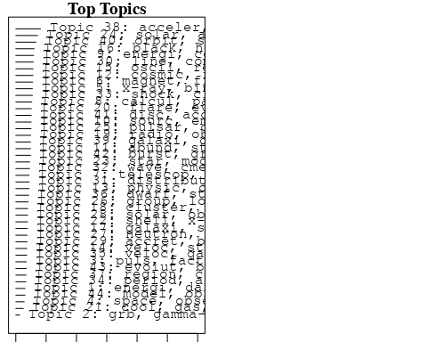

plotQuote(thoughts6, width = 30, main = "Topic 6")  
plotQuote(thoughts18, width = 30, main = "Topic 18")

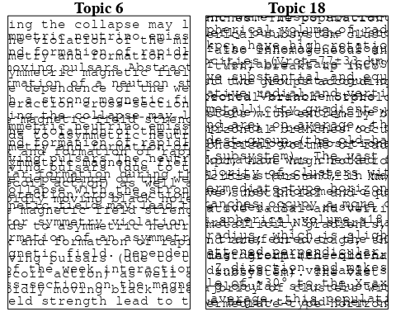

# Calculate and plot the correlation between topics  
mod.out.corr <- topicCorr(Research_topics)  
plot(mod.out.corr, cex = 1.5)  
  
  
# For each topic  
for (topic_num in 1:44) {  
 # Plot the word cloud  
 cloud(Research_topics, topic = topic_num, scale = c(2, 0.25))  
 Sys.sleep(2)  
}

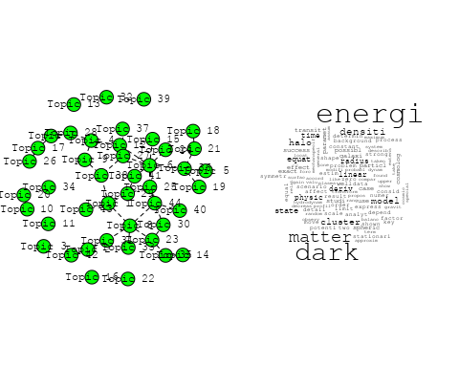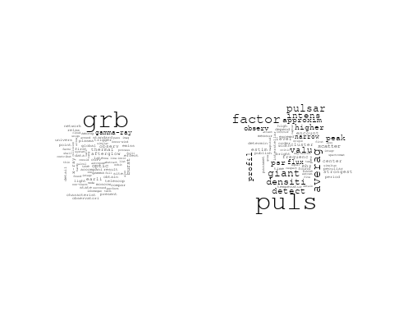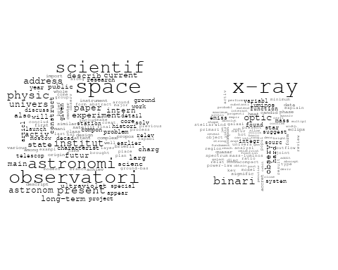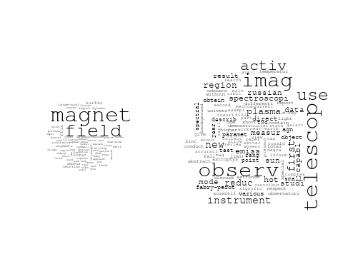

## Warning in wordcloud::wordcloud(words = vocab, freq = vec, max.words =  
## max.words, : calcul could not be fit on page. It will not be plotted.

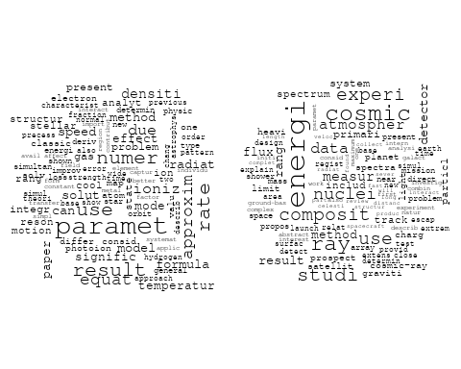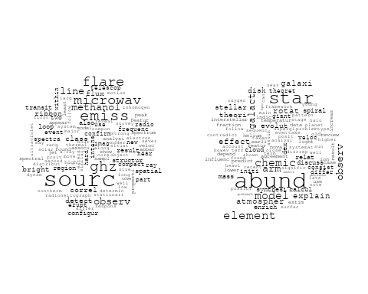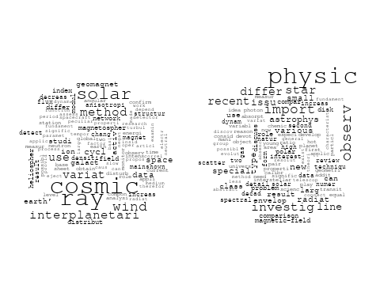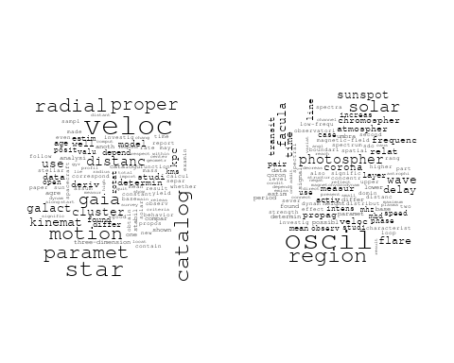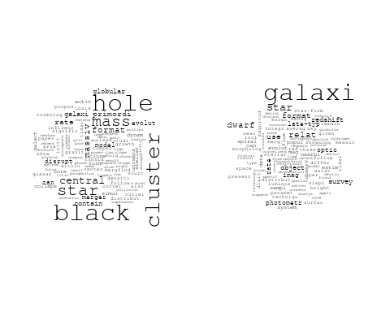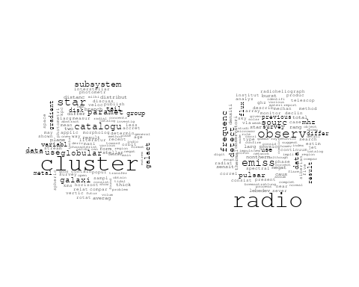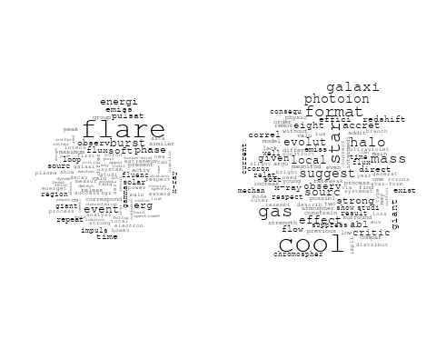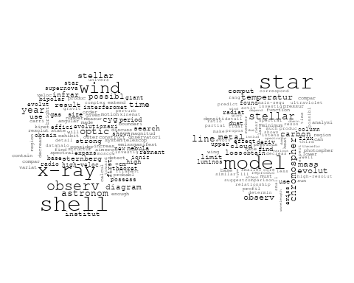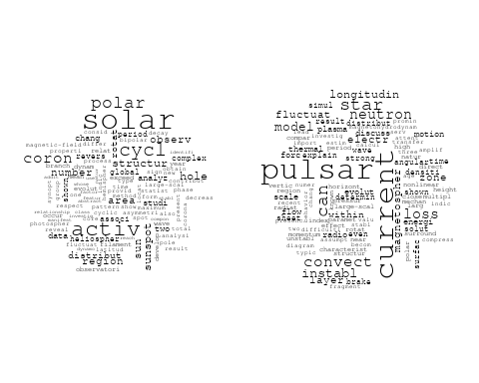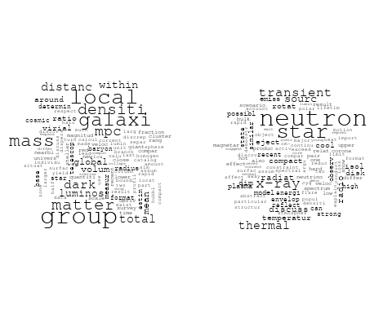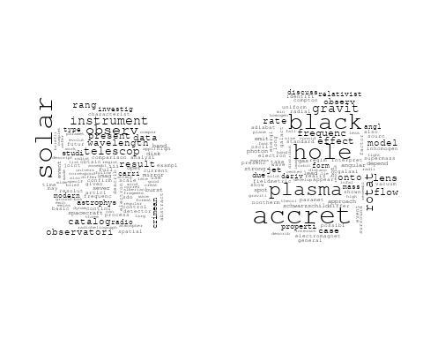

## Warning in wordcloud::wordcloud(words = vocab, freq = vec, max.words =  
## max.words, : distribut could not be fit on page. It will not be plotted.

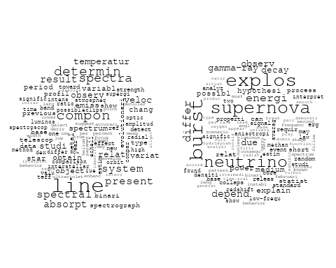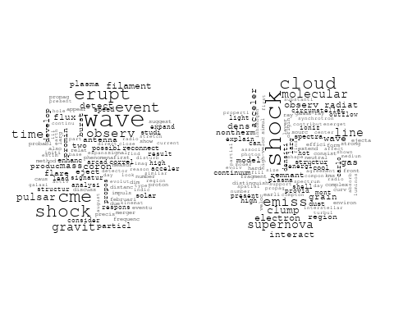

## Warning in wordcloud::wordcloud(words = vocab, freq = vec, max.words =  
## max.words, : distanc could not be fit on page. It will not be plotted.

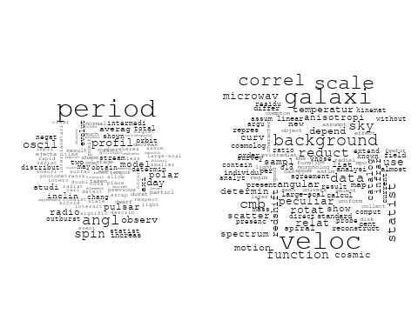

## Warning in wordcloud::wordcloud(words = vocab, freq = vec, max.words =  
## max.words, : object could not be fit on page. It will not be plotted.

## Warning in wordcloud::wordcloud(words = vocab, freq = vec, max.words =  
## max.words, : sourc could not be fit on page. It will not be plotted.

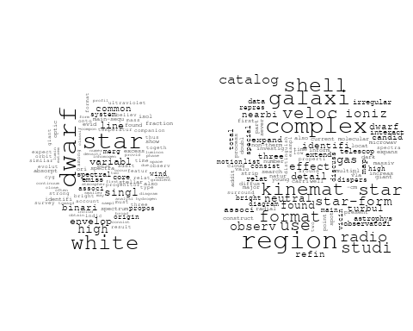

## Warning in wordcloud::wordcloud(words = vocab, freq = vec, max.words =  
## max.words, : ray could not be fit on page. It will not be plotted.

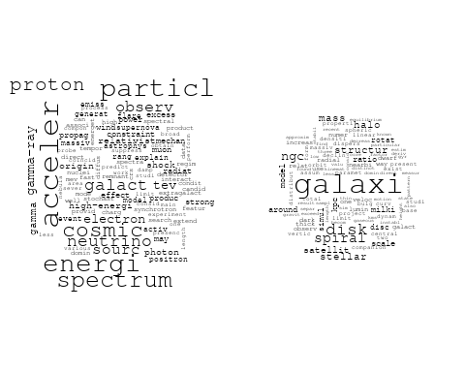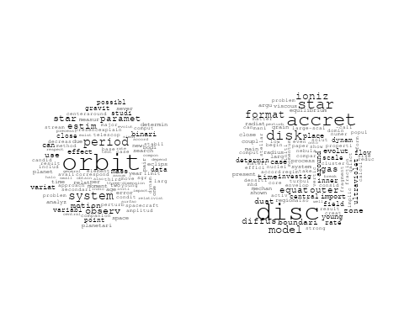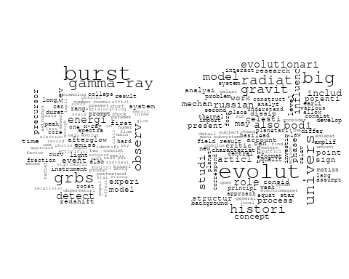

# Get the topic proportions for each document  
topic_proportions <- Research_topics$theta  
  
# Find the index of the topic with the highest proportion for each document  
# This will be the topic that each document is most likely to belong to  
max_topic_idx <- apply(topic_proportions, 1, which.max)  
  
# Add this as a new column to your data  
data_independent$topic <- max_topic_idx  
  
  
  
# Define the intervals  
intervals <- c('1824_1899', '1900_1964', '1965_1974', '1975_1984', '1985_1994', '1995_1999', '2000_2004', '2005_2009', '2010_2014', '2015_2019', '2020_2022')  
colors <- c('pink', 'blue', 'purple', 'yellow', 'green', 'pink', 'orange', 'violet', 'green', 'blue', 'pink')  
  
# Loop through the intervals and plot  
for(i in seq_along(intervals)){  
 # Filter data for when the pub_interval is equal to 1  
 data_filtered <- data_independent[data_independent[[paste0('pub_interval_', intervals[i])]] == 1,]  
   
 # Make the histogram  
   
 p <- ggplot(data_filtered, aes(x = topic)) +  
 geom_histogram(binwidth = 1, fill = colors[i], color = "black") +  
 xlab("Topic") +  
 ylab("Count") +  
 ggtitle(paste0("Topics from year ", gsub("_", " to ", intervals[i])))  
   
 print(p)  
}  
  
  
  
  
##Topic generation for ES (in collaboration) publications  
  
data_collab <- data[data[["ES"]] != 0,]  
  
# Save the original title data for future use  
data_collab$original_concatenated_title_abstract <- data_collab$concatenated_title_abstract  
  
#pre-processing the titles using textProcessor from the stm package  
processed_text <- textProcessor(data_collab$concatenated_title_abstract, metadata = data_collab)

## Building corpus...   
## Converting to Lower Case...   
## Removing punctuation...   
## Removing stopwords...   
## Removing numbers...   
## Stemming...   
## Creating Output...

# Further prepare the data by removing low-frequency terms  
out_text <- prepDocuments(processed_text$documents, processed_text$vocab, processed_text$meta)

## Removing 2094 of 8129 terms (2094 of 137739 tokens) due to frequency   
## Your corpus now has 1669 documents, 6035 terms and 135645 tokens.

docs_text <- out_text$documents  
vocab_text <- out_text$vocab  
meta_text <- out_text$meta  
  
  
#Prepare data  
plotRemoved(processed_text$documents, lower.thresh = seq(1, 200, by = 100))

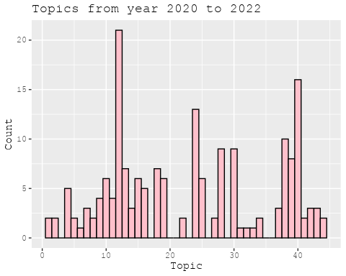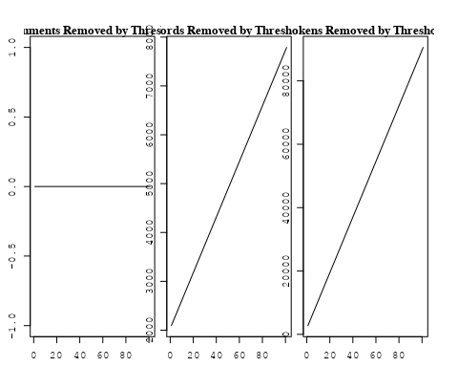

out_text <- prepDocuments(processed_text$documents, processed_text$vocab, processed_text$meta, lower.thresh = 8)

## Removing 6154 of 8129 terms (16026 of 137739 tokens) due to frequency   
## Your corpus now has 1669 documents, 1975 terms and 121713 tokens.

str(out_text$meta)

## 'data.frame': 1669 obs. of 39 variables:  
## $ concept_id : chr "https://openalex.org/C44870925" "https://openalex.org/C44870925" "https://openalex.org/C44870925" "https://openalex.org/C1276947" ...  
## $ work_id : chr "https://openalex.org/W2122555548" "https://openalex.org/W3123041789" "https://openalex.org/W4206317057" "https://openalex.org/W4206317057" ...  
## $ publication_year : int 2007 2003 2021 2021 2012 2007 2019 1998 1998 2011 ...  
## $ title : chr "Medium-resolution Isaac Newton Telescope library of empirical spectra - II. The stellar atmospheric parameters" "Detection of the ISW and SZ effects from the CMB-Galaxy correlation" "The effect of mission duration on LISA science objectives" "The effect of mission duration on LISA science objectives" ...  
## $ paperabstract : chr "We present a homogeneous set of stellar atmospheric parameters (T-eff, log g, [Fe/H]) for MILES, a new spectral"| __truncated__ "We present a cross-correlation analysis of the W ilkinson Microwave Anisotropy Probe cosmic microwave backgroun"| __truncated__ "The science objectives of the LISA mission have been defined under the implicit assumption of a 4-years continu"| __truncated__ "The science objectives of the LISA mission have been defined under the implicit assumption of a 4-years continu"| __truncated__ ...  
## $ country : chr "ES ES" "ES ES" "ES CN ES NL CN NL US US" "ES CN ES NL CN NL US US" ...  
## $ year_concept : chr "2007+https://openalex.org/C44870925" "2003+https://openalex.org/C44870925" "2021+https://openalex.org/C44870925" "2021+https://openalex.org/C1276947" ...  
## $ concatenated_title_abstract : chr "Medium-resolution Isaac Newton Telescope library of empirical spectra - II. The stellar atmospheric parameters "| __truncated__ "Detection of the ISW and SZ effects from the CMB-Galaxy correlation We present a cross-correlation analysis of "| __truncated__ "The effect of mission duration on LISA science objectives The science objectives of the LISA mission have been "| __truncated__ "The effect of mission duration on LISA science objectives The science objectives of the LISA mission have been "| __truncated__ ...  
## $ US : num 0 0 25 25 0 ...  
## $ IN : num 0 0 0 0 0 0 0 0 0 0 ...  
## $ DE : num 0 0 0 0 50 50 0 0 0 0 ...  
## $ CH : num 0 0 0 0 0 0 0 0 0 0 ...  
## $ GB : num 0 0 0 0 0 0 0 0 0 0 ...  
## $ CN : num 0 0 25 25 0 0 0 0 0 0 ...  
## $ FR : num 0 0 0 0 0 0 0 0 0 0 ...  
## $ IT : num 0 0 0 0 0 0 0 0 0 50 ...  
## $ RU : num 0 0 0 0 0 0 0 0 0 0 ...  
## $ CA : num 0 0 0 0 0 0 0 0 0 0 ...  
## $ NL : num 0 0 25 25 0 0 0 0 0 0 ...  
## $ AU : num 0 0 0 0 0 0 0 0 0 0 ...  
## $ JP : num 0 0 0 0 0 0 0 0 0 0 ...  
## $ ES : num 100 100 25 25 50 ...  
## $ IL : num 0 0 0 0 0 0 0 0 0 0 ...  
## $ Americas : num 0 0 0 0 0 0 0 0 0 0 ...  
## $ Europe : num 0 0 0 0 0 0 0 0 0 0 ...  
## $ Africa : num 0 0 0 0 0 0 0 0 0 0 ...  
## $ AsiaAndOceania : num 0 0 0 0 0 0 0 0 0 0 ...  
## $ pub_interval_2020_2022 : int 0 0 1 1 0 0 0 0 0 0 ...  
## $ pub_interval_2015_2019 : int 0 0 0 0 0 0 1 0 0 0 ...  
## $ pub_interval_2010_2014 : int 0 0 0 0 1 0 0 0 0 1 ...  
## $ pub_interval_2005_2009 : int 1 0 0 0 0 1 0 0 0 0 ...  
## $ pub_interval_2000_2004 : int 0 1 0 0 0 0 0 0 0 0 ...  
## $ pub_interval_1995_1999 : int 0 0 0 0 0 0 0 1 1 0 ...  
## $ pub_interval_1985_1994 : int 0 0 0 0 0 0 0 0 0 0 ...  
## $ pub_interval_1975_1984 : int 0 0 0 0 0 0 0 0 0 0 ...  
## $ pub_interval_1965_1974 : int 0 0 0 0 0 0 0 0 0 0 ...  
## $ pub_interval_1900_1964 : int 0 0 0 0 0 0 0 0 0 0 ...  
## $ pub_interval_1824_1899 : int 0 0 0 0 0 0 0 0 0 0 ...  
## $ original_concatenated_title_abstract: chr "Medium-resolution Isaac Newton Telescope library of empirical spectra - II. The stellar atmospheric parameters "| __truncated__ "Detection of the ISW and SZ effects from the CMB-Galaxy correlation We present a cross-correlation analysis of "| __truncated__ "The effect of mission duration on LISA science objectives The science objectives of the LISA mission have been "| __truncated__ "The effect of mission duration on LISA science objectives The science objectives of the LISA mission have been "| __truncated__ ...

# Initialize an empty formula string  
prevalence_formula_str <- "~"  
  
# Define the publication intervals  
pub_intervals <- c("pub_interval_2020_2022", "pub_interval_2015_2019", "pub_interval_2010_2014",   
 "pub_interval_2005_2009", "pub_interval_2000_2004", "pub_interval_1995_1999",  
 "pub_interval_1985_1994", "pub_interval_1975_1984", "pub_interval_1965_1974",  
 "pub_interval_1900_1964", "pub_interval_1824_1899")  
  
# Add each publication interval to the formula string  
for (interval in pub_intervals) {  
 # add an if statement to handle the first addition (without '+')  
 if (prevalence_formula_str == "~") {  
 prevalence_formula_str <- paste(prevalence_formula_str, interval)  
 } else {  
 prevalence_formula_str <- paste(prevalence_formula_str, "+", interval)  
 }  
}  
  
  
# Convert the string to a formula  
prevalence_formula <- as.formula(prevalence_formula_str)  
print(prevalence_formula)

## ~pub_interval_2020_2022 + pub_interval_2015_2019 + pub_interval_2010_2014 +   
## pub_interval_2005_2009 + pub_interval_2000_2004 + pub_interval_1995_1999 +   
## pub_interval_1985_1994 + pub_interval_1975_1984 + pub_interval_1965_1974 +   
## pub_interval_1900_1964 + pub_interval_1824_1899

# Run STM model  
Research_topics <- stm(documents = out_text$documents,   
 vocab = out_text$vocab,   
 K = 44,   
 prevalence = prevalence_formula,   
 data = out_text$meta,   
 init.type = "Spectral",  
 max.em.its = 1000,  
 gamma.prior = 'L1')

## Beginning Spectral Initialization   
## Calculating the gram matrix...  
## Finding anchor words...  
## ............................................  
## Recovering initialization...  
## ...................  
## Initialization complete.  
## ........................................................................................................  
## Completed E-Step (1 seconds).   
## Completed M-Step.   
## Completing Iteration 1 (approx. per word bound = -6.408)   
## ........................................................................................................  
## Completed E-Step (1 seconds).   
## Completed M-Step.   
## Completing Iteration 2 (approx. per word bound = -6.111, relative change = 4.648e-02)   
## ........................................................................................................  
## Completed E-Step (1 seconds).   
## Completed M-Step.   
## Completing Iteration 3 (approx. per word bound = -6.027, relative change = 1.362e-02)   
## ........................................................................................................  
## Completed E-Step (1 seconds).   
## Completed M-Step.   
## Completing Iteration 4 (approx. per word bound = -5.992, relative change = 5.798e-03)   
## ........................................................................................................  
## Completed E-Step (1 seconds).   
## Completed M-Step.   
## Completing Iteration 5 (approx. per word bound = -5.973, relative change = 3.256e-03)   
## Topic 1: nova, discuss, one, classic, model   
## Topic 2: binari, star, x-ray, massiv, mass   
## Topic 3: star, format, galaxi, ngc, mass   
## Topic 4: optic, x-ray, flare, emiss, activ   
## Topic 5: cluster, galaxi, redshift, morpholog, group   
## Topic 6: rotat, space, support, case, object   
## Topic 7: paper, correct, result, use, photometr   
## Topic 8: telescop, impact, observ, perform, magic   
## Topic 9: stellar, popul, star, model, age   
## Topic 10: data, use, map, wmap, microwav   
## Topic 11: star, neutron, can, gravit, wave   
## Topic 12: jet, radio, observ, studi, activ   
## Topic 13: line, emiss, sourc, region, detect   
## Topic 14: quasar, estim, x-ray, time, gravit   
## Topic 15: dwarf, white, cool, mass, evolut   
## Topic 16: hole, black, mass, cluster, galact   
## Topic 17: halo, matter, dark, mass, simul   
## Topic 18: observ, maser, system, disk, outflow   
## Topic 19: galaxi, bar, spiral, disk, ring   
## Topic 20: burst, merger, event, emiss, grb   
## Topic 21: observ, obtain, data, local, result   
## Topic 22: galaxi, bulg, correl, paramet, concentr   
## Topic 23: magnet, field, observ, solar, line   
## Topic 24: can, accret, model, use, definit   
## Topic 25: star, system, binari, determin, stellar   
## Topic 26: galaxi, popul, cluster, stellar, gradient   
## Topic 27: dark, energi, univers, cosmolog, model   
## Topic 28: star, wind, model, observ, mode   
## Topic 29: galaxi, gas, veloc, region, kinemat   
## Topic 30: star, dwarf, mass, cluster, member   
## Topic 31: galaxi, agn, sampl, redshift, select   
## Topic 32: planet, transit, orbit, star, observ   
## Topic 33: abund, galaxi, region, model, metal   
## Topic 34: observ, neutrino, energi, sourc, cosmic   
## Topic 35: model, mass, curv, matter, rotat   
## Topic 36: supernova, model, shock, type, explos   
## Topic 37: outburst, accret, observ, disc, period   
## Topic 38: galaxi, luminos, dust, model, format   
## Topic 39: data, observ, star, frequenc, effect   
## Topic 40: nebula, planetari, emiss, observ, star   
## Topic 41: group, asteroid, veloc, move, object   
## Topic 42: cluster, globular, galact, group, foreground   
## Topic 43: type, progenitor, supernova, mass, explos   
## Topic 44: subhalo, dark, sourc, matter, galact   
## ........................................................................................................  
## Completed E-Step (1 seconds).   
## Completed M-Step.   
## Completing Iteration 6 (approx. per word bound = -5.960, relative change = 2.142e-03)   
## ........................................................................................................  
## Completed E-Step (1 seconds).   
## Completed M-Step.   
## Completing Iteration 7 (approx. per word bound = -5.951, relative change = 1.561e-03)   
## ........................................................................................................  
## Completed E-Step (1 seconds).   
## Completed M-Step.   
## Completing Iteration 8 (approx. per word bound = -5.944, relative change = 1.169e-03)   
## ........................................................................................................  
## Completed E-Step (1 seconds).   
## Completed M-Step.   
## Completing Iteration 9 (approx. per word bound = -5.939, relative change = 8.189e-04)   
## ........................................................................................................  
## Completed E-Step (1 seconds).   
## Completed M-Step.   
## Completing Iteration 10 (approx. per word bound = -5.935, relative change = 6.101e-04)   
## Topic 1: nova, one, nuclear, classic, model   
## Topic 2: star, binari, mass, system, massiv   
## Topic 3: star, format, galaxi, stellar, mass   
## Topic 4: optic, x-ray, emiss, flare, activ   
## Topic 5: cluster, galaxi, redshift, morpholog, relat   
## Topic 6: rotat, space, envelop, support, speci   
## Topic 7: use, result, galaxi, correct, redshift   
## Topic 8: telescop, impact, observ, perform, energi   
## Topic 9: stellar, popul, star, model, age   
## Topic 10: data, use, survey, scale, map   
## Topic 11: star, neutron, can, gravit, field   
## Topic 12: radio, jet, observ, studi, use   
## Topic 13: line, emiss, sourc, region, ngc   
## Topic 14: quasar, x-ray, estim, time, gravit   
## Topic 15: dwarf, white, cool, mass, evolut   
## Topic 16: hole, black, mass, cluster, observ   
## Topic 17: halo, matter, mass, dark, simul   
## Topic 18: observ, maser, sourc, outflow, emiss   
## Topic 19: bar, galaxi, spiral, disk, ring   
## Topic 20: burst, merger, event, gravit, emiss   
## Topic 21: observ, burst, grb, obtain, data   
## Topic 22: galaxi, bulg, ellipt, paramet, spiral   
## Topic 23: magnet, field, solar, observ, line   
## Topic 24: model, accret, can, x-ray, code   
## Topic 25: star, system, binari, determin, stellar   
## Topic 26: galaxi, popul, cluster, stellar, gradient   
## Topic 27: dark, energi, cosmolog, univers, model   
## Topic 28: star, wind, model, observ, mode   
## Topic 29: galaxi, gas, veloc, region, kinemat   
## Topic 30: star, dwarf, cluster, mass, member   
## Topic 31: galaxi, agn, sampl, select, survey   
## Topic 32: planet, transit, star, orbit, observ   
## Topic 33: abund, galaxi, region, model, metal   
## Topic 34: observ, neutrino, energi, cosmic, sourc   
## Topic 35: model, mass, galaxi, rotat, matter   
## Topic 36: model, supernova, shock, type, veloc   
## Topic 37: outburst, accret, observ, period, x-ray   
## Topic 38: galaxi, luminos, dust, model, format   
## Topic 39: data, observ, frequenc, star, mode   
## Topic 40: nebula, planetari, emiss, pne, observ   
## Topic 41: group, asteroid, move, veloc, kinemat   
## Topic 42: cluster, ngc, globular, galact, group   
## Topic 43: type, progenitor, supernova, mass, explos   
## Topic 44: dark, subhalo, matter, sourc, annihil   
## ........................................................................................................  
## Completed E-Step (1 seconds).   
## Completed M-Step.   
## Completing Iteration 11 (approx. per word bound = -5.932, relative change = 4.889e-04)   
## ........................................................................................................  
## Completed E-Step (1 seconds).   
## Completed M-Step.   
## Completing Iteration 12 (approx. per word bound = -5.930, relative change = 4.244e-04)   
## ........................................................................................................  
## Completed E-Step (1 seconds).   
## Completed M-Step.   
## Completing Iteration 13 (approx. per word bound = -5.928, relative change = 3.728e-04)   
## ........................................................................................................  
## Completed E-Step (1 seconds).   
## Completed M-Step.   
## Completing Iteration 14 (approx. per word bound = -5.926, relative change = 3.448e-04)   
## ........................................................................................................  
## Completed E-Step (1 seconds).   
## Completed M-Step.   
## Completing Iteration 15 (approx. per word bound = -5.924, relative change = 3.259e-04)   
## Topic 1: nova, nuclear, one, model, classic   
## Topic 2: star, binari, mass, system, massiv   
## Topic 3: star, format, galaxi, stellar, mass   
## Topic 4: x-ray, emiss, optic, flare, activ   
## Topic 5: cluster, galaxi, redshift, morpholog, relat   
## Topic 6: rotat, space, envelop, support, speci   
## Topic 7: use, galaxi, result, sdss, redshift   
## Topic 8: telescop, impact, observ, perform, energi   
## Topic 9: stellar, star, popul, model, spectral   
## Topic 10: data, use, survey, scale, effect   
## Topic 11: star, neutron, can, gravit, detect   
## Topic 12: radio, jet, observ, studi, power   
## Topic 13: line, emiss, region, sourc, ngc   
## Topic 14: quasar, x-ray, estim, lens, mass   
## Topic 15: dwarf, white, cool, mass, evolut   
## Topic 16: hole, black, mass, cluster, observ   
## Topic 17: halo, mass, matter, dark, simul   
## Topic 18: observ, maser, sourc, emiss, outflow   
## Topic 19: bar, galaxi, spiral, disk, ring   
## Topic 20: burst, merger, event, gravit, wave   
## Topic 21: observ, burst, grb, obtain, period   
## Topic 22: galaxi, bulg, ellipt, spiral, paramet   
## Topic 23: magnet, field, solar, observ, line   
## Topic 24: model, accret, can, x-ray, code   
## Topic 25: star, system, binari, determin, stellar   
## Topic 26: galaxi, popul, cluster, stellar, gradient   
## Topic 27: dark, energi, cosmolog, univers, model   
## Topic 28: star, wind, model, observ, mode   
## Topic 29: galaxi, gas, veloc, region, kinemat   
## Topic 30: star, dwarf, cluster, mass, member   
## Topic 31: galaxi, agn, sampl, select, survey   
## Topic 32: planet, transit, star, orbit, observ   
## Topic 33: abund, galaxi, model, region, metal   
## Topic 34: observ, neutrino, energi, sourc, cosmic   
## Topic 35: mass, model, galaxi, rotat, matter   
## Topic 36: model, supernova, shock, type, veloc   
## Topic 37: outburst, accret, observ, period, x-ray   
## Topic 38: galaxi, luminos, dust, format, model   
## Topic 39: data, observ, frequenc, star, mode   
## Topic 40: nebula, planetari, emiss, pne, observ   
## Topic 41: group, asteroid, kinemat, move, veloc   
## Topic 42: cluster, ngc, globular, galact, group   
## Topic 43: type, progenitor, supernova, mass, explos   
## Topic 44: dark, matter, subhalo, sourc, annihil   
## ........................................................................................................  
## Completed E-Step (1 seconds).   
## Completed M-Step.   
## Completing Iteration 16 (approx. per word bound = -5.922, relative change = 3.236e-04)   
## ........................................................................................................  
## Completed E-Step (1 seconds).   
## Completed M-Step.   
## Completing Iteration 17 (approx. per word bound = -5.920, relative change = 2.845e-04)   
## ........................................................................................................  
## Completed E-Step (1 seconds).   
## Completed M-Step.   
## Completing Iteration 18 (approx. per word bound = -5.919, relative change = 2.476e-04)   
## ........................................................................................................  
## Completed E-Step (1 seconds).   
## Completed M-Step.   
## Completing Iteration 19 (approx. per word bound = -5.917, relative change = 2.395e-04)   
## ........................................................................................................  
## Completed E-Step (1 seconds).   
## Completed M-Step.   
## Completing Iteration 20 (approx. per word bound = -5.916, relative change = 1.902e-04)   
## Topic 1: nova, nuclear, one, model, classic   
## Topic 2: star, binari, mass, system, massiv   
## Topic 3: star, format, galaxi, stellar, mass   
## Topic 4: emiss, x-ray, optic, flare, activ   
## Topic 5: cluster, galaxi, redshift, morpholog, relat   
## Topic 6: rotat, envelop, space, speci, format   
## Topic 7: sdss, galaxi, use, result, redshift   
## Topic 8: telescop, impact, observ, perform, energi   
## Topic 9: stellar, star, popul, model, spectral   
## Topic 10: data, use, survey, scale, effect   
## Topic 11: star, neutron, can, gravit, detect   
## Topic 12: radio, jet, observ, studi, use   
## Topic 13: line, emiss, region, sourc, ngc   
## Topic 14: quasar, x-ray, estim, lens, time   
## Topic 15: dwarf, white, cool, mass, evolut   
## Topic 16: hole, black, mass, cluster, observ   
## Topic 17: halo, mass, matter, dark, simul   
## Topic 18: observ, maser, sourc, emiss, outflow   
## Topic 19: bar, galaxi, spiral, disk, ring   
## Topic 20: burst, merger, event, gravit, wave   
## Topic 21: observ, burst, sunspot, grb, obtain   
## Topic 22: galaxi, bulg, spiral, ellipt, paramet   
## Topic 23: magnet, field, observ, line, solar   
## Topic 24: model, accret, can, x-ray, code   
## Topic 25: star, system, binari, determin, stellar   
## Topic 26: galaxi, popul, cluster, stellar, gradient   
## Topic 27: dark, energi, cosmolog, model, univers   
## Topic 28: star, model, wind, observ, mode   
## Topic 29: galaxi, gas, veloc, region, kinemat   
## Topic 30: star, cluster, dwarf, mass, member   
## Topic 31: galaxi, agn, sampl, select, survey   
## Topic 32: planet, transit, star, orbit, observ   
## Topic 33: abund, galaxi, metal, model, region   
## Topic 34: neutrino, observ, energi, cosmic, sourc   
## Topic 35: mass, model, galaxi, matter, rotat   
## Topic 36: model, supernova, shock, veloc, type   
## Topic 37: outburst, accret, observ, period, x-ray   
## Topic 38: galaxi, luminos, dust, format, model   
## Topic 39: data, observ, frequenc, star, mode   
## Topic 40: nebula, planetari, emiss, pne, star   
## Topic 41: group, asteroid, kinemat, move, veloc   
## Topic 42: cluster, ngc, globular, galact, group   
## Topic 43: type, progenitor, supernova, mass, explos   
## Topic 44: dark, matter, annihil, subhalo, sourc   
## ........................................................................................................  
## Completed E-Step (1 seconds).   
## Completed M-Step.   
## Completing Iteration 21 (approx. per word bound = -5.915, relative change = 1.704e-04)   
## ........................................................................................................  
## Completed E-Step (1 seconds).   
## Completed M-Step.   
## Completing Iteration 22 (approx. per word bound = -5.914, relative change = 1.676e-04)   
## ........................................................................................................  
## Completed E-Step (1 seconds).   
## Completed M-Step.   
## Completing Iteration 23 (approx. per word bound = -5.913, relative change = 1.605e-04)   
## ........................................................................................................  
## Completed E-Step (1 seconds).   
## Completed M-Step.   
## Completing Iteration 24 (approx. per word bound = -5.912, relative change = 1.339e-04)   
## ........................................................................................................  
## Completed E-Step (1 seconds).   
## Completed M-Step.   
## Completing Iteration 25 (approx. per word bound = -5.912, relative change = 1.126e-04)   
## Topic 1: nova, nuclear, one, model, classic   
## Topic 2: star, binari, mass, system, massiv   
## Topic 3: star, format, galaxi, stellar, mass   
## Topic 4: emiss, x-ray, optic, flare, activ   
## Topic 5: cluster, galaxi, redshift, morpholog, relat   
## Topic 6: rotat, envelop, space, speci, molecul   
## Topic 7: sdss, galaxi, use, result, redshift   
## Topic 8: telescop, impact, observ, perform, magic   
## Topic 9: stellar, star, popul, model, spectral   
## Topic 10: data, scale, use, survey, model   
## Topic 11: star, neutron, can, gravit, detect   
## Topic 12: radio, jet, observ, studi, use   
## Topic 13: line, emiss, region, sourc, ngc   
## Topic 14: quasar, x-ray, estim, lens, time   
## Topic 15: dwarf, white, cool, mass, evolut   
## Topic 16: hole, black, mass, cluster, observ   
## Topic 17: halo, mass, matter, dark, simul   
## Topic 18: observ, maser, sourc, emiss, outflow   
## Topic 19: bar, galaxi, spiral, disk, ring   
## Topic 20: burst, merger, event, gravit, wave   
## Topic 21: observ, burst, sunspot, optic, grb   
## Topic 22: galaxi, bulg, spiral, ellipt, paramet   
## Topic 23: magnet, field, line, observ, solar   
## Topic 24: model, accret, can, x-ray, code   
## Topic 25: star, system, binari, determin, stellar   
## Topic 26: galaxi, popul, cluster, stellar, gradient   
## Topic 27: dark, energi, cosmolog, univers, model   
## Topic 28: star, model, wind, observ, mode   
## Topic 29: galaxi, gas, veloc, region, kinemat   
## Topic 30: star, cluster, dwarf, mass, member   
## Topic 31: galaxi, agn, sampl, select, survey   
## Topic 32: planet, star, transit, orbit, observ   
## Topic 33: abund, model, metal, galaxi, region   
## Topic 34: neutrino, observ, energi, sourc, cosmic   
## Topic 35: mass, galaxi, model, matter, rotat   
## Topic 36: model, supernova, shock, veloc, type   
## Topic 37: outburst, accret, observ, period, x-ray   
## Topic 38: galaxi, luminos, dust, format, star   
## Topic 39: data, observ, frequenc, star, mode   
## Topic 40: nebula, planetari, emiss, pne, star   
## Topic 41: group, asteroid, star, move, kinemat   
## Topic 42: cluster, ngc, globular, galact, system   
## Topic 43: type, progenitor, supernova, mass, explos   
## Topic 44: dark, matter, annihil, subhalo, limit   
## ........................................................................................................  
## Completed E-Step (1 seconds).   
## Completed M-Step.   
## Completing Iteration 26 (approx. per word bound = -5.911, relative change = 9.771e-05)   
## ........................................................................................................  
## Completed E-Step (1 seconds).   
## Completed M-Step.   
## Completing Iteration 27 (approx. per word bound = -5.911, relative change = 9.178e-05)   
## ........................................................................................................  
## Completed E-Step (1 seconds).   
## Completed M-Step.   
## Completing Iteration 28 (approx. per word bound = -5.910, relative change = 3.531e-05)   
## ........................................................................................................  
## Completed E-Step (1 seconds).   
## Completed M-Step.   
## Completing Iteration 29 (approx. per word bound = -5.910, relative change = 1.092e-04)   
## ........................................................................................................  
## Completed E-Step (1 seconds).   
## Completed M-Step.   
## Completing Iteration 30 (approx. per word bound = -5.909, relative change = 7.580e-05)   
## Topic 1: nova, nuclear, one, model, classic   
## Topic 2: star, binari, mass, system, massiv   
## Topic 3: star, format, galaxi, stellar, mass   
## Topic 4: emiss, x-ray, flare, optic, activ   
## Topic 5: cluster, galaxi, redshift, morpholog, relat   
## Topic 6: rotat, envelop, space, speci, molecul   
## Topic 7: galaxi, sdss, use, redshift, result   
## Topic 8: telescop, impact, observ, perform, magic   
## Topic 9: stellar, star, popul, model, spectral   
## Topic 10: data, scale, use, survey, model   
## Topic 11: star, neutron, can, gravit, detect   
## Topic 12: radio, jet, observ, studi, power   
## Topic 13: line, emiss, region, sourc, ngc   
## Topic 14: quasar, x-ray, estim, lens, time   
## Topic 15: dwarf, white, cool, mass, evolut   
## Topic 16: hole, black, mass, cluster, observ   
## Topic 17: halo, mass, matter, dark, simul   
## Topic 18: observ, maser, sourc, outflow, emiss   
## Topic 19: bar, galaxi, spiral, disk, ring   
## Topic 20: burst, merger, event, gravit, wave   
## Topic 21: observ, burst, sunspot, optic, period   
## Topic 22: galaxi, bulg, spiral, ellipt, paramet   
## Topic 23: magnet, field, line, observ, solar   
## Topic 24: model, accret, x-ray, can, code   
## Topic 25: system, star, binari, determin, stellar   
## Topic 26: galaxi, popul, cluster, stellar, gradient   
## Topic 27: dark, energi, cosmolog, univers, model   
## Topic 28: star, model, wind, observ, mode   
## Topic 29: galaxi, gas, veloc, region, kinemat   
## Topic 30: star, cluster, dwarf, mass, member   
## Topic 31: galaxi, agn, sampl, select, survey   
## Topic 32: planet, star, transit, orbit, observ   
## Topic 33: abund, model, metal, galaxi, region   
## Topic 34: neutrino, observ, energi, sourc, cosmic   
## Topic 35: mass, galaxi, model, matter, rotat   
## Topic 36: model, supernova, shock, veloc, type   
## Topic 37: outburst, accret, period, observ, x-ray   
## Topic 38: galaxi, luminos, dust, format, star   
## Topic 39: data, frequenc, observ, star, mode   
## Topic 40: nebula, planetari, emiss, pne, star   
## Topic 41: group, asteroid, star, move, veloc   
## Topic 42: cluster, ngc, globular, galact, system   
## Topic 43: type, progenitor, supernova, mass, explos   
## Topic 44: dark, matter, subhalo, annihil, limit   
## ........................................................................................................  
## Completed E-Step (1 seconds).   
## Completed M-Step.   
## Completing Iteration 31 (approx. per word bound = -5.909, relative change = 7.946e-05)   
## ........................................................................................................  
## Completed E-Step (1 seconds).   
## Completed M-Step.   
## Completing Iteration 32 (approx. per word bound = -5.908, relative change = 7.497e-05)   
## ........................................................................................................  
## Completed E-Step (1 seconds).   
## Completed M-Step.   
## Completing Iteration 33 (approx. per word bound = -5.908, relative change = 6.671e-05)   
## ........................................................................................................  
## Completed E-Step (1 seconds).   
## Completed M-Step.   
## Completing Iteration 34 (approx. per word bound = -5.908, relative change = 6.749e-05)   
## ........................................................................................................  
## Completed E-Step (1 seconds).   
## Completed M-Step.   
## Completing Iteration 35 (approx. per word bound = -5.907, relative change = 6.894e-05)   
## Topic 1: nova, nuclear, one, model, classic   
## Topic 2: star, binari, mass, system, massiv   
## Topic 3: star, format, galaxi, stellar, mass   
## Topic 4: emiss, x-ray, flare, optic, activ   
## Topic 5: cluster, galaxi, redshift, morpholog, relat   
## Topic 6: rotat, envelop, speci, space, molecul   
## Topic 7: galaxi, sdss, redshift, use, result   
## Topic 8: telescop, impact, observ, perform, magic   
## Topic 9: stellar, star, popul, model, spectral   
## Topic 10: data, scale, use, survey, map   
## Topic 11: star, neutron, can, detect, gravit   
## Topic 12: jet, radio, observ, studi, power   
## Topic 13: line, emiss, region, sourc, ngc   
## Topic 14: quasar, x-ray, estim, lens, time   
## Topic 15: dwarf, white, cool, mass, evolut   
## Topic 16: hole, black, mass, cluster, observ   
## Topic 17: halo, mass, matter, simul, dark   
## Topic 18: observ, maser, sourc, outflow, emiss   
## Topic 19: bar, galaxi, spiral, disk, ring   
## Topic 20: burst, merger, event, gravit, wave   
## Topic 21: observ, burst, sunspot, period, optic   
## Topic 22: galaxi, bulg, profil, spiral, ellipt   
## Topic 23: magnet, field, line, observ, solar   
## Topic 24: model, accret, x-ray, can, rate   
## Topic 25: system, star, binari, determin, stellar   
## Topic 26: galaxi, popul, cluster, stellar, gradient   
## Topic 27: dark, energi, cosmolog, univers, model   
## Topic 28: star, model, wind, observ, mode   
## Topic 29: galaxi, gas, veloc, region, kinemat   
## Topic 30: star, cluster, dwarf, mass, member   
## Topic 31: galaxi, agn, sampl, select, survey   
## Topic 32: planet, star, transit, orbit, observ   
## Topic 33: abund, model, metal, galaxi, region   
## Topic 34: neutrino, observ, energi, sourc, cosmic   
## Topic 35: mass, galaxi, matter, model, rotat   
## Topic 36: model, supernova, shock, veloc, type   
## Topic 37: outburst, accret, period, observ, x-ray   
## Topic 38: galaxi, luminos, dust, format, star   
## Topic 39: data, frequenc, observ, star, mode   
## Topic 40: nebula, planetari, emiss, pne, star   
## Topic 41: group, asteroid, star, move, veloc   
## Topic 42: cluster, ngc, globular, galact, system   
## Topic 43: type, progenitor, supernova, mass, explos   
## Topic 44: dark, matter, subhalo, annihil, search   
## ........................................................................................................  
## Completed E-Step (1 seconds).   
## Completed M-Step.   
## Completing Iteration 36 (approx. per word bound = -5.907, relative change = 5.588e-05)   
## ........................................................................................................  
## Completed E-Step (1 seconds).   
## Completed M-Step.   
## Completing Iteration 37 (approx. per word bound = -5.906, relative change = 1.052e-04)   
## ........................................................................................................  
## Completed E-Step (1 seconds).   
## Completed M-Step.   
## Completing Iteration 38 (approx. per word bound = -5.906, relative change = 8.003e-05)   
## ........................................................................................................  
## Completed E-Step (1 seconds).   
## Completed M-Step.   
## Completing Iteration 39 (approx. per word bound = -5.906, relative change = 2.606e-05)   
## ........................................................................................................  
## Completed E-Step (1 seconds).   
## Completed M-Step.   
## Completing Iteration 40 (approx. per word bound = -5.905, relative change = 7.043e-05)   
## Topic 1: nova, nuclear, one, model, classic   
## Topic 2: star, binari, mass, system, massiv   
## Topic 3: star, format, galaxi, stellar, mass   
## Topic 4: emiss, x-ray, flare, optic, activ   
## Topic 5: cluster, galaxi, redshift, morpholog, relat   
## Topic 6: rotat, envelop, speci, space, cloud   
## Topic 7: galaxi, sdss, redshift, use, result   
## Topic 8: telescop, impact, observ, perform, magic   
## Topic 9: stellar, star, popul, model, spectral   
## Topic 10: data, scale, use, survey, map   
## Topic 11: star, neutron, can, rotat, detect   
## Topic 12: jet, radio, observ, studi, power   
## Topic 13: line, emiss, region, sourc, ngc   
## Topic 14: quasar, x-ray, estim, lens, time   
## Topic 15: dwarf, white, mass, cool, evolut   
## Topic 16: hole, black, mass, cluster, observ   
## Topic 17: halo, mass, simul, matter, dark   
## Topic 18: observ, maser, sourc, outflow, emiss   
## Topic 19: bar, galaxi, spiral, disk, ring   
## Topic 20: burst, merger, event, gravit, wave   
## Topic 21: observ, burst, sunspot, period, optic   
## Topic 22: galaxi, bulg, profil, spiral, ellipt   
## Topic 23: magnet, field, line, observ, solar   
## Topic 24: model, accret, x-ray, can, rate   
## Topic 25: system, star, binari, determin, stellar   
## Topic 26: galaxi, popul, cluster, stellar, gradient   
## Topic 27: dark, energi, cosmolog, univers, model   
## Topic 28: star, model, wind, observ, mode   
## Topic 29: galaxi, gas, veloc, region, kinemat   
## Topic 30: star, cluster, dwarf, mass, member   
## Topic 31: galaxi, agn, sampl, select, survey   
## Topic 32: planet, star, transit, orbit, observ   
## Topic 33: abund, model, metal, galaxi, region   
## Topic 34: neutrino, observ, energi, sourc, cosmic   
## Topic 35: mass, galaxi, matter, model, rotat   
## Topic 36: model, supernova, shock, veloc, evolut   
## Topic 37: outburst, accret, x-ray, period, observ   
## Topic 38: galaxi, luminos, dust, format, star   
## Topic 39: data, frequenc, observ, star, mode   
## Topic 40: nebula, planetari, emiss, pne, star   
## Topic 41: group, asteroid, star, veloc, move   
## Topic 42: cluster, ngc, globular, galact, system   
## Topic 43: type, progenitor, supernova, mass, explos   
## Topic 44: dark, matter, subhalo, annihil, search   
## ........................................................................................................  
## Completed E-Step (1 seconds).   
## Completed M-Step.   
## Completing Iteration 41 (approx. per word bound = -5.904, relative change = 1.207e-04)   
## ........................................................................................................  
## Completed E-Step (1 seconds).   
## Completed M-Step.   
## Completing Iteration 42 (approx. per word bound = -5.904, relative change = 6.623e-05)   
## ........................................................................................................  
## Completed E-Step (1 seconds).   
## Completed M-Step.   
## Completing Iteration 43 (approx. per word bound = -5.904, relative change = 5.476e-05)   
## ........................................................................................................  
## Completed E-Step (1 seconds).   
## Completed M-Step.   
## Completing Iteration 44 (approx. per word bound = -5.903, relative change = 5.362e-05)   
## ........................................................................................................  
## Completed E-Step (1 seconds).   
## Completed M-Step.   
## Completing Iteration 45 (approx. per word bound = -5.903, relative change = 5.875e-05)   
## Topic 1: nova, nuclear, one, model, classic   
## Topic 2: star, binari, mass, system, massiv   
## Topic 3: star, format, galaxi, stellar, mass   
## Topic 4: emiss, x-ray, flare, optic, activ   
## Topic 5: cluster, galaxi, redshift, morpholog, relat   
## Topic 6: rotat, envelop, speci, cloud, molecul   
## Topic 7: galaxi, sdss, redshift, use, survey   
## Topic 8: telescop, impact, observ, perform, magic   
## Topic 9: stellar, star, popul, model, spectral   
## Topic 10: data, scale, use, survey, map   
## Topic 11: star, neutron, can, rotat, detect   
## Topic 12: jet, radio, observ, studi, power   
## Topic 13: line, emiss, region, sourc, ngc   
## Topic 14: quasar, x-ray, estim, lens, time   
## Topic 15: dwarf, white, mass, cool, evolut   
## Topic 16: hole, black, mass, cluster, observ   
## Topic 17: halo, mass, simul, matter, dark   
## Topic 18: observ, maser, sourc, outflow, emiss   
## Topic 19: bar, galaxi, spiral, disk, ring   
## Topic 20: burst, merger, event, gravit, wave   
## Topic 21: observ, burst, solar, sunspot, period   
## Topic 22: galaxi, bulg, profil, spiral, ellipt   
## Topic 23: magnet, field, line, observ, solar   
## Topic 24: model, x-ray, can, accret, rate   
## Topic 25: system, star, binari, determin, stellar   
## Topic 26: galaxi, popul, stellar, cluster, gradient   
## Topic 27: dark, energi, cosmolog, univers, model   
## Topic 28: star, model, wind, observ, mode   
## Topic 29: galaxi, gas, veloc, region, kinemat   
## Topic 30: star, cluster, dwarf, mass, member   
## Topic 31: galaxi, agn, sampl, select, survey   
## Topic 32: planet, star, transit, orbit, observ   
## Topic 33: abund, model, metal, galaxi, region   
## Topic 34: neutrino, observ, energi, sourc, cosmic   
## Topic 35: mass, matter, galaxi, model, rotat   
## Topic 36: model, shock, supernova, veloc, evolut   
## Topic 37: outburst, x-ray, accret, period, observ   
## Topic 38: galaxi, luminos, dust, format, star   
## Topic 39: data, frequenc, observ, star, mode   
## Topic 40: nebula, planetari, emiss, pne, star   
## Topic 41: group, asteroid, star, veloc, move   
## Topic 42: cluster, ngc, globular, galact, system   
## Topic 43: type, progenitor, supernova, mass, explos   
## Topic 44: dark, matter, subhalo, search, annihil   
## ........................................................................................................  
## Completed E-Step (1 seconds).   
## Completed M-Step.   
## Completing Iteration 46 (approx. per word bound = -5.903, relative change = 6.247e-05)   
## ........................................................................................................  
## Completed E-Step (1 seconds).   
## Completed M-Step.   
## Completing Iteration 47 (approx. per word bound = -5.902, relative change = 6.679e-05)   
## ........................................................................................................  
## Completed E-Step (1 seconds).   
## Completed M-Step.   
## Completing Iteration 48 (approx. per word bound = -5.902, relative change = 6.041e-05)   
## ........................................................................................................  
## Completed E-Step (1 seconds).   
## Completed M-Step.   
## Completing Iteration 49 (approx. per word bound = -5.902, relative change = 5.205e-05)   
## ........................................................................................................  
## Completed E-Step (1 seconds).   
## Completed M-Step.   
## Completing Iteration 50 (approx. per word bound = -5.901, relative change = 5.113e-05)   
## Topic 1: nova, nuclear, one, model, classic   
## Topic 2: star, binari, mass, system, massiv   
## Topic 3: star, format, galaxi, stellar, mass   
## Topic 4: emiss, x-ray, optic, activ, flare   
## Topic 5: cluster, galaxi, redshift, morpholog, relat   
## Topic 6: rotat, envelop, speci, cloud, molecul   
## Topic 7: galaxi, sdss, redshift, use, survey   
## Topic 8: telescop, impact, observ, perform, magic   
## Topic 9: stellar, star, popul, model, spectral   
## Topic 10: data, scale, use, survey, model   
## Topic 11: star, neutron, can, rotat, detect   
## Topic 12: jet, radio, observ, studi, emiss   
## Topic 13: line, emiss, region, sourc, ngc   
## Topic 14: quasar, x-ray, estim, lens, line   
## Topic 15: dwarf, white, mass, cool, evolut   
## Topic 16: hole, black, mass, cluster, observ   
## Topic 17: halo, mass, simul, matter, dark   
## Topic 18: observ, maser, sourc, outflow, emiss   
## Topic 19: bar, galaxi, spiral, disk, ring   
## Topic 20: burst, merger, event, gravit, wave   
## Topic 21: observ, solar, burst, sunspot, period   
## Topic 22: galaxi, bulg, profil, spiral, ellipt   
## Topic 23: magnet, field, line, observ, solar   
## Topic 24: model, can, x-ray, rate, accret   
## Topic 25: star, system, binari, determin, stellar   
## Topic 26: galaxi, popul, stellar, cluster, gradient   
## Topic 27: dark, energi, cosmolog, univers, model   
## Topic 28: star, model, wind, observ, mode   
## Topic 29: galaxi, gas, veloc, region, kinemat   
## Topic 30: star, cluster, dwarf, mass, member   
## Topic 31: agn, galaxi, sampl, select, survey   
## Topic 32: planet, star, transit, orbit, observ   
## Topic 33: abund, model, metal, galaxi, region   
## Topic 34: neutrino, energi, observ, sourc, cosmic   
## Topic 35: mass, matter, galaxi, model, gravit   
## Topic 36: model, shock, supernova, veloc, evolut   
## Topic 37: outburst, x-ray, period, accret, observ   
## Topic 38: galaxi, luminos, dust, format, star   
## Topic 39: data, frequenc, observ, mode, star   
## Topic 40: nebula, planetari, emiss, pne, star   
## Topic 41: group, asteroid, star, veloc, move   
## Topic 42: cluster, ngc, globular, galact, system   
## Topic 43: type, progenitor, supernova, mass, explos   
## Topic 44: dark, matter, subhalo, search, annihil   
## ........................................................................................................  
## Completed E-Step (1 seconds).   
## Completed M-Step.   
## Completing Iteration 51 (approx. per word bound = -5.901, relative change = 5.293e-05)   
## ........................................................................................................  
## Completed E-Step (1 seconds).   
## Completed M-Step.   
## Completing Iteration 52 (approx. per word bound = -5.901, relative change = 5.289e-05)   
## ........................................................................................................  
## Completed E-Step (1 seconds).   
## Completed M-Step.   
## Completing Iteration 53 (approx. per word bound = -5.900, relative change = 5.095e-05)   
## ........................................................................................................  
## Completed E-Step (1 seconds).   
## Completed M-Step.   
## Completing Iteration 54 (approx. per word bound = -5.900, relative change = 3.752e-05)   
## ........................................................................................................  
## Completed E-Step (1 seconds).   
## Completed M-Step.   
## Completing Iteration 55 (approx. per word bound = -5.900, relative change = 3.133e-05)   
## Topic 1: nova, nuclear, one, model, classic   
## Topic 2: star, binari, mass, system, massiv   
## Topic 3: star, format, galaxi, stellar, mass   
## Topic 4: emiss, x-ray, activ, flare, optic   
## Topic 5: cluster, galaxi, redshift, morpholog, relat   
## Topic 6: rotat, envelop, speci, cloud, molecul   
## Topic 7: galaxi, sdss, redshift, survey, use   
## Topic 8: telescop, impact, observ, perform, magic   
## Topic 9: stellar, star, popul, model, spectral   
## Topic 10: data, scale, use, survey, model   
## Topic 11: star, neutron, can, rotat, detect   
## Topic 12: jet, radio, observ, studi, emiss   
## Topic 13: line, emiss, region, ngc, sourc   
## Topic 14: quasar, x-ray, estim, lens, line   
## Topic 15: dwarf, white, mass, cool, evolut   
## Topic 16: hole, black, mass, cluster, observ   
## Topic 17: halo, mass, simul, matter, dark   
## Topic 18: observ, maser, sourc, outflow, emiss   
## Topic 19: bar, galaxi, spiral, disk, ring   
## Topic 20: burst, merger, event, gravit, wave   
## Topic 21: observ, solar, burst, sunspot, period   
## Topic 22: galaxi, bulg, profil, spiral, ellipt   
## Topic 23: magnet, field, line, observ, solar   
## Topic 24: model, can, x-ray, rate, accret   
## Topic 25: system, star, binari, determin, stellar   
## Topic 26: galaxi, popul, stellar, cluster, gradient   
## Topic 27: dark, energi, cosmolog, univers, model   
## Topic 28: star, model, wind, observ, mode   
## Topic 29: galaxi, gas, veloc, region, kinemat   
## Topic 30: star, cluster, dwarf, mass, member   
## Topic 31: agn, galaxi, sampl, select, survey   
## Topic 32: planet, star, transit, orbit, observ   
## Topic 33: abund, model, metal, galaxi, region   
## Topic 34: neutrino, energi, observ, sourc, cosmic   
## Topic 35: mass, matter, galaxi, model, gravit   
## Topic 36: model, shock, supernova, veloc, evolut   
## Topic 37: outburst, x-ray, period, optic, accret   
## Topic 38: galaxi, luminos, dust, format, star   
## Topic 39: data, frequenc, observ, mode, star   
## Topic 40: nebula, planetari, emiss, pne, star   
## Topic 41: group, asteroid, star, veloc, move   
## Topic 42: cluster, ngc, globular, galact, system   
## Topic 43: type, progenitor, supernova, mass, explos   
## Topic 44: dark, matter, subhalo, search, annihil   
## ........................................................................................................  
## Completed E-Step (1 seconds).   
## Completed M-Step.   
## Completing Iteration 56 (approx. per word bound = -5.900, relative change = 3.381e-05)   
## ........................................................................................................  
## Completed E-Step (1 seconds).   
## Completed M-Step.   
## Completing Iteration 57 (approx. per word bound = -5.900, relative change = 3.095e-05)   
## ........................................................................................................  
## Completed E-Step (1 seconds).   
## Completed M-Step.   
## Completing Iteration 58 (approx. per word bound = -5.899, relative change = 2.583e-05)   
## ........................................................................................................  
## Completed E-Step (1 seconds).   
## Completed M-Step.   
## Completing Iteration 59 (approx. per word bound = -5.899, relative change = 2.608e-05)   
## ........................................................................................................  
## Completed E-Step (1 seconds).   
## Completed M-Step.   
## Completing Iteration 60 (approx. per word bound = -5.899, relative change = 2.741e-05)   
## Topic 1: nova, nuclear, one, model, classic   
## Topic 2: star, binari, mass, system, massiv   
## Topic 3: star, format, galaxi, stellar, mass   
## Topic 4: emiss, x-ray, activ, flare, optic   
## Topic 5: cluster, galaxi, redshift, morpholog, relat   
## Topic 6: rotat, envelop, speci, cloud, molecul   
## Topic 7: galaxi, sdss, redshift, survey, use   
## Topic 8: telescop, impact, observ, perform, magic   
## Topic 9: stellar, star, popul, model, spectral   
## Topic 10: data, scale, use, survey, model   
## Topic 11: star, neutron, can, rotat, detect   
## Topic 12: jet, radio, observ, studi, emiss   
## Topic 13: line, emiss, region, ngc, sourc   
## Topic 14: quasar, x-ray, estim, lens, line   
## Topic 15: dwarf, white, mass, cool, evolut   
## Topic 16: hole, black, mass, cluster, x-ray   
## Topic 17: halo, mass, simul, matter, dark   
## Topic 18: observ, maser, sourc, outflow, emiss   
## Topic 19: bar, galaxi, spiral, disk, ring   
## Topic 20: burst, merger, event, gravit, wave   
## Topic 21: observ, solar, burst, sunspot, period   
## Topic 22: galaxi, bulg, profil, spiral, ellipt   
## Topic 23: magnet, field, line, observ, solar   
## Topic 24: model, can, x-ray, rate, accret   
## Topic 25: system, star, binari, determin, stellar   
## Topic 26: galaxi, popul, stellar, cluster, gradient   
## Topic 27: dark, energi, cosmolog, univers, model   
## Topic 28: star, model, wind, observ, mode   
## Topic 29: galaxi, gas, veloc, region, kinemat   
## Topic 30: star, cluster, dwarf, mass, member   
## Topic 31: agn, galaxi, sampl, select, survey   
## Topic 32: planet, star, transit, orbit, observ   
## Topic 33: abund, model, metal, galaxi, region   
## Topic 34: neutrino, energi, observ, sourc, cosmic   
## Topic 35: mass, matter, galaxi, model, gravit   
## Topic 36: model, shock, supernova, veloc, evolut   
## Topic 37: outburst, x-ray, optic, period, accret   
## Topic 38: galaxi, luminos, dust, format, star   
## Topic 39: data, frequenc, observ, mode, star   
## Topic 40: nebula, planetari, emiss, pne, star   
## Topic 41: group, asteroid, star, veloc, move   
## Topic 42: cluster, ngc, globular, galact, system   
## Topic 43: type, progenitor, supernova, mass, explos   
## Topic 44: dark, matter, subhalo, search, annihil   
## ........................................................................................................  
## Completed E-Step (1 seconds).   
## Completed M-Step.   
## Completing Iteration 61 (approx. per word bound = -5.899, relative change = 3.166e-05)   
## ........................................................................................................  
## Completed E-Step (1 seconds).   
## Completed M-Step.   
## Completing Iteration 62 (approx. per word bound = -5.899, relative change = 3.431e-05)   
## ........................................................................................................  
## Completed E-Step (1 seconds).   
## Completed M-Step.   
## Completing Iteration 63 (approx. per word bound = -5.899, relative change = 3.294e-05)   
## ........................................................................................................  
## Completed E-Step (1 seconds).   
## Completed M-Step.   
## Model Converged

# Plot the STM model summary  
plot(Research_topics, type = "summary", xlim = c(0, 0.3))  
  
# Print the top 10 labels for each topic  
topic_labels <- labelTopics(Research_topics, n=10)  
print(topic_labels)

## Topic 1 Top Words:  
## Highest Prob: nova, nuclear, one, model, classic, discuss, emiss, nucleosynthesi, product, produc   
## FREX: nova, classic, nucleosynthesi, grain, product, nuclear, isotop, thermonuclear, radioact, kepler   
## Lift: runaway, kepler, radioact, nova, thermonuclear, classic, nucleosynthesi, isotop, reaction, experiment   
## Score: nova, kepler, nucleosynthesi, thermonuclear, runaway, explos, nuclear, grain, classic, isotop   
## Topic 2 Top Words:  
## Highest Prob: star, binari, mass, system, massiv, wind, x-ray, companion, observ, studi   
## FREX: binari, companion, wind, secondari, understand, massiv, roch, donor, sin, loss   
## Lift: roch, sin, donor, indirect, summaris, driver, binari, ultim, truli, companion   
## Score: binari, sin, wind, star, companion, x-ray, donor, massiv, roch, neutron   
## Topic 3 Top Words:  
## Highest Prob: star, format, galaxi, stellar, mass, form, young, popul, accret, disc   
## FREX: format, milki, disc, old, gyr, form, ago, histori, starburst, young   
## Lift: violent, ago, intermediate-ag, elus, old, milki, preced, thick, self-gravit, sustain   
## Score: violent, star, milki, disc, format, gyr, galaxi, young, accret, old   
## Topic 4 Top Words:  
## Highest Prob: emiss, x-ray, activ, flare, optic, sourc, region, galact, soft, seyfert   
## FREX: flare, soft, seyfert, nucleus, repeat, γray, activ, balmer, knot, circumnuclear   
## Lift: repeat, soft, flare, narrow-lin, persist, seyfert, genuin, torus, puzzl, broad-lin   
## Score: repeat, flare, seyfert, soft, x-ray, γray, agn, nucleus, emiss, activ   
## Topic 5 Top Words:  
## Highest Prob: cluster, galaxi, redshift, morpholog, relat, sampl, evolut, high, larg, void   
## FREX: void, cluster, morpholog, coma, specif, lens, ulirg, classifi, redshift, concentr   
## Lift: free-fre, void, pay, coma, absent, environment, spanish, mesh, classifi, attent   
## Score: cluster, free-fre, redshift, void, ulirg, lens, galaxi, morpholog, coma, merger   
## Topic 6 Top Words:  
## Highest Prob: rotat, envelop, speci, cloud, molecul, format, molecular, interstellar, detect, star   
## FREX: molecul, speci, irc, carbon, envelop, moment, interstellar, rotat, chemistri, circumstellar   
## Lift: acknowledg, irc, molecul, carbon-rich, c-rich, gas-phas, crl, carbon, organ, speci   
## Score: acknowledg, molecul, speci, circumstellar, carbon, envelop, irc, rotat, chemistri, molecular   
## Topic 7 Top Words:  
## Highest Prob: galaxi, sdss, redshift, survey, use, result, colour, distribut, photometr, sky   
## FREX: sdss, colour, catalogu, sloan, digit, sky, magnitud, redshift, correct, photometr   
## Lift: access, sdss, digit, sloan, ultra, wing, visual, catalogu, r-band, public   
## Score: sdss, redshift, colour, access, catalogu, sloan, digit, galaxi, sky, photometr   
## Topic 8 Top Words:  
## Highest Prob: telescop, impact, observ, perform, magic, energi, system, background, detect, analysi   
## FREX: impact, magic, telescop, gev, perform, crab, background, cherenkov, sensit, publish   
## Lift: shed, hadron, meteoroid, impact, scientif, magic, nondetect, cherenkov, night, cosmic-ray   
## Score: magic, shed, telescop, gev, cherenkov, crab, impact, scientif, background, meteoroid   
## Topic 9 Top Words:  
## Highest Prob: stellar, star, popul, model, spectral, spectra, cluster, librari, paramet, synthesi   
## FREX: librari, synthesi, triplet, popul, spectra, stellar, obscur, spatial, empir, ring   
## Lift: page, librari, lambda, synthesi, triplet, youngest, decoupl, line-blanket, suspect, αfe   
## Score: librari, page, synthesi, obscur, stellar, popul, ring, triplet, star, cluster   
## Topic 10 Top Words:  
## Highest Prob: data, scale, use, map, model, survey, effect, microwav, wmap, detect   
## FREX: wmap, microwav, non-gaussian, cmb, map, anisotropi, bias, gaussian, isw, cross-correl   
## Lift: bao, non-gaussian, wmap, isw, sachs-wolf, varianc, wilkinson, wavelet, anisotropi, cmb   
## Score: wmap, varianc, microwav, non-gaussian, cmb, isw, bao, bias, anisotropi, wavelet   
## Topic 11 Top Words:  
## Highest Prob: star, neutron, can, rotat, detect, gravit, field, also, wave, miss   
## FREX: neutron, miss, millisecond, pulsat, sphere, wave, instabl, secondari, whether, bulk   
## Lift: miss, neutron, born, maxim, veil, millisecond, sphere, damp, canon, dissip   
## Score: neutron, miss, star, pulsar, millisecond, pulsat, magnet, wave, veil, rotat   
## Topic 12 Top Words:  
## Highest Prob: jet, radio, observ, studi, emiss, power, use, relativist, associ, activ   
## FREX: jet, radio, relativist, synchrotron, power, lirg, sound, speed, ghz, wavelength   
## Lift: nasa, lorentz, jet, synchrotron, beam, radio, relativist, centimet, sound, lirg   
## Score: jet, radio, nasa, relativist, synchrotron, lirg, sound, centimet, polar, lorentz   
## Topic 13 Top Words:  
## Highest Prob: line, emiss, region, ngc, sourc, observ, detect, toward, differ, galact   
## FREX: line, ghz, cm-, toward, northern, molecular, absorpt, column, ngc, intens   
## Lift: northern, mantl, ion, blueshift, echell, photodissoci, ghz, orion, cm-, spectrophotometri   
## Score: northern, line, ngc, molecular, ghz, cm-, chemistri, column, far-infrar, emiss   
## Topic 14 Top Words:  
## Highest Prob: quasar, x-ray, estim, line, lens, observ, mass, time, use, flux   
## FREX: quasar, blr, microlens, lens, broad, fwhm, len, qso, weak, corona   
## Lift: blr, programm, len, subtract, quasar, microlens, qso, corona, interven, serv   
## Score: quasar, blr, lens, microlens, programm, len, x-ray, fwhm, qso, broad   
## Topic 15 Top Words:  
## Highest Prob: dwarf, white, mass, cool, evolut, luminos, use, star, effect, time   
## FREX: white, cool, dwarf, burn, crystal, relationship, coeffici, initi, collis, done   
## Lift: crystal, white, done, outcom, sim, cool, coeffici, treatment, burn, hypothes   
## Score: white, crystal, dwarf, cool, burn, neutrino, collis, luminos, delay, coeffici   
## Topic 16 Top Words:  
## Highest Prob: hole, black, mass, cluster, x-ray, observ, accret, galact, pbh, disk   
## FREX: hole, black, pbh, stellar-mass, disrupt, primordi, tidal, palomar, tail, hour   
## Lift: stellar-mass, pbh, hole, black, ligo, disrupt, quasi-period, palomar, hour, cygni   
## Score: black, hole, stellar-mass, pbh, x-ray, cluster, palomar, tidal, primordi, accret   
## Topic 17 Top Words:  
## Highest Prob: halo, mass, simul, matter, dark, galaxi, densiti, veloc, distribut, profil   
## FREX: halo, simul, virial, substructur, reproduc, strip, imf, matter, particl, densiti   
## Lift: substructur, phase-spac, rais, halo, imf, virial, hierarch, logarithm, disentangl, strip   
## Score: halo, dark, matter, virial, substructur, rais, particl, simul, cosmolog, imf   
## Topic 18 Top Words:  
## Highest Prob: observ, maser, sourc, outflow, emiss, vla, radio, associ, system, compon   
## FREX: maser, vla, outflow, collim, continuum, water, protostar, associ, separ, circumstellar   
## Lift: vla, maser, protostar, cepheus, ysos, collim, mji, arcsec, outflow, preferenti   
## Score: maser, protostar, vla, outflow, collim, jet, radio, ysos, circumstellar, continuum   
## Topic 19 Top Words:  
## Highest Prob: bar, galaxi, spiral, disk, ring, structur, find, inner, outer, nuclear   
## FREX: bar, ring, spiral, arm, outer, inner, length, pattern, break, gradient   
## Lift: redder, bar, fourier, isophot, arm, guid, ring, sharp, block, torqu   
## Score: bar, spiral, ring, redder, disk, arm, galaxi, gradient, fourier, bulg   
## Topic 20 Top Words:  
## Highest Prob: burst, merger, event, gravit, wave, emiss, detect, binari, star, distribut   
## FREX: merger, burst, institut, wave, emitt, γray, lisa, encount, event, unusu   
## Lift: institut, ligo-virgo, coalesc, emitt, antenna, fall, lisa, tripl, cocoon, burst   
## Score: institut, burst, merger, γray, lisa, grb, gamma-ray, emitt, wave, black   
## Topic 21 Top Words:  
## Highest Prob: observ, solar, burst, period, sunspot, optic, grb, obtain, present, use   
## FREX: sunspot, grb, spacecraft, grbs, solar, cycl, instrument, period, burst, record   
## Lift: spacecraft, supplement, interplanetari, grb, grbs, sunspot, tripl, record, cycl, swift   
## Score: grb, sunspot, supplement, burst, grbs, spacecraft, gamma-ray, period, solar, swift   
## Topic 22 Top Words:  
## Highest Prob: galaxi, bulg, profil, spiral, ellipt, paramet, relat, correl, concentr, central   
## FREX: bulg, ellipt, concentr, sersic, spiral, profil, early-typ, correl, index, late-typ   
## Lift: spearman, bulg, sersic, lenticular, monoton, exponenti, ellipt, truncat, concentr, simpli   
## Score: bulg, spearman, sersic, spiral, ellipt, galaxi, concentr, profil, early-typ, disk   
## Topic 23 Top Words:  
## Highest Prob: magnet, field, line, observ, solar, strength, sun, flux, polar, region   
## FREX: stoke, magnet, photospher, strength, emerg, quiet, chromospher, sun, field, invers   
## Lift: quiet-sun, hinod, spectropolarimetr, stoke, unsign, internetwork, hanl, quiet, vector, emerg   
## Score: magnet, stoke, quiet, unsign, strength, polar, photospher, chromospher, sun, solar   
## Topic 24 Top Words:  
## Highest Prob: model, x-ray, can, rate, accret, simul, code, result, use, pulsar   
## FREX: definit, code, simpl, applic, inject, pulsar, amplif, geometri, concept, mont   
## Lift: definit, concept, amplif, inject, magnetohydrodynam, ideal, lepton, recurr, mont, implement   
## Score: definit, pulsar, x-ray, amplif, accret, code, particl, inject, psf, applic   
## Topic 25 Top Words:  
## Highest Prob: system, star, binari, determin, stellar, paramet, use, mass, accur, eclips   
## FREX: eclips, accur, determin, binari, radii, detach, system, fundament, distanc, teff   
## Lift: andromeda, detach, teff, asteroseismolog, eclips, prescript, modern, superior, modot, blend   
## Score: binari, andromeda, eclips, detach, radii, age, accur, orbit, star, system   
## Topic 26 Top Words:  
## Highest Prob: galaxi, popul, stellar, cluster, gradient, metal, gcs, properti, host, colour   
## FREX: gcs, gradient, virgo, colour, upturn, ellipt, metal, popul, bcgs, brightest   
## Lift: upturn, bcgs, gcs, bimod, virgo, gemini, harass, easili, αfe, gradient   
## Score: upturn, gcs, bcgs, gradient, colour, ellipt, cluster, metal, galaxi, virgo   
## Topic 27 Top Words:  
## Highest Prob: dark, energi, cosmolog, univers, model, state, includ, paramet, equat, new   
## FREX: cosmolog, univers, equat, dark, state, tension, energi, constraint, constant, expans   
## Lift: singular, tension, fluid, sub, horizon, λcdm, complementari, curvatur, inclus, mention   
## Score: dark, cosmolog, singular, energi, univers, tension, equat, expans, scalar, matter   
## Topic 28 Top Words:  
## Highest Prob: star, model, wind, observ, mode, predict, detect, pulsat, theoret, mass   
## FREX: pulsat, mode, mass-loss, agb, wind, instabl, solar-lik, convect, problem, theoret   
## Lift: jump, solar-lik, non-adiabat, mass-loss, nucleosynthet, inhibit, non-radi, pulsat, binar, word   
## Score: jump, pulsat, wind, mode, star, agb, mass-loss, magnet, convect, solar-lik   
## Topic 29 Top Words:  
## Highest Prob: galaxi, gas, veloc, region, kinemat, ioniz, nucleus, lyα, ulirg, show   
## FREX: lyα, gas, ulirg, nucleus, starburst, kinemat, ioniz, kpc, merg, spectroscopi   
## Lift: recycl, inflow, lyα, intergalact, high-z, ulirg, fuel, b-band, ultralumin, qsos   
## Score: ulirg, gas, recycl, lyα, galaxi, kinemat, nucleus, ioniz, starburst, molecular   
## Topic 30 Top Words:  
## Highest Prob: star, cluster, dwarf, mass, member, object, brown, pleiad, identifi, candid   
## FREX: brown, member, pleiad, substellar, dwarf, lithium, open, low-mass, mas, candid   
## Lift: plate, brown, pleiad, substellar, teid, turnoff, member, coeval, fade, squar   
## Score: pleiad, brown, member, substellar, cluster, dwarf, plate, myr, lithium, star   
## Topic 31 Top Words:  
## Highest Prob: agn, galaxi, sampl, select, survey, fraction, redshift, power-law, popul, seyfert   
## FREX: agn, select, power-law, mir, liner, seyfert, spitzer, fraction, deep, red   
## Lift: color-select, liner, mir, irac, agn, deepest, color-color, power-law, unabsorb, spitzer   
## Score: agn, color-select, mir, seyfert, liner, power-law, irac, select, spitzer, galaxi   
## Topic 32 Top Words:  
## Highest Prob: planet, star, transit, orbit, observ, atmospher, exoplanet, giant, period, planetari   
## FREX: planet, exoplanet, corot, transit, orbit, jupit, earth, giant, atmospher, escap   
## Lift: corot, jupit, super-earth, radial-veloc, planet, exoplanet, corot-b, extrasolar, tau, occult   
## Score: planet, corot, exoplanet, orbit, transit, atmospher, jupit, giant, planetari, period   
## Topic 33 Top Words:  
## Highest Prob: abund, model, metal, galaxi, region, star, oxygen, ioniz, ratio, chemic   
## FREX: abund, oxygen, metal, chemic, ioniz, photoion, temperatur, agreement, supergi, element   
## Lift: auror, oxygen, low-metal, nitrogen, hii, abund, non-lt, overabund, wolf–rayet, enrich   
## Score: abund, oxygen, auror, metal, chemic, ioniz, temperatur, photoion, gradient, supergi   
## Topic 34 Top Words:  
## Highest Prob: neutrino, energi, observ, sourc, cosmic, ray, flux, magic, tev, data   
## FREX: neutrino, ray, cosmic, tev, astronomi, magic, gev, decay, prospect, gamma   
## Lift: astronomi, tev, hess, neutrino, ray, prospect, gamma, magic, gev, high-energi   
## Score: astronomi, neutrino, magic, tev, ray, cosmic, gev, gamma-ray, energi, γray   
## Topic 35 Top Words:  
## Highest Prob: mass, matter, galaxi, model, gravit, field, graviti, theori, rotat, dark   
## FREX: graviti, axion, theori, scalar, pressur, equat, gravit, curv, matter, baryon   
## Lift: impos, axion, modif, scalar, newtonian, action, graviti, debat, pressur, stand   
## Score: impos, matter, axion, scalar, graviti, dark, theori, baryon, gravit, curv   
## Topic 36 Top Words:  
## Highest Prob: model, shock, supernova, veloc, evolut, type, explos, shell, observ, simul   
## FREX: shock, shell, ejecta, explos, front, remnant, supernova, medium, propag, deflagr   
## Lift: caviti, deflagr, tycho, front, ambient, revers, ejecta, ensu, deceler, shell   
## Score: caviti, shock, explos, supernova, shell, deflagr, ejecta, front, remnant, propag   
## Topic 37 Top Words:  
## Highest Prob: outburst, x-ray, optic, period, accret, observ, orbit, disk, curv, disc   
## FREX: outburst, transient, xte, quiescenc, period, quiescent, disc, modul, accret, curv   
## Lift: nova-lik, superhump, rxte, outburst, xte, quiescenc, time-resolv, ellipsoid, transient, sudden   
## Score: outburst, superhump, xte, x-ray, period, quiescenc, accret, pulsar, transient, orbit   
## Topic 38 Top Words:  
## Highest Prob: galaxi, luminos, dust, format, star, model, observ, function, redshift, evolut   
## FREX: fuv, nuv, dust, attenu, law, sfr, fir, luminos, sed, bin   
## Lift: nuv, fir, fuv, attenu, sfr, sfrs, passiv, groth, galex, bin   
## Score: fir, nuv, fuv, attenu, sfr, dust, galaxi, luminos, sed, law   
## Topic 39 Top Words:  
## Highest Prob: data, frequenc, observ, mode, star, variabl, effect, comet, also, new   
## FREX: comet, frequenc, mode, variabl, campaign, ultraviolet, spot, monitor, chang, gaia   
## Lift: short-term, comet, campaign, capabl, latitud, gaia, damp, loop, drift, european   
## Score: short-term, comet, mode, frequenc, campaign, variabl, spot, magnet, gaia, monitor   
## Topic 40 Top Words:  
## Highest Prob: nebula, planetari, emiss, pne, star, central, observ, bipolar, sampl, line   
## FREX: pne, nebula, planetari, bipolar, align, post-agb, central, outflow, agb, narrowband   
## Lift: narrowband, pne, bipolar, post-agb, align, nebula, vlt, planetari, suspect, strengthen   
## Score: nebula, pne, planetari, narrowband, bipolar, post-agb, emiss, jet, align, outflow   
## Topic 41 Top Words:  
## Highest Prob: group, asteroid, star, veloc, move, kinemat, object, studi, dynam, may   
## FREX: asteroid, group, move, web, kinemat, oort, narrow, classif, late-typ, stabl   
## Lift: oort, asteroid, neighborhood, catastroph, heterogen, trans-neptunian, obvious, move, temporarili, group   
## Score: asteroid, oort, group, move, trans-neptunian, member, kinemat, neighborhood, myr, heterogen   
## Topic 42 Top Words:  
## Highest Prob: cluster, ngc, globular, galact, system, age, star, group, two, open   
## FREX: globular, open, ngc, cluster, horizontal-branch, tracer, metal-poor, blue, horizont, del   
## Lift: del, horizontal-branch, globular, wide-field, retain, encompass, color-magnitud, galactocentr, palomar, horizont   
## Score: cluster, globular, del, ngc, horizontal-branch, palomar, age, color-magnitud, group, horizont   
## Topic 43 Top Words:  
## Highest Prob: type, progenitor, supernova, mass, explos, imag, sne, galaxi, star, rate   
## FREX: progenitor, sne, supernova, type, explos, hubbl, explod, normal, supergi, initi   
## Lift: explod, sne, wolf-rayet, chandrasekhar, progenitor, back, fate, week, supernova, explos   
## Score: supernova, explod, progenitor, explos, sne, type, quasar, supergi, hubbl, chandrasekhar   
## Topic 44 Top Words:  
## Highest Prob: dark, matter, subhalo, search, annihil, limit, sourc, wimp, particl, gamma-ray   
## FREX: subhalo, wimp, annihil, matter, search, dark, cross, channel, section, particl   
## Lift: fermi-lat, wimp, subhalo, cross, annihil, section, stringent, channel, unidentifi, strategi   
## Score: subhalo, annihil, dark, fermi-lat, matter, wimp, gamma-ray, channel, cherenkov, section

# Match the processed documents with the original titles  
matched_titles <- out_text$meta$original_concatenated_title_abstract  
  
# Print top 5 documents for each topic  
top_docs <- findThoughts(Research_topics, texts = matched_titles, n = 5)$docs[[1]]  
print(top_docs)

## [1] "Gamma‐ray emission from individual classical novae Classical novae are important producers of radioactive nuclei, such as 7 Be, 13 N, 18 F, 22 Na and 26 Al. The disintegration of these nuclei produces positrons (except for 7 Be) that through annihilation with electrons produce photons of energies 511 keV and below. Furthermore, 7 Be and 22 Na decay producing photons with energies of 478 keV and 1275 keV, respectively, well in the -ray domain. Therefore, novae are potential sources of -ray emission. We have developed two codes in order to analyze carefully the -ray emission of individual classical novae: a hydrodynamical one, which follows both the accretion and the explosion stages, and a Monte-Carlo one, able to treat both the production and the transfer of -ray photons. Both codes have been coupled in order to simulate realistic explosions. The properties of -ray spectra and -ray light curves (for the continuum and for the lines at 511, 478 and 1275 keV) have been analyzed, with a special emphasis on the difference between carbon-oxygen and oxygen-neon novae. Predictions of detectability of individual novae by the future SPI spectrometer on board the INTEGRAL satellite are made. Concerning 26 Al, its decay produces photons of 1809 keV but it occurs on a timescale much longer than the typical time interval between nova outbursts in the Galaxy, making it undetectable in individual novae. The accumulated emission of 26 Al from many Galactic novae has not been modeled in this paper."   
## [2] "Gamma--ray emission from individual classical novae Classical novae are important producers of radioactive nuclei, such as 7 Be, 13 N, 18 F, 22 Na and 26 Al. The disintegration of these nuclei produces positrons (except for 7 Be) that through annihilation with electrons produce photons of energies 511 keV and below. Furthermore, 7 Be and 22 Na decay producing photons with energies of 478 keV and 1275 keV, respectively, well in the -ray domain. Therefore, novae are potential sources of -ray emission. We have developed two codes in order to analyze carefully the -ray emission of individual classical novae: a hydrodynamical one, which follows both the accretion and the explosion stages, and a Monte-Carlo one, able to treat both the production and the transfer of -ray photons. Both codes have been coupled in order to simulate realistic explosions. The properties of -ray spectra and -ray light curves (for the continuum and for the lines at 511, 478 and 1275 keV) have been analyzed, with a special emphasis on the difference between carbon-oxygen and oxygen-neon novae. Predictions of detectability of individual novae by the future SPI spectrometer on board the INTEGRAL satellite are made. Concerning 26 Al, its decay produces photons of 1809 keV but it occurs on a timescale much longer than the typical time interval between nova outbursts in the Galaxy, making it undetectable in individual novae. The accumulated emission of 26 Al from many Galactic novae has not been modeled in this paper."  
## [3] "Gamma‐ray emission from individual classical novae Classical novae are important producers of radioactive nuclei, such as 7 Be, 13 N, 18 F, 22 Na and 26 Al. The disintegration of these nuclei produces positrons (except for 7 Be) that through annihilation with electrons produce photons of energies 511 keV and below. Furthermore, 7 Be and 22 Na decay producing photons with energies of 478 keV and 1275 keV, respectively, well in the -ray domain. Therefore, novae are potential sources of -ray emission. We have developed two codes in order to analyze carefully the -ray emission of individual classical novae: a hydrodynamical one, which follows both the accretion and the explosion stages, and a Monte-Carlo one, able to treat both the production and the transfer of -ray photons. Both codes have been coupled in order to simulate realistic explosions. The properties of -ray spectra and -ray light curves (for the continuum and for the lines at 511, 478 and 1275 keV) have been analyzed, with a special emphasis on the difference between carbon-oxygen and oxygen-neon novae. Predictions of detectability of individual novae by the future SPI spectrometer on board the INTEGRAL satellite are made. Concerning 26 Al, its decay produces photons of 1809 keV but it occurs on a timescale much longer than the typical time interval between nova outbursts in the Galaxy, making it undetectable in individual novae. The accumulated emission of 26 Al from many Galactic novae has not been modeled in this paper."   
## [4] "Nuclear Uncertainties in the NeNa-MgAl Cycles and Production of 22Na and 26Al during Nova Outbursts Classical novae eject significant amounts of nuclear-processed material into the interstellar medium. Among the isotopes synthesized during such explosions, two radioactive nuclei deserve particular attention: 22Na and 26Al. In this paper, we investigate the nuclear paths leading to 22Na and 26Al production during nova outbursts by means of an implicit hydrodynamic code that follows the course of the thermonuclear runaway from the onset of accretion up to the ejection stage. New evolutionary sequences of ONe novae have been computed, using updated nuclear reaction rates relevant to 22Na and 26Al production. Special attention is focused on the role played by nuclear uncertainties within the NeNa and MgAl cycles in the synthesis of such radioactive species. From a series of hydrodynamic models, which assume upper, recommended, or lower estimates of the reaction rates, we derive limits on the production of both 22Na and 26Al. We outline a list of nuclear reactions that deserve new experimental investigations in order to reduce the wide dispersion introduced by nuclear uncertainties in the 22Na and 26Al yields."   
## [5] "Nucleosynthesis in Classical Novae: CO versus ONe White Dwarfs Detailed nucleosynthesis in the ejecta of classical novae has been determined for a grid of hydrodynamic nova models. The reported 14 evolutionary sequences, followed from the onset of accretion up to the explosion and ejection stages, span a range of CO and ONe white dwarf masses (0.8-1.35 M☉) and mixing levels between the accreted envelope and the underlying white dwarf core (25%-75%). The synthesis of each isotope from 1H to 40Ca is discussed, along with its sensitivity to model parameters. Special emphasis is placed on isotopes such as 13C,15N, and 17O, whose synthesis may account for a significant fraction of their Galactic content. Production of the radioactive isotopes 7Be,22Na, and 26Al is also analyzed, since they may provide a direct test of the thermonuclear runaway model through their γ-ray emission. The resulting elemental yields reproduce the spectroscopic abundance determinations of several well-studied classical novae fairly well."

# Find and plot the key "thoughts" or documents for selected topics  
thoughts6 <- findThoughts(Research_topics, texts = matched_titles, n = 3, topics = 6)$docs[[1]]  
thoughts18 <- findThoughts(Research_topics, texts = matched_titles, n = 3, topics = 18)$docs[[1]]  
par(mfrow = c(1, 2), mar = c(0.5, 0.5, 1, 0.5))

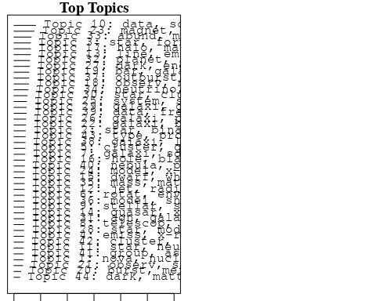

plotQuote(thoughts6, width = 30, main = "Topic 6")  
plotQuote(thoughts18, width = 30, main = "Topic 18")

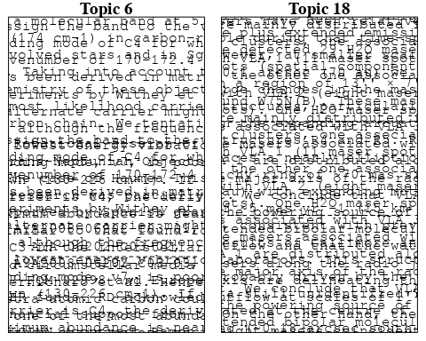

# Calculate and plot the correlation between topics  
mod.out.corr <- topicCorr(Research_topics)  
plot(mod.out.corr, cex = 1.5)  
  
  
# For each topic  
for (topic_num in 1:44) {  
 # Plot the word cloud  
 cloud(Research_topics, topic = topic_num, scale = c(2, 0.25))  
 Sys.sleep(2)  
}

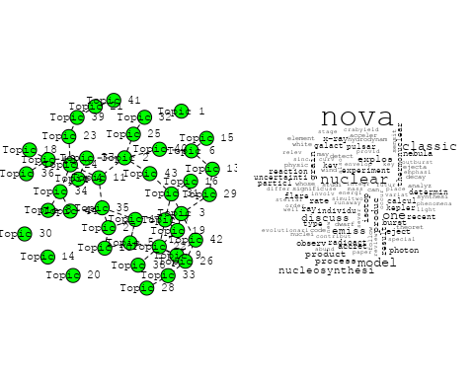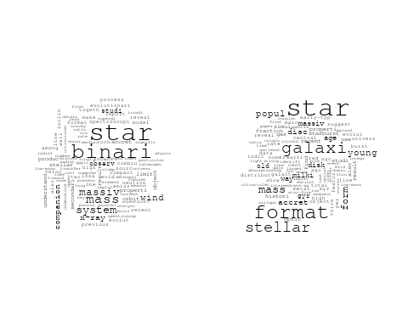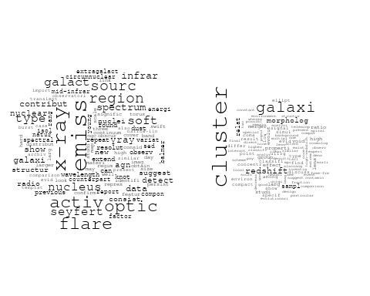

## Warning in wordcloud::wordcloud(words = vocab, freq = vec, max.words =  
## max.words, : rotat could not be fit on page. It will not be plotted.

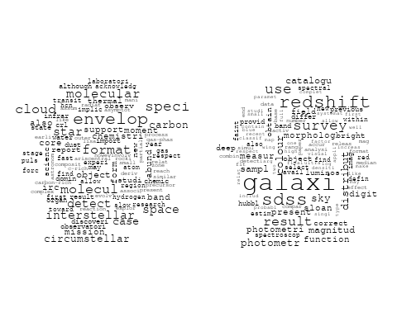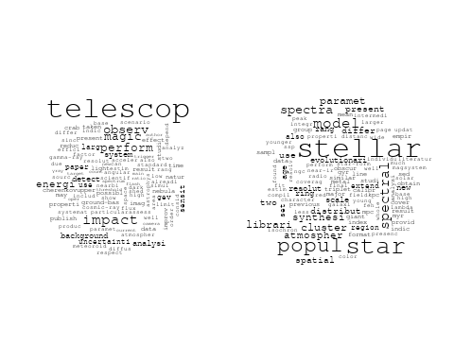

## Warning in wordcloud::wordcloud(words = vocab, freq = vec, max.words =  
## max.words, : anisotropi could not be fit on page. It will not be plotted.

## Warning in wordcloud::wordcloud(words = vocab, freq = vec, max.words =  
## max.words, : galaxi could not be fit on page. It will not be plotted.

## Warning in wordcloud::wordcloud(words = vocab, freq = vec, max.words =  
## max.words, : survey could not be fit on page. It will not be plotted.

## Warning in wordcloud::wordcloud(words = vocab, freq = vec, max.words =  
## max.words, : background could not be fit on page. It will not be plotted.

## Warning in wordcloud::wordcloud(words = vocab, freq = vec, max.words =  
## max.words, : model could not be fit on page. It will not be plotted.

## Warning in wordcloud::wordcloud(words = vocab, freq = vec, max.words =  
## max.words, : angular could not be fit on page. It will not be plotted.

## Warning in wordcloud::wordcloud(words = vocab, freq = vec, max.words =  
## max.words, : correl could not be fit on page. It will not be plotted.

## Warning in wordcloud::wordcloud(words = vocab, freq = vec, max.words =  
## max.words, : larg could not be fit on page. It will not be plotted.

## Warning in wordcloud::wordcloud(words = vocab, freq = vec, max.words =  
## max.words, : power could not be fit on page. It will not be plotted.

## Warning in wordcloud::wordcloud(words = vocab, freq = vec, max.words =  
## max.words, : agreement could not be fit on page. It will not be plotted.

## Warning in wordcloud::wordcloud(words = vocab, freq = vec, max.words =  
## max.words, : signific could not be fit on page. It will not be plotted.

## Warning in wordcloud::wordcloud(words = vocab, freq = vec, max.words =  
## max.words, : determin could not be fit on page. It will not be plotted.

## Warning in wordcloud::wordcloud(words = vocab, freq = vec, max.words =  
## max.words, : bias could not be fit on page. It will not be plotted.

## Warning in wordcloud::wordcloud(words = vocab, freq = vec, max.words =  
## max.words, : matter could not be fit on page. It will not be plotted.

## Warning in wordcloud::wordcloud(words = vocab, freq = vec, max.words =  
## max.words, : present could not be fit on page. It will not be plotted.

## Warning in wordcloud::wordcloud(words = vocab, freq = vec, max.words =  
## max.words, : effect could not be fit on page. It will not be plotted.

## Warning in wordcloud::wordcloud(words = vocab, freq = vec, max.words =  
## max.words, : sampl could not be fit on page. It will not be plotted.

## Warning in wordcloud::wordcloud(words = vocab, freq = vec, max.words =  
## max.words, : constraint could not be fit on page. It will not be plotted.

## Warning in wordcloud::wordcloud(words = vocab, freq = vec, max.words =  
## max.words, : structur could not be fit on page. It will not be plotted.

## Warning in wordcloud::wordcloud(words = vocab, freq = vec, max.words =  
## max.words, : foreground could not be fit on page. It will not be plotted.

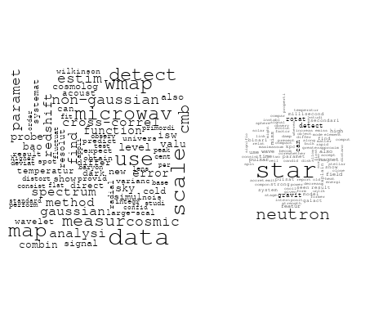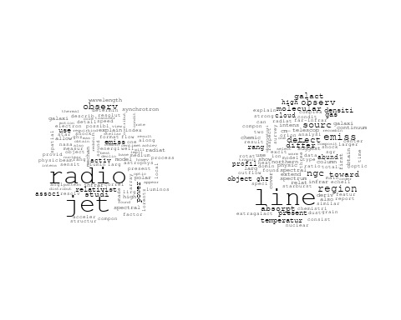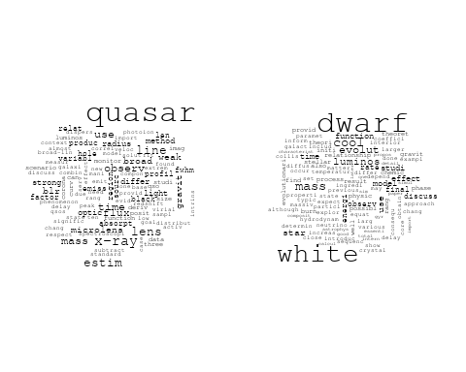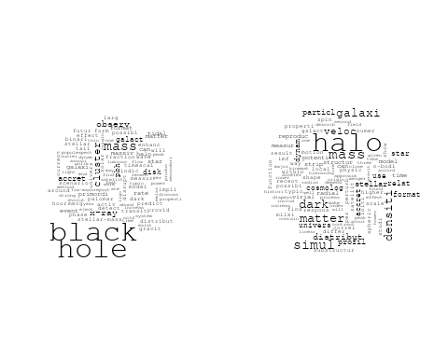

## Warning in wordcloud::wordcloud(words = vocab, freq = vec, max.words =  
## max.words, : observ could not be fit on page. It will not be plotted.

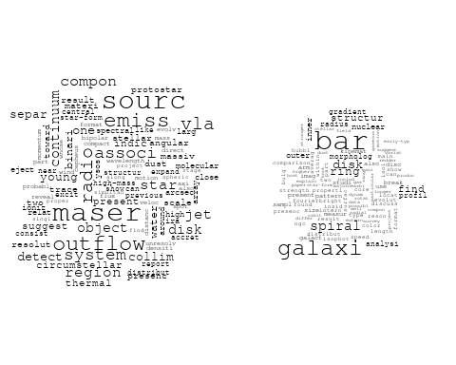

## Warning in wordcloud::wordcloud(words = vocab, freq = vec, max.words =  
## max.words, : period could not be fit on page. It will not be plotted.

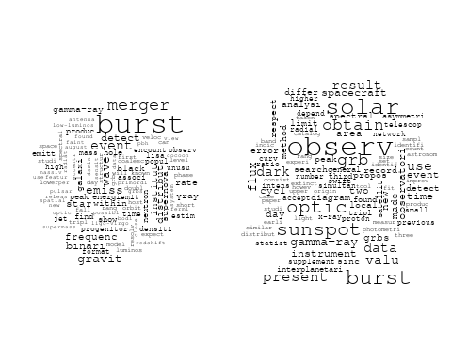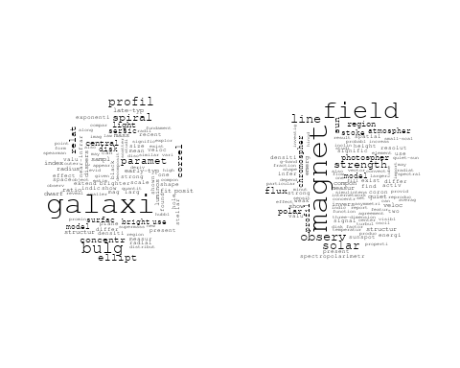

## Warning in wordcloud::wordcloud(words = vocab, freq = vec, max.words =  
## max.words, : binari could not be fit on page. It will not be plotted.

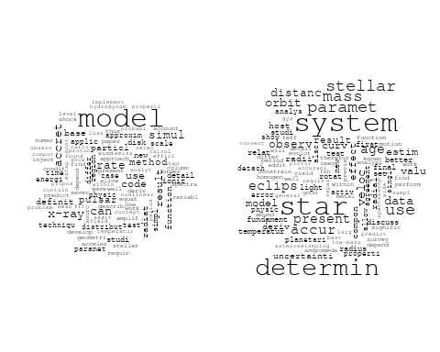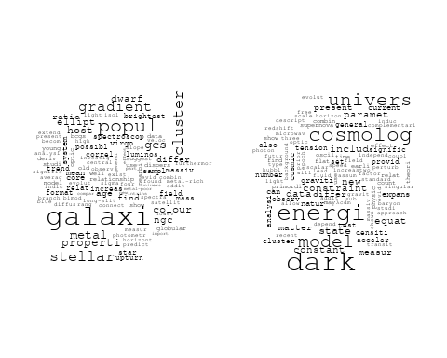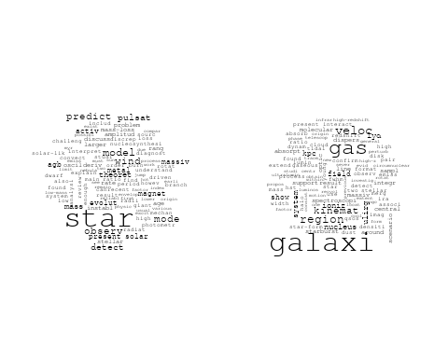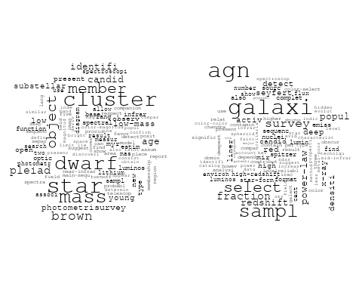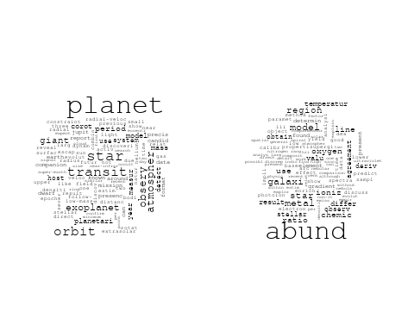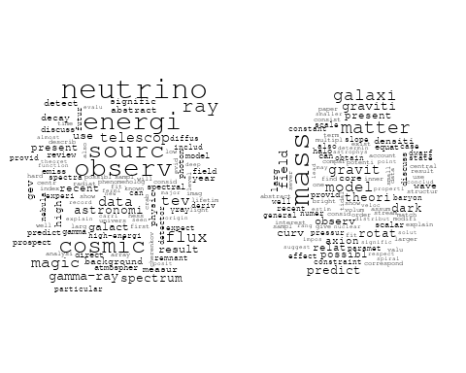

## Warning in wordcloud::wordcloud(words = vocab, freq = vec, max.words =  
## max.words, : supernova could not be fit on page. It will not be plotted.

## Warning in wordcloud::wordcloud(words = vocab, freq = vec, max.words =  
## max.words, : progenitor could not be fit on page. It will not be plotted.

## Warning in wordcloud::wordcloud(words = vocab, freq = vec, max.words =  
## max.words, : outburst could not be fit on page. It will not be plotted.

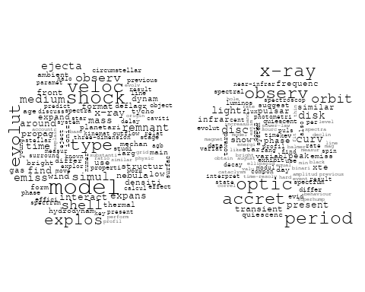

## Warning in wordcloud::wordcloud(words = vocab, freq = vec, max.words =  
## max.words, : also could not be fit on page. It will not be plotted.

## Warning in wordcloud::wordcloud(words = vocab, freq = vec, max.words =  
## max.words, : first could not be fit on page. It will not be plotted.

## Warning in wordcloud::wordcloud(words = vocab, freq = vec, max.words =  
## max.words, : mode could not be fit on page. It will not be plotted.

## Warning in wordcloud::wordcloud(words = vocab, freq = vec, max.words =  
## max.words, : ultraviolet could not be fit on page. It will not be plotted.

## Warning in wordcloud::wordcloud(words = vocab, freq = vec, max.words =  
## max.words, : obtain could not be fit on page. It will not be plotted.

## Warning in wordcloud::wordcloud(words = vocab, freq = vec, max.words =  
## max.words, : magnet could not be fit on page. It will not be plotted.

## Warning in wordcloud::wordcloud(words = vocab, freq = vec, max.words =  
## max.words, : data could not be fit on page. It will not be plotted.

## Warning in wordcloud::wordcloud(words = vocab, freq = vec, max.words =  
## max.words, : telescop could not be fit on page. It will not be plotted.

## Warning in wordcloud::wordcloud(words = vocab, freq = vec, max.words =  
## max.words, : short-term could not be fit on page. It will not be plotted.

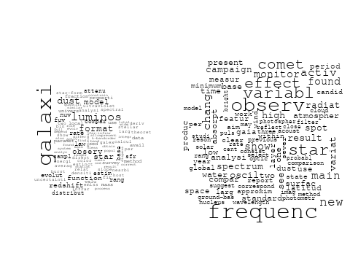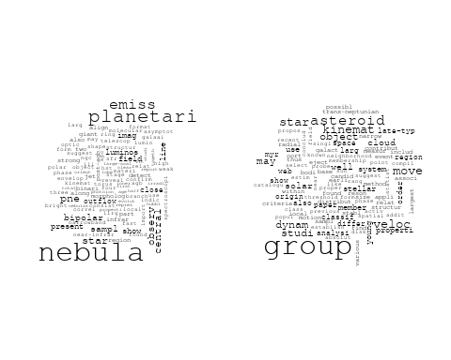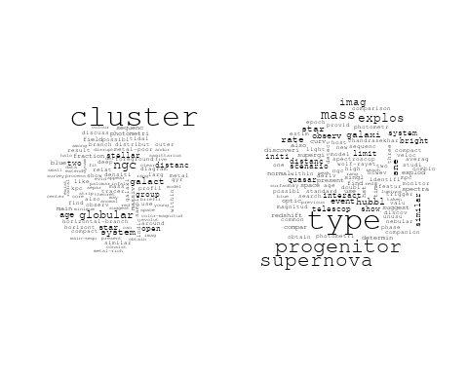

# Get the topic proportions for each document  
topic_proportions <- Research_topics$theta  
  
# Find the index of the topic with the highest proportion for each document  
# This will be the topic that each document is most likely to belong to  
max_topic_idx <- apply(topic_proportions, 1, which.max)  
  
# Add this as a new column to your data  
data_collab$topic <- max_topic_idx  
  
library(ggplot2)  
  
# Define the intervals  
intervals <- c('1824_1899', '1900_1964', '1965_1974', '1975_1984', '1985_1994', '1995_1999', '2000_2004', '2005_2009', '2010_2014', '2015_2019', '2020_2022')  
colors <- c('pink', 'blue', 'purple', 'yellow', 'green', 'pink', 'orange', 'violet', 'green', 'blue', 'pink')  
  
# Loop through the intervals and plot  
for(i in seq_along(intervals)){  
 # Filter data for when the pub_interval is equal to 1  
 data_filtered <- data_collab[data_collab[[paste0('pub_interval_', intervals[i])]] == 1,]  
   
 # Make the histogram  
   
 p <- ggplot(data_filtered, aes(x = topic)) +  
 geom_histogram(binwidth = 1, fill = colors[i], color = "black") +  
 xlab("Topic") +  
 ylab("Count") +  
 ggtitle(paste0("Topics from year ", gsub("_", " to ", intervals[i])))  
   
 print(p)  
}  
  
  
##Topic generation for ES (independent) publications  
  
data_independent <- data[data[["ES"]] == 100,]  
  
# Save the original title data for future use  
data_independent$original_concatenated_title_abstract <- data_independent$concatenated_title_abstract  
  
#pre-processing the titles using textProcessor from the stm package  
processed_text <- textProcessor(data_independent$concatenated_title_abstract, metadata = data_independent)

## Building corpus...   
## Converting to Lower Case...   
## Removing punctuation...   
## Removing stopwords...   
## Removing numbers...   
## Stemming...   
## Creating Output...

# Further prepare the data by removing low-frequency terms  
out_text <- prepDocuments(processed_text$documents, processed_text$vocab, processed_text$meta)

## Removing 1293 of 4794 terms (1293 of 50244 tokens) due to frequency   
## Your corpus now has 615 documents, 3501 terms and 48951 tokens.

docs_text <- out_text$documents  
vocab_text <- out_text$vocab  
meta_text <- out_text$meta  
  
  
#Prepare data  
plotRemoved(processed_text$documents, lower.thresh = seq(1, 200, by = 100))

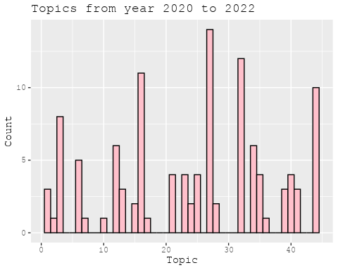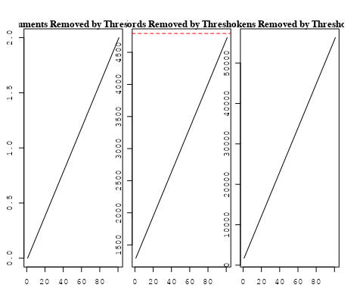

out_text <- prepDocuments(processed_text$documents, processed_text$vocab, processed_text$meta, lower.thresh = 8)

## Removing 3620 of 4794 terms (9522 of 50244 tokens) due to frequency   
## Your corpus now has 615 documents, 1174 terms and 40722 tokens.

str(out_text$meta)

## 'data.frame': 615 obs. of 39 variables:  
## $ concept_id : chr "https://openalex.org/C44870925" "https://openalex.org/C44870925" "https://openalex.org/C44870925" "https://openalex.org/C1276947" ...  
## $ work_id : chr "https://openalex.org/W2122555548" "https://openalex.org/W3123041789" "https://openalex.org/W2025340613" "https://openalex.org/W2025340613" ...  
## $ publication_year : int 2007 2003 1998 1998 2007 2003 2010 2002 1994 1994 ...  
## $ title : chr "Medium-resolution Isaac Newton Telescope library of empirical spectra - II. The stellar atmospheric parameters" "Detection of the ISW and SZ effects from the CMB-Galaxy correlation" "Nucleosynthesis in Classical Novae: CO versus ONe White Dwarfs" "Nucleosynthesis in Classical Novae: CO versus ONe White Dwarfs" ...  
## $ paperabstract : chr "We present a homogeneous set of stellar atmospheric parameters (T-eff, log g, [Fe/H]) for MILES, a new spectral"| __truncated__ "We present a cross-correlation analysis of the W ilkinson Microwave Anisotropy Probe cosmic microwave backgroun"| __truncated__ "Detailed nucleosynthesis in the ejecta of classical novae has been determined for a grid of hydrodynamic nova m"| __truncated__ "Detailed nucleosynthesis in the ejecta of classical novae has been determined for a grid of hydrodynamic nova m"| __truncated__ ...  
## $ country : chr "ES ES" "ES ES" "ES ES ES ES" "ES ES ES ES" ...  
## $ year_concept : chr "2007+https://openalex.org/C44870925" "2003+https://openalex.org/C44870925" "1998+https://openalex.org/C44870925" "1998+https://openalex.org/C1276947" ...  
## $ concatenated_title_abstract : chr "Medium-resolution Isaac Newton Telescope library of empirical spectra - II. The stellar atmospheric parameters "| __truncated__ "Detection of the ISW and SZ effects from the CMB-Galaxy correlation We present a cross-correlation analysis of "| __truncated__ "Nucleosynthesis in Classical Novae: CO versus ONe White Dwarfs Detailed nucleosynthesis in the ejecta of classi"| __truncated__ "Nucleosynthesis in Classical Novae: CO versus ONe White Dwarfs Detailed nucleosynthesis in the ejecta of classi"| __truncated__ ...  
## $ US : num 0 0 0 0 0 0 0 0 0 0 ...  
## $ IN : num 0 0 0 0 0 0 0 0 0 0 ...  
## $ DE : num 0 0 0 0 0 0 0 0 0 0 ...  
## $ CH : num 0 0 0 0 0 0 0 0 0 0 ...  
## $ GB : num 0 0 0 0 0 0 0 0 0 0 ...  
## $ CN : num 0 0 0 0 0 0 0 0 0 0 ...  
## $ FR : num 0 0 0 0 0 0 0 0 0 0 ...  
## $ IT : num 0 0 0 0 0 0 0 0 0 0 ...  
## $ RU : num 0 0 0 0 0 0 0 0 0 0 ...  
## $ CA : num 0 0 0 0 0 0 0 0 0 0 ...  
## $ NL : num 0 0 0 0 0 0 0 0 0 0 ...  
## $ AU : num 0 0 0 0 0 0 0 0 0 0 ...  
## $ JP : num 0 0 0 0 0 0 0 0 0 0 ...  
## $ ES : num 100 100 100 100 100 100 100 100 100 100 ...  
## $ IL : num 0 0 0 0 0 0 0 0 0 0 ...  
## $ Americas : num 0 0 0 0 0 0 0 0 0 0 ...  
## $ Europe : num 0 0 0 0 0 0 0 0 0 0 ...  
## $ Africa : num 0 0 0 0 0 0 0 0 0 0 ...  
## $ AsiaAndOceania : num 0 0 0 0 0 0 0 0 0 0 ...  
## $ pub_interval_2020_2022 : int 0 0 0 0 0 0 0 0 0 0 ...  
## $ pub_interval_2015_2019 : int 0 0 0 0 0 0 0 0 0 0 ...  
## $ pub_interval_2010_2014 : int 0 0 0 0 0 0 1 0 0 0 ...  
## $ pub_interval_2005_2009 : int 1 0 0 0 1 0 0 0 0 0 ...  
## $ pub_interval_2000_2004 : int 0 1 0 0 0 1 0 1 0 0 ...  
## $ pub_interval_1995_1999 : int 0 0 1 1 0 0 0 0 0 0 ...  
## $ pub_interval_1985_1994 : int 0 0 0 0 0 0 0 0 1 1 ...  
## $ pub_interval_1975_1984 : int 0 0 0 0 0 0 0 0 0 0 ...  
## $ pub_interval_1965_1974 : int 0 0 0 0 0 0 0 0 0 0 ...  
## $ pub_interval_1900_1964 : int 0 0 0 0 0 0 0 0 0 0 ...  
## $ pub_interval_1824_1899 : int 0 0 0 0 0 0 0 0 0 0 ...  
## $ original_concatenated_title_abstract: chr "Medium-resolution Isaac Newton Telescope library of empirical spectra - II. The stellar atmospheric parameters "| __truncated__ "Detection of the ISW and SZ effects from the CMB-Galaxy correlation We present a cross-correlation analysis of "| __truncated__ "Nucleosynthesis in Classical Novae: CO versus ONe White Dwarfs Detailed nucleosynthesis in the ejecta of classi"| __truncated__ "Nucleosynthesis in Classical Novae: CO versus ONe White Dwarfs Detailed nucleosynthesis in the ejecta of classi"| __truncated__ ...

# Initialize an empty formula string  
prevalence_formula_str <- "~"  
  
# Define the publication intervals  
pub_intervals <- c("pub_interval_2020_2022", "pub_interval_2015_2019", "pub_interval_2010_2014",   
 "pub_interval_2005_2009", "pub_interval_2000_2004", "pub_interval_1995_1999",  
 "pub_interval_1985_1994", "pub_interval_1975_1984", "pub_interval_1965_1974",  
 "pub_interval_1900_1964", "pub_interval_1824_1899")  
  
# Add each publication interval to the formula string  
for (interval in pub_intervals) {  
 # add an if statement to handle the first addition (without '+')  
 if (prevalence_formula_str == "~") {  
 prevalence_formula_str <- paste(prevalence_formula_str, interval)  
 } else {  
 prevalence_formula_str <- paste(prevalence_formula_str, "+", interval)  
 }  
}  
  
  
# Convert the string to a formula  
prevalence_formula <- as.formula(prevalence_formula_str)  
print(prevalence_formula)

## ~pub_interval_2020_2022 + pub_interval_2015_2019 + pub_interval_2010_2014 +   
## pub_interval_2005_2009 + pub_interval_2000_2004 + pub_interval_1995_1999 +   
## pub_interval_1985_1994 + pub_interval_1975_1984 + pub_interval_1965_1974 +   
## pub_interval_1900_1964 + pub_interval_1824_1899

# Run STM model  
Research_topics <- stm(documents = out_text$documents,   
 vocab = out_text$vocab,   
 K = 44,   
 prevalence = prevalence_formula,   
 data = out_text$meta,   
 init.type = "Spectral",  
 max.em.its = 1000,  
 gamma.prior = 'L1')

## Beginning Spectral Initialization   
## Calculating the gram matrix...  
## Finding anchor words...  
## ............................................  
## Recovering initialization...  
## ...........  
## Initialization complete.  
## ......................................................................................................  
## Completed E-Step (0 seconds).   
## Completed M-Step.   
## Completing Iteration 1 (approx. per word bound = -6.068)   
## ......................................................................................................  
## Completed E-Step (0 seconds).   
## Completed M-Step.   
## Completing Iteration 2 (approx. per word bound = -5.733, relative change = 5.528e-02)   
## ......................................................................................................  
## Completed E-Step (0 seconds).   
## Completed M-Step.   
## Completing Iteration 3 (approx. per word bound = -5.618, relative change = 2.003e-02)   
## ......................................................................................................  
## Completed E-Step (0 seconds).   
## Completed M-Step.   
## Completing Iteration 4 (approx. per word bound = -5.568, relative change = 8.935e-03)   
## ......................................................................................................  
## Completed E-Step (0 seconds).   
## Completed M-Step.   
## Completing Iteration 5 (approx. per word bound = -5.540, relative change = 5.036e-03)   
## Topic 1: star, neutron, solar, system, agb   
## Topic 2: rotat, support, object, space, envelop   
## Topic 3: dark, data, new, cross-correl, use   
## Topic 4: infrar, flare, optic, detect, γray   
## Topic 5: nova, wind, weak, argument, identifi   
## Topic 6: star, format, ngc, astrophys, form   
## Topic 7: cluster, galaxi, simul, cosmolog, merger   
## Topic 8: effect, experi, lens, cluster, studi   
## Topic 9: popul, star, line, studi, accret   
## Topic 10: neutrino, recent, will, physic, review   
## Topic 11: univers, map, black, hole, mass   
## Topic 12: galaxi, star, format, dust, young   
## Topic 13: telescop, impact, type, paper, larg   
## Topic 14: data, mass, use, distribut, result   
## Topic 15: stellar, model, planet, measur, use   
## Topic 16: nebula, emiss, planetari, observ, imag   
## Topic 17: star, planet, mode, observ, detect   
## Topic 18: galaxi, cluster, paramet, concentr, central   
## Topic 19: signific, ray, produc, photon, emiss   
## Topic 20: cosmic, model, data, wmap, ray   
## Topic 21: dark, observ, magic, matter, telescop   
## Topic 22: veloc, period, frequenc, time, show   
## Topic 23: x-ray, binari, orbit, system, sourc   
## Topic 24: magnet, field, observ, strength, model   
## Topic 25: model, ioniz, emiss, line, nebular   
## Topic 26: luminos, sdss, function, galaxi, use   
## Topic 27: gas, line, microlens, ioniz, veloc   
## Topic 28: model, wind, observ, theoret, star   
## Topic 29: bar, galaxi, ring, spiral, bulg   
## Topic 30: discuss, model, hydrodynam, classic, one   
## Topic 31: object, move, dynam, may, group   
## Topic 32: sourc, type, soft, agn, seyfert   
## Topic 33: white, dwarf, cool, use, evolut   
## Topic 34: transit, observ, solar, planet, sunspot   
## Topic 35: star, abund, stellar, paramet, model   
## Topic 36: star, group, kinemat, stellar, member   
## Topic 37: use, effect, estim, function, project   
## Topic 38: stellar, star, cluster, age, young   
## Topic 39: radio, jet, sourc, scale, region   
## Topic 40: system, age, dwarf, star, object   
## Topic 41: massiv, mass, companion, star, black   
## Topic 42: halo, matter, dark, mass, densiti   
## Topic 43: line, region, abund, speci, observ   
## Topic 44: measur, bao, acoust, photometr, scale   
## ......................................................................................................  
## Completed E-Step (0 seconds).   
## Completed M-Step.   
## Completing Iteration 6 (approx. per word bound = -5.524, relative change = 2.855e-03)   
## ......................................................................................................  
## Completed E-Step (0 seconds).   
## Completed M-Step.   
## Completing Iteration 7 (approx. per word bound = -5.512, relative change = 2.058e-03)   
## ......................................................................................................  
## Completed E-Step (0 seconds).   
## Completed M-Step.   
## Completing Iteration 8 (approx. per word bound = -5.503, relative change = 1.647e-03)   
## ......................................................................................................  
## Completed E-Step (0 seconds).   
## Completed M-Step.   
## Completing Iteration 9 (approx. per word bound = -5.497, relative change = 1.177e-03)   
## ......................................................................................................  
## Completed E-Step (0 seconds).   
## Completed M-Step.   
## Completing Iteration 10 (approx. per word bound = -5.492, relative change = 8.691e-04)   
## Topic 1: star, neutron, solar, system, model   
## Topic 2: rotat, object, mass, particl, support   
## Topic 3: data, new, dark, sampl, cross-correl   
## Topic 4: flare, infrar, optic, γray, detect   
## Topic 5: nova, wind, rate, diagnost, galaxi   
## Topic 6: star, format, ngc, region, form   
## Topic 7: cluster, simul, galaxi, scientif, merger   
## Topic 8: effect, experi, signal, detect, cluster   
## Topic 9: popul, star, line, studi, stellar   
## Topic 10: neutrino, energi, will, recent, physic   
## Topic 11: univers, map, black, hole, mass   
## Topic 12: galaxi, star, format, dust, young   
## Topic 13: telescop, impact, type, paper, supernova   
## Topic 14: data, mass, use, distribut, result   
## Topic 15: stellar, model, planet, measur, use   
## Topic 16: nebula, emiss, planetari, observ, imag   
## Topic 17: star, planet, observ, mode, detect   
## Topic 18: galaxi, bulg, spiral, paramet, cluster   
## Topic 19: signific, ray, produc, photon, emiss   
## Topic 20: cosmic, model, data, microwav, ray   
## Topic 21: dark, observ, magic, matter, telescop   
## Topic 22: frequenc, period, oscil, time, veloc   
## Topic 23: x-ray, binari, orbit, system, sourc   
## Topic 24: magnet, field, observ, strength, model   
## Topic 25: model, emiss, line, nebular, ioniz   
## Topic 26: luminos, galaxi, function, sdss, redshift   
## Topic 27: gas, line, veloc, microlens, ioniz   
## Topic 28: model, observ, theoret, star, wind   
## Topic 29: bar, galaxi, ring, disk, outer   
## Topic 30: discuss, classic, model, one, dwarf   
## Topic 31: object, move, dynam, group, may   
## Topic 32: type, soft, agn, sourc, seyfert   
## Topic 33: white, dwarf, cool, use, evolut   
## Topic 34: transit, observ, solar, planet, mission   
## Topic 35: star, abund, paramet, stellar, model   
## Topic 36: star, group, kinemat, member, stellar   
## Topic 37: use, estim, effect, function, project   
## Topic 38: stellar, star, cluster, galaxi, age   
## Topic 39: radio, jet, sourc, scale, emiss   
## Topic 40: age, system, star, object, dwarf   
## Topic 41: massiv, mass, star, black, hole   
## Topic 42: halo, matter, dark, mass, densiti   
## Topic 43: line, region, abund, speci, observ   
## Topic 44: measur, bao, acoust, photometr, scale   
## ......................................................................................................  
## Completed E-Step (0 seconds).   
## Completed M-Step.   
## Completing Iteration 11 (approx. per word bound = -5.488, relative change = 7.826e-04)   
## ......................................................................................................  
## Completed E-Step (0 seconds).   
## Completed M-Step.   
## Completing Iteration 12 (approx. per word bound = -5.484, relative change = 6.228e-04)   
## ......................................................................................................  
## Completed E-Step (0 seconds).   
## Completed M-Step.   
## Completing Iteration 13 (approx. per word bound = -5.482, relative change = 4.776e-04)   
## ......................................................................................................  
## Completed E-Step (0 seconds).   
## Completed M-Step.   
## Completing Iteration 14 (approx. per word bound = -5.479, relative change = 5.435e-04)   
## ......................................................................................................  
## Completed E-Step (0 seconds).   
## Completed M-Step.   
## Completing Iteration 15 (approx. per word bound = -5.476, relative change = 4.446e-04)   
## Topic 1: star, neutron, solar, system, model   
## Topic 2: rotat, star, object, particl, mass   
## Topic 3: data, new, dark, sampl, cross-correl   
## Topic 4: flare, infrar, optic, γray, detect   
## Topic 5: nova, wind, rate, diagnost, interpret   
## Topic 6: star, format, ngc, region, form   
## Topic 7: cluster, simul, galaxi, scientif, merger   
## Topic 8: effect, experi, detect, signal, cluster   
## Topic 9: popul, star, line, stellar, compact   
## Topic 10: neutrino, energi, will, physic, recent   
## Topic 11: univers, map, black, hole, mass   
## Topic 12: galaxi, star, format, dust, young   
## Topic 13: telescop, impact, type, paper, supernova   
## Topic 14: data, mass, distribut, use, star   
## Topic 15: stellar, model, planet, measur, use   
## Topic 16: nebula, emiss, planetari, observ, imag   
## Topic 17: star, planet, observ, mode, detect   
## Topic 18: galaxi, bulg, spiral, paramet, concentr   
## Topic 19: signific, ray, produc, photon, emiss   
## Topic 20: cosmic, model, data, microwav, ray   
## Topic 21: dark, observ, magic, matter, telescop   
## Topic 22: frequenc, oscil, period, time, show   
## Topic 23: x-ray, binari, orbit, system, observ   
## Topic 24: magnet, field, observ, strength, model   
## Topic 25: model, emiss, line, star, nebular   
## Topic 26: luminos, galaxi, sdss, function, redshift   
## Topic 27: gas, line, veloc, microlens, ioniz   
## Topic 28: model, observ, theoret, can, radiat   
## Topic 29: bar, galaxi, ring, disk, outer   
## Topic 30: discuss, classic, model, one, dwarf   
## Topic 31: dynam, move, object, group, may   
## Topic 32: type, soft, agn, seyfert, sourc   
## Topic 33: white, dwarf, cool, use, evolut   
## Topic 34: transit, observ, solar, planet, mission   
## Topic 35: star, abund, paramet, model, stellar   
## Topic 36: star, group, kinemat, member, stellar   
## Topic 37: use, function, project, effect, estim   
## Topic 38: star, stellar, cluster, galaxi, age   
## Topic 39: radio, jet, sourc, scale, emiss   
## Topic 40: age, system, star, object, determin   
## Topic 41: massiv, mass, star, black, hole   
## Topic 42: halo, matter, dark, mass, densiti   
## Topic 43: line, region, abund, speci, observ   
## Topic 44: measur, bao, acoust, scale, redshift   
## ......................................................................................................  
## Completed E-Step (0 seconds).   
## Completed M-Step.   
## Completing Iteration 16 (approx. per word bound = -5.474, relative change = 4.322e-04)   
## ......................................................................................................  
## Completed E-Step (0 seconds).   
## Completed M-Step.   
## Completing Iteration 17 (approx. per word bound = -5.472, relative change = 4.025e-04)   
## ......................................................................................................  
## Completed E-Step (0 seconds).   
## Completed M-Step.   
## Completing Iteration 18 (approx. per word bound = -5.470, relative change = 3.592e-04)   
## ......................................................................................................  
## Completed E-Step (0 seconds).   
## Completed M-Step.   
## Completing Iteration 19 (approx. per word bound = -5.468, relative change = 3.395e-04)   
## ......................................................................................................  
## Completed E-Step (0 seconds).   
## Completed M-Step.   
## Completing Iteration 20 (approx. per word bound = -5.466, relative change = 3.657e-04)   
## Topic 1: star, neutron, solar, system, model   
## Topic 2: rotat, star, object, particl, mass   
## Topic 3: data, new, dark, sampl, cross-correl   
## Topic 4: flare, optic, infrar, γray, detect   
## Topic 5: nova, wind, rate, diagnost, interpret   
## Topic 6: star, format, ngc, region, form   
## Topic 7: cluster, simul, galaxi, scientif, merger   
## Topic 8: effect, experi, detect, signal, cluster   
## Topic 9: popul, star, line, compact, stellar   
## Topic 10: neutrino, energi, will, physic, recent   
## Topic 11: univers, black, hole, map, mass   
## Topic 12: galaxi, star, format, dust, young   
## Topic 13: telescop, impact, type, supernova, paper   
## Topic 14: mass, data, distribut, frequenc, star   
## Topic 15: stellar, model, planet, measur, use   
## Topic 16: nebula, emiss, planetari, observ, imag   
## Topic 17: star, planet, observ, mode, detect   
## Topic 18: galaxi, bulg, spiral, paramet, concentr   
## Topic 19: signific, produc, ray, photon, emiss   
## Topic 20: cosmic, model, data, microwav, map   
## Topic 21: dark, observ, magic, matter, telescop   
## Topic 22: frequenc, oscil, time, period, show   
## Topic 23: x-ray, binari, orbit, system, period   
## Topic 24: magnet, field, observ, strength, model   
## Topic 25: model, emiss, star, line, nebular   
## Topic 26: luminos, galaxi, redshift, sdss, function   
## Topic 27: gas, veloc, line, microlens, ioniz   
## Topic 28: model, observ, can, theoret, pulsar   
## Topic 29: bar, galaxi, ring, disk, outer   
## Topic 30: discuss, classic, model, one, dwarf   
## Topic 31: dynam, move, object, group, may   
## Topic 32: type, soft, agn, sourc, emiss   
## Topic 33: white, dwarf, cool, use, evolut   
## Topic 34: transit, observ, solar, planet, mission   
## Topic 35: star, abund, paramet, model, stellar   
## Topic 36: star, group, kinemat, stellar, member   
## Topic 37: use, function, project, method, effect   
## Topic 38: star, stellar, cluster, galaxi, age   
## Topic 39: radio, jet, sourc, scale, emiss   
## Topic 40: age, system, star, determin, object   
## Topic 41: massiv, mass, star, black, hole   
## Topic 42: halo, matter, dark, mass, densiti   
## Topic 43: line, region, abund, speci, observ   
## Topic 44: measur, bao, acoust, redshift, scale   
## ......................................................................................................  
## Completed E-Step (0 seconds).   
## Completed M-Step.   
## Completing Iteration 21 (approx. per word bound = -5.464, relative change = 3.295e-04)   
## ......................................................................................................  
## Completed E-Step (0 seconds).   
## Completed M-Step.   
## Completing Iteration 22 (approx. per word bound = -5.463, relative change = 2.888e-04)   
## ......................................................................................................  
## Completed E-Step (0 seconds).   
## Completed M-Step.   
## Completing Iteration 23 (approx. per word bound = -5.461, relative change = 2.566e-04)   
## ......................................................................................................  
## Completed E-Step (0 seconds).   
## Completed M-Step.   
## Completing Iteration 24 (approx. per word bound = -5.460, relative change = 2.481e-04)   
## ......................................................................................................  
## Completed E-Step (0 seconds).   
## Completed M-Step.   
## Completing Iteration 25 (approx. per word bound = -5.458, relative change = 2.450e-04)   
## Topic 1: star, neutron, solar, system, model   
## Topic 2: rotat, star, object, particl, mass   
## Topic 3: data, new, dark, sampl, correl   
## Topic 4: flare, optic, infrar, γray, detect   
## Topic 5: nova, wind, rate, star, diagnost   
## Topic 6: star, format, ngc, region, star-form   
## Topic 7: cluster, simul, galaxi, merger, scientif   
## Topic 8: effect, detect, experi, signal, cluster   
## Topic 9: popul, star, line, studi, compact   
## Topic 10: neutrino, energi, physic, will, recent   
## Topic 11: univers, black, hole, map, mass   
## Topic 12: galaxi, star, format, dust, young   
## Topic 13: telescop, impact, type, supernova, paper   
## Topic 14: mass, data, distribut, frequenc, star   
## Topic 15: stellar, model, planet, measur, use   
## Topic 16: nebula, emiss, planetari, observ, imag   
## Topic 17: star, planet, observ, mode, detect   
## Topic 18: galaxi, bulg, spiral, paramet, concentr   
## Topic 19: signific, produc, ray, photon, emiss   
## Topic 20: cosmic, model, data, microwav, map   
## Topic 21: dark, observ, magic, matter, telescop   
## Topic 22: frequenc, oscil, time, period, mode   
## Topic 23: x-ray, binari, orbit, system, period   
## Topic 24: magnet, field, observ, strength, model   
## Topic 25: model, star, emiss, line, ioniz   
## Topic 26: luminos, galaxi, redshift, sdss, function   
## Topic 27: gas, veloc, line, microlens, ioniz   
## Topic 28: model, pulsar, can, observ, present   
## Topic 29: bar, galaxi, ring, disk, outer   
## Topic 30: discuss, classic, model, one, dwarf   
## Topic 31: dynam, move, group, object, may   
## Topic 32: type, soft, agn, emiss, sourc   
## Topic 33: white, dwarf, cool, use, evolut   
## Topic 34: transit, observ, solar, planet, mission   
## Topic 35: star, abund, paramet, model, stellar   
## Topic 36: star, group, kinemat, stellar, member   
## Topic 37: use, function, project, method, effect   
## Topic 38: star, stellar, galaxi, cluster, age   
## Topic 39: radio, jet, sourc, scale, emiss   
## Topic 40: age, system, star, determin, object   
## Topic 41: massiv, mass, star, black, hole   
## Topic 42: halo, matter, dark, mass, densiti   
## Topic 43: line, region, abund, speci, observ   
## Topic 44: measur, acoust, bao, redshift, scale   
## ......................................................................................................  
## Completed E-Step (0 seconds).   
## Completed M-Step.   
## Completing Iteration 26 (approx. per word bound = -5.457, relative change = 2.034e-04)   
## ......................................................................................................  
## Completed E-Step (0 seconds).   
## Completed M-Step.   
## Completing Iteration 27 (approx. per word bound = -5.457, relative change = 1.543e-04)   
## ......................................................................................................  
## Completed E-Step (0 seconds).   
## Completed M-Step.   
## Completing Iteration 28 (approx. per word bound = -5.456, relative change = 1.268e-04)   
## ......................................................................................................  
## Completed E-Step (0 seconds).   
## Completed M-Step.   
## Completing Iteration 29 (approx. per word bound = -5.455, relative change = 1.138e-04)   
## ......................................................................................................  
## Completed E-Step (0 seconds).   
## Completed M-Step.   
## Completing Iteration 30 (approx. per word bound = -5.455, relative change = 1.213e-04)   
## Topic 1: star, neutron, solar, system, model   
## Topic 2: rotat, star, mass, object, particl   
## Topic 3: data, new, dark, sampl, correl   
## Topic 4: flare, optic, infrar, γray, detect   
## Topic 5: nova, wind, rate, star, diagnost   
## Topic 6: star, format, ngc, region, gas   
## Topic 7: cluster, simul, galaxi, merger, scientif   
## Topic 8: effect, detect, experi, signal, cluster   
## Topic 9: popul, star, line, compact, stellar   
## Topic 10: neutrino, energi, physic, will, field   
## Topic 11: univers, black, hole, map, mass   
## Topic 12: galaxi, star, format, dust, young   
## Topic 13: telescop, impact, type, supernova, paper   
## Topic 14: mass, data, distribut, frequenc, star   
## Topic 15: stellar, model, planet, measur, use   
## Topic 16: nebula, emiss, planetari, observ, bipolar   
## Topic 17: star, planet, observ, mode, detect   
## Topic 18: galaxi, bulg, spiral, paramet, concentr   
## Topic 19: signific, produc, ray, photon, emiss   
## Topic 20: cosmic, model, data, microwav, map   
## Topic 21: dark, observ, magic, matter, telescop   
## Topic 22: frequenc, oscil, time, period, mode   
## Topic 23: x-ray, binari, orbit, system, period   
## Topic 24: magnet, field, observ, strength, model   
## Topic 25: model, star, emiss, line, ioniz   
## Topic 26: luminos, galaxi, redshift, sdss, function   
## Topic 27: gas, veloc, line, microlens, ioniz   
## Topic 28: model, pulsar, can, present, energi   
## Topic 29: bar, galaxi, ring, disk, outer   
## Topic 30: discuss, classic, model, one, dwarf   
## Topic 31: move, dynam, group, object, may   
## Topic 32: type, soft, agn, emiss, sourc   
## Topic 33: white, dwarf, cool, use, evolut   
## Topic 34: transit, observ, solar, planet, mission   
## Topic 35: star, abund, paramet, model, stellar   
## Topic 36: star, group, kinemat, well, stellar   
## Topic 37: use, function, project, method, effect   
## Topic 38: star, stellar, galaxi, cluster, age   
## Topic 39: radio, jet, sourc, scale, emiss   
## Topic 40: age, system, star, determin, object   
## Topic 41: massiv, mass, star, black, hole   
## Topic 42: halo, matter, dark, mass, densiti   
## Topic 43: line, abund, region, speci, observ   
## Topic 44: measur, acoust, bao, redshift, scale   
## ......................................................................................................  
## Completed E-Step (0 seconds).   
## Completed M-Step.   
## Completing Iteration 31 (approx. per word bound = -5.454, relative change = 1.406e-04)   
## ......................................................................................................  
## Completed E-Step (0 seconds).   
## Completed M-Step.   
## Completing Iteration 32 (approx. per word bound = -5.453, relative change = 1.553e-04)   
## ......................................................................................................  
## Completed E-Step (0 seconds).   
## Completed M-Step.   
## Completing Iteration 33 (approx. per word bound = -5.452, relative change = 1.366e-04)   
## ......................................................................................................  
## Completed E-Step (0 seconds).   
## Completed M-Step.   
## Completing Iteration 34 (approx. per word bound = -5.452, relative change = 1.066e-04)   
## ......................................................................................................  
## Completed E-Step (0 seconds).   
## Completed M-Step.   
## Completing Iteration 35 (approx. per word bound = -5.451, relative change = 8.910e-05)   
## Topic 1: star, neutron, solar, system, model   
## Topic 2: rotat, star, mass, object, particl   
## Topic 3: data, new, dark, sampl, correl   
## Topic 4: flare, optic, infrar, γray, detect   
## Topic 5: nova, wind, rate, star, diagnost   
## Topic 6: star, format, ngc, region, field   
## Topic 7: cluster, simul, galaxi, scientif, merger   
## Topic 8: effect, detect, experi, signal, cluster   
## Topic 9: popul, star, line, compact, stellar   
## Topic 10: neutrino, energi, physic, field, recent   
## Topic 11: univers, black, hole, map, mass   
## Topic 12: galaxi, star, format, dust, young   
## Topic 13: telescop, impact, type, supernova, paper   
## Topic 14: mass, data, distribut, frequenc, star   
## Topic 15: stellar, model, planet, measur, use   
## Topic 16: nebula, emiss, planetari, observ, bipolar   
## Topic 17: star, planet, observ, mode, detect   
## Topic 18: galaxi, bulg, spiral, paramet, concentr   
## Topic 19: signific, produc, ray, photon, emiss   
## Topic 20: cosmic, model, data, microwav, map   
## Topic 21: dark, observ, magic, matter, telescop   
## Topic 22: frequenc, oscil, time, period, mode   
## Topic 23: x-ray, orbit, binari, system, period   
## Topic 24: magnet, field, observ, strength, model   
## Topic 25: model, star, emiss, line, ioniz   
## Topic 26: luminos, galaxi, redshift, sdss, function   
## Topic 27: gas, veloc, line, microlens, ioniz   
## Topic 28: model, pulsar, can, present, energi   
## Topic 29: bar, galaxi, ring, disk, outer   
## Topic 30: discuss, classic, model, one, dwarf   
## Topic 31: move, dynam, group, object, may   
## Topic 32: type, soft, agn, emiss, seyfert   
## Topic 33: white, dwarf, cool, use, evolut   
## Topic 34: transit, observ, solar, planet, mission   
## Topic 35: star, abund, paramet, model, stellar   
## Topic 36: star, group, kinemat, stellar, well   
## Topic 37: use, project, function, method, time   
## Topic 38: star, stellar, galaxi, cluster, age   
## Topic 39: radio, jet, sourc, scale, emiss   
## Topic 40: age, system, star, determin, object   
## Topic 41: massiv, mass, star, black, hole   
## Topic 42: halo, matter, dark, mass, densiti   
## Topic 43: line, abund, region, speci, observ   
## Topic 44: measur, acoust, bao, redshift, scale   
## ......................................................................................................  
## Completed E-Step (0 seconds).   
## Completed M-Step.   
## Completing Iteration 36 (approx. per word bound = -5.451, relative change = 7.658e-05)   
## ......................................................................................................  
## Completed E-Step (0 seconds).   
## Completed M-Step.   
## Completing Iteration 37 (approx. per word bound = -5.450, relative change = 7.558e-05)   
## ......................................................................................................  
## Completed E-Step (0 seconds).   
## Completed M-Step.   
## Completing Iteration 38 (approx. per word bound = -5.450, relative change = 8.890e-05)   
## ......................................................................................................  
## Completed E-Step (0 seconds).   
## Completed M-Step.   
## Completing Iteration 39 (approx. per word bound = -5.449, relative change = 8.884e-05)   
## ......................................................................................................  
## Completed E-Step (0 seconds).   
## Completed M-Step.   
## Completing Iteration 40 (approx. per word bound = -5.449, relative change = 9.266e-05)   
## Topic 1: star, neutron, solar, system, model   
## Topic 2: rotat, star, object, mass, particl   
## Topic 3: data, new, dark, sampl, correl   
## Topic 4: flare, optic, infrar, γray, detect   
## Topic 5: nova, wind, rate, star, diagnost   
## Topic 6: star, format, ngc, region, field   
## Topic 7: cluster, simul, galaxi, scientif, merger   
## Topic 8: effect, detect, experi, signal, cluster   
## Topic 9: popul, star, line, compact, galaxi   
## Topic 10: neutrino, energi, physic, field, recent   
## Topic 11: univers, black, hole, map, mass   
## Topic 12: galaxi, star, format, dust, young   
## Topic 13: telescop, impact, type, supernova, paper   
## Topic 14: mass, data, distribut, frequenc, star   
## Topic 15: stellar, model, planet, measur, use   
## Topic 16: nebula, emiss, planetari, observ, bipolar   
## Topic 17: star, planet, observ, mode, detect   
## Topic 18: galaxi, bulg, spiral, paramet, concentr   
## Topic 19: signific, produc, ray, photon, emiss   
## Topic 20: cosmic, model, data, microwav, map   
## Topic 21: dark, observ, magic, matter, telescop   
## Topic 22: frequenc, oscil, time, period, mode   
## Topic 23: x-ray, orbit, binari, system, period   
## Topic 24: magnet, field, observ, strength, model   
## Topic 25: model, star, emiss, line, ioniz   
## Topic 26: luminos, galaxi, redshift, sdss, function   
## Topic 27: gas, veloc, line, microlens, ioniz   
## Topic 28: model, pulsar, can, present, energi   
## Topic 29: bar, galaxi, ring, disk, outer   
## Topic 30: discuss, classic, model, one, dwarf   
## Topic 31: move, group, dynam, object, may   
## Topic 32: type, soft, agn, emiss, seyfert   
## Topic 33: white, dwarf, cool, use, evolut   
## Topic 34: transit, observ, solar, planet, mission   
## Topic 35: star, abund, paramet, model, stellar   
## Topic 36: star, group, kinemat, stellar, well   
## Topic 37: use, project, function, time, method   
## Topic 38: star, stellar, galaxi, cluster, sequenc   
## Topic 39: radio, jet, sourc, scale, emiss   
## Topic 40: age, system, star, determin, object   
## Topic 41: massiv, mass, star, black, hole   
## Topic 42: halo, matter, dark, mass, densiti   
## Topic 43: line, abund, region, speci, observ   
## Topic 44: measur, acoust, bao, redshift, scale   
## ......................................................................................................  
## Completed E-Step (0 seconds).   
## Completed M-Step.   
## Completing Iteration 41 (approx. per word bound = -5.448, relative change = 8.828e-05)   
## ......................................................................................................  
## Completed E-Step (0 seconds).   
## Completed M-Step.   
## Completing Iteration 42 (approx. per word bound = -5.448, relative change = 9.268e-05)   
## ......................................................................................................  
## Completed E-Step (0 seconds).   
## Completed M-Step.   
## Completing Iteration 43 (approx. per word bound = -5.447, relative change = 8.043e-05)   
## ......................................................................................................  
## Completed E-Step (0 seconds).   
## Completed M-Step.   
## Completing Iteration 44 (approx. per word bound = -5.447, relative change = 7.967e-05)   
## ......................................................................................................  
## Completed E-Step (0 seconds).   
## Completed M-Step.   
## Completing Iteration 45 (approx. per word bound = -5.447, relative change = 6.742e-05)   
## Topic 1: star, neutron, solar, system, model   
## Topic 2: rotat, star, object, mass, particl   
## Topic 3: data, new, dark, sampl, correl   
## Topic 4: flare, optic, infrar, γray, detect   
## Topic 5: nova, wind, rate, star, diagnost   
## Topic 6: format, star, ngc, region, field   
## Topic 7: cluster, simul, galaxi, scientif, merger   
## Topic 8: effect, detect, signal, experi, cluster   
## Topic 9: popul, star, line, galaxi, compact   
## Topic 10: neutrino, energi, physic, field, recent   
## Topic 11: univers, black, hole, map, mass   
## Topic 12: galaxi, star, format, dust, young   
## Topic 13: telescop, impact, type, supernova, paper   
## Topic 14: mass, data, distribut, frequenc, star   
## Topic 15: stellar, model, planet, measur, use   
## Topic 16: nebula, emiss, planetari, observ, bipolar   
## Topic 17: star, planet, observ, mode, detect   
## Topic 18: galaxi, bulg, spiral, paramet, concentr   
## Topic 19: signific, produc, ray, photon, emiss   
## Topic 20: cosmic, model, data, microwav, map   
## Topic 21: dark, observ, magic, matter, telescop   
## Topic 22: frequenc, oscil, time, period, mode   
## Topic 23: x-ray, orbit, binari, system, period   
## Topic 24: magnet, field, observ, strength, model   
## Topic 25: model, star, emiss, line, ioniz   
## Topic 26: luminos, galaxi, redshift, sdss, function   
## Topic 27: gas, veloc, line, microlens, ioniz   
## Topic 28: model, pulsar, can, present, energi   
## Topic 29: bar, galaxi, ring, disk, outer   
## Topic 30: discuss, classic, model, one, dwarf   
## Topic 31: move, dynam, group, object, may   
## Topic 32: type, soft, agn, emiss, seyfert   
## Topic 33: white, dwarf, cool, use, evolut   
## Topic 34: transit, observ, solar, planet, mission   
## Topic 35: star, abund, paramet, model, stellar   
## Topic 36: star, group, kinemat, stellar, young   
## Topic 37: use, project, function, time, effect   
## Topic 38: star, stellar, galaxi, sequenc, age   
## Topic 39: radio, jet, sourc, scale, emiss   
## Topic 40: age, system, star, determin, object   
## Topic 41: massiv, mass, star, black, hole   
## Topic 42: halo, matter, dark, mass, densiti   
## Topic 43: line, abund, region, speci, observ   
## Topic 44: measur, acoust, bao, redshift, scale   
## ......................................................................................................  
## Completed E-Step (0 seconds).   
## Completed M-Step.   
## Completing Iteration 46 (approx. per word bound = -5.446, relative change = 5.633e-05)   
## ......................................................................................................  
## Completed E-Step (0 seconds).   
## Completed M-Step.   
## Completing Iteration 47 (approx. per word bound = -5.446, relative change = 6.034e-05)   
## ......................................................................................................  
## Completed E-Step (0 seconds).   
## Completed M-Step.   
## Completing Iteration 48 (approx. per word bound = -5.446, relative change = 6.708e-05)   
## ......................................................................................................  
## Completed E-Step (0 seconds).   
## Completed M-Step.   
## Completing Iteration 49 (approx. per word bound = -5.445, relative change = 6.641e-05)   
## ......................................................................................................  
## Completed E-Step (0 seconds).   
## Completed M-Step.   
## Completing Iteration 50 (approx. per word bound = -5.445, relative change = 8.226e-05)   
## Topic 1: star, neutron, solar, system, model   
## Topic 2: rotat, star, object, mass, particl   
## Topic 3: data, new, dark, sampl, correl   
## Topic 4: flare, optic, infrar, γray, detect   
## Topic 5: nova, wind, rate, star, diagnost   
## Topic 6: format, star, ngc, magnet, field   
## Topic 7: cluster, simul, galaxi, scientif, merger   
## Topic 8: effect, detect, signal, experi, cluster   
## Topic 9: popul, star, line, galaxi, compact   
## Topic 10: neutrino, energi, physic, field, recent   
## Topic 11: univers, black, hole, map, mass   
## Topic 12: galaxi, star, format, dust, young   
## Topic 13: telescop, impact, type, supernova, paper   
## Topic 14: mass, data, distribut, frequenc, star   
## Topic 15: stellar, model, planet, measur, use   
## Topic 16: nebula, emiss, planetari, observ, bipolar   
## Topic 17: star, planet, observ, mode, detect   
## Topic 18: galaxi, bulg, spiral, paramet, concentr   
## Topic 19: signific, produc, ray, photon, emiss   
## Topic 20: cosmic, model, data, microwav, map   
## Topic 21: dark, observ, magic, matter, telescop   
## Topic 22: frequenc, oscil, time, period, mode   
## Topic 23: x-ray, binari, orbit, system, period   
## Topic 24: magnet, field, observ, strength, model   
## Topic 25: model, star, emiss, line, ioniz   
## Topic 26: luminos, galaxi, redshift, sdss, function   
## Topic 27: gas, veloc, line, microlens, ioniz   
## Topic 28: model, pulsar, can, present, energi   
## Topic 29: bar, galaxi, ring, disk, outer   
## Topic 30: discuss, classic, model, one, dwarf   
## Topic 31: move, dynam, group, object, may   
## Topic 32: type, soft, agn, emiss, seyfert   
## Topic 33: white, dwarf, cool, use, evolut   
## Topic 34: transit, observ, solar, planet, mission   
## Topic 35: star, abund, paramet, model, stellar   
## Topic 36: star, group, kinemat, young, stellar   
## Topic 37: use, project, function, time, effect   
## Topic 38: star, stellar, galaxi, sequenc, age   
## Topic 39: radio, jet, sourc, scale, emiss   
## Topic 40: age, star, system, determin, object   
## Topic 41: massiv, mass, star, black, hole   
## Topic 42: halo, matter, dark, mass, densiti   
## Topic 43: line, abund, region, speci, observ   
## Topic 44: measur, acoust, bao, redshift, scale   
## ......................................................................................................  
## Completed E-Step (0 seconds).   
## Completed M-Step.   
## Completing Iteration 51 (approx. per word bound = -5.444, relative change = 7.395e-05)   
## ......................................................................................................  
## Completed E-Step (0 seconds).   
## Completed M-Step.   
## Completing Iteration 52 (approx. per word bound = -5.444, relative change = 5.458e-05)   
## ......................................................................................................  
## Completed E-Step (0 seconds).   
## Completed M-Step.   
## Completing Iteration 53 (approx. per word bound = -5.444, relative change = 4.486e-05)   
## ......................................................................................................  
## Completed E-Step (0 seconds).   
## Completed M-Step.   
## Completing Iteration 54 (approx. per word bound = -5.444, relative change = 3.751e-05)   
## ......................................................................................................  
## Completed E-Step (0 seconds).   
## Completed M-Step.   
## Completing Iteration 55 (approx. per word bound = -5.443, relative change = 3.543e-05)   
## Topic 1: star, neutron, solar, system, model   
## Topic 2: rotat, star, mass, object, particl   
## Topic 3: data, new, dark, sampl, correl   
## Topic 4: flare, optic, infrar, detect, γray   
## Topic 5: nova, wind, rate, star, diagnost   
## Topic 6: format, star, ngc, magnet, field   
## Topic 7: cluster, simul, galaxi, scientif, merger   
## Topic 8: effect, detect, signal, cluster, experi   
## Topic 9: popul, star, galaxi, line, compact   
## Topic 10: neutrino, energi, physic, field, recent   
## Topic 11: univers, black, hole, map, mass   
## Topic 12: galaxi, star, format, dust, young   
## Topic 13: telescop, impact, type, supernova, paper   
## Topic 14: mass, data, distribut, frequenc, work   
## Topic 15: stellar, model, planet, measur, use   
## Topic 16: nebula, emiss, planetari, observ, bipolar   
## Topic 17: star, planet, observ, mode, detect   
## Topic 18: galaxi, bulg, spiral, paramet, concentr   
## Topic 19: signific, produc, ray, photon, emiss   
## Topic 20: cosmic, model, data, microwav, map   
## Topic 21: dark, observ, magic, matter, telescop   
## Topic 22: frequenc, oscil, time, period, mode   
## Topic 23: x-ray, binari, orbit, system, period   
## Topic 24: magnet, field, observ, strength, model   
## Topic 25: model, star, emiss, line, ioniz   
## Topic 26: luminos, galaxi, redshift, sdss, function   
## Topic 27: gas, veloc, line, microlens, ioniz   
## Topic 28: model, pulsar, can, present, energi   
## Topic 29: bar, galaxi, ring, disk, outer   
## Topic 30: discuss, classic, one, model, dwarf   
## Topic 31: move, dynam, group, object, may   
## Topic 32: type, soft, agn, emiss, seyfert   
## Topic 33: white, dwarf, cool, use, evolut   
## Topic 34: transit, observ, solar, planet, mission   
## Topic 35: star, abund, paramet, model, stellar   
## Topic 36: star, group, kinemat, young, stellar   
## Topic 37: use, project, function, time, effect   
## Topic 38: star, stellar, galaxi, sequenc, age   
## Topic 39: radio, jet, sourc, scale, emiss   
## Topic 40: age, star, system, determin, object   
## Topic 41: massiv, mass, star, black, hole   
## Topic 42: halo, matter, dark, mass, densiti   
## Topic 43: line, abund, region, speci, observ   
## Topic 44: measur, acoust, bao, redshift, scale   
## ......................................................................................................  
## Completed E-Step (0 seconds).   
## Completed M-Step.   
## Completing Iteration 56 (approx. per word bound = -5.443, relative change = 4.162e-05)   
## ......................................................................................................  
## Completed E-Step (0 seconds).   
## Completed M-Step.   
## Completing Iteration 57 (approx. per word bound = -5.443, relative change = 4.057e-05)   
## ......................................................................................................  
## Completed E-Step (0 seconds).   
## Completed M-Step.   
## Completing Iteration 58 (approx. per word bound = -5.443, relative change = 3.159e-05)   
## ......................................................................................................  
## Completed E-Step (0 seconds).   
## Completed M-Step.   
## Completing Iteration 59 (approx. per word bound = -5.443, relative change = 2.750e-05)   
## ......................................................................................................  
## Completed E-Step (0 seconds).   
## Completed M-Step.   
## Completing Iteration 60 (approx. per word bound = -5.443, relative change = 2.395e-05)   
## Topic 1: star, neutron, solar, system, model   
## Topic 2: rotat, star, mass, object, particl   
## Topic 3: data, new, dark, sampl, correl   
## Topic 4: flare, optic, infrar, detect, γray   
## Topic 5: nova, wind, rate, star, diagnost   
## Topic 6: format, star, ngc, magnet, field   
## Topic 7: cluster, simul, galaxi, scientif, merger   
## Topic 8: effect, detect, signal, cluster, experi   
## Topic 9: popul, star, galaxi, line, stellar   
## Topic 10: neutrino, energi, physic, field, dark   
## Topic 11: univers, black, hole, map, mass   
## Topic 12: galaxi, star, format, dust, young   
## Topic 13: telescop, impact, type, supernova, paper   
## Topic 14: mass, data, distribut, frequenc, work   
## Topic 15: stellar, model, planet, measur, use   
## Topic 16: nebula, emiss, planetari, observ, bipolar   
## Topic 17: star, planet, observ, mode, detect   
## Topic 18: galaxi, bulg, spiral, paramet, concentr   
## Topic 19: signific, produc, ray, photon, emiss   
## Topic 20: cosmic, model, data, microwav, map   
## Topic 21: dark, observ, magic, matter, telescop   
## Topic 22: frequenc, oscil, time, period, mode   
## Topic 23: x-ray, binari, orbit, system, period   
## Topic 24: magnet, field, observ, strength, model   
## Topic 25: model, star, emiss, line, ioniz   
## Topic 26: luminos, galaxi, redshift, sdss, function   
## Topic 27: gas, veloc, line, microlens, ioniz   
## Topic 28: model, pulsar, can, present, energi   
## Topic 29: bar, galaxi, ring, disk, outer   
## Topic 30: discuss, classic, one, model, dwarf   
## Topic 31: move, group, dynam, object, may   
## Topic 32: type, soft, agn, emiss, seyfert   
## Topic 33: white, dwarf, cool, use, evolut   
## Topic 34: transit, observ, solar, planet, mission   
## Topic 35: star, abund, paramet, model, stellar   
## Topic 36: star, group, kinemat, young, stellar   
## Topic 37: use, project, function, time, effect   
## Topic 38: star, stellar, galaxi, sequenc, age   
## Topic 39: radio, jet, sourc, scale, emiss   
## Topic 40: age, star, system, determin, object   
## Topic 41: massiv, mass, star, black, hole   
## Topic 42: halo, matter, dark, mass, densiti   
## Topic 43: line, abund, region, speci, observ   
## Topic 44: measur, acoust, bao, redshift, scale   
## ......................................................................................................  
## Completed E-Step (0 seconds).   
## Completed M-Step.   
## Completing Iteration 61 (approx. per word bound = -5.442, relative change = 2.575e-05)   
## ......................................................................................................  
## Completed E-Step (0 seconds).   
## Completed M-Step.   
## Completing Iteration 62 (approx. per word bound = -5.442, relative change = 2.671e-05)   
## ......................................................................................................  
## Completed E-Step (0 seconds).   
## Completed M-Step.   
## Completing Iteration 63 (approx. per word bound = -5.442, relative change = 3.295e-05)   
## ......................................................................................................  
## Completed E-Step (0 seconds).   
## Completed M-Step.   
## Completing Iteration 64 (approx. per word bound = -5.442, relative change = 3.173e-05)   
## ......................................................................................................  
## Completed E-Step (0 seconds).   
## Completed M-Step.   
## Completing Iteration 65 (approx. per word bound = -5.442, relative change = 3.142e-05)   
## Topic 1: star, neutron, solar, system, model   
## Topic 2: rotat, star, mass, object, particl   
## Topic 3: data, new, dark, sampl, correl   
## Topic 4: flare, optic, infrar, detect, γray   
## Topic 5: nova, wind, rate, star, diagnost   
## Topic 6: format, star, ngc, field, magnet   
## Topic 7: cluster, simul, galaxi, scientif, merger   
## Topic 8: effect, detect, signal, cluster, lens   
## Topic 9: popul, star, galaxi, line, stellar   
## Topic 10: neutrino, energi, physic, dark, field   
## Topic 11: univers, black, hole, map, mass   
## Topic 12: galaxi, star, format, dust, young   
## Topic 13: telescop, impact, type, supernova, paper   
## Topic 14: mass, data, distribut, frequenc, work   
## Topic 15: stellar, model, planet, measur, use   
## Topic 16: nebula, emiss, planetari, observ, bipolar   
## Topic 17: star, planet, observ, mode, detect   
## Topic 18: galaxi, bulg, spiral, paramet, concentr   
## Topic 19: signific, produc, ray, photon, emiss   
## Topic 20: cosmic, model, data, microwav, map   
## Topic 21: dark, observ, magic, matter, telescop   
## Topic 22: frequenc, oscil, time, period, observ   
## Topic 23: x-ray, orbit, binari, system, period   
## Topic 24: magnet, field, observ, strength, model   
## Topic 25: model, star, emiss, line, ioniz   
## Topic 26: luminos, galaxi, redshift, sdss, function   
## Topic 27: gas, veloc, line, microlens, ioniz   
## Topic 28: model, pulsar, can, present, energi   
## Topic 29: bar, galaxi, ring, disk, outer   
## Topic 30: discuss, classic, one, model, dwarf   
## Topic 31: move, group, dynam, object, may   
## Topic 32: type, soft, agn, emiss, seyfert   
## Topic 33: white, dwarf, cool, use, evolut   
## Topic 34: transit, observ, solar, planet, mission   
## Topic 35: star, abund, paramet, model, stellar   
## Topic 36: star, group, young, kinemat, stellar   
## Topic 37: use, project, function, time, effect   
## Topic 38: star, stellar, galaxi, sequenc, age   
## Topic 39: radio, jet, sourc, scale, emiss   
## Topic 40: age, star, system, determin, object   
## Topic 41: massiv, mass, star, black, hole   
## Topic 42: halo, matter, dark, mass, densiti   
## Topic 43: line, abund, region, observ, speci   
## Topic 44: measur, acoust, bao, redshift, scale   
## ......................................................................................................  
## Completed E-Step (0 seconds).   
## Completed M-Step.   
## Completing Iteration 66 (approx. per word bound = -5.442, relative change = 3.488e-05)   
## ......................................................................................................  
## Completed E-Step (0 seconds).   
## Completed M-Step.   
## Completing Iteration 67 (approx. per word bound = -5.441, relative change = 3.903e-05)   
## ......................................................................................................  
## Completed E-Step (0 seconds).   
## Completed M-Step.   
## Completing Iteration 68 (approx. per word bound = -5.441, relative change = 3.987e-05)   
## ......................................................................................................  
## Completed E-Step (0 seconds).   
## Completed M-Step.   
## Completing Iteration 69 (approx. per word bound = -5.441, relative change = 4.096e-05)   
## ......................................................................................................  
## Completed E-Step (0 seconds).   
## Completed M-Step.   
## Completing Iteration 70 (approx. per word bound = -5.441, relative change = 3.885e-05)   
## Topic 1: star, neutron, solar, system, model   
## Topic 2: rotat, star, mass, object, particl   
## Topic 3: data, new, dark, sampl, correl   
## Topic 4: flare, optic, infrar, detect, γray   
## Topic 5: nova, wind, rate, star, diagnost   
## Topic 6: format, star, ngc, field, magnet   
## Topic 7: cluster, simul, galaxi, scientif, merger   
## Topic 8: effect, detect, signal, cluster, lens   
## Topic 9: popul, star, galaxi, line, stellar   
## Topic 10: neutrino, energi, physic, dark, field   
## Topic 11: univers, black, hole, map, mass   
## Topic 12: galaxi, star, format, dust, young   
## Topic 13: telescop, impact, type, supernova, paper   
## Topic 14: mass, data, distribut, frequenc, work   
## Topic 15: stellar, model, planet, measur, use   
## Topic 16: nebula, emiss, planetari, observ, bipolar   
## Topic 17: star, planet, observ, mode, detect   
## Topic 18: galaxi, bulg, spiral, paramet, concentr   
## Topic 19: signific, produc, ray, photon, emiss   
## Topic 20: cosmic, model, data, microwav, map   
## Topic 21: dark, observ, magic, matter, telescop   
## Topic 22: frequenc, oscil, time, period, observ   
## Topic 23: x-ray, orbit, binari, system, period   
## Topic 24: magnet, field, observ, strength, model   
## Topic 25: model, star, emiss, ioniz, line   
## Topic 26: luminos, galaxi, redshift, sdss, function   
## Topic 27: gas, veloc, line, microlens, ioniz   
## Topic 28: model, pulsar, can, present, energi   
## Topic 29: bar, galaxi, ring, disk, outer   
## Topic 30: discuss, classic, one, model, dwarf   
## Topic 31: move, dynam, group, object, may   
## Topic 32: type, soft, agn, emiss, seyfert   
## Topic 33: white, dwarf, cool, use, evolut   
## Topic 34: transit, observ, solar, planet, mission   
## Topic 35: star, abund, paramet, model, stellar   
## Topic 36: star, group, young, kinemat, stellar   
## Topic 37: use, project, function, time, compon   
## Topic 38: star, stellar, galaxi, sequenc, age   
## Topic 39: radio, jet, sourc, scale, emiss   
## Topic 40: age, star, system, determin, object   
## Topic 41: massiv, mass, star, black, hole   
## Topic 42: halo, matter, dark, mass, densiti   
## Topic 43: line, abund, region, observ, speci   
## Topic 44: measur, acoust, bao, redshift, scale   
## ......................................................................................................  
## Completed E-Step (0 seconds).   
## Completed M-Step.   
## Completing Iteration 71 (approx. per word bound = -5.440, relative change = 3.747e-05)   
## ......................................................................................................  
## Completed E-Step (0 seconds).   
## Completed M-Step.   
## Completing Iteration 72 (approx. per word bound = -5.440, relative change = 3.555e-05)   
## ......................................................................................................  
## Completed E-Step (0 seconds).   
## Completed M-Step.   
## Completing Iteration 73 (approx. per word bound = -5.440, relative change = 3.407e-05)   
## ......................................................................................................  
## Completed E-Step (0 seconds).   
## Completed M-Step.   
## Completing Iteration 74 (approx. per word bound = -5.440, relative change = 3.081e-05)   
## ......................................................................................................  
## Completed E-Step (0 seconds).   
## Completed M-Step.   
## Completing Iteration 75 (approx. per word bound = -5.440, relative change = 2.766e-05)   
## Topic 1: star, neutron, solar, system, model   
## Topic 2: rotat, star, mass, object, particl   
## Topic 3: data, new, dark, sampl, correl   
## Topic 4: flare, optic, infrar, detect, γray   
## Topic 5: nova, wind, rate, star, diagnost   
## Topic 6: format, star, ngc, field, magnet   
## Topic 7: cluster, simul, galaxi, scientif, merger   
## Topic 8: effect, detect, signal, cluster, lens   
## Topic 9: popul, star, galaxi, line, stellar   
## Topic 10: neutrino, energi, physic, dark, field   
## Topic 11: univers, black, hole, map, mass   
## Topic 12: galaxi, star, format, dust, young   
## Topic 13: telescop, impact, type, supernova, paper   
## Topic 14: mass, data, distribut, frequenc, star   
## Topic 15: stellar, model, planet, measur, use   
## Topic 16: nebula, emiss, planetari, observ, bipolar   
## Topic 17: star, planet, observ, mode, detect   
## Topic 18: galaxi, bulg, spiral, paramet, concentr   
## Topic 19: signific, produc, ray, photon, emiss   
## Topic 20: cosmic, model, data, microwav, map   
## Topic 21: dark, observ, magic, matter, telescop   
## Topic 22: frequenc, oscil, time, period, observ   
## Topic 23: x-ray, orbit, binari, system, period   
## Topic 24: magnet, field, observ, strength, model   
## Topic 25: model, star, emiss, ioniz, line   
## Topic 26: luminos, galaxi, redshift, sdss, function   
## Topic 27: gas, veloc, line, microlens, ioniz   
## Topic 28: model, pulsar, present, can, energi   
## Topic 29: bar, galaxi, ring, disk, outer   
## Topic 30: discuss, classic, one, model, dwarf   
## Topic 31: move, dynam, group, object, may   
## Topic 32: type, soft, agn, emiss, seyfert   
## Topic 33: white, dwarf, cool, use, evolut   
## Topic 34: transit, observ, solar, planet, mission   
## Topic 35: star, abund, paramet, model, stellar   
## Topic 36: star, group, young, kinemat, well   
## Topic 37: use, project, function, time, compon   
## Topic 38: star, stellar, galaxi, sequenc, halo   
## Topic 39: radio, jet, sourc, scale, emiss   
## Topic 40: age, star, system, determin, object   
## Topic 41: massiv, mass, star, black, hole   
## Topic 42: halo, matter, dark, mass, densiti   
## Topic 43: line, abund, region, observ, speci   
## Topic 44: measur, acoust, bao, redshift, scale   
## ......................................................................................................  
## Completed E-Step (0 seconds).   
## Completed M-Step.   
## Completing Iteration 76 (approx. per word bound = -5.440, relative change = 2.643e-05)   
## ......................................................................................................  
## Completed E-Step (0 seconds).   
## Completed M-Step.   
## Completing Iteration 77 (approx. per word bound = -5.440, relative change = 2.721e-05)   
## ......................................................................................................  
## Completed E-Step (0 seconds).   
## Completed M-Step.   
## Completing Iteration 78 (approx. per word bound = -5.439, relative change = 2.751e-05)   
## ......................................................................................................  
## Completed E-Step (0 seconds).   
## Completed M-Step.   
## Completing Iteration 79 (approx. per word bound = -5.439, relative change = 2.680e-05)   
## ......................................................................................................  
## Completed E-Step (0 seconds).   
## Completed M-Step.   
## Completing Iteration 80 (approx. per word bound = -5.439, relative change = 2.840e-05)   
## Topic 1: star, neutron, solar, system, model   
## Topic 2: rotat, star, mass, object, particl   
## Topic 3: data, new, dark, sampl, correl   
## Topic 4: flare, optic, infrar, detect, γray   
## Topic 5: nova, wind, rate, star, diagnost   
## Topic 6: format, star, ngc, field, magnet   
## Topic 7: cluster, simul, galaxi, scientif, merger   
## Topic 8: effect, detect, signal, cluster, lens   
## Topic 9: popul, star, galaxi, line, stellar   
## Topic 10: neutrino, energi, physic, dark, field   
## Topic 11: univers, black, hole, map, mass   
## Topic 12: galaxi, star, format, dust, young   
## Topic 13: telescop, impact, type, supernova, paper   
## Topic 14: mass, data, distribut, frequenc, star   
## Topic 15: stellar, model, planet, measur, use   
## Topic 16: nebula, emiss, planetari, observ, bipolar   
## Topic 17: star, planet, observ, mode, detect   
## Topic 18: galaxi, bulg, spiral, paramet, concentr   
## Topic 19: signific, produc, ray, photon, emiss   
## Topic 20: cosmic, model, data, microwav, map   
## Topic 21: dark, observ, magic, matter, subhalo   
## Topic 22: frequenc, oscil, time, period, observ   
## Topic 23: x-ray, orbit, binari, system, period   
## Topic 24: magnet, field, observ, strength, model   
## Topic 25: model, star, emiss, ioniz, line   
## Topic 26: luminos, galaxi, redshift, sdss, function   
## Topic 27: gas, veloc, line, microlens, ioniz   
## Topic 28: model, pulsar, present, can, energi   
## Topic 29: bar, galaxi, ring, disk, outer   
## Topic 30: discuss, classic, one, model, dwarf   
## Topic 31: move, group, dynam, object, may   
## Topic 32: type, soft, agn, emiss, seyfert   
## Topic 33: white, dwarf, cool, use, evolut   
## Topic 34: transit, observ, solar, planet, mission   
## Topic 35: star, abund, paramet, model, stellar   
## Topic 36: star, group, young, kinemat, well   
## Topic 37: use, project, function, time, compon   
## Topic 38: star, stellar, galaxi, sequenc, halo   
## Topic 39: radio, jet, sourc, scale, emiss   
## Topic 40: age, star, system, determin, object   
## Topic 41: massiv, mass, star, black, hole   
## Topic 42: halo, matter, dark, mass, densiti   
## Topic 43: line, abund, region, observ, speci   
## Topic 44: measur, acoust, bao, redshift, scale   
## ......................................................................................................  
## Completed E-Step (0 seconds).   
## Completed M-Step.   
## Completing Iteration 81 (approx. per word bound = -5.439, relative change = 2.983e-05)   
## ......................................................................................................  
## Completed E-Step (0 seconds).   
## Completed M-Step.   
## Completing Iteration 82 (approx. per word bound = -5.439, relative change = 2.873e-05)   
## ......................................................................................................  
## Completed E-Step (0 seconds).   
## Completed M-Step.   
## Completing Iteration 83 (approx. per word bound = -5.439, relative change = 3.100e-05)   
## ......................................................................................................  
## Completed E-Step (0 seconds).   
## Completed M-Step.   
## Completing Iteration 84 (approx. per word bound = -5.438, relative change = 3.963e-05)   
## ......................................................................................................  
## Completed E-Step (0 seconds).   
## Completed M-Step.   
## Completing Iteration 85 (approx. per word bound = -5.438, relative change = 4.898e-05)   
## Topic 1: star, neutron, solar, system, model   
## Topic 2: rotat, star, mass, object, stellar   
## Topic 3: data, new, dark, sampl, correl   
## Topic 4: flare, optic, infrar, detect, γray   
## Topic 5: nova, wind, rate, star, diagnost   
## Topic 6: format, star, ngc, field, magnet   
## Topic 7: cluster, simul, galaxi, scientif, merger   
## Topic 8: effect, detect, signal, cluster, lens   
## Topic 9: popul, star, galaxi, line, stellar   
## Topic 10: neutrino, energi, physic, dark, field   
## Topic 11: univers, black, hole, map, mass   
## Topic 12: galaxi, star, format, dust, young   
## Topic 13: telescop, impact, type, supernova, paper   
## Topic 14: mass, data, distribut, frequenc, star   
## Topic 15: stellar, model, planet, measur, use   
## Topic 16: nebula, emiss, planetari, observ, bipolar   
## Topic 17: star, planet, observ, mode, detect   
## Topic 18: galaxi, bulg, spiral, paramet, concentr   
## Topic 19: signific, produc, ray, photon, emiss   
## Topic 20: cosmic, model, data, microwav, map   
## Topic 21: dark, observ, magic, matter, subhalo   
## Topic 22: frequenc, oscil, time, period, observ   
## Topic 23: x-ray, orbit, binari, system, period   
## Topic 24: magnet, field, observ, strength, model   
## Topic 25: model, star, emiss, ioniz, line   
## Topic 26: luminos, galaxi, redshift, sdss, function   
## Topic 27: gas, veloc, line, microlens, ioniz   
## Topic 28: model, pulsar, present, can, energi   
## Topic 29: bar, galaxi, ring, disk, outer   
## Topic 30: discuss, classic, one, model, dwarf   
## Topic 31: move, group, object, dynam, may   
## Topic 32: type, soft, agn, emiss, seyfert   
## Topic 33: white, dwarf, cool, use, evolut   
## Topic 34: transit, observ, solar, planet, mission   
## Topic 35: star, abund, paramet, model, stellar   
## Topic 36: star, group, young, kinemat, stellar   
## Topic 37: use, project, function, time, compon   
## Topic 38: star, stellar, galaxi, sequenc, halo   
## Topic 39: radio, jet, sourc, scale, emiss   
## Topic 40: age, star, system, determin, object   
## Topic 41: massiv, mass, star, black, hole   
## Topic 42: halo, matter, dark, mass, densiti   
## Topic 43: line, region, abund, observ, speci   
## Topic 44: measur, acoust, bao, redshift, scale   
## ......................................................................................................  
## Completed E-Step (0 seconds).   
## Completed M-Step.   
## Completing Iteration 86 (approx. per word bound = -5.438, relative change = 4.419e-05)   
## ......................................................................................................  
## Completed E-Step (0 seconds).   
## Completed M-Step.   
## Completing Iteration 87 (approx. per word bound = -5.438, relative change = 2.899e-05)   
## ......................................................................................................  
## Completed E-Step (0 seconds).   
## Completed M-Step.   
## Completing Iteration 88 (approx. per word bound = -5.438, relative change = 2.549e-05)   
## ......................................................................................................  
## Completed E-Step (0 seconds).   
## Completed M-Step.   
## Completing Iteration 89 (approx. per word bound = -5.437, relative change = 2.668e-05)   
## ......................................................................................................  
## Completed E-Step (0 seconds).   
## Completed M-Step.   
## Completing Iteration 90 (approx. per word bound = -5.437, relative change = 2.951e-05)   
## Topic 1: star, neutron, solar, system, model   
## Topic 2: rotat, star, mass, object, stellar   
## Topic 3: data, new, dark, sampl, correl   
## Topic 4: flare, optic, infrar, detect, γray   
## Topic 5: nova, wind, rate, star, diagnost   
## Topic 6: format, star, ngc, field, magnet   
## Topic 7: cluster, simul, galaxi, scientif, merger   
## Topic 8: effect, detect, signal, cluster, lens   
## Topic 9: popul, star, galaxi, line, stellar   
## Topic 10: neutrino, energi, physic, dark, field   
## Topic 11: univers, black, hole, map, mass   
## Topic 12: galaxi, star, format, dust, young   
## Topic 13: telescop, impact, type, supernova, paper   
## Topic 14: mass, data, distribut, frequenc, star   
## Topic 15: stellar, model, planet, measur, use   
## Topic 16: nebula, emiss, planetari, observ, bipolar   
## Topic 17: star, planet, observ, mode, detect   
## Topic 18: galaxi, bulg, spiral, paramet, concentr   
## Topic 19: signific, produc, ray, photon, emiss   
## Topic 20: cosmic, model, data, microwav, map   
## Topic 21: dark, observ, magic, matter, subhalo   
## Topic 22: frequenc, oscil, time, period, observ   
## Topic 23: x-ray, orbit, binari, system, period   
## Topic 24: magnet, field, observ, strength, model   
## Topic 25: model, star, emiss, ioniz, line   
## Topic 26: luminos, galaxi, redshift, sdss, function   
## Topic 27: gas, veloc, line, microlens, ioniz   
## Topic 28: model, pulsar, present, can, energi   
## Topic 29: bar, galaxi, ring, disk, outer   
## Topic 30: discuss, classic, one, model, dwarf   
## Topic 31: move, group, object, dynam, may   
## Topic 32: type, soft, agn, emiss, seyfert   
## Topic 33: white, dwarf, cool, use, evolut   
## Topic 34: transit, observ, solar, planet, mission   
## Topic 35: star, abund, paramet, model, stellar   
## Topic 36: star, group, young, kinemat, stellar   
## Topic 37: use, project, function, time, compon   
## Topic 38: star, stellar, galaxi, sequenc, halo   
## Topic 39: radio, jet, sourc, scale, emiss   
## Topic 40: age, star, system, determin, object   
## Topic 41: massiv, mass, star, black, hole   
## Topic 42: halo, matter, dark, mass, densiti   
## Topic 43: line, region, abund, observ, speci   
## Topic 44: measur, acoust, bao, redshift, scale   
## ......................................................................................................  
## Completed E-Step (0 seconds).   
## Completed M-Step.   
## Completing Iteration 91 (approx. per word bound = -5.437, relative change = 2.857e-05)   
## ......................................................................................................  
## Completed E-Step (0 seconds).   
## Completed M-Step.   
## Completing Iteration 92 (approx. per word bound = -5.437, relative change = 2.259e-05)   
## ......................................................................................................  
## Completed E-Step (0 seconds).   
## Completed M-Step.   
## Completing Iteration 93 (approx. per word bound = -5.437, relative change = 2.309e-05)   
## ......................................................................................................  
## Completed E-Step (0 seconds).   
## Completed M-Step.   
## Completing Iteration 94 (approx. per word bound = -5.437, relative change = 2.052e-05)   
## ......................................................................................................  
## Completed E-Step (0 seconds).   
## Completed M-Step.   
## Completing Iteration 95 (approx. per word bound = -5.437, relative change = 2.573e-05)   
## Topic 1: star, neutron, solar, system, model   
## Topic 2: rotat, star, mass, object, stellar   
## Topic 3: data, new, dark, sampl, correl   
## Topic 4: flare, optic, infrar, detect, γray   
## Topic 5: nova, wind, rate, star, diagnost   
## Topic 6: format, star, ngc, field, magnet   
## Topic 7: cluster, simul, galaxi, scientif, merger   
## Topic 8: effect, detect, signal, cluster, lens   
## Topic 9: popul, star, galaxi, line, stellar   
## Topic 10: neutrino, energi, physic, dark, field   
## Topic 11: univers, black, hole, mass, map   
## Topic 12: galaxi, star, format, dust, young   
## Topic 13: telescop, impact, type, supernova, paper   
## Topic 14: mass, data, distribut, frequenc, star   
## Topic 15: stellar, model, planet, measur, use   
## Topic 16: nebula, emiss, planetari, observ, bipolar   
## Topic 17: star, planet, observ, mode, detect   
## Topic 18: galaxi, bulg, spiral, paramet, concentr   
## Topic 19: signific, produc, ray, photon, emiss   
## Topic 20: cosmic, model, data, map, microwav   
## Topic 21: dark, observ, magic, matter, subhalo   
## Topic 22: frequenc, oscil, time, period, observ   
## Topic 23: x-ray, orbit, binari, system, period   
## Topic 24: magnet, field, observ, strength, model   
## Topic 25: model, star, emiss, ioniz, line   
## Topic 26: luminos, galaxi, redshift, sdss, function   
## Topic 27: gas, veloc, line, microlens, ioniz   
## Topic 28: model, pulsar, present, can, energi   
## Topic 29: bar, galaxi, ring, disk, outer   
## Topic 30: discuss, classic, one, model, dwarf   
## Topic 31: move, group, object, dynam, may   
## Topic 32: type, soft, agn, emiss, seyfert   
## Topic 33: white, dwarf, cool, use, evolut   
## Topic 34: transit, observ, solar, planet, mission   
## Topic 35: star, abund, paramet, model, stellar   
## Topic 36: star, group, young, kinemat, stellar   
## Topic 37: use, project, function, time, compon   
## Topic 38: star, stellar, galaxi, sequenc, halo   
## Topic 39: radio, jet, sourc, scale, emiss   
## Topic 40: age, star, system, determin, object   
## Topic 41: massiv, mass, star, black, hole   
## Topic 42: halo, matter, dark, mass, densiti   
## Topic 43: line, region, abund, observ, speci   
## Topic 44: measur, acoust, bao, redshift, scale   
## ......................................................................................................  
## Completed E-Step (0 seconds).   
## Completed M-Step.   
## Completing Iteration 96 (approx. per word bound = -5.436, relative change = 2.632e-05)   
## ......................................................................................................  
## Completed E-Step (0 seconds).   
## Completed M-Step.   
## Completing Iteration 97 (approx. per word bound = -5.436, relative change = 2.559e-05)   
## ......................................................................................................  
## Completed E-Step (0 seconds).   
## Completed M-Step.   
## Completing Iteration 98 (approx. per word bound = -5.436, relative change = 2.285e-05)   
## ......................................................................................................  
## Completed E-Step (0 seconds).   
## Completed M-Step.   
## Completing Iteration 99 (approx. per word bound = -5.436, relative change = 2.336e-05)   
## ......................................................................................................  
## Completed E-Step (0 seconds).   
## Completed M-Step.   
## Completing Iteration 100 (approx. per word bound = -5.436, relative change = 2.938e-05)   
## Topic 1: star, neutron, solar, system, model   
## Topic 2: rotat, star, mass, object, stellar   
## Topic 3: data, new, dark, sampl, correl   
## Topic 4: flare, optic, detect, γray, infrar   
## Topic 5: nova, wind, rate, star, diagnost   
## Topic 6: format, star, ngc, field, magnet   
## Topic 7: cluster, simul, galaxi, scientif, merger   
## Topic 8: effect, detect, signal, cluster, lens   
## Topic 9: popul, star, galaxi, line, stellar   
## Topic 10: neutrino, energi, physic, dark, field   
## Topic 11: univers, black, hole, mass, map   
## Topic 12: galaxi, star, format, dust, young   
## Topic 13: telescop, impact, type, supernova, paper   
## Topic 14: mass, data, distribut, frequenc, star   
## Topic 15: stellar, model, planet, measur, use   
## Topic 16: nebula, emiss, planetari, observ, bipolar   
## Topic 17: star, planet, observ, mode, detect   
## Topic 18: galaxi, bulg, spiral, paramet, concentr   
## Topic 19: signific, produc, ray, photon, emiss   
## Topic 20: cosmic, model, data, map, microwav   
## Topic 21: dark, observ, magic, matter, subhalo   
## Topic 22: frequenc, oscil, time, period, observ   
## Topic 23: x-ray, orbit, binari, system, period   
## Topic 24: magnet, field, observ, strength, model   
## Topic 25: model, star, emiss, ioniz, line   
## Topic 26: luminos, galaxi, redshift, sdss, function   
## Topic 27: gas, veloc, line, microlens, ioniz   
## Topic 28: model, pulsar, present, can, energi   
## Topic 29: bar, galaxi, ring, disk, outer   
## Topic 30: discuss, classic, one, model, dwarf   
## Topic 31: move, group, object, dynam, may   
## Topic 32: type, soft, agn, emiss, seyfert   
## Topic 33: white, dwarf, cool, use, evolut   
## Topic 34: transit, observ, solar, planet, mission   
## Topic 35: star, abund, paramet, model, stellar   
## Topic 36: star, group, young, kinemat, stellar   
## Topic 37: use, project, function, time, compon   
## Topic 38: star, stellar, galaxi, sequenc, halo   
## Topic 39: radio, jet, sourc, scale, emiss   
## Topic 40: age, star, system, determin, object   
## Topic 41: massiv, mass, star, black, hole   
## Topic 42: halo, matter, dark, mass, densiti   
## Topic 43: line, region, abund, observ, speci   
## Topic 44: measur, acoust, bao, redshift, scale   
## ......................................................................................................  
## Completed E-Step (0 seconds).   
## Completed M-Step.   
## Completing Iteration 101 (approx. per word bound = -5.436, relative change = 2.601e-05)   
## ......................................................................................................  
## Completed E-Step (0 seconds).   
## Completed M-Step.   
## Completing Iteration 102 (approx. per word bound = -5.436, relative change = 2.199e-05)   
## ......................................................................................................  
## Completed E-Step (0 seconds).   
## Completed M-Step.   
## Completing Iteration 103 (approx. per word bound = -5.436, relative change = 2.338e-05)   
## ......................................................................................................  
## Completed E-Step (0 seconds).   
## Completed M-Step.   
## Completing Iteration 104 (approx. per word bound = -5.435, relative change = 2.527e-05)   
## ......................................................................................................  
## Completed E-Step (0 seconds).   
## Completed M-Step.   
## Completing Iteration 105 (approx. per word bound = -5.435, relative change = 3.267e-05)   
## Topic 1: star, neutron, solar, system, model   
## Topic 2: rotat, star, mass, object, stellar   
## Topic 3: data, new, sampl, dark, correl   
## Topic 4: flare, optic, detect, γray, transient   
## Topic 5: nova, wind, rate, star, diagnost   
## Topic 6: star, format, ngc, field, magnet   
## Topic 7: cluster, simul, galaxi, scientif, merger   
## Topic 8: effect, detect, signal, cluster, lens   
## Topic 9: popul, star, galaxi, line, stellar   
## Topic 10: neutrino, energi, physic, dark, field   
## Topic 11: univers, black, hole, mass, map   
## Topic 12: galaxi, star, format, dust, young   
## Topic 13: telescop, impact, type, supernova, paper   
## Topic 14: mass, data, distribut, frequenc, star   
## Topic 15: stellar, model, planet, measur, use   
## Topic 16: nebula, emiss, planetari, observ, bipolar   
## Topic 17: star, planet, observ, mode, detect   
## Topic 18: galaxi, bulg, spiral, paramet, concentr   
## Topic 19: signific, produc, ray, photon, emiss   
## Topic 20: cosmic, model, data, map, microwav   
## Topic 21: dark, observ, magic, matter, subhalo   
## Topic 22: frequenc, oscil, time, period, observ   
## Topic 23: x-ray, orbit, binari, system, period   
## Topic 24: magnet, field, observ, strength, model   
## Topic 25: model, star, emiss, ioniz, line   
## Topic 26: luminos, galaxi, redshift, sdss, function   
## Topic 27: gas, veloc, line, microlens, ioniz   
## Topic 28: model, pulsar, present, can, energi   
## Topic 29: bar, galaxi, ring, disk, outer   
## Topic 30: discuss, classic, one, model, dwarf   
## Topic 31: move, group, object, dynam, may   
## Topic 32: type, soft, agn, emiss, seyfert   
## Topic 33: white, dwarf, cool, use, evolut   
## Topic 34: transit, observ, solar, planet, mission   
## Topic 35: star, abund, paramet, model, stellar   
## Topic 36: star, group, young, kinemat, stellar   
## Topic 37: use, project, function, time, compon   
## Topic 38: star, stellar, galaxi, sequenc, halo   
## Topic 39: radio, jet, sourc, scale, emiss   
## Topic 40: age, star, system, determin, object   
## Topic 41: massiv, mass, star, binari, black   
## Topic 42: halo, matter, dark, mass, densiti   
## Topic 43: line, region, abund, observ, speci   
## Topic 44: measur, acoust, bao, redshift, scale   
## ......................................................................................................  
## Completed E-Step (0 seconds).   
## Completed M-Step.   
## Completing Iteration 106 (approx. per word bound = -5.435, relative change = 4.185e-05)   
## ......................................................................................................  
## Completed E-Step (0 seconds).   
## Completed M-Step.   
## Completing Iteration 107 (approx. per word bound = -5.435, relative change = 2.883e-05)   
## ......................................................................................................  
## Completed E-Step (0 seconds).   
## Completed M-Step.   
## Completing Iteration 108 (approx. per word bound = -5.435, relative change = 1.993e-05)   
## ......................................................................................................  
## Completed E-Step (0 seconds).   
## Completed M-Step.   
## Completing Iteration 109 (approx. per word bound = -5.435, relative change = 1.663e-05)   
## ......................................................................................................  
## Completed E-Step (0 seconds).   
## Completed M-Step.   
## Completing Iteration 110 (approx. per word bound = -5.435, relative change = 1.112e-05)   
## Topic 1: star, neutron, solar, system, model   
## Topic 2: rotat, star, mass, object, stellar   
## Topic 3: data, new, sampl, dark, galaxi   
## Topic 4: flare, optic, detect, γray, transient   
## Topic 5: nova, wind, rate, star, diagnost   
## Topic 6: star, format, ngc, field, magnet   
## Topic 7: cluster, simul, galaxi, scientif, merger   
## Topic 8: effect, detect, signal, cluster, lens   
## Topic 9: popul, star, galaxi, line, stellar   
## Topic 10: neutrino, energi, physic, dark, field   
## Topic 11: univers, black, hole, mass, map   
## Topic 12: galaxi, star, format, dust, young   
## Topic 13: telescop, impact, type, supernova, paper   
## Topic 14: mass, data, distribut, frequenc, star   
## Topic 15: stellar, model, planet, measur, use   
## Topic 16: nebula, emiss, planetari, observ, bipolar   
## Topic 17: star, planet, observ, mode, detect   
## Topic 18: galaxi, bulg, spiral, paramet, concentr   
## Topic 19: signific, produc, ray, photon, emiss   
## Topic 20: cosmic, model, map, data, microwav   
## Topic 21: dark, observ, magic, matter, subhalo   
## Topic 22: frequenc, oscil, time, period, observ   
## Topic 23: x-ray, orbit, binari, system, period   
## Topic 24: magnet, field, observ, strength, model   
## Topic 25: model, star, emiss, ioniz, line   
## Topic 26: luminos, galaxi, redshift, sdss, function   
## Topic 27: gas, veloc, line, microlens, ioniz   
## Topic 28: model, pulsar, present, can, energi   
## Topic 29: bar, galaxi, ring, disk, outer   
## Topic 30: discuss, classic, one, model, dwarf   
## Topic 31: move, group, object, dynam, may   
## Topic 32: type, soft, agn, emiss, seyfert   
## Topic 33: white, dwarf, cool, use, evolut   
## Topic 34: transit, observ, solar, planet, mission   
## Topic 35: star, abund, paramet, model, stellar   
## Topic 36: star, group, young, kinemat, stellar   
## Topic 37: use, project, function, time, compon   
## Topic 38: star, stellar, galaxi, sequenc, halo   
## Topic 39: radio, jet, sourc, scale, emiss   
## Topic 40: age, star, system, determin, object   
## Topic 41: massiv, mass, star, binari, black   
## Topic 42: halo, matter, dark, mass, densiti   
## Topic 43: line, region, abund, observ, speci   
## Topic 44: measur, acoust, bao, redshift, scale   
## ......................................................................................................  
## Completed E-Step (0 seconds).   
## Completed M-Step.   
## Completing Iteration 111 (approx. per word bound = -5.434, relative change = 1.387e-05)   
## ......................................................................................................  
## Completed E-Step (0 seconds).   
## Completed M-Step.   
## Completing Iteration 112 (approx. per word bound = -5.434, relative change = 1.558e-05)   
## ......................................................................................................  
## Completed E-Step (0 seconds).   
## Completed M-Step.   
## Completing Iteration 113 (approx. per word bound = -5.434, relative change = 1.763e-05)   
## ......................................................................................................  
## Completed E-Step (0 seconds).   
## Completed M-Step.   
## Completing Iteration 114 (approx. per word bound = -5.434, relative change = 1.878e-05)   
## ......................................................................................................  
## Completed E-Step (0 seconds).   
## Completed M-Step.   
## Completing Iteration 115 (approx. per word bound = -5.434, relative change = 1.734e-05)   
## Topic 1: star, neutron, solar, system, model   
## Topic 2: rotat, star, object, mass, stellar   
## Topic 3: data, new, sampl, dark, galaxi   
## Topic 4: flare, optic, detect, γray, transient   
## Topic 5: nova, wind, rate, star, diagnost   
## Topic 6: star, format, ngc, field, magnet   
## Topic 7: cluster, simul, galaxi, scientif, merger   
## Topic 8: effect, detect, signal, cluster, lens   
## Topic 9: popul, star, galaxi, line, stellar   
## Topic 10: neutrino, energi, physic, dark, field   
## Topic 11: univers, mass, black, hole, map   
## Topic 12: galaxi, star, format, dust, young   
## Topic 13: telescop, impact, type, supernova, remnant   
## Topic 14: mass, data, distribut, frequenc, star   
## Topic 15: stellar, model, planet, measur, use   
## Topic 16: nebula, emiss, planetari, observ, bipolar   
## Topic 17: star, planet, observ, mode, detect   
## Topic 18: galaxi, bulg, spiral, paramet, concentr   
## Topic 19: signific, produc, ray, photon, emiss   
## Topic 20: cosmic, model, data, map, microwav   
## Topic 21: dark, observ, magic, matter, subhalo   
## Topic 22: frequenc, oscil, time, period, observ   
## Topic 23: x-ray, orbit, binari, system, period   
## Topic 24: magnet, field, observ, strength, model   
## Topic 25: model, star, emiss, ioniz, line   
## Topic 26: luminos, galaxi, redshift, sdss, function   
## Topic 27: gas, veloc, line, microlens, ioniz   
## Topic 28: model, pulsar, present, can, observ   
## Topic 29: bar, galaxi, ring, disk, outer   
## Topic 30: discuss, classic, one, model, dwarf   
## Topic 31: move, group, object, dynam, may   
## Topic 32: type, soft, agn, emiss, seyfert   
## Topic 33: white, dwarf, cool, use, evolut   
## Topic 34: transit, observ, solar, planet, mission   
## Topic 35: star, abund, paramet, model, stellar   
## Topic 36: star, group, young, kinemat, stellar   
## Topic 37: use, project, function, time, compon   
## Topic 38: star, stellar, galaxi, sequenc, halo   
## Topic 39: radio, jet, sourc, scale, emiss   
## Topic 40: age, star, system, determin, object   
## Topic 41: massiv, mass, star, binari, black   
## Topic 42: halo, matter, dark, mass, densiti   
## Topic 43: line, region, abund, observ, speci   
## Topic 44: measur, acoust, bao, redshift, scale   
## ......................................................................................................  
## Completed E-Step (0 seconds).   
## Completed M-Step.   
## Completing Iteration 116 (approx. per word bound = -5.434, relative change = 1.874e-05)   
## ......................................................................................................  
## Completed E-Step (0 seconds).   
## Completed M-Step.   
## Completing Iteration 117 (approx. per word bound = -5.434, relative change = 1.897e-05)   
## ......................................................................................................  
## Completed E-Step (0 seconds).   
## Completed M-Step.   
## Completing Iteration 118 (approx. per word bound = -5.434, relative change = 1.936e-05)   
## ......................................................................................................  
## Completed E-Step (0 seconds).   
## Completed M-Step.   
## Completing Iteration 119 (approx. per word bound = -5.434, relative change = 1.871e-05)   
## ......................................................................................................  
## Completed E-Step (0 seconds).   
## Completed M-Step.   
## Completing Iteration 120 (approx. per word bound = -5.434, relative change = 1.930e-05)   
## Topic 1: star, neutron, solar, system, model   
## Topic 2: rotat, star, object, mass, stellar   
## Topic 3: data, new, sampl, dark, correl   
## Topic 4: flare, optic, detect, γray, transient   
## Topic 5: nova, wind, rate, star, diagnost   
## Topic 6: star, format, ngc, field, magnet   
## Topic 7: cluster, simul, galaxi, scientif, merger   
## Topic 8: effect, detect, signal, cluster, lens   
## Topic 9: popul, star, galaxi, line, stellar   
## Topic 10: neutrino, energi, physic, dark, field   
## Topic 11: univers, mass, black, hole, map   
## Topic 12: galaxi, star, format, dust, young   
## Topic 13: telescop, impact, type, supernova, remnant   
## Topic 14: mass, data, distribut, frequenc, star   
## Topic 15: stellar, model, planet, measur, use   
## Topic 16: nebula, planetari, emiss, observ, bipolar   
## Topic 17: star, planet, observ, mode, detect   
## Topic 18: galaxi, bulg, spiral, paramet, concentr   
## Topic 19: signific, produc, ray, photon, emiss   
## Topic 20: cosmic, model, data, map, method   
## Topic 21: dark, observ, magic, matter, subhalo   
## Topic 22: frequenc, oscil, time, period, observ   
## Topic 23: x-ray, orbit, binari, system, period   
## Topic 24: magnet, field, observ, strength, model   
## Topic 25: model, star, emiss, ioniz, line   
## Topic 26: luminos, galaxi, redshift, sdss, function   
## Topic 27: gas, veloc, line, microlens, ioniz   
## Topic 28: model, pulsar, present, can, observ   
## Topic 29: bar, galaxi, ring, disk, outer   
## Topic 30: discuss, classic, one, model, dwarf   
## Topic 31: move, group, object, dynam, may   
## Topic 32: type, soft, agn, emiss, seyfert   
## Topic 33: white, dwarf, cool, use, evolut   
## Topic 34: transit, observ, solar, planet, mission   
## Topic 35: star, abund, paramet, model, stellar   
## Topic 36: star, group, young, kinemat, stellar   
## Topic 37: use, project, function, time, compon   
## Topic 38: star, stellar, galaxi, sequenc, halo   
## Topic 39: radio, jet, sourc, scale, emiss   
## Topic 40: age, star, system, determin, object   
## Topic 41: massiv, mass, star, binari, black   
## Topic 42: halo, matter, dark, mass, densiti   
## Topic 43: line, region, abund, observ, speci   
## Topic 44: measur, acoust, bao, redshift, scale   
## ......................................................................................................  
## Completed E-Step (0 seconds).   
## Completed M-Step.   
## Completing Iteration 121 (approx. per word bound = -5.434, relative change = 1.232e-05)   
## ......................................................................................................  
## Completed E-Step (0 seconds).   
## Completed M-Step.   
## Completing Iteration 122 (approx. per word bound = -5.433, relative change = 3.110e-05)   
## ......................................................................................................  
## Completed E-Step (0 seconds).   
## Completed M-Step.   
## Completing Iteration 123 (approx. per word bound = -5.433, relative change = 4.273e-05)   
## ......................................................................................................  
## Completed E-Step (0 seconds).   
## Completed M-Step.   
## Completing Iteration 124 (approx. per word bound = -5.433, relative change = 3.185e-05)   
## ......................................................................................................  
## Completed E-Step (0 seconds).   
## Completed M-Step.   
## Completing Iteration 125 (approx. per word bound = -5.433, relative change = 3.058e-05)   
## Topic 1: star, neutron, solar, system, model   
## Topic 2: rotat, star, mass, object, stellar   
## Topic 3: data, new, sampl, dark, correl   
## Topic 4: flare, optic, detect, γray, transient   
## Topic 5: nova, wind, rate, star, diagnost   
## Topic 6: star, format, ngc, field, magnet   
## Topic 7: cluster, simul, galaxi, scientif, merger   
## Topic 8: effect, detect, signal, cluster, lens   
## Topic 9: popul, star, galaxi, line, stellar   
## Topic 10: neutrino, energi, physic, dark, field   
## Topic 11: univers, mass, black, hole, map   
## Topic 12: galaxi, star, format, dust, young   
## Topic 13: telescop, impact, type, supernova, remnant   
## Topic 14: mass, data, distribut, frequenc, star   
## Topic 15: stellar, model, planet, measur, use   
## Topic 16: nebula, planetari, emiss, observ, bipolar   
## Topic 17: star, planet, observ, mode, detect   
## Topic 18: galaxi, bulg, spiral, paramet, concentr   
## Topic 19: signific, produc, ray, photon, emiss   
## Topic 20: cosmic, model, data, method, map   
## Topic 21: dark, observ, magic, matter, subhalo   
## Topic 22: frequenc, oscil, time, period, observ   
## Topic 23: x-ray, orbit, binari, system, period   
## Topic 24: magnet, field, observ, strength, model   
## Topic 25: model, star, emiss, ioniz, line   
## Topic 26: luminos, galaxi, redshift, sdss, function   
## Topic 27: gas, veloc, line, microlens, ioniz   
## Topic 28: model, pulsar, present, can, observ   
## Topic 29: bar, galaxi, ring, disk, outer   
## Topic 30: discuss, classic, one, model, dwarf   
## Topic 31: move, group, object, dynam, may   
## Topic 32: type, soft, agn, emiss, seyfert   
## Topic 33: white, dwarf, cool, use, evolut   
## Topic 34: transit, observ, solar, planet, mission   
## Topic 35: star, abund, paramet, model, stellar   
## Topic 36: star, group, young, kinemat, stellar   
## Topic 37: use, project, function, time, compon   
## Topic 38: star, stellar, galaxi, sequenc, halo   
## Topic 39: radio, jet, sourc, scale, emiss   
## Topic 40: age, star, system, determin, object   
## Topic 41: massiv, mass, star, binari, black   
## Topic 42: halo, matter, dark, mass, densiti   
## Topic 43: line, region, abund, observ, speci   
## Topic 44: measur, acoust, bao, redshift, scale   
## ......................................................................................................  
## Completed E-Step (0 seconds).   
## Completed M-Step.   
## Completing Iteration 126 (approx. per word bound = -5.433, relative change = 1.946e-05)   
## ......................................................................................................  
## Completed E-Step (0 seconds).   
## Completed M-Step.   
## Completing Iteration 127 (approx. per word bound = -5.433, relative change = 1.433e-05)   
## ......................................................................................................  
## Completed E-Step (0 seconds).   
## Completed M-Step.   
## Completing Iteration 128 (approx. per word bound = -5.433, relative change = 1.342e-05)   
## ......................................................................................................  
## Completed E-Step (0 seconds).   
## Completed M-Step.   
## Completing Iteration 129 (approx. per word bound = -5.432, relative change = 1.382e-05)   
## ......................................................................................................  
## Completed E-Step (0 seconds).   
## Completed M-Step.   
## Completing Iteration 130 (approx. per word bound = -5.432, relative change = 1.144e-05)   
## Topic 1: star, neutron, solar, system, model   
## Topic 2: rotat, star, mass, object, stellar   
## Topic 3: data, new, sampl, dark, correl   
## Topic 4: flare, optic, detect, γray, transient   
## Topic 5: nova, wind, rate, star, diagnost   
## Topic 6: star, format, ngc, field, magnet   
## Topic 7: cluster, simul, galaxi, scientif, merger   
## Topic 8: effect, detect, signal, cluster, lens   
## Topic 9: popul, star, galaxi, line, stellar   
## Topic 10: neutrino, energi, physic, dark, field   
## Topic 11: univers, black, hole, mass, map   
## Topic 12: galaxi, star, format, dust, young   
## Topic 13: telescop, impact, type, supernova, remnant   
## Topic 14: mass, data, distribut, frequenc, star   
## Topic 15: stellar, model, planet, measur, use   
## Topic 16: nebula, planetari, emiss, observ, bipolar   
## Topic 17: star, planet, observ, mode, detect   
## Topic 18: galaxi, bulg, spiral, paramet, concentr   
## Topic 19: signific, produc, ray, photon, emiss   
## Topic 20: cosmic, model, data, method, map   
## Topic 21: dark, observ, magic, matter, subhalo   
## Topic 22: frequenc, oscil, time, period, observ   
## Topic 23: x-ray, orbit, binari, system, period   
## Topic 24: magnet, field, observ, strength, model   
## Topic 25: model, star, emiss, ioniz, line   
## Topic 26: luminos, galaxi, redshift, sdss, function   
## Topic 27: gas, veloc, line, microlens, ioniz   
## Topic 28: model, pulsar, present, observ, can   
## Topic 29: bar, galaxi, ring, disk, outer   
## Topic 30: discuss, classic, one, model, dwarf   
## Topic 31: move, group, object, dynam, may   
## Topic 32: soft, type, agn, emiss, seyfert   
## Topic 33: white, dwarf, cool, use, evolut   
## Topic 34: transit, observ, solar, planet, mission   
## Topic 35: star, abund, paramet, model, stellar   
## Topic 36: star, group, young, kinemat, stellar   
## Topic 37: use, project, function, time, compon   
## Topic 38: star, stellar, galaxi, sequenc, halo   
## Topic 39: radio, jet, sourc, scale, emiss   
## Topic 40: age, star, system, determin, object   
## Topic 41: massiv, mass, star, binari, black   
## Topic 42: halo, matter, mass, dark, densiti   
## Topic 43: line, region, abund, observ, speci   
## Topic 44: measur, acoust, bao, redshift, scale   
## ......................................................................................................  
## Completed E-Step (0 seconds).   
## Completed M-Step.   
## Completing Iteration 131 (approx. per word bound = -5.432, relative change = 1.321e-05)   
## ......................................................................................................  
## Completed E-Step (0 seconds).   
## Completed M-Step.   
## Completing Iteration 132 (approx. per word bound = -5.432, relative change = 1.471e-05)   
## ......................................................................................................  
## Completed E-Step (0 seconds).   
## Completed M-Step.   
## Completing Iteration 133 (approx. per word bound = -5.432, relative change = 1.887e-05)   
## ......................................................................................................  
## Completed E-Step (0 seconds).   
## Completed M-Step.   
## Completing Iteration 134 (approx. per word bound = -5.432, relative change = 1.998e-05)   
## ......................................................................................................  
## Completed E-Step (0 seconds).   
## Completed M-Step.   
## Completing Iteration 135 (approx. per word bound = -5.432, relative change = 1.767e-05)   
## Topic 1: star, neutron, solar, system, model   
## Topic 2: rotat, star, mass, object, stellar   
## Topic 3: data, new, sampl, dark, correl   
## Topic 4: flare, optic, γray, detect, transient   
## Topic 5: nova, wind, rate, star, diagnost   
## Topic 6: star, format, ngc, field, magnet   
## Topic 7: cluster, simul, galaxi, scientif, merger   
## Topic 8: effect, detect, signal, cluster, lens   
## Topic 9: popul, star, galaxi, line, stellar   
## Topic 10: neutrino, energi, physic, dark, field   
## Topic 11: univers, black, hole, mass, map   
## Topic 12: galaxi, star, format, dust, young   
## Topic 13: telescop, impact, type, supernova, remnant   
## Topic 14: mass, data, distribut, frequenc, star   
## Topic 15: stellar, model, planet, measur, use   
## Topic 16: nebula, planetari, emiss, observ, bipolar   
## Topic 17: star, planet, observ, mode, detect   
## Topic 18: galaxi, bulg, spiral, paramet, concentr   
## Topic 19: signific, produc, ray, photon, emiss   
## Topic 20: cosmic, model, data, method, map   
## Topic 21: dark, observ, magic, matter, subhalo   
## Topic 22: frequenc, oscil, time, period, observ   
## Topic 23: x-ray, orbit, binari, system, period   
## Topic 24: magnet, field, observ, strength, model   
## Topic 25: model, star, emiss, ioniz, line   
## Topic 26: luminos, galaxi, redshift, sdss, function   
## Topic 27: gas, veloc, line, microlens, ioniz   
## Topic 28: model, pulsar, present, observ, can   
## Topic 29: bar, galaxi, disk, outer, ring   
## Topic 30: discuss, classic, one, model, dwarf   
## Topic 31: move, group, object, dynam, may   
## Topic 32: soft, type, agn, emiss, seyfert   
## Topic 33: white, dwarf, cool, use, evolut   
## Topic 34: transit, observ, solar, planet, mission   
## Topic 35: star, abund, paramet, model, stellar   
## Topic 36: star, group, young, kinemat, member   
## Topic 37: use, project, function, time, compon   
## Topic 38: star, stellar, galaxi, sequenc, halo   
## Topic 39: radio, jet, sourc, scale, emiss   
## Topic 40: age, star, system, determin, object   
## Topic 41: massiv, mass, star, binari, black   
## Topic 42: halo, matter, mass, dark, densiti   
## Topic 43: line, region, abund, observ, speci   
## Topic 44: measur, acoust, bao, redshift, scale   
## ......................................................................................................  
## Completed E-Step (0 seconds).   
## Completed M-Step.   
## Completing Iteration 136 (approx. per word bound = -5.432, relative change = 1.493e-05)   
## ......................................................................................................  
## Completed E-Step (0 seconds).   
## Completed M-Step.   
## Completing Iteration 137 (approx. per word bound = -5.432, relative change = 1.014e-05)   
## ......................................................................................................  
## Completed E-Step (0 seconds).   
## Completed M-Step.   
## Model Converged

# Plot the STM model summary  
plot(Research_topics, type = "summary", xlim = c(0, 0.3))  
  
# Print the top 10 labels for each topic  
topic_labels <- labelTopics(Research_topics, n=10)  
print(topic_labels)

## Topic 1 Top Words:  
## Highest Prob: star, neutron, solar, system, model, mass, sourc, present, agb, theori   
## FREX: neutron, agb, theori, miss, graviti, solar, materi, nucleosynthesi, demonstr, scalar   
## Lift: miss, agb, graviti, scalar, suitabl, nucleosynthesi, neutron, birth, theori, materi   
## Score: neutron, agb, miss, star, solar, nucleosynthesi, theori, scalar, challeng, radii   
## Topic 2 Top Words:  
## Highest Prob: rotat, star, mass, object, stellar, thermal, puls, particl, space, interact   
## FREX: puls, thermal, rotat, contract, branch, metal-poor, episod, support, particl, interact   
## Lift: contract, puls, asymptot, thermal, principl, hypothet, late, third, metal-poor, episod   
## Score: contract, puls, rotat, envelop, thermal, agb, episod, metal-poor, branch, particl   
## Topic 3 Top Words:  
## Highest Prob: data, new, sampl, dark, correl, cross-correl, galaxi, find, energi, survey   
## FREX: cross-correl, varianc, correl, wmap, flat, constraint, sampl, anisotropi, new, combin   
## Lift: varianc, cross-correl, confid, flat, degeneraci, anisotropi, wmap, median, prior, break   
## Score: cross-correl, varianc, wmap, dark, flat, sdss, confid, anisotropi, correl, redshift   
## Topic 4 Top Words:  
## Highest Prob: flare, optic, γray, detect, transient, sourc, infrar, isol, galact, activ   
## FREX: flare, transient, γray, isol, optic, infrar, disc, day, high-energi, pulsar   
## Lift: transient, flare, isol, γray, return, long-term, quiescent, high-energi, rare, entir   
## Score: transient, flare, γray, optic, pulsar, isol, neutron, infrar, disc, high-energi   
## Topic 5 Top Words:  
## Highest Prob: nova, wind, rate, star, diagnost, present, mass, predict, interpret, theoret   
## FREX: nova, wind, diagnost, interpret, rate, loss, clump, overestim, multipl, tidal   
## Lift: nova, wind, clump, overestim, diagnost, outlin, multipl, progress, reduct, confin   
## Score: nova, wind, overestim, diagnost, clump, review, loss, progress, rate, interpret   
## Topic 6 Top Words:  
## Highest Prob: star, format, ngc, ring, field, magnet, region, starburst, gas, cloud   
## FREX: ring, ngc, starburst, articl, collaps, format, star-form, extrem, infal, domin   
## Lift: articl, infal, collaps, play, wherea, extrem, ring, high-mass, control, starburst   
## Score: ngc, articl, ring, starburst, magnet, format, star, star-form, cloud, gas   
## Topic 7 Top Words:  
## Highest Prob: cluster, simul, galaxi, scientif, merger, collis, hydrodynam, cosmolog, event, result   
## FREX: scientif, merger, collis, simul, cluster, hydrodynam, event, specif, scheme, cosmolog   
## Lift: scientif, classifi, collis, merger, incorpor, hydrodynam, scheme, relax, non-linear, refin   
## Score: scientif, merger, cluster, collis, simul, hydrodynam, cosmolog, classifi, galaxi, non-linear   
## Topic 8 Top Words:  
## Highest Prob: effect, detect, signal, cluster, lens, experi, studi, background, high, author   
## FREX: lens, author, experi, signal, high-redshift, contamin, effect, background, cmb, nois   
## Lift: author, contamin, scienc, optim, signatur, lens, experi, high-redshift, spectrograph, arcmin   
## Score: lens, author, signal, cmb, background, contamin, experi, high-redshift, cluster, optim   
## Topic 9 Top Words:  
## Highest Prob: popul, star, galaxi, line, stellar, studi, properti, compact, cluster, age   
## FREX: popul, compact, obscur, lobe, local, line, hii, histori, lumin, ring   
## Lift: popul, obscur, hii, lobe, compact, emphas, long-slit, entir, subject, lumin   
## Score: popul, obscur, age, lobe, myr, compact, line, ring, star, galaxi   
## Topic 10 Top Words:  
## Highest Prob: neutrino, energi, physic, dark, field, recent, observ, present, will, review   
## FREX: neutrino, prospect, astronomi, physic, review, experiment, will, open, research, year   
## Lift: prospect, neutrino, astronomi, experiment, novel, research, open, scalar, divers, emphasi   
## Score: neutrino, prospect, astronomi, review, dark, research, experiment, scalar, challeng, year   
## Topic 11 Top Words:  
## Highest Prob: univers, black, hole, mass, map, effect, lens, matter, gravit, outsid   
## FREX: black, hole, map, outsid, univers, primordi, lens, bias, gravit, acceler   
## Lift: outsid, finit, exploit, black, hole, acceler, horizon, primordi, principl, lens   
## Score: outsid, lens, black, hole, map, univers, primordi, dark, matter, cmb   
## Topic 12 Top Words:  
## Highest Prob: galaxi, star, format, dust, young, observ, evolut, law, fraction, mass   
## FREX: law, early-typ, dust, ultraviolet, fraction, sed, magellan, young, gyr, absorpt   
## Lift: magellan, law, output, ultraviolet, clumpi, early-typ, sed, bulk, bump, zero   
## Score: galaxi, early-typ, magellan, law, dust, young, star, sed, ultraviolet, fraction   
## Topic 13 Top Words:  
## Highest Prob: telescop, impact, type, supernova, remnant, paper, space, larg, use, natur   
## FREX: impact, telescop, remnant, supernova, count, diffus, type, hst, publish, paper   
## Lift: impact, telescop, diffus, remnant, count, compris, supernova, surviv, hst, astronomi   
## Score: impact, telescop, remnant, count, supernova, diffus, companion, type, hst, astronomi   
## Topic 14 Top Words:  
## Highest Prob: mass, data, distribut, frequenc, star, relationship, residu, campaign, use, deriv   
## FREX: residu, relationship, frequenc, campaign, distribut, variabl, triplet, anomal, comparison, tracer   
## Lift: residu, campaign, relationship, six, triplet, anomal, tracer, argument, eclips, frequenc   
## Score: residu, relationship, campaign, triplet, frequenc, mass, white, anomal, distribut, equal   
## Topic 15 Top Words:  
## Highest Prob: stellar, model, planet, measur, use, observ, earth, atmospher, spectral, result   
## FREX: earth, gain, reflect, planet, scatter, water, pattern, surfac, triplet, atmospher   
## Lift: gain, reflect, earth, earth-lik, transform, coher, triplet, definit, month, hypothet   
## Score: planet, gain, earth, triplet, near-ir, scatter, cloud, synthesi, atmospher, reflect   
## Topic 16 Top Words:  
## Highest Prob: nebula, planetari, emiss, observ, bipolar, giant, star, imag, detect, extend   
## FREX: nebula, planetari, bipolar, giant, circumstellar, extend, morpholog, photoion, molecular, materi   
## Lift: bipolar, nebula, planetari, northern, lobe, fainter, away, circumstellar, hst, context   
## Score: bipolar, nebula, planetari, emiss, giant, circumstellar, lobe, molecular, photoion, morpholog   
## Topic 17 Top Words:  
## Highest Prob: star, planet, observ, mode, detect, activ, atmospher, age, model, helium   
## FREX: mode, helium, lithium, convect, planet, exoplanet, escap, see, giant, pulsat   
## Lift: lithium, helium, convect, min, oldest, mode, isochron, promis, exoplanet, escap   
## Score: lithium, planet, mode, helium, convect, exoplanet, star, age, radii, oscil   
## Topic 18 Top Words:  
## Highest Prob: galaxi, bulg, spiral, paramet, concentr, central, disk, cluster, ellipt, light   
## FREX: bulg, spiral, concentr, ellipt, coma, index, central, galaxi, sersic, late-typ   
## Lift: sersic, coma, ellipt, bulg, concentr, spiral, monoton, exponenti, index, quantit   
## Score: bulg, galaxi, coma, spiral, concentr, ellipt, sersic, late-typ, void, disk   
## Topic 19 Top Words:  
## Highest Prob: signific, produc, ray, photon, emiss, kev, individu, energi, classic, one   
## FREX: signific, photon, ray, kev, produc, individu, decay, classic, nuclei, furthermor   
## Lift: signific, kev, photon, ray, except, furthermor, produc, spectromet, individu, radioact   
## Score: signific, kev, ray, photon, produc, individu, classic, emiss, decay, nuclei   
## Topic 20 Top Words:  
## Highest Prob: cosmic, model, data, method, map, microwav, simul, analysi, use, obtain   
## FREX: cosmic, microwav, map, applic, non-gaussian, foreground, wmap, void, method, cold   
## Lift: foreground, non-gaussian, microwav, wilkinson, cosmic, bayesian, applic, wmap, gaussian, evalu   
## Score: microwav, cosmic, wmap, foreground, non-gaussian, map, void, wilkinson, ray, background   
## Topic 21 Top Words:  
## Highest Prob: dark, observ, magic, matter, subhalo, telescop, gamma-ray, sourc, cherenkov, annihil   
## FREX: magic, subhalo, cherenkov, gamma-ray, annihil, tev, gev, status, dark, search   
## Lift: cherenkov, gev, status, magic, section, subhalo, gamma, wimp, annihil, channel   
## Score: magic, subhalo, dark, annihil, cherenkov, status, tev, gev, gamma-ray, wimp   
## Topic 22 Top Words:  
## Highest Prob: frequenc, oscil, time, period, observ, mode, show, neutron, outburst, spin   
## FREX: frequenc, oscil, spin, propag, mode, photospher, chromospher, outburst, global, wave   
## Lift: spin, propag, believ, frequenc, layer, monitor, oscil, declin, vertic, bodi   
## Score: spin, oscil, mode, outburst, chromospher, propag, period, frequenc, neutron, photospher   
## Topic 23 Top Words:  
## Highest Prob: x-ray, orbit, binari, system, period, star, observ, sourc, compon, separ   
## FREX: x-ray, orbit, binari, period, separ, system, compon, distanc, associ, solut   
## Lift: x-ray, orbit, binari, modul, separ, eccentr, durat, solut, bound, period   
## Score: x-ray, binari, orbit, period, system, companion, compon, sourc, modul, separ   
## Topic 24 Top Words:  
## Highest Prob: magnet, field, observ, strength, model, line, sun, solar, flux, photospher   
## FREX: magnet, strength, quiet, sun, photospher, field, polar, stoke, invers, flux   
## Lift: quiet, stoke, emerg, spectropolarimetr, small-scal, invers, polar, strength, hypothesi, magnet   
## Score: magnet, quiet, strength, polar, field, stoke, photospher, sun, spectropolarimetr, invers   
## Topic 25 Top Words:  
## Highest Prob: model, star, emiss, ioniz, line, nebular, metal, stellar, supernova, explos   
## FREX: nebular, metal, ioniz, impli, mechan, discrep, explos, supernova, burst, photoion   
## Lift: nebular, overabund, ejecta, emission-lin, high-dens, nitrogen, excel, discrep, photoion, experienc   
## Score: nebular, ioniz, impli, explos, metal, age, photoion, burst, myr, ejecta   
## Topic 26 Top Words:  
## Highest Prob: luminos, galaxi, redshift, sdss, function, use, format, survey, correct, densiti   
## FREX: sdss, luminos, correct, end, redshift, complet, function, excess, red, erg   
## Lift: correct, sdss, away, erg, notabl, mask, compris, emission-lin, end, excess   
## Score: sdss, correct, luminos, redshift, galaxi, function, survey, faint, sloan, digit   
## Topic 27 Top Words:  
## Highest Prob: gas, veloc, line, microlens, ioniz, dispers, galaxi, differ, kinemat, outflow   
## FREX: microlens, gas, outflow, dispers, veloc, ioniz, perturb, quasar, line, kinemat   
## Lift: microlens, outflow, len, broad, qsos, perturb, quasar, gas, tail, influenc   
## Score: microlens, gas, ioniz, veloc, outflow, dispers, kinemat, line, qso, quasar   
## Topic 28 Top Words:  
## Highest Prob: model, pulsar, present, observ, can, energi, radiat, emiss, system, sever   
## FREX: pulsar, phenomenolog, high-energi, radiat, geometri, astrophys, shock, contain, jet, symmetr   
## Lift: phenomenolog, compton, high-energi, pulsar, geometri, energet, opposit, synchrotron, astrophys, contain   
## Score: pulsar, phenomenolog, high-energi, wind, γray, jet, geometri, compton, shock, radiat   
## Topic 29 Top Words:  
## Highest Prob: bar, galaxi, disk, outer, disc, profil, spiral, kpc, compon, bulg   
## FREX: bar, outer, disc, kpc, disk, spiral, bulg, length, arm, profil   
## Lift: bar, outer, arm, length, thin, disc, kpc, spheroid, distinct, opposit   
## Score: bar, bulg, outer, disk, disc, arm, kpc, spiral, ring, galaxi   
## Topic 30 Top Words:  
## Highest Prob: discuss, classic, one, model, dwarf, white, accret, synthesi, isotop, explos   
## FREX: discuss, classic, isotop, synthesi, nucleosynthesi, product, explos, radioact, accret, eject   
## Lift: discuss, radioact, thermonuclear, isotop, classic, onset, product, fair, nucleosynthesi, synthesi   
## Score: discuss, isotop, classic, nucleosynthesi, white, synthesi, explos, thermonuclear, radioact, product   
## Topic 31 Top Words:  
## Highest Prob: move, group, object, dynam, may, veloc, distribut, star, analysi, solar   
## FREX: move, oort, largest, dynam, trans-neptunian, reson, spatial, stabl, group, may   
## Lift: oort, trans-neptunian, move, reservoir, outlier, path, rule, axe, next, largest   
## Score: oort, move, group, trans-neptunian, reson, stabl, next, outlier, cloud, largest   
## Topic 32 Top Words:  
## Highest Prob: soft, type, agn, emiss, seyfert, sourc, galaxi, galact, nucleus, optic   
## FREX: soft, agn, seyfert, type, nucleus, cent, contribut, infrar, subhalo, nuclear   
## Lift: agn, soft, seyfert, nucleus, random, outlier, scheme, come, intrins, type   
## Score: soft, agn, seyfert, nucleus, subhalo, type, pulsar, emiss, activ, sourc   
## Topic 33 Top Words:  
## Highest Prob: white, dwarf, cool, use, evolut, studi, outburst, particl, possibl, effect   
## FREX: white, cool, dwarf, notic, axion, outburst, interior, delay, particl, introduc   
## Lift: notic, white, cool, axion, interior, done, differenti, coeffici, hypothes, appropri   
## Score: white, dwarf, cool, notic, outburst, axion, delay, particl, interior, differenti   
## Topic 34 Top Words:  
## Highest Prob: transit, observ, solar, planet, mission, sunspot, group, epoch, data, period   
## FREX: transit, mission, sunspot, epoch, collect, precis, solar, exoplanet, record, planet   
## Lift: collect, mission, epoch, transit, sunspot, permit, record, durat, follow-, cycl   
## Score: sunspot, transit, epoch, collect, planet, mission, solar, group, exoplanet, chromospher   
## Topic 35 Top Words:  
## Highest Prob: star, abund, paramet, model, stellar, ratio, differ, observ, result, atmospher   
## FREX: abund, feh, element, secondari, metal, set, ratio, homogen, atmospher, paramet   
## Lift: feh, secondari, minim, abund, enrich, homogen, moder, synthet, iron, rule   
## Score: abund, feh, star, agb, secondari, neutron, atmospher, element, metal, ratio   
## Topic 36 Top Words:  
## Highest Prob: star, group, young, kinemat, member, stellar, well, myr, candid, link   
## FREX: member, link, candid, late-typ, group, myr, kinemat, list, young, target   
## Lift: link, member, list, candid, substellar, membership, seri, target, compil, excel   
## Score: link, group, myr, member, late-typ, kinemat, young, candid, star, list   
## Topic 37 Top Words:  
## Highest Prob: use, project, function, time, compon, light, volum, curv, fit, error   
## FREX: project, volum, curv, code, error, compon, intern, function, light, fit   
## Lift: project, volum, intern, qso, code, fix, collabor, coverag, underestim, public   
## Score: project, qso, error, lens, volum, function, curv, univers, mag, compon   
## Topic 38 Top Words:  
## Highest Prob: star, stellar, galaxi, sequenc, halo, ngc, age, cluster, young, milki   
## FREX: sequenc, milki, globular, old, blue, ngc, starburst, halo, near-ir, gaia   
## Lift: color-magnitud, globular, gaia, briefli, horizont, elus, sequenc, milki, near-ir, old   
## Score: ngc, globular, milki, halo, age, sequenc, starburst, young, color-magnitud, near-ir   
## Topic 39 Top Words:  
## Highest Prob: radio, jet, sourc, scale, emiss, region, optic, distribut, high, associ   
## FREX: jet, radio, knot, peak, sed, star-form, parsec, associ, scale, mag   
## Lift: parsec, jet, radio, synchrotron, knot, fwhm, eight, multiwavelength, unresolv, circumnuclear   
## Score: jet, radio, parsec, ngc, knot, sed, star-form, scale, mag, multiwavelength   
## Topic 40 Top Words:  
## Highest Prob: age, star, system, determin, object, dwarf, mass, photometri, valu, brown   
## FREX: age, photometri, brown, gyr, teid, accur, host, smooth, determin, asteroseismolog   
## Lift: brown, teid, photometri, asteroseismolog, substellar, smooth, advantag, gyr, unlik, nevertheless   
## Score: age, brown, photometri, teid, gyr, dwarf, accur, system, asteroseismolog, substellar   
## Topic 41 Top Words:  
## Highest Prob: massiv, mass, star, binari, black, hole, companion, model, also, accret   
## FREX: massiv, black, hole, binari, companion, mass, low-mass, accret, neutron, spectroscopi   
## Lift: massiv, irradi, black, hole, companion, inclin, low-mass, refin, eclips, binari   
## Score: massiv, black, hole, binari, companion, mass, neutron, star, low-mass, accret   
## Topic 42 Top Words:  
## Highest Prob: halo, matter, mass, dark, densiti, profil, veloc, simul, model, field   
## FREX: halo, profil, matter, densiti, dark, spheric, shape, hierarch, veloc, cosmolog   
## Lift: hierarch, halo, formal, framework, random, spheric, modifi, pressur, nonlinear, analyt   
## Score: halo, dark, matter, densiti, profil, hierarch, cosmolog, mass, merger, veloc   
## Topic 43 Top Words:  
## Highest Prob: line, region, abund, observ, speci, ngc, detect, galaxi, molecular, chemistri   
## FREX: speci, chemistri, molecul, molecular, ngc, grain, ghz, chemic, oxygen, abund   
## Lift: ghz, chemistri, molecul, speci, grain, tentat, organ, atom, oxygen, column   
## Score: speci, chemistri, ngc, molecul, ghz, abund, molecular, chemic, grain, line   
## Topic 44 Top Words:  
## Highest Prob: measur, acoust, bao, redshift, scale, photometr, survey, angular, galaxi, baryon   
## FREX: bao, acoust, photometr, baryon, angular, parametr, redshift, scale, error, measur   
## Lift: bao, parametr, acoust, horizon, baryon, distort, growth, digit, systemat, photometr   
## Score: bao, acoust, parametr, redshift, photometr, baryon, growth, error, oscil, scale

# Match the processed documents with the original titles  
matched_titles <- out_text$meta$original_concatenated_title_abstract  
  
# Print top 5 documents for each topic  
top_docs <- findThoughts(Research_topics, texts = matched_titles, n = 5)$docs[[1]]  
print(top_docs)

## [1] "On neutron stars in $f(R)$ theories: Small radii, large masses and large energy emitted in a merger Abstract In the context of f ( R ) gravity theories, we show that the apparent mass of a neutron star as seen from an observer at infinity is numerically calculable but requires careful matching, first at the star’s edge, between interior and exterior solutions, none of them being totally Schwarzschild-like but presenting instead small oscillations of the curvature scalar R ; and second at large radii, where the Newtonian potential is used to identify the mass of the neutron star. We find that for the same equation of state, this mass definition is always larger than its general relativistic counterpart. We exemplify this with quadratic R 2 and Hu–Sawicki-like modifications of the standard General Relativity action. Therefore, the finding of two-solar mass neutron stars basically imposes no constraint on stable f ( R ) theories. However, star radii are in general smaller than in General Relativity, which can give an observational handle on such classes of models at the astrophysical level. Both larger masses and smaller matter radii are due to much of the apparent effective energy residing in the outer metric for scalar–tensor theories. Finally, because the f ( R ) neutron star masses can be much larger than General Relativity counterparts, the total energy available for radiating gravitational waves could be of order several solar masses, and thus a merger of these stars constitutes an interesting wave source."  
## [2] "The Equation of State for the Nucleonic and Hyperonic Core of Neutron Stars Abstract We re-examine the equation of state for the nucleonic and hyperonic inner core of neutron stars that satisfies the 2M⊙ observations as well as the recent determinations of stellar radii below 13 km, while fulfilling the saturation properties of nuclear matter and finite nuclei together with the constraints on the high-density nuclear pressure coming from heavy-ion collisions. The recent nucleonic FSU2R and hyperonic FSU2H models are updated in order to improve the behaviour of pure neutron matter at subsaturation densities. The corresponding nuclear matter properties at saturation, the symmetry energy, and its slope turn out to be compatible with recent experimental and theoretical determinations. We obtain the mass, radius, and composition of neutron stars for the two updated models and study the impact on these properties of the uncertainties in the hyperon–nucleon couplings estimated from hypernuclear data. We find that the onset of appearance of each hyperon strongly depends on the hyperon–nuclear uncertainties, whereas the maximum masses for neutron stars differ by at most 0.1M⊙, although a larger deviation should be expected tied to the lack of knowledge of the hyperon potentials at the high densities present in the centre of 2M⊙ stars. For easier use, we provide tables with the results from the FSU2R and FSU2H models for the equation of state and the neutron star mass–radius relation."   
## [3] "The Equation of State for the Nucleonic and Hyperonic Core of Neutron Stars Abstract We re-examine the equation of state for the nucleonic and hyperonic inner core of neutron stars that satisfies the 2M⊙ observations as well as the recent determinations of stellar radii below 13 km, while fulfilling the saturation properties of nuclear matter and finite nuclei together with the constraints on the high-density nuclear pressure coming from heavy-ion collisions. The recent nucleonic FSU2R and hyperonic FSU2H models are updated in order to improve the behaviour of pure neutron matter at subsaturation densities. The corresponding nuclear matter properties at saturation, the symmetry energy, and its slope turn out to be compatible with recent experimental and theoretical determinations. We obtain the mass, radius, and composition of neutron stars for the two updated models and study the impact on these properties of the uncertainties in the hyperon–nucleon couplings estimated from hypernuclear data. We find that the onset of appearance of each hyperon strongly depends on the hyperon–nuclear uncertainties, whereas the maximum masses for neutron stars differ by at most 0.1M⊙, although a larger deviation should be expected tied to the lack of knowledge of the hyperon potentials at the high densities present in the centre of 2M⊙ stars. For easier use, we provide tables with the results from the FSU2R and FSU2H models for the equation of state and the neutron star mass–radius relation."   
## [4] "Neutron stars in generalized f(R) gravity A gravity theory is considered with the Einstein-Hilbert Lagrangean R+aR2+bRμνRμν, Rμν being Ricci’s tensor and R the curvature scalar. The parameters a and b are taken of order 1 km2. Arguments are given which suggest that the effective theory so obtained might be a fair approximation of a viable theory. A numerical integration is performed of the field equations for a free neutron gas. The result is that the star mass increases with increasing central density until about 1 solar mass and then decreases. The baryon number increases monotonically, which suggests that the theory allows stars in equilibrium with arbitrary baryon number, no matter how large."   
## [5] "Neutron stars in generalized f(R) gravity A gravity theory is considered with the Einstein-Hilbert Lagrangean R+aR2+bRμνRμν, Rμν being Ricci’s tensor and R the curvature scalar. The parameters a and b are taken of order 1 km2. Arguments are given which suggest that the effective theory so obtained might be a fair approximation of a viable theory. A numerical integration is performed of the field equations for a free neutron gas. The result is that the star mass increases with increasing central density until about 1 solar mass and then decreases. The baryon number increases monotonically, which suggests that the theory allows stars in equilibrium with arbitrary baryon number, no matter how large."

# Find and plot the key "thoughts" or documents for selected topics  
thoughts6 <- findThoughts(Research_topics, texts = matched_titles, n = 3, topics = 6)$docs[[1]]  
thoughts18 <- findThoughts(Research_topics, texts = matched_titles, n = 3, topics = 18)$docs[[1]]  
par(mfrow = c(1, 2), mar = c(0.5, 0.5, 1, 0.5))

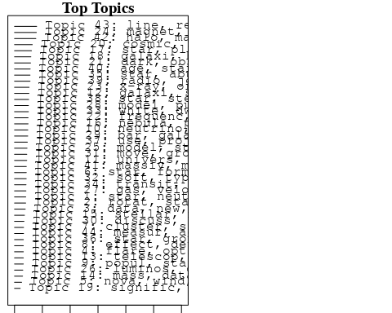

plotQuote(thoughts6, width = 30, main = "Topic 6")  
plotQuote(thoughts18, width = 30, main = "Topic 18")

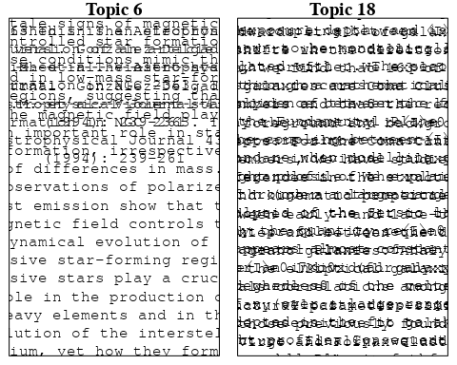

# Calculate and plot the correlation between topics  
mod.out.corr <- topicCorr(Research_topics)  
plot(mod.out.corr, cex = 1.5)  
  
  
# For each topic  
for (topic_num in 1:44) {  
 # Plot the word cloud  
 cloud(Research_topics, topic = topic_num, scale = c(2, 0.25))  
 Sys.sleep(2)  
}

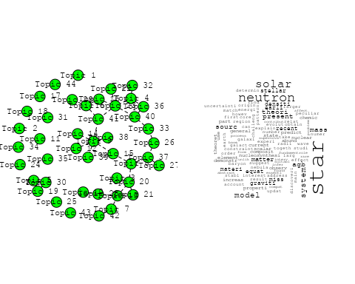

## Warning in wordcloud::wordcloud(words = vocab, freq = vec, max.words =  
## max.words, : sampl could not be fit on page. It will not be plotted.

## Warning in wordcloud::wordcloud(words = vocab, freq = vec, max.words =  
## max.words, : cross-correl could not be fit on page. It will not be plotted.

## Warning in wordcloud::wordcloud(words = vocab, freq = vec, max.words =  
## max.words, : energi could not be fit on page. It will not be plotted.

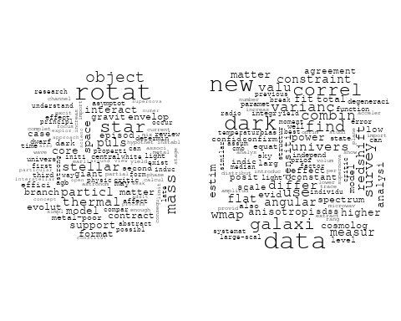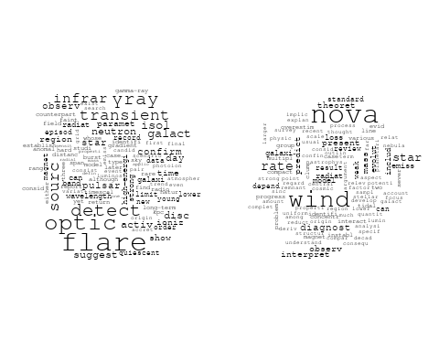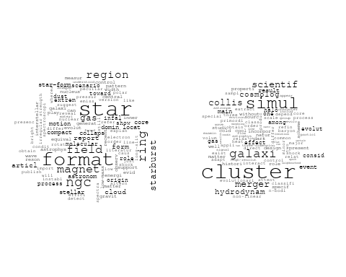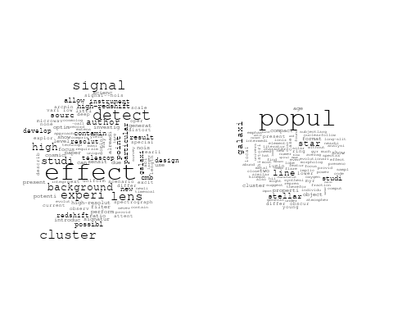

## Warning in wordcloud::wordcloud(words = vocab, freq = vec, max.words =  
## max.words, : black could not be fit on page. It will not be plotted.

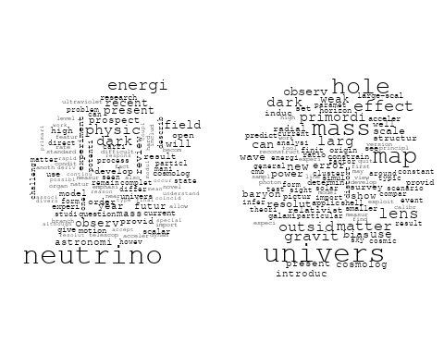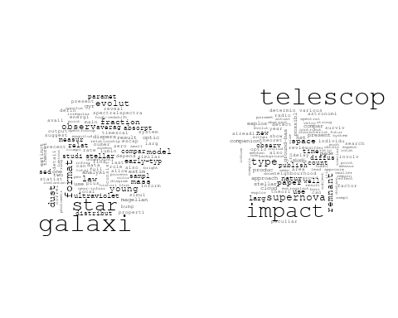

## Warning in wordcloud::wordcloud(words = vocab, freq = vec, max.words =  
## max.words, : model could not be fit on page. It will not be plotted.

## Warning in wordcloud::wordcloud(words = vocab, freq = vec, max.words =  
## max.words, : techniqu could not be fit on page. It will not be plotted.

## Warning in wordcloud::wordcloud(words = vocab, freq = vec, max.words =  
## max.words, : measur could not be fit on page. It will not be plotted.

## Warning in wordcloud::wordcloud(words = vocab, freq = vec, max.words =  
## max.words, : accuraci could not be fit on page. It will not be plotted.

## Warning in wordcloud::wordcloud(words = vocab, freq = vec, max.words =  
## max.words, : scatter could not be fit on page. It will not be plotted.

## Warning in wordcloud::wordcloud(words = vocab, freq = vec, max.words =  
## max.words, : earth could not be fit on page. It will not be plotted.

## Warning in wordcloud::wordcloud(words = vocab, freq = vec, max.words =  
## max.words, : observatori could not be fit on page. It will not be plotted.

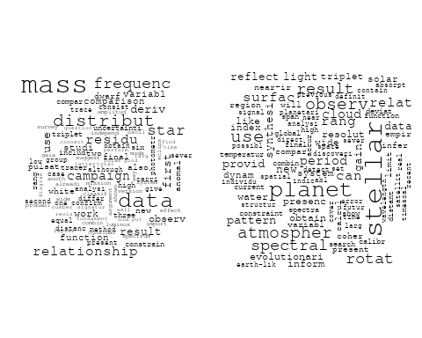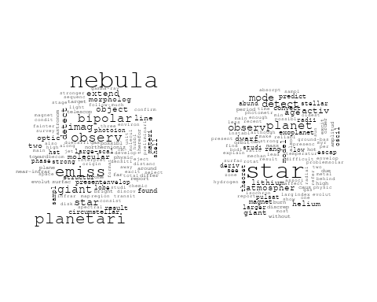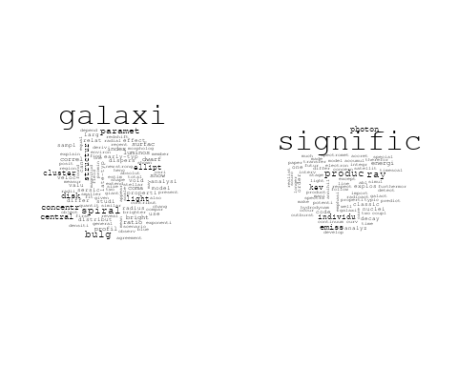

## Warning in wordcloud::wordcloud(words = vocab, freq = vec, max.words =  
## max.words, : gamma-ray could not be fit on page. It will not be plotted.

## Warning in wordcloud::wordcloud(words = vocab, freq = vec, max.words =  
## max.words, : matter could not be fit on page. It will not be plotted.

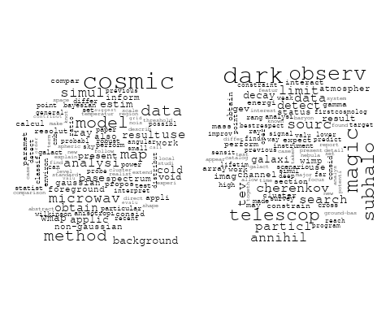

## Warning in wordcloud::wordcloud(words = vocab, freq = vec, max.words =  
## max.words, : oscil could not be fit on page. It will not be plotted.

## Warning in wordcloud::wordcloud(words = vocab, freq = vec, max.words =  
## max.words, : mode could not be fit on page. It will not be plotted.

## Warning in wordcloud::wordcloud(words = vocab, freq = vec, max.words =  
## max.words, : chromospher could not be fit on page. It will not be plotted.

## Warning in wordcloud::wordcloud(words = vocab, freq = vec, max.words =  
## max.words, : global could not be fit on page. It will not be plotted.

## Warning in wordcloud::wordcloud(words = vocab, freq = vec, max.words =  
## max.words, : properti could not be fit on page. It will not be plotted.

## Warning in wordcloud::wordcloud(words = vocab, freq = vec, max.words =  
## max.words, : secondari could not be fit on page. It will not be plotted.

## Warning in wordcloud::wordcloud(words = vocab, freq = vec, max.words =  
## max.words, : accret could not be fit on page. It will not be plotted.

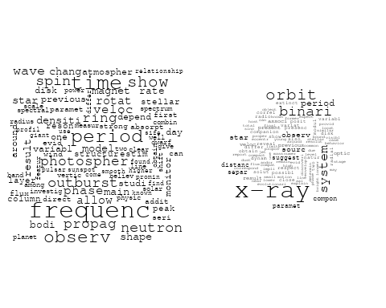

## Warning in wordcloud::wordcloud(words = vocab, freq = vec, max.words =  
## max.words, : ioniz could not be fit on page. It will not be plotted.

## Warning in wordcloud::wordcloud(words = vocab, freq = vec, max.words =  
## max.words, : electron could not be fit on page. It will not be plotted.

## Warning in wordcloud::wordcloud(words = vocab, freq = vec, max.words =  
## max.words, : explos could not be fit on page. It will not be plotted.

## Warning in wordcloud::wordcloud(words = vocab, freq = vec, max.words =  
## max.words, : metal could not be fit on page. It will not be plotted.

## Warning in wordcloud::wordcloud(words = vocab, freq = vec, max.words =  
## max.words, : mechan could not be fit on page. It will not be plotted.

## Warning in wordcloud::wordcloud(words = vocab, freq = vec, max.words =  
## max.words, : emiss could not be fit on page. It will not be plotted.

## Warning in wordcloud::wordcloud(words = vocab, freq = vec, max.words =  
## max.words, : presenc could not be fit on page. It will not be plotted.

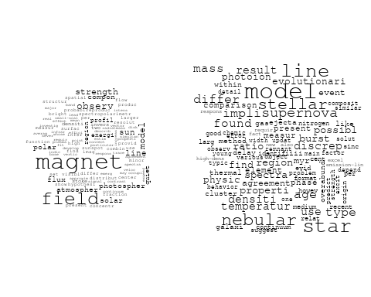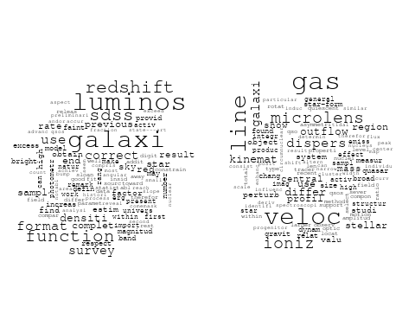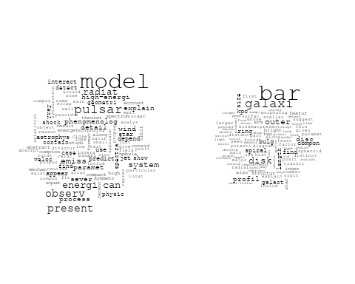

## Warning in wordcloud::wordcloud(words = vocab, freq = vec, max.words =  
## max.words, : solar could not be fit on page. It will not be plotted.

## Warning in wordcloud::wordcloud(words = vocab, freq = vec, max.words =  
## max.words, : may could not be fit on page. It will not be plotted.

## Warning in wordcloud::wordcloud(words = vocab, freq = vec, max.words =  
## max.words, : paramet could not be fit on page. It will not be plotted.

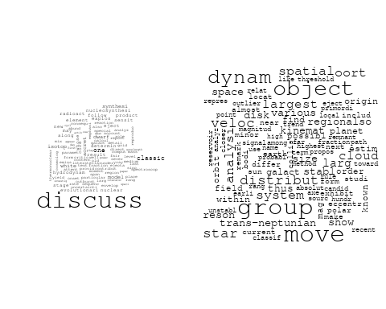

## Warning in wordcloud::wordcloud(words = vocab, freq = vec, max.words =  
## max.words, : emiss could not be fit on page. It will not be plotted.

## Warning in wordcloud::wordcloud(words = vocab, freq = vec, max.words =  
## max.words, : agn could not be fit on page. It will not be plotted.

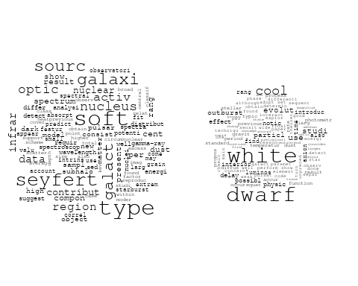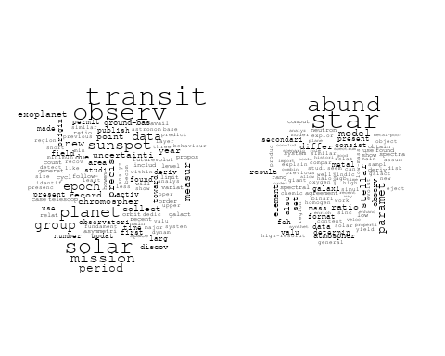

## Warning in wordcloud::wordcloud(words = vocab, freq = vec, max.words =  
## max.words, : compon could not be fit on page. It will not be plotted.

## Warning in wordcloud::wordcloud(words = vocab, freq = vec, max.words =  
## max.words, : project could not be fit on page. It will not be plotted.

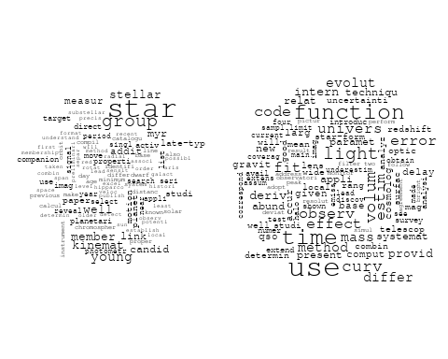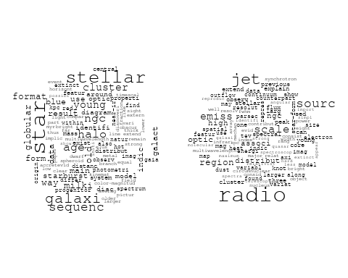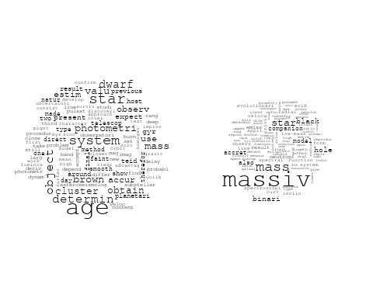

## Warning in wordcloud::wordcloud(words = vocab, freq = vec, max.words =  
## max.words, : region could not be fit on page. It will not be plotted.

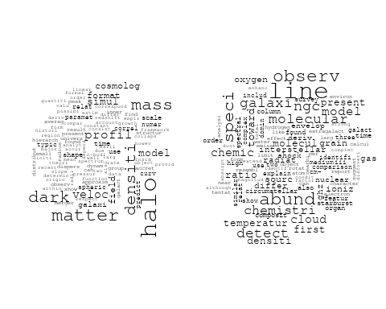

## Warning in wordcloud::wordcloud(words = vocab, freq = vec, max.words =  
## max.words, : photometr could not be fit on page. It will not be plotted.

## Warning in wordcloud::wordcloud(words = vocab, freq = vec, max.words =  
## max.words, : measur could not be fit on page. It will not be plotted.

## Warning in wordcloud::wordcloud(words = vocab, freq = vec, max.words =  
## max.words, : paramet could not be fit on page. It will not be plotted.

## Warning in wordcloud::wordcloud(words = vocab, freq = vec, max.words =  
## max.words, : survey could not be fit on page. It will not be plotted.

# Get the topic proportions for each document  
topic_proportions <- Research_topics$theta  
  
# Find the index of the topic with the highest proportion for each document  
# This will be the topic that each document is most likely to belong to  
max_topic_idx <- apply(topic_proportions, 1, which.max)  
  
# Add this as a new column to your data  
data_independent$topic <- max_topic_idx  
  
  
  
# Define the intervals  
intervals <- c('1824_1899', '1900_1964', '1965_1974', '1975_1984', '1985_1994', '1995_1999', '2000_2004', '2005_2009', '2010_2014', '2015_2019', '2020_2022')  
colors <- c('pink', 'blue', 'purple', 'yellow', 'green', 'pink', 'orange', 'violet', 'green', 'blue', 'pink')  
  
# Loop through the intervals and plot  
for(i in seq_along(intervals)){  
 # Filter data for when the pub_interval is equal to 1  
 data_filtered <- data_independent[data_independent[[paste0('pub_interval_', intervals[i])]] == 1,]  
   
 # Make the histogram  
   
 p <- ggplot(data_filtered, aes(x = topic)) +  
 geom_histogram(binwidth = 1, fill = colors[i], color = "black") +  
 xlab("Topic") +  
 ylab("Count") +  
 ggtitle(paste0("Topics from year ", gsub("_", " to ", intervals[i])))  
   
 print(p)  
}  
  
  
  
  
##Topic generation for IN (in collaboration) publications  
  
data_collab <- data[data[["IN"]] != 0,]  
  
# Save the original title data for future use  
data_collab$original_concatenated_title_abstract <- data_collab$concatenated_title_abstract  
  
#pre-processing the titles using textProcessor from the stm package  
processed_text <- textProcessor(data_collab$concatenated_title_abstract, metadata = data_collab)

## Building corpus...   
## Converting to Lower Case...   
## Removing punctuation...   
## Removing stopwords...   
## Removing numbers...   
## Stemming...   
## Creating Output...

# Further prepare the data by removing low-frequency terms  
out_text <- prepDocuments(processed_text$documents, processed_text$vocab, processed_text$meta)

## Removing 2086 of 6741 terms (2086 of 85067 tokens) due to frequency   
## Your corpus now has 1126 documents, 4655 terms and 82981 tokens.

docs_text <- out_text$documents  
vocab_text <- out_text$vocab  
meta_text <- out_text$meta  
  
  
#Prepare data  
plotRemoved(processed_text$documents, lower.thresh = seq(1, 200, by = 100))

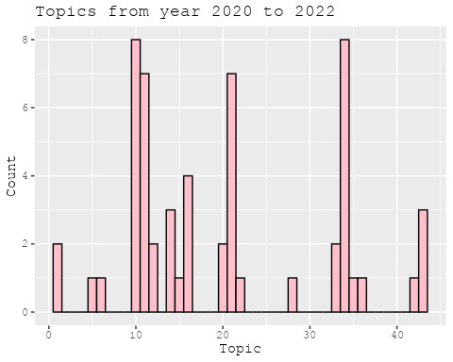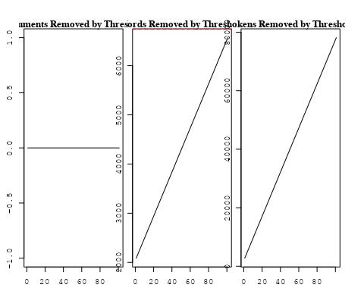

out_text <- prepDocuments(processed_text$documents, processed_text$vocab, processed_text$meta, lower.thresh = 8)

## Removing 5142 of 6741 terms (12471 of 85067 tokens) due to frequency   
## Your corpus now has 1126 documents, 1599 terms and 72596 tokens.

str(out_text$meta)

## 'data.frame': 1126 obs. of 39 variables:  
## $ concept_id : chr "https://openalex.org/C1276947" "https://openalex.org/C44870925" "https://openalex.org/C44870925" "https://openalex.org/C44870925" ...  
## $ work_id : chr "https://openalex.org/W3104346433" "https://openalex.org/W2948771331" "https://openalex.org/W3101308139" "https://openalex.org/W1586945094" ...  
## $ publication_year : int 2003 2019 2006 1998 2004 2007 2006 1997 2010 2010 ...  
## $ title : chr "The Origin of X-shaped Radio Galaxies: Clues from the Z-symmetric Secondary Lobes" "Observational constraints on viscous Ricci dark energy model" "Photometric and spectroscopic evolution of the type IIP supernova SN 2004et" "A stellar origin for the short-lived nuclides in the early Solar System" ...  
## $ paperabstract : chr "Existing radio images of a few X-shaped radio galaxies reveal Z-symmetric morphologies in their weaker secondar"| __truncated__ "In this paper, Ricci dark energy (RDE) model with bulk viscosity is studied to observe the cosmic accelerating "| __truncated__ "We present optical photometry and spectroscopy of the normal type IIP supernova SN2004A, which was discovered i"| __truncated__ "Primitive meteorites contain isotopes that are the decay products of short-lived nuclides in the early Solar Sy"| __truncated__ ...  
## $ country : chr "IN US" "IN IN" "IN IN" "US IN" ...  
## $ year_concept : chr "2003+https://openalex.org/C1276947" "2019+https://openalex.org/C44870925" "2006+https://openalex.org/C44870925" "1998+https://openalex.org/C44870925" ...  
## $ concatenated_title_abstract : chr "The Origin of X-shaped Radio Galaxies: Clues from the Z-symmetric Secondary Lobes Existing radio images of a fe"| __truncated__ "Observational constraints on viscous Ricci dark energy model In this paper, Ricci dark energy (RDE) model with "| __truncated__ "Photometric and spectroscopic evolution of the type IIP supernova SN 2004et We present optical photometry and s"| __truncated__ "A stellar origin for the short-lived nuclides in the early Solar System Primitive meteorites contain isotopes t"| __truncated__ ...  
## $ US : num 50 0 0 50 50 0 0 0 0 0 ...  
## $ IN : num 50 100 100 50 50 100 100 100 100 100 ...  
## $ DE : num 0 0 0 0 0 0 0 0 0 0 ...  
## $ CH : num 0 0 0 0 0 0 0 0 0 0 ...  
## $ GB : num 0 0 0 0 0 0 0 0 0 0 ...  
## $ CN : num 0 0 0 0 0 0 0 0 0 0 ...  
## $ FR : num 0 0 0 0 0 0 0 0 0 0 ...  
## $ IT : num 0 0 0 0 0 0 0 0 0 0 ...  
## $ RU : num 0 0 0 0 0 0 0 0 0 0 ...  
## $ CA : num 0 0 0 0 0 0 0 0 0 0 ...  
## $ NL : num 0 0 0 0 0 0 0 0 0 0 ...  
## $ AU : num 0 0 0 0 0 0 0 0 0 0 ...  
## $ JP : num 0 0 0 0 0 0 0 0 0 0 ...  
## $ ES : num 0 0 0 0 0 0 0 0 0 0 ...  
## $ IL : num 0 0 0 0 0 0 0 0 0 0 ...  
## $ Americas : num 0 0 0 0 0 0 0 0 0 0 ...  
## $ Europe : num 0 0 0 0 0 0 0 0 0 0 ...  
## $ Africa : num 0 0 0 0 0 0 0 0 0 0 ...  
## $ AsiaAndOceania : num 0 0 0 0 0 0 0 0 0 0 ...  
## $ pub_interval_2020_2022 : int 0 0 0 0 0 0 0 0 0 0 ...  
## $ pub_interval_2015_2019 : int 0 1 0 0 0 0 0 0 0 0 ...  
## $ pub_interval_2010_2014 : int 0 0 0 0 0 0 0 0 1 1 ...  
## $ pub_interval_2005_2009 : int 0 0 1 0 0 1 1 0 0 0 ...  
## $ pub_interval_2000_2004 : int 1 0 0 0 1 0 0 0 0 0 ...  
## $ pub_interval_1995_1999 : int 0 0 0 1 0 0 0 1 0 0 ...  
## $ pub_interval_1985_1994 : int 0 0 0 0 0 0 0 0 0 0 ...  
## $ pub_interval_1975_1984 : int 0 0 0 0 0 0 0 0 0 0 ...  
## $ pub_interval_1965_1974 : int 0 0 0 0 0 0 0 0 0 0 ...  
## $ pub_interval_1900_1964 : int 0 0 0 0 0 0 0 0 0 0 ...  
## $ pub_interval_1824_1899 : int 0 0 0 0 0 0 0 0 0 0 ...  
## $ original_concatenated_title_abstract: chr "The Origin of X-shaped Radio Galaxies: Clues from the Z-symmetric Secondary Lobes Existing radio images of a fe"| __truncated__ "Observational constraints on viscous Ricci dark energy model In this paper, Ricci dark energy (RDE) model with "| __truncated__ "Photometric and spectroscopic evolution of the type IIP supernova SN 2004et We present optical photometry and s"| __truncated__ "A stellar origin for the short-lived nuclides in the early Solar System Primitive meteorites contain isotopes t"| __truncated__ ...

# Initialize an empty formula string  
prevalence_formula_str <- "~"  
  
# Define the publication intervals  
pub_intervals <- c("pub_interval_2020_2022", "pub_interval_2015_2019", "pub_interval_2010_2014",   
 "pub_interval_2005_2009", "pub_interval_2000_2004", "pub_interval_1995_1999",  
 "pub_interval_1985_1994", "pub_interval_1975_1984", "pub_interval_1965_1974",  
 "pub_interval_1900_1964", "pub_interval_1824_1899")  
  
# Add each publication interval to the formula string  
for (interval in pub_intervals) {  
 # add an if statement to handle the first addition (without '+')  
 if (prevalence_formula_str == "~") {  
 prevalence_formula_str <- paste(prevalence_formula_str, interval)  
 } else {  
 prevalence_formula_str <- paste(prevalence_formula_str, "+", interval)  
 }  
}  
  
  
# Convert the string to a formula  
prevalence_formula <- as.formula(prevalence_formula_str)  
print(prevalence_formula)

## ~pub_interval_2020_2022 + pub_interval_2015_2019 + pub_interval_2010_2014 +   
## pub_interval_2005_2009 + pub_interval_2000_2004 + pub_interval_1995_1999 +   
## pub_interval_1985_1994 + pub_interval_1975_1984 + pub_interval_1965_1974 +   
## pub_interval_1900_1964 + pub_interval_1824_1899

# Run STM model  
Research_topics <- stm(documents = out_text$documents,   
 vocab = out_text$vocab,   
 K = 44,   
 prevalence = prevalence_formula,   
 data = out_text$meta,   
 init.type = "Spectral",  
 max.em.its = 1000,  
 gamma.prior = 'L1')

## Beginning Spectral Initialization   
## Calculating the gram matrix...  
## Finding anchor words...  
## ............................................  
## Recovering initialization...  
## ...............  
## Initialization complete.  
## ......................................................................................................  
## Completed E-Step (1 seconds).   
## Completed M-Step.   
## Completing Iteration 1 (approx. per word bound = -6.117)   
## ......................................................................................................  
## Completed E-Step (1 seconds).   
## Completed M-Step.   
## Completing Iteration 2 (approx. per word bound = -5.831, relative change = 4.665e-02)   
## ......................................................................................................  
## Completed E-Step (0 seconds).   
## Completed M-Step.   
## Completing Iteration 3 (approx. per word bound = -5.754, relative change = 1.327e-02)   
## ......................................................................................................  
## Completed E-Step (0 seconds).   
## Completed M-Step.   
## Completing Iteration 4 (approx. per word bound = -5.721, relative change = 5.670e-03)   
## ......................................................................................................  
## Completed E-Step (0 seconds).   
## Completed M-Step.   
## Completing Iteration 5 (approx. per word bound = -5.706, relative change = 2.734e-03)   
## Topic 1: solar, rotat, use, abund, cycl   
## Topic 2: period, glitch, pulsar, observ, time   
## Topic 3: galaxi, distribut, disc, morpholog, find   
## Topic 4: cluster, data, compon, analysi, use   
## Topic 5: system, absorpt, detect, line, -cm   
## Topic 6: pulsar, null, puls, emiss, radio   
## Topic 7: x-ray, observ, orbit, binari, time   
## Topic 8: disk, star, halo, potenti, respons   
## Topic 9: star, compact, physic, model, solut   
## Topic 10: cosmic, ray, energi, galaxi, particl   
## Topic 11: variabl, blazar, optic, lac, observ   
## Topic 12: dark, energi, model, paramet, matter   
## Topic 13: data, model, radio, correct, detect   
## Topic 14: radio, galaxi, sourc, jet, structur   
## Topic 15: magnet, field, turbul, flux, dynamo   
## Topic 16: observ, data, supernova, model, paramet   
## Topic 17: model, paramet, cosmolog, univers, observ   
## Topic 18: burst, class, observ, time, type   
## Topic 19: radio, galaxi, agn, ioniz, model   
## Topic 20: x-ray, flare, state, spectral, sourc   
## Topic 21: star, cluster, lyra, variabl, curv   
## Topic 22: galaxi, telescop, star, optic, imag   
## Topic 23: signific, densiti, temperatur, effect, found   
## Topic 24: radio, sourc, mhz, observ, polar   
## Topic 25: star, model, neutron, inner, energi   
## Topic 26: ngc, cluster, imag, use, detect   
## Topic 27: star, disc, abund, metal, element   
## Topic 28: observ, spectrum, measur, power, scintil   
## Topic 29: design, instrument, telescop, present, measur   
## Topic 30: star, planet, mass, may, euv   
## Topic 31: mass, galaxi, cluster, use, relat   
## Topic 32: quasar, radio, optic, luminos, use   
## Topic 33: observ, telescop, energi, γray, nebula   
## Topic 34: dust, polar, observ, grain, interstellar   
## Topic 35: hole, black, flow, shock, accret   
## Topic 36: star, neutron, pulsar, field, magnet   
## Topic 37: region, observ, erupt, coron, activ   
## Topic 38: radio, supernova, type, mass, observ   
## Topic 39: solar, flare, cycl, studi, activ   
## Topic 40: cluster, star, region, mass, found   
## Topic 41: field, matter, dark, univers, can   
## Topic 42: emiss, radio, new, drift, observ   
## Topic 43: line, spectra, optic, show, nova   
## Topic 44: model, statefind, dark, energi, univers   
## ......................................................................................................  
## Completed E-Step (0 seconds).   
## Completed M-Step.   
## Completing Iteration 6 (approx. per word bound = -5.696, relative change = 1.599e-03)   
## ......................................................................................................  
## Completed E-Step (0 seconds).   
## Completed M-Step.   
## Completing Iteration 7 (approx. per word bound = -5.690, relative change = 1.139e-03)   
## ......................................................................................................  
## Completed E-Step (0 seconds).   
## Completed M-Step.   
## Completing Iteration 8 (approx. per word bound = -5.685, relative change = 8.632e-04)   
## ......................................................................................................  
## Completed E-Step (0 seconds).   
## Completed M-Step.   
## Completing Iteration 9 (approx. per word bound = -5.682, relative change = 6.025e-04)   
## ......................................................................................................  
## Completed E-Step (0 seconds).   
## Completed M-Step.   
## Completing Iteration 10 (approx. per word bound = -5.679, relative change = 4.828e-04)   
## Topic 1: solar, rotat, use, variat, cycl   
## Topic 2: period, glitch, pulsar, observ, time   
## Topic 3: galaxi, distribut, disc, morpholog, dwarf   
## Topic 4: cluster, data, compon, use, analysi   
## Topic 5: system, absorpt, detect, line, -cm   
## Topic 6: pulsar, null, puls, emiss, profil   
## Topic 7: x-ray, observ, orbit, binari, time   
## Topic 8: disk, star, halo, potenti, accret   
## Topic 9: star, model, compact, solut, condit   
## Topic 10: ray, cosmic, energi, particl, galaxi   
## Topic 11: variabl, blazar, optic, lac, observ   
## Topic 12: dark, energi, model, paramet, matter   
## Topic 13: model, data, radio, detect, solar   
## Topic 14: radio, galaxi, sourc, jet, structur   
## Topic 15: magnet, field, turbul, wave, dynamo   
## Topic 16: observ, data, supernova, model, paramet   
## Topic 17: model, paramet, cosmolog, univers, observ   
## Topic 18: burst, observ, class, time, x-ray   
## Topic 19: radio, galaxi, agn, ioniz, nucleus   
## Topic 20: x-ray, flare, state, spectral, sourc   
## Topic 21: star, cluster, lyra, curv, variabl   
## Topic 22: galaxi, star, telescop, optic, imag   
## Topic 23: effect, signific, densiti, temperatur, found   
## Topic 24: radio, sourc, mhz, observ, galaxi   
## Topic 25: star, neutron, inner, outer, doubl   
## Topic 26: ngc, imag, cluster, use, detect   
## Topic 27: star, disc, abund, element, chemic   
## Topic 28: observ, spectrum, measur, power, scintil   
## Topic 29: design, telescop, present, measur, instrument   
## Topic 30: star, planet, mass, euv, may   
## Topic 31: mass, galaxi, cluster, use, relat   
## Topic 32: quasar, radio, optic, luminos, use   
## Topic 33: observ, telescop, energi, γray, nebula   
## Topic 34: dust, polar, observ, grain, interstellar   
## Topic 35: black, hole, flow, accret, shock   
## Topic 36: star, neutron, pulsar, field, magnet   
## Topic 37: region, coron, observ, erupt, flare   
## Topic 38: radio, supernova, type, observ, mass   
## Topic 39: solar, flare, cycl, activ, studi   
## Topic 40: cluster, star, region, age, mass   
## Topic 41: matter, field, dark, cosmic, univers   
## Topic 42: emiss, sequenc, drift, radio, studi   
## Topic 43: line, spectra, optic, nova, show   
## Topic 44: model, statefind, energi, dark, univers   
## ......................................................................................................  
## Completed E-Step (0 seconds).   
## Completed M-Step.   
## Completing Iteration 11 (approx. per word bound = -5.676, relative change = 4.486e-04)   
## ......................................................................................................  
## Completed E-Step (0 seconds).   
## Completed M-Step.   
## Completing Iteration 12 (approx. per word bound = -5.674, relative change = 3.782e-04)   
## ......................................................................................................  
## Completed E-Step (0 seconds).   
## Completed M-Step.   
## Completing Iteration 13 (approx. per word bound = -5.672, relative change = 3.213e-04)   
## ......................................................................................................  
## Completed E-Step (0 seconds).   
## Completed M-Step.   
## Completing Iteration 14 (approx. per word bound = -5.671, relative change = 2.578e-04)   
## ......................................................................................................  
## Completed E-Step (0 seconds).   
## Completed M-Step.   
## Completing Iteration 15 (approx. per word bound = -5.670, relative change = 2.271e-04)   
## Topic 1: solar, rotat, use, variat, cycl   
## Topic 2: period, glitch, pulsar, observ, time   
## Topic 3: galaxi, distribut, disc, morpholog, find   
## Topic 4: cluster, data, use, compon, group   
## Topic 5: system, absorpt, detect, line, -cm   
## Topic 6: pulsar, null, emiss, puls, profil   
## Topic 7: x-ray, observ, orbit, binari, time   
## Topic 8: disk, star, halo, potenti, accret   
## Topic 9: model, star, compact, solut, condit   
## Topic 10: ray, cosmic, energi, particl, sourc   
## Topic 11: variabl, optic, blazar, observ, lac   
## Topic 12: dark, energi, paramet, model, matter   
## Topic 13: model, data, radio, detect, solar   
## Topic 14: radio, galaxi, sourc, jet, structur   
## Topic 15: magnet, field, turbul, wave, dynamo   
## Topic 16: observ, data, model, paramet, supernova   
## Topic 17: model, paramet, cosmolog, univers, energi   
## Topic 18: burst, observ, class, time, x-ray   
## Topic 19: radio, galaxi, agn, ioniz, nucleus   
## Topic 20: x-ray, flare, state, spectral, sourc   
## Topic 21: star, cluster, lyra, curv, variabl   
## Topic 22: galaxi, star, telescop, optic, imag   
## Topic 23: effect, densiti, signific, temperatur, found   
## Topic 24: radio, sourc, mhz, observ, galaxi   
## Topic 25: star, neutron, inner, outer, doubl   
## Topic 26: ngc, imag, use, cluster, detect   
## Topic 27: star, abund, disc, element, show   
## Topic 28: observ, spectrum, measur, power, scintil   
## Topic 29: design, telescop, present, measur, instrument   
## Topic 30: star, planet, mass, euv, rate   
## Topic 31: mass, galaxi, cluster, use, relat   
## Topic 32: quasar, radio, optic, luminos, use   
## Topic 33: observ, telescop, energi, γray, nebula   
## Topic 34: dust, polar, observ, grain, interstellar   
## Topic 35: black, hole, flow, accret, shock   
## Topic 36: star, neutron, pulsar, field, magnet   
## Topic 37: region, observ, coron, erupt, flare   
## Topic 38: radio, supernova, observ, type, mass   
## Topic 39: solar, flare, cycl, activ, studi   
## Topic 40: cluster, star, region, age, found   
## Topic 41: matter, dark, field, can, univers   
## Topic 42: emiss, sequenc, studi, drift, new   
## Topic 43: line, spectra, optic, nova, light   
## Topic 44: model, statefind, energi, dark, univers   
## ......................................................................................................  
## Completed E-Step (0 seconds).   
## Completed M-Step.   
## Completing Iteration 16 (approx. per word bound = -5.669, relative change = 1.981e-04)   
## ......................................................................................................  
## Completed E-Step (0 seconds).   
## Completed M-Step.   
## Completing Iteration 17 (approx. per word bound = -5.668, relative change = 1.644e-04)   
## ......................................................................................................  
## Completed E-Step (0 seconds).   
## Completed M-Step.   
## Completing Iteration 18 (approx. per word bound = -5.667, relative change = 1.576e-04)   
## ......................................................................................................  
## Completed E-Step (0 seconds).   
## Completed M-Step.   
## Completing Iteration 19 (approx. per word bound = -5.666, relative change = 1.587e-04)   
## ......................................................................................................  
## Completed E-Step (0 seconds).   
## Completed M-Step.   
## Completing Iteration 20 (approx. per word bound = -5.665, relative change = 1.603e-04)   
## Topic 1: solar, rotat, use, variat, abund   
## Topic 2: period, glitch, pulsar, observ, time   
## Topic 3: galaxi, distribut, disc, morpholog, find   
## Topic 4: cluster, data, use, group, compon   
## Topic 5: system, absorpt, detect, line, -cm   
## Topic 6: pulsar, null, emiss, puls, profil   
## Topic 7: x-ray, observ, orbit, kev, binari   
## Topic 8: disk, star, halo, potenti, accret   
## Topic 9: model, star, compact, solut, condit   
## Topic 10: ray, cosmic, energi, particl, galaxi   
## Topic 11: variabl, optic, blazar, observ, lac   
## Topic 12: dark, energi, paramet, can, model   
## Topic 13: model, data, radio, solar, detect   
## Topic 14: radio, galaxi, sourc, jet, structur   
## Topic 15: magnet, field, turbul, wave, dynamo   
## Topic 16: observ, data, model, paramet, supernova   
## Topic 17: model, paramet, cosmolog, univers, energi   
## Topic 18: burst, class, observ, time, x-ray   
## Topic 19: galaxi, radio, agn, ioniz, nucleus   
## Topic 20: x-ray, flare, state, spectral, sourc   
## Topic 21: star, cluster, lyra, curv, variabl   
## Topic 22: galaxi, star, telescop, optic, imag   
## Topic 23: effect, densiti, signific, temperatur, found   
## Topic 24: radio, sourc, mhz, observ, galaxi   
## Topic 25: star, inner, neutron, outer, doubl   
## Topic 26: ngc, imag, use, cluster, detect   
## Topic 27: star, abund, disc, element, show   
## Topic 28: observ, spectrum, measur, power, scintil   
## Topic 29: design, telescop, present, measur, instrument   
## Topic 30: star, planet, mass, euv, rate   
## Topic 31: mass, galaxi, cluster, use, halo   
## Topic 32: quasar, radio, optic, luminos, use   
## Topic 33: observ, telescop, energi, γray, tev   
## Topic 34: dust, polar, observ, grain, interstellar   
## Topic 35: black, hole, flow, accret, shock   
## Topic 36: star, neutron, pulsar, field, magnet   
## Topic 37: region, observ, coron, flare, erupt   
## Topic 38: radio, supernova, observ, type, mass   
## Topic 39: solar, flare, cycl, activ, studi   
## Topic 40: cluster, star, region, age, found   
## Topic 41: matter, dark, field, can, galact   
## Topic 42: emiss, sequenc, studi, drift, new   
## Topic 43: line, spectra, optic, nova, light   
## Topic 44: model, statefind, dark, energi, univers   
## ......................................................................................................  
## Completed E-Step (0 seconds).   
## Completed M-Step.   
## Completing Iteration 21 (approx. per word bound = -5.664, relative change = 1.502e-04)   
## ......................................................................................................  
## Completed E-Step (0 seconds).   
## Completed M-Step.   
## Completing Iteration 22 (approx. per word bound = -5.663, relative change = 1.373e-04)   
## ......................................................................................................  
## Completed E-Step (0 seconds).   
## Completed M-Step.   
## Completing Iteration 23 (approx. per word bound = -5.663, relative change = 1.003e-04)   
## ......................................................................................................  
## Completed E-Step (0 seconds).   
## Completed M-Step.   
## Completing Iteration 24 (approx. per word bound = -5.662, relative change = 1.519e-04)   
## ......................................................................................................  
## Completed E-Step (0 seconds).   
## Completed M-Step.   
## Completing Iteration 25 (approx. per word bound = -5.661, relative change = 1.089e-04)   
## Topic 1: solar, rotat, use, variat, period   
## Topic 2: period, glitch, pulsar, observ, time   
## Topic 3: galaxi, distribut, disc, morpholog, find   
## Topic 4: cluster, data, group, use, compon   
## Topic 5: system, absorpt, detect, line, -cm   
## Topic 6: pulsar, null, emiss, puls, profil   
## Topic 7: x-ray, observ, orbit, kev, time   
## Topic 8: disk, star, halo, potenti, accret   
## Topic 9: model, star, compact, solut, condit   
## Topic 10: ray, cosmic, energi, galaxi, particl   
## Topic 11: variabl, optic, blazar, observ, lac   
## Topic 12: dark, energi, can, redshift, paramet   
## Topic 13: model, data, radio, solar, cycl   
## Topic 14: radio, galaxi, sourc, jet, structur   
## Topic 15: magnet, field, turbul, wave, dynamo   
## Topic 16: observ, data, model, paramet, supernova   
## Topic 17: model, paramet, cosmolog, univers, energi   
## Topic 18: burst, class, observ, time, x-ray   
## Topic 19: galaxi, radio, agn, ioniz, nucleus   
## Topic 20: x-ray, flare, spectral, state, sourc   
## Topic 21: star, cluster, lyra, curv, paramet   
## Topic 22: galaxi, star, telescop, optic, imag   
## Topic 23: densiti, effect, signific, temperatur, found   
## Topic 24: radio, sourc, mhz, observ, galaxi   
## Topic 25: star, inner, outer, doubl, neutron   
## Topic 26: ngc, imag, use, cluster, detect   
## Topic 27: star, abund, disc, element, show   
## Topic 28: observ, spectrum, power, measur, scintil   
## Topic 29: design, telescop, present, measur, instrument   
## Topic 30: star, planet, mass, euv, rate   
## Topic 31: mass, galaxi, cluster, use, halo   
## Topic 32: quasar, radio, optic, luminos, use   
## Topic 33: observ, telescop, energi, γray, tev   
## Topic 34: dust, polar, observ, grain, interstellar   
## Topic 35: black, hole, flow, accret, shock   
## Topic 36: star, neutron, pulsar, field, magnet   
## Topic 37: region, observ, coron, flare, erupt   
## Topic 38: radio, observ, supernova, type, mass   
## Topic 39: solar, flare, cycl, activ, studi   
## Topic 40: cluster, star, region, age, found   
## Topic 41: matter, dark, field, can, scale   
## Topic 42: emiss, sequenc, studi, drift, radio   
## Topic 43: line, spectra, optic, nova, light   
## Topic 44: model, statefind, dark, energi, univers   
## ......................................................................................................  
## Completed E-Step (0 seconds).   
## Completed M-Step.   
## Completing Iteration 26 (approx. per word bound = -5.661, relative change = 8.722e-05)   
## ......................................................................................................  
## Completed E-Step (0 seconds).   
## Completed M-Step.   
## Completing Iteration 27 (approx. per word bound = -5.660, relative change = 8.372e-05)   
## ......................................................................................................  
## Completed E-Step (0 seconds).   
## Completed M-Step.   
## Completing Iteration 28 (approx. per word bound = -5.660, relative change = 7.555e-05)   
## ......................................................................................................  
## Completed E-Step (0 seconds).   
## Completed M-Step.   
## Completing Iteration 29 (approx. per word bound = -5.659, relative change = 7.093e-05)   
## ......................................................................................................  
## Completed E-Step (0 seconds).   
## Completed M-Step.   
## Completing Iteration 30 (approx. per word bound = -5.659, relative change = 6.323e-05)   
## Topic 1: solar, rotat, use, variat, period   
## Topic 2: period, glitch, pulsar, observ, time   
## Topic 3: galaxi, distribut, disc, morpholog, find   
## Topic 4: cluster, data, group, use, compon   
## Topic 5: system, absorpt, detect, line, -cm   
## Topic 6: pulsar, null, emiss, puls, profil   
## Topic 7: x-ray, observ, orbit, time, kev   
## Topic 8: disk, star, halo, potenti, accret   
## Topic 9: model, star, compact, solut, condit   
## Topic 10: ray, cosmic, energi, galaxi, particl   
## Topic 11: variabl, optic, blazar, observ, lac   
## Topic 12: dark, energi, can, redshift, equat   
## Topic 13: model, data, radio, solar, cycl   
## Topic 14: radio, galaxi, sourc, jet, structur   
## Topic 15: magnet, field, turbul, wave, dynamo   
## Topic 16: observ, data, model, paramet, energi   
## Topic 17: model, paramet, cosmolog, univers, energi   
## Topic 18: burst, class, observ, time, x-ray   
## Topic 19: galaxi, radio, agn, ioniz, nucleus   
## Topic 20: x-ray, flare, spectral, state, sourc   
## Topic 21: star, cluster, lyra, curv, paramet   
## Topic 22: galaxi, star, telescop, optic, imag   
## Topic 23: densiti, signific, effect, temperatur, model   
## Topic 24: radio, sourc, mhz, observ, galaxi   
## Topic 25: star, inner, outer, doubl, neutron   
## Topic 26: ngc, imag, use, cluster, detect   
## Topic 27: star, abund, disc, element, show   
## Topic 28: observ, spectrum, power, measur, scintil   
## Topic 29: design, telescop, present, measur, instrument   
## Topic 30: star, planet, mass, euv, rate   
## Topic 31: mass, galaxi, cluster, use, halo   
## Topic 32: quasar, radio, optic, luminos, use   
## Topic 33: observ, telescop, energi, γray, tev   
## Topic 34: dust, polar, observ, grain, interstellar   
## Topic 35: black, hole, flow, accret, shock   
## Topic 36: star, neutron, pulsar, field, magnet   
## Topic 37: region, observ, coron, flare, erupt   
## Topic 38: radio, type, observ, supernova, mass   
## Topic 39: solar, flare, cycl, activ, studi   
## Topic 40: cluster, star, region, age, found   
## Topic 41: matter, dark, field, can, scale   
## Topic 42: emiss, sequenc, studi, drift, radio   
## Topic 43: line, spectra, nova, optic, light   
## Topic 44: model, statefind, dark, energi, univers   
## ......................................................................................................  
## Completed E-Step (0 seconds).   
## Completed M-Step.   
## Completing Iteration 31 (approx. per word bound = -5.659, relative change = 6.923e-05)   
## ......................................................................................................  
## Completed E-Step (0 seconds).   
## Completed M-Step.   
## Completing Iteration 32 (approx. per word bound = -5.658, relative change = 8.006e-05)   
## ......................................................................................................  
## Completed E-Step (0 seconds).   
## Completed M-Step.   
## Completing Iteration 33 (approx. per word bound = -5.658, relative change = 8.422e-05)   
## ......................................................................................................  
## Completed E-Step (0 seconds).   
## Completed M-Step.   
## Completing Iteration 34 (approx. per word bound = -5.657, relative change = 9.526e-05)   
## ......................................................................................................  
## Completed E-Step (0 seconds).   
## Completed M-Step.   
## Completing Iteration 35 (approx. per word bound = -5.657, relative change = 4.611e-05)   
## Topic 1: solar, rotat, use, variat, period   
## Topic 2: period, glitch, pulsar, observ, time   
## Topic 3: galaxi, distribut, disc, morpholog, find   
## Topic 4: cluster, data, use, group, classif   
## Topic 5: system, absorpt, detect, line, -cm   
## Topic 6: pulsar, null, emiss, puls, profil   
## Topic 7: x-ray, observ, orbit, time, kev   
## Topic 8: disk, star, halo, potenti, accret   
## Topic 9: model, star, compact, solut, condit   
## Topic 10: ray, cosmic, energi, galaxi, particl   
## Topic 11: variabl, optic, blazar, observ, lac   
## Topic 12: dark, energi, equat, redshift, interact   
## Topic 13: model, data, radio, solar, cycl   
## Topic 14: radio, galaxi, sourc, jet, structur   
## Topic 15: magnet, field, turbul, wave, dynamo   
## Topic 16: observ, data, model, energi, supernova   
## Topic 17: model, paramet, cosmolog, univers, energi   
## Topic 18: burst, class, observ, time, x-ray   
## Topic 19: galaxi, radio, agn, ioniz, nucleus   
## Topic 20: x-ray, flare, spectral, state, sourc   
## Topic 21: star, cluster, lyra, curv, paramet   
## Topic 22: galaxi, star, telescop, optic, imag   
## Topic 23: densiti, signific, effect, temperatur, loop   
## Topic 24: radio, sourc, mhz, observ, galaxi   
## Topic 25: star, inner, doubl, outer, neutron   
## Topic 26: ngc, imag, use, cluster, detect   
## Topic 27: star, abund, disc, element, dwarf   
## Topic 28: observ, spectrum, power, measur, scintil   
## Topic 29: design, present, telescop, measur, instrument   
## Topic 30: star, planet, mass, euv, rate   
## Topic 31: mass, galaxi, cluster, use, halo   
## Topic 32: quasar, radio, optic, luminos, use   
## Topic 33: observ, telescop, energi, γray, tev   
## Topic 34: dust, polar, observ, grain, model   
## Topic 35: black, hole, flow, accret, shock   
## Topic 36: star, neutron, pulsar, field, magnet   
## Topic 37: region, observ, flare, magnet, erupt   
## Topic 38: type, radio, observ, mass, associ   
## Topic 39: solar, flare, cycl, activ, studi   
## Topic 40: cluster, star, region, age, found   
## Topic 41: matter, dark, field, can, scale   
## Topic 42: emiss, sequenc, studi, drift, radio   
## Topic 43: line, spectra, nova, optic, light   
## Topic 44: model, statefind, dark, energi, univers   
## ......................................................................................................  
## Completed E-Step (0 seconds).   
## Completed M-Step.   
## Completing Iteration 36 (approx. per word bound = -5.656, relative change = 1.012e-04)   
## ......................................................................................................  
## Completed E-Step (0 seconds).   
## Completed M-Step.   
## Completing Iteration 37 (approx. per word bound = -5.656, relative change = 5.330e-05)   
## ......................................................................................................  
## Completed E-Step (0 seconds).   
## Completed M-Step.   
## Completing Iteration 38 (approx. per word bound = -5.656, relative change = 6.371e-05)   
## ......................................................................................................  
## Completed E-Step (0 seconds).   
## Completed M-Step.   
## Completing Iteration 39 (approx. per word bound = -5.655, relative change = 5.852e-05)   
## ......................................................................................................  
## Completed E-Step (0 seconds).   
## Completed M-Step.   
## Completing Iteration 40 (approx. per word bound = -5.655, relative change = 4.752e-05)   
## Topic 1: solar, rotat, use, variat, period   
## Topic 2: period, glitch, pulsar, observ, time   
## Topic 3: galaxi, distribut, disc, morpholog, find   
## Topic 4: cluster, data, use, group, classif   
## Topic 5: system, absorpt, detect, line, -cm   
## Topic 6: pulsar, null, emiss, puls, profil   
## Topic 7: x-ray, observ, orbit, time, kev   
## Topic 8: disk, star, halo, potenti, accret   
## Topic 9: model, star, compact, solut, condit   
## Topic 10: ray, cosmic, energi, particl, galaxi   
## Topic 11: variabl, optic, blazar, observ, lac   
## Topic 12: dark, energi, equat, interact, can   
## Topic 13: model, data, radio, cycl, solar   
## Topic 14: radio, galaxi, sourc, jet, structur   
## Topic 15: magnet, field, turbul, wave, dynamo   
## Topic 16: observ, data, model, energi, dark   
## Topic 17: model, paramet, cosmolog, univers, energi   
## Topic 18: burst, class, observ, time, x-ray   
## Topic 19: galaxi, radio, agn, ioniz, nucleus   
## Topic 20: x-ray, flare, spectral, state, sourc   
## Topic 21: star, cluster, lyra, curv, paramet   
## Topic 22: galaxi, star, telescop, optic, format   
## Topic 23: densiti, signific, effect, temperatur, cloud   
## Topic 24: radio, sourc, mhz, observ, galaxi   
## Topic 25: star, inner, doubl, outer, neutron   
## Topic 26: ngc, imag, use, cluster, detect   
## Topic 27: star, abund, disc, element, dwarf   
## Topic 28: observ, spectrum, power, measur, scintil   
## Topic 29: design, present, telescop, measur, india   
## Topic 30: star, planet, mass, euv, rate   
## Topic 31: mass, galaxi, cluster, use, halo   
## Topic 32: quasar, radio, optic, use, luminos   
## Topic 33: observ, telescop, energi, γray, tev   
## Topic 34: dust, polar, observ, grain, model   
## Topic 35: black, hole, flow, accret, shock   
## Topic 36: star, neutron, pulsar, field, magnet   
## Topic 37: region, observ, flare, magnet, erupt   
## Topic 38: type, radio, observ, cmes, associ   
## Topic 39: solar, flare, cycl, activ, system   
## Topic 40: cluster, star, region, age, found   
## Topic 41: matter, dark, field, can, scale   
## Topic 42: emiss, sequenc, studi, drift, radio   
## Topic 43: line, spectra, nova, optic, light   
## Topic 44: model, dark, statefind, energi, univers   
## ......................................................................................................  
## Completed E-Step (0 seconds).   
## Completed M-Step.   
## Completing Iteration 41 (approx. per word bound = -5.655, relative change = 4.921e-05)   
## ......................................................................................................  
## Completed E-Step (0 seconds).   
## Completed M-Step.   
## Completing Iteration 42 (approx. per word bound = -5.655, relative change = 5.066e-05)   
## ......................................................................................................  
## Completed E-Step (0 seconds).   
## Completed M-Step.   
## Completing Iteration 43 (approx. per word bound = -5.654, relative change = 2.491e-05)   
## ......................................................................................................  
## Completed E-Step (0 seconds).   
## Completed M-Step.   
## Completing Iteration 44 (approx. per word bound = -5.654, relative change = 9.678e-05)   
## ......................................................................................................  
## Completed E-Step (0 seconds).   
## Completed M-Step.   
## Completing Iteration 45 (approx. per word bound = -5.654, relative change = 5.041e-05)   
## Topic 1: solar, rotat, use, variat, period   
## Topic 2: period, glitch, pulsar, observ, time   
## Topic 3: galaxi, distribut, disc, morpholog, find   
## Topic 4: cluster, data, use, group, classif   
## Topic 5: system, absorpt, detect, line, -cm   
## Topic 6: pulsar, null, emiss, puls, profil   
## Topic 7: x-ray, observ, orbit, time, kev   
## Topic 8: disk, star, halo, potenti, accret   
## Topic 9: model, star, compact, solut, condit   
## Topic 10: ray, cosmic, energi, galaxi, particl   
## Topic 11: variabl, optic, blazar, observ, lac   
## Topic 12: dark, energi, equat, interact, can   
## Topic 13: model, data, radio, detect, solar   
## Topic 14: radio, galaxi, sourc, jet, structur   
## Topic 15: magnet, field, turbul, wave, dynamo   
## Topic 16: observ, data, model, energi, paramet   
## Topic 17: model, paramet, cosmolog, univers, energi   
## Topic 18: burst, class, observ, time, x-ray   
## Topic 19: galaxi, radio, agn, ioniz, nucleus   
## Topic 20: x-ray, flare, spectral, state, sourc   
## Topic 21: star, cluster, lyra, curv, paramet   
## Topic 22: galaxi, star, telescop, optic, format   
## Topic 23: densiti, signific, effect, cloud, temperatur   
## Topic 24: radio, sourc, mhz, observ, galaxi   
## Topic 25: star, inner, doubl, outer, neutron   
## Topic 26: ngc, imag, use, cluster, detect   
## Topic 27: star, abund, disc, element, dwarf   
## Topic 28: observ, spectrum, power, measur, scintil   
## Topic 29: design, present, telescop, measur, india   
## Topic 30: star, planet, mass, euv, rate   
## Topic 31: mass, galaxi, cluster, halo, use   
## Topic 32: quasar, radio, optic, use, luminos   
## Topic 33: observ, telescop, energi, γray, tev   
## Topic 34: dust, polar, observ, grain, model   
## Topic 35: black, hole, flow, accret, shock   
## Topic 36: star, neutron, pulsar, field, magnet   
## Topic 37: region, observ, magnet, flare, erupt   
## Topic 38: type, radio, cmes, observ, associ   
## Topic 39: solar, flare, cycl, activ, system   
## Topic 40: cluster, star, region, age, found   
## Topic 41: matter, dark, field, can, scale   
## Topic 42: emiss, sequenc, studi, drift, new   
## Topic 43: line, spectra, optic, nova, light   
## Topic 44: model, dark, energi, statefind, univers   
## ......................................................................................................  
## Completed E-Step (0 seconds).   
## Completed M-Step.   
## Completing Iteration 46 (approx. per word bound = -5.653, relative change = 4.488e-05)   
## ......................................................................................................  
## Completed E-Step (0 seconds).   
## Completed M-Step.   
## Completing Iteration 47 (approx. per word bound = -5.653, relative change = 5.000e-05)   
## ......................................................................................................  
## Completed E-Step (0 seconds).   
## Completed M-Step.   
## Completing Iteration 48 (approx. per word bound = -5.653, relative change = 5.022e-05)   
## ......................................................................................................  
## Completed E-Step (0 seconds).   
## Completed M-Step.   
## Completing Iteration 49 (approx. per word bound = -5.653, relative change = 4.164e-05)   
## ......................................................................................................  
## Completed E-Step (0 seconds).   
## Completed M-Step.   
## Completing Iteration 50 (approx. per word bound = -5.652, relative change = 3.482e-05)   
## Topic 1: solar, rotat, use, period, variat   
## Topic 2: period, glitch, pulsar, observ, time   
## Topic 3: galaxi, distribut, disc, morpholog, find   
## Topic 4: cluster, data, use, group, classif   
## Topic 5: system, absorpt, detect, line, -cm   
## Topic 6: pulsar, null, emiss, puls, profil   
## Topic 7: x-ray, observ, orbit, time, kev   
## Topic 8: disk, star, halo, potenti, central   
## Topic 9: model, star, compact, solut, condit   
## Topic 10: ray, cosmic, energi, galaxi, particl   
## Topic 11: variabl, optic, blazar, observ, lac   
## Topic 12: dark, energi, equat, interact, can   
## Topic 13: model, data, radio, detect, solar   
## Topic 14: radio, galaxi, sourc, jet, structur   
## Topic 15: magnet, field, turbul, wave, dynamo   
## Topic 16: observ, data, model, energi, paramet   
## Topic 17: model, paramet, cosmolog, univers, energi   
## Topic 18: burst, class, observ, time, x-ray   
## Topic 19: galaxi, radio, agn, ioniz, nucleus   
## Topic 20: x-ray, flare, spectral, state, sourc   
## Topic 21: star, cluster, lyra, curv, paramet   
## Topic 22: galaxi, star, telescop, optic, format   
## Topic 23: densiti, signific, effect, cloud, interstellar   
## Topic 24: radio, sourc, mhz, observ, galaxi   
## Topic 25: star, inner, doubl, outer, neutron   
## Topic 26: ngc, imag, use, cluster, detect   
## Topic 27: star, abund, disc, element, dwarf   
## Topic 28: observ, spectrum, power, measur, scintil   
## Topic 29: design, present, telescop, measur, india   
## Topic 30: star, planet, mass, euv, rate   
## Topic 31: mass, galaxi, cluster, halo, use   
## Topic 32: quasar, radio, optic, use, luminos   
## Topic 33: observ, telescop, energi, γray, tev   
## Topic 34: dust, polar, observ, grain, model   
## Topic 35: black, hole, flow, accret, shock   
## Topic 36: star, neutron, pulsar, field, magnet   
## Topic 37: region, observ, magnet, flare, erupt   
## Topic 38: type, radio, cmes, observ, associ   
## Topic 39: solar, flare, cycl, activ, system   
## Topic 40: cluster, star, region, age, found   
## Topic 41: matter, dark, field, scale, can   
## Topic 42: emiss, sequenc, studi, drift, new   
## Topic 43: line, spectra, optic, nova, light   
## Topic 44: model, dark, energi, statefind, univers   
## ......................................................................................................  
## Completed E-Step (0 seconds).   
## Completed M-Step.   
## Completing Iteration 51 (approx. per word bound = -5.652, relative change = 3.346e-05)   
## ......................................................................................................  
## Completed E-Step (0 seconds).   
## Completed M-Step.   
## Completing Iteration 52 (approx. per word bound = -5.652, relative change = 3.087e-05)   
## ......................................................................................................  
## Completed E-Step (0 seconds).   
## Completed M-Step.   
## Completing Iteration 53 (approx. per word bound = -5.652, relative change = 3.305e-05)   
## ......................................................................................................  
## Completed E-Step (0 seconds).   
## Completed M-Step.   
## Completing Iteration 54 (approx. per word bound = -5.652, relative change = 3.558e-05)   
## ......................................................................................................  
## Completed E-Step (0 seconds).   
## Completed M-Step.   
## Completing Iteration 55 (approx. per word bound = -5.651, relative change = 3.832e-05)   
## Topic 1: solar, rotat, use, period, variat   
## Topic 2: period, glitch, pulsar, observ, time   
## Topic 3: galaxi, distribut, disc, morpholog, find   
## Topic 4: cluster, data, use, group, classif   
## Topic 5: system, absorpt, detect, line, -cm   
## Topic 6: pulsar, null, emiss, puls, profil   
## Topic 7: x-ray, observ, orbit, time, kev   
## Topic 8: disk, star, halo, potenti, central   
## Topic 9: model, star, compact, solut, condit   
## Topic 10: ray, cosmic, energi, galaxi, particl   
## Topic 11: variabl, optic, blazar, observ, lac   
## Topic 12: dark, energi, equat, can, interact   
## Topic 13: model, data, radio, detect, solar   
## Topic 14: radio, galaxi, sourc, jet, structur   
## Topic 15: magnet, field, turbul, wave, dynamo   
## Topic 16: observ, data, model, energi, paramet   
## Topic 17: model, paramet, cosmolog, univers, energi   
## Topic 18: burst, class, observ, time, x-ray   
## Topic 19: galaxi, radio, agn, ioniz, nucleus   
## Topic 20: x-ray, flare, spectral, state, sourc   
## Topic 21: star, cluster, lyra, curv, paramet   
## Topic 22: galaxi, star, telescop, optic, format   
## Topic 23: densiti, signific, effect, cloud, interstellar   
## Topic 24: radio, sourc, mhz, observ, galaxi   
## Topic 25: star, inner, doubl, outer, neutron   
## Topic 26: ngc, imag, use, cluster, detect   
## Topic 27: star, abund, disc, element, dwarf   
## Topic 28: observ, spectrum, power, scintil, measur   
## Topic 29: design, present, telescop, measur, india   
## Topic 30: star, planet, mass, euv, rate   
## Topic 31: mass, galaxi, cluster, halo, use   
## Topic 32: quasar, radio, optic, use, luminos   
## Topic 33: observ, telescop, energi, γray, tev   
## Topic 34: dust, polar, observ, grain, model   
## Topic 35: black, hole, flow, accret, shock   
## Topic 36: star, neutron, pulsar, field, magnet   
## Topic 37: region, observ, magnet, flare, erupt   
## Topic 38: radio, type, cmes, associ, observ   
## Topic 39: solar, flare, cycl, activ, system   
## Topic 40: cluster, star, region, age, found   
## Topic 41: matter, dark, field, scale, can   
## Topic 42: emiss, sequenc, studi, drift, new   
## Topic 43: line, spectra, optic, nova, supernova   
## Topic 44: model, dark, energi, statefind, univers   
## ......................................................................................................  
## Completed E-Step (0 seconds).   
## Completed M-Step.   
## Completing Iteration 56 (approx. per word bound = -5.651, relative change = 3.614e-05)   
## ......................................................................................................  
## Completed E-Step (0 seconds).   
## Completed M-Step.   
## Completing Iteration 57 (approx. per word bound = -5.651, relative change = 3.587e-05)   
## ......................................................................................................  
## Completed E-Step (0 seconds).   
## Completed M-Step.   
## Completing Iteration 58 (approx. per word bound = -5.651, relative change = 4.637e-05)   
## ......................................................................................................  
## Completed E-Step (0 seconds).   
## Completed M-Step.   
## Completing Iteration 59 (approx. per word bound = -5.650, relative change = 3.933e-05)   
## ......................................................................................................  
## Completed E-Step (0 seconds).   
## Completed M-Step.   
## Completing Iteration 60 (approx. per word bound = -5.650, relative change = 3.106e-05)   
## Topic 1: solar, rotat, use, period, variat   
## Topic 2: period, glitch, pulsar, observ, time   
## Topic 3: galaxi, distribut, disc, morpholog, find   
## Topic 4: cluster, data, use, group, classif   
## Topic 5: system, absorpt, detect, line, -cm   
## Topic 6: pulsar, null, emiss, puls, profil   
## Topic 7: x-ray, observ, orbit, time, kev   
## Topic 8: disk, star, halo, potenti, central   
## Topic 9: model, star, compact, solut, condit   
## Topic 10: ray, cosmic, energi, galaxi, particl   
## Topic 11: variabl, optic, blazar, observ, lac   
## Topic 12: dark, energi, can, equat, interact   
## Topic 13: model, data, radio, detect, solar   
## Topic 14: radio, galaxi, sourc, jet, structur   
## Topic 15: magnet, field, turbul, wave, dynamo   
## Topic 16: observ, data, model, energi, paramet   
## Topic 17: model, paramet, cosmolog, univers, energi   
## Topic 18: burst, class, observ, time, x-ray   
## Topic 19: galaxi, radio, agn, ioniz, nucleus   
## Topic 20: x-ray, flare, spectral, state, sourc   
## Topic 21: star, cluster, lyra, curv, paramet   
## Topic 22: galaxi, star, telescop, optic, format   
## Topic 23: densiti, signific, effect, cloud, interstellar   
## Topic 24: radio, sourc, mhz, observ, galaxi   
## Topic 25: star, inner, doubl, outer, neutron   
## Topic 26: ngc, imag, use, cluster, detect   
## Topic 27: star, abund, disc, element, dwarf   
## Topic 28: observ, spectrum, power, scintil, fluctuat   
## Topic 29: design, present, telescop, measur, india   
## Topic 30: star, planet, mass, euv, rate   
## Topic 31: mass, galaxi, cluster, halo, use   
## Topic 32: quasar, radio, optic, use, luminos   
## Topic 33: observ, telescop, energi, γray, tev   
## Topic 34: dust, polar, observ, grain, model   
## Topic 35: black, hole, flow, accret, shock   
## Topic 36: star, neutron, pulsar, field, magnet   
## Topic 37: region, observ, magnet, flare, erupt   
## Topic 38: cmes, radio, associ, type, observ   
## Topic 39: solar, flare, cycl, activ, system   
## Topic 40: cluster, star, region, age, found   
## Topic 41: matter, dark, field, scale, can   
## Topic 42: emiss, sequenc, studi, drift, new   
## Topic 43: line, spectra, optic, nova, supernova   
## Topic 44: model, dark, energi, statefind, univers   
## ......................................................................................................  
## Completed E-Step (0 seconds).   
## Completed M-Step.   
## Completing Iteration 61 (approx. per word bound = -5.650, relative change = 2.694e-05)   
## ......................................................................................................  
## Completed E-Step (0 seconds).   
## Completed M-Step.   
## Completing Iteration 62 (approx. per word bound = -5.650, relative change = 2.638e-05)   
## ......................................................................................................  
## Completed E-Step (0 seconds).   
## Completed M-Step.   
## Model Converged

# Plot the STM model summary  
plot(Research_topics, type = "summary", xlim = c(0, 0.3))  
  
# Print the top 10 labels for each topic  
topic_labels <- labelTopics(Research_topics, n=10)  
print(topic_labels)

## Topic 1 Top Words:  
## Highest Prob: solar, rotat, use, period, variat, data, cycl, model, studi, abund   
## FREX: solar, corona, sunspot, rotat, latitud, sun, cycl, convect, variat, period   
## Lift: helioseism, helioseismolog, latitud, kodaikan, convect, revis, wavelet, sunspot, hemispher, split   
## Score: solar, helioseismolog, cycl, sunspot, abund, rotat, latitud, sun, convect, period   
## Topic 2 Top Words:  
## Highest Prob: period, glitch, pulsar, observ, time, orbit, valu, model, detect, mass   
## FREX: glitch, period, remnant, orbit, mjd, lower, eclips, pulsar, amplitud, put   
## Lift: glitch, remnant, mjd, put, frequent, excel, hitherto, instanc, secular, eclips   
## Score: glitch, pulsar, period, orbit, mjd, remnant, eclips, psr, bound, counter   
## Topic 3 Top Words:  
## Highest Prob: galaxi, distribut, disc, morpholog, find, use, bar, ratio, luminos, dwarf   
## FREX: bar, morpholog, faint, bulg, disc, spiral, galaxi, irregular, ellipt, sdss   
## Lift: bar, bulg, sloan, two-dimension, brighter, gas-rich, arm, faint, qsos, spheroid   
## Score: bar, galaxi, disc, faint, bulg, ellipt, morpholog, dwarf, spiral, sdss   
## Topic 4 Top Words:  
## Highest Prob: cluster, data, use, group, classif, compon, analysi, galaxi, paramet, three   
## FREX: classif, multivari, gcs, kernel, grb, group, princip, grbs, gamma-ray, techniqu   
## Lift: kernel, multivari, gcs, grb, princip, classif, learn, varianc, grbs, lag   
## Score: kernel, cluster, classif, multivari, gcs, grbs, grb, gamma-ray, group, galaxi   
## Topic 5 Top Words:  
## Highest Prob: system, absorpt, detect, line, -cm, redshift, galaxi, sampl, absorb, dla   
## FREX: absorpt, -cm, dla, system, absorb, damp, metal, molecular, sight, toward   
## Lift: dla, damp, quasi-stellar, appreci, absorpt, -cm, sight, absorb, rest, qsos   
## Score: dla, absorpt, -cm, system, absorb, redshift, metal, galaxi, line, log   
## Topic 6 Top Words:  
## Highest Prob: pulsar, null, emiss, puls, profil, radio, compon, field, observ, find   
## FREX: null, puls, pulsar, psr, profil, geometri, height, altitud, emit, magnetospher   
## Lift: null, psr, puls, longitud, cap, magnetospher, pulsar, geometri, altitud, multifrequ   
## Score: null, pulsar, puls, psr, cap, emiss, profil, geometri, radio, mhz   
## Topic 7 Top Words:  
## Highest Prob: x-ray, observ, orbit, time, kev, binari, astrosat, pulsat, present, energi   
## FREX: pulsat, x-ray, astrosat, orbit, mission, detector, kev, chandra, ring, eclips   
## Lift: mission, segment, juli, pulsat, brief, ring, detector, astrosat, capabl, eclips   
## Score: mission, x-ray, astrosat, orbit, kev, pulsat, chandra, puls, detector, binari   
## Topic 8 Top Words:  
## Highest Prob: disk, star, halo, potenti, central, accret, respons, galaxi, also, inner   
## FREX: disk, halo, potenti, respons, central, strength, high-mass, perturb, inner, reduct   
## Lift: high-mass, encount, disk, axisymmetr, self-consist, net, hint, twice, reduct, lose   
## Score: disk, high-mass, halo, potenti, star, perturb, accret, ellipt, inner, pre-main-sequ   
## Topic 9 Top Words:  
## Highest Prob: model, star, compact, solut, condit, physic, object, anisotrop, class, mass   
## FREX: anisotrop, condit, solut, metric, compact, stabil, spheric, relativist, dimens, symmetr   
## Lift: mathemat, static, anisotrop, symmetr, singular, ansatz, stabil, einstein, spheric, einstein’   
## Score: mathemat, solut, anisotrop, strang, equat, condit, compact, spheric, star, graviti   
## Topic 10 Top Words:  
## Highest Prob: ray, cosmic, energi, galaxi, particl, sourc, high, spectrum, radiat, observ   
## FREX: ray, cosmic, particl, gamma, neutrino, milki, driven, wind, secondari, gev   
## Lift: milki, ray, particl, low-energi, neutrino, cosmic, window, gamma, driven, etc   
## Score: ray, milki, cosmic, neutrino, particl, galaxi, gamma, proton, gev, astrosat   
## Topic 11 Top Words:  
## Highest Prob: variabl, optic, blazar, observ, lac, sourc, data, variat, peak, result   
## FREX: lac, blazar, variabl, monitor, intranight, night, optic, pks, peak, six   
## Lift: intranight, lac, pks, blazar, night, monitor, programm, low-energi, minut, variabl   
## Score: blazar, intranight, lac, variabl, optic, night, quasar, monitor, pks, colour   
## Topic 12 Top Words:  
## Highest Prob: dark, energi, can, equat, interact, reconstruct, method, data, redshift, gas   
## FREX: reconstruct, chaplygin, modifi, equat, approxim, nonlinear, dark, histori, interact, method   
## Lift: chaplygin, model-independ, bao, reconstruct, nonlinear, modifi, exot, arbitrari, histori, planck   
## Score: chaplygin, dark, reconstruct, equat, matter, neutrino, nonlinear, energi, shock, modifi   
## Topic 13 Top Words:  
## Highest Prob: model, data, radio, detect, solar, cycl, dynamo, spot, use, stellar   
## FREX: spot, dynamo, cycl, astrophi, aspect, kind, whether, theoret, extrapol, stellar   
## Lift: spot, kind, astrophi, aspect, whether, transport, prospect, extrapol, right, begin   
## Score: spot, dynamo, cycl, solar, aspect, astrophi, radio, extrapol, lobe, sunspot   
## Topic 14 Top Words:  
## Highest Prob: radio, galaxi, sourc, jet, structur, gas, size, giant, medium, compact   
## FREX: large-scal, css, lobe, jet, igm, intergalact, ambient, size, structur, environ   
## Lift: hotspot, css, ambient, overdens, lobe, specul, intergalact, paradigm, igm, shorter   
## Score: galaxi, radio, hotspot, lobe, jet, css, sourc, igm, intergalact, black   
## Topic 15 Top Words:  
## Highest Prob: magnet, field, turbul, wave, dynamo, helic, flux, can, scale, model   
## FREX: turbul, helic, magnet, dynamo, wave, field, mhd, forc, tube, generat   
## Lift: helic, turbul, equipartit, tube, magnetohydrodynam, dynamo, mhd, alpha, forc, amplifi   
## Score: helic, magnet, dynamo, turbul, field, wave, tube, forc, mhd, advect   
## Topic 16 Top Words:  
## Highest Prob: observ, data, model, energi, paramet, supernova, dark, constraint, measur, type   
## FREX: constraint, cmb, supernova, incomplet, anisotropi, set, microwav, prefer, statist, spectroscop   
## Lift: incomplet, cmb, difficulti, prefer, arm, constraint, dataset, varianc, signal--nois, next   
## Score: incomplet, cmb, dark, supernova, constraint, anisotropi, cosmolog, energi, prefer, cosmic   
## Topic 17 Top Words:  
## Highest Prob: model, paramet, cosmolog, univers, energi, observ, dark, graviti, present, valu   
## FREX: cosmolog, univers, scalar, graviti, code, creation, emerg, deceler, expans, hubbl   
## Lift: creation, latest, scalar, phantom, code, frw, choic, quintess, deceler, holograph   
## Score: creation, cosmolog, dark, graviti, univers, scalar, deceler, holograph, hubbl, energi   
## Topic 18 Top Words:  
## Highest Prob: burst, class, observ, time, x-ray, sourc, state, bats, type, igr   
## FREX: burst, bats, igr, class, grs, regular, quiescent, timescal, durat, irregular   
## Lift: bats, burst, igr, grs, arriv, supplement, thermonuclear, regular, quiescent, spacecraft   
## Score: burst, bats, igr, grs, class, regular, x-ray, quiescent, timescal, catalog   
## Topic 19 Top Words:  
## Highest Prob: galaxi, radio, agn, ioniz, nucleus, model, line, sourc, activ, galact   
## FREX: agn, nucleus, ioniz, ghz, starburst, nuclei, continuum, recombin, unresolv, array   
## Lift: unresolv, nucleus, agn, starburst, recombin, list, ghz, ongo, dual, double-peak   
## Score: nucleus, unresolv, agn, galaxi, ioniz, starburst, ghz, radio, nuclei, dual   
## Topic 20 Top Words:  
## Highest Prob: x-ray, flare, spectral, state, sourc, observ, energi, model, data, emiss   
## FREX: flare, compton, soft, spectral, kev, state, x-ray, rxte, broad-band, plasma   
## Lift: xmm–newton, suzaku, blackbodi, rosat, rossi, broad-band, late-typ, cut-, compton, rxte   
## Score: flare, x-ray, kev, xmm–newton, outburst, compton, soft, suzaku, rxte, spectral   
## Topic 21 Top Words:  
## Highest Prob: star, cluster, lyra, curv, paramet, light, variabl, rrc, distanc, fourier   
## FREX: lyra, rrc, rrab, fourier, curv, decomposit, distanc, light, globular, modul   
## Lift: lyra, rrc, rrab, decomposit, fourier, smc, globular, feh, branch, magellan   
## Score: rrc, lyra, rrab, star, fourier, cluster, globular, decomposit, feh, variabl   
## Topic 22 Top Words:  
## Highest Prob: galaxi, star, telescop, optic, format, imag, emiss, observ, prime, mrk   
## FREX: prime, devasth, mrk, dot, telescop, cm−, tidal, fuv, erg, shape   
## Lift: devasth, prime, instal, defici, nainit, offset, cm−, fuv, dot, lowest   
## Score: devasth, galaxi, prime, fuv, mrk, telescop, star, dot, dwarf, star-form   
## Topic 23 Top Words:  
## Highest Prob: densiti, signific, effect, cloud, interstellar, model, temperatur, found, loop, format   
## FREX: loop, interstellar, cloud, molecul, speci, contribut, molecular, temperatur, cross, outflow   
## Lift: cross, ism, speci, molecul, compress, loop, experiment, semi-analyt, generic, fill   
## Score: cross, loop, molecul, speci, interstellar, cloud, outflow, molecular, metal, ism   
## Topic 24 Top Words:  
## Highest Prob: radio, sourc, mhz, observ, galaxi, polar, telescop, emiss, spectral, detect   
## FREX: mhz, mji, radio, metrewav, sourc, polar, eastern, gmrt, beam, diffus   
## Lift: faraday, mji, eastern, outskirt, metrewav, steepen, mhz, high-redshift, nuclear, rms   
## Score: radio, mhz, faraday, mji, galaxi, sourc, polar, metrewav, lobe, eastern   
## Topic 25 Top Words:  
## Highest Prob: star, inner, doubl, outer, neutron, observ, strang, possibl, energi, kev   
## FREX: doubl, inner, outer, strang, convers, neutron, quark, collaps, kev, margin   
## Lift: convers, doubl, engin, strang, quark, inner, outer, symmetri, margin, invok   
## Score: convers, strang, doubl, neutron, inner, outer, star, kev, quark, burst   
## Topic 26 Top Words:  
## Highest Prob: ngc, imag, use, cluster, detect, data, star, present, survey, result   
## FREX: ngc, cmds, diagram, fuv, imag, red, classifi, versus, globular, gaia   
## Lift: cmds, gaia, -board, ngc, synthet, fuv, compris, ground-bas, excel, colour-magnitud   
## Score: ngc, cmds, cluster, fuv, imag, globular, astrosat, photometr, gaia, photometri   
## Topic 27 Top Words:  
## Highest Prob: star, abund, disc, element, dwarf, show, object, result, observ, effect   
## FREX: element, stream, disc, abund, precess, ram, white, dwarf, feh, chemic   
## Lift: stream, ram, precess, element, metal-poor, pure, feh, grow, tauri, dex   
## Score: stream, disc, abund, star, element, ram, feh, precess, dwarf, strip   
## Topic 28 Top Words:  
## Highest Prob: observ, spectrum, power, scintil, fluctuat, densiti, measur, signal, radiat, estim   
## FREX: scintil, fluctuat, power, signal, refract, spectrum, angular, microwav, local, background   
## Lift: diamet, refract, scintil, cm-, fluctuat, bandwidth, remov, clean, anomal, wmap   
## Score: scintil, diamet, fluctuat, pulsar, signal, refract, drift, foreground, power, spectrum   
## Topic 29 Top Words:  
## Highest Prob: design, present, telescop, measur, india, system, instrument, calibr, antenna, develop   
## FREX: design, antenna, india, calibr, institut, astronomi, astronom, scienc, instrument, filter   
## Lift: built, design, antenna, concept, technolog, spectromet, institut, filter, india, termin   
## Score: design, antenna, built, calibr, instrument, filter, india, concept, signal, astronomi   
## Topic 30 Top Words:  
## Highest Prob: star, planet, mass, euv, rate, may, known, atmospher, escap, ultraviolet   
## FREX: planet, euv, escap, ultraviolet, atmospher, amount, discov, hydrodynam, star-form, atom   
## Lift: escap, planet, hydrodynam, debat, owe, euv, infal, suffici, amount, ultraviolet   
## Score: escap, planet, euv, atmospher, bolometr, star-form, hydrodynam, amount, ultraviolet, star   
## Topic 31 Top Words:  
## Highest Prob: mass, galaxi, cluster, use, halo, hole, obtain, relat, black, sampl   
## FREX: halo, radial, supermass, fundament, mass, multipl, chandra, relax, hole, massiv   
## Lift: newtonian, n-bodi, present-day, relax, link, supermass, likelihood, tight, defici, fundament   
## Score: newtonian, galaxi, cluster, mass, black, supermass, hole, halo, chandra, relax   
## Topic 32 Top Words:  
## Highest Prob: quasar, radio, optic, use, luminos, find, radio-loud, correl, redshift, observ   
## FREX: quasar, radio-loud, select, catalog, radio-quiet, foreground, redden, vla, color, luminos   
## Lift: radio-loud, quasar, radio-quiet, color, vla, smbh, select, catalog, redden, divis   
## Score: radio-loud, quasar, catalog, radio-quiet, radio, redden, foreground, color, vla, select   
## Topic 33 Top Words:  
## Highest Prob: observ, telescop, energi, γray, tev, nebula, optic, sourc, data, emiss   
## FREX: γray, tev, tactic, vhe, nebula, cherenkov, crab, camera, gev, decemb   
## Lift: vhe, cherenkov, tactic, himalaya, γray, tev, crab, decemb, nebula, gev   
## Score: γray, tev, tactic, vhe, nebula, crab, cherenkov, himalaya, telescop, camera   
## Topic 34 Top Words:  
## Highest Prob: dust, polar, observ, grain, model, composit, extinct, featur, gas, intraclust   
## FREX: dust, grain, intraclust, extinct, icm, composit, silic, polar, layer, dusti   
## Lift: icm, silic, intraclust, transfer, dust, condens, ira, extinct, grain, oblat   
## Score: dust, icm, grain, extinct, polar, intraclust, composit, silic, dusti, condens   
## Topic 35 Top Words:  
## Highest Prob: black, hole, flow, accret, shock, outburst, model, spectral, paramet, oscil   
## FREX: black, flow, hole, outburst, accret, shock, qpos, oscil, hard, qpo   
## Lift: qpo, qpos, keplerian, stand, flow, black, viscos, hole, centrifug, quasi-period   
## Score: black, hole, flow, keplerian, outburst, accret, shock, qpo, oscil, stand   
## Topic 36 Top Words:  
## Highest Prob: star, neutron, pulsar, field, magnet, emiss, evolut, algorithm, studi, can   
## FREX: neutron, algorithm, millisecond, electromagnet, applic, astrophys, pulsar, see, communiti, conclud   
## Lift: millisecond, electromagnet, algorithm, neutron, hysteresi, communiti, summar, learn, softer, effort   
## Score: neutron, pulsar, millisecond, magnet, star, algorithm, igr, binari, astrophys, strang   
## Topic 37 Top Words:  
## Highest Prob: region, observ, magnet, flare, erupt, activ, coron, solar, flux, jet   
## FREX: erupt, rope, reconnect, promin, filament, noaa, coron, flare, cme, region   
## Lift: drive, sdo, line--sight, reconnect, rope, twist, aia, noaa, soho, erupt   
## Score: erupt, flare, drive, coron, rope, filament, magnet, reconnect, cme, solar   
## Topic 38 Top Words:  
## Highest Prob: associ, cmes, radio, type, observ, mass, interact, eject, event, supernova   
## FREX: cmes, plateau, eject, cme, explos, associ, event, storm, sne, novemb   
## Lift: plateau, cmes, novemb, modif, perspect, explos, progenitor, travel, storm, sne   
## Score: plateau, cmes, cme, explos, eject, supernova, sne, ejecta, radio, coron   
## Topic 39 Top Words:  
## Highest Prob: solar, flare, cycl, activ, system, studi, product, intens, earli, abund   
## FREX: solar, proton, product, cycl, meteorit, minimum, earli, intens, flare, ion   
## Lift: meteorit, reaction, cosmic-ray, proton, million, tilt, ion, geomagnet, record, heavi   
## Score: solar, meteorit, cycl, flare, proton, grain, abund, ion, minimum, sun   
## Topic 40 Top Words:  
## Highest Prob: cluster, star, region, age, found, mass, young, function, myr, open   
## FREX: age, myr, young, open, cluster, ysos, slope, classic, function, region   
## Lift: salpet, ysos, slitless, k-band, peripheri, shallow, myr, age, open, young   
## Score: cluster, ysos, age, young, myr, star, salpet, ngc, near-infrar, photometri   
## Topic 41 Top Words:  
## Highest Prob: matter, dark, field, scale, can, rotat, galact, effect, univers, possibl   
## FREX: matter, primordi, graviti, scale, anisotropi, flat, small-scal, dark, rotat, theori   
## Lift: surpris, primordi, era, experiment, vacuum, small-scal, non-linear, matter, quark, symmetri   
## Score: matter, dark, surpris, graviti, primordi, anisotropi, cosmolog, cosmic, rotat, galact   
## Topic 42 Top Words:  
## Highest Prob: emiss, sequenc, studi, drift, new, radio, observ, pulsar, magnet, origin   
## FREX: sequenc, drift, coher, turn, numer, ago, emiss, map, column, mode   
## Lift: ago, coher, sequenc, pathway, effort, organ, drift, turn, cap, permit   
## Score: ago, drift, sequenc, pulsar, emiss, cap, coher, molecul, puls, magnet   
## Topic 43 Top Words:  
## Highest Prob: line, spectra, optic, nova, supernova, light, phase, indic, show, earli   
## FREX: nova, line, spectra, earli, ejecta, day, helium, supernova, light, oph   
## Lift: helium, ophiuchi, nova, recurr, ubvri, oph, ejecta, near-ir, accompani, earli   
## Score: helium, nova, ejecta, line, supernova, outburst, near-infrar, ophiuchi, earli, day   
## Topic 44 Top Words:  
## Highest Prob: model, dark, energi, statefind, univers, paramet, observ, diagnost, show, holograph   
## FREX: statefind, diagnost, holograph, dark, univers, plot, deceler, quintess, differenti, tool   
## Lift: statefind, diagnost, holograph, plot, wit, frw, phantom, quintess, avoid, tool   
## Score: statefind, dark, holograph, diagnost, quintess, univers, deceler, energi, cosmolog, frw

# Match the processed documents with the original titles  
matched_titles <- out_text$meta$original_concatenated_title_abstract  
  
# Print top 5 documents for each topic  
top_docs <- findThoughts(Research_topics, texts = matched_titles, n = 5)$docs[[1]]  
print(top_docs)

## [1] "Solar-Cycle Characteristics in Kodaikanal Sunspot Area: North–South Asymmetry, Phase Distribution and Gnevyshev Gap Solar activity is asymmetric in the two hemispheres in almost all cycles. This asymmetry is observed both in cycle amplitude and period. We have used about 90 years of sunspot-area data from the Kodaikanal Solar Observatory to study the north–south asymmetry in sunspot activity. The monthly mean sunspot-area showed the northern hemisphere dominated in Solar Cycles 16, 19, and 20, and the southern hemisphere dominated in Solar Cycles 18, 22, and 23. The 13-month smoothed data indicated that in Solar Cycle 17 and 21, the northern and southern hemisphere showed equal amplitude. Cumulative sunspot area showed that the northern hemisphere dominated in Solar Cycles 18, 19, 20, and 21, with a large difference between the two hemispheres in Solar Cycles 19 and 20. The northern hemisphere activity led by 12, 15, and 2 months in Solar Cycles 20, 21, and 22, respectively. No significant phase difference is found between the two hemispheres in Solar Cycles 16, 17, 18, 19, and 23. The wavelet technique is used to find Rieger-type periodicities in the sunspot cycles. The cross-wavelet analysis of these data sets showed several statistically significant common periodicities like the Rieger-type periodicities and quasi-biennial oscillations. The Gnevyshev gap was found in both the hemispheric data in Solar Cycles 16, 18, 21, 22, and 23. These results are consistent with the earlier reported characteristics of north–south asymmetry in sunspot-area data. These results suggest that the Kodaikanal Observatory data complement the existing sunspot data from other observatories to study solar activity over long and short periods."  
## [2] "Variations in the Solar Coronal Rotation with Altitude – Revisited Here we report an in-depth reanalysis of an article by Vats et al. (Astrophys. J.548, L87, 2001) that was based on measurements of differential rotation with altitude as a function of observing frequencies (as lower and higher frequencies indicate higher and lower heights, respectively) in the solar corona. The radial differential rotation of the solar corona is estimated from daily measurements of the disc-integrated solar radio flux at 11 frequencies: 275, 405, 670, 810, 925, 1080, 1215, 1350, 1620, 1755, and 2800 MHz. We use the same data as were used in Vats et al. (2001), but instead of the twelfth maxima of autocorrelograms used there, we use the first secondary maximum to derive the synodic rotation period. We estimate synodic rotation by Gaussian fit of the first secondary maximum. Vats et al. (2001) reported that the sidereal rotation period increases with increasing frequency. The variation found by them was from 23.6 to 24.15 days in this frequency range, with a difference of only 0.55 days. The present study finds that the sidereal rotation period increases with decreasing frequency. The variation range is from 24.4 to 22.5 days, and the difference is about three times larger (1.9 days). However, both studies give a similar rotation period at 925 MHz. In Vats et al. (2001) the Pearson’s factor with trend line was 0.86, whereas present analysis obtained a ∼0.97${\\sim}\\,0.97$ Pearson’s factor with the trend line. Our study shows that the solar corona rotates more slowly at higher altitudes, which contradicts the findings reported in Vats et al. (2001)."   
## [3] "Variations in the Solar Coronal Rotation with Altitude - Revisited Here we report an in-depth reanalysis of an article by Vats et al. (Astrophys. J.548, L87, 2001) that was based on measurements of differential rotation with altitude as a function of observing frequencies (as lower and higher frequencies indicate higher and lower heights, respectively) in the solar corona. The radial differential rotation of the solar corona is estimated from daily measurements of the disc-integrated solar radio flux at 11 frequencies: 275, 405, 670, 810, 925, 1080, 1215, 1350, 1620, 1755, and 2800 MHz. We use the same data as were used in Vats et al. (2001), but instead of the twelfth maxima of autocorrelograms used there, we use the first secondary maximum to derive the synodic rotation period. We estimate synodic rotation by Gaussian fit of the first secondary maximum. Vats et al. (2001) reported that the sidereal rotation period increases with increasing frequency. The variation found by them was from 23.6 to 24.15 days in this frequency range, with a difference of only 0.55 days. The present study finds that the sidereal rotation period increases with decreasing frequency. The variation range is from 24.4 to 22.5 days, and the difference is about three times larger (1.9 days). However, both studies give a similar rotation period at 925 MHz. In Vats et al. (2001) the Pearson’s factor with trend line was 0.86, whereas present analysis obtained a ∼0.97${\\sim}\\,0.97$ Pearson’s factor with the trend line. Our study shows that the solar corona rotates more slowly at higher altitudes, which contradicts the findings reported in Vats et al. (2001)."   
## [4] "Helioseismology and Solar Abundances Helioseismology has allowed us to study the structure of the Sun in unprecedented detail. One of the triumphs of the theory of stellar evolution was that helioseismic studies had shown that the structure of solar models is very similar to that of the Sun. However, this agreement has been spoiled by recent revisions of the solar heavy-element abundances. Heavy-element abundances determine the opacity of the stellar material and hence, are an important input to stellar model calculations. The models with the new, low abundances do not satisfy helioseismic constraints. We review here how heavy-element abundances affect solar models, how these models are tested with helioseismology, and the impact of the new abundances on standard solar models. We also discuss the attempts made to improve the agreement of the low-abundance models with the Sun and discuss how helioseismology is being used to determine the solar heavy-element abundances. A review of current literature shows that attempts to improve agreement between solar models with low heavy-element abundances and seismic inference have been unsuccessful so far. The low-metallicity models that have the least disagreement with seismic data require changing all input physics to stellar models beyond their acceptable ranges. Seismic determinations of the solar heavy-element abundances yield results that are consistent with the older, higher values of the solar abundance, and hence, no major changes to the inputs to solar models are required to make higher-metallicity solar models consistent with the helioseismic data."   
## [5] "Helioseismology and Solar Abundances Helioseismology has allowed us to study the structure of the Sun in unprecedented detail. One of the triumphs of the theory of stellar evolution was that helioseismic studies had shown that the structure of solar models is very similar to that of the Sun. However, this agreement has been spoiled by recent revisions of the solar heavy-element abundances. Heavy-element abundances determine the opacity of the stellar material and hence, are an important input to stellar model calculations. The models with the new, low abundances do not satisfy helioseismic constraints. We review here how heavy-element abundances affect solar models, how these models are tested with helioseismology, and the impact of the new abundances on standard solar models. We also discuss the attempts made to improve the agreement of the low-abundance models with the Sun and discuss how helioseismology is being used to determine the solar heavy-element abundances. A review of current literature shows that attempts to improve agreement between solar models with low heavy-element abundances and seismic inference have been unsuccessful so far. The low-metallicity models that have the least disagreement with seismic data require changing all input physics to stellar models beyond their acceptable ranges. Seismic determinations of the solar heavy-element abundances yield results that are consistent with the older, higher values of the solar abundance, and hence, no major changes to the inputs to solar models are required to make higher-metallicity solar models consistent with the helioseismic data."

# Find and plot the key "thoughts" or documents for selected topics  
thoughts6 <- findThoughts(Research_topics, texts = matched_titles, n = 3, topics = 6)$docs[[1]]  
thoughts18 <- findThoughts(Research_topics, texts = matched_titles, n = 3, topics = 18)$docs[[1]]  
par(mfrow = c(1, 2), mar = c(0.5, 0.5, 1, 0.5))

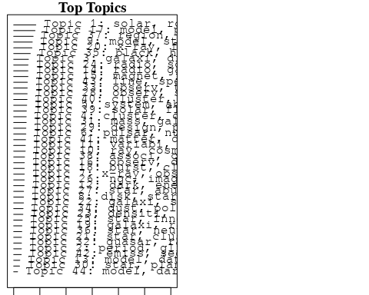

plotQuote(thoughts6, width = 30, main = "Topic 6")  
plotQuote(thoughts18, width = 30, main = "Topic 18")

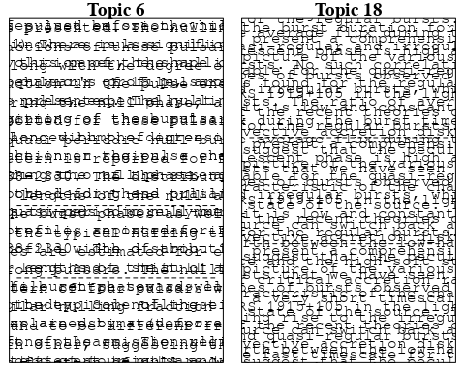

# Calculate and plot the correlation between topics  
mod.out.corr <- topicCorr(Research_topics)  
plot(mod.out.corr, cex = 1.5)  
  
  
# For each topic  
for (topic_num in 1:44) {  
 # Plot the word cloud  
 cloud(Research_topics, topic = topic_num, scale = c(2, 0.25))  
 Sys.sleep(2)  
}

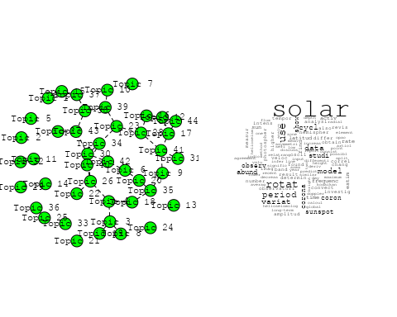

## Warning in wordcloud::wordcloud(words = vocab, freq = vec, max.words =  
## max.words, : glitch could not be fit on page. It will not be plotted.

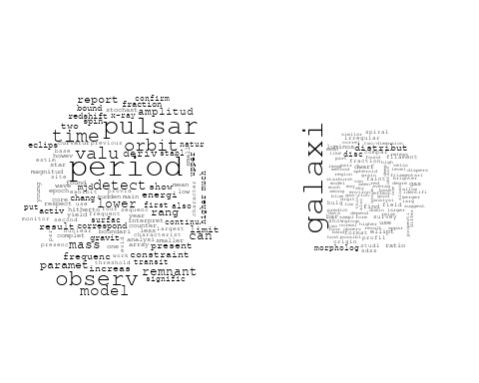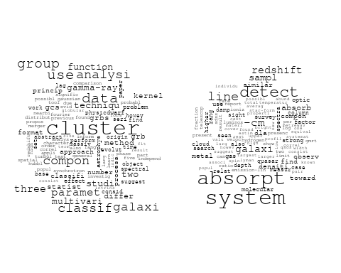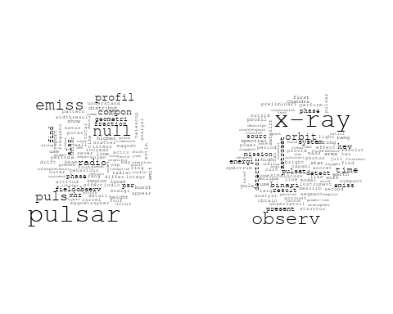

## Warning in wordcloud::wordcloud(words = vocab, freq = vec, max.words =  
## max.words, : compact could not be fit on page. It will not be plotted.

## Warning in wordcloud::wordcloud(words = vocab, freq = vec, max.words =  
## max.words, : object could not be fit on page. It will not be plotted.

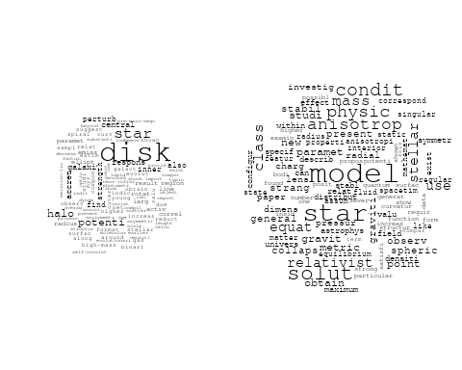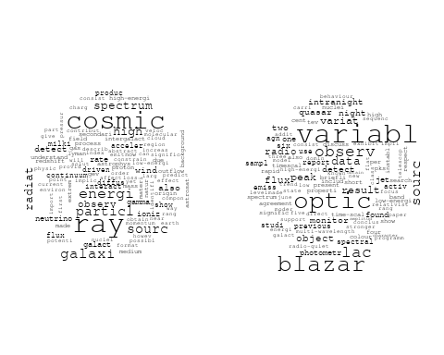

## Warning in wordcloud::wordcloud(words = vocab, freq = vec, max.words =  
## max.words, : energi could not be fit on page. It will not be plotted.

## Warning in wordcloud::wordcloud(words = vocab, freq = vec, max.words =  
## max.words, : radio could not be fit on page. It will not be plotted.

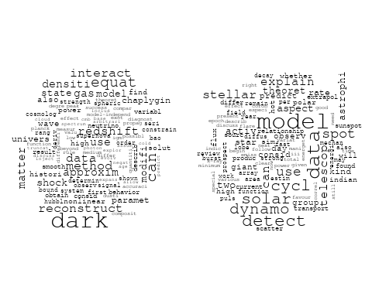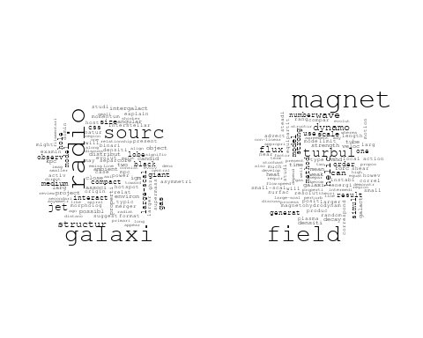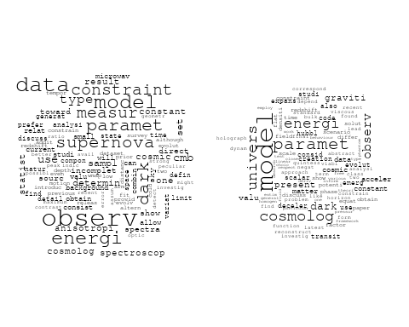

## Warning in wordcloud::wordcloud(words = vocab, freq = vec, max.words =  
## max.words, : radio could not be fit on page. It will not be plotted.

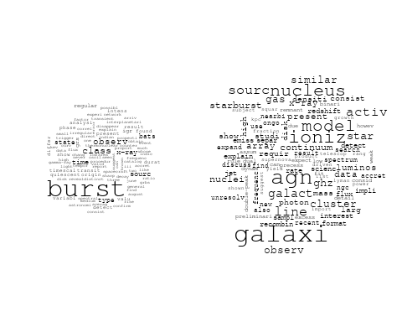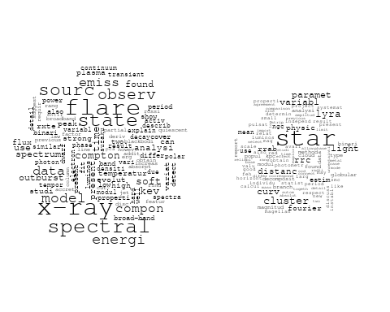

## Warning in wordcloud::wordcloud(words = vocab, freq = vec, max.words =  
## max.words, : densiti could not be fit on page. It will not be plotted.

## Warning in wordcloud::wordcloud(words = vocab, freq = vec, max.words =  
## max.words, : interstellar could not be fit on page. It will not be plotted.

## Warning in wordcloud::wordcloud(words = vocab, freq = vec, max.words =  
## max.words, : molecular could not be fit on page. It will not be plotted.

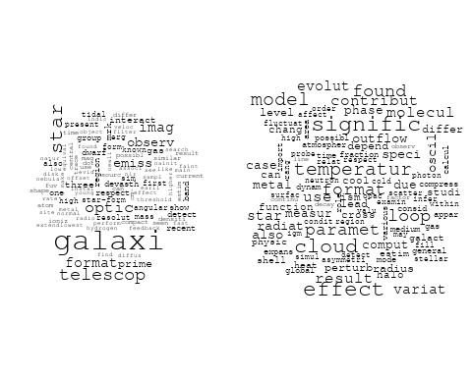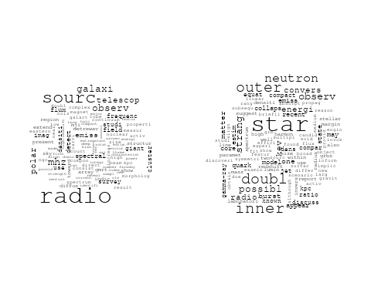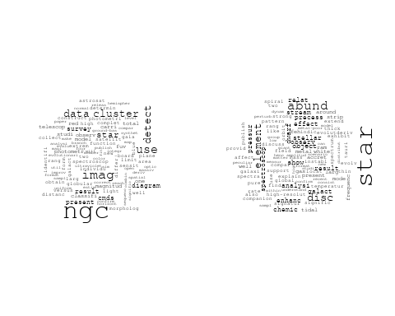

## Warning in wordcloud::wordcloud(words = vocab, freq = vec, max.words =  
## max.words, : densiti could not be fit on page. It will not be plotted.

## Warning in wordcloud::wordcloud(words = vocab, freq = vec, max.words =  
## max.words, : pulsar could not be fit on page. It will not be plotted.

## Warning in wordcloud::wordcloud(words = vocab, freq = vec, max.words =  
## max.words, : signal could not be fit on page. It will not be plotted.

## Warning in wordcloud::wordcloud(words = vocab, freq = vec, max.words =  
## max.words, : background could not be fit on page. It will not be plotted.

## Warning in wordcloud::wordcloud(words = vocab, freq = vec, max.words =  
## max.words, : instrument could not be fit on page. It will not be plotted.

## Warning in wordcloud::wordcloud(words = vocab, freq = vec, max.words =  
## max.words, : spectrograph could not be fit on page. It will not be plotted.

## Warning in wordcloud::wordcloud(words = vocab, freq = vec, max.words =  
## max.words, : india could not be fit on page. It will not be plotted.

## Warning in wordcloud::wordcloud(words = vocab, freq = vec, max.words =  
## max.words, : system could not be fit on page. It will not be plotted.

## Warning in wordcloud::wordcloud(words = vocab, freq = vec, max.words =  
## max.words, : research could not be fit on page. It will not be plotted.

## Warning in wordcloud::wordcloud(words = vocab, freq = vec, max.words =  
## max.words, : reflect could not be fit on page. It will not be plotted.

## Warning in wordcloud::wordcloud(words = vocab, freq = vec, max.words =  
## max.words, : observatori could not be fit on page. It will not be plotted.

## Warning in wordcloud::wordcloud(words = vocab, freq = vec, max.words =  
## max.words, : radio could not be fit on page. It will not be plotted.

## Warning in wordcloud::wordcloud(words = vocab, freq = vec, max.words =  
## max.words, : frequenc could not be fit on page. It will not be plotted.

## Warning in wordcloud::wordcloud(words = vocab, freq = vec, max.words =  
## max.words, : laboratori could not be fit on page. It will not be plotted.

## Warning in wordcloud::wordcloud(words = vocab, freq = vec, max.words =  
## max.words, : transient could not be fit on page. It will not be plotted.

## Warning in wordcloud::wordcloud(words = vocab, freq = vec, max.words =  
## max.words, : astronom could not be fit on page. It will not be plotted.

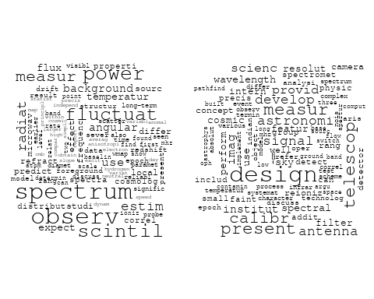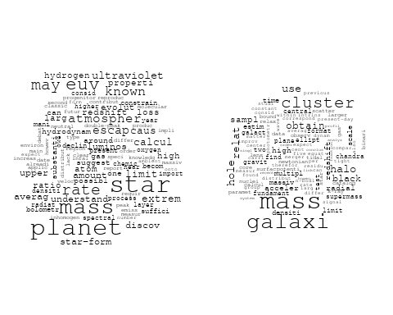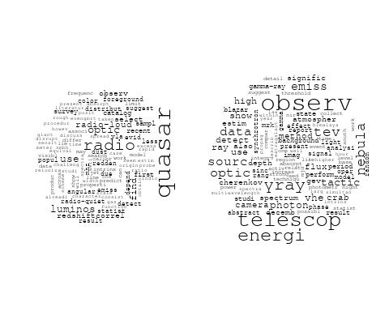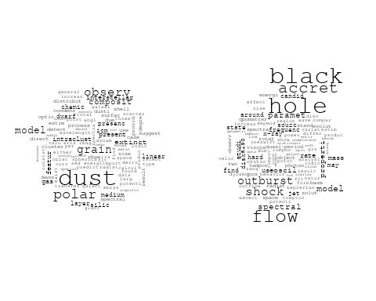

## Warning in wordcloud::wordcloud(words = vocab, freq = vec, max.words =  
## max.words, : pulsar could not be fit on page. It will not be plotted.

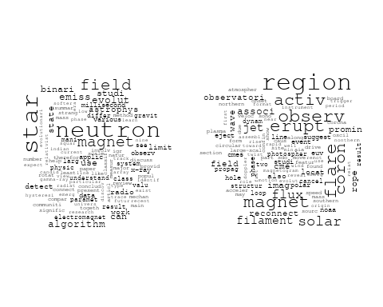

## Warning in wordcloud::wordcloud(words = vocab, freq = vec, max.words =  
## max.words, : type could not be fit on page. It will not be plotted.

## Warning in wordcloud::wordcloud(words = vocab, freq = vec, max.words =  
## max.words, : eject could not be fit on page. It will not be plotted.

## Warning in wordcloud::wordcloud(words = vocab, freq = vec, max.words =  
## max.words, : event could not be fit on page. It will not be plotted.

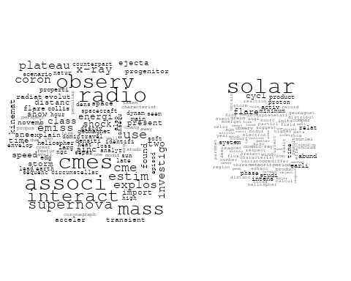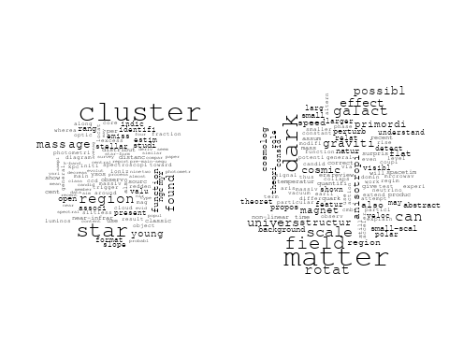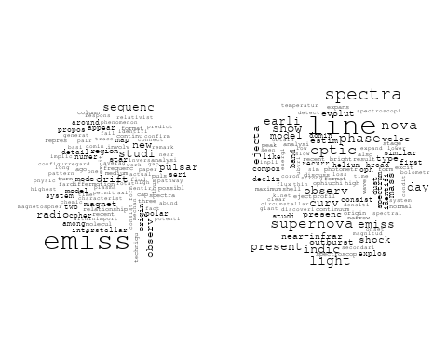

# Get the topic proportions for each document  
topic_proportions <- Research_topics$theta  
  
# Find the index of the topic with the highest proportion for each document  
# This will be the topic that each document is most likely to belong to  
max_topic_idx <- apply(topic_proportions, 1, which.max)  
  
# Add this as a new column to your data  
data_collab$topic <- max_topic_idx  
  
library(ggplot2)  
  
# Define the intervals  
intervals <- c('1824_1899', '1900_1964', '1965_1974', '1975_1984', '1985_1994', '1995_1999', '2000_2004', '2005_2009', '2010_2014', '2015_2019', '2020_2022')  
colors <- c('pink', 'blue', 'purple', 'yellow', 'green', 'pink', 'orange', 'violet', 'green', 'blue', 'pink')  
  
# Loop through the intervals and plot  
for(i in seq_along(intervals)){  
 # Filter data for when the pub_interval is equal to 1  
 data_filtered <- data_collab[data_collab[[paste0('pub_interval_', intervals[i])]] == 1,]  
   
 # Make the histogram  
   
 p <- ggplot(data_filtered, aes(x = topic)) +  
 geom_histogram(binwidth = 1, fill = colors[i], color = "black") +  
 xlab("Topic") +  
 ylab("Count") +  
 ggtitle(paste0("Topics from year ", gsub("_", " to ", intervals[i])))  
   
 print(p)  
}  
  
  
##Topic generation for IN (independent) publications  
  
data_independent <- data[data[["IN"]] == 100,]  
  
# Save the original title data for future use  
data_independent$original_concatenated_title_abstract <- data_independent$concatenated_title_abstract  
  
#pre-processing the titles using textProcessor from the stm package  
processed_text <- textProcessor(data_independent$concatenated_title_abstract, metadata = data_independent)

## Building corpus...   
## Converting to Lower Case...   
## Removing punctuation...   
## Removing stopwords...   
## Removing numbers...   
## Stemming...   
## Creating Output...

# Further prepare the data by removing low-frequency terms  
out_text <- prepDocuments(processed_text$documents, processed_text$vocab, processed_text$meta)

## Removing 1697 of 5170 terms (1697 of 49825 tokens) due to frequency   
## Your corpus now has 679 documents, 3473 terms and 48128 tokens.

docs_text <- out_text$documents  
vocab_text <- out_text$vocab  
meta_text <- out_text$meta  
  
  
#Prepare data  
plotRemoved(processed_text$documents, lower.thresh = seq(1, 200, by = 100))

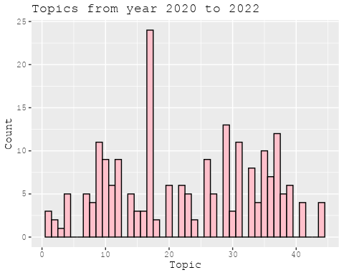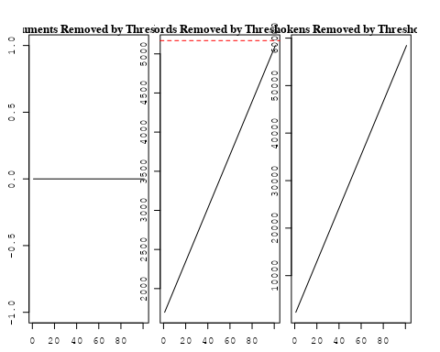

out_text <- prepDocuments(processed_text$documents, processed_text$vocab, processed_text$meta, lower.thresh = 8)

## Removing 4007 of 5170 terms (9831 of 49825 tokens) due to frequency   
## Your corpus now has 679 documents, 1163 terms and 39994 tokens.

str(out_text$meta)

## 'data.frame': 679 obs. of 39 variables:  
## $ concept_id : chr "https://openalex.org/C44870925" "https://openalex.org/C44870925" "https://openalex.org/C44870925" "https://openalex.org/C44870925" ...  
## $ work_id : chr "https://openalex.org/W2948771331" "https://openalex.org/W3101308139" "https://openalex.org/W3103178815" "https://openalex.org/W3123603278" ...  
## $ publication_year : int 2019 2006 2007 2006 1997 2010 2010 2006 2008 2022 ...  
## $ title : chr "Observational constraints on viscous Ricci dark energy model" "Photometric and spectroscopic evolution of the type IIP supernova SN 2004et" "Fluorine in R Coronae Borealis Stars" "Origin of Disc Lopsidedness in the Eridanus Group of Galaxies" ...  
## $ paperabstract : chr "In this paper, Ricci dark energy (RDE) model with bulk viscosity is studied to observe the cosmic accelerating "| __truncated__ "We present optical photometry and spectroscopy of the normal type IIP supernova SN2004A, which was discovered i"| __truncated__ "Neutral fluorine (F I) lines are identified in the optical spectra of several R Coronae Borealis stars (RCBs) a"| __truncated__ "The HI surface density maps for a sample of 18 galaxies in the Eridanus group are Fourier analysed. This analys"| __truncated__ ...  
## $ country : chr "IN IN" "IN IN" "IN IN" "IN IN" ...  
## $ year_concept : chr "2019+https://openalex.org/C44870925" "2006+https://openalex.org/C44870925" "2007+https://openalex.org/C44870925" "2006+https://openalex.org/C44870925" ...  
## $ concatenated_title_abstract : chr "Observational constraints on viscous Ricci dark energy model In this paper, Ricci dark energy (RDE) model with "| __truncated__ "Photometric and spectroscopic evolution of the type IIP supernova SN 2004et We present optical photometry and s"| __truncated__ "Fluorine in R Coronae Borealis Stars Neutral fluorine (F I) lines are identified in the optical spectra of seve"| __truncated__ "Origin of Disc Lopsidedness in the Eridanus Group of Galaxies The HI surface density maps for a sample of 18 ga"| __truncated__ ...  
## $ US : num 0 0 0 0 0 0 0 0 0 0 ...  
## $ IN : num 100 100 100 100 100 100 100 100 100 100 ...  
## $ DE : num 0 0 0 0 0 0 0 0 0 0 ...  
## $ CH : num 0 0 0 0 0 0 0 0 0 0 ...  
## $ GB : num 0 0 0 0 0 0 0 0 0 0 ...  
## $ CN : num 0 0 0 0 0 0 0 0 0 0 ...  
## $ FR : num 0 0 0 0 0 0 0 0 0 0 ...  
## $ IT : num 0 0 0 0 0 0 0 0 0 0 ...  
## $ RU : num 0 0 0 0 0 0 0 0 0 0 ...  
## $ CA : num 0 0 0 0 0 0 0 0 0 0 ...  
## $ NL : num 0 0 0 0 0 0 0 0 0 0 ...  
## $ AU : num 0 0 0 0 0 0 0 0 0 0 ...  
## $ JP : num 0 0 0 0 0 0 0 0 0 0 ...  
## $ ES : num 0 0 0 0 0 0 0 0 0 0 ...  
## $ IL : num 0 0 0 0 0 0 0 0 0 0 ...  
## $ Americas : num 0 0 0 0 0 0 0 0 0 0 ...  
## $ Europe : num 0 0 0 0 0 0 0 0 0 0 ...  
## $ Africa : num 0 0 0 0 0 0 0 0 0 0 ...  
## $ AsiaAndOceania : num 0 0 0 0 0 0 0 0 0 0 ...  
## $ pub_interval_2020_2022 : int 0 0 0 0 0 0 0 0 0 1 ...  
## $ pub_interval_2015_2019 : int 1 0 0 0 0 0 0 0 0 0 ...  
## $ pub_interval_2010_2014 : int 0 0 0 0 0 1 1 0 0 0 ...  
## $ pub_interval_2005_2009 : int 0 1 1 1 0 0 0 1 1 0 ...  
## $ pub_interval_2000_2004 : int 0 0 0 0 0 0 0 0 0 0 ...  
## $ pub_interval_1995_1999 : int 0 0 0 0 1 0 0 0 0 0 ...  
## $ pub_interval_1985_1994 : int 0 0 0 0 0 0 0 0 0 0 ...  
## $ pub_interval_1975_1984 : int 0 0 0 0 0 0 0 0 0 0 ...  
## $ pub_interval_1965_1974 : int 0 0 0 0 0 0 0 0 0 0 ...  
## $ pub_interval_1900_1964 : int 0 0 0 0 0 0 0 0 0 0 ...  
## $ pub_interval_1824_1899 : int 0 0 0 0 0 0 0 0 0 0 ...  
## $ original_concatenated_title_abstract: chr "Observational constraints on viscous Ricci dark energy model In this paper, Ricci dark energy (RDE) model with "| __truncated__ "Photometric and spectroscopic evolution of the type IIP supernova SN 2004et We present optical photometry and s"| __truncated__ "Fluorine in R Coronae Borealis Stars Neutral fluorine (F I) lines are identified in the optical spectra of seve"| __truncated__ "Origin of Disc Lopsidedness in the Eridanus Group of Galaxies The HI surface density maps for a sample of 18 ga"| __truncated__ ...

# Initialize an empty formula string  
prevalence_formula_str <- "~"  
  
# Define the publication intervals  
pub_intervals <- c("pub_interval_2020_2022", "pub_interval_2015_2019", "pub_interval_2010_2014",   
 "pub_interval_2005_2009", "pub_interval_2000_2004", "pub_interval_1995_1999",  
 "pub_interval_1985_1994", "pub_interval_1975_1984", "pub_interval_1965_1974",  
 "pub_interval_1900_1964", "pub_interval_1824_1899")  
  
# Add each publication interval to the formula string  
for (interval in pub_intervals) {  
 # add an if statement to handle the first addition (without '+')  
 if (prevalence_formula_str == "~") {  
 prevalence_formula_str <- paste(prevalence_formula_str, interval)  
 } else {  
 prevalence_formula_str <- paste(prevalence_formula_str, "+", interval)  
 }  
}  
  
  
# Convert the string to a formula  
prevalence_formula <- as.formula(prevalence_formula_str)  
print(prevalence_formula)

## ~pub_interval_2020_2022 + pub_interval_2015_2019 + pub_interval_2010_2014 +   
## pub_interval_2005_2009 + pub_interval_2000_2004 + pub_interval_1995_1999 +   
## pub_interval_1985_1994 + pub_interval_1975_1984 + pub_interval_1965_1974 +   
## pub_interval_1900_1964 + pub_interval_1824_1899

# Run STM model  
Research_topics <- stm(documents = out_text$documents,   
 vocab = out_text$vocab,   
 K = 43,   
 prevalence = prevalence_formula,   
 data = out_text$meta,   
 init.type = "Spectral",  
 max.em.its = 1000,  
 gamma.prior = 'L1')

## Beginning Spectral Initialization   
## Calculating the gram matrix...  
## Finding anchor words...  
## ...........................................  
## Recovering initialization...  
## ...........  
## Initialization complete.  
## .................................................................................................................  
## Completed E-Step (0 seconds).   
## Completed M-Step.   
## Completing Iteration 1 (approx. per word bound = -5.832)   
## .................................................................................................................  
## Completed E-Step (0 seconds).   
## Completed M-Step.   
## Completing Iteration 2 (approx. per word bound = -5.590, relative change = 4.155e-02)   
## .................................................................................................................  
## Completed E-Step (0 seconds).   
## Completed M-Step.   
## Completing Iteration 3 (approx. per word bound = -5.515, relative change = 1.340e-02)   
## .................................................................................................................  
## Completed E-Step (0 seconds).   
## Completed M-Step.   
## Completing Iteration 4 (approx. per word bound = -5.482, relative change = 6.005e-03)   
## .................................................................................................................  
## Completed E-Step (0 seconds).   
## Completed M-Step.   
## Completing Iteration 5 (approx. per word bound = -5.464, relative change = 3.307e-03)   
## Topic 1: cluster, use, group, data, mass   
## Topic 2: pulsar, null, emiss, puls, profil   
## Topic 3: x-ray, binari, observ, spectral, time   
## Topic 4: univers, astronomi, astronom, india, collaps   
## Topic 5: radio, quasar, luminos, detect, first   
## Topic 6: magnet, field, pulsar, particl, can   
## Topic 7: mass, supernova, type, estim, distanc   
## Topic 8: model, energi, dark, observ, paramet   
## Topic 9: observ, band, sourc, show, variabl   
## Topic 10: galaxi, find, sampl, distribut, sdss   
## Topic 11: neutron, star, field, discuss, evolut   
## Topic 12: model, data, dynamo, flux, cycl   
## Topic 13: star, mass, rate, limit, known   
## Topic 14: disk, galaxi, potenti, hole, black   
## Topic 15: matter, dark, galact, rotat, graviti   
## Topic 16: dwarf, star, gas, outflow, metal   
## Topic 17: object, compact, effect, photon, solut   
## Topic 18: star, associ, found, along, cloud   
## Topic 19: telescop, observ, energi, nebula, tev   
## Topic 20: line, shock, spectra, nova, observ   
## Topic 21: solar, cycl, period, data, activ   
## Topic 22: radio, galaxi, doubl, jet, inner   
## Topic 23: ngc, cluster, imag, star, use   
## Topic 24: ray, cosmic, galaxi, energi, sourc   
## Topic 25: coron, loop, oscil, observ, region   
## Topic 26: use, model, effect, code, simul   
## Topic 27: scintil, densiti, pulsar, observ, drift   
## Topic 28: signal, spectrum, power, background, anisotropi   
## Topic 29: quasar, optic, sampl, agn, observ   
## Topic 30: sourc, radio, observ, use, mhz   
## Topic 31: flow, shock, black, accret, hole   
## Topic 32: rate, disc, variat, accret, show   
## Topic 33: radio, measur, design, pressur, spectrum   
## Topic 34: model, star, class, condit, mass   
## Topic 35: telescop, optic, instrument, present, develop   
## Topic 36: paramet, model, valu, data, observ   
## Topic 37: period, orbit, rotat, solar, x-ray   
## Topic 38: field, acceler, graviti, model, time   
## Topic 39: erupt, jet, magnet, filament, observ   
## Topic 40: flare, solar, observ, found, associ   
## Topic 41: cluster, star, region, found, age   
## Topic 42: burst, sourc, x-ray, state, observ   
## Topic 43: spectrum, solar, proton, earli, energi   
## .................................................................................................................  
## Completed E-Step (0 seconds).   
## Completed M-Step.   
## Completing Iteration 6 (approx. per word bound = -5.451, relative change = 2.293e-03)   
## .................................................................................................................  
## Completed E-Step (0 seconds).   
## Completed M-Step.   
## Completing Iteration 7 (approx. per word bound = -5.442, relative change = 1.615e-03)   
## .................................................................................................................  
## Completed E-Step (0 seconds).   
## Completed M-Step.   
## Completing Iteration 8 (approx. per word bound = -5.436, relative change = 1.079e-03)   
## .................................................................................................................  
## Completed E-Step (0 seconds).   
## Completed M-Step.   
## Completing Iteration 9 (approx. per word bound = -5.432, relative change = 8.263e-04)   
## .................................................................................................................  
## Completed E-Step (0 seconds).   
## Completed M-Step.   
## Completing Iteration 10 (approx. per word bound = -5.428, relative change = 7.166e-04)   
## Topic 1: cluster, use, data, group, mass   
## Topic 2: pulsar, null, emiss, puls, energi   
## Topic 3: x-ray, kev, binari, spectral, observ   
## Topic 4: univers, astronomi, astronom, collaps, physic   
## Topic 5: radio, quasar, detect, luminos, first   
## Topic 6: magnet, field, pulsar, particl, can   
## Topic 7: mass, supernova, type, estim, distanc   
## Topic 8: model, energi, dark, observ, paramet   
## Topic 9: observ, band, star, show, absorpt   
## Topic 10: galaxi, find, distribut, sampl, sdss   
## Topic 11: star, neutron, field, astrophys, discuss   
## Topic 12: model, data, dynamo, flux, cycl   
## Topic 13: star, rate, mass, known, caus   
## Topic 14: disk, galaxi, potenti, hole, black   
## Topic 15: matter, dark, galact, rotat, graviti   
## Topic 16: star, gas, dwarf, outflow, metal   
## Topic 17: object, compact, effect, around, photon   
## Topic 18: star, associ, found, along, cloud   
## Topic 19: observ, telescop, energi, nebula, tev   
## Topic 20: line, spectra, nova, observ, present   
## Topic 21: solar, cycl, period, data, activ   
## Topic 22: radio, galaxi, doubl, jet, inner   
## Topic 23: ngc, cluster, imag, star, use   
## Topic 24: ray, cosmic, galaxi, energi, sourc   
## Topic 25: coron, loop, region, observ, oscil   
## Topic 26: effect, use, simul, code, scale   
## Topic 27: scintil, pulsar, densiti, observ, drift   
## Topic 28: signal, spectrum, power, anisotropi, background   
## Topic 29: quasar, optic, sampl, agn, observ   
## Topic 30: sourc, radio, observ, use, mhz   
## Topic 31: flow, shock, accret, black, hole   
## Topic 32: rate, disc, variat, accret, show   
## Topic 33: radio, design, measur, spectrum, galaxi   
## Topic 34: model, star, condit, mass, class   
## Topic 35: telescop, optic, instrument, present, develop   
## Topic 36: paramet, model, data, valu, observ   
## Topic 37: period, orbit, rotat, x-ray, solar   
## Topic 38: field, acceler, scale, dynamo, time   
## Topic 39: jet, magnet, erupt, filament, observ   
## Topic 40: flare, observ, solar, associ, found   
## Topic 41: cluster, star, region, found, age   
## Topic 42: burst, sourc, x-ray, state, observ   
## Topic 43: spectrum, solar, proton, earli, energi   
## .................................................................................................................  
## Completed E-Step (0 seconds).   
## Completed M-Step.   
## Completing Iteration 11 (approx. per word bound = -5.425, relative change = 6.310e-04)   
## .................................................................................................................  
## Completed E-Step (0 seconds).   
## Completed M-Step.   
## Completing Iteration 12 (approx. per word bound = -5.422, relative change = 5.477e-04)   
## .................................................................................................................  
## Completed E-Step (0 seconds).   
## Completed M-Step.   
## Completing Iteration 13 (approx. per word bound = -5.419, relative change = 5.101e-04)   
## .................................................................................................................  
## Completed E-Step (0 seconds).   
## Completed M-Step.   
## Completing Iteration 14 (approx. per word bound = -5.416, relative change = 5.326e-04)   
## .................................................................................................................  
## Completed E-Step (0 seconds).   
## Completed M-Step.   
## Completing Iteration 15 (approx. per word bound = -5.413, relative change = 4.594e-04)   
## Topic 1: cluster, use, data, mass, group   
## Topic 2: pulsar, null, emiss, puls, profil   
## Topic 3: x-ray, kev, energi, spectral, binari   
## Topic 4: univers, astronomi, astronom, physic, collaps   
## Topic 5: radio, quasar, detect, luminos, first   
## Topic 6: magnet, field, pulsar, particl, can   
## Topic 7: supernova, mass, type, estim, eject   
## Topic 8: model, energi, dark, observ, paramet   
## Topic 9: observ, band, star, show, optic   
## Topic 10: galaxi, find, distribut, sdss, two   
## Topic 11: star, neutron, astrophys, field, discuss   
## Topic 12: model, data, dynamo, flux, solar   
## Topic 13: star, mass, rate, known, caus   
## Topic 14: disk, galaxi, potenti, hole, black   
## Topic 15: matter, dark, galact, graviti, rotat   
## Topic 16: star, gas, dwarf, outflow, metal   
## Topic 17: object, compact, effect, photon, around   
## Topic 18: star, associ, found, cloud, along   
## Topic 19: observ, telescop, energi, nebula, tev   
## Topic 20: line, spectra, nova, observ, emiss   
## Topic 21: solar, cycl, data, period, activ   
## Topic 22: radio, galaxi, doubl, jet, size   
## Topic 23: ngc, cluster, imag, star, use   
## Topic 24: ray, cosmic, energi, galaxi, sourc   
## Topic 25: coron, region, loop, observ, oscil   
## Topic 26: effect, simul, code, use, scale   
## Topic 27: scintil, pulsar, densiti, observ, drift   
## Topic 28: signal, spectrum, power, anisotropi, background   
## Topic 29: quasar, optic, sampl, agn, observ   
## Topic 30: sourc, radio, observ, use, mhz   
## Topic 31: flow, shock, black, accret, hole   
## Topic 32: rate, disc, variat, accret, rotat   
## Topic 33: radio, design, measur, spectrum, galaxi   
## Topic 34: model, star, mass, condit, equat   
## Topic 35: telescop, optic, instrument, present, develop   
## Topic 36: paramet, model, data, valu, observ   
## Topic 37: period, rotat, orbit, solar, x-ray   
## Topic 38: field, acceler, scale, dynamo, surfac   
## Topic 39: jet, magnet, erupt, flare, filament   
## Topic 40: flare, observ, solar, associ, found   
## Topic 41: cluster, star, region, found, mass   
## Topic 42: burst, sourc, x-ray, state, observ   
## Topic 43: spectrum, solar, proton, earli, energi   
## .................................................................................................................  
## Completed E-Step (0 seconds).   
## Completed M-Step.   
## Completing Iteration 16 (approx. per word bound = -5.411, relative change = 4.202e-04)   
## .................................................................................................................  
## Completed E-Step (0 seconds).   
## Completed M-Step.   
## Completing Iteration 17 (approx. per word bound = -5.409, relative change = 3.985e-04)   
## .................................................................................................................  
## Completed E-Step (0 seconds).   
## Completed M-Step.   
## Completing Iteration 18 (approx. per word bound = -5.407, relative change = 3.622e-04)   
## .................................................................................................................  
## Completed E-Step (0 seconds).   
## Completed M-Step.   
## Completing Iteration 19 (approx. per word bound = -5.405, relative change = 3.496e-04)   
## .................................................................................................................  
## Completed E-Step (0 seconds).   
## Completed M-Step.   
## Completing Iteration 20 (approx. per word bound = -5.403, relative change = 3.363e-04)   
## Topic 1: cluster, use, mass, data, obtain   
## Topic 2: pulsar, null, emiss, puls, profil   
## Topic 3: x-ray, kev, energi, spectral, observ   
## Topic 4: univers, astronomi, astronom, collaps, interest   
## Topic 5: radio, quasar, detect, luminos, first   
## Topic 6: magnet, field, pulsar, particl, can   
## Topic 7: mass, supernova, type, estim, eject   
## Topic 8: model, energi, dark, observ, paramet   
## Topic 9: observ, band, star, optic, show   
## Topic 10: galaxi, find, distribut, sdss, two   
## Topic 11: star, neutron, astrophys, field, observ   
## Topic 12: model, data, dynamo, solar, cycl   
## Topic 13: star, mass, rate, known, caus   
## Topic 14: disk, galaxi, potenti, halo, hole   
## Topic 15: matter, dark, galact, graviti, rotat   
## Topic 16: star, gas, outflow, dwarf, metal   
## Topic 17: object, compact, effect, photon, around   
## Topic 18: star, associ, found, cloud, age   
## Topic 19: observ, telescop, energi, nebula, tev   
## Topic 20: line, spectra, nova, emiss, observ   
## Topic 21: solar, cycl, data, period, activ   
## Topic 22: radio, galaxi, doubl, jet, size   
## Topic 23: ngc, cluster, imag, star, use   
## Topic 24: ray, cosmic, galaxi, energi, sourc   
## Topic 25: coron, region, loop, observ, oscil   
## Topic 26: effect, simul, code, scale, use   
## Topic 27: scintil, pulsar, densiti, observ, drift   
## Topic 28: signal, spectrum, power, anisotropi, background   
## Topic 29: quasar, optic, sampl, agn, blazar   
## Topic 30: sourc, radio, observ, use, mhz   
## Topic 31: flow, shock, black, hole, accret   
## Topic 32: rate, disc, variat, rotat, accret   
## Topic 33: radio, design, measur, spectrum, galaxi   
## Topic 34: model, star, mass, condit, equat   
## Topic 35: telescop, optic, instrument, present, develop   
## Topic 36: paramet, model, data, valu, observ   
## Topic 37: rotat, period, orbit, solar, use   
## Topic 38: field, acceler, sampl, scale, dynamo   
## Topic 39: jet, magnet, erupt, flare, filament   
## Topic 40: flare, observ, solar, associ, cmes   
## Topic 41: cluster, star, region, found, mass   
## Topic 42: burst, sourc, state, x-ray, observ   
## Topic 43: spectrum, solar, proton, earli, energi   
## .................................................................................................................  
## Completed E-Step (0 seconds).   
## Completed M-Step.   
## Completing Iteration 21 (approx. per word bound = -5.402, relative change = 2.794e-04)   
## .................................................................................................................  
## Completed E-Step (0 seconds).   
## Completed M-Step.   
## Completing Iteration 22 (approx. per word bound = -5.401, relative change = 2.365e-04)   
## .................................................................................................................  
## Completed E-Step (0 seconds).   
## Completed M-Step.   
## Completing Iteration 23 (approx. per word bound = -5.399, relative change = 2.205e-04)   
## .................................................................................................................  
## Completed E-Step (0 seconds).   
## Completed M-Step.   
## Completing Iteration 24 (approx. per word bound = -5.398, relative change = 2.502e-04)   
## .................................................................................................................  
## Completed E-Step (0 seconds).   
## Completed M-Step.   
## Completing Iteration 25 (approx. per word bound = -5.397, relative change = 2.512e-04)   
## Topic 1: cluster, use, mass, obtain, data   
## Topic 2: pulsar, null, emiss, puls, profil   
## Topic 3: energi, x-ray, kev, spectral, observ   
## Topic 4: univers, astronomi, collaps, astronom, interest   
## Topic 5: radio, quasar, luminos, detect, first   
## Topic 6: magnet, field, pulsar, particl, can   
## Topic 7: mass, supernova, type, eject, distanc   
## Topic 8: model, energi, dark, observ, paramet   
## Topic 9: observ, optic, star, band, show   
## Topic 10: galaxi, find, distribut, sdss, two   
## Topic 11: star, neutron, astrophys, field, binari   
## Topic 12: model, data, solar, dynamo, cycl   
## Topic 13: star, rate, mass, known, caus   
## Topic 14: disk, galaxi, potenti, halo, hole   
## Topic 15: matter, dark, galact, graviti, rotat   
## Topic 16: star, gas, outflow, metal, dwarf   
## Topic 17: object, compact, effect, photon, hole   
## Topic 18: star, associ, found, cloud, age   
## Topic 19: observ, telescop, energi, tev, data   
## Topic 20: line, spectra, nova, emiss, observ   
## Topic 21: solar, cycl, data, activ, period   
## Topic 22: radio, galaxi, doubl, jet, size   
## Topic 23: ngc, cluster, imag, star, use   
## Topic 24: ray, cosmic, galaxi, energi, sourc   
## Topic 25: coron, region, loop, observ, oscil   
## Topic 26: effect, code, simul, scale, studi   
## Topic 27: scintil, pulsar, densiti, observ, drift   
## Topic 28: signal, spectrum, power, anisotropi, background   
## Topic 29: quasar, optic, sampl, blazar, observ   
## Topic 30: sourc, radio, observ, use, mhz   
## Topic 31: flow, shock, black, hole, accret   
## Topic 32: rate, disc, variat, rotat, show   
## Topic 33: radio, design, measur, spectrum, galaxi   
## Topic 34: model, star, mass, condit, equat   
## Topic 35: telescop, optic, instrument, present, develop   
## Topic 36: paramet, model, data, valu, observ   
## Topic 37: rotat, period, orbit, solar, use   
## Topic 38: field, acceler, sampl, radial, scale   
## Topic 39: jet, magnet, erupt, flare, filament   
## Topic 40: flare, observ, solar, associ, cmes   
## Topic 41: cluster, star, region, found, mass   
## Topic 42: burst, sourc, state, x-ray, observ   
## Topic 43: spectrum, solar, proton, earli, energi   
## .................................................................................................................  
## Completed E-Step (0 seconds).   
## Completed M-Step.   
## Completing Iteration 26 (approx. per word bound = -5.395, relative change = 2.238e-04)   
## .................................................................................................................  
## Completed E-Step (0 seconds).   
## Completed M-Step.   
## Completing Iteration 27 (approx. per word bound = -5.394, relative change = 2.019e-04)   
## .................................................................................................................  
## Completed E-Step (0 seconds).   
## Completed M-Step.   
## Completing Iteration 28 (approx. per word bound = -5.393, relative change = 2.219e-04)   
## .................................................................................................................  
## Completed E-Step (0 seconds).   
## Completed M-Step.   
## Completing Iteration 29 (approx. per word bound = -5.392, relative change = 2.339e-04)   
## .................................................................................................................  
## Completed E-Step (0 seconds).   
## Completed M-Step.   
## Completing Iteration 30 (approx. per word bound = -5.391, relative change = 2.048e-04)   
## Topic 1: cluster, use, mass, data, obtain   
## Topic 2: pulsar, null, emiss, puls, profil   
## Topic 3: energi, x-ray, kev, spectral, observ   
## Topic 4: univers, astronomi, collaps, astronom, interest   
## Topic 5: radio, quasar, luminos, detect, first   
## Topic 6: magnet, field, pulsar, particl, can   
## Topic 7: mass, supernova, type, eject, estim   
## Topic 8: model, energi, dark, observ, paramet   
## Topic 9: observ, optic, star, show, band   
## Topic 10: galaxi, find, distribut, sdss, luminos   
## Topic 11: star, neutron, astrophys, field, binari   
## Topic 12: model, data, solar, dynamo, cycl   
## Topic 13: star, rate, mass, known, caus   
## Topic 14: galaxi, disk, potenti, halo, hole   
## Topic 15: matter, dark, graviti, galact, rotat   
## Topic 16: star, gas, outflow, metal, dwarf   
## Topic 17: object, effect, compact, hole, photon   
## Topic 18: star, associ, found, cloud, age   
## Topic 19: telescop, observ, energi, tev, data   
## Topic 20: line, spectra, nova, emiss, observ   
## Topic 21: solar, cycl, data, activ, period   
## Topic 22: radio, galaxi, doubl, jet, size   
## Topic 23: ngc, cluster, imag, star, use   
## Topic 24: ray, cosmic, galaxi, energi, sourc   
## Topic 25: coron, region, loop, observ, oscil   
## Topic 26: effect, code, simul, scale, studi   
## Topic 27: scintil, pulsar, densiti, observ, drift   
## Topic 28: signal, spectrum, power, anisotropi, background   
## Topic 29: quasar, optic, sampl, blazar, observ   
## Topic 30: sourc, radio, observ, use, mhz   
## Topic 31: flow, shock, black, hole, accret   
## Topic 32: rate, disc, variat, rotat, show   
## Topic 33: design, radio, measur, spectrum, galaxi   
## Topic 34: model, star, mass, condit, solut   
## Topic 35: telescop, optic, instrument, present, develop   
## Topic 36: paramet, model, data, valu, observ   
## Topic 37: rotat, period, orbit, use, solar   
## Topic 38: field, acceler, sampl, radial, scale   
## Topic 39: jet, magnet, erupt, flare, filament   
## Topic 40: flare, observ, solar, associ, cmes   
## Topic 41: cluster, star, region, found, mass   
## Topic 42: burst, sourc, state, x-ray, observ   
## Topic 43: spectrum, solar, proton, earli, energi   
## .................................................................................................................  
## Completed E-Step (0 seconds).   
## Completed M-Step.   
## Completing Iteration 31 (approx. per word bound = -5.390, relative change = 1.636e-04)   
## .................................................................................................................  
## Completed E-Step (0 seconds).   
## Completed M-Step.   
## Completing Iteration 32 (approx. per word bound = -5.389, relative change = 1.302e-04)   
## .................................................................................................................  
## Completed E-Step (0 seconds).   
## Completed M-Step.   
## Completing Iteration 33 (approx. per word bound = -5.389, relative change = 1.202e-04)   
## .................................................................................................................  
## Completed E-Step (0 seconds).   
## Completed M-Step.   
## Completing Iteration 34 (approx. per word bound = -5.388, relative change = 1.109e-04)   
## .................................................................................................................  
## Completed E-Step (0 seconds).   
## Completed M-Step.   
## Completing Iteration 35 (approx. per word bound = -5.387, relative change = 9.624e-05)   
## Topic 1: cluster, use, mass, data, obtain   
## Topic 2: pulsar, null, emiss, puls, profil   
## Topic 3: energi, kev, x-ray, observ, spectral   
## Topic 4: univers, astronomi, collaps, astronom, interest   
## Topic 5: radio, quasar, luminos, detect, first   
## Topic 6: magnet, field, pulsar, particl, can   
## Topic 7: mass, supernova, type, eject, estim   
## Topic 8: model, energi, dark, observ, paramet   
## Topic 9: observ, optic, star, show, band   
## Topic 10: galaxi, find, distribut, sdss, luminos   
## Topic 11: star, neutron, astrophys, field, binari   
## Topic 12: model, data, solar, dynamo, cycl   
## Topic 13: star, rate, mass, euv, known   
## Topic 14: galaxi, disk, potenti, halo, hole   
## Topic 15: matter, dark, graviti, galact, rotat   
## Topic 16: star, gas, outflow, metal, dwarf   
## Topic 17: object, effect, compact, hole, photon   
## Topic 18: star, associ, found, cloud, age   
## Topic 19: telescop, observ, energi, tev, data   
## Topic 20: line, spectra, nova, emiss, observ   
## Topic 21: solar, cycl, data, activ, sunspot   
## Topic 22: radio, galaxi, doubl, jet, size   
## Topic 23: ngc, cluster, imag, star, use   
## Topic 24: ray, cosmic, galaxi, energi, sourc   
## Topic 25: region, coron, loop, observ, oscil   
## Topic 26: effect, code, simul, scale, studi   
## Topic 27: scintil, pulsar, observ, densiti, drift   
## Topic 28: signal, spectrum, power, anisotropi, background   
## Topic 29: quasar, optic, sampl, blazar, observ   
## Topic 30: sourc, radio, observ, use, mhz   
## Topic 31: flow, shock, black, hole, accret   
## Topic 32: rate, disc, variat, rotat, show   
## Topic 33: design, radio, measur, spectrum, galaxi   
## Topic 34: model, star, mass, condit, solut   
## Topic 35: telescop, optic, instrument, present, develop   
## Topic 36: paramet, model, data, valu, observ   
## Topic 37: rotat, period, orbit, use, solar   
## Topic 38: field, acceler, sampl, galaxi, radial   
## Topic 39: jet, magnet, erupt, flare, filament   
## Topic 40: flare, observ, solar, associ, cmes   
## Topic 41: cluster, star, region, found, mass   
## Topic 42: burst, sourc, state, x-ray, observ   
## Topic 43: spectrum, solar, proton, earli, energi   
## .................................................................................................................  
## Completed E-Step (0 seconds).   
## Completed M-Step.   
## Completing Iteration 36 (approx. per word bound = -5.387, relative change = 8.248e-05)   
## .................................................................................................................  
## Completed E-Step (0 seconds).   
## Completed M-Step.   
## Model Converged

# Plot the STM model summary  
plot(Research_topics, type = "summary", xlim = c(0, 0.3))  
  
# Print the top 10 labels for each topic  
topic_labels <- labelTopics(Research_topics, n=10)  
print(topic_labels)

## Topic 1 Top Words:  
## Highest Prob: cluster, use, mass, data, obtain, group, analysi, galaxi, three, two   
## FREX: catalog, classif, cluster, group, classifi, gamma-ray, horizont, problem, correct, three   
## Lift: horizont, classifi, classif, dataset, catalog, gamma-ray, network, five, divid, correct   
## Score: horizont, cluster, catalog, gamma-ray, burst, classif, group, mass, classifi, galaxi   
## Topic 2 Top Words:  
## Highest Prob: pulsar, null, emiss, puls, profil, phase, compon, fraction, radio, energi   
## FREX: null, puls, pulsar, profil, fraction, psr, suzaku, cover, broad-band, emiss   
## Lift: null, puls, psr, cut-, suzaku, pulsar, column, iron, partial, instanc   
## Score: null, pulsar, puls, psr, suzaku, emiss, cut-, fraction, burst, broad-band   
## Topic 3 Top Words:  
## Highest Prob: energi, kev, x-ray, observ, spectral, band, high, astrosat, transient, binari   
## FREX: kev, astrosat, transient, detector, x-ray, mission, energi, perform, binari, band   
## Lift: mission, detector, kev, astrosat, capabl, preliminari, descript, transient, account, calibr   
## Score: mission, kev, astrosat, detector, x-ray, transient, capabl, energi, binari, instrument   
## Topic 4 Top Words:  
## Highest Prob: univers, astronomi, collaps, astronom, interest, physic, will, mathemat, india, scienc   
## FREX: astronomi, astronom, mathemat, interest, scienc, collaps, univers, done, quantum, india   
## Lift: mathemat, astronom, quantum, astronomi, done, subject, scienc, interest, institut, conduct   
## Score: mathemat, astronomi, astronom, univers, collaps, scienc, indian, infrar, india, quantum   
## Topic 5 Top Words:  
## Highest Prob: radio, quasar, luminos, detect, first, optic, low, redshift, vla, survey   
## FREX: quasar, vla, radio, catalog, luminos, survey, -cm, search, first, low   
## Lift: vla, mji, rough, alreadi, quasar, radio-loud, catalog, -cm, hitherto, discrimin   
## Score: vla, quasar, radio, catalog, radio-loud, -cm, luminos, survey, redshift, absorpt   
## Topic 6 Top Words:  
## Highest Prob: magnet, field, pulsar, particl, can, algorithm, dynamo, detect, use, strong   
## FREX: magnet, algorithm, particl, field, actual, turbul, dynamo, pulsar, materi, collect   
## Lift: actual, algorithm, magnet, turbul, particl, kinet, large-scal, advect, non-linear, materi   
## Score: actual, magnet, pulsar, dynamo, field, algorithm, turbul, particl, collect, kinet   
## Topic 7 Top Words:  
## Highest Prob: mass, supernova, type, eject, estim, explos, distanc, energi, envelop, ejecta   
## FREX: supernova, eject, explos, type, envelop, ejecta, sinc, distanc, mass, day   
## Lift: envelop, explos, supernova, eject, ejecta, late, sinc, subject, type, discov   
## Score: envelop, supernova, explos, eject, ejecta, mass, type, day, ngc, expans   
## Topic 8 Top Words:  
## Highest Prob: model, energi, dark, observ, paramet, cosmolog, univers, matter, constraint, constant   
## FREX: dark, deceler, holograph, cosmolog, reconstruct, constraint, univers, energi, constant, expans   
## Lift: holograph, reconstruct, diagnost, deceler, scalar, quintess, horizon, dark, latest, cutoff   
## Score: holograph, dark, cosmolog, univers, energi, deceler, reconstruct, expans, constraint, scalar   
## Topic 9 Top Words:  
## Highest Prob: observ, optic, star, show, band, nebula, nir, sourc, suggest, mag   
## FREX: nebula, nir, diamet, mag, optic, band, variabl, spectroscop, photometr, depth   
## Lift: diamet, nir, mag, nebula, pulsat, high-resolut, rather, depth, broad, spectroscop   
## Score: diamet, nebula, nir, mag, optic, star, near-infrar, photometr, band, absorpt   
## Topic 10 Top Words:  
## Highest Prob: galaxi, find, distribut, sdss, luminos, two, possibl, higher, larg, survey   
## FREX: sdss, galaxi, sloan, digit, blue, filament, grain, level, filamentari, brighter   
## Lift: sloan, sdss, filamentari, brighter, blue, digit, releas, shorter, address, revers   
## Score: sloan, galaxi, sdss, filament, filamentari, blue, grain, ellipt, brighter, digit   
## Topic 11 Top Words:  
## Highest Prob: star, neutron, astrophys, field, binari, evolut, state, observ, magnet, physic   
## FREX: neutron, astrophys, star, basic, binari, squar, communiti, review, dens, applic   
## Lift: basic, neutron, communiti, squar, astrophys, focus, review, millisecond, era, dens   
## Score: neutron, basic, star, astrophys, binari, magnet, pulsar, laboratori, communiti, review   
## Topic 12 Top Words:  
## Highest Prob: model, data, solar, dynamo, cycl, flux, stellar, explain, calcul, activ   
## FREX: dynamo, cycl, whether, kind, aspect, calcul, stellar, current, explain, model   
## Lift: whether, kind, extrapol, begin, aspect, especi, dynamo, now, favour, theoret   
## Score: whether, dynamo, cycl, solar, aspect, extrapol, kind, stellar, model, theoret   
## Topic 13 Top Words:  
## Highest Prob: star, rate, mass, euv, known, caus, ultraviolet, luminos, gas, limit   
## FREX: ultraviolet, euv, hydrogen, known, caus, star-form, atom, unknown, hydrodynam, amount   
## Lift: unknown, ultraviolet, amount, bolometr, hydrodynam, hydrogen, euv, owe, lack, alreadi   
## Score: unknown, star, star-form, euv, hydrogen, ultraviolet, bolometr, hydrodynam, atom, mass   
## Topic 14 Top Words:  
## Highest Prob: galaxi, disk, potenti, halo, hole, black, ellipt, plane, gas, central   
## FREX: disk, potenti, plane, ellipt, halo, respons, spiral, black, radius, central   
## Lift: plane, disk, net, reduct, ellipt, spiral, potenti, halo, fourier, respons   
## Score: plane, disk, galaxi, ellipt, potenti, black, hole, halo, spiral, reduct   
## Topic 15 Top Words:  
## Highest Prob: matter, dark, graviti, galact, rotat, theori, constant, mass, quark, flat   
## FREX: matter, graviti, dark, quark, theori, flat, constant, galact, speed, spacetim   
## Lift: quark, graviti, matter, flat, spacetim, theori, einstein’, symmetri, shift, via   
## Score: quark, matter, graviti, dark, flat, galact, theori, rotat, constant, cosmolog   
## Topic 16 Top Words:  
## Highest Prob: star, gas, outflow, metal, dwarf, model, galaxi, format, cool, drive   
## FREX: metal, outflow, cool, drive, dwarf, gas, enrich, white, format, halo   
## Lift: drive, enrich, cool, metal, outflow, fill, semi-analyt, generic, white, shell   
## Score: drive, metal, outflow, cool, star, dwarf, gas, white, enrich, galaxi   
## Topic 17 Top Words:  
## Highest Prob: object, effect, compact, hole, photon, black, around, charg, radiat, plasma   
## FREX: object, photon, charg, compact, plasma, around, affect, tidal, black, spin   
## Lift: charg, affect, object, spacetim, tidal, spin, photon, precess, plasma, impact   
## Score: charg, object, black, hole, compact, tidal, precess, plasma, photon, spacetim   
## Topic 18 Top Words:  
## Highest Prob: star, associ, found, cloud, age, light, curv, along, format, show   
## FREX: associ, age, cloud, coordin, gradient, seri, quantit, curv, light, central   
## Lift: coordin, quantit, gradient, implos, catalogu, somewhat, past, fact, continu, exampl   
## Score: coordin, star, age, gradient, cloud, associ, quantit, binari, seri, light   
## Topic 19 Top Words:  
## Highest Prob: telescop, observ, energi, tev, data, γray, vhe, tactic, nebula, emiss   
## FREX: tev, tactic, γray, vhe, crab, cherenkov, nebula, decemb, telescop, camera   
## Lift: cherenkov, tactic, tev, himalaya, vhe, γray, decemb, crab, sed, februari   
## Score: tev, himalaya, vhe, tactic, nebula, crab, γray, telescop, cherenkov, decemb   
## Topic 20 Top Words:  
## Highest Prob: line, spectra, nova, emiss, present, observ, show, shock, phase, system   
## FREX: nova, line, oph, near-infrar, recurr, ejecta, spectra, ophiuchi, shock, broad   
## Lift: oph, ophiuchi, nova, recurr, near-ir, ejecta, promin, lyman, display, expand   
## Score: oph, nova, line, ejecta, ophiuchi, near-infrar, recurr, shock, outburst, spectra   
## Topic 21 Top Words:  
## Highest Prob: solar, cycl, data, sunspot, activ, period, intens, variat, phase, hemispher   
## FREX: cycl, sunspot, hemispher, solar, intens, minimum, period, activ, amplitud, variat   
## Lift: hemispher, sunspot, record, cycl, tilt, minimum, interplanetari, spot, deep, intens   
## Score: hemispher, solar, cycl, sunspot, period, intens, minimum, activ, heliospher, variat   
## Topic 22 Top Words:  
## Highest Prob: radio, galaxi, doubl, jet, size, sourc, outer, inner, activ, sampl   
## FREX: doubl, outer, kpc, size, inner, jet, lumin, radio, polar, merger   
## Lift: doubl, merg, kpc, outer, asymmetr, inner, margin, size, eastern, project   
## Score: doubl, jet, radio, outer, kpc, galaxi, inner, size, lumin, giant   
## Topic 23 Top Words:  
## Highest Prob: ngc, cluster, imag, star, use, observ, cmds, data, present, detect   
## FREX: ngc, cmds, imag, globular, cluster, diagram, morpholog, astrosat, branch, blue   
## Lift: cmds, globular, ngc, branch, ground-bas, versus, util, photometri, astrosat, tight   
## Score: cmds, ngc, cluster, globular, imag, astrosat, star, photometri, morpholog, diagram   
## Topic 24 Top Words:  
## Highest Prob: ray, cosmic, galaxi, energi, sourc, high, way, wind, dwarf, gamma   
## FREX: ray, cosmic, way, gamma, wind, driven, dwarf, environ, produc, interact   
## Lift: way, ray, driven, gamma, yet, intergalact, crucial, cosmic, nuclear, wind   
## Score: way, ray, cosmic, galaxi, gamma, dwarf, wind, driven, interact, energi   
## Topic 25 Top Words:  
## Highest Prob: region, coron, loop, observ, oscil, solar, wave, imag, line, time   
## FREX: loop, coron, oscil, wave, width, tempor, euv, region, doppler, intens   
## Lift: loop, doppler, damp, gaussian, coron, wave, onboard, euv, oscil, width   
## Score: loop, coron, oscil, wave, solar, hole, doppler, euv, width, burst   
## Topic 26 Top Words:  
## Highest Prob: effect, code, simul, scale, studi, evolut, use, format, forc, densiti   
## FREX: code, simul, forc, nonlinear, interstellar, scale, collaps, perturb, spatial, grain   
## Lift: code, nonlinear, forc, simul, steadi, interstellar, speci, implement, regim, count   
## Score: code, forc, nonlinear, collaps, grain, scale, simul, interstellar, perturb, non-linear   
## Topic 27 Top Words:  
## Highest Prob: scintil, pulsar, observ, densiti, drift, fluctuat, measur, flux, studi, refract   
## FREX: scintil, drift, refract, fluctuat, long-term, pulsar, densiti, scatter, local, cm-   
## Lift: refract, scintil, cm-, drift, anomal, ooti, reliabl, bandwidth, long-term, august   
## Score: scintil, pulsar, refract, drift, fluctuat, long-term, cm-, densiti, ooti, anomal   
## Topic 28 Top Words:  
## Highest Prob: signal, spectrum, power, anisotropi, background, radiat, temperatur, observ, microwav, estim   
## FREX: anisotropi, signal, microwav, background, cmb, power, temperatur, wmap, fluctuat, radiat   
## Lift: anisotropi, microwav, principl, contamin, signal, wmap, cmb, uncorrel, map, bias   
## Score: anisotropi, signal, cmb, microwav, power, wmap, background, cosmolog, foreground, fluctuat   
## Topic 29 Top Words:  
## Highest Prob: quasar, optic, sampl, blazar, observ, agn, line, detect, spectra, redshift   
## FREX: blazar, quasar, agn, sampl, stronger, radio-quiet, optic, absorb, emission-lin, variabl   
## Lift: stronger, blazar, radio-quiet, agn, rest, quasar, attribut, radio-loud, spread, equival   
## Score: stronger, quasar, blazar, agn, sampl, radio-quiet, optic, redden, emission-lin, radio-loud   
## Topic 30 Top Words:  
## Highest Prob: sourc, radio, observ, use, mhz, detect, telescop, model, find, angular   
## FREX: mhz, foreground, gmrt, sourc, angular, giant, radio, across, per, distant   
## Lift: distant, gmrt, foreground, astrophi, mhz, mji, somewhat, across, metrewav, procedur   
## Score: distant, foreground, mhz, radio, sourc, gmrt, giant, telescop, angular, metrewav   
## Topic 31 Top Words:  
## Highest Prob: flow, shock, black, hole, accret, paramet, point, solut, model, oscil   
## FREX: flow, shock, black, accret, qpo, hole, point, viscos, quasi-period, solut   
## Lift: schwarzschild, qpo, stand, flow, qpos, viscos, shock, quasi-period, analyt, accret   
## Score: schwarzschild, flow, shock, black, hole, accret, qpo, solut, viscos, wave   
## Topic 32 Top Words:  
## Highest Prob: rate, disc, variat, rotat, show, prefer, mode, accret, use, surfac   
## FREX: disc, prefer, mode, growth, nuclei, rate, variat, global, precess, rotat   
## Lift: prefer, growth, disc, littl, convect, mode, precess, global, nuclei, split   
## Score: prefer, disc, precess, variat, mode, rotat, rate, global, growth, nuclei   
## Topic 33 Top Words:  
## Highest Prob: design, radio, measur, spectrum, galaxi, pressur, featur, system, background, gas   
## FREX: design, aris, intern, pressur, concept, reioniz, poor, precis, absolut, reflect   
## Lift: poor, concept, inject, absolut, design, intern, switch, aris, reflect, strip   
## Score: poor, design, reioniz, intern, aris, concept, switch, -cm, pressur, strip   
## Topic 34 Top Words:  
## Highest Prob: model, star, mass, condit, solut, class, equat, stellar, anisotrop, compact   
## FREX: anisotrop, dimens, condit, bound, solut, stabl, metric, stabil, class, equat   
## Lift: dimens, anisotrop, ansatz, satisfi, stabl, stabil, bound, space-tim, symmetr, condit   
## Score: dimens, anisotrop, solut, equat, condit, star, class, stabil, strang, bound   
## Topic 35 Top Words:  
## Highest Prob: telescop, optic, instrument, present, develop, mrk, use, filter, design, galaxi   
## FREX: mrk, filter, instrument, develop, telescop, design, faint, spectrograph, apertur, cm−   
## Lift: apertur, filter, cm−, old, spectrograph, mrk, instal, suitabl, faint, nainit   
## Score: apertur, telescop, filter, design, mrk, instrument, develop, spectrograph, faint, camera   
## Topic 36 Top Words:  
## Highest Prob: paramet, model, data, valu, observ, use, redshift, obtain, measur, can   
## FREX: paramet, valu, constraint, determin, emerg, exot, redshift, viabl, yield, cosmolog   
## Lift: exot, bao, geometr, viabl, rule, zero, joint, yield, emerg, paramet   
## Score: exot, paramet, redshift, constraint, cosmolog, valu, graviti, emerg, viabl, bao   
## Topic 37 Top Words:  
## Highest Prob: rotat, period, orbit, use, solar, x-ray, eclips, measur, time, coron   
## FREX: orbit, period, eclips, rotat, corona, rxte, coron, chang, modul, frequenc   
## Lift: eclips, orbit, establish, decad, corona, put, rotat, rxte, period, instanc   
## Score: eclips, period, orbit, rotat, coron, solar, rxte, corona, x-ray, modul   
## Topic 38 Top Words:  
## Highest Prob: field, acceler, sampl, galaxi, radial, surfac, scale, dynamo, relat, test   
## FREX: acceler, radial, chandra, surfac, coupl, field, dynamo, sampl, scale, relax   
## Lift: coupl, relax, chandra, stochast, coher, realiz, shear, radial, dynamo, acceler   
## Score: coupl, dynamo, chandra, acceler, field, radial, stochast, sampl, scale, relax   
## Topic 39 Top Words:  
## Highest Prob: jet, magnet, erupt, flare, filament, observ, cme, region, solar, southern   
## FREX: erupt, southern, filament, cme, jet, reconnect, cancel, flare, magnet, confin   
## Lift: southern, reconnect, erupt, cancel, sdo, filament, cme, noaa, circular, confin   
## Score: southern, erupt, filament, jet, flare, cme, magnet, cancel, reconnect, solar   
## Topic 40 Top Words:  
## Highest Prob: flare, observ, solar, associ, cmes, found, time, use, interact, storm   
## FREX: flare, cmes, storm, associ, cme, geomagnet, interact, white-light, kinemat, speed   
## Lift: storm, white-light, cmes, geomagnet, flare, earth, occurr, collis, kinemat, interplanetari   
## Score: flare, white-light, cmes, storm, solar, coron, cme, associ, interact, geomagnet   
## Topic 41 Top Words:  
## Highest Prob: cluster, star, region, found, mass, age, cent, indic, young, dust   
## FREX: cent, young, myr, cluster, age, dust, per, core, classic, open   
## Lift: cent, myr, young, pre-main-sequ, member, open, redden, classic, per, multiwavelength   
## Score: cent, cluster, myr, star, young, age, redden, dust, ngc, classic   
## Topic 42 Top Words:  
## Highest Prob: burst, sourc, state, x-ray, observ, outburst, spectral, class, igr, time   
## FREX: burst, igr, grs, outburst, compton, state, regular, class, x-ray, quiescent   
## Lift: igr, softer, grs, rossi, blackbodi, pca, swift, lmc, quiescent, burst   
## Score: igr, burst, outburst, grs, class, x-ray, state, regular, sourc, spectral   
## Topic 43 Top Words:  
## Highest Prob: spectrum, solar, proton, earli, energi, system, ion, product, ioniz, rate   
## FREX: proton, earli, ion, gev, product, diffus, ioniz, molecular, spectrum, break   
## Lift: proton, ion, sight, gev, break, earli, product, mev, chemic, steepen   
## Score: proton, solar, gev, ion, earli, grain, product, abund, diffus, spectrum

# Match the processed documents with the original titles  
matched_titles <- out_text$meta$original_concatenated_title_abstract  
  
# Print top 5 documents for each topic  
top_docs <- findThoughts(Research_topics, texts = matched_titles, n = 5)$docs[[1]]  
print(top_docs)

## [1] "Distinction of groups of gamma-ray bursts in the BATSE catalog through fuzzy clustering Abstract In search for the possible astrophysical sources behind origination of the diverse gamma-ray bursts, cluster analyses are performed to find homogeneous groups, which discover an intermediate group other than the conventional short and long bursts. However, very recently, few studies indicate a possibility of the existence of more than three (namely five) groups. Therefore, in this paper, fuzzy clustering is conducted on the gamma-ray bursts from the final ‘Burst and Transient Source Experiment’ catalog to cross-check the significance of these new groups. Meticulous study on individual bursts based on their memberships in the fuzzy clusters confirms the previously well-known three groups against the newly found five."   
## [2] "Distinction of groups of gamma-ray bursts in the BATSE catalog through fuzzy clustering Abstract In search for the possible astrophysical sources behind origination of the diverse gamma-ray bursts, cluster analyses are performed to find homogeneous groups, which discover an intermediate group other than the conventional short and long bursts. However, very recently, few studies indicate a possibility of the existence of more than three (namely five) groups. Therefore, in this paper, fuzzy clustering is conducted on the gamma-ray bursts from the final ‘Burst and Transient Source Experiment’ catalog to cross-check the significance of these new groups. Meticulous study on individual bursts based on their memberships in the fuzzy clusters confirms the previously well-known three groups against the newly found five."   
## [3] "Galaxy cluster hydrostatic masses using Tolman-Oppenheimer-Volkoff equation. Motivated by previous studies in literature about the potential importance of relativistic corrections to galaxy cluster hydrostatic masses, we calculate the masses of 12 relaxed clusters (with Chandra X-ray data) using the Tolman-Oppenheimer-Volkov (TOV) equation of hydrostatic equilibrium and the ideal gas equation of state. Analytical formulae for gas density and temperature profiles for these clusters, previously derived by Vikhlinin et al (astro-ph/0507092) were used to obtain these masses. We compare the TOV-based masses with those obtained using the corresponding Newtonian equation of hydrostatic equilibrium. We find that the fractional relative difference between the two masses are negligible, corresponding to $\\sim \\mathcal{O}(10^{-5})$."   
## [4] "Galaxy cluster hydrostatic masses using Tolman–Oppenheimer–Volkoff equation Motivated by previous studies in literature about the potential importance of relativistic corrections to galaxy cluster hydrostatic masses, we calculate the masses of 12 relaxed clusters (with Chandra X-ray data) using the Tolman-Oppenheimer-Volkov (TOV) equation of hydrostatic equilibrium and the ideal gas equation of state. Analytical formulae for gas density and temperature profiles for these clusters, previously derived by Vikhlinin et al (astro-ph/0507092) were used to obtain these masses. We compare the TOV-based masses with those obtained using the corresponding Newtonian equation of hydrostatic equilibrium. We find that the fractional relative difference between the two masses are negligible, corresponding to $\\sim \\mathcal{O}(10^{-5})$."   
## [5] "Limit on graviton mass using stacked galaxy cluster catalogs from SPT-SZ, Planck-SZ and SDSS-redMaPPer In the last few years, there has been a resurgence of interest in obtaining observational bounds on the graviton mass, following the detection of gravitational waves, because of the versatility of massive graviton theories in resolving multiple problems in cosmology and fundamental physics. In this work, we apply the method proposed in Rana et al.(arXiv:1801.03309), which consists of looking for Yukawa-like fall off in the gravitational potential, to stacked galaxy cluster catalogs from three disparate surveys. These include catalogs from 2500 sq. degree SPT-SZ survey, the Planck all-sky SZ catalog, and a redMaPPer selected catalog from 10,000 sq. degree of SDSS-DR8 data. The 90\\% c.l. limits which we obtained on the graviton mass using SPT, Planck and SDSS are: $m_g 2.62 imes 10^{20}$ km, $4.12 imes 10^{20}$ km, $9.76 imes 10^{20}$ km. These limits are about five times more stringent than the previous best bound from galaxy clusters."

# Find and plot the key "thoughts" or documents for selected topics  
thoughts6 <- findThoughts(Research_topics, texts = matched_titles, n = 3, topics = 6)$docs[[1]]  
thoughts18 <- findThoughts(Research_topics, texts = matched_titles, n = 3, topics = 18)$docs[[1]]  
par(mfrow = c(1, 2), mar = c(0.5, 0.5, 1, 0.5))

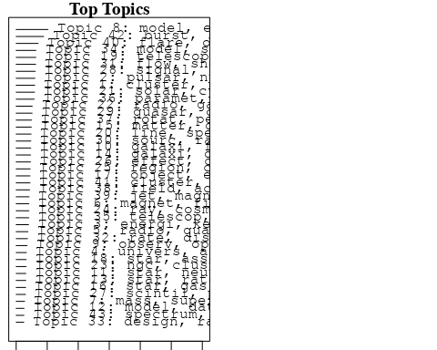

plotQuote(thoughts6, width = 30, main = "Topic 6")  
plotQuote(thoughts18, width = 30, main = "Topic 18")

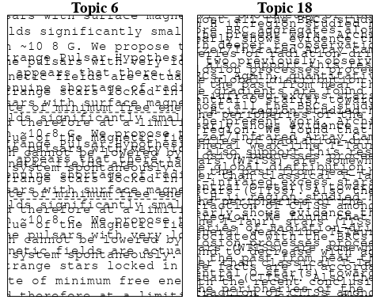

# Calculate and plot the correlation between topics  
mod.out.corr <- topicCorr(Research_topics)  
plot(mod.out.corr, cex = 1.5)  
  
  
# For each topic  
for (topic_num in 1:43) {  
 # Plot the word cloud  
 cloud(Research_topics, topic = topic_num, scale = c(2, 0.25))  
 Sys.sleep(2)  
}

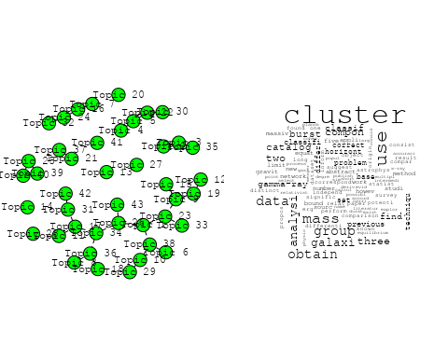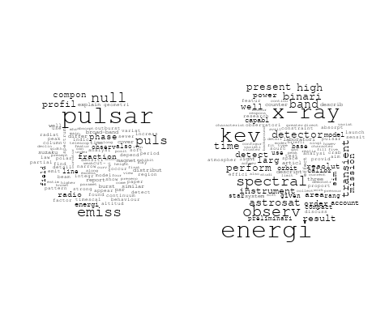

## Warning in wordcloud::wordcloud(words = vocab, freq = vec, max.words =  
## max.words, : understand could not be fit on page. It will not be plotted.

## Warning in wordcloud::wordcloud(words = vocab, freq = vec, max.words =  
## max.words, : graviti could not be fit on page. It will not be plotted.

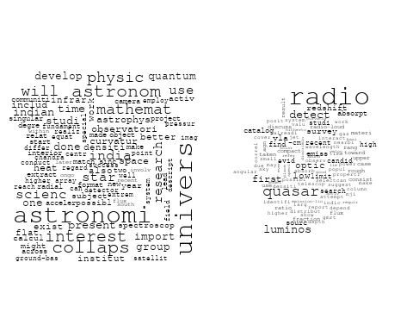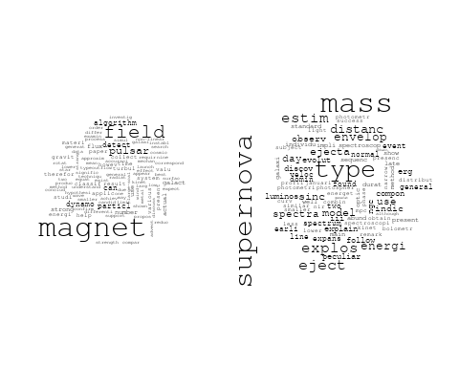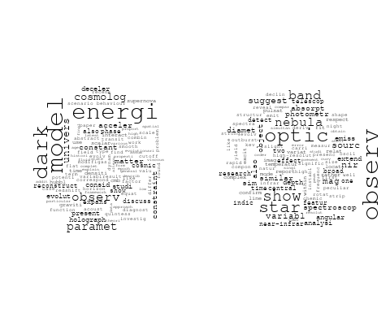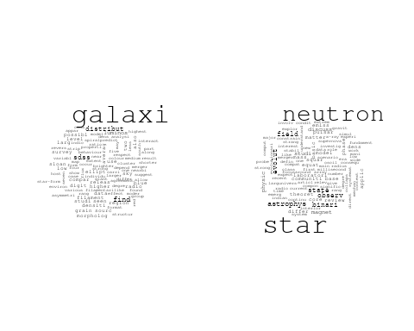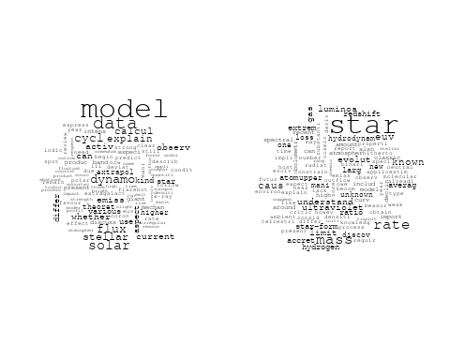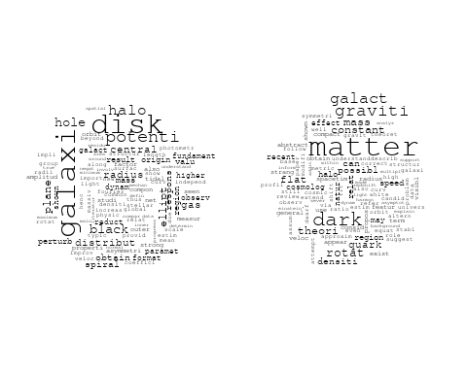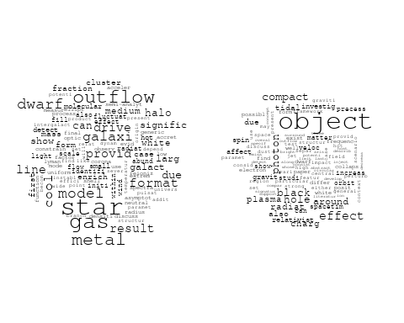

## Warning in wordcloud::wordcloud(words = vocab, freq = vec, max.words =  
## max.words, : telescop could not be fit on page. It will not be plotted.

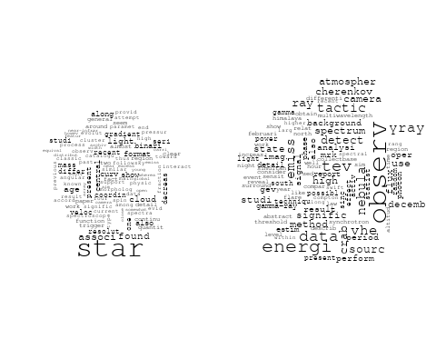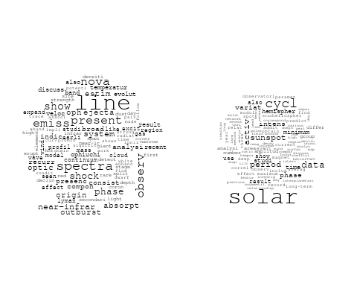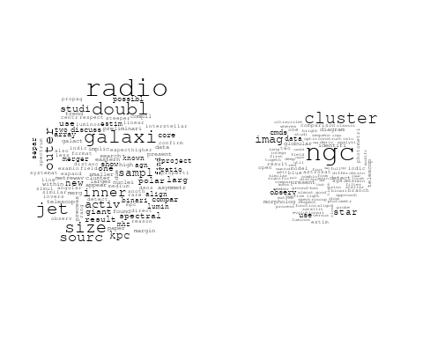

## Warning in wordcloud::wordcloud(words = vocab, freq = vec, max.words =  
## max.words, : region could not be fit on page. It will not be plotted.

## Warning in wordcloud::wordcloud(words = vocab, freq = vec, max.words =  
## max.words, : observ could not be fit on page. It will not be plotted.

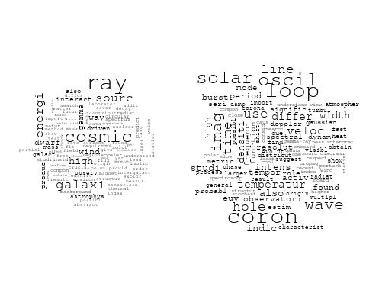

## Warning in wordcloud::wordcloud(words = vocab, freq = vec, max.words =  
## max.words, : simul could not be fit on page. It will not be plotted.

## Warning in wordcloud::wordcloud(words = vocab, freq = vec, max.words =  
## max.words, : function could not be fit on page. It will not be plotted.

## Warning in wordcloud::wordcloud(words = vocab, freq = vec, max.words =  
## max.words, : relationship could not be fit on page. It will not be plotted.

## Warning in wordcloud::wordcloud(words = vocab, freq = vec, max.words =  
## max.words, : studi could not be fit on page. It will not be plotted.

## Warning in wordcloud::wordcloud(words = vocab, freq = vec, max.words =  
## max.words, : scale could not be fit on page. It will not be plotted.

## Warning in wordcloud::wordcloud(words = vocab, freq = vec, max.words =  
## max.words, : format could not be fit on page. It will not be plotted.

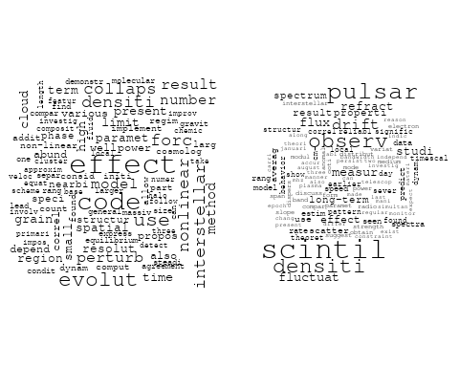

## Warning in wordcloud::wordcloud(words = vocab, freq = vec, max.words =  
## max.words, : background could not be fit on page. It will not be plotted.

## Warning in wordcloud::wordcloud(words = vocab, freq = vec, max.words =  
## max.words, : blazar could not be fit on page. It will not be plotted.

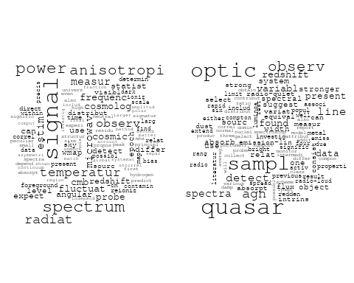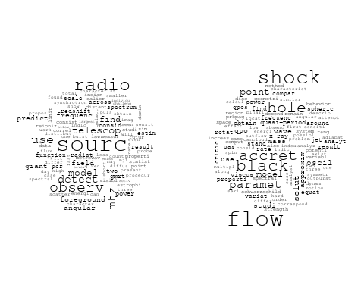

## Warning in wordcloud::wordcloud(words = vocab, freq = vec, max.words =  
## max.words, : radio could not be fit on page. It will not be plotted.

## Warning in wordcloud::wordcloud(words = vocab, freq = vec, max.words =  
## max.words, : calibr could not be fit on page. It will not be plotted.

## Warning in wordcloud::wordcloud(words = vocab, freq = vec, max.words =  
## max.words, : design could not be fit on page. It will not be plotted.

## Warning in wordcloud::wordcloud(words = vocab, freq = vec, max.words =  
## max.words, : frequenc could not be fit on page. It will not be plotted.

## Warning in wordcloud::wordcloud(words = vocab, freq = vec, max.words =  
## max.words, : spectrum could not be fit on page. It will not be plotted.

## Warning in wordcloud::wordcloud(words = vocab, freq = vec, max.words =  
## max.words, : system could not be fit on page. It will not be plotted.

## Warning in wordcloud::wordcloud(words = vocab, freq = vec, max.words =  
## max.words, : present could not be fit on page. It will not be plotted.

## Warning in wordcloud::wordcloud(words = vocab, freq = vec, max.words =  
## max.words, : pressur could not be fit on page. It will not be plotted.

## Warning in wordcloud::wordcloud(words = vocab, freq = vec, max.words =  
## max.words, : measur could not be fit on page. It will not be plotted.

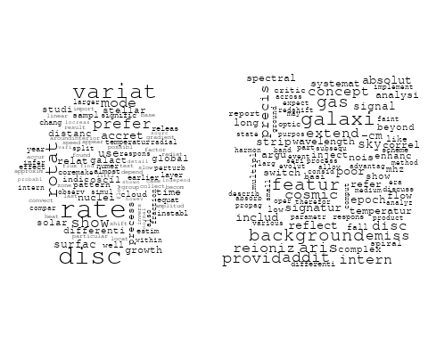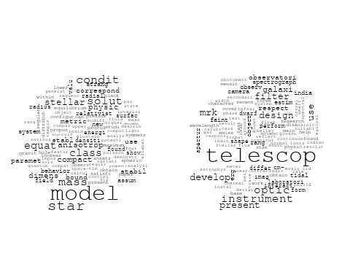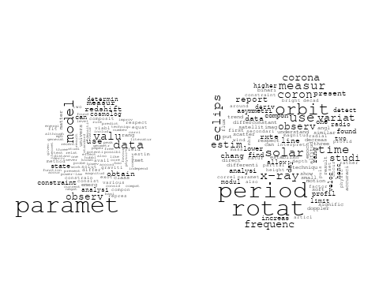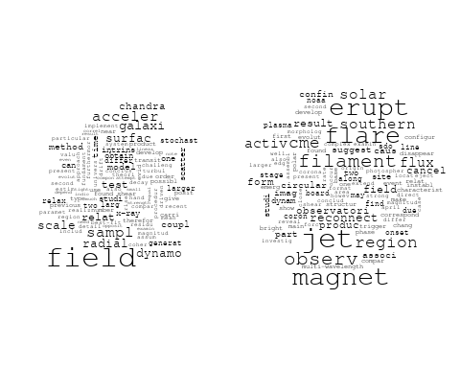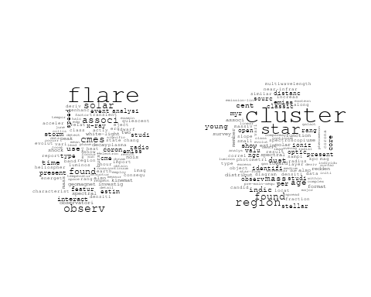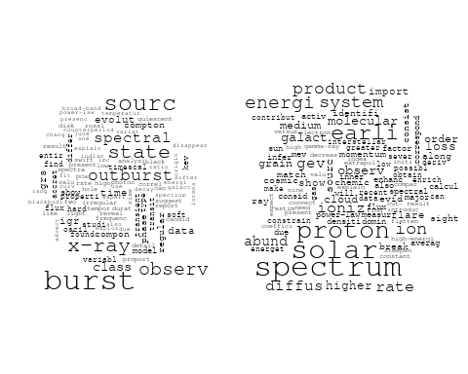

# Get the topic proportions for each document  
topic_proportions <- Research_topics$theta  
  
# Find the index of the topic with the highest proportion for each document  
# This will be the topic that each document is most likely to belong to  
max_topic_idx <- apply(topic_proportions, 1, which.max)  
  
# Add this as a new column to your data  
data_independent$topic <- max_topic_idx  
  
  
  
# Define the intervals  
intervals <- c('1824_1899', '1900_1964', '1965_1974', '1975_1984', '1985_1994', '1995_1999', '2000_2004', '2005_2009', '2010_2014', '2015_2019', '2020_2022')  
colors <- c('pink', 'blue', 'purple', 'yellow', 'green', 'pink', 'orange', 'violet', 'green', 'blue', 'pink')  
  
# Loop through the intervals and plot  
for(i in seq_along(intervals)){  
 # Filter data for when the pub_interval is equal to 1  
 data_filtered <- data_independent[data_independent[[paste0('pub_interval_', intervals[i])]] == 1,]  
   
 # Make the histogram  
   
 p <- ggplot(data_filtered, aes(x = topic)) +  
 geom_histogram(binwidth = 1, fill = colors[i], color = "black") +  
 xlab("Topic") +  
 ylab("Count") +  
 ggtitle(paste0("Topics from year ", gsub("_", " to ", intervals[i])))  
   
 print(p)  
}

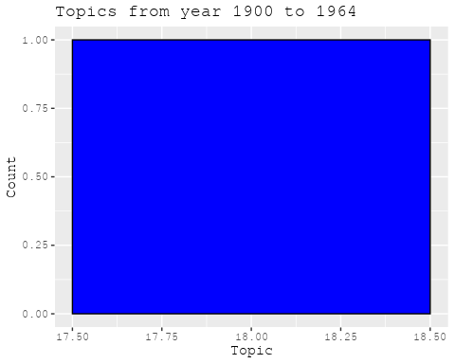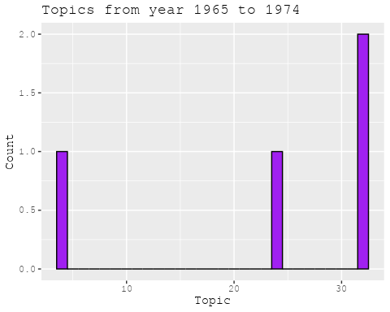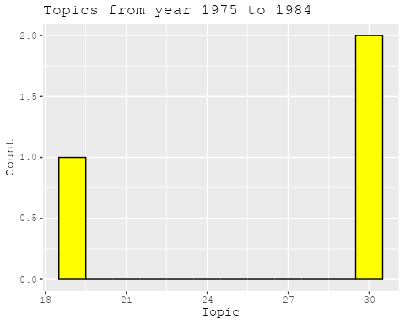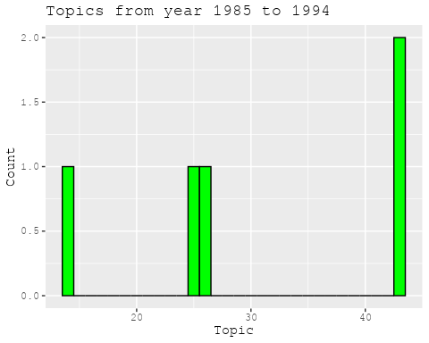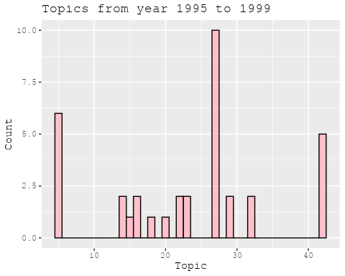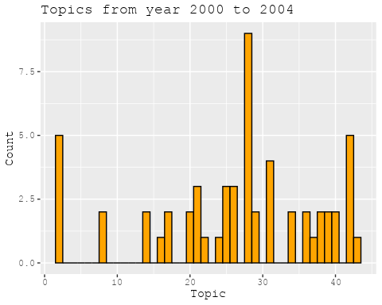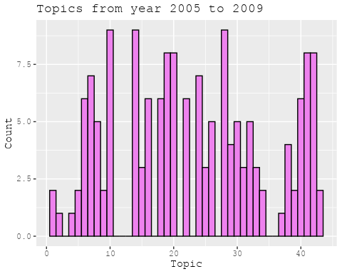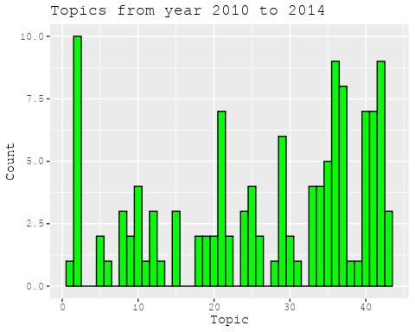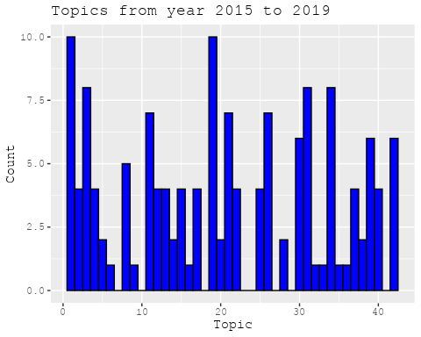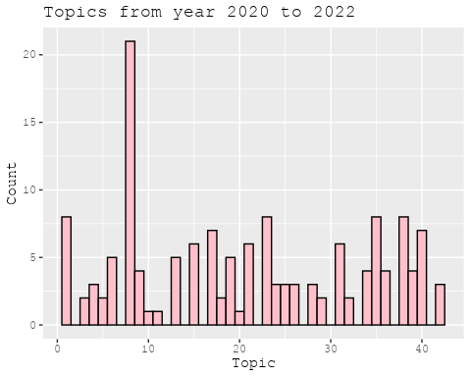

##Topic generation for AsiaAndOceania (in collaboration) publications  
  
data_collab <- data[data[["AsiaAndOceania"]] != 0,]  
  
# Save the original title data for future use  
data_collab$original_concatenated_title_abstract <- data_collab$concatenated_title_abstract  
  
#pre-processing the titles using textProcessor from the stm package  
processed_text <- textProcessor(data_collab$concatenated_title_abstract, metadata = data_collab)

## Building corpus...   
## Converting to Lower Case...   
## Removing punctuation...   
## Removing stopwords...   
## Removing numbers...   
## Stemming...   
## Creating Output...

# Further prepare the data by removing low-frequency terms  
out_text <- prepDocuments(processed_text$documents, processed_text$vocab, processed_text$meta)

## Removing 2196 of 6950 terms (2196 of 88052 tokens) due to frequency   
## Your corpus now has 1136 documents, 4754 terms and 85856 tokens.

docs_text <- out_text$documents  
vocab_text <- out_text$vocab  
meta_text <- out_text$meta  
  
  
#Prepare data  
plotRemoved(processed_text$documents, lower.thresh = seq(1, 200, by = 100))

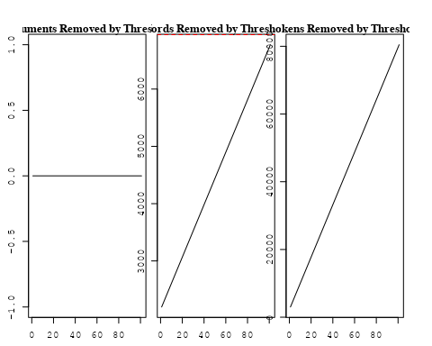

out_text <- prepDocuments(processed_text$documents, processed_text$vocab, processed_text$meta, lower.thresh = 8)

## Removing 5349 of 6950 terms (12874 of 88052 tokens) due to frequency   
## Your corpus now has 1136 documents, 1601 terms and 75178 tokens.

str(out_text$meta)

## 'data.frame': 1136 obs. of 39 variables:  
## $ concept_id : chr "https://openalex.org/C44870925" "https://openalex.org/C44870925" "https://openalex.org/C1276947" "https://openalex.org/C44870925" ...  
## $ work_id : chr "https://openalex.org/W1971228182" "https://openalex.org/W3121271699" "https://openalex.org/W2312475649" "https://openalex.org/W2020890029" ...  
## $ publication_year : int 2003 2008 2013 2007 2007 1999 2020 2003 2018 2000 ...  
## $ title : chr "Limits on the evolution of galaxies from the statistics of gravitational lenses" "Lyman alpha emitting galaxies at 0.2 < z < 0.35 from GALEX spectroscopy" "Death of Massive Stars (IAU S279): Supernovae and Gamma-Ray Bursts, Proceedings of the International Astronomic"| __truncated__ "The NIRSPEC Brown Dwarf Spectroscopic Survey. II. High-Resolution J-Band Spectra of M, L, and T Dwarfs" ...  
## $ paperabstract : chr "We use gravitational lenses from the Cosmic Lens All-Sky Survey to constrain the evolution of galaxies since re"| __truncated__ "The GALEX (Galaxy Evolution Explorer) spectroscopic survey mode, with a resolution of about 8 A in the FUV (135"| __truncated__ "students and, sometimes, even in scholars. While motion and change are the nature of the world – to quote the b"| __truncated__ "We present a sequence of high-resolution (R ~ 20,000, or 15 km s^(-1)) infrared spectra of stars and brown dwar"| __truncated__ ...  
## $ country : chr "KR GB GB KR" "KR FR KR FR" "TW" "US KR" ...  
## $ year_concept : chr "2003+https://openalex.org/C44870925" "2008+https://openalex.org/C44870925" "2013+https://openalex.org/C1276947" "2007+https://openalex.org/C44870925" ...  
## $ concatenated_title_abstract : chr "Limits on the evolution of galaxies from the statistics of gravitational lenses We use gravitational lenses fro"| __truncated__ "Lyman alpha emitting galaxies at 0.2 < z < 0.35 from GALEX spectroscopy The GALEX (Galaxy Evolution Explorer) s"| __truncated__ "Death of Massive Stars (IAU S279): Supernovae and Gamma-Ray Bursts, Proceedings of the International Astronomic"| __truncated__ "The NIRSPEC Brown Dwarf Spectroscopic Survey. II. High-Resolution J-Band Spectra of M, L, and T Dwarfs We prese"| __truncated__ ...  
## $ US : num 0 0 0 50 50 0 0 0 25 0 ...  
## $ IN : num 0 0 0 0 0 0 0 0 0 0 ...  
## $ DE : num 0 0 0 0 0 0 0 0 50 0 ...  
## $ CH : num 0 0 0 0 0 0 0 0 0 0 ...  
## $ GB : num 50 0 0 0 0 0 0 0 0 0 ...  
## $ CN : num 0 0 0 0 0 0 0 0 0 0 ...  
## $ FR : num 0 50 0 0 0 0 0 0 0 0 ...  
## $ IT : num 0 0 0 0 0 0 0 0 0 0 ...  
## $ RU : num 0 0 0 0 0 0 0 0 0 0 ...  
## $ CA : num 0 0 0 0 0 0 0 0 0 0 ...  
## $ NL : num 0 0 0 0 0 0 0 0 0 0 ...  
## $ AU : num 0 0 0 0 0 0 0 0 0 0 ...  
## $ JP : num 0 0 0 0 0 0 0 0 0 0 ...  
## $ ES : num 0 0 0 0 0 0 0 0 0 0 ...  
## $ IL : num 0 0 0 0 0 0 0 0 0 0 ...  
## $ Americas : num 0 0 0 0 0 0 0 0 0 0 ...  
## $ Europe : num 0 0 0 0 0 0 0 0 0 0 ...  
## $ Africa : num 0 0 0 0 0 0 0 0 0 0 ...  
## $ AsiaAndOceania : num 50 50 100 50 50 100 100 100 25 100 ...  
## $ pub_interval_2020_2022 : int 0 0 0 0 0 0 1 0 0 0 ...  
## $ pub_interval_2015_2019 : int 0 0 0 0 0 0 0 0 1 0 ...  
## $ pub_interval_2010_2014 : int 0 0 1 0 0 0 0 0 0 0 ...  
## $ pub_interval_2005_2009 : int 0 1 0 1 1 0 0 0 0 0 ...  
## $ pub_interval_2000_2004 : int 1 0 0 0 0 0 0 1 0 1 ...  
## $ pub_interval_1995_1999 : int 0 0 0 0 0 1 0 0 0 0 ...  
## $ pub_interval_1985_1994 : int 0 0 0 0 0 0 0 0 0 0 ...  
## $ pub_interval_1975_1984 : int 0 0 0 0 0 0 0 0 0 0 ...  
## $ pub_interval_1965_1974 : int 0 0 0 0 0 0 0 0 0 0 ...  
## $ pub_interval_1900_1964 : int 0 0 0 0 0 0 0 0 0 0 ...  
## $ pub_interval_1824_1899 : int 0 0 0 0 0 0 0 0 0 0 ...  
## $ original_concatenated_title_abstract: chr "Limits on the evolution of galaxies from the statistics of gravitational lenses We use gravitational lenses fro"| __truncated__ "Lyman alpha emitting galaxies at 0.2 < z < 0.35 from GALEX spectroscopy The GALEX (Galaxy Evolution Explorer) s"| __truncated__ "Death of Massive Stars (IAU S279): Supernovae and Gamma-Ray Bursts, Proceedings of the International Astronomic"| __truncated__ "The NIRSPEC Brown Dwarf Spectroscopic Survey. II. High-Resolution J-Band Spectra of M, L, and T Dwarfs We prese"| __truncated__ ...

# Initialize an empty formula string  
prevalence_formula_str <- "~"  
  
# Define the publication intervals  
pub_intervals <- c("pub_interval_2020_2022", "pub_interval_2015_2019", "pub_interval_2010_2014",   
 "pub_interval_2005_2009", "pub_interval_2000_2004", "pub_interval_1995_1999",  
 "pub_interval_1985_1994", "pub_interval_1975_1984", "pub_interval_1965_1974",  
 "pub_interval_1900_1964", "pub_interval_1824_1899")  
  
# Add each publication interval to the formula string  
for (interval in pub_intervals) {  
 # add an if statement to handle the first addition (without '+')  
 if (prevalence_formula_str == "~") {  
 prevalence_formula_str <- paste(prevalence_formula_str, interval)  
 } else {  
 prevalence_formula_str <- paste(prevalence_formula_str, "+", interval)  
 }  
}  
  
  
# Convert the string to a formula  
prevalence_formula <- as.formula(prevalence_formula_str)  
print(prevalence_formula)

## ~pub_interval_2020_2022 + pub_interval_2015_2019 + pub_interval_2010_2014 +   
## pub_interval_2005_2009 + pub_interval_2000_2004 + pub_interval_1995_1999 +   
## pub_interval_1985_1994 + pub_interval_1975_1984 + pub_interval_1965_1974 +   
## pub_interval_1900_1964 + pub_interval_1824_1899

# Run STM model  
Research_topics <- stm(documents = out_text$documents,   
 vocab = out_text$vocab,   
 K = 44,   
 prevalence = prevalence_formula,   
 data = out_text$meta,   
 init.type = "Spectral",  
 max.em.its = 1000,  
 gamma.prior = 'L1')

## Beginning Spectral Initialization   
## Calculating the gram matrix...  
## Finding anchor words...  
## ............................................  
## Recovering initialization...  
## ................  
## Initialization complete.  
## .......................................................................................................  
## Completed E-Step (1 seconds).   
## Completed M-Step.   
## Completing Iteration 1 (approx. per word bound = -6.187)   
## .......................................................................................................  
## Completed E-Step (1 seconds).   
## Completed M-Step.   
## Completing Iteration 2 (approx. per word bound = -5.913, relative change = 4.418e-02)   
## .......................................................................................................  
## Completed E-Step (0 seconds).   
## Completed M-Step.   
## Completing Iteration 3 (approx. per word bound = -5.828, relative change = 1.451e-02)   
## .......................................................................................................  
## Completed E-Step (0 seconds).   
## Completed M-Step.   
## Completing Iteration 4 (approx. per word bound = -5.789, relative change = 6.664e-03)   
## .......................................................................................................  
## Completed E-Step (0 seconds).   
## Completed M-Step.   
## Completing Iteration 5 (approx. per word bound = -5.766, relative change = 3.954e-03)   
## Topic 1: function, cloud, detect, beam, rate   
## Topic 2: galaxi, sampl, blue, redshift, low   
## Topic 3: univers, physic, space, scienc, astronomi   
## Topic 4: spectrum, differ, deriv, cosmolog, energi   
## Topic 5: data, result, correct, observ, detector   
## Topic 6: hole, black, accret, flow, paramet   
## Topic 7: radio, galaxi, object, optic, emiss   
## Topic 8: tidal, event, dwarf, galaxi, observ   
## Topic 9: cluster, star, galaxi, format, cold   
## Topic 10: supernova, progenitor, remnant, mass, lightcurv   
## Topic 11: astrophys, studi, relativist, statist, theoret   
## Topic 12: void, map, sky, data, halo   
## Topic 13: star, compact, graviti, model, solut   
## Topic 14: galaxi, luminos, fuv, color, nuv   
## Topic 15: light, detect, curv, event, microlens   
## Topic 16: grain, polar, dust, size, distribut   
## Topic 17: line, comet, observ, orbit, relat   
## Topic 18: electron, emiss, wind, primari, solar   
## Topic 19: core, emiss, observ, sourc, jet   
## Topic 20: galaxi, morpholog, type, luminos, densiti   
## Topic 21: galaxi, mass, massiv, stellar, black   
## Topic 22: galaxi, pair, merger, redshift, luminos   
## Topic 23: star, abund, system, binari, mass   
## Topic 24: planet, correl, structur, ring, tidal   
## Topic 25: energi, model, dark, field, cosmolog   
## Topic 26: disk, magnet, instabl, diffus, gas   
## Topic 27: dark, matter, model, energi, can   
## Topic 28: galaxi, star, format, use, stellar   
## Topic 29: accret, star, neutron, mass, disk   
## Topic 30: x-ray, sourc, detect, outburst, optic   
## Topic 31: densiti, profil, lyα, peak, galaxi   
## Topic 32: period, system, binari, mass, orbit   
## Topic 33: planetari, caustic, planet, detect, mass   
## Topic 34: cluster, galaxi, rotat, globular, star   
## Topic 35: sourc, event, microlens, len, imag   
## Topic 36: star, disk, format, young, accret   
## Topic 37: solar, observ, wave, coron, atmospher   
## Topic 38: shock, particl, energi, acceler, pulsar   
## Topic 39: dwarf, bulg, galaxi, use, star   
## Topic 40: galaxi, early-typ, redshift, cosmolog, statist   
## Topic 41: mass, cluster, imag, use, host   
## Topic 42: gas, molecular, format, ngc, observ   
## Topic 43: magnet, field, solar, observ, region   
## Topic 44: rotat, star, differenti, stellar, equat   
## .......................................................................................................  
## Completed E-Step (0 seconds).   
## Completed M-Step.   
## Completing Iteration 6 (approx. per word bound = -5.752, relative change = 2.397e-03)   
## .......................................................................................................  
## Completed E-Step (0 seconds).   
## Completed M-Step.   
## Completing Iteration 7 (approx. per word bound = -5.743, relative change = 1.560e-03)   
## .......................................................................................................  
## Completed E-Step (0 seconds).   
## Completed M-Step.   
## Completing Iteration 8 (approx. per word bound = -5.737, relative change = 1.012e-03)   
## .......................................................................................................  
## Completed E-Step (0 seconds).   
## Completed M-Step.   
## Completing Iteration 9 (approx. per word bound = -5.732, relative change = 8.399e-04)   
## .......................................................................................................  
## Completed E-Step (0 seconds).   
## Completed M-Step.   
## Completing Iteration 10 (approx. per word bound = -5.728, relative change = 6.860e-04)   
## Topic 1: function, detect, beam, cloud, rate   
## Topic 2: galaxi, sampl, survey, blue, redshift   
## Topic 3: univers, space, scienc, physic, expans   
## Topic 4: spectrum, differ, method, cosmolog, deriv   
## Topic 5: data, result, use, investig, observ   
## Topic 6: hole, black, accret, flow, paramet   
## Topic 7: radio, galaxi, optic, object, spectral   
## Topic 8: tidal, dwarf, galaxi, event, star   
## Topic 9: cluster, star, format, galaxi, cold   
## Topic 10: supernova, progenitor, remnant, mass, lightcurv   
## Topic 11: astrophys, system, theoret, studi, statist   
## Topic 12: void, map, sky, data, result   
## Topic 13: star, compact, graviti, model, solut   
## Topic 14: galaxi, fuv, luminos, nuv, color   
## Topic 15: detect, light, event, microlens, planet   
## Topic 16: polar, grain, dust, size, distribut   
## Topic 17: line, comet, observ, orbit, relat   
## Topic 18: electron, emiss, wind, primari, ion   
## Topic 19: core, observ, emiss, sourc, jet   
## Topic 20: galaxi, morpholog, type, luminos, densiti   
## Topic 21: galaxi, mass, massiv, stellar, black   
## Topic 22: galaxi, merger, redshift, luminos, pair   
## Topic 23: star, abund, system, mass, binari   
## Topic 24: planet, correl, structur, tidal, distribut   
## Topic 25: energi, model, dark, field, univers   
## Topic 26: disk, instabl, magnet, turbul, diffus   
## Topic 27: dark, matter, model, energi, can   
## Topic 28: galaxi, star, format, use, stellar   
## Topic 29: accret, star, mass, neutron, disk   
## Topic 30: x-ray, sourc, outburst, detect, optic   
## Topic 31: densiti, profil, peak, lyα, galaxi   
## Topic 32: period, system, binari, mass, compon   
## Topic 33: planetari, caustic, planet, detect, event   
## Topic 34: cluster, galaxi, globular, age, rotat   
## Topic 35: event, microlens, sourc, len, star   
## Topic 36: star, disk, format, accret, young   
## Topic 37: solar, observ, wave, coron, flare   
## Topic 38: shock, particl, acceler, energi, pulsar   
## Topic 39: dwarf, bulg, galaxi, use, disc   
## Topic 40: galaxi, cosmolog, statist, early-typ, redshift   
## Topic 41: mass, cluster, galaxi, imag, host   
## Topic 42: gas, molecular, ngc, format, observ   
## Topic 43: magnet, field, solar, observ, region   
## Topic 44: rotat, star, differenti, stellar, equat   
## .......................................................................................................  
## Completed E-Step (0 seconds).   
## Completed M-Step.   
## Completing Iteration 11 (approx. per word bound = -5.726, relative change = 4.980e-04)   
## .......................................................................................................  
## Completed E-Step (0 seconds).   
## Completed M-Step.   
## Completing Iteration 12 (approx. per word bound = -5.723, relative change = 3.962e-04)   
## .......................................................................................................  
## Completed E-Step (0 seconds).   
## Completed M-Step.   
## Completing Iteration 13 (approx. per word bound = -5.721, relative change = 3.284e-04)   
## .......................................................................................................  
## Completed E-Step (0 seconds).   
## Completed M-Step.   
## Completing Iteration 14 (approx. per word bound = -5.720, relative change = 2.759e-04)   
## .......................................................................................................  
## Completed E-Step (0 seconds).   
## Completed M-Step.   
## Completing Iteration 15 (approx. per word bound = -5.719, relative change = 2.418e-04)   
## Topic 1: function, detect, beam, cloud, jet   
## Topic 2: galaxi, sampl, survey, observ, redshift   
## Topic 3: univers, space, scienc, physic, group   
## Topic 4: spectrum, differ, method, cosmolog, deriv   
## Topic 5: data, use, result, investig, detector   
## Topic 6: hole, black, accret, flow, paramet   
## Topic 7: radio, galaxi, optic, object, spectral   
## Topic 8: tidal, galaxi, dwarf, perturb, star   
## Topic 9: cluster, star, format, galaxi, cold   
## Topic 10: supernova, progenitor, remnant, lightcurv, mass   
## Topic 11: astrophys, system, theoret, relativist, studi   
## Topic 12: void, map, sky, data, result   
## Topic 13: star, graviti, compact, model, solut   
## Topic 14: galaxi, fuv, luminos, nuv, ellipt   
## Topic 15: detect, microlens, event, planet, light   
## Topic 16: polar, grain, dust, size, distribut   
## Topic 17: line, observ, comet, orbit, relat   
## Topic 18: electron, emiss, ion, primari, cluster   
## Topic 19: core, observ, emiss, jet, sourc   
## Topic 20: galaxi, morpholog, type, luminos, densiti   
## Topic 21: galaxi, mass, massiv, stellar, black   
## Topic 22: galaxi, redshift, merger, luminos, pair   
## Topic 23: star, system, binari, abund, mass   
## Topic 24: planet, correl, structur, tidal, distribut   
## Topic 25: energi, model, dark, field, univers   
## Topic 26: instabl, disk, magnet, turbul, gas   
## Topic 27: dark, matter, model, energi, can   
## Topic 28: galaxi, star, format, use, stellar   
## Topic 29: accret, star, mass, neutron, disk   
## Topic 30: x-ray, sourc, outburst, detect, optic   
## Topic 31: densiti, profil, peak, lyα, galaxi   
## Topic 32: period, system, light, mass, binari   
## Topic 33: planetari, caustic, planet, detect, separ   
## Topic 34: cluster, galaxi, globular, age, popul   
## Topic 35: event, microlens, sourc, len, star   
## Topic 36: star, disk, format, accret, young   
## Topic 37: solar, observ, wave, coron, flare   
## Topic 38: particl, shock, acceler, pulsar, energi   
## Topic 39: dwarf, bulg, galaxi, use, disc   
## Topic 40: galaxi, lens, cosmolog, statist, redshift   
## Topic 41: mass, cluster, galaxi, imag, host   
## Topic 42: gas, molecular, ngc, format, observ   
## Topic 43: magnet, field, solar, observ, region   
## Topic 44: rotat, star, differenti, stellar, equat   
## .......................................................................................................  
## Completed E-Step (0 seconds).   
## Completed M-Step.   
## Completing Iteration 16 (approx. per word bound = -5.717, relative change = 2.315e-04)   
## .......................................................................................................  
## Completed E-Step (0 seconds).   
## Completed M-Step.   
## Completing Iteration 17 (approx. per word bound = -5.716, relative change = 2.087e-04)   
## .......................................................................................................  
## Completed E-Step (0 seconds).   
## Completed M-Step.   
## Completing Iteration 18 (approx. per word bound = -5.715, relative change = 1.969e-04)   
## .......................................................................................................  
## Completed E-Step (0 seconds).   
## Completed M-Step.   
## Completing Iteration 19 (approx. per word bound = -5.714, relative change = 2.020e-04)   
## .......................................................................................................  
## Completed E-Step (0 seconds).   
## Completed M-Step.   
## Completing Iteration 20 (approx. per word bound = -5.713, relative change = 1.801e-04)   
## Topic 1: function, detect, beam, cloud, jet   
## Topic 2: galaxi, sampl, survey, observ, redshift   
## Topic 3: univers, space, scienc, physic, group   
## Topic 4: spectrum, differ, method, deriv, cosmolog   
## Topic 5: data, use, result, investig, detector   
## Topic 6: hole, black, accret, flow, paramet   
## Topic 7: radio, galaxi, optic, object, spectral   
## Topic 8: galaxi, tidal, dwarf, star, perturb   
## Topic 9: cluster, star, format, galaxi, cold   
## Topic 10: supernova, progenitor, remnant, lightcurv, mass   
## Topic 11: astrophys, system, theoret, relativist, astronom   
## Topic 12: void, map, sky, data, result   
## Topic 13: star, graviti, compact, model, solut   
## Topic 14: galaxi, fuv, luminos, nuv, ellipt   
## Topic 15: detect, microlens, event, planet, observ   
## Topic 16: polar, grain, dust, size, distribut   
## Topic 17: line, observ, comet, orbit, spectral   
## Topic 18: electron, emiss, ion, radio, cluster   
## Topic 19: core, observ, emiss, jet, sourc   
## Topic 20: galaxi, morpholog, type, luminos, densiti   
## Topic 21: galaxi, mass, massiv, stellar, black   
## Topic 22: galaxi, redshift, merger, luminos, pair   
## Topic 23: star, binari, system, abund, mass   
## Topic 24: planet, correl, tidal, structur, distribut   
## Topic 25: energi, model, dark, univers, field   
## Topic 26: instabl, disk, magnet, turbul, gas   
## Topic 27: dark, matter, model, energi, can   
## Topic 28: galaxi, star, format, use, stellar   
## Topic 29: accret, star, mass, neutron, disk   
## Topic 30: x-ray, sourc, outburst, detect, optic   
## Topic 31: densiti, peak, profil, lyα, galaxi   
## Topic 32: period, light, system, curv, mass   
## Topic 33: planetari, caustic, planet, separ, detect   
## Topic 34: cluster, galaxi, globular, popul, age   
## Topic 35: event, microlens, sourc, len, star   
## Topic 36: star, disk, format, accret, stellar   
## Topic 37: solar, observ, wave, coron, flare   
## Topic 38: particl, shock, acceler, pulsar, energi   
## Topic 39: dwarf, bulg, galaxi, use, disc   
## Topic 40: galaxi, lens, statist, cosmolog, distribut   
## Topic 41: mass, cluster, galaxi, imag, host   
## Topic 42: gas, molecular, ngc, format, observ   
## Topic 43: magnet, field, solar, observ, region   
## Topic 44: rotat, star, differenti, stellar, equat   
## .......................................................................................................  
## Completed E-Step (0 seconds).   
## Completed M-Step.   
## Completing Iteration 21 (approx. per word bound = -5.712, relative change = 1.508e-04)   
## .......................................................................................................  
## Completed E-Step (0 seconds).   
## Completed M-Step.   
## Completing Iteration 22 (approx. per word bound = -5.711, relative change = 1.267e-04)   
## .......................................................................................................  
## Completed E-Step (0 seconds).   
## Completed M-Step.   
## Completing Iteration 23 (approx. per word bound = -5.710, relative change = 1.155e-04)   
## .......................................................................................................  
## Completed E-Step (0 seconds).   
## Completed M-Step.   
## Completing Iteration 24 (approx. per word bound = -5.710, relative change = 1.267e-04)   
## .......................................................................................................  
## Completed E-Step (0 seconds).   
## Completed M-Step.   
## Completing Iteration 25 (approx. per word bound = -5.709, relative change = 1.122e-04)   
## Topic 1: detect, function, beam, cloud, jet   
## Topic 2: galaxi, sampl, survey, redshift, observ   
## Topic 3: univers, space, scienc, physic, group   
## Topic 4: spectrum, differ, method, deriv, cosmolog   
## Topic 5: data, use, result, investig, studi   
## Topic 6: hole, black, accret, flow, paramet   
## Topic 7: radio, galaxi, optic, object, spectral   
## Topic 8: galaxi, dwarf, tidal, star, perturb   
## Topic 9: cluster, star, format, galaxi, cold   
## Topic 10: supernova, progenitor, remnant, lightcurv, mass   
## Topic 11: astrophys, system, astronom, theoret, statist   
## Topic 12: void, map, sky, result, data   
## Topic 13: star, graviti, compact, model, solut   
## Topic 14: galaxi, fuv, luminos, nuv, ellipt   
## Topic 15: detect, microlens, event, planet, observ   
## Topic 16: polar, grain, dust, size, distribut   
## Topic 17: line, observ, comet, orbit, spectral   
## Topic 18: electron, emiss, radio, ion, cluster   
## Topic 19: core, observ, emiss, jet, sourc   
## Topic 20: galaxi, morpholog, type, luminos, densiti   
## Topic 21: galaxi, mass, massiv, stellar, black   
## Topic 22: galaxi, redshift, merger, luminos, pair   
## Topic 23: star, binari, system, abund, mass   
## Topic 24: planet, correl, tidal, structur, distribut   
## Topic 25: energi, model, dark, univers, phase   
## Topic 26: instabl, disk, magnet, turbul, gas   
## Topic 27: dark, matter, model, energi, can   
## Topic 28: galaxi, star, format, use, stellar   
## Topic 29: accret, star, mass, neutron, disk   
## Topic 30: x-ray, outburst, detect, sourc, optic   
## Topic 31: densiti, peak, profil, lyα, galaxi   
## Topic 32: period, light, curv, system, variabl   
## Topic 33: planetari, caustic, planet, separ, detect   
## Topic 34: cluster, galaxi, popul, age, rotat   
## Topic 35: event, microlens, sourc, len, star   
## Topic 36: star, disk, format, accret, stellar   
## Topic 37: solar, observ, wave, coron, flare   
## Topic 38: particl, shock, pulsar, acceler, energi   
## Topic 39: dwarf, bulg, galaxi, use, disc   
## Topic 40: galaxi, lens, statist, cosmolog, distribut   
## Topic 41: mass, cluster, galaxi, imag, environ   
## Topic 42: gas, molecular, ngc, observ, format   
## Topic 43: magnet, field, solar, observ, region   
## Topic 44: rotat, star, differenti, stellar, equat   
## .......................................................................................................  
## Completed E-Step (0 seconds).   
## Completed M-Step.   
## Completing Iteration 26 (approx. per word bound = -5.709, relative change = 9.675e-05)   
## .......................................................................................................  
## Completed E-Step (0 seconds).   
## Completed M-Step.   
## Completing Iteration 27 (approx. per word bound = -5.708, relative change = 8.556e-05)   
## .......................................................................................................  
## Completed E-Step (0 seconds).   
## Completed M-Step.   
## Completing Iteration 28 (approx. per word bound = -5.708, relative change = 8.074e-05)   
## .......................................................................................................  
## Completed E-Step (0 seconds).   
## Completed M-Step.   
## Completing Iteration 29 (approx. per word bound = -5.707, relative change = 7.568e-05)   
## .......................................................................................................  
## Completed E-Step (0 seconds).   
## Completed M-Step.   
## Completing Iteration 30 (approx. per word bound = -5.707, relative change = 7.397e-05)   
## Topic 1: detect, function, beam, cloud, jet   
## Topic 2: galaxi, sampl, survey, redshift, observ   
## Topic 3: univers, space, scienc, physic, group   
## Topic 4: spectrum, differ, method, model, cosmolog   
## Topic 5: data, use, result, investig, studi   
## Topic 6: hole, black, accret, flow, paramet   
## Topic 7: radio, galaxi, optic, object, spectral   
## Topic 8: galaxi, dwarf, tidal, star, perturb   
## Topic 9: cluster, star, format, galaxi, cold   
## Topic 10: supernova, progenitor, remnant, lightcurv, mass   
## Topic 11: astrophys, system, astronom, theoret, statist   
## Topic 12: void, map, sky, result, power   
## Topic 13: star, graviti, compact, model, solut   
## Topic 14: galaxi, fuv, luminos, nuv, ellipt   
## Topic 15: detect, microlens, event, planet, observ   
## Topic 16: polar, grain, dust, size, distribut   
## Topic 17: line, observ, comet, orbit, ratio   
## Topic 18: electron, emiss, radio, ion, cluster   
## Topic 19: core, observ, jet, sourc, emiss   
## Topic 20: galaxi, morpholog, type, luminos, densiti   
## Topic 21: galaxi, mass, massiv, stellar, black   
## Topic 22: galaxi, redshift, merger, luminos, pair   
## Topic 23: star, binari, system, abund, mass   
## Topic 24: planet, correl, tidal, structur, orbit   
## Topic 25: energi, model, dark, univers, phase   
## Topic 26: instabl, disk, turbul, magnet, gas   
## Topic 27: dark, matter, model, energi, can   
## Topic 28: galaxi, star, format, use, stellar   
## Topic 29: accret, star, mass, neutron, disk   
## Topic 30: x-ray, outburst, detect, sourc, optic   
## Topic 31: densiti, peak, profil, lyα, galaxi   
## Topic 32: period, light, curv, system, variabl   
## Topic 33: planetari, caustic, planet, separ, detect   
## Topic 34: cluster, galaxi, popul, age, rotat   
## Topic 35: event, microlens, sourc, len, star   
## Topic 36: star, disk, format, accret, stellar   
## Topic 37: solar, observ, wave, coron, flare   
## Topic 38: particl, shock, pulsar, acceler, energi   
## Topic 39: dwarf, bulg, galaxi, use, disc   
## Topic 40: galaxi, lens, cosmolog, statist, per   
## Topic 41: mass, cluster, galaxi, imag, environ   
## Topic 42: gas, molecular, ngc, observ, nebula   
## Topic 43: magnet, field, solar, observ, region   
## Topic 44: rotat, star, differenti, stellar, measur   
## .......................................................................................................  
## Completed E-Step (0 seconds).   
## Completed M-Step.   
## Completing Iteration 31 (approx. per word bound = -5.706, relative change = 7.005e-05)   
## .......................................................................................................  
## Completed E-Step (0 seconds).   
## Completed M-Step.   
## Completing Iteration 32 (approx. per word bound = -5.706, relative change = 7.036e-05)   
## .......................................................................................................  
## Completed E-Step (0 seconds).   
## Completed M-Step.   
## Completing Iteration 33 (approx. per word bound = -5.706, relative change = 6.810e-05)   
## .......................................................................................................  
## Completed E-Step (0 seconds).   
## Completed M-Step.   
## Completing Iteration 34 (approx. per word bound = -5.705, relative change = 6.832e-05)   
## .......................................................................................................  
## Completed E-Step (0 seconds).   
## Completed M-Step.   
## Completing Iteration 35 (approx. per word bound = -5.705, relative change = 6.879e-05)   
## Topic 1: detect, function, beam, cloud, jet   
## Topic 2: galaxi, sampl, survey, redshift, observ   
## Topic 3: univers, space, scienc, physic, group   
## Topic 4: spectrum, differ, method, model, cosmolog   
## Topic 5: data, use, result, investig, studi   
## Topic 6: hole, black, accret, flow, paramet   
## Topic 7: radio, galaxi, optic, object, emiss   
## Topic 8: galaxi, dwarf, tidal, star, perturb   
## Topic 9: cluster, star, format, galaxi, cold   
## Topic 10: supernova, progenitor, remnant, lightcurv, mass   
## Topic 11: astrophys, system, theoret, astronom, statist   
## Topic 12: void, map, sky, result, power   
## Topic 13: star, graviti, compact, model, solut   
## Topic 14: galaxi, fuv, luminos, nuv, ellipt   
## Topic 15: detect, microlens, event, planet, observ   
## Topic 16: polar, grain, dust, size, distribut   
## Topic 17: line, observ, comet, ratio, orbit   
## Topic 18: electron, emiss, radio, ion, cluster   
## Topic 19: core, observ, jet, sourc, emiss   
## Topic 20: galaxi, morpholog, type, luminos, densiti   
## Topic 21: galaxi, mass, massiv, stellar, black   
## Topic 22: galaxi, redshift, merger, luminos, rate   
## Topic 23: star, binari, system, abund, mass   
## Topic 24: planet, correl, tidal, structur, orbit   
## Topic 25: energi, model, dark, univers, phase   
## Topic 26: instabl, disk, turbul, magnet, diffus   
## Topic 27: dark, matter, model, energi, can   
## Topic 28: galaxi, star, format, use, stellar   
## Topic 29: accret, star, mass, neutron, disk   
## Topic 30: x-ray, outburst, detect, sourc, optic   
## Topic 31: densiti, peak, profil, lyα, galaxi   
## Topic 32: period, light, curv, system, variabl   
## Topic 33: planetari, caustic, planet, separ, detect   
## Topic 34: cluster, galaxi, age, popul, rotat   
## Topic 35: event, microlens, sourc, len, star   
## Topic 36: star, disk, format, accret, stellar   
## Topic 37: solar, observ, wave, coron, flare   
## Topic 38: particl, shock, acceler, pulsar, energi   
## Topic 39: dwarf, bulg, galaxi, use, disc   
## Topic 40: galaxi, lens, cosmolog, statist, per   
## Topic 41: mass, cluster, galaxi, imag, environ   
## Topic 42: gas, molecular, ngc, observ, nebula   
## Topic 43: magnet, field, solar, observ, region   
## Topic 44: rotat, star, differenti, stellar, measur   
## .......................................................................................................  
## Completed E-Step (0 seconds).   
## Completed M-Step.   
## Completing Iteration 36 (approx. per word bound = -5.704, relative change = 8.094e-05)   
## .......................................................................................................  
## Completed E-Step (0 seconds).   
## Completed M-Step.   
## Completing Iteration 37 (approx. per word bound = -5.704, relative change = 7.012e-05)   
## .......................................................................................................  
## Completed E-Step (0 seconds).   
## Completed M-Step.   
## Completing Iteration 38 (approx. per word bound = -5.704, relative change = 6.770e-05)   
## .......................................................................................................  
## Completed E-Step (0 seconds).   
## Completed M-Step.   
## Completing Iteration 39 (approx. per word bound = -5.703, relative change = 5.796e-05)   
## .......................................................................................................  
## Completed E-Step (0 seconds).   
## Completed M-Step.   
## Completing Iteration 40 (approx. per word bound = -5.703, relative change = 4.541e-05)   
## Topic 1: detect, function, beam, cloud, jet   
## Topic 2: galaxi, sampl, survey, redshift, observ   
## Topic 3: univers, space, scienc, physic, group   
## Topic 4: spectrum, differ, method, model, cosmolog   
## Topic 5: data, use, result, investig, studi   
## Topic 6: hole, black, accret, flow, paramet   
## Topic 7: radio, galaxi, optic, object, emiss   
## Topic 8: galaxi, dwarf, tidal, star, perturb   
## Topic 9: cluster, star, format, galaxi, cold   
## Topic 10: supernova, progenitor, remnant, lightcurv, mass   
## Topic 11: astrophys, system, theoret, statist, astronom   
## Topic 12: void, map, sky, result, power   
## Topic 13: star, graviti, model, compact, solut   
## Topic 14: galaxi, fuv, luminos, nuv, ellipt   
## Topic 15: detect, microlens, event, planet, observ   
## Topic 16: polar, grain, dust, size, distribut   
## Topic 17: line, observ, comet, ratio, spectral   
## Topic 18: electron, emiss, radio, ion, cluster   
## Topic 19: core, observ, jet, sourc, emiss   
## Topic 20: galaxi, morpholog, type, luminos, depend   
## Topic 21: galaxi, mass, massiv, stellar, black   
## Topic 22: galaxi, redshift, merger, luminos, rate   
## Topic 23: star, binari, system, abund, mass   
## Topic 24: planet, correl, tidal, structur, orbit   
## Topic 25: energi, model, dark, univers, phase   
## Topic 26: instabl, disk, turbul, magnet, diffus   
## Topic 27: dark, matter, model, energi, can   
## Topic 28: galaxi, star, format, use, stellar   
## Topic 29: accret, star, mass, neutron, disk   
## Topic 30: x-ray, outburst, detect, sourc, optic   
## Topic 31: densiti, peak, lyα, profil, galaxi   
## Topic 32: period, light, curv, system, variabl   
## Topic 33: planetari, caustic, planet, separ, detect   
## Topic 34: cluster, galaxi, age, popul, rotat   
## Topic 35: event, microlens, sourc, len, star   
## Topic 36: star, disk, format, accret, stellar   
## Topic 37: solar, observ, wave, flare, coron   
## Topic 38: particl, shock, acceler, pulsar, energi   
## Topic 39: dwarf, bulg, galaxi, use, disc   
## Topic 40: galaxi, lens, cosmolog, statist, per   
## Topic 41: mass, cluster, galaxi, environ, host   
## Topic 42: gas, molecular, ngc, observ, nebula   
## Topic 43: magnet, field, solar, observ, region   
## Topic 44: rotat, star, differenti, stellar, measur   
## .......................................................................................................  
## Completed E-Step (0 seconds).   
## Completed M-Step.   
## Completing Iteration 41 (approx. per word bound = -5.703, relative change = 4.220e-05)   
## .......................................................................................................  
## Completed E-Step (0 seconds).   
## Completed M-Step.   
## Completing Iteration 42 (approx. per word bound = -5.702, relative change = 4.295e-05)   
## .......................................................................................................  
## Completed E-Step (0 seconds).   
## Completed M-Step.   
## Completing Iteration 43 (approx. per word bound = -5.702, relative change = 4.091e-05)   
## .......................................................................................................  
## Completed E-Step (0 seconds).   
## Completed M-Step.   
## Completing Iteration 44 (approx. per word bound = -5.702, relative change = 3.535e-05)   
## .......................................................................................................  
## Completed E-Step (0 seconds).   
## Completed M-Step.   
## Completing Iteration 45 (approx. per word bound = -5.702, relative change = 3.453e-05)   
## Topic 1: detect, function, beam, cloud, jet   
## Topic 2: galaxi, sampl, survey, redshift, massiv   
## Topic 3: univers, space, scienc, physic, group   
## Topic 4: spectrum, differ, method, model, cosmolog   
## Topic 5: data, use, result, investig, studi   
## Topic 6: hole, black, accret, flow, paramet   
## Topic 7: radio, galaxi, optic, object, emiss   
## Topic 8: galaxi, dwarf, tidal, star, perturb   
## Topic 9: cluster, star, format, galaxi, cold   
## Topic 10: supernova, progenitor, remnant, lightcurv, mass   
## Topic 11: astrophys, system, theoret, statist, astronom   
## Topic 12: void, map, sky, galaxi, result   
## Topic 13: star, graviti, model, compact, solut   
## Topic 14: galaxi, fuv, luminos, nuv, ellipt   
## Topic 15: detect, microlens, event, planet, observ   
## Topic 16: polar, grain, dust, size, distribut   
## Topic 17: line, observ, comet, ratio, spectral   
## Topic 18: electron, emiss, radio, ion, cluster   
## Topic 19: core, observ, jet, sourc, emiss   
## Topic 20: galaxi, morpholog, type, luminos, depend   
## Topic 21: galaxi, mass, massiv, stellar, black   
## Topic 22: galaxi, redshift, merger, luminos, rate   
## Topic 23: star, binari, system, mass, abund   
## Topic 24: planet, correl, tidal, structur, orbit   
## Topic 25: energi, model, dark, univers, phase   
## Topic 26: disk, instabl, turbul, magnet, diffus   
## Topic 27: dark, matter, model, energi, can   
## Topic 28: galaxi, star, format, use, stellar   
## Topic 29: accret, star, mass, neutron, disk   
## Topic 30: x-ray, outburst, detect, sourc, optic   
## Topic 31: densiti, peak, lyα, profil, galaxi   
## Topic 32: period, light, curv, system, variabl   
## Topic 33: planetari, caustic, planet, separ, detect   
## Topic 34: cluster, galaxi, age, popul, rotat   
## Topic 35: event, microlens, sourc, len, star   
## Topic 36: star, disk, format, accret, stellar   
## Topic 37: solar, observ, wave, flare, coron   
## Topic 38: particl, shock, acceler, pulsar, energi   
## Topic 39: dwarf, bulg, galaxi, use, disc   
## Topic 40: galaxi, lens, cosmolog, statist, per   
## Topic 41: mass, cluster, galaxi, environ, host   
## Topic 42: gas, molecular, ngc, observ, nebula   
## Topic 43: magnet, field, solar, observ, region   
## Topic 44: rotat, star, differenti, stellar, measur   
## .......................................................................................................  
## Completed E-Step (0 seconds).   
## Completed M-Step.   
## Completing Iteration 46 (approx. per word bound = -5.702, relative change = 3.729e-05)   
## .......................................................................................................  
## Completed E-Step (0 seconds).   
## Completed M-Step.   
## Completing Iteration 47 (approx. per word bound = -5.701, relative change = 4.238e-05)   
## .......................................................................................................  
## Completed E-Step (0 seconds).   
## Completed M-Step.   
## Completing Iteration 48 (approx. per word bound = -5.701, relative change = 4.376e-05)   
## .......................................................................................................  
## Completed E-Step (0 seconds).   
## Completed M-Step.   
## Completing Iteration 49 (approx. per word bound = -5.701, relative change = 4.126e-05)   
## .......................................................................................................  
## Completed E-Step (0 seconds).   
## Completed M-Step.   
## Completing Iteration 50 (approx. per word bound = -5.701, relative change = 4.587e-05)   
## Topic 1: detect, function, beam, cloud, jet   
## Topic 2: galaxi, sampl, survey, redshift, massiv   
## Topic 3: univers, space, scienc, physic, group   
## Topic 4: spectrum, differ, method, model, cosmolog   
## Topic 5: data, use, result, investig, studi   
## Topic 6: hole, black, accret, flow, paramet   
## Topic 7: radio, galaxi, optic, object, emiss   
## Topic 8: galaxi, dwarf, tidal, star, perturb   
## Topic 9: cluster, star, format, galaxi, cold   
## Topic 10: supernova, progenitor, remnant, lightcurv, mass   
## Topic 11: astrophys, system, theoret, statist, research   
## Topic 12: void, map, sky, galaxi, result   
## Topic 13: star, graviti, model, compact, solut   
## Topic 14: galaxi, fuv, luminos, nuv, ellipt   
## Topic 15: detect, microlens, event, planet, observ   
## Topic 16: polar, grain, dust, size, distribut   
## Topic 17: line, observ, comet, ratio, spectral   
## Topic 18: electron, emiss, radio, ion, cluster   
## Topic 19: core, observ, jet, sourc, emiss   
## Topic 20: galaxi, morpholog, type, luminos, depend   
## Topic 21: galaxi, mass, massiv, stellar, black   
## Topic 22: galaxi, redshift, merger, luminos, rate   
## Topic 23: star, binari, system, mass, abund   
## Topic 24: planet, correl, tidal, structur, orbit   
## Topic 25: energi, model, dark, univers, phase   
## Topic 26: disk, instabl, turbul, magnet, diffus   
## Topic 27: dark, matter, model, energi, can   
## Topic 28: galaxi, star, format, use, stellar   
## Topic 29: accret, star, mass, neutron, disk   
## Topic 30: x-ray, outburst, detect, sourc, optic   
## Topic 31: densiti, peak, lyα, profil, galaxi   
## Topic 32: period, light, curv, system, variabl   
## Topic 33: planetari, caustic, planet, separ, detect   
## Topic 34: cluster, galaxi, age, popul, rotat   
## Topic 35: event, microlens, sourc, len, star   
## Topic 36: star, disk, format, accret, stellar   
## Topic 37: solar, observ, wave, flare, coron   
## Topic 38: particl, shock, acceler, pulsar, energi   
## Topic 39: dwarf, bulg, galaxi, use, disc   
## Topic 40: galaxi, lens, cosmolog, statist, per   
## Topic 41: mass, cluster, galaxi, environ, host   
## Topic 42: gas, molecular, ngc, observ, nebula   
## Topic 43: magnet, field, solar, observ, region   
## Topic 44: rotat, star, differenti, stellar, measur   
## .......................................................................................................  
## Completed E-Step (0 seconds).   
## Completed M-Step.   
## Completing Iteration 51 (approx. per word bound = -5.700, relative change = 4.228e-05)   
## .......................................................................................................  
## Completed E-Step (0 seconds).   
## Completed M-Step.   
## Completing Iteration 52 (approx. per word bound = -5.700, relative change = 3.261e-05)   
## .......................................................................................................  
## Completed E-Step (0 seconds).   
## Completed M-Step.   
## Completing Iteration 53 (approx. per word bound = -5.700, relative change = 3.024e-05)   
## .......................................................................................................  
## Completed E-Step (0 seconds).   
## Completed M-Step.   
## Completing Iteration 54 (approx. per word bound = -5.700, relative change = 3.563e-05)   
## .......................................................................................................  
## Completed E-Step (0 seconds).   
## Completed M-Step.   
## Completing Iteration 55 (approx. per word bound = -5.700, relative change = 3.589e-05)   
## Topic 1: detect, function, beam, cloud, jet   
## Topic 2: galaxi, sampl, survey, redshift, massiv   
## Topic 3: univers, space, scienc, physic, group   
## Topic 4: spectrum, differ, method, model, cosmolog   
## Topic 5: data, use, result, investig, studi   
## Topic 6: hole, black, accret, flow, paramet   
## Topic 7: radio, galaxi, optic, object, emiss   
## Topic 8: galaxi, dwarf, tidal, star, perturb   
## Topic 9: cluster, star, format, galaxi, cold   
## Topic 10: supernova, progenitor, remnant, lightcurv, mass   
## Topic 11: astrophys, system, theoret, statist, research   
## Topic 12: void, map, sky, galaxi, result   
## Topic 13: star, graviti, model, compact, solut   
## Topic 14: galaxi, fuv, luminos, nuv, ellipt   
## Topic 15: detect, microlens, event, planet, observ   
## Topic 16: polar, grain, dust, size, distribut   
## Topic 17: line, observ, comet, ratio, spectral   
## Topic 18: electron, emiss, radio, ion, cluster   
## Topic 19: core, observ, jet, sourc, emiss   
## Topic 20: galaxi, morpholog, type, luminos, depend   
## Topic 21: galaxi, mass, massiv, stellar, black   
## Topic 22: galaxi, redshift, merger, luminos, rate   
## Topic 23: star, binari, system, mass, abund   
## Topic 24: planet, correl, tidal, orbit, structur   
## Topic 25: energi, model, dark, univers, phase   
## Topic 26: disk, instabl, turbul, magnet, diffus   
## Topic 27: dark, matter, model, energi, can   
## Topic 28: galaxi, star, format, use, stellar   
## Topic 29: accret, star, mass, neutron, disk   
## Topic 30: x-ray, outburst, detect, sourc, optic   
## Topic 31: densiti, peak, lyα, profil, galaxi   
## Topic 32: period, light, curv, system, variabl   
## Topic 33: planetari, caustic, planet, separ, detect   
## Topic 34: cluster, galaxi, age, popul, rotat   
## Topic 35: event, microlens, sourc, len, star   
## Topic 36: star, disk, format, accret, stellar   
## Topic 37: solar, observ, wave, flare, coron   
## Topic 38: particl, shock, acceler, pulsar, energi   
## Topic 39: dwarf, bulg, galaxi, use, disc   
## Topic 40: galaxi, lens, cosmolog, statist, per   
## Topic 41: mass, cluster, galaxi, environ, host   
## Topic 42: gas, molecular, ngc, observ, nebula   
## Topic 43: magnet, field, solar, observ, region   
## Topic 44: rotat, star, differenti, stellar, measur   
## .......................................................................................................  
## Completed E-Step (0 seconds).   
## Completed M-Step.   
## Completing Iteration 56 (approx. per word bound = -5.699, relative change = 3.561e-05)   
## .......................................................................................................  
## Completed E-Step (0 seconds).   
## Completed M-Step.   
## Completing Iteration 57 (approx. per word bound = -5.699, relative change = 2.781e-05)   
## .......................................................................................................  
## Completed E-Step (0 seconds).   
## Completed M-Step.   
## Completing Iteration 58 (approx. per word bound = -5.699, relative change = 2.400e-05)   
## .......................................................................................................  
## Completed E-Step (0 seconds).   
## Completed M-Step.   
## Completing Iteration 59 (approx. per word bound = -5.699, relative change = 2.701e-05)   
## .......................................................................................................  
## Completed E-Step (0 seconds).   
## Completed M-Step.   
## Completing Iteration 60 (approx. per word bound = -5.699, relative change = 3.125e-05)   
## Topic 1: detect, function, beam, cloud, jet   
## Topic 2: galaxi, sampl, survey, redshift, massiv   
## Topic 3: univers, space, scienc, physic, group   
## Topic 4: spectrum, differ, method, model, cosmolog   
## Topic 5: data, use, result, investig, studi   
## Topic 6: hole, black, accret, flow, paramet   
## Topic 7: radio, galaxi, optic, object, emiss   
## Topic 8: galaxi, dwarf, tidal, star, perturb   
## Topic 9: cluster, star, format, galaxi, cold   
## Topic 10: supernova, progenitor, remnant, lightcurv, mass   
## Topic 11: astrophys, system, statist, theoret, research   
## Topic 12: void, map, galaxi, sky, result   
## Topic 13: star, graviti, model, compact, solut   
## Topic 14: galaxi, fuv, luminos, nuv, ellipt   
## Topic 15: detect, microlens, event, planet, observ   
## Topic 16: polar, grain, dust, size, distribut   
## Topic 17: line, observ, comet, ratio, spectral   
## Topic 18: electron, emiss, radio, ion, cluster   
## Topic 19: core, observ, jet, sourc, emiss   
## Topic 20: galaxi, morpholog, type, luminos, depend   
## Topic 21: galaxi, mass, massiv, stellar, black   
## Topic 22: galaxi, redshift, merger, luminos, rate   
## Topic 23: star, system, binari, mass, abund   
## Topic 24: planet, correl, tidal, orbit, structur   
## Topic 25: energi, model, dark, univers, phase   
## Topic 26: disk, instabl, turbul, magnet, diffus   
## Topic 27: dark, matter, model, energi, can   
## Topic 28: galaxi, star, format, use, stellar   
## Topic 29: accret, star, mass, neutron, disk   
## Topic 30: x-ray, outburst, detect, sourc, optic   
## Topic 31: densiti, peak, lyα, profil, galaxi   
## Topic 32: period, light, curv, system, variabl   
## Topic 33: planetari, caustic, planet, separ, detect   
## Topic 34: cluster, galaxi, age, popul, rotat   
## Topic 35: event, microlens, sourc, len, star   
## Topic 36: star, disk, format, accret, stellar   
## Topic 37: solar, observ, wave, flare, coron   
## Topic 38: particl, shock, acceler, pulsar, energi   
## Topic 39: dwarf, bulg, galaxi, use, disc   
## Topic 40: galaxi, lens, cosmolog, statist, per   
## Topic 41: mass, cluster, galaxi, environ, host   
## Topic 42: gas, molecular, ngc, observ, nebula   
## Topic 43: magnet, field, solar, observ, region   
## Topic 44: rotat, star, differenti, stellar, measur   
## .......................................................................................................  
## Completed E-Step (0 seconds).   
## Completed M-Step.   
## Completing Iteration 61 (approx. per word bound = -5.699, relative change = 3.126e-05)   
## .......................................................................................................  
## Completed E-Step (0 seconds).   
## Completed M-Step.   
## Completing Iteration 62 (approx. per word bound = -5.698, relative change = 3.349e-05)   
## .......................................................................................................  
## Completed E-Step (0 seconds).   
## Completed M-Step.   
## Completing Iteration 63 (approx. per word bound = -5.698, relative change = 3.536e-05)   
## .......................................................................................................  
## Completed E-Step (0 seconds).   
## Completed M-Step.   
## Completing Iteration 64 (approx. per word bound = -5.698, relative change = 2.810e-05)   
## .......................................................................................................  
## Completed E-Step (0 seconds).   
## Completed M-Step.   
## Completing Iteration 65 (approx. per word bound = -5.698, relative change = 2.244e-05)   
## Topic 1: detect, function, beam, cloud, jet   
## Topic 2: galaxi, sampl, survey, redshift, massiv   
## Topic 3: univers, space, scienc, physic, group   
## Topic 4: spectrum, differ, method, model, cosmolog   
## Topic 5: data, use, result, studi, investig   
## Topic 6: hole, black, accret, flow, paramet   
## Topic 7: radio, galaxi, optic, object, emiss   
## Topic 8: galaxi, dwarf, tidal, star, perturb   
## Topic 9: cluster, star, format, galaxi, cold   
## Topic 10: supernova, progenitor, remnant, lightcurv, mass   
## Topic 11: astrophys, system, statist, theoret, research   
## Topic 12: void, map, galaxi, sky, result   
## Topic 13: star, graviti, model, compact, solut   
## Topic 14: galaxi, fuv, luminos, nuv, color   
## Topic 15: detect, microlens, event, planet, observ   
## Topic 16: polar, grain, dust, size, distribut   
## Topic 17: line, observ, comet, ratio, spectral   
## Topic 18: electron, emiss, radio, ion, cluster   
## Topic 19: core, observ, jet, sourc, emiss   
## Topic 20: galaxi, morpholog, type, luminos, depend   
## Topic 21: galaxi, mass, massiv, stellar, black   
## Topic 22: galaxi, redshift, merger, luminos, rate   
## Topic 23: star, system, binari, mass, abund   
## Topic 24: planet, correl, tidal, orbit, structur   
## Topic 25: energi, model, dark, univers, phase   
## Topic 26: disk, instabl, turbul, magnet, diffus   
## Topic 27: dark, matter, model, energi, can   
## Topic 28: galaxi, star, format, use, stellar   
## Topic 29: accret, star, mass, neutron, disk   
## Topic 30: x-ray, outburst, detect, sourc, optic   
## Topic 31: densiti, peak, lyα, profil, galaxi   
## Topic 32: light, period, curv, system, variabl   
## Topic 33: planetari, caustic, planet, separ, detect   
## Topic 34: cluster, galaxi, age, popul, rotat   
## Topic 35: event, microlens, sourc, len, star   
## Topic 36: star, disk, format, accret, stellar   
## Topic 37: solar, observ, wave, flare, coron   
## Topic 38: particl, shock, acceler, pulsar, energi   
## Topic 39: dwarf, bulg, galaxi, use, disc   
## Topic 40: galaxi, lens, cosmolog, per, statist   
## Topic 41: mass, cluster, galaxi, environ, host   
## Topic 42: gas, molecular, ngc, observ, nebula   
## Topic 43: magnet, field, solar, observ, region   
## Topic 44: rotat, star, differenti, stellar, measur   
## .......................................................................................................  
## Completed E-Step (0 seconds).   
## Completed M-Step.   
## Completing Iteration 66 (approx. per word bound = -5.698, relative change = 2.264e-05)   
## .......................................................................................................  
## Completed E-Step (0 seconds).   
## Completed M-Step.   
## Completing Iteration 67 (approx. per word bound = -5.698, relative change = 2.253e-05)   
## .......................................................................................................  
## Completed E-Step (0 seconds).   
## Completed M-Step.   
## Completing Iteration 68 (approx. per word bound = -5.698, relative change = 2.228e-05)   
## .......................................................................................................  
## Completed E-Step (0 seconds).   
## Completed M-Step.   
## Completing Iteration 69 (approx. per word bound = -5.697, relative change = 2.521e-05)   
## .......................................................................................................  
## Completed E-Step (0 seconds).   
## Completed M-Step.   
## Completing Iteration 70 (approx. per word bound = -5.697, relative change = 3.258e-05)   
## Topic 1: detect, function, beam, cloud, jet   
## Topic 2: galaxi, sampl, survey, redshift, massiv   
## Topic 3: univers, space, scienc, physic, group   
## Topic 4: spectrum, differ, method, model, cosmolog   
## Topic 5: data, use, result, studi, investig   
## Topic 6: hole, black, accret, flow, paramet   
## Topic 7: radio, galaxi, optic, object, emiss   
## Topic 8: galaxi, dwarf, tidal, star, perturb   
## Topic 9: cluster, star, format, galaxi, cold   
## Topic 10: supernova, progenitor, remnant, lightcurv, mass   
## Topic 11: astrophys, system, statist, theoret, research   
## Topic 12: void, map, galaxi, sky, result   
## Topic 13: star, graviti, model, compact, solut   
## Topic 14: galaxi, fuv, luminos, nuv, color   
## Topic 15: detect, microlens, event, planet, observ   
## Topic 16: polar, grain, dust, size, distribut   
## Topic 17: line, observ, comet, ratio, spectral   
## Topic 18: electron, emiss, radio, ion, cluster   
## Topic 19: core, observ, jet, sourc, emiss   
## Topic 20: galaxi, morpholog, type, luminos, depend   
## Topic 21: galaxi, mass, massiv, stellar, measur   
## Topic 22: galaxi, redshift, merger, luminos, rate   
## Topic 23: star, binari, system, mass, abund   
## Topic 24: planet, correl, tidal, orbit, structur   
## Topic 25: energi, model, dark, univers, phase   
## Topic 26: disk, instabl, turbul, diffus, magnet   
## Topic 27: dark, matter, model, energi, can   
## Topic 28: galaxi, star, format, use, stellar   
## Topic 29: accret, star, mass, neutron, disk   
## Topic 30: x-ray, outburst, detect, sourc, optic   
## Topic 31: densiti, peak, lyα, profil, galaxi   
## Topic 32: light, period, curv, system, variabl   
## Topic 33: planetari, caustic, planet, separ, detect   
## Topic 34: cluster, galaxi, age, popul, rotat   
## Topic 35: event, microlens, sourc, len, star   
## Topic 36: star, disk, format, accret, stellar   
## Topic 37: solar, observ, wave, flare, coron   
## Topic 38: particl, shock, acceler, pulsar, energi   
## Topic 39: dwarf, bulg, galaxi, use, disc   
## Topic 40: galaxi, lens, cosmolog, per, statist   
## Topic 41: mass, cluster, galaxi, environ, host   
## Topic 42: gas, molecular, ngc, observ, nebula   
## Topic 43: magnet, field, solar, observ, region   
## Topic 44: rotat, star, differenti, stellar, measur   
## .......................................................................................................  
## Completed E-Step (0 seconds).   
## Completed M-Step.   
## Completing Iteration 71 (approx. per word bound = -5.697, relative change = 3.856e-05)   
## .......................................................................................................  
## Completed E-Step (0 seconds).   
## Completed M-Step.   
## Completing Iteration 72 (approx. per word bound = -5.697, relative change = 3.054e-05)   
## .......................................................................................................  
## Completed E-Step (0 seconds).   
## Completed M-Step.   
## Completing Iteration 73 (approx. per word bound = -5.697, relative change = 2.097e-05)   
## .......................................................................................................  
## Completed E-Step (0 seconds).   
## Completed M-Step.   
## Completing Iteration 74 (approx. per word bound = -5.697, relative change = 1.829e-05)   
## .......................................................................................................  
## Completed E-Step (0 seconds).   
## Completed M-Step.   
## Completing Iteration 75 (approx. per word bound = -5.696, relative change = 1.744e-05)   
## Topic 1: detect, function, beam, cloud, jet   
## Topic 2: galaxi, sampl, survey, redshift, massiv   
## Topic 3: univers, space, scienc, physic, group   
## Topic 4: spectrum, differ, method, model, cosmolog   
## Topic 5: data, use, result, studi, investig   
## Topic 6: hole, black, accret, flow, paramet   
## Topic 7: radio, galaxi, optic, object, emiss   
## Topic 8: galaxi, dwarf, tidal, star, perturb   
## Topic 9: cluster, star, format, galaxi, cold   
## Topic 10: supernova, progenitor, remnant, lightcurv, mass   
## Topic 11: astrophys, system, statist, theoret, research   
## Topic 12: void, map, galaxi, sky, result   
## Topic 13: star, graviti, model, compact, solut   
## Topic 14: galaxi, fuv, luminos, nuv, color   
## Topic 15: detect, microlens, event, planet, observ   
## Topic 16: polar, grain, dust, size, distribut   
## Topic 17: line, observ, comet, ratio, spectral   
## Topic 18: electron, emiss, radio, ion, cluster   
## Topic 19: core, observ, jet, sourc, emiss   
## Topic 20: galaxi, morpholog, type, luminos, depend   
## Topic 21: galaxi, mass, massiv, stellar, measur   
## Topic 22: galaxi, redshift, merger, luminos, rate   
## Topic 23: star, binari, system, mass, abund   
## Topic 24: planet, correl, tidal, orbit, structur   
## Topic 25: energi, model, dark, univers, phase   
## Topic 26: disk, instabl, turbul, diffus, magnet   
## Topic 27: dark, matter, model, energi, can   
## Topic 28: galaxi, star, format, use, stellar   
## Topic 29: accret, star, mass, neutron, disk   
## Topic 30: x-ray, outburst, detect, sourc, optic   
## Topic 31: densiti, peak, lyα, profil, galaxi   
## Topic 32: light, curv, period, system, variabl   
## Topic 33: planetari, caustic, planet, separ, detect   
## Topic 34: cluster, galaxi, age, popul, rotat   
## Topic 35: event, microlens, sourc, len, star   
## Topic 36: star, disk, format, accret, stellar   
## Topic 37: solar, observ, wave, flare, coron   
## Topic 38: particl, shock, acceler, pulsar, energi   
## Topic 39: dwarf, bulg, galaxi, use, disc   
## Topic 40: galaxi, lens, cosmolog, per, statist   
## Topic 41: mass, cluster, galaxi, environ, host   
## Topic 42: gas, molecular, ngc, nebula, observ   
## Topic 43: magnet, field, solar, observ, region   
## Topic 44: rotat, star, differenti, stellar, measur   
## .......................................................................................................  
## Completed E-Step (0 seconds).   
## Completed M-Step.   
## Completing Iteration 76 (approx. per word bound = -5.696, relative change = 1.749e-05)   
## .......................................................................................................  
## Completed E-Step (0 seconds).   
## Completed M-Step.   
## Completing Iteration 77 (approx. per word bound = -5.696, relative change = 1.818e-05)   
## .......................................................................................................  
## Completed E-Step (0 seconds).   
## Completed M-Step.   
## Completing Iteration 78 (approx. per word bound = -5.696, relative change = 1.967e-05)   
## .......................................................................................................  
## Completed E-Step (0 seconds).   
## Completed M-Step.   
## Completing Iteration 79 (approx. per word bound = -5.696, relative change = 2.298e-05)   
## .......................................................................................................  
## Completed E-Step (0 seconds).   
## Completed M-Step.   
## Completing Iteration 80 (approx. per word bound = -5.696, relative change = 2.320e-05)   
## Topic 1: detect, function, beam, cloud, jet   
## Topic 2: galaxi, sampl, survey, redshift, massiv   
## Topic 3: univers, space, scienc, physic, group   
## Topic 4: spectrum, differ, method, model, cosmolog   
## Topic 5: data, use, result, studi, investig   
## Topic 6: hole, black, accret, flow, paramet   
## Topic 7: radio, galaxi, optic, object, emiss   
## Topic 8: galaxi, dwarf, tidal, star, perturb   
## Topic 9: cluster, star, format, galaxi, cold   
## Topic 10: supernova, progenitor, remnant, lightcurv, mass   
## Topic 11: astrophys, statist, system, theoret, research   
## Topic 12: void, map, galaxi, sky, result   
## Topic 13: star, graviti, model, compact, solut   
## Topic 14: galaxi, fuv, luminos, nuv, color   
## Topic 15: detect, microlens, event, planet, observ   
## Topic 16: polar, grain, dust, size, distribut   
## Topic 17: line, observ, comet, ratio, spectral   
## Topic 18: electron, emiss, radio, ion, cluster   
## Topic 19: core, observ, jet, sourc, emiss   
## Topic 20: galaxi, morpholog, type, luminos, depend   
## Topic 21: galaxi, mass, massiv, stellar, measur   
## Topic 22: galaxi, redshift, merger, luminos, rate   
## Topic 23: star, binari, system, mass, abund   
## Topic 24: planet, correl, tidal, orbit, structur   
## Topic 25: energi, model, dark, univers, phase   
## Topic 26: disk, instabl, turbul, diffus, magnet   
## Topic 27: dark, matter, model, energi, can   
## Topic 28: galaxi, star, format, use, stellar   
## Topic 29: accret, star, mass, neutron, disk   
## Topic 30: x-ray, outburst, detect, sourc, optic   
## Topic 31: densiti, peak, lyα, profil, galaxi   
## Topic 32: light, curv, period, system, variabl   
## Topic 33: planetari, caustic, planet, separ, detect   
## Topic 34: cluster, galaxi, age, rotat, popul   
## Topic 35: event, microlens, sourc, len, star   
## Topic 36: star, disk, format, accret, stellar   
## Topic 37: solar, observ, wave, flare, coron   
## Topic 38: particl, shock, acceler, pulsar, energi   
## Topic 39: dwarf, bulg, galaxi, use, disc   
## Topic 40: galaxi, lens, cosmolog, per, statist   
## Topic 41: mass, cluster, galaxi, environ, host   
## Topic 42: gas, molecular, ngc, nebula, observ   
## Topic 43: magnet, field, solar, observ, region   
## Topic 44: rotat, star, differenti, stellar, measur   
## .......................................................................................................  
## Completed E-Step (0 seconds).   
## Completed M-Step.   
## Completing Iteration 81 (approx. per word bound = -5.696, relative change = 1.960e-05)   
## .......................................................................................................  
## Completed E-Step (0 seconds).   
## Completed M-Step.   
## Completing Iteration 82 (approx. per word bound = -5.696, relative change = 1.996e-05)   
## .......................................................................................................  
## Completed E-Step (0 seconds).   
## Completed M-Step.   
## Completing Iteration 83 (approx. per word bound = -5.696, relative change = 1.735e-05)   
## .......................................................................................................  
## Completed E-Step (0 seconds).   
## Completed M-Step.   
## Completing Iteration 84 (approx. per word bound = -5.695, relative change = 1.700e-05)   
## .......................................................................................................  
## Completed E-Step (0 seconds).   
## Completed M-Step.   
## Completing Iteration 85 (approx. per word bound = -5.695, relative change = 1.774e-05)   
## Topic 1: detect, function, beam, cloud, jet   
## Topic 2: galaxi, sampl, survey, redshift, massiv   
## Topic 3: univers, space, scienc, physic, group   
## Topic 4: spectrum, differ, method, model, cosmolog   
## Topic 5: data, use, result, studi, investig   
## Topic 6: hole, black, accret, flow, paramet   
## Topic 7: radio, galaxi, optic, object, emiss   
## Topic 8: galaxi, dwarf, tidal, star, perturb   
## Topic 9: cluster, star, format, galaxi, cold   
## Topic 10: supernova, progenitor, remnant, lightcurv, mass   
## Topic 11: astrophys, statist, system, theoret, research   
## Topic 12: void, map, galaxi, sky, result   
## Topic 13: star, graviti, model, compact, solut   
## Topic 14: galaxi, fuv, luminos, nuv, color   
## Topic 15: detect, microlens, event, planet, observ   
## Topic 16: polar, grain, dust, size, distribut   
## Topic 17: line, observ, comet, ratio, spectral   
## Topic 18: electron, emiss, radio, ion, cluster   
## Topic 19: core, observ, jet, sourc, emiss   
## Topic 20: galaxi, morpholog, type, luminos, depend   
## Topic 21: galaxi, mass, massiv, stellar, measur   
## Topic 22: galaxi, redshift, merger, luminos, rate   
## Topic 23: star, binari, system, mass, abund   
## Topic 24: planet, correl, tidal, orbit, structur   
## Topic 25: energi, model, dark, univers, phase   
## Topic 26: disk, instabl, turbul, diffus, magnet   
## Topic 27: dark, matter, model, energi, can   
## Topic 28: galaxi, star, format, use, stellar   
## Topic 29: accret, star, mass, neutron, disk   
## Topic 30: x-ray, outburst, detect, sourc, optic   
## Topic 31: densiti, peak, lyα, profil, galaxi   
## Topic 32: light, curv, period, system, variabl   
## Topic 33: planetari, caustic, planet, separ, detect   
## Topic 34: cluster, galaxi, age, rotat, popul   
## Topic 35: event, microlens, sourc, len, star   
## Topic 36: star, disk, format, accret, stellar   
## Topic 37: solar, observ, wave, flare, coron   
## Topic 38: particl, shock, acceler, pulsar, energi   
## Topic 39: dwarf, bulg, galaxi, use, disc   
## Topic 40: galaxi, lens, cosmolog, per, statist   
## Topic 41: mass, cluster, galaxi, environ, host   
## Topic 42: gas, molecular, ngc, nebula, observ   
## Topic 43: magnet, field, solar, observ, region   
## Topic 44: rotat, star, differenti, stellar, measur   
## .......................................................................................................  
## Completed E-Step (0 seconds).   
## Completed M-Step.   
## Completing Iteration 86 (approx. per word bound = -5.695, relative change = 1.609e-05)   
## .......................................................................................................  
## Completed E-Step (0 seconds).   
## Completed M-Step.   
## Completing Iteration 87 (approx. per word bound = -5.695, relative change = 1.577e-05)   
## .......................................................................................................  
## Completed E-Step (0 seconds).   
## Completed M-Step.   
## Completing Iteration 88 (approx. per word bound = -5.695, relative change = 1.615e-05)   
## .......................................................................................................  
## Completed E-Step (0 seconds).   
## Completed M-Step.   
## Completing Iteration 89 (approx. per word bound = -5.695, relative change = 1.785e-05)   
## .......................................................................................................  
## Completed E-Step (0 seconds).   
## Completed M-Step.   
## Completing Iteration 90 (approx. per word bound = -5.695, relative change = 1.902e-05)   
## Topic 1: detect, function, beam, cloud, jet   
## Topic 2: galaxi, sampl, survey, redshift, massiv   
## Topic 3: univers, space, scienc, physic, group   
## Topic 4: spectrum, differ, method, model, cosmolog   
## Topic 5: data, use, result, studi, investig   
## Topic 6: hole, black, accret, flow, paramet   
## Topic 7: radio, galaxi, optic, object, emiss   
## Topic 8: galaxi, dwarf, tidal, star, perturb   
## Topic 9: cluster, star, format, galaxi, cold   
## Topic 10: supernova, progenitor, remnant, lightcurv, mass   
## Topic 11: astrophys, statist, system, theoret, research   
## Topic 12: void, map, galaxi, sky, result   
## Topic 13: star, graviti, model, compact, solut   
## Topic 14: galaxi, fuv, luminos, nuv, color   
## Topic 15: detect, microlens, event, planet, observ   
## Topic 16: polar, grain, dust, size, distribut   
## Topic 17: line, observ, comet, ratio, spectral   
## Topic 18: electron, emiss, radio, ion, cluster   
## Topic 19: core, observ, jet, sourc, emiss   
## Topic 20: galaxi, morpholog, type, luminos, depend   
## Topic 21: galaxi, mass, massiv, stellar, measur   
## Topic 22: galaxi, redshift, merger, luminos, rate   
## Topic 23: star, binari, system, mass, abund   
## Topic 24: planet, correl, tidal, orbit, structur   
## Topic 25: energi, model, dark, univers, phase   
## Topic 26: disk, instabl, turbul, diffus, magnet   
## Topic 27: dark, matter, model, energi, can   
## Topic 28: galaxi, star, format, use, stellar   
## Topic 29: accret, star, mass, neutron, disk   
## Topic 30: x-ray, outburst, detect, sourc, optic   
## Topic 31: densiti, peak, lyα, profil, galaxi   
## Topic 32: light, curv, period, system, variabl   
## Topic 33: caustic, planetari, planet, separ, detect   
## Topic 34: cluster, galaxi, age, rotat, popul   
## Topic 35: event, microlens, sourc, len, star   
## Topic 36: star, disk, format, accret, stellar   
## Topic 37: solar, observ, wave, flare, coron   
## Topic 38: particl, shock, acceler, pulsar, energi   
## Topic 39: dwarf, bulg, galaxi, use, disc   
## Topic 40: galaxi, lens, cosmolog, per, statist   
## Topic 41: mass, cluster, galaxi, environ, host   
## Topic 42: gas, molecular, ngc, nebula, observ   
## Topic 43: magnet, field, solar, observ, region   
## Topic 44: rotat, star, differenti, stellar, measur   
## .......................................................................................................  
## Completed E-Step (0 seconds).   
## Completed M-Step.   
## Completing Iteration 91 (approx. per word bound = -5.695, relative change = 1.628e-05)   
## .......................................................................................................  
## Completed E-Step (0 seconds).   
## Completed M-Step.   
## Completing Iteration 92 (approx. per word bound = -5.695, relative change = 1.622e-05)   
## .......................................................................................................  
## Completed E-Step (0 seconds).   
## Completed M-Step.   
## Completing Iteration 93 (approx. per word bound = -5.695, relative change = 1.567e-05)   
## .......................................................................................................  
## Completed E-Step (0 seconds).   
## Completed M-Step.   
## Completing Iteration 94 (approx. per word bound = -5.695, relative change = 1.522e-05)   
## .......................................................................................................  
## Completed E-Step (0 seconds).   
## Completed M-Step.   
## Completing Iteration 95 (approx. per word bound = -5.694, relative change = 1.522e-05)   
## Topic 1: detect, beam, function, cloud, jet   
## Topic 2: galaxi, sampl, survey, redshift, massiv   
## Topic 3: univers, space, scienc, physic, group   
## Topic 4: spectrum, differ, method, model, cosmolog   
## Topic 5: data, use, result, studi, investig   
## Topic 6: hole, black, accret, flow, paramet   
## Topic 7: radio, galaxi, optic, object, emiss   
## Topic 8: galaxi, dwarf, tidal, star, perturb   
## Topic 9: cluster, star, format, galaxi, cold   
## Topic 10: supernova, progenitor, remnant, lightcurv, mass   
## Topic 11: astrophys, statist, system, theoret, research   
## Topic 12: void, map, galaxi, sky, result   
## Topic 13: star, graviti, model, compact, solut   
## Topic 14: galaxi, fuv, luminos, nuv, color   
## Topic 15: detect, microlens, event, planet, observ   
## Topic 16: polar, grain, dust, size, distribut   
## Topic 17: line, observ, comet, ratio, spectral   
## Topic 18: electron, emiss, radio, ion, cluster   
## Topic 19: core, observ, jet, sourc, emiss   
## Topic 20: galaxi, morpholog, type, luminos, depend   
## Topic 21: galaxi, mass, massiv, stellar, measur   
## Topic 22: galaxi, redshift, merger, luminos, rate   
## Topic 23: star, system, binari, mass, abund   
## Topic 24: planet, correl, tidal, orbit, structur   
## Topic 25: energi, model, dark, univers, phase   
## Topic 26: disk, instabl, turbul, diffus, magnet   
## Topic 27: dark, matter, model, energi, can   
## Topic 28: galaxi, star, format, use, stellar   
## Topic 29: accret, star, mass, neutron, disk   
## Topic 30: x-ray, outburst, detect, sourc, optic   
## Topic 31: densiti, peak, lyα, profil, galaxi   
## Topic 32: light, curv, period, system, variabl   
## Topic 33: caustic, planetari, planet, separ, detect   
## Topic 34: cluster, age, galaxi, rotat, popul   
## Topic 35: event, microlens, sourc, len, star   
## Topic 36: star, disk, format, accret, stellar   
## Topic 37: solar, observ, wave, flare, coron   
## Topic 38: particl, shock, acceler, pulsar, energi   
## Topic 39: dwarf, bulg, galaxi, use, disc   
## Topic 40: galaxi, lens, cosmolog, per, statist   
## Topic 41: mass, cluster, galaxi, environ, host   
## Topic 42: gas, molecular, ngc, nebula, observ   
## Topic 43: magnet, field, solar, observ, region   
## Topic 44: rotat, star, differenti, stellar, measur   
## .......................................................................................................  
## Completed E-Step (0 seconds).   
## Completed M-Step.   
## Completing Iteration 96 (approx. per word bound = -5.694, relative change = 2.089e-05)   
## .......................................................................................................  
## Completed E-Step (0 seconds).   
## Completed M-Step.   
## Completing Iteration 97 (approx. per word bound = -5.694, relative change = 2.585e-05)   
## .......................................................................................................  
## Completed E-Step (0 seconds).   
## Completed M-Step.   
## Completing Iteration 98 (approx. per word bound = -5.694, relative change = 2.352e-05)   
## .......................................................................................................  
## Completed E-Step (0 seconds).   
## Completed M-Step.   
## Completing Iteration 99 (approx. per word bound = -5.694, relative change = 1.803e-05)   
## .......................................................................................................  
## Completed E-Step (1 seconds).   
## Completed M-Step.   
## Completing Iteration 100 (approx. per word bound = -5.694, relative change = 1.541e-05)   
## Topic 1: detect, beam, function, cloud, jet   
## Topic 2: galaxi, sampl, survey, redshift, massiv   
## Topic 3: univers, space, scienc, physic, group   
## Topic 4: spectrum, differ, method, model, cosmolog   
## Topic 5: data, use, result, studi, investig   
## Topic 6: hole, black, accret, flow, paramet   
## Topic 7: radio, galaxi, optic, object, emiss   
## Topic 8: galaxi, dwarf, tidal, star, cluster   
## Topic 9: cluster, star, format, galaxi, cold   
## Topic 10: supernova, progenitor, remnant, lightcurv, mass   
## Topic 11: astrophys, statist, system, theoret, research   
## Topic 12: void, map, galaxi, sky, result   
## Topic 13: star, graviti, model, compact, solut   
## Topic 14: galaxi, fuv, luminos, nuv, color   
## Topic 15: detect, microlens, event, planet, observ   
## Topic 16: polar, grain, dust, size, distribut   
## Topic 17: line, observ, comet, ratio, region   
## Topic 18: electron, emiss, radio, ion, cluster   
## Topic 19: core, observ, jet, sourc, emiss   
## Topic 20: galaxi, morpholog, type, luminos, depend   
## Topic 21: galaxi, mass, massiv, stellar, measur   
## Topic 22: galaxi, redshift, merger, luminos, rate   
## Topic 23: star, system, binari, mass, abund   
## Topic 24: planet, correl, tidal, orbit, structur   
## Topic 25: energi, model, dark, univers, phase   
## Topic 26: disk, instabl, turbul, diffus, magnet   
## Topic 27: dark, matter, model, energi, can   
## Topic 28: galaxi, star, format, use, stellar   
## Topic 29: accret, star, mass, neutron, disk   
## Topic 30: x-ray, outburst, detect, sourc, optic   
## Topic 31: densiti, peak, lyα, profil, galaxi   
## Topic 32: light, curv, period, system, variabl   
## Topic 33: caustic, planetari, planet, separ, detect   
## Topic 34: cluster, age, rotat, galaxi, popul   
## Topic 35: event, microlens, sourc, len, star   
## Topic 36: star, disk, format, accret, stellar   
## Topic 37: solar, observ, wave, flare, coron   
## Topic 38: particl, shock, acceler, pulsar, energi   
## Topic 39: dwarf, bulg, galaxi, use, disc   
## Topic 40: galaxi, lens, cosmolog, per, statist   
## Topic 41: mass, cluster, galaxi, environ, host   
## Topic 42: gas, molecular, ngc, nebula, observ   
## Topic 43: magnet, field, solar, observ, region   
## Topic 44: rotat, star, differenti, stellar, measur   
## .......................................................................................................  
## Completed E-Step (0 seconds).   
## Completed M-Step.   
## Completing Iteration 101 (approx. per word bound = -5.694, relative change = 2.097e-05)   
## .......................................................................................................  
## Completed E-Step (0 seconds).   
## Completed M-Step.   
## Completing Iteration 102 (approx. per word bound = -5.694, relative change = 1.700e-05)   
## .......................................................................................................  
## Completed E-Step (0 seconds).   
## Completed M-Step.   
## Completing Iteration 103 (approx. per word bound = -5.694, relative change = 1.383e-05)   
## .......................................................................................................  
## Completed E-Step (0 seconds).   
## Completed M-Step.   
## Completing Iteration 104 (approx. per word bound = -5.693, relative change = 1.156e-05)   
## .......................................................................................................  
## Completed E-Step (0 seconds).   
## Completed M-Step.   
## Model Converged

# Plot the STM model summary  
plot(Research_topics, type = "summary", xlim = c(0, 0.3))  
  
# Print the top 10 labels for each topic  
topic_labels <- labelTopics(Research_topics, n=10)  
print(topic_labels)

## Topic 1 Top Words:  
## Highest Prob: detect, beam, function, cloud, jet, rate, can, relativist, fit, photometri   
## FREX: beam, asteroid, relativist, jet, cloud, astrometri, individu, accuraci, neutral, psf   
## Lift: beam, astrometri, fals, psf, asteroid, moment, underestim, latter, assess, mach   
## Score: beam, jet, psf, asteroid, relativist, astrometri, cloud, photometri, astrometr, neutral   
## Topic 2 Top Words:  
## Highest Prob: galaxi, sampl, survey, redshift, massiv, sdss, observ, use, photometr, larg   
## FREX: sampl, sdss, rest-fram, survey, spectroscopi, photometr, calibr, distant, definit, red   
## Lift: definit, rest-fram, unbias, overlap, subsampl, neither, high-qual, well-defin, lyman, distant   
## Score: galaxi, sdss, definit, sampl, survey, color, rest-fram, redshift, photometr, calibr   
## Topic 3 Top Words:  
## Highest Prob: univers, space, scienc, physic, group, astronomi, depart, local, expans, studi   
## FREX: scienc, depart, astronomi, univers, space, institut, thermodynam, group, expans, sne   
## Lift: depart, scienc, tri, laboratori, thermodynam, verifi, technolog, astronomi, sne, institut   
## Score: depart, univers, scienc, astronomi, institut, sne, expans, thermodynam, technolog, group   
## Topic 4 Top Words:  
## Highest Prob: spectrum, differ, method, model, cosmolog, deriv, data, energi, paramet, background   
## FREX: spectrum, method, cobe, super, extragalact, cm-, background, parameter, intens, interv   
## Lift: super, receiv, parameter, cobe, deal, everi, extragalact, spectrum, compris, cm-   
## Score: super, spectrum, cobe, cosmolog, method, extragalact, cm-, background, energi, intens   
## Topic 5 Top Words:  
## Highest Prob: data, use, result, studi, investig, detector, set, observ, cosmic, analysi   
## FREX: detector, publish, instrument, mission, ray, set, year, perform, oper, data   
## Lift: publish, detector, mission, pipelin, oper, preliminari, nation, reduct, instrument, descript   
## Score: publish, detector, instrument, mission, cosmic, ray, satellit, data, calibr, pipelin   
## Topic 6 Top Words:  
## Highest Prob: hole, black, accret, flow, paramet, energi, charg, current, mass, time   
## FREX: black, hole, charg, seed, deflect, flow, supermass, momentum, accret, scenario   
## Lift: deflect, black, hole, supermass, vicin, seed, toy, face, charg, evapor   
## Score: black, hole, deflect, accret, seed, charg, flow, supermass, regular, lens   
## Topic 7 Top Words:  
## Highest Prob: radio, galaxi, optic, object, emiss, spectral, agn, survey, distribut, observ   
## FREX: radio, agn, unifi, object, spectral, array, optic, ira, alpha, iii   
## Lift: unifi, southern, briefli, broad-lin, low-frequ, obvious, ultralumin, radio, perhap, alpha   
## Score: radio, unifi, agn, galaxi, ira, optic, ultralumin, alpha, array, broad-lin   
## Topic 8 Top Words:  
## Highest Prob: galaxi, dwarf, tidal, cluster, star, perturb, globular, interact, show, stellar   
## FREX: tidal, globular, dwarf, disrupt, perturb, forc, center, virgo, merg, arm   
## Lift: month, preserv, disrupt, tidal, forc, n-bodi, virgo, enrich, tail, gas-rich   
## Score: tidal, dwarf, globular, galaxi, month, disrupt, cluster, arm, perturb, orbit   
## Topic 9 Top Words:  
## Highest Prob: cluster, star, format, galaxi, cold, gas, satellit, quench, young, found   
## FREX: quench, cold, strip, open, intraclust, cluster, reservoir, satellit, extinct, might   
## Lift: intraclust, reservoir, quench, strip, thank, open, ysos, ubiquit, highlight, reconcil   
## Score: cluster, intraclust, satellit, quench, strip, cold, open, young, redden, gas   
## Topic 10 Top Words:  
## Highest Prob: supernova, progenitor, remnant, lightcurv, mass, observ, ejecta, popul, binari, clump   
## FREX: progenitor, lightcurv, supernova, remnant, ejecta, clump, vela, synthesi, aris, binari   
## Lift: lightcurv, ejecta, remnant, progenitor, divers, supernova, core-collaps, synthesi, vela, clump   
## Score: lightcurv, supernova, progenitor, remnant, ejecta, vela, synthesi, clump, binari, popul   
## Topic 11 Top Words:  
## Highest Prob: astrophys, statist, system, theoret, research, field, reaction, studi, astronom, camera   
## FREX: reaction, research, astrophys, camera, review, ccd, articl, advanc, summar, theoret   
## Lift: topic, summar, articl, realiz, basi, output, knowledg, reaction, research, advanc   
## Score: topic, microlens, reaction, camera, astrophys, research, review, ccd, lens, articl   
## Topic 12 Top Words:  
## Highest Prob: void, map, galaxi, sky, result, effect, power, halo, scale, data   
## FREX: void, map, microwav, spin, anisotropi, align, gaussian, cmb, sky, power   
## Lift: void, likelihood, cross-correl, hemispher, cmb, reioniz, microwav, gaussian, spin, anisotropi   
## Score: void, map, cmb, microwav, spin, anisotropi, gaussian, sky, align, reioniz   
## Topic 13 Top Words:  
## Highest Prob: star, graviti, model, compact, solut, equat, anisotrop, condit, use, physic   
## FREX: graviti, anisotrop, formula, metric, text, solut, see, compact, condit, symmetr   
## Lift: text, barua, krori, formula, metric, strang, spacetim, anisotrop, cylindr, symmetr   
## Score: metric, graviti, text, barua, equat, anisotrop, formula, krori, solut, strang   
## Topic 14 Top Words:  
## Highest Prob: galaxi, fuv, luminos, nuv, ellipt, color, galex, profil, early-typ, observ   
## FREX: fuv, nuv, ellipt, galex, color, early-typ, sauron, profil, luminos, satellit   
## Lift: sauron, near-ultraviolet, upturn, far-ultraviolet, fuv, lenticular, nuv, atlas, ellipt, brightest   
## Score: fuv, nuv, galex, color, galaxi, sauron, ellipt, early-typ, luminos, colour   
## Topic 15 Top Words:  
## Highest Prob: detect, microlens, event, planet, observ, spot, light, star, curv, satellit   
## FREX: spot, microlens, deviat, ring, event, satellit, light, planet, curv, detect   
## Lift: spot, feasibl, leav, deviat, prospect, alter, favour, chanc, proven, unless   
## Score: spot, microlens, planet, event, satellit, detect, curv, ring, len, magnif   
## Topic 16 Top Words:  
## Highest Prob: polar, grain, dust, size, distribut, growth, disk, angl, observ, accret   
## FREX: grain, polar, dust, growth, size, polarimetr, angl, degre, interstellar, effici   
## Lift: grain, polar, polarimetr, growth, acquir, size, dust, feedback, degre, varieti   
## Score: grain, polar, dust, growth, polarimetr, size, angl, accret, interstellar, disk   
## Topic 17 Top Words:  
## Highest Prob: line, observ, comet, ratio, region, spectral, relat, orbit, temperatur, obtain   
## FREX: line, comet, absorpt, toward, element, spectral, water, high-resolut, temperatur, wavelength   
## Lift: comet, heliocentr, line, water, excit, opac, inward, split, absorpt, speci   
## Score: comet, line, heliocentr, orbit, spectral, jupit, water, absorpt, excit, wavelength   
## Topic 18 Top Words:  
## Highest Prob: electron, emiss, radio, ion, cluster, primari, shock, cosmic, galact, magnet   
## FREX: electron, ion, primari, secondari, synchrotron, bubbl, excess, relic, radio, collis   
## Lift: strike, ion, electron, bubbl, primari, resembl, relic, outskirt, secondari, synchrotron   
## Score: electron, ion, radio, synchrotron, strike, primari, shock, secondari, emiss, cosmic   
## Topic 19 Top Words:  
## Highest Prob: core, observ, jet, sourc, emiss, region, maser, outflow, compon, submillimet   
## FREX: maser, sio, submillimet, outflow, jet, protostar, core, continuum, ghz, envelop   
## Lift: maser, sio, protostar, submillimet, sma, infal, protostellar, vlbi, collim, envelop   
## Score: sio, maser, jet, outflow, submillimet, core, protostar, protostellar, continuum, ghz   
## Topic 20 Top Words:  
## Highest Prob: galaxi, morpholog, type, luminos, depend, densiti, neighbor, local, properti, increas   
## FREX: morpholog, neighbor, type, late, transform, depend, late-typ, luminos, sloan, smooth   
## Lift: neighbor, morpholog, volume-limit, look, late-typ, predomin, late, tradit, collect, transform   
## Score: neighbor, morpholog, galaxi, luminos, type, color, late-typ, mpc, sloan, volume-limit   
## Topic 21 Top Words:  
## Highest Prob: galaxi, mass, massiv, stellar, measur, black, hole, gas, veloc, star   
## FREX: milki, nucleus, billion, way, massiv, content, year, quiescent, per, spheroid   
## Lift: billion, milki, hierarch, nucleus, spheroid, hundr, quiescent, content, delay, mitig   
## Score: billion, galaxi, black, hole, massiv, milki, nucleus, quiescent, content, gas   
## Topic 22 Top Words:  
## Highest Prob: galaxi, redshift, merger, luminos, rate, pair, evolut, sequenc, mass, quasar   
## FREX: pair, quasar, merger, sequenc, blue, redshift, deep, red, merg, host   
## Lift: mpc-, quasar, uv-opt, control, domain, pair, sequenc, mild, merg, uncertain   
## Score: galaxi, merger, quasar, redshift, luminos, pair, blue, mpc-, sequenc, host   
## Topic 23 Top Words:  
## Highest Prob: star, system, binari, mass, massiv, abund, neutron, metal-poor, core, period   
## FREX: metal-poor, helium, neutron, binari, abund, chemic, element, nuclei, system, star   
## Lift: metal-poor, helium, heavi, nucleosynthesi, radioact, birth, chemic, doubl, moment, carbon   
## Score: metal-poor, star, binari, helium, neutron, period, birth, abund, orbit, radioact   
## Topic 24 Top Words:  
## Highest Prob: planet, correl, tidal, orbit, structur, extrasolar, size, increas, distribut, base   
## FREX: extrasolar, planet, inflat, correl, tidal, fine, trend, jupit, close-, heat   
## Lift: fine, close-, inflat, extrasolar, axe, adiabat, logarithm, eccentr, jupit, trend   
## Score: planet, fine, extrasolar, tidal, close-, orbit, correl, inflat, jupit, ring   
## Topic 25 Top Words:  
## Highest Prob: energi, model, dark, univers, phase, cosmolog, acceler, field, paramet, interact   
## FREX: phase, turbul, phantom, energi, scalar, deceler, action, acceler, theori, framework   
## Lift: action, phantom, dynamo, era, deceler, quintess, newtonian, non-linear, treatment, behav   
## Score: action, energi, dark, scalar, phantom, deceler, turbul, quintess, acceler, cosmolog   
## Topic 26 Top Words:  
## Highest Prob: disk, instabl, turbul, diffus, magnet, gas, simul, model, perturb, shock   
## FREX: instabl, diffus, turbul, mhd, parker, vertic, nonlinear, perturb, gaseous, code   
## Lift: parker, mhd, self-gravit, self-grav, parallel, instabl, gaseous, vertic, diffus, resist   
## Score: parker, diffus, turbul, instabl, magnet, disk, shock, perturb, mhd, nonlinear   
## Topic 27 Top Words:  
## Highest Prob: dark, matter, model, energi, can, data, observ, interact, baryon, univers   
## FREX: dark, matter, baryon, neutrino, hubbl, annihil, coupl, acoust, cmb, interact   
## Lift: annihil, baryon, acoust, neutrino, lambdacdm, dark, mev, axion, matter, novel   
## Score: dark, matter, annihil, baryon, neutrino, hubbl, cmb, energi, acoust, oscil   
## Topic 28 Top Words:  
## Highest Prob: galaxi, star, format, use, stellar, abund, star-form, deriv, observ, region   
## FREX: star-form, attenu, abund, ionis, galex, format, agn, oxygen, diagnost, log   
## Lift: oxygen, ionis, attenu, mount, sfr, princip, log, sometim, simpli, subsampl   
## Score: attenu, oxygen, galex, galaxi, star-form, ionis, agn, abund, format, sdss   
## Topic 29 Top Words:  
## Highest Prob: accret, star, mass, neutron, disk, can, hole, flow, burst, black   
## FREX: burst, neutron, accret, gamma-ray, precess, flow, coalesc, compton, cool, short   
## Lift: precess, viscous, coalesc, compton, fall, gamma-ray, erg, reconcil, burst, plausibl   
## Score: accret, precess, neutron, hole, black, burst, flow, gamma-ray, disk, disc   
## Topic 30 Top Words:  
## Highest Prob: x-ray, outburst, detect, sourc, optic, disk, cai, ori, binari, new   
## FREX: outburst, x-ray, cai, ori, mantl, organ, precursor, molecul, catalog, materi   
## Lift: outburst, mantl, cai, ori, chandra, x-ray, organ, remot, protoplanetari, cometari   
## Score: outburst, x-ray, ori, cai, mantl, chandra, organ, jet, binari, monitor   
## Topic 31 Top Words:  
## Highest Prob: densiti, peak, lyα, galaxi, profil, halo, core, find, starburst, photon   
## FREX: lyα, peak, starburst, photon, profil, column, collaps, halo, scatter, core   
## Lift: lyα, column, escap, starburst, reson, peak, lyman, photon, absorb, asymmetr   
## Score: lyα, starburst, peak, halo, photon, column, profil, lyman, core, emerg   
## Topic 32 Top Words:  
## Highest Prob: light, curv, period, variabl, system, mass, use, binari, variat, measur   
## FREX: variabl, period, curv, light, variat, eclips, ccd, day, binari, photometri   
## Lift: creation, eclips, minima, ever, variabl, day, ccd, illustr, visual, longer   
## Score: period, eclips, variabl, curv, creation, binari, photometri, light, orbit, photometr   
## Topic 33 Top Words:  
## Highest Prob: caustic, planetari, planet, separ, detect, event, mass, microlens, star, two   
## FREX: caustic, planetari, separ, planet, cross, express, perturb, microlens, project, radii   
## Lift: caustic, comprehens, planetari, express, restrict, parent, portion, cross, separ, planet   
## Score: caustic, planetari, planet, microlens, magnif, event, express, perturb, orbit, len   
## Topic 34 Top Words:  
## Highest Prob: cluster, age, rotat, galaxi, popul, star, metal, stellar, model, veloc   
## FREX: age, metal, cluster, horizontal-branch, abel, globular, member, popul, far-uv, old   
## Lift: abel, horizontal-branch, far-uv, spectrophotometr, feh, member, metal-rich, redder, globular, older   
## Score: cluster, abel, globular, horizontal-branch, metal, age, rotat, popul, spectrophotometr, far-uv   
## Topic 35 Top Words:  
## Highest Prob: event, microlens, sourc, len, star, observ, colour, imag, differ, use   
## FREX: len, blend, microlens, event, colour, alert, degeneraci, moa, kpc, chang   
## Lift: blend, alert, moa, real-tim, degeneraci, distort, dramat, macho, night, len   
## Score: microlens, blend, len, colour, event, alert, bulg, lens, moa, real-tim   
## Topic 36 Top Words:  
## Highest Prob: star, disk, format, accret, stellar, evolut, young, herbig, giant, activ   
## FREX: herbig, aeb, disk, circumstellar, agb, branch, spiral, arm, young, myr   
## Lift: aeb, herbig, agb, intermediate-mass, ago, branch, spitzer, circumstellar, birth, asymptot   
## Score: aeb, herbig, disk, star, spiral, accret, circumstellar, arm, giant, birth   
## Topic 37 Top Words:  
## Highest Prob: solar, observ, wave, flare, coron, event, atmospher, oscil, pulsat, imag   
## FREX: coron, flare, wave, pulsat, erupt, atmospher, reconnect, solar, loop, speed   
## Lift: euv, erupt, pulsat, reconnect, flare, coron, loop, wave, propag, corona   
## Score: coron, erupt, flare, wave, solar, euv, pulsat, oscil, loop, atmospher   
## Topic 38 Top Words:  
## Highest Prob: particl, shock, acceler, pulsar, energi, emiss, observ, inject, model, radiat   
## FREX: pulsar, particl, inject, crab, puls, shock, acceler, energet, gap, magnetospher   
## Lift: crab, time-depend, arriv, puls, gev, pulsar, inject, γray, mach, magnetospher   
## Score: shock, pulsar, particl, inject, acceler, vela, γray, puls, crab, time-depend   
## Topic 39 Top Words:  
## Highest Prob: dwarf, bulg, galaxi, use, disc, surfac, star, galact, optic, model   
## FREX: bulg, disc, dwarf, diagram, depth, surfac, deproject, intrins, correct, typic   
## Lift: deproject, abil, bulg, semi-analyt, extrapol, diagram, depth, two-compon, reject, latitud   
## Score: bulg, deproject, dwarf, disc, inclin, dust, galaxi, diagram, depth, latitud   
## Topic 40 Top Words:  
## Highest Prob: galaxi, lens, cosmolog, per, statist, distribut, early-typ, find, dispers, veloc   
## FREX: lens, constrain, early-typ, per, dispers, statist, cent, cosmolog, len, version   
## Lift: version, equal, -ski, upon, constrain, lens, cent, dispers, early-typ, goal   
## Score: lens, version, early-typ, len, cosmolog, cent, galaxi, dispers, statist, redshift   
## Topic 41 Top Words:  
## Highest Prob: mass, cluster, galaxi, environ, host, imag, system, stellar, use, high   
## FREX: environ, host, problem, shallow, low-dens, camera, hst, concentr, multipl, collid   
## Lift: shallow, hst, collid, low-dens, psf, underestim, spectromet, decompos, camera, environ   
## Score: shallow, cluster, host, environ, psf, camera, galaxi, hst, colour, ngc   
## Topic 42 Top Words:  
## Highest Prob: gas, molecular, ngc, nebula, observ, star, format, shock, veloc, line   
## FREX: molecular, nebula, ngc, gas, sgr, ioniz, knot, inclin, major, hco   
## Lift: thinner, sgr, photoion, ram, molecular, nebula, ngc, speci, edge-, knot   
## Score: molecular, gas, nebula, ngc, shock, disc, sgr, thinner, torus, planetari   
## Topic 43 Top Words:  
## Highest Prob: magnet, field, solar, observ, region, strength, activ, cycl, photospher, structur   
## FREX: magnet, photospher, field, cycl, strength, filament, solar, horizont, invers, minimum   
## Lift: horizont, magnetogram, photospher, diverg, magnet, toroid, soho, filament, cycl, field   
## Score: magnet, field, magnetogram, cycl, photospher, solar, horizont, filament, strength, interplanetari   
## Topic 44 Top Words:  
## Highest Prob: rotat, star, differenti, stellar, measur, detect, equat, oscil, sun-lik, use   
## FREX: rotat, differenti, sun-lik, zone, faster, sun, oscil, convect, pole, layer   
## Lift: sun-lik, differenti, pole, rotat, faster, convect, zone, decompos, sun, under   
## Score: rotat, sun-lik, differenti, oscil, pole, equat, faster, zone, convect, sun

# Match the processed documents with the original titles  
matched_titles <- out_text$meta$original_concatenated_title_abstract  
  
# Print top 5 documents for each topic  
top_docs <- findThoughts(Research_topics, texts = matched_titles, n = 5)$docs[[1]]  
print(top_docs)

## [1] "Improved Asteroid Astrometry and Photometry with Trail Fitting Asteroid detections in astronomical images may appear as trails due to a combination of their apparent rate of motion and exposure duration. Nearby asteroids in particular typically have high apparent rates of motion and acceleration. Their recovery, especially on their discovery apparition, depends upon obtaining good astrometry from the trailed detections. We present an analytic function describing a trailed detection under the assumption of a Gaussian point spread function (PSF) and constant rate of motion. We have fit the function to both synthetic and real trailed asteroid detections from the Pan-STARRS1 survey telescope to obtain accurate astrometry and photometry. For short trails our trailing function yields the same astrometric and photometry accuracy as a functionally simpler two-dimensional Gaussian but the latter underestimates the length of the trail—a parameter that can be important for measuring the object's rate of motion and assessing its cometary activity. For trails longer than about 10 pixels (~3× PSF) our trail fitting provides ~3× better astrometric accuracy and up to two magnitudes improvement in the photometry. The trail fitting algorithm can be implemented at the source detection level for all detections to provide trail length and position angle that can be used to reduce the false tracklet rate."   
## [2] "Improved Asteroid Astrometry and Photometry with Trail Fitting Asteroid detections in astronomical images may appear as trails due to a combination of their apparent rate of motion and exposure duration. Nearby asteroids in particular typically have high apparent rates of motion and acceleration. Their recovery, especially on their discovery apparition, depends upon obtaining good astrometry from the trailed detections. We present an analytic function describing a trailed detection under the assumption of a Gaussian point spread function (PSF) and constant rate of motion. We have fit the function to both synthetic and real trailed asteroid detections from the Pan-STARRS1 survey telescope to obtain accurate astrometry and photometry. For short trails our trailing function yields the same astrometric and photometry accuracy as a functionally simpler two-dimensional Gaussian but the latter underestimates the length of the trail—a parameter that can be important for measuring the object's rate of motion and assessing its cometary activity. For trails longer than about 10 pixels (~3× PSF) our trail fitting provides ~3× better astrometric accuracy and up to two magnitudes improvement in the photometry. The trail fitting algorithm can be implemented at the source detection level for all detections to provide trail length and position angle that can be used to reduce the false tracklet rate."   
## [3] "Improved Asteroid Astrometry and Photometry with Trail Fitting Asteroid detections in astronomical images may appear as trails due to a combination of their apparent rate of motion and exposure duration. Nearby asteroids in particular typically have high apparent rates of motion and acceleration. Their recovery, especially on their discovery apparition, depends upon obtaining good astrometry from the trailed detections. We present an analytic function describing a trailed detection under the assumption of a Gaussian point spread function (PSF) and constant rate of motion. We have fit the function to both synthetic and real trailed asteroid detections from the Pan-STARRS1 survey telescope to obtain accurate astrometry and photometry. For short trails our trailing function yields the same astrometric and photometry accuracy as a functionally simpler two-dimensional Gaussian but the latter underestimates the length of the trail—a parameter that can be important for measuring the object's rate of motion and assessing its cometary activity. For trails longer than about 10 pixels (~3× PSF) our trail fitting provides ~3× better astrometric accuracy and up to two magnitudes improvement in the photometry. The trail fitting algorithm can be implemented at the source detection level for all detections to provide trail length and position angle that can be used to reduce the false tracklet rate."   
## [4] "Improved Asteroid Astrometry and Photometry with Trail Fitting Asteroid detections in astronomical images may appear as trails due to a combination of their apparent rate of motion and exposure duration. Nearby asteroids in particular typically have high apparent rates of motion and acceleration. Their recovery, especially on their discovery apparition, depends upon obtaining good astrometry from the trailed detections. We present an analytic function describing a trailed detection under the assumption of a Gaussian point spread function (PSF) and constant rate of motion. We have fit the function to both synthetic and real trailed asteroid detections from the Pan-STARRS1 survey telescope to obtain accurate astrometry and photometry. For short trails our trailing function yields the same astrometric and photometry accuracy as a functionally simpler two-dimensional Gaussian but the latter underestimates the length of the trail—a parameter that can be important for measuring the object's rate of motion and assessing its cometary activity. For trails longer than about 10 pixels (~3× PSF) our trail fitting provides ~3× better astrometric accuracy and up to two magnitudes improvement in the photometry. The trail fitting algorithm can be implemented at the source detection level for all detections to provide trail length and position angle that can be used to reduce the false tracklet rate."   
## [5] "Hydrodynamic Interactions of Relativistic Extragalactic Jets with Dense Clouds We have studied three-dimensional hydrodynamic interactions of relativistic extragalactic jets with two-phase ambient media. These jets propagate through a denser homogeneous gas and then impact clouds with densities 100 to 1000 times higher than the initial beam density. The deflection angle of the jet is influenced more by the density contrast of the cloud than by the beam Mach number of the jet. A relativistic jet with low relativistic beam Mach number can eventually be slightly bent after it crosses the dense cloud; however, we have not seen permanently bent structures in the interaction of a high relativistic beam Mach number jet with a cloud. The relativistic jet impacts on dense clouds do not necessarily destroy the clouds completely, and much of the cloud body can survive as a coherent blob. This enhancement of cloud durability is partly due to the geometric influence of the off-axis collisions we consider and also arises from the lower rate of cloud fragmentation through the Kelvin-Helmholtz instability for relativistic jets. To compare our simulations with observed extragalactic radio jets, we have computed the approximate surface distributions of synchrotron emission at different viewing angles. These surface intensity maps show that relativistic jets interacting with clouds can produce synchrotron emission knots similar to structures observed in many VLBI-scale radio sources. We find that the synchrotron emission increases steeply at the moment of impact and the emission peaks right before the jet passes through the cloud."

# Find and plot the key "thoughts" or documents for selected topics  
thoughts6 <- findThoughts(Research_topics, texts = matched_titles, n = 3, topics = 6)$docs[[1]]  
thoughts18 <- findThoughts(Research_topics, texts = matched_titles, n = 3, topics = 18)$docs[[1]]  
par(mfrow = c(1, 2), mar = c(0.5, 0.5, 1, 0.5))

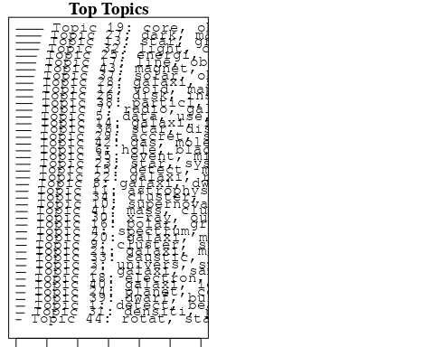

plotQuote(thoughts6, width = 30, main = "Topic 6")  
plotQuote(thoughts18, width = 30, main = "Topic 18")

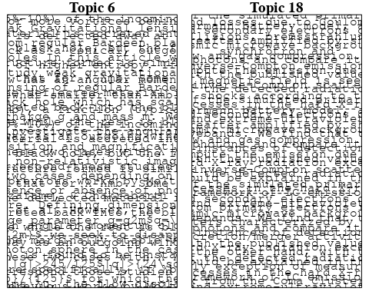

# Calculate and plot the correlation between topics  
mod.out.corr <- topicCorr(Research_topics)  
plot(mod.out.corr, cex = 1.5)  
  
  
# For each topic  
for (topic_num in 1:44) {  
 # Plot the word cloud  
 cloud(Research_topics, topic = topic_num, scale = c(2, 0.25))  
 Sys.sleep(2)  
}

## Warning in wordcloud::wordcloud(words = vocab, freq = vec, max.words =  
## max.words, : photometri could not be fit on page. It will not be plotted.

## Warning in wordcloud::wordcloud(words = vocab, freq = vec, max.words =  
## max.words, : asteroid could not be fit on page. It will not be plotted.

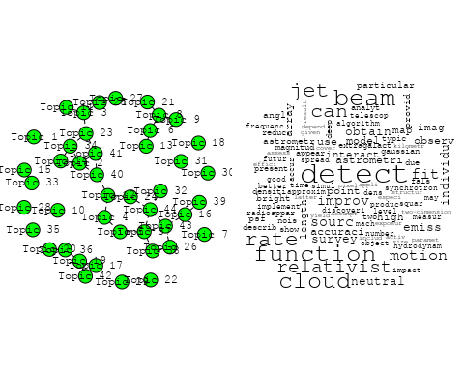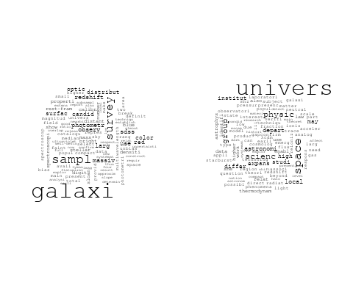

## Warning in wordcloud::wordcloud(words = vocab, freq = vec, max.words =  
## max.words, : spectrum could not be fit on page. It will not be plotted.

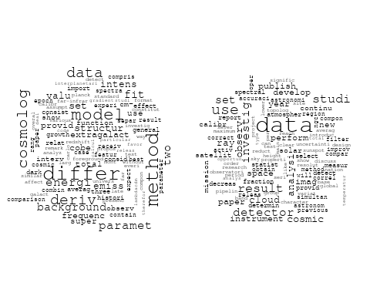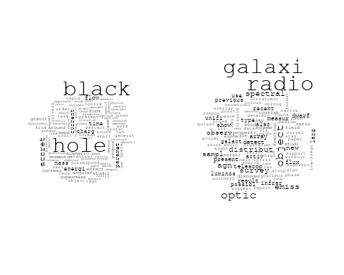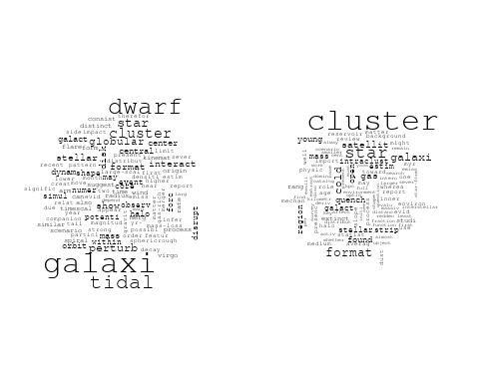

## Warning in wordcloud::wordcloud(words = vocab, freq = vec, max.words =  
## max.words, : astrophys could not be fit on page. It will not be plotted.

## Warning in wordcloud::wordcloud(words = vocab, freq = vec, max.words =  
## max.words, : system could not be fit on page. It will not be plotted.

## Warning in wordcloud::wordcloud(words = vocab, freq = vec, max.words =  
## max.words, : radiat could not be fit on page. It will not be plotted.

## Warning in wordcloud::wordcloud(words = vocab, freq = vec, max.words =  
## max.words, : camera could not be fit on page. It will not be plotted.

## Warning in wordcloud::wordcloud(words = vocab, freq = vec, max.words =  
## max.words, : discuss could not be fit on page. It will not be plotted.

## Warning in wordcloud::wordcloud(words = vocab, freq = vec, max.words =  
## max.words, : reaction could not be fit on page. It will not be plotted.

## Warning in wordcloud::wordcloud(words = vocab, freq = vec, max.words =  
## max.words, : cover could not be fit on page. It will not be plotted.

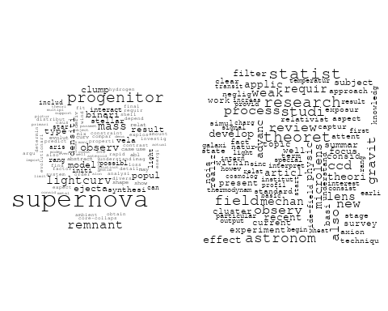

## Warning in wordcloud::wordcloud(words = vocab, freq = vec, max.words =  
## max.words, : scale could not be fit on page. It will not be plotted.

## Warning in wordcloud::wordcloud(words = vocab, freq = vec, max.words =  
## max.words, : void could not be fit on page. It will not be plotted.

## Warning in wordcloud::wordcloud(words = vocab, freq = vec, max.words =  
## max.words, : observ could not be fit on page. It will not be plotted.

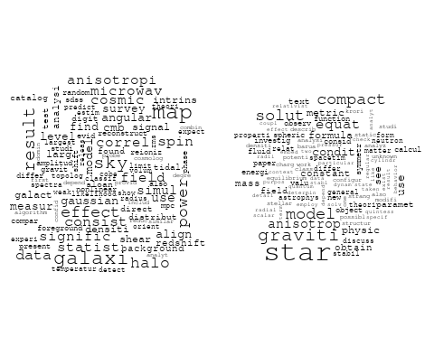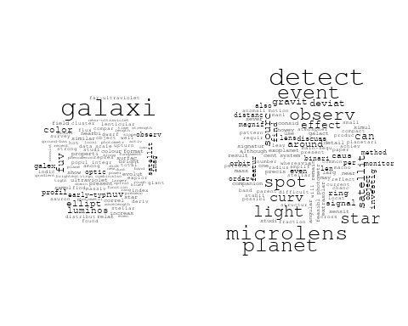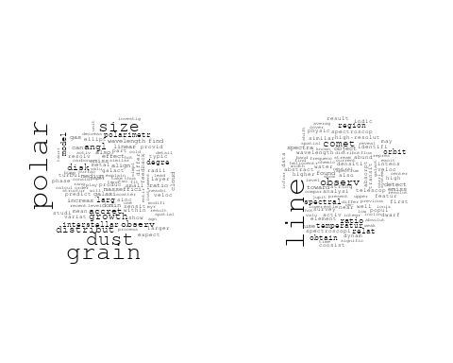

## Warning in wordcloud::wordcloud(words = vocab, freq = vec, max.words =  
## max.words, : observ could not be fit on page. It will not be plotted.

## Warning in wordcloud::wordcloud(words = vocab, freq = vec, max.words =  
## max.words, : continuum could not be fit on page. It will not be plotted.

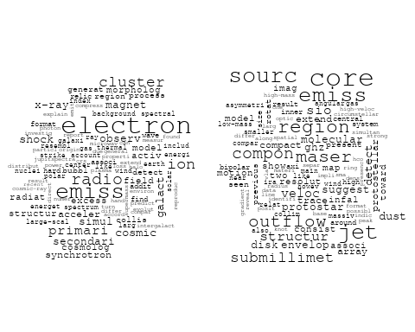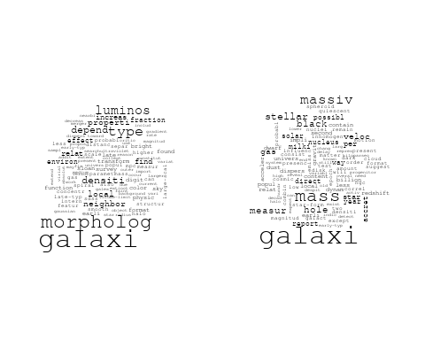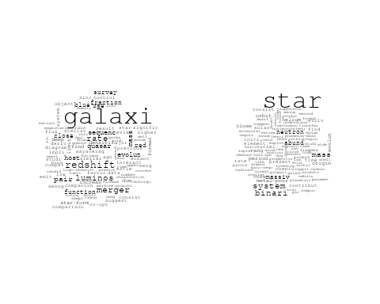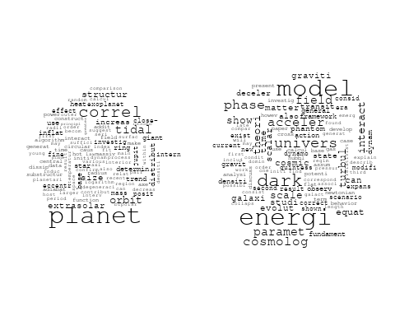

## Warning in wordcloud::wordcloud(words = vocab, freq = vec, max.words =  
## max.words, : shock could not be fit on page. It will not be plotted.

## Warning in wordcloud::wordcloud(words = vocab, freq = vec, max.words =  
## max.words, : instabl could not be fit on page. It will not be plotted.

## Warning in wordcloud::wordcloud(words = vocab, freq = vec, max.words =  
## max.words, : interstellar could not be fit on page. It will not be plotted.

## Warning in wordcloud::wordcloud(words = vocab, freq = vec, max.words =  
## max.words, : similar could not be fit on page. It will not be plotted.

## Warning in wordcloud::wordcloud(words = vocab, freq = vec, max.words =  
## max.words, : simul could not be fit on page. It will not be plotted.

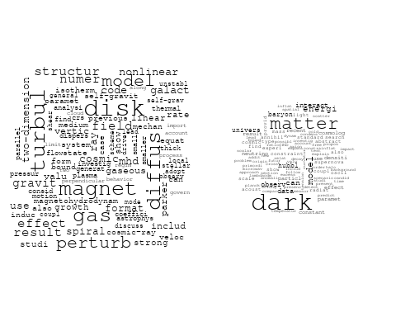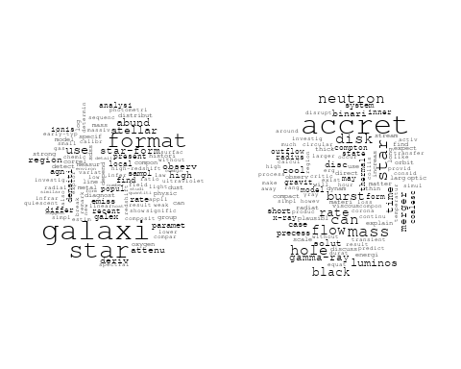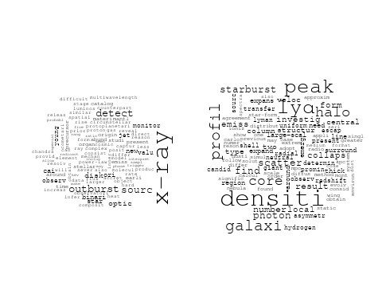

## Warning in wordcloud::wordcloud(words = vocab, freq = vec, max.words =  
## max.words, : photometr could not be fit on page. It will not be plotted.

## Warning in wordcloud::wordcloud(words = vocab, freq = vec, max.words =  
## max.words, : measur could not be fit on page. It will not be plotted.

## Warning in wordcloud::wordcloud(words = vocab, freq = vec, max.words =  
## max.words, : light could not be fit on page. It will not be plotted.

## Warning in wordcloud::wordcloud(words = vocab, freq = vec, max.words =  
## max.words, : planetari could not be fit on page. It will not be plotted.

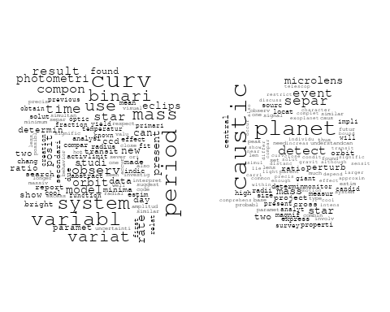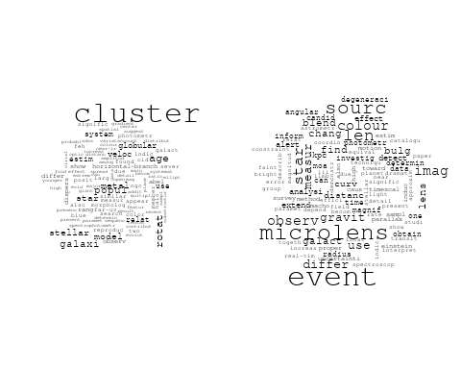

## Warning in wordcloud::wordcloud(words = vocab, freq = vec, max.words =  
## max.words, : solar could not be fit on page. It will not be plotted.

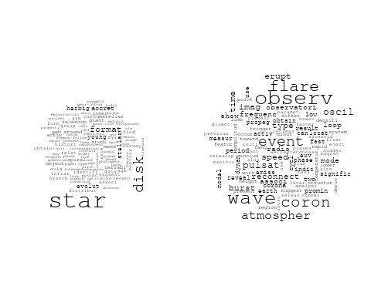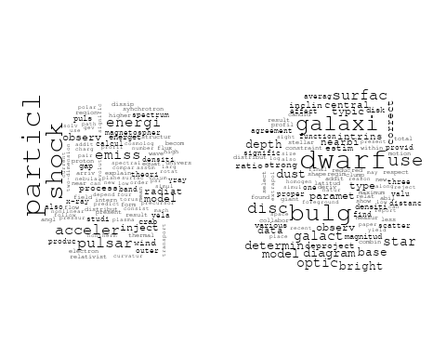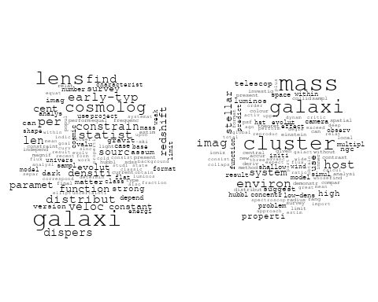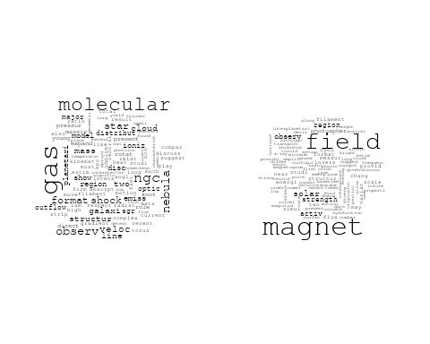

# Get the topic proportions for each document  
topic_proportions <- Research_topics$theta  
  
# Find the index of the topic with the highest proportion for each document  
# This will be the topic that each document is most likely to belong to  
max_topic_idx <- apply(topic_proportions, 1, which.max)  
  
# Add this as a new column to your data  
data_collab$topic <- max_topic_idx  
  
library(ggplot2)  
  
# Define the intervals  
intervals <- c('1824_1899', '1900_1964', '1965_1974', '1975_1984', '1985_1994', '1995_1999', '2000_2004', '2005_2009', '2010_2014', '2015_2019', '2020_2022')  
colors <- c('pink', 'blue', 'purple', 'yellow', 'green', 'pink', 'orange', 'violet', 'green', 'blue', 'pink')  
  
# Loop through the intervals and plot  
for(i in seq_along(intervals)){  
 # Filter data for when the pub_interval is equal to 1  
 data_filtered <- data_collab[data_collab[[paste0('pub_interval_', intervals[i])]] == 1,]  
   
 # Make the histogram  
   
 p <- ggplot(data_filtered, aes(x = topic)) +  
 geom_histogram(binwidth = 1, fill = colors[i], color = "black") +  
 xlab("Topic") +  
 ylab("Count") +  
 ggtitle(paste0("Topics from year ", gsub("_", " to ", intervals[i])))  
   
 print(p)  
}  
  
  
##Topic generation for AsiaAndOceania (independent) publications  
  
data_independent <- data[data[["AsiaAndOceania"]] == 100,]  
  
# Save the original title data for future use  
data_independent$original_concatenated_title_abstract <- data_independent$concatenated_title_abstract  
  
#pre-processing the titles using textProcessor from the stm package  
processed_text <- textProcessor(data_independent$concatenated_title_abstract, metadata = data_independent)

## Building corpus...   
## Converting to Lower Case...   
## Removing punctuation...   
## Removing stopwords...   
## Removing numbers...   
## Stemming...   
## Creating Output...

# Further prepare the data by removing low-frequency terms  
out_text <- prepDocuments(processed_text$documents, processed_text$vocab, processed_text$meta)

## Removing 1325 of 3878 terms (1325 of 27459 tokens) due to frequency   
## Your corpus now has 394 documents, 2553 terms and 26134 tokens.

docs_text <- out_text$documents  
vocab_text <- out_text$vocab  
meta_text <- out_text$meta  
  
  
#Prepare data  
plotRemoved(processed_text$documents, lower.thresh = seq(1, 200, by = 100))

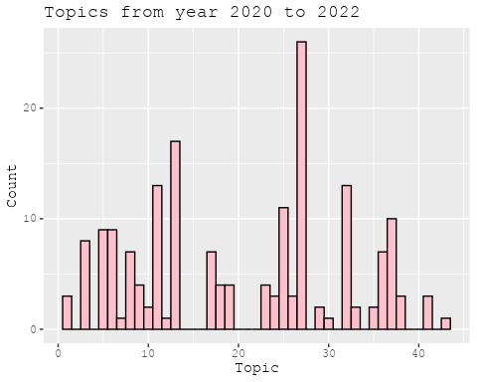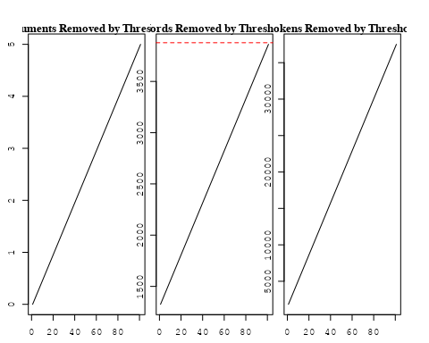

out_text <- prepDocuments(processed_text$documents, processed_text$vocab, processed_text$meta, lower.thresh = 8)

## Removing 3126 of 3878 terms (7560 of 27459 tokens) due to frequency   
## Your corpus now has 394 documents, 752 terms and 19899 tokens.

str(out_text$meta)

## 'data.frame': 394 obs. of 39 variables:  
## $ concept_id : chr "https://openalex.org/C1276947" "https://openalex.org/C44870925" "https://openalex.org/C44870925" "https://openalex.org/C44870925" ...  
## $ work_id : chr "https://openalex.org/W2312475649" "https://openalex.org/W3103116086" "https://openalex.org/W3104821685" "https://openalex.org/W2008912709" ...  
## $ publication_year : int 2013 1999 2020 2003 2000 1996 2003 2005 2010 2006 ...  
## $ title : chr "Death of Massive Stars (IAU S279): Supernovae and Gamma-Ray Bursts, Proceedings of the International Astronomic"| __truncated__ "Cosmic Shear from Galaxy Spins" "Accelerated expansion of the Universe in the presence of dark matter pressure" "Collapse of Magnetized Singular Isothermal Toroids. II. Rotation and Magnetic Braking" ...  
## $ paperabstract : chr "students and, sometimes, even in scholars. While motion and change are the nature of the world – to quote the b"| __truncated__ "We discuss the origin of galactic angular momentum and the statistics of the present-day spin distribution. It "| __truncated__ "Expansion dynamics of the Universe is an important subject in modern cosmology. The dark energy equation of sta"| __truncated__ "We study numerically the collapse of rotating magnetized molecular cloud cores, focusing on rotation and magnet"| __truncated__ ...  
## $ country : chr "TW" "TW TW" "IR IR" "TW TW" ...  
## $ year_concept : chr "2013+https://openalex.org/C1276947" "1999+https://openalex.org/C44870925" "2020+https://openalex.org/C44870925" "2003+https://openalex.org/C44870925" ...  
## $ concatenated_title_abstract : chr "Death of Massive Stars (IAU S279): Supernovae and Gamma-Ray Bursts, Proceedings of the International Astronomic"| __truncated__ "Cosmic Shear from Galaxy Spins We discuss the origin of galactic angular momentum and the statistics of the pre"| __truncated__ "Accelerated expansion of the Universe in the presence of dark matter pressure Expansion dynamics of the Univers"| __truncated__ "Collapse of Magnetized Singular Isothermal Toroids. II. Rotation and Magnetic Braking We study numerically the "| __truncated__ ...  
## $ US : num 0 0 0 0 0 0 0 0 0 0 ...  
## $ IN : num 0 0 0 0 0 0 0 0 0 0 ...  
## $ DE : num 0 0 0 0 0 0 0 0 0 0 ...  
## $ CH : num 0 0 0 0 0 0 0 0 0 0 ...  
## $ GB : num 0 0 0 0 0 0 0 0 0 0 ...  
## $ CN : num 0 0 0 0 0 0 0 0 0 0 ...  
## $ FR : num 0 0 0 0 0 0 0 0 0 0 ...  
## $ IT : num 0 0 0 0 0 0 0 0 0 0 ...  
## $ RU : num 0 0 0 0 0 0 0 0 0 0 ...  
## $ CA : num 0 0 0 0 0 0 0 0 0 0 ...  
## $ NL : num 0 0 0 0 0 0 0 0 0 0 ...  
## $ AU : num 0 0 0 0 0 0 0 0 0 0 ...  
## $ JP : num 0 0 0 0 0 0 0 0 0 0 ...  
## $ ES : num 0 0 0 0 0 0 0 0 0 0 ...  
## $ IL : num 0 0 0 0 0 0 0 0 0 0 ...  
## $ Americas : num 0 0 0 0 0 0 0 0 0 0 ...  
## $ Europe : num 0 0 0 0 0 0 0 0 0 0 ...  
## $ Africa : num 0 0 0 0 0 0 0 0 0 0 ...  
## $ AsiaAndOceania : num 100 100 100 100 100 100 100 100 100 100 ...  
## $ pub_interval_2020_2022 : int 0 0 1 0 0 0 0 0 0 0 ...  
## $ pub_interval_2015_2019 : int 0 0 0 0 0 0 0 0 0 0 ...  
## $ pub_interval_2010_2014 : int 1 0 0 0 0 0 0 0 1 0 ...  
## $ pub_interval_2005_2009 : int 0 0 0 0 0 0 0 1 0 1 ...  
## $ pub_interval_2000_2004 : int 0 0 0 1 1 0 1 0 0 0 ...  
## $ pub_interval_1995_1999 : int 0 1 0 0 0 1 0 0 0 0 ...  
## $ pub_interval_1985_1994 : int 0 0 0 0 0 0 0 0 0 0 ...  
## $ pub_interval_1975_1984 : int 0 0 0 0 0 0 0 0 0 0 ...  
## $ pub_interval_1965_1974 : int 0 0 0 0 0 0 0 0 0 0 ...  
## $ pub_interval_1900_1964 : int 0 0 0 0 0 0 0 0 0 0 ...  
## $ pub_interval_1824_1899 : int 0 0 0 0 0 0 0 0 0 0 ...  
## $ original_concatenated_title_abstract: chr "Death of Massive Stars (IAU S279): Supernovae and Gamma-Ray Bursts, Proceedings of the International Astronomic"| __truncated__ "Cosmic Shear from Galaxy Spins We discuss the origin of galactic angular momentum and the statistics of the pre"| __truncated__ "Accelerated expansion of the Universe in the presence of dark matter pressure Expansion dynamics of the Univers"| __truncated__ "Collapse of Magnetized Singular Isothermal Toroids. II. Rotation and Magnetic Braking We study numerically the "| __truncated__ ...

# Initialize an empty formula string  
prevalence_formula_str <- "~"  
  
# Define the publication intervals  
pub_intervals <- c("pub_interval_2020_2022", "pub_interval_2015_2019", "pub_interval_2010_2014",   
 "pub_interval_2005_2009", "pub_interval_2000_2004", "pub_interval_1995_1999",  
 "pub_interval_1985_1994", "pub_interval_1975_1984", "pub_interval_1965_1974",  
 "pub_interval_1900_1964", "pub_interval_1824_1899")  
  
# Add each publication interval to the formula string  
for (interval in pub_intervals) {  
 # add an if statement to handle the first addition (without '+')  
 if (prevalence_formula_str == "~") {  
 prevalence_formula_str <- paste(prevalence_formula_str, interval)  
 } else {  
 prevalence_formula_str <- paste(prevalence_formula_str, "+", interval)  
 }  
}  
  
  
# Convert the string to a formula  
prevalence_formula <- as.formula(prevalence_formula_str)  
print(prevalence_formula)

## ~pub_interval_2020_2022 + pub_interval_2015_2019 + pub_interval_2010_2014 +   
## pub_interval_2005_2009 + pub_interval_2000_2004 + pub_interval_1995_1999 +   
## pub_interval_1985_1994 + pub_interval_1975_1984 + pub_interval_1965_1974 +   
## pub_interval_1900_1964 + pub_interval_1824_1899

# Run STM model  
Research_topics <- stm(documents = out_text$documents,   
 vocab = out_text$vocab,   
 K = 42,   
 prevalence = prevalence_formula,   
 data = out_text$meta,   
 init.type = "Spectral",  
 max.em.its = 1000,  
 gamma.prior = 'L1')

## Beginning Spectral Initialization   
## Calculating the gram matrix...  
## Finding anchor words...  
## ..........................................  
## Recovering initialization...  
## .......  
## Initialization complete.  
## ...................................................................................................................................  
## Completed E-Step (0 seconds).   
## Completed M-Step.   
## Completing Iteration 1 (approx. per word bound = -5.490)   
## ...................................................................................................................................  
## Completed E-Step (0 seconds).   
## Completed M-Step.   
## Completing Iteration 2 (approx. per word bound = -5.281, relative change = 3.815e-02)   
## ...................................................................................................................................  
## Completed E-Step (0 seconds).   
## Completed M-Step.   
## Completing Iteration 3 (approx. per word bound = -5.197, relative change = 1.594e-02)   
## ...................................................................................................................................  
## Completed E-Step (0 seconds).   
## Completed M-Step.   
## Completing Iteration 4 (approx. per word bound = -5.152, relative change = 8.540e-03)   
## ...................................................................................................................................  
## Completed E-Step (0 seconds).   
## Completed M-Step.   
## Completing Iteration 5 (approx. per word bound = -5.127, relative change = 4.868e-03)   
## Topic 1: function, galaxi, paramet, veloc, dispers   
## Topic 2: angl, polar, profil, research, investig   
## Topic 3: star, dwarf, survey, variabl, identifi   
## Topic 4: event, light, spot, curv, observ   
## Topic 5: tidal, galaxi, cluster, star, dwarf   
## Topic 6: physic, ngc, photometr, astronomi, emerg   
## Topic 7: model, energi, paramet, scalar, interact   
## Topic 8: coron, wave, solar, observ, flare   
## Topic 9: densiti, analysi, shape, deriv, region   
## Topic 10: planetari, caustic, perturb, express, central   
## Topic 11: period, mass, variat, use, uncertainti   
## Topic 12: hole, black, charg, studi, case   
## Topic 13: event, colour, sourc, len, microlens   
## Topic 14: supernova, binari, model, mass, progenitor   
## Topic 15: radio, galaxi, region, observ, object   
## Topic 16: binari, compon, system, curv, use   
## Topic 17: star, compact, graviti, anisotrop, condit   
## Topic 18: shock, comput, may, typic, near   
## Topic 19: cosmolog, time, accret, luminos, binari   
## Topic 20: matter, effect, halo, weak, gravit   
## Topic 21: size, growth, distribut, accret, dust   
## Topic 22: perturb, instabl, disk, model, mode   
## Topic 23: galaxi, luminos, increas, morpholog, ellipt   
## Topic 24: univers, dark, energi, matter, model   
## Topic 25: detect, planet, magnif, microlens, event   
## Topic 26: solar, outflow, disc, mass, dust   
## Topic 27: correct, energi, domin, late, time   
## Topic 28: stream, collis, orbit, known, activ   
## Topic 29: magnet, jet, field, format, disk   
## Topic 30: emiss, x-ray, pulsar, optic, core   
## Topic 31: cosmic, statist, ray, cloud, particl   
## Topic 32: star, neutron, equat, equilibrium, mass   
## Topic 33: paper, mechan, author, discuss, various   
## Topic 34: galaxi, gas, cold, strip, format   
## Topic 35: data, cluster, use, set, observ   
## Topic 36: galaxi, profil, densiti, satellit, number   
## Topic 37: radiat, energi, particl, theori, framework   
## Topic 38: dark, matter, model, can, interact   
## Topic 39: see, formula, differ, field, effect   
## Topic 40: cluster, galaxi, rotat, use, veloc   
## Topic 41: line, gas, shock, veloc, structur   
## Topic 42: map, layer, strong, provid, howev   
## ...................................................................................................................................  
## Completed E-Step (0 seconds).   
## Completed M-Step.   
## Completing Iteration 6 (approx. per word bound = -5.110, relative change = 3.239e-03)   
## ...................................................................................................................................  
## Completed E-Step (0 seconds).   
## Completed M-Step.   
## Completing Iteration 7 (approx. per word bound = -5.098, relative change = 2.516e-03)   
## ...................................................................................................................................  
## Completed E-Step (0 seconds).   
## Completed M-Step.   
## Completing Iteration 8 (approx. per word bound = -5.087, relative change = 2.067e-03)   
## ...................................................................................................................................  
## Completed E-Step (0 seconds).   
## Completed M-Step.   
## Completing Iteration 9 (approx. per word bound = -5.079, relative change = 1.645e-03)   
## ...................................................................................................................................  
## Completed E-Step (0 seconds).   
## Completed M-Step.   
## Completing Iteration 10 (approx. per word bound = -5.072, relative change = 1.354e-03)   
## Topic 1: function, galaxi, paramet, cosmolog, veloc   
## Topic 2: angl, galaxi, polar, scatter, profil   
## Topic 3: star, dwarf, galaxi, survey, variabl   
## Topic 4: event, light, spot, curv, microlens   
## Topic 5: tidal, galaxi, cluster, star, dwarf   
## Topic 6: ngc, physic, photometr, age, astronomi   
## Topic 7: model, energi, paramet, scalar, interact   
## Topic 8: coron, solar, wave, observ, magnet   
## Topic 9: densiti, region, deriv, analysi, well   
## Topic 10: planetari, caustic, perturb, express, central   
## Topic 11: period, variat, uncertainti, mass, eclips   
## Topic 12: hole, black, charg, studi, gravit   
## Topic 13: event, colour, sourc, len, microlens   
## Topic 14: supernova, binari, model, mass, progenitor   
## Topic 15: radio, galaxi, region, observ, object   
## Topic 16: binari, system, curv, use, light   
## Topic 17: star, compact, graviti, anisotrop, model   
## Topic 18: shock, comput, typic, cluster, may   
## Topic 19: time, cosmolog, accret, luminos, binari   
## Topic 20: matter, weak, lens, gravit, halo   
## Topic 21: size, growth, distribut, dust, accret   
## Topic 22: instabl, perturb, mode, disk, model   
## Topic 23: galaxi, luminos, morpholog, increas, ellipt   
## Topic 24: univers, dark, energi, matter, cosmolog   
## Topic 25: detect, magnif, planet, microlens, event   
## Topic 26: solar, outflow, disc, mass, rate   
## Topic 27: correct, time, domin, energi, model   
## Topic 28: stream, collis, orbit, known, form   
## Topic 29: magnet, jet, format, field, disk   
## Topic 30: emiss, x-ray, optic, detect, pulsar   
## Topic 31: cosmic, statist, simul, ray, cloud   
## Topic 32: star, neutron, equat, mass, equilibrium   
## Topic 33: mechan, author, paper, discuss, interpret   
## Topic 34: galaxi, gas, cold, strip, format   
## Topic 35: data, cluster, use, set, method   
## Topic 36: galaxi, profil, satellit, densiti, peak   
## Topic 37: particl, radiat, energi, theori, wind   
## Topic 38: dark, matter, can, model, excess   
## Topic 39: see, formula, field, differ, galact   
## Topic 40: cluster, galaxi, rotat, veloc, use   
## Topic 41: line, gas, shock, veloc, structur   
## Topic 42: map, layer, strong, provid, evid   
## ...................................................................................................................................  
## Completed E-Step (0 seconds).   
## Completed M-Step.   
## Completing Iteration 11 (approx. per word bound = -5.065, relative change = 1.286e-03)   
## ...................................................................................................................................  
## Completed E-Step (0 seconds).   
## Completed M-Step.   
## Completing Iteration 12 (approx. per word bound = -5.059, relative change = 1.181e-03)   
## ...................................................................................................................................  
## Completed E-Step (0 seconds).   
## Completed M-Step.   
## Completing Iteration 13 (approx. per word bound = -5.054, relative change = 1.107e-03)   
## ...................................................................................................................................  
## Completed E-Step (0 seconds).   
## Completed M-Step.   
## Completing Iteration 14 (approx. per word bound = -5.049, relative change = 9.202e-04)   
## ...................................................................................................................................  
## Completed E-Step (0 seconds).   
## Completed M-Step.   
## Completing Iteration 15 (approx. per word bound = -5.044, relative change = 1.020e-03)   
## Topic 1: function, galaxi, cosmolog, paramet, statist   
## Topic 2: galaxi, scatter, line, profil, polar   
## Topic 3: star, galaxi, survey, variabl, dwarf   
## Topic 4: event, spot, light, curv, microlens   
## Topic 5: galaxi, tidal, cluster, star, dwarf   
## Topic 6: ngc, age, physic, photometr, differ   
## Topic 7: model, energi, paramet, dark, interact   
## Topic 8: coron, solar, wave, observ, magnet   
## Topic 9: region, densiti, deriv, analysi, well   
## Topic 10: caustic, planetari, perturb, express, central   
## Topic 11: period, variat, uncertainti, eclips, mass   
## Topic 12: hole, black, charg, studi, orbit   
## Topic 13: event, colour, sourc, len, microlens   
## Topic 14: supernova, binari, model, mass, progenitor   
## Topic 15: radio, galaxi, region, observ, object   
## Topic 16: binari, curv, system, use, light   
## Topic 17: star, graviti, compact, model, anisotrop   
## Topic 18: shock, planet, typic, comput, cluster   
## Topic 19: time, accret, cosmolog, luminos, binari   
## Topic 20: matter, weak, lens, gravit, effect   
## Topic 21: size, distribut, growth, accret, dust   
## Topic 22: instabl, mode, perturb, model, disk   
## Topic 23: galaxi, luminos, morpholog, increas, ellipt   
## Topic 24: univers, dark, energi, cosmolog, expans   
## Topic 25: detect, microlens, event, satellit, magnif   
## Topic 26: disc, outflow, solar, mass, perturb   
## Topic 27: correct, time, model, domin, energi   
## Topic 28: stream, collis, orbit, known, form   
## Topic 29: magnet, jet, field, format, disk   
## Topic 30: emiss, x-ray, optic, pulsar, detect   
## Topic 31: cosmic, particl, ray, magnet, cloud   
## Topic 32: star, neutron, equat, mass, equilibrium   
## Topic 33: mechan, statist, author, consid, discuss   
## Topic 34: galaxi, gas, strip, cold, format   
## Topic 35: data, cluster, use, set, observ   
## Topic 36: galaxi, profil, satellit, densiti, peak   
## Topic 37: radiat, particl, theori, energi, wind   
## Topic 38: dark, matter, can, model, excess   
## Topic 39: see, formula, field, galact, differ   
## Topic 40: cluster, galaxi, rotat, veloc, use   
## Topic 41: line, gas, shock, veloc, core   
## Topic 42: map, layer, strong, provid, howev   
## ...................................................................................................................................  
## Completed E-Step (0 seconds).   
## Completed M-Step.   
## Completing Iteration 16 (approx. per word bound = -5.040, relative change = 7.367e-04)   
## ...................................................................................................................................  
## Completed E-Step (0 seconds).   
## Completed M-Step.   
## Completing Iteration 17 (approx. per word bound = -5.037, relative change = 6.694e-04)   
## ...................................................................................................................................  
## Completed E-Step (0 seconds).   
## Completed M-Step.   
## Completing Iteration 18 (approx. per word bound = -5.034, relative change = 5.394e-04)   
## ...................................................................................................................................  
## Completed E-Step (0 seconds).   
## Completed M-Step.   
## Completing Iteration 19 (approx. per word bound = -5.032, relative change = 4.207e-04)   
## ...................................................................................................................................  
## Completed E-Step (0 seconds).   
## Completed M-Step.   
## Completing Iteration 20 (approx. per word bound = -5.030, relative change = 3.993e-04)   
## Topic 1: function, galaxi, cosmolog, paramet, statist   
## Topic 2: galaxi, scatter, line, photon, profil   
## Topic 3: star, galaxi, survey, variabl, dwarf   
## Topic 4: event, spot, light, curv, microlens   
## Topic 5: galaxi, tidal, cluster, star, dwarf   
## Topic 6: age, ngc, photometr, differ, astronomi   
## Topic 7: model, energi, paramet, dark, interact   
## Topic 8: solar, coron, wave, observ, magnet   
## Topic 9: region, densiti, deriv, well, analysi   
## Topic 10: caustic, planetari, perturb, express, central   
## Topic 11: period, variat, uncertainti, eclips, mass   
## Topic 12: hole, black, charg, studi, orbit   
## Topic 13: event, colour, sourc, len, microlens   
## Topic 14: supernova, binari, model, mass, progenitor   
## Topic 15: radio, galaxi, region, observ, sourc   
## Topic 16: binari, curv, system, use, light   
## Topic 17: star, graviti, compact, model, anisotrop   
## Topic 18: planet, shock, typic, comput, high   
## Topic 19: time, accret, luminos, binari, can   
## Topic 20: matter, weak, lens, gravit, effect   
## Topic 21: size, distribut, growth, accret, dust   
## Topic 22: instabl, mode, perturb, model, disk   
## Topic 23: galaxi, luminos, morpholog, increas, ellipt   
## Topic 24: univers, dark, energi, cosmolog, expans   
## Topic 25: detect, microlens, event, satellit, magnif   
## Topic 26: disc, outflow, solar, mass, perturb   
## Topic 27: correct, time, model, energi, domin   
## Topic 28: stream, collis, orbit, known, form   
## Topic 29: magnet, jet, format, field, disk   
## Topic 30: emiss, x-ray, optic, pulsar, spectral   
## Topic 31: cosmic, particl, ray, magnet, cloud   
## Topic 32: star, neutron, mass, equat, equilibrium   
## Topic 33: mechan, statist, author, consid, physic   
## Topic 34: galaxi, gas, strip, cold, format   
## Topic 35: data, cluster, use, set, observ   
## Topic 36: galaxi, profil, satellit, densiti, peak   
## Topic 37: radiat, particl, theori, energi, wind   
## Topic 38: dark, matter, can, model, excess   
## Topic 39: see, formula, field, galact, effect   
## Topic 40: cluster, galaxi, rotat, veloc, use   
## Topic 41: line, gas, shock, veloc, core   
## Topic 42: map, layer, strong, provid, howev   
## ...................................................................................................................................  
## Completed E-Step (0 seconds).   
## Completed M-Step.   
## Completing Iteration 21 (approx. per word bound = -5.028, relative change = 4.065e-04)   
## ...................................................................................................................................  
## Completed E-Step (0 seconds).   
## Completed M-Step.   
## Completing Iteration 22 (approx. per word bound = -5.026, relative change = 4.330e-04)   
## ...................................................................................................................................  
## Completed E-Step (0 seconds).   
## Completed M-Step.   
## Completing Iteration 23 (approx. per word bound = -5.024, relative change = 3.724e-04)   
## ...................................................................................................................................  
## Completed E-Step (0 seconds).   
## Completed M-Step.   
## Completing Iteration 24 (approx. per word bound = -5.023, relative change = 2.777e-04)   
## ...................................................................................................................................  
## Completed E-Step (0 seconds).   
## Completed M-Step.   
## Completing Iteration 25 (approx. per word bound = -5.021, relative change = 2.375e-04)   
## Topic 1: function, galaxi, cosmolog, paramet, statist   
## Topic 2: galaxi, scatter, line, profil, polar   
## Topic 3: star, galaxi, survey, variabl, dwarf   
## Topic 4: event, spot, light, curv, microlens   
## Topic 5: galaxi, tidal, cluster, star, dwarf   
## Topic 6: age, ngc, differ, star, astronomi   
## Topic 7: model, energi, paramet, dark, interact   
## Topic 8: solar, coron, wave, observ, magnet   
## Topic 9: region, densiti, deriv, well, alon   
## Topic 10: caustic, planetari, express, central, perturb   
## Topic 11: period, variat, uncertainti, eclips, mass   
## Topic 12: hole, black, charg, studi, orbit   
## Topic 13: event, colour, sourc, len, microlens   
## Topic 14: supernova, binari, model, mass, progenitor   
## Topic 15: radio, galaxi, region, observ, sourc   
## Topic 16: curv, binari, system, use, light   
## Topic 17: graviti, star, compact, model, anisotrop   
## Topic 18: planet, planetari, typic, shock, high   
## Topic 19: time, accret, luminos, binari, can   
## Topic 20: matter, weak, lens, gravit, effect   
## Topic 21: size, distribut, growth, accret, dust   
## Topic 22: instabl, mode, perturb, model, disk   
## Topic 23: galaxi, luminos, morpholog, increas, ellipt   
## Topic 24: univers, dark, energi, cosmolog, expans   
## Topic 25: detect, microlens, event, satellit, magnif   
## Topic 26: disc, outflow, mass, solar, perturb   
## Topic 27: correct, time, model, energi, domin   
## Topic 28: stream, collis, orbit, known, form   
## Topic 29: magnet, jet, format, field, disk   
## Topic 30: emiss, x-ray, pulsar, spectral, optic   
## Topic 31: cosmic, particl, ray, magnet, cloud   
## Topic 32: star, neutron, mass, equat, equilibrium   
## Topic 33: mechan, statist, author, consid, physic   
## Topic 34: galaxi, gas, strip, cold, star   
## Topic 35: data, cluster, use, set, observ   
## Topic 36: galaxi, profil, satellit, densiti, peak   
## Topic 37: radiat, particl, theori, wind, energi   
## Topic 38: dark, matter, can, excess, model   
## Topic 39: see, formula, field, galact, effect   
## Topic 40: cluster, galaxi, rotat, veloc, use   
## Topic 41: gas, line, shock, veloc, core   
## Topic 42: layer, map, strong, provid, howev   
## ...................................................................................................................................  
## Completed E-Step (0 seconds).   
## Completed M-Step.   
## Completing Iteration 26 (approx. per word bound = -5.020, relative change = 2.445e-04)   
## ...................................................................................................................................  
## Completed E-Step (0 seconds).   
## Completed M-Step.   
## Completing Iteration 27 (approx. per word bound = -5.019, relative change = 2.445e-04)   
## ...................................................................................................................................  
## Completed E-Step (0 seconds).   
## Completed M-Step.   
## Completing Iteration 28 (approx. per word bound = -5.018, relative change = 2.088e-04)   
## ...................................................................................................................................  
## Completed E-Step (0 seconds).   
## Completed M-Step.   
## Completing Iteration 29 (approx. per word bound = -5.017, relative change = 1.651e-04)   
## ...................................................................................................................................  
## Completed E-Step (0 seconds).   
## Completed M-Step.   
## Completing Iteration 30 (approx. per word bound = -5.016, relative change = 1.648e-04)   
## Topic 1: function, galaxi, cosmolog, paramet, statist   
## Topic 2: galaxi, scatter, line, profil, ngc   
## Topic 3: star, galaxi, survey, variabl, dwarf   
## Topic 4: event, spot, light, microlens, curv   
## Topic 5: galaxi, tidal, cluster, star, dwarf   
## Topic 6: age, ngc, differ, star, astronomi   
## Topic 7: model, energi, paramet, dark, interact   
## Topic 8: solar, coron, wave, observ, magnet   
## Topic 9: region, densiti, deriv, well, alon   
## Topic 10: caustic, planetari, express, central, perturb   
## Topic 11: period, variat, uncertainti, eclips, mass   
## Topic 12: hole, black, charg, studi, orbit   
## Topic 13: event, colour, sourc, len, microlens   
## Topic 14: supernova, binari, model, mass, progenitor   
## Topic 15: radio, galaxi, region, observ, sourc   
## Topic 16: curv, binari, system, light, use   
## Topic 17: graviti, star, compact, model, anisotrop   
## Topic 18: planet, planetari, typic, high, shock   
## Topic 19: time, accret, luminos, binari, can   
## Topic 20: matter, weak, lens, gravit, effect   
## Topic 21: size, distribut, growth, accret, dust   
## Topic 22: instabl, mode, perturb, model, disk   
## Topic 23: galaxi, luminos, morpholog, increas, ellipt   
## Topic 24: univers, dark, energi, cosmolog, expans   
## Topic 25: detect, microlens, satellit, event, magnif   
## Topic 26: disc, outflow, mass, solar, perturb   
## Topic 27: correct, time, model, energi, domin   
## Topic 28: stream, collis, orbit, known, form   
## Topic 29: jet, magnet, format, field, disk   
## Topic 30: emiss, x-ray, pulsar, optic, spectral   
## Topic 31: cosmic, particl, ray, magnet, cloud   
## Topic 32: star, neutron, mass, equilibrium, equat   
## Topic 33: mechan, statist, author, consid, physic   
## Topic 34: galaxi, gas, strip, cold, star   
## Topic 35: data, cluster, use, set, observ   
## Topic 36: galaxi, profil, satellit, densiti, peak   
## Topic 37: radiat, particl, theori, wind, energi   
## Topic 38: dark, matter, can, excess, model   
## Topic 39: see, formula, field, galact, effect   
## Topic 40: cluster, galaxi, rotat, veloc, use   
## Topic 41: gas, line, shock, veloc, core   
## Topic 42: simultan, layer, map, strong, provid   
## ...................................................................................................................................  
## Completed E-Step (0 seconds).   
## Completed M-Step.   
## Completing Iteration 31 (approx. per word bound = -5.015, relative change = 1.679e-04)   
## ...................................................................................................................................  
## Completed E-Step (0 seconds).   
## Completed M-Step.   
## Completing Iteration 32 (approx. per word bound = -5.014, relative change = 1.823e-04)   
## ...................................................................................................................................  
## Completed E-Step (0 seconds).   
## Completed M-Step.   
## Completing Iteration 33 (approx. per word bound = -5.013, relative change = 1.997e-04)   
## ...................................................................................................................................  
## Completed E-Step (0 seconds).   
## Completed M-Step.   
## Completing Iteration 34 (approx. per word bound = -5.012, relative change = 1.956e-04)   
## ...................................................................................................................................  
## Completed E-Step (0 seconds).   
## Completed M-Step.   
## Completing Iteration 35 (approx. per word bound = -5.012, relative change = 1.658e-04)   
## Topic 1: function, galaxi, cosmolog, paramet, statist   
## Topic 2: galaxi, scatter, line, profil, ngc   
## Topic 3: star, galaxi, survey, variabl, dwarf   
## Topic 4: event, spot, microlens, light, curv   
## Topic 5: galaxi, tidal, cluster, star, dwarf   
## Topic 6: age, ngc, differ, star, astronomi   
## Topic 7: model, energi, paramet, dark, interact   
## Topic 8: solar, coron, wave, observ, magnet   
## Topic 9: region, densiti, deriv, well, alon   
## Topic 10: caustic, planetari, central, express, perturb   
## Topic 11: period, variat, uncertainti, eclips, mass   
## Topic 12: hole, black, charg, studi, orbit   
## Topic 13: event, colour, sourc, len, microlens   
## Topic 14: supernova, binari, model, mass, progenitor   
## Topic 15: radio, galaxi, region, observ, sourc   
## Topic 16: curv, binari, system, light, use   
## Topic 17: graviti, star, compact, model, anisotrop   
## Topic 18: planet, planetari, typic, high, magnif   
## Topic 19: time, accret, luminos, binari, can   
## Topic 20: matter, lens, weak, gravit, effect   
## Topic 21: size, distribut, growth, accret, dust   
## Topic 22: instabl, mode, perturb, model, disk   
## Topic 23: galaxi, luminos, morpholog, increas, ellipt   
## Topic 24: univers, dark, energi, cosmolog, expans   
## Topic 25: detect, microlens, satellit, event, magnif   
## Topic 26: disc, outflow, mass, solar, perturb   
## Topic 27: correct, time, energi, model, dark   
## Topic 28: stream, collis, orbit, known, form   
## Topic 29: jet, magnet, format, field, disk   
## Topic 30: emiss, x-ray, pulsar, optic, nebula   
## Topic 31: cosmic, particl, magnet, ray, cloud   
## Topic 32: star, neutron, mass, equilibrium, equat   
## Topic 33: mechan, statist, author, consid, physic   
## Topic 34: galaxi, gas, strip, cold, star   
## Topic 35: data, use, cluster, orbit, observ   
## Topic 36: galaxi, profil, satellit, densiti, peak   
## Topic 37: radiat, particl, theori, wind, energi   
## Topic 38: dark, matter, can, excess, model   
## Topic 39: see, formula, field, galact, effect   
## Topic 40: cluster, galaxi, rotat, veloc, use   
## Topic 41: shock, gas, line, veloc, core   
## Topic 42: simultan, layer, map, strong, detect   
## ...................................................................................................................................  
## Completed E-Step (0 seconds).   
## Completed M-Step.   
## Completing Iteration 36 (approx. per word bound = -5.011, relative change = 1.427e-04)   
## ...................................................................................................................................  
## Completed E-Step (0 seconds).   
## Completed M-Step.   
## Completing Iteration 37 (approx. per word bound = -5.010, relative change = 1.347e-04)   
## ...................................................................................................................................  
## Completed E-Step (0 seconds).   
## Completed M-Step.   
## Completing Iteration 38 (approx. per word bound = -5.009, relative change = 1.613e-04)   
## ...................................................................................................................................  
## Completed E-Step (0 seconds).   
## Completed M-Step.   
## Completing Iteration 39 (approx. per word bound = -5.009, relative change = 1.656e-04)   
## ...................................................................................................................................  
## Completed E-Step (0 seconds).   
## Completed M-Step.   
## Completing Iteration 40 (approx. per word bound = -5.008, relative change = 1.484e-04)   
## Topic 1: function, galaxi, cosmolog, paramet, statist   
## Topic 2: galaxi, scatter, line, profil, ngc   
## Topic 3: star, galaxi, survey, variabl, dwarf   
## Topic 4: event, spot, microlens, light, observ   
## Topic 5: galaxi, tidal, cluster, star, dwarf   
## Topic 6: age, differ, star, ngc, astronomi   
## Topic 7: model, energi, paramet, dark, interact   
## Topic 8: solar, coron, wave, observ, magnet   
## Topic 9: region, densiti, deriv, well, alon   
## Topic 10: caustic, planetari, central, express, perturb   
## Topic 11: period, variat, uncertainti, eclips, mass   
## Topic 12: black, hole, charg, studi, orbit   
## Topic 13: event, colour, sourc, len, microlens   
## Topic 14: supernova, binari, model, mass, progenitor   
## Topic 15: radio, galaxi, region, observ, sourc   
## Topic 16: curv, binari, system, light, use   
## Topic 17: graviti, star, compact, model, anisotrop   
## Topic 18: planet, planetari, typic, high, magnif   
## Topic 19: time, accret, binari, luminos, can   
## Topic 20: matter, lens, weak, gravit, halo   
## Topic 21: size, distribut, growth, accret, dust   
## Topic 22: instabl, mode, model, perturb, disk   
## Topic 23: galaxi, luminos, morpholog, increas, ellipt   
## Topic 24: univers, dark, energi, cosmolog, expans   
## Topic 25: detect, microlens, satellit, event, magnif   
## Topic 26: disc, outflow, mass, solar, perturb   
## Topic 27: correct, time, energi, model, dark   
## Topic 28: stream, collis, orbit, known, form   
## Topic 29: jet, magnet, format, field, disk   
## Topic 30: emiss, x-ray, pulsar, nebula, optic   
## Topic 31: cosmic, particl, magnet, ray, cloud   
## Topic 32: star, neutron, mass, equilibrium, equat   
## Topic 33: mechan, statist, author, consid, physic   
## Topic 34: galaxi, gas, strip, cold, star   
## Topic 35: data, use, cluster, orbit, method   
## Topic 36: galaxi, profil, satellit, densiti, peak   
## Topic 37: radiat, particl, theori, wind, energi   
## Topic 38: dark, matter, can, excess, model   
## Topic 39: see, formula, field, galact, effect   
## Topic 40: cluster, galaxi, rotat, veloc, use   
## Topic 41: shock, gas, line, veloc, core   
## Topic 42: simultan, layer, map, strong, detect   
## ...................................................................................................................................  
## Completed E-Step (0 seconds).   
## Completed M-Step.   
## Completing Iteration 41 (approx. per word bound = -5.007, relative change = 1.057e-04)   
## ...................................................................................................................................  
## Completed E-Step (0 seconds).   
## Completed M-Step.   
## Completing Iteration 42 (approx. per word bound = -5.007, relative change = 1.357e-04)   
## ...................................................................................................................................  
## Completed E-Step (0 seconds).   
## Completed M-Step.   
## Completing Iteration 43 (approx. per word bound = -5.006, relative change = 1.239e-04)   
## ...................................................................................................................................  
## Completed E-Step (0 seconds).   
## Completed M-Step.   
## Completing Iteration 44 (approx. per word bound = -5.005, relative change = 1.234e-04)   
## ...................................................................................................................................  
## Completed E-Step (0 seconds).   
## Completed M-Step.   
## Completing Iteration 45 (approx. per word bound = -5.005, relative change = 1.354e-04)   
## Topic 1: function, galaxi, cosmolog, paramet, statist   
## Topic 2: galaxi, scatter, line, profil, ngc   
## Topic 3: star, galaxi, survey, variabl, dwarf   
## Topic 4: event, spot, microlens, observ, light   
## Topic 5: galaxi, tidal, cluster, star, dwarf   
## Topic 6: age, differ, star, ngc, astronomi   
## Topic 7: model, energi, paramet, dark, interact   
## Topic 8: solar, coron, wave, observ, magnet   
## Topic 9: region, densiti, deriv, well, alon   
## Topic 10: caustic, planetari, central, express, perturb   
## Topic 11: period, variat, uncertainti, eclips, mass   
## Topic 12: black, hole, charg, studi, orbit   
## Topic 13: event, colour, sourc, len, microlens   
## Topic 14: supernova, model, binari, mass, progenitor   
## Topic 15: radio, galaxi, region, observ, sourc   
## Topic 16: curv, binari, system, light, use   
## Topic 17: graviti, star, compact, model, anisotrop   
## Topic 18: planet, planetari, typic, high, magnif   
## Topic 19: time, accret, binari, luminos, can   
## Topic 20: matter, lens, gravit, weak, halo   
## Topic 21: size, distribut, growth, accret, dust   
## Topic 22: instabl, mode, model, disk, observ   
## Topic 23: galaxi, luminos, morpholog, increas, ellipt   
## Topic 24: univers, dark, energi, cosmolog, matter   
## Topic 25: detect, microlens, satellit, event, magnif   
## Topic 26: disc, outflow, mass, solar, perturb   
## Topic 27: correct, energi, time, model, dark   
## Topic 28: stream, collis, orbit, form, known   
## Topic 29: jet, magnet, format, field, disk   
## Topic 30: emiss, x-ray, pulsar, nebula, optic   
## Topic 31: cosmic, particl, magnet, ray, cloud   
## Topic 32: star, neutron, mass, equilibrium, equat   
## Topic 33: mechan, statist, author, consid, physic   
## Topic 34: galaxi, gas, strip, cold, star   
## Topic 35: data, use, cluster, orbit, observ   
## Topic 36: galaxi, profil, satellit, densiti, peak   
## Topic 37: radiat, particl, theori, energi, wind   
## Topic 38: dark, matter, can, excess, mass   
## Topic 39: see, formula, field, galact, effect   
## Topic 40: cluster, galaxi, rotat, veloc, use   
## Topic 41: shock, gas, line, veloc, core   
## Topic 42: simultan, layer, map, strong, detect   
## ...................................................................................................................................  
## Completed E-Step (0 seconds).   
## Completed M-Step.   
## Completing Iteration 46 (approx. per word bound = -5.004, relative change = 1.433e-04)   
## ...................................................................................................................................  
## Completed E-Step (0 seconds).   
## Completed M-Step.   
## Completing Iteration 47 (approx. per word bound = -5.003, relative change = 1.375e-04)   
## ...................................................................................................................................  
## Completed E-Step (0 seconds).   
## Completed M-Step.   
## Completing Iteration 48 (approx. per word bound = -5.003, relative change = 1.222e-04)   
## ...................................................................................................................................  
## Completed E-Step (0 seconds).   
## Completed M-Step.   
## Completing Iteration 49 (approx. per word bound = -5.002, relative change = 1.263e-04)   
## ...................................................................................................................................  
## Completed E-Step (0 seconds).   
## Completed M-Step.   
## Completing Iteration 50 (approx. per word bound = -5.001, relative change = 1.398e-04)   
## Topic 1: function, galaxi, cosmolog, paramet, statist   
## Topic 2: galaxi, scatter, profil, line, ngc   
## Topic 3: star, galaxi, survey, variabl, dwarf   
## Topic 4: event, spot, observ, microlens, light   
## Topic 5: galaxi, tidal, cluster, star, dwarf   
## Topic 6: age, differ, star, ngc, astronomi   
## Topic 7: model, energi, paramet, dark, interact   
## Topic 8: solar, coron, wave, observ, magnet   
## Topic 9: region, densiti, deriv, alon, shape   
## Topic 10: caustic, planetari, central, express, perturb   
## Topic 11: period, variat, uncertainti, eclips, mass   
## Topic 12: black, hole, charg, studi, orbit   
## Topic 13: event, colour, sourc, len, microlens   
## Topic 14: supernova, model, binari, mass, progenitor   
## Topic 15: radio, galaxi, region, observ, sourc   
## Topic 16: curv, binari, system, light, use   
## Topic 17: graviti, star, compact, model, anisotrop   
## Topic 18: planet, planetari, typic, high, detect   
## Topic 19: time, accret, binari, luminos, can   
## Topic 20: matter, lens, gravit, weak, cluster   
## Topic 21: size, distribut, growth, accret, dust   
## Topic 22: instabl, mode, model, observ, disk   
## Topic 23: galaxi, luminos, morpholog, increas, ellipt   
## Topic 24: univers, dark, energi, cosmolog, matter   
## Topic 25: detect, microlens, satellit, event, magnif   
## Topic 26: disc, outflow, mass, solar, perturb   
## Topic 27: correct, energi, time, model, dark   
## Topic 28: stream, collis, orbit, form, veloc   
## Topic 29: jet, magnet, format, field, disk   
## Topic 30: emiss, x-ray, pulsar, nebula, optic   
## Topic 31: cosmic, particl, magnet, ray, cloud   
## Topic 32: star, neutron, mass, equilibrium, equat   
## Topic 33: mechan, statist, author, consid, physic   
## Topic 34: galaxi, gas, strip, cold, star   
## Topic 35: data, use, cluster, orbit, observ   
## Topic 36: galaxi, profil, satellit, densiti, peak   
## Topic 37: radiat, particl, theori, energi, wind   
## Topic 38: dark, matter, can, excess, mass   
## Topic 39: see, formula, field, galact, effect   
## Topic 40: cluster, galaxi, rotat, veloc, use   
## Topic 41: shock, line, gas, veloc, core   
## Topic 42: simultan, layer, map, strong, detect   
## ...................................................................................................................................  
## Completed E-Step (0 seconds).   
## Completed M-Step.   
## Completing Iteration 51 (approx. per word bound = -5.001, relative change = 1.235e-04)   
## ...................................................................................................................................  
## Completed E-Step (0 seconds).   
## Completed M-Step.   
## Completing Iteration 52 (approx. per word bound = -5.000, relative change = 8.992e-05)   
## ...................................................................................................................................  
## Completed E-Step (0 seconds).   
## Completed M-Step.   
## Completing Iteration 53 (approx. per word bound = -5.000, relative change = 8.996e-05)   
## ...................................................................................................................................  
## Completed E-Step (0 seconds).   
## Completed M-Step.   
## Completing Iteration 54 (approx. per word bound = -4.999, relative change = 1.002e-04)   
## ...................................................................................................................................  
## Completed E-Step (0 seconds).   
## Completed M-Step.   
## Completing Iteration 55 (approx. per word bound = -4.999, relative change = 9.700e-05)   
## Topic 1: function, galaxi, cosmolog, paramet, statist   
## Topic 2: galaxi, scatter, profil, line, ngc   
## Topic 3: star, galaxi, survey, variabl, dwarf   
## Topic 4: event, spot, observ, microlens, light   
## Topic 5: galaxi, cluster, star, tidal, dwarf   
## Topic 6: age, differ, star, ngc, astronomi   
## Topic 7: model, energi, paramet, dark, interact   
## Topic 8: solar, coron, wave, observ, magnet   
## Topic 9: region, densiti, deriv, alon, shape   
## Topic 10: caustic, planetari, central, express, perturb   
## Topic 11: period, variat, uncertainti, eclips, mass   
## Topic 12: black, hole, charg, studi, orbit   
## Topic 13: event, colour, sourc, len, microlens   
## Topic 14: supernova, binari, model, mass, progenitor   
## Topic 15: radio, galaxi, region, observ, sourc   
## Topic 16: curv, binari, system, light, use   
## Topic 17: graviti, star, compact, model, anisotrop   
## Topic 18: planet, planetari, typic, high, detect   
## Topic 19: time, accret, binari, luminos, can   
## Topic 20: matter, cluster, gravit, lens, weak   
## Topic 21: size, distribut, growth, accret, dust   
## Topic 22: instabl, mode, model, observ, gravit   
## Topic 23: galaxi, luminos, morpholog, increas, ellipt   
## Topic 24: univers, dark, energi, cosmolog, matter   
## Topic 25: detect, microlens, satellit, event, magnif   
## Topic 26: disc, outflow, tidal, mass, solar   
## Topic 27: correct, energi, time, dark, model   
## Topic 28: stream, collis, orbit, form, known   
## Topic 29: jet, magnet, format, field, disk   
## Topic 30: emiss, x-ray, pulsar, nebula, spectral   
## Topic 31: cosmic, particl, ray, magnet, cloud   
## Topic 32: star, neutron, mass, equilibrium, equat   
## Topic 33: mechan, statist, author, consid, physic   
## Topic 34: galaxi, gas, strip, cold, star   
## Topic 35: data, use, cluster, orbit, observ   
## Topic 36: galaxi, profil, satellit, densiti, peak   
## Topic 37: radiat, particl, theori, wind, energi   
## Topic 38: dark, matter, can, excess, mass   
## Topic 39: see, formula, field, galact, effect   
## Topic 40: cluster, galaxi, rotat, veloc, use   
## Topic 41: shock, line, gas, veloc, core   
## Topic 42: simultan, layer, map, strong, detect   
## ...................................................................................................................................  
## Completed E-Step (0 seconds).   
## Completed M-Step.   
## Completing Iteration 56 (approx. per word bound = -4.998, relative change = 8.013e-05)   
## ...................................................................................................................................  
## Completed E-Step (0 seconds).   
## Completed M-Step.   
## Completing Iteration 57 (approx. per word bound = -4.998, relative change = 8.099e-05)   
## ...................................................................................................................................  
## Completed E-Step (0 seconds).   
## Completed M-Step.   
## Completing Iteration 58 (approx. per word bound = -4.998, relative change = 8.348e-05)   
## ...................................................................................................................................  
## Completed E-Step (0 seconds).   
## Completed M-Step.   
## Completing Iteration 59 (approx. per word bound = -4.997, relative change = 7.397e-05)   
## ...................................................................................................................................  
## Completed E-Step (0 seconds).   
## Completed M-Step.   
## Completing Iteration 60 (approx. per word bound = -4.997, relative change = 5.628e-05)   
## Topic 1: function, galaxi, cosmolog, paramet, statist   
## Topic 2: galaxi, scatter, profil, line, ngc   
## Topic 3: star, galaxi, survey, variabl, dwarf   
## Topic 4: event, spot, observ, microlens, light   
## Topic 5: galaxi, cluster, star, tidal, dwarf   
## Topic 6: age, star, differ, ngc, astronomi   
## Topic 7: model, energi, paramet, dark, interact   
## Topic 8: solar, coron, wave, observ, magnet   
## Topic 9: region, densiti, deriv, alon, shape   
## Topic 10: caustic, planetari, central, express, perturb   
## Topic 11: period, variat, uncertainti, eclips, mass   
## Topic 12: black, hole, charg, studi, orbit   
## Topic 13: event, colour, sourc, len, microlens   
## Topic 14: supernova, binari, mass, progenitor, model   
## Topic 15: radio, galaxi, region, observ, sourc   
## Topic 16: curv, binari, system, light, use   
## Topic 17: graviti, star, compact, model, anisotrop   
## Topic 18: planet, planetari, typic, high, detect   
## Topic 19: time, accret, binari, luminos, can   
## Topic 20: cluster, matter, gravit, lens, weak   
## Topic 21: size, distribut, growth, accret, dust   
## Topic 22: instabl, mode, model, observ, gravit   
## Topic 23: galaxi, luminos, morpholog, increas, ellipt   
## Topic 24: univers, dark, energi, cosmolog, matter   
## Topic 25: detect, microlens, satellit, event, magnif   
## Topic 26: disc, outflow, tidal, mass, solar   
## Topic 27: correct, energi, time, dark, model   
## Topic 28: stream, collis, orbit, form, known   
## Topic 29: jet, magnet, format, field, disk   
## Topic 30: emiss, x-ray, pulsar, nebula, spectral   
## Topic 31: cosmic, particl, ray, magnet, cloud   
## Topic 32: star, neutron, mass, equilibrium, equat   
## Topic 33: mechan, statist, author, consid, physic   
## Topic 34: galaxi, gas, strip, cold, star   
## Topic 35: data, use, cluster, orbit, method   
## Topic 36: galaxi, profil, satellit, densiti, peak   
## Topic 37: radiat, particl, theori, wind, energi   
## Topic 38: dark, matter, can, excess, mass   
## Topic 39: see, formula, field, galact, effect   
## Topic 40: cluster, galaxi, rotat, veloc, use   
## Topic 41: shock, line, gas, veloc, structur   
## Topic 42: simultan, layer, map, strong, detect   
## ...................................................................................................................................  
## Completed E-Step (0 seconds).   
## Completed M-Step.   
## Completing Iteration 61 (approx. per word bound = -4.997, relative change = 4.767e-05)   
## ...................................................................................................................................  
## Completed E-Step (0 seconds).   
## Completed M-Step.   
## Completing Iteration 62 (approx. per word bound = -4.996, relative change = 5.354e-05)   
## ...................................................................................................................................  
## Completed E-Step (0 seconds).   
## Completed M-Step.   
## Completing Iteration 63 (approx. per word bound = -4.996, relative change = 6.172e-05)   
## ...................................................................................................................................  
## Completed E-Step (0 seconds).   
## Completed M-Step.   
## Completing Iteration 64 (approx. per word bound = -4.996, relative change = 5.962e-05)   
## ...................................................................................................................................  
## Completed E-Step (0 seconds).   
## Completed M-Step.   
## Completing Iteration 65 (approx. per word bound = -4.996, relative change = 7.182e-05)   
## Topic 1: function, galaxi, cosmolog, paramet, statist   
## Topic 2: galaxi, scatter, profil, line, ngc   
## Topic 3: star, galaxi, survey, variabl, dwarf   
## Topic 4: event, spot, observ, microlens, light   
## Topic 5: galaxi, cluster, star, tidal, dwarf   
## Topic 6: age, star, differ, ngc, astronomi   
## Topic 7: model, energi, paramet, dark, interact   
## Topic 8: solar, coron, wave, magnet, observ   
## Topic 9: region, densiti, deriv, alon, shape   
## Topic 10: caustic, planetari, central, express, perturb   
## Topic 11: period, variat, uncertainti, eclips, mass   
## Topic 12: black, hole, charg, studi, orbit   
## Topic 13: event, colour, sourc, len, microlens   
## Topic 14: supernova, binari, mass, progenitor, model   
## Topic 15: radio, galaxi, region, observ, sourc   
## Topic 16: curv, binari, system, light, use   
## Topic 17: graviti, star, compact, model, anisotrop   
## Topic 18: planet, planetari, typic, high, detect   
## Topic 19: time, accret, binari, luminos, can   
## Topic 20: cluster, matter, gravit, lens, weak   
## Topic 21: size, distribut, growth, accret, dust   
## Topic 22: instabl, mode, model, observ, gravit   
## Topic 23: galaxi, luminos, morpholog, increas, ellipt   
## Topic 24: univers, dark, energi, cosmolog, matter   
## Topic 25: detect, microlens, satellit, event, magnif   
## Topic 26: disc, outflow, tidal, mass, solar   
## Topic 27: correct, energi, time, dark, model   
## Topic 28: stream, collis, orbit, form, known   
## Topic 29: jet, magnet, format, field, disk   
## Topic 30: emiss, pulsar, x-ray, nebula, spectral   
## Topic 31: cosmic, particl, ray, magnet, cloud   
## Topic 32: star, neutron, mass, equilibrium, equat   
## Topic 33: mechan, statist, author, consid, physic   
## Topic 34: galaxi, gas, strip, cold, star   
## Topic 35: data, use, cluster, orbit, observ   
## Topic 36: galaxi, profil, satellit, densiti, peak   
## Topic 37: radiat, particl, theori, wind, energi   
## Topic 38: dark, matter, can, excess, mass   
## Topic 39: see, formula, field, galact, effect   
## Topic 40: cluster, galaxi, rotat, veloc, use   
## Topic 41: shock, line, gas, veloc, structur   
## Topic 42: simultan, layer, map, strong, detect   
## ...................................................................................................................................  
## Completed E-Step (0 seconds).   
## Completed M-Step.   
## Completing Iteration 66 (approx. per word bound = -4.995, relative change = 9.064e-05)   
## ...................................................................................................................................  
## Completed E-Step (0 seconds).   
## Completed M-Step.   
## Completing Iteration 67 (approx. per word bound = -4.995, relative change = 7.917e-05)   
## ...................................................................................................................................  
## Completed E-Step (0 seconds).   
## Completed M-Step.   
## Completing Iteration 68 (approx. per word bound = -4.994, relative change = 6.007e-05)   
## ...................................................................................................................................  
## Completed E-Step (0 seconds).   
## Completed M-Step.   
## Completing Iteration 69 (approx. per word bound = -4.994, relative change = 5.622e-05)   
## ...................................................................................................................................  
## Completed E-Step (0 seconds).   
## Completed M-Step.   
## Completing Iteration 70 (approx. per word bound = -4.994, relative change = 4.999e-05)   
## Topic 1: function, galaxi, cosmolog, paramet, statist   
## Topic 2: galaxi, scatter, profil, line, ngc   
## Topic 3: star, galaxi, survey, variabl, dwarf   
## Topic 4: event, spot, observ, microlens, light   
## Topic 5: galaxi, cluster, star, tidal, dwarf   
## Topic 6: age, star, differ, ngc, astronomi   
## Topic 7: model, energi, paramet, dark, interact   
## Topic 8: solar, coron, wave, magnet, observ   
## Topic 9: region, densiti, deriv, alon, shape   
## Topic 10: caustic, planetari, central, express, perturb   
## Topic 11: period, variat, uncertainti, eclips, mass   
## Topic 12: black, hole, charg, studi, orbit   
## Topic 13: event, colour, sourc, len, microlens   
## Topic 14: supernova, binari, mass, progenitor, model   
## Topic 15: radio, galaxi, region, observ, sourc   
## Topic 16: curv, binari, system, light, use   
## Topic 17: graviti, star, compact, model, anisotrop   
## Topic 18: planet, planetari, typic, high, detect   
## Topic 19: time, accret, binari, luminos, x-ray   
## Topic 20: cluster, matter, gravit, lens, weak   
## Topic 21: size, distribut, growth, accret, dust   
## Topic 22: mode, instabl, model, observ, gravit   
## Topic 23: galaxi, luminos, morpholog, increas, ellipt   
## Topic 24: univers, dark, energi, cosmolog, matter   
## Topic 25: detect, microlens, satellit, event, magnif   
## Topic 26: disc, outflow, tidal, mass, solar   
## Topic 27: correct, energi, time, dark, model   
## Topic 28: stream, collis, orbit, form, veloc   
## Topic 29: jet, magnet, format, field, disk   
## Topic 30: emiss, pulsar, x-ray, nebula, spectral   
## Topic 31: cosmic, particl, ray, cloud, magnet   
## Topic 32: star, neutron, mass, equilibrium, equat   
## Topic 33: mechan, statist, author, consid, physic   
## Topic 34: galaxi, gas, strip, cold, star   
## Topic 35: data, use, cluster, orbit, observ   
## Topic 36: galaxi, profil, satellit, densiti, peak   
## Topic 37: radiat, particl, theori, wind, energi   
## Topic 38: dark, matter, can, excess, mass   
## Topic 39: see, formula, field, galact, effect   
## Topic 40: cluster, galaxi, rotat, veloc, use   
## Topic 41: shock, line, gas, veloc, structur   
## Topic 42: simultan, layer, detect, map, strong   
## ...................................................................................................................................  
## Completed E-Step (0 seconds).   
## Completed M-Step.   
## Completing Iteration 71 (approx. per word bound = -4.994, relative change = 3.975e-05)   
## ...................................................................................................................................  
## Completed E-Step (0 seconds).   
## Completed M-Step.   
## Completing Iteration 72 (approx. per word bound = -4.993, relative change = 3.981e-05)   
## ...................................................................................................................................  
## Completed E-Step (0 seconds).   
## Completed M-Step.   
## Completing Iteration 73 (approx. per word bound = -4.993, relative change = 4.271e-05)   
## ...................................................................................................................................  
## Completed E-Step (0 seconds).   
## Completed M-Step.   
## Completing Iteration 74 (approx. per word bound = -4.993, relative change = 5.017e-05)   
## ...................................................................................................................................  
## Completed E-Step (0 seconds).   
## Completed M-Step.   
## Completing Iteration 75 (approx. per word bound = -4.993, relative change = 4.141e-05)   
## Topic 1: function, galaxi, cosmolog, paramet, statist   
## Topic 2: galaxi, scatter, profil, line, ngc   
## Topic 3: star, galaxi, survey, variabl, dwarf   
## Topic 4: event, spot, observ, microlens, light   
## Topic 5: galaxi, cluster, star, tidal, dwarf   
## Topic 6: age, star, differ, ngc, astronomi   
## Topic 7: model, energi, paramet, dark, interact   
## Topic 8: solar, coron, wave, magnet, observ   
## Topic 9: region, densiti, deriv, alon, shape   
## Topic 10: caustic, planetari, central, express, perturb   
## Topic 11: period, variat, uncertainti, eclips, mass   
## Topic 12: black, hole, charg, studi, orbit   
## Topic 13: event, colour, sourc, len, microlens   
## Topic 14: supernova, binari, mass, progenitor, model   
## Topic 15: radio, galaxi, region, observ, sourc   
## Topic 16: curv, binari, system, light, use   
## Topic 17: graviti, star, compact, model, anisotrop   
## Topic 18: planet, planetari, typic, high, detect   
## Topic 19: time, accret, x-ray, binari, luminos   
## Topic 20: cluster, matter, gravit, lens, halo   
## Topic 21: size, distribut, growth, accret, dust   
## Topic 22: mode, instabl, model, observ, gravit   
## Topic 23: galaxi, luminos, morpholog, increas, ellipt   
## Topic 24: univers, dark, energi, cosmolog, matter   
## Topic 25: detect, microlens, satellit, event, magnif   
## Topic 26: disc, outflow, tidal, mass, solar   
## Topic 27: correct, energi, time, dark, model   
## Topic 28: stream, collis, orbit, form, veloc   
## Topic 29: jet, magnet, format, field, disk   
## Topic 30: emiss, pulsar, nebula, model, spectral   
## Topic 31: cosmic, particl, ray, cloud, magnet   
## Topic 32: star, neutron, mass, equilibrium, equat   
## Topic 33: mechan, statist, author, consid, physic   
## Topic 34: galaxi, gas, strip, cold, star   
## Topic 35: data, use, cluster, orbit, observ   
## Topic 36: galaxi, profil, satellit, densiti, peak   
## Topic 37: radiat, particl, theori, wind, energi   
## Topic 38: dark, matter, can, excess, mass   
## Topic 39: see, formula, field, galact, effect   
## Topic 40: cluster, galaxi, rotat, veloc, use   
## Topic 41: shock, line, gas, veloc, structur   
## Topic 42: simultan, detect, layer, map, strong   
## ...................................................................................................................................  
## Completed E-Step (0 seconds).   
## Completed M-Step.   
## Completing Iteration 76 (approx. per word bound = -4.993, relative change = 4.437e-05)   
## ...................................................................................................................................  
## Completed E-Step (0 seconds).   
## Completed M-Step.   
## Completing Iteration 77 (approx. per word bound = -4.992, relative change = 7.858e-05)   
## ...................................................................................................................................  
## Completed E-Step (0 seconds).   
## Completed M-Step.   
## Completing Iteration 78 (approx. per word bound = -4.992, relative change = 4.866e-05)   
## ...................................................................................................................................  
## Completed E-Step (0 seconds).   
## Completed M-Step.   
## Completing Iteration 79 (approx. per word bound = -4.992, relative change = 2.682e-05)   
## ...................................................................................................................................  
## Completed E-Step (0 seconds).   
## Completed M-Step.   
## Completing Iteration 80 (approx. per word bound = -4.992, relative change = 2.731e-05)   
## Topic 1: function, galaxi, cosmolog, paramet, statist   
## Topic 2: galaxi, scatter, profil, line, ngc   
## Topic 3: star, galaxi, survey, variabl, dwarf   
## Topic 4: event, spot, observ, microlens, light   
## Topic 5: galaxi, cluster, star, tidal, dwarf   
## Topic 6: age, star, differ, ngc, astronomi   
## Topic 7: model, energi, paramet, dark, interact   
## Topic 8: solar, coron, wave, magnet, observ   
## Topic 9: region, densiti, deriv, alon, shape   
## Topic 10: caustic, planetari, central, express, perturb   
## Topic 11: period, variat, uncertainti, eclips, mass   
## Topic 12: black, hole, charg, studi, orbit   
## Topic 13: event, colour, sourc, len, microlens   
## Topic 14: supernova, binari, mass, progenitor, model   
## Topic 15: radio, galaxi, region, observ, sourc   
## Topic 16: curv, binari, system, light, use   
## Topic 17: graviti, star, compact, model, anisotrop   
## Topic 18: planet, planetari, typic, high, detect   
## Topic 19: time, accret, x-ray, binari, luminos   
## Topic 20: cluster, matter, lens, gravit, halo   
## Topic 21: size, distribut, growth, accret, dust   
## Topic 22: mode, instabl, model, observ, gravit   
## Topic 23: galaxi, luminos, morpholog, increas, ellipt   
## Topic 24: univers, dark, energi, cosmolog, matter   
## Topic 25: detect, microlens, satellit, event, magnif   
## Topic 26: disc, outflow, tidal, mass, solar   
## Topic 27: correct, energi, time, dark, model   
## Topic 28: stream, collis, orbit, form, veloc   
## Topic 29: jet, magnet, format, field, disk   
## Topic 30: emiss, pulsar, nebula, model, spectral   
## Topic 31: cosmic, particl, ray, cloud, magnet   
## Topic 32: star, neutron, mass, equilibrium, equat   
## Topic 33: mechan, statist, author, consid, physic   
## Topic 34: galaxi, gas, strip, cold, star   
## Topic 35: data, use, cluster, orbit, observ   
## Topic 36: galaxi, profil, satellit, densiti, peak   
## Topic 37: radiat, particl, theori, wind, energi   
## Topic 38: dark, matter, can, excess, mass   
## Topic 39: see, formula, field, galact, effect   
## Topic 40: cluster, galaxi, rotat, veloc, use   
## Topic 41: shock, line, gas, veloc, structur   
## Topic 42: simultan, detect, layer, map, strong   
## ...................................................................................................................................  
## Completed E-Step (0 seconds).   
## Completed M-Step.   
## Completing Iteration 81 (approx. per word bound = -4.992, relative change = 2.827e-05)   
## ...................................................................................................................................  
## Completed E-Step (0 seconds).   
## Completed M-Step.   
## Completing Iteration 82 (approx. per word bound = -4.991, relative change = 3.902e-05)   
## ...................................................................................................................................  
## Completed E-Step (0 seconds).   
## Completed M-Step.   
## Completing Iteration 83 (approx. per word bound = -4.991, relative change = 4.403e-05)   
## ...................................................................................................................................  
## Completed E-Step (0 seconds).   
## Completed M-Step.   
## Completing Iteration 84 (approx. per word bound = -4.991, relative change = 4.455e-05)   
## ...................................................................................................................................  
## Completed E-Step (0 seconds).   
## Completed M-Step.   
## Completing Iteration 85 (approx. per word bound = -4.991, relative change = 3.318e-05)   
## Topic 1: function, galaxi, cosmolog, paramet, statist   
## Topic 2: galaxi, scatter, profil, line, ngc   
## Topic 3: star, galaxi, survey, variabl, dwarf   
## Topic 4: event, spot, observ, microlens, light   
## Topic 5: galaxi, cluster, star, tidal, dwarf   
## Topic 6: age, star, differ, ngc, astronomi   
## Topic 7: model, energi, paramet, interact, dark   
## Topic 8: solar, coron, wave, magnet, observ   
## Topic 9: region, densiti, deriv, alon, shape   
## Topic 10: caustic, planetari, central, express, perturb   
## Topic 11: period, variat, uncertainti, eclips, mass   
## Topic 12: black, hole, studi, charg, orbit   
## Topic 13: event, colour, sourc, len, microlens   
## Topic 14: supernova, binari, mass, progenitor, model   
## Topic 15: radio, galaxi, region, observ, sourc   
## Topic 16: curv, binari, system, light, use   
## Topic 17: graviti, star, compact, model, anisotrop   
## Topic 18: planet, planetari, typic, high, detect   
## Topic 19: x-ray, time, accret, binari, luminos   
## Topic 20: cluster, matter, lens, halo, gravit   
## Topic 21: size, distribut, growth, accret, dust   
## Topic 22: mode, instabl, model, observ, gravit   
## Topic 23: galaxi, luminos, morpholog, increas, ellipt   
## Topic 24: univers, dark, energi, cosmolog, matter   
## Topic 25: detect, microlens, satellit, event, magnif   
## Topic 26: disc, outflow, tidal, mass, solar   
## Topic 27: correct, energi, time, dark, model   
## Topic 28: stream, collis, orbit, form, veloc   
## Topic 29: jet, magnet, format, field, disk   
## Topic 30: emiss, pulsar, nebula, model, spectral   
## Topic 31: cosmic, particl, ray, cloud, magnet   
## Topic 32: star, neutron, mass, equilibrium, equat   
## Topic 33: mechan, statist, author, consid, physic   
## Topic 34: galaxi, gas, strip, cold, star   
## Topic 35: data, use, cluster, orbit, observ   
## Topic 36: galaxi, profil, satellit, densiti, peak   
## Topic 37: radiat, particl, theori, wind, energi   
## Topic 38: dark, matter, can, excess, mass   
## Topic 39: see, formula, field, galact, effect   
## Topic 40: cluster, galaxi, rotat, veloc, use   
## Topic 41: shock, line, gas, veloc, structur   
## Topic 42: simultan, detect, layer, map, strong   
## ...................................................................................................................................  
## Completed E-Step (0 seconds).   
## Completed M-Step.   
## Completing Iteration 86 (approx. per word bound = -4.991, relative change = 2.529e-05)   
## ...................................................................................................................................  
## Completed E-Step (0 seconds).   
## Completed M-Step.   
## Completing Iteration 87 (approx. per word bound = -4.990, relative change = 2.752e-05)   
## ...................................................................................................................................  
## Completed E-Step (0 seconds).   
## Completed M-Step.   
## Completing Iteration 88 (approx. per word bound = -4.990, relative change = 2.266e-05)   
## ...................................................................................................................................  
## Completed E-Step (0 seconds).   
## Completed M-Step.   
## Completing Iteration 89 (approx. per word bound = -4.990, relative change = 2.173e-05)   
## ...................................................................................................................................  
## Completed E-Step (0 seconds).   
## Completed M-Step.   
## Completing Iteration 90 (approx. per word bound = -4.990, relative change = 2.239e-05)   
## Topic 1: function, galaxi, cosmolog, paramet, statist   
## Topic 2: galaxi, scatter, profil, line, ngc   
## Topic 3: star, galaxi, survey, variabl, dwarf   
## Topic 4: event, spot, observ, microlens, light   
## Topic 5: galaxi, cluster, star, tidal, dwarf   
## Topic 6: age, star, differ, ngc, astronomi   
## Topic 7: model, energi, paramet, interact, dark   
## Topic 8: solar, coron, wave, magnet, observ   
## Topic 9: region, densiti, deriv, alon, shape   
## Topic 10: caustic, planetari, central, express, perturb   
## Topic 11: period, variat, uncertainti, eclips, mass   
## Topic 12: black, hole, studi, charg, orbit   
## Topic 13: event, colour, sourc, len, microlens   
## Topic 14: supernova, binari, mass, progenitor, model   
## Topic 15: radio, galaxi, region, observ, sourc   
## Topic 16: curv, binari, system, light, use   
## Topic 17: graviti, star, compact, model, anisotrop   
## Topic 18: planet, planetari, typic, high, detect   
## Topic 19: x-ray, time, accret, binari, luminos   
## Topic 20: cluster, matter, lens, halo, gravit   
## Topic 21: size, distribut, growth, accret, dust   
## Topic 22: mode, instabl, model, observ, gravit   
## Topic 23: galaxi, luminos, morpholog, increas, ellipt   
## Topic 24: univers, dark, energi, cosmolog, matter   
## Topic 25: detect, microlens, satellit, event, magnif   
## Topic 26: disc, outflow, tidal, mass, solar   
## Topic 27: correct, energi, time, dark, model   
## Topic 28: stream, collis, orbit, form, veloc   
## Topic 29: jet, magnet, format, field, disk   
## Topic 30: emiss, pulsar, nebula, spectral, model   
## Topic 31: cosmic, particl, ray, cloud, magnet   
## Topic 32: star, neutron, mass, equilibrium, equat   
## Topic 33: mechan, statist, author, consid, physic   
## Topic 34: galaxi, gas, strip, cold, star   
## Topic 35: data, use, cluster, orbit, observ   
## Topic 36: galaxi, profil, satellit, densiti, peak   
## Topic 37: radiat, particl, theori, wind, energi   
## Topic 38: dark, matter, can, excess, mass   
## Topic 39: see, formula, field, galact, effect   
## Topic 40: cluster, galaxi, rotat, veloc, use   
## Topic 41: shock, line, gas, veloc, structur   
## Topic 42: simultan, detect, layer, map, strong   
## ...................................................................................................................................  
## Completed E-Step (0 seconds).   
## Completed M-Step.   
## Completing Iteration 91 (approx. per word bound = -4.990, relative change = 2.584e-05)   
## ...................................................................................................................................  
## Completed E-Step (0 seconds).   
## Completed M-Step.   
## Completing Iteration 92 (approx. per word bound = -4.990, relative change = 2.765e-05)   
## ...................................................................................................................................  
## Completed E-Step (0 seconds).   
## Completed M-Step.   
## Completing Iteration 93 (approx. per word bound = -4.990, relative change = 2.214e-05)   
## ...................................................................................................................................  
## Completed E-Step (0 seconds).   
## Completed M-Step.   
## Completing Iteration 94 (approx. per word bound = -4.990, relative change = 2.398e-05)   
## ...................................................................................................................................  
## Completed E-Step (0 seconds).   
## Completed M-Step.   
## Completing Iteration 95 (approx. per word bound = -4.989, relative change = 2.279e-05)   
## Topic 1: function, galaxi, cosmolog, paramet, statist   
## Topic 2: galaxi, scatter, profil, line, ngc   
## Topic 3: star, galaxi, survey, variabl, dwarf   
## Topic 4: event, spot, observ, microlens, light   
## Topic 5: galaxi, cluster, star, tidal, dwarf   
## Topic 6: age, star, differ, ngc, astronomi   
## Topic 7: model, energi, paramet, interact, dark   
## Topic 8: coron, solar, wave, magnet, observ   
## Topic 9: region, densiti, deriv, alon, shape   
## Topic 10: caustic, planetari, central, express, perturb   
## Topic 11: period, variat, uncertainti, eclips, mass   
## Topic 12: black, hole, studi, charg, orbit   
## Topic 13: event, colour, sourc, len, microlens   
## Topic 14: supernova, binari, mass, progenitor, model   
## Topic 15: radio, galaxi, region, observ, sourc   
## Topic 16: curv, binari, system, light, use   
## Topic 17: graviti, star, compact, model, anisotrop   
## Topic 18: planet, planetari, typic, high, detect   
## Topic 19: x-ray, time, accret, binari, luminos   
## Topic 20: cluster, matter, lens, halo, gravit   
## Topic 21: size, distribut, growth, accret, dust   
## Topic 22: mode, instabl, model, observ, gravit   
## Topic 23: galaxi, luminos, morpholog, increas, ellipt   
## Topic 24: univers, dark, energi, cosmolog, matter   
## Topic 25: detect, microlens, satellit, event, magnif   
## Topic 26: disc, outflow, tidal, mass, solar   
## Topic 27: correct, energi, dark, time, model   
## Topic 28: stream, collis, orbit, form, veloc   
## Topic 29: jet, magnet, format, field, disk   
## Topic 30: emiss, pulsar, nebula, spectral, model   
## Topic 31: cosmic, particl, ray, magnet, cloud   
## Topic 32: star, neutron, mass, equilibrium, equat   
## Topic 33: mechan, statist, author, consid, physic   
## Topic 34: galaxi, gas, strip, cold, star   
## Topic 35: data, use, cluster, orbit, observ   
## Topic 36: galaxi, profil, satellit, densiti, peak   
## Topic 37: radiat, particl, theori, wind, energi   
## Topic 38: dark, matter, can, excess, mass   
## Topic 39: see, formula, field, galact, effect   
## Topic 40: cluster, galaxi, rotat, veloc, use   
## Topic 41: shock, line, gas, veloc, structur   
## Topic 42: simultan, detect, layer, map, strong   
## ...................................................................................................................................  
## Completed E-Step (0 seconds).   
## Completed M-Step.   
## Completing Iteration 96 (approx. per word bound = -4.989, relative change = 2.287e-05)   
## ...................................................................................................................................  
## Completed E-Step (0 seconds).   
## Completed M-Step.   
## Completing Iteration 97 (approx. per word bound = -4.989, relative change = 1.646e-05)   
## ...................................................................................................................................  
## Completed E-Step (0 seconds).   
## Completed M-Step.   
## Completing Iteration 98 (approx. per word bound = -4.989, relative change = 1.427e-05)   
## ...................................................................................................................................  
## Completed E-Step (0 seconds).   
## Completed M-Step.   
## Completing Iteration 99 (approx. per word bound = -4.989, relative change = 1.854e-05)   
## ...................................................................................................................................  
## Completed E-Step (0 seconds).   
## Completed M-Step.   
## Completing Iteration 100 (approx. per word bound = -4.989, relative change = 1.854e-05)   
## Topic 1: function, galaxi, cosmolog, paramet, statist   
## Topic 2: galaxi, scatter, profil, line, ngc   
## Topic 3: star, galaxi, survey, variabl, dwarf   
## Topic 4: event, spot, observ, microlens, light   
## Topic 5: galaxi, cluster, star, tidal, dwarf   
## Topic 6: age, star, differ, ngc, astronomi   
## Topic 7: model, energi, paramet, interact, dark   
## Topic 8: coron, solar, wave, magnet, observ   
## Topic 9: region, densiti, deriv, alon, optic   
## Topic 10: caustic, planetari, central, express, perturb   
## Topic 11: period, variat, uncertainti, eclips, mass   
## Topic 12: black, hole, studi, charg, orbit   
## Topic 13: event, colour, sourc, len, microlens   
## Topic 14: supernova, binari, mass, progenitor, model   
## Topic 15: radio, galaxi, region, observ, sourc   
## Topic 16: curv, binari, system, light, use   
## Topic 17: graviti, star, compact, model, anisotrop   
## Topic 18: planet, planetari, typic, high, detect   
## Topic 19: x-ray, time, accret, binari, luminos   
## Topic 20: cluster, matter, lens, halo, gravit   
## Topic 21: size, distribut, growth, accret, dust   
## Topic 22: mode, instabl, model, observ, gravit   
## Topic 23: galaxi, luminos, morpholog, increas, ellipt   
## Topic 24: univers, dark, energi, cosmolog, matter   
## Topic 25: detect, microlens, satellit, event, magnif   
## Topic 26: disc, outflow, tidal, mass, solar   
## Topic 27: correct, energi, dark, time, model   
## Topic 28: stream, collis, orbit, form, veloc   
## Topic 29: jet, magnet, format, field, disk   
## Topic 30: emiss, pulsar, nebula, spectral, model   
## Topic 31: cosmic, particl, ray, magnet, cloud   
## Topic 32: star, neutron, mass, equilibrium, equat   
## Topic 33: mechan, statist, author, consid, physic   
## Topic 34: galaxi, gas, strip, cold, star   
## Topic 35: data, use, cluster, orbit, observ   
## Topic 36: galaxi, profil, satellit, densiti, peak   
## Topic 37: radiat, particl, theori, wind, energi   
## Topic 38: dark, matter, can, excess, mass   
## Topic 39: see, formula, field, galact, effect   
## Topic 40: cluster, galaxi, rotat, veloc, use   
## Topic 41: shock, line, gas, veloc, structur   
## Topic 42: simultan, detect, layer, map, strong   
## ...................................................................................................................................  
## Completed E-Step (0 seconds).   
## Completed M-Step.   
## Completing Iteration 101 (approx. per word bound = -4.989, relative change = 2.289e-05)   
## ...................................................................................................................................  
## Completed E-Step (0 seconds).   
## Completed M-Step.   
## Completing Iteration 102 (approx. per word bound = -4.989, relative change = 2.307e-05)   
## ...................................................................................................................................  
## Completed E-Step (0 seconds).   
## Completed M-Step.   
## Completing Iteration 103 (approx. per word bound = -4.989, relative change = 4.756e-05)   
## ...................................................................................................................................  
## Completed E-Step (0 seconds).   
## Completed M-Step.   
## Completing Iteration 104 (approx. per word bound = -4.988, relative change = 7.018e-05)   
## ...................................................................................................................................  
## Completed E-Step (0 seconds).   
## Completed M-Step.   
## Completing Iteration 105 (approx. per word bound = -4.988, relative change = 2.667e-05)   
## Topic 1: function, galaxi, cosmolog, paramet, statist   
## Topic 2: galaxi, scatter, profil, line, ngc   
## Topic 3: star, galaxi, survey, variabl, dwarf   
## Topic 4: event, spot, observ, microlens, light   
## Topic 5: galaxi, cluster, star, tidal, dwarf   
## Topic 6: age, star, differ, ngc, astronomi   
## Topic 7: model, energi, paramet, interact, dark   
## Topic 8: coron, solar, wave, magnet, observ   
## Topic 9: region, densiti, deriv, alon, optic   
## Topic 10: caustic, planetari, central, express, perturb   
## Topic 11: period, variat, uncertainti, eclips, mass   
## Topic 12: black, hole, studi, charg, orbit   
## Topic 13: event, colour, sourc, len, microlens   
## Topic 14: supernova, binari, mass, progenitor, model   
## Topic 15: radio, galaxi, region, observ, sourc   
## Topic 16: curv, binari, system, light, use   
## Topic 17: graviti, star, compact, model, anisotrop   
## Topic 18: planet, planetari, typic, high, detect   
## Topic 19: x-ray, time, accret, binari, luminos   
## Topic 20: cluster, matter, lens, gravit, halo   
## Topic 21: size, distribut, growth, accret, dust   
## Topic 22: mode, instabl, model, observ, gravit   
## Topic 23: galaxi, luminos, morpholog, increas, ellipt   
## Topic 24: univers, dark, energi, cosmolog, matter   
## Topic 25: detect, microlens, satellit, event, magnif   
## Topic 26: disc, tidal, outflow, mass, solar   
## Topic 27: correct, energi, dark, time, model   
## Topic 28: stream, collis, orbit, form, veloc   
## Topic 29: jet, magnet, format, field, disk   
## Topic 30: emiss, pulsar, nebula, model, spectral   
## Topic 31: cosmic, particl, ray, magnet, cloud   
## Topic 32: star, neutron, mass, equilibrium, equat   
## Topic 33: mechan, statist, author, consid, physic   
## Topic 34: galaxi, gas, strip, cold, star   
## Topic 35: data, use, cluster, orbit, observ   
## Topic 36: galaxi, profil, satellit, densiti, peak   
## Topic 37: radiat, particl, theori, wind, energi   
## Topic 38: dark, matter, can, excess, mass   
## Topic 39: see, formula, field, galact, effect   
## Topic 40: cluster, galaxi, rotat, veloc, use   
## Topic 41: shock, line, gas, veloc, structur   
## Topic 42: detect, layer, simultan, strong, map   
## ...................................................................................................................................  
## Completed E-Step (0 seconds).   
## Completed M-Step.   
## Completing Iteration 106 (approx. per word bound = -4.988, relative change = 1.972e-05)   
## ...................................................................................................................................  
## Completed E-Step (0 seconds).   
## Completed M-Step.   
## Completing Iteration 107 (approx. per word bound = -4.988, relative change = 2.444e-05)   
## ...................................................................................................................................  
## Completed E-Step (0 seconds).   
## Completed M-Step.   
## Completing Iteration 108 (approx. per word bound = -4.988, relative change = 3.214e-05)   
## ...................................................................................................................................  
## Completed E-Step (0 seconds).   
## Completed M-Step.   
## Completing Iteration 109 (approx. per word bound = -4.988, relative change = 4.118e-05)   
## ...................................................................................................................................  
## Completed E-Step (0 seconds).   
## Completed M-Step.   
## Completing Iteration 110 (approx. per word bound = -4.987, relative change = 3.566e-05)   
## Topic 1: function, galaxi, cosmolog, paramet, statist   
## Topic 2: galaxi, scatter, profil, line, ngc   
## Topic 3: star, galaxi, survey, variabl, dwarf   
## Topic 4: event, spot, observ, microlens, light   
## Topic 5: galaxi, cluster, star, tidal, dwarf   
## Topic 6: age, star, differ, ngc, astronomi   
## Topic 7: model, energi, paramet, interact, dark   
## Topic 8: coron, solar, wave, magnet, observ   
## Topic 9: region, densiti, deriv, alon, optic   
## Topic 10: caustic, planetari, central, express, perturb   
## Topic 11: period, variat, uncertainti, eclips, mass   
## Topic 12: black, hole, studi, charg, orbit   
## Topic 13: event, colour, sourc, len, microlens   
## Topic 14: supernova, binari, mass, progenitor, model   
## Topic 15: radio, galaxi, region, observ, sourc   
## Topic 16: curv, binari, system, light, use   
## Topic 17: graviti, star, compact, model, anisotrop   
## Topic 18: planet, planetari, typic, high, detect   
## Topic 19: x-ray, time, accret, binari, luminos   
## Topic 20: cluster, matter, lens, gravit, halo   
## Topic 21: size, distribut, growth, accret, dust   
## Topic 22: mode, instabl, model, observ, gravit   
## Topic 23: galaxi, luminos, morpholog, increas, ellipt   
## Topic 24: univers, dark, energi, cosmolog, matter   
## Topic 25: detect, microlens, satellit, event, magnif   
## Topic 26: disc, tidal, outflow, mass, solar   
## Topic 27: correct, energi, dark, time, model   
## Topic 28: stream, collis, orbit, form, veloc   
## Topic 29: jet, magnet, format, field, disk   
## Topic 30: emiss, pulsar, nebula, model, spectral   
## Topic 31: cosmic, particl, ray, magnet, cloud   
## Topic 32: star, neutron, mass, equilibrium, equat   
## Topic 33: mechan, statist, author, consid, physic   
## Topic 34: galaxi, gas, strip, cold, star   
## Topic 35: data, use, cluster, orbit, observ   
## Topic 36: galaxi, profil, satellit, densiti, peak   
## Topic 37: radiat, particl, theori, wind, energi   
## Topic 38: dark, matter, can, excess, mass   
## Topic 39: see, formula, field, galact, effect   
## Topic 40: cluster, galaxi, rotat, veloc, use   
## Topic 41: shock, line, gas, veloc, structur   
## Topic 42: detect, layer, simultan, strong, map   
## ...................................................................................................................................  
## Completed E-Step (0 seconds).   
## Completed M-Step.   
## Completing Iteration 111 (approx. per word bound = -4.987, relative change = 3.109e-05)   
## ...................................................................................................................................  
## Completed E-Step (0 seconds).   
## Completed M-Step.   
## Completing Iteration 112 (approx. per word bound = -4.987, relative change = 1.811e-05)   
## ...................................................................................................................................  
## Completed E-Step (0 seconds).   
## Completed M-Step.   
## Completing Iteration 113 (approx. per word bound = -4.987, relative change = 1.709e-05)   
## ...................................................................................................................................  
## Completed E-Step (0 seconds).   
## Completed M-Step.   
## Completing Iteration 114 (approx. per word bound = -4.987, relative change = 2.074e-05)   
## ...................................................................................................................................  
## Completed E-Step (0 seconds).   
## Completed M-Step.   
## Completing Iteration 115 (approx. per word bound = -4.987, relative change = 2.119e-05)   
## Topic 1: function, galaxi, cosmolog, paramet, statist   
## Topic 2: galaxi, scatter, profil, line, ngc   
## Topic 3: star, galaxi, survey, variabl, dwarf   
## Topic 4: event, spot, observ, microlens, light   
## Topic 5: galaxi, cluster, star, tidal, dwarf   
## Topic 6: age, star, differ, ngc, astronomi   
## Topic 7: model, energi, paramet, interact, dark   
## Topic 8: coron, solar, wave, magnet, observ   
## Topic 9: region, densiti, deriv, alon, optic   
## Topic 10: caustic, planetari, central, express, perturb   
## Topic 11: period, variat, uncertainti, eclips, mass   
## Topic 12: black, hole, studi, charg, orbit   
## Topic 13: event, colour, sourc, len, microlens   
## Topic 14: supernova, binari, mass, progenitor, model   
## Topic 15: radio, galaxi, region, observ, sourc   
## Topic 16: curv, binari, system, light, use   
## Topic 17: graviti, star, compact, model, anisotrop   
## Topic 18: planet, planetari, typic, high, detect   
## Topic 19: x-ray, time, accret, binari, luminos   
## Topic 20: cluster, matter, lens, gravit, halo   
## Topic 21: size, distribut, growth, accret, dust   
## Topic 22: mode, instabl, model, observ, gravit   
## Topic 23: galaxi, luminos, morpholog, increas, ellipt   
## Topic 24: univers, dark, energi, cosmolog, matter   
## Topic 25: detect, microlens, satellit, event, magnif   
## Topic 26: disc, tidal, outflow, mass, solar   
## Topic 27: correct, energi, dark, time, model   
## Topic 28: stream, collis, orbit, form, veloc   
## Topic 29: jet, magnet, format, field, disk   
## Topic 30: emiss, pulsar, nebula, model, spectral   
## Topic 31: cosmic, particl, ray, magnet, cloud   
## Topic 32: star, neutron, mass, equilibrium, equat   
## Topic 33: mechan, statist, author, consid, physic   
## Topic 34: galaxi, gas, strip, cold, star   
## Topic 35: data, use, cluster, orbit, observ   
## Topic 36: galaxi, profil, satellit, densiti, peak   
## Topic 37: radiat, particl, theori, wind, energi   
## Topic 38: dark, matter, can, excess, mass   
## Topic 39: see, formula, field, galact, effect   
## Topic 40: cluster, galaxi, rotat, veloc, use   
## Topic 41: shock, line, gas, veloc, structur   
## Topic 42: detect, layer, simultan, strong, map   
## ...................................................................................................................................  
## Completed E-Step (0 seconds).   
## Completed M-Step.   
## Completing Iteration 116 (approx. per word bound = -4.987, relative change = 1.487e-05)   
## ...................................................................................................................................  
## Completed E-Step (0 seconds).   
## Completed M-Step.   
## Completing Iteration 117 (approx. per word bound = -4.987, relative change = 1.226e-05)   
## ...................................................................................................................................  
## Completed E-Step (0 seconds).   
## Completed M-Step.   
## Completing Iteration 118 (approx. per word bound = -4.987, relative change = 1.033e-05)   
## ...................................................................................................................................  
## Completed E-Step (0 seconds).   
## Completed M-Step.   
## Completing Iteration 119 (approx. per word bound = -4.987, relative change = 1.100e-05)   
## ...................................................................................................................................  
## Completed E-Step (0 seconds).   
## Completed M-Step.   
## Completing Iteration 120 (approx. per word bound = -4.986, relative change = 1.042e-05)   
## Topic 1: function, galaxi, cosmolog, paramet, statist   
## Topic 2: galaxi, scatter, profil, line, ngc   
## Topic 3: star, galaxi, survey, variabl, dwarf   
## Topic 4: event, spot, observ, microlens, light   
## Topic 5: galaxi, cluster, star, tidal, dwarf   
## Topic 6: age, star, differ, ngc, astronomi   
## Topic 7: model, energi, paramet, interact, dark   
## Topic 8: coron, solar, wave, magnet, observ   
## Topic 9: region, densiti, deriv, alon, optic   
## Topic 10: caustic, planetari, central, express, perturb   
## Topic 11: period, variat, uncertainti, eclips, mass   
## Topic 12: black, hole, studi, charg, orbit   
## Topic 13: event, colour, sourc, len, microlens   
## Topic 14: supernova, binari, mass, progenitor, model   
## Topic 15: radio, galaxi, region, observ, sourc   
## Topic 16: curv, binari, system, light, use   
## Topic 17: graviti, star, compact, model, anisotrop   
## Topic 18: planet, planetari, typic, high, detect   
## Topic 19: x-ray, time, accret, binari, luminos   
## Topic 20: cluster, matter, lens, gravit, halo   
## Topic 21: size, distribut, growth, accret, dust   
## Topic 22: mode, instabl, model, observ, gravit   
## Topic 23: galaxi, luminos, morpholog, increas, ellipt   
## Topic 24: univers, dark, energi, cosmolog, matter   
## Topic 25: detect, microlens, satellit, event, magnif   
## Topic 26: disc, tidal, outflow, mass, solar   
## Topic 27: energi, correct, dark, model, time   
## Topic 28: stream, collis, orbit, form, veloc   
## Topic 29: jet, magnet, format, field, disk   
## Topic 30: emiss, pulsar, nebula, model, spectral   
## Topic 31: cosmic, particl, ray, magnet, cloud   
## Topic 32: star, neutron, mass, equilibrium, equat   
## Topic 33: mechan, statist, author, consid, physic   
## Topic 34: galaxi, gas, strip, cold, star   
## Topic 35: data, use, cluster, orbit, observ   
## Topic 36: galaxi, profil, satellit, densiti, peak   
## Topic 37: radiat, particl, theori, wind, energi   
## Topic 38: dark, matter, can, excess, mass   
## Topic 39: see, formula, field, galact, effect   
## Topic 40: cluster, galaxi, rotat, veloc, use   
## Topic 41: shock, gas, line, veloc, structur   
## Topic 42: detect, layer, simultan, strong, map   
## ...................................................................................................................................  
## Completed E-Step (0 seconds).   
## Completed M-Step.   
## Completing Iteration 121 (approx. per word bound = -4.986, relative change = 1.442e-05)   
## ...................................................................................................................................  
## Completed E-Step (0 seconds).   
## Completed M-Step.   
## Completing Iteration 122 (approx. per word bound = -4.986, relative change = 1.318e-05)   
## ...................................................................................................................................  
## Completed E-Step (0 seconds).   
## Completed M-Step.   
## Completing Iteration 123 (approx. per word bound = -4.986, relative change = 1.160e-05)   
## ...................................................................................................................................  
## Completed E-Step (0 seconds).   
## Completed M-Step.   
## Completing Iteration 124 (approx. per word bound = -4.986, relative change = 1.081e-05)   
## ...................................................................................................................................  
## Completed E-Step (0 seconds).   
## Completed M-Step.   
## Completing Iteration 125 (approx. per word bound = -4.986, relative change = 1.017e-05)   
## Topic 1: function, galaxi, cosmolog, paramet, statist   
## Topic 2: galaxi, scatter, profil, line, ngc   
## Topic 3: star, galaxi, survey, variabl, dwarf   
## Topic 4: event, spot, observ, microlens, light   
## Topic 5: galaxi, cluster, star, tidal, dwarf   
## Topic 6: age, star, differ, ngc, astronomi   
## Topic 7: model, energi, interact, paramet, dark   
## Topic 8: coron, solar, wave, magnet, observ   
## Topic 9: region, densiti, deriv, alon, optic   
## Topic 10: caustic, planetari, central, express, perturb   
## Topic 11: period, variat, uncertainti, eclips, mass   
## Topic 12: black, hole, studi, charg, orbit   
## Topic 13: event, colour, sourc, len, microlens   
## Topic 14: supernova, binari, mass, progenitor, model   
## Topic 15: radio, galaxi, region, observ, sourc   
## Topic 16: curv, binari, system, light, use   
## Topic 17: graviti, star, compact, model, anisotrop   
## Topic 18: planet, planetari, typic, high, detect   
## Topic 19: x-ray, time, accret, binari, luminos   
## Topic 20: cluster, matter, lens, gravit, halo   
## Topic 21: size, distribut, growth, accret, dust   
## Topic 22: mode, instabl, model, observ, gravit   
## Topic 23: galaxi, luminos, morpholog, increas, ellipt   
## Topic 24: univers, dark, energi, cosmolog, matter   
## Topic 25: detect, microlens, satellit, event, magnif   
## Topic 26: disc, tidal, outflow, mass, solar   
## Topic 27: energi, correct, dark, model, time   
## Topic 28: stream, collis, orbit, form, veloc   
## Topic 29: jet, magnet, format, field, disk   
## Topic 30: emiss, pulsar, nebula, model, spectral   
## Topic 31: cosmic, particl, ray, magnet, cloud   
## Topic 32: star, neutron, mass, equilibrium, equat   
## Topic 33: mechan, statist, author, consid, physic   
## Topic 34: galaxi, gas, strip, cold, star   
## Topic 35: data, use, cluster, orbit, observ   
## Topic 36: galaxi, profil, satellit, densiti, peak   
## Topic 37: radiat, particl, theori, wind, energi   
## Topic 38: dark, matter, can, excess, mass   
## Topic 39: see, formula, field, galact, effect   
## Topic 40: cluster, galaxi, rotat, veloc, use   
## Topic 41: shock, gas, line, veloc, structur   
## Topic 42: detect, layer, simultan, strong, map   
## ...................................................................................................................................  
## Completed E-Step (0 seconds).   
## Completed M-Step.   
## Completing Iteration 126 (approx. per word bound = -4.986, relative change = 1.044e-05)   
## ...................................................................................................................................  
## Completed E-Step (0 seconds).   
## Completed M-Step.   
## Model Converged

# Plot the STM model summary  
plot(Research_topics, type = "summary", xlim = c(0, 0.3))  
  
# Print the top 10 labels for each topic  
topic_labels <- labelTopics(Research_topics, n=10)  
print(topic_labels)

## Topic 1 Top Words:  
## Highest Prob: function, galaxi, cosmolog, paramet, statist, evolut, veloc, dispers, model, densiti   
## FREX: function, dispers, early-typ, statist, cosmolog, evolut, continu, hubbl, constrain, assum   
## Lift: function, introduc, continu, constrain, carlo, mont, dispers, early-typ, differenti, statist   
## Score: function, early-typ, lens, dispers, galaxi, sdss, hubbl, cosmolog, statist, len   
## Topic 2 Top Words:  
## Highest Prob: galaxi, scatter, profil, line, ngc, photon, emerg, investig, thick, research   
## FREX: scatter, research, ngc, emerg, thick, photon, profil, line, polar, broad   
## Lift: research, broad, scatter, thick, ngc, emerg, polar, photon, agreement, static   
## Score: research, scatter, thick, photon, ngc, profil, emerg, galaxi, polar, line   
## Topic 3 Top Words:  
## Highest Prob: star, galaxi, survey, variabl, dwarf, format, identifi, studi, giant, telescop   
## FREX: variabl, identifi, super, giant, star, dwarf, survey, telescop, monitor, asymptot   
## Lift: super, variabl, asymptot, giant, monitor, identifi, red, nuclear, call, histori   
## Score: star, super, dwarf, variabl, giant, survey, telescop, monitor, identifi, red   
## Topic 4 Top Words:  
## Highest Prob: event, spot, observ, microlens, light, detect, curv, can, gravit, investig   
## FREX: spot, event, microlens, deviat, light, curv, sensit, detect, bulg, space   
## Lift: spot, advantag, equival, deviat, event, next, sensit, precis, instead, feasibl   
## Score: spot, event, microlens, curv, light, advantag, equival, detect, deviat, magnet   
## Topic 5 Top Words:  
## Highest Prob: galaxi, cluster, star, tidal, dwarf, disrupt, massiv, popul, way, molecular   
## FREX: disrupt, dwarf, tidal, milki, way, popul, merg, sever, massiv, multipl   
## Lift: disrupt, merg, milki, multipl, contain, way, distinct, tidal, dwarf, thought   
## Score: disrupt, galaxi, dwarf, cluster, tidal, milki, molecular, merg, popul, event   
## Topic 6 Top Words:  
## Highest Prob: age, star, differ, ngc, astronomi, cluster, model, system, photometr, x-ray   
## FREX: age, astronomi, ngc, systemat, photometr, photometri, open, strength, distanc, level   
## Lift: astronomi, age, ngc, open, systemat, photometri, strength, necessari, comparison, come   
## Score: astronomi, age, ngc, photometri, photometr, cluster, x-ray, systemat, metal, come   
## Topic 7 Top Words:  
## Highest Prob: model, energi, interact, paramet, dark, scalar, evolut, cosmolog, two, valu   
## FREX: scalar, interact, model, coupl, deceler, energi, evolut, tensor, paramet, cosmolog   
## Lift: tensor, scalar, deceler, best, coupl, context, reconstruct, scenario, plot, deal   
## Score: scalar, model, energi, tensor, deceler, dark, interact, evolut, paramet, coupl   
## Topic 8 Top Words:  
## Highest Prob: coron, solar, wave, magnet, observ, region, flare, activ, studi, speed   
## FREX: coron, wave, solar, flare, speed, magnet, activ, oscil, faster, flux   
## Lift: coron, flare, wave, faster, solar, earth, reveal, oscil, eject, speed   
## Score: coron, solar, wave, flare, magnet, deceler, radio, activ, faster, speed   
## Topic 9 Top Words:  
## Highest Prob: region, densiti, deriv, alon, optic, shape, array, detect, observ, infer   
## FREX: alon, array, shape, deriv, region, infer, allow, optic, densiti, generat   
## Lift: alon, array, allow, infer, shape, generat, deriv, repres, limit, fluid   
## Score: alon, array, shape, region, densiti, optic, infer, allow, deriv, frequenc   
## Topic 10 Top Words:  
## Highest Prob: caustic, planetari, central, express, perturb, two, properti, microlens, analyt, locat   
## FREX: caustic, planetari, express, central, locat, analyt, perturb, understand, ratio, properti   
## Lift: caustic, express, planetari, locat, away, analyt, understand, conduct, most, merg   
## Score: caustic, planetari, microlens, perturb, express, planet, lens, analyt, locat, central   
## Topic 11 Top Words:  
## Highest Prob: period, variat, uncertainti, eclips, mass, use, light, time, due, star   
## FREX: period, uncertainti, eclips, variat, due, made, rate, vari, either, separ   
## Lift: uncertainti, eclips, period, variat, either, made, partial, vari, experiment, precis   
## Score: uncertainti, eclips, period, variat, photometri, vari, light, rate, eight, due   
## Topic 12 Top Words:  
## Highest Prob: black, hole, studi, charg, orbit, gravit, case, lens, time, space   
## FREX: black, hole, charg, orbit, regular, space, lens, weak, singular, case   
## Lift: black, hole, charg, defin, regular, singular, orbit, basic, space, exist   
## Score: black, hole, lens, charg, regular, orbit, singular, weak, space, case   
## Topic 13 Top Words:  
## Highest Prob: event, colour, sourc, len, microlens, chang, curv, measur, lens, star   
## FREX: colour, len, event, sourc, chang, microlens, measur, lens, proper, inform   
## Lift: colour, proper, len, einstein, chang, induc, follow-, equival, event, inform   
## Score: colour, microlens, len, event, lens, chang, sourc, curv, measur, proper   
## Topic 14 Top Words:  
## Highest Prob: supernova, binari, mass, progenitor, model, stellar, popul, star, interact, type   
## FREX: supernova, progenitor, binari, popul, ejecta, stellar, aris, evolutionari, includ, interact   
## Lift: ejecta, progenitor, supernova, aris, evolutionari, popul, binari, planck, hydrogen, initi   
## Score: progenitor, supernova, ejecta, binari, aris, popul, hydrogen, stellar, metal, evolutionari   
## Topic 15 Top Words:  
## Highest Prob: radio, galaxi, region, observ, sourc, object, extend, compact, cluster, compon   
## FREX: radio, extend, relic, vla, compon, compact, sourc, sky, object, merger   
## Lift: vla, radio, relic, argu, continuum, second, follow-, discoveri, ultraviolet, unlik   
## Score: radio, vla, galaxi, relic, argu, emiss, shock, region, sourc, survey   
## Topic 16 Top Words:  
## Highest Prob: curv, binari, system, light, use, observ, new, compon, determin, result   
## FREX: binari, curv, fill, compon, eclips, light, respect, new, system, primari   
## Lift: fill, primari, eclips, diagram, sinc, respect, stage, compon, binari, rather   
## Score: fill, binari, eclips, curv, primari, light, period, compon, bright, diagram   
## Topic 17 Top Words:  
## Highest Prob: graviti, star, compact, model, anisotrop, equat, condit, metric, solut, physic   
## FREX: graviti, anisotrop, metric, condit, compact, barua, krori, stabil, fluid, solut   
## Lift: barua, krori, graviti, metric, stabil, anisotrop, fluid, unknown, condit, symmetr   
## Score: graviti, metric, anisotrop, barua, krori, compact, condit, unknown, stabil, equat   
## Topic 18 Top Words:  
## Highest Prob: planet, planetari, typic, high, detect, event, magnif, microlens, sourc, comput   
## FREX: typic, planet, magnif, planetari, need, cool, high, involv, comput, lie   
## Lift: typic, cool, advantag, interv, certain, lie, need, involv, planet, magnif   
## Score: planetari, typic, planet, magnif, microlens, advantag, event, perturb, lie, cool   
## Topic 19 Top Words:  
## Highest Prob: x-ray, time, accret, binari, luminos, can, burst, effect, structur, scale   
## FREX: x-ray, burst, accret, luminos, merger, homogen, simpl, gamma-ray, binari, predict   
## Lift: homogen, burst, sim, gamma-ray, erg, signatur, x-ray, constitut, spread, simpl   
## Score: burst, homogen, accret, x-ray, binari, luminos, gamma-ray, merger, neutron, erg   
## Topic 20 Top Words:  
## Highest Prob: cluster, matter, lens, gravit, halo, weak, effect, code, galaxi, present   
## FREX: weak, halo, code, nonlinear, dissip, lens, astrophys, numer, neutrino, cross   
## Lift: dissip, nonlinear, code, weak, two-dimension, extens, relev, project, neutrino, nuclei   
## Score: lens, dissip, cluster, weak, nonlinear, neutrino, code, matter, halo, review   
## Topic 21 Top Words:  
## Highest Prob: size, distribut, growth, accret, dust, interstellar, larger, galaxi, mass, cloud   
## FREX: size, growth, interstellar, dust, distribut, larger, accret, metal, effici, cloud   
## Lift: interstellar, growth, size, effici, metal, content, critic, larger, dust, individu   
## Score: interstellar, growth, size, dust, accret, metal, distribut, cloud, larger, effici   
## Topic 22 Top Words:  
## Highest Prob: mode, instabl, model, observ, gravit, wave, obtain, rotat, compact, signific   
## FREX: mode, instabl, wave, correspond, diagram, compact, employ, clear, observatori, signific   
## Lift: mode, instabl, diagram, isotrop, correspond, wave, stabl, employ, rather, match   
## Score: mode, instabl, wave, diagram, disk, perturb, model, frequenc, period, compact   
## Topic 23 Top Words:  
## Highest Prob: galaxi, luminos, morpholog, increas, ellipt, type, observ, early-typ, densiti, transform   
## FREX: morpholog, ellipt, luminos, early-typ, transform, increas, probabl, hot, earli, dwarf   
## Lift: ellipt, bluer, early-typ, morpholog, transform, luminos, hot, trend, thought, virial   
## Score: ellipt, luminos, morpholog, early-typ, galaxi, transform, increas, bluer, dwarf, virial   
## Topic 24 Top Words:  
## Highest Prob: univers, dark, energi, cosmolog, matter, expans, paramet, model, observ, acceler   
## FREX: univers, expans, cosmolog, dark, baryon, energi, flat, hubbl, matter, state   
## Lift: univers, baryon, expans, flat, inhomogen, curvatur, account, viabl, microwav, hubbl   
## Score: univers, dark, energi, expans, cosmolog, hubbl, baryon, matter, supernova, flat   
## Topic 25 Top Words:  
## Highest Prob: detect, microlens, satellit, event, magnif, planet, galact, imag, bulg, observ   
## FREX: bulg, extrasolar, magnif, satellit, feasibl, microlens, planet, pattern, togeth, rapid   
## Lift: extrasolar, feasibl, bulg, rapid, magnif, realist, faint, serious, togeth, via   
## Score: microlens, magnif, extrasolar, satellit, planet, event, faint, bulg, feasibl, detect   
## Topic 26 Top Words:  
## Highest Prob: disc, tidal, outflow, mass, solar, perturb, accret, dust, zone, chang   
## FREX: disc, outflow, tidal, zone, radius, solar, spiral, driven, chang, perturb   
## Lift: zone, driven, outflow, disc, away, spiral, tidal, inner, loss, depth   
## Score: zone, outflow, disc, tidal, perturb, solar, accret, dust, driven, chang   
## Topic 27 Top Words:  
## Highest Prob: energi, correct, dark, model, time, paramet, densiti, show, matter, domin   
## FREX: correct, energi, domin, hubbl, quintess, dark, assum, time, futur, late   
## Lift: correct, futur, domin, quintess, hubbl, late, assum, viabl, behavior, length   
## Score: correct, dark, energi, domin, hubbl, quintess, late, matter, model, assum   
## Topic 28 Top Words:  
## Highest Prob: stream, collis, orbit, form, veloc, known, analysi, acceler, energi, also   
## FREX: stream, collis, known, orbit, nuclei, form, inclin, activ, role, acceler   
## Lift: stream, collis, nuclei, erg, constitut, steadi, known, impact, inclin, regular   
## Score: stream, collis, erg, orbit, inclin, regular, known, acceler, form, veloc   
## Topic 29 Top Words:  
## Highest Prob: jet, magnet, format, field, disk, rotat, young, molecular, observ, model   
## FREX: jet, magnet, young, format, molecular, disk, origin, rotat, wavelength, field   
## Lift: jet, young, insid, origin, magnet, wavelength, heat, allow, resolut, later   
## Score: jet, magnet, young, molecular, format, disk, accret, rotat, field, outflow   
## Topic 30 Top Words:  
## Highest Prob: emiss, pulsar, nebula, model, spectral, acceler, field, observ, particl, infrar   
## FREX: pulsar, nebula, emiss, spectral, outer, infrar, crab, acceler, produc, electron   
## Lift: nebula, pulsar, infrar, outer, crab, two-dimension, emiss, spectral, solv, pair   
## Score: nebula, pulsar, emiss, crab, infrar, spectral, outer, particl, acceler, x-ray   
## Topic 31 Top Words:  
## Highest Prob: cosmic, particl, ray, magnet, cloud, diffus, simul, perturb, analysi, decreas   
## FREX: ray, cosmic, diffus, cloud, decreas, particl, linear, global, simul, instabl   
## Lift: ray, diffus, cosmic, global, sound, stronger, transport, linear, decreas, instabl   
## Score: ray, diffus, cosmic, cloud, particl, magnet, perturb, growth, global, shock   
## Topic 32 Top Words:  
## Highest Prob: star, neutron, mass, equilibrium, equat, hole, calcul, case, use, maximum   
## FREX: neutron, equilibrium, calcul, equat, nuclear, maximum, eject, hole, gamma-ray, materi   
## Lift: equilibrium, neutron, nuclear, eject, maximum, materi, precursor, smooth, durat, erg   
## Score: equilibrium, neutron, hole, equat, star, burst, gamma-ray, eject, disk, materi   
## Topic 33 Top Words:  
## Highest Prob: mechan, statist, author, consid, physic, interpret, simul, astronom, discuss, equat   
## FREX: mechan, author, statist, astronom, fluctuat, interpret, consid, heat, applic, approach   
## Lift: author, fluctuat, mechan, statist, start, intern, heat, astronom, steadi, applic   
## Score: author, mechan, statist, intern, astronom, applic, heat, interpret, fluctuat, start   
## Topic 34 Top Words:  
## Highest Prob: galaxi, gas, strip, cold, star, format, satellit, pressur, role, inclin   
## FREX: strip, cold, role, inclin, gas, pressur, play, move, disc, satellit   
## Lift: strip, act, cold, substanti, full, inclin, environ, question, star-form, role   
## Score: strip, cold, satellit, gas, galaxi, inclin, role, review, star-form, disc   
## Topic 35 Top Words:  
## Highest Prob: data, use, cluster, orbit, observ, accuraci, method, can, set, spectral   
## FREX: accuraci, concentr, orbit, data, spectral, degre, set, spectra, method, accur   
## Lift: accuraci, concentr, classifi, degre, element, accur, success, orbit, digit, sloan   
## Score: accuraci, orbit, cluster, planet, concentr, element, set, spectral, data, spectra   
## Topic 36 Top Words:  
## Highest Prob: galaxi, profil, satellit, densiti, peak, find, well, number, distribut, emiss   
## FREX: profil, peak, satellit, neutral, length, wide, expand, number, power-law, well   
## Lift: neutral, length, power-law, surround, exponenti, wide, expand, slope, profil, peak   
## Score: satellit, neutral, galaxi, profil, peak, emiss, hydrogen, densiti, expand, faint   
## Topic 37 Top Words:  
## Highest Prob: radiat, particl, theori, wind, energi, framework, observ, effect, pulsar, order   
## FREX: radiat, framework, wind, theori, particl, pulsar, relativist, plasma, order, standard   
## Lift: framework, radiat, standard, relativist, plasma, volum, wind, passag, theori, low   
## Score: framework, particl, pulsar, radiat, wind, theori, plasma, energi, crab, shock   
## Topic 38 Top Words:  
## Highest Prob: dark, matter, can, excess, mass, halo, relat, model, particl, interact   
## FREX: excess, matter, dark, halo, bound, electron, experi, coupl, propos, neutrino   
## Lift: excess, experi, bound, matter, dark, electron, symmetri, neutrino, halo, constrain   
## Score: dark, excess, matter, bound, neutrino, particl, halo, electron, experi, search   
## Topic 39 Top Words:  
## Highest Prob: see, formula, field, galact, effect, magnet, region, observ, differ, test   
## FREX: formula, see, galact, search, test, field, follow, forc, experiment, microwav   
## Lift: formula, see, microwav, experiment, follow, forc, quantiti, impact, signatur, anisotropi   
## Score: formula, see, search, magnet, field, experiment, anisotropi, microwav, test, forc   
## Topic 40 Top Words:  
## Highest Prob: cluster, galaxi, rotat, veloc, use, dispers, sdss, measur, show, relat   
## FREX: cluster, dispers, sdss, rotat, select, per, gradient, search, member, sampl   
## Lift: select, spectroscop, member, gradient, cent, dispers, per, sdss, site, cluster   
## Score: cluster, galaxi, select, sdss, rotat, dispers, satellit, veloc, spectroscop, search   
## Topic 41 Top Words:  
## Highest Prob: shock, gas, line, veloc, structur, core, molecular, cloud, absorpt, distribut   
## FREX: shock, line, gas, absorpt, core, molecular, structur, cloud, veloc, kpc   
## Lift: absorpt, fast, most, kpc, line, shock, core, asymmetri, high-resolut, gas   
## Score: absorpt, shock, gas, line, molecular, cloud, core, veloc, ioniz, structur   
## Topic 42 Top Words:  
## Highest Prob: detect, layer, simultan, strong, map, observ, provid, present, howev, toward   
## FREX: layer, simultan, map, asymmetr, asymmetri, spheric, strong, toward, evid, materi   
## Lift: layer, understood, simultan, asymmetr, break, asymmetri, map, symmetri, materi, spheric   
## Score: layer, simultan, map, spheric, asymmetr, asymmetri, outflow, materi, symmetr, difficult

# Match the processed documents with the original titles  
matched_titles <- out_text$meta$original_concatenated_title_abstract  
  
# Print top 5 documents for each topic  
top_docs <- findThoughts(Research_topics, texts = matched_titles, n = 5)$docs[[1]]  
print(top_docs)

## [1] "Galaxy evolution from strong‐lensing statistics: the differential evolution of the velocity dispersion function in concord with the Λ cold dark matter paradigm We study galaxy evolution from z = 1 to 0 as a function of velocity dispersion σ for galaxies with σ ≳ 95 km s -1 based on the measured and Monte Carlo realized local velocity dispersion functions (VDFs) of galaxies and the revised statistical properties of 30 strongly lensed sources from the Cosmic Lens All-Sky Survey, the PMN-NVSS Extragalactic Lens Survey and the Hubble Space Telescope Snapshot survey. We assume that the total (luminous plus dark) mass profile of a galaxy is isothermal in the optical region for 0 < z ≤ 1 as suggested by mass modelling of lensing galaxies. This study is the first to investigate the evolution of the VDF shape as well as the overall number density. It is also the first to study the evolution of the total and the late-type VDFs in addition to the early-type VDF. For the evolutionary behaviours of the VDFs, we find that: (1) the number density of massive (mostly early-type) galaxies with σ ≳ 200 km s -1 evolves differentially in the way that the number density evolution is greater at a higher velocity dispersion; (2) the number density of intermediate- and low-mass early-type galaxies (95 km s -1 ≲ σ ≲ 200 km s -1 ) is nearly constant and (3) the late-type VDF transformed from the Monte Carlo realized circular velocity function is consistent with no evolution in its shape or integrated number density consistent with galaxy survey results. These evolutionary behaviours of the VDFs are strikingly similar to those of the dark halo mass function (DMF) from N-body simulations and the stellar mass function (SMF) predicted by recent semi-analytic models of galaxy formation under the current A cold dark matter hierarchical structure formation paradigm. Interestingly, the VDF evolutions appear to be qualitatively different from 'stellar-mass-downsizing' evolutions obtained by many galaxy surveys. The co-evolution of the DMF, the VDF and the SMF is investigated in quantitative detail based on up-to-date theoretical and observational results in a following paper. We consider several possible systematic errors for the lensing analysis and find that they are not likely to alter the conclusions."  
## [2] "Constraints on the Velocity Dispersion Function of Early-Type Galaxies from the Statistics of Strong Gravitational Lensing We use the distribution of gravitationally lensed image separations observed in the Cosmic Lens All-Sky Survey (CLASS) and the PMN-NVSS Extragalactic Lens Survey (PANELS), which are (nearly) complete for the image separation range 03 ≤ Δθ ≤ 6'', to constrain a model velocity dispersion function (VF) of early-type galaxies. Assuming a current concordance cosmological model and adopting a singular isothermal ellipsoid (SIE) model for galactic potentials, we consider constraining both a characteristic velocity dispersion (parameter σ*) and the shape of the function (parameters α and β; from Sheth et al.) for 0.3 z 1. If all three parameters are allowed to vary, then none of the parameters can be tightly constrained by the lensing data because of the small size of the sample. If we fix the shape of the function by either the SDSS local stellar VF or an inferred local stellar VF based on the SSRS2 galaxy sample, then the constrained values of σ* are nearly equal to the corresponding stellar values; we have fSIE/center(≡ σ*,SIE/σ*,center) = 0.90 ± 0.18 (SDSS) or 1.04 ± 0.19 (SSRS2), assuming nonevolution of the function between the present epoch and z ~ 0.6. Finally, using only the CLASS statistical sample (from Browne et al.), and thus including an absolute multiple-imaging probability, we find that the SDSS stellar VF may have significantly underestimated the abundance of morphologically early-type galaxies."   
## [3] "Cosmological Parameters from the SDSS DR5 Velocity Dispersion Function of Early-Type Galaxies through Radio-selected Lens Statistics We improve strong lensing constraints on cosmological parameters in light of the new measurement of the velocity dispersion function of early-type galaxies based on the SDSS DR5 data and recent semianalytical modeling of galaxy formation. Using both the number statistics of the CLASS statistical sample and the image separation distribution of the CLASS and the PANELS radio-selected lenses, we find the cosmological matter density to be Ωm, 0 = 0.25 (68% CL) assuming evolutions of galaxies predicted by a semianalytical model of galaxy formation and Ωm, 0 = 0.26 assuming no evolution of galaxies for a flat cosmology with an Einstein cosmological constant. For a flat cosmology with a generalized dark energy, we find the nonevolving dark energy equation of state wx < -1.2 (wx < -0.5) at the 68% CL (95% CL)."   
## [4] "Cosmological Parameters from the SDSS DR5 Velocity Dispersion Function of Early-Type Galaxies through Radio-Selected Lens Statistics We improve strong lensing constraints on cosmological parameters in light of the new measurement of the velocity dispersion function of early-type galaxies based on the SDSS DR5 data and recent semianalytical modeling of galaxy formation. Using both the number statistics of the CLASS statistical sample and the image separation distribution of the CLASS and the PANELS radio-selected lenses, we find the cosmological matter density to be Ωm, 0 = 0.25 (68% CL) assuming evolutions of galaxies predicted by a semianalytical model of galaxy formation and Ωm, 0 = 0.26 assuming no evolution of galaxies for a flat cosmology with an Einstein cosmological constant. For a flat cosmology with a generalized dark energy, we find the nonevolving dark energy equation of state wx < -1.2 (wx < -0.5) at the 68% CL (95% CL)."   
## [5] "Beta- Star- Continuity and Beta- Star- Contra- Continuity In 2014 Mubarki, Al-Rshudi, and Al- Juhani introduced and studied the notion of a set in general topology called β*-open set and investigated its fundamental properties and studied the relationships between β*-open set and other topological sets including β*-continuity in topological spaces. We introduce and investigate several properties and characterizations of a new class of functions between topological spaces called β*- open, β*- closed, β*- continuous and β*- irresolute functions in topological spaces. We also introduce slightly β*- continuous, totally β*- continuous and almost β*- continuous functions between topological spaces and establish several characterizations of these new forms of functions. Furthermore, we also introduce and investigate certain ramifications of contra continuous and allied functions, namely, contra β*- continuous, and almost contra β*-continuous functions along with their several properties, characterizations and natural relationships. Moreover, we introduce new types of closed graphs by using β*- open sets and investigate its properties and characterizations in topological spaces."

# Find and plot the key "thoughts" or documents for selected topics  
thoughts6 <- findThoughts(Research_topics, texts = matched_titles, n = 3, topics = 6)$docs[[1]]  
thoughts18 <- findThoughts(Research_topics, texts = matched_titles, n = 3, topics = 18)$docs[[1]]  
par(mfrow = c(1, 2), mar = c(0.5, 0.5, 1, 0.5))

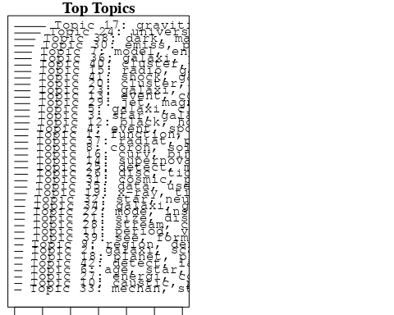

plotQuote(thoughts6, width = 30, main = "Topic 6")  
plotQuote(thoughts18, width = 30, main = "Topic 18")

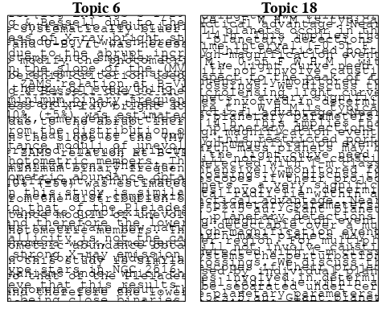

# Calculate and plot the correlation between topics  
mod.out.corr <- topicCorr(Research_topics)  
plot(mod.out.corr, cex = 1.5)  
  
  
# For each topic  
for (topic_num in 1:42) {  
 # Plot the word cloud  
 cloud(Research_topics, topic = topic_num, scale = c(2, 0.25))  
 Sys.sleep(2)  
}

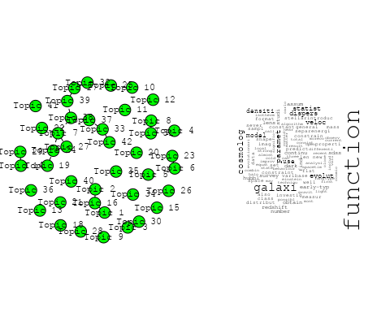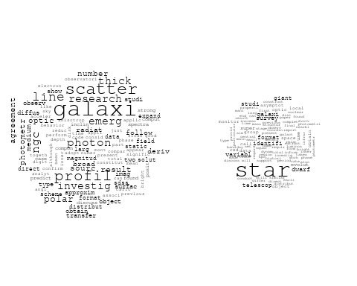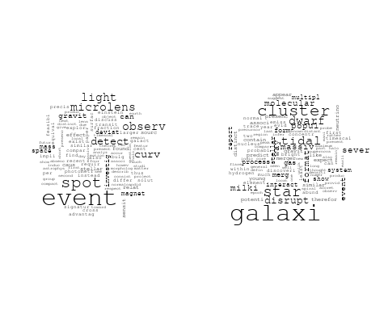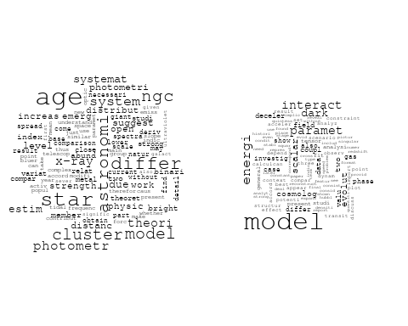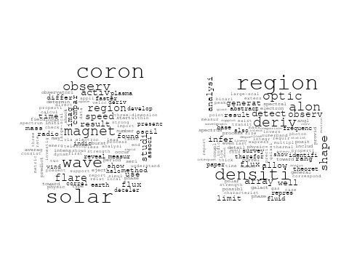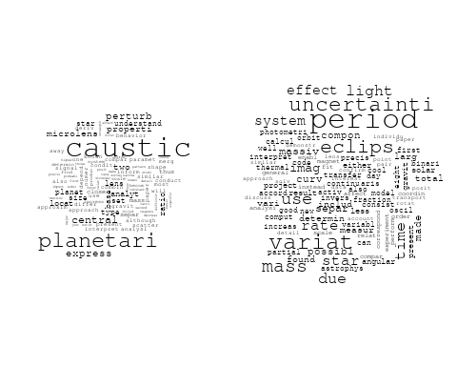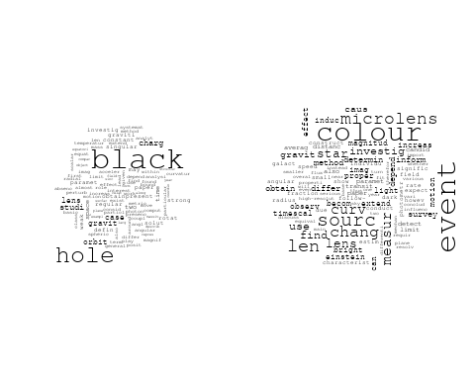

## Warning in wordcloud::wordcloud(words = vocab, freq = vec, max.words =  
## max.words, : supernova could not be fit on page. It will not be plotted.

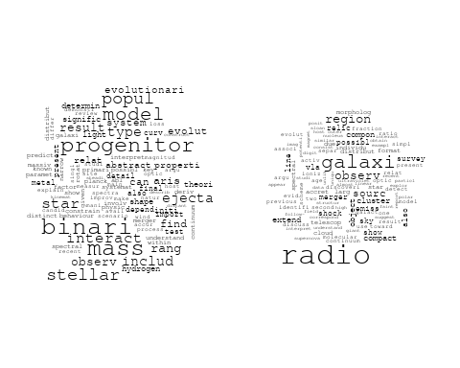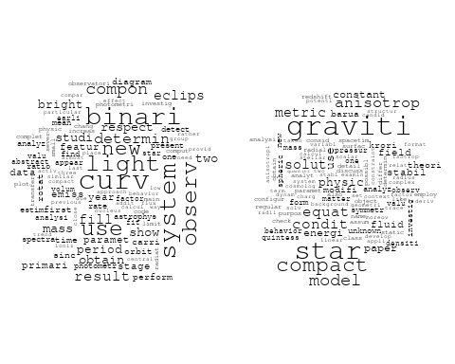

## Warning in wordcloud::wordcloud(words = vocab, freq = vec, max.words =  
## max.words, : planet could not be fit on page. It will not be plotted.

## Warning in wordcloud::wordcloud(words = vocab, freq = vec, max.words =  
## max.words, : microlens could not be fit on page. It will not be plotted.

## Warning in wordcloud::wordcloud(words = vocab, freq = vec, max.words =  
## max.words, : planetari could not be fit on page. It will not be plotted.

## Warning in wordcloud::wordcloud(words = vocab, freq = vec, max.words =  
## max.words, : merger could not be fit on page. It will not be plotted.

## Warning in wordcloud::wordcloud(words = vocab, freq = vec, max.words =  
## max.words, : accret could not be fit on page. It will not be plotted.

## Warning in wordcloud::wordcloud(words = vocab, freq = vec, max.words =  
## max.words, : effect could not be fit on page. It will not be plotted.

## Warning in wordcloud::wordcloud(words = vocab, freq = vec, max.words =  
## max.words, : binari could not be fit on page. It will not be plotted.

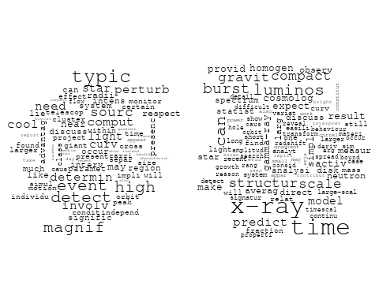

## Warning in wordcloud::wordcloud(words = vocab, freq = vec, max.words =  
## max.words, : matter could not be fit on page. It will not be plotted.

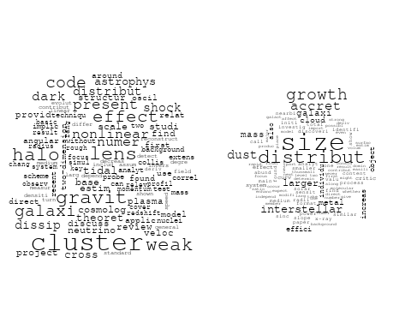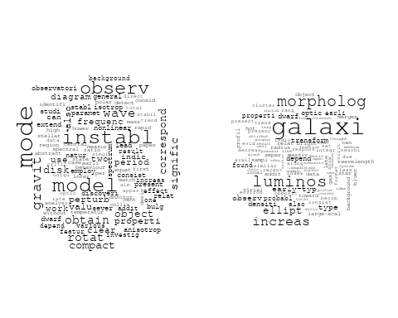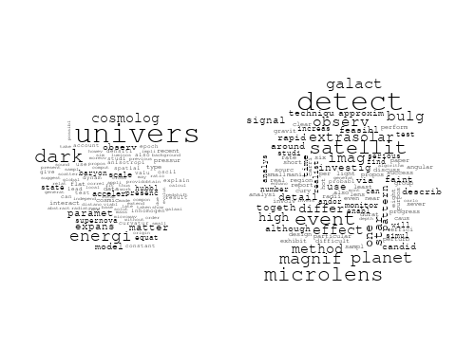

## Warning in wordcloud::wordcloud(words = vocab, freq = vec, max.words =  
## max.words, : frequenc could not be fit on page. It will not be plotted.

## Warning in wordcloud::wordcloud(words = vocab, freq = vec, max.words =  
## max.words, : disc could not be fit on page. It will not be plotted.

## Warning in wordcloud::wordcloud(words = vocab, freq = vec, max.words =  
## max.words, : tidal could not be fit on page. It will not be plotted.

## Warning in wordcloud::wordcloud(words = vocab, freq = vec, max.words =  
## max.words, : perturb could not be fit on page. It will not be plotted.

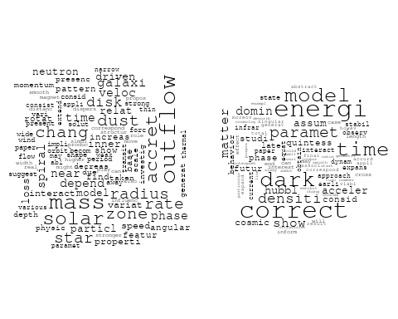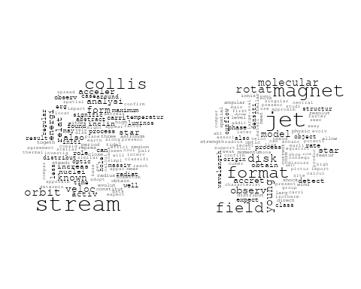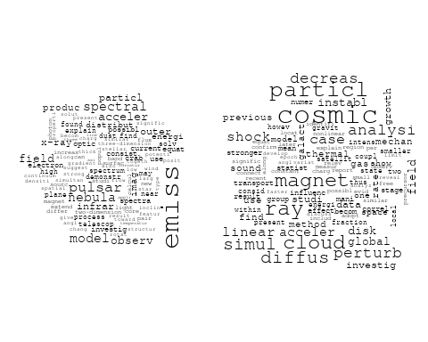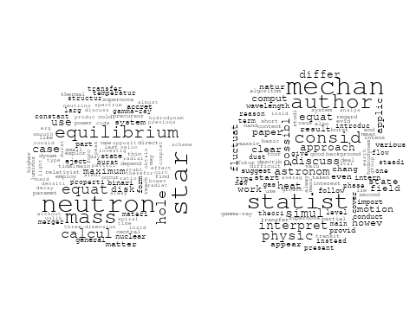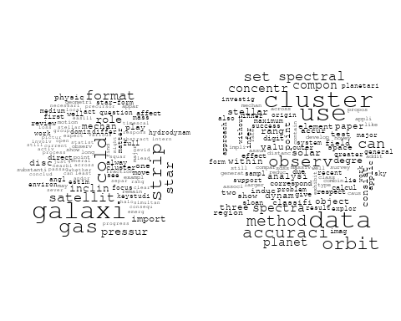

## Warning in wordcloud::wordcloud(words = vocab, freq = vec, max.words =  
## max.words, : particl could not be fit on page. It will not be plotted.

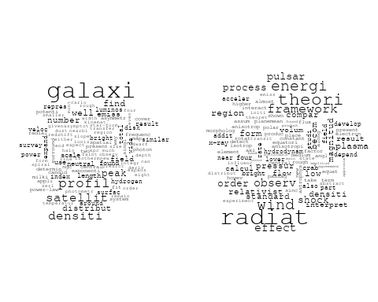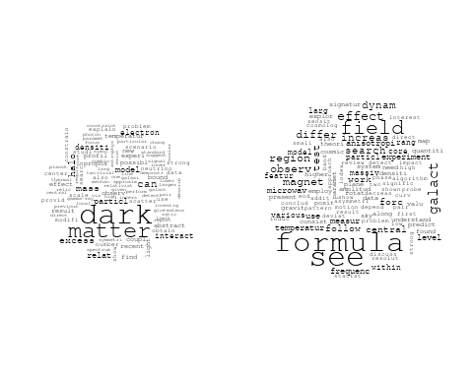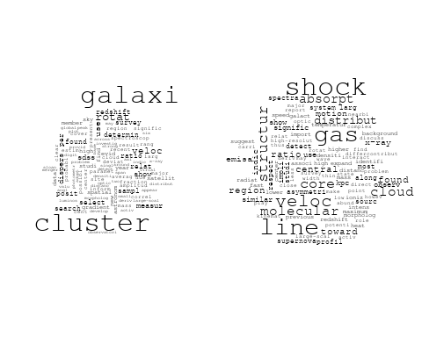

## Warning in wordcloud::wordcloud(words = vocab, freq = vec, max.words =  
## max.words, : strong could not be fit on page. It will not be plotted.

## Warning in wordcloud::wordcloud(words = vocab, freq = vec, max.words =  
## max.words, : asymmetri could not be fit on page. It will not be plotted.

## Warning in wordcloud::wordcloud(words = vocab, freq = vec, max.words =  
## max.words, : outflow could not be fit on page. It will not be plotted.

## Warning in wordcloud::wordcloud(words = vocab, freq = vec, max.words =  
## max.words, : evid could not be fit on page. It will not be plotted.

## Warning in wordcloud::wordcloud(words = vocab, freq = vec, max.words =  
## max.words, : provid could not be fit on page. It will not be plotted.

## Warning in wordcloud::wordcloud(words = vocab, freq = vec, max.words =  
## max.words, : present could not be fit on page. It will not be plotted.

## Warning in wordcloud::wordcloud(words = vocab, freq = vec, max.words =  
## max.words, : inhomogen could not be fit on page. It will not be plotted.

## Warning in wordcloud::wordcloud(words = vocab, freq = vec, max.words =  
## max.words, : howev could not be fit on page. It will not be plotted.

## Warning in wordcloud::wordcloud(words = vocab, freq = vec, max.words =  
## max.words, : observ could not be fit on page. It will not be plotted.

# Get the topic proportions for each document  
topic_proportions <- Research_topics$theta  
  
# Find the index of the topic with the highest proportion for each document  
# This will be the topic that each document is most likely to belong to  
max_topic_idx <- apply(topic_proportions, 1, which.max)  
  
# Add this as a new column to your data  
data_independent$topic <- max_topic_idx  
  
  
  
# Define the intervals  
intervals <- c('1824_1899', '1900_1964', '1965_1974', '1975_1984', '1985_1994', '1995_1999', '2000_2004', '2005_2009', '2010_2014', '2015_2019', '2020_2022')  
colors <- c('pink', 'blue', 'purple', 'yellow', 'green', 'pink', 'orange', 'violet', 'green', 'blue', 'pink')  
  
# Loop through the intervals and plot  
for(i in seq_along(intervals)){  
 # Filter data for when the pub_interval is equal to 1  
 data_filtered <- data_independent[data_independent[[paste0('pub_interval_', intervals[i])]] == 1,]  
   
 # Make the histogram  
   
 p <- ggplot(data_filtered, aes(x = topic)) +  
 geom_histogram(binwidth = 1, fill = colors[i], color = "black") +  
 xlab("Topic") +  
 ylab("Count") +  
 ggtitle(paste0("Topics from year ", gsub("_", " to ", intervals[i])))  
   
 print(p)  
}  
  
  
  
  
##Topic generation for IL (in collaboration) publications  
  
data_collab <- data[data[["IL"]] != 0,]  
  
# Save the original title data for future use  
data_collab$original_concatenated_title_abstract <- data_collab$concatenated_title_abstract  
  
#pre-processing the titles using textProcessor from the stm package  
processed_text <- textProcessor(data_collab$concatenated_title_abstract, metadata = data_collab)

## Building corpus...   
## Converting to Lower Case...   
## Removing punctuation...   
## Removing stopwords...   
## Removing numbers...   
## Stemming...   
## Creating Output...

# Further prepare the data by removing low-frequency terms  
out_text <- prepDocuments(processed_text$documents, processed_text$vocab, processed_text$meta)

## Removing 1026 of 4819 terms (1026 of 67316 tokens) due to frequency   
## Your corpus now has 868 documents, 3793 terms and 66290 tokens.

docs_text <- out_text$documents  
vocab_text <- out_text$vocab  
meta_text <- out_text$meta  
  
  
#Prepare data  
plotRemoved(processed_text$documents, lower.thresh = seq(1, 200, by = 100))

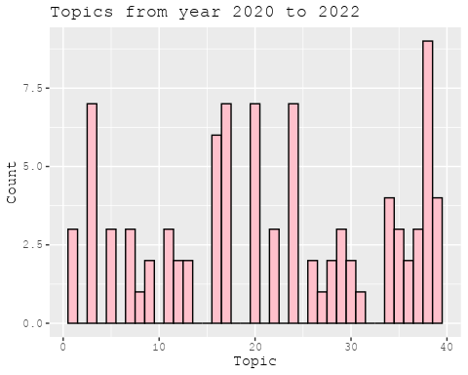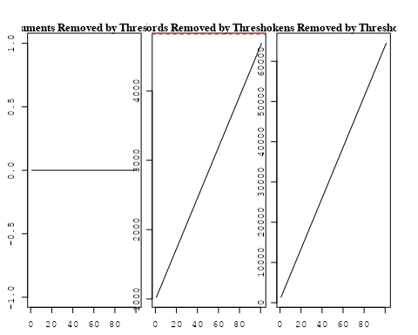

out_text <- prepDocuments(processed_text$documents, processed_text$vocab, processed_text$meta, lower.thresh = 8)

## Removing 3481 of 4819 terms (9522 of 67316 tokens) due to frequency   
## Your corpus now has 868 documents, 1338 terms and 57794 tokens.

str(out_text$meta)

## 'data.frame': 868 obs. of 39 variables:  
## $ concept_id : chr "https://openalex.org/C1276947" "https://openalex.org/C44870925" "https://openalex.org/C44870925" "https://openalex.org/C44870925" ...  
## $ work_id : chr "https://openalex.org/W2001391456" "https://openalex.org/W3105164062" "https://openalex.org/W1967579928" "https://openalex.org/W2057332312" ...  
## $ publication_year : int 2011 2002 2005 1989 2009 2001 2004 2016 2006 2006 ...  
## $ title : chr "Supernova SN 2011fe from an exploding carbon–oxygen white dwarf star" "Quantification of Uncertainty in the Measurement of Magnetic Fields in Clusters of Galaxies" "An intriguing correlation between the masses and periods of the transiting planets" "Recovering the full velocity and density fields from large-scale redshift-distance samples" ...  
## $ paperabstract : chr "Type Ia supernovae have been used empirically as ‘standard candles’ to demonstrate the acceleration of the expa"| __truncated__ "We assess the principal statistical and physical uncertainties associated with the determination of magnetic fi"| __truncated__ "We point out an intriguing relation between the masses of the transiting planets and their orbital periods. For"| __truncated__ "A new method for extracting the large-scale three-dimensional velocity and mass density fields from measurement"| __truncated__ ...  
## $ country : chr "IL US US US US US US US IL US" "US IL IL US" "IL" "IL US" ...  
## $ year_concept : chr "2011+https://openalex.org/C1276947" "2002+https://openalex.org/C44870925" "2005+https://openalex.org/C44870925" "1989+https://openalex.org/C44870925" ...  
## $ concatenated_title_abstract : chr "Supernova SN 2011fe from an exploding carbon–oxygen white dwarf star Type Ia supernovae have been used empirica"| __truncated__ "Quantification of Uncertainty in the Measurement of Magnetic Fields in Clusters of Galaxies We assess the princ"| __truncated__ "An intriguing correlation between the masses and periods of the transiting planets We point out an intriguing r"| __truncated__ "Recovering the full velocity and density fields from large-scale redshift-distance samples A new method for ext"| __truncated__ ...  
## $ US : num 80 50 0 50 50 0 0 0 0 0 ...  
## $ IN : num 0 0 0 0 0 0 0 0 0 0 ...  
## $ DE : num 0 0 0 0 0 ...  
## $ CH : num 0 0 0 0 0 ...  
## $ GB : num 0 0 0 0 0 0 0 0 0 0 ...  
## $ CN : num 0 0 0 0 0 0 0 0 0 0 ...  
## $ FR : num 0 0 0 0 0 0 0 0 0 0 ...  
## $ IT : num 0 0 0 0 0 0 0 0 0 0 ...  
## $ RU : num 0 0 0 0 0 0 0 0 0 0 ...  
## $ CA : num 0 0 0 0 0 0 0 0 0 0 ...  
## $ NL : num 0 0 0 0 0 0 0 0 0 0 ...  
## $ AU : num 0 0 0 0 0 0 0 0 0 0 ...  
## $ JP : num 0 0 0 0 0 0 0 0 0 0 ...  
## $ ES : num 0 0 0 0 0 0 0 0 0 0 ...  
## $ IL : num 20 50 100 50 50 ...  
## $ Americas : num 0 0 0 0 0 0 0 0 0 0 ...  
## $ Europe : num 0 0 0 0 0 0 0 0 0 0 ...  
## $ Africa : num 0 0 0 0 0 0 0 0 0 0 ...  
## $ AsiaAndOceania : num 0 0 0 0 0 0 0 0 0 0 ...  
## $ pub_interval_2020_2022 : int 0 0 0 0 0 0 0 0 0 0 ...  
## $ pub_interval_2015_2019 : int 0 0 0 0 0 0 0 1 0 0 ...  
## $ pub_interval_2010_2014 : int 1 0 0 0 0 0 0 0 0 0 ...  
## $ pub_interval_2005_2009 : int 0 0 1 0 1 0 0 0 1 1 ...  
## $ pub_interval_2000_2004 : int 0 1 0 0 0 1 1 0 0 0 ...  
## $ pub_interval_1995_1999 : int 0 0 0 0 0 0 0 0 0 0 ...  
## $ pub_interval_1985_1994 : int 0 0 0 1 0 0 0 0 0 0 ...  
## $ pub_interval_1975_1984 : int 0 0 0 0 0 0 0 0 0 0 ...  
## $ pub_interval_1965_1974 : int 0 0 0 0 0 0 0 0 0 0 ...  
## $ pub_interval_1900_1964 : int 0 0 0 0 0 0 0 0 0 0 ...  
## $ pub_interval_1824_1899 : int 0 0 0 0 0 0 0 0 0 0 ...  
## $ original_concatenated_title_abstract: chr "Supernova SN 2011fe from an exploding carbon–oxygen white dwarf star Type Ia supernovae have been used empirica"| __truncated__ "Quantification of Uncertainty in the Measurement of Magnetic Fields in Clusters of Galaxies We assess the princ"| __truncated__ "An intriguing correlation between the masses and periods of the transiting planets We point out an intriguing r"| __truncated__ "Recovering the full velocity and density fields from large-scale redshift-distance samples A new method for ext"| __truncated__ ...

# Initialize an empty formula string  
prevalence_formula_str <- "~"  
  
# Define the publication intervals  
pub_intervals <- c("pub_interval_2020_2022", "pub_interval_2015_2019", "pub_interval_2010_2014",   
 "pub_interval_2005_2009", "pub_interval_2000_2004", "pub_interval_1995_1999",  
 "pub_interval_1985_1994", "pub_interval_1975_1984", "pub_interval_1965_1974",  
 "pub_interval_1900_1964", "pub_interval_1824_1899")  
  
# Add each publication interval to the formula string  
for (interval in pub_intervals) {  
 # add an if statement to handle the first addition (without '+')  
 if (prevalence_formula_str == "~") {  
 prevalence_formula_str <- paste(prevalence_formula_str, interval)  
 } else {  
 prevalence_formula_str <- paste(prevalence_formula_str, "+", interval)  
 }  
}  
  
  
# Convert the string to a formula  
prevalence_formula <- as.formula(prevalence_formula_str)  
print(prevalence_formula)

## ~pub_interval_2020_2022 + pub_interval_2015_2019 + pub_interval_2010_2014 +   
## pub_interval_2005_2009 + pub_interval_2000_2004 + pub_interval_1995_1999 +   
## pub_interval_1985_1994 + pub_interval_1975_1984 + pub_interval_1965_1974 +   
## pub_interval_1900_1964 + pub_interval_1824_1899

# Run STM model  
Research_topics <- stm(documents = out_text$documents,   
 vocab = out_text$vocab,   
 K = 44,   
 prevalence = prevalence_formula,   
 data = out_text$meta,   
 init.type = "Spectral",  
 max.em.its = 1000,  
 gamma.prior = 'L1')

## Beginning Spectral Initialization   
## Calculating the gram matrix...  
## Finding anchor words...  
## ............................................  
## Recovering initialization...  
## .............  
## Initialization complete.  
## ............................................................................................................  
## Completed E-Step (0 seconds).   
## Completed M-Step.   
## Completing Iteration 1 (approx. per word bound = -5.990)   
## ............................................................................................................  
## Completed E-Step (0 seconds).   
## Completed M-Step.   
## Completing Iteration 2 (approx. per word bound = -5.727, relative change = 4.402e-02)   
## ............................................................................................................  
## Completed E-Step (0 seconds).   
## Completed M-Step.   
## Completing Iteration 3 (approx. per word bound = -5.642, relative change = 1.468e-02)   
## ............................................................................................................  
## Completed E-Step (0 seconds).   
## Completed M-Step.   
## Completing Iteration 4 (approx. per word bound = -5.604, relative change = 6.822e-03)   
## ............................................................................................................  
## Completed E-Step (0 seconds).   
## Completed M-Step.   
## Completing Iteration 5 (approx. per word bound = -5.584, relative change = 3.567e-03)   
## Topic 1: supernova, report, explos, event, star   
## Topic 2: origin, can, paper, discuss, via   
## Topic 3: burst, gamma-ray, neutrino, may, ray   
## Topic 4: measur, correl, relat, error, data   
## Topic 5: black, hole, mass, agn, use   
## Topic 6: emiss, line, iii, x-ray, featur   
## Topic 7: x-ray, observ, sourc, activ, spectral   
## Topic 8: magnitud, mag, ptf, photometr, catalog   
## Topic 9: nebula, planetari, star, observ, binari   
## Topic 10: veloc, mass, galaxi, gas, dynam   
## Topic 11: galaxi, radio, star, dark, popul   
## Topic 12: cluster, model, imag, mass, profil   
## Topic 13: supernova, star, dwarf, white, mass   
## Topic 14: variat, detect, observ, period, beam   
## Topic 15: quasar, sampl, redshift, present, near-infrar   
## Topic 16: metal, galaxi, model, abund, iii   
## Topic 17: sne, type, supernova, ii-p, sampl   
## Topic 18: lens, galaxi, redshift, imag, distribut   
## Topic 19: afterglow, burst, observ, grb, grbs   
## Topic 20: line, continuum, galaxi, emiss, luminos   
## Topic 21: halo, sourc, cosmolog, plasma, compact   
## Topic 22: emiss, cluster, electron, observ, radio   
## Topic 23: magnet, field, star, rotat, agb   
## Topic 24: galaxi, format, star, trigger, dwarf   
## Topic 25: disk, star, central, orbit, stellar   
## Topic 26: transit, per, cent, new, planetari   
## Topic 27: jet, wind, form, bubbl, nebula   
## Topic 28: orbit, power, densiti, scale, limit   
## Topic 29: star, shock, emiss, hot, temperatur   
## Topic 30: nova, outburst, evolut, mass, solar   
## Topic 31: galaxi, univers, matter, fluctuat, first   
## Topic 32: agn, radio, luminos, accret, type   
## Topic 33: energi, observ, wind, electron, γray   
## Topic 34: scenario, delay, time, merger, requir   
## Topic 35: binari, rotat, pulsar, wind, period   
## Topic 36: event, star, disrupt, tidal, transient   
## Topic 37: starburst, star, format, gas, ngc   
## Topic 38: mass, star, young, binari, detect   
## Topic 39: redshift, measur, background, cosmolog, temperatur   
## Topic 40: sne, supernova, rate, format, time   
## Topic 41: galaxi, mbh, black, hole, relat   
## Topic 42: distribut, model, densiti, observ, phase   
## Topic 43: planet, orbit, mass, star, system   
## Topic 44: radio-loud, absorpt, high, strong, indic   
## ............................................................................................................  
## Completed E-Step (0 seconds).   
## Completed M-Step.   
## Completing Iteration 6 (approx. per word bound = -5.572, relative change = 2.230e-03)   
## ............................................................................................................  
## Completed E-Step (0 seconds).   
## Completed M-Step.   
## Completing Iteration 7 (approx. per word bound = -5.563, relative change = 1.522e-03)   
## ............................................................................................................  
## Completed E-Step (0 seconds).   
## Completed M-Step.   
## Completing Iteration 8 (approx. per word bound = -5.556, relative change = 1.258e-03)   
## ............................................................................................................  
## Completed E-Step (0 seconds).   
## Completed M-Step.   
## Completing Iteration 9 (approx. per word bound = -5.550, relative change = 1.019e-03)   
## ............................................................................................................  
## Completed E-Step (0 seconds).   
## Completed M-Step.   
## Completing Iteration 10 (approx. per word bound = -5.545, relative change = 8.927e-04)   
## Topic 1: supernova, explos, star, progenitor, event   
## Topic 2: origin, can, discuss, paper, due   
## Topic 3: burst, neutrino, gamma-ray, ray, may   
## Topic 4: correl, measur, relat, error, data   
## Topic 5: black, hole, mass, agn, activ   
## Topic 6: emiss, line, iii, x-ray, ngc   
## Topic 7: x-ray, observ, sourc, absorpt, kev   
## Topic 8: magnitud, ptf, mag, photometr, catalog   
## Topic 9: nebula, planetari, star, binari, branch   
## Topic 10: galaxi, veloc, mass, gas, pressur   
## Topic 11: radio, galaxi, star, dark, local   
## Topic 12: cluster, model, mass, imag, profil   
## Topic 13: supernova, star, dwarf, white, mass   
## Topic 14: variat, data, detect, period, new   
## Topic 15: quasar, x-ray, redshift, sampl, present   
## Topic 16: metal, galaxi, model, line, ratio   
## Topic 17: sne, type, supernova, ii-p, sampl   
## Topic 18: lens, galaxi, redshift, imag, distribut   
## Topic 19: afterglow, burst, observ, grb, gamma-ray   
## Topic 20: line, continuum, galaxi, luminos, emiss   
## Topic 21: halo, sourc, cosmolog, plasma, compact   
## Topic 22: emiss, cluster, radio, observ, electron   
## Topic 23: magnet, field, star, rotat, agb   
## Topic 24: galaxi, format, star, trigger, dwarf   
## Topic 25: star, disk, central, orbit, stellar   
## Topic 26: transit, per, new, cent, observ   
## Topic 27: jet, form, bubbl, wind, slow   
## Topic 28: orbit, power, densiti, scale, observ   
## Topic 29: star, shock, emiss, neutron, hot   
## Topic 30: nova, outburst, evolut, solar, atmospher   
## Topic 31: galaxi, univers, matter, dark, first   
## Topic 32: agn, luminos, radio, type, accret   
## Topic 33: energi, wind, electron, observ, γray   
## Topic 34: scenario, time, merger, requir, delay   
## Topic 35: binari, rotat, period, pulsar, merger   
## Topic 36: event, star, disrupt, tidal, flare   
## Topic 37: starburst, star, format, galaxi, ngc   
## Topic 38: mass, young, star, binari, spectroscop   
## Topic 39: redshift, background, measur, cosmolog, detect   
## Topic 40: sne, supernova, rate, time, dtd   
## Topic 41: mbh, galaxi, black, hole, mass   
## Topic 42: distribut, model, densiti, observ, phase   
## Topic 43: planet, orbit, mass, star, system   
## Topic 44: radio-loud, absorpt, strong, high, indic   
## ............................................................................................................  
## Completed E-Step (0 seconds).   
## Completed M-Step.   
## Completing Iteration 11 (approx. per word bound = -5.541, relative change = 7.662e-04)   
## ............................................................................................................  
## Completed E-Step (0 seconds).   
## Completed M-Step.   
## Completing Iteration 12 (approx. per word bound = -5.538, relative change = 6.253e-04)   
## ............................................................................................................  
## Completed E-Step (0 seconds).   
## Completed M-Step.   
## Completing Iteration 13 (approx. per word bound = -5.535, relative change = 5.290e-04)   
## ............................................................................................................  
## Completed E-Step (0 seconds).   
## Completed M-Step.   
## Completing Iteration 14 (approx. per word bound = -5.532, relative change = 4.504e-04)   
## ............................................................................................................  
## Completed E-Step (0 seconds).   
## Completed M-Step.   
## Completing Iteration 15 (approx. per word bound = -5.530, relative change = 4.373e-04)   
## Topic 1: supernova, explos, star, progenitor, event   
## Topic 2: origin, discuss, can, also, paper   
## Topic 3: burst, neutrino, gamma-ray, ray, may   
## Topic 4: correl, measur, relat, error, data   
## Topic 5: black, hole, mass, agn, activ   
## Topic 6: emiss, iii, line, x-ray, ngc   
## Topic 7: x-ray, observ, sourc, densiti, kev   
## Topic 8: magnitud, ptf, mag, photometr, survey   
## Topic 9: nebula, planetari, star, binari, branch   
## Topic 10: galaxi, veloc, mass, pressur, gas   
## Topic 11: radio, galaxi, star, dark, local   
## Topic 12: cluster, model, mass, profil, imag   
## Topic 13: star, supernova, dwarf, white, mass   
## Topic 14: variat, data, day, new, period   
## Topic 15: quasar, x-ray, redshift, sampl, observ   
## Topic 16: metal, galaxi, ratio, model, line   
## Topic 17: sne, type, supernova, ii-p, redshift   
## Topic 18: lens, galaxi, redshift, imag, len   
## Topic 19: afterglow, burst, observ, grb, gamma-ray   
## Topic 20: line, continuum, galaxi, luminos, emiss   
## Topic 21: halo, sourc, cosmolog, plasma, compact   
## Topic 22: emiss, cluster, radio, observ, electron   
## Topic 23: magnet, field, star, rotat, agb   
## Topic 24: galaxi, format, star, trigger, dwarf   
## Topic 25: star, disk, central, orbit, stellar   
## Topic 26: transit, per, cent, new, observ   
## Topic 27: jet, form, bubbl, slow, wind   
## Topic 28: power, orbit, densiti, tidal, observ   
## Topic 29: star, shock, emiss, neutron, hot   
## Topic 30: nova, outburst, evolut, solar, mass   
## Topic 31: galaxi, univers, matter, first, dark   
## Topic 32: agn, luminos, radio, type, accret   
## Topic 33: energi, wind, electron, observ, acceler   
## Topic 34: scenario, time, merger, requir, delay   
## Topic 35: binari, rotat, period, merger, satellit   
## Topic 36: event, star, disrupt, tidal, flare   
## Topic 37: starburst, star, format, galaxi, ngc   
## Topic 38: mass, spectroscop, binari, young, star   
## Topic 39: redshift, background, cosmolog, measur, detect   
## Topic 40: sne, rate, supernova, time, dtd   
## Topic 41: mbh, galaxi, hole, black, mass   
## Topic 42: distribut, model, densiti, observ, phase   
## Topic 43: planet, orbit, mass, star, system   
## Topic 44: radio-loud, absorpt, strong, high, indic   
## ............................................................................................................  
## Completed E-Step (0 seconds).   
## Completed M-Step.   
## Completing Iteration 16 (approx. per word bound = -5.528, relative change = 3.994e-04)   
## ............................................................................................................  
## Completed E-Step (0 seconds).   
## Completed M-Step.   
## Completing Iteration 17 (approx. per word bound = -5.526, relative change = 3.627e-04)   
## ............................................................................................................  
## Completed E-Step (0 seconds).   
## Completed M-Step.   
## Completing Iteration 18 (approx. per word bound = -5.524, relative change = 3.212e-04)   
## ............................................................................................................  
## Completed E-Step (0 seconds).   
## Completed M-Step.   
## Completing Iteration 19 (approx. per word bound = -5.522, relative change = 2.746e-04)   
## ............................................................................................................  
## Completed E-Step (1 seconds).   
## Completed M-Step.   
## Completing Iteration 20 (approx. per word bound = -5.521, relative change = 2.710e-04)   
## Topic 1: supernova, explos, star, progenitor, studi   
## Topic 2: discuss, origin, can, also, paper   
## Topic 3: burst, neutrino, gamma-ray, ray, may   
## Topic 4: correl, measur, relat, error, data   
## Topic 5: black, hole, mass, agn, activ   
## Topic 6: emiss, line, iii, x-ray, ngc   
## Topic 7: x-ray, observ, sourc, densiti, kev   
## Topic 8: magnitud, ptf, mag, photometr, catalog   
## Topic 9: nebula, planetari, star, binari, branch   
## Topic 10: galaxi, veloc, mass, pressur, gas   
## Topic 11: radio, galaxi, star, dark, local   
## Topic 12: cluster, model, mass, profil, imag   
## Topic 13: star, supernova, dwarf, white, mass   
## Topic 14: variat, data, day, new, period   
## Topic 15: quasar, x-ray, redshift, observ, near-infrar   
## Topic 16: metal, galaxi, ratio, model, line   
## Topic 17: sne, type, supernova, ii-p, redshift   
## Topic 18: lens, galaxi, redshift, imag, len   
## Topic 19: afterglow, burst, observ, grb, gamma-ray   
## Topic 20: line, continuum, galaxi, luminos, region   
## Topic 21: halo, sourc, cosmolog, plasma, compact   
## Topic 22: emiss, cluster, radio, observ, electron   
## Topic 23: magnet, field, star, rotat, agb   
## Topic 24: galaxi, format, star, trigger, dwarf   
## Topic 25: star, disk, central, orbit, stellar   
## Topic 26: per, transit, cent, observ, variabl   
## Topic 27: jet, bubbl, form, slow, accret   
## Topic 28: power, orbit, densiti, tidal, fluctuat   
## Topic 29: star, shock, emiss, neutron, hot   
## Topic 30: nova, evolut, outburst, solar, atmospher   
## Topic 31: galaxi, univers, matter, first, local   
## Topic 32: agn, luminos, radio, type, accret   
## Topic 33: energi, wind, electron, observ, acceler   
## Topic 34: scenario, time, merger, requir, rapid   
## Topic 35: binari, rotat, period, merger, satellit   
## Topic 36: event, disrupt, star, tidal, accret   
## Topic 37: starburst, star, format, cluster, galaxi   
## Topic 38: mass, binari, spectroscop, star, ratio   
## Topic 39: redshift, background, cosmolog, measur, detect   
## Topic 40: sne, rate, supernova, time, dtd   
## Topic 41: mbh, galaxi, hole, black, mass   
## Topic 42: distribut, model, densiti, observ, phase   
## Topic 43: planet, orbit, mass, star, system   
## Topic 44: radio-loud, absorpt, strong, indic, domin   
## ............................................................................................................  
## Completed E-Step (0 seconds).   
## Completed M-Step.   
## Completing Iteration 21 (approx. per word bound = -5.519, relative change = 2.502e-04)   
## ............................................................................................................  
## Completed E-Step (0 seconds).   
## Completed M-Step.   
## Completing Iteration 22 (approx. per word bound = -5.518, relative change = 2.342e-04)   
## ............................................................................................................  
## Completed E-Step (0 seconds).   
## Completed M-Step.   
## Completing Iteration 23 (approx. per word bound = -5.517, relative change = 2.395e-04)   
## ............................................................................................................  
## Completed E-Step (0 seconds).   
## Completed M-Step.   
## Completing Iteration 24 (approx. per word bound = -5.516, relative change = 2.333e-04)   
## ............................................................................................................  
## Completed E-Step (0 seconds).   
## Completed M-Step.   
## Completing Iteration 25 (approx. per word bound = -5.514, relative change = 2.159e-04)   
## Topic 1: supernova, explos, star, progenitor, studi   
## Topic 2: discuss, also, origin, paper, can   
## Topic 3: neutrino, burst, ray, gamma-ray, may   
## Topic 4: correl, measur, relat, error, data   
## Topic 5: black, hole, mass, agn, activ   
## Topic 6: emiss, line, iii, x-ray, ngc   
## Topic 7: x-ray, observ, sourc, densiti, gas   
## Topic 8: magnitud, ptf, photometr, catalog, mag   
## Topic 9: nebula, planetari, star, wind, binari   
## Topic 10: galaxi, veloc, mass, pressur, gas   
## Topic 11: radio, galaxi, star, dark, local   
## Topic 12: cluster, model, mass, profil, imag   
## Topic 13: star, supernova, dwarf, white, mass   
## Topic 14: variat, data, day, new, period   
## Topic 15: quasar, x-ray, redshift, observ, near-infrar   
## Topic 16: metal, galaxi, ratio, model, abund   
## Topic 17: sne, type, supernova, ii-p, redshift   
## Topic 18: lens, galaxi, redshift, len, imag   
## Topic 19: afterglow, burst, observ, grb, gamma-ray   
## Topic 20: line, continuum, galaxi, luminos, region   
## Topic 21: halo, sourc, cosmolog, plasma, compact   
## Topic 22: emiss, cluster, radio, observ, electron   
## Topic 23: magnet, field, star, rotat, agb   
## Topic 24: galaxi, format, star, trigger, dwarf   
## Topic 25: star, disk, central, orbit, stellar   
## Topic 26: per, cent, transit, observ, variabl   
## Topic 27: jet, bubbl, form, slow, accret   
## Topic 28: power, orbit, densiti, tidal, fluctuat   
## Topic 29: star, shock, emiss, neutron, hot   
## Topic 30: nova, evolut, outburst, atmospher, mass   
## Topic 31: galaxi, univers, matter, first, local   
## Topic 32: agn, luminos, radio, type, accret   
## Topic 33: energi, wind, electron, observ, acceler   
## Topic 34: scenario, time, merger, requir, rapid   
## Topic 35: binari, rotat, period, merger, satellit   
## Topic 36: event, disrupt, star, accret, tidal   
## Topic 37: starburst, star, format, cluster, galaxi   
## Topic 38: mass, binari, spectroscop, star, ratio   
## Topic 39: redshift, background, cosmolog, measur, use   
## Topic 40: sne, rate, supernova, time, dtd   
## Topic 41: mbh, galaxi, hole, black, mass   
## Topic 42: distribut, model, densiti, observ, phase   
## Topic 43: planet, orbit, mass, star, system   
## Topic 44: radio-loud, absorpt, strong, domin, indic   
## ............................................................................................................  
## Completed E-Step (0 seconds).   
## Completed M-Step.   
## Completing Iteration 26 (approx. per word bound = -5.513, relative change = 1.928e-04)   
## ............................................................................................................  
## Completed E-Step (0 seconds).   
## Completed M-Step.   
## Completing Iteration 27 (approx. per word bound = -5.512, relative change = 1.737e-04)   
## ............................................................................................................  
## Completed E-Step (0 seconds).   
## Completed M-Step.   
## Completing Iteration 28 (approx. per word bound = -5.512, relative change = 1.332e-04)   
## ............................................................................................................  
## Completed E-Step (0 seconds).   
## Completed M-Step.   
## Completing Iteration 29 (approx. per word bound = -5.511, relative change = 1.251e-04)   
## ............................................................................................................  
## Completed E-Step (0 seconds).   
## Completed M-Step.   
## Completing Iteration 30 (approx. per word bound = -5.510, relative change = 1.282e-04)   
## Topic 1: supernova, explos, star, progenitor, studi   
## Topic 2: discuss, also, observ, paper, dust   
## Topic 3: neutrino, burst, ray, gamma-ray, may   
## Topic 4: correl, measur, relat, error, data   
## Topic 5: black, hole, mass, agn, activ   
## Topic 6: emiss, line, iii, x-ray, ngc   
## Topic 7: x-ray, observ, sourc, densiti, gas   
## Topic 8: magnitud, photometr, catalog, ptf, calibr   
## Topic 9: nebula, planetari, star, wind, binari   
## Topic 10: galaxi, veloc, pressur, mass, gas   
## Topic 11: radio, galaxi, star, dark, local   
## Topic 12: cluster, model, mass, profil, imag   
## Topic 13: star, supernova, dwarf, white, mass   
## Topic 14: variat, data, day, new, observ   
## Topic 15: quasar, x-ray, redshift, observ, near-infrar   
## Topic 16: metal, galaxi, ratio, model, abund   
## Topic 17: sne, type, supernova, ii-p, redshift   
## Topic 18: lens, galaxi, redshift, len, imag   
## Topic 19: burst, afterglow, observ, grb, gamma-ray   
## Topic 20: line, continuum, galaxi, luminos, region   
## Topic 21: halo, sourc, cosmolog, plasma, compact   
## Topic 22: emiss, cluster, observ, radio, electron   
## Topic 23: magnet, field, star, rotat, x-ray   
## Topic 24: galaxi, format, star, trigger, dwarf   
## Topic 25: star, disk, central, orbit, stellar   
## Topic 26: per, cent, observ, transit, variabl   
## Topic 27: jet, bubbl, form, slow, gas   
## Topic 28: power, orbit, densiti, tidal, fluctuat   
## Topic 29: star, shock, emiss, neutron, hot   
## Topic 30: nova, evolut, outburst, mass, atmospher   
## Topic 31: galaxi, univers, first, matter, local   
## Topic 32: agn, luminos, radio, type, accret   
## Topic 33: energi, wind, electron, observ, acceler   
## Topic 34: scenario, time, merger, requir, rapid   
## Topic 35: binari, rotat, period, merger, satellit   
## Topic 36: event, disrupt, accret, tidal, star   
## Topic 37: starburst, star, format, cluster, galaxi   
## Topic 38: mass, spectroscop, binari, ratio, star   
## Topic 39: redshift, background, cosmolog, measur, use   
## Topic 40: sne, rate, supernova, time, dtd   
## Topic 41: mbh, galaxi, hole, black, mass   
## Topic 42: distribut, model, densiti, observ, phase   
## Topic 43: planet, orbit, mass, star, system   
## Topic 44: radio-loud, absorpt, strong, domin, indic   
## ............................................................................................................  
## Completed E-Step (0 seconds).   
## Completed M-Step.   
## Completing Iteration 31 (approx. per word bound = -5.509, relative change = 1.500e-04)   
## ............................................................................................................  
## Completed E-Step (0 seconds).   
## Completed M-Step.   
## Completing Iteration 32 (approx. per word bound = -5.509, relative change = 1.357e-04)   
## ............................................................................................................  
## Completed E-Step (0 seconds).   
## Completed M-Step.   
## Completing Iteration 33 (approx. per word bound = -5.508, relative change = 8.986e-05)   
## ............................................................................................................  
## Completed E-Step (0 seconds).   
## Completed M-Step.   
## Completing Iteration 34 (approx. per word bound = -5.508, relative change = 8.094e-05)   
## ............................................................................................................  
## Completed E-Step (0 seconds).   
## Completed M-Step.   
## Completing Iteration 35 (approx. per word bound = -5.507, relative change = 8.524e-05)   
## Topic 1: supernova, explos, star, progenitor, studi   
## Topic 2: dust, discuss, observ, also, sed   
## Topic 3: neutrino, burst, ray, gamma-ray, may   
## Topic 4: correl, measur, relat, error, data   
## Topic 5: black, hole, mass, agn, activ   
## Topic 6: emiss, iii, line, x-ray, ngc   
## Topic 7: x-ray, observ, densiti, sourc, gas   
## Topic 8: magnitud, photometr, catalog, ptf, sourc   
## Topic 9: nebula, planetari, star, wind, binari   
## Topic 10: galaxi, veloc, pressur, mass, gas   
## Topic 11: radio, galaxi, star, dark, local   
## Topic 12: cluster, model, mass, profil, imag   
## Topic 13: supernova, star, dwarf, white, mass   
## Topic 14: variat, data, day, observ, new   
## Topic 15: quasar, x-ray, observ, near-infrar, redshift   
## Topic 16: metal, galaxi, ratio, model, abund   
## Topic 17: sne, type, supernova, ii-p, redshift   
## Topic 18: lens, galaxi, imag, redshift, len   
## Topic 19: burst, afterglow, observ, grb, gamma-ray   
## Topic 20: line, continuum, galaxi, luminos, region   
## Topic 21: halo, sourc, cosmolog, plasma, compact   
## Topic 22: emiss, cluster, radio, observ, electron   
## Topic 23: magnet, field, star, rotat, x-ray   
## Topic 24: galaxi, format, star, trigger, dwarf   
## Topic 25: star, disk, central, orbit, stellar   
## Topic 26: per, cent, observ, transit, variabl   
## Topic 27: jet, form, bubbl, slow, gas   
## Topic 28: power, orbit, tidal, densiti, heat   
## Topic 29: star, shock, emiss, neutron, hot   
## Topic 30: nova, evolut, outburst, mass, atmospher   
## Topic 31: galaxi, univers, first, local, matter   
## Topic 32: agn, luminos, radio, type, accret   
## Topic 33: energi, wind, electron, observ, acceler   
## Topic 34: scenario, time, merger, requir, rapid   
## Topic 35: binari, rotat, period, merger, radio   
## Topic 36: event, disrupt, accret, tidal, star   
## Topic 37: starburst, star, cluster, format, galaxi   
## Topic 38: mass, spectroscop, binari, ratio, secondari   
## Topic 39: redshift, background, cosmolog, measur, use   
## Topic 40: sne, rate, supernova, time, dtd   
## Topic 41: galaxi, mbh, hole, black, mass   
## Topic 42: distribut, model, densiti, observ, phase   
## Topic 43: planet, orbit, mass, star, system   
## Topic 44: radio-loud, absorpt, strong, indic, domin   
## ............................................................................................................  
## Completed E-Step (0 seconds).   
## Completed M-Step.   
## Completing Iteration 36 (approx. per word bound = -5.507, relative change = 9.056e-05)   
## ............................................................................................................  
## Completed E-Step (0 seconds).   
## Completed M-Step.   
## Completing Iteration 37 (approx. per word bound = -5.506, relative change = 8.491e-05)   
## ............................................................................................................  
## Completed E-Step (0 seconds).   
## Completed M-Step.   
## Completing Iteration 38 (approx. per word bound = -5.506, relative change = 8.626e-05)   
## ............................................................................................................  
## Completed E-Step (0 seconds).   
## Completed M-Step.   
## Completing Iteration 39 (approx. per word bound = -5.505, relative change = 9.222e-05)   
## ............................................................................................................  
## Completed E-Step (0 seconds).   
## Completed M-Step.   
## Completing Iteration 40 (approx. per word bound = -5.505, relative change = 7.743e-05)   
## Topic 1: supernova, explos, star, progenitor, studi   
## Topic 2: dust, discuss, observ, also, sed   
## Topic 3: neutrino, burst, ray, gamma-ray, may   
## Topic 4: correl, measur, relat, error, data   
## Topic 5: black, hole, mass, agn, activ   
## Topic 6: emiss, iii, line, x-ray, ngc   
## Topic 7: x-ray, observ, densiti, sourc, gas   
## Topic 8: magnitud, photometr, catalog, sourc, calibr   
## Topic 9: nebula, planetari, star, wind, binari   
## Topic 10: galaxi, veloc, pressur, mass, gas   
## Topic 11: radio, galaxi, star, stellar, local   
## Topic 12: cluster, model, mass, profil, imag   
## Topic 13: supernova, star, dwarf, white, mass   
## Topic 14: variat, data, day, observ, light   
## Topic 15: quasar, x-ray, observ, near-infrar, present   
## Topic 16: metal, galaxi, ratio, model, abund   
## Topic 17: sne, type, supernova, redshift, ii-p   
## Topic 18: lens, galaxi, imag, redshift, len   
## Topic 19: burst, afterglow, observ, grb, gamma-ray   
## Topic 20: line, galaxi, continuum, luminos, region   
## Topic 21: halo, sourc, cosmolog, plasma, matter   
## Topic 22: emiss, cluster, radio, observ, electron   
## Topic 23: magnet, field, star, rotat, x-ray   
## Topic 24: galaxi, format, star, trigger, dwarf   
## Topic 25: star, disk, central, orbit, stellar   
## Topic 26: per, cent, observ, transit, variabl   
## Topic 27: jet, form, bubbl, slow, gas   
## Topic 28: power, orbit, tidal, densiti, heat   
## Topic 29: star, shock, emiss, neutron, hot   
## Topic 30: nova, evolut, outburst, mass, atmospher   
## Topic 31: galaxi, univers, first, local, matter   
## Topic 32: agn, luminos, radio, type, accret   
## Topic 33: energi, wind, electron, observ, acceler   
## Topic 34: scenario, time, merger, requir, rapid   
## Topic 35: binari, rotat, period, merger, radio   
## Topic 36: event, disrupt, accret, tidal, star   
## Topic 37: starburst, star, cluster, format, galaxi   
## Topic 38: mass, spectroscop, binari, ratio, secondari   
## Topic 39: redshift, background, cosmolog, measur, use   
## Topic 40: sne, rate, supernova, time, dtd   
## Topic 41: galaxi, mbh, hole, black, mass   
## Topic 42: distribut, model, densiti, observ, phase   
## Topic 43: planet, orbit, mass, star, system   
## Topic 44: radio-loud, absorpt, strong, indic, domin   
## ............................................................................................................  
## Completed E-Step (0 seconds).   
## Completed M-Step.   
## Completing Iteration 41 (approx. per word bound = -5.504, relative change = 6.941e-05)   
## ............................................................................................................  
## Completed E-Step (0 seconds).   
## Completed M-Step.   
## Completing Iteration 42 (approx. per word bound = -5.504, relative change = 9.066e-05)   
## ............................................................................................................  
## Completed E-Step (0 seconds).   
## Completed M-Step.   
## Completing Iteration 43 (approx. per word bound = -5.504, relative change = 8.395e-05)   
## ............................................................................................................  
## Completed E-Step (0 seconds).   
## Completed M-Step.   
## Completing Iteration 44 (approx. per word bound = -5.503, relative change = 7.345e-05)   
## ............................................................................................................  
## Completed E-Step (0 seconds).   
## Completed M-Step.   
## Completing Iteration 45 (approx. per word bound = -5.503, relative change = 7.024e-05)   
## Topic 1: supernova, explos, star, progenitor, studi   
## Topic 2: dust, observ, discuss, sed, also   
## Topic 3: neutrino, burst, ray, gamma-ray, may   
## Topic 4: correl, measur, relat, error, data   
## Topic 5: black, hole, mass, agn, activ   
## Topic 6: emiss, iii, line, x-ray, ngc   
## Topic 7: x-ray, observ, densiti, sourc, ioniz   
## Topic 8: magnitud, photometr, catalog, sourc, calibr   
## Topic 9: nebula, planetari, star, wind, binari   
## Topic 10: galaxi, veloc, pressur, mass, gas   
## Topic 11: radio, galaxi, star, local, stellar   
## Topic 12: cluster, model, mass, profil, imag   
## Topic 13: supernova, star, dwarf, white, mass   
## Topic 14: variat, data, day, observ, light   
## Topic 15: quasar, x-ray, near-infrar, observ, present   
## Topic 16: metal, galaxi, ratio, model, abund   
## Topic 17: sne, type, supernova, redshift, ii-p   
## Topic 18: lens, galaxi, imag, redshift, len   
## Topic 19: burst, afterglow, observ, grb, gamma-ray   
## Topic 20: line, galaxi, continuum, luminos, region   
## Topic 21: halo, sourc, cosmolog, matter, plasma   
## Topic 22: emiss, cluster, radio, observ, electron   
## Topic 23: magnet, field, star, rotat, x-ray   
## Topic 24: galaxi, format, star, trigger, dwarf   
## Topic 25: star, disk, central, orbit, stellar   
## Topic 26: per, cent, observ, transit, variabl   
## Topic 27: jet, form, bubbl, slow, gas   
## Topic 28: power, orbit, tidal, densiti, heat   
## Topic 29: star, shock, emiss, neutron, hot   
## Topic 30: nova, evolut, outburst, mass, atmospher   
## Topic 31: galaxi, univers, first, local, matter   
## Topic 32: agn, luminos, radio, type, accret   
## Topic 33: energi, wind, electron, observ, acceler   
## Topic 34: scenario, time, merger, requir, rapid   
## Topic 35: binari, rotat, period, merger, radio   
## Topic 36: event, disrupt, accret, tidal, star   
## Topic 37: starburst, star, cluster, format, galaxi   
## Topic 38: mass, spectroscop, binari, ratio, secondari   
## Topic 39: redshift, background, cosmolog, measur, use   
## Topic 40: sne, rate, supernova, time, dtd   
## Topic 41: galaxi, mbh, hole, black, mass   
## Topic 42: distribut, model, densiti, observ, phase   
## Topic 43: planet, orbit, mass, star, system   
## Topic 44: radio-loud, absorpt, strong, indic, first   
## ............................................................................................................  
## Completed E-Step (0 seconds).   
## Completed M-Step.   
## Completing Iteration 46 (approx. per word bound = -5.502, relative change = 7.295e-05)   
## ............................................................................................................  
## Completed E-Step (0 seconds).   
## Completed M-Step.   
## Completing Iteration 47 (approx. per word bound = -5.502, relative change = 7.031e-05)   
## ............................................................................................................  
## Completed E-Step (0 seconds).   
## Completed M-Step.   
## Completing Iteration 48 (approx. per word bound = -5.502, relative change = 6.372e-05)   
## ............................................................................................................  
## Completed E-Step (0 seconds).   
## Completed M-Step.   
## Completing Iteration 49 (approx. per word bound = -5.501, relative change = 7.072e-05)   
## ............................................................................................................  
## Completed E-Step (0 seconds).   
## Completed M-Step.   
## Completing Iteration 50 (approx. per word bound = -5.501, relative change = 6.282e-05)   
## Topic 1: supernova, explos, star, progenitor, studi   
## Topic 2: dust, observ, discuss, sed, wave   
## Topic 3: neutrino, burst, ray, gamma-ray, may   
## Topic 4: correl, measur, relat, error, data   
## Topic 5: black, hole, mass, agn, activ   
## Topic 6: emiss, iii, line, x-ray, ngc   
## Topic 7: x-ray, observ, densiti, sourc, ioniz   
## Topic 8: magnitud, photometr, catalog, sourc, calibr   
## Topic 9: nebula, planetari, wind, star, binari   
## Topic 10: galaxi, veloc, pressur, mass, gas   
## Topic 11: radio, galaxi, star, local, stellar   
## Topic 12: cluster, model, mass, profil, imag   
## Topic 13: supernova, star, dwarf, white, mass   
## Topic 14: variat, data, day, observ, light   
## Topic 15: quasar, x-ray, near-infrar, observ, present   
## Topic 16: metal, galaxi, ratio, model, abund   
## Topic 17: sne, type, supernova, redshift, ii-p   
## Topic 18: lens, galaxi, imag, redshift, len   
## Topic 19: afterglow, burst, observ, grb, gamma-ray   
## Topic 20: line, galaxi, continuum, luminos, region   
## Topic 21: halo, sourc, cosmolog, matter, plasma   
## Topic 22: emiss, cluster, radio, observ, electron   
## Topic 23: magnet, field, star, rotat, x-ray   
## Topic 24: galaxi, format, star, trigger, dwarf   
## Topic 25: star, disk, central, orbit, stellar   
## Topic 26: per, cent, observ, transit, variabl   
## Topic 27: jet, form, bubbl, slow, gas   
## Topic 28: power, orbit, tidal, densiti, heat   
## Topic 29: star, shock, emiss, neutron, hot   
## Topic 30: nova, evolut, outburst, mass, atmospher   
## Topic 31: galaxi, univers, first, local, matter   
## Topic 32: agn, luminos, radio, type, accret   
## Topic 33: energi, wind, electron, observ, acceler   
## Topic 34: scenario, time, merger, requir, rotat   
## Topic 35: binari, rotat, period, merger, radio   
## Topic 36: event, disrupt, accret, tidal, star   
## Topic 37: starburst, star, cluster, format, galaxi   
## Topic 38: mass, spectroscop, binari, ratio, secondari   
## Topic 39: redshift, background, cosmolog, measur, use   
## Topic 40: sne, rate, supernova, time, dtd   
## Topic 41: galaxi, mbh, hole, black, mass   
## Topic 42: distribut, model, densiti, observ, phase   
## Topic 43: planet, orbit, mass, star, system   
## Topic 44: radio-loud, absorpt, strong, indic, first   
## ............................................................................................................  
## Completed E-Step (0 seconds).   
## Completed M-Step.   
## Completing Iteration 51 (approx. per word bound = -5.501, relative change = 5.554e-05)   
## ............................................................................................................  
## Completed E-Step (0 seconds).   
## Completed M-Step.   
## Completing Iteration 52 (approx. per word bound = -5.500, relative change = 5.049e-05)   
## ............................................................................................................  
## Completed E-Step (0 seconds).   
## Completed M-Step.   
## Completing Iteration 53 (approx. per word bound = -5.500, relative change = 4.609e-05)   
## ............................................................................................................  
## Completed E-Step (0 seconds).   
## Completed M-Step.   
## Completing Iteration 54 (approx. per word bound = -5.500, relative change = 4.751e-05)   
## ............................................................................................................  
## Completed E-Step (0 seconds).   
## Completed M-Step.   
## Completing Iteration 55 (approx. per word bound = -5.499, relative change = 5.139e-05)   
## Topic 1: supernova, explos, star, progenitor, studi   
## Topic 2: dust, observ, wave, sed, discuss   
## Topic 3: neutrino, burst, ray, gamma-ray, may   
## Topic 4: correl, measur, relat, error, data   
## Topic 5: black, hole, mass, agn, activ   
## Topic 6: emiss, iii, line, x-ray, ngc   
## Topic 7: x-ray, observ, densiti, sourc, ioniz   
## Topic 8: magnitud, photometr, catalog, sourc, calibr   
## Topic 9: nebula, planetari, wind, star, binari   
## Topic 10: galaxi, veloc, pressur, mass, gas   
## Topic 11: radio, galaxi, star, stellar, local   
## Topic 12: cluster, model, mass, profil, imag   
## Topic 13: star, supernova, dwarf, white, mass   
## Topic 14: variat, data, day, observ, light   
## Topic 15: quasar, x-ray, near-infrar, observ, optic   
## Topic 16: metal, galaxi, ratio, model, abund   
## Topic 17: sne, type, supernova, redshift, ii-p   
## Topic 18: lens, galaxi, imag, redshift, len   
## Topic 19: afterglow, burst, observ, grb, gamma-ray   
## Topic 20: line, galaxi, continuum, luminos, region   
## Topic 21: halo, sourc, matter, cosmolog, plasma   
## Topic 22: emiss, cluster, radio, observ, electron   
## Topic 23: magnet, field, star, rotat, x-ray   
## Topic 24: galaxi, format, star, trigger, dwarf   
## Topic 25: star, disk, central, orbit, stellar   
## Topic 26: per, cent, observ, transit, variabl   
## Topic 27: jet, form, bubbl, slow, gas   
## Topic 28: power, orbit, tidal, densiti, heat   
## Topic 29: star, shock, emiss, neutron, hot   
## Topic 30: nova, evolut, outburst, mass, atmospher   
## Topic 31: galaxi, univers, first, local, observ   
## Topic 32: agn, luminos, radio, type, accret   
## Topic 33: energi, wind, electron, observ, acceler   
## Topic 34: scenario, time, merger, requir, rotat   
## Topic 35: binari, rotat, period, merger, radio   
## Topic 36: event, disrupt, accret, tidal, flare   
## Topic 37: starburst, star, cluster, format, galaxi   
## Topic 38: mass, spectroscop, binari, ratio, secondari   
## Topic 39: redshift, background, cosmolog, measur, use   
## Topic 40: sne, supernova, rate, time, dtd   
## Topic 41: galaxi, mbh, hole, black, mass   
## Topic 42: distribut, model, densiti, observ, phase   
## Topic 43: planet, orbit, mass, star, system   
## Topic 44: radio-loud, absorpt, strong, indic, first   
## ............................................................................................................  
## Completed E-Step (0 seconds).   
## Completed M-Step.   
## Completing Iteration 56 (approx. per word bound = -5.499, relative change = 4.773e-05)   
## ............................................................................................................  
## Completed E-Step (0 seconds).   
## Completed M-Step.   
## Completing Iteration 57 (approx. per word bound = -5.499, relative change = 4.728e-05)   
## ............................................................................................................  
## Completed E-Step (0 seconds).   
## Completed M-Step.   
## Completing Iteration 58 (approx. per word bound = -5.499, relative change = 5.082e-05)   
## ............................................................................................................  
## Completed E-Step (0 seconds).   
## Completed M-Step.   
## Completing Iteration 59 (approx. per word bound = -5.498, relative change = 5.603e-05)   
## ............................................................................................................  
## Completed E-Step (0 seconds).   
## Completed M-Step.   
## Completing Iteration 60 (approx. per word bound = -5.498, relative change = 4.850e-05)   
## Topic 1: supernova, explos, star, progenitor, studi   
## Topic 2: dust, wave, observ, sed, discuss   
## Topic 3: neutrino, burst, ray, gamma-ray, may   
## Topic 4: correl, measur, relat, error, data   
## Topic 5: black, hole, mass, agn, activ   
## Topic 6: emiss, iii, line, x-ray, ngc   
## Topic 7: x-ray, observ, densiti, sourc, ioniz   
## Topic 8: magnitud, photometr, catalog, sourc, calibr   
## Topic 9: nebula, planetari, wind, star, binari   
## Topic 10: galaxi, veloc, pressur, mass, gas   
## Topic 11: radio, galaxi, star, stellar, local   
## Topic 12: cluster, model, mass, profil, imag   
## Topic 13: star, supernova, dwarf, white, mass   
## Topic 14: variat, data, day, observ, light   
## Topic 15: quasar, x-ray, near-infrar, observ, optic   
## Topic 16: metal, galaxi, ratio, model, abund   
## Topic 17: sne, type, supernova, redshift, ii-p   
## Topic 18: lens, galaxi, imag, redshift, len   
## Topic 19: afterglow, burst, observ, grb, gamma-ray   
## Topic 20: line, galaxi, continuum, luminos, region   
## Topic 21: halo, matter, sourc, dark, cosmolog   
## Topic 22: emiss, cluster, radio, observ, electron   
## Topic 23: magnet, field, star, rotat, x-ray   
## Topic 24: galaxi, format, star, trigger, dwarf   
## Topic 25: star, disk, central, orbit, stellar   
## Topic 26: per, cent, observ, variabl, transit   
## Topic 27: jet, form, bubbl, slow, gas   
## Topic 28: power, orbit, tidal, densiti, heat   
## Topic 29: star, shock, emiss, neutron, hot   
## Topic 30: nova, evolut, outburst, mass, atmospher   
## Topic 31: galaxi, univers, first, local, observ   
## Topic 32: agn, luminos, radio, type, accret   
## Topic 33: energi, wind, electron, observ, acceler   
## Topic 34: scenario, time, merger, requir, rotat   
## Topic 35: binari, rotat, period, merger, radio   
## Topic 36: event, disrupt, accret, tidal, flare   
## Topic 37: starburst, star, cluster, format, galaxi   
## Topic 38: mass, spectroscop, binari, ratio, secondari   
## Topic 39: redshift, cosmolog, background, measur, use   
## Topic 40: sne, supernova, rate, dtd, time   
## Topic 41: galaxi, mbh, hole, black, mass   
## Topic 42: distribut, model, densiti, observ, phase   
## Topic 43: planet, orbit, mass, star, system   
## Topic 44: radio-loud, absorpt, strong, indic, radio   
## ............................................................................................................  
## Completed E-Step (0 seconds).   
## Completed M-Step.   
## Completing Iteration 61 (approx. per word bound = -5.498, relative change = 4.605e-05)   
## ............................................................................................................  
## Completed E-Step (0 seconds).   
## Completed M-Step.   
## Completing Iteration 62 (approx. per word bound = -5.498, relative change = 3.705e-05)   
## ............................................................................................................  
## Completed E-Step (0 seconds).   
## Completed M-Step.   
## Completing Iteration 63 (approx. per word bound = -5.497, relative change = 3.271e-05)   
## ............................................................................................................  
## Completed E-Step (0 seconds).   
## Completed M-Step.   
## Completing Iteration 64 (approx. per word bound = -5.497, relative change = 3.295e-05)   
## ............................................................................................................  
## Completed E-Step (0 seconds).   
## Completed M-Step.   
## Completing Iteration 65 (approx. per word bound = -5.497, relative change = 2.830e-05)   
## Topic 1: supernova, explos, star, progenitor, studi   
## Topic 2: dust, wave, observ, sed, discuss   
## Topic 3: neutrino, burst, ray, gamma-ray, may   
## Topic 4: correl, measur, relat, error, data   
## Topic 5: black, hole, mass, agn, activ   
## Topic 6: emiss, line, iii, x-ray, ngc   
## Topic 7: x-ray, observ, densiti, sourc, ioniz   
## Topic 8: magnitud, photometr, catalog, sourc, calibr   
## Topic 9: nebula, planetari, wind, star, binari   
## Topic 10: galaxi, veloc, pressur, mass, gas   
## Topic 11: radio, galaxi, star, stellar, local   
## Topic 12: cluster, model, mass, profil, imag   
## Topic 13: star, supernova, dwarf, white, mass   
## Topic 14: variat, data, day, observ, light   
## Topic 15: quasar, x-ray, near-infrar, observ, optic   
## Topic 16: metal, galaxi, ratio, model, abund   
## Topic 17: sne, type, supernova, redshift, ii-p   
## Topic 18: lens, galaxi, imag, redshift, len   
## Topic 19: afterglow, burst, observ, grb, gamma-ray   
## Topic 20: line, galaxi, continuum, luminos, region   
## Topic 21: halo, matter, sourc, dark, plasma   
## Topic 22: emiss, cluster, radio, observ, electron   
## Topic 23: magnet, field, star, rotat, x-ray   
## Topic 24: galaxi, format, star, trigger, dwarf   
## Topic 25: star, disk, central, orbit, stellar   
## Topic 26: per, cent, observ, variabl, transit   
## Topic 27: jet, form, bubbl, slow, gas   
## Topic 28: power, orbit, tidal, densiti, heat   
## Topic 29: star, shock, emiss, neutron, hot   
## Topic 30: nova, evolut, outburst, mass, atmospher   
## Topic 31: galaxi, univers, first, local, observ   
## Topic 32: agn, luminos, radio, type, accret   
## Topic 33: energi, wind, electron, observ, acceler   
## Topic 34: scenario, time, merger, requir, rotat   
## Topic 35: binari, rotat, period, merger, satellit   
## Topic 36: event, disrupt, accret, tidal, flare   
## Topic 37: starburst, star, cluster, format, galaxi   
## Topic 38: mass, spectroscop, binari, ratio, secondari   
## Topic 39: redshift, cosmolog, background, measur, use   
## Topic 40: sne, supernova, rate, dtd, time   
## Topic 41: galaxi, mbh, hole, black, mass   
## Topic 42: distribut, model, densiti, observ, phase   
## Topic 43: planet, orbit, mass, star, system   
## Topic 44: radio-loud, absorpt, strong, radio, indic   
## ............................................................................................................  
## Completed E-Step (0 seconds).   
## Completed M-Step.   
## Completing Iteration 66 (approx. per word bound = -5.497, relative change = 2.613e-05)   
## ............................................................................................................  
## Completed E-Step (0 seconds).   
## Completed M-Step.   
## Completing Iteration 67 (approx. per word bound = -5.497, relative change = 2.627e-05)   
## ............................................................................................................  
## Completed E-Step (0 seconds).   
## Completed M-Step.   
## Completing Iteration 68 (approx. per word bound = -5.497, relative change = 2.510e-05)   
## ............................................................................................................  
## Completed E-Step (0 seconds).   
## Completed M-Step.   
## Completing Iteration 69 (approx. per word bound = -5.497, relative change = 2.829e-05)   
## ............................................................................................................  
## Completed E-Step (0 seconds).   
## Completed M-Step.   
## Completing Iteration 70 (approx. per word bound = -5.496, relative change = 3.457e-05)   
## Topic 1: supernova, explos, star, progenitor, studi   
## Topic 2: dust, wave, observ, sed, discuss   
## Topic 3: neutrino, burst, ray, gamma-ray, may   
## Topic 4: correl, measur, relat, error, data   
## Topic 5: black, hole, mass, agn, activ   
## Topic 6: emiss, line, iii, x-ray, ngc   
## Topic 7: x-ray, observ, densiti, sourc, ioniz   
## Topic 8: magnitud, photometr, catalog, sourc, calibr   
## Topic 9: nebula, planetari, wind, star, binari   
## Topic 10: galaxi, veloc, pressur, mass, gas   
## Topic 11: radio, galaxi, star, stellar, local   
## Topic 12: cluster, model, mass, profil, imag   
## Topic 13: supernova, star, dwarf, white, mass   
## Topic 14: variat, data, day, observ, light   
## Topic 15: quasar, x-ray, near-infrar, optic, observ   
## Topic 16: metal, galaxi, ratio, model, abund   
## Topic 17: sne, type, supernova, redshift, sampl   
## Topic 18: lens, galaxi, imag, redshift, len   
## Topic 19: afterglow, burst, observ, grb, gamma-ray   
## Topic 20: line, galaxi, continuum, luminos, region   
## Topic 21: halo, matter, sourc, dark, plasma   
## Topic 22: emiss, cluster, radio, observ, electron   
## Topic 23: magnet, field, star, rotat, x-ray   
## Topic 24: galaxi, format, star, trigger, dwarf   
## Topic 25: star, disk, central, orbit, stellar   
## Topic 26: per, cent, observ, variabl, transit   
## Topic 27: jet, form, bubbl, slow, gas   
## Topic 28: power, orbit, tidal, densiti, heat   
## Topic 29: star, shock, emiss, neutron, hot   
## Topic 30: nova, evolut, outburst, mass, atmospher   
## Topic 31: galaxi, univers, first, local, observ   
## Topic 32: agn, luminos, radio, type, accret   
## Topic 33: energi, wind, electron, observ, acceler   
## Topic 34: scenario, time, merger, requir, rotat   
## Topic 35: binari, rotat, period, merger, satellit   
## Topic 36: event, disrupt, accret, tidal, flare   
## Topic 37: starburst, star, cluster, format, galaxi   
## Topic 38: mass, spectroscop, binari, ratio, secondari   
## Topic 39: redshift, cosmolog, background, measur, use   
## Topic 40: sne, supernova, rate, dtd, time   
## Topic 41: galaxi, mbh, hole, black, mass   
## Topic 42: distribut, model, densiti, observ, phase   
## Topic 43: planet, orbit, mass, star, system   
## Topic 44: radio-loud, radio, absorpt, strong, indic   
## ............................................................................................................  
## Completed E-Step (0 seconds).   
## Completed M-Step.   
## Completing Iteration 71 (approx. per word bound = -5.496, relative change = 3.737e-05)   
## ............................................................................................................  
## Completed E-Step (0 seconds).   
## Completed M-Step.   
## Completing Iteration 72 (approx. per word bound = -5.496, relative change = 3.378e-05)   
## ............................................................................................................  
## Completed E-Step (0 seconds).   
## Completed M-Step.   
## Completing Iteration 73 (approx. per word bound = -5.496, relative change = 3.248e-05)   
## ............................................................................................................  
## Completed E-Step (0 seconds).   
## Completed M-Step.   
## Completing Iteration 74 (approx. per word bound = -5.496, relative change = 3.423e-05)   
## ............................................................................................................  
## Completed E-Step (0 seconds).   
## Completed M-Step.   
## Completing Iteration 75 (approx. per word bound = -5.495, relative change = 3.711e-05)   
## Topic 1: supernova, explos, star, progenitor, studi   
## Topic 2: dust, wave, observ, sed, discuss   
## Topic 3: neutrino, burst, ray, gamma-ray, may   
## Topic 4: measur, relat, correl, error, data   
## Topic 5: black, hole, mass, agn, nuclei   
## Topic 6: emiss, line, iii, x-ray, ngc   
## Topic 7: x-ray, observ, densiti, sourc, ioniz   
## Topic 8: magnitud, photometr, catalog, sourc, calibr   
## Topic 9: nebula, planetari, wind, star, binari   
## Topic 10: galaxi, veloc, pressur, mass, gas   
## Topic 11: radio, galaxi, star, stellar, local   
## Topic 12: cluster, model, mass, profil, imag   
## Topic 13: supernova, star, dwarf, white, mass   
## Topic 14: variat, data, day, observ, light   
## Topic 15: quasar, x-ray, near-infrar, optic, observ   
## Topic 16: metal, galaxi, ratio, model, abund   
## Topic 17: sne, type, supernova, redshift, sampl   
## Topic 18: lens, galaxi, imag, redshift, len   
## Topic 19: afterglow, burst, observ, grb, emiss   
## Topic 20: line, galaxi, continuum, luminos, region   
## Topic 21: halo, matter, sourc, dark, plasma   
## Topic 22: emiss, cluster, radio, observ, electron   
## Topic 23: magnet, field, star, rotat, x-ray   
## Topic 24: galaxi, format, star, trigger, dwarf   
## Topic 25: star, disk, central, orbit, stellar   
## Topic 26: per, cent, observ, variabl, transit   
## Topic 27: jet, form, bubbl, slow, gas   
## Topic 28: power, orbit, tidal, densiti, heat   
## Topic 29: star, shock, emiss, neutron, hot   
## Topic 30: nova, evolut, outburst, mass, atmospher   
## Topic 31: galaxi, univers, first, local, observ   
## Topic 32: agn, luminos, radio, type, accret   
## Topic 33: energi, wind, electron, observ, acceler   
## Topic 34: scenario, time, merger, requir, rotat   
## Topic 35: binari, rotat, period, merger, satellit   
## Topic 36: event, disrupt, accret, tidal, flare   
## Topic 37: starburst, star, cluster, format, galaxi   
## Topic 38: mass, spectroscop, binari, ratio, secondari   
## Topic 39: redshift, cosmolog, background, measur, use   
## Topic 40: sne, supernova, rate, dtd, time   
## Topic 41: galaxi, mbh, hole, black, mass   
## Topic 42: distribut, model, densiti, observ, phase   
## Topic 43: planet, orbit, mass, star, system   
## Topic 44: radio-loud, radio, absorpt, strong, first   
## ............................................................................................................  
## Completed E-Step (0 seconds).   
## Completed M-Step.   
## Completing Iteration 76 (approx. per word bound = -5.495, relative change = 3.981e-05)   
## ............................................................................................................  
## Completed E-Step (0 seconds).   
## Completed M-Step.   
## Completing Iteration 77 (approx. per word bound = -5.495, relative change = 5.059e-05)   
## ............................................................................................................  
## Completed E-Step (0 seconds).   
## Completed M-Step.   
## Completing Iteration 78 (approx. per word bound = -5.495, relative change = 3.617e-05)   
## ............................................................................................................  
## Completed E-Step (0 seconds).   
## Completed M-Step.   
## Completing Iteration 79 (approx. per word bound = -5.495, relative change = 2.449e-05)   
## ............................................................................................................  
## Completed E-Step (0 seconds).   
## Completed M-Step.   
## Completing Iteration 80 (approx. per word bound = -5.494, relative change = 2.089e-05)   
## Topic 1: supernova, explos, star, progenitor, studi   
## Topic 2: dust, wave, observ, sed, discuss   
## Topic 3: neutrino, burst, ray, gamma-ray, may   
## Topic 4: measur, relat, error, correl, data   
## Topic 5: black, hole, mass, agn, nuclei   
## Topic 6: emiss, line, iii, x-ray, ngc   
## Topic 7: x-ray, observ, densiti, sourc, ioniz   
## Topic 8: magnitud, photometr, catalog, sourc, calibr   
## Topic 9: nebula, planetari, wind, star, binari   
## Topic 10: galaxi, veloc, pressur, mass, gas   
## Topic 11: radio, galaxi, star, stellar, local   
## Topic 12: cluster, model, mass, profil, imag   
## Topic 13: star, supernova, dwarf, white, mass   
## Topic 14: variat, data, day, observ, light   
## Topic 15: quasar, x-ray, near-infrar, optic, observ   
## Topic 16: metal, galaxi, ratio, model, abund   
## Topic 17: sne, type, supernova, redshift, sampl   
## Topic 18: lens, galaxi, imag, redshift, len   
## Topic 19: afterglow, burst, observ, grb, emiss   
## Topic 20: line, galaxi, luminos, continuum, region   
## Topic 21: halo, matter, sourc, dark, plasma   
## Topic 22: emiss, cluster, radio, observ, electron   
## Topic 23: magnet, field, star, rotat, x-ray   
## Topic 24: galaxi, format, star, trigger, dwarf   
## Topic 25: star, disk, central, orbit, stellar   
## Topic 26: per, cent, observ, variabl, transit   
## Topic 27: jet, form, bubbl, slow, gas   
## Topic 28: power, orbit, tidal, densiti, heat   
## Topic 29: star, shock, emiss, neutron, hot   
## Topic 30: nova, evolut, outburst, mass, atmospher   
## Topic 31: galaxi, univers, first, local, observ   
## Topic 32: agn, luminos, radio, type, accret   
## Topic 33: energi, wind, electron, observ, acceler   
## Topic 34: scenario, time, merger, requir, rotat   
## Topic 35: binari, rotat, period, merger, satellit   
## Topic 36: event, disrupt, accret, tidal, flare   
## Topic 37: starburst, star, cluster, format, galaxi   
## Topic 38: mass, spectroscop, binari, ratio, secondari   
## Topic 39: redshift, cosmolog, background, measur, use   
## Topic 40: sne, supernova, rate, dtd, time   
## Topic 41: galaxi, mbh, black, hole, mass   
## Topic 42: distribut, model, densiti, observ, phase   
## Topic 43: planet, orbit, mass, star, system   
## Topic 44: radio-loud, radio, absorpt, strong, radio-quiet   
## ............................................................................................................  
## Completed E-Step (0 seconds).   
## Completed M-Step.   
## Completing Iteration 81 (approx. per word bound = -5.494, relative change = 2.207e-05)   
## ............................................................................................................  
## Completed E-Step (0 seconds).   
## Completed M-Step.   
## Completing Iteration 82 (approx. per word bound = -5.494, relative change = 2.603e-05)   
## ............................................................................................................  
## Completed E-Step (0 seconds).   
## Completed M-Step.   
## Completing Iteration 83 (approx. per word bound = -5.494, relative change = 2.692e-05)   
## ............................................................................................................  
## Completed E-Step (0 seconds).   
## Completed M-Step.   
## Completing Iteration 84 (approx. per word bound = -5.494, relative change = 2.847e-05)   
## ............................................................................................................  
## Completed E-Step (0 seconds).   
## Completed M-Step.   
## Completing Iteration 85 (approx. per word bound = -5.494, relative change = 2.513e-05)   
## Topic 1: supernova, explos, star, progenitor, studi   
## Topic 2: dust, wave, observ, sed, also   
## Topic 3: neutrino, burst, ray, gamma-ray, may   
## Topic 4: measur, relat, error, correl, data   
## Topic 5: black, hole, mass, agn, nuclei   
## Topic 6: emiss, line, iii, x-ray, ngc   
## Topic 7: x-ray, observ, densiti, sourc, ioniz   
## Topic 8: magnitud, photometr, catalog, sourc, calibr   
## Topic 9: nebula, planetari, wind, star, binari   
## Topic 10: galaxi, veloc, pressur, mass, gas   
## Topic 11: radio, galaxi, star, stellar, local   
## Topic 12: cluster, model, mass, profil, imag   
## Topic 13: star, supernova, dwarf, white, mass   
## Topic 14: variat, data, day, observ, light   
## Topic 15: quasar, x-ray, optic, near-infrar, observ   
## Topic 16: metal, galaxi, ratio, model, abund   
## Topic 17: sne, type, supernova, redshift, sampl   
## Topic 18: lens, galaxi, imag, redshift, len   
## Topic 19: afterglow, burst, observ, grb, emiss   
## Topic 20: line, galaxi, luminos, continuum, region   
## Topic 21: halo, matter, sourc, dark, plasma   
## Topic 22: emiss, cluster, radio, observ, electron   
## Topic 23: magnet, field, star, rotat, x-ray   
## Topic 24: galaxi, format, star, trigger, dwarf   
## Topic 25: star, disk, central, orbit, stellar   
## Topic 26: per, cent, observ, variabl, transit   
## Topic 27: jet, form, bubbl, slow, gas   
## Topic 28: power, orbit, tidal, densiti, heat   
## Topic 29: star, shock, emiss, neutron, hot   
## Topic 30: nova, evolut, outburst, mass, atmospher   
## Topic 31: galaxi, univers, first, local, observ   
## Topic 32: agn, luminos, radio, type, accret   
## Topic 33: energi, wind, electron, observ, acceler   
## Topic 34: scenario, time, merger, requir, rotat   
## Topic 35: binari, rotat, period, merger, satellit   
## Topic 36: event, disrupt, accret, tidal, flare   
## Topic 37: starburst, star, cluster, format, galaxi   
## Topic 38: mass, spectroscop, binari, ratio, secondari   
## Topic 39: redshift, cosmolog, background, measur, use   
## Topic 40: sne, supernova, rate, dtd, time   
## Topic 41: galaxi, mbh, black, hole, mass   
## Topic 42: distribut, model, densiti, observ, phase   
## Topic 43: planet, orbit, mass, star, system   
## Topic 44: radio, radio-loud, absorpt, strong, radio-quiet   
## ............................................................................................................  
## Completed E-Step (0 seconds).   
## Completed M-Step.   
## Completing Iteration 86 (approx. per word bound = -5.494, relative change = 2.303e-05)   
## ............................................................................................................  
## Completed E-Step (0 seconds).   
## Completed M-Step.   
## Completing Iteration 87 (approx. per word bound = -5.493, relative change = 2.587e-05)   
## ............................................................................................................  
## Completed E-Step (0 seconds).   
## Completed M-Step.   
## Completing Iteration 88 (approx. per word bound = -5.493, relative change = 2.680e-05)   
## ............................................................................................................  
## Completed E-Step (0 seconds).   
## Completed M-Step.   
## Completing Iteration 89 (approx. per word bound = -5.493, relative change = 2.269e-05)   
## ............................................................................................................  
## Completed E-Step (0 seconds).   
## Completed M-Step.   
## Completing Iteration 90 (approx. per word bound = -5.493, relative change = 2.004e-05)   
## Topic 1: supernova, explos, star, progenitor, studi   
## Topic 2: dust, wave, observ, sed, also   
## Topic 3: neutrino, burst, ray, gamma-ray, may   
## Topic 4: measur, relat, error, correl, data   
## Topic 5: black, hole, mass, agn, nuclei   
## Topic 6: emiss, line, iii, x-ray, ngc   
## Topic 7: x-ray, observ, densiti, sourc, ioniz   
## Topic 8: magnitud, photometr, catalog, sourc, calibr   
## Topic 9: nebula, planetari, wind, star, binari   
## Topic 10: galaxi, veloc, pressur, mass, gas   
## Topic 11: radio, galaxi, star, stellar, local   
## Topic 12: cluster, model, mass, profil, imag   
## Topic 13: star, supernova, dwarf, white, mass   
## Topic 14: variat, data, day, observ, light   
## Topic 15: quasar, x-ray, optic, near-infrar, observ   
## Topic 16: metal, galaxi, ratio, model, abund   
## Topic 17: sne, type, supernova, redshift, sampl   
## Topic 18: lens, galaxi, imag, redshift, len   
## Topic 19: afterglow, burst, observ, grb, emiss   
## Topic 20: line, galaxi, luminos, continuum, region   
## Topic 21: halo, matter, sourc, dark, plasma   
## Topic 22: emiss, cluster, radio, observ, electron   
## Topic 23: magnet, field, star, rotat, x-ray   
## Topic 24: galaxi, format, star, trigger, dwarf   
## Topic 25: star, disk, central, orbit, stellar   
## Topic 26: per, cent, observ, variabl, transit   
## Topic 27: jet, form, bubbl, slow, gas   
## Topic 28: power, orbit, tidal, densiti, heat   
## Topic 29: star, shock, emiss, neutron, hot   
## Topic 30: nova, evolut, outburst, mass, atmospher   
## Topic 31: galaxi, univers, first, local, observ   
## Topic 32: agn, luminos, radio, type, accret   
## Topic 33: energi, wind, electron, observ, acceler   
## Topic 34: scenario, time, merger, requir, rotat   
## Topic 35: binari, rotat, period, merger, satellit   
## Topic 36: event, disrupt, accret, tidal, flare   
## Topic 37: starburst, star, cluster, format, galaxi   
## Topic 38: mass, spectroscop, binari, ratio, secondari   
## Topic 39: redshift, cosmolog, background, measur, use   
## Topic 40: sne, supernova, rate, dtd, time   
## Topic 41: galaxi, mbh, black, hole, mass   
## Topic 42: distribut, model, densiti, observ, phase   
## Topic 43: planet, orbit, mass, star, system   
## Topic 44: radio, radio-loud, absorpt, strong, radio-quiet   
## ............................................................................................................  
## Completed E-Step (0 seconds).   
## Completed M-Step.   
## Completing Iteration 91 (approx. per word bound = -5.493, relative change = 2.378e-05)   
## ............................................................................................................  
## Completed E-Step (0 seconds).   
## Completed M-Step.   
## Completing Iteration 92 (approx. per word bound = -5.493, relative change = 2.561e-05)   
## ............................................................................................................  
## Completed E-Step (0 seconds).   
## Completed M-Step.   
## Completing Iteration 93 (approx. per word bound = -5.493, relative change = 3.120e-05)   
## ............................................................................................................  
## Completed E-Step (0 seconds).   
## Completed M-Step.   
## Completing Iteration 94 (approx. per word bound = -5.492, relative change = 3.032e-05)   
## ............................................................................................................  
## Completed E-Step (0 seconds).   
## Completed M-Step.   
## Completing Iteration 95 (approx. per word bound = -5.492, relative change = 2.580e-05)   
## Topic 1: supernova, explos, star, progenitor, studi   
## Topic 2: dust, wave, observ, sed, also   
## Topic 3: neutrino, burst, ray, gamma-ray, may   
## Topic 4: measur, relat, error, correl, data   
## Topic 5: black, hole, mass, agn, nuclei   
## Topic 6: emiss, line, iii, x-ray, ngc   
## Topic 7: x-ray, observ, densiti, sourc, ioniz   
## Topic 8: magnitud, photometr, catalog, sourc, calibr   
## Topic 9: nebula, planetari, wind, star, binari   
## Topic 10: galaxi, veloc, pressur, mass, gas   
## Topic 11: radio, galaxi, star, stellar, local   
## Topic 12: cluster, model, mass, profil, imag   
## Topic 13: supernova, star, dwarf, white, mass   
## Topic 14: variat, data, day, observ, light   
## Topic 15: quasar, x-ray, optic, near-infrar, observ   
## Topic 16: metal, galaxi, ratio, model, abund   
## Topic 17: sne, type, supernova, redshift, sampl   
## Topic 18: lens, galaxi, imag, redshift, len   
## Topic 19: afterglow, burst, observ, grb, emiss   
## Topic 20: line, galaxi, luminos, continuum, region   
## Topic 21: halo, matter, sourc, plasma, dark   
## Topic 22: emiss, cluster, radio, observ, electron   
## Topic 23: magnet, field, star, rotat, x-ray   
## Topic 24: galaxi, format, star, trigger, dwarf   
## Topic 25: star, disk, central, orbit, stellar   
## Topic 26: per, cent, observ, variabl, transit   
## Topic 27: jet, form, bubbl, slow, gas   
## Topic 28: orbit, power, tidal, densiti, star   
## Topic 29: star, shock, emiss, neutron, hot   
## Topic 30: nova, evolut, outburst, mass, atmospher   
## Topic 31: galaxi, univers, first, local, observ   
## Topic 32: agn, luminos, radio, type, accret   
## Topic 33: energi, wind, electron, observ, acceler   
## Topic 34: scenario, time, merger, requir, rotat   
## Topic 35: binari, rotat, period, merger, satellit   
## Topic 36: event, disrupt, accret, tidal, flare   
## Topic 37: starburst, star, cluster, format, galaxi   
## Topic 38: mass, spectroscop, binari, ratio, secondari   
## Topic 39: redshift, cosmolog, background, measur, use   
## Topic 40: sne, supernova, rate, dtd, time   
## Topic 41: galaxi, black, hole, mass, mbh   
## Topic 42: distribut, model, densiti, observ, phase   
## Topic 43: planet, orbit, mass, star, system   
## Topic 44: radio, radio-loud, absorpt, strong, radio-quiet   
## ............................................................................................................  
## Completed E-Step (0 seconds).   
## Completed M-Step.   
## Completing Iteration 96 (approx. per word bound = -5.492, relative change = 2.462e-05)   
## ............................................................................................................  
## Completed E-Step (0 seconds).   
## Completed M-Step.   
## Completing Iteration 97 (approx. per word bound = -5.492, relative change = 2.073e-05)   
## ............................................................................................................  
## Completed E-Step (0 seconds).   
## Completed M-Step.   
## Completing Iteration 98 (approx. per word bound = -5.492, relative change = 3.023e-05)   
## ............................................................................................................  
## Completed E-Step (0 seconds).   
## Completed M-Step.   
## Completing Iteration 99 (approx. per word bound = -5.492, relative change = 3.999e-05)   
## ............................................................................................................  
## Completed E-Step (0 seconds).   
## Completed M-Step.   
## Completing Iteration 100 (approx. per word bound = -5.491, relative change = 4.119e-05)   
## Topic 1: supernova, explos, star, progenitor, studi   
## Topic 2: dust, wave, observ, sed, also   
## Topic 3: neutrino, burst, ray, gamma-ray, may   
## Topic 4: measur, relat, error, correl, data   
## Topic 5: black, hole, mass, agn, nuclei   
## Topic 6: emiss, line, iii, x-ray, ngc   
## Topic 7: x-ray, observ, densiti, sourc, ioniz   
## Topic 8: magnitud, photometr, catalog, sourc, calibr   
## Topic 9: nebula, planetari, wind, star, binari   
## Topic 10: galaxi, veloc, pressur, mass, gas   
## Topic 11: radio, galaxi, star, stellar, local   
## Topic 12: cluster, model, mass, profil, imag   
## Topic 13: star, supernova, dwarf, white, mass   
## Topic 14: variat, data, day, observ, light   
## Topic 15: quasar, x-ray, optic, near-infrar, observ   
## Topic 16: metal, galaxi, ratio, model, abund   
## Topic 17: sne, type, supernova, redshift, sampl   
## Topic 18: lens, galaxi, imag, redshift, len   
## Topic 19: afterglow, burst, observ, grb, emiss   
## Topic 20: line, galaxi, luminos, continuum, region   
## Topic 21: halo, matter, sourc, plasma, dark   
## Topic 22: emiss, cluster, radio, observ, electron   
## Topic 23: magnet, field, star, rotat, x-ray   
## Topic 24: galaxi, format, star, trigger, dwarf   
## Topic 25: star, disk, central, orbit, stellar   
## Topic 26: per, cent, observ, variabl, transit   
## Topic 27: jet, form, bubbl, slow, gas   
## Topic 28: orbit, power, mbh, star, tidal   
## Topic 29: star, shock, emiss, neutron, hot   
## Topic 30: nova, evolut, outburst, mass, atmospher   
## Topic 31: galaxi, univers, first, observ, local   
## Topic 32: agn, luminos, type, radio, accret   
## Topic 33: energi, wind, electron, observ, acceler   
## Topic 34: scenario, time, merger, requir, rotat   
## Topic 35: binari, rotat, period, merger, satellit   
## Topic 36: event, disrupt, accret, tidal, flare   
## Topic 37: starburst, star, cluster, format, galaxi   
## Topic 38: mass, spectroscop, binari, ratio, secondari   
## Topic 39: redshift, cosmolog, background, measur, use   
## Topic 40: sne, supernova, rate, dtd, time   
## Topic 41: galaxi, mass, black, hole, quasar   
## Topic 42: distribut, model, densiti, observ, phase   
## Topic 43: planet, orbit, mass, star, system   
## Topic 44: radio, radio-loud, absorpt, radio-quiet, strong   
## ............................................................................................................  
## Completed E-Step (0 seconds).   
## Completed M-Step.   
## Completing Iteration 101 (approx. per word bound = -5.491, relative change = 2.984e-05)   
## ............................................................................................................  
## Completed E-Step (0 seconds).   
## Completed M-Step.   
## Completing Iteration 102 (approx. per word bound = -5.491, relative change = 2.410e-05)   
## ............................................................................................................  
## Completed E-Step (0 seconds).   
## Completed M-Step.   
## Completing Iteration 103 (approx. per word bound = -5.491, relative change = 2.178e-05)   
## ............................................................................................................  
## Completed E-Step (0 seconds).   
## Completed M-Step.   
## Completing Iteration 104 (approx. per word bound = -5.491, relative change = 1.736e-05)   
## ............................................................................................................  
## Completed E-Step (0 seconds).   
## Completed M-Step.   
## Completing Iteration 105 (approx. per word bound = -5.491, relative change = 1.992e-05)   
## Topic 1: supernova, explos, star, progenitor, studi   
## Topic 2: dust, wave, observ, sed, also   
## Topic 3: neutrino, burst, ray, gamma-ray, may   
## Topic 4: measur, relat, error, correl, data   
## Topic 5: black, hole, mass, agn, nuclei   
## Topic 6: emiss, line, iii, x-ray, ngc   
## Topic 7: x-ray, observ, densiti, sourc, ioniz   
## Topic 8: magnitud, photometr, catalog, sourc, calibr   
## Topic 9: nebula, planetari, wind, star, binari   
## Topic 10: galaxi, veloc, pressur, mass, gas   
## Topic 11: radio, galaxi, star, local, stellar   
## Topic 12: cluster, model, mass, profil, imag   
## Topic 13: star, supernova, dwarf, white, mass   
## Topic 14: variat, data, day, observ, light   
## Topic 15: quasar, x-ray, optic, near-infrar, observ   
## Topic 16: metal, galaxi, ratio, model, abund   
## Topic 17: sne, type, supernova, redshift, sampl   
## Topic 18: lens, galaxi, imag, redshift, len   
## Topic 19: afterglow, burst, observ, grb, emiss   
## Topic 20: line, galaxi, luminos, continuum, region   
## Topic 21: halo, matter, sourc, plasma, dark   
## Topic 22: emiss, cluster, radio, observ, electron   
## Topic 23: magnet, field, star, rotat, x-ray   
## Topic 24: galaxi, format, star, trigger, dwarf   
## Topic 25: star, disk, central, orbit, stellar   
## Topic 26: per, cent, observ, transit, variabl   
## Topic 27: jet, form, bubbl, slow, gas   
## Topic 28: orbit, mbh, power, star, tidal   
## Topic 29: star, shock, emiss, neutron, hot   
## Topic 30: nova, evolut, outburst, mass, atmospher   
## Topic 31: galaxi, univers, first, observ, local   
## Topic 32: agn, luminos, type, radio, accret   
## Topic 33: energi, wind, electron, observ, acceler   
## Topic 34: scenario, time, merger, requir, rotat   
## Topic 35: binari, rotat, period, merger, satellit   
## Topic 36: event, disrupt, accret, tidal, flare   
## Topic 37: starburst, star, cluster, format, galaxi   
## Topic 38: mass, spectroscop, binari, ratio, secondari   
## Topic 39: redshift, cosmolog, background, measur, use   
## Topic 40: sne, supernova, rate, dtd, time   
## Topic 41: galaxi, mass, black, hole, quasar   
## Topic 42: distribut, model, densiti, observ, phase   
## Topic 43: planet, orbit, mass, star, system   
## Topic 44: radio, radio-loud, absorpt, radio-quiet, strong   
## ............................................................................................................  
## Completed E-Step (0 seconds).   
## Completed M-Step.   
## Completing Iteration 106 (approx. per word bound = -5.491, relative change = 2.260e-05)   
## ............................................................................................................  
## Completed E-Step (0 seconds).   
## Completed M-Step.   
## Completing Iteration 107 (approx. per word bound = -5.491, relative change = 3.463e-05)   
## ............................................................................................................  
## Completed E-Step (0 seconds).   
## Completed M-Step.   
## Completing Iteration 108 (approx. per word bound = -5.490, relative change = 3.030e-05)   
## ............................................................................................................  
## Completed E-Step (0 seconds).   
## Completed M-Step.   
## Completing Iteration 109 (approx. per word bound = -5.490, relative change = 2.242e-05)   
## ............................................................................................................  
## Completed E-Step (0 seconds).   
## Completed M-Step.   
## Completing Iteration 110 (approx. per word bound = -5.490, relative change = 1.968e-05)   
## Topic 1: supernova, explos, star, progenitor, studi   
## Topic 2: dust, wave, observ, sed, also   
## Topic 3: neutrino, burst, ray, gamma-ray, may   
## Topic 4: measur, relat, error, correl, data   
## Topic 5: black, hole, mass, agn, nuclei   
## Topic 6: emiss, line, iii, x-ray, ngc   
## Topic 7: x-ray, observ, densiti, sourc, ioniz   
## Topic 8: magnitud, photometr, catalog, sourc, calibr   
## Topic 9: nebula, planetari, wind, star, binari   
## Topic 10: galaxi, veloc, pressur, mass, gas   
## Topic 11: radio, galaxi, star, local, stellar   
## Topic 12: cluster, model, mass, profil, imag   
## Topic 13: star, supernova, dwarf, white, mass   
## Topic 14: variat, data, day, observ, light   
## Topic 15: quasar, x-ray, optic, near-infrar, observ   
## Topic 16: metal, galaxi, ratio, model, abund   
## Topic 17: sne, type, supernova, redshift, sampl   
## Topic 18: lens, galaxi, imag, redshift, len   
## Topic 19: afterglow, burst, observ, grb, emiss   
## Topic 20: line, galaxi, luminos, continuum, region   
## Topic 21: halo, matter, sourc, plasma, dark   
## Topic 22: emiss, cluster, radio, observ, electron   
## Topic 23: magnet, field, star, rotat, x-ray   
## Topic 24: galaxi, format, star, trigger, dwarf   
## Topic 25: star, disk, central, orbit, stellar   
## Topic 26: per, cent, observ, transit, mass   
## Topic 27: jet, form, bubbl, slow, gas   
## Topic 28: orbit, mbh, power, star, tidal   
## Topic 29: star, shock, emiss, neutron, hot   
## Topic 30: nova, evolut, outburst, mass, atmospher   
## Topic 31: galaxi, univers, first, observ, local   
## Topic 32: agn, luminos, type, radio, accret   
## Topic 33: energi, wind, electron, observ, acceler   
## Topic 34: scenario, time, merger, requir, rotat   
## Topic 35: binari, rotat, period, merger, satellit   
## Topic 36: event, disrupt, accret, tidal, flare   
## Topic 37: starburst, star, cluster, format, galaxi   
## Topic 38: mass, spectroscop, binari, ratio, secondari   
## Topic 39: redshift, cosmolog, background, measur, use   
## Topic 40: sne, supernova, rate, dtd, time   
## Topic 41: galaxi, mass, quasar, black, hole   
## Topic 42: distribut, model, densiti, observ, phase   
## Topic 43: planet, orbit, mass, star, system   
## Topic 44: radio, radio-loud, absorpt, radio-quiet, strong   
## ............................................................................................................  
## Completed E-Step (0 seconds).   
## Completed M-Step.   
## Completing Iteration 111 (approx. per word bound = -5.490, relative change = 1.962e-05)   
## ............................................................................................................  
## Completed E-Step (0 seconds).   
## Completed M-Step.   
## Completing Iteration 112 (approx. per word bound = -5.490, relative change = 1.860e-05)   
## ............................................................................................................  
## Completed E-Step (0 seconds).   
## Completed M-Step.   
## Completing Iteration 113 (approx. per word bound = -5.490, relative change = 1.713e-05)   
## ............................................................................................................  
## Completed E-Step (0 seconds).   
## Completed M-Step.   
## Completing Iteration 114 (approx. per word bound = -5.490, relative change = 1.873e-05)   
## ............................................................................................................  
## Completed E-Step (0 seconds).   
## Completed M-Step.   
## Completing Iteration 115 (approx. per word bound = -5.490, relative change = 1.611e-05)   
## Topic 1: supernova, explos, star, progenitor, studi   
## Topic 2: dust, wave, observ, sed, also   
## Topic 3: neutrino, burst, ray, gamma-ray, may   
## Topic 4: measur, relat, error, correl, data   
## Topic 5: black, hole, mass, agn, nuclei   
## Topic 6: emiss, line, iii, x-ray, ngc   
## Topic 7: x-ray, observ, densiti, sourc, ioniz   
## Topic 8: magnitud, photometr, catalog, sourc, calibr   
## Topic 9: nebula, planetari, wind, star, binari   
## Topic 10: galaxi, veloc, pressur, mass, gas   
## Topic 11: radio, galaxi, star, local, stellar   
## Topic 12: cluster, model, mass, profil, imag   
## Topic 13: star, supernova, dwarf, white, mass   
## Topic 14: variat, data, day, observ, light   
## Topic 15: quasar, x-ray, optic, near-infrar, observ   
## Topic 16: metal, galaxi, ratio, model, abund   
## Topic 17: sne, type, supernova, redshift, sampl   
## Topic 18: lens, galaxi, imag, redshift, len   
## Topic 19: afterglow, burst, observ, grb, emiss   
## Topic 20: line, galaxi, luminos, continuum, region   
## Topic 21: halo, matter, sourc, plasma, dark   
## Topic 22: emiss, cluster, radio, observ, electron   
## Topic 23: magnet, field, star, rotat, x-ray   
## Topic 24: galaxi, format, star, trigger, dwarf   
## Topic 25: star, disk, central, orbit, stellar   
## Topic 26: per, cent, observ, mass, transit   
## Topic 27: jet, form, bubbl, slow, gas   
## Topic 28: orbit, mbh, power, star, tidal   
## Topic 29: star, shock, emiss, neutron, radiat   
## Topic 30: nova, evolut, outburst, atmospher, mass   
## Topic 31: galaxi, univers, first, observ, local   
## Topic 32: agn, luminos, type, accret, radio   
## Topic 33: energi, wind, electron, observ, acceler   
## Topic 34: scenario, time, merger, requir, rotat   
## Topic 35: binari, period, rotat, merger, satellit   
## Topic 36: event, disrupt, accret, tidal, flare   
## Topic 37: starburst, star, cluster, format, galaxi   
## Topic 38: spectroscop, mass, binari, ratio, secondari   
## Topic 39: redshift, cosmolog, background, measur, use   
## Topic 40: sne, supernova, rate, dtd, time   
## Topic 41: galaxi, mass, quasar, black, hole   
## Topic 42: distribut, model, densiti, observ, phase   
## Topic 43: planet, orbit, mass, star, system   
## Topic 44: radio, radio-loud, radio-quiet, absorpt, strong   
## ............................................................................................................  
## Completed E-Step (0 seconds).   
## Completed M-Step.   
## Model Converged

# Plot the STM model summary  
plot(Research_topics, type = "summary", xlim = c(0, 0.3))  
  
# Print the top 10 labels for each topic  
topic_labels <- labelTopics(Research_topics, n=10)  
print(topic_labels)

## Topic 1 Top Words:  
## Highest Prob: supernova, explos, star, progenitor, studi, observ, event, massiv, report, type   
## FREX: explos, progenitor, blue, supernova, understand, see, late, materi, establish, identifi   
## Lift: campaign, multiwavelength, late, supergi, see, understand, establish, decad, blue, explos   
## Score: explos, supernova, progenitor, campaign, event, see, photometr, blue, spectroscop, outburst   
## Topic 2 Top Words:  
## Highest Prob: dust, wave, observ, sed, also, model, present, discuss, link, compon   
## FREX: dust, sed, link, wave, astrophys, infrar, composit, paper, interpret, qsos   
## Lift: link, subtract, aspect, dust, third, composit, beyond, qsos, templat, element   
## Score: link, sed, dust, qsos, wave, starburst, infrar, agn, subtract, atmospher   
## Topic 3 Top Words:  
## Highest Prob: neutrino, burst, ray, gamma-ray, may, cosmic, sourc, gamma, energi, interact   
## FREX: neutrino, ray, gamma, cosmic-ray, ultra-high-energi, gamma-ray, tool, burst, extragalact, cosmic   
## Lift: ultra-high-energi, tool, neutrino, cosmic-ray, counterpart, ray, gamma, extragalact, highest, photospher   
## Score: neutrino, ray, ultra-high-energi, tool, cosmic-ray, burst, gamma, gamma-ray, grb, cosmic   
## Topic 4 Top Words:  
## Highest Prob: measur, relat, error, correl, data, mass, transit, planet, infer, residu   
## FREX: error, residu, infer, uncertainti, transit, intrigu, radial-veloc, angl, correl, conclus   
## Lift: radial-veloc, residu, error, intrigu, agre, overlap, cowork, host-galaxi, logarithm, favour   
## Score: error, residu, planet, radial-veloc, orbit, infer, transit, uncertainti, cowork, correl   
## Topic 5 Top Words:  
## Highest Prob: black, hole, mass, agn, nuclei, activ, galact, use, factor, relationship   
## FREX: black, hole, lledd, relationship, nuclei, agn, reverberation-bas, dispers, factor, activ   
## Lift: reverberation-bas, preclud, lledd, discrimin, quiescent, black, eddington, hole, bring, map   
## Score: black, hole, agn, reverberation-bas, lledd, relationship, mass, nuclei, calibr, activ   
## Topic 6 Top Words:  
## Highest Prob: emiss, line, iii, x-ray, ngc, featur, suggest, spectrum, quasar, may   
## FREX: iii, featur, ngc, emiss, coher, blueshift, blr, line, spectrum, narrow   
## Lift: coher, blueshift, iii, weaker, prototyp, boroson, green, featur, signal--nois, asymmetr   
## Score: iii, emiss, ngc, coher, blr, x-ray, blueshift, chandra, quasar, featur   
## Topic 7 Top Words:  
## Highest Prob: x-ray, observ, densiti, sourc, ioniz, gas, line, kev, agn, nuclei   
## FREX: ioniz, x-ray, kev, hard, column, absorb, spectrum, densiti, fit, intens   
## Lift: hard, column, absorb, xmm-newton, radio-quiet, extrapol, equal, primarili, kev, archiv   
## Score: hard, x-ray, column, radio-quiet, kev, ioniz, agn, absorb, absorpt, xmm-newton   
## Topic 8 Top Words:  
## Highest Prob: magnitud, photometr, catalog, sourc, calibr, ptf, mag, survey, will, sky   
## FREX: catalog, calibr, ptf, magnitud, factori, mag, area, sky, photometr, palomar   
## Lift: factori, area, catalog, ptf, repeat, calibr, palomar, sloan, refer, proper-mot   
## Score: ptf, catalog, calibr, photometr, factori, mag, palomar, area, magnitud, sky   
## Topic 9 Top Words:  
## Highest Prob: nebula, planetari, wind, star, binari, branch, system, observ, bipolar, companion   
## FREX: nebula, planetari, branch, bipolar, wind, pns, agb, companion, morpholog, giant   
## Lift: pns, harbor, nebula, bipolar, planetari, branch, equatori, post-agb, morpholog, agb   
## Score: nebula, planetari, bipolar, pns, binari, branch, wind, agb, equatori, companion   
## Topic 10 Top Words:  
## Highest Prob: galaxi, veloc, pressur, mass, gas, line, disk, mond, dynam, matter   
## FREX: pressur, mond, baryon, veloc, lyα, suppress, radii, disk, dynam, fact   
## Lift: mond, newtonian, pressur, suppress, modifi, fact, lyα, recombin, spectrograph, radii   
## Score: mond, pressur, baryon, lyα, newtonian, disk, rotat, radii, veloc, halo   
## Topic 11 Top Words:  
## Highest Prob: radio, galaxi, star, local, stellar, dark, popul, photoion, mass, high-veloc   
## FREX: high-veloc, photoion, local, center, absorb, probe, extend, present-day, compact, cloud   
## Lift: high-veloc, present-day, live, atom, early-typ, emerg, ion, photoion, specul, unresolv   
## Score: high-veloc, photoion, radio, mbh, dark, metal, halo, absorb, local, parsec   
## Topic 12 Top Words:  
## Highest Prob: cluster, model, mass, profil, imag, galaxi, distribut, lens, use, dark   
## FREX: profil, cluster, concentr, subaru, distort, lens, imag, bias, radius, deep   
## Lift: strong-lens, distort, uncov, subaru, dilut, shallow, steepen, mpc, concentr, cdm   
## Score: lens, profil, cluster, strong-lens, subaru, imag, dark, cdm, distort, member   
## Topic 13 Top Words:  
## Highest Prob: star, supernova, dwarf, white, mass, type, envelop, progenitor, core, massiv   
## FREX: white, dwarf, envelop, deton, explod, core, progenitor, helium, companion, supernova   
## Lift: deton, helium, thermonuclear, white, ignit, chandrasekhar, deposit, explod, envelop, nebular   
## Score: white, dwarf, deton, envelop, supernova, progenitor, binari, explod, helium, core   
## Topic 14 Top Words:  
## Highest Prob: variat, data, day, observ, light, new, optic, period, first, effect   
## FREX: variat, day, beam, curv, algorithm, corot, decay, inform, period, set   
## Lift: corot, algorithm, extract, millimet, minut, beam, induc, decay, variat, modul   
## Score: corot, variat, beam, photometr, day, algorithm, binari, curv, inform, decay   
## Topic 15 Top Words:  
## Highest Prob: quasar, x-ray, optic, near-infrar, observ, present, detect, chandra, sampl, lumin   
## FREX: near-infrar, quasar, chandra, rest-fram, x-ray, high-redshift, optic, lumin, band, among   
## Lift: near-infrar, rest-fram, steeper, parameter, joint, quasar, chandra, broadband, soft, palomar   
## Score: quasar, near-infrar, chandra, rest-fram, x-ray, palomar, high-redshift, digit, nine, kev   
## Topic 16 Top Words:  
## Highest Prob: metal, galaxi, ratio, model, abund, iii, line, stellar, excit, galact   
## FREX: metal, abund, excit, iii, ratio, mid-infrar, oxygen, good, iron, nebular   
## Lift: oxygen, mid-infrar, metal, abund, excit, procedur, time-depend, nebular, iron, incorpor   
## Score: metal, iii, oxygen, excit, mid-infrar, abund, nebular, starburst, ratio, atmospher   
## Topic 17 Top Words:  
## Highest Prob: sne, type, supernova, redshift, sampl, ii-p, survey, fraction, use, intergalact   
## FREX: ii-p, sne, classif, core-collaps, intergalact, classifi, hubbl, fraction, type, photometri   
## Lift: ii-p, reject, classifi, classif, sne, qualiti, subclass, photometri, intergalact, core-collaps   
## Score: sne, ii-p, core-collaps, classifi, supernova, type, classif, photometri, photometr, candid   
## Topic 18 Top Words:  
## Highest Prob: lens, galaxi, imag, redshift, len, supernova, gravit, distribut, mass, cosmolog   
## FREX: lens, len, imag, magnif, gravit, foreground, multipl, grbs, count, multipli   
## Lift: len, magnif, foreground, multipli, lens, sphere, everi, bats, realist, isotherm   
## Score: lens, len, magnif, imag, grbs, foreground, redshift, supernova, gravit, cosmolog   
## Topic 19 Top Words:  
## Highest Prob: afterglow, burst, observ, grb, emiss, gamma-ray, grbs, shock, jet, model   
## FREX: afterglow, grb, burst, swift, grbs, frequenc, shell, gamma-ray, firebal, angl   
## Lift: afterglow, swift, collisionless, grb, engin, self-absorpt, revers, outlin, tempor, frequenc   
## Score: afterglow, grb, burst, grbs, swift, gamma-ray, firebal, jet, shock, frequenc   
## Topic 20 Top Words:  
## Highest Prob: line, galaxi, luminos, continuum, region, seyfert, emiss, agn, size, nuclei   
## FREX: seyfert, narrow-lin, emission-lin, continuum, blr, broad-lin, size, line, width, relationship   
## Lift: narrow-lin, lag, balmer, line-emit, doppler, emission-lin, seyfert, monitor, reverber, ground-bas   
## Score: narrow-lin, seyfert, emission-lin, blr, continuum, broad-lin, liner, agn, reverber, relationship   
## Topic 21 Top Words:  
## Highest Prob: halo, matter, sourc, plasma, dark, cosmolog, compact, densiti, particl, galact   
## FREX: plasma, halo, maxim, compact, firebal, particl, matter, equilibrium, kinet, dark   
## Lift: maxim, infal, inevit, halo, plasma, kinet, equilibrium, n-bodi, modot, motiv   
## Score: halo, maxim, plasma, firebal, dark, particl, matter, cosmolog, compact, equilibrium   
## Topic 22 Top Words:  
## Highest Prob: emiss, cluster, radio, observ, electron, field, relativist, region, measur, magnet   
## FREX: electron, intraclust, nontherm, relativist, cluster, instabl, compton, kev, compon, emiss   
## Lift: faraday, intraclust, non-therm, nontherm, knowledg, phenomena, deduc, briefli, princip, orient   
## Score: cluster, emiss, electron, radio, nontherm, relativist, intraclust, magnet, faraday, kev   
## Topic 23 Top Words:  
## Highest Prob: magnet, field, star, rotat, x-ray, agb, activ, strong, role, luminos   
## FREX: magnet, field, agb, role, instabl, turbul, dynamo, rotat, asymptot, large-scal   
## Lift: dynamo, spot, magnet, amplifi, satur, role, field, turbul, agb, keplerian   
## Score: magnet, field, agb, dynamo, turbul, rotat, asymptot, large-scal, x-ray, branch   
## Topic 24 Top Words:  
## Highest Prob: galaxi, format, star, trigger, dwarf, gas, interact, cluster, halo, mass   
## FREX: trigger, primari, format, sequenc, cold, collis, dwarf, relev, interact, critic   
## Lift: trigger, high-z, stream, analog, colour, relev, collis, accumul, primari, sequenc   
## Score: trigger, dwarf, galaxi, format, halo, high-z, starburst, interact, sequenc, star   
## Topic 25 Top Words:  
## Highest Prob: star, disk, central, orbit, stellar, galact, spiral, center, mass, two   
## FREX: disk, spiral, reson, central, vertic, bar, center, parsec, perturb, plane   
## Lift: vertic, eso, updat, reson, adapt, bar, orient, disk, spiral, happen   
## Score: disk, vertic, orbit, central, parsec, bar, spiral, star, reson, plane   
## Topic 26 Top Words:  
## Highest Prob: per, cent, observ, mass, transit, variabl, planet, new, planetari, scatter   
## FREX: cent, per, follow-, variabl, transit, date, graviti, amplitud, monitor, uncertainti   
## Lift: follow-, wise, low-dens, jupit, date, cent, colour, templat, accuraci, graviti   
## Score: follow-, cent, planet, per, planetari, photometr, date, jupit, transit, variabl   
## Topic 27 Top Words:  
## Highest Prob: jet, form, bubbl, slow, gas, accret, galaxi, cool, cluster, two   
## FREX: jet, bubbl, slow, lobe, inflat, launch, blown, ambient, narrow, collim   
## Lift: mass-los, bubbl, inflat, blown, expel, lobe, jet, slow, prevent, symmetri   
## Score: jet, bubbl, lobe, slow, inflat, blown, collim, symmetri, mass-los, mass-loss   
## Topic 28 Top Words:  
## Highest Prob: orbit, mbh, power, star, tidal, near, relax, observ, rate, massiv   
## FREX: relax, mbh, power, turbul, fluctuat, tidal, large-scal, challeng, near, sink   
## Lift: challeng, sink, mbhs, relax, alon, dissip, turbul, feed, mbh, under   
## Score: mbh, orbit, turbul, challeng, relax, fluctuat, tidal, large-scal, mbhs, heat   
## Topic 29 Top Words:  
## Highest Prob: star, shock, emiss, neutron, radiat, hot, temperatur, earli, model, thermal   
## FREX: neutron, shock, hot, temperatur, creat, earli, radiat, surfac, grbs, thermal   
## Lift: creat, neutron, effort, emphasi, hot, notabl, upcom, attempt, photospher, shock   
## Score: neutron, shock, creat, hot, emiss, grbs, temperatur, merger, surfac, radiat   
## Topic 30 Top Words:  
## Highest Prob: nova, evolut, outburst, atmospher, mass, calcul, solar, model, accret, temperatur   
## FREX: nova, outburst, atmospher, comet, impact, calcul, solar, transfer, heat, loss   
## Lift: nova, experiment, outburst, comet, impact, atmospher, positron, transfer, interstellar, start   
## Score: nova, outburst, comet, atmospher, impact, transfer, heat, solar, particl, calcul   
## Topic 31 Top Words:  
## Highest Prob: galaxi, univers, first, observ, local, matter, cosmic, form, fluctuat, cosmolog   
## FREX: fluctuat, univers, bias, local, baryon, -cm, bang, matter, theori, perturb   
## Lift: bang, poisson, situat, big, -cm, million, descript, essenti, fluctuat, astronom   
## Score: baryon, bang, fluctuat, -cm, univers, reioniz, bias, dark, matter, cosmic   
## Topic 32 Top Words:  
## Highest Prob: agn, luminos, type, accret, radio, rate, galact, activ, nuclei, relat   
## FREX: liner, loud, agn, low-luminos, sed, disc, blr, luminos, nuclei, edd   
## Lift: bolometr, loud, low-luminos, liner, practic, edd, corona, hidden, low-ion, geometr   
## Score: agn, loud, liner, blr, sed, low-luminos, radio, edd, disc, luminos   
## Topic 33 Top Words:  
## Highest Prob: energi, wind, electron, observ, acceler, pulsar, shock, burst, gamma-ray, magnet   
## FREX: pulsar, electron, acceler, γray, tev, wind, plasma, energi, gamma-ray, relativist   
## Lift: millisecond, inject, tev, pulsar, equipartit, satisfi, mev, uniti, invers, electron   
## Score: electron, wind, pulsar, γray, gamma-ray, magnet, shock, plasma, burst, energi   
## Topic 34 Top Words:  
## Highest Prob: scenario, time, merger, requir, rotat, spin, rapid, format, explos, delay   
## FREX: scenario, spin, degener, merger, rapid, long, interv, requir, delay, core   
## Lift: degener, scenario, spin, spin-, interv, turn, end, long, ineffici, termin   
## Score: degener, scenario, merger, sne, spin, explos, rotat, envelop, delay, core   
## Topic 35 Top Words:  
## Highest Prob: binari, period, rotat, merger, satellit, radio, measur, high, short, find   
## FREX: binari, obliqu, satellit, period, merger, short, align, rotat, outflow, even   
## Lift: obliqu, spacecraft, arbitrarili, channel, stand, configur, mild, align, moon, eight   
## Score: binari, obliqu, merger, rotat, satellit, period, align, outflow, short, axi   
## Topic 36 Top Words:  
## Highest Prob: event, disrupt, accret, tidal, flare, discoveri, transient, mag, report, optic   
## FREX: disrupt, event, discoveri, brown, flare, tidal, onto, transient, supermass, mag   
## Lift: brown, disrupt, unexplor, sudden, event, tradit, discoveri, fainter, onto, vicin   
## Score: event, brown, disrupt, ptf, discoveri, tidal, flare, mag, accret, supermass   
## Topic 37 Top Words:  
## Highest Prob: starburst, star, cluster, format, galaxi, ngc, stellar, molecular, gas, ring   
## FREX: starburst, molecular, ring, age, myr, ngc, parsec, star-form, complex, cluster   
## Lift: molecular, starburst, super, ring, myr, millimet, live, parsec, percent, synthesi   
## Score: starburst, molecular, ngc, ring, parsec, myr, cluster, star, hst, synthesi   
## Topic 38 Top Words:  
## Highest Prob: spectroscop, mass, binari, ratio, secondari, star, young, two, system, observ   
## FREX: spectroscop, secondari, young, ratio, well-defin, spectroscopi, binari, infrar, low-mass, reveal   
## Lift: well-defin, spectroscop, evapor, secondari, young, low-mass, subsampl, main-sequ, archiv, identif   
## Score: binari, spectroscop, well-defin, secondari, young, spectroscopi, ratio, infrar, comet, main-sequ   
## Topic 39 Top Words:  
## Highest Prob: redshift, cosmolog, background, measur, use, temperatur, microwav, detect, cosmic, observ   
## FREX: background, microwav, experi, signal, γray, lyα, cosmolog, redshift, medium, temperatur   
## Lift: microwav, next, lyman, capabl, therebi, carlo, mont, background, experi, unambigu   
## Score: microwav, background, redshift, cosmolog, lyα, γray, experi, qsos, cosmic, signal   
## Topic 40 Top Words:  
## Highest Prob: sne, supernova, rate, dtd, time, galaxi, format, per, star, distribut   
## FREX: dtd, sfh, gyr, sne, delay-tim, sfhs, per, delay, histori, confid   
## Lift: delay-tim, dtd, sfh, sfhs, gyr, hypothet, brief, recov, inconsist, shed   
## Score: dtd, sne, sfh, sfhs, delay-tim, supernova, progenitor, gyr, cent, hypothet   
## Topic 41 Top Words:  
## Highest Prob: galaxi, mass, quasar, black, hole, relat, correl, mbh, sampl, luminos   
## FREX: mbh, bulg, nonlinear, host, bimod, hole, black, nearbi, quasar, spiral   
## Lift: nonlinear, bimod, bulg, otherwis, late-typ, extent, resid, mbh, proport, host   
## Score: nonlinear, quasar, mbh, bulg, hole, black, bimod, galaxi, broad-lin, host   
## Topic 42 Top Words:  
## Highest Prob: distribut, model, densiti, observ, phase, oscil, magnetospher, rate, pair, reioniz   
## FREX: oscil, magnetospher, reioniz, tail, pair, magellan, rough, phase, size, flare   
## Lift: tail, magnetospher, oscil, distinguish, magellan, differenti, rough, reioniz, repeat, pictur   
## Score: magnetospher, tail, reioniz, oscil, magellan, pair, phase, flare, rough, surfac   
## Topic 43 Top Words:  
## Highest Prob: planet, orbit, mass, star, system, deriv, stellar, distribut, secondari, candid   
## FREX: planet, orbit, astrometr, secondari, extrasolar, candid, deriv, satellit, upper, cdm   
## Lift: extrasolar, astrometr, planet, manifest, astrometri, secondari, twice, candid, despit, exoplanet   
## Score: planet, extrasolar, orbit, candid, astrometr, secondari, satellit, system, binari, cdm   
## Topic 44 Top Words:  
## Highest Prob: radio, radio-loud, radio-quiet, absorpt, strong, first, indic, possibl, also, larg   
## FREX: radio-loud, radio-quiet, radio, absorpt, clue, strong, broad, candid, inclin, outflow   
## Lift: radio-loud, radio-quiet, clue, primarili, inclin, engin, partial, remark, pass, qsos   
## Score: radio-loud, radio-quiet, radio, absorpt, candid, qsos, outflow, broad, clue, engin

# Match the processed documents with the original titles  
matched_titles <- out_text$meta$original_concatenated_title_abstract  
  
# Print top 5 documents for each topic  
top_docs <- findThoughts(Research_topics, texts = matched_titles, n = 5)$docs[[1]]  
print(top_docs)

## [1] "A Wolf–Rayet-like progenitor of SN 2013cu from spectral observations of a stellar wind The explosive fate of massive Wolf–Rayet stars (WRSs) is a key open question in stellar physics. An appealing option is that hydrogen-deficient WRSs are the progenitors of some hydrogen-poor supernova explosions of types IIb, Ib and Ic (ref. 2). A blue object, having luminosity and colours consistent with those of some WRSs, has recently been identified in pre-explosion images at the location of a supernova of type Ib (ref. 3), but has not yet been conclusively determined to have been the progenitor. Similar work has so far only resulted in non-detections. Comparison of early photometric observations of type Ic supernovae with theoretical models suggests that the progenitor stars had radii of less than 1012 centimetres, as expected for some WRSs. The signature of WRSs, their emission line spectra, cannot be probed by such studies. Here we report the detection of strong emission lines in a spectrum of type IIb supernova 2013cu (iPTF13ast) obtained approximately 15.5 hours after explosion (by ‘flash spectroscopy’, which captures the effects of the supernova explosion shock breakout flash on material surrounding the progenitor star). We identify Wolf–Rayet-like wind signatures, suggesting a progenitor of the WN(h) subclass (those WRSs with winds dominated by helium and nitrogen, with traces of hydrogen). The extent of this dense wind may indicate increased mass loss from the progenitor shortly before its explosion, consistent with recent theoretical predictions."   
## [2] "A Wolf–Rayet-like progenitor of SN 2013cu from spectral observations of a stellar wind The explosive fate of massive Wolf–Rayet stars (WRSs) is a key open question in stellar physics. An appealing option is that hydrogen-deficient WRSs are the progenitors of some hydrogen-poor supernova explosions of types IIb, Ib and Ic (ref. 2). A blue object, having luminosity and colours consistent with those of some WRSs, has recently been identified in pre-explosion images at the location of a supernova of type Ib (ref. 3), but has not yet been conclusively determined to have been the progenitor. Similar work has so far only resulted in non-detections. Comparison of early photometric observations of type Ic supernovae with theoretical models suggests that the progenitor stars had radii of less than 1012 centimetres, as expected for some WRSs. The signature of WRSs, their emission line spectra, cannot be probed by such studies. Here we report the detection of strong emission lines in a spectrum of type IIb supernova 2013cu (iPTF13ast) obtained approximately 15.5 hours after explosion (by ‘flash spectroscopy’, which captures the effects of the supernova explosion shock breakout flash on material surrounding the progenitor star). We identify Wolf–Rayet-like wind signatures, suggesting a progenitor of the WN(h) subclass (those WRSs with winds dominated by helium and nitrogen, with traces of hydrogen). The extent of this dense wind may indicate increased mass loss from the progenitor shortly before its explosion, consistent with recent theoretical predictions."   
## [3] "A massive hypergiant star as the progenitor of the supernova SN 2005gl Our understanding of the evolution of massive stars before their final explosions as supernovae is incomplete, from both an observational and a theoretical standpoint. A key missing piece in the supernova puzzle is the difficulty of identifying and studying progenitor stars. In only a single case—that of supernova SN 1987A in the Large Magellanic Cloud—has a star been detected at the supernova location before the explosion, and been subsequently shown to have vanished after the supernova event. The progenitor of SN 1987A was a blue supergiant, which required a rethink of stellar evolution models. The progenitor of supernova SN 2005gl was proposed to be an extremely luminous object, but the association was not robustly established (it was not even clear that the putative progenitor was a single luminous star). Here we report that the previously proposed object was indeed the progenitor star of SN 2005gl. This very massive star was likely a luminous blue variable that standard stellar evolution predicts should not have exploded in that state."   
## [4] "A massive hypergiant star as the progenitor of the supernova SN 2005gl Our understanding of the evolution of massive stars before their final explosions as supernovae is incomplete, from both an observational and a theoretical standpoint. A key missing piece in the supernova puzzle is the difficulty of identifying and studying progenitor stars. In only a single case—that of supernova SN 1987A in the Large Magellanic Cloud—has a star been detected at the supernova location before the explosion, and been subsequently shown to have vanished after the supernova event. The progenitor of SN 1987A was a blue supergiant, which required a rethink of stellar evolution models. The progenitor of supernova SN 2005gl was proposed to be an extremely luminous object, but the association was not robustly established (it was not even clear that the putative progenitor was a single luminous star). Here we report that the previously proposed object was indeed the progenitor star of SN 2005gl. This very massive star was likely a luminous blue variable that standard stellar evolution predicts should not have exploded in that state."   
## [5] "The Most Luminous Supernovae Over a decade ago, a group of supernova explosions with peak luminosities far exceeding (often by >100 times) those of normal events has been identified. These superluminous supernovae (SLSNe) have been a focus of intensive study. I review the accumulated observations and discuss the implications for the physics of these extreme explosions. ▪ SLSNe can be classified into hydrogen-poor (SLSNe-I) and hydrogen-rich (SLSNe-II) events. ▪ Combining photometric and spectroscopic analysis of samples of nearby SLSNe-I and lower-luminosity events, a threshold of [Formula: see text] mag at peak appears to separate SLSNe-I from the normal population. ▪ SLSN-I light curves can be quite complex, presenting both early bumps and late postpeak undulations. ▪ SLSNe-I spectroscopically evolve from an early hot photospheric phase with a blue continuum and weak absorption lines, through a cool photospheric phase resembling spectra of SNe Ic, and into the late nebular phase. ▪ SLSNe-II are not nearly as well studied, lacking information based on large-sample studies. Proposed models for the SLSN power source are challenged to explain all the observations. SLSNe arise from massive progenitors, with some events associated with very massive stars ([Formula: see text] M[Formula: see text]). Host galaxies of SLSNe in the nearby Universe tend to have low mass and subsolar metallicity. SLSNe are rare, with rates <100 times lower than ordinary supernovae. SLSN cosmology and their use as beacons to study the high-redshift Universe offer exciting prospects."

# Find and plot the key "thoughts" or documents for selected topics  
thoughts6 <- findThoughts(Research_topics, texts = matched_titles, n = 3, topics = 6)$docs[[1]]  
thoughts18 <- findThoughts(Research_topics, texts = matched_titles, n = 3, topics = 18)$docs[[1]]  
par(mfrow = c(1, 2), mar = c(0.5, 0.5, 1, 0.5))

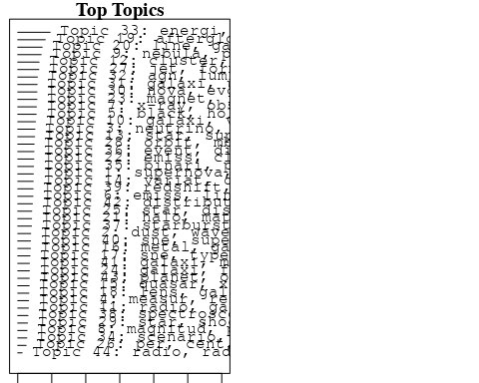

plotQuote(thoughts6, width = 30, main = "Topic 6")  
plotQuote(thoughts18, width = 30, main = "Topic 18")

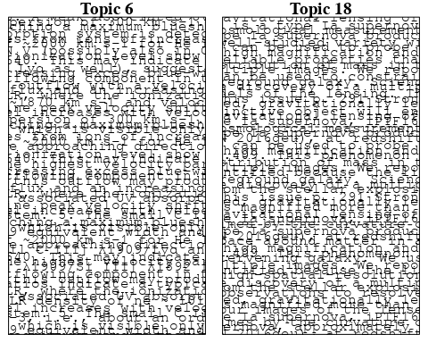

# Calculate and plot the correlation between topics  
mod.out.corr <- topicCorr(Research_topics)  
plot(mod.out.corr, cex = 1.5)  
  
  
# For each topic  
for (topic_num in 1:44) {  
 # Plot the word cloud  
 cloud(Research_topics, topic = topic_num, scale = c(2, 0.25))  
 Sys.sleep(2)  
}

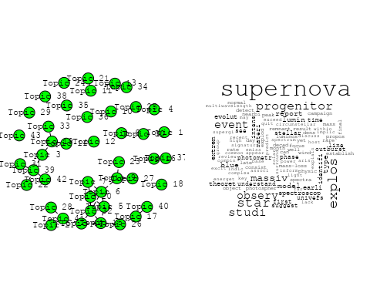

## Warning in wordcloud::wordcloud(words = vocab, freq = vec, max.words =  
## max.words, : wave could not be fit on page. It will not be plotted.

## Warning in wordcloud::wordcloud(words = vocab, freq = vec, max.words =  
## max.words, : discuss could not be fit on page. It will not be plotted.

## Warning in wordcloud::wordcloud(words = vocab, freq = vec, max.words =  
## max.words, : starburst could not be fit on page. It will not be plotted.

## Warning in wordcloud::wordcloud(words = vocab, freq = vec, max.words =  
## max.words, : physic could not be fit on page. It will not be plotted.

## Warning in wordcloud::wordcloud(words = vocab, freq = vec, max.words =  
## max.words, : composit could not be fit on page. It will not be plotted.

## Warning in wordcloud::wordcloud(words = vocab, freq = vec, max.words =  
## max.words, : studi could not be fit on page. It will not be plotted.

## Warning in wordcloud::wordcloud(words = vocab, freq = vec, max.words =  
## max.words, : properti could not be fit on page. It will not be plotted.

## Warning in wordcloud::wordcloud(words = vocab, freq = vec, max.words =  
## max.words, : interpret could not be fit on page. It will not be plotted.

## Warning in wordcloud::wordcloud(words = vocab, freq = vec, max.words =  
## max.words, : cosmic-ray could not be fit on page. It will not be plotted.

## Warning in wordcloud::wordcloud(words = vocab, freq = vec, max.words =  
## max.words, : gamma-ray could not be fit on page. It will not be plotted.

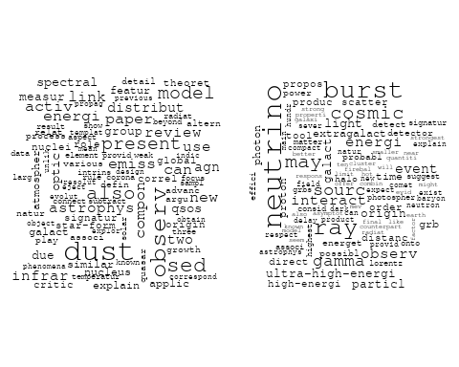

## Warning in wordcloud::wordcloud(words = vocab, freq = vec, max.words =  
## max.words, : relat could not be fit on page. It will not be plotted.

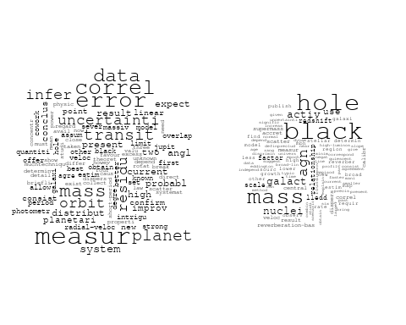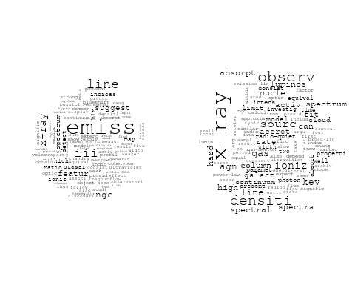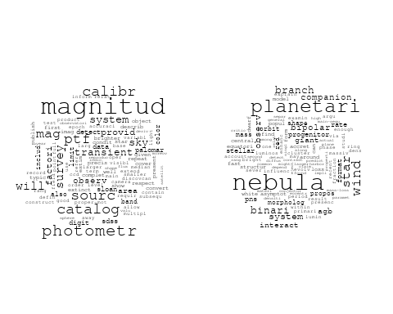

## Warning in wordcloud::wordcloud(words = vocab, freq = vec, max.words =  
## max.words, : radio could not be fit on page. It will not be plotted.

## Warning in wordcloud::wordcloud(words = vocab, freq = vec, max.words =  
## max.words, : high-veloc could not be fit on page. It will not be plotted.

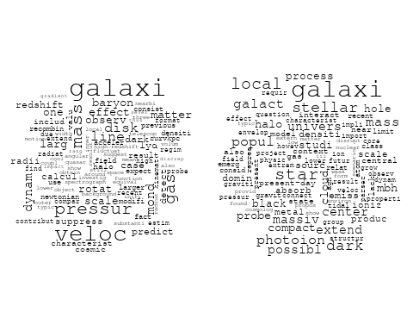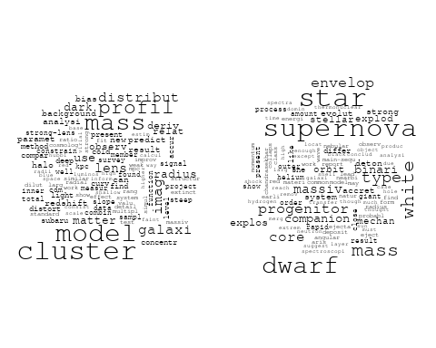

## Warning in wordcloud::wordcloud(words = vocab, freq = vec, max.words =  
## max.words, : observ could not be fit on page. It will not be plotted.

## Warning in wordcloud::wordcloud(words = vocab, freq = vec, max.words =  
## max.words, : light could not be fit on page. It will not be plotted.

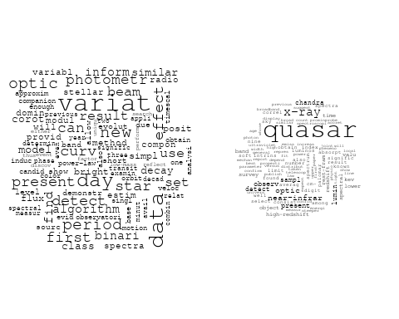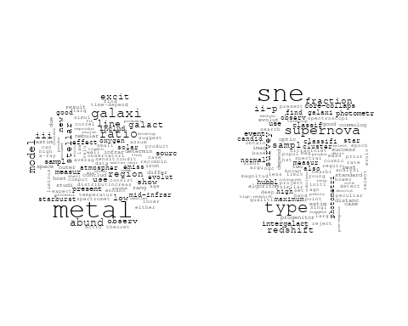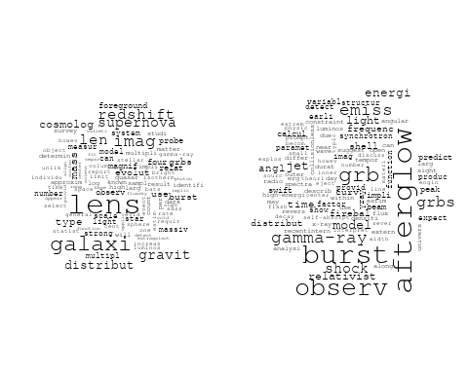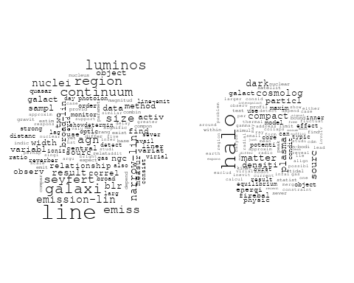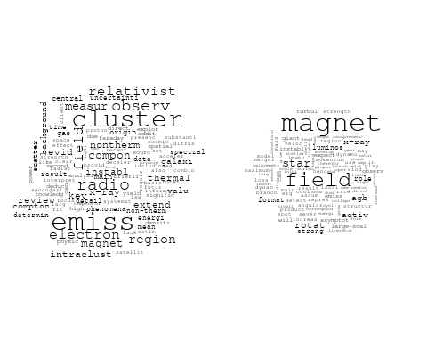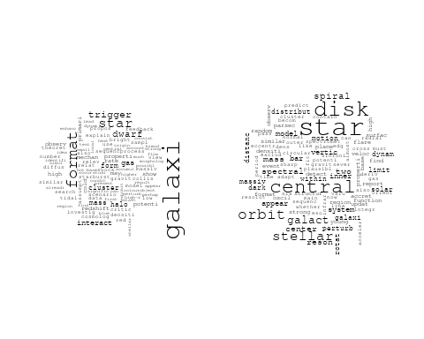

## Warning in wordcloud::wordcloud(words = vocab, freq = vec, max.words =  
## max.words, : observ could not be fit on page. It will not be plotted.

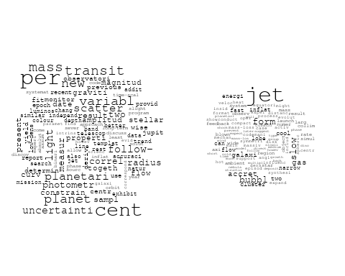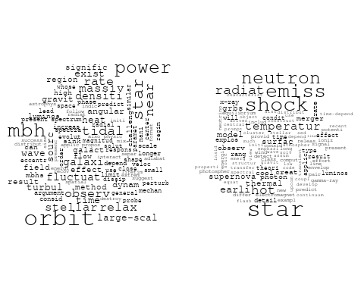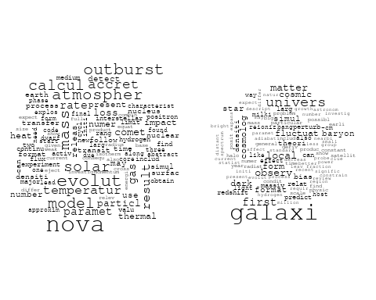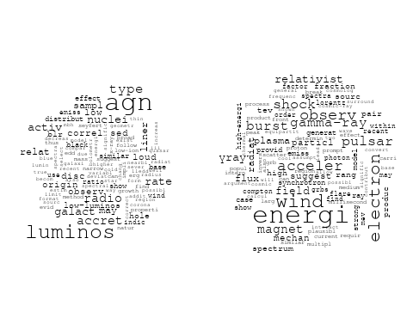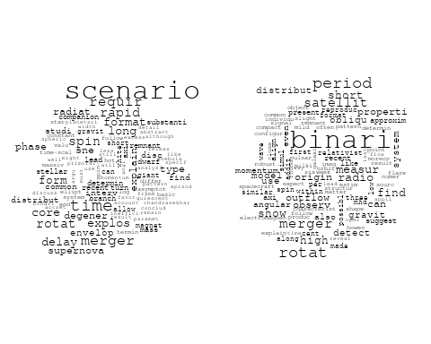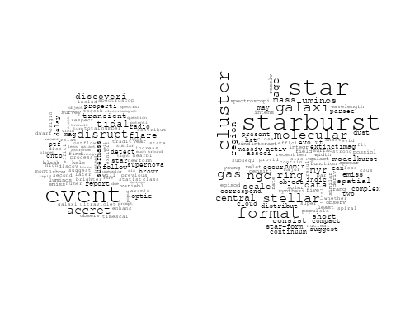

## Warning in wordcloud::wordcloud(words = vocab, freq = vec, max.words =  
## max.words, : spectroscop could not be fit on page. It will not be plotted.

## Warning in wordcloud::wordcloud(words = vocab, freq = vec, max.words =  
## max.words, : secondari could not be fit on page. It will not be plotted.

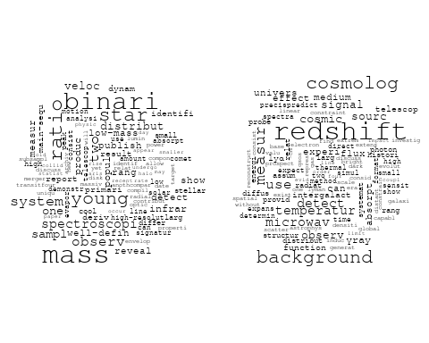

## Warning in wordcloud::wordcloud(words = vocab, freq = vec, max.words =  
## max.words, : supernova could not be fit on page. It will not be plotted.

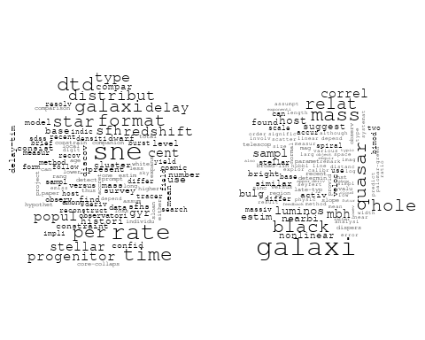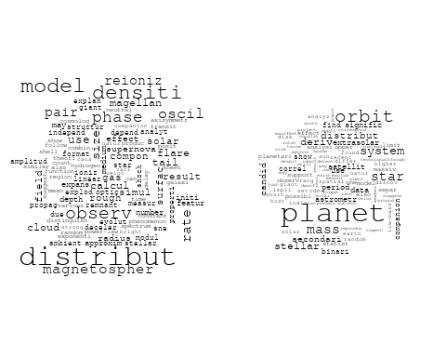

# Get the topic proportions for each document  
topic_proportions <- Research_topics$theta  
  
# Find the index of the topic with the highest proportion for each document  
# This will be the topic that each document is most likely to belong to  
max_topic_idx <- apply(topic_proportions, 1, which.max)  
  
# Add this as a new column to your data  
data_collab$topic <- max_topic_idx  
  
library(ggplot2)  
  
# Define the intervals  
intervals <- c('1824_1899', '1900_1964', '1965_1974', '1975_1984', '1985_1994', '1995_1999', '2000_2004', '2005_2009', '2010_2014', '2015_2019', '2020_2022')  
colors <- c('pink', 'blue', 'purple', 'yellow', 'green', 'pink', 'orange', 'violet', 'green', 'blue', 'pink')  
  
# Loop through the intervals and plot  
for(i in seq_along(intervals)){  
 # Filter data for when the pub_interval is equal to 1  
 data_filtered <- data_collab[data_collab[[paste0('pub_interval_', intervals[i])]] == 1,]  
   
 # Make the histogram  
   
 p <- ggplot(data_filtered, aes(x = topic)) +  
 geom_histogram(binwidth = 1, fill = colors[i], color = "black") +  
 xlab("Topic") +  
 ylab("Count") +  
 ggtitle(paste0("Topics from year ", gsub("_", " to ", intervals[i])))  
   
 print(p)  
}  
  
  
##Topic generation for IL (independent) publications  
  
data_independent <- data[data[["IL"]] == 100,]  
  
# Save the original title data for future use  
data_independent$original_concatenated_title_abstract <- data_independent$concatenated_title_abstract  
  
#pre-processing the titles using textProcessor from the stm package  
processed_text <- textProcessor(data_independent$concatenated_title_abstract, metadata = data_independent)

## Building corpus...   
## Converting to Lower Case...   
## Removing punctuation...   
## Removing stopwords...   
## Removing numbers...   
## Stemming...   
## Creating Output...

# Further prepare the data by removing low-frequency terms  
out_text <- prepDocuments(processed_text$documents, processed_text$vocab, processed_text$meta)

## Removing 584 of 2848 terms (584 of 27295 tokens) due to frequency   
## Your corpus now has 366 documents, 2264 terms and 26711 tokens.

docs_text <- out_text$documents  
vocab_text <- out_text$vocab  
meta_text <- out_text$meta  
  
  
#Prepare data  
plotRemoved(processed_text$documents, lower.thresh = seq(1, 200, by = 100))

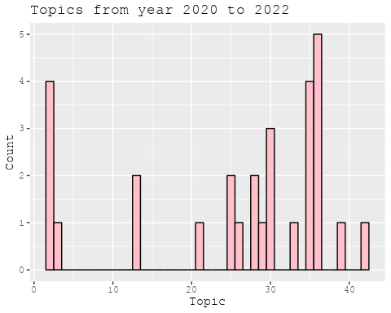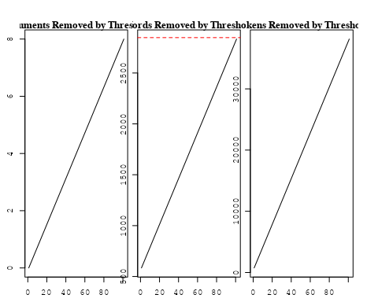

out_text <- prepDocuments(processed_text$documents, processed_text$vocab, processed_text$meta, lower.thresh = 8)

## Removing 2089 of 2848 terms (6087 of 27295 tokens) due to frequency   
## Your corpus now has 366 documents, 759 terms and 21208 tokens.

str(out_text$meta)

## 'data.frame': 366 obs. of 39 variables:  
## $ concept_id : chr "https://openalex.org/C44870925" "https://openalex.org/C1276947" "https://openalex.org/C44870925" "https://openalex.org/C44870925" ...  
## $ work_id : chr "https://openalex.org/W1967579928" "https://openalex.org/W3103594067" "https://openalex.org/W1499693082" "https://openalex.org/W2092236899" ...  
## $ publication_year : int 2005 2001 2004 2006 2008 2011 2012 2004 2003 1996 ...  
## $ title : chr "An intriguing correlation between the masses and periods of the transiting planets" "Radiation Pressure Acceleration by X-rays in Active Galactic Nuclei" "An Interpretation of the hνpeak-Eiso Correlation for Gamma-Ray Bursts" "Accreting White Dwarfs among the Planetary Nebulae Most Luminous in [O III] λ5007 Emission" ...  
## $ paperabstract : chr "We point out an intriguing relation between the masses of the transiting planets and their orbital periods. For"| __truncated__ "We present calculations of the dynamics of highly ionized gas (HIG) clouds that are confined by external pressu"| __truncated__ "The hνpeak/100 keV ~ (Eiso/1052 ergs)1/2 correlation reported recently by Amati et al. and Lamb et al. for long"| __truncated__ "I propose that some of the most luminous planetary nebulae (PNs) are actually proto-PNs, where a companion whit"| __truncated__ ...  
## $ country : chr "IL" "IL IL" "IL IL" "IL" ...  
## $ year_concept : chr "2005+https://openalex.org/C44870925" "2001+https://openalex.org/C1276947" "2004+https://openalex.org/C44870925" "2006+https://openalex.org/C44870925" ...  
## $ concatenated_title_abstract : chr "An intriguing correlation between the masses and periods of the transiting planets We point out an intriguing r"| __truncated__ "Radiation Pressure Acceleration by X-rays in Active Galactic Nuclei We present calculations of the dynamics of "| __truncated__ "An Interpretation of the hνpeak-Eiso Correlation for Gamma-Ray Bursts The hνpeak/100 keV ~ (Eiso/1052 ergs)1/2 "| __truncated__ "Accreting White Dwarfs among the Planetary Nebulae Most Luminous in [O III] λ5007 Emission I propose that some "| __truncated__ ...  
## $ US : num 0 0 0 0 0 0 0 0 0 0 ...  
## $ IN : num 0 0 0 0 0 0 0 0 0 0 ...  
## $ DE : num 0 0 0 0 0 0 0 0 0 0 ...  
## $ CH : num 0 0 0 0 0 0 0 0 0 0 ...  
## $ GB : num 0 0 0 0 0 0 0 0 0 0 ...  
## $ CN : num 0 0 0 0 0 0 0 0 0 0 ...  
## $ FR : num 0 0 0 0 0 0 0 0 0 0 ...  
## $ IT : num 0 0 0 0 0 0 0 0 0 0 ...  
## $ RU : num 0 0 0 0 0 0 0 0 0 0 ...  
## $ CA : num 0 0 0 0 0 0 0 0 0 0 ...  
## $ NL : num 0 0 0 0 0 0 0 0 0 0 ...  
## $ AU : num 0 0 0 0 0 0 0 0 0 0 ...  
## $ JP : num 0 0 0 0 0 0 0 0 0 0 ...  
## $ ES : num 0 0 0 0 0 0 0 0 0 0 ...  
## $ IL : num 100 100 100 100 100 100 100 100 100 100 ...  
## $ Americas : num 0 0 0 0 0 0 0 0 0 0 ...  
## $ Europe : num 0 0 0 0 0 0 0 0 0 0 ...  
## $ Africa : num 0 0 0 0 0 0 0 0 0 0 ...  
## $ AsiaAndOceania : num 0 0 0 0 0 0 0 0 0 0 ...  
## $ pub_interval_2020_2022 : int 0 0 0 0 0 0 0 0 0 0 ...  
## $ pub_interval_2015_2019 : int 0 0 0 0 0 0 0 0 0 0 ...  
## $ pub_interval_2010_2014 : int 0 0 0 0 0 1 1 0 0 0 ...  
## $ pub_interval_2005_2009 : int 1 0 0 1 1 0 0 0 0 0 ...  
## $ pub_interval_2000_2004 : int 0 1 1 0 0 0 0 1 1 0 ...  
## $ pub_interval_1995_1999 : int 0 0 0 0 0 0 0 0 0 1 ...  
## $ pub_interval_1985_1994 : int 0 0 0 0 0 0 0 0 0 0 ...  
## $ pub_interval_1975_1984 : int 0 0 0 0 0 0 0 0 0 0 ...  
## $ pub_interval_1965_1974 : int 0 0 0 0 0 0 0 0 0 0 ...  
## $ pub_interval_1900_1964 : int 0 0 0 0 0 0 0 0 0 0 ...  
## $ pub_interval_1824_1899 : int 0 0 0 0 0 0 0 0 0 0 ...  
## $ original_concatenated_title_abstract: chr "An intriguing correlation between the masses and periods of the transiting planets We point out an intriguing r"| __truncated__ "Radiation Pressure Acceleration by X-rays in Active Galactic Nuclei We present calculations of the dynamics of "| __truncated__ "An Interpretation of the hνpeak-Eiso Correlation for Gamma-Ray Bursts The hνpeak/100 keV ~ (Eiso/1052 ergs)1/2 "| __truncated__ "Accreting White Dwarfs among the Planetary Nebulae Most Luminous in [O III] λ5007 Emission I propose that some "| __truncated__ ...

# Initialize an empty formula string  
prevalence_formula_str <- "~"  
  
# Define the publication intervals  
pub_intervals <- c("pub_interval_2020_2022", "pub_interval_2015_2019", "pub_interval_2010_2014",   
 "pub_interval_2005_2009", "pub_interval_2000_2004", "pub_interval_1995_1999",  
 "pub_interval_1985_1994", "pub_interval_1975_1984", "pub_interval_1965_1974",  
 "pub_interval_1900_1964", "pub_interval_1824_1899")  
  
# Add each publication interval to the formula string  
for (interval in pub_intervals) {  
 # add an if statement to handle the first addition (without '+')  
 if (prevalence_formula_str == "~") {  
 prevalence_formula_str <- paste(prevalence_formula_str, interval)  
 } else {  
 prevalence_formula_str <- paste(prevalence_formula_str, "+", interval)  
 }  
}  
  
  
# Convert the string to a formula  
prevalence_formula <- as.formula(prevalence_formula_str)  
print(prevalence_formula)

## ~pub_interval_2020_2022 + pub_interval_2015_2019 + pub_interval_2010_2014 +   
## pub_interval_2005_2009 + pub_interval_2000_2004 + pub_interval_1995_1999 +   
## pub_interval_1985_1994 + pub_interval_1975_1984 + pub_interval_1965_1974 +   
## pub_interval_1900_1964 + pub_interval_1824_1899

# Run STM model  
Research_topics <- stm(documents = out_text$documents,   
 vocab = out_text$vocab,   
 K = 35,   
 prevalence = prevalence_formula,   
 data = out_text$meta,   
 init.type = "Spectral",  
 max.em.its = 1000,  
 gamma.prior = 'L1')

## Beginning Spectral Initialization   
## Calculating the gram matrix...  
## Finding anchor words...  
## ...................................  
## Recovering initialization...  
## .......  
## Initialization complete.  
## ..........................................................................................................................  
## Completed E-Step (0 seconds).   
## Completed M-Step.   
## Completing Iteration 1 (approx. per word bound = -5.426)   
## ..........................................................................................................................  
## Completed E-Step (0 seconds).   
## Completed M-Step.   
## Completing Iteration 2 (approx. per word bound = -5.192, relative change = 4.300e-02)   
## ..........................................................................................................................  
## Completed E-Step (0 seconds).   
## Completed M-Step.   
## Completing Iteration 3 (approx. per word bound = -5.114, relative change = 1.504e-02)   
## ..........................................................................................................................  
## Completed E-Step (0 seconds).   
## Completed M-Step.   
## Completing Iteration 4 (approx. per word bound = -5.077, relative change = 7.315e-03)   
## ..........................................................................................................................  
## Completed E-Step (0 seconds).   
## Completed M-Step.   
## Completing Iteration 5 (approx. per word bound = -5.056, relative change = 4.030e-03)   
## Topic 1: supernova, month, first, explos, observ   
## Topic 2: emiss, iii, shock, veloc, ratio   
## Topic 3: burst, gamma-ray, wind, lorentz, energi   
## Topic 4: valu, dynam, modifi, galact, mass   
## Topic 5: relat, transit, planet, explain, mass   
## Topic 6: power, scale, time, case, new   
## Topic 7: nova, mass, evolut, accret, dwarf   
## Topic 8: planetari, nebula, binari, system, observ   
## Topic 9: event, supernova, discoveri, mag, report   
## Topic 10: energi, emiss, pair, thermal, surfac   
## Topic 11: period, binari, beam, effect, rotat   
## Topic 12: model, reioniz, densiti, distribut, measur   
## Topic 13: sourc, burst, energi, γray, ray   
## Topic 14: luminos, agn, radio, accret, rate   
## Topic 15: magnet, field, instabl, shock, bubbl   
## Topic 16: halo, dark, matter, pressur, densiti   
## Topic 17: quasar, correl, sampl, variabl, interv   
## Topic 18: per, transit, mass, cent, radius   
## Topic 19: galaxi, mass, black, hole, relat   
## Topic 20: wind, observ, effect, spectra, show   
## Topic 21: radio, flare, outflow, detect, merger   
## Topic 22: agn, line, blr, iii, emiss   
## Topic 23: planet, orbit, mass, stellar, secondari   
## Topic 24: radio, x-ray, correl, quasar, emiss   
## Topic 25: first, galaxi, star, format, form   
## Topic 26: luminos, agn, activ, result, x-ray   
## Topic 27: jet, galaxi, gas, star, bubbl   
## Topic 28: nebula, lumin, pns, popul, planetari   
## Topic 29: star, stellar, mbh, black, hole   
## Topic 30: shock, observ, acceler, can, veloc   
## Topic 31: star, planet, branch, event, orbit   
## Topic 32: magnet, field, star, agb, role   
## Topic 33: wind, jet, slow, form, nebula   
## Topic 34: supernova, sne, time, type, star   
## Topic 35: imag, cluster, observ, ring, afterglow   
## ..........................................................................................................................  
## Completed E-Step (0 seconds).   
## Completed M-Step.   
## Completing Iteration 6 (approx. per word bound = -5.043, relative change = 2.639e-03)   
## ..........................................................................................................................  
## Completed E-Step (0 seconds).   
## Completed M-Step.   
## Completing Iteration 7 (approx. per word bound = -5.033, relative change = 1.920e-03)   
## ..........................................................................................................................  
## Completed E-Step (0 seconds).   
## Completed M-Step.   
## Completing Iteration 8 (approx. per word bound = -5.026, relative change = 1.448e-03)   
## ..........................................................................................................................  
## Completed E-Step (0 seconds).   
## Completed M-Step.   
## Completing Iteration 9 (approx. per word bound = -5.021, relative change = 1.066e-03)   
## ..........................................................................................................................  
## Completed E-Step (0 seconds).   
## Completed M-Step.   
## Completing Iteration 10 (approx. per word bound = -5.016, relative change = 8.544e-04)   
## Topic 1: supernova, month, first, explos, observ   
## Topic 2: emiss, iii, shock, veloc, line   
## Topic 3: burst, gamma-ray, wind, lorentz, factor   
## Topic 4: valu, dynam, modifi, disk, effect   
## Topic 5: relat, transit, planet, explain, period   
## Topic 6: particl, mass, sourc, new, power   
## Topic 7: nova, mass, accret, evolut, dwarf   
## Topic 8: planetari, nebula, binari, progenitor, observ   
## Topic 9: event, supernova, mag, discoveri, report   
## Topic 10: energi, pair, thermal, emiss, surfac   
## Topic 11: period, binari, beam, rotat, effect   
## Topic 12: model, reioniz, distribut, densiti, ioniz   
## Topic 13: burst, γray, sourc, energi, field   
## Topic 14: luminos, agn, radio, accret, rate   
## Topic 15: magnet, field, instabl, shock, plasma   
## Topic 16: halo, dark, matter, pressur, densiti   
## Topic 17: quasar, correl, sampl, variabl, interv   
## Topic 18: transit, per, mass, radius, cent   
## Topic 19: galaxi, mass, black, hole, star   
## Topic 20: wind, observ, effect, spectra, disc   
## Topic 21: radio, flare, outflow, detect, merger   
## Topic 22: agn, line, blr, emiss, type   
## Topic 23: planet, stellar, orbit, mass, secondari   
## Topic 24: radio, x-ray, correl, origin, emiss   
## Topic 25: first, galaxi, cosmic, form, redshift   
## Topic 26: luminos, activ, agn, result, x-ray   
## Topic 27: jet, galaxi, gas, bubbl, star   
## Topic 28: lumin, nebula, pns, planetari, iii   
## Topic 29: star, stellar, mbh, black, hole   
## Topic 30: shock, acceler, observ, veloc, x-ray   
## Topic 31: star, planet, branch, orbit, envelop   
## Topic 32: magnet, field, star, agb, role   
## Topic 33: wind, jet, slow, form, nebula   
## Topic 34: sne, supernova, time, format, type   
## Topic 35: imag, cluster, observ, ring, afterglow   
## ..........................................................................................................................  
## Completed E-Step (0 seconds).   
## Completed M-Step.   
## Completing Iteration 11 (approx. per word bound = -5.013, relative change = 7.233e-04)   
## ..........................................................................................................................  
## Completed E-Step (0 seconds).   
## Completed M-Step.   
## Completing Iteration 12 (approx. per word bound = -5.010, relative change = 5.612e-04)   
## ..........................................................................................................................  
## Completed E-Step (0 seconds).   
## Completed M-Step.   
## Completing Iteration 13 (approx. per word bound = -5.008, relative change = 4.595e-04)   
## ..........................................................................................................................  
## Completed E-Step (0 seconds).   
## Completed M-Step.   
## Completing Iteration 14 (approx. per word bound = -5.005, relative change = 4.389e-04)   
## ..........................................................................................................................  
## Completed E-Step (0 seconds).   
## Completed M-Step.   
## Completing Iteration 15 (approx. per word bound = -5.003, relative change = 4.992e-04)   
## Topic 1: supernova, month, first, explos, observ   
## Topic 2: emiss, iii, line, shock, veloc   
## Topic 3: gamma-ray, burst, wind, lorentz, factor   
## Topic 4: valu, dynam, modifi, disk, effect   
## Topic 5: relat, transit, planet, period, explain   
## Topic 6: particl, neutrino, mass, sourc, new   
## Topic 7: nova, mass, accret, evolut, dwarf   
## Topic 8: planetari, nebula, binari, observ, progenitor   
## Topic 9: event, supernova, mag, discoveri, report   
## Topic 10: energi, pair, emiss, thermal, model   
## Topic 11: period, binari, beam, rotat, effect   
## Topic 12: model, reioniz, densiti, distribut, ioniz   
## Topic 13: burst, γray, sourc, energi, ray   
## Topic 14: luminos, agn, radio, accret, loud   
## Topic 15: magnet, field, instabl, shock, plasma   
## Topic 16: halo, dark, matter, pressur, densiti   
## Topic 17: quasar, correl, sampl, variabl, luminos   
## Topic 18: transit, mass, per, radius, cent   
## Topic 19: galaxi, mass, black, hole, star   
## Topic 20: wind, observ, disc, spectra, effect   
## Topic 21: radio, flare, outflow, detect, merger   
## Topic 22: agn, line, blr, emiss, type   
## Topic 23: planet, mass, stellar, orbit, secondari   
## Topic 24: radio, x-ray, correl, quasar, origin   
## Topic 25: first, galaxi, cosmic, observ, star   
## Topic 26: luminos, activ, agn, result, x-ray   
## Topic 27: jet, galaxi, gas, bubbl, star   
## Topic 28: nebula, lumin, pns, planetari, iii   
## Topic 29: star, stellar, mbh, black, hole   
## Topic 30: acceler, shock, observ, veloc, x-ray   
## Topic 31: star, planet, branch, envelop, orbit   
## Topic 32: magnet, field, star, agb, role   
## Topic 33: wind, jet, slow, form, nebula   
## Topic 34: sne, supernova, time, format, delay   
## Topic 35: imag, cluster, observ, ring, afterglow   
## ..........................................................................................................................  
## Completed E-Step (0 seconds).   
## Completed M-Step.   
## Completing Iteration 16 (approx. per word bound = -5.001, relative change = 4.218e-04)   
## ..........................................................................................................................  
## Completed E-Step (0 seconds).   
## Completed M-Step.   
## Completing Iteration 17 (approx. per word bound = -4.999, relative change = 3.459e-04)   
## ..........................................................................................................................  
## Completed E-Step (0 seconds).   
## Completed M-Step.   
## Completing Iteration 18 (approx. per word bound = -4.997, relative change = 3.452e-04)   
## ..........................................................................................................................  
## Completed E-Step (0 seconds).   
## Completed M-Step.   
## Completing Iteration 19 (approx. per word bound = -4.996, relative change = 3.328e-04)   
## ..........................................................................................................................  
## Completed E-Step (0 seconds).   
## Completed M-Step.   
## Completing Iteration 20 (approx. per word bound = -4.994, relative change = 3.210e-04)   
## Topic 1: supernova, month, first, explos, observ   
## Topic 2: emiss, iii, line, shock, veloc   
## Topic 3: gamma-ray, burst, wind, lorentz, factor   
## Topic 4: valu, dynam, modifi, effect, disk   
## Topic 5: relat, transit, planet, period, explain   
## Topic 6: particl, neutrino, new, mass, detect   
## Topic 7: accret, nova, mass, evolut, dwarf   
## Topic 8: nebula, planetari, binari, observ, progenitor   
## Topic 9: event, supernova, mag, discoveri, report   
## Topic 10: energi, pair, emiss, thermal, model   
## Topic 11: period, binari, beam, rotat, effect   
## Topic 12: model, reioniz, densiti, distribut, ioniz   
## Topic 13: burst, γray, sourc, energi, ray   
## Topic 14: luminos, agn, radio, accret, loud   
## Topic 15: magnet, field, instabl, shock, plasma   
## Topic 16: halo, dark, matter, pressur, densiti   
## Topic 17: quasar, correl, sampl, luminos, variabl   
## Topic 18: transit, mass, per, radius, cent   
## Topic 19: galaxi, mass, black, hole, star   
## Topic 20: wind, observ, disc, spectra, effect   
## Topic 21: flare, radio, outflow, detect, merger   
## Topic 22: agn, line, blr, emiss, type   
## Topic 23: planet, mass, orbit, secondari, stellar   
## Topic 24: radio, x-ray, correl, origin, quasar   
## Topic 25: first, galaxi, observ, cosmic, star   
## Topic 26: luminos, activ, agn, result, x-ray   
## Topic 27: jet, galaxi, bubbl, gas, star   
## Topic 28: nebula, lumin, pns, planetari, iii   
## Topic 29: star, stellar, mbh, black, hole   
## Topic 30: acceler, shock, observ, veloc, x-ray   
## Topic 31: star, planet, branch, envelop, orbit   
## Topic 32: magnet, field, star, agb, role   
## Topic 33: wind, jet, slow, form, nebula   
## Topic 34: sne, supernova, time, format, delay   
## Topic 35: imag, cluster, observ, ring, afterglow   
## ..........................................................................................................................  
## Completed E-Step (0 seconds).   
## Completed M-Step.   
## Completing Iteration 21 (approx. per word bound = -4.993, relative change = 3.286e-04)   
## ..........................................................................................................................  
## Completed E-Step (0 seconds).   
## Completed M-Step.   
## Completing Iteration 22 (approx. per word bound = -4.991, relative change = 2.778e-04)   
## ..........................................................................................................................  
## Completed E-Step (0 seconds).   
## Completed M-Step.   
## Completing Iteration 23 (approx. per word bound = -4.990, relative change = 2.299e-04)   
## ..........................................................................................................................  
## Completed E-Step (0 seconds).   
## Completed M-Step.   
## Completing Iteration 24 (approx. per word bound = -4.989, relative change = 1.921e-04)   
## ..........................................................................................................................  
## Completed E-Step (0 seconds).   
## Completed M-Step.   
## Completing Iteration 25 (approx. per word bound = -4.988, relative change = 1.436e-04)   
## Topic 1: supernova, month, first, explos, observ   
## Topic 2: emiss, iii, line, shock, veloc   
## Topic 3: burst, gamma-ray, wind, lorentz, factor   
## Topic 4: valu, dynam, modifi, effect, disk   
## Topic 5: relat, transit, planet, explain, techniqu   
## Topic 6: detect, particl, neutrino, new, scenario   
## Topic 7: accret, nova, mass, evolut, dwarf   
## Topic 8: nebula, planetari, binari, observ, progenitor   
## Topic 9: event, supernova, mag, discoveri, report   
## Topic 10: energi, pair, emiss, model, spectrum   
## Topic 11: period, binari, beam, rotat, effect   
## Topic 12: model, reioniz, densiti, distribut, ioniz   
## Topic 13: burst, γray, energi, sourc, ray   
## Topic 14: luminos, agn, radio, accret, loud   
## Topic 15: magnet, field, instabl, shock, plasma   
## Topic 16: halo, dark, matter, pressur, gas   
## Topic 17: quasar, correl, sampl, luminos, variabl   
## Topic 18: transit, mass, per, cent, deriv   
## Topic 19: galaxi, mass, black, hole, format   
## Topic 20: wind, observ, disc, spectra, effect   
## Topic 21: flare, radio, outflow, detect, merger   
## Topic 22: agn, line, blr, emiss, type   
## Topic 23: planet, mass, orbit, secondari, stellar   
## Topic 24: radio, x-ray, correl, origin, quasar   
## Topic 25: first, galaxi, cosmic, observ, star   
## Topic 26: luminos, activ, agn, result, x-ray   
## Topic 27: jet, galaxi, bubbl, gas, cluster   
## Topic 28: nebula, lumin, pns, planetari, iii   
## Topic 29: star, stellar, mbh, black, hole   
## Topic 30: shock, acceler, observ, x-ray, veloc   
## Topic 31: star, planet, branch, envelop, orbit   
## Topic 32: magnet, star, field, agb, role   
## Topic 33: wind, jet, slow, form, nebula   
## Topic 34: sne, supernova, time, format, delay   
## Topic 35: imag, cluster, observ, ring, afterglow   
## ..........................................................................................................................  
## Completed E-Step (0 seconds).   
## Completed M-Step.   
## Completing Iteration 26 (approx. per word bound = -4.988, relative change = 1.302e-04)   
## ..........................................................................................................................  
## Completed E-Step (0 seconds).   
## Completed M-Step.   
## Completing Iteration 27 (approx. per word bound = -4.987, relative change = 1.369e-04)   
## ..........................................................................................................................  
## Completed E-Step (0 seconds).   
## Completed M-Step.   
## Completing Iteration 28 (approx. per word bound = -4.986, relative change = 1.487e-04)   
## ..........................................................................................................................  
## Completed E-Step (0 seconds).   
## Completed M-Step.   
## Completing Iteration 29 (approx. per word bound = -4.986, relative change = 1.286e-04)   
## ..........................................................................................................................  
## Completed E-Step (0 seconds).   
## Completed M-Step.   
## Completing Iteration 30 (approx. per word bound = -4.985, relative change = 9.834e-05)   
## Topic 1: supernova, month, first, explos, observ   
## Topic 2: emiss, iii, line, shock, veloc   
## Topic 3: burst, gamma-ray, wind, lorentz, factor   
## Topic 4: dynam, valu, modifi, effect, disk   
## Topic 5: transit, relat, planet, techniqu, explain   
## Topic 6: detect, particl, neutrino, scenario, new   
## Topic 7: nova, accret, mass, evolut, dwarf   
## Topic 8: nebula, planetari, binari, observ, progenitor   
## Topic 9: event, supernova, mag, discoveri, report   
## Topic 10: energi, pair, emiss, model, spectrum   
## Topic 11: period, binari, beam, effect, rotat   
## Topic 12: model, reioniz, densiti, distribut, ioniz   
## Topic 13: burst, energi, sourc, γray, ray   
## Topic 14: luminos, agn, radio, accret, loud   
## Topic 15: magnet, field, instabl, shock, plasma   
## Topic 16: halo, dark, matter, pressur, gas   
## Topic 17: quasar, correl, luminos, sampl, variabl   
## Topic 18: transit, mass, per, cent, deriv   
## Topic 19: galaxi, mass, black, hole, format   
## Topic 20: wind, observ, disc, spectra, effect   
## Topic 21: flare, radio, outflow, detect, merger   
## Topic 22: agn, line, blr, emiss, type   
## Topic 23: planet, mass, orbit, secondari, stellar   
## Topic 24: radio, x-ray, correl, quasar, origin   
## Topic 25: first, galaxi, observ, cosmic, star   
## Topic 26: luminos, agn, activ, result, x-ray   
## Topic 27: jet, galaxi, bubbl, gas, cluster   
## Topic 28: nebula, pns, lumin, planetari, iii   
## Topic 29: star, stellar, mbh, black, hole   
## Topic 30: shock, acceler, observ, x-ray, veloc   
## Topic 31: star, planet, branch, envelop, orbit   
## Topic 32: magnet, star, field, agb, role   
## Topic 33: wind, jet, slow, form, nebula   
## Topic 34: sne, supernova, time, format, delay   
## Topic 35: imag, cluster, observ, ring, afterglow   
## ..........................................................................................................................  
## Completed E-Step (0 seconds).   
## Completed M-Step.   
## Completing Iteration 31 (approx. per word bound = -4.985, relative change = 8.565e-05)   
## ..........................................................................................................................  
## Completed E-Step (0 seconds).   
## Completed M-Step.   
## Completing Iteration 32 (approx. per word bound = -4.984, relative change = 8.933e-05)   
## ..........................................................................................................................  
## Completed E-Step (0 seconds).   
## Completed M-Step.   
## Completing Iteration 33 (approx. per word bound = -4.984, relative change = 9.138e-05)   
## ..........................................................................................................................  
## Completed E-Step (0 seconds).   
## Completed M-Step.   
## Completing Iteration 34 (approx. per word bound = -4.983, relative change = 8.944e-05)   
## ..........................................................................................................................  
## Completed E-Step (0 seconds).   
## Completed M-Step.   
## Completing Iteration 35 (approx. per word bound = -4.983, relative change = 9.033e-05)   
## Topic 1: supernova, month, first, explos, observ   
## Topic 2: iii, emiss, line, shock, veloc   
## Topic 3: burst, gamma-ray, wind, lorentz, factor   
## Topic 4: dynam, valu, modifi, effect, disk   
## Topic 5: transit, relat, planet, techniqu, explain   
## Topic 6: detect, neutrino, particl, scenario, new   
## Topic 7: accret, nova, mass, evolut, dwarf   
## Topic 8: nebula, planetari, binari, observ, progenitor   
## Topic 9: event, supernova, mag, discoveri, report   
## Topic 10: energi, pair, emiss, model, spectrum   
## Topic 11: period, binari, beam, effect, rotat   
## Topic 12: model, reioniz, densiti, distribut, ioniz   
## Topic 13: burst, energi, sourc, ray, observ   
## Topic 14: luminos, agn, radio, accret, loud   
## Topic 15: magnet, field, instabl, shock, plasma   
## Topic 16: halo, dark, matter, pressur, gas   
## Topic 17: quasar, correl, luminos, sampl, variabl   
## Topic 18: transit, mass, per, cent, deriv   
## Topic 19: galaxi, mass, black, hole, format   
## Topic 20: wind, observ, disc, spectra, effect   
## Topic 21: flare, radio, outflow, detect, merger   
## Topic 22: agn, line, blr, emiss, type   
## Topic 23: planet, mass, orbit, stellar, secondari   
## Topic 24: radio, x-ray, correl, quasar, origin   
## Topic 25: first, galaxi, observ, cosmic, star   
## Topic 26: luminos, agn, activ, result, x-ray   
## Topic 27: jet, galaxi, bubbl, gas, cluster   
## Topic 28: nebula, pns, lumin, planetari, iii   
## Topic 29: star, stellar, mbh, black, hole   
## Topic 30: shock, acceler, observ, x-ray, veloc   
## Topic 31: star, planet, branch, envelop, orbit   
## Topic 32: magnet, star, field, agb, role   
## Topic 33: wind, jet, slow, form, lobe   
## Topic 34: sne, supernova, time, format, delay   
## Topic 35: imag, cluster, observ, ring, afterglow   
## ..........................................................................................................................  
## Completed E-Step (0 seconds).   
## Completed M-Step.   
## Completing Iteration 36 (approx. per word bound = -4.982, relative change = 8.666e-05)   
## ..........................................................................................................................  
## Completed E-Step (0 seconds).   
## Completed M-Step.   
## Completing Iteration 37 (approx. per word bound = -4.982, relative change = 9.028e-05)   
## ..........................................................................................................................  
## Completed E-Step (0 seconds).   
## Completed M-Step.   
## Completing Iteration 38 (approx. per word bound = -4.981, relative change = 1.036e-04)   
## ..........................................................................................................................  
## Completed E-Step (0 seconds).   
## Completed M-Step.   
## Completing Iteration 39 (approx. per word bound = -4.981, relative change = 7.935e-05)   
## ..........................................................................................................................  
## Completed E-Step (0 seconds).   
## Completed M-Step.   
## Completing Iteration 40 (approx. per word bound = -4.981, relative change = 6.620e-05)   
## Topic 1: supernova, month, first, explos, observ   
## Topic 2: iii, emiss, line, shock, veloc   
## Topic 3: burst, gamma-ray, wind, lorentz, factor   
## Topic 4: dynam, valu, modifi, effect, disk   
## Topic 5: transit, relat, planet, techniqu, explain   
## Topic 6: detect, neutrino, scenario, particl, new   
## Topic 7: nova, accret, mass, evolut, dwarf   
## Topic 8: nebula, planetari, binari, observ, progenitor   
## Topic 9: event, supernova, mag, discoveri, report   
## Topic 10: energi, pair, emiss, model, spectrum   
## Topic 11: period, binari, beam, effect, rotat   
## Topic 12: model, reioniz, densiti, distribut, ioniz   
## Topic 13: burst, energi, sourc, ray, observ   
## Topic 14: luminos, agn, radio, accret, loud   
## Topic 15: magnet, field, instabl, shock, plasma   
## Topic 16: halo, dark, matter, pressur, gas   
## Topic 17: quasar, correl, luminos, sampl, variabl   
## Topic 18: transit, mass, per, deriv, cent   
## Topic 19: galaxi, mass, black, hole, format   
## Topic 20: wind, observ, disc, spectra, effect   
## Topic 21: flare, radio, outflow, detect, merger   
## Topic 22: agn, line, blr, emiss, type   
## Topic 23: planet, mass, orbit, stellar, secondari   
## Topic 24: radio, x-ray, correl, quasar, origin   
## Topic 25: first, galaxi, observ, cosmic, star   
## Topic 26: luminos, agn, activ, result, x-ray   
## Topic 27: jet, galaxi, bubbl, gas, cluster   
## Topic 28: nebula, pns, lumin, planetari, iii   
## Topic 29: star, stellar, mbh, black, hole   
## Topic 30: shock, acceler, observ, x-ray, veloc   
## Topic 31: star, planet, branch, envelop, orbit   
## Topic 32: magnet, star, field, agb, role   
## Topic 33: wind, jet, form, slow, lobe   
## Topic 34: sne, time, supernova, format, delay   
## Topic 35: imag, cluster, observ, ring, afterglow   
## ..........................................................................................................................  
## Completed E-Step (0 seconds).   
## Completed M-Step.   
## Completing Iteration 41 (approx. per word bound = -4.980, relative change = 6.694e-05)   
## ..........................................................................................................................  
## Completed E-Step (0 seconds).   
## Completed M-Step.   
## Completing Iteration 42 (approx. per word bound = -4.980, relative change = 6.878e-05)   
## ..........................................................................................................................  
## Completed E-Step (0 seconds).   
## Completed M-Step.   
## Completing Iteration 43 (approx. per word bound = -4.980, relative change = 6.438e-05)   
## ..........................................................................................................................  
## Completed E-Step (0 seconds).   
## Completed M-Step.   
## Completing Iteration 44 (approx. per word bound = -4.979, relative change = 5.365e-05)   
## ..........................................................................................................................  
## Completed E-Step (0 seconds).   
## Completed M-Step.   
## Completing Iteration 45 (approx. per word bound = -4.979, relative change = 4.217e-05)   
## Topic 1: supernova, month, first, explos, observ   
## Topic 2: iii, emiss, line, shock, veloc   
## Topic 3: burst, gamma-ray, wind, lorentz, factor   
## Topic 4: dynam, valu, modifi, effect, disk   
## Topic 5: transit, relat, planet, techniqu, explain   
## Topic 6: detect, neutrino, particl, scenario, new   
## Topic 7: nova, accret, mass, evolut, dwarf   
## Topic 8: nebula, planetari, binari, observ, progenitor   
## Topic 9: event, supernova, mag, discoveri, report   
## Topic 10: energi, pair, emiss, model, spectrum   
## Topic 11: period, binari, beam, effect, rotat   
## Topic 12: model, reioniz, densiti, distribut, ioniz   
## Topic 13: burst, energi, sourc, ray, γray   
## Topic 14: luminos, agn, radio, accret, loud   
## Topic 15: magnet, field, instabl, shock, plasma   
## Topic 16: halo, dark, matter, pressur, gas   
## Topic 17: quasar, correl, luminos, sampl, variabl   
## Topic 18: transit, mass, per, deriv, cent   
## Topic 19: galaxi, mass, black, hole, format   
## Topic 20: wind, observ, disc, spectra, effect   
## Topic 21: flare, radio, outflow, detect, merger   
## Topic 22: agn, line, blr, emiss, type   
## Topic 23: planet, mass, stellar, orbit, secondari   
## Topic 24: radio, x-ray, correl, quasar, origin   
## Topic 25: first, galaxi, observ, cosmic, star   
## Topic 26: luminos, agn, activ, result, x-ray   
## Topic 27: jet, galaxi, bubbl, gas, cluster   
## Topic 28: nebula, pns, lumin, planetari, iii   
## Topic 29: star, stellar, mbh, black, hole   
## Topic 30: shock, acceler, observ, x-ray, veloc   
## Topic 31: star, planet, branch, envelop, orbit   
## Topic 32: magnet, star, field, agb, role   
## Topic 33: wind, jet, form, slow, lobe   
## Topic 34: sne, time, supernova, format, delay   
## Topic 35: imag, cluster, observ, ring, afterglow   
## ..........................................................................................................................  
## Completed E-Step (0 seconds).   
## Completed M-Step.   
## Completing Iteration 46 (approx. per word bound = -4.979, relative change = 3.633e-05)   
## ..........................................................................................................................  
## Completed E-Step (0 seconds).   
## Completed M-Step.   
## Completing Iteration 47 (approx. per word bound = -4.979, relative change = 3.699e-05)   
## ..........................................................................................................................  
## Completed E-Step (0 seconds).   
## Completed M-Step.   
## Completing Iteration 48 (approx. per word bound = -4.979, relative change = 4.043e-05)   
## ..........................................................................................................................  
## Completed E-Step (0 seconds).   
## Completed M-Step.   
## Completing Iteration 49 (approx. per word bound = -4.979, relative change = 4.382e-05)   
## ..........................................................................................................................  
## Completed E-Step (0 seconds).   
## Completed M-Step.   
## Completing Iteration 50 (approx. per word bound = -4.978, relative change = 4.511e-05)   
## Topic 1: supernova, month, first, explos, observ   
## Topic 2: iii, emiss, line, shock, veloc   
## Topic 3: burst, gamma-ray, wind, lorentz, factor   
## Topic 4: dynam, valu, modifi, effect, disk   
## Topic 5: transit, relat, planet, techniqu, explain   
## Topic 6: detect, neutrino, particl, scenario, new   
## Topic 7: nova, accret, mass, evolut, dwarf   
## Topic 8: nebula, planetari, binari, observ, progenitor   
## Topic 9: event, supernova, mag, discoveri, report   
## Topic 10: energi, pair, emiss, model, spectrum   
## Topic 11: period, binari, beam, effect, rotat   
## Topic 12: model, reioniz, densiti, distribut, ioniz   
## Topic 13: burst, energi, sourc, ray, γray   
## Topic 14: luminos, agn, radio, accret, loud   
## Topic 15: magnet, field, instabl, shock, plasma   
## Topic 16: halo, dark, matter, pressur, gas   
## Topic 17: quasar, correl, luminos, sampl, variabl   
## Topic 18: mass, transit, per, deriv, cent   
## Topic 19: galaxi, mass, black, hole, format   
## Topic 20: wind, observ, disc, spectra, effect   
## Topic 21: flare, radio, outflow, detect, merger   
## Topic 22: agn, line, blr, emiss, type   
## Topic 23: planet, mass, stellar, orbit, secondari   
## Topic 24: radio, x-ray, correl, quasar, origin   
## Topic 25: first, galaxi, observ, cosmic, star   
## Topic 26: luminos, agn, activ, result, x-ray   
## Topic 27: jet, galaxi, bubbl, gas, cluster   
## Topic 28: nebula, pns, lumin, planetari, iii   
## Topic 29: star, stellar, mbh, black, hole   
## Topic 30: shock, acceler, observ, x-ray, veloc   
## Topic 31: star, planet, branch, envelop, orbit   
## Topic 32: magnet, star, field, agb, role   
## Topic 33: wind, jet, form, slow, lobe   
## Topic 34: sne, time, supernova, format, delay   
## Topic 35: imag, cluster, observ, ring, afterglow   
## ..........................................................................................................................  
## Completed E-Step (0 seconds).   
## Completed M-Step.   
## Completing Iteration 51 (approx. per word bound = -4.978, relative change = 4.406e-05)   
## ..........................................................................................................................  
## Completed E-Step (0 seconds).   
## Completed M-Step.   
## Completing Iteration 52 (approx. per word bound = -4.978, relative change = 4.330e-05)   
## ..........................................................................................................................  
## Completed E-Step (0 seconds).   
## Completed M-Step.   
## Completing Iteration 53 (approx. per word bound = -4.978, relative change = 4.122e-05)   
## ..........................................................................................................................  
## Completed E-Step (0 seconds).   
## Completed M-Step.   
## Completing Iteration 54 (approx. per word bound = -4.977, relative change = 4.111e-05)   
## ..........................................................................................................................  
## Completed E-Step (0 seconds).   
## Completed M-Step.   
## Completing Iteration 55 (approx. per word bound = -4.977, relative change = 3.849e-05)   
## Topic 1: supernova, month, first, explos, observ   
## Topic 2: iii, emiss, line, shock, veloc   
## Topic 3: burst, gamma-ray, wind, lorentz, factor   
## Topic 4: dynam, valu, modifi, effect, disk   
## Topic 5: transit, relat, planet, techniqu, explain   
## Topic 6: detect, neutrino, particl, scenario, new   
## Topic 7: nova, accret, mass, evolut, dwarf   
## Topic 8: nebula, planetari, binari, observ, progenitor   
## Topic 9: event, supernova, mag, discoveri, report   
## Topic 10: energi, pair, emiss, model, spectrum   
## Topic 11: period, binari, beam, effect, rotat   
## Topic 12: model, reioniz, densiti, distribut, ioniz   
## Topic 13: burst, energi, sourc, observ, γray   
## Topic 14: luminos, agn, radio, accret, loud   
## Topic 15: magnet, field, instabl, shock, plasma   
## Topic 16: halo, dark, matter, pressur, gas   
## Topic 17: quasar, correl, luminos, sampl, variabl   
## Topic 18: mass, transit, per, deriv, planet   
## Topic 19: galaxi, mass, black, hole, format   
## Topic 20: wind, observ, disc, spectra, effect   
## Topic 21: flare, radio, outflow, detect, merger   
## Topic 22: agn, line, blr, emiss, type   
## Topic 23: planet, mass, stellar, orbit, secondari   
## Topic 24: radio, x-ray, correl, quasar, origin   
## Topic 25: first, galaxi, observ, cosmic, star   
## Topic 26: luminos, agn, activ, result, x-ray   
## Topic 27: jet, galaxi, bubbl, gas, cluster   
## Topic 28: nebula, pns, lumin, planetari, iii   
## Topic 29: star, stellar, mbh, black, hole   
## Topic 30: shock, acceler, observ, x-ray, veloc   
## Topic 31: star, planet, branch, envelop, orbit   
## Topic 32: magnet, star, field, agb, role   
## Topic 33: wind, jet, form, slow, lobe   
## Topic 34: sne, time, supernova, format, delay   
## Topic 35: imag, cluster, observ, ring, afterglow   
## ..........................................................................................................................  
## Completed E-Step (0 seconds).   
## Completed M-Step.   
## Completing Iteration 56 (approx. per word bound = -4.977, relative change = 3.578e-05)   
## ..........................................................................................................................  
## Completed E-Step (0 seconds).   
## Completed M-Step.   
## Completing Iteration 57 (approx. per word bound = -4.977, relative change = 3.742e-05)   
## ..........................................................................................................................  
## Completed E-Step (0 seconds).   
## Completed M-Step.   
## Completing Iteration 58 (approx. per word bound = -4.977, relative change = 4.757e-05)   
## ..........................................................................................................................  
## Completed E-Step (0 seconds).   
## Completed M-Step.   
## Completing Iteration 59 (approx. per word bound = -4.976, relative change = 5.636e-05)   
## ..........................................................................................................................  
## Completed E-Step (0 seconds).   
## Completed M-Step.   
## Completing Iteration 60 (approx. per word bound = -4.976, relative change = 5.391e-05)   
## Topic 1: supernova, month, first, explos, observ   
## Topic 2: iii, emiss, line, shock, veloc   
## Topic 3: burst, gamma-ray, wind, lorentz, factor   
## Topic 4: dynam, valu, modifi, effect, disk   
## Topic 5: transit, relat, planet, techniqu, explain   
## Topic 6: detect, neutrino, particl, scenario, new   
## Topic 7: nova, accret, mass, evolut, dwarf   
## Topic 8: nebula, planetari, binari, observ, progenitor   
## Topic 9: event, supernova, mag, discoveri, report   
## Topic 10: energi, pair, emiss, model, spectrum   
## Topic 11: period, binari, beam, effect, rotat   
## Topic 12: model, reioniz, densiti, distribut, ioniz   
## Topic 13: burst, energi, sourc, observ, γray   
## Topic 14: luminos, agn, radio, accret, loud   
## Topic 15: magnet, field, instabl, shock, plasma   
## Topic 16: halo, dark, matter, pressur, gas   
## Topic 17: quasar, correl, luminos, sampl, variabl   
## Topic 18: transit, mass, deriv, per, planet   
## Topic 19: galaxi, mass, black, hole, format   
## Topic 20: wind, observ, disc, spectra, effect   
## Topic 21: flare, radio, outflow, detect, merger   
## Topic 22: agn, line, blr, emiss, type   
## Topic 23: planet, mass, stellar, orbit, secondari   
## Topic 24: radio, x-ray, correl, quasar, origin   
## Topic 25: first, galaxi, observ, cosmic, star   
## Topic 26: luminos, agn, activ, result, x-ray   
## Topic 27: jet, galaxi, bubbl, gas, cluster   
## Topic 28: nebula, pns, lumin, planetari, iii   
## Topic 29: star, stellar, mbh, black, hole   
## Topic 30: shock, acceler, observ, x-ray, veloc   
## Topic 31: star, planet, branch, envelop, orbit   
## Topic 32: magnet, star, field, agb, role   
## Topic 33: wind, jet, form, slow, lobe   
## Topic 34: sne, time, supernova, format, delay   
## Topic 35: imag, cluster, observ, ring, afterglow   
## ..........................................................................................................................  
## Completed E-Step (0 seconds).   
## Completed M-Step.   
## Completing Iteration 61 (approx. per word bound = -4.976, relative change = 7.560e-05)   
## ..........................................................................................................................  
## Completed E-Step (0 seconds).   
## Completed M-Step.   
## Completing Iteration 62 (approx. per word bound = -4.975, relative change = 7.749e-05)   
## ..........................................................................................................................  
## Completed E-Step (0 seconds).   
## Completed M-Step.   
## Completing Iteration 63 (approx. per word bound = -4.975, relative change = 8.961e-05)   
## ..........................................................................................................................  
## Completed E-Step (0 seconds).   
## Completed M-Step.   
## Completing Iteration 64 (approx. per word bound = -4.975, relative change = 7.595e-05)   
## ..........................................................................................................................  
## Completed E-Step (0 seconds).   
## Completed M-Step.   
## Completing Iteration 65 (approx. per word bound = -4.974, relative change = 4.615e-05)   
## Topic 1: supernova, month, first, explos, observ   
## Topic 2: iii, emiss, line, shock, veloc   
## Topic 3: burst, gamma-ray, wind, lorentz, factor   
## Topic 4: dynam, valu, modifi, effect, disk   
## Topic 5: transit, relat, planet, techniqu, explain   
## Topic 6: detect, neutrino, particl, scenario, new   
## Topic 7: nova, accret, mass, evolut, dwarf   
## Topic 8: nebula, planetari, binari, observ, progenitor   
## Topic 9: event, supernova, mag, discoveri, report   
## Topic 10: energi, pair, emiss, model, spectrum   
## Topic 11: period, binari, beam, effect, rotat   
## Topic 12: model, reioniz, densiti, distribut, ioniz   
## Topic 13: burst, energi, sourc, observ, γray   
## Topic 14: luminos, agn, radio, accret, loud   
## Topic 15: magnet, field, instabl, shock, plasma   
## Topic 16: halo, dark, matter, pressur, gas   
## Topic 17: quasar, correl, luminos, sampl, variabl   
## Topic 18: transit, mass, deriv, planet, planetari   
## Topic 19: galaxi, mass, black, hole, format   
## Topic 20: wind, observ, disc, spectra, effect   
## Topic 21: flare, radio, outflow, detect, merger   
## Topic 22: agn, line, blr, emiss, type   
## Topic 23: planet, mass, stellar, orbit, secondari   
## Topic 24: radio, x-ray, correl, quasar, origin   
## Topic 25: first, galaxi, observ, cosmic, star   
## Topic 26: luminos, agn, activ, result, x-ray   
## Topic 27: jet, galaxi, bubbl, gas, cluster   
## Topic 28: nebula, pns, lumin, planetari, iii   
## Topic 29: star, stellar, mbh, hole, black   
## Topic 30: shock, acceler, observ, x-ray, veloc   
## Topic 31: star, planet, branch, envelop, orbit   
## Topic 32: magnet, star, field, agb, role   
## Topic 33: wind, jet, form, slow, lobe   
## Topic 34: sne, time, supernova, format, delay   
## Topic 35: imag, cluster, observ, ring, afterglow   
## ..........................................................................................................................  
## Completed E-Step (0 seconds).   
## Completed M-Step.   
## Completing Iteration 66 (approx. per word bound = -4.974, relative change = 4.432e-05)   
## ..........................................................................................................................  
## Completed E-Step (0 seconds).   
## Completed M-Step.   
## Completing Iteration 67 (approx. per word bound = -4.974, relative change = 4.418e-05)   
## ..........................................................................................................................  
## Completed E-Step (0 seconds).   
## Completed M-Step.   
## Completing Iteration 68 (approx. per word bound = -4.974, relative change = 2.839e-05)   
## ..........................................................................................................................  
## Completed E-Step (0 seconds).   
## Completed M-Step.   
## Completing Iteration 69 (approx. per word bound = -4.974, relative change = 2.309e-05)   
## ..........................................................................................................................  
## Completed E-Step (0 seconds).   
## Completed M-Step.   
## Completing Iteration 70 (approx. per word bound = -4.973, relative change = 2.557e-05)   
## Topic 1: supernova, month, first, explos, observ   
## Topic 2: iii, emiss, line, shock, veloc   
## Topic 3: burst, gamma-ray, wind, lorentz, factor   
## Topic 4: dynam, valu, modifi, effect, disk   
## Topic 5: transit, relat, planet, techniqu, explain   
## Topic 6: detect, neutrino, particl, scenario, new   
## Topic 7: nova, accret, mass, evolut, dwarf   
## Topic 8: nebula, planetari, binari, observ, progenitor   
## Topic 9: event, supernova, mag, discoveri, report   
## Topic 10: energi, pair, emiss, model, spectrum   
## Topic 11: period, binari, beam, effect, rotat   
## Topic 12: model, reioniz, densiti, distribut, ioniz   
## Topic 13: burst, energi, sourc, observ, γray   
## Topic 14: luminos, radio, agn, accret, loud   
## Topic 15: magnet, field, instabl, shock, plasma   
## Topic 16: halo, dark, matter, pressur, gas   
## Topic 17: quasar, correl, luminos, sampl, variabl   
## Topic 18: transit, mass, deriv, planet, planetari   
## Topic 19: galaxi, mass, black, hole, format   
## Topic 20: wind, observ, disc, spectra, effect   
## Topic 21: flare, radio, outflow, detect, merger   
## Topic 22: agn, line, blr, emiss, type   
## Topic 23: planet, mass, stellar, orbit, secondari   
## Topic 24: radio, x-ray, correl, quasar, origin   
## Topic 25: first, galaxi, observ, cosmic, star   
## Topic 26: luminos, agn, activ, result, x-ray   
## Topic 27: jet, galaxi, bubbl, gas, cluster   
## Topic 28: nebula, pns, lumin, planetari, iii   
## Topic 29: star, stellar, mbh, hole, black   
## Topic 30: shock, acceler, observ, x-ray, veloc   
## Topic 31: star, planet, branch, envelop, orbit   
## Topic 32: magnet, star, field, agb, role   
## Topic 33: wind, jet, form, slow, lobe   
## Topic 34: sne, time, supernova, format, delay   
## Topic 35: imag, cluster, observ, ring, afterglow   
## ..........................................................................................................................  
## Completed E-Step (0 seconds).   
## Completed M-Step.   
## Completing Iteration 71 (approx. per word bound = -4.973, relative change = 4.485e-05)   
## ..........................................................................................................................  
## Completed E-Step (0 seconds).   
## Completed M-Step.   
## Completing Iteration 72 (approx. per word bound = -4.973, relative change = 6.142e-05)   
## ..........................................................................................................................  
## Completed E-Step (0 seconds).   
## Completed M-Step.   
## Completing Iteration 73 (approx. per word bound = -4.973, relative change = 5.729e-05)   
## ..........................................................................................................................  
## Completed E-Step (0 seconds).   
## Completed M-Step.   
## Completing Iteration 74 (approx. per word bound = -4.972, relative change = 2.851e-05)   
## ..........................................................................................................................  
## Completed E-Step (0 seconds).   
## Completed M-Step.   
## Completing Iteration 75 (approx. per word bound = -4.972, relative change = 1.914e-05)   
## Topic 1: supernova, month, first, explos, observ   
## Topic 2: iii, emiss, line, shock, veloc   
## Topic 3: burst, gamma-ray, wind, lorentz, factor   
## Topic 4: dynam, valu, modifi, effect, disk   
## Topic 5: transit, relat, planet, techniqu, explain   
## Topic 6: detect, neutrino, particl, can, new   
## Topic 7: nova, accret, mass, evolut, dwarf   
## Topic 8: nebula, planetari, binari, observ, progenitor   
## Topic 9: event, supernova, mag, discoveri, report   
## Topic 10: energi, pair, emiss, model, spectrum   
## Topic 11: period, binari, beam, effect, rotat   
## Topic 12: model, reioniz, densiti, distribut, ioniz   
## Topic 13: burst, energi, sourc, observ, γray   
## Topic 14: luminos, radio, agn, accret, loud   
## Topic 15: magnet, field, instabl, shock, plasma   
## Topic 16: halo, dark, matter, pressur, gas   
## Topic 17: quasar, correl, luminos, sampl, variabl   
## Topic 18: transit, mass, deriv, planet, planetari   
## Topic 19: galaxi, mass, black, hole, format   
## Topic 20: wind, observ, disc, spectra, effect   
## Topic 21: flare, radio, outflow, detect, merger   
## Topic 22: agn, line, blr, emiss, type   
## Topic 23: planet, mass, stellar, orbit, secondari   
## Topic 24: radio, x-ray, correl, quasar, origin   
## Topic 25: first, galaxi, observ, cosmic, star   
## Topic 26: luminos, agn, activ, result, x-ray   
## Topic 27: jet, galaxi, bubbl, gas, cluster   
## Topic 28: nebula, pns, lumin, planetari, iii   
## Topic 29: star, stellar, mbh, hole, black   
## Topic 30: shock, acceler, observ, x-ray, veloc   
## Topic 31: star, planet, branch, envelop, orbit   
## Topic 32: magnet, star, field, agb, role   
## Topic 33: wind, jet, form, slow, lobe   
## Topic 34: sne, time, supernova, format, delay   
## Topic 35: imag, cluster, observ, ring, afterglow   
## ..........................................................................................................................  
## Completed E-Step (0 seconds).   
## Completed M-Step.   
## Completing Iteration 76 (approx. per word bound = -4.972, relative change = 1.606e-05)   
## ..........................................................................................................................  
## Completed E-Step (0 seconds).   
## Completed M-Step.   
## Completing Iteration 77 (approx. per word bound = -4.972, relative change = 1.452e-05)   
## ..........................................................................................................................  
## Completed E-Step (0 seconds).   
## Completed M-Step.   
## Completing Iteration 78 (approx. per word bound = -4.972, relative change = 1.373e-05)   
## ..........................................................................................................................  
## Completed E-Step (0 seconds).   
## Completed M-Step.   
## Completing Iteration 79 (approx. per word bound = -4.972, relative change = 1.420e-05)   
## ..........................................................................................................................  
## Completed E-Step (0 seconds).   
## Completed M-Step.   
## Completing Iteration 80 (approx. per word bound = -4.972, relative change = 1.536e-05)   
## Topic 1: supernova, month, first, explos, observ   
## Topic 2: iii, emiss, line, shock, veloc   
## Topic 3: burst, gamma-ray, wind, lorentz, factor   
## Topic 4: dynam, valu, modifi, effect, disk   
## Topic 5: transit, relat, planet, techniqu, explain   
## Topic 6: detect, neutrino, particl, can, new   
## Topic 7: nova, accret, mass, evolut, dwarf   
## Topic 8: nebula, planetari, binari, observ, progenitor   
## Topic 9: event, supernova, mag, discoveri, report   
## Topic 10: energi, pair, emiss, model, spectrum   
## Topic 11: period, binari, beam, effect, rotat   
## Topic 12: model, reioniz, densiti, distribut, ioniz   
## Topic 13: burst, energi, sourc, γray, observ   
## Topic 14: luminos, radio, agn, accret, loud   
## Topic 15: magnet, field, instabl, shock, plasma   
## Topic 16: halo, dark, matter, pressur, gas   
## Topic 17: quasar, correl, luminos, sampl, variabl   
## Topic 18: transit, mass, deriv, planet, planetari   
## Topic 19: galaxi, mass, black, hole, format   
## Topic 20: wind, observ, disc, spectra, effect   
## Topic 21: flare, radio, outflow, detect, merger   
## Topic 22: agn, line, blr, emiss, type   
## Topic 23: planet, mass, stellar, orbit, secondari   
## Topic 24: radio, x-ray, correl, quasar, origin   
## Topic 25: first, galaxi, observ, cosmic, star   
## Topic 26: luminos, agn, activ, result, x-ray   
## Topic 27: jet, galaxi, bubbl, gas, cluster   
## Topic 28: nebula, pns, lumin, planetari, iii   
## Topic 29: star, stellar, mbh, hole, black   
## Topic 30: shock, acceler, observ, x-ray, veloc   
## Topic 31: star, planet, branch, envelop, orbit   
## Topic 32: magnet, star, field, agb, role   
## Topic 33: wind, jet, form, slow, lobe   
## Topic 34: sne, time, supernova, format, delay   
## Topic 35: imag, cluster, observ, ring, afterglow   
## ..........................................................................................................................  
## Completed E-Step (0 seconds).   
## Completed M-Step.   
## Completing Iteration 81 (approx. per word bound = -4.972, relative change = 1.793e-05)   
## ..........................................................................................................................  
## Completed E-Step (0 seconds).   
## Completed M-Step.   
## Completing Iteration 82 (approx. per word bound = -4.972, relative change = 2.012e-05)   
## ..........................................................................................................................  
## Completed E-Step (0 seconds).   
## Completed M-Step.   
## Completing Iteration 83 (approx. per word bound = -4.972, relative change = 2.280e-05)   
## ..........................................................................................................................  
## Completed E-Step (0 seconds).   
## Completed M-Step.   
## Completing Iteration 84 (approx. per word bound = -4.972, relative change = 2.332e-05)   
## ..........................................................................................................................  
## Completed E-Step (0 seconds).   
## Completed M-Step.   
## Completing Iteration 85 (approx. per word bound = -4.972, relative change = 2.243e-05)   
## Topic 1: supernova, month, first, explos, observ   
## Topic 2: iii, emiss, line, shock, veloc   
## Topic 3: burst, gamma-ray, wind, lorentz, factor   
## Topic 4: dynam, valu, modifi, effect, disk   
## Topic 5: transit, relat, planet, techniqu, explain   
## Topic 6: detect, neutrino, particl, can, new   
## Topic 7: nova, accret, mass, evolut, dwarf   
## Topic 8: nebula, planetari, binari, observ, progenitor   
## Topic 9: event, supernova, mag, discoveri, report   
## Topic 10: energi, pair, emiss, model, spectrum   
## Topic 11: period, binari, beam, effect, rotat   
## Topic 12: model, reioniz, densiti, distribut, ioniz   
## Topic 13: burst, energi, sourc, γray, observ   
## Topic 14: luminos, radio, agn, accret, loud   
## Topic 15: magnet, field, instabl, shock, plasma   
## Topic 16: halo, dark, matter, pressur, gas   
## Topic 17: quasar, correl, luminos, sampl, variabl   
## Topic 18: transit, mass, deriv, planet, planetari   
## Topic 19: galaxi, mass, black, hole, format   
## Topic 20: wind, observ, disc, spectra, effect   
## Topic 21: flare, radio, outflow, detect, merger   
## Topic 22: agn, line, blr, emiss, type   
## Topic 23: planet, mass, stellar, orbit, secondari   
## Topic 24: radio, x-ray, correl, quasar, origin   
## Topic 25: first, galaxi, observ, cosmic, star   
## Topic 26: luminos, agn, activ, result, x-ray   
## Topic 27: jet, galaxi, bubbl, gas, cluster   
## Topic 28: nebula, pns, lumin, planetari, iii   
## Topic 29: star, stellar, mbh, hole, black   
## Topic 30: shock, acceler, observ, x-ray, veloc   
## Topic 31: star, planet, branch, envelop, orbit   
## Topic 32: magnet, star, field, agb, role   
## Topic 33: wind, jet, form, slow, lobe   
## Topic 34: sne, supernova, time, format, delay   
## Topic 35: imag, cluster, observ, ring, afterglow   
## ..........................................................................................................................  
## Completed E-Step (0 seconds).   
## Completed M-Step.   
## Completing Iteration 86 (approx. per word bound = -4.971, relative change = 2.209e-05)   
## ..........................................................................................................................  
## Completed E-Step (0 seconds).   
## Completed M-Step.   
## Completing Iteration 87 (approx. per word bound = -4.971, relative change = 2.068e-05)   
## ..........................................................................................................................  
## Completed E-Step (0 seconds).   
## Completed M-Step.   
## Completing Iteration 88 (approx. per word bound = -4.971, relative change = 2.006e-05)   
## ..........................................................................................................................  
## Completed E-Step (0 seconds).   
## Completed M-Step.   
## Completing Iteration 89 (approx. per word bound = -4.971, relative change = 1.961e-05)   
## ..........................................................................................................................  
## Completed E-Step (0 seconds).   
## Completed M-Step.   
## Completing Iteration 90 (approx. per word bound = -4.971, relative change = 2.087e-05)   
## Topic 1: supernova, month, first, explos, observ   
## Topic 2: iii, emiss, line, shock, veloc   
## Topic 3: burst, gamma-ray, wind, lorentz, factor   
## Topic 4: dynam, valu, modifi, effect, disk   
## Topic 5: transit, relat, planet, techniqu, explain   
## Topic 6: detect, neutrino, particl, matter, can   
## Topic 7: nova, accret, mass, evolut, dwarf   
## Topic 8: nebula, planetari, binari, observ, progenitor   
## Topic 9: event, supernova, mag, discoveri, report   
## Topic 10: energi, pair, emiss, model, spectrum   
## Topic 11: period, binari, beam, effect, rotat   
## Topic 12: model, reioniz, densiti, distribut, ioniz   
## Topic 13: burst, energi, sourc, γray, observ   
## Topic 14: luminos, radio, agn, accret, loud   
## Topic 15: magnet, field, instabl, shock, plasma   
## Topic 16: halo, dark, matter, pressur, gas   
## Topic 17: quasar, correl, luminos, sampl, variabl   
## Topic 18: transit, mass, deriv, planet, planetari   
## Topic 19: galaxi, mass, black, hole, format   
## Topic 20: wind, observ, disc, spectra, effect   
## Topic 21: flare, radio, outflow, detect, merger   
## Topic 22: agn, line, blr, emiss, type   
## Topic 23: planet, mass, orbit, stellar, secondari   
## Topic 24: radio, x-ray, correl, quasar, emiss   
## Topic 25: first, galaxi, observ, cosmic, star   
## Topic 26: luminos, agn, activ, result, x-ray   
## Topic 27: jet, galaxi, bubbl, gas, cluster   
## Topic 28: nebula, pns, lumin, planetari, iii   
## Topic 29: star, stellar, mbh, hole, black   
## Topic 30: shock, acceler, observ, x-ray, veloc   
## Topic 31: star, planet, branch, envelop, orbit   
## Topic 32: magnet, star, field, agb, role   
## Topic 33: wind, jet, form, slow, lobe   
## Topic 34: sne, supernova, time, format, delay   
## Topic 35: imag, cluster, observ, ring, afterglow   
## ..........................................................................................................................  
## Completed E-Step (0 seconds).   
## Completed M-Step.   
## Completing Iteration 91 (approx. per word bound = -4.971, relative change = 1.922e-05)   
## ..........................................................................................................................  
## Completed E-Step (0 seconds).   
## Completed M-Step.   
## Completing Iteration 92 (approx. per word bound = -4.971, relative change = 2.070e-05)   
## ..........................................................................................................................  
## Completed E-Step (0 seconds).   
## Completed M-Step.   
## Completing Iteration 93 (approx. per word bound = -4.971, relative change = 2.442e-05)   
## ..........................................................................................................................  
## Completed E-Step (0 seconds).   
## Completed M-Step.   
## Completing Iteration 94 (approx. per word bound = -4.971, relative change = 2.749e-05)   
## ..........................................................................................................................  
## Completed E-Step (0 seconds).   
## Completed M-Step.   
## Completing Iteration 95 (approx. per word bound = -4.970, relative change = 2.668e-05)   
## Topic 1: supernova, month, first, explos, observ   
## Topic 2: iii, emiss, line, shock, veloc   
## Topic 3: burst, gamma-ray, wind, lorentz, factor   
## Topic 4: dynam, valu, modifi, effect, disk   
## Topic 5: transit, relat, planet, techniqu, explain   
## Topic 6: detect, neutrino, particl, matter, can   
## Topic 7: nova, accret, mass, evolut, dwarf   
## Topic 8: nebula, planetari, binari, observ, progenitor   
## Topic 9: event, supernova, mag, discoveri, report   
## Topic 10: energi, pair, emiss, model, spectrum   
## Topic 11: period, binari, beam, effect, rotat   
## Topic 12: model, reioniz, densiti, distribut, ioniz   
## Topic 13: burst, energi, sourc, γray, observ   
## Topic 14: luminos, radio, agn, accret, loud   
## Topic 15: magnet, field, instabl, shock, plasma   
## Topic 16: halo, dark, matter, pressur, gas   
## Topic 17: quasar, correl, luminos, sampl, host   
## Topic 18: transit, mass, deriv, planet, planetari   
## Topic 19: galaxi, mass, black, hole, format   
## Topic 20: wind, observ, disc, spectra, effect   
## Topic 21: flare, radio, outflow, detect, merger   
## Topic 22: agn, line, blr, emiss, type   
## Topic 23: planet, mass, orbit, secondari, stellar   
## Topic 24: radio, x-ray, correl, quasar, emiss   
## Topic 25: first, galaxi, observ, cosmic, star   
## Topic 26: luminos, agn, activ, result, x-ray   
## Topic 27: jet, galaxi, bubbl, gas, cluster   
## Topic 28: nebula, pns, lumin, planetari, iii   
## Topic 29: star, stellar, mbh, hole, black   
## Topic 30: shock, acceler, observ, paramet, veloc   
## Topic 31: star, planet, branch, envelop, orbit   
## Topic 32: magnet, star, field, agb, role   
## Topic 33: wind, jet, form, slow, lobe   
## Topic 34: sne, supernova, time, format, delay   
## Topic 35: imag, cluster, observ, ring, afterglow   
## ..........................................................................................................................  
## Completed E-Step (0 seconds).   
## Completed M-Step.   
## Completing Iteration 96 (approx. per word bound = -4.970, relative change = 1.608e-05)   
## ..........................................................................................................................  
## Completed E-Step (0 seconds).   
## Completed M-Step.   
## Completing Iteration 97 (approx. per word bound = -4.970, relative change = 1.121e-05)   
## ..........................................................................................................................  
## Completed E-Step (0 seconds).   
## Completed M-Step.   
## Completing Iteration 98 (approx. per word bound = -4.970, relative change = 1.332e-05)   
## ..........................................................................................................................  
## Completed E-Step (0 seconds).   
## Completed M-Step.   
## Completing Iteration 99 (approx. per word bound = -4.970, relative change = 1.101e-05)   
## ..........................................................................................................................  
## Completed E-Step (0 seconds).   
## Completed M-Step.   
## Completing Iteration 100 (approx. per word bound = -4.970, relative change = 1.446e-05)   
## Topic 1: supernova, month, first, explos, observ   
## Topic 2: iii, emiss, line, shock, veloc   
## Topic 3: burst, gamma-ray, wind, lorentz, factor   
## Topic 4: dynam, valu, modifi, effect, disk   
## Topic 5: transit, relat, planet, techniqu, explain   
## Topic 6: detect, neutrino, particl, matter, can   
## Topic 7: nova, accret, mass, evolut, dwarf   
## Topic 8: nebula, planetari, binari, observ, progenitor   
## Topic 9: event, supernova, mag, discoveri, report   
## Topic 10: energi, pair, emiss, model, spectrum   
## Topic 11: period, binari, beam, effect, rotat   
## Topic 12: model, reioniz, densiti, distribut, ioniz   
## Topic 13: burst, energi, sourc, γray, observ   
## Topic 14: luminos, radio, agn, accret, loud   
## Topic 15: magnet, field, instabl, shock, plasma   
## Topic 16: halo, dark, matter, pressur, gas   
## Topic 17: quasar, correl, luminos, sampl, host   
## Topic 18: transit, mass, deriv, planet, planetari   
## Topic 19: galaxi, mass, black, hole, format   
## Topic 20: wind, observ, disc, spectra, effect   
## Topic 21: flare, radio, outflow, detect, merger   
## Topic 22: agn, line, blr, emiss, type   
## Topic 23: planet, mass, orbit, secondari, stellar   
## Topic 24: radio, x-ray, correl, quasar, emiss   
## Topic 25: first, galaxi, observ, cosmic, star   
## Topic 26: luminos, agn, activ, result, x-ray   
## Topic 27: jet, galaxi, bubbl, gas, cluster   
## Topic 28: nebula, pns, lumin, planetari, iii   
## Topic 29: star, stellar, mbh, hole, black   
## Topic 30: shock, acceler, observ, paramet, veloc   
## Topic 31: star, planet, branch, envelop, orbit   
## Topic 32: magnet, star, field, agb, role   
## Topic 33: wind, jet, form, slow, lobe   
## Topic 34: sne, supernova, time, format, delay   
## Topic 35: imag, cluster, observ, ring, afterglow   
## ..........................................................................................................................  
## Completed E-Step (0 seconds).   
## Completed M-Step.   
## Completing Iteration 101 (approx. per word bound = -4.970, relative change = 1.330e-05)   
## ..........................................................................................................................  
## Completed E-Step (0 seconds).   
## Completed M-Step.   
## Completing Iteration 102 (approx. per word bound = -4.970, relative change = 1.217e-05)   
## ..........................................................................................................................  
## Completed E-Step (0 seconds).   
## Completed M-Step.   
## Completing Iteration 103 (approx. per word bound = -4.970, relative change = 1.194e-05)   
## ..........................................................................................................................  
## Completed E-Step (0 seconds).   
## Completed M-Step.   
## Completing Iteration 104 (approx. per word bound = -4.970, relative change = 1.293e-05)   
## ..........................................................................................................................  
## Completed E-Step (0 seconds).   
## Completed M-Step.   
## Completing Iteration 105 (approx. per word bound = -4.970, relative change = 1.347e-05)   
## Topic 1: supernova, month, first, explos, observ   
## Topic 2: iii, emiss, line, shock, veloc   
## Topic 3: burst, gamma-ray, wind, lorentz, factor   
## Topic 4: dynam, valu, modifi, effect, disk   
## Topic 5: transit, relat, planet, techniqu, explain   
## Topic 6: detect, neutrino, particl, matter, can   
## Topic 7: nova, accret, mass, evolut, dwarf   
## Topic 8: nebula, planetari, binari, observ, progenitor   
## Topic 9: event, supernova, mag, discoveri, report   
## Topic 10: energi, pair, emiss, model, spectrum   
## Topic 11: period, binari, beam, effect, rotat   
## Topic 12: model, reioniz, densiti, distribut, ioniz   
## Topic 13: burst, energi, sourc, γray, observ   
## Topic 14: luminos, radio, agn, accret, loud   
## Topic 15: magnet, field, instabl, shock, plasma   
## Topic 16: halo, dark, matter, pressur, gas   
## Topic 17: quasar, correl, luminos, sampl, host   
## Topic 18: transit, mass, deriv, planet, planetari   
## Topic 19: galaxi, mass, black, hole, format   
## Topic 20: wind, observ, disc, spectra, effect   
## Topic 21: flare, radio, outflow, detect, merger   
## Topic 22: agn, line, blr, emiss, type   
## Topic 23: planet, mass, orbit, secondari, stellar   
## Topic 24: radio, x-ray, correl, quasar, emiss   
## Topic 25: first, galaxi, observ, cosmic, star   
## Topic 26: luminos, agn, activ, result, x-ray   
## Topic 27: jet, galaxi, bubbl, gas, cluster   
## Topic 28: nebula, pns, lumin, planetari, iii   
## Topic 29: star, stellar, mbh, hole, black   
## Topic 30: shock, acceler, observ, paramet, veloc   
## Topic 31: star, planet, branch, envelop, orbit   
## Topic 32: magnet, star, field, agb, role   
## Topic 33: wind, jet, form, slow, lobe   
## Topic 34: sne, supernova, time, format, delay   
## Topic 35: imag, cluster, observ, ring, afterglow   
## ..........................................................................................................................  
## Completed E-Step (0 seconds).   
## Completed M-Step.   
## Completing Iteration 106 (approx. per word bound = -4.970, relative change = 1.102e-05)   
## ..........................................................................................................................  
## Completed E-Step (0 seconds).   
## Completed M-Step.   
## Model Converged

# Plot the STM model summary  
plot(Research_topics, type = "summary", xlim = c(0, 0.3))  
  
# Print the top 10 labels for each topic  
topic_labels <- labelTopics(Research_topics, n=10)  
print(topic_labels)

## Topic 1 Top Words:  
## Highest Prob: supernova, month, first, explos, observ, star, report, materi, sourc, massiv   
## FREX: month, supernova, materi, explos, explod, first, outburst, mass-loss, common, report   
## Lift: month, materi, class, establish, explod, final, eject, kev, connect, outburst   
## Score: month, supernova, explos, explod, materi, first, mass-loss, outburst, spectroscop, day   
## Topic 2 Top Words:  
## Highest Prob: iii, emiss, line, shock, veloc, blr, ratio, quasar, may, increas   
## FREX: iii, blr, resolv, coher, emiss, increas, grbs, level, cm-, featur   
## Lift: coher, iii, rich, resolv, cm-, clear, serv, featur, free, level   
## Score: iii, coher, emiss, blr, resolv, quasar, shock, grbs, clear, cm-   
## Topic 3 Top Words:  
## Highest Prob: burst, gamma-ray, wind, lorentz, factor, afterglow, grb, energi, observ, produc   
## FREX: gamma-ray, lorentz, burst, afterglow, factor, firebal, gamma, ray, high-energi, grb   
## Lift: lorentz, gamma-ray, gamma, high-energi, firebal, burst, front, afterglow, prompt, ray   
## Score: lorentz, gamma-ray, burst, grb, firebal, wind, afterglow, gamma, high-energi, electron   
## Topic 4 Top Words:  
## Highest Prob: dynam, valu, modifi, effect, disk, theori, perturb, galact, motion, relat   
## FREX: modifi, dynam, disk, theori, perturb, motion, valu, must, effect, remain   
## Lift: modifi, motion, perturb, disk, theori, remain, distant, dynam, outer, circular   
## Score: modifi, dynam, theori, perturb, valu, disk, motion, dwarf, distant, galact   
## Topic 5 Top Words:  
## Highest Prob: transit, relat, planet, techniqu, explain, period, mass, known, decreas, consist   
## FREX: techniqu, transit, decreas, point, relat, known, explain, planet, short-period, period   
## Lift: techniqu, transit, known, six, short-period, point, decreas, seem, linear, explain   
## Score: techniqu, planet, transit, known, relat, decreas, period, six, short-period, point   
## Topic 6 Top Words:  
## Highest Prob: detect, neutrino, particl, matter, can, new, scenario, univers, sourc, present   
## FREX: neutrino, challeng, particl, need, scenario, matter, weak, univers, critic, detect   
## Lift: challeng, emerg, neutrino, sun, need, experi, critic, atom, abstract, astrophys   
## Score: challeng, neutrino, univers, particl, matter, dark, emerg, scenario, need, power   
## Topic 7 Top Words:  
## Highest Prob: nova, accret, mass, evolut, dwarf, gas, white, model, outburst, follow   
## FREX: nova, evolut, outburst, transfer, white, releas, accret, nucleus, dwarf, start   
## Lift: nova, transfer, nucleus, outburst, releas, start, evolut, white, full, cycl   
## Score: nova, white, outburst, dwarf, evolut, accret, transfer, gas, cycl, mass   
## Topic 8 Top Words:  
## Highest Prob: nebula, planetari, binari, observ, progenitor, system, star, bipolar, interact, stellar   
## FREX: nebula, planetari, progenitor, binari, bipolar, system, interact, agb, harbor, asymptot   
## Lift: harbor, bipolar, nebula, planetari, progenitor, binari, correspond, claim, conjectur, necessari   
## Score: nebula, planetari, binari, bipolar, progenitor, harbor, system, agb, branch, giant   
## Topic 9 Top Words:  
## Highest Prob: event, supernova, mag, discoveri, report, spectroscop, studi, phase, see, survey   
## FREX: mag, event, discoveri, see, spectroscop, contribut, survey, supernova, phase, photospher   
## Lift: mag, see, discoveri, spectroscop, event, contribut, photospher, bump, statist, ago   
## Score: mag, event, discoveri, see, spectroscop, supernova, nearbi, phase, report, sne   
## Topic 10 Top Words:  
## Highest Prob: energi, pair, emiss, model, spectrum, photon, distribut, spectral, mev, surfac   
## FREX: pair, photon, mev, surfac, energi, spectral, hot, thermal, spectrum, product   
## Lift: pair, mev, break, surfac, intern, photon, depth, kev, spectral, take   
## Score: pair, energi, mev, photon, surfac, hot, spectrum, emiss, spectral, product   
## Topic 11 Top Words:  
## Highest Prob: period, binari, beam, effect, rotat, measur, photometr, use, variat, detect   
## FREX: beam, period, variat, photometr, rotat, binari, candid, measur, minut, search   
## Lift: beam, minut, variat, period, moreov, thought, photometr, inform, reflect, search   
## Score: beam, period, binari, photometr, minut, candid, variat, rotat, measur, separ   
## Topic 12 Top Words:  
## Highest Prob: model, reioniz, densiti, distribut, ioniz, observ, measur, use, absorpt, gas   
## FREX: reioniz, ioniz, absorpt, signal, column, densiti, test, distribut, model, fit   
## Lift: reioniz, column, comput, work, fit, comparison, signal, cm-, global, propag   
## Score: reioniz, ioniz, column, absorpt, signal, -cm, continuum, fit, distribut, cm-   
## Topic 13 Top Words:  
## Highest Prob: burst, energi, sourc, γray, observ, ray, gamma-ray, grbs, field, cosmic   
## FREX: γray, ray, burst, argument, grbs, compton, bats, gamma-ray, grb, cosmic   
## Lift: argument, bats, compton, ray, γray, kinet, durat, strengthen, proton, greater   
## Score: argument, γray, burst, ray, grbs, grb, gamma-ray, bats, compton, energi   
## Topic 14 Top Words:  
## Highest Prob: luminos, radio, agn, accret, loud, liner, nuclei, rate, galact, hole   
## FREX: loud, liner, low-luminos, agn, nuclei, radio, seyfert, sed, edd, low-ion   
## Lift: loud, liner, thin, low-ion, low-luminos, shift, sed, edd, mode, reliabl   
## Score: loud, liner, agn, radio, low-luminos, low-ion, luminos, seyfert, sed, edd   
## Topic 15 Top Words:  
## Highest Prob: magnet, field, instabl, shock, plasma, energi, electron, radio, relativist, flux   
## FREX: instabl, plasma, magnet, field, electron, frequenc, shock, flux, particl, relativist   
## Lift: instabl, plasma, frequenc, termin, propag, compress, electron, particl, equilibrium, free   
## Score: instabl, magnet, plasma, electron, field, shock, relativist, flux, particl, radio   
## Topic 16 Top Words:  
## Highest Prob: halo, dark, matter, pressur, gas, densiti, mass, baryon, photoion, characterist   
## FREX: halo, dark, pressur, photoion, baryon, matter, characterist, suppress, high-redshift, profil   
## Lift: halo, adiabat, address, satellit, baryon, fact, pressur, high-redshift, photoion, dark   
## Score: halo, dark, pressur, baryon, photoion, matter, high-redshift, metal, characterist, gas   
## Topic 17 Top Words:  
## Highest Prob: quasar, correl, luminos, sampl, host, variabl, estim, two, interv, similar   
## FREX: quasar, host, interv, correl, width, variabl, sinc, broad-lin, sampl, versus   
## Lift: interv, versus, sinc, host, amplitud, quasar, error, otherwis, correl, variabl   
## Score: quasar, interv, correl, sampl, variabl, width, broad-lin, host, luminos, sinc   
## Topic 18 Top Words:  
## Highest Prob: transit, mass, deriv, planet, planetari, per, radius, cent, follow-, use   
## FREX: follow-, radius, uncertainti, deriv, cent, per, photometr, transit, systemat, observatori   
## Lift: follow-, uncertainti, better, transit, observatori, radius, low-dens, systemat, photometr, deriv   
## Score: follow-, planet, transit, photometr, planetari, uncertainti, per, cent, radius, spectroscop   
## Topic 19 Top Words:  
## Highest Prob: galaxi, mass, black, hole, format, star, relat, interact, bulg, nearbi   
## FREX: galaxi, black, bulg, nearbi, hole, primari, late-typ, assumpt, mbh, interact   
## Lift: late-typ, bulg, primari, oscil, relev, dispers, nearbi, vicin, assumpt, spiral   
## Score: galaxi, black, late-typ, bulg, hole, nearbi, mass, mbh, format, dwarf   
## Topic 20 Top Words:  
## Highest Prob: wind, observ, disc, spectra, effect, rate, show, galact, interpret, growth   
## FREX: disc, interpret, wind, spectra, growth, sed, standard, power, effect, deviat   
## Lift: interpret, standard, disc, deviat, growth, comput, spectra, vicin, error, sed   
## Score: interpret, disc, wind, spectra, growth, sed, standard, power, agn, galact   
## Topic 21 Top Words:  
## Highest Prob: flare, radio, outflow, detect, merger, binari, neutron, short, produc, gravit   
## FREX: flare, outflow, merger, neutron, short, radio, γray, gravit, solar, delay   
## Lift: flare, outflow, decay, detector, signatur, solar, neutron, short, γray, merger   
## Score: flare, outflow, radio, merger, γray, delay, neutron, binari, short, gravit   
## Topic 22 Top Words:  
## Highest Prob: agn, line, blr, emiss, type, galact, nuclei, luminos, use, activ   
## FREX: agn, blr, broad, line, narrow, width, true, profil, edd, strength   
## Lift: obscur, true, boroson, green, broad, bolometr, blr, bias, edd, strength   
## Score: agn, blr, line, true, obscur, narrow, edd, width, broad, narrow-lin   
## Topic 23 Top Words:  
## Highest Prob: planet, mass, orbit, secondari, stellar, deriv, candid, star, system, extrasolar   
## FREX: secondari, planet, candid, extrasolar, deriv, orbit, upper, stellar, analyz, signific   
## Lift: extrasolar, secondari, candid, upper, planet, anoth, analyz, deriv, conclus, alreadi   
## Score: planet, extrasolar, secondari, orbit, candid, system, stellar, mass, period, upper   
## Topic 24 Top Words:  
## Highest Prob: radio, x-ray, correl, quasar, emiss, origin, relat, activ, sampl, also   
## FREX: radio, x-ray, radio-quiet, note, origin, correl, select, quasar, radio-loud, variabl   
## Lift: note, radio-quiet, radio-loud, lie, select, rais, palomar-green, bias, establish, hundr   
## Score: radio, quasar, note, radio-quiet, correl, x-ray, variabl, select, emiss, origin   
## Topic 25 Top Words:  
## Highest Prob: first, galaxi, observ, cosmic, star, univers, form, -cm, fluctuat, also   
## FREX: first, -cm, cosmic, fluctuat, univers, earli, milki, redshift, perturb, year   
## Lift: milki, -cm, era, fluctuat, essenti, first, distant, past, cosmic, univers   
## Score: -cm, first, milki, univers, fluctuat, cosmic, galaxi, redshift, year, era   
## Topic 26 Top Words:  
## Highest Prob: luminos, agn, activ, result, x-ray, relationship, find, sampl, ratio, method   
## FREX: relationship, metal, method, broad-lin, yet, activ, well-known, x-ray, agn, ratio   
## Lift: well-known, relationship, yet, give, metal, valid, address, law, index, abund   
## Score: relationship, agn, metal, well-known, luminos, broad-lin, yet, activ, x-ray, continuum   
## Topic 27 Top Words:  
## Highest Prob: jet, galaxi, bubbl, gas, cluster, star, cool, form, ambient, accret   
## FREX: bubbl, jet, ambient, feedback, cool, inflat, cluster, launch, expel, gas   
## Lift: ambient, bubbl, prevent, expel, feedback, inflat, jet, insid, core-collaps, wide   
## Score: jet, bubbl, ambient, cluster, inflat, gas, cool, feedback, galaxi, expel   
## Topic 28 Top Words:  
## Highest Prob: nebula, pns, lumin, planetari, iii, accret, stellar, luminos, account, dwarf   
## FREX: pns, lumin, nebula, might, iii, maximum, accret, planetari, popul, white   
## Lift: pns, lumin, sustain, actual, nuclear, old, young, make, continu, maximum   
## Score: pns, nebula, lumin, iii, planetari, white, sustain, popul, dwarf, might   
## Topic 29 Top Words:  
## Highest Prob: star, stellar, mbh, hole, black, orbit, near, massiv, mass, bound   
## FREX: mbh, bound, near, relax, center, hole, black, gravit, probe, central   
## Lift: bound, relax, graviti, center, spiral, mbh, probe, prospect, near, connect   
## Score: bound, mbh, relax, orbit, hole, black, stellar, center, near, massiv   
## Topic 30 Top Words:  
## Highest Prob: shock, acceler, observ, paramet, veloc, x-ray, flow, can, high, pressur   
## FREX: acceler, flow, shock, pressur, effici, unless, veloc, paramet, inner, absorpt   
## Lift: unless, extern, acceler, inner, problem, effici, reduc, law, equilibrium, flow   
## Score: unless, acceler, shock, pressur, flow, electron, absorpt, effici, x-ray, ioniz   
## Topic 31 Top Words:  
## Highest Prob: star, planet, branch, envelop, orbit, event, brown, mass, dwarf, will   
## FREX: envelop, brown, branch, transient, red, separ, main-sequ, momentum, will, planet   
## Lift: brown, main-sequ, merg, envelop, transient, red, turn, branch, second, toward   
## Score: brown, planet, branch, envelop, orbit, separ, transient, red, giant, dwarf   
## Topic 32 Top Words:  
## Highest Prob: magnet, star, field, agb, role, format, angular, giant, asymptot, branch   
## FREX: agb, magnet, role, field, angular, loss, asymptot, giant, shape, momentum   
## Lift: role, play, agb, attribut, amount, magnet, henc, ellipt, axisymmetr, dust   
## Score: magnet, role, agb, field, branch, giant, nebula, planetari, asymptot, cycl   
## Topic 33 Top Words:  
## Highest Prob: wind, jet, form, slow, lobe, nebula, accret, structur, mass-loss, system   
## FREX: lobe, slow, equatori, mass-loss, wind, symmetri, fast, jet, episod, red   
## Lift: lobe, equatori, symmetri, plane, collim, episod, slow, mass-loss, dens, closer   
## Score: lobe, wind, equatori, nebula, jet, slow, mass-loss, episod, ring, symmetri   
## Topic 34 Top Words:  
## Highest Prob: sne, supernova, time, format, delay, type, rate, star, per, distribut   
## FREX: sne, delay, per, scenario, supernova, redshift, cent, time, progenitor, chandrasekhar   
## Lift: chandrasekhar, sne, delay, spin, expans, project, remnant, per, fall, termin   
## Score: sne, delay, chandrasekhar, supernova, per, explos, progenitor, redshift, type, cent   
## Topic 35 Top Words:  
## Highest Prob: imag, cluster, observ, ring, afterglow, curv, calcul, grb, light, emiss   
## FREX: imag, ring, cluster, afterglow, frequenc, five, grb, curv, synchrotron, star-form   
## Lift: imag, ring, star-form, five, frequenc, describ, afterglow, synchrotron, solut, curv   
## Score: imag, ring, cluster, grb, star-form, frequenc, afterglow, synchrotron, five, spectra

# Match the processed documents with the original titles  
matched_titles <- out_text$meta$original_concatenated_title_abstract  
  
# Print top 5 documents for each topic  
top_docs <- findThoughts(Research_topics, texts = matched_titles, n = 5)$docs[[1]]  
print(top_docs)

## [1] "The HEAO A-1 X-ray source catalog The catalog of X-ray sources detected during the NRL Large Area Sky Survey (LASS) with the HEAO 1 satellite is presented. The catalog is derived from the first six months of data from HEAO 1 and includes sources detected during one full scan. Positions and intensities for a total of 842 different sources are included, with a limiting flux of 250 nJy at 5 keV. The catalog is more than 90 percent complete at a flux level equivalent to 1.5 microjoules at 5 keV for a Crab-like spectrum. Cross-references with published literature are provided and coincidental identifications are proposed for some of the sources which have been never studied before. A cross-sectional line drawing of the sensor module of HEAO I is also provided."   
## [2] "The HEAO A-1 X-ray source catalog The catalog of X-ray sources detected during the NRL Large Area Sky Survey (LASS) with the HEAO 1 satellite is presented. The catalog is derived from the first six months of data from HEAO 1 and includes sources detected during one full scan. Positions and intensities for a total of 842 different sources are included, with a limiting flux of 250 nJy at 5 keV. The catalog is more than 90 percent complete at a flux level equivalent to 1.5 microjoules at 5 keV for a Crab-like spectrum. Cross-references with published literature are provided and coincidental identifications are proposed for some of the sources which have been never studied before. A cross-sectional line drawing of the sensor module of HEAO I is also provided."   
## [3] "An outburst from a massive star 40 days before a supernova explosion Some observations suggest that very massive stars experience extreme mass-loss episodes shortly before they explode as supernovae, as do several models. Establishing a causal connection between these mass-loss episodes and the final explosion would provide a novel way to study pre-supernova massive-star evolution. Here we report observations of a mass-loss event detected 40 days before the explosion of the type IIn supernova SN 2010mc (also known as PTF 10tel). Our photometric and spectroscopic data suggest that this event is a result of an energetic outburst, radiating at least 6 × 1047 erg of energy and releasing about 10−2 solar masses of material at typical velocities of 2,000 km s−1. The temporal proximity of the mass-loss outburst and the supernova explosion implies a causal connection between them. Moreover, we find that the outburst luminosity and velocity are consistent with the predictions of the wave-driven pulsation model, and disfavour alternative suggestions."   
## [4] "An outburst from a massive star 40 days before a supernova explosion Some observations suggest that very massive stars experience extreme mass-loss episodes shortly before they explode as supernovae, as do several models. Establishing a causal connection between these mass-loss episodes and the final explosion would provide a novel way to study pre-supernova massive-star evolution. Here we report observations of a mass-loss event detected 40 days before the explosion of the type IIn supernova SN 2010mc (also known as PTF 10tel). Our photometric and spectroscopic data suggest that this event is a result of an energetic outburst, radiating at least 6 × 1047 erg of energy and releasing about 10−2 solar masses of material at typical velocities of 2,000 km s−1. The temporal proximity of the mass-loss outburst and the supernova explosion implies a causal connection between them. Moreover, we find that the outburst luminosity and velocity are consistent with the predictions of the wave-driven pulsation model, and disfavour alternative suggestions."   
## [5] "Enceladus: First Observed Primordial Soup Could Arbitrate Origin-of-Life Debate. Abstract A recent breakthrough publication has reported complex organic molecules in the plumes emanating from the subglacial water ocean of Saturn's moon Enceladus (Postberg et al., 2018, Nature 558:564–568). Based on detailed chemical scrutiny, the authors invoke primordial or endogenously synthesized carbon-rich monomers (<200 u) and polymers (up to 8000 u). This appears to represent the first reported extraterrestrial organics-rich water body, a conceivable milieu for early steps in life's origin (“prebiotic soup”). One may ask which origin-of-life scenario appears more consistent with the reported molecular configurations on Enceladus. The observed monomeric organics are carbon-rich unsaturated molecules, vastly different from present-day metabolites, amino acids, and nucleotide bases, but quite chemically akin to simple lipids. The organic polymers are proposed to resemble terrestrial insoluble kerogens and humic substances, as well as refractory organic macromolecules found in carbonaceous chondritic meteorites. The authors posit that such polymers, upon long-term hydrous interactions, might break down to micelle-forming amphiphiles. In support of this, published detailed analyses of the Murchison chondrite are dominated by an immense diversity of likely amphiphilic monomers. Our specific quantitative model for compositionally reproducing lipid micelles is amphiphile-based and benefits from a pronounced organic diversity. It thus contrasts with other origin models, which require the presence of very specific building blocks and are expected to be hindered by excess of irrelevant compounds. Thus, the Enceladus finds support the possibility of a pre-RNA Lipid World scenario for life's origin."

# Find and plot the key "thoughts" or documents for selected topics  
thoughts6 <- findThoughts(Research_topics, texts = matched_titles, n = 3, topics = 6)$docs[[1]]  
thoughts18 <- findThoughts(Research_topics, texts = matched_titles, n = 3, topics = 18)$docs[[1]]  
par(mfrow = c(1, 2), mar = c(0.5, 0.5, 1, 0.5))

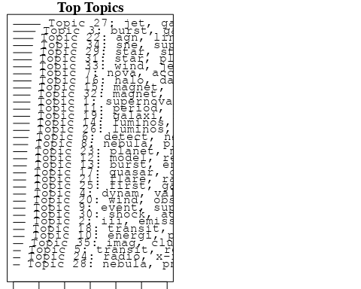

plotQuote(thoughts6, width = 30, main = "Topic 6")  
plotQuote(thoughts18, width = 30, main = "Topic 18")

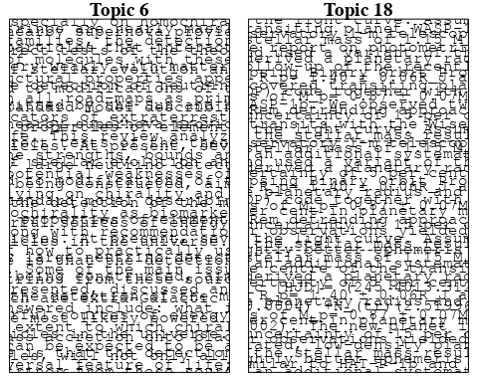

# Calculate and plot the correlation between topics  
mod.out.corr <- topicCorr(Research_topics)  
plot(mod.out.corr, cex = 1.5)  
  
  
# For each topic  
for (topic_num in 1:35) {  
 # Plot the word cloud  
 cloud(Research_topics, topic = topic_num, scale = c(2, 0.25))  
 Sys.sleep(2)  
}

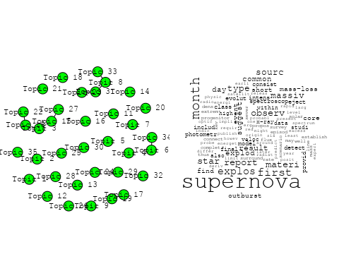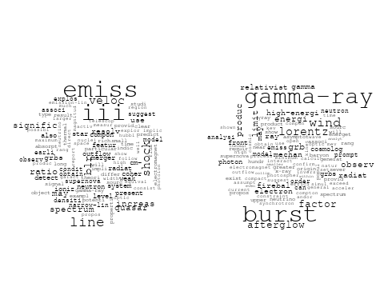

## Warning in wordcloud::wordcloud(words = vocab, freq = vec, max.words =  
## max.words, : effect could not be fit on page. It will not be plotted.

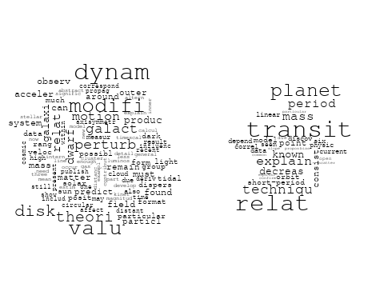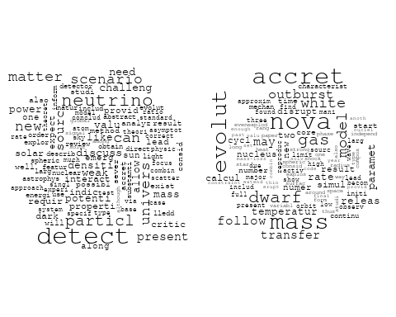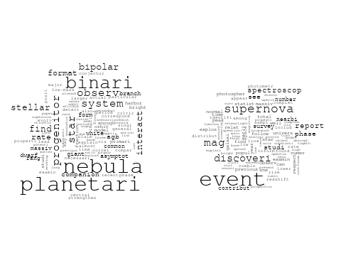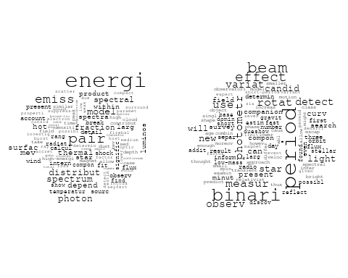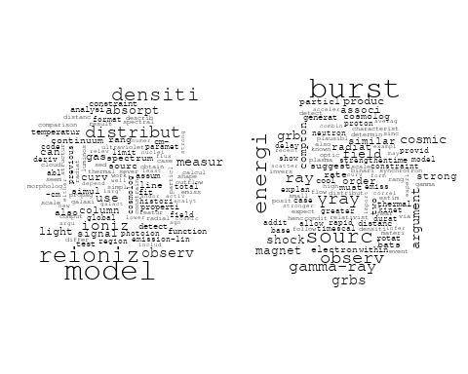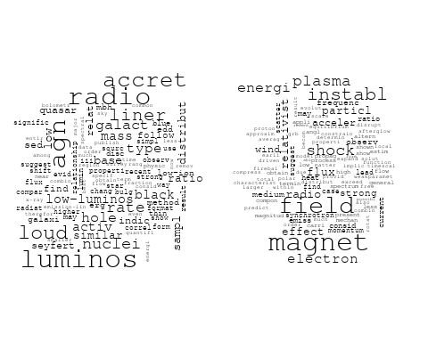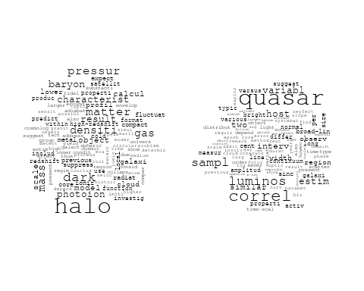

## Warning in wordcloud::wordcloud(words = vocab, freq = vec, max.words =  
## max.words, : deriv could not be fit on page. It will not be plotted.

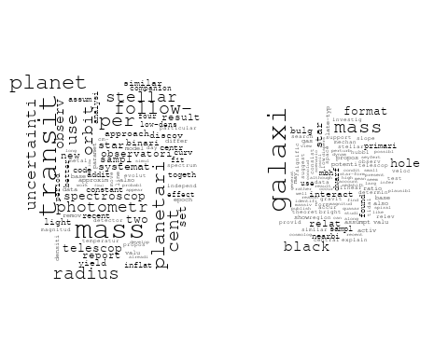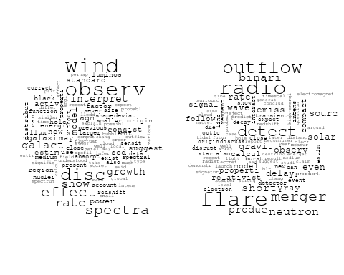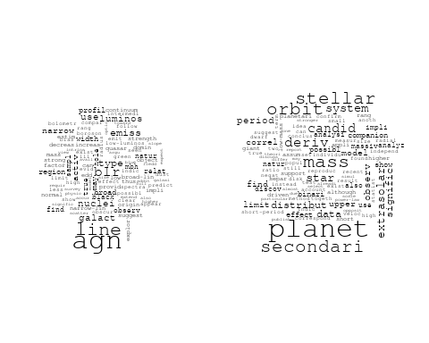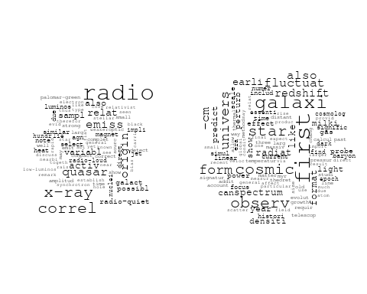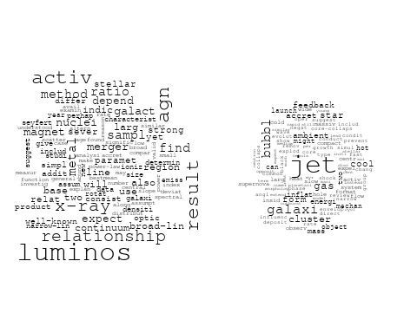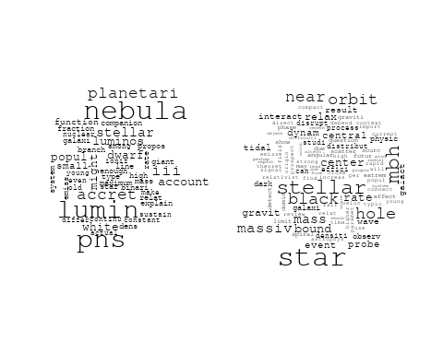

## Warning in wordcloud::wordcloud(words = vocab, freq = vec, max.words =  
## max.words, : shock could not be fit on page. It will not be plotted.

## Warning in wordcloud::wordcloud(words = vocab, freq = vec, max.words =  
## max.words, : high could not be fit on page. It will not be plotted.

## Warning in wordcloud::wordcloud(words = vocab, freq = vec, max.words =  
## max.words, : x-ray could not be fit on page. It will not be plotted.

## Warning in wordcloud::wordcloud(words = vocab, freq = vec, max.words =  
## max.words, : absorpt could not be fit on page. It will not be plotted.

## Warning in wordcloud::wordcloud(words = vocab, freq = vec, max.words =  
## max.words, : similar could not be fit on page. It will not be plotted.

## Warning in wordcloud::wordcloud(words = vocab, freq = vec, max.words =  
## max.words, : equilibrium could not be fit on page. It will not be plotted.

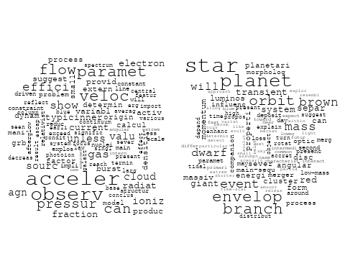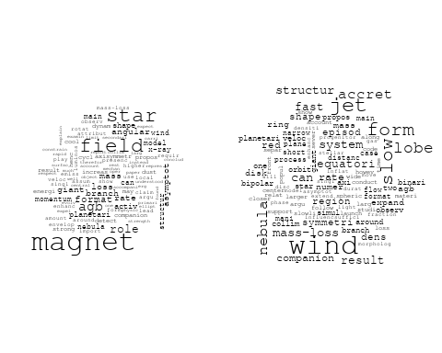

## Warning in wordcloud::wordcloud(words = vocab, freq = vec, max.words =  
## max.words, : supernova could not be fit on page. It will not be plotted.

## Warning in wordcloud::wordcloud(words = vocab, freq = vec, max.words =  
## max.words, : afterglow could not be fit on page. It will not be plotted.

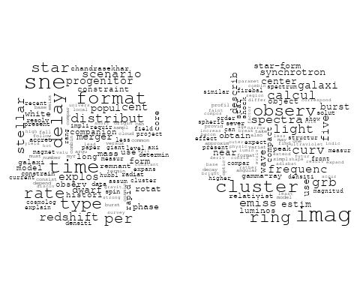

# Get the topic proportions for each document  
topic_proportions <- Research_topics$theta  
  
# Find the index of the topic with the highest proportion for each document  
# This will be the topic that each document is most likely to belong to  
max_topic_idx <- apply(topic_proportions, 1, which.max)  
  
# Add this as a new column to your data  
data_independent$topic <- max_topic_idx  
  
  
  
# Define the intervals  
intervals <- c('1824_1899', '1900_1964', '1965_1974', '1975_1984', '1985_1994', '1995_1999', '2000_2004', '2005_2009', '2010_2014', '2015_2019', '2020_2022')  
colors <- c('pink', 'blue', 'purple', 'yellow', 'green', 'pink', 'orange', 'violet', 'green', 'blue', 'pink')  
  
# Loop through the intervals and plot  
for(i in seq_along(intervals)){  
 # Filter data for when the pub_interval is equal to 1  
 data_filtered <- data_independent[data_independent[[paste0('pub_interval_', intervals[i])]] == 1,]  
   
 # Make the histogram  
   
 p <- ggplot(data_filtered, aes(x = topic)) +  
 geom_histogram(binwidth = 1, fill = colors[i], color = "black") +  
 xlab("Topic") +  
 ylab("Count") +  
 ggtitle(paste0("Topics from year ", gsub("_", " to ", intervals[i])))  
   
 print(p)  
}

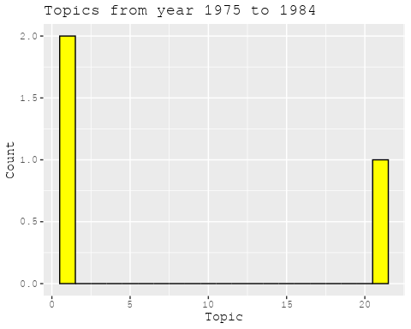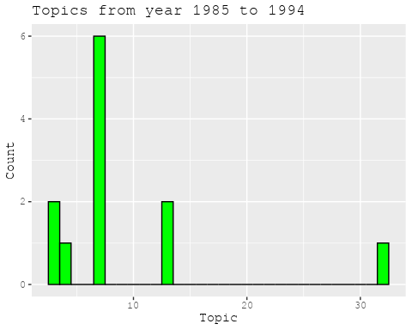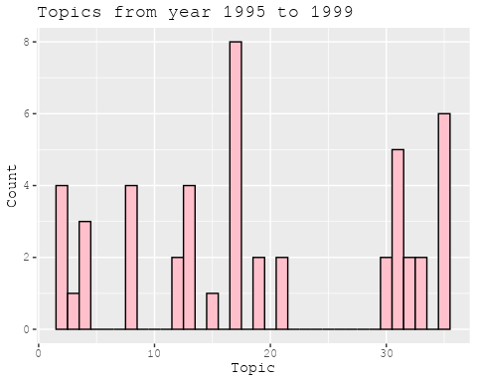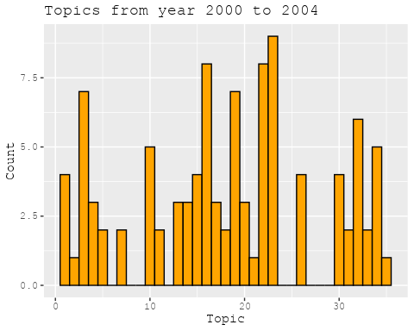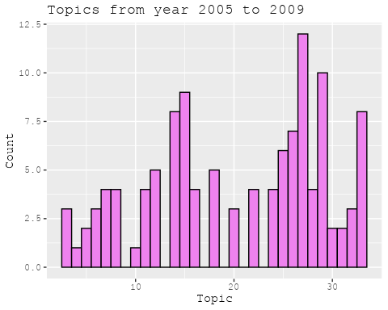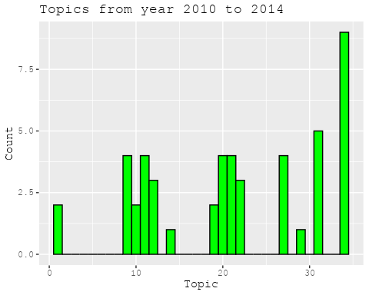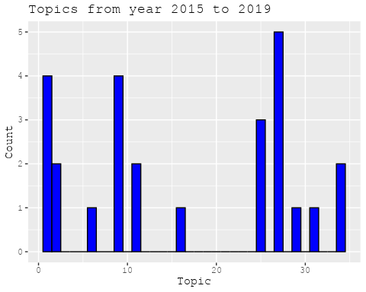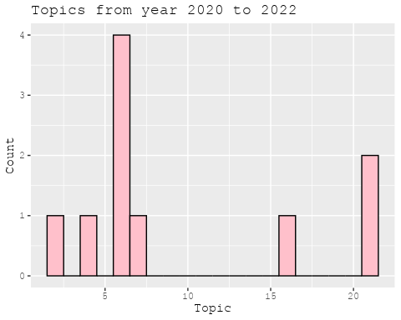

##Topic generation for CH (in collaboration) publications  
  
data_collab <- data[data[["CH"]] != 0,]  
  
# Save the original title data for future use  
data_collab$original_concatenated_title_abstract <- data_collab$concatenated_title_abstract  
  
#pre-processing the titles using textProcessor from the stm package  
processed_text <- textProcessor(data_collab$concatenated_title_abstract, metadata = data_collab)

## Building corpus...   
## Converting to Lower Case...   
## Removing punctuation...   
## Removing stopwords...   
## Removing numbers...   
## Stemming...   
## Creating Output...

# Further prepare the data by removing low-frequency terms  
out_text <- prepDocuments(processed_text$documents, processed_text$vocab, processed_text$meta)

## Removing 1612 of 6166 terms (1612 of 76116 tokens) due to frequency   
## Your corpus now has 899 documents, 4554 terms and 74504 tokens.

docs_text <- out_text$documents  
vocab_text <- out_text$vocab  
meta_text <- out_text$meta  
  
  
#Prepare data  
plotRemoved(processed_text$documents, lower.thresh = seq(1, 200, by = 100))

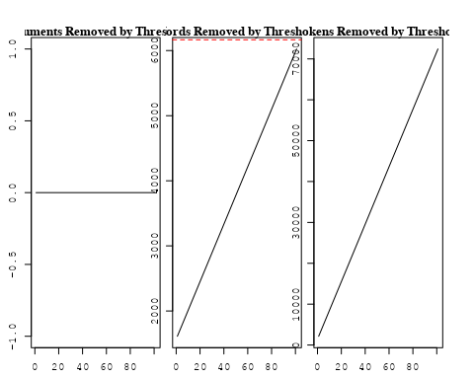

out_text <- prepDocuments(processed_text$documents, processed_text$vocab, processed_text$meta, lower.thresh = 8)

## Removing 4724 of 6166 terms (12075 of 76116 tokens) due to frequency   
## Your corpus now has 899 documents, 1442 terms and 64041 tokens.

str(out_text$meta)

## 'data.frame': 899 obs. of 39 variables:  
## $ concept_id : chr "https://openalex.org/C44870925" "https://openalex.org/C44870925" "https://openalex.org/C44870925" "https://openalex.org/C44870925" ...  
## $ work_id : chr "https://openalex.org/W2055827975" "https://openalex.org/W2798563684" "https://openalex.org/W2167125520" "https://openalex.org/W2174274577" ...  
## $ publication_year : int 2007 2018 2003 2010 2012 2009 2010 1997 2009 2011 ...  
## $ title : chr "Cosmic magnetic fields and the CMB" "Magnetic structure of solar flare regions producing hard X-ray pulsations" "Dark matter and dark energy: summary and future directions" "WASP-32b: A Transiting Hot Jupiter Planet Orbiting a Lithium-Poor, Solar-Type Star" ...  
## $ paperabstract : chr "Abstract I describe the imprint which primordial magnetic fields can leave on the cosmic microwave background ("| __truncated__ "Abstract We present analysis of the magnetic field in seven solar flare regions accompanied by the pulsations o"| __truncated__ "This paper reviews the progress reported at the Discussion Meeting and advertises some possible future directio"| __truncated__ "ABSTRACT. We report the discovery of a transiting planet orbiting the star TYC 2-1155-1. The star, WASP-32, is "| __truncated__ ...  
## $ country : chr "CH CH" "CH RU GB RU CN" "CH" "GB CH" ...  
## $ year_concept : chr "2007+https://openalex.org/C44870925" "2018+https://openalex.org/C44870925" "2003+https://openalex.org/C44870925" "2010+https://openalex.org/C44870925" ...  
## $ concatenated_title_abstract : chr "Cosmic magnetic fields and the CMB Abstract I describe the imprint which primordial magnetic fields can leave o"| __truncated__ "Magnetic structure of solar flare regions producing hard X-ray pulsations Abstract We present analysis of the m"| __truncated__ "Dark matter and dark energy: summary and future directions This paper reviews the progress reported at the Disc"| __truncated__ "WASP-32b: A Transiting Hot Jupiter Planet Orbiting a Lithium-Poor, Solar-Type Star ABSTRACT. We report the disc"| __truncated__ ...  
## $ US : num 0 0 0 0 50 0 0 50 0 20 ...  
## $ IN : num 0 0 0 0 0 0 0 0 0 0 ...  
## $ DE : num 0 0 0 0 0 0 0 0 0 0 ...  
## $ CH : num 100 20 100 50 25 50 50 50 50 20 ...  
## $ GB : num 0 20 0 50 25 0 0 0 0 0 ...  
## $ CN : num 0 20 0 0 0 0 0 0 0 0 ...  
## $ FR : num 0 0 0 0 0 0 0 0 0 20 ...  
## $ IT : num 0 0 0 0 0 50 50 0 50 0 ...  
## $ RU : num 0 40 0 0 0 0 0 0 0 0 ...  
## $ CA : num 0 0 0 0 0 0 0 0 0 0 ...  
## $ NL : num 0 0 0 0 0 0 0 0 0 0 ...  
## $ AU : num 0 0 0 0 0 0 0 0 0 0 ...  
## $ JP : num 0 0 0 0 0 0 0 0 0 0 ...  
## $ ES : num 0 0 0 0 0 0 0 0 0 0 ...  
## $ IL : num 0 0 0 0 0 0 0 0 0 0 ...  
## $ Americas : num 0 0 0 0 0 0 0 0 0 0 ...  
## $ Europe : num 0 0 0 0 0 0 0 0 0 40 ...  
## $ Africa : num 0 0 0 0 0 0 0 0 0 0 ...  
## $ AsiaAndOceania : num 0 0 0 0 0 0 0 0 0 0 ...  
## $ pub_interval_2020_2022 : int 0 0 0 0 0 0 0 0 0 0 ...  
## $ pub_interval_2015_2019 : int 0 1 0 0 0 0 0 0 0 0 ...  
## $ pub_interval_2010_2014 : int 0 0 0 1 1 0 1 0 0 1 ...  
## $ pub_interval_2005_2009 : int 1 0 0 0 0 1 0 0 1 0 ...  
## $ pub_interval_2000_2004 : int 0 0 1 0 0 0 0 0 0 0 ...  
## $ pub_interval_1995_1999 : int 0 0 0 0 0 0 0 1 0 0 ...  
## $ pub_interval_1985_1994 : int 0 0 0 0 0 0 0 0 0 0 ...  
## $ pub_interval_1975_1984 : int 0 0 0 0 0 0 0 0 0 0 ...  
## $ pub_interval_1965_1974 : int 0 0 0 0 0 0 0 0 0 0 ...  
## $ pub_interval_1900_1964 : int 0 0 0 0 0 0 0 0 0 0 ...  
## $ pub_interval_1824_1899 : int 0 0 0 0 0 0 0 0 0 0 ...  
## $ original_concatenated_title_abstract: chr "Cosmic magnetic fields and the CMB Abstract I describe the imprint which primordial magnetic fields can leave o"| __truncated__ "Magnetic structure of solar flare regions producing hard X-ray pulsations Abstract We present analysis of the m"| __truncated__ "Dark matter and dark energy: summary and future directions This paper reviews the progress reported at the Disc"| __truncated__ "WASP-32b: A Transiting Hot Jupiter Planet Orbiting a Lithium-Poor, Solar-Type Star ABSTRACT. We report the disc"| __truncated__ ...

# Initialize an empty formula string  
prevalence_formula_str <- "~"  
  
# Define the publication intervals  
pub_intervals <- c("pub_interval_2020_2022", "pub_interval_2015_2019", "pub_interval_2010_2014",   
 "pub_interval_2005_2009", "pub_interval_2000_2004", "pub_interval_1995_1999",  
 "pub_interval_1985_1994", "pub_interval_1975_1984", "pub_interval_1965_1974",  
 "pub_interval_1900_1964", "pub_interval_1824_1899")  
  
# Add each publication interval to the formula string  
for (interval in pub_intervals) {  
 # add an if statement to handle the first addition (without '+')  
 if (prevalence_formula_str == "~") {  
 prevalence_formula_str <- paste(prevalence_formula_str, interval)  
 } else {  
 prevalence_formula_str <- paste(prevalence_formula_str, "+", interval)  
 }  
}  
  
  
# Convert the string to a formula  
prevalence_formula <- as.formula(prevalence_formula_str)  
print(prevalence_formula)

## ~pub_interval_2020_2022 + pub_interval_2015_2019 + pub_interval_2010_2014 +   
## pub_interval_2005_2009 + pub_interval_2000_2004 + pub_interval_1995_1999 +   
## pub_interval_1985_1994 + pub_interval_1975_1984 + pub_interval_1965_1974 +   
## pub_interval_1900_1964 + pub_interval_1824_1899

# Run STM model  
Research_topics <- stm(documents = out_text$documents,   
 vocab = out_text$vocab,   
 K = 42,   
 prevalence = prevalence_formula,   
 data = out_text$meta,   
 init.type = "Spectral",  
 max.em.its = 1000,  
 gamma.prior = 'L1')

## Beginning Spectral Initialization   
## Calculating the gram matrix...  
## Finding anchor words...  
## ..........................................  
## Recovering initialization...  
## ..............  
## Initialization complete.  
## ................................................................................................................  
## Completed E-Step (0 seconds).   
## Completed M-Step.   
## Completing Iteration 1 (approx. per word bound = -6.142)   
## ................................................................................................................  
## Completed E-Step (0 seconds).   
## Completed M-Step.   
## Completing Iteration 2 (approx. per word bound = -5.883, relative change = 4.213e-02)   
## ................................................................................................................  
## Completed E-Step (0 seconds).   
## Completed M-Step.   
## Completing Iteration 3 (approx. per word bound = -5.794, relative change = 1.514e-02)   
## ................................................................................................................  
## Completed E-Step (0 seconds).   
## Completed M-Step.   
## Completing Iteration 4 (approx. per word bound = -5.754, relative change = 6.915e-03)   
## ................................................................................................................  
## Completed E-Step (0 seconds).   
## Completed M-Step.   
## Completing Iteration 5 (approx. per word bound = -5.731, relative change = 3.903e-03)   
## Topic 1: des, polar, scatter, planetari, orbit   
## Topic 2: radiat, lyα, photon, observ, graviti   
## Topic 3: galaxi, cluster, survey, sampl, central   
## Topic 4: transit, integr, gamma-ray, instrument, decad   
## Topic 5: cluster, bias, redshift, correl, statist   
## Topic 6: star, mass, dwarf, segreg, method   
## Topic 7: correct, new, will, precis, mission   
## Topic 8: metal, galaxi, massiv, disk, might   
## Topic 9: shock, acceler, particl, supernova, cosmic   
## Topic 10: dark, matter, mass, halo, model   
## Topic 11: planet, star, orbit, planetari, stellar   
## Topic 12: energi, paramet, general, power, cosmolog   
## Topic 13: galaxi, disk, bar, simul, format   
## Topic 14: model, observ, agn, feedback, distribut   
## Topic 15: metal, gradient, bulg, age, effect   
## Topic 16: galaxi, satellit, distanc, distribut, mpc   
## Topic 17: shape, impact, moon, format, collis   
## Topic 18: local, map, field, simul, cluster   
## Topic 19: space, field, instrument, describ, design   
## Topic 20: galaxi, gas, observ, clump, format   
## Topic 21: black, hole, luminos, mass, star   
## Topic 22: emiss, accret, x-ray, galact, model   
## Topic 23: accret, planet, format, planetesim, myr   
## Topic 24: survey, use, sampl, galaxi, redshift   
## Topic 25: matter, particl, dark, gravit, simul   
## Topic 26: merger, galaxi, gas, disk, format   
## Topic 27: solar, comet, isotop, system, ratio   
## Topic 28: flare, x-ray, emiss, observ, solar   
## Topic 29: telescop, observ, imag, flux, point   
## Topic 30: cluster, star, system, binari, dynam   
## Topic 31: halo, galaxi, mass, dark, disc   
## Topic 32: detect, disk, dwarf, distribut, featur   
## Topic 33: supernova, type, rate, reaction, model   
## Topic 34: abund, group, dwarf, galaxi, cen   
## Topic 35: field, magnet, review, generat, observ   
## Topic 36: solar, interstellar, sun, wind, helium   
## Topic 37: galaxi, veloc, star, distribut, core   
## Topic 38: observ, grb, can, rhessi, grbs   
## Topic 39: disc, gas, mass, turbul, spiral   
## Topic 40: halo, orbit, matter, dark, shape   
## Topic 41: x-ray, accret, frequenc, neutron, observ   
## Topic 42: mass, imf, stellar, initi, univers   
## ................................................................................................................  
## Completed E-Step (0 seconds).   
## Completed M-Step.   
## Completing Iteration 6 (approx. per word bound = -5.718, relative change = 2.398e-03)   
## ................................................................................................................  
## Completed E-Step (0 seconds).   
## Completed M-Step.   
## Completing Iteration 7 (approx. per word bound = -5.708, relative change = 1.636e-03)   
## ................................................................................................................  
## Completed E-Step (0 seconds).   
## Completed M-Step.   
## Completing Iteration 8 (approx. per word bound = -5.702, relative change = 1.155e-03)   
## ................................................................................................................  
## Completed E-Step (0 seconds).   
## Completed M-Step.   
## Completing Iteration 9 (approx. per word bound = -5.697, relative change = 8.361e-04)   
## ................................................................................................................  
## Completed E-Step (0 seconds).   
## Completed M-Step.   
## Completing Iteration 10 (approx. per word bound = -5.693, relative change = 6.699e-04)   
## Topic 1: des, polar, scatter, planetari, obtain   
## Topic 2: radiat, lyα, observ, photon, emiss   
## Topic 3: galaxi, central, cluster, survey, fraction   
## Topic 4: transit, integr, instrument, gamma-ray, detector   
## Topic 5: cluster, bias, redshift, galaxi, correl   
## Topic 6: star, mass, dwarf, segreg, cool   
## Topic 7: correct, will, precis, mission, new   
## Topic 8: metal, massiv, galaxi, disk, might   
## Topic 9: shock, acceler, particl, supernova, cosmic   
## Topic 10: dark, matter, halo, mass, model   
## Topic 11: planet, star, orbit, planetari, exoplanet   
## Topic 12: energi, paramet, model, cosmolog, power   
## Topic 13: galaxi, disk, bar, simul, format   
## Topic 14: model, feedback, agn, observ, distribut   
## Topic 15: metal, gradient, bulg, age, evolut   
## Topic 16: galaxi, satellit, distanc, mpc, distribut   
## Topic 17: shape, impact, moon, format, collis   
## Topic 18: map, cluster, baryon, simul, cosmic   
## Topic 19: space, field, instrument, spectroscopi, describ   
## Topic 20: galaxi, gas, clump, observ, format   
## Topic 21: black, hole, luminos, mass, observ   
## Topic 22: emiss, x-ray, accret, galact, model   
## Topic 23: accret, planet, format, planetesim, jupit   
## Topic 24: survey, use, galaxi, sampl, redshift   
## Topic 25: particl, matter, dark, simul, densiti   
## Topic 26: merger, gas, galaxi, disk, format   
## Topic 27: solar, comet, isotop, system, ratio   
## Topic 28: flare, x-ray, emiss, observ, solar   
## Topic 29: telescop, observ, imag, flux, point   
## Topic 30: cluster, star, system, binari, dynam   
## Topic 31: halo, galaxi, mass, disc, tidal   
## Topic 32: detect, disk, cluster, distribut, dwarf   
## Topic 33: supernova, type, rate, explos, reaction   
## Topic 34: abund, group, dwarf, galaxi, cen   
## Topic 35: field, magnet, review, physic, observ   
## Topic 36: solar, interstellar, sun, wind, helium   
## Topic 37: galaxi, veloc, star, distribut, halo   
## Topic 38: observ, grb, rhessi, can, grbs   
## Topic 39: disc, gas, turbul, mass, spiral   
## Topic 40: halo, orbit, dark, matter, shape   
## Topic 41: x-ray, accret, frequenc, neutron, observ   
## Topic 42: mass, imf, stellar, initi, univers   
## ................................................................................................................  
## Completed E-Step (0 seconds).   
## Completed M-Step.   
## Completing Iteration 11 (approx. per word bound = -5.690, relative change = 6.173e-04)   
## ................................................................................................................  
## Completed E-Step (0 seconds).   
## Completed M-Step.   
## Completing Iteration 12 (approx. per word bound = -5.686, relative change = 5.445e-04)   
## ................................................................................................................  
## Completed E-Step (0 seconds).   
## Completed M-Step.   
## Completing Iteration 13 (approx. per word bound = -5.684, relative change = 4.343e-04)   
## ................................................................................................................  
## Completed E-Step (0 seconds).   
## Completed M-Step.   
## Completing Iteration 14 (approx. per word bound = -5.682, relative change = 3.660e-04)   
## ................................................................................................................  
## Completed E-Step (0 seconds).   
## Completed M-Step.   
## Completing Iteration 15 (approx. per word bound = -5.680, relative change = 3.212e-04)   
## Topic 1: des, polar, scatter, obtain, estim   
## Topic 2: radiat, lyα, observ, emiss, quantum   
## Topic 3: galaxi, central, fraction, sampl, cluster   
## Topic 4: transit, integr, instrument, gamma-ray, detector   
## Topic 5: cluster, bias, redshift, galaxi, correl   
## Topic 6: star, mass, dwarf, segreg, cool   
## Topic 7: correct, will, precis, mission, effect   
## Topic 8: metal, galaxi, massiv, disk, star   
## Topic 9: shock, acceler, particl, ray, cosmic   
## Topic 10: dark, matter, halo, mass, model   
## Topic 11: planet, star, orbit, exoplanet, planetari   
## Topic 12: energi, paramet, model, cosmolog, dark   
## Topic 13: galaxi, disk, bar, simul, disc   
## Topic 14: model, feedback, agn, observ, star   
## Topic 15: metal, gradient, bulg, evolut, age   
## Topic 16: galaxi, satellit, distanc, distribut, cosmolog   
## Topic 17: shape, impact, moon, collis, format   
## Topic 18: map, cluster, baryon, cosmic, simul   
## Topic 19: space, field, spectroscopi, instrument, describ   
## Topic 20: galaxi, gas, clump, observ, star   
## Topic 21: black, hole, luminos, mass, observ   
## Topic 22: emiss, x-ray, accret, galact, model   
## Topic 23: accret, planet, format, planetesim, jupit   
## Topic 24: survey, use, galaxi, sampl, redshift   
## Topic 25: particl, matter, dark, simul, densiti   
## Topic 26: merger, gas, disk, galaxi, format   
## Topic 27: solar, comet, isotop, system, grain   
## Topic 28: flare, x-ray, observ, emiss, solar   
## Topic 29: telescop, observ, imag, flux, point   
## Topic 30: cluster, star, system, binari, dynam   
## Topic 31: halo, galaxi, mass, disc, tidal   
## Topic 32: detect, galaxi, cluster, disk, dwarf   
## Topic 33: supernova, type, explos, rate, calcul   
## Topic 34: group, abund, dwarf, galaxi, cen   
## Topic 35: field, magnet, physic, review, observ   
## Topic 36: solar, interstellar, sun, wind, observ   
## Topic 37: galaxi, veloc, star, halo, distribut   
## Topic 38: observ, grb, rhessi, can, grbs   
## Topic 39: disc, gas, model, turbul, mass   
## Topic 40: halo, orbit, dark, matter, shape   
## Topic 41: x-ray, accret, frequenc, observ, neutron   
## Topic 42: mass, imf, stellar, initi, univers   
## ................................................................................................................  
## Completed E-Step (0 seconds).   
## Completed M-Step.   
## Completing Iteration 16 (approx. per word bound = -5.679, relative change = 2.767e-04)   
## ................................................................................................................  
## Completed E-Step (0 seconds).   
## Completed M-Step.   
## Completing Iteration 17 (approx. per word bound = -5.677, relative change = 2.348e-04)   
## ................................................................................................................  
## Completed E-Step (0 seconds).   
## Completed M-Step.   
## Completing Iteration 18 (approx. per word bound = -5.676, relative change = 1.968e-04)   
## ................................................................................................................  
## Completed E-Step (0 seconds).   
## Completed M-Step.   
## Completing Iteration 19 (approx. per word bound = -5.675, relative change = 1.785e-04)   
## ................................................................................................................  
## Completed E-Step (0 seconds).   
## Completed M-Step.   
## Completing Iteration 20 (approx. per word bound = -5.674, relative change = 1.628e-04)   
## Topic 1: des, polar, scatter, obtain, estim   
## Topic 2: radiat, lyα, observ, quantum, emiss   
## Topic 3: galaxi, central, fraction, sampl, cluster   
## Topic 4: transit, integr, instrument, gamma-ray, detector   
## Topic 5: cluster, bias, redshift, galaxi, correl   
## Topic 6: star, mass, dwarf, segreg, cool   
## Topic 7: correct, will, precis, mission, effect   
## Topic 8: metal, galaxi, massiv, disk, star   
## Topic 9: shock, acceler, particl, ray, cosmic   
## Topic 10: dark, matter, halo, mass, model   
## Topic 11: planet, star, orbit, exoplanet, atmospher   
## Topic 12: energi, paramet, model, cosmolog, dark   
## Topic 13: galaxi, disk, bar, simul, disc   
## Topic 14: model, feedback, agn, format, star   
## Topic 15: metal, gradient, bulg, galaxi, evolut   
## Topic 16: galaxi, satellit, distanc, distribut, cosmolog   
## Topic 17: shape, impact, moon, collis, format   
## Topic 18: map, cluster, baryon, cosmic, univers   
## Topic 19: space, field, spectroscopi, instrument, describ   
## Topic 20: galaxi, clump, gas, observ, star   
## Topic 21: black, hole, luminos, mass, observ   
## Topic 22: emiss, accret, galact, x-ray, model   
## Topic 23: accret, planet, format, planetesim, jupit   
## Topic 24: survey, galaxi, use, sampl, redshift   
## Topic 25: particl, matter, dark, simul, densiti   
## Topic 26: merger, gas, disk, galaxi, format   
## Topic 27: solar, comet, system, isotop, grain   
## Topic 28: flare, x-ray, observ, emiss, solar   
## Topic 29: observ, telescop, imag, flux, use   
## Topic 30: cluster, star, binari, system, dynam   
## Topic 31: halo, galaxi, mass, disc, tidal   
## Topic 32: detect, galaxi, cluster, dwarf, disk   
## Topic 33: supernova, type, explos, calcul, reaction   
## Topic 34: group, abund, dwarf, galaxi, cen   
## Topic 35: field, magnet, physic, x-ray, review   
## Topic 36: solar, interstellar, sun, wind, observ   
## Topic 37: galaxi, veloc, star, halo, distribut   
## Topic 38: observ, grb, rhessi, can, grbs   
## Topic 39: disc, gas, model, mass, turbul   
## Topic 40: halo, orbit, dark, matter, shape   
## Topic 41: x-ray, accret, frequenc, observ, neutron   
## Topic 42: mass, imf, stellar, initi, star   
## ................................................................................................................  
## Completed E-Step (0 seconds).   
## Completed M-Step.   
## Completing Iteration 21 (approx. per word bound = -5.673, relative change = 1.562e-04)   
## ................................................................................................................  
## Completed E-Step (0 seconds).   
## Completed M-Step.   
## Completing Iteration 22 (approx. per word bound = -5.672, relative change = 1.436e-04)   
## ................................................................................................................  
## Completed E-Step (0 seconds).   
## Completed M-Step.   
## Completing Iteration 23 (approx. per word bound = -5.672, relative change = 1.376e-04)   
## ................................................................................................................  
## Completed E-Step (0 seconds).   
## Completed M-Step.   
## Completing Iteration 24 (approx. per word bound = -5.671, relative change = 1.302e-04)   
## ................................................................................................................  
## Completed E-Step (0 seconds).   
## Completed M-Step.   
## Completing Iteration 25 (approx. per word bound = -5.670, relative change = 1.373e-04)   
## Topic 1: des, polar, scatter, obtain, planetari   
## Topic 2: radiat, lyα, observ, emiss, quantum   
## Topic 3: galaxi, central, fraction, sampl, cluster   
## Topic 4: transit, integr, instrument, gamma-ray, detector   
## Topic 5: cluster, bias, galaxi, redshift, correl   
## Topic 6: star, mass, dwarf, segreg, cool   
## Topic 7: correct, will, precis, mission, effect   
## Topic 8: metal, galaxi, massiv, disk, star   
## Topic 9: shock, acceler, particl, ray, cosmic   
## Topic 10: dark, matter, halo, mass, model   
## Topic 11: planet, star, orbit, exoplanet, atmospher   
## Topic 12: model, energi, paramet, cosmolog, dark   
## Topic 13: galaxi, disk, bar, simul, disc   
## Topic 14: model, feedback, format, agn, star   
## Topic 15: metal, gradient, galaxi, bulg, evolut   
## Topic 16: galaxi, satellit, distanc, distribut, cosmolog   
## Topic 17: shape, impact, moon, collis, result   
## Topic 18: map, cluster, baryon, cosmic, simul   
## Topic 19: space, field, spectroscopi, instrument, describ   
## Topic 20: galaxi, gas, observ, format, clump   
## Topic 21: black, hole, luminos, mass, observ   
## Topic 22: emiss, accret, galact, x-ray, model   
## Topic 23: accret, planet, format, planetesim, jupit   
## Topic 24: survey, galaxi, use, sampl, redshift   
## Topic 25: particl, matter, simul, dark, densiti   
## Topic 26: merger, gas, disk, galaxi, format   
## Topic 27: solar, comet, system, isotop, grain   
## Topic 28: flare, observ, x-ray, emiss, solar   
## Topic 29: observ, telescop, imag, flux, use   
## Topic 30: cluster, star, system, binari, dynam   
## Topic 31: halo, galaxi, mass, disc, tidal   
## Topic 32: detect, galaxi, cluster, dwarf, disk   
## Topic 33: supernova, type, explos, calcul, reaction   
## Topic 34: group, abund, galaxi, dwarf, cen   
## Topic 35: field, magnet, x-ray, physic, stellar   
## Topic 36: solar, interstellar, sun, wind, observ   
## Topic 37: galaxi, veloc, star, halo, distribut   
## Topic 38: observ, grb, rhessi, can, grbs   
## Topic 39: disc, gas, model, mass, turbul   
## Topic 40: halo, orbit, dark, matter, shape   
## Topic 41: x-ray, accret, frequenc, observ, neutron   
## Topic 42: mass, imf, stellar, initi, star   
## ................................................................................................................  
## Completed E-Step (0 seconds).   
## Completed M-Step.   
## Completing Iteration 26 (approx. per word bound = -5.669, relative change = 1.510e-04)   
## ................................................................................................................  
## Completed E-Step (0 seconds).   
## Completed M-Step.   
## Completing Iteration 27 (approx. per word bound = -5.669, relative change = 1.257e-04)   
## ................................................................................................................  
## Completed E-Step (0 seconds).   
## Completed M-Step.   
## Completing Iteration 28 (approx. per word bound = -5.668, relative change = 1.085e-04)   
## ................................................................................................................  
## Completed E-Step (0 seconds).   
## Completed M-Step.   
## Completing Iteration 29 (approx. per word bound = -5.667, relative change = 9.749e-05)   
## ................................................................................................................  
## Completed E-Step (0 seconds).   
## Completed M-Step.   
## Completing Iteration 30 (approx. per word bound = -5.667, relative change = 9.982e-05)   
## Topic 1: des, polar, scatter, obtain, planetari   
## Topic 2: radiat, lyα, observ, emiss, absorpt   
## Topic 3: galaxi, central, fraction, sampl, cluster   
## Topic 4: transit, integr, instrument, gamma-ray, detector   
## Topic 5: cluster, bias, galaxi, redshift, correl   
## Topic 6: star, mass, dwarf, segreg, cool   
## Topic 7: correct, will, precis, mission, effect   
## Topic 8: metal, galaxi, massiv, disk, star   
## Topic 9: shock, acceler, particl, ray, cosmic   
## Topic 10: dark, matter, halo, mass, model   
## Topic 11: planet, star, orbit, exoplanet, atmospher   
## Topic 12: model, energi, paramet, cosmolog, dark   
## Topic 13: galaxi, disk, bar, simul, disc   
## Topic 14: model, feedback, format, agn, star   
## Topic 15: metal, gradient, galaxi, bulg, evolut   
## Topic 16: galaxi, satellit, distanc, distribut, cosmolog   
## Topic 17: shape, impact, moon, collis, result   
## Topic 18: map, cluster, baryon, cosmic, estim   
## Topic 19: space, field, spectroscopi, instrument, describ   
## Topic 20: galaxi, gas, observ, format, clump   
## Topic 21: black, hole, luminos, observ, mass   
## Topic 22: emiss, accret, galact, model, x-ray   
## Topic 23: accret, planet, format, planetesim, jupit   
## Topic 24: survey, galaxi, use, sampl, redshift   
## Topic 25: particl, matter, simul, densiti, dark   
## Topic 26: merger, gas, disk, galaxi, format   
## Topic 27: solar, comet, system, isotop, grain   
## Topic 28: flare, observ, x-ray, emiss, solar   
## Topic 29: observ, telescop, imag, flux, use   
## Topic 30: cluster, star, system, binari, dynam   
## Topic 31: halo, galaxi, mass, disc, tidal   
## Topic 32: detect, galaxi, cluster, dwarf, disk   
## Topic 33: supernova, type, explos, model, calcul   
## Topic 34: group, abund, galaxi, dwarf, cen   
## Topic 35: field, magnet, x-ray, physic, stellar   
## Topic 36: solar, interstellar, sun, wind, observ   
## Topic 37: galaxi, veloc, star, halo, distribut   
## Topic 38: observ, grb, rhessi, can, grbs   
## Topic 39: disc, gas, model, mass, turbul   
## Topic 40: halo, orbit, dark, matter, shape   
## Topic 41: x-ray, accret, frequenc, observ, neutron   
## Topic 42: mass, imf, stellar, initi, star   
## ................................................................................................................  
## Completed E-Step (0 seconds).   
## Completed M-Step.   
## Completing Iteration 31 (approx. per word bound = -5.666, relative change = 1.103e-04)   
## ................................................................................................................  
## Completed E-Step (0 seconds).   
## Completed M-Step.   
## Completing Iteration 32 (approx. per word bound = -5.666, relative change = 9.751e-05)   
## ................................................................................................................  
## Completed E-Step (0 seconds).   
## Completed M-Step.   
## Completing Iteration 33 (approx. per word bound = -5.665, relative change = 8.121e-05)   
## ................................................................................................................  
## Completed E-Step (0 seconds).   
## Completed M-Step.   
## Completing Iteration 34 (approx. per word bound = -5.665, relative change = 9.020e-05)   
## ................................................................................................................  
## Completed E-Step (0 seconds).   
## Completed M-Step.   
## Completing Iteration 35 (approx. per word bound = -5.664, relative change = 8.897e-05)   
## Topic 1: des, polar, scatter, obtain, planetari   
## Topic 2: radiat, lyα, observ, emiss, quantum   
## Topic 3: galaxi, central, fraction, cluster, sampl   
## Topic 4: transit, integr, instrument, gamma-ray, detector   
## Topic 5: cluster, bias, galaxi, redshift, correl   
## Topic 6: star, mass, dwarf, segreg, cool   
## Topic 7: correct, will, precis, mission, effect   
## Topic 8: metal, galaxi, massiv, disk, star   
## Topic 9: shock, acceler, particl, ray, cosmic   
## Topic 10: dark, matter, halo, mass, model   
## Topic 11: planet, star, orbit, exoplanet, atmospher   
## Topic 12: model, energi, paramet, dark, cosmolog   
## Topic 13: galaxi, disk, bar, simul, disc   
## Topic 14: model, feedback, format, agn, star   
## Topic 15: metal, gradient, galaxi, bulg, evolut   
## Topic 16: galaxi, satellit, distanc, distribut, cosmolog   
## Topic 17: impact, shape, moon, collis, result   
## Topic 18: map, cluster, baryon, cosmic, estim   
## Topic 19: space, field, spectroscopi, instrument, star   
## Topic 20: galaxi, gas, observ, format, clump   
## Topic 21: black, hole, observ, mass, merger   
## Topic 22: emiss, accret, galact, model, x-ray   
## Topic 23: accret, planet, format, planetesim, jupit   
## Topic 24: survey, galaxi, use, sampl, redshift   
## Topic 25: particl, matter, simul, densiti, dark   
## Topic 26: merger, gas, disk, galaxi, format   
## Topic 27: solar, comet, system, isotop, grain   
## Topic 28: flare, observ, x-ray, emiss, solar   
## Topic 29: observ, telescop, imag, flux, use   
## Topic 30: cluster, star, binari, system, dynam   
## Topic 31: halo, galaxi, mass, disc, tidal   
## Topic 32: detect, galaxi, cluster, dwarf, disk   
## Topic 33: supernova, type, explos, model, calcul   
## Topic 34: group, abund, galaxi, dwarf, cen   
## Topic 35: field, magnet, x-ray, physic, stellar   
## Topic 36: solar, interstellar, sun, wind, observ   
## Topic 37: galaxi, veloc, star, halo, distribut   
## Topic 38: observ, grb, rhessi, can, grbs   
## Topic 39: disc, gas, model, mass, turbul   
## Topic 40: halo, orbit, dark, matter, shape   
## Topic 41: x-ray, accret, frequenc, observ, neutron   
## Topic 42: mass, imf, stellar, initi, star   
## ................................................................................................................  
## Completed E-Step (0 seconds).   
## Completed M-Step.   
## Completing Iteration 36 (approx. per word bound = -5.664, relative change = 7.769e-05)   
## ................................................................................................................  
## Completed E-Step (0 seconds).   
## Completed M-Step.   
## Completing Iteration 37 (approx. per word bound = -5.663, relative change = 6.336e-05)   
## ................................................................................................................  
## Completed E-Step (0 seconds).   
## Completed M-Step.   
## Completing Iteration 38 (approx. per word bound = -5.663, relative change = 5.845e-05)   
## ................................................................................................................  
## Completed E-Step (0 seconds).   
## Completed M-Step.   
## Completing Iteration 39 (approx. per word bound = -5.663, relative change = 5.131e-05)   
## ................................................................................................................  
## Completed E-Step (0 seconds).   
## Completed M-Step.   
## Completing Iteration 40 (approx. per word bound = -5.663, relative change = 4.968e-05)   
## Topic 1: des, polar, scatter, obtain, planetari   
## Topic 2: radiat, lyα, observ, emiss, quantum   
## Topic 3: galaxi, central, fraction, cluster, sampl   
## Topic 4: transit, integr, instrument, gamma-ray, detector   
## Topic 5: cluster, bias, galaxi, redshift, correl   
## Topic 6: star, mass, dwarf, segreg, cool   
## Topic 7: correct, will, precis, mission, effect   
## Topic 8: metal, galaxi, massiv, disk, star   
## Topic 9: shock, acceler, particl, ray, cosmic   
## Topic 10: dark, matter, halo, mass, model   
## Topic 11: planet, star, orbit, exoplanet, atmospher   
## Topic 12: model, energi, paramet, dark, cosmolog   
## Topic 13: galaxi, disk, bar, simul, disc   
## Topic 14: model, feedback, format, galaxi, agn   
## Topic 15: metal, gradient, galaxi, bulg, evolut   
## Topic 16: galaxi, satellit, distanc, distribut, cosmolog   
## Topic 17: impact, shape, moon, collis, result   
## Topic 18: map, cluster, baryon, cosmic, estim   
## Topic 19: space, field, spectroscopi, instrument, star   
## Topic 20: galaxi, gas, observ, format, clump   
## Topic 21: black, hole, observ, mass, merger   
## Topic 22: emiss, accret, galact, model, x-ray   
## Topic 23: accret, planet, format, planetesim, jupit   
## Topic 24: survey, galaxi, sampl, use, redshift   
## Topic 25: particl, matter, simul, densiti, gravit   
## Topic 26: merger, gas, disk, galaxi, format   
## Topic 27: solar, comet, system, isotop, grain   
## Topic 28: flare, observ, x-ray, emiss, solar   
## Topic 29: observ, telescop, imag, flux, use   
## Topic 30: cluster, star, binari, system, dynam   
## Topic 31: halo, galaxi, mass, disc, tidal   
## Topic 32: detect, galaxi, cluster, dwarf, disk   
## Topic 33: supernova, type, explos, model, calcul   
## Topic 34: group, abund, galaxi, dwarf, cen   
## Topic 35: field, magnet, x-ray, physic, stellar   
## Topic 36: solar, interstellar, sun, wind, observ   
## Topic 37: galaxi, veloc, star, halo, distribut   
## Topic 38: observ, grb, rhessi, can, grbs   
## Topic 39: disc, gas, model, mass, turbul   
## Topic 40: halo, orbit, dark, matter, shape   
## Topic 41: x-ray, accret, frequenc, observ, neutron   
## Topic 42: mass, imf, stellar, initi, star   
## ................................................................................................................  
## Completed E-Step (0 seconds).   
## Completed M-Step.   
## Completing Iteration 41 (approx. per word bound = -5.662, relative change = 4.295e-05)   
## ................................................................................................................  
## Completed E-Step (0 seconds).   
## Completed M-Step.   
## Completing Iteration 42 (approx. per word bound = -5.662, relative change = 4.438e-05)   
## ................................................................................................................  
## Completed E-Step (0 seconds).   
## Completed M-Step.   
## Completing Iteration 43 (approx. per word bound = -5.662, relative change = 4.304e-05)   
## ................................................................................................................  
## Completed E-Step (0 seconds).   
## Completed M-Step.   
## Completing Iteration 44 (approx. per word bound = -5.662, relative change = 4.110e-05)   
## ................................................................................................................  
## Completed E-Step (0 seconds).   
## Completed M-Step.   
## Completing Iteration 45 (approx. per word bound = -5.661, relative change = 4.688e-05)   
## Topic 1: des, polar, scatter, obtain, planetari   
## Topic 2: radiat, lyα, observ, emiss, photon   
## Topic 3: galaxi, central, fraction, cluster, sampl   
## Topic 4: transit, integr, instrument, gamma-ray, detector   
## Topic 5: cluster, bias, galaxi, redshift, correl   
## Topic 6: star, mass, dwarf, segreg, cool   
## Topic 7: correct, will, precis, mission, effect   
## Topic 8: metal, massiv, galaxi, disk, star   
## Topic 9: shock, acceler, particl, ray, cosmic   
## Topic 10: dark, matter, halo, mass, model   
## Topic 11: planet, star, orbit, exoplanet, atmospher   
## Topic 12: model, energi, paramet, dark, cosmolog   
## Topic 13: galaxi, disk, bar, simul, disc   
## Topic 14: model, feedback, format, galaxi, agn   
## Topic 15: metal, gradient, galaxi, bulg, evolut   
## Topic 16: galaxi, satellit, distanc, distribut, cosmolog   
## Topic 17: impact, shape, moon, collis, result   
## Topic 18: map, cluster, baryon, cosmic, estim   
## Topic 19: space, field, spectroscopi, instrument, star   
## Topic 20: galaxi, gas, observ, format, star   
## Topic 21: black, hole, mass, observ, merger   
## Topic 22: emiss, accret, galact, model, annihil   
## Topic 23: accret, planet, format, planetesim, jupit   
## Topic 24: survey, galaxi, sampl, use, redshift   
## Topic 25: particl, simul, matter, densiti, gravit   
## Topic 26: merger, disk, gas, galaxi, format   
## Topic 27: solar, comet, system, isotop, grain   
## Topic 28: flare, observ, x-ray, emiss, solar   
## Topic 29: observ, telescop, imag, flux, use   
## Topic 30: cluster, star, binari, system, dynam   
## Topic 31: halo, galaxi, mass, disc, tidal   
## Topic 32: detect, galaxi, cluster, dwarf, disk   
## Topic 33: supernova, type, explos, model, calcul   
## Topic 34: group, abund, galaxi, dwarf, cen   
## Topic 35: field, magnet, x-ray, physic, stellar   
## Topic 36: solar, interstellar, sun, wind, observ   
## Topic 37: galaxi, veloc, star, halo, distribut   
## Topic 38: observ, grb, rhessi, can, grbs   
## Topic 39: disc, gas, model, mass, turbul   
## Topic 40: halo, orbit, dark, matter, shape   
## Topic 41: x-ray, accret, frequenc, observ, neutron   
## Topic 42: mass, stellar, imf, initi, star   
## ................................................................................................................  
## Completed E-Step (0 seconds).   
## Completed M-Step.   
## Completing Iteration 46 (approx. per word bound = -5.661, relative change = 3.948e-05)   
## ................................................................................................................  
## Completed E-Step (0 seconds).   
## Completed M-Step.   
## Completing Iteration 47 (approx. per word bound = -5.661, relative change = 3.374e-05)   
## ................................................................................................................  
## Completed E-Step (0 seconds).   
## Completed M-Step.   
## Completing Iteration 48 (approx. per word bound = -5.661, relative change = 2.437e-05)   
## ................................................................................................................  
## Completed E-Step (0 seconds).   
## Completed M-Step.   
## Completing Iteration 49 (approx. per word bound = -5.661, relative change = 2.849e-05)   
## ................................................................................................................  
## Completed E-Step (0 seconds).   
## Completed M-Step.   
## Completing Iteration 50 (approx. per word bound = -5.660, relative change = 2.221e-05)   
## Topic 1: des, polar, scatter, planetari, obtain   
## Topic 2: radiat, lyα, observ, emiss, quantum   
## Topic 3: galaxi, central, fraction, cluster, sampl   
## Topic 4: transit, integr, instrument, gamma-ray, detector   
## Topic 5: cluster, bias, galaxi, redshift, correl   
## Topic 6: star, mass, dwarf, segreg, cool   
## Topic 7: correct, will, precis, mission, effect   
## Topic 8: metal, massiv, disk, galaxi, star   
## Topic 9: shock, acceler, particl, ray, cosmic   
## Topic 10: dark, matter, halo, mass, model   
## Topic 11: planet, star, orbit, exoplanet, atmospher   
## Topic 12: model, energi, paramet, dark, cosmolog   
## Topic 13: galaxi, disk, bar, simul, disc   
## Topic 14: model, feedback, format, galaxi, agn   
## Topic 15: metal, gradient, galaxi, bulg, evolut   
## Topic 16: galaxi, satellit, distanc, distribut, cosmolog   
## Topic 17: impact, shape, moon, collis, result   
## Topic 18: map, cluster, baryon, cosmic, estim   
## Topic 19: space, field, spectroscopi, instrument, star   
## Topic 20: galaxi, gas, observ, format, star   
## Topic 21: black, hole, mass, observ, merger   
## Topic 22: emiss, accret, galact, model, annihil   
## Topic 23: accret, planet, format, planetesim, jupit   
## Topic 24: survey, galaxi, sampl, use, redshift   
## Topic 25: particl, simul, matter, densiti, gravit   
## Topic 26: merger, disk, gas, galaxi, format   
## Topic 27: solar, comet, system, isotop, grain   
## Topic 28: flare, observ, x-ray, emiss, solar   
## Topic 29: observ, telescop, imag, flux, use   
## Topic 30: cluster, star, binari, system, dynam   
## Topic 31: halo, galaxi, mass, disc, tidal   
## Topic 32: detect, galaxi, cluster, dwarf, disk   
## Topic 33: supernova, type, explos, model, calcul   
## Topic 34: group, abund, galaxi, dwarf, cen   
## Topic 35: field, magnet, x-ray, physic, stellar   
## Topic 36: solar, interstellar, sun, wind, observ   
## Topic 37: galaxi, veloc, star, halo, distribut   
## Topic 38: observ, grb, rhessi, can, grbs   
## Topic 39: disc, gas, model, mass, turbul   
## Topic 40: halo, orbit, dark, matter, shape   
## Topic 41: x-ray, accret, frequenc, observ, neutron   
## Topic 42: mass, stellar, imf, initi, star   
## ................................................................................................................  
## Completed E-Step (0 seconds).   
## Completed M-Step.   
## Completing Iteration 51 (approx. per word bound = -5.660, relative change = 2.724e-05)   
## ................................................................................................................  
## Completed E-Step (0 seconds).   
## Completed M-Step.   
## Completing Iteration 52 (approx. per word bound = -5.660, relative change = 3.234e-05)   
## ................................................................................................................  
## Completed E-Step (0 seconds).   
## Completed M-Step.   
## Completing Iteration 53 (approx. per word bound = -5.660, relative change = 3.415e-05)   
## ................................................................................................................  
## Completed E-Step (0 seconds).   
## Completed M-Step.   
## Completing Iteration 54 (approx. per word bound = -5.660, relative change = 2.871e-05)   
## ................................................................................................................  
## Completed E-Step (0 seconds).   
## Completed M-Step.   
## Completing Iteration 55 (approx. per word bound = -5.660, relative change = 2.981e-05)   
## Topic 1: des, polar, scatter, planetari, obtain   
## Topic 2: radiat, lyα, observ, emiss, quantum   
## Topic 3: galaxi, central, fraction, cluster, sampl   
## Topic 4: transit, integr, instrument, gamma-ray, detector   
## Topic 5: cluster, bias, galaxi, redshift, correl   
## Topic 6: star, mass, dwarf, segreg, cool   
## Topic 7: correct, will, precis, mission, time   
## Topic 8: metal, massiv, disk, galaxi, star   
## Topic 9: shock, acceler, particl, ray, cosmic   
## Topic 10: dark, matter, halo, mass, model   
## Topic 11: planet, star, orbit, exoplanet, atmospher   
## Topic 12: model, energi, paramet, dark, cosmolog   
## Topic 13: galaxi, disk, bar, simul, disc   
## Topic 14: model, feedback, format, galaxi, agn   
## Topic 15: metal, gradient, galaxi, bulg, evolut   
## Topic 16: galaxi, satellit, distanc, distribut, cosmolog   
## Topic 17: impact, shape, moon, collis, result   
## Topic 18: map, cluster, baryon, estim, cosmic   
## Topic 19: space, field, spectroscopi, instrument, star   
## Topic 20: galaxi, gas, observ, format, star   
## Topic 21: black, hole, mass, observ, merger   
## Topic 22: emiss, accret, galact, model, annihil   
## Topic 23: accret, planet, format, planetesim, jupit   
## Topic 24: survey, galaxi, sampl, use, redshift   
## Topic 25: particl, simul, densiti, matter, gravit   
## Topic 26: merger, disk, gas, galaxi, format   
## Topic 27: solar, comet, system, isotop, grain   
## Topic 28: flare, observ, x-ray, emiss, solar   
## Topic 29: observ, telescop, imag, flux, use   
## Topic 30: cluster, star, binari, system, dynam   
## Topic 31: halo, galaxi, mass, disc, tidal   
## Topic 32: detect, galaxi, cluster, dwarf, disk   
## Topic 33: supernova, type, explos, model, calcul   
## Topic 34: group, abund, dwarf, galaxi, cen   
## Topic 35: field, magnet, x-ray, physic, stellar   
## Topic 36: solar, interstellar, sun, wind, observ   
## Topic 37: galaxi, veloc, star, halo, distribut   
## Topic 38: observ, grb, rhessi, can, energi   
## Topic 39: disc, gas, model, mass, turbul   
## Topic 40: halo, orbit, dark, matter, shape   
## Topic 41: x-ray, accret, frequenc, observ, neutron   
## Topic 42: mass, stellar, imf, initi, star   
## ................................................................................................................  
## Completed E-Step (0 seconds).   
## Completed M-Step.   
## Completing Iteration 56 (approx. per word bound = -5.659, relative change = 2.839e-05)   
## ................................................................................................................  
## Completed E-Step (0 seconds).   
## Completed M-Step.   
## Completing Iteration 57 (approx. per word bound = -5.659, relative change = 3.173e-05)   
## ................................................................................................................  
## Completed E-Step (0 seconds).   
## Completed M-Step.   
## Completing Iteration 58 (approx. per word bound = -5.659, relative change = 3.745e-05)   
## ................................................................................................................  
## Completed E-Step (0 seconds).   
## Completed M-Step.   
## Completing Iteration 59 (approx. per word bound = -5.659, relative change = 3.534e-05)   
## ................................................................................................................  
## Completed E-Step (0 seconds).   
## Completed M-Step.   
## Completing Iteration 60 (approx. per word bound = -5.659, relative change = 3.203e-05)   
## Topic 1: des, polar, scatter, planetari, obtain   
## Topic 2: radiat, lyα, observ, quantum, emiss   
## Topic 3: galaxi, central, fraction, cluster, mass   
## Topic 4: transit, integr, instrument, gamma-ray, detector   
## Topic 5: cluster, bias, galaxi, redshift, correl   
## Topic 6: star, mass, dwarf, segreg, cool   
## Topic 7: correct, will, precis, mission, time   
## Topic 8: metal, massiv, disk, galaxi, star   
## Topic 9: shock, acceler, particl, ray, cosmic   
## Topic 10: dark, matter, halo, mass, model   
## Topic 11: planet, star, orbit, exoplanet, atmospher   
## Topic 12: model, energi, paramet, dark, cosmolog   
## Topic 13: galaxi, disk, bar, simul, disc   
## Topic 14: model, feedback, format, galaxi, star   
## Topic 15: metal, gradient, galaxi, bulg, evolut   
## Topic 16: galaxi, satellit, distanc, distribut, cosmolog   
## Topic 17: impact, shape, moon, collis, result   
## Topic 18: map, cluster, baryon, estim, cosmic   
## Topic 19: space, field, spectroscopi, instrument, star   
## Topic 20: galaxi, observ, gas, format, clump   
## Topic 21: black, hole, mass, merger, observ   
## Topic 22: emiss, galact, accret, model, annihil   
## Topic 23: accret, planet, format, planetesim, jupit   
## Topic 24: survey, galaxi, sampl, use, redshift   
## Topic 25: particl, simul, densiti, matter, numer   
## Topic 26: merger, disk, gas, galaxi, format   
## Topic 27: solar, comet, system, isotop, grain   
## Topic 28: flare, observ, x-ray, emiss, radio   
## Topic 29: observ, telescop, imag, flux, use   
## Topic 30: cluster, star, binari, system, dynam   
## Topic 31: halo, galaxi, mass, disc, tidal   
## Topic 32: detect, galaxi, cluster, dwarf, disk   
## Topic 33: supernova, type, explos, model, calcul   
## Topic 34: group, abund, dwarf, galaxi, cen   
## Topic 35: field, magnet, x-ray, physic, stellar   
## Topic 36: solar, interstellar, sun, wind, observ   
## Topic 37: galaxi, veloc, star, halo, distribut   
## Topic 38: observ, grb, rhessi, can, energi   
## Topic 39: disc, gas, model, turbul, mass   
## Topic 40: halo, orbit, dark, matter, shape   
## Topic 41: x-ray, accret, frequenc, observ, luminos   
## Topic 42: mass, stellar, imf, initi, star   
## ................................................................................................................  
## Completed E-Step (0 seconds).   
## Completed M-Step.   
## Completing Iteration 61 (approx. per word bound = -5.658, relative change = 3.143e-05)   
## ................................................................................................................  
## Completed E-Step (0 seconds).   
## Completed M-Step.   
## Completing Iteration 62 (approx. per word bound = -5.658, relative change = 3.088e-05)   
## ................................................................................................................  
## Completed E-Step (0 seconds).   
## Completed M-Step.   
## Completing Iteration 63 (approx. per word bound = -5.658, relative change = 3.186e-05)   
## ................................................................................................................  
## Completed E-Step (0 seconds).   
## Completed M-Step.   
## Completing Iteration 64 (approx. per word bound = -5.658, relative change = 2.539e-05)   
## ................................................................................................................  
## Completed E-Step (0 seconds).   
## Completed M-Step.   
## Completing Iteration 65 (approx. per word bound = -5.658, relative change = 2.156e-05)   
## Topic 1: des, polar, scatter, planetari, obtain   
## Topic 2: radiat, lyα, observ, quantum, emiss   
## Topic 3: galaxi, cluster, fraction, central, mass   
## Topic 4: transit, integr, instrument, gamma-ray, detector   
## Topic 5: cluster, bias, galaxi, redshift, correl   
## Topic 6: star, mass, dwarf, segreg, cool   
## Topic 7: correct, will, precis, mission, time   
## Topic 8: metal, massiv, galaxi, disk, star   
## Topic 9: shock, acceler, particl, ray, cosmic   
## Topic 10: dark, matter, halo, mass, model   
## Topic 11: planet, star, orbit, exoplanet, atmospher   
## Topic 12: model, energi, paramet, dark, cosmolog   
## Topic 13: galaxi, disk, bar, simul, disc   
## Topic 14: model, feedback, format, galaxi, star   
## Topic 15: metal, gradient, galaxi, bulg, evolut   
## Topic 16: galaxi, satellit, distanc, distribut, cosmolog   
## Topic 17: impact, shape, moon, collis, result   
## Topic 18: map, cluster, baryon, estim, cosmic   
## Topic 19: space, field, spectroscopi, instrument, star   
## Topic 20: galaxi, observ, format, gas, clump   
## Topic 21: black, hole, mass, merger, observ   
## Topic 22: emiss, galact, accret, model, annihil   
## Topic 23: accret, planet, format, planetesim, jupit   
## Topic 24: survey, galaxi, sampl, use, redshift   
## Topic 25: particl, simul, densiti, matter, numer   
## Topic 26: merger, disk, gas, galaxi, format   
## Topic 27: solar, comet, system, isotop, grain   
## Topic 28: flare, observ, x-ray, emiss, radio   
## Topic 29: observ, imag, telescop, flux, use   
## Topic 30: cluster, star, binari, system, dynam   
## Topic 31: halo, galaxi, mass, disc, tidal   
## Topic 32: detect, galaxi, cluster, dwarf, disk   
## Topic 33: supernova, type, explos, model, calcul   
## Topic 34: group, abund, dwarf, galaxi, cen   
## Topic 35: field, magnet, x-ray, physic, stellar   
## Topic 36: solar, interstellar, sun, wind, observ   
## Topic 37: galaxi, veloc, star, halo, distribut   
## Topic 38: observ, grb, rhessi, can, energi   
## Topic 39: disc, gas, model, turbul, mass   
## Topic 40: halo, orbit, dark, matter, shape   
## Topic 41: x-ray, accret, frequenc, observ, luminos   
## Topic 42: mass, stellar, imf, initi, star   
## ................................................................................................................  
## Completed E-Step (0 seconds).   
## Completed M-Step.   
## Completing Iteration 66 (approx. per word bound = -5.658, relative change = 2.367e-05)   
## ................................................................................................................  
## Completed E-Step (0 seconds).   
## Completed M-Step.   
## Completing Iteration 67 (approx. per word bound = -5.658, relative change = 2.390e-05)   
## ................................................................................................................  
## Completed E-Step (0 seconds).   
## Completed M-Step.   
## Completing Iteration 68 (approx. per word bound = -5.657, relative change = 2.365e-05)   
## ................................................................................................................  
## Completed E-Step (0 seconds).   
## Completed M-Step.   
## Completing Iteration 69 (approx. per word bound = -5.657, relative change = 2.547e-05)   
## ................................................................................................................  
## Completed E-Step (0 seconds).   
## Completed M-Step.   
## Completing Iteration 70 (approx. per word bound = -5.657, relative change = 2.937e-05)   
## Topic 1: des, polar, scatter, planetari, obtain   
## Topic 2: radiat, lyα, observ, quantum, emiss   
## Topic 3: galaxi, cluster, fraction, central, mass   
## Topic 4: transit, integr, instrument, gamma-ray, detector   
## Topic 5: cluster, bias, galaxi, redshift, correl   
## Topic 6: star, mass, dwarf, segreg, cool   
## Topic 7: correct, will, precis, mission, time   
## Topic 8: metal, massiv, galaxi, disk, star   
## Topic 9: shock, acceler, particl, ray, cosmic   
## Topic 10: dark, matter, halo, mass, model   
## Topic 11: planet, star, orbit, exoplanet, atmospher   
## Topic 12: model, energi, paramet, dark, cosmolog   
## Topic 13: galaxi, disk, bar, simul, disc   
## Topic 14: model, feedback, format, galaxi, star   
## Topic 15: metal, gradient, galaxi, bulg, age   
## Topic 16: galaxi, satellit, distanc, distribut, cosmolog   
## Topic 17: impact, shape, moon, collis, result   
## Topic 18: map, cluster, baryon, estim, cosmic   
## Topic 19: space, field, spectroscopi, instrument, star   
## Topic 20: galaxi, observ, format, gas, clump   
## Topic 21: black, hole, mass, merger, observ   
## Topic 22: emiss, galact, accret, model, annihil   
## Topic 23: accret, planet, format, planetesim, jupit   
## Topic 24: survey, galaxi, sampl, use, redshift   
## Topic 25: particl, simul, densiti, matter, numer   
## Topic 26: merger, disk, gas, galaxi, format   
## Topic 27: solar, comet, system, isotop, grain   
## Topic 28: flare, observ, x-ray, emiss, radio   
## Topic 29: observ, imag, telescop, flux, use   
## Topic 30: cluster, star, binari, system, dynam   
## Topic 31: halo, galaxi, mass, disc, tidal   
## Topic 32: detect, galaxi, cluster, dwarf, disk   
## Topic 33: supernova, type, explos, model, calcul   
## Topic 34: group, abund, dwarf, galaxi, cen   
## Topic 35: field, magnet, x-ray, physic, stellar   
## Topic 36: solar, interstellar, sun, wind, observ   
## Topic 37: galaxi, veloc, star, halo, distribut   
## Topic 38: observ, grb, rhessi, can, energi   
## Topic 39: disc, gas, model, turbul, mass   
## Topic 40: halo, orbit, dark, matter, shape   
## Topic 41: x-ray, accret, frequenc, observ, luminos   
## Topic 42: mass, stellar, imf, initi, star   
## ................................................................................................................  
## Completed E-Step (0 seconds).   
## Completed M-Step.   
## Completing Iteration 71 (approx. per word bound = -5.657, relative change = 2.478e-05)   
## ................................................................................................................  
## Completed E-Step (0 seconds).   
## Completed M-Step.   
## Completing Iteration 72 (approx. per word bound = -5.657, relative change = 2.338e-05)   
## ................................................................................................................  
## Completed E-Step (0 seconds).   
## Completed M-Step.   
## Completing Iteration 73 (approx. per word bound = -5.657, relative change = 2.371e-05)   
## ................................................................................................................  
## Completed E-Step (0 seconds).   
## Completed M-Step.   
## Completing Iteration 74 (approx. per word bound = -5.657, relative change = 2.136e-05)   
## ................................................................................................................  
## Completed E-Step (0 seconds).   
## Completed M-Step.   
## Completing Iteration 75 (approx. per word bound = -5.656, relative change = 2.652e-05)   
## Topic 1: des, polar, scatter, planetari, obtain   
## Topic 2: radiat, lyα, observ, emiss, quantum   
## Topic 3: galaxi, cluster, fraction, central, mass   
## Topic 4: transit, integr, instrument, gamma-ray, detector   
## Topic 5: cluster, bias, galaxi, redshift, correl   
## Topic 6: star, mass, dwarf, segreg, cool   
## Topic 7: correct, will, precis, mission, time   
## Topic 8: metal, massiv, disk, galaxi, star   
## Topic 9: shock, acceler, particl, ray, cosmic   
## Topic 10: dark, matter, halo, mass, model   
## Topic 11: planet, star, orbit, exoplanet, atmospher   
## Topic 12: model, energi, dark, paramet, cosmolog   
## Topic 13: galaxi, disk, bar, simul, disc   
## Topic 14: model, feedback, format, galaxi, star   
## Topic 15: metal, gradient, galaxi, bulg, age   
## Topic 16: galaxi, satellit, distanc, distribut, cosmolog   
## Topic 17: impact, shape, moon, collis, result   
## Topic 18: map, cluster, baryon, estim, cosmic   
## Topic 19: space, field, spectroscopi, instrument, star   
## Topic 20: galaxi, observ, format, gas, clump   
## Topic 21: black, hole, mass, merger, observ   
## Topic 22: emiss, galact, accret, model, annihil   
## Topic 23: accret, planet, format, planetesim, jupit   
## Topic 24: survey, galaxi, sampl, use, redshift   
## Topic 25: particl, simul, densiti, matter, numer   
## Topic 26: merger, disk, gas, galaxi, format   
## Topic 27: solar, comet, system, isotop, grain   
## Topic 28: flare, observ, x-ray, emiss, radio   
## Topic 29: observ, imag, telescop, flux, use   
## Topic 30: cluster, star, binari, system, dynam   
## Topic 31: halo, galaxi, disc, mass, tidal   
## Topic 32: detect, galaxi, cluster, dwarf, disk   
## Topic 33: supernova, type, explos, model, calcul   
## Topic 34: group, abund, dwarf, galaxi, cen   
## Topic 35: field, magnet, x-ray, physic, stellar   
## Topic 36: solar, interstellar, sun, wind, observ   
## Topic 37: galaxi, veloc, star, halo, distribut   
## Topic 38: observ, grb, rhessi, can, energi   
## Topic 39: disc, gas, model, turbul, mass   
## Topic 40: halo, orbit, dark, matter, shape   
## Topic 41: x-ray, accret, frequenc, luminos, observ   
## Topic 42: mass, stellar, imf, initi, star   
## ................................................................................................................  
## Completed E-Step (0 seconds).   
## Completed M-Step.   
## Completing Iteration 76 (approx. per word bound = -5.656, relative change = 2.513e-05)   
## ................................................................................................................  
## Completed E-Step (0 seconds).   
## Completed M-Step.   
## Completing Iteration 77 (approx. per word bound = -5.656, relative change = 1.931e-05)   
## ................................................................................................................  
## Completed E-Step (0 seconds).   
## Completed M-Step.   
## Completing Iteration 78 (approx. per word bound = -5.656, relative change = 1.692e-05)   
## ................................................................................................................  
## Completed E-Step (0 seconds).   
## Completed M-Step.   
## Completing Iteration 79 (approx. per word bound = -5.656, relative change = 1.636e-05)   
## ................................................................................................................  
## Completed E-Step (0 seconds).   
## Completed M-Step.   
## Completing Iteration 80 (approx. per word bound = -5.656, relative change = 1.644e-05)   
## Topic 1: des, polar, scatter, planetari, obtain   
## Topic 2: radiat, lyα, observ, emiss, quantum   
## Topic 3: galaxi, cluster, fraction, central, luminos   
## Topic 4: transit, integr, instrument, gamma-ray, detector   
## Topic 5: cluster, bias, galaxi, redshift, correl   
## Topic 6: star, mass, dwarf, segreg, cool   
## Topic 7: correct, will, precis, mission, time   
## Topic 8: metal, massiv, disk, galaxi, star   
## Topic 9: shock, acceler, particl, ray, cosmic   
## Topic 10: dark, matter, halo, mass, model   
## Topic 11: planet, star, orbit, exoplanet, atmospher   
## Topic 12: model, energi, dark, paramet, cosmolog   
## Topic 13: galaxi, disk, bar, simul, disc   
## Topic 14: model, feedback, format, galaxi, star   
## Topic 15: metal, gradient, galaxi, bulg, age   
## Topic 16: galaxi, satellit, distanc, distribut, cosmolog   
## Topic 17: impact, shape, moon, collis, result   
## Topic 18: map, cluster, baryon, estim, cosmic   
## Topic 19: space, field, spectroscopi, instrument, star   
## Topic 20: galaxi, format, observ, gas, clump   
## Topic 21: black, hole, mass, merger, observ   
## Topic 22: emiss, galact, accret, model, annihil   
## Topic 23: accret, planet, format, planetesim, jupit   
## Topic 24: survey, galaxi, sampl, use, redshift   
## Topic 25: particl, simul, densiti, matter, numer   
## Topic 26: merger, disk, gas, galaxi, format   
## Topic 27: solar, comet, system, isotop, grain   
## Topic 28: flare, observ, x-ray, emiss, radio   
## Topic 29: observ, imag, telescop, flux, use   
## Topic 30: cluster, star, binari, system, dynam   
## Topic 31: halo, galaxi, disc, mass, tidal   
## Topic 32: detect, galaxi, cluster, dwarf, disk   
## Topic 33: supernova, type, explos, model, calcul   
## Topic 34: group, abund, dwarf, galaxi, cen   
## Topic 35: field, magnet, x-ray, physic, stellar   
## Topic 36: solar, interstellar, sun, wind, observ   
## Topic 37: galaxi, veloc, star, halo, distribut   
## Topic 38: observ, grb, rhessi, can, energi   
## Topic 39: disc, gas, model, turbul, mass   
## Topic 40: halo, orbit, dark, matter, shape   
## Topic 41: x-ray, accret, frequenc, luminos, observ   
## Topic 42: mass, stellar, imf, initi, star   
## ................................................................................................................  
## Completed E-Step (0 seconds).   
## Completed M-Step.   
## Completing Iteration 81 (approx. per word bound = -5.656, relative change = 1.657e-05)   
## ................................................................................................................  
## Completed E-Step (0 seconds).   
## Completed M-Step.   
## Completing Iteration 82 (approx. per word bound = -5.656, relative change = 1.772e-05)   
## ................................................................................................................  
## Completed E-Step (0 seconds).   
## Completed M-Step.   
## Completing Iteration 83 (approx. per word bound = -5.656, relative change = 1.774e-05)   
## ................................................................................................................  
## Completed E-Step (0 seconds).   
## Completed M-Step.   
## Completing Iteration 84 (approx. per word bound = -5.655, relative change = 2.123e-05)   
## ................................................................................................................  
## Completed E-Step (0 seconds).   
## Completed M-Step.   
## Completing Iteration 85 (approx. per word bound = -5.655, relative change = 1.778e-05)   
## Topic 1: des, polar, scatter, planetari, obtain   
## Topic 2: radiat, lyα, observ, emiss, quantum   
## Topic 3: galaxi, cluster, fraction, central, luminos   
## Topic 4: transit, integr, instrument, gamma-ray, detector   
## Topic 5: cluster, bias, galaxi, redshift, correl   
## Topic 6: star, mass, dwarf, segreg, cool   
## Topic 7: correct, will, precis, mission, effect   
## Topic 8: metal, massiv, galaxi, disk, star   
## Topic 9: shock, acceler, particl, ray, cosmic   
## Topic 10: dark, matter, halo, mass, model   
## Topic 11: planet, star, orbit, exoplanet, atmospher   
## Topic 12: model, energi, dark, paramet, cosmolog   
## Topic 13: galaxi, disk, bar, simul, disc   
## Topic 14: model, feedback, format, galaxi, star   
## Topic 15: metal, galaxi, gradient, bulg, age   
## Topic 16: galaxi, satellit, distanc, distribut, cosmolog   
## Topic 17: impact, shape, moon, collis, result   
## Topic 18: map, cluster, baryon, estim, cosmic   
## Topic 19: space, field, spectroscopi, star, instrument   
## Topic 20: galaxi, observ, format, gas, clump   
## Topic 21: black, hole, mass, merger, observ   
## Topic 22: emiss, galact, accret, model, annihil   
## Topic 23: accret, planet, format, planetesim, giant   
## Topic 24: survey, galaxi, sampl, use, redshift   
## Topic 25: particl, simul, densiti, matter, numer   
## Topic 26: merger, disk, gas, galaxi, format   
## Topic 27: solar, comet, system, isotop, grain   
## Topic 28: flare, observ, x-ray, emiss, radio   
## Topic 29: observ, imag, telescop, flux, use   
## Topic 30: cluster, star, binari, system, dynam   
## Topic 31: halo, galaxi, disc, mass, tidal   
## Topic 32: detect, galaxi, cluster, dwarf, disk   
## Topic 33: supernova, type, explos, model, calcul   
## Topic 34: group, abund, dwarf, galaxi, cen   
## Topic 35: field, magnet, x-ray, physic, stellar   
## Topic 36: solar, interstellar, sun, wind, observ   
## Topic 37: galaxi, veloc, star, halo, distribut   
## Topic 38: observ, grb, rhessi, can, energi   
## Topic 39: disc, gas, model, turbul, mass   
## Topic 40: halo, orbit, dark, matter, shape   
## Topic 41: x-ray, accret, frequenc, luminos, observ   
## Topic 42: mass, stellar, imf, initi, star   
## ................................................................................................................  
## Completed E-Step (0 seconds).   
## Completed M-Step.   
## Completing Iteration 86 (approx. per word bound = -5.655, relative change = 1.466e-05)   
## ................................................................................................................  
## Completed E-Step (0 seconds).   
## Completed M-Step.   
## Completing Iteration 87 (approx. per word bound = -5.655, relative change = 1.498e-05)   
## ................................................................................................................  
## Completed E-Step (0 seconds).   
## Completed M-Step.   
## Completing Iteration 88 (approx. per word bound = -5.655, relative change = 1.334e-05)   
## ................................................................................................................  
## Completed E-Step (0 seconds).   
## Completed M-Step.   
## Completing Iteration 89 (approx. per word bound = -5.655, relative change = 1.364e-05)   
## ................................................................................................................  
## Completed E-Step (0 seconds).   
## Completed M-Step.   
## Completing Iteration 90 (approx. per word bound = -5.655, relative change = 1.474e-05)   
## Topic 1: des, polar, scatter, planetari, obtain   
## Topic 2: radiat, lyα, observ, emiss, quantum   
## Topic 3: galaxi, cluster, fraction, central, luminos   
## Topic 4: transit, integr, instrument, gamma-ray, detector   
## Topic 5: cluster, bias, galaxi, redshift, correl   
## Topic 6: star, mass, dwarf, segreg, cool   
## Topic 7: correct, will, precis, mission, effect   
## Topic 8: metal, massiv, galaxi, disk, star   
## Topic 9: shock, acceler, particl, ray, cosmic   
## Topic 10: dark, matter, halo, mass, model   
## Topic 11: planet, star, orbit, exoplanet, atmospher   
## Topic 12: model, energi, dark, paramet, cosmolog   
## Topic 13: galaxi, disk, bar, simul, disc   
## Topic 14: model, format, feedback, galaxi, star   
## Topic 15: metal, galaxi, gradient, bulg, age   
## Topic 16: galaxi, satellit, distanc, distribut, cosmolog   
## Topic 17: impact, shape, moon, collis, result   
## Topic 18: map, cluster, baryon, estim, cosmic   
## Topic 19: space, field, spectroscopi, star, instrument   
## Topic 20: galaxi, observ, format, gas, clump   
## Topic 21: black, hole, mass, merger, observ   
## Topic 22: emiss, galact, accret, model, annihil   
## Topic 23: accret, planet, format, planetesim, giant   
## Topic 24: survey, galaxi, sampl, use, redshift   
## Topic 25: particl, simul, densiti, matter, numer   
## Topic 26: merger, disk, gas, galaxi, format   
## Topic 27: solar, comet, system, isotop, grain   
## Topic 28: flare, observ, x-ray, emiss, radio   
## Topic 29: observ, imag, telescop, flux, use   
## Topic 30: cluster, star, binari, dynam, system   
## Topic 31: halo, galaxi, disc, mass, tidal   
## Topic 32: detect, galaxi, cluster, dwarf, disk   
## Topic 33: supernova, type, model, explos, calcul   
## Topic 34: group, dwarf, abund, galaxi, cen   
## Topic 35: field, magnet, x-ray, physic, stellar   
## Topic 36: solar, interstellar, sun, wind, observ   
## Topic 37: galaxi, veloc, star, halo, distribut   
## Topic 38: observ, grb, rhessi, can, energi   
## Topic 39: disc, gas, model, turbul, mass   
## Topic 40: halo, orbit, dark, matter, shape   
## Topic 41: x-ray, accret, frequenc, luminos, observ   
## Topic 42: mass, stellar, imf, initi, star   
## ................................................................................................................  
## Completed E-Step (0 seconds).   
## Completed M-Step.   
## Completing Iteration 91 (approx. per word bound = -5.655, relative change = 1.644e-05)   
## ................................................................................................................  
## Completed E-Step (0 seconds).   
## Completed M-Step.   
## Completing Iteration 92 (approx. per word bound = -5.655, relative change = 1.754e-05)   
## ................................................................................................................  
## Completed E-Step (0 seconds).   
## Completed M-Step.   
## Completing Iteration 93 (approx. per word bound = -5.655, relative change = 1.434e-05)   
## ................................................................................................................  
## Completed E-Step (0 seconds).   
## Completed M-Step.   
## Completing Iteration 94 (approx. per word bound = -5.655, relative change = 1.397e-05)   
## ................................................................................................................  
## Completed E-Step (1 seconds).   
## Completed M-Step.   
## Completing Iteration 95 (approx. per word bound = -5.655, relative change = 1.348e-05)   
## Topic 1: des, polar, scatter, planetari, obtain   
## Topic 2: radiat, lyα, observ, emiss, quantum   
## Topic 3: galaxi, cluster, fraction, luminos, central   
## Topic 4: transit, integr, instrument, gamma-ray, detector   
## Topic 5: cluster, bias, galaxi, redshift, correl   
## Topic 6: star, mass, dwarf, segreg, cool   
## Topic 7: correct, will, precis, mission, effect   
## Topic 8: metal, massiv, disk, galaxi, star   
## Topic 9: shock, acceler, particl, ray, cosmic   
## Topic 10: dark, matter, halo, mass, model   
## Topic 11: planet, star, orbit, exoplanet, atmospher   
## Topic 12: model, energi, dark, paramet, cosmolog   
## Topic 13: galaxi, disk, bar, simul, disc   
## Topic 14: model, format, galaxi, feedback, star   
## Topic 15: metal, galaxi, gradient, bulg, age   
## Topic 16: galaxi, satellit, distanc, distribut, cosmolog   
## Topic 17: impact, shape, moon, collis, result   
## Topic 18: map, cluster, baryon, estim, cosmic   
## Topic 19: space, field, spectroscopi, star, instrument   
## Topic 20: galaxi, observ, format, gas, clump   
## Topic 21: black, hole, mass, merger, observ   
## Topic 22: emiss, galact, accret, model, annihil   
## Topic 23: accret, planet, format, planetesim, giant   
## Topic 24: survey, galaxi, sampl, use, redshift   
## Topic 25: particl, simul, densiti, matter, numer   
## Topic 26: merger, disk, gas, galaxi, format   
## Topic 27: solar, comet, system, isotop, grain   
## Topic 28: flare, observ, x-ray, emiss, radio   
## Topic 29: observ, imag, telescop, flux, use   
## Topic 30: cluster, star, binari, dynam, system   
## Topic 31: halo, galaxi, disc, mass, tidal   
## Topic 32: detect, galaxi, cluster, dwarf, disk   
## Topic 33: supernova, type, model, explos, calcul   
## Topic 34: group, dwarf, abund, galaxi, cen   
## Topic 35: field, magnet, x-ray, physic, stellar   
## Topic 36: solar, interstellar, sun, wind, observ   
## Topic 37: galaxi, veloc, star, halo, distribut   
## Topic 38: observ, grb, rhessi, can, energi   
## Topic 39: disc, gas, model, turbul, mass   
## Topic 40: halo, orbit, dark, matter, shape   
## Topic 41: x-ray, accret, luminos, frequenc, observ   
## Topic 42: mass, stellar, imf, initi, star   
## ................................................................................................................  
## Completed E-Step (0 seconds).   
## Completed M-Step.   
## Completing Iteration 96 (approx. per word bound = -5.654, relative change = 1.168e-05)   
## ................................................................................................................  
## Completed E-Step (0 seconds).   
## Completed M-Step.   
## Completing Iteration 97 (approx. per word bound = -5.654, relative change = 1.164e-05)   
## ................................................................................................................  
## Completed E-Step (0 seconds).   
## Completed M-Step.   
## Completing Iteration 98 (approx. per word bound = -5.654, relative change = 1.371e-05)   
## ................................................................................................................  
## Completed E-Step (0 seconds).   
## Completed M-Step.   
## Completing Iteration 99 (approx. per word bound = -5.654, relative change = 1.578e-05)   
## ................................................................................................................  
## Completed E-Step (0 seconds).   
## Completed M-Step.   
## Completing Iteration 100 (approx. per word bound = -5.654, relative change = 1.517e-05)   
## Topic 1: des, polar, scatter, planetari, obtain   
## Topic 2: radiat, lyα, observ, emiss, quantum   
## Topic 3: galaxi, cluster, fraction, luminos, mass   
## Topic 4: transit, integr, instrument, gamma-ray, detector   
## Topic 5: cluster, bias, galaxi, redshift, correl   
## Topic 6: star, mass, dwarf, segreg, brown   
## Topic 7: correct, will, precis, mission, effect   
## Topic 8: metal, massiv, disk, star, galaxi   
## Topic 9: shock, acceler, particl, ray, cosmic   
## Topic 10: dark, matter, halo, mass, model   
## Topic 11: planet, star, orbit, exoplanet, atmospher   
## Topic 12: model, energi, dark, paramet, cosmolog   
## Topic 13: galaxi, disk, bar, simul, disc   
## Topic 14: model, format, galaxi, feedback, star   
## Topic 15: metal, galaxi, gradient, bulg, age   
## Topic 16: galaxi, satellit, distanc, distribut, cosmolog   
## Topic 17: impact, shape, moon, collis, result   
## Topic 18: map, cluster, baryon, estim, cosmic   
## Topic 19: space, field, spectroscopi, star, instrument   
## Topic 20: galaxi, observ, format, gas, clump   
## Topic 21: black, hole, mass, merger, observ   
## Topic 22: emiss, galact, accret, model, annihil   
## Topic 23: accret, planet, format, planetesim, giant   
## Topic 24: survey, galaxi, sampl, use, redshift   
## Topic 25: particl, simul, densiti, matter, numer   
## Topic 26: merger, disk, gas, galaxi, format   
## Topic 27: solar, comet, system, isotop, grain   
## Topic 28: flare, observ, x-ray, emiss, radio   
## Topic 29: observ, imag, telescop, flux, use   
## Topic 30: cluster, star, binari, dynam, system   
## Topic 31: halo, galaxi, disc, mass, tidal   
## Topic 32: detect, galaxi, cluster, dwarf, disk   
## Topic 33: supernova, type, model, explos, calcul   
## Topic 34: group, dwarf, abund, galaxi, cen   
## Topic 35: field, magnet, x-ray, physic, stellar   
## Topic 36: solar, interstellar, sun, wind, observ   
## Topic 37: galaxi, veloc, star, halo, distribut   
## Topic 38: observ, grb, rhessi, can, energi   
## Topic 39: disc, gas, model, turbul, mass   
## Topic 40: halo, orbit, dark, matter, shape   
## Topic 41: x-ray, accret, luminos, frequenc, observ   
## Topic 42: mass, stellar, imf, initi, star   
## ................................................................................................................  
## Completed E-Step (0 seconds).   
## Completed M-Step.   
## Completing Iteration 101 (approx. per word bound = -5.654, relative change = 1.440e-05)   
## ................................................................................................................  
## Completed E-Step (0 seconds).   
## Completed M-Step.   
## Completing Iteration 102 (approx. per word bound = -5.654, relative change = 1.304e-05)   
## ................................................................................................................  
## Completed E-Step (0 seconds).   
## Completed M-Step.   
## Completing Iteration 103 (approx. per word bound = -5.654, relative change = 1.137e-05)   
## ................................................................................................................  
## Completed E-Step (0 seconds).   
## Completed M-Step.   
## Completing Iteration 104 (approx. per word bound = -5.654, relative change = 1.277e-05)   
## ................................................................................................................  
## Completed E-Step (0 seconds).   
## Completed M-Step.   
## Completing Iteration 105 (approx. per word bound = -5.654, relative change = 1.038e-05)   
## Topic 1: des, polar, scatter, planetari, obtain   
## Topic 2: radiat, lyα, observ, emiss, quantum   
## Topic 3: galaxi, cluster, fraction, luminos, mass   
## Topic 4: transit, integr, instrument, gamma-ray, detector   
## Topic 5: cluster, bias, galaxi, redshift, correl   
## Topic 6: star, mass, dwarf, segreg, brown   
## Topic 7: correct, will, precis, mission, effect   
## Topic 8: metal, massiv, disk, star, galaxi   
## Topic 9: shock, acceler, particl, ray, cosmic   
## Topic 10: dark, matter, halo, mass, model   
## Topic 11: planet, star, orbit, exoplanet, atmospher   
## Topic 12: model, energi, dark, paramet, cosmolog   
## Topic 13: galaxi, disk, bar, simul, disc   
## Topic 14: model, format, galaxi, feedback, star   
## Topic 15: metal, galaxi, gradient, bulg, age   
## Topic 16: galaxi, satellit, distanc, distribut, cosmolog   
## Topic 17: impact, shape, moon, collis, result   
## Topic 18: map, cluster, baryon, estim, cosmic   
## Topic 19: space, field, spectroscopi, star, instrument   
## Topic 20: galaxi, observ, format, gas, clump   
## Topic 21: black, hole, mass, merger, observ   
## Topic 22: emiss, galact, accret, model, annihil   
## Topic 23: accret, planet, format, planetesim, giant   
## Topic 24: survey, galaxi, sampl, use, redshift   
## Topic 25: particl, simul, densiti, matter, numer   
## Topic 26: merger, disk, gas, galaxi, format   
## Topic 27: solar, comet, system, isotop, grain   
## Topic 28: flare, observ, x-ray, emiss, radio   
## Topic 29: observ, imag, telescop, flux, use   
## Topic 30: cluster, star, binari, dynam, system   
## Topic 31: halo, galaxi, disc, mass, tidal   
## Topic 32: detect, galaxi, cluster, dwarf, disk   
## Topic 33: supernova, type, model, explos, calcul   
## Topic 34: group, dwarf, abund, galaxi, cen   
## Topic 35: field, magnet, x-ray, physic, stellar   
## Topic 36: solar, interstellar, sun, wind, observ   
## Topic 37: galaxi, veloc, star, halo, distribut   
## Topic 38: observ, grb, rhessi, can, energi   
## Topic 39: disc, gas, model, turbul, mass   
## Topic 40: halo, orbit, dark, matter, shape   
## Topic 41: x-ray, accret, luminos, frequenc, observ   
## Topic 42: mass, stellar, imf, initi, star   
## ................................................................................................................  
## Completed E-Step (0 seconds).   
## Completed M-Step.   
## Model Converged

# Plot the STM model summary  
plot(Research_topics, type = "summary", xlim = c(0, 0.3))  
  
# Print the top 10 labels for each topic  
topic_labels <- labelTopics(Research_topics, n=10)  
print(topic_labels)

## Topic 1 Top Words:  
## Highest Prob: des, polar, scatter, planetari, obtain, orbit, estim, direct, polarimetr, first   
## FREX: des, polar, scatter, polarimetr, planetari, geometr, obtain, smallest, subject, almost   
## Lift: des, polarimetr, polar, scatter, geometr, longitud, smallest, dimens, ideal, visibl   
## Score: des, polar, polarimetr, planetari, scatter, orbit, atmospher, column, subject, bodi   
## Topic 2 Top Words:  
## Highest Prob: radiat, lyα, observ, emiss, quantum, photon, absorpt, energi, line, graviti   
## FREX: lyα, quantum, radiat, synchrotron, graviti, absorpt, photon, column, nebula, emit   
## Lift: synchrotron, quantum, lyα, column, γray, graviti, fluoresc, time-scal, absorpt, equival   
## Score: lyα, synchrotron, quantum, radiat, photon, column, absorpt, quasar, graviti, γray   
## Topic 3 Top Words:  
## Highest Prob: galaxi, cluster, fraction, luminos, mass, central, halo, survey, sampl, satellit   
## FREX: digit, sloan, fraction, member, sdss, bar, luminos, sky, rise, late-typ   
## Lift: low-redshift, catalogu, sdss, artifici, sloan, bulge-domin, digit, qso, drawn, cut   
## Score: galaxi, bar, sloan, digit, low-redshift, sdss, cluster, halo, member, survey   
## Topic 4 Top Words:  
## Highest Prob: transit, integr, instrument, gamma-ray, detector, will, sourc, techniqu, particl, known   
## FREX: transit, integr, decad, detector, gamma-ray, instrument, articl, astronomi, scienc, techniqu   
## Lift: transit, decad, topic, articl, phenomena, gamma, integr, thank, laboratori, impuls   
## Score: transit, integr, detector, gamma-ray, instrument, astronomi, decad, articl, mission, neutrino   
## Topic 5 Top Words:  
## Highest Prob: cluster, bias, galaxi, redshift, correl, statist, sampl, quasar, survey, show   
## FREX: bias, quasar, correl, abel, statist, cluster, redshift, concord, margin, sampl   
## Lift: abel, two-point, bias, concord, split, catalog, believ, quasar, flux-limit, λcdm   
## Score: cluster, abel, bias, quasar, redshift, correl, two-point, statist, margin, survey   
## Topic 6 Top Words:  
## Highest Prob: star, mass, dwarf, segreg, brown, cool, densiti, hot, emiss, radio   
## FREX: segreg, brown, sequenc, chosen, radio, hot, cool, xmm-newton, appli, ioniz   
## Lift: brown, segreg, chosen, retain, sequenc, presum, confin, mild, subset, comov   
## Score: brown, segreg, dwarf, star, radio, sequenc, ioniz, coron, wind, chosen   
## Topic 7 Top Words:  
## Highest Prob: correct, will, precis, mission, effect, measur, time, energi, new, paper   
## FREX: correct, precis, mission, detector, window, will, paper, hubbl, magnitud, improv   
## Lift: window, technolog, correct, precis, mission, detector, reject, scheme, strategi, fainter   
## Score: window, precis, mission, correct, detector, hubbl, will, search, improv, photometri   
## Topic 8 Top Words:  
## Highest Prob: metal, massiv, disk, star, galaxi, might, ulx, bhs, observ, sourc   
## FREX: metal, ulx, might, bhs, massiv, ultra-lumin, metal-poor, disk, anticorrel, ism   
## Lift: ultra-lumin, ulx, bhs, anticorrel, might, metal-poor, metal, low-metal, incorpor, high-veloc   
## Score: ulx, metal, ultra-lumin, bhs, ism, might, disk, metal-poor, x-ray, black   
## Topic 9 Top Words:  
## Highest Prob: shock, acceler, particl, ray, cosmic, plasma, energi, wind, supernova, magnet   
## FREX: shock, acceler, crs, ray, plasma, pulsar, particl, wind, relativist, compact   
## Lift: crs, kinet, shock, acceler, non-therm, pulsar, ambient, compact, nontherm, relativist   
## Score: crs, shock, acceler, pulsar, plasma, ray, ism, supernova, magnet, wind   
## Topic 10 Top Words:  
## Highest Prob: dark, matter, halo, mass, model, galaxi, observ, scale, densiti, substructur   
## FREX: dark, matter, substructur, neutrino, halo, lens, constraint, standard, warm, scale   
## Lift: asymmetri, contract, indirect, cross, matter, proport, dark, paradigm, viabl, residu   
## Score: dark, matter, halo, neutrino, asymmetri, substructur, lens, contract, subhalo, warm   
## Topic 11 Top Words:  
## Highest Prob: planet, star, orbit, exoplanet, atmospher, stellar, planetari, wasp-b, data, system   
## FREX: exoplanet, wasp-b, planet, atmospher, planetari, orbit, day, depth, extrasolar, photospher   
## Lift: wasp-b, extrasolar, exoplanet, solar-typ, everi, empir, atmospher, limb, photospher, irradi   
## Score: planet, exoplanet, wasp-b, atmospher, orbit, planetari, extrasolar, solar-typ, star, chromospher   
## Topic 12 Top Words:  
## Highest Prob: model, energi, dark, paramet, cosmolog, power, spectrum, data, general, background   
## FREX: microwav, general, background, paramet, cmb, spectrum, primordi, constant, gaussian, nois   
## Lift: thermodynam, gaussian, microwav, scalar, express, cmb, wilkinson, degeneraci, planck, cross-correl   
## Score: thermodynam, dark, cmb, microwav, cosmolog, background, spectrum, energi, cosmic, primordi   
## Topic 13 Top Words:  
## Highest Prob: galaxi, disk, bar, simul, disc, angular, momentum, can, format, ring   
## FREX: bar, angular, momentum, ring, disk, friction, ngc, morpholog, disc, rotat   
## Lift: ring, friction, angular, momentum, n-bodysmooth, destroy, bar, secular, persist, sometim   
## Score: ring, bar, disk, disc, momentum, angular, galaxi, secular, kinemat, ngc   
## Topic 14 Top Words:  
## Highest Prob: model, format, galaxi, feedback, star, agn, gas, observ, activ, mass   
## FREX: feedback, agn, activ, effici, homogen, amplif, nucleus, model, adapt, truncat   
## Lift: homogen, feedback, agn, mesh, amplif, microlens, refin, suppli, effici, truncat   
## Score: feedback, agn, homogen, amplif, activ, effici, microlens, format, gas, baryon   
## Topic 15 Top Words:  
## Highest Prob: metal, galaxi, gradient, bulg, age, evolut, popul, stellar, observ, ratio   
## FREX: gradient, metal, bulg, age, colour, shallow, chemic, dex, infal, deduc   
## Lift: deduc, gradient, dex, shallow, colour, negat, metal, younger, inconsist, bulg   
## Score: metal, gradient, bulg, deduc, colour, age, dex, chemic, shallow, abund   
## Topic 16 Top Words:  
## Highest Prob: galaxi, satellit, distanc, distribut, cosmolog, centaurus, mpc, show, host, ngc   
## FREX: centaurus, satellit, clf, mpc, ngc, cepheid, distanc, dfgrs, host, plane   
## Lift: centaurus, clf, dfgrs, cepheid, juli, mock, uniform, flux-limit, mpc, corot   
## Score: centaurus, clf, satellit, dfgrs, mpc, cepheid, ngc, galaxi, host, distanc   
## Topic 17 Top Words:  
## Highest Prob: impact, shape, moon, collis, result, small, format, object, system, rang   
## FREX: moon, collis, impact, shape, saturn, asteroid, encount, small, bodi, object   
## Lift: saturn, moon, possess, collis, asteroid, closest, equatori, encount, impact, guid   
## Score: moon, saturn, collis, asteroid, impact, shape, bodi, cometari, encount, comet   
## Topic 18 Top Words:  
## Highest Prob: map, cluster, baryon, estim, cosmic, univers, simul, field, observ, gas   
## FREX: map, baryon, trace, magnetohydrodynam, reconstruct, web, filament, realist, algorithm, converg   
## Lift: magnetohydrodynam, web, trace, map, algorithm, mask, gain, reconstruct, realist, shear   
## Score: magnetohydrodynam, map, filament, baryon, web, cosmic, cluster, reconstruct, lens, converg   
## Topic 19 Top Words:  
## Highest Prob: space, field, spectroscopi, star, instrument, galaxi, evolut, describ, disk, telescop   
## FREX: spectroscopi, space, design, build, instrument, scientif, describ, observatori, clump, secular   
## Lift: interfac, scientif, build, design, hst, basi, guid, coverag, drive, communiti   
## Score: interfac, design, secular, scientif, instrument, fragment, space, spectroscopi, hst, clump   
## Topic 20 Top Words:  
## Highest Prob: galaxi, observ, format, gas, clump, star-form, star, molecular, mass, cloud   
## FREX: clump, molecular, star-form, epoch, resolut, cloud, distant, dens, lens, ref   
## Lift: ref, emission-lin, molecular, clump, ubiquit, rest-fram, overestim, star-form, distant, reioniz   
## Score: molecular, star-form, ref, clump, galaxi, cloud, lens, reioniz, resolut, fragment   
## Topic 21 Top Words:  
## Highest Prob: black, hole, mass, merger, observ, star, galaxi, obscur, lumin, supermass   
## FREX: black, hole, obscur, lumin, supermass, nuclear, stage, merger, excess, formal   
## Lift: lowest, black, hole, obscur, gas-rich, formal, symmetr, strongest, supermass, situat   
## Score: black, hole, obscur, merger, supermass, lowest, lumin, nuclear, stage, host   
## Topic 22 Top Words:  
## Highest Prob: emiss, galact, accret, model, annihil, nova, data, black, hole, sourc   
## FREX: annihil, nova, emiss, onto, variabl, fermi, galact, excess, prefer, accret   
## Lift: nova, annihil, chandra, gro, fermi, vicin, onto, mark, prefer, dramat   
## Score: nova, annihil, emiss, black, hole, accret, gro, agn, smbhs, gev   
## Topic 23 Top Words:  
## Highest Prob: accret, planet, format, planetesim, giant, jupit, myr, gas, mass, orbit   
## FREX: planetesim, jupit, myr, runaway, terrestri, accret, planet, giant, migrat, growth   
## Lift: runaway, planetesim, migrat, jupit, terrestri, myr, solid, kilometr, reservoir, protoplanetari   
## Score: planetesim, planet, runaway, jupit, myr, accret, terrestri, giant, protoplanetari, bodi   
## Topic 24 Top Words:  
## Highest Prob: survey, galaxi, sampl, use, redshift, select, rang, field, number, bright   
## FREX: select, survey, sampl, slope, classif, construct, photometri, redshift, end, bright   
## Lift: follow-, program, classif, reliabl, select, lyman, conduct, deg, criteria, criterion   
## Score: survey, select, follow-, redshift, sampl, program, photometri, bright, dust, criterion   
## Topic 25 Top Words:  
## Highest Prob: particl, simul, densiti, matter, numer, gravit, use, mass, resolut, halo   
## FREX: numer, particl, wave, relax, smooth, hydrodynam, resolut, gravit, fluid, instabl   
## Lift: fluid, relax, code, sph, transport, suffer, numer, grid, smooth, surviv   
## Score: fluid, particl, instabl, matter, resolut, gravit, dark, wave, halo, neutron   
## Topic 26 Top Words:  
## Highest Prob: merger, disk, gas, galaxi, format, remnant, black, hole, relat, cool   
## FREX: merger, remnant, dissip, thin, smbh, merg, supermass, cool, thick, smbhs   
## Lift: necessari, merger, remnant, thin, alma, smbh, dissip, unstabl, inflow, smbhs   
## Score: merger, remnant, black, hole, disk, necessari, supermass, dissip, smbh, smbhs   
## Topic 27 Top Words:  
## Highest Prob: solar, comet, system, isotop, grain, ratio, dust, meteorit, composit, product   
## FREX: comet, grain, isotop, meteorit, volatil, product, composit, dust, ice, element   
## Lift: grain, nucleosynthet, volatil, meteorit, comet, water, ice, isotop, lifetim, cometari   
## Score: grain, comet, isotop, meteorit, volatil, dust, ice, water, solar, composit   
## Topic 28 Top Words:  
## Highest Prob: flare, observ, x-ray, emiss, radio, solar, star, energi, coron, distribut   
## FREX: flare, radio, coron, corona, burst, activ, law, chromospher, x-ray, pulsat   
## Lift: mhz, flare, loop, pulsat, evapor, chromospher, radio, coron, occurr, durat   
## Score: flare, coron, radio, x-ray, mhz, corona, burst, emiss, chromospher, solar   
## Topic 29 Top Words:  
## Highest Prob: observ, imag, telescop, flux, use, point, studi, natur, differ, align   
## FREX: coma, cherenkov, align, flux, telescop, intens, imag, natur, oper, point   
## Lift: cherenkov, camera, tool, coma, filter, nomin, oper, evalu, anomal, led   
## Score: cherenkov, coma, imag, telescop, align, filter, flux, astronomi, neutrino, intens   
## Topic 30 Top Words:  
## Highest Prob: cluster, star, binari, dynam, system, planet, initi, popul, observ, differ   
## FREX: binari, cluster, substructur, multipl, dynam, initi, young, disrupt, planet, globular   
## Lift: high-mass, accompani, alter, multipl, often, destroy, expand, virial, substructur, binari   
## Score: cluster, planet, binari, high-mass, substructur, initi, globular, young, multipl, star   
## Topic 31 Top Words:  
## Highest Prob: halo, galaxi, disc, mass, tidal, dwarf, spin, dark, accret, model   
## FREX: spin, tidal, magellan, stream, lmc, filament, align, halo, debri, environ   
## Lift: lmc, magellan, debri, spin, tide, stream, remov, assembl, tend, minor   
## Score: halo, lmc, disc, filament, magellan, tidal, spin, dwarf, dark, align   
## Topic 32 Top Words:  
## Highest Prob: detect, galaxi, cluster, dwarf, disk, distribut, format, object, star, featur   
## FREX: detect, ordinari, early-typ, virgo, dwarf, project, blue, spiral, arm, sloan   
## Lift: detect, ordinari, harass, certain, early-typ, mask, basic, flatten, oblat, display   
## Score: detect, ordinari, early-typ, dwarf, cluster, virgo, disk, sloan, digit, arm   
## Topic 33 Top Words:  
## Highest Prob: supernova, type, model, explos, calcul, reaction, star, nuclear, rate, mass   
## FREX: supernova, reaction, explos, nuclear, calcul, nucleosynthesi, burn, type, isotop, shell   
## Lift: reaction, live, burn, explos, supernova, shell, employ, nucleosynthesi, nuclear, away   
## Score: supernova, reaction, explos, live, nuclear, burn, isotop, nucleosynthesi, nuclei, type   
## Topic 34 Top Words:  
## Highest Prob: group, dwarf, abund, galaxi, cen, oxygen, region, distanc, tidal, densiti   
## FREX: group, cen, oxygen, abund, nucleosynthesi, captur, dwarf, electron, calibr, yield   
## Lift: cen, oxygen, ejecta, innermost, group, white, calibr, captur, eso, fourier   
## Score: oxygen, cen, group, dwarf, abund, sculptor, color, nucleosynthesi, explos, neutrino   
## Topic 35 Top Words:  
## Highest Prob: field, magnet, x-ray, physic, stellar, star, observ, structur, generat, evolut   
## FREX: magnet, field, generat, plasma, physic, advanc, diagnost, x-ray, coron, review   
## Lift: emphasi, advanc, magnet, stochast, status, domain, diagnost, permit, special, generat   
## Score: magnet, x-ray, field, coron, plasma, emphasi, generat, review, astronomi, cmb   
## Topic 36 Top Words:  
## Highest Prob: solar, interstellar, sun, wind, observ, model, helium, neutral, proton, heliospher   
## FREX: helium, sun, interstellar, heliospher, solar, neutral, proton, atom, wind, ion   
## Lift: heliospher, helium, interplanetari, atom, neutral, ion, proton, interstellar, sun, ioniz   
## Score: heliospher, solar, interstellar, helium, atom, proton, sun, wind, neutral, ion   
## Topic 37 Top Words:  
## Highest Prob: galaxi, veloc, star, halo, distribut, core, kinemat, field, radial, cluster   
## FREX: spheroid, kinemat, core, intraclust, radial, fornax, veloc, virgo, dispers, candid   
## Lift: fornax, intraclust, sculptor, spheroid, dsphs, rms, dot, anisotrop, radial, virgo   
## Score: fornax, sculptor, kinemat, spheroid, halo, intraclust, virgo, dsphs, veloc, core   
## Topic 38 Top Words:  
## Highest Prob: observ, grb, rhessi, can, energi, grbs, mev, one, peak, function   
## FREX: rhessi, grb, grbs, mev, absorb, prompt, puls, count, fail, event   
## Lift: grbs, prompt, rhessi, grb, fail, mev, absorb, gamma, novel, count   
## Score: grb, grbs, rhessi, mev, prompt, puls, absorb, flare, gamma-ray, compton   
## Topic 39 Top Words:  
## Highest Prob: disc, gas, model, turbul, mass, spiral, observ, galaxi, bar, arm   
## FREX: turbul, disc, arm, spiral, submillimetr, corot, tracer, pattern, infrar, speed   
## Lift: submillimetr, corot, arm, turbul, near-infrar, tracer, generic, stabil, outsid, action   
## Score: submillimetr, disc, turbul, bar, arm, corot, spiral, gas, tracer, ism   
## Topic 40 Top Words:  
## Highest Prob: halo, orbit, dark, matter, shape, satellit, way, simul, milki, recov   
## FREX: recov, shape, subhalo, halo, concentr, triaxial, milki, chang, orbit, way   
## Lift: proper, triaxial, face, grown, recov, subhalo, primarili, nine, spheric, concentr   
## Score: halo, triaxial, dark, orbit, proper, recov, subhalo, matter, milki, shape   
## Topic 41 Top Words:  
## Highest Prob: x-ray, accret, luminos, frequenc, observ, neutron, hard, outburst, binari, variabl   
## FREX: outburst, frequenc, variabl, hard, neutron, compton, x-ray, khz, oscil, pulsar   
## Lift: khz, rossi, rxte, outburst, swift, compton, harmon, reflect, puls, variabl   
## Score: x-ray, khz, outburst, hard, neutron, frequenc, compton, pulsar, accret, binari   
## Topic 42 Top Words:  
## Highest Prob: mass, stellar, imf, initi, star, univers, function, popul, galaxi, central   
## FREX: imf, content, initi, critic, impli, early-typ, stellar, univers, function, cent   
## Lift: imf, benchmark, critic, drawn, contract, impli, content, explan, isotherm, look   
## Score: imf, early-typ, stellar, initi, contract, content, cent, critic, dispers, present-day

# Match the processed documents with the original titles  
matched_titles <- out_text$meta$original_concatenated_title_abstract  
  
# Print top 5 documents for each topic  
top_docs <- findThoughts(Research_topics, texts = matched_titles, n = 5)$docs[[1]]  
print(top_docs)

## [1] "First Detection of Polarized Scattered Light from an Exoplanetary Atmosphere We report the first direct detection of an exoplanet in the visible polarized light. The transiting planet HD 189733b is one of the very hot Jupiters with shortest periods and, thus, smallest orbits, which makes them ideal candidates for polarimetric detections. We obtained polarimetric measurements of HD 189733 in the B band well distributed over the orbital period and detected two polarization maxima near planetary elongations with a peak amplitude of ∼2 # 10 . Assuming Rayleigh scattering, we estimated the effective size of the scattering atmo4 sphere (Lambert sphere) to be 1.5 0.2 , which is 30% larger than the radius of the opaque body previously RJ inferred from transits. If the scattering matter fills the planetary Roche lobe, the lower limit of the geometrical albedo can be estimated as 0.14. The phase dependence of polarization indicates that the planetary orbit is oriented almost in a north-south direction with a longitude of ascending node Q p (16 or 196) 8. We obtain independent estimates of the orbit inclination i p 98 8 and eccentricity e p 0.0 (with an uncertainty of 0.05), which are in excellent agreement with values determined previously from transits and radial velocities. Our findings clearly demonstrate the power of polarimetry and open a new dimension in exploring exoplanetary atmospheres even for systems without transits. Subject headings: planetary systems — stars: individual (HD 189733)techniques: polarimetric Online material: color figures"  
## [2] "First Detection of Polarized Scattered Light from an Exoplanetary Atmosphere We report the first direct detection of an exoplanet in the visible polarized light. The transiting planet HD 189733b is one of the very hot Jupiters with shortest periods and, thus, smallest orbits, which makes them ideal candidates for polarimetric detections. We obtained polarimetric measurements of HD 189733 in the B band well distributed over the orbital period and detected two polarization maxima near planetary elongations with a peak amplitude of ∼2 # 10 . Assuming Rayleigh scattering, we estimated the effective size of the scattering atmo4 sphere (Lambert sphere) to be 1.5 0.2 , which is 30% larger than the radius of the opaque body previously RJ inferred from transits. If the scattering matter fills the planetary Roche lobe, the lower limit of the geometrical albedo can be estimated as 0.14. The phase dependence of polarization indicates that the planetary orbit is oriented almost in a north-south direction with a longitude of ascending node Q p (16 or 196) 8. We obtain independent estimates of the orbit inclination i p 98 8 and eccentricity e p 0.0 (with an uncertainty of 0.05), which are in excellent agreement with values determined previously from transits and radial velocities. Our findings clearly demonstrate the power of polarimetry and open a new dimension in exploring exoplanetary atmospheres even for systems without transits. Subject headings: planetary systems — stars: individual (HD 189733)techniques: polarimetric Online material: color figures"  
## [3] "First detection of polarized scattered light from an exoplanetary atmosphere We report the first direct detection of an exoplanet in the visible polarized light. The transiting planet HD 189733b is one of the very hot Jupiters with shortest periods and, thus, smallest orbits, which makes them ideal candidates for polarimetric detections. We obtained polarimetric measurements of HD 189733 in the B band well distributed over the orbital period and detected two polarization maxima near planetary elongations with a peak amplitude of ∼2 # 10 . Assuming Rayleigh scattering, we estimated the effective size of the scattering atmo4 sphere (Lambert sphere) to be 1.5 0.2 , which is 30% larger than the radius of the opaque body previously RJ inferred from transits. If the scattering matter fills the planetary Roche lobe, the lower limit of the geometrical albedo can be estimated as 0.14. The phase dependence of polarization indicates that the planetary orbit is oriented almost in a north-south direction with a longitude of ascending node Q p (16 or 196) 8. We obtain independent estimates of the orbit inclination i p 98 8 and eccentricity e p 0.0 (with an uncertainty of 0.05), which are in excellent agreement with values determined previously from transits and radial velocities. Our findings clearly demonstrate the power of polarimetry and open a new dimension in exploring exoplanetary atmospheres even for systems without transits. Subject headings: planetary systems — stars: individual (HD 189733)techniques: polarimetric Online material: color figures"  
## [4] "First detection of polarized scattered light from an exoplanetary atmosphere We report the first direct detection of an exoplanet in the visible polarized light. The transiting planet HD 189733b is one of the very hot Jupiters with shortest periods and, thus, smallest orbits, which makes them ideal candidates for polarimetric detections. We obtained polarimetric measurements of HD 189733 in the B band well distributed over the orbital period and detected two polarization maxima near planetary elongations with a peak amplitude of ∼2 # 10 . Assuming Rayleigh scattering, we estimated the effective size of the scattering atmo4 sphere (Lambert sphere) to be 1.5 0.2 , which is 30% larger than the radius of the opaque body previously RJ inferred from transits. If the scattering matter fills the planetary Roche lobe, the lower limit of the geometrical albedo can be estimated as 0.14. The phase dependence of polarization indicates that the planetary orbit is oriented almost in a north-south direction with a longitude of ascending node Q p (16 or 196) 8. We obtain independent estimates of the orbit inclination i p 98 8 and eccentricity e p 0.0 (with an uncertainty of 0.05), which are in excellent agreement with values determined previously from transits and radial velocities. Our findings clearly demonstrate the power of polarimetry and open a new dimension in exploring exoplanetary atmospheres even for systems without transits. Subject headings: planetary systems — stars: individual (HD 189733)techniques: polarimetric Online material: color figures"  
## [5] "Detection of C3 in Diffuse Interstellar Clouds The smallest polyatomic carbon chain, C3, has been identified in interstellar clouds (Av ~ 1 mag) toward ζ Ophiuchi, 20 Aquilae, and ζ Persei by detection of the origin band in its A 1Πu-X 1Σ electronic transition, near 4052 A. Individual rotational lines were resolved up to J = 30, allowing the rotational-level column densities and temperature distributions to be determined. The inferred limits for the total column densities (~1-2 × 1012 cm-2) offer a strong incentive to laboratory and astrophysical searches for the longer carbon chains. Concurrent searches for C, C, and C were negative, but provide sensitive estimates for their maximum column densities."

# Find and plot the key "thoughts" or documents for selected topics  
thoughts6 <- findThoughts(Research_topics, texts = matched_titles, n = 3, topics = 6)$docs[[1]]  
thoughts18 <- findThoughts(Research_topics, texts = matched_titles, n = 3, topics = 18)$docs[[1]]  
par(mfrow = c(1, 2), mar = c(0.5, 0.5, 1, 0.5))

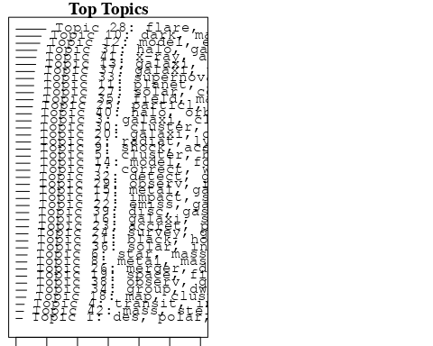

plotQuote(thoughts6, width = 30, main = "Topic 6")  
plotQuote(thoughts18, width = 30, main = "Topic 18")

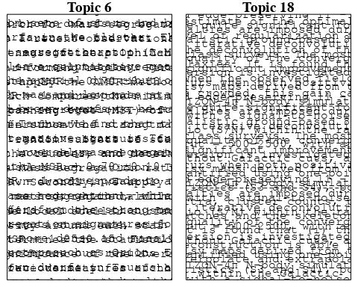

# Calculate and plot the correlation between topics  
mod.out.corr <- topicCorr(Research_topics)  
plot(mod.out.corr, cex = 1.5)  
  
  
# For each topic  
for (topic_num in 1:42) {  
 # Plot the word cloud  
 cloud(Research_topics, topic = topic_num, scale = c(2, 0.25))  
 Sys.sleep(2)  
}

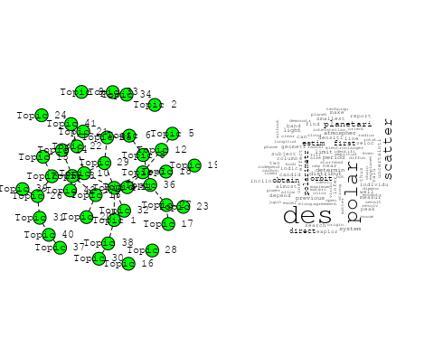

## Warning in wordcloud::wordcloud(words = vocab, freq = vec, max.words =  
## max.words, : radiat could not be fit on page. It will not be plotted.

## Warning in wordcloud::wordcloud(words = vocab, freq = vec, max.words =  
## max.words, : lyα could not be fit on page. It will not be plotted.

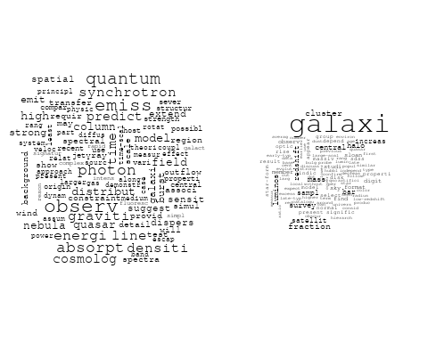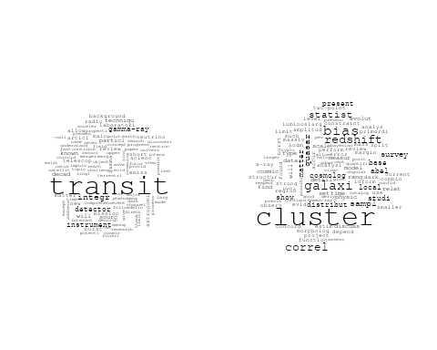

## Warning in wordcloud::wordcloud(words = vocab, freq = vec, max.words =  
## max.words, : correct could not be fit on page. It will not be plotted.

## Warning in wordcloud::wordcloud(words = vocab, freq = vec, max.words =  
## max.words, : magnitud could not be fit on page. It will not be plotted.

## Warning in wordcloud::wordcloud(words = vocab, freq = vec, max.words =  
## max.words, : first could not be fit on page. It will not be plotted.

## Warning in wordcloud::wordcloud(words = vocab, freq = vec, max.words =  
## max.words, : measur could not be fit on page. It will not be plotted.

## Warning in wordcloud::wordcloud(words = vocab, freq = vec, max.words =  
## max.words, : paper could not be fit on page. It will not be plotted.

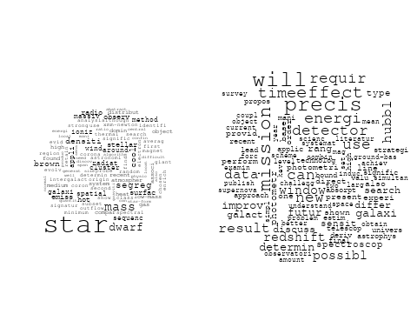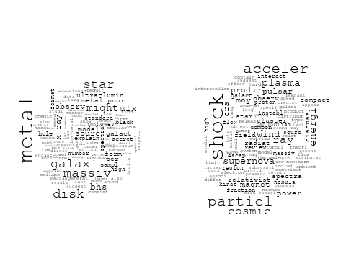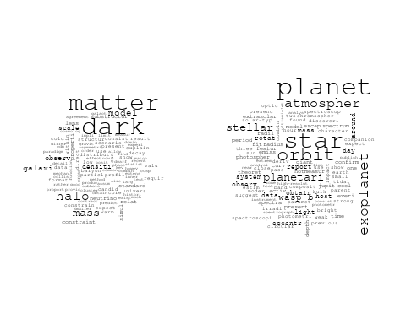

## Warning in wordcloud::wordcloud(words = vocab, freq = vec, max.words =  
## max.words, : energi could not be fit on page. It will not be plotted.

## Warning in wordcloud::wordcloud(words = vocab, freq = vec, max.words =  
## max.words, : cosmolog could not be fit on page. It will not be plotted.

## Warning in wordcloud::wordcloud(words = vocab, freq = vec, max.words =  
## max.words, : background could not be fit on page. It will not be plotted.

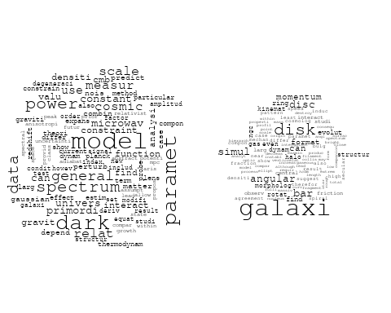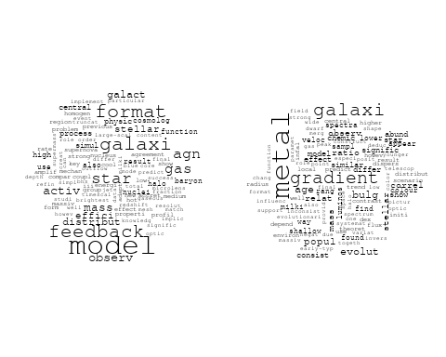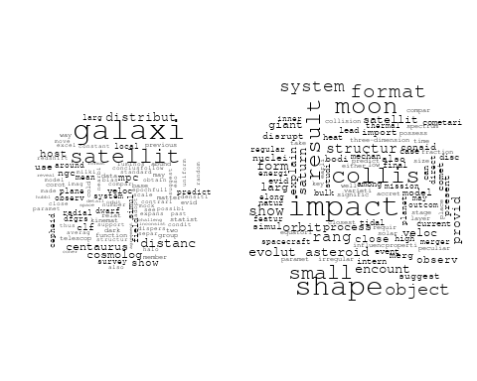

## Warning in wordcloud::wordcloud(words = vocab, freq = vec, max.words =  
## max.words, : redshift could not be fit on page. It will not be plotted.

## Warning in wordcloud::wordcloud(words = vocab, freq = vec, max.words =  
## max.words, : space could not be fit on page. It will not be plotted.

## Warning in wordcloud::wordcloud(words = vocab, freq = vec, max.words =  
## max.words, : sever could not be fit on page. It will not be plotted.

## Warning in wordcloud::wordcloud(words = vocab, freq = vec, max.words =  
## max.words, : field could not be fit on page. It will not be plotted.

## Warning in wordcloud::wordcloud(words = vocab, freq = vec, max.words =  
## max.words, : interstellar could not be fit on page. It will not be plotted.

## Warning in wordcloud::wordcloud(words = vocab, freq = vec, max.words =  
## max.words, : galaxi could not be fit on page. It will not be plotted.

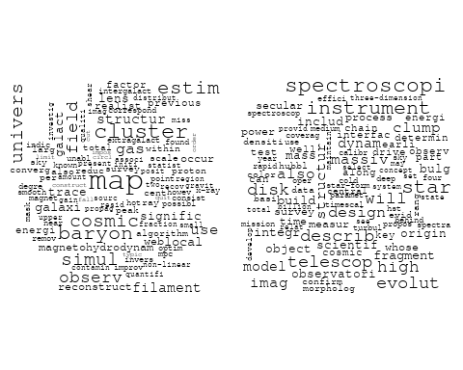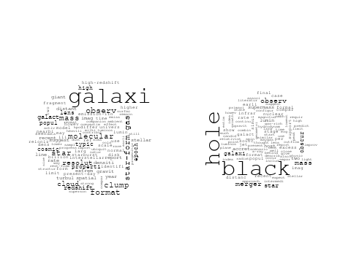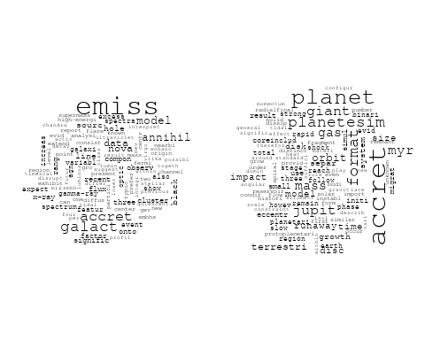

## Warning in wordcloud::wordcloud(words = vocab, freq = vec, max.words =  
## max.words, : survey could not be fit on page. It will not be plotted.

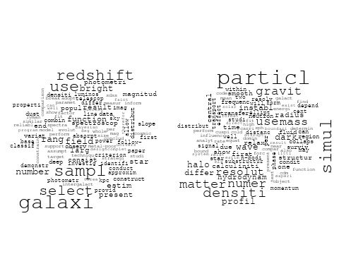

## Warning in wordcloud::wordcloud(words = vocab, freq = vec, max.words =  
## max.words, : meteorit could not be fit on page. It will not be plotted.

## Warning in wordcloud::wordcloud(words = vocab, freq = vec, max.words =  
## max.words, : composit could not be fit on page. It will not be plotted.

## Warning in wordcloud::wordcloud(words = vocab, freq = vec, max.words =  
## max.words, : element could not be fit on page. It will not be plotted.

## Warning in wordcloud::wordcloud(words = vocab, freq = vec, max.words =  
## max.words, : variat could not be fit on page. It will not be plotted.

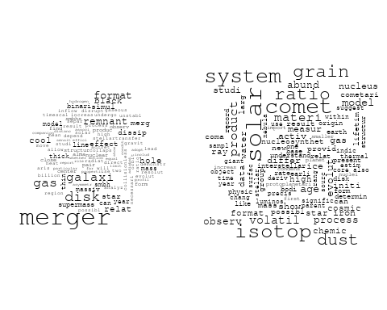

## Warning in wordcloud::wordcloud(words = vocab, freq = vec, max.words =  
## max.words, : observ could not be fit on page. It will not be plotted.

## Warning in wordcloud::wordcloud(words = vocab, freq = vec, max.words =  
## max.words, : differ could not be fit on page. It will not be plotted.

## Warning in wordcloud::wordcloud(words = vocab, freq = vec, max.words =  
## max.words, : coma could not be fit on page. It will not be plotted.

## Warning in wordcloud::wordcloud(words = vocab, freq = vec, max.words =  
## max.words, : investig could not be fit on page. It will not be plotted.

## Warning in wordcloud::wordcloud(words = vocab, freq = vec, max.words =  
## max.words, : angular could not be fit on page. It will not be plotted.

## Warning in wordcloud::wordcloud(words = vocab, freq = vec, max.words =  
## max.words, : identifi could not be fit on page. It will not be plotted.

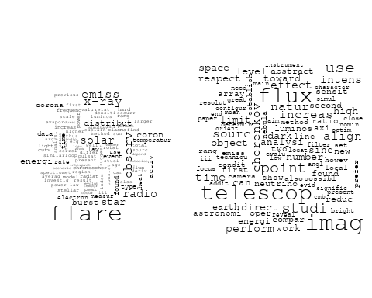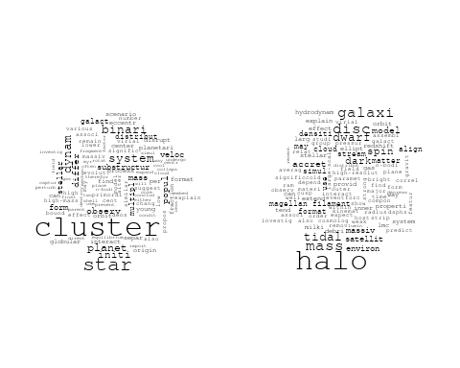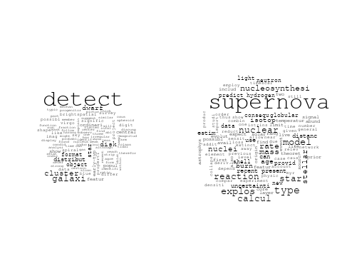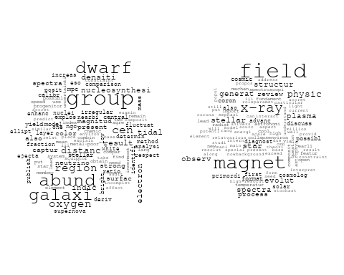

## Warning in wordcloud::wordcloud(words = vocab, freq = vec, max.words =  
## max.words, : halo could not be fit on page. It will not be plotted.

## Warning in wordcloud::wordcloud(words = vocab, freq = vec, max.words =  
## max.words, : distribut could not be fit on page. It will not be plotted.

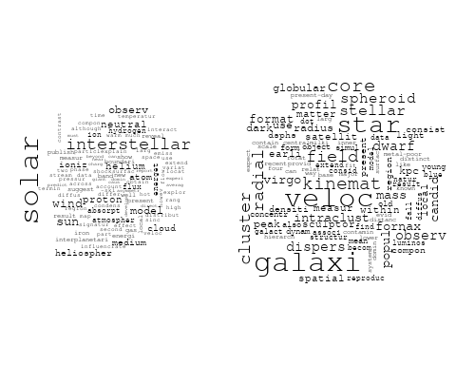

## Warning in wordcloud::wordcloud(words = vocab, freq = vec, max.words =  
## max.words, : observ could not be fit on page. It will not be plotted.

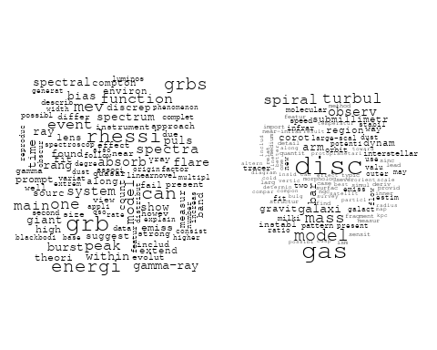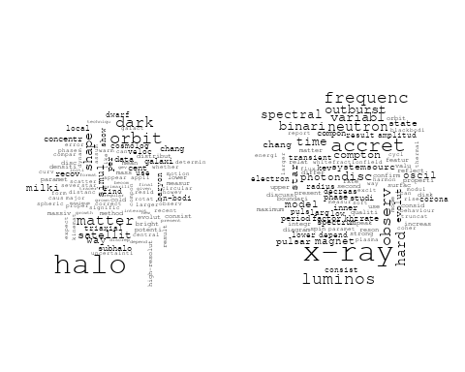

# Get the topic proportions for each document  
topic_proportions <- Research_topics$theta  
  
# Find the index of the topic with the highest proportion for each document  
# This will be the topic that each document is most likely to belong to  
max_topic_idx <- apply(topic_proportions, 1, which.max)  
  
# Add this as a new column to your data  
data_collab$topic <- max_topic_idx  
  
library(ggplot2)  
  
# Define the intervals  
intervals <- c('1824_1899', '1900_1964', '1965_1974', '1975_1984', '1985_1994', '1995_1999', '2000_2004', '2005_2009', '2010_2014', '2015_2019', '2020_2022')  
colors <- c('pink', 'blue', 'purple', 'yellow', 'green', 'pink', 'orange', 'violet', 'green', 'blue', 'pink')  
  
# Loop through the intervals and plot  
for(i in seq_along(intervals)){  
 # Filter data for when the pub_interval is equal to 1  
 data_filtered <- data_collab[data_collab[[paste0('pub_interval_', intervals[i])]] == 1,]  
   
 # Make the histogram  
   
 p <- ggplot(data_filtered, aes(x = topic)) +  
 geom_histogram(binwidth = 1, fill = colors[i], color = "black") +  
 xlab("Topic") +  
 ylab("Count") +  
 ggtitle(paste0("Topics from year ", gsub("_", " to ", intervals[i])))  
   
 print(p)  
}  
  
  
##Topic generation for CH (independent) publications  
  
data_independent <- data[data[["CH"]] == 100,]  
  
# Save the original title data for future use  
data_independent$original_concatenated_title_abstract <- data_independent$concatenated_title_abstract  
  
#pre-processing the titles using textProcessor from the stm package  
processed_text <- textProcessor(data_independent$concatenated_title_abstract, metadata = data_independent)

## Building corpus...   
## Converting to Lower Case...   
## Removing punctuation...   
## Removing stopwords...   
## Removing numbers...   
## Stemming...   
## Creating Output...

# Further prepare the data by removing low-frequency terms  
out_text <- prepDocuments(processed_text$documents, processed_text$vocab, processed_text$meta)

## Removing 901 of 3322 terms (901 of 24510 tokens) due to frequency   
## Your corpus now has 294 documents, 2421 terms and 23609 tokens.

docs_text <- out_text$documents  
vocab_text <- out_text$vocab  
meta_text <- out_text$meta  
  
  
#Prepare data  
plotRemoved(processed_text$documents, lower.thresh = seq(1, 200, by = 100))

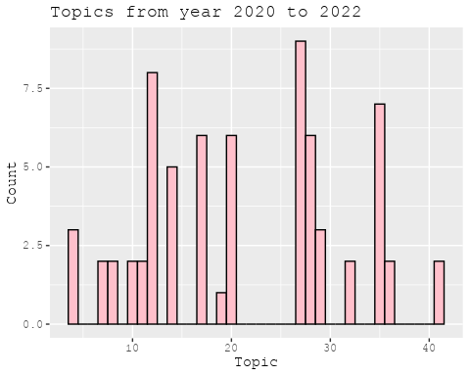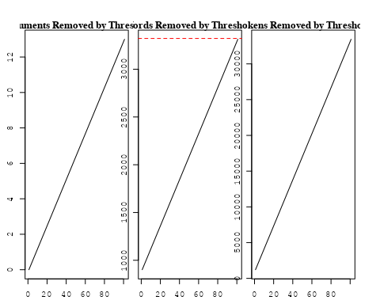

out_text <- prepDocuments(processed_text$documents, processed_text$vocab, processed_text$meta, lower.thresh = 8)

## Removing 2592 of 3322 terms (6801 of 24510 tokens) due to frequency   
## Your corpus now has 294 documents, 730 terms and 17709 tokens.

str(out_text$meta)

## 'data.frame': 294 obs. of 39 variables:  
## $ concept_id : chr "https://openalex.org/C44870925" "https://openalex.org/C44870925" "https://openalex.org/C44870925" "https://openalex.org/C44870925" ...  
## $ work_id : chr "https://openalex.org/W2055827975" "https://openalex.org/W2167125520" "https://openalex.org/W3098334024" "https://openalex.org/W3106489939" ...  
## $ publication_year : int 2007 2003 1996 2008 2020 2006 2020 2008 2006 2020 ...  
## $ title : chr "Cosmic magnetic fields and the CMB" "Dark matter and dark energy: summary and future directions" "Geological Isotope Anomalies as Signatures of Nearby Supernovae" "Small Dwarf Galaxies within Larger Dwarfs: Why Some Are Luminous while Most Go Dark" ...  
## $ paperabstract : chr "Abstract I describe the imprint which primordial magnetic fields can leave on the cosmic microwave background ("| __truncated__ "This paper reviews the progress reported at the Discussion Meeting and advertises some possible future directio"| __truncated__ "Nearby supernova explosions may cause geological isotope anomalies via the direct deposition of debris or by co"| __truncated__ "We consider the possibility that the Magellanic Clouds were the largest members of a group of dwarf galaxies th"| __truncated__ ...  
## $ country : chr "CH CH" "CH" "CH CH" "CH CH" ...  
## $ year_concept : chr "2007+https://openalex.org/C44870925" "2003+https://openalex.org/C44870925" "1996+https://openalex.org/C44870925" "2008+https://openalex.org/C44870925" ...  
## $ concatenated_title_abstract : chr "Cosmic magnetic fields and the CMB Abstract I describe the imprint which primordial magnetic fields can leave o"| __truncated__ "Dark matter and dark energy: summary and future directions This paper reviews the progress reported at the Disc"| __truncated__ "Geological Isotope Anomalies as Signatures of Nearby Supernovae Nearby supernova explosions may cause geologica"| __truncated__ "Small Dwarf Galaxies within Larger Dwarfs: Why Some Are Luminous while Most Go Dark We consider the possibility"| __truncated__ ...  
## $ US : num 0 0 0 0 0 0 0 0 0 0 ...  
## $ IN : num 0 0 0 0 0 0 0 0 0 0 ...  
## $ DE : num 0 0 0 0 0 0 0 0 0 0 ...  
## $ CH : num 100 100 100 100 100 100 100 100 100 100 ...  
## $ GB : num 0 0 0 0 0 0 0 0 0 0 ...  
## $ CN : num 0 0 0 0 0 0 0 0 0 0 ...  
## $ FR : num 0 0 0 0 0 0 0 0 0 0 ...  
## $ IT : num 0 0 0 0 0 0 0 0 0 0 ...  
## $ RU : num 0 0 0 0 0 0 0 0 0 0 ...  
## $ CA : num 0 0 0 0 0 0 0 0 0 0 ...  
## $ NL : num 0 0 0 0 0 0 0 0 0 0 ...  
## $ AU : num 0 0 0 0 0 0 0 0 0 0 ...  
## $ JP : num 0 0 0 0 0 0 0 0 0 0 ...  
## $ ES : num 0 0 0 0 0 0 0 0 0 0 ...  
## $ IL : num 0 0 0 0 0 0 0 0 0 0 ...  
## $ Americas : num 0 0 0 0 0 0 0 0 0 0 ...  
## $ Europe : num 0 0 0 0 0 0 0 0 0 0 ...  
## $ Africa : num 0 0 0 0 0 0 0 0 0 0 ...  
## $ AsiaAndOceania : num 0 0 0 0 0 0 0 0 0 0 ...  
## $ pub_interval_2020_2022 : int 0 0 0 0 1 0 1 0 0 1 ...  
## $ pub_interval_2015_2019 : int 0 0 0 0 0 0 0 0 0 0 ...  
## $ pub_interval_2010_2014 : int 0 0 0 0 0 0 0 0 0 0 ...  
## $ pub_interval_2005_2009 : int 1 0 0 1 0 1 0 1 1 0 ...  
## $ pub_interval_2000_2004 : int 0 1 0 0 0 0 0 0 0 0 ...  
## $ pub_interval_1995_1999 : int 0 0 1 0 0 0 0 0 0 0 ...  
## $ pub_interval_1985_1994 : int 0 0 0 0 0 0 0 0 0 0 ...  
## $ pub_interval_1975_1984 : int 0 0 0 0 0 0 0 0 0 0 ...  
## $ pub_interval_1965_1974 : int 0 0 0 0 0 0 0 0 0 0 ...  
## $ pub_interval_1900_1964 : int 0 0 0 0 0 0 0 0 0 0 ...  
## $ pub_interval_1824_1899 : int 0 0 0 0 0 0 0 0 0 0 ...  
## $ original_concatenated_title_abstract: chr "Cosmic magnetic fields and the CMB Abstract I describe the imprint which primordial magnetic fields can leave o"| __truncated__ "Dark matter and dark energy: summary and future directions This paper reviews the progress reported at the Disc"| __truncated__ "Geological Isotope Anomalies as Signatures of Nearby Supernovae Nearby supernova explosions may cause geologica"| __truncated__ "Small Dwarf Galaxies within Larger Dwarfs: Why Some Are Luminous while Most Go Dark We consider the possibility"| __truncated__ ...

# Initialize an empty formula string  
prevalence_formula_str <- "~"  
  
# Define the publication intervals  
pub_intervals <- c("pub_interval_2020_2022", "pub_interval_2015_2019", "pub_interval_2010_2014",   
 "pub_interval_2005_2009", "pub_interval_2000_2004", "pub_interval_1995_1999",  
 "pub_interval_1985_1994", "pub_interval_1975_1984", "pub_interval_1965_1974",  
 "pub_interval_1900_1964", "pub_interval_1824_1899")  
  
# Add each publication interval to the formula string  
for (interval in pub_intervals) {  
 # add an if statement to handle the first addition (without '+')  
 if (prevalence_formula_str == "~") {  
 prevalence_formula_str <- paste(prevalence_formula_str, interval)  
 } else {  
 prevalence_formula_str <- paste(prevalence_formula_str, "+", interval)  
 }  
}  
  
  
# Convert the string to a formula  
prevalence_formula <- as.formula(prevalence_formula_str)  
print(prevalence_formula)

## ~pub_interval_2020_2022 + pub_interval_2015_2019 + pub_interval_2010_2014 +   
## pub_interval_2005_2009 + pub_interval_2000_2004 + pub_interval_1995_1999 +   
## pub_interval_1985_1994 + pub_interval_1975_1984 + pub_interval_1965_1974 +   
## pub_interval_1900_1964 + pub_interval_1824_1899

# Run STM model  
Research_topics <- stm(documents = out_text$documents,   
 vocab = out_text$vocab,   
 K = 35,   
 prevalence = prevalence_formula,   
 data = out_text$meta,   
 init.type = "Spectral",  
 max.em.its = 1000,  
 gamma.prior = 'L1')

## Beginning Spectral Initialization   
## Calculating the gram matrix...  
## Finding anchor words...  
## ...................................  
## Recovering initialization...  
## .......  
## Initialization complete.  
## ...................................................................................................................................................  
## Completed E-Step (0 seconds).   
## Completed M-Step.   
## Completing Iteration 1 (approx. per word bound = -5.449)   
## ...................................................................................................................................................  
## Completed E-Step (0 seconds).   
## Completed M-Step.   
## Completing Iteration 2 (approx. per word bound = -5.245, relative change = 3.746e-02)   
## ...................................................................................................................................................  
## Completed E-Step (0 seconds).   
## Completed M-Step.   
## Completing Iteration 3 (approx. per word bound = -5.166, relative change = 1.511e-02)   
## ...................................................................................................................................................  
## Completed E-Step (0 seconds).   
## Completed M-Step.   
## Completing Iteration 4 (approx. per word bound = -5.126, relative change = 7.796e-03)   
## ...................................................................................................................................................  
## Completed E-Step (0 seconds).   
## Completed M-Step.   
## Completing Iteration 5 (approx. per word bound = -5.101, relative change = 4.728e-03)   
## Topic 1: may, equival, emiss, produc, predict   
## Topic 2: dwarf, dark, galaxi, energi, cdm   
## Topic 3: cluster, star, planet, veloc, dynam   
## Topic 4: model, galaxi, feedback, activ, galact   
## Topic 5: dark, matter, halo, gravit, galaxi   
## Topic 6: instrument, design, power, requir, photometr   
## Topic 7: number, time, particl, first, achiev   
## Topic 8: galaxi, bar, ellipt, dynam, ngc   
## Topic 9: constraint, photon, paramet, model, relat   
## Topic 10: star, orbit, stellar, planet, sun   
## Topic 11: halo, cluster, mass, filament, structur   
## Topic 12: band, spectrum, function, line, can   
## Topic 13: evolut, format, studi, observ, model   
## Topic 14: supernova, bias, spectra, can, system   
## Topic 15: field, magnet, observ, cosmic, cosmolog   
## Topic 16: mass, nuclear, merger, star, densiti   
## Topic 17: disc, shock, particl, system, spiral   
## Topic 18: impact, planet, giant, format, result   
## Topic 19: galaxi, des, cluster, disk, distribut   
## Topic 20: neutrino, dark, matter, model, univers   
## Topic 21: accret, myr, mass, gas, solar   
## Topic 22: model, observ, stellar, kinemat, tidal   
## Topic 23: star, stellar, x-ray, radio, emiss   
## Topic 24: star, gas, metal, galact, form   
## Topic 25: radiat, cosmolog, cosmic, background, microwav   
## Topic 26: galaxi, black, hole, format, gas   
## Topic 27: satellit, galaxi, densiti, distribut, simul   
## Topic 28: distanc, mpc, ngc, galaxi, local   
## Topic 29: flare, observ, polar, solar, time   
## Topic 30: clump, resolut, galaxi, lens, observ   
## Topic 31: isotop, ratio, meteorit, data, effect   
## Topic 32: dark, matter, detector, detect, direct   
## Topic 33: record, solar, cosmic, ray, howev   
## Topic 34: data, use, galaxi, hubbl, improv   
## Topic 35: local, tracer, matter, dark, star   
## ...................................................................................................................................................  
## Completed E-Step (0 seconds).   
## Completed M-Step.   
## Completing Iteration 6 (approx. per word bound = -5.084, relative change = 3.511e-03)   
## ...................................................................................................................................................  
## Completed E-Step (0 seconds).   
## Completed M-Step.   
## Completing Iteration 7 (approx. per word bound = -5.070, relative change = 2.757e-03)   
## ...................................................................................................................................................  
## Completed E-Step (0 seconds).   
## Completed M-Step.   
## Completing Iteration 8 (approx. per word bound = -5.060, relative change = 1.962e-03)   
## ...................................................................................................................................................  
## Completed E-Step (0 seconds).   
## Completed M-Step.   
## Completing Iteration 9 (approx. per word bound = -5.052, relative change = 1.545e-03)   
## ...................................................................................................................................................  
## Completed E-Step (0 seconds).   
## Completed M-Step.   
## Completing Iteration 10 (approx. per word bound = -5.045, relative change = 1.333e-03)   
## Topic 1: may, equival, gas, line, emiss   
## Topic 2: dwarf, galaxi, strip, cdm, satellit   
## Topic 3: cluster, star, planet, dynam, veloc   
## Topic 4: galaxi, model, feedback, activ, galact   
## Topic 5: dark, matter, halo, galaxi, gravit   
## Topic 6: instrument, design, redshift, requir, photometr   
## Topic 7: time, particl, first, number, achiev   
## Topic 8: galaxi, bar, dynam, ellipt, rotat   
## Topic 9: dark, redshift, energi, model, paramet   
## Topic 10: star, orbit, stellar, planet, sun   
## Topic 11: halo, cluster, mass, filament, format   
## Topic 12: band, spectrum, line, function, energi   
## Topic 13: format, evolut, studi, observ, galaxi   
## Topic 14: supernova, bias, spectra, can, system   
## Topic 15: field, magnet, observ, cosmic, cosmolog   
## Topic 16: mass, star, nuclear, densiti, cluster   
## Topic 17: disc, particl, shock, spiral, momentum   
## Topic 18: impact, planet, giant, format, terrestri   
## Topic 19: des, galaxi, cluster, disk, dwarf   
## Topic 20: neutrino, matter, model, dark, cosmolog   
## Topic 21: accret, myr, mass, gas, solar   
## Topic 22: model, observ, stellar, kinemat, tidal   
## Topic 23: star, stellar, x-ray, radio, emiss   
## Topic 24: star, gas, metal, galact, format   
## Topic 25: radiat, cosmolog, cosmic, background, microwav   
## Topic 26: black, hole, galaxi, gas, format   
## Topic 27: satellit, galaxi, distribut, densiti, radial   
## Topic 28: distanc, mpc, ngc, local, mean   
## Topic 29: flare, observ, polar, solar, x-ray   
## Topic 30: clump, resolut, galaxi, star, imag   
## Topic 31: isotop, ratio, meteorit, data, product   
## Topic 32: dark, matter, detector, detect, direct   
## Topic 33: record, cosmic, solar, ray, process   
## Topic 34: use, data, improv, hubbl, lens   
## Topic 35: local, tracer, matter, dark, densiti   
## ...................................................................................................................................................  
## Completed E-Step (0 seconds).   
## Completed M-Step.   
## Completing Iteration 11 (approx. per word bound = -5.040, relative change = 1.080e-03)   
## ...................................................................................................................................................  
## Completed E-Step (0 seconds).   
## Completed M-Step.   
## Completing Iteration 12 (approx. per word bound = -5.036, relative change = 7.597e-04)   
## ...................................................................................................................................................  
## Completed E-Step (0 seconds).   
## Completed M-Step.   
## Completing Iteration 13 (approx. per word bound = -5.033, relative change = 6.147e-04)   
## ...................................................................................................................................................  
## Completed E-Step (0 seconds).   
## Completed M-Step.   
## Completing Iteration 14 (approx. per word bound = -5.030, relative change = 6.244e-04)   
## ...................................................................................................................................................  
## Completed E-Step (0 seconds).   
## Completed M-Step.   
## Completing Iteration 15 (approx. per word bound = -5.027, relative change = 5.655e-04)   
## Topic 1: may, gas, equival, dens, line   
## Topic 2: dwarf, galaxi, cdm, strip, cloud   
## Topic 3: cluster, star, planet, veloc, dynam   
## Topic 4: galaxi, model, feedback, activ, galact   
## Topic 5: dark, halo, matter, galaxi, gravit   
## Topic 6: instrument, redshift, design, precis, requir   
## Topic 7: time, particl, number, first, achiev   
## Topic 8: galaxi, bar, dynam, ellipt, ngc   
## Topic 9: dark, energi, redshift, model, photon   
## Topic 10: star, orbit, stellar, planet, sun   
## Topic 11: halo, cluster, mass, filament, format   
## Topic 12: band, spectrum, line, function, energi   
## Topic 13: format, evolut, galaxi, studi, disc   
## Topic 14: supernova, bias, spectra, system, can   
## Topic 15: field, magnet, observ, cosmic, cosmolog   
## Topic 16: mass, star, nuclear, densiti, cluster   
## Topic 17: disc, particl, shock, spiral, momentum   
## Topic 18: impact, planet, giant, format, terrestri   
## Topic 19: des, galaxi, cluster, disk, dwarf   
## Topic 20: neutrino, model, matter, dark, cosmolog   
## Topic 21: accret, myr, mass, solar, gas   
## Topic 22: model, observ, stellar, kinemat, galaxi   
## Topic 23: star, stellar, x-ray, radio, emiss   
## Topic 24: gas, star, metal, format, galact   
## Topic 25: radiat, cosmolog, cosmic, background, microwav   
## Topic 26: black, hole, galaxi, gas, format   
## Topic 27: satellit, galaxi, distribut, densiti, radial   
## Topic 28: distanc, mpc, ngc, local, mean   
## Topic 29: flare, observ, polar, solar, x-ray   
## Topic 30: clump, resolut, galaxi, imag, observ   
## Topic 31: isotop, ratio, meteorit, product, data   
## Topic 32: dark, matter, detector, detect, direct   
## Topic 33: record, cosmic, solar, ray, process   
## Topic 34: use, improv, hubbl, data, lens   
## Topic 35: local, tracer, matter, dark, densiti   
## ...................................................................................................................................................  
## Completed E-Step (0 seconds).   
## Completed M-Step.   
## Completing Iteration 16 (approx. per word bound = -5.024, relative change = 5.013e-04)   
## ...................................................................................................................................................  
## Completed E-Step (0 seconds).   
## Completed M-Step.   
## Completing Iteration 17 (approx. per word bound = -5.022, relative change = 4.897e-04)   
## ...................................................................................................................................................  
## Completed E-Step (0 seconds).   
## Completed M-Step.   
## Completing Iteration 18 (approx. per word bound = -5.019, relative change = 4.988e-04)   
## ...................................................................................................................................................  
## Completed E-Step (0 seconds).   
## Completed M-Step.   
## Completing Iteration 19 (approx. per word bound = -5.017, relative change = 4.094e-04)   
## ...................................................................................................................................................  
## Completed E-Step (0 seconds).   
## Completed M-Step.   
## Completing Iteration 20 (approx. per word bound = -5.015, relative change = 3.623e-04)   
## Topic 1: may, gas, equival, dens, line   
## Topic 2: dwarf, galaxi, cdm, strip, cloud   
## Topic 3: cluster, star, planet, veloc, dynam   
## Topic 4: galaxi, model, feedback, activ, galact   
## Topic 5: halo, dark, matter, galaxi, gravit   
## Topic 6: redshift, design, precis, instrument, requir   
## Topic 7: time, particl, achiev, first, number   
## Topic 8: galaxi, bar, dynam, ellipt, ngc   
## Topic 9: dark, energi, redshift, photon, model   
## Topic 10: star, orbit, stellar, planet, sun   
## Topic 11: halo, cluster, mass, filament, format   
## Topic 12: band, spectrum, line, function, energi   
## Topic 13: format, evolut, galaxi, studi, disc   
## Topic 14: supernova, bias, system, can, spectra   
## Topic 15: field, magnet, observ, cosmic, cosmolog   
## Topic 16: mass, star, densiti, nuclear, cluster   
## Topic 17: disc, particl, shock, format, momentum   
## Topic 18: impact, planet, giant, format, terrestri   
## Topic 19: des, galaxi, cluster, disk, dwarf   
## Topic 20: neutrino, matter, model, dark, standard   
## Topic 21: accret, myr, solar, mass, gas   
## Topic 22: model, observ, galaxi, stellar, distribut   
## Topic 23: star, stellar, x-ray, radio, emiss   
## Topic 24: gas, metal, star, format, galact   
## Topic 25: radiat, cosmolog, cosmic, background, microwav   
## Topic 26: black, hole, galaxi, gas, format   
## Topic 27: satellit, galaxi, distribut, densiti, radial   
## Topic 28: distanc, mpc, ngc, local, mean   
## Topic 29: flare, observ, polar, solar, x-ray   
## Topic 30: clump, galaxi, resolut, imag, observ   
## Topic 31: isotop, ratio, meteorit, product, data   
## Topic 32: dark, matter, detector, detect, direct   
## Topic 33: record, cosmic, solar, ray, process   
## Topic 34: use, improv, hubbl, lens, time   
## Topic 35: local, tracer, matter, dark, densiti   
## ...................................................................................................................................................  
## Completed E-Step (0 seconds).   
## Completed M-Step.   
## Completing Iteration 21 (approx. per word bound = -5.014, relative change = 3.490e-04)   
## ...................................................................................................................................................  
## Completed E-Step (0 seconds).   
## Completed M-Step.   
## Completing Iteration 22 (approx. per word bound = -5.012, relative change = 3.349e-04)   
## ...................................................................................................................................................  
## Completed E-Step (0 seconds).   
## Completed M-Step.   
## Completing Iteration 23 (approx. per word bound = -5.010, relative change = 3.179e-04)   
## ...................................................................................................................................................  
## Completed E-Step (0 seconds).   
## Completed M-Step.   
## Completing Iteration 24 (approx. per word bound = -5.009, relative change = 2.640e-04)   
## ...................................................................................................................................................  
## Completed E-Step (0 seconds).   
## Completed M-Step.   
## Completing Iteration 25 (approx. per word bound = -5.008, relative change = 2.522e-04)   
## Topic 1: may, gas, equival, dens, line   
## Topic 2: dwarf, galaxi, cdm, strip, cloud   
## Topic 3: cluster, star, planet, veloc, dynam   
## Topic 4: galaxi, model, feedback, activ, galact   
## Topic 5: halo, dark, matter, galaxi, gravit   
## Topic 6: redshift, design, precis, instrument, requir   
## Topic 7: time, particl, achiev, first, number   
## Topic 8: galaxi, bar, dynam, ellipt, ngc   
## Topic 9: dark, energi, redshift, photon, model   
## Topic 10: star, orbit, stellar, planet, sun   
## Topic 11: halo, cluster, mass, filament, format   
## Topic 12: band, spectrum, line, energi, function   
## Topic 13: format, evolut, galaxi, studi, disc   
## Topic 14: supernova, system, bias, can, spectra   
## Topic 15: field, magnet, observ, cosmic, cosmolog   
## Topic 16: mass, star, densiti, nuclear, cluster   
## Topic 17: disc, particl, shock, format, momentum   
## Topic 18: impact, planet, giant, format, terrestri   
## Topic 19: des, galaxi, cluster, disk, dwarf   
## Topic 20: neutrino, model, matter, dark, standard   
## Topic 21: accret, myr, mass, gas, solar   
## Topic 22: model, observ, distribut, galaxi, stellar   
## Topic 23: star, stellar, x-ray, radio, emiss   
## Topic 24: gas, metal, star, format, galact   
## Topic 25: radiat, cosmolog, background, cosmic, constraint   
## Topic 26: black, hole, galaxi, gas, format   
## Topic 27: satellit, galaxi, distribut, densiti, radial   
## Topic 28: distanc, mpc, ngc, local, mean   
## Topic 29: flare, observ, polar, solar, x-ray   
## Topic 30: clump, galaxi, resolut, imag, observ   
## Topic 31: isotop, ratio, meteorit, product, data   
## Topic 32: dark, matter, detector, detect, direct   
## Topic 33: record, cosmic, solar, ray, process   
## Topic 34: use, improv, hubbl, lens, time   
## Topic 35: local, tracer, matter, dark, densiti   
## ...................................................................................................................................................  
## Completed E-Step (0 seconds).   
## Completed M-Step.   
## Completing Iteration 26 (approx. per word bound = -5.006, relative change = 2.796e-04)   
## ...................................................................................................................................................  
## Completed E-Step (0 seconds).   
## Completed M-Step.   
## Completing Iteration 27 (approx. per word bound = -5.005, relative change = 2.276e-04)   
## ...................................................................................................................................................  
## Completed E-Step (0 seconds).   
## Completed M-Step.   
## Completing Iteration 28 (approx. per word bound = -5.004, relative change = 1.841e-04)   
## ...................................................................................................................................................  
## Completed E-Step (0 seconds).   
## Completed M-Step.   
## Completing Iteration 29 (approx. per word bound = -5.003, relative change = 1.623e-04)   
## ...................................................................................................................................................  
## Completed E-Step (0 seconds).   
## Completed M-Step.   
## Completing Iteration 30 (approx. per word bound = -5.003, relative change = 1.622e-04)   
## Topic 1: gas, may, equival, dens, line   
## Topic 2: dwarf, galaxi, cdm, strip, cloud   
## Topic 3: cluster, star, planet, veloc, dynam   
## Topic 4: galaxi, model, feedback, galact, central   
## Topic 5: halo, dark, matter, galaxi, gravit   
## Topic 6: redshift, design, precis, instrument, requir   
## Topic 7: time, particl, achiev, first, simul   
## Topic 8: galaxi, bar, ellipt, dynam, ngc   
## Topic 9: dark, energi, redshift, photon, model   
## Topic 10: star, orbit, planet, stellar, sun   
## Topic 11: halo, cluster, mass, filament, format   
## Topic 12: band, spectrum, line, energi, emiss   
## Topic 13: format, evolut, galaxi, studi, disc   
## Topic 14: supernova, system, bias, can, spectra   
## Topic 15: field, magnet, observ, cosmic, cosmolog   
## Topic 16: mass, star, densiti, nuclear, cluster   
## Topic 17: disc, shock, particl, format, momentum   
## Topic 18: impact, planet, giant, format, terrestri   
## Topic 19: des, galaxi, cluster, disk, dwarf   
## Topic 20: neutrino, model, matter, dark, standard   
## Topic 21: accret, myr, mass, solar, gas   
## Topic 22: model, observ, distribut, galaxi, stellar   
## Topic 23: star, stellar, x-ray, radio, emiss   
## Topic 24: gas, metal, star, format, galaxi   
## Topic 25: radiat, cosmolog, background, cosmic, constraint   
## Topic 26: black, hole, galaxi, gas, format   
## Topic 27: satellit, galaxi, distribut, densiti, radial   
## Topic 28: distanc, mpc, ngc, local, mean   
## Topic 29: flare, observ, polar, solar, x-ray   
## Topic 30: clump, galaxi, resolut, imag, observ   
## Topic 31: isotop, ratio, meteorit, product, data   
## Topic 32: dark, matter, detector, detect, direct   
## Topic 33: record, cosmic, solar, ray, galaxi   
## Topic 34: use, improv, lens, hubbl, time   
## Topic 35: local, tracer, matter, dark, densiti   
## ...................................................................................................................................................  
## Completed E-Step (0 seconds).   
## Completed M-Step.   
## Completing Iteration 31 (approx. per word bound = -5.002, relative change = 1.381e-04)   
## ...................................................................................................................................................  
## Completed E-Step (0 seconds).   
## Completed M-Step.   
## Completing Iteration 32 (approx. per word bound = -5.001, relative change = 1.434e-04)   
## ...................................................................................................................................................  
## Completed E-Step (0 seconds).   
## Completed M-Step.   
## Completing Iteration 33 (approx. per word bound = -5.001, relative change = 1.378e-04)   
## ...................................................................................................................................................  
## Completed E-Step (0 seconds).   
## Completed M-Step.   
## Completing Iteration 34 (approx. per word bound = -5.000, relative change = 1.226e-04)   
## ...................................................................................................................................................  
## Completed E-Step (0 seconds).   
## Completed M-Step.   
## Completing Iteration 35 (approx. per word bound = -4.999, relative change = 1.256e-04)   
## Topic 1: gas, may, equival, dens, line   
## Topic 2: dwarf, galaxi, cdm, strip, cloud   
## Topic 3: cluster, star, planet, veloc, dynam   
## Topic 4: galaxi, model, feedback, galact, central   
## Topic 5: halo, dark, galaxi, matter, gravit   
## Topic 6: redshift, design, precis, requir, photometr   
## Topic 7: time, particl, achiev, first, simul   
## Topic 8: galaxi, bar, ellipt, dynam, ngc   
## Topic 9: dark, energi, redshift, photon, model   
## Topic 10: star, orbit, planet, stellar, sun   
## Topic 11: halo, cluster, mass, filament, format   
## Topic 12: band, spectrum, energi, emiss, line   
## Topic 13: format, evolut, galaxi, studi, disc   
## Topic 14: supernova, system, bias, can, spectra   
## Topic 15: field, magnet, observ, cosmic, cosmolog   
## Topic 16: mass, star, densiti, nuclear, cluster   
## Topic 17: disc, shock, particl, format, momentum   
## Topic 18: impact, planet, giant, format, terrestri   
## Topic 19: des, galaxi, cluster, disk, dwarf   
## Topic 20: neutrino, model, matter, dark, standard   
## Topic 21: accret, myr, mass, solar, gas   
## Topic 22: model, observ, galaxi, distribut, stellar   
## Topic 23: star, stellar, x-ray, radio, emiss   
## Topic 24: gas, metal, star, format, galaxi   
## Topic 25: radiat, cosmolog, background, cosmic, data   
## Topic 26: black, hole, galaxi, gas, format   
## Topic 27: satellit, galaxi, distribut, densiti, radial   
## Topic 28: distanc, mpc, ngc, local, mean   
## Topic 29: flare, observ, polar, solar, x-ray   
## Topic 30: clump, galaxi, resolut, imag, observ   
## Topic 31: isotop, ratio, meteorit, product, data   
## Topic 32: dark, matter, detector, detect, direct   
## Topic 33: record, cosmic, solar, ray, galaxi   
## Topic 34: use, improv, lens, time, hubbl   
## Topic 35: local, tracer, matter, dark, densiti   
## ...................................................................................................................................................  
## Completed E-Step (0 seconds).   
## Completed M-Step.   
## Completing Iteration 36 (approx. per word bound = -4.999, relative change = 1.249e-04)   
## ...................................................................................................................................................  
## Completed E-Step (0 seconds).   
## Completed M-Step.   
## Completing Iteration 37 (approx. per word bound = -4.998, relative change = 1.182e-04)   
## ...................................................................................................................................................  
## Completed E-Step (0 seconds).   
## Completed M-Step.   
## Completing Iteration 38 (approx. per word bound = -4.998, relative change = 1.126e-04)   
## ...................................................................................................................................................  
## Completed E-Step (0 seconds).   
## Completed M-Step.   
## Completing Iteration 39 (approx. per word bound = -4.997, relative change = 1.112e-04)   
## ...................................................................................................................................................  
## Completed E-Step (0 seconds).   
## Completed M-Step.   
## Completing Iteration 40 (approx. per word bound = -4.996, relative change = 1.094e-04)   
## Topic 1: gas, may, equival, dens, line   
## Topic 2: dwarf, galaxi, cdm, strip, cloud   
## Topic 3: cluster, star, planet, veloc, dynam   
## Topic 4: galaxi, model, feedback, galact, central   
## Topic 5: halo, dark, galaxi, matter, gravit   
## Topic 6: redshift, design, precis, requir, photometr   
## Topic 7: time, particl, achiev, simul, first   
## Topic 8: galaxi, bar, ellipt, dynam, ngc   
## Topic 9: dark, energi, redshift, photon, model   
## Topic 10: star, orbit, planet, stellar, sun   
## Topic 11: halo, cluster, mass, filament, format   
## Topic 12: band, emiss, energi, spectrum, line   
## Topic 13: format, evolut, galaxi, studi, disc   
## Topic 14: supernova, system, bias, can, spectra   
## Topic 15: field, magnet, observ, cosmic, cosmolog   
## Topic 16: mass, star, densiti, nuclear, cluster   
## Topic 17: disc, shock, particl, format, momentum   
## Topic 18: impact, planet, giant, format, terrestri   
## Topic 19: des, galaxi, cluster, disk, dwarf   
## Topic 20: neutrino, model, dark, matter, standard   
## Topic 21: accret, myr, mass, solar, gas   
## Topic 22: model, observ, galaxi, distribut, stellar   
## Topic 23: star, stellar, x-ray, radio, emiss   
## Topic 24: gas, metal, star, format, galaxi   
## Topic 25: radiat, cosmolog, background, cosmic, constraint   
## Topic 26: black, hole, galaxi, gas, format   
## Topic 27: satellit, galaxi, distribut, densiti, radial   
## Topic 28: distanc, mpc, ngc, local, mean   
## Topic 29: flare, observ, polar, solar, x-ray   
## Topic 30: clump, galaxi, resolut, imag, observ   
## Topic 31: isotop, ratio, meteorit, product, data   
## Topic 32: dark, matter, detector, detect, direct   
## Topic 33: record, cosmic, solar, ray, galaxi   
## Topic 34: use, improv, lens, time, hubbl   
## Topic 35: local, tracer, matter, dark, densiti   
## ...................................................................................................................................................  
## Completed E-Step (0 seconds).   
## Completed M-Step.   
## Completing Iteration 41 (approx. per word bound = -4.996, relative change = 1.127e-04)   
## ...................................................................................................................................................  
## Completed E-Step (0 seconds).   
## Completed M-Step.   
## Completing Iteration 42 (approx. per word bound = -4.995, relative change = 9.582e-05)   
## ...................................................................................................................................................  
## Completed E-Step (0 seconds).   
## Completed M-Step.   
## Completing Iteration 43 (approx. per word bound = -4.995, relative change = 6.008e-05)   
## ...................................................................................................................................................  
## Completed E-Step (0 seconds).   
## Completed M-Step.   
## Completing Iteration 44 (approx. per word bound = -4.995, relative change = 5.975e-05)   
## ...................................................................................................................................................  
## Completed E-Step (0 seconds).   
## Completed M-Step.   
## Completing Iteration 45 (approx. per word bound = -4.994, relative change = 5.855e-05)   
## Topic 1: gas, may, equival, dens, line   
## Topic 2: dwarf, galaxi, cdm, strip, can   
## Topic 3: cluster, star, planet, veloc, dynam   
## Topic 4: galaxi, model, feedback, galact, central   
## Topic 5: halo, dark, galaxi, matter, gravit   
## Topic 6: redshift, design, precis, requir, photometr   
## Topic 7: time, particl, achiev, simul, first   
## Topic 8: galaxi, bar, ellipt, dynam, ngc   
## Topic 9: dark, energi, redshift, photon, model   
## Topic 10: star, orbit, planet, stellar, sun   
## Topic 11: halo, cluster, mass, filament, format   
## Topic 12: band, emiss, energi, spectrum, line   
## Topic 13: format, evolut, galaxi, studi, disc   
## Topic 14: supernova, system, bias, can, spectra   
## Topic 15: field, magnet, observ, cosmic, cosmolog   
## Topic 16: mass, star, densiti, nuclear, cluster   
## Topic 17: disc, shock, particl, format, momentum   
## Topic 18: impact, planet, giant, format, terrestri   
## Topic 19: des, galaxi, cluster, disk, dwarf   
## Topic 20: neutrino, model, dark, matter, standard   
## Topic 21: accret, myr, mass, solar, gas   
## Topic 22: model, observ, galaxi, distribut, stellar   
## Topic 23: star, stellar, x-ray, radio, emiss   
## Topic 24: gas, metal, star, format, galaxi   
## Topic 25: radiat, cosmolog, background, cosmic, constraint   
## Topic 26: black, hole, galaxi, gas, format   
## Topic 27: satellit, galaxi, distribut, densiti, radial   
## Topic 28: distanc, mpc, ngc, local, mean   
## Topic 29: flare, observ, polar, solar, x-ray   
## Topic 30: clump, galaxi, resolut, imag, observ   
## Topic 31: isotop, ratio, meteorit, product, data   
## Topic 32: dark, matter, detector, detect, direct   
## Topic 33: record, cosmic, solar, ray, galaxi   
## Topic 34: use, improv, lens, time, hubbl   
## Topic 35: local, tracer, matter, dark, densiti   
## ...................................................................................................................................................  
## Completed E-Step (0 seconds).   
## Completed M-Step.   
## Completing Iteration 46 (approx. per word bound = -4.994, relative change = 4.945e-05)   
## ...................................................................................................................................................  
## Completed E-Step (0 seconds).   
## Completed M-Step.   
## Completing Iteration 47 (approx. per word bound = -4.994, relative change = 4.770e-05)   
## ...................................................................................................................................................  
## Completed E-Step (0 seconds).   
## Completed M-Step.   
## Completing Iteration 48 (approx. per word bound = -4.994, relative change = 4.286e-05)   
## ...................................................................................................................................................  
## Completed E-Step (0 seconds).   
## Completed M-Step.   
## Completing Iteration 49 (approx. per word bound = -4.994, relative change = 4.070e-05)   
## ...................................................................................................................................................  
## Completed E-Step (0 seconds).   
## Completed M-Step.   
## Completing Iteration 50 (approx. per word bound = -4.993, relative change = 4.481e-05)   
## Topic 1: gas, may, equival, dens, line   
## Topic 2: dwarf, galaxi, cdm, strip, can   
## Topic 3: cluster, star, planet, veloc, dynam   
## Topic 4: galaxi, model, feedback, galact, central   
## Topic 5: halo, dark, galaxi, matter, gravit   
## Topic 6: redshift, design, precis, requir, photometr   
## Topic 7: time, particl, achiev, simul, first   
## Topic 8: galaxi, bar, ellipt, dynam, ngc   
## Topic 9: dark, energi, redshift, photon, model   
## Topic 10: star, orbit, planet, stellar, sun   
## Topic 11: halo, cluster, mass, filament, format   
## Topic 12: band, emiss, energi, spectrum, line   
## Topic 13: format, evolut, galaxi, studi, disc   
## Topic 14: supernova, system, bias, can, spectra   
## Topic 15: field, magnet, observ, cosmic, cosmolog   
## Topic 16: mass, star, densiti, nuclear, cluster   
## Topic 17: disc, shock, particl, format, momentum   
## Topic 18: impact, planet, giant, format, terrestri   
## Topic 19: des, galaxi, cluster, disk, dwarf   
## Topic 20: neutrino, model, dark, matter, standard   
## Topic 21: accret, myr, mass, solar, gas   
## Topic 22: model, observ, galaxi, distribut, stellar   
## Topic 23: star, x-ray, stellar, radio, emiss   
## Topic 24: gas, metal, star, format, galaxi   
## Topic 25: radiat, cosmolog, background, cosmic, constraint   
## Topic 26: black, hole, galaxi, gas, format   
## Topic 27: satellit, galaxi, distribut, densiti, radial   
## Topic 28: distanc, mpc, ngc, local, mean   
## Topic 29: flare, observ, polar, solar, x-ray   
## Topic 30: clump, galaxi, resolut, imag, observ   
## Topic 31: isotop, ratio, meteorit, product, data   
## Topic 32: dark, matter, detector, detect, direct   
## Topic 33: record, cosmic, solar, ray, galaxi   
## Topic 34: use, improv, lens, time, hubbl   
## Topic 35: local, tracer, matter, dark, densiti   
## ...................................................................................................................................................  
## Completed E-Step (0 seconds).   
## Completed M-Step.   
## Completing Iteration 51 (approx. per word bound = -4.993, relative change = 3.934e-05)   
## ...................................................................................................................................................  
## Completed E-Step (0 seconds).   
## Completed M-Step.   
## Completing Iteration 52 (approx. per word bound = -4.993, relative change = 3.457e-05)   
## ...................................................................................................................................................  
## Completed E-Step (0 seconds).   
## Completed M-Step.   
## Completing Iteration 53 (approx. per word bound = -4.993, relative change = 3.837e-05)   
## ...................................................................................................................................................  
## Completed E-Step (0 seconds).   
## Completed M-Step.   
## Completing Iteration 54 (approx. per word bound = -4.993, relative change = 3.650e-05)   
## ...................................................................................................................................................  
## Completed E-Step (0 seconds).   
## Completed M-Step.   
## Completing Iteration 55 (approx. per word bound = -4.992, relative change = 3.041e-05)   
## Topic 1: gas, may, equival, dens, line   
## Topic 2: dwarf, galaxi, cdm, strip, can   
## Topic 3: cluster, star, planet, veloc, dynam   
## Topic 4: galaxi, model, feedback, galact, central   
## Topic 5: halo, dark, galaxi, matter, gravit   
## Topic 6: redshift, design, precis, requir, photometr   
## Topic 7: time, particl, achiev, simul, first   
## Topic 8: galaxi, bar, ellipt, dynam, ngc   
## Topic 9: dark, energi, redshift, photon, model   
## Topic 10: star, orbit, planet, stellar, sun   
## Topic 11: halo, cluster, mass, filament, format   
## Topic 12: band, emiss, energi, spectrum, line   
## Topic 13: format, evolut, galaxi, studi, disc   
## Topic 14: supernova, system, bias, can, spectra   
## Topic 15: field, magnet, observ, cosmic, cosmolog   
## Topic 16: mass, star, densiti, nuclear, cluster   
## Topic 17: disc, shock, particl, format, momentum   
## Topic 18: impact, planet, giant, format, terrestri   
## Topic 19: des, galaxi, cluster, disk, dwarf   
## Topic 20: neutrino, model, dark, matter, standard   
## Topic 21: accret, myr, mass, solar, gas   
## Topic 22: model, observ, galaxi, distribut, stellar   
## Topic 23: star, x-ray, stellar, radio, emiss   
## Topic 24: gas, metal, star, format, galaxi   
## Topic 25: radiat, cosmolog, background, cosmic, constraint   
## Topic 26: black, hole, galaxi, gas, format   
## Topic 27: satellit, galaxi, distribut, radial, densiti   
## Topic 28: distanc, mpc, ngc, local, mean   
## Topic 29: flare, observ, polar, solar, x-ray   
## Topic 30: clump, galaxi, resolut, imag, observ   
## Topic 31: isotop, ratio, meteorit, product, data   
## Topic 32: dark, matter, detector, detect, direct   
## Topic 33: record, cosmic, solar, ray, galaxi   
## Topic 34: use, improv, lens, time, hubbl   
## Topic 35: local, tracer, matter, dark, densiti   
## ...................................................................................................................................................  
## Completed E-Step (0 seconds).   
## Completed M-Step.   
## Completing Iteration 56 (approx. per word bound = -4.992, relative change = 2.988e-05)   
## ...................................................................................................................................................  
## Completed E-Step (0 seconds).   
## Completed M-Step.   
## Completing Iteration 57 (approx. per word bound = -4.992, relative change = 3.161e-05)   
## ...................................................................................................................................................  
## Completed E-Step (0 seconds).   
## Completed M-Step.   
## Completing Iteration 58 (approx. per word bound = -4.992, relative change = 3.366e-05)   
## ...................................................................................................................................................  
## Completed E-Step (0 seconds).   
## Completed M-Step.   
## Completing Iteration 59 (approx. per word bound = -4.992, relative change = 3.490e-05)   
## ...................................................................................................................................................  
## Completed E-Step (0 seconds).   
## Completed M-Step.   
## Completing Iteration 60 (approx. per word bound = -4.992, relative change = 3.260e-05)   
## Topic 1: gas, may, equival, dens, line   
## Topic 2: dwarf, galaxi, strip, cdm, can   
## Topic 3: cluster, star, planet, veloc, dynam   
## Topic 4: galaxi, model, feedback, galact, central   
## Topic 5: halo, dark, galaxi, matter, gravit   
## Topic 6: redshift, design, precis, requir, photometr   
## Topic 7: time, particl, achiev, simul, first   
## Topic 8: galaxi, bar, ellipt, dynam, ngc   
## Topic 9: dark, energi, redshift, photon, model   
## Topic 10: star, orbit, planet, stellar, sun   
## Topic 11: halo, cluster, mass, filament, format   
## Topic 12: band, emiss, energi, spectrum, line   
## Topic 13: format, evolut, galaxi, studi, disc   
## Topic 14: supernova, system, bias, can, spectra   
## Topic 15: field, magnet, observ, cosmic, cosmolog   
## Topic 16: mass, star, densiti, nuclear, cluster   
## Topic 17: disc, shock, particl, format, momentum   
## Topic 18: impact, planet, giant, format, terrestri   
## Topic 19: des, galaxi, cluster, disk, dwarf   
## Topic 20: neutrino, model, dark, matter, standard   
## Topic 21: accret, myr, mass, solar, gas   
## Topic 22: model, observ, galaxi, distribut, stellar   
## Topic 23: star, x-ray, stellar, radio, emiss   
## Topic 24: gas, metal, star, format, galaxi   
## Topic 25: radiat, cosmolog, background, cosmic, constraint   
## Topic 26: black, hole, galaxi, gas, format   
## Topic 27: satellit, galaxi, distribut, radial, densiti   
## Topic 28: distanc, mpc, ngc, local, mean   
## Topic 29: flare, observ, polar, solar, x-ray   
## Topic 30: clump, galaxi, resolut, imag, observ   
## Topic 31: isotop, ratio, meteorit, data, product   
## Topic 32: dark, matter, detector, detect, direct   
## Topic 33: record, cosmic, solar, ray, galaxi   
## Topic 34: use, improv, lens, time, hubbl   
## Topic 35: local, tracer, matter, dark, densiti   
## ...................................................................................................................................................  
## Completed E-Step (0 seconds).   
## Completed M-Step.   
## Completing Iteration 61 (approx. per word bound = -4.992, relative change = 2.921e-05)   
## ...................................................................................................................................................  
## Completed E-Step (0 seconds).   
## Completed M-Step.   
## Completing Iteration 62 (approx. per word bound = -4.991, relative change = 3.029e-05)   
## ...................................................................................................................................................  
## Completed E-Step (0 seconds).   
## Completed M-Step.   
## Completing Iteration 63 (approx. per word bound = -4.991, relative change = 2.945e-05)   
## ...................................................................................................................................................  
## Completed E-Step (0 seconds).   
## Completed M-Step.   
## Completing Iteration 64 (approx. per word bound = -4.991, relative change = 3.139e-05)   
## ...................................................................................................................................................  
## Completed E-Step (0 seconds).   
## Completed M-Step.   
## Completing Iteration 65 (approx. per word bound = -4.991, relative change = 2.942e-05)   
## Topic 1: gas, may, equival, dens, line   
## Topic 2: dwarf, galaxi, strip, can, cdm   
## Topic 3: cluster, star, planet, veloc, dynam   
## Topic 4: galaxi, model, feedback, galact, central   
## Topic 5: halo, dark, galaxi, matter, gravit   
## Topic 6: redshift, design, precis, requir, photometr   
## Topic 7: time, particl, achiev, simul, first   
## Topic 8: galaxi, bar, ellipt, dynam, ngc   
## Topic 9: dark, energi, redshift, photon, model   
## Topic 10: star, orbit, planet, stellar, sun   
## Topic 11: halo, cluster, mass, filament, format   
## Topic 12: band, emiss, energi, spectrum, line   
## Topic 13: format, evolut, galaxi, studi, disc   
## Topic 14: supernova, system, bias, can, spectra   
## Topic 15: field, magnet, observ, cosmic, cosmolog   
## Topic 16: mass, star, densiti, nuclear, cluster   
## Topic 17: disc, shock, particl, format, momentum   
## Topic 18: impact, planet, giant, format, terrestri   
## Topic 19: des, galaxi, cluster, disk, dwarf   
## Topic 20: neutrino, model, dark, matter, standard   
## Topic 21: accret, myr, mass, solar, gas   
## Topic 22: model, galaxi, observ, distribut, stellar   
## Topic 23: star, x-ray, stellar, radio, emiss   
## Topic 24: gas, metal, star, format, galaxi   
## Topic 25: radiat, cosmolog, background, cosmic, constraint   
## Topic 26: black, hole, galaxi, gas, format   
## Topic 27: satellit, galaxi, distribut, radial, densiti   
## Topic 28: distanc, mpc, ngc, local, mean   
## Topic 29: flare, observ, polar, solar, x-ray   
## Topic 30: clump, galaxi, resolut, imag, observ   
## Topic 31: isotop, ratio, meteorit, data, energi   
## Topic 32: dark, matter, detector, detect, direct   
## Topic 33: record, cosmic, solar, ray, galaxi   
## Topic 34: use, improv, lens, time, hubbl   
## Topic 35: local, tracer, matter, dark, densiti   
## ...................................................................................................................................................  
## Completed E-Step (0 seconds).   
## Completed M-Step.   
## Completing Iteration 66 (approx. per word bound = -4.991, relative change = 3.285e-05)   
## ...................................................................................................................................................  
## Completed E-Step (0 seconds).   
## Completed M-Step.   
## Completing Iteration 67 (approx. per word bound = -4.991, relative change = 3.347e-05)   
## ...................................................................................................................................................  
## Completed E-Step (0 seconds).   
## Completed M-Step.   
## Completing Iteration 68 (approx. per word bound = -4.990, relative change = 3.768e-05)   
## ...................................................................................................................................................  
## Completed E-Step (0 seconds).   
## Completed M-Step.   
## Completing Iteration 69 (approx. per word bound = -4.990, relative change = 3.675e-05)   
## ...................................................................................................................................................  
## Completed E-Step (0 seconds).   
## Completed M-Step.   
## Completing Iteration 70 (approx. per word bound = -4.990, relative change = 3.119e-05)   
## Topic 1: gas, may, equival, dens, line   
## Topic 2: dwarf, galaxi, strip, can, cdm   
## Topic 3: cluster, star, planet, veloc, dynam   
## Topic 4: galaxi, model, feedback, galact, central   
## Topic 5: halo, dark, galaxi, matter, gravit   
## Topic 6: redshift, design, precis, requir, photometr   
## Topic 7: time, particl, achiev, simul, first   
## Topic 8: galaxi, bar, ellipt, dynam, ngc   
## Topic 9: dark, energi, redshift, photon, model   
## Topic 10: star, orbit, planet, stellar, sun   
## Topic 11: halo, cluster, mass, filament, format   
## Topic 12: band, emiss, energi, spectrum, line   
## Topic 13: format, evolut, galaxi, studi, disc   
## Topic 14: supernova, system, bias, can, spectra   
## Topic 15: field, magnet, observ, cosmic, cosmolog   
## Topic 16: mass, star, densiti, nuclear, cluster   
## Topic 17: disc, shock, particl, format, spiral   
## Topic 18: impact, planet, giant, format, terrestri   
## Topic 19: des, galaxi, cluster, disk, dwarf   
## Topic 20: neutrino, model, dark, matter, standard   
## Topic 21: accret, myr, mass, solar, gas   
## Topic 22: model, galaxi, observ, distribut, stellar   
## Topic 23: star, x-ray, stellar, radio, emiss   
## Topic 24: gas, metal, star, format, galaxi   
## Topic 25: radiat, cosmolog, background, cosmic, data   
## Topic 26: black, hole, galaxi, gas, format   
## Topic 27: satellit, galaxi, distribut, radial, densiti   
## Topic 28: distanc, mpc, ngc, local, mean   
## Topic 29: flare, observ, polar, solar, x-ray   
## Topic 30: clump, galaxi, resolut, imag, observ   
## Topic 31: isotop, ratio, meteorit, data, energi   
## Topic 32: dark, matter, detector, detect, direct   
## Topic 33: record, cosmic, solar, ray, galaxi   
## Topic 34: use, improv, lens, time, hubbl   
## Topic 35: local, tracer, matter, dark, densiti   
## ...................................................................................................................................................  
## Completed E-Step (0 seconds).   
## Completed M-Step.   
## Completing Iteration 71 (approx. per word bound = -4.990, relative change = 2.629e-05)   
## ...................................................................................................................................................  
## Completed E-Step (0 seconds).   
## Completed M-Step.   
## Completing Iteration 72 (approx. per word bound = -4.990, relative change = 2.526e-05)   
## ...................................................................................................................................................  
## Completed E-Step (0 seconds).   
## Completed M-Step.   
## Completing Iteration 73 (approx. per word bound = -4.990, relative change = 2.524e-05)   
## ...................................................................................................................................................  
## Completed E-Step (0 seconds).   
## Completed M-Step.   
## Completing Iteration 74 (approx. per word bound = -4.990, relative change = 2.628e-05)   
## ...................................................................................................................................................  
## Completed E-Step (0 seconds).   
## Completed M-Step.   
## Completing Iteration 75 (approx. per word bound = -4.989, relative change = 2.570e-05)   
## Topic 1: gas, may, equival, dens, line   
## Topic 2: dwarf, galaxi, strip, can, cloud   
## Topic 3: cluster, star, planet, veloc, dynam   
## Topic 4: galaxi, model, feedback, galact, central   
## Topic 5: halo, dark, galaxi, matter, gravit   
## Topic 6: redshift, design, precis, requir, photometr   
## Topic 7: time, particl, achiev, simul, first   
## Topic 8: galaxi, bar, ellipt, dynam, ngc   
## Topic 9: dark, energi, redshift, photon, model   
## Topic 10: star, orbit, planet, stellar, sun   
## Topic 11: halo, cluster, mass, filament, format   
## Topic 12: band, emiss, energi, spectrum, line   
## Topic 13: format, evolut, galaxi, studi, disc   
## Topic 14: supernova, system, bias, can, spectra   
## Topic 15: field, magnet, observ, cosmic, cosmolog   
## Topic 16: mass, star, densiti, nuclear, cluster   
## Topic 17: disc, shock, particl, format, spiral   
## Topic 18: impact, planet, giant, format, terrestri   
## Topic 19: des, galaxi, cluster, disk, dwarf   
## Topic 20: neutrino, model, dark, matter, standard   
## Topic 21: accret, myr, mass, solar, gas   
## Topic 22: model, galaxi, observ, distribut, stellar   
## Topic 23: star, x-ray, stellar, radio, emiss   
## Topic 24: gas, metal, star, format, galaxi   
## Topic 25: radiat, cosmolog, background, cosmic, data   
## Topic 26: black, hole, galaxi, gas, format   
## Topic 27: satellit, galaxi, distribut, radial, densiti   
## Topic 28: distanc, mpc, ngc, local, mean   
## Topic 29: flare, observ, polar, solar, x-ray   
## Topic 30: clump, galaxi, resolut, imag, observ   
## Topic 31: isotop, ratio, meteorit, energi, data   
## Topic 32: dark, matter, detector, detect, direct   
## Topic 33: record, cosmic, solar, ray, galaxi   
## Topic 34: use, improv, lens, time, hubbl   
## Topic 35: local, tracer, matter, dark, densiti   
## ...................................................................................................................................................  
## Completed E-Step (0 seconds).   
## Completed M-Step.   
## Completing Iteration 76 (approx. per word bound = -4.989, relative change = 3.213e-05)   
## ...................................................................................................................................................  
## Completed E-Step (0 seconds).   
## Completed M-Step.   
## Completing Iteration 77 (approx. per word bound = -4.989, relative change = 3.435e-05)   
## ...................................................................................................................................................  
## Completed E-Step (0 seconds).   
## Completed M-Step.   
## Completing Iteration 78 (approx. per word bound = -4.989, relative change = 2.749e-05)   
## ...................................................................................................................................................  
## Completed E-Step (0 seconds).   
## Completed M-Step.   
## Completing Iteration 79 (approx. per word bound = -4.989, relative change = 2.034e-05)   
## ...................................................................................................................................................  
## Completed E-Step (0 seconds).   
## Completed M-Step.   
## Completing Iteration 80 (approx. per word bound = -4.989, relative change = 1.865e-05)   
## Topic 1: gas, may, equival, dens, line   
## Topic 2: dwarf, galaxi, strip, can, cloud   
## Topic 3: cluster, star, planet, veloc, dynam   
## Topic 4: galaxi, model, feedback, galact, central   
## Topic 5: halo, dark, galaxi, matter, gravit   
## Topic 6: redshift, design, precis, requir, photometr   
## Topic 7: time, particl, achiev, simul, first   
## Topic 8: galaxi, bar, ellipt, dynam, ngc   
## Topic 9: dark, energi, redshift, photon, model   
## Topic 10: star, orbit, planet, stellar, sun   
## Topic 11: halo, cluster, mass, filament, format   
## Topic 12: band, emiss, energi, spectrum, line   
## Topic 13: format, evolut, galaxi, studi, disc   
## Topic 14: supernova, system, bias, can, spectra   
## Topic 15: field, magnet, observ, cosmic, cosmolog   
## Topic 16: mass, star, densiti, nuclear, cluster   
## Topic 17: disc, shock, particl, format, spiral   
## Topic 18: impact, planet, giant, format, terrestri   
## Topic 19: des, galaxi, cluster, disk, dwarf   
## Topic 20: neutrino, model, dark, matter, standard   
## Topic 21: accret, myr, mass, solar, gas   
## Topic 22: model, galaxi, observ, distribut, stellar   
## Topic 23: star, x-ray, stellar, radio, emiss   
## Topic 24: gas, metal, star, format, galaxi   
## Topic 25: radiat, cosmolog, background, cosmic, data   
## Topic 26: black, hole, galaxi, gas, format   
## Topic 27: satellit, galaxi, distribut, radial, densiti   
## Topic 28: distanc, mpc, ngc, local, mean   
## Topic 29: flare, observ, polar, solar, x-ray   
## Topic 30: clump, galaxi, resolut, imag, observ   
## Topic 31: isotop, ratio, meteorit, energi, data   
## Topic 32: dark, matter, detector, detect, direct   
## Topic 33: record, cosmic, solar, ray, galaxi   
## Topic 34: use, improv, lens, time, hubbl   
## Topic 35: local, tracer, matter, dark, densiti   
## ...................................................................................................................................................  
## Completed E-Step (0 seconds).   
## Completed M-Step.   
## Completing Iteration 81 (approx. per word bound = -4.989, relative change = 1.672e-05)   
## ...................................................................................................................................................  
## Completed E-Step (0 seconds).   
## Completed M-Step.   
## Completing Iteration 82 (approx. per word bound = -4.989, relative change = 1.391e-05)   
## ...................................................................................................................................................  
## Completed E-Step (0 seconds).   
## Completed M-Step.   
## Completing Iteration 83 (approx. per word bound = -4.989, relative change = 1.360e-05)   
## ...................................................................................................................................................  
## Completed E-Step (0 seconds).   
## Completed M-Step.   
## Completing Iteration 84 (approx. per word bound = -4.988, relative change = 1.896e-05)   
## ...................................................................................................................................................  
## Completed E-Step (0 seconds).   
## Completed M-Step.   
## Completing Iteration 85 (approx. per word bound = -4.988, relative change = 2.038e-05)   
## Topic 1: gas, may, equival, dens, line   
## Topic 2: dwarf, galaxi, strip, can, cloud   
## Topic 3: cluster, star, planet, veloc, dynam   
## Topic 4: galaxi, model, feedback, galact, central   
## Topic 5: halo, dark, galaxi, matter, gravit   
## Topic 6: redshift, design, precis, requir, photometr   
## Topic 7: time, particl, achiev, simul, first   
## Topic 8: galaxi, bar, ellipt, dynam, ngc   
## Topic 9: dark, energi, redshift, photon, model   
## Topic 10: star, orbit, planet, stellar, sun   
## Topic 11: halo, cluster, mass, filament, format   
## Topic 12: band, emiss, energi, line, spectrum   
## Topic 13: format, evolut, galaxi, disc, studi   
## Topic 14: supernova, system, bias, can, spectra   
## Topic 15: field, magnet, observ, cosmic, cosmolog   
## Topic 16: mass, star, densiti, nuclear, cluster   
## Topic 17: disc, shock, particl, format, spiral   
## Topic 18: impact, planet, giant, format, terrestri   
## Topic 19: des, galaxi, cluster, disk, dwarf   
## Topic 20: neutrino, model, dark, matter, standard   
## Topic 21: accret, myr, mass, solar, gas   
## Topic 22: model, galaxi, observ, distribut, stellar   
## Topic 23: star, x-ray, stellar, radio, emiss   
## Topic 24: gas, metal, star, format, galaxi   
## Topic 25: radiat, cosmolog, background, cosmic, data   
## Topic 26: black, hole, galaxi, gas, format   
## Topic 27: satellit, galaxi, distribut, radial, densiti   
## Topic 28: distanc, mpc, ngc, local, mean   
## Topic 29: flare, observ, polar, solar, x-ray   
## Topic 30: clump, galaxi, resolut, imag, observ   
## Topic 31: isotop, ratio, meteorit, energi, data   
## Topic 32: dark, matter, detector, detect, direct   
## Topic 33: record, cosmic, solar, ray, galaxi   
## Topic 34: use, improv, lens, time, hubbl   
## Topic 35: local, tracer, matter, dark, densiti   
## ...................................................................................................................................................  
## Completed E-Step (0 seconds).   
## Completed M-Step.   
## Completing Iteration 86 (approx. per word bound = -4.988, relative change = 2.328e-05)   
## ...................................................................................................................................................  
## Completed E-Step (0 seconds).   
## Completed M-Step.   
## Completing Iteration 87 (approx. per word bound = -4.988, relative change = 3.329e-05)   
## ...................................................................................................................................................  
## Completed E-Step (0 seconds).   
## Completed M-Step.   
## Completing Iteration 88 (approx. per word bound = -4.988, relative change = 2.746e-05)   
## ...................................................................................................................................................  
## Completed E-Step (0 seconds).   
## Completed M-Step.   
## Completing Iteration 89 (approx. per word bound = -4.988, relative change = 2.256e-05)   
## ...................................................................................................................................................  
## Completed E-Step (0 seconds).   
## Completed M-Step.   
## Completing Iteration 90 (approx. per word bound = -4.988, relative change = 2.019e-05)   
## Topic 1: gas, may, equival, dens, line   
## Topic 2: dwarf, galaxi, strip, can, cloud   
## Topic 3: cluster, star, planet, veloc, dynam   
## Topic 4: galaxi, model, feedback, galact, central   
## Topic 5: halo, dark, galaxi, matter, gravit   
## Topic 6: redshift, design, precis, requir, photometr   
## Topic 7: time, particl, achiev, simul, first   
## Topic 8: galaxi, bar, ellipt, dynam, ngc   
## Topic 9: dark, energi, redshift, photon, model   
## Topic 10: star, orbit, planet, stellar, sun   
## Topic 11: halo, cluster, mass, filament, baryon   
## Topic 12: band, emiss, energi, line, spectrum   
## Topic 13: format, evolut, galaxi, disc, studi   
## Topic 14: supernova, system, bias, can, spectra   
## Topic 15: field, magnet, observ, cosmic, cosmolog   
## Topic 16: mass, star, densiti, nuclear, cluster   
## Topic 17: disc, shock, particl, spiral, format   
## Topic 18: impact, planet, giant, format, terrestri   
## Topic 19: des, galaxi, cluster, disk, dwarf   
## Topic 20: neutrino, model, dark, matter, standard   
## Topic 21: accret, myr, mass, solar, gas   
## Topic 22: model, galaxi, observ, distribut, stellar   
## Topic 23: star, x-ray, stellar, radio, emiss   
## Topic 24: metal, gas, star, format, galaxi   
## Topic 25: radiat, cosmolog, background, cosmic, data   
## Topic 26: black, hole, galaxi, gas, format   
## Topic 27: satellit, galaxi, distribut, radial, densiti   
## Topic 28: distanc, mpc, ngc, local, mean   
## Topic 29: flare, observ, polar, solar, x-ray   
## Topic 30: clump, galaxi, resolut, imag, observ   
## Topic 31: isotop, ratio, meteorit, energi, data   
## Topic 32: dark, matter, detector, detect, direct   
## Topic 33: record, cosmic, solar, ray, galaxi   
## Topic 34: use, improv, lens, time, hubbl   
## Topic 35: local, matter, tracer, dark, densiti   
## ...................................................................................................................................................  
## Completed E-Step (0 seconds).   
## Completed M-Step.   
## Completing Iteration 91 (approx. per word bound = -4.988, relative change = 1.900e-05)   
## ...................................................................................................................................................  
## Completed E-Step (0 seconds).   
## Completed M-Step.   
## Completing Iteration 92 (approx. per word bound = -4.988, relative change = 1.759e-05)   
## ...................................................................................................................................................  
## Completed E-Step (0 seconds).   
## Completed M-Step.   
## Completing Iteration 93 (approx. per word bound = -4.987, relative change = 1.702e-05)   
## ...................................................................................................................................................  
## Completed E-Step (0 seconds).   
## Completed M-Step.   
## Completing Iteration 94 (approx. per word bound = -4.987, relative change = 2.213e-05)   
## ...................................................................................................................................................  
## Completed E-Step (0 seconds).   
## Completed M-Step.   
## Completing Iteration 95 (approx. per word bound = -4.987, relative change = 1.391e-05)   
## Topic 1: gas, may, equival, dens, line   
## Topic 2: dwarf, galaxi, can, strip, cloud   
## Topic 3: cluster, star, planet, veloc, dynam   
## Topic 4: galaxi, model, feedback, galact, central   
## Topic 5: halo, dark, galaxi, matter, gravit   
## Topic 6: redshift, design, precis, requir, photometr   
## Topic 7: time, particl, achiev, simul, first   
## Topic 8: galaxi, bar, ellipt, dynam, ngc   
## Topic 9: dark, energi, redshift, photon, model   
## Topic 10: star, orbit, planet, stellar, sun   
## Topic 11: halo, cluster, mass, filament, baryon   
## Topic 12: band, emiss, energi, line, spectrum   
## Topic 13: format, evolut, galaxi, disc, studi   
## Topic 14: supernova, system, bias, can, spectra   
## Topic 15: field, magnet, observ, cosmic, cosmolog   
## Topic 16: mass, star, densiti, nuclear, cluster   
## Topic 17: disc, shock, particl, spiral, format   
## Topic 18: impact, planet, giant, format, terrestri   
## Topic 19: des, galaxi, cluster, disk, dwarf   
## Topic 20: neutrino, model, dark, matter, standard   
## Topic 21: accret, myr, mass, solar, gas   
## Topic 22: model, galaxi, observ, distribut, stellar   
## Topic 23: star, x-ray, stellar, radio, emiss   
## Topic 24: metal, gas, star, format, galaxi   
## Topic 25: radiat, cosmolog, background, cosmic, data   
## Topic 26: black, hole, galaxi, gas, format   
## Topic 27: satellit, galaxi, distribut, radial, densiti   
## Topic 28: distanc, mpc, ngc, local, mean   
## Topic 29: flare, observ, polar, solar, x-ray   
## Topic 30: clump, galaxi, resolut, imag, observ   
## Topic 31: isotop, ratio, meteorit, energi, data   
## Topic 32: dark, matter, detector, detect, direct   
## Topic 33: record, cosmic, solar, ray, galaxi   
## Topic 34: use, improv, lens, time, hubbl   
## Topic 35: local, matter, tracer, dark, densiti   
## ...................................................................................................................................................  
## Completed E-Step (0 seconds).   
## Completed M-Step.   
## Completing Iteration 96 (approx. per word bound = -4.987, relative change = 1.099e-05)   
## ...................................................................................................................................................  
## Completed E-Step (0 seconds).   
## Completed M-Step.   
## Model Converged

# Plot the STM model summary  
plot(Research_topics, type = "summary", xlim = c(0, 0.3))  
  
# Print the top 10 labels for each topic  
topic_labels <- labelTopics(Research_topics, n=10)  
print(topic_labels)

## Topic 1 Top Words:  
## Highest Prob: gas, may, equival, dens, line, emiss, induc, predict, observ, effect   
## FREX: equival, dens, line, induc, molecular, need, gas, may, make, medium   
## Lift: equival, dens, need, intergalact, molecular, make, wide, substanti, ongo, induc   
## Score: equival, gas, intergalact, molecular, line, dens, emiss, ioniz, quasar, medium   
## Topic 2 Top Words:  
## Highest Prob: dwarf, galaxi, can, strip, cloud, satellit, group, tidal, cdm, distribut   
## FREX: strip, dwarf, discov, cdm, cloud, group, surviv, satellit, subhalo, tidal   
## Lift: discov, strip, cdm, surviv, without, inflow, cuspi, cloud, lumin, dwarf   
## Score: discov, dwarf, cloud, strip, cdm, group, tidal, surviv, subhalo, associ   
## Topic 3 Top Words:  
## Highest Prob: cluster, star, planet, veloc, dynam, system, mass, center, galact, initi   
## FREX: cluster, veloc, center, young, planet, planetari, substructur, dynam, eccentr, initi   
## Lift: young, planetari, parent, centr, substructur, virial, chang, radii, expand, plausibl   
## Score: planet, young, cluster, planetari, eccentr, star, center, veloc, parent, dynam   
## Topic 4 Top Words:  
## Highest Prob: galaxi, model, feedback, central, galact, format, nuclei, activ, compar, group   
## FREX: feedback, nuclei, central, activ, group, compar, luminos, blue, discrep, center   
## Lift: nuclei, feedback, discrep, nucleus, iii, luminos, activ, affect, compar, group   
## Score: nuclei, feedback, group, activ, galaxi, luminos, digit, sloan, central, format   
## Topic 5 Top Words:  
## Highest Prob: halo, dark, galaxi, matter, gravit, hydrodynam, spheroid, may, pressur, extend   
## FREX: hydrodynam, spheroid, creat, pressur, ram, extend, halo, gravit, cuspi, forc   
## Lift: creat, ram, cuspi, spheroid, hydrodynam, pressur, remov, extend, gyr, embed   
## Score: creat, halo, hydrodynam, ram, dark, spheroid, pressur, matter, gravit, cuspi   
## Topic 6 Top Words:  
## Highest Prob: redshift, design, precis, requir, photometr, galaxi, instrument, survey, power, will   
## FREX: design, precis, photometr, spectroscop, redshift, instrument, requir, confirm, spectroscopi, survey   
## Lift: design, precis, photometr, spectroscop, integr, confirm, photometri, key, build, four   
## Score: design, precis, photometr, instrument, spectroscop, key, photometri, redshift, spectroscopi, power   
## Topic 7 Top Words:  
## Highest Prob: time, particl, achiev, simul, first, use, radius, astronomi, number, scienc   
## FREX: achiev, radius, astronomi, scienc, contribut, particl, time, dust, resolv, number   
## Lift: achiev, contribut, scienc, radius, numer, oper, dust, radii, sinc, astronomi   
## Score: achiev, astronomi, particl, dust, scienc, time, oper, sinc, radius, resolv   
## Topic 8 Top Words:  
## Highest Prob: galaxi, bar, ellipt, dynam, ngc, rotat, interact, halo, near, kinemat   
## FREX: bar, ellipt, rotat, ngc, near, rise, therefor, kinemat, optic, dynam   
## Lift: bar, rise, ellipt, must, maximum, rotat, optic, issu, princip, rough   
## Score: bar, ngc, ellipt, optic, rotat, galaxi, disc, interact, kinemat, dynam   
## Topic 9 Top Words:  
## Highest Prob: dark, energi, redshift, photon, model, paramet, measur, spectrum, constraint, cosmolog   
## FREX: photon, level, spectrum, redshift, linear, paramet, quasar, constraint, energi, microwav   
## Lift: photon, level, quasar, linear, decay, index, microwav, confid, phenomenolog, compat   
## Score: photon, dark, quasar, spectrum, energi, microwav, linear, redshift, level, mpc   
## Topic 10 Top Words:  
## Highest Prob: star, orbit, planet, stellar, sun, detect, massiv, cool, surfac, magnitud   
## FREX: orbit, sun, star, stellar, magnitud, around, planet, extrem, surfac, cool   
## Lift: sun, imprint, around, extrem, enhanc, orbit, respect, magnitud, align, three-dimension   
## Score: sun, planet, star, orbit, stellar, massiv, eccentr, extrem, cool, align   
## Topic 11 Top Words:  
## Highest Prob: halo, cluster, mass, filament, baryon, structur, simul, matter, format, gas   
## FREX: filament, halo, baryon, epoch, environ, cluster, tend, structur, bias, large-scal   
## Lift: filament, tend, miss, assembl, align, baryon, halo, coincid, resid, epoch   
## Score: filament, halo, cluster, baryon, align, environ, cent, miss, large-scal, epoch   
## Topic 12 Top Words:  
## Highest Prob: band, emiss, energi, line, spectrum, function, observ, diffus, rang, known   
## FREX: band, known, diffus, line, acceler, wind, point, spectrum, wave, emiss   
## Lift: band, array, diffus, acceler, wave, known, absorpt, signal, point, wind   
## Score: band, emiss, wind, spectrum, line, diffus, acceler, known, wave, spectral   
## Topic 13 Top Words:  
## Highest Prob: format, evolut, galaxi, disc, studi, observ, model, star, system, simul   
## FREX: evolut, self-consist, effici, element, studi, format, thermal, disc, core, tidal   
## Lift: self-consist, primarili, element, control, evolut, thermal, fulli, intern, outer, influenc   
## Score: self-consist, disc, format, planet, evolut, tidal, effici, giant, system, element   
## Topic 14 Top Words:  
## Highest Prob: supernova, system, bias, can, spectra, event, effect, possibl, observ, one   
## FREX: supernova, bias, event, rate, gamma-ray, along, discrep, burst, spectra, extinct   
## Lift: supernova, burst, extinct, discrep, bias, unlik, gamma-ray, along, hundr, rate   
## Score: supernova, lens, burst, gamma-ray, event, system, extinct, bias, along, spectra   
## Topic 15 Top Words:  
## Highest Prob: field, magnet, observ, cosmic, cosmolog, scale, primordi, especi, review, evolut   
## FREX: magnet, field, especi, primordi, review, target, cosmic, propos, signatur, diagnost   
## Lift: especi, magnet, primordi, field, signatur, target, cover, advanc, diagnost, review   
## Score: magnet, field, especi, cosmic, primordi, review, diagnost, techniqu, intergalact, scale   
## Topic 16 Top Words:  
## Highest Prob: mass, star, densiti, nuclear, cluster, use, merger, matter, function, differ   
## FREX: nuclear, merger, densiti, fit, function, correl, compar, calcul, appli, binari   
## Lift: nuclear, implic, influenc, fit, approxim, take, imprint, correl, state, emit   
## Score: nuclear, merger, cluster, function, frequenc, star, binari, matter, appli, correl   
## Topic 17 Top Words:  
## Highest Prob: disc, shock, particl, spiral, format, momentum, angular, mass, separ, gas   
## FREX: shock, disc, momentum, spiral, angular, instabl, separ, particl, binari, fragment   
## Lift: shock, instabl, momentum, disc, complex, angular, isol, enhanc, separ, fragment   
## Score: shock, disc, momentum, angular, spiral, fragment, separ, instabl, planet, binari   
## Topic 18 Top Words:  
## Highest Prob: impact, planet, giant, format, terrestri, result, size, small, orbit, eccentr   
## FREX: impact, terrestri, eccentr, small, shape, giant, disrupt, planet, size, stage   
## Lift: impact, terrestri, collis, stage, configur, give, eccentr, implic, last, small   
## Score: impact, planet, terrestri, eccentr, runaway, giant, small, shape, stage, size   
## Topic 19 Top Words:  
## Highest Prob: des, galaxi, cluster, disk, dwarf, distribut, format, object, star, early-typ   
## FREX: des, early-typ, virgo, ordinari, featur, disk, shape, digit, sloan, object   
## Lift: des, early-typ, virgo, harass, display, flatten, ordinari, digit, sloan, pictur   
## Score: des, early-typ, ordinari, disk, cluster, digit, sloan, virgo, dwarf, featur   
## Topic 20 Top Words:  
## Highest Prob: neutrino, model, dark, matter, standard, can, cosmolog, mass, extens, scale   
## FREX: neutrino, standard, extens, univers, scale, baryon, model, dark, exist, matter   
## Lift: extens, neutrino, standard, astrophys, exist, experi, candid, framework, cdm, univers   
## Score: neutrino, extens, dark, standard, matter, univers, baryon, cosmolog, scale, three   
## Topic 21 Top Words:  
## Highest Prob: accret, myr, mass, solar, gas, rapid, model, runaway, format, evid   
## FREX: myr, accret, rapid, runaway, grow, reach, solar, subsequ, evid, materi   
## Lift: myr, grow, runaway, -call, accret, rapid, framework, subsequ, unknown, distinct   
## Score: myr, accret, runaway, grow, planet, solar, rapid, gas, distinct, reach   
## Topic 22 Top Words:  
## Highest Prob: model, galaxi, observ, distribut, stellar, kinemat, tidal, way, mass, milki   
## FREX: arm, reproduc, kinemat, peak, debri, timescal, ellipt, earli, way, milki   
## Lift: timescal, reproduc, debri, hierarch, old, bulg, minor, furthermor, rather, arm   
## Score: timescal, reproduc, arm, debri, tidal, merger, kinemat, milki, ellipt, bulg   
## Topic 23 Top Words:  
## Highest Prob: star, x-ray, stellar, radio, emiss, magnet, coron, cool, astronomi, wind   
## FREX: radio, x-ray, coron, corona, wind, plasma, astronomi, atmospher, sequenc, stellar   
## Lift: radio, coron, corona, sequenc, plasma, wind, x-ray, diagram, atmospher, astronomi   
## Score: radio, x-ray, coron, magnet, wind, emiss, astronomi, corona, plasma, star   
## Topic 24 Top Words:  
## Highest Prob: metal, gas, star, format, galaxi, galact, form, halo, globular, model   
## FREX: metal, globular, chemic, gas, content, nearbi, effici, galact, interstellar, pressur   
## Lift: metal, chemic, concentr, ultraviolet, molecular, content, interstellar, variat, globular, nearbi   
## Score: metal, gas, chemic, star, globular, nearbi, format, cloud, molecular, interstellar   
## Topic 25 Top Words:  
## Highest Prob: radiat, cosmolog, background, cosmic, data, constraint, microwav, initi, anisotropi, part   
## FREX: radiat, background, cosmolog, microwav, anisotropi, constraint, primordi, initi, cosmic, part   
## Lift: radiat, anisotropi, microwav, primordi, accur, inform, background, perturb, constraint, evolv   
## Score: radiat, microwav, background, cosmolog, anisotropi, cosmic, constraint, initi, primordi, perturb   
## Topic 26 Top Words:  
## Highest Prob: black, hole, galaxi, gas, format, merger, star, supermass, mass, dissip   
## FREX: black, hole, supermass, merger, dissip, smbhs, merg, host, gas, remnant   
## Lift: smbhs, supermass, black, hole, dissip, inflow, alway, merger, merg, far   
## Score: black, hole, merger, smbhs, supermass, dissip, gas, format, remnant, disk   
## Topic 27 Top Words:  
## Highest Prob: satellit, galaxi, distribut, radial, densiti, simul, dwarf, orbit, core, use   
## FREX: satellit, radial, friction, host, abund, owe, subhalo, globular, core, dispers   
## Lift: friction, radial, satellit, posit, owe, subhalo, abund, dispers, unabl, rule   
## Score: friction, satellit, radial, owe, abund, subhalo, dwarf, host, globular, milki   
## Topic 28 Top Words:  
## Highest Prob: distanc, mpc, ngc, local, mean, galaxi, field, expans, telescop, veloc   
## FREX: distanc, mpc, expans, ngc, mean, uniform, adopt, member, local, telescop   
## Lift: uniform, expans, distanc, five, mpc, besid, contrari, ngc, togeth, onto   
## Score: distanc, mpc, ngc, uniform, expans, member, made, local, mean, adopt   
## Topic 29 Top Words:  
## Highest Prob: flare, observ, polar, solar, x-ray, time, result, energi, emiss, rang   
## FREX: flare, polar, x-ray, frequenc, solar, curv, light, scatter, burst, degre   
## Lift: flare, polar, maximum, curv, width, scatter, array, burst, simultan, degre   
## Score: flare, polar, x-ray, emiss, solar, frequenc, curv, burst, width, magnet   
## Topic 30 Top Words:  
## Highest Prob: clump, galaxi, resolut, imag, observ, spatial, lens, galact, star, fragment   
## FREX: clump, spatial, resolut, fragment, lens, imag, high-redshift, giant, gravit, hubbl   
## Lift: clump, high-redshift, fragment, ubiquit, lens, must, resolut, kpc, distant, chain   
## Score: clump, lens, fragment, imag, resolut, giant, high-redshift, disk, spatial, bulg   
## Topic 31 Top Words:  
## Highest Prob: isotop, ratio, meteorit, energi, data, effect, product, measur, rang, period   
## FREX: isotop, meteorit, ratio, product, period, terrestri, mission, type, variat, fall   
## Lift: isotop, meteorit, product, period, kev, variat, ratio, type, whether, mission   
## Score: isotop, meteorit, product, terrestri, ratio, mission, variat, period, ray, energi   
## Topic 32 Top Words:  
## Highest Prob: dark, matter, detector, detect, direct, energi, particl, will, search, sourc   
## FREX: detector, direct, search, dark, detect, flux, matter, coupl, gamma-ray, will   
## Lift: detector, flux, -call, coupl, search, discoveri, address, direct, gamma-ray, detect   
## Score: detector, dark, matter, search, detect, flux, gamma-ray, energi, will, coupl   
## Topic 33 Top Words:  
## Highest Prob: record, cosmic, solar, ray, galaxi, year, observ, galact, disk, like   
## FREX: record, ray, like, past, year, solar, cosmic, global, theoret, influenc   
## Lift: record, ray, past, consider, global, influenc, good, theoret, make, most   
## Score: record, ray, past, cosmic, solar, year, cloud, consider, influenc, disk   
## Topic 34 Top Words:  
## Highest Prob: use, improv, lens, time, mass, hubbl, substructur, gravit, model, galaxi   
## FREX: improv, lens, hubbl, substructur, general, subhalo, paper, time, flux, evid   
## Lift: improv, lens, surround, hubbl, lie, substructur, general, inner, subhalo, flux   
## Score: improv, lens, hubbl, subhalo, substructur, general, imag, simpl, gravit, paper   
## Topic 35 Top Words:  
## Highest Prob: local, matter, tracer, dark, densiti, star, assum, correct, determin, method   
## FREX: local, tracer, assum, correct, gev, method, confid, cent, profil, per   
## Lift: tracer, gev, markov, confid, local, evolv, margin, assum, literatur, correct   
## Score: tracer, local, dark, matter, disc, confid, method, cent, gev, markov

# Match the processed documents with the original titles  
matched_titles <- out_text$meta$original_concatenated_title_abstract  
  
# Print top 5 documents for each topic  
top_docs <- findThoughts(Research_topics, texts = matched_titles, n = 5)$docs[[1]]  
print(top_docs)

## [1] "Fluorescent Lyα Emission from the High-Redshift Intergalactic Medium We combine a high-resolution hydro simulation of the ΛCDM cosmology with two radiative transfer schemes (for continuum and line radiation) to predict the properties, spectra, and spatial distribution of fluorescent Lyα emission at z ~ 3. We focus on line radiation produced by recombinations in the dense intergalactic medium ionized by UV photons. In particular, we consider both a uniform background and the case in which gas clouds are illuminated by a nearby quasar. We find that the emission from optically thick regions is substantially less than predicted from the widely used static, plane-parallel model. The effects induced by a realistic velocity field and by the complex geometric structure of the emitting regions are discussed in detail. We make predictions for the expected brightness and size distributions of the fluorescent sources. Our results account for recent null detections and can be used to plan new observational campaigns both in the field (to measure the intensity of the diffuse UV background) and in the proximity of bright quasars (to understand the origin of high column density absorbers)."   
## [2] "Fluorescent Lyα Emission from the High-Redshift Intergalactic Medium We combine a high-resolution hydro simulation of the ΛCDM cosmology with two radiative transfer schemes (for continuum and line radiation) to predict the properties, spectra, and spatial distribution of fluorescent Lyα emission at z ~ 3. We focus on line radiation produced by recombinations in the dense intergalactic medium ionized by UV photons. In particular, we consider both a uniform background and the case in which gas clouds are illuminated by a nearby quasar. We find that the emission from optically thick regions is substantially less than predicted from the widely used static, plane-parallel model. The effects induced by a realistic velocity field and by the complex geometric structure of the emitting regions are discussed in detail. We make predictions for the expected brightness and size distributions of the fluorescent sources. Our results account for recent null detections and can be used to plan new observational campaigns both in the field (to measure the intensity of the diffuse UV background) and in the proximity of bright quasars (to understand the origin of high column density absorbers)."   
## [3] "HCN versus HCO+ as Dense Molecular Gas Mass Tracers in Luminous Infrared Galaxies It has recently been argued that the HCN J = 1-0 line emission may not be an unbiased tracer of dense molecular gas (n 104 cm-3) in luminous infrared galaxies (LIRGs; LFIR > 1011 L☉) and that HCO+ J = 1-0 may constitute a better tracer instead, casting doubt onto earlier claims supporting the former as a good tracer of such gas. In this paper new sensitive HCN J = 4-3 observations of four such galaxies are presented, revealing a surprisingly wide excitation range for their dense gas phase that may render the J = 1-0 transition from either species a poor proxy of its mass. Moreover, the well-known sensitivity of the HCO+ abundance to the ionization degree of molecular gas (an important issue omitted from the ongoing discussion about the relative merits of HCN and HCO+ as dense gas tracers) may severely reduce the HCO+ abundance in the star-forming and highly turbulent molecular gas found in LIRGs, while HCN remains abundant. This may result in the decreasing HCO+/HCN J = 1-0 line ratios with increasing IR luminosity found in LIRGs, and it casts doubts on HCO+ rather than HCN as a good dense molecular gas tracer. Multitransition observations of both molecules are needed to identify the best such tracer and its relation to ongoing star formation, and to constrain what may be a considerable range of dense gas properties in such galaxies."  
## [4] "Cosmology: synchrotron radiation and quantum gravity. Photons may evade a synchrotron radiation constraint on quantum gravity by violating the equivalence principle."   
## [5] "Cosmology: synchrotron radiation and quantum gravity. Photons may evade a synchrotron radiation constraint on quantum gravity by violating the equivalence principle."

# Find and plot the key "thoughts" or documents for selected topics  
thoughts6 <- findThoughts(Research_topics, texts = matched_titles, n = 3, topics = 6)$docs[[1]]  
thoughts18 <- findThoughts(Research_topics, texts = matched_titles, n = 3, topics = 18)$docs[[1]]  
par(mfrow = c(1, 2), mar = c(0.5, 0.5, 1, 0.5))

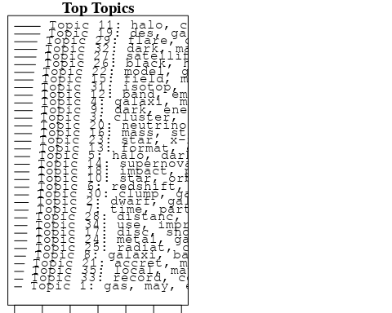

plotQuote(thoughts6, width = 30, main = "Topic 6")  
plotQuote(thoughts18, width = 30, main = "Topic 18")

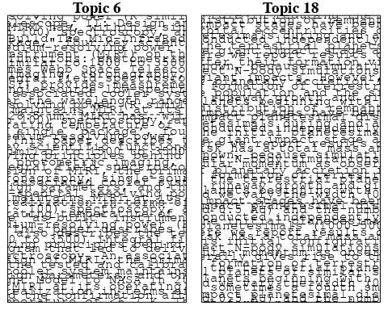

# Calculate and plot the correlation between topics  
mod.out.corr <- topicCorr(Research_topics)  
plot(mod.out.corr, cex = 1.5)  
  
  
# For each topic  
for (topic_num in 1:35) {  
 # Plot the word cloud  
 cloud(Research_topics, topic = topic_num, scale = c(2, 0.25))  
 Sys.sleep(2)  
}

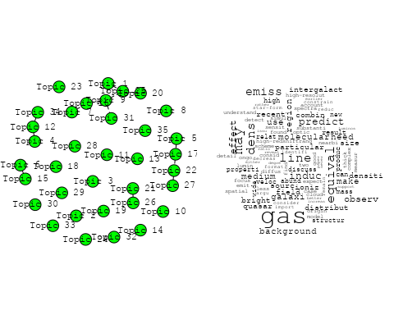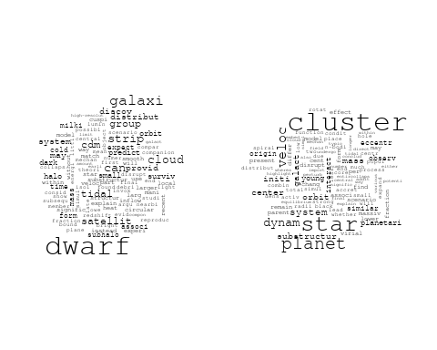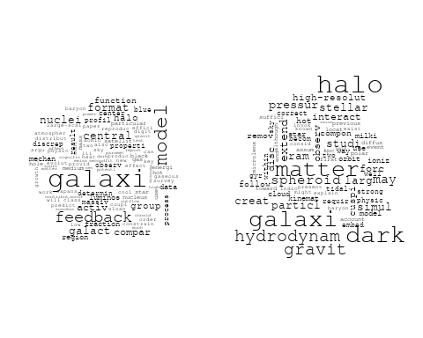

## Warning in wordcloud::wordcloud(words = vocab, freq = vec, max.words =  
## max.words, : spectroscop could not be fit on page. It will not be plotted.

## Warning in wordcloud::wordcloud(words = vocab, freq = vec, max.words =  
## max.words, : spectroscopi could not be fit on page. It will not be plotted.

## Warning in wordcloud::wordcloud(words = vocab, freq = vec, max.words =  
## max.words, : precis could not be fit on page. It will not be plotted.

## Warning in wordcloud::wordcloud(words = vocab, freq = vec, max.words =  
## max.words, : requir could not be fit on page. It will not be plotted.

## Warning in wordcloud::wordcloud(words = vocab, freq = vec, max.words =  
## max.words, : survey could not be fit on page. It will not be plotted.

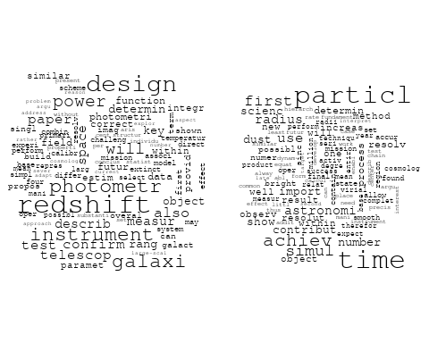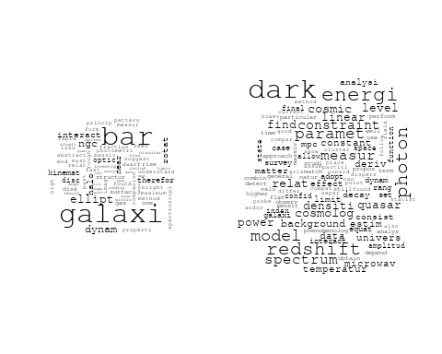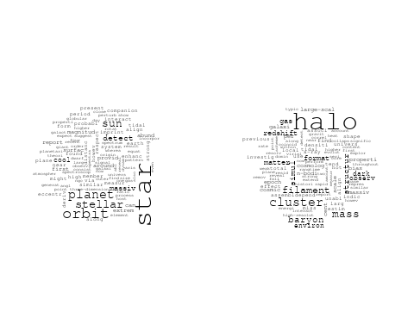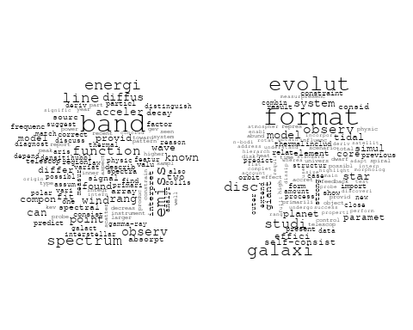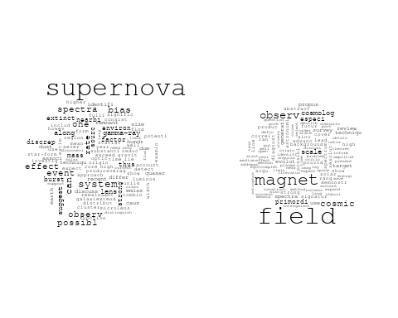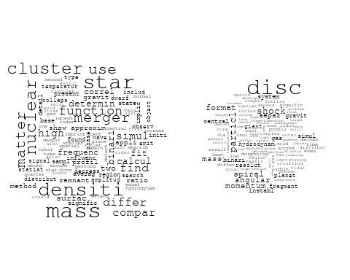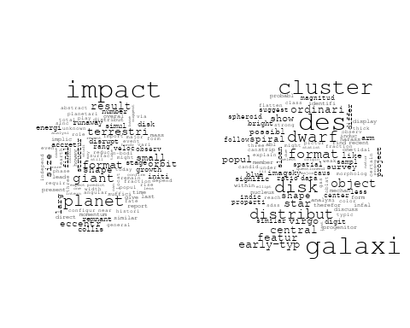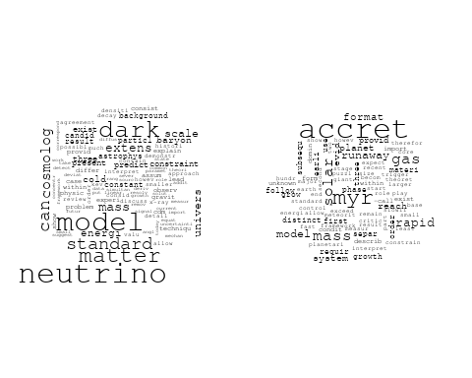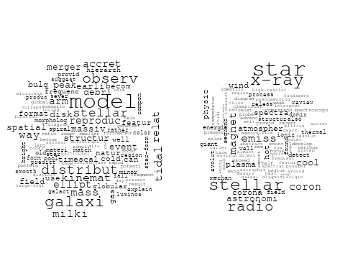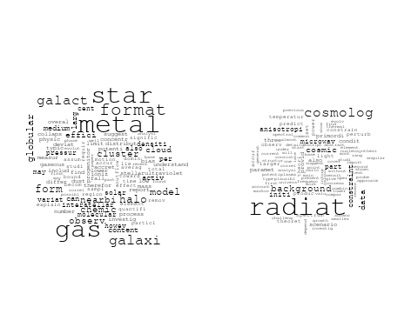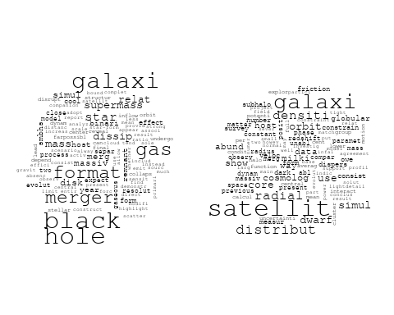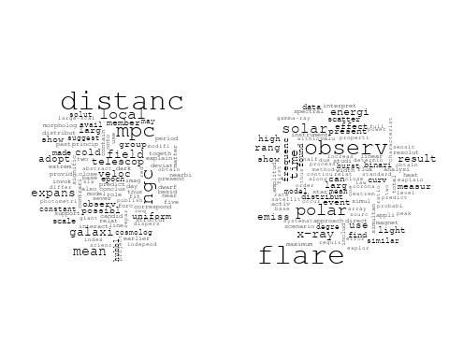

## Warning in wordcloud::wordcloud(words = vocab, freq = vec, max.words =  
## max.words, : clump could not be fit on page. It will not be plotted.

## Warning in wordcloud::wordcloud(words = vocab, freq = vec, max.words =  
## max.words, : meteorit could not be fit on page. It will not be plotted.

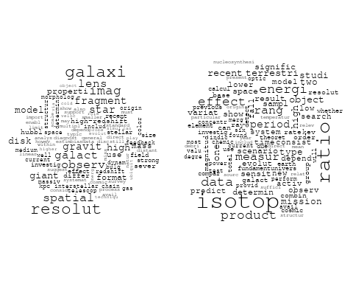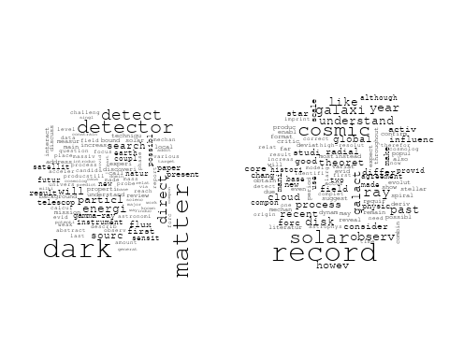

## Warning in wordcloud::wordcloud(words = vocab, freq = vec, max.words =  
## max.words, : gravit could not be fit on page. It will not be plotted.

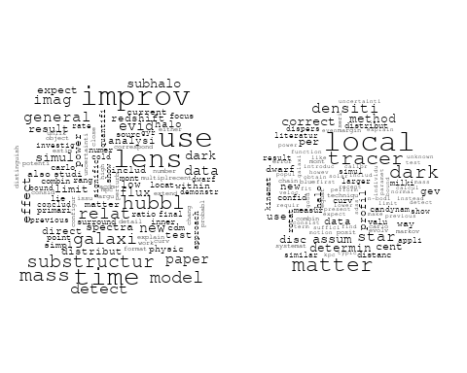

# Get the topic proportions for each document  
topic_proportions <- Research_topics$theta  
  
# Find the index of the topic with the highest proportion for each document  
# This will be the topic that each document is most likely to belong to  
max_topic_idx <- apply(topic_proportions, 1, which.max)  
  
# Add this as a new column to your data  
data_independent$topic <- max_topic_idx  
  
  
  
# Define the intervals  
intervals <- c('1824_1899', '1900_1964', '1965_1974', '1975_1984', '1985_1994', '1995_1999', '2000_2004', '2005_2009', '2010_2014', '2015_2019', '2020_2022')  
colors <- c('pink', 'blue', 'purple', 'yellow', 'green', 'pink', 'orange', 'violet', 'green', 'blue', 'pink')  
  
# Loop through the intervals and plot  
for(i in seq_along(intervals)){  
 # Filter data for when the pub_interval is equal to 1  
 data_filtered <- data_independent[data_independent[[paste0('pub_interval_', intervals[i])]] == 1,]  
   
 # Make the histogram  
   
 p <- ggplot(data_filtered, aes(x = topic)) +  
 geom_histogram(binwidth = 1, fill = colors[i], color = "black") +  
 xlab("Topic") +  
 ylab("Count") +  
 ggtitle(paste0("Topics from year ", gsub("_", " to ", intervals[i])))  
   
 print(p)  
}

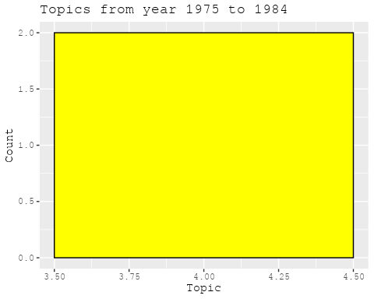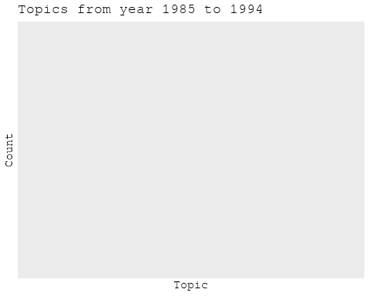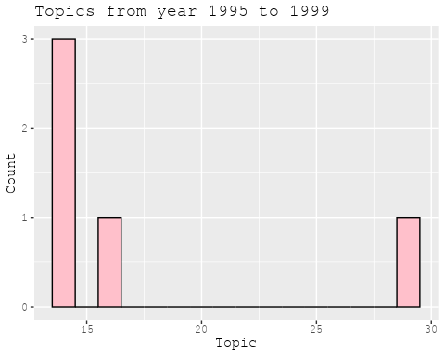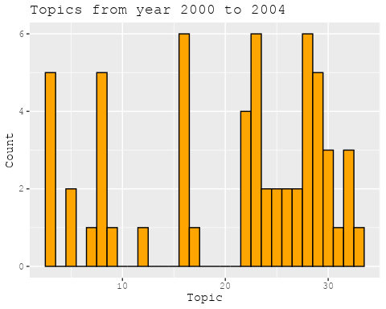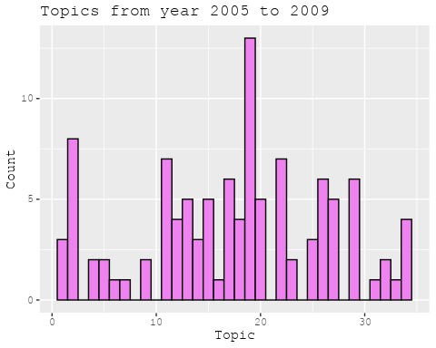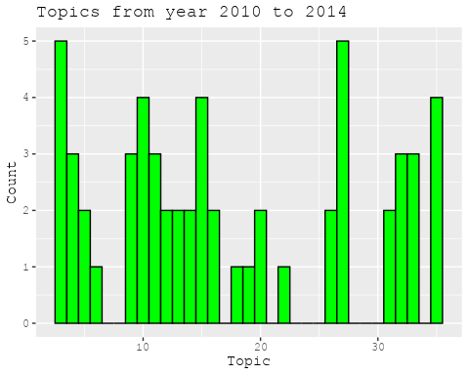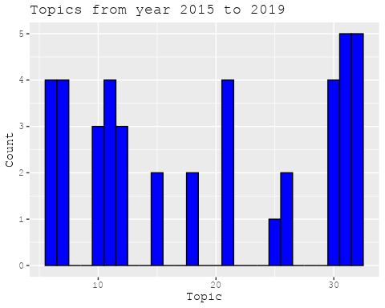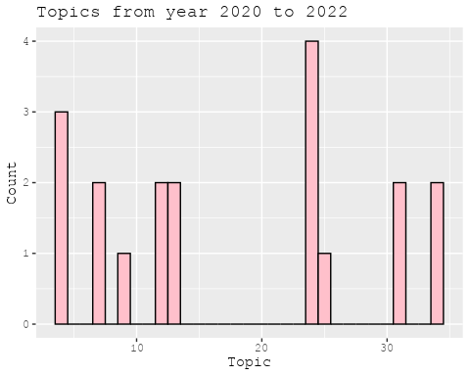

##Topic generation for Africa (in collaboration) publications  
  
data_collab <- data[data[["Africa"]] != 0,]  
  
# Save the original title data for future use  
data_collab$original_concatenated_title_abstract <- data_collab$concatenated_title_abstract  
  
#pre-processing the titles using textProcessor from the stm package  
processed_text <- textProcessor(data_collab$concatenated_title_abstract, metadata = data_collab)

## Building corpus...   
## Converting to Lower Case...   
## Removing punctuation...   
## Removing stopwords...   
## Removing numbers...   
## Stemming...   
## Creating Output...

# Further prepare the data by removing low-frequency terms  
out_text <- prepDocuments(processed_text$documents, processed_text$vocab, processed_text$meta)

## Removing 886 of 3316 terms (886 of 24261 tokens) due to frequency   
## Your corpus now has 340 documents, 2430 terms and 23375 tokens.

docs_text <- out_text$documents  
vocab_text <- out_text$vocab  
meta_text <- out_text$meta  
  
  
#Prepare data  
plotRemoved(processed_text$documents, lower.thresh = seq(1, 200, by = 100))

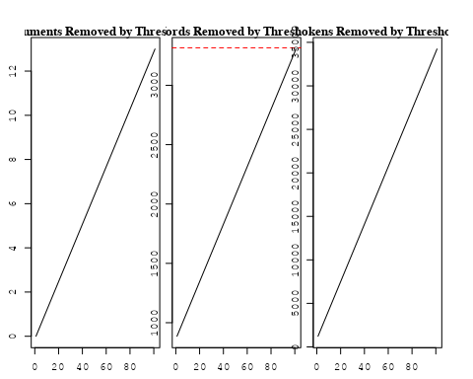

out_text <- prepDocuments(processed_text$documents, processed_text$vocab, processed_text$meta, lower.thresh = 8)

## Removing 2631 of 3316 terms (7127 of 24261 tokens) due to frequency   
## Your corpus now has 340 documents, 685 terms and 17134 tokens.

str(out_text$meta)

## 'data.frame': 340 obs. of 39 variables:  
## $ concept_id : chr "https://openalex.org/C44870925" "https://openalex.org/C1276947" "https://openalex.org/C44870925" "https://openalex.org/C44870925" ...  
## $ work_id : chr "https://openalex.org/W2977830513" "https://openalex.org/W2027124269" "https://openalex.org/W4214743726" "https://openalex.org/W2481259536" ...  
## $ publication_year : int 2019 2003 2022 2016 2010 1998 1998 2022 2007 2003 ...  
## $ title : chr "Relativistic Beaming Effects and Structural Asymmetries in Highly Asymmetric Double Radio Sources" "The interplay of astronomy and philosophy" "Discovery of pulsating components in eclipsing binary systems through the TESS light curves: the cases of CPD-3"| __truncated__ "Global Gradients for Cosmic-Ray Protons in the Heliosphere During the Solar Minimum of Cycle 23/24" ...  
## $ paperabstract : chr "We have studied the comparative importance of the relativistic beaming model (RBM) and the density variation mo"| __truncated__ "Astronomical & Astrophysical Transactions The Journal of the Eurasian Astronomical Society Publication details,"| __truncated__ "We present the first evidence for the pulsations of primary components of four eclipsing binary systems. The TE"| __truncated__ "Global gradients for cosmic-ray (CR) protons in the heliosphere are computed with a comprehensive modulation mo"| __truncated__ ...  
## $ country : chr "NG NG" "MZ" "TR BW BW TR" "ZA ZA" ...  
## $ year_concept : chr "2019+https://openalex.org/C44870925" "2003+https://openalex.org/C1276947" "2022+https://openalex.org/C44870925" "2016+https://openalex.org/C44870925" ...  
## $ concatenated_title_abstract : chr "Relativistic Beaming Effects and Structural Asymmetries in Highly Asymmetric Double Radio Sources We have studi"| __truncated__ "The interplay of astronomy and philosophy Astronomical & Astrophysical Transactions The Journal of the Eurasian"| __truncated__ "Discovery of pulsating components in eclipsing binary systems through the TESS light curves: the cases of CPD-3"| __truncated__ "Global Gradients for Cosmic-Ray Protons in the Heliosphere During the Solar Minimum of Cycle 23/24 Global gradi"| __truncated__ ...  
## $ US : num 0 0 0 0 0 0 0 0 0 0 ...  
## $ IN : num 0 0 0 0 0 0 0 0 0 0 ...  
## $ DE : num 0 0 0 0 0 0 0 0 0 0 ...  
## $ CH : num 0 0 0 0 0 0 0 0 0 0 ...  
## $ GB : num 0 0 0 0 50 0 0 0 0 0 ...  
## $ CN : num 0 0 0 0 0 0 0 0 0 0 ...  
## $ FR : num 0 0 0 0 0 0 0 0 0 0 ...  
## $ IT : num 0 0 0 0 0 0 0 0 0 0 ...  
## $ RU : num 0 0 0 0 0 0 0 0 0 0 ...  
## $ CA : num 0 0 0 0 0 0 0 0 0 0 ...  
## $ NL : num 0 0 0 0 0 0 0 0 0 0 ...  
## $ AU : num 0 0 0 0 0 0 0 0 0 0 ...  
## $ JP : num 0 0 0 0 0 0 0 0 0 0 ...  
## $ ES : num 0 0 0 0 0 0 0 0 0 0 ...  
## $ IL : num 0 0 0 0 0 0 0 0 0 0 ...  
## $ Americas : num 0 0 0 0 0 0 0 0 0 0 ...  
## $ Europe : num 0 0 50 0 0 0 0 0 0 0 ...  
## $ Africa : num 100 100 50 100 50 100 100 100 50 100 ...  
## $ AsiaAndOceania : num 0 0 0 0 0 0 0 0 50 0 ...  
## $ pub_interval_2020_2022 : int 0 0 1 0 0 0 0 1 0 0 ...  
## $ pub_interval_2015_2019 : int 1 0 0 1 0 0 0 0 0 0 ...  
## $ pub_interval_2010_2014 : int 0 0 0 0 1 0 0 0 0 0 ...  
## $ pub_interval_2005_2009 : int 0 0 0 0 0 0 0 0 1 0 ...  
## $ pub_interval_2000_2004 : int 0 1 0 0 0 0 0 0 0 1 ...  
## $ pub_interval_1995_1999 : int 0 0 0 0 0 1 1 0 0 0 ...  
## $ pub_interval_1985_1994 : int 0 0 0 0 0 0 0 0 0 0 ...  
## $ pub_interval_1975_1984 : int 0 0 0 0 0 0 0 0 0 0 ...  
## $ pub_interval_1965_1974 : int 0 0 0 0 0 0 0 0 0 0 ...  
## $ pub_interval_1900_1964 : int 0 0 0 0 0 0 0 0 0 0 ...  
## $ pub_interval_1824_1899 : int 0 0 0 0 0 0 0 0 0 0 ...  
## $ original_concatenated_title_abstract: chr "Relativistic Beaming Effects and Structural Asymmetries in Highly Asymmetric Double Radio Sources We have studi"| __truncated__ "The interplay of astronomy and philosophy Astronomical & Astrophysical Transactions The Journal of the Eurasian"| __truncated__ "Discovery of pulsating components in eclipsing binary systems through the TESS light curves: the cases of CPD-3"| __truncated__ "Global Gradients for Cosmic-Ray Protons in the Heliosphere During the Solar Minimum of Cycle 23/24 Global gradi"| __truncated__ ...

# Initialize an empty formula string  
prevalence_formula_str <- "~"  
  
# Define the publication intervals  
pub_intervals <- c("pub_interval_2020_2022", "pub_interval_2015_2019", "pub_interval_2010_2014",   
 "pub_interval_2005_2009", "pub_interval_2000_2004", "pub_interval_1995_1999",  
 "pub_interval_1985_1994", "pub_interval_1975_1984", "pub_interval_1965_1974",  
 "pub_interval_1900_1964", "pub_interval_1824_1899")  
  
# Add each publication interval to the formula string  
for (interval in pub_intervals) {  
 # add an if statement to handle the first addition (without '+')  
 if (prevalence_formula_str == "~") {  
 prevalence_formula_str <- paste(prevalence_formula_str, interval)  
 } else {  
 prevalence_formula_str <- paste(prevalence_formula_str, "+", interval)  
 }  
}  
  
  
# Convert the string to a formula  
prevalence_formula <- as.formula(prevalence_formula_str)  
print(prevalence_formula)

## ~pub_interval_2020_2022 + pub_interval_2015_2019 + pub_interval_2010_2014 +   
## pub_interval_2005_2009 + pub_interval_2000_2004 + pub_interval_1995_1999 +   
## pub_interval_1985_1994 + pub_interval_1975_1984 + pub_interval_1965_1974 +   
## pub_interval_1900_1964 + pub_interval_1824_1899

# Run STM model  
Research_topics <- stm(documents = out_text$documents,   
 vocab = out_text$vocab,   
 K = 36,   
 prevalence = prevalence_formula,   
 data = out_text$meta,   
 init.type = "Spectral",  
 max.em.its = 1000,  
 gamma.prior = 'L1')

## Beginning Spectral Initialization   
## Calculating the gram matrix...  
## Finding anchor words...  
## ....................................  
## Recovering initialization...  
## ......  
## Initialization complete.  
## .................................................................................................................  
## Completed E-Step (0 seconds).   
## Completed M-Step.   
## Completing Iteration 1 (approx. per word bound = -5.231)   
## .................................................................................................................  
## Completed E-Step (0 seconds).   
## Completed M-Step.   
## Completing Iteration 2 (approx. per word bound = -5.014, relative change = 4.144e-02)   
## .................................................................................................................  
## Completed E-Step (0 seconds).   
## Completed M-Step.   
## Completing Iteration 3 (approx. per word bound = -4.950, relative change = 1.270e-02)   
## .................................................................................................................  
## Completed E-Step (0 seconds).   
## Completed M-Step.   
## Completing Iteration 4 (approx. per word bound = -4.922, relative change = 5.693e-03)   
## .................................................................................................................  
## Completed E-Step (0 seconds).   
## Completed M-Step.   
## Completing Iteration 5 (approx. per word bound = -4.905, relative change = 3.486e-03)   
## Topic 1: univers, research, scale, differ, physic   
## Topic 2: pulsar, emiss, radio, paper, polar   
## Topic 3: variabl, cataclysm, coher, optic, rapid   
## Topic 4: time, pulsar, amplitud, vari, data   
## Topic 5: planet, correl, star, orbit, distribut   
## Topic 6: sensit, candid, explor, investig, interact   
## Topic 7: nova, period, orbit, modul, sdss   
## Topic 8: system, binari, veloc, star, radial   
## Topic 9: cluster, use, studi, sourc, star   
## Topic 10: magnitud, star, absolut, relat, photometri   
## Topic 11: galaxi, bar, disk, ngc, ring   
## Topic 12: cluster, galaxi, gradient, properti, stellar   
## Topic 13: instabl, interstellar, anisotropi, particl, cloud   
## Topic 14: theori, field, predict, general, magnet   
## Topic 15: pulsar, frequenc, event, sudden, spin   
## Topic 16: mira, parallax, zero-point, cluster, galact   
## Topic 17: hole, black, radiat, pair, system   
## Topic 18: method, use, blazar, photon, tev   
## Topic 19: oscil, period, dwarf, nova, observ   
## Topic 20: physic, cosmolog, dark, structur, matter   
## Topic 21: radio, blazar, galaxi, lac, fsrqs   
## Topic 22: equat, star, anisotrop, model, compact   
## Topic 23: modul, observ, solar, proton, model   
## Topic 24: beam, observ, model, size, differ   
## Topic 25: survey, supernova, sampl, train, simul   
## Topic 26: burst, radio, type, solar, observ   
## Topic 27: optic, period, x-ray, counterpart, day   
## Topic 28: pulsat, mode, star, observ, frequenc   
## Topic 29: radiat, model, effect, star, result   
## Topic 30: eclips, system, mechan, period, variat   
## Topic 31: distanc, cepheid, mag, ngc, modulus   
## Topic 32: galaxi, star, format, use, simul   
## Topic 33: energi, emiss, gamma, gamma-ray, ray   
## Topic 34: galaxi, field, find, veloc, halo   
## Topic 35: disc, invers, system, compton, gamma-ray   
## Topic 36: astronomi, via, radio, astrophys, place   
## .................................................................................................................  
## Completed E-Step (0 seconds).   
## Completed M-Step.   
## Completing Iteration 6 (approx. per word bound = -4.894, relative change = 2.310e-03)   
## .................................................................................................................  
## Completed E-Step (0 seconds).   
## Completed M-Step.   
## Completing Iteration 7 (approx. per word bound = -4.885, relative change = 1.759e-03)   
## .................................................................................................................  
## Completed E-Step (0 seconds).   
## Completed M-Step.   
## Completing Iteration 8 (approx. per word bound = -4.878, relative change = 1.386e-03)   
## .................................................................................................................  
## Completed E-Step (0 seconds).   
## Completed M-Step.   
## Completing Iteration 9 (approx. per word bound = -4.873, relative change = 1.097e-03)   
## .................................................................................................................  
## Completed E-Step (0 seconds).   
## Completed M-Step.   
## Completing Iteration 10 (approx. per word bound = -4.868, relative change = 1.064e-03)   
## Topic 1: univers, research, scale, time, differ   
## Topic 2: pulsar, emiss, radio, polar, paper   
## Topic 3: variabl, cataclysm, coher, optic, rapid   
## Topic 4: time, pulsar, amplitud, data, observ   
## Topic 5: planet, correl, star, orbit, distribut   
## Topic 6: candid, sensit, data, interact, princip   
## Topic 7: nova, period, orbit, modul, sdss   
## Topic 8: system, binari, veloc, star, radial   
## Topic 9: cluster, studi, use, star, sourc   
## Topic 10: magnitud, star, absolut, photometri, relat   
## Topic 11: galaxi, bar, disk, ngc, ring   
## Topic 12: cluster, galaxi, gradient, properti, stellar   
## Topic 13: instabl, interstellar, anisotropi, particl, solar   
## Topic 14: field, magnet, theori, observ, general   
## Topic 15: pulsar, frequenc, event, sudden, radio   
## Topic 16: mira, parallax, zero-point, cluster, galact   
## Topic 17: hole, black, radiat, pair, system   
## Topic 18: method, use, blazar, photon, tev   
## Topic 19: oscil, period, dwarf, nova, observ   
## Topic 20: dark, cosmolog, structur, cosmic, matter   
## Topic 21: radio, blazar, galaxi, lac, fsrqs   
## Topic 22: equat, star, model, anisotrop, valu   
## Topic 23: modul, observ, solar, proton, model   
## Topic 24: beam, observ, model, size, differ   
## Topic 25: survey, supernova, sampl, train, simul   
## Topic 26: burst, radio, type, solar, frequenc   
## Topic 27: period, optic, x-ray, counterpart, day   
## Topic 28: pulsat, mode, star, frequenc, observ   
## Topic 29: radiat, model, effect, star, result   
## Topic 30: eclips, mechan, period, system, variat   
## Topic 31: distanc, cepheid, mag, ngc, modulus   
## Topic 32: galaxi, star, format, simul, use   
## Topic 33: energi, emiss, gamma, gamma-ray, region   
## Topic 34: galaxi, densiti, halo, veloc, bright   
## Topic 35: disc, invers, system, compton, photon   
## Topic 36: astronomi, univers, via, physic, radio   
## .................................................................................................................  
## Completed E-Step (0 seconds).   
## Completed M-Step.   
## Completing Iteration 11 (approx. per word bound = -4.863, relative change = 9.331e-04)   
## .................................................................................................................  
## Completed E-Step (0 seconds).   
## Completed M-Step.   
## Completing Iteration 12 (approx. per word bound = -4.860, relative change = 7.260e-04)   
## .................................................................................................................  
## Completed E-Step (0 seconds).   
## Completed M-Step.   
## Completing Iteration 13 (approx. per word bound = -4.857, relative change = 5.564e-04)   
## .................................................................................................................  
## Completed E-Step (0 seconds).   
## Completed M-Step.   
## Completing Iteration 14 (approx. per word bound = -4.855, relative change = 4.209e-04)   
## .................................................................................................................  
## Completed E-Step (0 seconds).   
## Completed M-Step.   
## Completing Iteration 15 (approx. per word bound = -4.853, relative change = 3.805e-04)   
## Topic 1: univers, research, scale, time, differ   
## Topic 2: pulsar, emiss, radio, polar, paper   
## Topic 3: variabl, cataclysm, coher, observ, rapid   
## Topic 4: time, pulsar, amplitud, data, vari   
## Topic 5: planet, correl, star, orbit, distribut   
## Topic 6: candid, sensit, data, interact, radio   
## Topic 7: nova, period, orbit, modul, sdss   
## Topic 8: system, binari, veloc, star, radial   
## Topic 9: cluster, studi, star, use, sourc   
## Topic 10: magnitud, star, absolut, photometri, determin   
## Topic 11: galaxi, bar, disk, ngc, ring   
## Topic 12: cluster, galaxi, gradient, properti, stellar   
## Topic 13: instabl, interstellar, anisotropi, particl, solar   
## Topic 14: field, magnet, theori, observ, general   
## Topic 15: pulsar, frequenc, event, sudden, radio   
## Topic 16: mira, parallax, zero-point, cluster, galact   
## Topic 17: hole, black, radiat, system, pair   
## Topic 18: method, blazar, use, photon, tev   
## Topic 19: oscil, period, dwarf, nova, observ   
## Topic 20: cosmolog, dark, structur, cosmic, survey   
## Topic 21: radio, blazar, galaxi, lac, fsrqs   
## Topic 22: equat, star, model, anisotrop, valu   
## Topic 23: modul, observ, solar, proton, model   
## Topic 24: beam, observ, model, size, differ   
## Topic 25: survey, supernova, sampl, train, simul   
## Topic 26: burst, radio, type, solar, frequenc   
## Topic 27: optic, period, x-ray, counterpart, day   
## Topic 28: pulsat, mode, star, frequenc, observ   
## Topic 29: radiat, model, effect, star, result   
## Topic 30: eclips, mechan, period, variat, time   
## Topic 31: distanc, cepheid, mag, ngc, modulus   
## Topic 32: galaxi, star, format, simul, use   
## Topic 33: emiss, energi, gamma, gamma-ray, region   
## Topic 34: galaxi, densiti, halo, bright, veloc   
## Topic 35: disc, invers, system, compton, photon   
## Topic 36: univers, astronomi, via, physic, radio   
## .................................................................................................................  
## Completed E-Step (0 seconds).   
## Completed M-Step.   
## Completing Iteration 16 (approx. per word bound = -4.851, relative change = 3.709e-04)   
## .................................................................................................................  
## Completed E-Step (0 seconds).   
## Completed M-Step.   
## Completing Iteration 17 (approx. per word bound = -4.850, relative change = 3.737e-04)   
## .................................................................................................................  
## Completed E-Step (0 seconds).   
## Completed M-Step.   
## Completing Iteration 18 (approx. per word bound = -4.848, relative change = 3.350e-04)   
## .................................................................................................................  
## Completed E-Step (0 seconds).   
## Completed M-Step.   
## Completing Iteration 19 (approx. per word bound = -4.846, relative change = 3.397e-04)   
## .................................................................................................................  
## Completed E-Step (0 seconds).   
## Completed M-Step.   
## Completing Iteration 20 (approx. per word bound = -4.845, relative change = 3.545e-04)   
## Topic 1: univers, scale, research, time, differ   
## Topic 2: pulsar, radio, emiss, polar, depend   
## Topic 3: variabl, cataclysm, coher, observ, photometr   
## Topic 4: time, pulsar, amplitud, data, vari   
## Topic 5: planet, correl, star, orbit, distribut   
## Topic 6: candid, sensit, radio, interact, data   
## Topic 7: nova, period, orbit, modul, sdss   
## Topic 8: system, binari, veloc, star, radial   
## Topic 9: cluster, studi, star, use, sourc   
## Topic 10: magnitud, star, absolut, photometri, determin   
## Topic 11: galaxi, bar, disk, ngc, ring   
## Topic 12: cluster, galaxi, gradient, properti, stellar   
## Topic 13: instabl, interstellar, anisotropi, solar, factor   
## Topic 14: field, magnet, theori, observ, general   
## Topic 15: pulsar, frequenc, event, sudden, radio   
## Topic 16: mira, parallax, zero-point, cluster, galact   
## Topic 17: hole, black, radiat, system, pair   
## Topic 18: method, photon, tev, use, blazar   
## Topic 19: oscil, period, dwarf, nova, observ   
## Topic 20: cosmolog, dark, survey, cosmic, structur   
## Topic 21: radio, blazar, galaxi, lac, fsrqs   
## Topic 22: equat, star, model, anisotrop, valu   
## Topic 23: modul, observ, solar, proton, model   
## Topic 24: beam, observ, size, model, distribut   
## Topic 25: survey, supernova, sampl, train, simul   
## Topic 26: burst, radio, solar, type, observ   
## Topic 27: optic, period, x-ray, counterpart, day   
## Topic 28: pulsat, mode, star, frequenc, observ   
## Topic 29: radiat, model, effect, star, energi   
## Topic 30: eclips, mechan, period, time, variat   
## Topic 31: distanc, cepheid, mag, modulus, ngc   
## Topic 32: galaxi, star, format, simul, use   
## Topic 33: emiss, energi, gamma, gamma-ray, region   
## Topic 34: galaxi, densiti, halo, veloc, profil   
## Topic 35: disc, invers, system, compton, gamma-ray   
## Topic 36: univers, astronomi, physic, via, radio   
## .................................................................................................................  
## Completed E-Step (0 seconds).   
## Completed M-Step.   
## Completing Iteration 21 (approx. per word bound = -4.843, relative change = 3.202e-04)   
## .................................................................................................................  
## Completed E-Step (0 seconds).   
## Completed M-Step.   
## Completing Iteration 22 (approx. per word bound = -4.842, relative change = 3.106e-04)   
## .................................................................................................................  
## Completed E-Step (0 seconds).   
## Completed M-Step.   
## Completing Iteration 23 (approx. per word bound = -4.840, relative change = 2.820e-04)   
## .................................................................................................................  
## Completed E-Step (0 seconds).   
## Completed M-Step.   
## Completing Iteration 24 (approx. per word bound = -4.839, relative change = 2.260e-04)   
## .................................................................................................................  
## Completed E-Step (0 seconds).   
## Completed M-Step.   
## Completing Iteration 25 (approx. per word bound = -4.838, relative change = 2.029e-04)   
## Topic 1: univers, scale, research, time, differ   
## Topic 2: pulsar, radio, emiss, polar, depend   
## Topic 3: variabl, coher, cataclysm, observ, photometr   
## Topic 4: time, pulsar, amplitud, data, observ   
## Topic 5: planet, correl, star, orbit, distribut   
## Topic 6: candid, sensit, radio, interact, data   
## Topic 7: nova, period, orbit, modul, sdss   
## Topic 8: system, binari, veloc, star, radial   
## Topic 9: cluster, studi, star, use, sourc   
## Topic 10: magnitud, star, absolut, photometri, determin   
## Topic 11: galaxi, bar, disk, ngc, ring   
## Topic 12: cluster, galaxi, gradient, properti, stellar   
## Topic 13: instabl, interstellar, anisotropi, solar, particl   
## Topic 14: field, magnet, observ, general, motion   
## Topic 15: pulsar, frequenc, event, sudden, radio   
## Topic 16: mira, parallax, zero-point, cluster, galact   
## Topic 17: hole, black, radiat, system, pair   
## Topic 18: method, photon, tev, use, light   
## Topic 19: oscil, period, dwarf, nova, observ   
## Topic 20: cosmolog, dark, survey, cosmic, structur   
## Topic 21: radio, blazar, galaxi, lac, fsrqs   
## Topic 22: equat, star, anisotrop, model, mass   
## Topic 23: modul, observ, solar, proton, model   
## Topic 24: beam, observ, size, model, distribut   
## Topic 25: supernova, survey, sampl, train, simul   
## Topic 26: burst, radio, solar, type, frequenc   
## Topic 27: optic, period, x-ray, counterpart, day   
## Topic 28: pulsat, mode, star, frequenc, observ   
## Topic 29: radiat, model, effect, star, energi   
## Topic 30: eclips, mechan, time, period, variat   
## Topic 31: distanc, cepheid, mag, modulus, ngc   
## Topic 32: galaxi, star, format, simul, use   
## Topic 33: emiss, energi, gamma, gamma-ray, region   
## Topic 34: galaxi, densiti, halo, veloc, profil   
## Topic 35: disc, invers, system, compton, gamma-ray   
## Topic 36: univers, astronomi, physic, via, radio   
## .................................................................................................................  
## Completed E-Step (0 seconds).   
## Completed M-Step.   
## Completing Iteration 26 (approx. per word bound = -4.837, relative change = 1.962e-04)   
## .................................................................................................................  
## Completed E-Step (0 seconds).   
## Completed M-Step.   
## Completing Iteration 27 (approx. per word bound = -4.836, relative change = 1.882e-04)   
## .................................................................................................................  
## Completed E-Step (0 seconds).   
## Completed M-Step.   
## Completing Iteration 28 (approx. per word bound = -4.835, relative change = 1.625e-04)   
## .................................................................................................................  
## Completed E-Step (0 seconds).   
## Completed M-Step.   
## Completing Iteration 29 (approx. per word bound = -4.835, relative change = 1.271e-04)   
## .................................................................................................................  
## Completed E-Step (0 seconds).   
## Completed M-Step.   
## Completing Iteration 30 (approx. per word bound = -4.834, relative change = 9.783e-05)   
## Topic 1: univers, scale, research, time, differ   
## Topic 2: pulsar, radio, emiss, polar, model   
## Topic 3: variabl, coher, cataclysm, observ, photometr   
## Topic 4: time, amplitud, pulsar, data, vari   
## Topic 5: planet, correl, star, orbit, distribut   
## Topic 6: candid, sensit, radio, interact, princip   
## Topic 7: nova, period, orbit, modul, sdss   
## Topic 8: system, binari, veloc, star, radial   
## Topic 9: cluster, studi, star, use, sourc   
## Topic 10: magnitud, star, absolut, photometri, determin   
## Topic 11: galaxi, bar, disk, ngc, ring   
## Topic 12: cluster, galaxi, gradient, properti, stellar   
## Topic 13: instabl, interstellar, anisotropi, solar, particl   
## Topic 14: field, magnet, observ, general, motion   
## Topic 15: pulsar, frequenc, event, sudden, radio   
## Topic 16: mira, parallax, zero-point, cluster, galact   
## Topic 17: hole, black, radiat, system, pair   
## Topic 18: method, photon, tev, use, light   
## Topic 19: oscil, period, dwarf, nova, observ   
## Topic 20: cosmolog, dark, survey, cosmic, structur   
## Topic 21: radio, blazar, galaxi, lac, fsrqs   
## Topic 22: equat, star, anisotrop, model, mass   
## Topic 23: modul, observ, solar, proton, model   
## Topic 24: beam, observ, size, model, distribut   
## Topic 25: supernova, survey, sampl, train, simul   
## Topic 26: burst, radio, solar, type, frequenc   
## Topic 27: optic, period, x-ray, counterpart, day   
## Topic 28: pulsat, mode, star, frequenc, observ   
## Topic 29: radiat, model, effect, star, energi   
## Topic 30: eclips, mechan, time, period, variat   
## Topic 31: cepheid, distanc, mag, modulus, ngc   
## Topic 32: galaxi, star, format, simul, use   
## Topic 33: emiss, energi, gamma, gamma-ray, region   
## Topic 34: galaxi, densiti, halo, veloc, profil   
## Topic 35: disc, invers, system, compton, gamma-ray   
## Topic 36: univers, astronomi, physic, via, radio   
## .................................................................................................................  
## Completed E-Step (0 seconds).   
## Completed M-Step.   
## Completing Iteration 31 (approx. per word bound = -4.834, relative change = 9.222e-05)   
## .................................................................................................................  
## Completed E-Step (0 seconds).   
## Completed M-Step.   
## Completing Iteration 32 (approx. per word bound = -4.834, relative change = 8.536e-05)   
## .................................................................................................................  
## Completed E-Step (0 seconds).   
## Completed M-Step.   
## Completing Iteration 33 (approx. per word bound = -4.833, relative change = 8.020e-05)   
## .................................................................................................................  
## Completed E-Step (0 seconds).   
## Completed M-Step.   
## Completing Iteration 34 (approx. per word bound = -4.833, relative change = 8.843e-05)   
## .................................................................................................................  
## Completed E-Step (0 seconds).   
## Completed M-Step.   
## Completing Iteration 35 (approx. per word bound = -4.832, relative change = 1.054e-04)   
## Topic 1: univers, scale, research, time, model   
## Topic 2: pulsar, radio, emiss, polar, model   
## Topic 3: variabl, coher, cataclysm, observ, photometr   
## Topic 4: time, amplitud, pulsar, data, vari   
## Topic 5: planet, correl, star, orbit, distribut   
## Topic 6: candid, sensit, radio, interact, princip   
## Topic 7: nova, period, orbit, modul, sdss   
## Topic 8: system, binari, veloc, star, radial   
## Topic 9: cluster, studi, star, use, sourc   
## Topic 10: star, magnitud, absolut, mira, determin   
## Topic 11: galaxi, bar, disk, ngc, ring   
## Topic 12: cluster, galaxi, gradient, properti, stellar   
## Topic 13: instabl, interstellar, anisotropi, solar, particl   
## Topic 14: field, magnet, observ, general, motion   
## Topic 15: pulsar, frequenc, event, sudden, radio   
## Topic 16: mira, parallax, zero-point, cluster, galact   
## Topic 17: hole, black, radiat, system, pair   
## Topic 18: method, photon, tev, light, use   
## Topic 19: oscil, period, dwarf, nova, observ   
## Topic 20: dark, cosmolog, survey, cosmic, use   
## Topic 21: radio, blazar, galaxi, lac, fsrqs   
## Topic 22: equat, star, anisotrop, model, mass   
## Topic 23: modul, observ, solar, proton, model   
## Topic 24: beam, observ, size, model, distribut   
## Topic 25: supernova, survey, sampl, train, simul   
## Topic 26: burst, radio, solar, type, frequenc   
## Topic 27: optic, period, x-ray, counterpart, day   
## Topic 28: pulsat, mode, star, frequenc, observ   
## Topic 29: radiat, model, effect, star, energi   
## Topic 30: eclips, mechan, time, period, variat   
## Topic 31: cepheid, distanc, mag, modulus, ngc   
## Topic 32: galaxi, star, format, simul, use   
## Topic 33: emiss, energi, gamma, gamma-ray, region   
## Topic 34: galaxi, densiti, halo, veloc, profil   
## Topic 35: disc, invers, system, compton, gamma-ray   
## Topic 36: univers, astronomi, physic, radio, via   
## .................................................................................................................  
## Completed E-Step (0 seconds).   
## Completed M-Step.   
## Completing Iteration 36 (approx. per word bound = -4.832, relative change = 1.083e-04)   
## .................................................................................................................  
## Completed E-Step (0 seconds).   
## Completed M-Step.   
## Completing Iteration 37 (approx. per word bound = -4.831, relative change = 1.114e-04)   
## .................................................................................................................  
## Completed E-Step (0 seconds).   
## Completed M-Step.   
## Completing Iteration 38 (approx. per word bound = -4.831, relative change = 1.130e-04)   
## .................................................................................................................  
## Completed E-Step (0 seconds).   
## Completed M-Step.   
## Completing Iteration 39 (approx. per word bound = -4.830, relative change = 1.266e-04)   
## .................................................................................................................  
## Completed E-Step (0 seconds).   
## Completed M-Step.   
## Completing Iteration 40 (approx. per word bound = -4.829, relative change = 1.101e-04)   
## Topic 1: univers, scale, research, time, model   
## Topic 2: pulsar, radio, emiss, polar, model   
## Topic 3: variabl, coher, cataclysm, observ, blazar   
## Topic 4: time, amplitud, pulsar, data, vari   
## Topic 5: planet, correl, star, orbit, distribut   
## Topic 6: candid, sensit, radio, interact, princip   
## Topic 7: nova, period, orbit, modul, sdss   
## Topic 8: system, binari, veloc, star, radial   
## Topic 9: cluster, studi, star, use, sourc   
## Topic 10: star, absolut, magnitud, mira, determin   
## Topic 11: galaxi, bar, disk, ngc, ring   
## Topic 12: cluster, galaxi, gradient, properti, stellar   
## Topic 13: instabl, interstellar, anisotropi, solar, particl   
## Topic 14: field, magnet, observ, general, theori   
## Topic 15: pulsar, frequenc, event, sudden, radio   
## Topic 16: mira, parallax, zero-point, cluster, galact   
## Topic 17: black, hole, radiat, system, pair   
## Topic 18: method, photon, tev, use, light   
## Topic 19: oscil, period, dwarf, nova, observ   
## Topic 20: dark, cosmolog, survey, cosmic, use   
## Topic 21: radio, blazar, galaxi, lac, fsrqs   
## Topic 22: equat, star, anisotrop, model, mass   
## Topic 23: modul, observ, solar, proton, model   
## Topic 24: beam, observ, model, size, distribut   
## Topic 25: supernova, sampl, survey, train, simul   
## Topic 26: burst, radio, solar, type, frequenc   
## Topic 27: optic, period, x-ray, counterpart, day   
## Topic 28: pulsat, mode, star, frequenc, observ   
## Topic 29: radiat, model, effect, star, energi   
## Topic 30: eclips, mechan, time, period, variat   
## Topic 31: cepheid, distanc, mag, modulus, ngc   
## Topic 32: galaxi, star, format, simul, use   
## Topic 33: emiss, energi, gamma, gamma-ray, region   
## Topic 34: galaxi, densiti, halo, veloc, profil   
## Topic 35: disc, invers, system, compton, gamma-ray   
## Topic 36: univers, astronomi, physic, radio, via   
## .................................................................................................................  
## Completed E-Step (0 seconds).   
## Completed M-Step.   
## Completing Iteration 41 (approx. per word bound = -4.829, relative change = 9.089e-05)   
## .................................................................................................................  
## Completed E-Step (0 seconds).   
## Completed M-Step.   
## Completing Iteration 42 (approx. per word bound = -4.829, relative change = 7.479e-05)   
## .................................................................................................................  
## Completed E-Step (0 seconds).   
## Completed M-Step.   
## Completing Iteration 43 (approx. per word bound = -4.828, relative change = 7.150e-05)   
## .................................................................................................................  
## Completed E-Step (0 seconds).   
## Completed M-Step.   
## Completing Iteration 44 (approx. per word bound = -4.828, relative change = 7.633e-05)   
## .................................................................................................................  
## Completed E-Step (0 seconds).   
## Completed M-Step.   
## Completing Iteration 45 (approx. per word bound = -4.828, relative change = 7.516e-05)   
## Topic 1: univers, scale, research, time, model   
## Topic 2: pulsar, radio, emiss, polar, model   
## Topic 3: variabl, coher, cataclysm, observ, blazar   
## Topic 4: time, amplitud, pulsar, data, vari   
## Topic 5: planet, correl, star, orbit, distribut   
## Topic 6: candid, sensit, radio, interact, princip   
## Topic 7: nova, period, orbit, modul, sdss   
## Topic 8: system, binari, veloc, star, radial   
## Topic 9: cluster, studi, star, use, sourc   
## Topic 10: star, absolut, magnitud, mira, determin   
## Topic 11: galaxi, bar, disk, ngc, ring   
## Topic 12: cluster, galaxi, gradient, properti, stellar   
## Topic 13: instabl, interstellar, anisotropi, solar, particl   
## Topic 14: field, magnet, observ, general, theori   
## Topic 15: pulsar, frequenc, event, sudden, radio   
## Topic 16: mira, parallax, zero-point, cluster, galact   
## Topic 17: black, hole, radiat, system, pair   
## Topic 18: method, photon, tev, use, model   
## Topic 19: oscil, period, dwarf, nova, observ   
## Topic 20: dark, cosmolog, survey, cosmic, use   
## Topic 21: radio, blazar, galaxi, lac, fsrqs   
## Topic 22: equat, star, anisotrop, model, mass   
## Topic 23: modul, observ, solar, proton, model   
## Topic 24: beam, observ, model, size, distribut   
## Topic 25: supernova, sampl, survey, train, simul   
## Topic 26: burst, radio, solar, type, frequenc   
## Topic 27: optic, period, x-ray, counterpart, orbit   
## Topic 28: pulsat, mode, star, observ, frequenc   
## Topic 29: radiat, model, effect, star, energi   
## Topic 30: eclips, mechan, time, period, detect   
## Topic 31: cepheid, distanc, mag, modulus, ngc   
## Topic 32: galaxi, star, format, simul, use   
## Topic 33: emiss, energi, gamma, gamma-ray, region   
## Topic 34: galaxi, densiti, halo, veloc, profil   
## Topic 35: disc, invers, system, compton, gamma-ray   
## Topic 36: univers, astronomi, physic, radio, via   
## .................................................................................................................  
## Completed E-Step (0 seconds).   
## Completed M-Step.   
## Completing Iteration 46 (approx. per word bound = -4.827, relative change = 7.519e-05)   
## .................................................................................................................  
## Completed E-Step (0 seconds).   
## Completed M-Step.   
## Completing Iteration 47 (approx. per word bound = -4.827, relative change = 7.343e-05)   
## .................................................................................................................  
## Completed E-Step (0 seconds).   
## Completed M-Step.   
## Completing Iteration 48 (approx. per word bound = -4.827, relative change = 6.731e-05)   
## .................................................................................................................  
## Completed E-Step (0 seconds).   
## Completed M-Step.   
## Completing Iteration 49 (approx. per word bound = -4.826, relative change = 7.287e-05)   
## .................................................................................................................  
## Completed E-Step (0 seconds).   
## Completed M-Step.   
## Completing Iteration 50 (approx. per word bound = -4.826, relative change = 6.636e-05)   
## Topic 1: univers, scale, research, time, model   
## Topic 2: pulsar, radio, emiss, polar, model   
## Topic 3: variabl, coher, cataclysm, blazar, observ   
## Topic 4: time, amplitud, pulsar, data, solar   
## Topic 5: planet, correl, star, orbit, distribut   
## Topic 6: candid, sensit, radio, interact, princip   
## Topic 7: nova, period, orbit, modul, sdss   
## Topic 8: system, binari, veloc, star, radial   
## Topic 9: cluster, studi, star, use, sourc   
## Topic 10: star, absolut, magnitud, mira, determin   
## Topic 11: galaxi, bar, disk, ngc, ring   
## Topic 12: cluster, galaxi, gradient, properti, stellar   
## Topic 13: instabl, interstellar, anisotropi, solar, particl   
## Topic 14: field, magnet, observ, general, theori   
## Topic 15: pulsar, frequenc, event, sudden, radio   
## Topic 16: mira, parallax, zero-point, cluster, galact   
## Topic 17: black, hole, radiat, system, pair   
## Topic 18: method, photon, tev, use, model   
## Topic 19: oscil, period, dwarf, nova, observ   
## Topic 20: dark, cosmolog, survey, cosmic, use   
## Topic 21: radio, blazar, galaxi, lac, fsrqs   
## Topic 22: equat, star, anisotrop, model, matter   
## Topic 23: modul, observ, solar, proton, model   
## Topic 24: beam, observ, model, size, distribut   
## Topic 25: supernova, sampl, survey, train, simul   
## Topic 26: burst, radio, solar, type, frequenc   
## Topic 27: optic, period, x-ray, counterpart, orbit   
## Topic 28: pulsat, mode, star, observ, frequenc   
## Topic 29: radiat, model, effect, star, energi   
## Topic 30: eclips, mechan, time, detect, period   
## Topic 31: cepheid, distanc, mag, modulus, ngc   
## Topic 32: galaxi, star, format, simul, use   
## Topic 33: emiss, energi, gamma, gamma-ray, region   
## Topic 34: galaxi, densiti, halo, veloc, profil   
## Topic 35: disc, invers, system, compton, gamma-ray   
## Topic 36: univers, astronomi, physic, radio, via   
## .................................................................................................................  
## Completed E-Step (0 seconds).   
## Completed M-Step.   
## Completing Iteration 51 (approx. per word bound = -4.826, relative change = 6.478e-05)   
## .................................................................................................................  
## Completed E-Step (0 seconds).   
## Completed M-Step.   
## Completing Iteration 52 (approx. per word bound = -4.825, relative change = 5.670e-05)   
## .................................................................................................................  
## Completed E-Step (0 seconds).   
## Completed M-Step.   
## Completing Iteration 53 (approx. per word bound = -4.825, relative change = 4.341e-05)   
## .................................................................................................................  
## Completed E-Step (0 seconds).   
## Completed M-Step.   
## Completing Iteration 54 (approx. per word bound = -4.825, relative change = 4.169e-05)   
## .................................................................................................................  
## Completed E-Step (0 seconds).   
## Completed M-Step.   
## Completing Iteration 55 (approx. per word bound = -4.825, relative change = 4.571e-05)   
## Topic 1: univers, scale, research, time, model   
## Topic 2: pulsar, radio, emiss, polar, model   
## Topic 3: variabl, coher, cataclysm, blazar, observ   
## Topic 4: time, amplitud, solar, pulsar, data   
## Topic 5: planet, correl, star, orbit, distribut   
## Topic 6: candid, sensit, radio, galaxi, interact   
## Topic 7: nova, period, orbit, modul, sdss   
## Topic 8: system, binari, veloc, star, radial   
## Topic 9: cluster, studi, star, use, sourc   
## Topic 10: star, absolut, magnitud, mira, determin   
## Topic 11: galaxi, bar, disk, ngc, ring   
## Topic 12: cluster, galaxi, gradient, properti, stellar   
## Topic 13: instabl, interstellar, anisotropi, solar, particl   
## Topic 14: field, magnet, observ, general, theori   
## Topic 15: pulsar, frequenc, event, sudden, radio   
## Topic 16: mira, parallax, zero-point, cluster, galact   
## Topic 17: black, hole, radiat, system, pair   
## Topic 18: method, photon, tev, use, model   
## Topic 19: oscil, period, dwarf, nova, observ   
## Topic 20: dark, cosmolog, survey, cosmic, use   
## Topic 21: radio, blazar, galaxi, lac, fsrqs   
## Topic 22: equat, star, anisotrop, model, matter   
## Topic 23: modul, observ, proton, solar, model   
## Topic 24: beam, observ, model, size, distribut   
## Topic 25: supernova, sampl, survey, train, simul   
## Topic 26: burst, radio, solar, type, frequenc   
## Topic 27: optic, period, x-ray, counterpart, orbit   
## Topic 28: pulsat, mode, star, observ, frequenc   
## Topic 29: radiat, model, effect, star, energi   
## Topic 30: eclips, mechan, time, detect, period   
## Topic 31: cepheid, distanc, mag, modulus, ngc   
## Topic 32: galaxi, star, format, simul, use   
## Topic 33: emiss, energi, gamma, gamma-ray, region   
## Topic 34: galaxi, densiti, halo, veloc, profil   
## Topic 35: disc, invers, system, compton, gamma-ray   
## Topic 36: univers, astronomi, physic, radio, via   
## .................................................................................................................  
## Completed E-Step (0 seconds).   
## Completed M-Step.   
## Completing Iteration 56 (approx. per word bound = -4.824, relative change = 5.095e-05)   
## .................................................................................................................  
## Completed E-Step (0 seconds).   
## Completed M-Step.   
## Completing Iteration 57 (approx. per word bound = -4.824, relative change = 5.135e-05)   
## .................................................................................................................  
## Completed E-Step (0 seconds).   
## Completed M-Step.   
## Completing Iteration 58 (approx. per word bound = -4.824, relative change = 5.321e-05)   
## .................................................................................................................  
## Completed E-Step (0 seconds).   
## Completed M-Step.   
## Completing Iteration 59 (approx. per word bound = -4.824, relative change = 6.106e-05)   
## .................................................................................................................  
## Completed E-Step (0 seconds).   
## Completed M-Step.   
## Completing Iteration 60 (approx. per word bound = -4.823, relative change = 4.159e-05)   
## Topic 1: univers, scale, research, time, differ   
## Topic 2: pulsar, radio, emiss, polar, model   
## Topic 3: variabl, coher, cataclysm, blazar, observ   
## Topic 4: solar, amplitud, time, pulsar, data   
## Topic 5: planet, correl, star, orbit, distribut   
## Topic 6: candid, sensit, galaxi, radio, interact   
## Topic 7: nova, period, orbit, modul, sdss   
## Topic 8: system, binari, veloc, star, radial   
## Topic 9: cluster, studi, star, use, sourc   
## Topic 10: star, absolut, magnitud, mira, determin   
## Topic 11: galaxi, bar, disk, ngc, ring   
## Topic 12: cluster, galaxi, gradient, properti, stellar   
## Topic 13: instabl, interstellar, anisotropi, solar, particl   
## Topic 14: field, magnet, observ, general, theori   
## Topic 15: pulsar, frequenc, event, sudden, radio   
## Topic 16: mira, parallax, zero-point, cluster, galact   
## Topic 17: black, hole, radiat, system, pair   
## Topic 18: method, photon, tev, use, light   
## Topic 19: oscil, period, dwarf, nova, observ   
## Topic 20: dark, cosmolog, survey, cosmic, redshift   
## Topic 21: radio, blazar, galaxi, lac, fsrqs   
## Topic 22: equat, star, anisotrop, model, matter   
## Topic 23: modul, observ, proton, solar, model   
## Topic 24: beam, observ, model, size, distribut   
## Topic 25: supernova, sampl, survey, train, simul   
## Topic 26: burst, radio, solar, type, frequenc   
## Topic 27: optic, period, x-ray, counterpart, orbit   
## Topic 28: pulsat, mode, star, observ, frequenc   
## Topic 29: radiat, model, effect, star, energi   
## Topic 30: eclips, mechan, time, detect, period   
## Topic 31: cepheid, distanc, mag, modulus, ngc   
## Topic 32: galaxi, star, format, simul, use   
## Topic 33: emiss, energi, gamma, gamma-ray, region   
## Topic 34: galaxi, densiti, halo, veloc, profil   
## Topic 35: disc, invers, system, compton, gamma-ray   
## Topic 36: univers, physic, astronomi, radio, via   
## .................................................................................................................  
## Completed E-Step (0 seconds).   
## Completed M-Step.   
## Completing Iteration 61 (approx. per word bound = -4.823, relative change = 3.225e-05)   
## .................................................................................................................  
## Completed E-Step (0 seconds).   
## Completed M-Step.   
## Completing Iteration 62 (approx. per word bound = -4.823, relative change = 2.740e-05)   
## .................................................................................................................  
## Completed E-Step (0 seconds).   
## Completed M-Step.   
## Completing Iteration 63 (approx. per word bound = -4.823, relative change = 2.998e-05)   
## .................................................................................................................  
## Completed E-Step (0 seconds).   
## Completed M-Step.   
## Completing Iteration 64 (approx. per word bound = -4.823, relative change = 4.122e-05)   
## .................................................................................................................  
## Completed E-Step (0 seconds).   
## Completed M-Step.   
## Completing Iteration 65 (approx. per word bound = -4.822, relative change = 6.011e-05)   
## Topic 1: univers, scale, research, time, differ   
## Topic 2: pulsar, radio, polar, emiss, model   
## Topic 3: variabl, coher, cataclysm, blazar, observ   
## Topic 4: solar, time, pulsar, amplitud, data   
## Topic 5: planet, correl, star, orbit, distribut   
## Topic 6: candid, sensit, galaxi, radio, interact   
## Topic 7: nova, period, orbit, modul, sdss   
## Topic 8: system, binari, veloc, star, radial   
## Topic 9: cluster, studi, star, use, sourc   
## Topic 10: star, absolut, magnitud, mira, determin   
## Topic 11: galaxi, bar, disk, ngc, ring   
## Topic 12: cluster, galaxi, gradient, properti, stellar   
## Topic 13: instabl, interstellar, anisotropi, particl, solar   
## Topic 14: field, magnet, observ, general, theori   
## Topic 15: pulsar, frequenc, event, sudden, radio   
## Topic 16: mira, parallax, zero-point, cluster, galact   
## Topic 17: black, hole, radiat, system, pair   
## Topic 18: method, photon, tev, use, light   
## Topic 19: oscil, period, dwarf, nova, observ   
## Topic 20: dark, cosmolog, survey, redshift, cosmic   
## Topic 21: radio, blazar, galaxi, lac, fsrqs   
## Topic 22: equat, star, anisotrop, model, matter   
## Topic 23: modul, observ, proton, solar, model   
## Topic 24: beam, observ, size, model, distribut   
## Topic 25: supernova, sampl, survey, train, simul   
## Topic 26: burst, radio, solar, type, frequenc   
## Topic 27: optic, period, x-ray, counterpart, orbit   
## Topic 28: pulsat, mode, star, observ, frequenc   
## Topic 29: radiat, model, effect, star, energi   
## Topic 30: eclips, mechan, time, detect, period   
## Topic 31: cepheid, distanc, mag, modulus, ngc   
## Topic 32: galaxi, star, format, simul, use   
## Topic 33: emiss, energi, gamma, gamma-ray, region   
## Topic 34: galaxi, densiti, halo, veloc, profil   
## Topic 35: disc, invers, system, compton, gamma-ray   
## Topic 36: univers, physic, astronomi, radio, via   
## .................................................................................................................  
## Completed E-Step (0 seconds).   
## Completed M-Step.   
## Completing Iteration 66 (approx. per word bound = -4.822, relative change = 3.912e-05)   
## .................................................................................................................  
## Completed E-Step (0 seconds).   
## Completed M-Step.   
## Completing Iteration 67 (approx. per word bound = -4.822, relative change = 2.517e-05)   
## .................................................................................................................  
## Completed E-Step (0 seconds).   
## Completed M-Step.   
## Completing Iteration 68 (approx. per word bound = -4.822, relative change = 2.326e-05)   
## .................................................................................................................  
## Completed E-Step (0 seconds).   
## Completed M-Step.   
## Completing Iteration 69 (approx. per word bound = -4.822, relative change = 2.932e-05)   
## .................................................................................................................  
## Completed E-Step (0 seconds).   
## Completed M-Step.   
## Completing Iteration 70 (approx. per word bound = -4.822, relative change = 3.538e-05)   
## Topic 1: univers, scale, research, time, differ   
## Topic 2: pulsar, radio, polar, emiss, model   
## Topic 3: variabl, coher, cataclysm, blazar, observ   
## Topic 4: solar, time, pulsar, amplitud, data   
## Topic 5: planet, correl, star, orbit, distribut   
## Topic 6: candid, sensit, galaxi, radio, interact   
## Topic 7: nova, period, orbit, modul, sdss   
## Topic 8: system, binari, veloc, star, radial   
## Topic 9: cluster, studi, star, sourc, use   
## Topic 10: star, absolut, magnitud, mira, determin   
## Topic 11: galaxi, bar, disk, ngc, ring   
## Topic 12: cluster, galaxi, gradient, properti, stellar   
## Topic 13: instabl, interstellar, anisotropi, particl, solar   
## Topic 14: field, magnet, observ, general, theori   
## Topic 15: pulsar, frequenc, event, sudden, radio   
## Topic 16: mira, parallax, zero-point, cluster, galact   
## Topic 17: black, hole, radiat, system, pair   
## Topic 18: method, photon, tev, use, light   
## Topic 19: oscil, period, dwarf, nova, observ   
## Topic 20: dark, cosmolog, survey, redshift, use   
## Topic 21: radio, blazar, galaxi, lac, fsrqs   
## Topic 22: equat, star, anisotrop, model, matter   
## Topic 23: modul, observ, proton, solar, model   
## Topic 24: beam, observ, size, model, distribut   
## Topic 25: supernova, sampl, survey, train, simul   
## Topic 26: burst, radio, solar, type, frequenc   
## Topic 27: optic, period, x-ray, counterpart, orbit   
## Topic 28: pulsat, mode, star, observ, frequenc   
## Topic 29: radiat, model, effect, star, energi   
## Topic 30: eclips, mechan, time, detect, period   
## Topic 31: cepheid, distanc, mag, modulus, ngc   
## Topic 32: galaxi, star, format, simul, use   
## Topic 33: emiss, energi, gamma, gamma-ray, region   
## Topic 34: galaxi, densiti, halo, veloc, profil   
## Topic 35: disc, invers, system, compton, gamma-ray   
## Topic 36: univers, physic, astronomi, radio, via   
## .................................................................................................................  
## Completed E-Step (0 seconds).   
## Completed M-Step.   
## Completing Iteration 71 (approx. per word bound = -4.822, relative change = 2.959e-05)   
## .................................................................................................................  
## Completed E-Step (0 seconds).   
## Completed M-Step.   
## Completing Iteration 72 (approx. per word bound = -4.821, relative change = 2.400e-05)   
## .................................................................................................................  
## Completed E-Step (0 seconds).   
## Completed M-Step.   
## Completing Iteration 73 (approx. per word bound = -4.821, relative change = 2.183e-05)   
## .................................................................................................................  
## Completed E-Step (0 seconds).   
## Completed M-Step.   
## Completing Iteration 74 (approx. per word bound = -4.821, relative change = 1.909e-05)   
## .................................................................................................................  
## Completed E-Step (0 seconds).   
## Completed M-Step.   
## Completing Iteration 75 (approx. per word bound = -4.821, relative change = 1.722e-05)   
## Topic 1: univers, scale, research, time, differ   
## Topic 2: pulsar, radio, polar, emiss, model   
## Topic 3: variabl, coher, cataclysm, blazar, observ   
## Topic 4: solar, time, pulsar, amplitud, data   
## Topic 5: planet, correl, star, orbit, distribut   
## Topic 6: candid, sensit, galaxi, radio, interact   
## Topic 7: nova, period, orbit, modul, sdss   
## Topic 8: system, binari, veloc, star, radial   
## Topic 9: cluster, studi, star, sourc, use   
## Topic 10: star, absolut, magnitud, mira, determin   
## Topic 11: galaxi, bar, disk, ngc, ring   
## Topic 12: cluster, galaxi, gradient, properti, stellar   
## Topic 13: instabl, interstellar, anisotropi, solar, particl   
## Topic 14: field, magnet, observ, general, theori   
## Topic 15: pulsar, frequenc, event, sudden, radio   
## Topic 16: mira, parallax, zero-point, cluster, galact   
## Topic 17: black, hole, radiat, system, pair   
## Topic 18: method, photon, tev, use, model   
## Topic 19: oscil, period, dwarf, nova, observ   
## Topic 20: dark, cosmolog, survey, redshift, use   
## Topic 21: radio, blazar, galaxi, lac, fsrqs   
## Topic 22: equat, star, anisotrop, model, matter   
## Topic 23: modul, observ, proton, model, solar   
## Topic 24: beam, observ, size, model, distribut   
## Topic 25: supernova, sampl, survey, train, simul   
## Topic 26: burst, radio, solar, type, frequenc   
## Topic 27: optic, period, x-ray, counterpart, orbit   
## Topic 28: pulsat, mode, star, observ, frequenc   
## Topic 29: radiat, model, effect, star, energi   
## Topic 30: eclips, mechan, time, detect, period   
## Topic 31: cepheid, distanc, mag, modulus, ngc   
## Topic 32: galaxi, star, format, simul, use   
## Topic 33: emiss, energi, gamma, gamma-ray, region   
## Topic 34: galaxi, densiti, halo, veloc, profil   
## Topic 35: disc, invers, system, compton, gamma-ray   
## Topic 36: univers, physic, astronomi, radio, via   
## .................................................................................................................  
## Completed E-Step (0 seconds).   
## Completed M-Step.   
## Completing Iteration 76 (approx. per word bound = -4.821, relative change = 1.547e-05)   
## .................................................................................................................  
## Completed E-Step (0 seconds).   
## Completed M-Step.   
## Completing Iteration 77 (approx. per word bound = -4.821, relative change = 1.413e-05)   
## .................................................................................................................  
## Completed E-Step (0 seconds).   
## Completed M-Step.   
## Completing Iteration 78 (approx. per word bound = -4.821, relative change = 1.767e-05)   
## .................................................................................................................  
## Completed E-Step (0 seconds).   
## Completed M-Step.   
## Completing Iteration 79 (approx. per word bound = -4.821, relative change = 1.820e-05)   
## .................................................................................................................  
## Completed E-Step (0 seconds).   
## Completed M-Step.   
## Completing Iteration 80 (approx. per word bound = -4.821, relative change = 1.496e-05)   
## Topic 1: univers, scale, research, time, differ   
## Topic 2: pulsar, radio, polar, emiss, model   
## Topic 3: variabl, coher, cataclysm, blazar, observ   
## Topic 4: solar, time, pulsar, amplitud, data   
## Topic 5: planet, correl, star, orbit, distribut   
## Topic 6: candid, sensit, galaxi, radio, interact   
## Topic 7: nova, period, orbit, modul, sdss   
## Topic 8: system, binari, veloc, star, radial   
## Topic 9: cluster, studi, star, sourc, use   
## Topic 10: star, absolut, magnitud, mira, determin   
## Topic 11: galaxi, bar, disk, ngc, ring   
## Topic 12: cluster, galaxi, gradient, properti, stellar   
## Topic 13: instabl, interstellar, anisotropi, solar, particl   
## Topic 14: field, magnet, observ, general, theori   
## Topic 15: pulsar, frequenc, event, sudden, radio   
## Topic 16: mira, parallax, zero-point, cluster, galact   
## Topic 17: black, hole, radiat, system, pair   
## Topic 18: method, photon, tev, use, model   
## Topic 19: oscil, period, dwarf, nova, observ   
## Topic 20: dark, cosmolog, survey, redshift, use   
## Topic 21: radio, blazar, galaxi, lac, fsrqs   
## Topic 22: equat, star, anisotrop, model, matter   
## Topic 23: modul, observ, proton, model, solar   
## Topic 24: beam, observ, size, model, distribut   
## Topic 25: supernova, sampl, survey, train, simul   
## Topic 26: burst, radio, solar, type, frequenc   
## Topic 27: optic, period, x-ray, counterpart, orbit   
## Topic 28: pulsat, mode, star, observ, frequenc   
## Topic 29: radiat, model, effect, star, energi   
## Topic 30: eclips, mechan, time, detect, period   
## Topic 31: cepheid, distanc, mag, modulus, ngc   
## Topic 32: galaxi, star, format, simul, use   
## Topic 33: emiss, energi, gamma, gamma-ray, region   
## Topic 34: galaxi, densiti, halo, veloc, profil   
## Topic 35: disc, invers, system, compton, gamma-ray   
## Topic 36: univers, physic, astronomi, radio, via   
## .................................................................................................................  
## Completed E-Step (0 seconds).   
## Completed M-Step.   
## Completing Iteration 81 (approx. per word bound = -4.821, relative change = 1.393e-05)   
## .................................................................................................................  
## Completed E-Step (0 seconds).   
## Completed M-Step.   
## Completing Iteration 82 (approx. per word bound = -4.821, relative change = 1.675e-05)   
## .................................................................................................................  
## Completed E-Step (0 seconds).   
## Completed M-Step.   
## Completing Iteration 83 (approx. per word bound = -4.821, relative change = 1.497e-05)   
## .................................................................................................................  
## Completed E-Step (0 seconds).   
## Completed M-Step.   
## Completing Iteration 84 (approx. per word bound = -4.821, relative change = 1.596e-05)   
## .................................................................................................................  
## Completed E-Step (0 seconds).   
## Completed M-Step.   
## Completing Iteration 85 (approx. per word bound = -4.820, relative change = 2.046e-05)   
## Topic 1: univers, scale, research, time, differ   
## Topic 2: pulsar, radio, polar, emiss, model   
## Topic 3: variabl, coher, cataclysm, blazar, observ   
## Topic 4: solar, time, pulsar, amplitud, data   
## Topic 5: planet, correl, star, orbit, distribut   
## Topic 6: candid, sensit, galaxi, radio, interact   
## Topic 7: nova, period, orbit, modul, sdss   
## Topic 8: system, binari, veloc, star, radial   
## Topic 9: cluster, studi, star, sourc, use   
## Topic 10: star, absolut, magnitud, mira, determin   
## Topic 11: galaxi, bar, disk, ngc, ring   
## Topic 12: cluster, galaxi, gradient, properti, stellar   
## Topic 13: instabl, interstellar, anisotropi, solar, particl   
## Topic 14: field, magnet, observ, general, theori   
## Topic 15: pulsar, frequenc, event, sudden, radio   
## Topic 16: mira, parallax, zero-point, cluster, galact   
## Topic 17: black, hole, radiat, system, pair   
## Topic 18: method, photon, tev, use, model   
## Topic 19: oscil, period, dwarf, nova, observ   
## Topic 20: dark, cosmolog, survey, redshift, use   
## Topic 21: radio, blazar, galaxi, lac, fsrqs   
## Topic 22: equat, star, anisotrop, model, matter   
## Topic 23: modul, observ, proton, model, solar   
## Topic 24: beam, observ, size, model, distribut   
## Topic 25: supernova, sampl, survey, train, simul   
## Topic 26: burst, radio, solar, type, frequenc   
## Topic 27: optic, period, x-ray, counterpart, orbit   
## Topic 28: pulsat, mode, star, observ, frequenc   
## Topic 29: radiat, model, effect, star, energi   
## Topic 30: eclips, mechan, time, detect, period   
## Topic 31: cepheid, distanc, mag, modulus, ngc   
## Topic 32: galaxi, star, format, simul, use   
## Topic 33: emiss, energi, gamma, gamma-ray, region   
## Topic 34: galaxi, densiti, halo, veloc, profil   
## Topic 35: disc, invers, system, compton, gamma-ray   
## Topic 36: univers, physic, astronomi, radio, via   
## .................................................................................................................  
## Completed E-Step (0 seconds).   
## Completed M-Step.   
## Completing Iteration 86 (approx. per word bound = -4.820, relative change = 2.021e-05)   
## .................................................................................................................  
## Completed E-Step (0 seconds).   
## Completed M-Step.   
## Model Converged

# Plot the STM model summary  
plot(Research_topics, type = "summary", xlim = c(0, 0.3))  
  
# Print the top 10 labels for each topic  
topic_labels <- labelTopics(Research_topics, n=10)  
print(topic_labels)

## Topic 1 Top Words:  
## Highest Prob: univers, scale, research, time, differ, model, futur, dark, can, cosmolog   
## FREX: research, scale, futur, univers, acceler, time, henc, spatial, point, propos   
## Lift: research, henc, spatial, scale, univers, aris, key, futur, graviti, point   
## Score: research, univers, scale, time, futur, cosmolog, dark, acceler, evolv, spatial   
## Topic 2 Top Words:  
## Highest Prob: pulsar, radio, polar, emiss, model, depend, local, well, quit, old   
## FREX: pulsar, polar, quit, local, old, depend, number, drift, generat, typic   
## Lift: quit, old, pulsar, polar, local, although, generat, age, number, latter   
## Score: pulsar, quit, polar, radio, old, local, emiss, drift, beam, age   
## Topic 3 Top Words:  
## Highest Prob: variabl, coher, cataclysm, blazar, observ, photometr, follow, rapid, optic, also   
## FREX: coher, cataclysm, follow, variabl, rapid, blazar, photometr, describ, character, candid   
## Lift: coher, follow, character, rapid, cataclysm, tempor, describ, variabl, plane, timescal   
## Score: coher, variabl, blazar, cataclysm, photometr, rapid, follow, candid, quasi-period, oscil   
## Topic 4 Top Words:  
## Highest Prob: solar, time, pulsar, amplitud, data, observ, vari, analysi, chang, year   
## FREX: vari, collect, amplitud, solar, monitor, angl, point, term, chang, exhibit   
## Lift: collect, largest, vari, behaviour, term, span, monitor, point, interv, neutron   
## Score: collect, pulsar, solar, amplitud, chang, monitor, angl, exhibit, term, vari   
## Topic 5 Top Words:  
## Highest Prob: planet, correl, star, orbit, distribut, addit, construct, posit, data, function   
## FREX: planet, correl, construct, addit, posit, expans, introduc, function, distribut, law   
## Lift: planet, construct, introduc, random, correl, expans, law, interv, function, easili   
## Score: planet, correl, orbit, construct, distribut, expans, posit, addit, law, random   
## Topic 6 Top Words:  
## Highest Prob: candid, sensit, galaxi, radio, interact, princip, morpholog, array, instrument, will   
## FREX: sensit, princip, candid, instrument, array, morpholog, interact, imag, synchrotron, constraint   
## Lift: princip, sensit, instrument, array, qualiti, morpholog, candid, requir, interact, imag   
## Score: princip, sensit, candid, array, morpholog, imag, synchrotron, galaxi, radio, interact   
## Topic 7 Top Words:  
## Highest Prob: nova, period, orbit, modul, sdss, eclips, show, variabl, probabl, photometri   
## FREX: nova, sdss, modul, faint, orbit, period, eclips, probabl, high-spe, cen   
## Lift: reflect, quiescenc, faint, nova, high-spe, cen, sdss, intermedi, identif, uma   
## Score: nova, sdss, orbit, modul, eclips, period, reflect, high-spe, cataclysm, faint   
## Topic 8 Top Words:  
## Highest Prob: system, binari, veloc, star, radial, compon, studi, close, primari, oph   
## FREX: radial, veloc, binari, close, system, compon, oph, primari, uma, secondari   
## Lift: double-lin, close, binari, veloc, radial, uma, oph, compon, five, primari   
## Score: binari, double-lin, veloc, oph, system, uma, radial, secondari, close, compon   
## Topic 9 Top Words:  
## Highest Prob: cluster, studi, star, sourc, use, open, estim, paramet, posit, proper   
## FREX: cluster, open, catalog, proper, posit, sourc, motion, total, target, import   
## Lift: catalog, open, proper, insuffici, target, lie, locat, total, cluster, taken   
## Score: cluster, catalog, open, proper, sourc, parallax, estim, motion, posit, target   
## Topic 10 Top Words:  
## Highest Prob: star, absolut, magnitud, mira, determin, period, calcul, photometri, relat, may   
## FREX: absolut, magnitud, colour, mira, calcul, under, consequ, appar, determin, photometri   
## Lift: absolut, under, magnitud, easili, random, literatur, mid-infrar, appar, unknown, accuraci   
## Score: absolut, mira, colour, magnitud, photometri, easili, determin, calcul, exhibit, under   
## Topic 11 Top Words:  
## Highest Prob: galaxi, bar, disk, ngc, ring, dust, spiral, gas, nuclear, bulg   
## FREX: bar, disk, ring, spiral, ngc, dust, nuclear, bulg, gas, galaxi   
## Lift: bar, ring, spiral, disk, dust, nuclear, bulg, ngc, gas, help   
## Score: bar, ring, galaxi, ngc, disk, dust, bulg, gas, spiral, nuclear   
## Topic 12 Top Words:  
## Highest Prob: cluster, galaxi, gradient, properti, stellar, bcgs, popul, host, possibl, find   
## FREX: bcgs, gradient, host, cluster, brightest, dispers, ellipt, properti, popul, long-slit   
## Lift: long-slit, bcgs, dispers, brightest, host, ellipt, gradient, aim, signal--nois, furthermor   
## Score: bcgs, gradient, cluster, host, dispers, brightest, ellipt, galaxi, long-slit, properti   
## Topic 13 Top Words:  
## Highest Prob: instabl, interstellar, anisotropi, solar, particl, factor, may, estim, cloud, flux   
## FREX: instabl, interstellar, anisotropi, particl, factor, intens, wind, thus, respect, gas   
## Lift: instabl, interstellar, anisotropi, reduc, factor, wind, thus, particl, temperatur, massiv   
## Score: instabl, interstellar, anisotropi, cloud, intens, gas, proton, temperatur, particl, factor   
## Topic 14 Top Words:  
## Highest Prob: field, magnet, observ, general, theori, motion, result, decad, relat, show   
## FREX: magnet, motion, general, decad, field, theori, diffus, minimum, drift, scatter   
## Lift: decad, motion, magnet, general, need, inclin, scatter, perturb, gev, theori   
## Score: decad, magnet, field, motion, theori, general, drift, minimum, orbit, solut   
## Topic 15 Top Words:  
## Highest Prob: pulsar, frequenc, event, sudden, radio, known, spin, signatur, ratio, chang   
## FREX: sudden, event, spin, signatur, phenomenon, pulsar, frequenc, known, believ, ratio   
## Lift: sudden, phenomenon, spin, signatur, believ, regard, event, among, common, collis   
## Score: sudden, pulsar, event, spin, frequenc, believ, phenomenon, signatur, radio, known   
## Topic 16 Top Words:  
## Highest Prob: mira, parallax, zero-point, cluster, galact, relat, hipparco, globular, lmc, use   
## FREX: zero-point, mira, globular, parallax, hipparco, lmc, branch, giant, galact, asymptot   
## Lift: globular, zero-point, agb, branch, mira, hipparco, parallax, asymptot, lmc, period–luminos   
## Score: mira, zero-point, parallax, lmc, globular, hipparco, branch, modulus, agb, magellan   
## Topic 17 Top Words:  
## Highest Prob: black, hole, radiat, system, pair, wave, will, binari, angl, gravit   
## FREX: black, hole, pair, radiat, wave, angl, separ, gravit, emit, graviti   
## Lift: black, hole, pair, wave, graviti, distant, isol, radiat, believ, separ   
## Score: black, hole, radiat, wave, pair, angl, believ, emit, binari, gravit   
## Topic 18 Top Words:  
## Highest Prob: method, photon, tev, use, model, light, blazar, γray, redshift, energi   
## FREX: tev, photon, method, γray, approach, background, extragalact, propag, redshift, simultan   
## Lift: tev, propag, simultan, approach, method, photon, background, extragalact, limit, fermi-lat   
## Score: tev, blazar, photon, γray, method, extragalact, redshift, background, gamma-ray, approach   
## Topic 19 Top Words:  
## Highest Prob: oscil, period, dwarf, nova, observ, quasi-period, hyi, outburst, cataclysm, variabl   
## FREX: oscil, dwarf, hyi, quasi-period, nova, outburst, accret, period, cataclysm, increas   
## Lift: hyi, quasi-period, oscil, dwarf, end, outburst, longer, accret, interpret, obscur   
## Score: hyi, nova, oscil, quasi-period, outburst, dwarf, cataclysm, period, accret, variabl   
## Topic 20 Top Words:  
## Highest Prob: dark, cosmolog, survey, redshift, use, cosmic, structur, galaxi, matter, data   
## FREX: cosmolog, dark, redshift, structur, survey, inform, cosmic, microwav, array, problem   
## Lift: inform, microwav, cosmolog, array, structur, constrain, dark, problem, probe, baryon   
## Score: inform, cosmolog, dark, redshift, survey, cosmic, microwav, matter, array, galaxi   
## Topic 21 Top Words:  
## Highest Prob: radio, blazar, galaxi, lac, fsrqs, subclass, luminos, distribut, result, high   
## FREX: lac, fsrqs, subclass, blazar, unif, sequenc, unifi, luminos, quasar, scheme   
## Lift: subclass, fsrqs, lac, unif, anti-correl, quasar, sequenc, unifi, scheme, subsampl   
## Score: lac, fsrqs, blazar, subclass, unif, radio, galaxi, unifi, sequenc, quasar   
## Topic 22 Top Words:  
## Highest Prob: equat, star, anisotrop, model, matter, mass, state, compact, physic, stellar   
## FREX: equat, anisotrop, state, compact, core, exact, solut, charg, anisotropi, featur   
## Lift: exact, equat, anisotrop, compact, core, state, incorpor, charg, solut, class   
## Score: exact, anisotrop, equat, state, compact, anisotropi, core, solut, charg, matter   
## Topic 23 Top Words:  
## Highest Prob: modul, observ, proton, model, solar, heliospher, cosmic, ray, spectra, comput   
## FREX: proton, heliospher, modul, comput, spectra, pamela, minimum, earth, ray, global   
## Lift: comprehens, pamela, heliospher, proton, illustr, cosmic-ray, global, comput, minimum, play   
## Score: modul, proton, heliospher, pamela, gradient, ray, comprehens, minimum, solar, cosmic   
## Topic 24 Top Words:  
## Highest Prob: beam, observ, size, model, distribut, matter, supernova, differ, sourc, distanc   
## FREX: beam, size, kpc, supernova, much, angular, appear, typic, even, distribut   
## Lift: kpc, beam, angular, much, size, smooth, hydrogen, remain, less, supernova   
## Score: beam, kpc, size, supernova, angular, matter, much, cosmolog, distribut, flare   
## Topic 25 Top Words:  
## Highest Prob: supernova, sampl, survey, train, simul, spectroscop, perform, base, photometr, result   
## FREX: supernova, train, spectroscop, perform, challeng, sampl, simul, survey, base, sky   
## Lift: train, supernova, nois, challeng, sky, spectroscop, perform, key, digit, sloan   
## Score: train, supernova, spectroscop, sampl, simul, photometr, challeng, survey, perform, sky   
## Topic 26 Top Words:  
## Highest Prob: burst, radio, solar, type, frequenc, observ, radiat, use, theori, found   
## FREX: burst, type, solar, sun, theori, start, speed, confirm, associ, frequenc   
## Lift: burst, sun, almost, start, iii, shock, medium, type, effici, speed   
## Score: burst, type, radio, solar, radiat, theori, correl, frequenc, start, event   
## Topic 27 Top Words:  
## Highest Prob: optic, period, x-ray, counterpart, orbit, day, smc, binari, sourc, variat   
## FREX: counterpart, day, smc, x-ray, optic, cycl, monitor, seen, outburst, period   
## Lift: counterpart, smc, day, monitor, seri, regular, lack, timescal, optic, x-ray   
## Score: counterpart, smc, x-ray, optic, period, outburst, binari, orbit, day, magellan   
## Topic 28 Top Words:  
## Highest Prob: pulsat, mode, star, observ, frequenc, sdss, result, found, also, analysi   
## FREX: mode, pulsat, sdss, frequenc, discov, drive, like, amplitud, white, sky   
## Lift: drive, mode, pulsat, digit, sloan, sky, seem, discov, capabl, independ   
## Score: pulsat, mode, sdss, drive, frequenc, digit, sloan, sky, star, colour   
## Topic 29 Top Words:  
## Highest Prob: radiat, model, effect, star, energi, result, relativist, line, stellar, densiti   
## FREX: radiat, relativist, flow, temperatur, line, along, abund, level, charg, atmospher   
## Lift: flow, heat, abund, temperatur, greater, atmospher, along, line, radiat, perturb   
## Score: flow, radiat, relativist, temperatur, heat, along, charg, atmospher, model, energi   
## Topic 30 Top Words:  
## Highest Prob: eclips, mechan, time, detect, period, star, variat, data, cvn, secondari   
## FREX: eclips, cvn, mechan, secondari, variat, bodi, precis, abl, third, detect   
## Lift: cvn, bodi, rule, abl, third, departur, eclips, enough, either, precis   
## Score: cvn, eclips, secondari, sdss, abl, bodi, mechan, variat, third, orbit   
## Topic 31 Top Words:  
## Highest Prob: cepheid, distanc, mag, modulus, ngc, deriv, base, observ, differ, wavelength   
## FREX: cepheid, mag, modulus, distanc, ngc, revis, lmc, agre, wavelength, base   
## Lift: cepheid, mag, error, agre, modulus, revis, literatur, classic, mid-infrar, period–luminos   
## Score: cepheid, mag, modulus, distanc, lmc, ngc, magellan, revis, wavelength, local   
## Topic 32 Top Words:  
## Highest Prob: galaxi, star, format, simul, use, way, stellar, histori, lumin, measur   
## FREX: way, histori, lumin, red, format, simul, singl, experi, stellar, extend   
## Lift: way, lumin, histori, singl, red, note, insuffici, complex, cent, aris   
## Score: way, lumin, galaxi, simul, format, histori, red, experi, stellar, star   
## Topic 33 Top Words:  
## Highest Prob: emiss, energi, gamma, gamma-ray, region, flare, ray, γray, x-ray, activ   
## FREX: gamma, gamma-ray, flare, γray, energi, ray, region, emiss, state, broadband   
## Lift: gamma, broadband, gamma-ray, jet, flare, episod, synchrotron, decay, state, acceler   
## Score: gamma, gamma-ray, emiss, energi, flare, ray, γray, broadband, synchrotron, x-ray   
## Topic 34 Top Words:  
## Highest Prob: galaxi, densiti, halo, veloc, profil, bright, radio, observ, field, find   
## FREX: halo, profil, bright, densiti, veloc, select, initi, imag, rotat, develop   
## Lift: halo, initi, profil, bright, enough, select, imag, requir, baryon, densiti   
## Score: halo, galaxi, veloc, bright, profil, select, imag, densiti, initi, radio   
## Topic 35 Top Words:  
## Highest Prob: disc, invers, system, compton, gamma-ray, infrar, photon, excess, scatter, observ   
## FREX: invers, compton, disc, excess, scatter, infrar, gamma-ray, psr, photon, product   
## Lift: invers, excess, psr, scatter, shock, compton, disc, product, infrar, growth   
## Score: invers, disc, gamma-ray, compton, psr, infrar, excess, photon, pulsar, scatter   
## Topic 36 Top Words:  
## Highest Prob: univers, physic, astronomi, radio, via, astrophys, studi, centr, place, space   
## FREX: astronomi, via, physic, univers, astrophys, place, centr, satellit, phase, advanc   
## Lift: via, astronomi, physic, satellit, place, astrophys, univers, centr, advanc, phase   
## Score: via, astronomi, univers, physic, astrophys, radio, centr, place, advanc, space

# Match the processed documents with the original titles  
matched_titles <- out_text$meta$original_concatenated_title_abstract  
  
# Print top 5 documents for each topic  
top_docs <- findThoughts(Research_topics, texts = matched_titles, n = 5)$docs[[1]]  
print(top_docs)

## [1] "The Evolving Block Universe and the Meshing Together of Times It has been proposed that spacetime should be regarded as an evolving block universe, bounded to the future by the present time, which continually extends to the future. This future boundary is defined at each time by measuring proper time along Ricci eigenlines from the start of the universe. A key point, then, is that physical reality can be represented at many different scales: hence, the passage of time may be seen as different at different scales, with quantum gravity determining the evolution of spacetime itself at the Planck scale, but quantum field theory and classical physics determining the evolution of events within spacetime at larger scales. The fundamental issue then arises as to how the effective times at different scales mesh together, leading to the concepts of global and local times."   
## [2] "The Evolving Block Universe and the Meshing Together of Times It has been proposed that spacetime should be regarded as an evolving block universe, bounded to the future by the present time, which continually extends to the future. This future boundary is defined at each time by measuring proper time along Ricci eigenlines from the start of the universe. A key point, then, is that physical reality can be represented at many different scales: hence, the passage of time may be seen as different at different scales, with quantum gravity determining the evolution of spacetime itself at the Planck scale, but quantum field theory and classical physics determining the evolution of events within spacetime at larger scales. The fundamental issue then arises as to how the effective times at different scales mesh together, leading to the concepts of global and local times."   
## [3] "Establishing homogeneity of the universe in the shadow of dark energy Abstract Assuming the universe is spatially homogeneous on the largest scales lays the foundation for almost all cosmology. This idea is based on the Copernican Principle, that we are not at a particularly special place in the universe. Surprisingly, this philosophical assumption has yet to be rigorously demonstrated independently of the standard paradigm. This issue has been brought to light by cosmological models which can potentially explain apparent acceleration by spatial inhomogeneity rather than dark energy. These models replace the temporal fine tuning associated with Λ with a spatial fine tuning, and so violate the Copernican assumption. While is seems unlikely that such models can really give a realistic solution to the dark energy problem, they do reveal how poorly constrained radial inhomogeneity actually is. So the bigger issue remains: How do we robustly test the Copernican Principle independently of dark energy or theory of gravity?"   
## [4] "Multiverses and physical cosmology The idea of a multiverse – an ensemble of universes – has received increasing attention in cosmology, both as the outcome of the originating process that generated our own universe, and as an explanation for why our universe appears to be fine-tuned for life and consciousness. Here we carefully consider how multiverses should be defined, stressing the distinction between the collection of all possible universes, and ensembles of really existing universes that are essential for an anthropic argument. We show that such realised multiverses are by no means unique. A proper measure on the space of all really existing universes or universe domains is needed, so that probabilities can be calculated, and major problems arise in terms of realised infinities. As an illustration we examine these issues in the case of the set of Friedmann-Lemaˆotre-Robertson-Walker (FLRW) universes. Then we briefly summarise scenarios like chaotic inflation, which suggest how ensembles of universe domains may be generated, and point out that the regularities which must underlie any systematic description of truly disjoint multiverses must imply some kind of common generating mechanism. Finally, we discuss the issue of testability, which underlies the question of whether multiverse proposals are really scientific propositions."  
## [5] "FLRW accelerating universe with interactive dark energy We have developed an accelerating cosmological model for the present universe which is phantom for the period $ (0 \\leq z \\leq 1.99)$ and quintessence phase for $(1.99 \\leq z \\leq 2.0315)$. The universe is assumed to be filled with barotropic and dark energy(DE) perfect fluid in which DE interact with matter. For a deceleration parameter(DP) having decelerating-accelerating transition phase of universe, we assume hybrid expansion law for scale factor. The transition red shift for the model is obtained as $z_t = 0.956$. The model satisfies current observational constraints."

# Find and plot the key "thoughts" or documents for selected topics  
thoughts6 <- findThoughts(Research_topics, texts = matched_titles, n = 3, topics = 6)$docs[[1]]  
thoughts18 <- findThoughts(Research_topics, texts = matched_titles, n = 3, topics = 18)$docs[[1]]  
par(mfrow = c(1, 2), mar = c(0.5, 0.5, 1, 0.5))

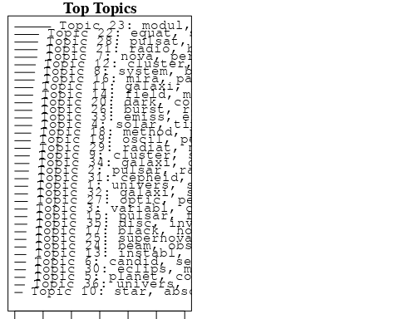

plotQuote(thoughts6, width = 30, main = "Topic 6")  
plotQuote(thoughts18, width = 30, main = "Topic 18")

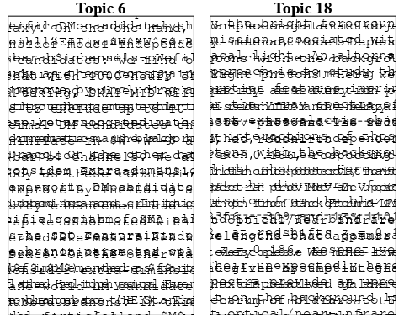

# Calculate and plot the correlation between topics  
mod.out.corr <- topicCorr(Research_topics)  
plot(mod.out.corr, cex = 1.5)  
  
  
# For each topic  
for (topic_num in 1:36) {  
 # Plot the word cloud  
 cloud(Research_topics, topic = topic_num, scale = c(2, 0.25))  
 Sys.sleep(2)  
}

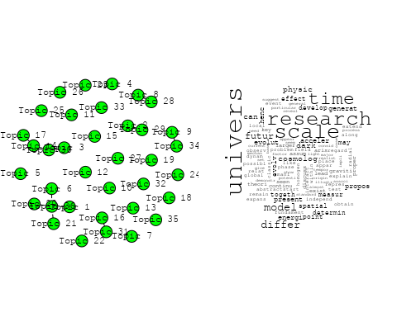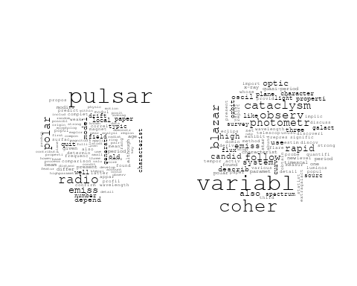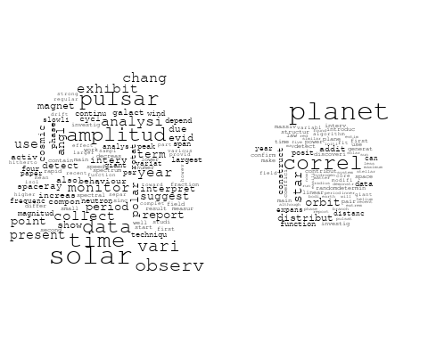

## Warning in wordcloud::wordcloud(words = vocab, freq = vec, max.words =  
## max.words, : constraint could not be fit on page. It will not be plotted.

## Warning in wordcloud::wordcloud(words = vocab, freq = vec, max.words =  
## max.words, : instrument could not be fit on page. It will not be plotted.

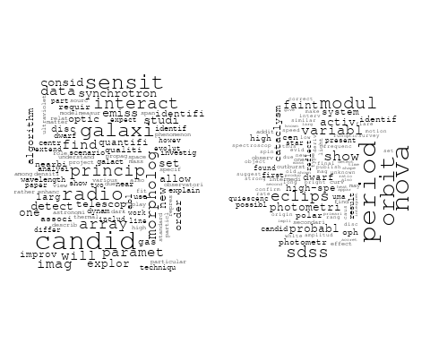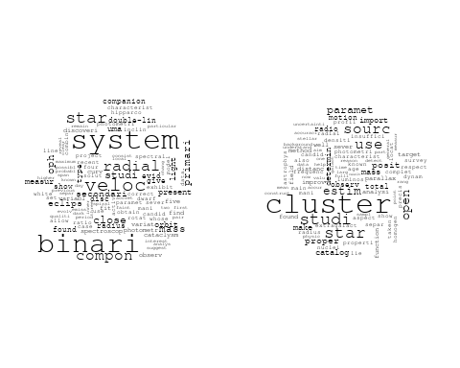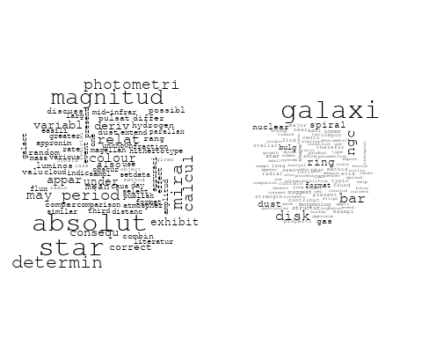

## Warning in wordcloud::wordcloud(words = vocab, freq = vec, max.words =  
## max.words, : interstellar could not be fit on page. It will not be plotted.

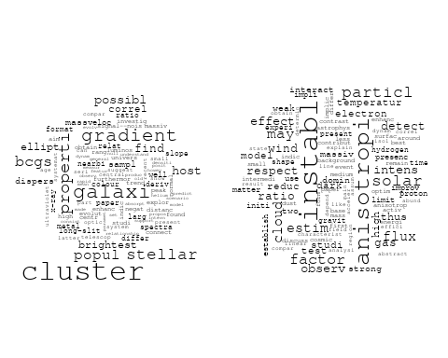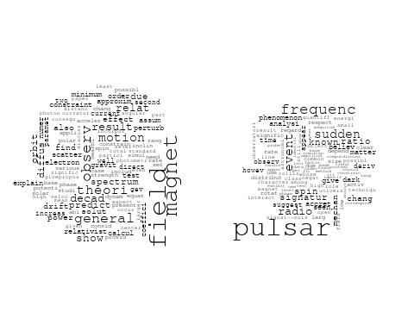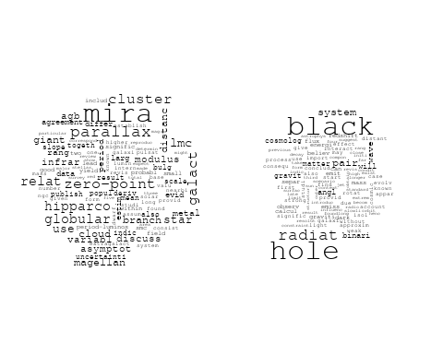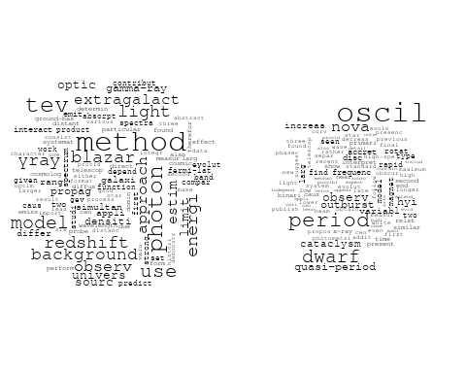

## Warning in wordcloud::wordcloud(words = vocab, freq = vec, max.words =  
## max.words, : cosmolog could not be fit on page. It will not be plotted.

## Warning in wordcloud::wordcloud(words = vocab, freq = vec, max.words =  
## max.words, : structur could not be fit on page. It will not be plotted.

## Warning in wordcloud::wordcloud(words = vocab, freq = vec, max.words =  
## max.words, : energi could not be fit on page. It will not be plotted.

## Warning in wordcloud::wordcloud(words = vocab, freq = vec, max.words =  
## max.words, : constrain could not be fit on page. It will not be plotted.

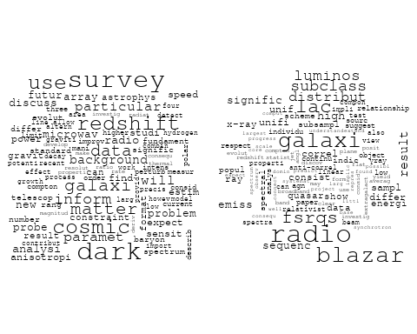

## Warning in wordcloud::wordcloud(words = vocab, freq = vec, max.words =  
## max.words, : particular could not be fit on page. It will not be plotted.

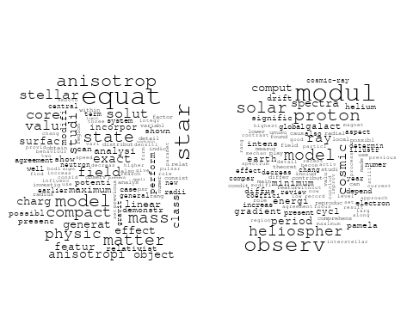

## Warning in wordcloud::wordcloud(words = vocab, freq = vec, max.words =  
## max.words, : survey could not be fit on page. It will not be plotted.

## Warning in wordcloud::wordcloud(words = vocab, freq = vec, max.words =  
## max.words, : supernova could not be fit on page. It will not be plotted.

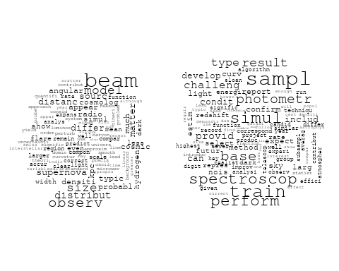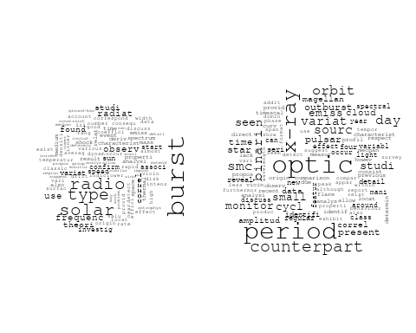

## Warning in wordcloud::wordcloud(words = vocab, freq = vec, max.words =  
## max.words, : signific could not be fit on page. It will not be plotted.

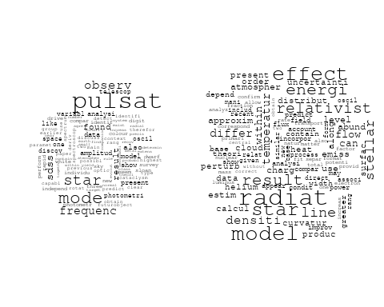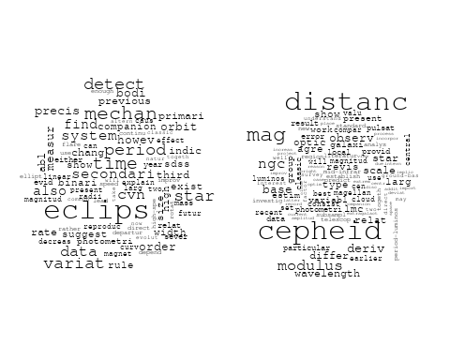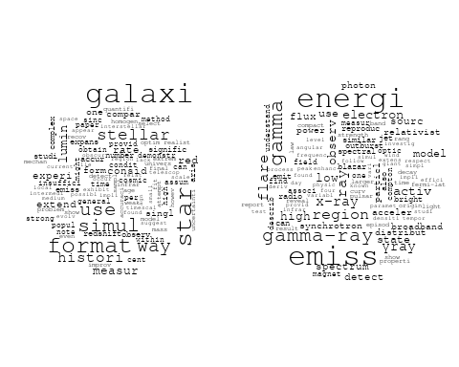

## Warning in wordcloud::wordcloud(words = vocab, freq = vec, max.words =  
## max.words, : compton could not be fit on page. It will not be plotted.

## Warning in wordcloud::wordcloud(words = vocab, freq = vec, max.words =  
## max.words, : system could not be fit on page. It will not be plotted.

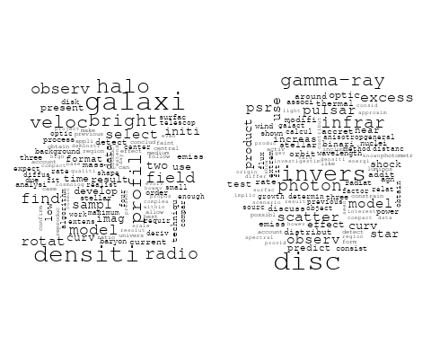

# Get the topic proportions for each document  
topic_proportions <- Research_topics$theta  
  
# Find the index of the topic with the highest proportion for each document  
# This will be the topic that each document is most likely to belong to  
max_topic_idx <- apply(topic_proportions, 1, which.max)  
  
# Add this as a new column to your data  
data_collab$topic <- max_topic_idx  
  
library(ggplot2)  
  
# Define the intervals  
intervals <- c('1824_1899', '1900_1964', '1965_1974', '1975_1984', '1985_1994', '1995_1999', '2000_2004', '2005_2009', '2010_2014', '2015_2019', '2020_2022')  
colors <- c('pink', 'blue', 'purple', 'yellow', 'green', 'pink', 'orange', 'violet', 'green', 'blue', 'pink')  
  
# Loop through the intervals and plot  
for(i in seq_along(intervals)){  
 # Filter data for when the pub_interval is equal to 1  
 data_filtered <- data_collab[data_collab[[paste0('pub_interval_', intervals[i])]] == 1,]  
   
 # Make the histogram  
   
 p <- ggplot(data_filtered, aes(x = topic)) +  
 geom_histogram(binwidth = 1, fill = colors[i], color = "black") +  
 xlab("Topic") +  
 ylab("Count") +  
 ggtitle(paste0("Topics from year ", gsub("_", " to ", intervals[i])))  
   
 print(p)  
}  
  
  
##Topic generation for Africa (independent) publications  
  
data_independent <- data[data[["Africa"]] == 100,]  
  
# Save the original title data for future use  
data_independent$original_concatenated_title_abstract <- data_independent$concatenated_title_abstract  
  
#pre-processing the titles using textProcessor from the stm package  
processed_text <- textProcessor(data_independent$concatenated_title_abstract, metadata = data_independent)

## Building corpus...   
## Converting to Lower Case...   
## Removing punctuation...   
## Removing stopwords...   
## Removing numbers...   
## Stemming...   
## Creating Output...

# Further prepare the data by removing low-frequency terms  
out_text <- prepDocuments(processed_text$documents, processed_text$vocab, processed_text$meta)

## Removing 596 of 2119 terms (596 of 10900 tokens) due to frequency   
## Your corpus now has 157 documents, 1523 terms and 10304 tokens.

docs_text <- out_text$documents  
vocab_text <- out_text$vocab  
meta_text <- out_text$meta  
  
  
#Prepare data  
plotRemoved(processed_text$documents, lower.thresh = seq(1, 200, by = 100))

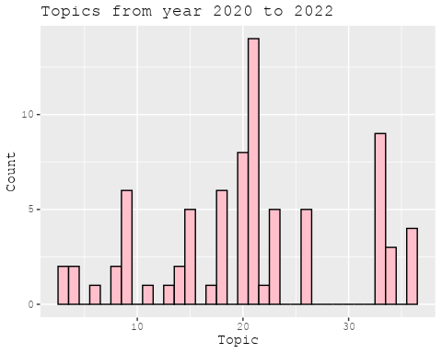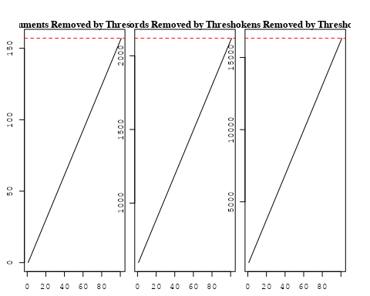

out_text <- prepDocuments(processed_text$documents, processed_text$vocab, processed_text$meta, lower.thresh = 8)

## Removing 1773 of 2119 terms (4785 of 10900 tokens) due to frequency   
## Your corpus now has 157 documents, 346 terms and 6115 tokens.

str(out_text$meta)

## 'data.frame': 157 obs. of 39 variables:  
## $ concept_id : chr "https://openalex.org/C44870925" "https://openalex.org/C1276947" "https://openalex.org/C44870925" "https://openalex.org/C44870925" ...  
## $ work_id : chr "https://openalex.org/W2977830513" "https://openalex.org/W2027124269" "https://openalex.org/W2481259536" "https://openalex.org/W3105366270" ...  
## $ publication_year : int 2019 2003 2016 1998 1998 2022 2003 2019 2004 2008 ...  
## $ title : chr "Relativistic Beaming Effects and Structural Asymmetries in Highly Asymmetric Double Radio Sources" "The interplay of astronomy and philosophy" "Global Gradients for Cosmic-Ray Protons in the Heliosphere During the Solar Minimum of Cycle 23/24" "Relaxational effects in radiating stellar collapse" ...  
## $ paperabstract : chr "We have studied the comparative importance of the relativistic beaming model (RBM) and the density variation mo"| __truncated__ "Astronomical & Astrophysical Transactions The Journal of the Eurasian Astronomical Society Publication details,"| __truncated__ "Global gradients for cosmic-ray (CR) protons in the heliosphere are computed with a comprehensive modulation mo"| __truncated__ "Relaxational effects in stellar heat transport can in many cases be significant. Relativistic Fourier—Eckart th"| __truncated__ ...  
## $ country : chr "NG NG" "MZ" "ZA ZA" "ZA ZA ZA ZA" ...  
## $ year_concept : chr "2019+https://openalex.org/C44870925" "2003+https://openalex.org/C1276947" "2016+https://openalex.org/C44870925" "1998+https://openalex.org/C44870925" ...  
## $ concatenated_title_abstract : chr "Relativistic Beaming Effects and Structural Asymmetries in Highly Asymmetric Double Radio Sources We have studi"| __truncated__ "The interplay of astronomy and philosophy Astronomical & Astrophysical Transactions The Journal of the Eurasian"| __truncated__ "Global Gradients for Cosmic-Ray Protons in the Heliosphere During the Solar Minimum of Cycle 23/24 Global gradi"| __truncated__ "Relaxational effects in radiating stellar collapse Relaxational effects in stellar heat transport can in many c"| __truncated__ ...  
## $ US : num 0 0 0 0 0 0 0 0 0 0 ...  
## $ IN : num 0 0 0 0 0 0 0 0 0 0 ...  
## $ DE : num 0 0 0 0 0 0 0 0 0 0 ...  
## $ CH : num 0 0 0 0 0 0 0 0 0 0 ...  
## $ GB : num 0 0 0 0 0 0 0 0 0 0 ...  
## $ CN : num 0 0 0 0 0 0 0 0 0 0 ...  
## $ FR : num 0 0 0 0 0 0 0 0 0 0 ...  
## $ IT : num 0 0 0 0 0 0 0 0 0 0 ...  
## $ RU : num 0 0 0 0 0 0 0 0 0 0 ...  
## $ CA : num 0 0 0 0 0 0 0 0 0 0 ...  
## $ NL : num 0 0 0 0 0 0 0 0 0 0 ...  
## $ AU : num 0 0 0 0 0 0 0 0 0 0 ...  
## $ JP : num 0 0 0 0 0 0 0 0 0 0 ...  
## $ ES : num 0 0 0 0 0 0 0 0 0 0 ...  
## $ IL : num 0 0 0 0 0 0 0 0 0 0 ...  
## $ Americas : num 0 0 0 0 0 0 0 0 0 0 ...  
## $ Europe : num 0 0 0 0 0 0 0 0 0 0 ...  
## $ Africa : num 100 100 100 100 100 100 100 100 100 100 ...  
## $ AsiaAndOceania : num 0 0 0 0 0 0 0 0 0 0 ...  
## $ pub_interval_2020_2022 : int 0 0 0 0 0 1 0 0 0 0 ...  
## $ pub_interval_2015_2019 : int 1 0 1 0 0 0 0 1 0 0 ...  
## $ pub_interval_2010_2014 : int 0 0 0 0 0 0 0 0 0 0 ...  
## $ pub_interval_2005_2009 : int 0 0 0 0 0 0 0 0 0 1 ...  
## $ pub_interval_2000_2004 : int 0 1 0 0 0 0 1 0 1 0 ...  
## $ pub_interval_1995_1999 : int 0 0 0 1 1 0 0 0 0 0 ...  
## $ pub_interval_1985_1994 : int 0 0 0 0 0 0 0 0 0 0 ...  
## $ pub_interval_1975_1984 : int 0 0 0 0 0 0 0 0 0 0 ...  
## $ pub_interval_1965_1974 : int 0 0 0 0 0 0 0 0 0 0 ...  
## $ pub_interval_1900_1964 : int 0 0 0 0 0 0 0 0 0 0 ...  
## $ pub_interval_1824_1899 : int 0 0 0 0 0 0 0 0 0 0 ...  
## $ original_concatenated_title_abstract: chr "Relativistic Beaming Effects and Structural Asymmetries in Highly Asymmetric Double Radio Sources We have studi"| __truncated__ "The interplay of astronomy and philosophy Astronomical & Astrophysical Transactions The Journal of the Eurasian"| __truncated__ "Global Gradients for Cosmic-Ray Protons in the Heliosphere During the Solar Minimum of Cycle 23/24 Global gradi"| __truncated__ "Relaxational effects in radiating stellar collapse Relaxational effects in stellar heat transport can in many c"| __truncated__ ...

# Initialize an empty formula string  
prevalence_formula_str <- "~"  
  
# Define the publication intervals  
pub_intervals <- c("pub_interval_2020_2022", "pub_interval_2015_2019", "pub_interval_2010_2014",   
 "pub_interval_2005_2009", "pub_interval_2000_2004", "pub_interval_1995_1999",  
 "pub_interval_1985_1994", "pub_interval_1975_1984", "pub_interval_1965_1974",  
 "pub_interval_1900_1964", "pub_interval_1824_1899")  
  
# Add each publication interval to the formula string  
for (interval in pub_intervals) {  
 # add an if statement to handle the first addition (without '+')  
 if (prevalence_formula_str == "~") {  
 prevalence_formula_str <- paste(prevalence_formula_str, interval)  
 } else {  
 prevalence_formula_str <- paste(prevalence_formula_str, "+", interval)  
 }  
}  
  
  
# Convert the string to a formula  
prevalence_formula <- as.formula(prevalence_formula_str)  
print(prevalence_formula)

## ~pub_interval_2020_2022 + pub_interval_2015_2019 + pub_interval_2010_2014 +   
## pub_interval_2005_2009 + pub_interval_2000_2004 + pub_interval_1995_1999 +   
## pub_interval_1985_1994 + pub_interval_1975_1984 + pub_interval_1965_1974 +   
## pub_interval_1900_1964 + pub_interval_1824_1899

# Run STM model  
Research_topics <- stm(documents = out_text$documents,   
 vocab = out_text$vocab,   
 K = 25,   
 prevalence = prevalence_formula,   
 data = out_text$meta,   
 init.type = "Spectral",  
 max.em.its = 1000,  
 gamma.prior = 'L1')

## Beginning Spectral Initialization   
## Calculating the gram matrix...  
## Finding anchor words...  
## .........................  
## Recovering initialization...  
## ...  
## Initialization complete.  
## .............................................................................................................................................................  
## Completed E-Step (0 seconds).   
## Completed M-Step.   
## Completing Iteration 1 (approx. per word bound = -4.737)   
## .............................................................................................................................................................  
## Completed E-Step (0 seconds).   
## Completed M-Step.   
## Completing Iteration 2 (approx. per word bound = -4.571, relative change = 3.505e-02)   
## .............................................................................................................................................................  
## Completed E-Step (0 seconds).   
## Completed M-Step.   
## Completing Iteration 3 (approx. per word bound = -4.517, relative change = 1.179e-02)   
## .............................................................................................................................................................  
## Completed E-Step (0 seconds).   
## Completed M-Step.   
## Completing Iteration 4 (approx. per word bound = -4.490, relative change = 5.910e-03)   
## .............................................................................................................................................................  
## Completed E-Step (0 seconds).   
## Completed M-Step.   
## Completing Iteration 5 (approx. per word bound = -4.474, relative change = 3.693e-03)   
## Topic 1: univers, can, problem, generat, process   
## Topic 2: pulsar, emiss, radio, old, depend   
## Topic 3: oscil, dwarf, period, variabl, cataclysm   
## Topic 4: interact, gravit, implic, sourc, mass   
## Topic 5: cluster, star, studi, open, estim   
## Topic 6: magnitud, deriv, parallax, distanc, scale   
## Topic 7: region, theoret, radio, astrophys, studi   
## Topic 8: nova, period, orbit, modul, eclips   
## Topic 9: surfac, star, valu, analysi, matter   
## Topic 10: pulsar, event, frequenc, radio, spin   
## Topic 11: galaxi, well, distanc, shape, curv   
## Topic 12: radio, galaxi, blazar, lac, fsrqs   
## Topic 13: modul, observ, proton, heliospher, model   
## Topic 14: follow, photometr, speed, high, candid   
## Topic 15: radiat, effect, flux, can, will   
## Topic 16: equat, charg, model, star, studi   
## Topic 17: theori, modifi, stellar, observ, use   
## Topic 18: variat, period, time, cycl, densiti   
## Topic 19: gamma-ray, photon, method, use, observ   
## Topic 20: solar, galact, use, result, data   
## Topic 21: simul, use, star, galaxi, measur   
## Topic 22: research, spectral, indic, physic, blazar   
## Topic 23: time, scale, evolv, differ, recent   
## Topic 24: field, model, magnet, energi, acceler   
## Topic 25: aspect, cosmic, modul, ray, observ   
## .............................................................................................................................................................  
## Completed E-Step (0 seconds).   
## Completed M-Step.   
## Completing Iteration 6 (approx. per word bound = -4.463, relative change = 2.401e-03)   
## .............................................................................................................................................................  
## Completed E-Step (0 seconds).   
## Completed M-Step.   
## Completing Iteration 7 (approx. per word bound = -4.454, relative change = 1.977e-03)   
## .............................................................................................................................................................  
## Completed E-Step (0 seconds).   
## Completed M-Step.   
## Completing Iteration 8 (approx. per word bound = -4.447, relative change = 1.517e-03)   
## .............................................................................................................................................................  
## Completed E-Step (0 seconds).   
## Completed M-Step.   
## Completing Iteration 9 (approx. per word bound = -4.442, relative change = 1.119e-03)   
## .............................................................................................................................................................  
## Completed E-Step (0 seconds).   
## Completed M-Step.   
## Completing Iteration 10 (approx. per word bound = -4.438, relative change = 1.026e-03)   
## Topic 1: univers, can, problem, generat, exist   
## Topic 2: pulsar, emiss, radio, old, polar   
## Topic 3: oscil, dwarf, period, nova, cataclysm   
## Topic 4: interact, gravit, implic, sourc, mass   
## Topic 5: cluster, star, studi, open, estim   
## Topic 6: magnitud, parallax, distanc, deriv, scale   
## Topic 7: radio, theoret, region, model, studi   
## Topic 8: nova, period, orbit, modul, eclips   
## Topic 9: surfac, star, valu, analysi, model   
## Topic 10: pulsar, event, frequenc, spin, known   
## Topic 11: galaxi, well, distanc, shape, differ   
## Topic 12: radio, galaxi, blazar, lac, fsrqs   
## Topic 13: modul, observ, proton, heliospher, model   
## Topic 14: follow, photometr, candid, photometri, speed   
## Topic 15: radiat, effect, flux, can, will   
## Topic 16: equat, charg, model, star, object   
## Topic 17: theori, modifi, stellar, observ, orbit   
## Topic 18: variat, period, time, cycl, sourc   
## Topic 19: gamma-ray, photon, method, use, blazar   
## Topic 20: solar, use, galact, result, deriv   
## Topic 21: simul, use, star, galaxi, redshift   
## Topic 22: spectral, research, ray, indic, object   
## Topic 23: time, scale, evolv, theori, differ   
## Topic 24: field, magnet, energi, ray, acceler   
## Topic 25: aspect, cosmic, modul, ray, observ   
## .............................................................................................................................................................  
## Completed E-Step (0 seconds).   
## Completed M-Step.   
## Completing Iteration 11 (approx. per word bound = -4.433, relative change = 1.035e-03)   
## .............................................................................................................................................................  
## Completed E-Step (0 seconds).   
## Completed M-Step.   
## Completing Iteration 12 (approx. per word bound = -4.429, relative change = 9.114e-04)   
## .............................................................................................................................................................  
## Completed E-Step (0 seconds).   
## Completed M-Step.   
## Completing Iteration 13 (approx. per word bound = -4.425, relative change = 8.559e-04)   
## .............................................................................................................................................................  
## Completed E-Step (0 seconds).   
## Completed M-Step.   
## Completing Iteration 14 (approx. per word bound = -4.422, relative change = 7.765e-04)   
## .............................................................................................................................................................  
## Completed E-Step (0 seconds).   
## Completed M-Step.   
## Completing Iteration 15 (approx. per word bound = -4.419, relative change = 7.363e-04)   
## Topic 1: univers, can, dark, problem, generat   
## Topic 2: pulsar, emiss, radio, old, polar   
## Topic 3: oscil, dwarf, period, nova, cataclysm   
## Topic 4: interact, gravit, implic, sourc, mass   
## Topic 5: cluster, star, studi, open, paramet   
## Topic 6: magnitud, parallax, distanc, deriv, scale   
## Topic 7: model, theoret, radio, region, observ   
## Topic 8: nova, period, orbit, modul, eclips   
## Topic 9: surfac, star, valu, analysi, matter   
## Topic 10: pulsar, event, frequenc, spin, known   
## Topic 11: galaxi, distanc, shape, well, particular   
## Topic 12: radio, galaxi, blazar, lac, fsrqs   
## Topic 13: modul, observ, proton, heliospher, model   
## Topic 14: follow, photometr, candid, speed, photometri   
## Topic 15: radiat, effect, flux, can, emiss   
## Topic 16: equat, charg, model, star, object   
## Topic 17: modifi, theori, stellar, observ, orbit   
## Topic 18: variat, period, time, cycl, densiti   
## Topic 19: gamma-ray, method, use, photon, blazar   
## Topic 20: solar, use, galact, result, deriv   
## Topic 21: simul, use, star, galaxi, redshift   
## Topic 22: ray, spectral, research, indic, object   
## Topic 23: time, scale, evolv, theori, differ   
## Topic 24: field, magnet, energi, acceler, ray   
## Topic 25: aspect, cosmic, modul, ray, observ   
## .............................................................................................................................................................  
## Completed E-Step (0 seconds).   
## Completed M-Step.   
## Completing Iteration 16 (approx. per word bound = -4.416, relative change = 7.278e-04)   
## .............................................................................................................................................................  
## Completed E-Step (0 seconds).   
## Completed M-Step.   
## Completing Iteration 17 (approx. per word bound = -4.412, relative change = 7.357e-04)   
## .............................................................................................................................................................  
## Completed E-Step (0 seconds).   
## Completed M-Step.   
## Completing Iteration 18 (approx. per word bound = -4.409, relative change = 7.267e-04)   
## .............................................................................................................................................................  
## Completed E-Step (0 seconds).   
## Completed M-Step.   
## Completing Iteration 19 (approx. per word bound = -4.406, relative change = 6.455e-04)   
## .............................................................................................................................................................  
## Completed E-Step (0 seconds).   
## Completed M-Step.   
## Completing Iteration 20 (approx. per word bound = -4.404, relative change = 4.423e-04)   
## Topic 1: univers, model, dark, can, problem   
## Topic 2: pulsar, emiss, radio, old, polar   
## Topic 3: oscil, dwarf, period, nova, cataclysm   
## Topic 4: gravit, implic, interact, mass, sourc   
## Topic 5: cluster, star, studi, open, paramet   
## Topic 6: magnitud, parallax, distanc, deriv, scale   
## Topic 7: model, observ, theoret, region, also   
## Topic 8: nova, period, orbit, modul, eclips   
## Topic 9: surfac, star, valu, analysi, matter   
## Topic 10: pulsar, event, frequenc, spin, known   
## Topic 11: galaxi, shape, distanc, particular, detect   
## Topic 12: radio, galaxi, blazar, lac, fsrqs   
## Topic 13: modul, observ, proton, heliospher, solar   
## Topic 14: follow, photometr, candid, speed, survey   
## Topic 15: radiat, can, emiss, will, flux   
## Topic 16: equat, charg, model, star, object   
## Topic 17: modifi, theori, effect, stellar, orbit   
## Topic 18: variat, period, time, cycl, sourc   
## Topic 19: gamma-ray, method, use, photon, blazar   
## Topic 20: solar, use, galact, result, deriv   
## Topic 21: simul, use, star, galaxi, redshift   
## Topic 22: ray, spectral, research, indic, object   
## Topic 23: time, evolv, scale, theori, differ   
## Topic 24: field, energi, magnet, acceler, ray   
## Topic 25: aspect, cosmic, modul, ray, observ   
## .............................................................................................................................................................  
## Completed E-Step (0 seconds).   
## Completed M-Step.   
## Completing Iteration 21 (approx. per word bound = -4.403, relative change = 3.414e-04)   
## .............................................................................................................................................................  
## Completed E-Step (0 seconds).   
## Completed M-Step.   
## Completing Iteration 22 (approx. per word bound = -4.401, relative change = 2.929e-04)   
## .............................................................................................................................................................  
## Completed E-Step (0 seconds).   
## Completed M-Step.   
## Completing Iteration 23 (approx. per word bound = -4.400, relative change = 2.544e-04)   
## .............................................................................................................................................................  
## Completed E-Step (0 seconds).   
## Completed M-Step.   
## Completing Iteration 24 (approx. per word bound = -4.399, relative change = 2.549e-04)   
## .............................................................................................................................................................  
## Completed E-Step (0 seconds).   
## Completed M-Step.   
## Completing Iteration 25 (approx. per word bound = -4.398, relative change = 2.858e-04)   
## Topic 1: univers, model, dark, can, problem   
## Topic 2: pulsar, emiss, radio, old, polar   
## Topic 3: oscil, dwarf, period, nova, cataclysm   
## Topic 4: gravit, implic, interact, mass, sourc   
## Topic 5: cluster, star, studi, open, paramet   
## Topic 6: magnitud, parallax, distanc, deriv, scale   
## Topic 7: model, observ, theoret, region, also   
## Topic 8: nova, period, orbit, modul, eclips   
## Topic 9: surfac, star, valu, analysi, matter   
## Topic 10: pulsar, event, frequenc, spin, known   
## Topic 11: galaxi, shape, distanc, detect, particular   
## Topic 12: radio, galaxi, blazar, lac, fsrqs   
## Topic 13: modul, proton, observ, heliospher, solar   
## Topic 14: follow, photometr, candid, survey, speed   
## Topic 15: radiat, can, emiss, will, solar   
## Topic 16: equat, charg, model, star, object   
## Topic 17: modifi, effect, theori, stellar, orbit   
## Topic 18: variat, period, time, cycl, sourc   
## Topic 19: gamma-ray, method, photon, use, blazar   
## Topic 20: solar, use, galact, result, deriv   
## Topic 21: simul, use, star, galaxi, redshift   
## Topic 22: ray, spectral, research, indic, object   
## Topic 23: time, evolv, scale, theori, differ   
## Topic 24: field, magnet, energi, acceler, ray   
## Topic 25: aspect, cosmic, modul, ray, observ   
## .............................................................................................................................................................  
## Completed E-Step (0 seconds).   
## Completed M-Step.   
## Completing Iteration 26 (approx. per word bound = -4.397, relative change = 3.146e-04)   
## .............................................................................................................................................................  
## Completed E-Step (0 seconds).   
## Completed M-Step.   
## Completing Iteration 27 (approx. per word bound = -4.395, relative change = 2.786e-04)   
## .............................................................................................................................................................  
## Completed E-Step (0 seconds).   
## Completed M-Step.   
## Completing Iteration 28 (approx. per word bound = -4.395, relative change = 1.620e-04)   
## .............................................................................................................................................................  
## Completed E-Step (0 seconds).   
## Completed M-Step.   
## Completing Iteration 29 (approx. per word bound = -4.394, relative change = 1.310e-04)   
## .............................................................................................................................................................  
## Completed E-Step (0 seconds).   
## Completed M-Step.   
## Completing Iteration 30 (approx. per word bound = -4.394, relative change = 1.147e-04)   
## Topic 1: univers, model, dark, can, energi   
## Topic 2: pulsar, emiss, radio, old, polar   
## Topic 3: oscil, dwarf, period, nova, cataclysm   
## Topic 4: gravit, implic, interact, mass, sourc   
## Topic 5: cluster, star, studi, open, paramet   
## Topic 6: magnitud, parallax, distanc, deriv, scale   
## Topic 7: model, observ, theoret, region, featur   
## Topic 8: nova, period, orbit, modul, eclips   
## Topic 9: surfac, star, valu, analysi, matter   
## Topic 10: pulsar, event, frequenc, spin, known   
## Topic 11: galaxi, shape, distanc, detect, particular   
## Topic 12: radio, galaxi, blazar, lac, fsrqs   
## Topic 13: modul, observ, proton, heliospher, solar   
## Topic 14: follow, photometr, candid, survey, speed   
## Topic 15: radiat, emiss, will, solar, can   
## Topic 16: equat, charg, model, star, object   
## Topic 17: modifi, effect, theori, stellar, orbit   
## Topic 18: variat, period, time, cycl, sourc   
## Topic 19: gamma-ray, method, photon, use, blazar   
## Topic 20: solar, use, galact, result, deriv   
## Topic 21: simul, use, star, galaxi, redshift   
## Topic 22: ray, spectral, research, indic, object   
## Topic 23: time, evolv, scale, theori, radio   
## Topic 24: field, magnet, energi, acceler, ray   
## Topic 25: aspect, cosmic, modul, ray, observ   
## .............................................................................................................................................................  
## Completed E-Step (0 seconds).   
## Completed M-Step.   
## Completing Iteration 31 (approx. per word bound = -4.393, relative change = 1.105e-04)   
## .............................................................................................................................................................  
## Completed E-Step (0 seconds).   
## Completed M-Step.   
## Completing Iteration 32 (approx. per word bound = -4.393, relative change = 1.155e-04)   
## .............................................................................................................................................................  
## Completed E-Step (0 seconds).   
## Completed M-Step.   
## Completing Iteration 33 (approx. per word bound = -4.392, relative change = 1.298e-04)   
## .............................................................................................................................................................  
## Completed E-Step (0 seconds).   
## Completed M-Step.   
## Completing Iteration 34 (approx. per word bound = -4.391, relative change = 1.215e-04)   
## .............................................................................................................................................................  
## Completed E-Step (0 seconds).   
## Completed M-Step.   
## Completing Iteration 35 (approx. per word bound = -4.391, relative change = 9.758e-05)   
## Topic 1: univers, model, dark, can, energi   
## Topic 2: pulsar, emiss, radio, old, polar   
## Topic 3: oscil, dwarf, period, nova, cataclysm   
## Topic 4: gravit, implic, interact, mass, sourc   
## Topic 5: cluster, star, studi, open, paramet   
## Topic 6: magnitud, parallax, distanc, deriv, scale   
## Topic 7: model, observ, theoret, region, featur   
## Topic 8: nova, period, orbit, modul, eclips   
## Topic 9: surfac, star, valu, analysi, matter   
## Topic 10: pulsar, event, frequenc, spin, known   
## Topic 11: galaxi, shape, detect, distanc, particular   
## Topic 12: radio, galaxi, blazar, lac, fsrqs   
## Topic 13: modul, proton, observ, heliospher, solar   
## Topic 14: follow, candid, photometr, survey, speed   
## Topic 15: radiat, solar, emiss, will, can   
## Topic 16: equat, charg, model, star, object   
## Topic 17: modifi, effect, theori, stellar, orbit   
## Topic 18: variat, period, time, cycl, sourc   
## Topic 19: gamma-ray, method, photon, use, blazar   
## Topic 20: solar, use, galact, result, deriv   
## Topic 21: simul, use, star, galaxi, redshift   
## Topic 22: ray, spectral, research, indic, object   
## Topic 23: time, evolv, scale, theori, radio   
## Topic 24: field, magnet, energi, acceler, ray   
## Topic 25: aspect, cosmic, modul, ray, observ   
## .............................................................................................................................................................  
## Completed E-Step (0 seconds).   
## Completed M-Step.   
## Completing Iteration 36 (approx. per word bound = -4.391, relative change = 1.077e-04)   
## .............................................................................................................................................................  
## Completed E-Step (0 seconds).   
## Completed M-Step.   
## Completing Iteration 37 (approx. per word bound = -4.390, relative change = 1.524e-04)   
## .............................................................................................................................................................  
## Completed E-Step (0 seconds).   
## Completed M-Step.   
## Completing Iteration 38 (approx. per word bound = -4.389, relative change = 1.447e-04)   
## .............................................................................................................................................................  
## Completed E-Step (0 seconds).   
## Completed M-Step.   
## Completing Iteration 39 (approx. per word bound = -4.389, relative change = 1.232e-04)   
## .............................................................................................................................................................  
## Completed E-Step (0 seconds).   
## Completed M-Step.   
## Completing Iteration 40 (approx. per word bound = -4.388, relative change = 9.826e-05)   
## Topic 1: univers, model, dark, energi, can   
## Topic 2: pulsar, emiss, radio, old, polar   
## Topic 3: oscil, dwarf, period, nova, cataclysm   
## Topic 4: gravit, implic, interact, mass, sourc   
## Topic 5: cluster, star, studi, open, paramet   
## Topic 6: magnitud, parallax, distanc, deriv, scale   
## Topic 7: model, observ, theoret, region, also   
## Topic 8: nova, period, orbit, modul, eclips   
## Topic 9: surfac, star, valu, analysi, matter   
## Topic 10: pulsar, event, frequenc, spin, known   
## Topic 11: galaxi, shape, detect, distanc, particular   
## Topic 12: radio, galaxi, blazar, lac, fsrqs   
## Topic 13: modul, proton, observ, heliospher, solar   
## Topic 14: follow, candid, survey, speed, photometr   
## Topic 15: radiat, solar, emiss, will, flux   
## Topic 16: equat, charg, model, star, object   
## Topic 17: modifi, effect, theori, stellar, orbit   
## Topic 18: variat, period, time, cycl, sourc   
## Topic 19: gamma-ray, method, photon, use, blazar   
## Topic 20: solar, use, galact, result, deriv   
## Topic 21: simul, use, star, galaxi, redshift   
## Topic 22: ray, spectral, research, indic, object   
## Topic 23: time, evolv, scale, theori, radio   
## Topic 24: field, magnet, energi, acceler, ray   
## Topic 25: aspect, cosmic, modul, ray, observ   
## .............................................................................................................................................................  
## Completed E-Step (0 seconds).   
## Completed M-Step.   
## Completing Iteration 41 (approx. per word bound = -4.388, relative change = 9.283e-05)   
## .............................................................................................................................................................  
## Completed E-Step (0 seconds).   
## Completed M-Step.   
## Completing Iteration 42 (approx. per word bound = -4.387, relative change = 1.203e-04)   
## .............................................................................................................................................................  
## Completed E-Step (0 seconds).   
## Completed M-Step.   
## Completing Iteration 43 (approx. per word bound = -4.387, relative change = 1.746e-04)   
## .............................................................................................................................................................  
## Completed E-Step (0 seconds).   
## Completed M-Step.   
## Completing Iteration 44 (approx. per word bound = -4.386, relative change = 1.161e-04)   
## .............................................................................................................................................................  
## Completed E-Step (0 seconds).   
## Completed M-Step.   
## Completing Iteration 45 (approx. per word bound = -4.386, relative change = 7.897e-05)   
## Topic 1: univers, model, dark, energi, can   
## Topic 2: pulsar, emiss, radio, old, polar   
## Topic 3: oscil, dwarf, period, nova, cataclysm   
## Topic 4: gravit, implic, interact, mass, sourc   
## Topic 5: cluster, star, studi, open, paramet   
## Topic 6: magnitud, parallax, distanc, deriv, scale   
## Topic 7: model, observ, theoret, region, featur   
## Topic 8: nova, period, orbit, modul, eclips   
## Topic 9: surfac, star, valu, analysi, matter   
## Topic 10: pulsar, event, frequenc, spin, known   
## Topic 11: galaxi, shape, detect, particular, bright   
## Topic 12: radio, galaxi, blazar, lac, fsrqs   
## Topic 13: modul, proton, observ, heliospher, solar   
## Topic 14: follow, candid, survey, speed, photometr   
## Topic 15: radiat, solar, emiss, will, flux   
## Topic 16: equat, charg, model, star, object   
## Topic 17: modifi, effect, theori, stellar, orbit   
## Topic 18: variat, period, time, cycl, sourc   
## Topic 19: gamma-ray, method, photon, use, blazar   
## Topic 20: solar, use, galact, result, deriv   
## Topic 21: simul, use, star, galaxi, redshift   
## Topic 22: ray, spectral, research, indic, object   
## Topic 23: time, evolv, scale, theori, radio   
## Topic 24: field, magnet, energi, acceler, ray   
## Topic 25: aspect, cosmic, modul, ray, observ   
## .............................................................................................................................................................  
## Completed E-Step (0 seconds).   
## Completed M-Step.   
## Completing Iteration 46 (approx. per word bound = -4.385, relative change = 8.777e-05)   
## .............................................................................................................................................................  
## Completed E-Step (0 seconds).   
## Completed M-Step.   
## Completing Iteration 47 (approx. per word bound = -4.385, relative change = 9.145e-05)   
## .............................................................................................................................................................  
## Completed E-Step (0 seconds).   
## Completed M-Step.   
## Completing Iteration 48 (approx. per word bound = -4.385, relative change = 9.049e-05)   
## .............................................................................................................................................................  
## Completed E-Step (0 seconds).   
## Completed M-Step.   
## Completing Iteration 49 (approx. per word bound = -4.384, relative change = 8.108e-05)   
## .............................................................................................................................................................  
## Completed E-Step (0 seconds).   
## Completed M-Step.   
## Completing Iteration 50 (approx. per word bound = -4.384, relative change = 7.416e-05)   
## Topic 1: univers, model, dark, energi, can   
## Topic 2: pulsar, emiss, radio, old, polar   
## Topic 3: oscil, dwarf, period, nova, cataclysm   
## Topic 4: gravit, implic, interact, mass, sourc   
## Topic 5: cluster, star, studi, open, paramet   
## Topic 6: magnitud, parallax, distanc, deriv, scale   
## Topic 7: model, observ, theoret, region, featur   
## Topic 8: nova, period, orbit, modul, eclips   
## Topic 9: surfac, star, valu, analysi, matter   
## Topic 10: pulsar, event, frequenc, spin, known   
## Topic 11: galaxi, shape, detect, particular, work   
## Topic 12: radio, galaxi, blazar, lac, fsrqs   
## Topic 13: modul, proton, observ, heliospher, solar   
## Topic 14: follow, candid, survey, speed, photometr   
## Topic 15: radiat, solar, emiss, will, flux   
## Topic 16: equat, charg, model, star, object   
## Topic 17: modifi, effect, theori, stellar, orbit   
## Topic 18: variat, period, time, cycl, sourc   
## Topic 19: gamma-ray, method, photon, use, blazar   
## Topic 20: solar, use, galact, result, correspond   
## Topic 21: simul, star, use, galaxi, redshift   
## Topic 22: ray, spectral, research, indic, object   
## Topic 23: time, evolv, scale, theori, radio   
## Topic 24: field, magnet, acceler, energi, ray   
## Topic 25: aspect, cosmic, modul, ray, observ   
## .............................................................................................................................................................  
## Completed E-Step (0 seconds).   
## Completed M-Step.   
## Completing Iteration 51 (approx. per word bound = -4.384, relative change = 7.020e-05)   
## .............................................................................................................................................................  
## Completed E-Step (0 seconds).   
## Completed M-Step.   
## Completing Iteration 52 (approx. per word bound = -4.383, relative change = 6.401e-05)   
## .............................................................................................................................................................  
## Completed E-Step (0 seconds).   
## Completed M-Step.   
## Completing Iteration 53 (approx. per word bound = -4.383, relative change = 6.243e-05)   
## .............................................................................................................................................................  
## Completed E-Step (0 seconds).   
## Completed M-Step.   
## Completing Iteration 54 (approx. per word bound = -4.383, relative change = 6.755e-05)   
## .............................................................................................................................................................  
## Completed E-Step (0 seconds).   
## Completed M-Step.   
## Completing Iteration 55 (approx. per word bound = -4.382, relative change = 8.056e-05)   
## Topic 1: univers, model, dark, energi, can   
## Topic 2: pulsar, emiss, radio, old, polar   
## Topic 3: oscil, period, dwarf, nova, cataclysm   
## Topic 4: gravit, implic, interact, mass, sourc   
## Topic 5: cluster, star, studi, open, paramet   
## Topic 6: magnitud, parallax, distanc, deriv, scale   
## Topic 7: model, observ, theoret, region, featur   
## Topic 8: nova, period, orbit, modul, eclips   
## Topic 9: surfac, star, valu, analysi, matter   
## Topic 10: pulsar, event, frequenc, spin, known   
## Topic 11: galaxi, shape, detect, particular, work   
## Topic 12: radio, galaxi, blazar, lac, fsrqs   
## Topic 13: modul, proton, observ, heliospher, solar   
## Topic 14: follow, candid, survey, speed, photometr   
## Topic 15: radiat, solar, emiss, will, flux   
## Topic 16: equat, charg, model, star, object   
## Topic 17: modifi, effect, theori, stellar, orbit   
## Topic 18: variat, period, time, cycl, sourc   
## Topic 19: gamma-ray, method, photon, use, blazar   
## Topic 20: solar, use, galact, result, correspond   
## Topic 21: simul, star, use, galaxi, redshift   
## Topic 22: ray, spectral, research, indic, object   
## Topic 23: time, evolv, scale, theori, radio   
## Topic 24: field, magnet, acceler, energi, ray   
## Topic 25: aspect, cosmic, modul, ray, observ   
## .............................................................................................................................................................  
## Completed E-Step (0 seconds).   
## Completed M-Step.   
## Completing Iteration 56 (approx. per word bound = -4.382, relative change = 6.584e-05)   
## .............................................................................................................................................................  
## Completed E-Step (0 seconds).   
## Completed M-Step.   
## Completing Iteration 57 (approx. per word bound = -4.382, relative change = 4.406e-05)   
## .............................................................................................................................................................  
## Completed E-Step (0 seconds).   
## Completed M-Step.   
## Completing Iteration 58 (approx. per word bound = -4.382, relative change = 4.007e-05)   
## .............................................................................................................................................................  
## Completed E-Step (0 seconds).   
## Completed M-Step.   
## Completing Iteration 59 (approx. per word bound = -4.382, relative change = 3.701e-05)   
## .............................................................................................................................................................  
## Completed E-Step (0 seconds).   
## Completed M-Step.   
## Completing Iteration 60 (approx. per word bound = -4.381, relative change = 3.321e-05)   
## Topic 1: univers, model, dark, energi, can   
## Topic 2: pulsar, emiss, radio, old, polar   
## Topic 3: oscil, period, dwarf, nova, cataclysm   
## Topic 4: gravit, implic, interact, mass, general   
## Topic 5: cluster, star, studi, open, paramet   
## Topic 6: magnitud, parallax, distanc, deriv, scale   
## Topic 7: model, observ, theoret, region, featur   
## Topic 8: nova, period, orbit, modul, eclips   
## Topic 9: surfac, star, valu, analysi, matter   
## Topic 10: pulsar, event, frequenc, spin, known   
## Topic 11: galaxi, shape, particular, detect, work   
## Topic 12: radio, galaxi, blazar, lac, fsrqs   
## Topic 13: modul, proton, observ, heliospher, solar   
## Topic 14: follow, candid, survey, speed, photometr   
## Topic 15: radiat, solar, emiss, will, flux   
## Topic 16: equat, charg, model, star, object   
## Topic 17: modifi, effect, theori, stellar, orbit   
## Topic 18: variat, period, time, cycl, sourc   
## Topic 19: gamma-ray, method, photon, use, blazar   
## Topic 20: solar, use, galact, result, correspond   
## Topic 21: simul, star, use, galaxi, redshift   
## Topic 22: ray, spectral, research, indic, object   
## Topic 23: time, evolv, scale, theori, radio   
## Topic 24: field, magnet, acceler, energi, ray   
## Topic 25: aspect, cosmic, modul, ray, observ   
## .............................................................................................................................................................  
## Completed E-Step (0 seconds).   
## Completed M-Step.   
## Completing Iteration 61 (approx. per word bound = -4.381, relative change = 3.509e-05)   
## .............................................................................................................................................................  
## Completed E-Step (0 seconds).   
## Completed M-Step.   
## Completing Iteration 62 (approx. per word bound = -4.381, relative change = 3.884e-05)   
## .............................................................................................................................................................  
## Completed E-Step (0 seconds).   
## Completed M-Step.   
## Completing Iteration 63 (approx. per word bound = -4.381, relative change = 4.915e-05)   
## .............................................................................................................................................................  
## Completed E-Step (0 seconds).   
## Completed M-Step.   
## Completing Iteration 64 (approx. per word bound = -4.381, relative change = 5.088e-05)   
## .............................................................................................................................................................  
## Completed E-Step (0 seconds).   
## Completed M-Step.   
## Completing Iteration 65 (approx. per word bound = -4.381, relative change = 3.494e-05)   
## Topic 1: univers, model, dark, energi, can   
## Topic 2: pulsar, emiss, radio, old, polar   
## Topic 3: oscil, period, dwarf, nova, cataclysm   
## Topic 4: gravit, implic, interact, general, sourc   
## Topic 5: cluster, star, studi, open, paramet   
## Topic 6: magnitud, parallax, distanc, deriv, scale   
## Topic 7: model, observ, theoret, region, featur   
## Topic 8: nova, period, orbit, modul, eclips   
## Topic 9: surfac, star, valu, analysi, matter   
## Topic 10: pulsar, event, frequenc, spin, known   
## Topic 11: galaxi, shape, particular, detect, work   
## Topic 12: radio, galaxi, blazar, lac, fsrqs   
## Topic 13: modul, proton, observ, heliospher, solar   
## Topic 14: follow, candid, survey, speed, photometr   
## Topic 15: radiat, solar, emiss, will, flux   
## Topic 16: equat, charg, model, star, object   
## Topic 17: modifi, effect, theori, stellar, orbit   
## Topic 18: variat, period, time, cycl, sourc   
## Topic 19: gamma-ray, method, use, photon, blazar   
## Topic 20: solar, use, galact, result, correspond   
## Topic 21: simul, star, use, galaxi, redshift   
## Topic 22: ray, spectral, research, indic, object   
## Topic 23: time, evolv, scale, theori, radio   
## Topic 24: field, magnet, acceler, energi, ray   
## Topic 25: aspect, cosmic, modul, ray, observ   
## .............................................................................................................................................................  
## Completed E-Step (0 seconds).   
## Completed M-Step.   
## Completing Iteration 66 (approx. per word bound = -4.380, relative change = 2.736e-05)   
## .............................................................................................................................................................  
## Completed E-Step (0 seconds).   
## Completed M-Step.   
## Completing Iteration 67 (approx. per word bound = -4.380, relative change = 2.134e-05)   
## .............................................................................................................................................................  
## Completed E-Step (0 seconds).   
## Completed M-Step.   
## Completing Iteration 68 (approx. per word bound = -4.380, relative change = 1.710e-05)   
## .............................................................................................................................................................  
## Completed E-Step (0 seconds).   
## Completed M-Step.   
## Completing Iteration 69 (approx. per word bound = -4.380, relative change = 2.461e-05)   
## .............................................................................................................................................................  
## Completed E-Step (0 seconds).   
## Completed M-Step.   
## Completing Iteration 70 (approx. per word bound = -4.380, relative change = 2.011e-05)   
## Topic 1: univers, model, dark, energi, can   
## Topic 2: pulsar, emiss, radio, old, polar   
## Topic 3: oscil, period, dwarf, nova, cataclysm   
## Topic 4: gravit, implic, interact, general, approxim   
## Topic 5: cluster, star, studi, open, paramet   
## Topic 6: magnitud, parallax, distanc, deriv, scale   
## Topic 7: model, observ, theoret, region, also   
## Topic 8: nova, period, orbit, modul, eclips   
## Topic 9: surfac, star, valu, analysi, matter   
## Topic 10: pulsar, event, frequenc, spin, known   
## Topic 11: galaxi, shape, particular, detect, work   
## Topic 12: radio, galaxi, blazar, lac, fsrqs   
## Topic 13: modul, proton, observ, heliospher, solar   
## Topic 14: follow, candid, survey, speed, photometr   
## Topic 15: radiat, solar, emiss, will, flux   
## Topic 16: equat, charg, model, star, object   
## Topic 17: modifi, effect, theori, stellar, orbit   
## Topic 18: variat, period, time, cycl, sourc   
## Topic 19: gamma-ray, method, use, photon, blazar   
## Topic 20: solar, use, galact, result, correspond   
## Topic 21: simul, star, use, galaxi, method   
## Topic 22: ray, spectral, research, indic, object   
## Topic 23: time, evolv, scale, theori, radio   
## Topic 24: field, magnet, acceler, energi, ray   
## Topic 25: aspect, cosmic, modul, ray, observ   
## .............................................................................................................................................................  
## Completed E-Step (0 seconds).   
## Completed M-Step.   
## Completing Iteration 71 (approx. per word bound = -4.380, relative change = 2.217e-05)   
## .............................................................................................................................................................  
## Completed E-Step (0 seconds).   
## Completed M-Step.   
## Completing Iteration 72 (approx. per word bound = -4.380, relative change = 2.260e-05)   
## .............................................................................................................................................................  
## Completed E-Step (0 seconds).   
## Completed M-Step.   
## Completing Iteration 73 (approx. per word bound = -4.380, relative change = 2.411e-05)   
## .............................................................................................................................................................  
## Completed E-Step (0 seconds).   
## Completed M-Step.   
## Completing Iteration 74 (approx. per word bound = -4.380, relative change = 2.838e-05)   
## .............................................................................................................................................................  
## Completed E-Step (0 seconds).   
## Completed M-Step.   
## Completing Iteration 75 (approx. per word bound = -4.379, relative change = 3.120e-05)   
## Topic 1: univers, model, dark, energi, can   
## Topic 2: pulsar, emiss, radio, old, polar   
## Topic 3: oscil, period, dwarf, nova, cataclysm   
## Topic 4: gravit, implic, interact, general, approxim   
## Topic 5: cluster, star, studi, open, paramet   
## Topic 6: magnitud, parallax, distanc, deriv, scale   
## Topic 7: model, observ, theoret, region, also   
## Topic 8: nova, period, orbit, modul, eclips   
## Topic 9: surfac, star, valu, analysi, matter   
## Topic 10: pulsar, event, frequenc, spin, known   
## Topic 11: galaxi, shape, particular, detect, work   
## Topic 12: radio, galaxi, blazar, lac, fsrqs   
## Topic 13: modul, proton, observ, heliospher, solar   
## Topic 14: follow, candid, survey, speed, photometr   
## Topic 15: radiat, solar, emiss, will, flux   
## Topic 16: equat, charg, model, star, object   
## Topic 17: modifi, effect, theori, stellar, orbit   
## Topic 18: variat, period, time, cycl, sourc   
## Topic 19: gamma-ray, method, use, photon, blazar   
## Topic 20: solar, use, galact, result, correspond   
## Topic 21: simul, star, use, galaxi, method   
## Topic 22: ray, spectral, research, indic, object   
## Topic 23: time, evolv, scale, theori, radio   
## Topic 24: field, magnet, acceler, energi, ray   
## Topic 25: aspect, cosmic, modul, ray, observ   
## .............................................................................................................................................................  
## Completed E-Step (0 seconds).   
## Completed M-Step.   
## Completing Iteration 76 (approx. per word bound = -4.379, relative change = 3.732e-05)   
## .............................................................................................................................................................  
## Completed E-Step (0 seconds).   
## Completed M-Step.   
## Completing Iteration 77 (approx. per word bound = -4.379, relative change = 4.086e-05)   
## .............................................................................................................................................................  
## Completed E-Step (0 seconds).   
## Completed M-Step.   
## Completing Iteration 78 (approx. per word bound = -4.379, relative change = 4.729e-05)   
## .............................................................................................................................................................  
## Completed E-Step (0 seconds).   
## Completed M-Step.   
## Completing Iteration 79 (approx. per word bound = -4.379, relative change = 4.864e-05)   
## .............................................................................................................................................................  
## Completed E-Step (0 seconds).   
## Completed M-Step.   
## Completing Iteration 80 (approx. per word bound = -4.378, relative change = 6.080e-05)   
## Topic 1: univers, model, dark, energi, can   
## Topic 2: pulsar, emiss, radio, old, polar   
## Topic 3: oscil, period, dwarf, nova, cataclysm   
## Topic 4: gravit, implic, interact, general, approxim   
## Topic 5: cluster, star, studi, open, paramet   
## Topic 6: magnitud, parallax, distanc, deriv, scale   
## Topic 7: model, observ, theoret, region, also   
## Topic 8: nova, period, orbit, modul, eclips   
## Topic 9: surfac, star, valu, analysi, matter   
## Topic 10: pulsar, event, frequenc, spin, known   
## Topic 11: galaxi, shape, particular, detect, work   
## Topic 12: radio, galaxi, blazar, lac, fsrqs   
## Topic 13: modul, proton, observ, heliospher, solar   
## Topic 14: follow, candid, survey, speed, photometr   
## Topic 15: radiat, solar, emiss, will, flux   
## Topic 16: equat, charg, model, star, object   
## Topic 17: modifi, effect, theori, stellar, orbit   
## Topic 18: variat, period, time, cycl, sourc   
## Topic 19: gamma-ray, method, use, photon, blazar   
## Topic 20: solar, use, galact, result, correspond   
## Topic 21: simul, star, use, galaxi, method   
## Topic 22: ray, spectral, research, indic, object   
## Topic 23: time, evolv, scale, theori, radio   
## Topic 24: field, magnet, acceler, energi, ray   
## Topic 25: aspect, cosmic, modul, ray, observ   
## .............................................................................................................................................................  
## Completed E-Step (0 seconds).   
## Completed M-Step.   
## Completing Iteration 81 (approx. per word bound = -4.378, relative change = 7.714e-05)   
## .............................................................................................................................................................  
## Completed E-Step (0 seconds).   
## Completed M-Step.   
## Completing Iteration 82 (approx. per word bound = -4.378, relative change = 6.440e-05)   
## .............................................................................................................................................................  
## Completed E-Step (0 seconds).   
## Completed M-Step.   
## Completing Iteration 83 (approx. per word bound = -4.378, relative change = 6.260e-05)   
## .............................................................................................................................................................  
## Completed E-Step (0 seconds).   
## Completed M-Step.   
## Completing Iteration 84 (approx. per word bound = -4.377, relative change = 1.022e-04)   
## .............................................................................................................................................................  
## Completed E-Step (0 seconds).   
## Completed M-Step.   
## Completing Iteration 85 (approx. per word bound = -4.377, relative change = 7.738e-05)   
## Topic 1: univers, model, dark, energi, can   
## Topic 2: pulsar, emiss, radio, old, polar   
## Topic 3: oscil, period, dwarf, nova, cataclysm   
## Topic 4: gravit, implic, interact, general, approxim   
## Topic 5: cluster, star, studi, open, paramet   
## Topic 6: magnitud, parallax, distanc, deriv, scale   
## Topic 7: observ, model, theoret, region, also   
## Topic 8: nova, period, orbit, modul, eclips   
## Topic 9: surfac, star, valu, analysi, matter   
## Topic 10: pulsar, event, frequenc, spin, known   
## Topic 11: galaxi, shape, particular, detect, work   
## Topic 12: radio, galaxi, blazar, lac, fsrqs   
## Topic 13: modul, proton, observ, heliospher, solar   
## Topic 14: follow, candid, survey, speed, photometr   
## Topic 15: radiat, solar, emiss, will, flux   
## Topic 16: equat, charg, model, star, object   
## Topic 17: modifi, effect, theori, stellar, orbit   
## Topic 18: variat, period, time, cycl, sourc   
## Topic 19: gamma-ray, method, use, photon, blazar   
## Topic 20: solar, use, galact, result, correspond   
## Topic 21: simul, star, use, galaxi, method   
## Topic 22: ray, spectral, research, indic, object   
## Topic 23: time, evolv, scale, theori, radio   
## Topic 24: field, magnet, acceler, energi, ray   
## Topic 25: aspect, cosmic, modul, ray, observ   
## .............................................................................................................................................................  
## Completed E-Step (0 seconds).   
## Completed M-Step.   
## Completing Iteration 86 (approx. per word bound = -4.377, relative change = 4.761e-05)   
## .............................................................................................................................................................  
## Completed E-Step (0 seconds).   
## Completed M-Step.   
## Completing Iteration 87 (approx. per word bound = -4.376, relative change = 3.691e-05)   
## .............................................................................................................................................................  
## Completed E-Step (0 seconds).   
## Completed M-Step.   
## Completing Iteration 88 (approx. per word bound = -4.376, relative change = 2.554e-05)   
## .............................................................................................................................................................  
## Completed E-Step (0 seconds).   
## Completed M-Step.   
## Completing Iteration 89 (approx. per word bound = -4.376, relative change = 2.782e-05)   
## .............................................................................................................................................................  
## Completed E-Step (0 seconds).   
## Completed M-Step.   
## Completing Iteration 90 (approx. per word bound = -4.376, relative change = 2.624e-05)   
## Topic 1: univers, model, dark, energi, can   
## Topic 2: pulsar, emiss, radio, old, polar   
## Topic 3: oscil, period, dwarf, nova, cataclysm   
## Topic 4: gravit, implic, interact, general, approxim   
## Topic 5: cluster, star, studi, open, paramet   
## Topic 6: magnitud, parallax, distanc, deriv, scale   
## Topic 7: observ, model, theoret, region, found   
## Topic 8: nova, period, orbit, modul, eclips   
## Topic 9: surfac, star, valu, analysi, matter   
## Topic 10: pulsar, event, frequenc, spin, known   
## Topic 11: galaxi, shape, particular, detect, work   
## Topic 12: radio, galaxi, blazar, lac, fsrqs   
## Topic 13: modul, proton, observ, heliospher, solar   
## Topic 14: follow, candid, survey, speed, photometr   
## Topic 15: radiat, solar, emiss, will, radio   
## Topic 16: equat, charg, model, star, object   
## Topic 17: modifi, effect, theori, stellar, orbit   
## Topic 18: variat, period, time, cycl, sourc   
## Topic 19: gamma-ray, method, use, photon, blazar   
## Topic 20: solar, use, result, galact, correspond   
## Topic 21: simul, star, use, galaxi, method   
## Topic 22: ray, spectral, research, indic, object   
## Topic 23: time, evolv, scale, theori, radio   
## Topic 24: field, magnet, acceler, energi, ray   
## Topic 25: aspect, cosmic, modul, ray, observ   
## .............................................................................................................................................................  
## Completed E-Step (0 seconds).   
## Completed M-Step.   
## Completing Iteration 91 (approx. per word bound = -4.376, relative change = 2.982e-05)   
## .............................................................................................................................................................  
## Completed E-Step (0 seconds).   
## Completed M-Step.   
## Completing Iteration 92 (approx. per word bound = -4.376, relative change = 3.263e-05)   
## .............................................................................................................................................................  
## Completed E-Step (0 seconds).   
## Completed M-Step.   
## Completing Iteration 93 (approx. per word bound = -4.376, relative change = 3.926e-05)   
## .............................................................................................................................................................  
## Completed E-Step (0 seconds).   
## Completed M-Step.   
## Completing Iteration 94 (approx. per word bound = -4.375, relative change = 3.537e-05)   
## .............................................................................................................................................................  
## Completed E-Step (0 seconds).   
## Completed M-Step.   
## Completing Iteration 95 (approx. per word bound = -4.375, relative change = 3.884e-05)   
## Topic 1: univers, model, dark, energi, can   
## Topic 2: pulsar, emiss, radio, old, polar   
## Topic 3: oscil, period, dwarf, nova, cataclysm   
## Topic 4: gravit, implic, interact, general, approxim   
## Topic 5: cluster, star, studi, open, paramet   
## Topic 6: magnitud, parallax, distanc, deriv, scale   
## Topic 7: observ, model, theoret, region, found   
## Topic 8: nova, period, orbit, modul, eclips   
## Topic 9: surfac, star, valu, analysi, matter   
## Topic 10: pulsar, event, frequenc, spin, known   
## Topic 11: galaxi, shape, particular, detect, work   
## Topic 12: radio, galaxi, blazar, lac, fsrqs   
## Topic 13: modul, proton, observ, heliospher, solar   
## Topic 14: follow, candid, survey, speed, photometr   
## Topic 15: radiat, solar, emiss, will, radio   
## Topic 16: equat, charg, model, star, object   
## Topic 17: modifi, effect, theori, stellar, orbit   
## Topic 18: variat, period, time, cycl, sourc   
## Topic 19: gamma-ray, method, use, photon, blazar   
## Topic 20: solar, use, result, galact, correspond   
## Topic 21: simul, star, use, galaxi, method   
## Topic 22: ray, spectral, research, indic, object   
## Topic 23: time, evolv, scale, theori, radio   
## Topic 24: field, magnet, acceler, energi, ray   
## Topic 25: aspect, cosmic, modul, ray, observ   
## .............................................................................................................................................................  
## Completed E-Step (0 seconds).   
## Completed M-Step.   
## Completing Iteration 96 (approx. per word bound = -4.375, relative change = 3.819e-05)   
## .............................................................................................................................................................  
## Completed E-Step (0 seconds).   
## Completed M-Step.   
## Completing Iteration 97 (approx. per word bound = -4.375, relative change = 3.926e-05)   
## .............................................................................................................................................................  
## Completed E-Step (0 seconds).   
## Completed M-Step.   
## Completing Iteration 98 (approx. per word bound = -4.375, relative change = 3.334e-05)   
## .............................................................................................................................................................  
## Completed E-Step (0 seconds).   
## Completed M-Step.   
## Completing Iteration 99 (approx. per word bound = -4.375, relative change = 3.574e-05)   
## .............................................................................................................................................................  
## Completed E-Step (0 seconds).   
## Completed M-Step.   
## Completing Iteration 100 (approx. per word bound = -4.374, relative change = 3.905e-05)   
## Topic 1: univers, model, dark, energi, can   
## Topic 2: pulsar, emiss, radio, old, polar   
## Topic 3: oscil, period, dwarf, nova, cataclysm   
## Topic 4: gravit, implic, interact, general, approxim   
## Topic 5: cluster, star, studi, open, paramet   
## Topic 6: magnitud, parallax, distanc, deriv, scale   
## Topic 7: observ, model, theoret, region, period   
## Topic 8: nova, period, orbit, modul, eclips   
## Topic 9: surfac, star, valu, analysi, matter   
## Topic 10: pulsar, event, frequenc, spin, known   
## Topic 11: galaxi, shape, particular, detect, work   
## Topic 12: radio, galaxi, blazar, lac, fsrqs   
## Topic 13: modul, proton, observ, heliospher, solar   
## Topic 14: follow, candid, survey, speed, photometr   
## Topic 15: radiat, solar, emiss, will, flux   
## Topic 16: equat, charg, model, star, object   
## Topic 17: modifi, effect, theori, stellar, orbit   
## Topic 18: variat, period, time, cycl, sourc   
## Topic 19: gamma-ray, method, use, photon, blazar   
## Topic 20: solar, use, result, galact, correspond   
## Topic 21: simul, star, use, galaxi, method   
## Topic 22: ray, spectral, research, indic, blazar   
## Topic 23: time, evolv, scale, theori, radio   
## Topic 24: field, magnet, acceler, energi, ray   
## Topic 25: aspect, cosmic, modul, ray, observ   
## .............................................................................................................................................................  
## Completed E-Step (0 seconds).   
## Completed M-Step.   
## Completing Iteration 101 (approx. per word bound = -4.374, relative change = 5.243e-05)   
## .............................................................................................................................................................  
## Completed E-Step (0 seconds).   
## Completed M-Step.   
## Completing Iteration 102 (approx. per word bound = -4.374, relative change = 6.891e-05)   
## .............................................................................................................................................................  
## Completed E-Step (0 seconds).   
## Completed M-Step.   
## Completing Iteration 103 (approx. per word bound = -4.374, relative change = 6.886e-05)   
## .............................................................................................................................................................  
## Completed E-Step (0 seconds).   
## Completed M-Step.   
## Completing Iteration 104 (approx. per word bound = -4.373, relative change = 6.698e-05)   
## .............................................................................................................................................................  
## Completed E-Step (0 seconds).   
## Completed M-Step.   
## Completing Iteration 105 (approx. per word bound = -4.373, relative change = 4.397e-05)   
## Topic 1: univers, model, dark, energi, can   
## Topic 2: pulsar, emiss, radio, old, polar   
## Topic 3: oscil, dwarf, period, nova, cataclysm   
## Topic 4: gravit, implic, interact, general, approxim   
## Topic 5: cluster, star, studi, open, paramet   
## Topic 6: magnitud, parallax, distanc, deriv, scale   
## Topic 7: observ, model, theoret, period, radial   
## Topic 8: nova, period, orbit, modul, eclips   
## Topic 9: surfac, star, valu, analysi, matter   
## Topic 10: pulsar, event, frequenc, spin, known   
## Topic 11: galaxi, shape, particular, detect, work   
## Topic 12: radio, galaxi, blazar, lac, fsrqs   
## Topic 13: modul, proton, observ, heliospher, solar   
## Topic 14: follow, candid, survey, speed, photometr   
## Topic 15: radiat, solar, emiss, will, flux   
## Topic 16: equat, charg, model, star, object   
## Topic 17: modifi, effect, theori, stellar, observ   
## Topic 18: variat, period, time, cycl, sourc   
## Topic 19: gamma-ray, method, use, photon, blazar   
## Topic 20: solar, use, result, galact, correspond   
## Topic 21: simul, star, use, galaxi, method   
## Topic 22: ray, spectral, research, indic, blazar   
## Topic 23: time, evolv, scale, theori, radio   
## Topic 24: field, magnet, acceler, energi, ray   
## Topic 25: aspect, cosmic, modul, ray, observ   
## .............................................................................................................................................................  
## Completed E-Step (0 seconds).   
## Completed M-Step.   
## Completing Iteration 106 (approx. per word bound = -4.373, relative change = 2.526e-05)   
## .............................................................................................................................................................  
## Completed E-Step (0 seconds).   
## Completed M-Step.   
## Completing Iteration 107 (approx. per word bound = -4.373, relative change = 2.163e-05)   
## .............................................................................................................................................................  
## Completed E-Step (0 seconds).   
## Completed M-Step.   
## Completing Iteration 108 (approx. per word bound = -4.373, relative change = 3.173e-05)   
## .............................................................................................................................................................  
## Completed E-Step (0 seconds).   
## Completed M-Step.   
## Completing Iteration 109 (approx. per word bound = -4.373, relative change = 4.281e-05)   
## .............................................................................................................................................................  
## Completed E-Step (0 seconds).   
## Completed M-Step.   
## Completing Iteration 110 (approx. per word bound = -4.372, relative change = 5.013e-05)   
## Topic 1: univers, model, dark, energi, can   
## Topic 2: pulsar, emiss, radio, old, polar   
## Topic 3: oscil, dwarf, period, nova, cataclysm   
## Topic 4: gravit, implic, interact, general, approxim   
## Topic 5: cluster, star, studi, open, paramet   
## Topic 6: magnitud, parallax, distanc, deriv, scale   
## Topic 7: observ, model, theoret, period, radial   
## Topic 8: nova, period, orbit, modul, eclips   
## Topic 9: surfac, star, valu, analysi, matter   
## Topic 10: pulsar, event, frequenc, spin, known   
## Topic 11: galaxi, shape, particular, detect, work   
## Topic 12: radio, galaxi, blazar, lac, fsrqs   
## Topic 13: modul, proton, observ, heliospher, solar   
## Topic 14: follow, candid, survey, speed, photometr   
## Topic 15: radiat, solar, emiss, will, flux   
## Topic 16: equat, charg, model, star, object   
## Topic 17: modifi, effect, theori, stellar, observ   
## Topic 18: variat, period, time, cycl, sourc   
## Topic 19: gamma-ray, method, use, photon, blazar   
## Topic 20: solar, use, result, galact, correspond   
## Topic 21: simul, star, use, galaxi, method   
## Topic 22: ray, spectral, research, indic, blazar   
## Topic 23: time, evolv, scale, theori, radio   
## Topic 24: field, magnet, acceler, energi, ray   
## Topic 25: aspect, cosmic, modul, ray, observ   
## .............................................................................................................................................................  
## Completed E-Step (0 seconds).   
## Completed M-Step.   
## Completing Iteration 111 (approx. per word bound = -4.372, relative change = 4.925e-05)   
## .............................................................................................................................................................  
## Completed E-Step (0 seconds).   
## Completed M-Step.   
## Completing Iteration 112 (approx. per word bound = -4.372, relative change = 3.880e-05)   
## .............................................................................................................................................................  
## Completed E-Step (0 seconds).   
## Completed M-Step.   
## Completing Iteration 113 (approx. per word bound = -4.372, relative change = 2.898e-05)   
## .............................................................................................................................................................  
## Completed E-Step (0 seconds).   
## Completed M-Step.   
## Completing Iteration 114 (approx. per word bound = -4.372, relative change = 2.512e-05)   
## .............................................................................................................................................................  
## Completed E-Step (0 seconds).   
## Completed M-Step.   
## Completing Iteration 115 (approx. per word bound = -4.372, relative change = 3.641e-05)   
## Topic 1: univers, model, dark, energi, can   
## Topic 2: pulsar, emiss, radio, old, polar   
## Topic 3: oscil, dwarf, period, nova, cataclysm   
## Topic 4: gravit, implic, interact, field, general   
## Topic 5: cluster, star, studi, open, paramet   
## Topic 6: magnitud, parallax, distanc, deriv, scale   
## Topic 7: observ, model, theoret, period, radial   
## Topic 8: nova, period, orbit, modul, eclips   
## Topic 9: surfac, star, valu, analysi, matter   
## Topic 10: pulsar, event, frequenc, spin, known   
## Topic 11: galaxi, shape, detect, particular, work   
## Topic 12: radio, galaxi, blazar, lac, fsrqs   
## Topic 13: modul, proton, observ, heliospher, solar   
## Topic 14: follow, candid, survey, speed, photometr   
## Topic 15: radiat, solar, emiss, will, flux   
## Topic 16: equat, charg, model, star, object   
## Topic 17: modifi, effect, theori, stellar, observ   
## Topic 18: variat, period, time, cycl, sourc   
## Topic 19: gamma-ray, method, use, photon, blazar   
## Topic 20: solar, use, result, galact, correspond   
## Topic 21: simul, star, use, galaxi, method   
## Topic 22: ray, spectral, research, indic, blazar   
## Topic 23: time, evolv, scale, theori, radio   
## Topic 24: field, magnet, acceler, energi, ray   
## Topic 25: aspect, cosmic, modul, ray, observ   
## .............................................................................................................................................................  
## Completed E-Step (0 seconds).   
## Completed M-Step.   
## Completing Iteration 116 (approx. per word bound = -4.371, relative change = 6.020e-05)   
## .............................................................................................................................................................  
## Completed E-Step (0 seconds).   
## Completed M-Step.   
## Completing Iteration 117 (approx. per word bound = -4.371, relative change = 1.000e-04)   
## .............................................................................................................................................................  
## Completed E-Step (0 seconds).   
## Completed M-Step.   
## Completing Iteration 118 (approx. per word bound = -4.370, relative change = 1.007e-04)   
## .............................................................................................................................................................  
## Completed E-Step (0 seconds).   
## Completed M-Step.   
## Completing Iteration 119 (approx. per word bound = -4.370, relative change = 5.985e-05)   
## .............................................................................................................................................................  
## Completed E-Step (0 seconds).   
## Completed M-Step.   
## Completing Iteration 120 (approx. per word bound = -4.370, relative change = 2.724e-05)   
## Topic 1: univers, model, dark, energi, can   
## Topic 2: pulsar, emiss, radio, old, polar   
## Topic 3: oscil, dwarf, period, nova, cataclysm   
## Topic 4: gravit, implic, interact, field, general   
## Topic 5: cluster, star, studi, open, paramet   
## Topic 6: magnitud, parallax, distanc, deriv, scale   
## Topic 7: observ, model, gradient, theoret, period   
## Topic 8: nova, period, orbit, modul, eclips   
## Topic 9: surfac, star, valu, analysi, matter   
## Topic 10: pulsar, event, frequenc, spin, known   
## Topic 11: galaxi, shape, detect, particular, work   
## Topic 12: radio, galaxi, blazar, lac, fsrqs   
## Topic 13: modul, proton, observ, heliospher, solar   
## Topic 14: follow, candid, survey, speed, photometr   
## Topic 15: radiat, solar, emiss, will, flux   
## Topic 16: equat, charg, model, star, field   
## Topic 17: modifi, effect, theori, stellar, observ   
## Topic 18: variat, period, time, cycl, sourc   
## Topic 19: gamma-ray, method, use, photon, blazar   
## Topic 20: solar, use, result, galact, correspond   
## Topic 21: simul, star, use, galaxi, method   
## Topic 22: ray, spectral, research, indic, blazar   
## Topic 23: time, evolv, scale, radio, theori   
## Topic 24: field, magnet, acceler, energi, ray   
## Topic 25: aspect, cosmic, modul, ray, observ   
## .............................................................................................................................................................  
## Completed E-Step (0 seconds).   
## Completed M-Step.   
## Completing Iteration 121 (approx. per word bound = -4.370, relative change = 2.837e-05)   
## .............................................................................................................................................................  
## Completed E-Step (0 seconds).   
## Completed M-Step.   
## Completing Iteration 122 (approx. per word bound = -4.370, relative change = 3.639e-05)   
## .............................................................................................................................................................  
## Completed E-Step (0 seconds).   
## Completed M-Step.   
## Completing Iteration 123 (approx. per word bound = -4.370, relative change = 4.530e-05)   
## .............................................................................................................................................................  
## Completed E-Step (0 seconds).   
## Completed M-Step.   
## Completing Iteration 124 (approx. per word bound = -4.369, relative change = 4.791e-05)   
## .............................................................................................................................................................  
## Completed E-Step (0 seconds).   
## Completed M-Step.   
## Completing Iteration 125 (approx. per word bound = -4.369, relative change = 3.392e-05)   
## Topic 1: univers, model, dark, energi, can   
## Topic 2: pulsar, emiss, radio, old, polar   
## Topic 3: oscil, period, dwarf, nova, cataclysm   
## Topic 4: gravit, implic, interact, field, general   
## Topic 5: cluster, star, studi, open, paramet   
## Topic 6: magnitud, parallax, distanc, deriv, scale   
## Topic 7: observ, model, gradient, theoret, period   
## Topic 8: nova, period, orbit, modul, eclips   
## Topic 9: surfac, star, valu, analysi, matter   
## Topic 10: pulsar, event, frequenc, spin, known   
## Topic 11: galaxi, shape, detect, particular, work   
## Topic 12: radio, galaxi, blazar, lac, fsrqs   
## Topic 13: modul, proton, observ, heliospher, solar   
## Topic 14: follow, candid, survey, speed, photometr   
## Topic 15: radiat, solar, emiss, will, flux   
## Topic 16: equat, charg, model, star, field   
## Topic 17: modifi, effect, theori, stellar, observ   
## Topic 18: variat, period, time, cycl, sourc   
## Topic 19: gamma-ray, method, use, photon, blazar   
## Topic 20: solar, use, result, galact, correspond   
## Topic 21: simul, star, use, galaxi, method   
## Topic 22: ray, spectral, research, indic, blazar   
## Topic 23: time, evolv, scale, radio, theori   
## Topic 24: field, magnet, acceler, energi, ray   
## Topic 25: aspect, cosmic, modul, ray, observ   
## .............................................................................................................................................................  
## Completed E-Step (0 seconds).   
## Completed M-Step.   
## Completing Iteration 126 (approx. per word bound = -4.369, relative change = 3.382e-05)   
## .............................................................................................................................................................  
## Completed E-Step (0 seconds).   
## Completed M-Step.   
## Completing Iteration 127 (approx. per word bound = -4.369, relative change = 2.617e-05)   
## .............................................................................................................................................................  
## Completed E-Step (0 seconds).   
## Completed M-Step.   
## Completing Iteration 128 (approx. per word bound = -4.369, relative change = 2.527e-05)   
## .............................................................................................................................................................  
## Completed E-Step (0 seconds).   
## Completed M-Step.   
## Completing Iteration 129 (approx. per word bound = -4.369, relative change = 2.378e-05)   
## .............................................................................................................................................................  
## Completed E-Step (0 seconds).   
## Completed M-Step.   
## Completing Iteration 130 (approx. per word bound = -4.369, relative change = 4.192e-05)   
## Topic 1: univers, model, dark, energi, can   
## Topic 2: pulsar, emiss, radio, old, polar   
## Topic 3: oscil, period, dwarf, nova, cataclysm   
## Topic 4: gravit, implic, interact, field, general   
## Topic 5: cluster, star, studi, open, paramet   
## Topic 6: magnitud, parallax, distanc, deriv, scale   
## Topic 7: observ, model, gradient, period, theoret   
## Topic 8: nova, period, orbit, modul, eclips   
## Topic 9: surfac, star, valu, analysi, matter   
## Topic 10: pulsar, event, frequenc, spin, known   
## Topic 11: galaxi, shape, detect, work, particular   
## Topic 12: radio, galaxi, blazar, lac, fsrqs   
## Topic 13: modul, proton, heliospher, observ, solar   
## Topic 14: follow, candid, survey, speed, photometr   
## Topic 15: radiat, solar, emiss, will, flux   
## Topic 16: equat, charg, model, star, field   
## Topic 17: modifi, effect, theori, stellar, observ   
## Topic 18: variat, period, time, cycl, sourc   
## Topic 19: gamma-ray, method, use, photon, blazar   
## Topic 20: solar, use, result, galact, correspond   
## Topic 21: simul, star, use, galaxi, method   
## Topic 22: ray, spectral, research, indic, blazar   
## Topic 23: time, evolv, scale, radio, theori   
## Topic 24: field, magnet, acceler, energi, ray   
## Topic 25: aspect, cosmic, modul, ray, observ   
## .............................................................................................................................................................  
## Completed E-Step (0 seconds).   
## Completed M-Step.   
## Completing Iteration 131 (approx. per word bound = -4.368, relative change = 5.093e-05)   
## .............................................................................................................................................................  
## Completed E-Step (0 seconds).   
## Completed M-Step.   
## Completing Iteration 132 (approx. per word bound = -4.368, relative change = 6.687e-05)   
## .............................................................................................................................................................  
## Completed E-Step (0 seconds).   
## Completed M-Step.   
## Completing Iteration 133 (approx. per word bound = -4.368, relative change = 7.585e-05)   
## .............................................................................................................................................................  
## Completed E-Step (0 seconds).   
## Completed M-Step.   
## Completing Iteration 134 (approx. per word bound = -4.367, relative change = 6.866e-05)   
## .............................................................................................................................................................  
## Completed E-Step (0 seconds).   
## Completed M-Step.   
## Completing Iteration 135 (approx. per word bound = -4.367, relative change = 5.430e-05)   
## Topic 1: univers, model, dark, energi, can   
## Topic 2: pulsar, emiss, radio, old, polar   
## Topic 3: oscil, period, dwarf, nova, cataclysm   
## Topic 4: gravit, implic, interact, field, general   
## Topic 5: cluster, star, studi, open, paramet   
## Topic 6: magnitud, parallax, distanc, deriv, scale   
## Topic 7: observ, model, gradient, period, comput   
## Topic 8: nova, period, orbit, modul, eclips   
## Topic 9: surfac, star, valu, analysi, matter   
## Topic 10: pulsar, event, frequenc, spin, known   
## Topic 11: galaxi, shape, detect, work, particular   
## Topic 12: radio, galaxi, blazar, lac, fsrqs   
## Topic 13: modul, proton, heliospher, observ, solar   
## Topic 14: follow, candid, survey, speed, photometr   
## Topic 15: radiat, solar, emiss, will, flux   
## Topic 16: equat, charg, model, star, field   
## Topic 17: modifi, effect, theori, stellar, observ   
## Topic 18: variat, period, time, cycl, sourc   
## Topic 19: gamma-ray, method, use, photon, blazar   
## Topic 20: solar, use, result, galact, data   
## Topic 21: simul, star, use, galaxi, method   
## Topic 22: ray, spectral, research, indic, blazar   
## Topic 23: time, scale, evolv, radio, theori   
## Topic 24: field, magnet, acceler, energi, ray   
## Topic 25: aspect, cosmic, modul, ray, observ   
## .............................................................................................................................................................  
## Completed E-Step (0 seconds).   
## Completed M-Step.   
## Completing Iteration 136 (approx. per word bound = -4.367, relative change = 3.747e-05)   
## .............................................................................................................................................................  
## Completed E-Step (0 seconds).   
## Completed M-Step.   
## Completing Iteration 137 (approx. per word bound = -4.367, relative change = 2.022e-05)   
## .............................................................................................................................................................  
## Completed E-Step (0 seconds).   
## Completed M-Step.   
## Completing Iteration 138 (approx. per word bound = -4.367, relative change = 1.436e-05)   
## .............................................................................................................................................................  
## Completed E-Step (0 seconds).   
## Completed M-Step.   
## Completing Iteration 139 (approx. per word bound = -4.367, relative change = 1.820e-05)   
## .............................................................................................................................................................  
## Completed E-Step (0 seconds).   
## Completed M-Step.   
## Completing Iteration 140 (approx. per word bound = -4.367, relative change = 1.442e-05)   
## Topic 1: univers, model, dark, energi, can   
## Topic 2: pulsar, emiss, radio, old, polar   
## Topic 3: oscil, period, dwarf, nova, cataclysm   
## Topic 4: gravit, implic, interact, field, general   
## Topic 5: cluster, star, studi, open, paramet   
## Topic 6: magnitud, parallax, distanc, deriv, scale   
## Topic 7: observ, model, gradient, comput, period   
## Topic 8: nova, period, orbit, modul, eclips   
## Topic 9: surfac, star, valu, analysi, matter   
## Topic 10: pulsar, event, frequenc, spin, known   
## Topic 11: galaxi, shape, detect, work, bright   
## Topic 12: radio, galaxi, blazar, lac, fsrqs   
## Topic 13: modul, proton, heliospher, observ, solar   
## Topic 14: follow, candid, survey, speed, photometr   
## Topic 15: radiat, solar, emiss, will, flux   
## Topic 16: equat, charg, model, star, field   
## Topic 17: modifi, effect, stellar, theori, observ   
## Topic 18: variat, period, time, cycl, sourc   
## Topic 19: gamma-ray, method, use, photon, blazar   
## Topic 20: solar, use, result, galact, data   
## Topic 21: simul, star, use, galaxi, method   
## Topic 22: ray, spectral, research, indic, blazar   
## Topic 23: time, scale, evolv, radio, theori   
## Topic 24: field, magnet, acceler, energi, ray   
## Topic 25: cosmic, aspect, modul, ray, observ   
## .............................................................................................................................................................  
## Completed E-Step (0 seconds).   
## Completed M-Step.   
## Model Converged

# Plot the STM model summary  
plot(Research_topics, type = "summary", xlim = c(0, 0.3))  
  
# Print the top 10 labels for each topic  
topic_labels <- labelTopics(Research_topics, n=10)  
print(topic_labels)

## Topic 1 Top Words:  
## Highest Prob: univers, model, dark, energi, can, problem, redshift, develop, generat, physic   
## FREX: univers, dark, problem, develop, generat, model, can, redshift, assum, energi   
## Lift: univers, problem, dark, develop, generat, aris, homogen, assum, exist, redshift   
## Score: univers, dark, model, problem, generat, redshift, homogen, energi, exist, develop   
## Topic 2 Top Words:  
## Highest Prob: pulsar, emiss, radio, old, polar, model, depend, well, drift, paper   
## FREX: old, polar, emiss, pulsar, drift, paper, quit, number, depend, comparison   
## Lift: old, quit, comparison, latter, number, age, pulsar, paper, polar, profil   
## Score: pulsar, old, emiss, radio, polar, paper, drift, age, number, latter   
## Topic 3 Top Words:  
## Highest Prob: oscil, period, dwarf, nova, cataclysm, variabl, quasi-period, observ, coher, rapid   
## FREX: oscil, dwarf, quasi-period, cataclysm, coher, nova, rapid, variabl, accret, x-ray   
## Lift: coher, oscil, quasi-period, near, rapid, dwarf, white, cataclysm, accret, primari   
## Score: oscil, nova, cataclysm, coher, dwarf, quasi-period, variabl, rapid, accret, period   
## Topic 4 Top Words:  
## Highest Prob: gravit, implic, interact, field, general, approxim, sourc, solut, mass, particl   
## FREX: gravit, implic, interact, approxim, solut, general, sourc, particl, astrophys, mass   
## Lift: implic, gravit, interact, approxim, presenc, mean, calcul, general, solut, particl   
## Score: implic, gravit, interact, particl, approxim, solut, general, mass, sourc, field   
## Topic 5 Top Words:  
## Highest Prob: cluster, star, studi, open, paramet, estim, use, proper, mass, motion   
## FREX: cluster, open, paramet, estim, proper, make, studi, motion, import, function   
## Lift: cluster, open, proper, import, estim, paramet, make, function, motion, age   
## Score: cluster, open, proper, star, estim, parallax, make, paramet, import, age   
## Topic 6 Top Words:  
## Highest Prob: magnitud, parallax, distanc, deriv, scale, star, type, relat, data, use   
## FREX: magnitud, parallax, deriv, distanc, type, scale, establish, cen, evid, base   
## Lift: magnitud, parallax, deriv, distanc, establish, evid, scale, factor, small, type   
## Score: magnitud, parallax, distanc, type, scale, cen, deriv, establish, star, analys   
## Topic 7 Top Words:  
## Highest Prob: observ, model, gradient, comput, period, theoret, radial, compar, global, found   
## FREX: gradient, theoret, comput, global, radial, reproduc, compar, good, model, observ   
## Lift: theoret, gradient, avail, reproduc, good, maximum, radial, explor, global, comput   
## Score: gradient, theoret, comput, global, reproduc, model, radial, period, good, featur   
## Topic 8 Top Words:  
## Highest Prob: nova, period, orbit, modul, eclips, show, variabl, probabl, photometri, activ   
## FREX: nova, orbit, eclips, faint, high-spe, probabl, identif, oph, period, photometri   
## Lift: high-spe, faint, identif, oph, eclips, uma, quiescenc, orbit, nova, probabl   
## Score: nova, orbit, eclips, modul, high-spe, faint, period, cataclysm, variabl, photometri   
## Topic 9 Top Words:  
## Highest Prob: surfac, star, valu, analysi, matter, case, condit, show, model, particular   
## FREX: surfac, valu, analysi, condit, star, case, matter, demonstr, particular, densiti   
## Lift: surfac, condit, appear, analysi, valu, generat, case, demonstr, anisotrop, obtain   
## Score: surfac, star, matter, analysi, condit, anisotrop, generat, case, demonstr, appear   
## Topic 10 Top Words:  
## Highest Prob: pulsar, event, frequenc, spin, known, seen, chang, ratio, mechan, radio   
## FREX: event, spin, pulsar, frequenc, known, ratio, accret, seen, mechan, chang   
## Lift: event, spin, pulsar, frequenc, line, ratio, accret, appear, small, known   
## Score: pulsar, event, spin, frequenc, accret, seen, known, chang, mechan, open   
## Topic 11 Top Words:  
## Highest Prob: galaxi, shape, detect, work, bright, particular, distanc, telescop, process, current   
## FREX: shape, galaxi, work, bright, detect, telescop, process, distanc, particular, current   
## Lift: shape, work, bright, telescop, detect, particular, process, galaxi, origin, distanc   
## Score: galaxi, shape, bright, work, distanc, telescop, variabl, particular, will, local   
## Topic 12 Top Words:  
## Highest Prob: radio, galaxi, blazar, lac, fsrqs, luminos, subclass, distribut, result, high   
## FREX: lac, fsrqs, unif, unifi, subclass, luminos, blazar, scheme, galaxi, individu   
## Lift: unif, unifi, anti-correl, individu, scheme, lac, yield, fsrqs, subclass, impli   
## Score: blazar, lac, fsrqs, galaxi, subclass, unifi, radio, unif, luminos, distribut   
## Topic 13 Top Words:  
## Highest Prob: modul, proton, heliospher, observ, solar, spectra, cosmic, model, diffus, ray   
## FREX: proton, heliospher, spectra, diffus, modul, earth, minimum, pamela, intens, drift   
## Lift: pamela, proton, diffus, earth, heliospher, intens, minimum, coeffici, spectra, drift   
## Score: proton, modul, heliospher, spectra, pamela, minimum, intens, solar, diffus, drift   
## Topic 14 Top Words:  
## Highest Prob: follow, candid, survey, speed, photometr, curv, repres, photometri, find, relat   
## FREX: follow, candid, speed, survey, photometr, repres, curv, photometri, find, will   
## Lift: follow, speed, repres, survey, candid, photometr, constraint, curv, expect, will   
## Score: follow, photometr, survey, candid, speed, repres, photometri, curv, will, constraint   
## Topic 15 Top Words:  
## Highest Prob: radiat, solar, emiss, will, flux, radio, may, matter, can, suggest   
## FREX: radiat, flux, will, solar, emiss, suggest, may, classic, appar, strong   
## Lift: radiat, will, flux, appar, problem, classic, strong, account, various, maximum   
## Score: radiat, emiss, will, solar, flux, matter, radio, classic, theori, appar   
## Topic 16 Top Words:  
## Highest Prob: equat, charg, model, star, field, object, studi, mass, matter, anisotrop   
## FREX: charg, equat, object, anisotrop, mass, solut, linear, stellar, featur, class   
## Lift: charg, equat, anisotrop, linear, solut, incorpor, class, object, featur, generat   
## Score: charg, equat, anisotrop, object, solut, matter, linear, mass, stellar, featur   
## Topic 17 Top Words:  
## Highest Prob: modifi, effect, stellar, theori, orbit, observ, result, increas, order, minimum   
## FREX: modifi, orbit, theori, stellar, minimum, order, effect, increas, secondari, predict   
## Lift: modifi, theori, order, stellar, secondari, fit, produc, various, case, effect   
## Score: modifi, orbit, theori, stellar, minimum, order, photometr, secondari, eclips, relativist   
## Topic 18 Top Words:  
## Highest Prob: variat, period, time, cycl, sourc, densiti, occur, year, high, may   
## FREX: variat, cycl, occur, densiti, ratio, year, sourc, correl, rapid, time   
## Lift: variat, occur, cycl, account, densiti, vari, factor, ratio, year, class   
## Score: variat, cycl, period, time, occur, densiti, rapid, spectral, seen, sourc   
## Topic 19 Top Words:  
## Highest Prob: gamma-ray, method, use, photon, blazar, observ, energi, estim, approach, redshift   
## FREX: gamma-ray, photon, method, approach, blazar, compton, product, estim, infrar, limit   
## Lift: gamma-ray, photon, product, infrar, approach, background, simultan, compton, method, limit   
## Score: gamma-ray, blazar, photon, method, compton, product, infrar, extragalact, simultan, approach   
## Topic 20 Top Words:  
## Highest Prob: solar, use, result, galact, data, correspond, observ, deriv, rang, techniqu   
## FREX: solar, correspond, galact, techniqu, structur, deriv, investig, amplitud, rotat, rang   
## Lift: correspond, structur, techniqu, dynam, amplitud, power, rotat, deriv, solar, investig   
## Score: correspond, solar, techniqu, galact, deriv, rotat, structur, amplitud, rang, radio   
## Topic 21 Top Words:  
## Highest Prob: simul, star, use, galaxi, method, sampl, measur, consid, extend, can   
## FREX: simul, sampl, extend, per, howev, method, consid, galaxi, popul, measur   
## Lift: simul, per, accur, note, extend, attempt, aris, sinc, problem, fit   
## Score: simul, galaxi, star, sampl, method, per, age, popul, howev, subsampl   
## Topic 22 Top Words:  
## Highest Prob: ray, spectral, research, indic, blazar, object, quasar, lac, fsrqs, radio   
## FREX: research, spectral, indic, quasar, ray, object, fsrqs, lac, blazar, subclass   
## Lift: research, spectral, quasar, indic, discov, relationship, object, sequenc, properti, thus   
## Score: research, blazar, spectral, quasar, lac, indic, fsrqs, ray, subclass, sequenc   
## Topic 23 Top Words:  
## Highest Prob: time, scale, evolv, radio, theori, differ, evolut, propos, recent, use   
## FREX: time, evolv, scale, evolut, theori, differ, recent, propos, mani, determin   
## Lift: evolv, time, scale, evolut, propos, mani, theori, recent, avail, consequ   
## Score: evolv, time, scale, theori, radio, evolut, differ, mani, propos, recent   
## Topic 24 Top Words:  
## Highest Prob: field, magnet, acceler, energi, ray, pulsar, region, electron, assum, particl   
## FREX: acceler, magnet, field, electron, assum, particl, region, relativist, power, ray   
## Lift: acceler, assum, gev, magnet, power, particl, constraint, larger, region, field   
## Score: acceler, pulsar, magnet, ray, field, particl, electron, relativist, photon, emiss   
## Topic 25 Top Words:  
## Highest Prob: cosmic, aspect, modul, ray, observ, present, year, made, solar, detail   
## FREX: aspect, cosmic, made, year, detail, modul, progress, numer, ray, becom   
## Lift: aspect, made, detail, becom, progress, year, point, attempt, develop, numer   
## Score: aspect, modul, cosmic, ray, made, detail, progress, year, becom, solar

# Match the processed documents with the original titles  
matched_titles <- out_text$meta$original_concatenated_title_abstract  
  
# Print top 5 documents for each topic  
top_docs <- findThoughts(Research_topics, texts = matched_titles, n = 5)$docs[[1]]  
print(top_docs)

## [1] "Multiverses and physical cosmology The idea of a multiverse – an ensemble of universes – has received increasing attention in cosmology, both as the outcome of the originating process that generated our own universe, and as an explanation for why our universe appears to be fine-tuned for life and consciousness. Here we carefully consider how multiverses should be defined, stressing the distinction between the collection of all possible universes, and ensembles of really existing universes that are essential for an anthropic argument. We show that such realised multiverses are by no means unique. A proper measure on the space of all really existing universes or universe domains is needed, so that probabilities can be calculated, and major problems arise in terms of realised infinities. As an illustration we examine these issues in the case of the set of Friedmann-Lemaˆotre-Robertson-Walker (FLRW) universes. Then we briefly summarise scenarios like chaotic inflation, which suggest how ensembles of universe domains may be generated, and point out that the regularities which must underlie any systematic description of truly disjoint multiverses must imply some kind of common generating mechanism. Finally, we discuss the issue of testability, which underlies the question of whether multiverse proposals are really scientific propositions."   
## [2] "Establishing homogeneity of the universe in the shadow of dark energy Abstract Assuming the universe is spatially homogeneous on the largest scales lays the foundation for almost all cosmology. This idea is based on the Copernican Principle, that we are not at a particularly special place in the universe. Surprisingly, this philosophical assumption has yet to be rigorously demonstrated independently of the standard paradigm. This issue has been brought to light by cosmological models which can potentially explain apparent acceleration by spatial inhomogeneity rather than dark energy. These models replace the temporal fine tuning associated with Λ with a spatial fine tuning, and so violate the Copernican assumption. While is seems unlikely that such models can really give a realistic solution to the dark energy problem, they do reveal how poorly constrained radial inhomogeneity actually is. So the bigger issue remains: How do we robustly test the Copernican Principle independently of dark energy or theory of gravity?"   
## [3] "Editorial: Rising Stars: Africa Department of Biochemistry, Ahmadu Bello University, Zaria, Nigeria, Africa Centre of Excellence for Neglected Tropical Diseases and Forensic Biotechnology (ACENTDFB), Ahmadu Bello University, Zaria, Nigeria, Department of Chemistry, Rhodes University, Grahamstown, South Africa, Faculty of Sciences and Techniques, Hassan II University of Casablanca, Casablanca, Morocco, Nanotechnology and Water Sustainability Research Unit, College of Science, Engineering and Technology, University of South Africa, Johannesburg, South Africa"   
## [4] "FLRW accelerating universe with interactive dark energy We have developed an accelerating cosmological model for the present universe which is phantom for the period $ (0 \\leq z \\leq 1.99)$ and quintessence phase for $(1.99 \\leq z \\leq 2.0315)$. The universe is assumed to be filled with barotropic and dark energy(DE) perfect fluid in which DE interact with matter. For a deceleration parameter(DP) having decelerating-accelerating transition phase of universe, we assume hybrid expansion law for scale factor. The transition red shift for the model is obtained as $z_t = 0.956$. The model satisfies current observational constraints."   
## [5] "We do not live in the Rh = ct universe We analyse the possibility that our Universe could be described by the model recently proposed by Melia & Shevchuk (2012), where the Hubble scaleRh = c/H is at all times equal to the distance ct that light has travelled since the Big Bang. In such a model, the scale factor is proportional to cosmic time and there is neither acceleration nor decelerat ion of the expansion. We first point out problems with the very foundations of the model and its consequences for the evolution of the Universe. Next, we compare predictions of the model with observational data. As probes of the expansion we use distance data of supernovae type Ia, as well as Hubble rate data obtained from cosmic chronometers and radial baryon acoustic oscillatio ns. We analyse the redshift evolution of the Hubble parameter and its redshift derivatives, toget her with the so-called Om diagnostic and the deceleration parameter. To reliably estimate smoot h functions and their derivatives from discrete data, we use the recently developed Gaussian Processes in Python package (GaPP). Our general conclusion is that the discussed model is strongly d isfavoured by observations, especially at low redshifts (z . 0.5). In particular, it predicts specific constant values for th e deceleration parameter and for redshift derivatives of the Hubble parame ter, which is ruled out by the data."

# Find and plot the key "thoughts" or documents for selected topics  
thoughts6 <- findThoughts(Research_topics, texts = matched_titles, n = 3, topics = 6)$docs[[1]]  
thoughts18 <- findThoughts(Research_topics, texts = matched_titles, n = 3, topics = 18)$docs[[1]]  
par(mfrow = c(1, 2), mar = c(0.5, 0.5, 1, 0.5))

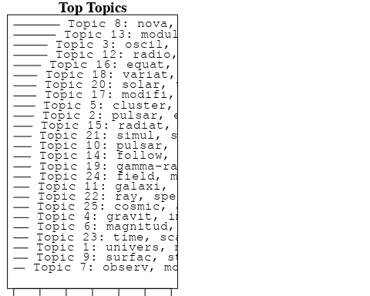

plotQuote(thoughts6, width = 30, main = "Topic 6")  
plotQuote(thoughts18, width = 30, main = "Topic 18")

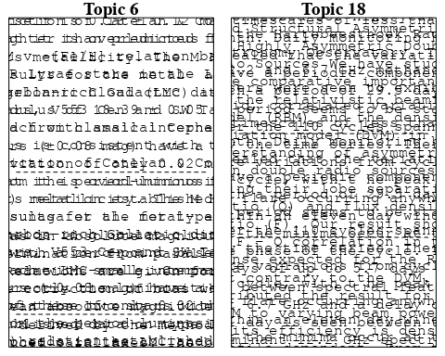

# Calculate and plot the correlation between topics  
mod.out.corr <- topicCorr(Research_topics)  
plot(mod.out.corr, cex = 1.5)  
  
  
# For each topic  
for (topic_num in 1:25) {  
 # Plot the word cloud  
 cloud(Research_topics, topic = topic_num, scale = c(2, 0.25))  
 Sys.sleep(2)  
}

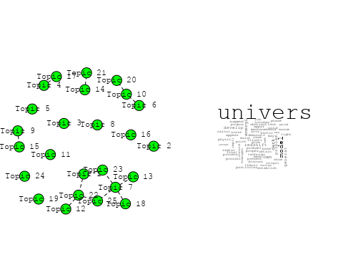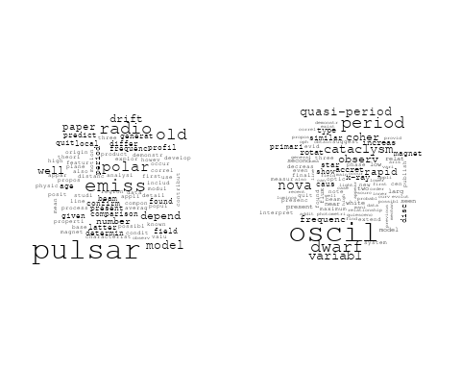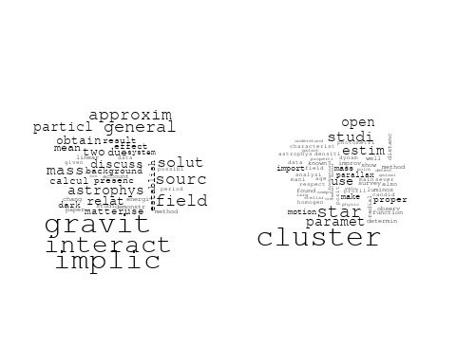

## Warning in wordcloud::wordcloud(words = vocab, freq = vec, max.words =  
## max.words, : parallax could not be fit on page. It will not be plotted.

## Warning in wordcloud::wordcloud(words = vocab, freq = vec, max.words =  
## max.words, : establish could not be fit on page. It will not be plotted.

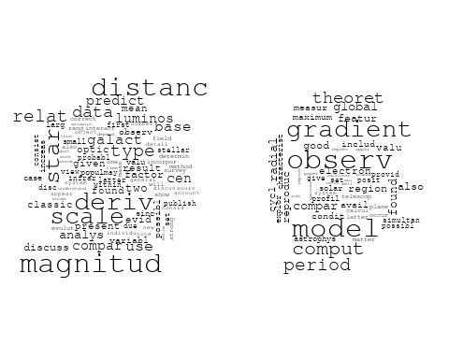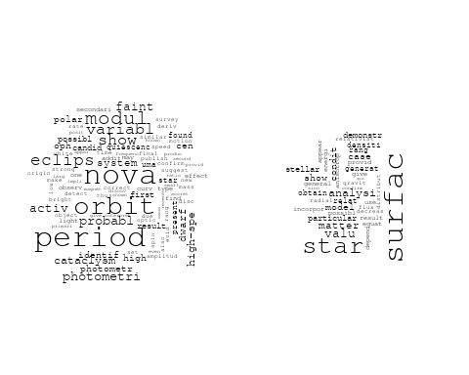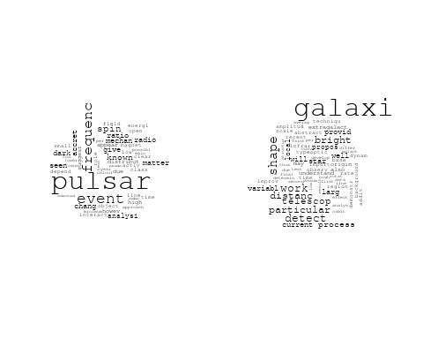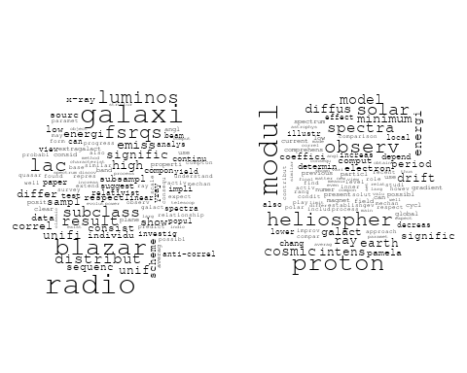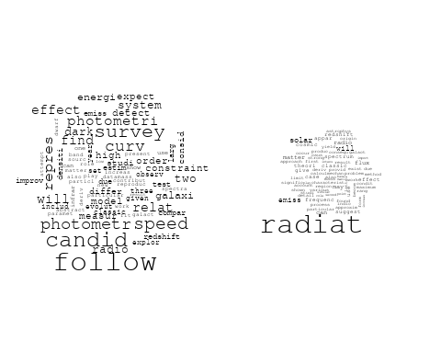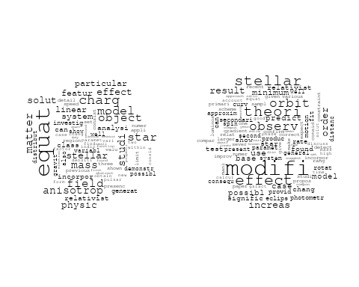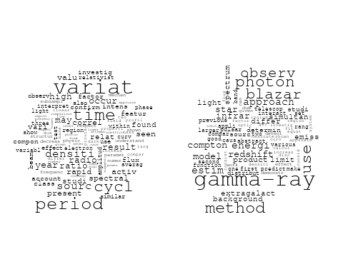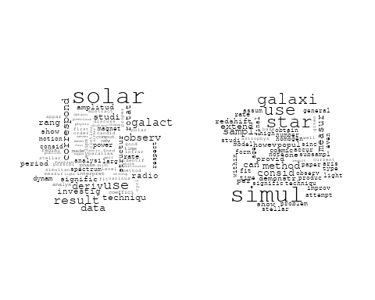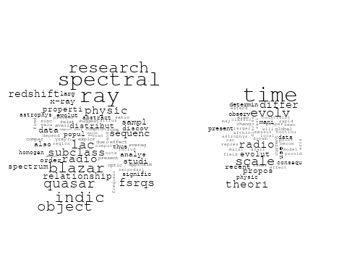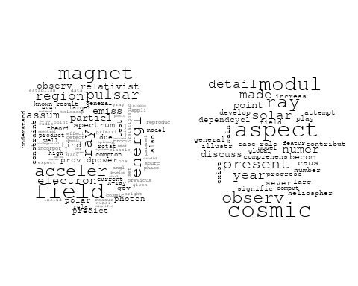

# Get the topic proportions for each document  
topic_proportions <- Research_topics$theta  
  
# Find the index of the topic with the highest proportion for each document  
# This will be the topic that each document is most likely to belong to  
max_topic_idx <- apply(topic_proportions, 1, which.max)  
  
# Add this as a new column to your data  
data_independent$topic <- max_topic_idx  
  
  
  
# Define the intervals  
intervals <- c('1824_1899', '1900_1964', '1965_1974', '1975_1984', '1985_1994', '1995_1999', '2000_2004', '2005_2009', '2010_2014', '2015_2019', '2020_2022')  
colors <- c('pink', 'blue', 'purple', 'yellow', 'green', 'pink', 'orange', 'violet', 'green', 'blue', 'pink')  
  
# Loop through the intervals and plot  
for(i in seq_along(intervals)){  
 # Filter data for when the pub_interval is equal to 1  
 data_filtered <- data_independent[data_independent[[paste0('pub_interval_', intervals[i])]] == 1,]  
   
 # Make the histogram  
   
 p <- ggplot(data_filtered, aes(x = topic)) +  
 geom_histogram(binwidth = 1, fill = colors[i], color = "black") +  
 xlab("Topic") +  
 ylab("Count") +  
 ggtitle(paste0("Topics from year ", gsub("_", " to ", intervals[i])))  
   
 print(p)  
}

